MORPHOLOGY UPDATE
Fresh water-induced hemolysis in near-drowning

Eitan Mirvis¹ Barbara J. Bain²
¹Department of Haematology, Imperial College NHS Healthcare Trust , St Mary’s Hospital, London W2 1NY, UK
²Centre for Haematology, St Mary’s Hospital Campus of Imperial College Faculty of Medicine, St Mary’s Hospital, London, W2 1NY, UK
Correspondence
Barbara J. Bain, Blood Sciences, St Mary’s Hospital, Praed Street, London, W2 1NY, United Kingdom. b.bain@imperial.ac.uk

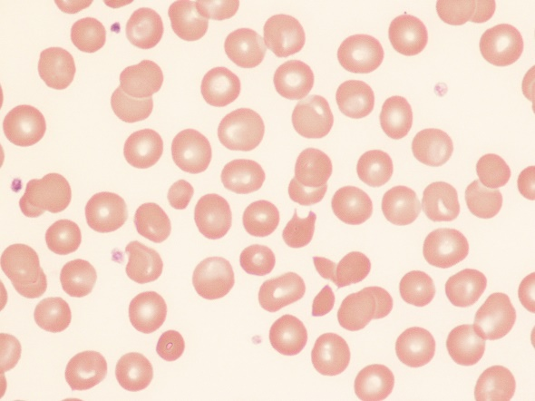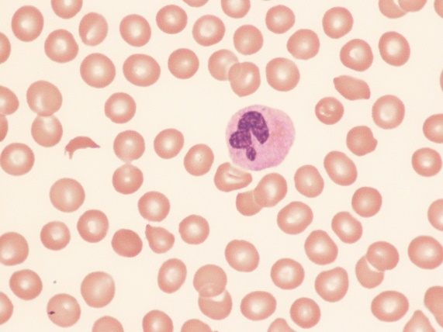
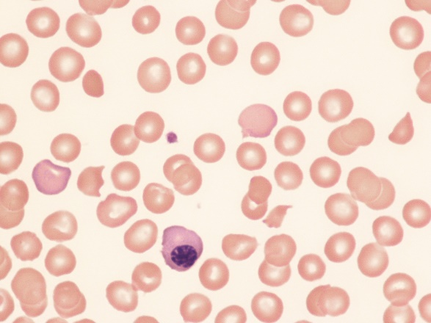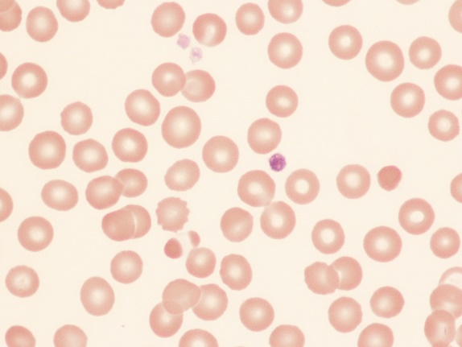
A 52-year-old Caucasian man fell into a London canal. After he failed to resurface, he was rescued by bystanders. It took them an estimated three minutes to find him as the water was dirty. After his return to the surface, they started cardiopulmonary resuscitation. When the paramedics arrived he was breathing with pulses present but his Glasgow Coma Score was 3/15. He was therefore intubated, was transferred urgently to hospital and was admitted to the intensive care unit where he was treated for severe aspiration pneumonitis. His alanine transaminase rose to 2376 units/l and aspartate transaminase to 4293 units/l, indicating hypoxic ischemic liver injury. He shortly developed pneumonia, a pleural effusion and sepsis. Meanwhile, his hemoglobin concentration (Hb), which on admission had been 180 g/L (with leucocytosis, neutrophilia, lymphocytosis and a normal platelet count) dropped rapidly, over the next six days, to 72 g/L. Coagulation tests now suggested disseminated intravascular coagulation (DIC), with platelets 43 × 10⁹/L, prothrombin time 34.5 seconds, activated partial thromboplastin time 52.1 seconds, fibrinogen 1.16 g/L and D-dimer >20,000 μg/L. His blood film (images, ×100 objective) showed schistocytes, irregularly contracted cells, nucleated red blood cells and polychromasia. There were occasional erythrocytes with retraction of hemoglobin to one side or both ends of the cell (bottom right image). His reticulocyte count was 101 × 10⁹/L on day 5. Bilirubin was 51 μmol/L and conjugated bilirubin 37 μmol/L. Lactate dehydrogenase was 1664 iu/L and haptoglobin 1.97 g/L. A direct antiglobulin test was weakly positive for IgG and negative for C3d. ADAMTS13 was 37 iu/L, excluding thrombotic thrombocytopenic purpura. With intensive support, including blood transfusion, the patient recovered and was discharged after 35 days.
The rapid fall in Hb is the absence of any signs of hemorrhage suggests hemolysis. The blood film features are indicative of microangiopathic hemolytic anemia with the irregularly contracted cells suggesting, in addition, oxidant damage.
Drowning and near-drowning in fresh-water is known to cause intravascular haemolysis, first reported in 1880; there is hemoglobinuria as a result of osmotic lysis of erythrocytes following absorption of water through the lungs.^{1,2} Hypoxia is a contributing factor to the hemolysis.³ Our observations support the interactions of further mechanisms including microangiopathic hemolytic anemia in the context of DIC. DIC has been reported previously.⁴ Finally, our observation of irregularly contracted cells and of hemoglobin retraction within erythrocytes suggest possible oxidant damage.

CONFLICT OF INTEREST
Nil

ORCID
0000-0003-3077-4579 Barbara Bain

REFERENCES
- Rath CE. Drowning hemoglobinuria. Blood. 1963;8(12):1099-1104.
- Byard RW, Cains G, Simpson E, et al. (2006) Drowning, haemodilution, haemolysis and staining of the intima of the aortic root-- preliminary observations. J Clin Forensic Med. 2006;13(3):121-124.
- Layon AJ, Modell JH, Warner DR, et al. Drowning: Update 2009. Anesthesiology. 2009;110:1390-
- Schwameis M, Schober A, Schörgenhofer C, et al. Asphyxia by drowning induces massive bleeding due to hyperfibrinolytic disseminated intravascular coagulation. Crit Care Med. 2015;43(11):2394-2402.
Email of coauthor for editorial purposes
Eitan Mirvis e.mirvis@nhs.net

