A highly efficient methodology to extract and quantity micro-(bio)plastics in sludges.

Federica Ruggero¹, Alexandra E. Porter², Nick Volvoulis³, Emiliano Carretti⁴, Tommaso Lotti¹, Riccardo Gori¹, Claudio Lubello¹

¹ University of Firenze, Department of Civil and Environmental Engineering, Italy
² Imperial College London, Faculty of Engineering, Department of Materials, UK
³ Imperial College London, Centre for Environmental Policy, UK
⁴ University of Firenze, Department of Chemistry “Ugo Schiff”, Italy

Abstract
Here, a novel approach for micro-(bio)plastics identification and quantification in sludge and in organic waste pulp, assimilable to sludge, was devised. In previous studies, different methods for microplastics recovery were devised for traditional plastics, while in the current research the developed methodology was tested on starch-based micro-(bio)plastics 0.1 – 2 mm size. Compostable bioplastics are expected to enter the anaerobic or aerobic biological treatments that lead to end-products that can be applied in agriculture; some critical conditions of the treatments (e.g. low temperature and humidity) can slowdown the degradation process and be responsible for microplastics presence in the end-product. The methodology consists on an initial oxidation step, with the use of H₂O₂ 35% concentrated to clear the sludges and remove the organic fraction, followed by a combination of flotation with NaCl and observation of the residues under a fluorescence microscope using a green filter. The workflow revealed an efficacy of 100% to 94% and from 96% to 92% for plastic fragments, 0.5-2 mm and 0.1-0.5 mm size, respectively. The methodology was then applied to samples of food waste pulp harvested after a shredding pre-treatment in an anaerobic digestion plant in Italy, where PE, MB and cellophane microplastics were recovered in amounts of 9±1.3/10 g < 2 mm and 4.8±1.2/10 g ≥2 mm. By, improving the background knowledge about microplastics and micro-bioplastics (together called in the current work micro-(bio)plastics) fate in biological treatments for the organic waste, the study highlights the need to lower the threshold size for plastics-quantification in organic amendants, which is currently set by legislations at 2 mm.

Graphical Abstract
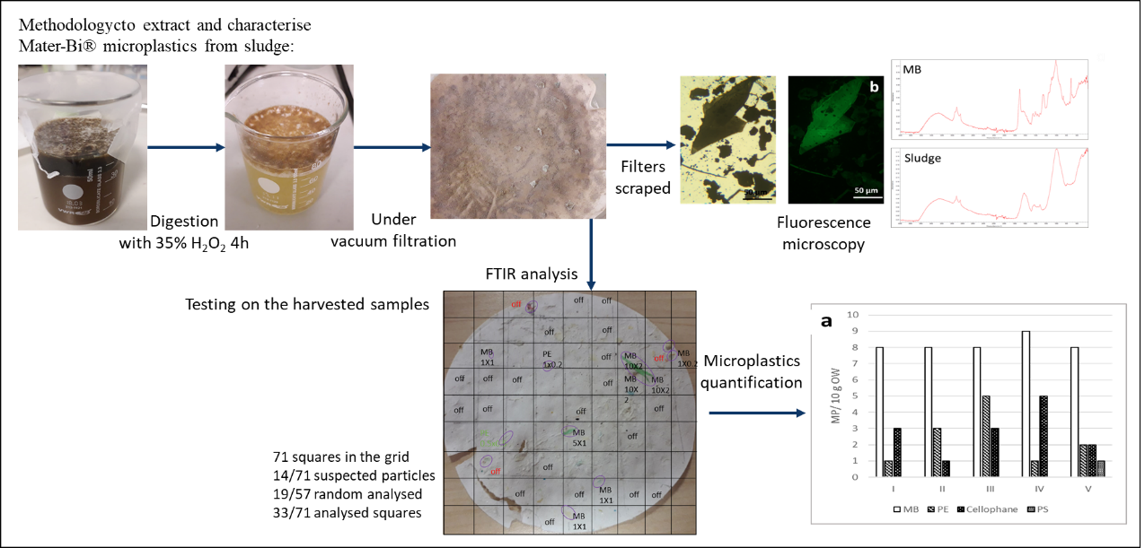

- Introduction

Plastic litter (either macro or microscale) is a major global environmental problem, however the real scale of the problem, and the ultimate fate of plastics, is not known. Plastics can degrade into microparticles (MPs) under various environmental conditions and will affect both waters and soils. Within these soils, and as a consequence of weathering, specific plastics can age and be degraded into smaller microplastics, in a size range between 5 mm and 10 𝜇m (Shruti and Kutralam-Muniasamy, 2019).
In order to reduce the amount of plastic waste and potential environmental impact of plastics, there is a drive towards using biodegradable plastics. Italy is one of the countries where bioplastic bags are imposed by the Government for organic waste collection (Law number 123/2017). These bioplastic bags available in the supermarkets are made of Mater-Bi® (MB): this material is composed by starch (20%), additives (10%) and polybutene adipate terephthalate (PBAT) (70%) (Bastioli, 1998), (Elfehri Borchani et al., 2015). This bioplastic is labelled as compostable in the aerobic and anaerobic biological treatments of the organic fraction of waste, in accordance with the EN 13432 (EN 13432, 2000). The standard provides specific conditions under which the biodegradation test is carried out: high temperature (58±2°C) over long-times scales (≥3 months). However, the process conditions (including time, temperature and moisture) of industrial biological treatments can largely differ from these standard testing conditions, as in the case of mesophilic temperatures (37±2°C) and shorter time-scale in the anaerobic digesters, both in sewage treatment plants and in organic waste biological treatments (Ruggero et al., 2020a). Due to this issue and to the fact that some traditional plastic bags continue into treatment plants, in spite of the obligation to use bioplastic bags for the organic waste collection, usually the plants are provided with mechanical pre-treatments to remove larger plastic items (Vigneswaran et al., 2016). Even so, some microplastic items are found in compost (from aerobic composting) and stabilized sludges (from anaerobic digestion). These microplastics are not only derived from traditional plastic bags, but also from incompletely biodegraded bioplastics (Weithmann et al., 2018).
The Italian legislation on compost quality (D.Lgs 75/2010) imposes that no more than 0.05% dry weight of plastic is present in organic amendants. However, the threshold set to define the presence of plastic materials is 2 mm, meaning that all the microplastics that eventually go through the meshes of a 2 mm sieve are considered to be compost. The D.Lgs. is an improvement on the previous threshold of 3.33 mm imposed by the D.Lgs. 217/2006, but a further decrease in this threshold is forecast with the introduction of a new legislation. The main issue here is related to the lack of a standardised methodology for the recovery into compost and sludges of microplastics below 2 mm. Few available studies are focused on microplastics detection in sludges and soil (Ruggero et al., 2020b): the methodologies applied exploit the use of oxidizing agents or acids for digestion of the organic matter (Li et al., 2018), after sieving the bulk sample to study the fraction of interest (< 2 mm) (Lares and Ncibi, 2018). Visual analyses have been also carried out on samples of soil to identify microplastics; however, due to the small size and the poor contrast between the plastics and the matrix, the detected particles are not early visible with the naked eye (Weithmann et al., 2018), (Prata et al., 2019). To this purpose, previous authors have improved the observations using scanning electron microscope (SEM) or optical microscope (Zhang et al., 2018),(Li et al., 2018).
Starting from the overview of the current available techniques, this study aims to devise a repeatable and efficient methodology to recover, image and quantify micro-(bio)plastics from 2 to 0.1 mm size from samples of sludges and organic waste pulp, assimilable to sludge, obtained from shredding pre-treatments. The methodology is applied to a pulp of shredded organic waste harvested from the field, containing endogenous micro-(bio)plastics, including Mater-Bi® (MB).

- Material and methodologies

The methodology used to extract micro-(bio)plastics is schematized in Figure 1 and the steps applied are depicted in Figures 1S-4S.

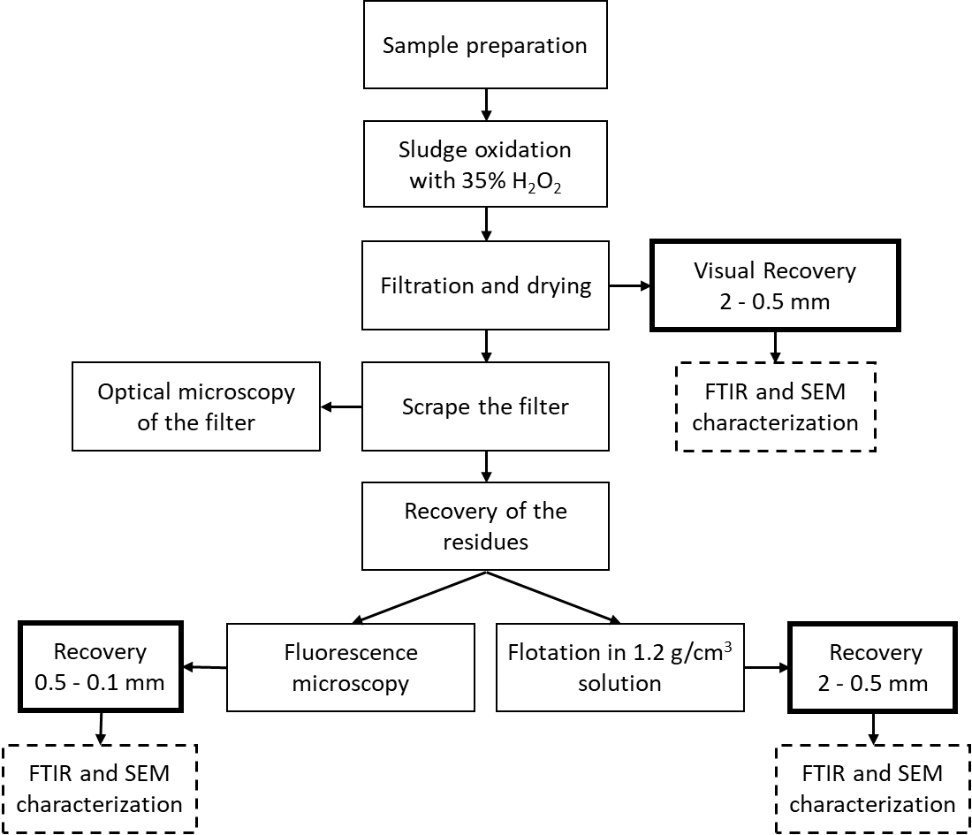
Fig. 1 Methodology used to recover and quantify microplastics (0.1-2 mm) in sludges.

2.1 Sample preparation

While in previous studies different methods for microplastics recovery were devised for traditional plastics, the current research tested the methodology on Mater-Bi® micro-bioplastics. MB microplastics were generated from Mater-Bi® biobags for organic waste collection, available in Italian supermarkets. Bags were frozen with liquid nitrogen and manually shredded. The pieces obtained with this procedure were sieved to subdivide them into three granulometric fractions: 1-2 mm, 0.5-1 mm, 0.5-0.1 mm.
One of the most critical steps to accurately quantify microplastics is sample preparation. For example, the sample could be contaminated with some microplastics from the lab equipment or pieces inside the sample could be accidentally removed during handling.
To define the efficacy of recovery of the methodology, samples were prepared in the laboratory by adding MB microplastics to plastic-free sludges. Before preparing the samples, microplastics, handled with tweezers, were counted and weighed. Then they were carefully transferred to the bottom of a 60 ml glass beaker. The beaker was filled with 10 ml of primary sludge.
Sludge were collected in October 2016 from the WWTP located in Cambridge, representing UK sewage water from an urban environment. These samples were quantified by ICP-OES (Inductively Coupled Plasma Optical-Emission Spectrometry) and ICP-MS (Inductively Coupled Plasma-Mass Spectrometry) in order to measure their elemental distribution. These results, together with other physico-chemical parameters of these media are listed in Table 1S, together with the details of the WWTP (Figure 5S) CIT. TO BE ADDED. Before entering the lab, they were disinfected and sieved with a 0.1 mm mesh, to remove the microplastics ≥ 0.1 mm.

  - Mater-Bi® oxidation with hydrogen peroxide (H₂O₂)

The first step of the methodology digests the Mater-Bi ®using an oxidizing agent. This treatment has been applied in previous studies to remove the organic matter in sludges and in biota and sediments (Claessens et al., 2013), (Prata et al., 2019). Other groups have used acid and alkali digestion, respectively with HCl or HNO₃ and with NaOH or KOH, to digest the microplastics, however these melt and age and will totally destroy the pieces of plastic, leading to an underestimation of their quantity (Karami et al., 2017), (Naidoo et al., 2017). Digestion with oxidizing agents, in particular 30-35% concentrated H₂O₂, is an effective method to remove organic matter. Previous work has shown that this treatment doesn’t significantly alter the structure of a number of plastics, including PE, PP, PS, PVC and PET (Nuelle et al., 2014). Following oxidation of the Mater-Bi®, 34.5-36.5% concentrated H₂O₂ (purchased by Sigma Aldrich) was chosen as the optimal condition; in fact a lower concentration (20%) does not clear the sludge from the organic matter, and a higher concentration (50%) has a visible digestion effect also on MB microplastics. To carry out this first step of the methodology, 30 ml of the oxidizing agent was added to the 60 ml glass beaker already containing the mixture of sludges and microplastics. The proportion sludge:H₂O₂ was 1:10 by weight. To homogenize the solution, the beaker was shaken on IKA® KS 130 basic orbital shaker at 160 mot/min for 5 min. The use of the orbital shaker allows a gentle mixing of the solution, preventing eventual loss of the microplastics.
The oxidizing agent was left to act for 4 hours at room temperature under a fume hood. However, having observed that after 2 hours the undissolved organic matter accumulated on the top of the beaker, the solution was shaken again at 160 mot/min for 20 min, until observing a homogeneous solution.

  - Filtration and drying

The solution of H₂O₂ and oxidized sludges was filtered under vacuum with a Buchner funnel that was 90 mm diameter. The contents of the beaker were transferred into the filter paper, then the beaker was carefully washed out with distilled water to remove any residual microplastics. The filter paper was gently recovered with tweezers and deposited on a covered glass dish. The sample was dried in the oven at 60 °C over-night.
When the filter paper was completely dry, a first visual recovery of microplastics was performed. The microplastics were recovered with tweezers and conserved in the fridge for subsequent characterization. The paper filter was weighed, and the residue was scratched off; after scratching, the paper filter was weighed again to obtain the weight of the residue (Equation 1). Moreover, the filter was kept for subsequent observation under an optical microscope, to assess whether any residual microplastics have remained adhered to its surface after the residue was brushed off. The observations were conducted on an Olympus BX51 microscope.

Equation 1.
$$Weight loss \left(\%\right)=\frac{{W_{s}-(W}_{r+pf}-W_{pf})}{W_{s}}*100$$

Where $W_{s}$ is the weight of sludges added at the beginning of the test, $W_{r+pf}$ is the weight of residue and paper filter and $W_{pf}$ is the weight of the residue paper filter after scratching the difference between $W_{r+pf}$and $W_{pf}.$

  - Flotation

After oxidation, the residue (and microplastics not recovered in the previous step) were subjected to two further treatments. Every step increased the risk of microplastic-loss and sample contamination.
For the flotation, a solution of NaCl 1.2 g/cm³ was prepared; the density of Mater-Bi® was measured experimentally with a pycnometer and ranges between 1.018-1.024 g/cm³, while the sludge density is 1.3 g/cm³. Thus, the density of the solution allowed for flotation of the microplastics and deposition of the sludge residues.
The NaCl solution was added to the residue in a 20 ml glass vial. After manual shaking for 1 minute, another 10 minutes was needed to observe that the particles inside the vial had reached equilibrium inside the water column. The surfactant was then recovered from the vial.
This technique of recovery has been applied on samples containing microplastics with a diameter >0.5 mm.

  - Fluorescence microscopy

Fluorescence microscopy has been applied in previous research to detect PE, PP and PS microplastics in sediments and biota (Shim et al., 2016). The samples with microplastics <0.5 mm were imaged by fluorescence microscopy after oxidation and filtration steps. A Brunel SP105F with pE300 LED inverted fluorescence microscope, with transmitted illumination - 6v 30watt (bright field and phase contrast available) was used for imaging. The available fluorescence channels in the microscope are: DAPI, FTIC and Texas Red, corresponding to violet (emission wavelengths 395 to 410 nm), blue (490 to 505 nm) and green (560 to 580 nm) filters respectively. Imaging was carried out using an objective lens strength of 4x. The microscope was fitted with Canon EOS 1200D camera to capture the images of the samples.
The three spectral ranges were tried first on Mater-Bi® and sludge residues separately to observe the tendency of each matrix to fluoresce. After this preliminary observation, full analysis was carried out.
For optical microscopy observation, the sample on the filter was placed on a glass slide and a drop of distilled water was added to the corners of the slide and a cover glass was deposited over the sample.

  - Characterization

Before starting the test and after the application of the recovery methodology, the MB microplastics were characterized with Fourier Transform Infrared (FTIR), using a Thermo Scientific™ Nicolet™ iS™10 FTIR Spectrometer with 2 cm⁻¹ spectral resolution, coupled with OMNIC software, and Scanning Electron Microscope (SEM) JEOL JSM-6010PLUS/LA analytical SEM, coupled with JEOL software. The SEM was set with a working distance 18 mm and accelerating voltage 20 kV; secondary electrons emitted by atoms excited by the electron beam are detected using a secondary electron detector.

  - Preliminary assessment of the effect of H₂O₂ on Mater-Bi® microplastics

First, the effect of H₂O₂ oxidation on MB microplastics was studied to assess if the pieces were strongly or negligibly aged by the oxidizing agent. Five pieces of microplastic of each granulometric fraction were weighed (W_{i}) and submitted to the oxidation process.
The microplastics were deposited at the bottom of a 60 ml beaker and 1 ml of 34.5-36.5% concentrated H₂O₂ was added in a proportion with MB 100:1. The solution was shaken, then deposited for four hours at room temperature in a fume hood. The solution was filtered with a Buchner funnel under vacuum filtration; the beaker was rinsed with distilled water and poured into the filter to ensure the removal of all of microplastics from the sides of the beaker. After the vacuum filtration, the paper filter was moved into a glass dish with a proper cover for drying into the oven at 60°C, overnight. Finally, the microplastics were recovered from the filter paper and weighed (W_{f}). The recovery $R\left(\%\right)$ was assessed from the weight loss, using Equation 2.

Equation 2.
$$R\left(\%\right)=\frac{W_{f}}{W_{i}}*100$$

  - Validation of the methodology

To assess the efficiency of the oxidation procedure, Mater-Bi® microplastics in a known amount were added to the plastic free sludges; the efficacy of recovery $R_{MP}\left(\%\right)$ was evaluated on the basis of the recovered number of microplastics after each recovery step (Equation 3).

Equation 3.
$$R_{MP}\left(\%\right)=\frac{\#_{r}}{\#_{i}}*100$$

Where $\#_{i}$and $\#_{r}$ represent the initial number of microplastics added and the number of microplastics recovered, respectively.
Table 1 reports the samples generated to test the methodology. The samples consist of sludges into which microplastics of different sizes were added. Five replicates of each granulometric fractions, and three replicates containing pieces of all the microplastic fractions were prepared and immediately submitted to the recovery procedure.

Table 1 Initial number of pieces (#_{i}) and weight (W_{i}) of Mater-Bi® microplastics used to assess the recovery methodology.
Sample | 1-2 mm |  | 0.5-1 mm |  | 0.1-0.5 mm |  | 0.1-2 mm
 | Pieces | W_{i} (g) | Pieces | W_{i} (g) | Pieces | W_{i} (g) | Pieces | W_{i} (g)
I | 10 | 0.0017 | 10 | 0.0005 | 7 | 0.0006 | 16 | 0.0018
II | 8 | 0.0012 | 8 | 0.0005 | 6 | 0.0004 | 15 | 0.0014
III | 11 | 0.0019 | 11 | 0.0007 | 7 | 0.0005 | 16 | 0.0019
IV | 10 | 0.0016 | 9 | 0.0005 | 8 | 0.0004
V | 10 | 0.0014 | 10 | 0.0004 | 8 | 0.0004

  - Application to field samples

The methodology was applied on organic waste samples harvested from a treatment plant located in the Northern Italy. The plant consists of a dry mesophilic (37±2°C) anaerobic digester, followed by a composting treatment. However, the digestion condition does not provide a proper degradation of bioplastic materials; beside this issue, the plant has also to handle some bags made from traditional not compostable plastic (mainly PE), used for organic waste collection in spite of the ban by the Italian regulators. For this reason, the plant is provided with a pre-treatment that aims to remove plastic bags and to shred the organic waste until a homogeneous pulp has been obtained. As the two processes are developed inside the same press machine, microplastics may be generated from the shredding of some plastic items remaining in the organic waste after separation. Samples of the organic waste pulp obtained after the pre-treatment were harvested and the presence of microplastics was investigated using the developed methodology. In order to characterise the plastic types expected in the samples, FTIR analyses were randomly carried out on bags removed by the separation pre-treatment.

    - Recovery of microplastics from harvested samples

The samples consist of 10 g of organic waste pulp, a matrix which is similar to sludge but is high heterogeneous. The waste pulp samples were diluted with tap water to obtain the same content of dry matter of the sludges used to validate the method, i.e. 6.5 %, (measured with Total Solids TS in accordance with ISO 11465, 1993). After 4 hours oxidation, the samples were recovered from the beaker, filtered under vacuum in a 90 mm paper filter and dried in the oven over night at 60°C. Due to the heterogeneity of the residue on the filter, mainly pieces of cellulosic material and food peels, the methodology was applied until the visual recovery step: the filter was divided into a grid 1x1 cm squares and each square was visually analysed. The items identified as microplastics were recovered and analysed by FTIR to verify and define the plastic type. The squares of the filter in which microplastics could not be detected visually, were analysed with FTIR. To prepare the background, a paper filter was wet using tap water, 35% H₂O₂ and water filtered from the organic waste pulp. One point of each square visually “free” of plastic was analysed with FTIR to check the presence of eventual microplastics not visually identified.
In some cases, the identification of microplastics was masked due to biodegradation and organic matter attached to the surface of the material. Thus, the Cauchy-Schwarz inequality was used to calculate the numeric score which describes the differences between two spectra, and on which a library search was based. In accordance with the Equation 4, the score ranged from 0 to 1; a score ranging from 0.8 to 1 is generally considered a good basis for polymer assignment (Rocha-Santos and Duarte, 2017).

Equation 4.
$$score=\frac{(sample,reference)}{|\left|sample\right||∙|\left|reference\right||}$$

    - Statistical analysis

Five samples of 10 g of diluted organic waste pulp were analysed. For each sample 71 squares were drawn in the grid filter, for a total of 355 squares analysed with FTIR.
The error of visual recovery of microplastics in each sample was estimated from the experimental data. Two errors were defined: an error of overestimation, called ε_{over}, that refers to the number of items visually recovered which are not plastics; and an error of underestimation, called ε_{under}, that means the number of squares in the filter which contain microplastics that could not be identified visually. From the experimental data is finally possible to derive the Equation 5 for microplastics estimation, starting from the number of visually recovered items, is:

Equation 5.
$$MP={MP}_{VR}-ε_{over}+ε_{under}$$

Where MP refers to the corrected estimation of microplastics present on the filter and MP_{VR} refers to the microplastics recovered visually from the filter after the oxidation process.

- Results and discussion

  - Preliminary assessment of the effect of oxidizing process on Mater-Bi® microplastics

The initial and final weights of the five samples of microplastics used to assess the effect of H₂O₂ on Mater-Bi® material are shown in Table 2S. The recovery (R%) has been calculated using Equation 2, as an average of the five samples in each size range.
The recovery of 1-2 mm and 0.1-0.5 mm is 100%, and for 0.5-1 mm diameter Mater-Bi® it is 96±5%. This small standard deviation from the mean of the five samples in the 0.5-1 mm size range is most likely related to sample handling, such as the accidental loss of Mater-Bi® fragments during sample transfer.
The recovered microplastics were characterised by SEM and FTIR. Figure 2 reports SEM micrographs which compare the MB microplastic surface before and after oxidation with 35% concentrated H₂O₂ for 4 hours. The Mater-Bi® was heterogeneous containing some grains within a smooth film. After oxidizing treatment, some holes were visible on the surface of the Mater-Bi. Since Mater-Bi® is composed of starch grains and PBAT, these micrographs suggest that starch has been partially degraded by hydrogen peroxide (Deschamps et al., 2008), (Szymońska et al., 2009).

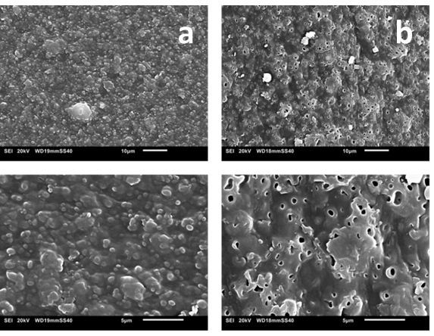
Fig. 2 SEM micrographs of Mater-Bi® surface. (a) The surface of pristine Mater-Bi®, (b) The Mater-Bi® surface after oxidation with 35% concentrated H₂O₂ for 4 hours.

The same samples were analysed with FTIR; Figure 3 shows representative spectra for 0.5-1 mm and 1-2 mm Mater-Bi® microplastics recovered after oxidation in comparison with a spectrum of the material taken before the treatment. The material maintained its characteristic absorption peaks after the oxidation process. The main peaks in the spectra matched the components of Mater-Bi® molecular structure, and are comparable with standards given in references (Elfehri Borchani et al., 2015), (Herrera et al., 2002), (Weng et al., 2013). The wavenumbers for starch are: 1274 cm⁻¹ (C-O in ester linkage) and 1163 cm⁻¹ (CH₂OH). The main peaks assigned to PBAT are: 1717 cm⁻¹ (C=O stretch), 1020 cm⁻¹ (ring vibration of benzene) and 726 cm⁻¹ (symmetric skeletal stretch of butyl group). The peak 2921 cm⁻¹ (asymmetric C-H₂ stretch typical of n-Alkanes) related to starch, was smoother after the oxidizing treatment, thus confirming the observations derived from SEM micrographs about a partial degradation of starch by hydrogen peroxide, which however does not compromise the recoverability of Mater-Bi® pieces.

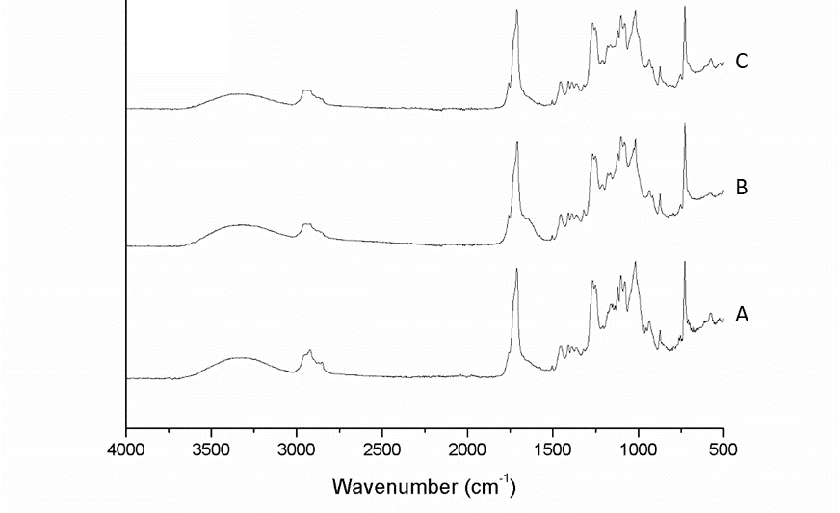
Fig. 3 Comparison between spectrum of a microplastic Mater-Bi® before the oxidation with 35% concentrated H₂O₂ for 4 hours (A) and after: 1-2 mm (B) and 0.5-1 mm (C) fractions respectively.

  - Validation of the methodology

The oxidation of sludges in H₂O₂ lead to a reduction of the sludge weight (W_{s}) of more than 99.96%. The weight loss of the Mater-Bi®, measured using Equation 1 on the samples is shown in Table 2.

Table 2. The table reports the weight loss of sludges containing MB microplastics of different sizes, after oxidation with H₂O₂.
Sludge sample | W_{s} (g) | W_{r} (g) | Weight loss (%)
1-2 mm | 7.4337±0.7028 | 0.00189±0.0003 | 99.975±0.004
0.5-1 mm | 6.5594±0.2376 | 0.00191±0.0005 | 99.971±0.007
0.1-0.5 mm | 5.9618±0.1106 | 0.00199±0.0002 | 99.967±0.004
0.1-2 mm | 5.4539±0.1197 | 0.00185±0.0002 | 99.967±0.003

Microplastics from sludge residues were recovered in accordance with the two branches of the described methodology. Samples containing microplastics 1-2 mm and 0.5-1 mm were recovered using the flotation protocol. The efficacy of recovery, calculated with Equation 3, of 1-2 mm microplastics is 93.7±2.9% from visual recovery after oxidation, rising to 100% after flotation. For samples containing microplastics 0.5-1 mm size, $R_{MP}\left(\%\right)$ is 83.9±5.8% after oxidation, rising to 93.7±2.8% after flotation. The time required for visual recovery after oxidation procedure did not exceed 5 minutes for 1-2 mm microplastics fraction, and 15 minutes for 0.5-1 mm fractions. The samples containing microplastics <0.5 mm were imaged in the fluorescence microscope. The recovery efficacy of microplastics of size 0.1-0.5 mm was 60.8±6% using visual recovery after oxidation, and 91.8±4.5% using fluorescence microscopy. The average recovery of the three samples containing microplastics in the size range of size 0.1-2 mm, was 80.8±3.2% after oxidation, and 95.8±2.1% with fluorescence. Figure 4 summarizes the four categories of samples: Each column represents the mean value of the samples, with the standard deviation of the total efficacy of recovery $R_{MP}\left(\%\right)$.

Fig. 4 Graph showing the recovery efficacy (R_{MP}%) of microplastics after oxidation and flotation for 1-2, 0.5-1. Microplastics shown in the third and fourth column (0.1-0.5 and 0.1-2 mm) are recovered after applying an oxidation treatment and fluorescence microscopy. The standard deviation of the final recovery is indicated for each column respectively.

Almost all of the <0.5 mm microplastics missed with visual recovery could been identified using fluorescence microscopy. A total of 11 items were recovered from the five samples containing microplastics with a size of 0.1-0.5 mm and 8 microplastics with a diameter of 0.1 to 2 mm were found in the residual powder of the sludges. Figure 5 reports two examples of Mater-Bi® microplastics that fluoresce under a green filter (the others are in Figures 6S-13S), while the surrounding residues of sludges were much less sensitive to fluorescence. The FTIR spectra confirmed that the fluorescing pieces in Figure 5 are Mater-Bi® microplastics.

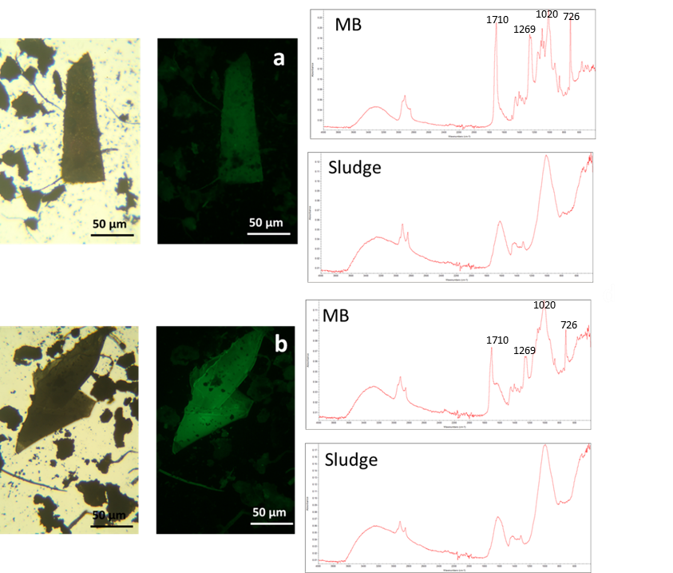
Fig. 5 Optical micrographs (left) and green fluorescence images of microplastics of Mater-Bi®, compared to observations without using a green filter. The microplastics were recovered from samples containing items of 0.1-0.5 mm IV (a) and V (b); the spectra confirm that the fluorescent items are MB microplastics, whilst the surrounding powder was sludge residue.

Filters after scraping were analysed under microscope, to check if any residues of microplastics were still attached to the filter surface (Figure 14S-15S).

  - Application to field samples

The plastic bags collected after separation pre-treatment were identified with FTIR and the peaks were assigned to characteristic peaks from Mater-Bi® and polyethylene (PE) bags. Only one polypropylene (PP) bag was found (Figure 16S). The FTIR analyses on the microplastics recovered from the filters identified also one polystyrene (PS) item and some microplastics of cellophane. Some reference peaks of each plastic type have been identified; they are reported in Table 3.

Table 3. Characteristic peaks (cm⁻¹) of plastic items found in the harvested organic waste samples.
Mater-Bi® | Polyethylene | Polypropylene | Cellophane | Polystyrene
1269 (C-O) | 2914 (CH₂) | 2950 (CH₂) | 2923 (CH₂) | 3100 (aromatic CH)
1710 (C=O) | 2845 (CH₂) | 2845 (CH₂) | 2845 (CH₂) | 1426 (ring stretch)
1020 (C₄H₉) | 1463 (CH₃, CH₂) | 1576 (C=C) | 1065 (C=S) | 765 (ring stretch)
726 (C₆H₆) | 721 (CH) | 1538 (C=C) | 1030 (CH) | 726 (C₆H₆)

In Figure 6 shows an example of the analysis carried out on the paper filter (additional examples are shown in Figures 17S-20S). FTIR spectra of PE, MB and PS microplastics visually recovered from C8, E9 and D6 squares are displayed to the right of the paper filter.

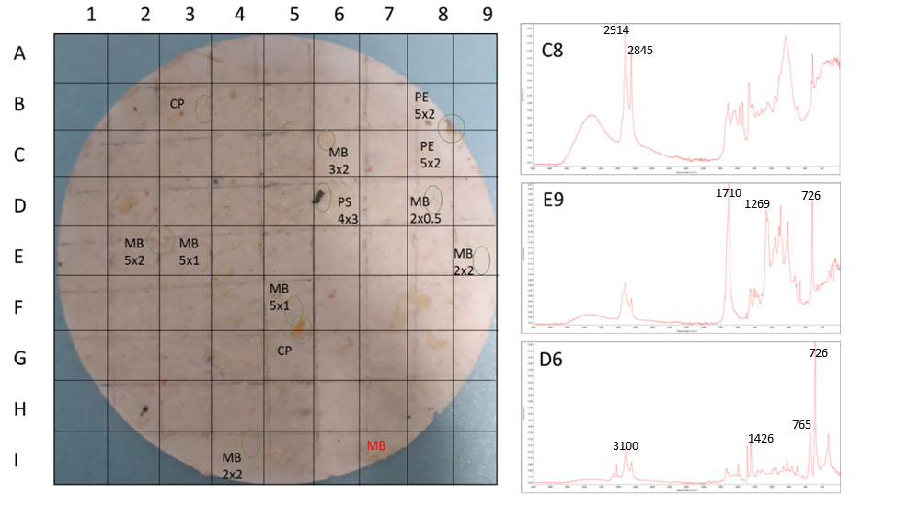
Fig. 6 Filter paper with a grid of 1x1 cm squares. The microplastics visually identified on the filter surface are circled in green, and three spectra are shown to the right of the image. They correspond to squares C8, E9 and D6, which identify PE, MB and PS microplastics, respectively. Square I7 contains an MB item (written in red) on its surface which was not visually identified.

After correction with FTIR analysis, the efficacy of the visual recovery from the filter is found to be in a range between 87.5% (filter III) and 100% (filters I and II). In filters IV and V the recovery efficacy was 93.3% and 92.3% respectively. These values are comparable with those previously assessed for the visual recovery method (Fig. 4).
The average number of microplastics recovered in 10 g sample is 14±1.5, of which 8.4±0.5 are MB and 5.4±1.7 are traditional microplastics, including cellophane, PE and PS. The histograms in Figure 7 depict the number of microplastics recovered in the five paper filters analysed. Moreover, the average number of microplastics with diameter <2 mm, meaning that at least one dimension is smaller than 2 mm, is 9±1.3 and ≥2 mm 4.8±1.2. The data point out that the current threshold of 2 mm devised for plastics quantification should be lowered, as the microplastics smaller than this size are almost the double that of items ≥2 mm.

Fig. 7 Quantification analysis made on five harvested samples of pre-treated food waste: the bar chart shows the number of microplastics recovered in 10 g of each organic waste sample OW (numbered from I to V).

From the experimental data, ε_{over} and ε_{under} in the Equation 5 have been determined to be 3±4% and 9±3%, respectively. The statistical elaboration of the 355 FTIR data, through which the experimental Equation 5 is built, appears to provide a simplification of the protocol for microplastics quantification. In a highly heterogeneous matrix where no further recovery techniques are applicable after visual inspection of the oxidized sample, the experimentally defined equation makes it possible to implement a pretty good correction in microplastics quantification.

- Conclusions

During the current study a recovery protocol was devised to extract and measure the amount of microplastics films, both Mater-Bi® and traditional plastics, in sludges and pulp of food waste pre-treated before digestion. The protocol is based on a combined methodology of oxidation using H₂O₂, flotation in NaCl and fluorescence microscopy. Preliminary characterization of the Mater-Bi® oxidized with H₂O₂ using SEM and FTIR was used to characterise whether the oxidation procedure led to significant changes in the morphology and chemical structure of the material; the analyses revealed that the small changes in the bioplastic material do not prevent its recoverability with the assessed protocol. The work is topical as the market and the use of compostable bags and single-use cutlery is increasing, and so these bioplastic products are expected to be delivered in increasing volumes to anaerobic digesters and composting plants. The efficacy of recovery of the methodology for sludges ranges from 100% to 94% for plastics fragments 0.5-2 mm size and from 96% to 92% for microplastics 0.1-0.5 mm size. The method is easily applicable to microplastics in sludges, where the oxidizing agent removes more than 99% of the bulk organic sample. The heterogeneity of the sample of food waste pulp harvested from the field after shredding pre-treatment made it necessary to take FTIR spectra of individual items on the filter after oxidation. From the FTIR analyses carried out on the bags separated during the pre-treatment, we expected to find PE and MB microplastics, which were effectively detected on the filter surface as well as cellophane, food peels and cellulosic microparticles. Importantly, the average number of the microplastics extracted was 9±1.3/10 g with diameter < 2 mm and 4.8±1.2/10 g for a size ≥2 mm. Both bio and traditional microplastics are destined to enter the digesters, where the process conditions (temperature and time) do not allow for a complete degradation of MB bioplastics. However, some anaerobic digestion plants are provided with a further composting treatment, which can improve the degradation of bioplastics. On the contrary, traditional PE microplastics are not supposed to be degraded during these treatments, thus they are expected to be found in compost. Taken together these findings highlight the need to lower the current threshold of 2 mm devised for micro-(bio)plastics quantification in the organic amendants.

- Acknowledgments

The characterization of samples and the experimental methodology has been carried out at the Imperial College London, Royal School of Mines. We thank Prof. Nick Voulvoulis, Imperial College London, for providing the sludges. An EPSRC grant EP/S025456/1 to AEP is acknowledged for funding.

References

Bastioli, C., 1998. Properties and applications of Mater-Bi starch-based materials. Polym. Degrad. Stab. 59.
Claessens, M., Cauwenberghe, L. Van, Vandegehuchte, M.B., Janssen, C.R., 2013. New techniques for the detection of microplastics in sediments and field collected organisms. Mar. Pollut. Bull. 70, 227–233. https://doi.org/10.1016/j.marpolbul.2013.03.009
Deschamps, P., Guillebeault, D., Devassine, J., Dauvillée, D., Haebe, S., Steup, M., Buléon, A., Putaux, J.L., Slomianny, M.C., Colleoni, C., Devin, A., Plancke, C., Tomavo, S., Derelle, E., Moreau, H., Ball, S., 2008. The heterotrophic dinoflagellate Crypthecodinium cohnii defines a model genetic system to investigate cytoplasmic starch synthesis. Eukaryot. Cell 7, 872–880. https://doi.org/10.1128/EC.00461-07
Elfehri Borchani, K., Carrot, C., Jaziri, M., 2015. Biocomposites of Alfa fibers dispersed in the Mater-Bi® type bioplastic: Morphology, mechanical and thermal properties. Compos. Part A Appl. Sci. Manuf. 78, 371–379. https://doi.org/10.1016/j.compositesa.2015.08.023
EN 13432, 2000. Packaging — Requirements for packaging recoverable through composting and biodegradation — Test scheme and evaluation criteria for the final acceptance of packaging.
Herrera, R., Franco, L., Rodrìguez-Galàn, A., Puiggalì, J., 2002. Characterization and Degradation Behavior of Poly ( butylene adipate- co -terephthalate )s. J. Polym. Sci. Part A Polym. Chem. 40, 4141–4157. https://doi.org/10.1002/pola.10501
ISO 11465, 1993. Soil quality — Determination of dry matter and water content on a mass basis — Gravimetric method.
Karami, A., Golieskardi, A., Keong, C., Romano, N., Bin, Y., Salamatinia, B., 2017. Science of the Total Environment A high-performance protocol for extraction of microplastics in fi sh. Sci. Total Environ. 578, 485–494. https://doi.org/10.1016/j.scitotenv.2016.10.213
Lares, M., Ncibi, M.C., 2018. Occurrence , identi fi cation and removal of microplastic particles and fi bers in conventional activated sludge process and advanced MBR technology 133, 236–246. https://doi.org/10.1016/j.watres.2018.01.049
Li, X., Chen, L., Mei, Q., Dong, B., Dai, X., Ding, G., Zeng, E.Y., 2018. Microplastics in sewage sludge from the wastewater treatment plants in China. Water Res. 142, 75–85. https://doi.org/10.1016/j.watres.2018.05.034
Naidoo, T., Goordiyal, K., Glassom, D., 2017. Are Nitric Acid ( HNO 3 ) Digestions Efficient in Isolating Microplastics from Juvenile Fish ?
Nuelle, M., Dekiff, J.H., Remy, D., Fries, E., 2014. A new analytical approach for monitoring microplastics in marine sediments. Environ. Pollut. 184, 161–169. https://doi.org/10.1016/j.envpol.2013.07.027
Prata, J.C., Costa, P., Duarte, A.C., Rocha-santos, T., 2019. Methods for sampling and detection of microplastics in water and sediment : A critical review Density separation. Trends Anal. Chem. 110, 150–159. https://doi.org/10.1016/j.trac.2018.10.029
Rocha-Santos, T.A.P., Duarte, A.C., 2017. Characterization and Analysis of Microplastics.
Ruggero, F., Carretti, E., Gori, R., Lotti, T., Lubello, C., 2020a. Monitoring of degradation of starch-based biopolymer fi lm under different composting conditions , using TGA , FTIR and SEM analysis . Chemosphere 246, 125770. https://doi.org/10.1016/j.chemosphere.2019.125770
Ruggero, F., Gori, R., Lubello, C., 2020b. Methodologies for Microplastics Recovery and Identification in Heterogeneous Solid Matrices: A Review. J. Polym. Environ. https://doi.org/10.1007/s10924-019-01644-3
Shim, W.J., Song, Y.K., Hong, S.H., Jang, M., 2016. Identification and quanti fi cation of microplastics using Nile Red staining 113, 469–476.
Shruti, V.C., Kutralam-Muniasamy, G., 2019. Bioplastics: Missing link in the era of Microplastics. Sci. Total Environ. 697, 134139. https://doi.org/10.1016/j.scitotenv.2019.134139
Szymońska, J., Targosz-Korecka, M., Krok, F., 2009. Characterization of starch nanoparticles. J. Phys. Conf. Ser. 146. https://doi.org/10.1088/1742-6596/146/1/012027
Vigneswaran, S., Kandasamy, J., Johir, M.A.H., 2016. Sustainable Operation of Composting in Solid Waste Management. Procedia Environ. Sci. 35, 408–415. https://doi.org/10.1016/j.proenv.2016.07.022
Weithmann, N., Möller, J.N., Löder, M.G.J., Piehl, S., Laforsch, C., Freitag, R., 2018. Organic fertilizer as a vehicle for the entry of microplastic into the environment. Sci. Adv. 4, 1–8. https://doi.org/10.1126/sciadv.aap8060
Weng, Y., Jin, Y., Meng, Q., Wang, L., Zhang, M., Wang, Y., 2013. Biodegradation behavior of poly ( butylene adipate-co- terephthalate ) ( PBAT ), poly ( lactic acid ) ( PLA ), and their blend under soil conditions. Polym. Test. 32, 918–926. https://doi.org/10.1016/j.polymertesting.2013.05.001
Zhang, S., Yang, X., Gertsen, H., Peters, P., Salánki, T., Geissen, V., 2018. A simple method for the extraction and identification of light density microplastics from soil. Sci. Total Environ. 616–617, 1056–1065. https://doi.org/10.1016/j.scitotenv.2017.10.213

