Speed of Sound and Derived Thermodynamic Properties of Para-Xylene at Temperatures between (306 and 448) K and at Pressures up to 66 MPa

Saif ZS. Al Ghafri⁺, Espoir Matabishi⁺, J.P. Martin Trusler⁺⁺, Eric F. May⁺ and Paul L. Stanwix ⁺

⁺ Department of Chemical Engineering, The University of Western Australia, Crawley 6009, Australia
⁺⁺ Department of Chemical Engineering, Imperial College London, South Kensington Campus, London SW7 2AZ, United Kingdom.

ABSTRACT
The speed of sound in p-xylene has been measured at temperatures ranging from (306 to 447) K and at pressures from just above saturation to 66 MPa. Measurements were performed using a new double-path pulse-echo instrument, fabricated from Invar 36, that was designed for ease of assembly and calibration as well as robust operation. The cell’s path length was calibrated with water at a single state point against the IAPWS–95 equation of state, with path length corrections for temperature and pressure calculated using material-property data. Validation measurements on water over the range of experimental conditions investigated resulted in deviations from IAPWS-95 that were smaller than the relative uncertainty of 0.1 %. The expanded relative uncertainty of the measurements over the reported ranges of pressure and temperature varied from (0.023 to 0.104) % at 95 % confidence. The measured data for p-xylene were compared with the Helmholtz equation of state (EOS) of Zhou et al., which is stated to have a relative uncertainty in sound-speed of 0.3 % in the liquid region. Relative deviations between experiment and the EOS of up to 1 % were observed, especially at high temperatures and low pressures, indicating that the current Helmholtz model should be revised using the new experimental data. Additionally, density, isobaric specific heat capacity, and other thermodynamic properties of p-xylene were derived from the speed-of-sound data by thermodynamic integration; these results expand upon the available literature data and are generally in good agreement with the current Helmholtz EOS. The relative expanded uncertainties for liquid density and isobaric specific heat capacity in this work are estimated to be 0.2 % and 1 %, respectively, equivalent to the uncertainty of the EOS.

Introduction

Para-Xylene (p-xylene) is widely utilized in the petrochemical industry, where it forms the basis for the synthesis of many organic compounds such as terephthalate, dimethyl terephthalate and polyester (PET) [1]. P-xylene is also an excellent solvent, in particular for aromatic solids such as waxes and asphaltenes, and is currently the most commonly selected solvent used for well stimulation, cleaning and inhibition of heavy organics [2, 3]. In many of these applications, the ability to predict thermodynamic properties of p-xylene over wide ranges of pressure and temperature is essential for process design. This is achieved using fundamental equations of state, from which thermodynamic properties can be calculated at specific conditions [4]. Developing and tuning a fundamental equation of state requires accurate data, such as speed of sound, across a wide range of conditions that ideally encompass the intended engineering or scientific application.
Currently, thermodynamic properties of compressed liquid p-xylene are not well known from an experimental perspective, as most previous studies have been conducted at saturation conditions [5]. Speed-of-sound data at saturation temperatures between (288.15 and 323.15) K were previously reported [6-9]. At higher pressures, Takagi [10] reported speed-of-sound data, with relative uncertainty of 0.3 % at T = 303.15 K, measured using the pulse-echo method at pressures between (0.1 and 200) MPa. Zotov et al. [11] reported speeds of sound for temperatures between (303.15 and 433.15) K and pressures between (10 and 250) MPa; however, points within this data set exhibit significant variation, with a repeatability of around 0.9 %. Apart from these two studies, no other sound-speed data are available for compressed liquid p-xylene.
Recently, equations of state for the xylene isomers (o-xylene, m-xylene, and p-xylene) and ethylbenzene have been developed by Zhou and co-authors [5]. Using the Helmholtz energy A as the fundamental property with independent variables of density ρ and temperature T, the equation of state (EOS) is formulated in dimensionless reduced form as follows:
$\frac{A\left(, T\right)}{RT}=α\left(δ, τ\right)= α^{0}\left(δ, τ\right)+ α^{r}\left(δ, τ\right)$ . (1)
Here, $α^{0}$ is the reduced ideal-gas Helmholtz energy, $α^{r}$ is the reduced residual Helmholtz energy, $δ$ is the reduced density, and $τ$ is the inverse reduced temperature. The residual part of the EOS was parameterised by Zhou et al. using available experimental data such as density, vapor pressures and speed of sound. However, the accuracy and range of applicability for the current EOS is limited by the quality and range of the available experimental data used in its formulation. For p-xylene, saturated-liquid sound-speeds at temperatures from (288 to 323) K were used in the model development. For density, the available data was more comprehensive, covering both saturated and compressed-liquid states over wide ranges of pressure and temperature (up to 673 K and 51 MPa). Heat capacities for p-xylene were limited to ambient and saturated pressure only, covering a temperature range from (285 to 573) K. (For a comprehensive collection of the available experimental data, the reader is referred to table 10 in reference [5].) Overall, the EOS for p-xylene [5] was stated to be valid over the temperature range (286.4 to 700) K and pressures up to 200 MPa. The EOS was also stated to have a relative uncertainty in saturated liquid density of 0.02 % between (290 and 350) K, and 0.2 % elsewhere. The relative uncertainties in density were 0.2 % in the liquid region and 1.0 % elsewhere, including the critical and vapor regions. The relative uncertainty in sound-speed was stated to be 0.3 % in the liquid region, and the relative uncertainty in heat capacity was 1.0 %. In general, these EOS uncertainties were significantly higher than typical measurement uncertainties for speed of sound, with expected measurement uncertainty less than 0.2 % for both sound-speed and derived liquid density.
This work presents speed-of-sound data for liquid p-xylene, measured at temperatures ranging from (306 to 447) K and at pressures up to 66 MPa, with overall combined standard relative uncertainties less than 0.052 %. Furthermore, density, isobaric specific heat capacity, isothermal compressibility, and isobaric expansivity have been derived from the data by way of a surface fit correlation and thermodynamic integration. Measurements were performed using a new dual-path pulse-echo device made from Invar 36, which has been characterised and calibrated by comparison with the IAPWS-95 EOS for water [12]. We expect that the new sound-speed data will make a significant contribution to the development of a more accurate equation of state for p-xylene.

Experimental Section

Apparatus
A schematic of the apparatus used in the present work is shown in Figure 1. The measuring device consisted of a dual-path ultrasonic cell located within a high pressure stainless steel vessel (SITEC, Part 740.1315), mounted with the bore oriented horizontally. The high-pressure vessel had an internal capacity of 50 ml and maximum operating working pressure and temperature of 100 MPa and 448 K, respectively. Temperature control was achieved by locating the cell within an air bath (Memmert UN110) with operating temperature range from (298.15 to 523.15) K and temperature stability of better than 0.1 K. The temperature was measured with two Platinum Resistance Thermometer (PRT) probes (1.6 mm diameter, NR-141-100S, Nitsushin) inserted within thermowells at the two ends of the cell, with a third monitoring the ambient air-bath temperature. Fluid injection and pressure control was achieved using a manual high-pressure syringe (HiP manual pumps, model 37-6-30) with maximum operating pressure of 100 MPa, operating through a fluid manifold located outside the air bath that allowed the system to be purged and evacuated prior to sample loading. The room-temperature sections of the fluid manifold were trace-heated and temperature controlled to minimise pressure fluctuations and ensure samples could be maintained as a single phase. The system pressure was monitored with a pressure transducer (Keller PA-33X). Temperature and pressure were continuously recorded using custom LabVIEW software, which also acquired and analysed the sound-speed data.

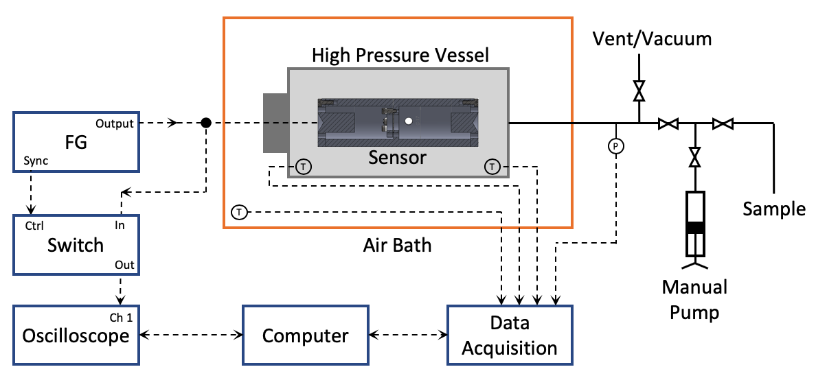
Figure 1: Schematic of the speed-of-sound experiment, showing the sensor contained within a temperature and pressure-controlled environment. Signal excitation and detection were achieved using a function generator (FG) and oscilloscope, respectively. The experimental conditions were monitored using a data acquisition system and the system is controlled via computer.

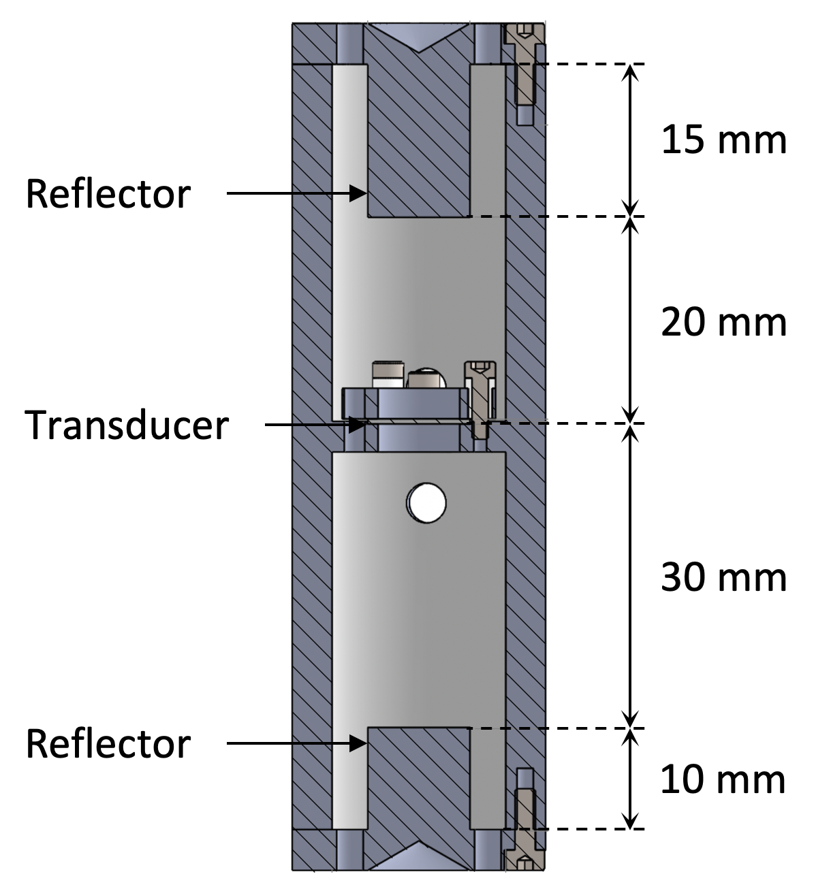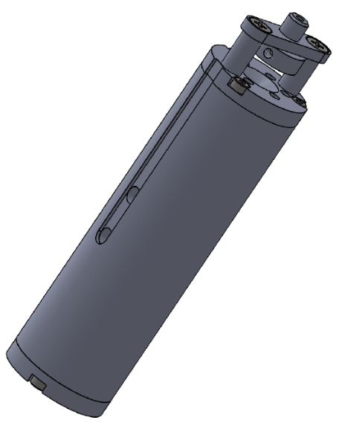
Figure 2: Schematic section and overall views of the ultrasonic cell. The cell body (spacer) and removable reflectors were fabricated from Invar to reduce thermal effects. The transducer is operated at 5 MHz.

A cross-sectional view of the ultrasonic cell is shown in Figure 2. Compared to previous cells [13-15], the design incorporated a range of features to improve performance, make the device more robust, and simplify operation. One of the main design considerations was material selection for the cell body. In addition to chemical compatibility, it is desirable for the physical properties of the material to have a small and well characterised response to temperature (thermal expansion) and pressure (compressibility), since the measurement principle directly depends on the cell’s dimensions. A range of materials have been reported in the literature, including stainless steel [13], fused quartz [14], and copper [15]. The device presented in this work was unique in that it was fabricated from Invar 36, an iron-nickel alloy with a characteristically-low thermal expansion. Compared with stainless steel, the linear coefficient of thermal expansion for Invar 36 is approximately 10 times lower over the operating temperature range whilst exhibiting a similar bulk modulus, machinability, and ease of fabrication. Compared with fused quartz, Invar 36 exhibits approximately twice the linear coefficient of thermal expansion; however, the bulk modulus of Invar is four times greater than that of fused quartz, fabrication of the device from metal is more straightforward, and overall assembly can be made more robust. The main body of the cell was constructed from four parts: the main spacer, the two end caps with reflectors, and a retaining ring for the transducer. As shown in Figure 2, the cell was designed with post-reflectors to reduce dispersion of the reflected wavefront associated with curvature near the walls of the cell. The lengths of the main spacer and the post reflectors were chosen to produce different path lengths to the dominant reflecting surfaces, ensuring that spurious echoes received by the transducer would be separated in time. A circular cone of aperture 120° was machined into the outer surface of the end caps to avoid direct reflections from the exterior interface of the cell.
Excitation and detection of the ultrasonic pulse and echo was achieved by way of a gold-plated ceramic piezoelectric disc transducer operated at its resonant frequency of 5 MHz, similar to that reported in [14]. The transducer was mounted coaxially within the cell body between a stepped shoulder and an electrically-isolated retaining ring; the cell body and retaining ring thus provided independent electrical contacts with the two faces of the transducer, one of which was ground. The electrical signal was passed via an electrical feedthrough (SITEC, part 770.8350-90, single electrical connection, ¼ HP 400 MPa) to the transducer and then to ground via the body of the cell. The transducer was normally excited by a 10-cycle tone-burst of 10 V peak-to-peak amplitude from a function generator (Keysight, 33511B). Detection of the echoes was performed using a digital oscilloscope (Keysight, DSOX3012T), connected to the cell in parallel with the function generator. The oscilloscope captured a time-series trace including the excitation pulse and echo train, triggered by the excitation pulse. To avoid saturation of the oscilloscope during transmission of the excitation pulse, a fast RF switch was used to isolate the input of the oscilloscope during the initial tone burst. Operation of the switch was synchronised with the function generator’s output via an inbuilt sync output on the device.

Materials
The measurements presented here were made on water, methylbenzene (toluene), and p-xylene as described in Table I. The water used was deionized to an electrical resistivity greater than 18 MΩ·cm at T = 298 K. The sample fluids p-xylene and methylbenzene were supplied by Sigma-Aldrich with a mass fraction purity higher than 99.8 %. The samples were degassed prior to loading in the cell. No further purification was attempted.

Procedure and Validation
The speed of sound $c$ was obtained from the relation:
$c=2∆L/∆t$, (2)
where ΔL is the difference between the long and short path lengths and Δt is the difference between the times of flight on the long and short paths, respectively. In this work, diffraction corrections [14, 16] to the speed-of-sound measurements were found to be less than 0.01 % under all conditions and therefore were not included in Eq. (2). A reference path length difference, ${∆L}_{0}$, was obtained at temperature T₀ = 306.1 K and pressure p₀ = 0.1 MPa by means of calibration measurements in pure water. The value of the speed of sound at this temperature and pressure was taken from the IAPWS-95 EOS [12], which, for this state point, has an uncertainty of 0.005%. The calibration resulted in a value for ${∆L}_{0}$ of 9.932 mm (the cell was designed with a path length difference of 10 mm, not accounting for machining and transducer dimension tolerances).
To extend the instrument calibration over the full temperature and pressure range of operation, the variation of the path length difference was accounted for by considering the material properties of Invar 36 using the following relation:
$2∆L(T,p)=2∆L_{0}\left[\frac{∆L(T)}{∆L_{0}}\left(1-\frac{1}{3}\frac{\left(p-p_{0}\right)}{B(T)}\right)\right]$ . (3)
where $∆L(T)/{∆L}_{0}$ is the integrated thermal expansion between T₀ and T, and B(T) is the bulk modulus. In this work, $∆L(T)/{∆L}_{0}$ was obtained from the experimental data of Tanji et al. [17] for Invar materials, correlated as follows:
$\frac{∆L(T)}{∆L_{0}}=exp\left[a\left(T-T_{0}\right)+\frac{1}{2}b\left(T^{2}-T_{0}^{2}\right)+\frac{1}{3}d\left(T^{3}-T_{0}^{3}\right)+\frac{1}{4}e\left(T^{4}-T_{0}^{4}\right)\right]$. (4)
The coefficients, a = -1.802 x 10⁵ K⁻¹, b = 1.811 x 10⁻⁷ K⁻², d = -5.917 x 10⁻¹⁰ K⁻³ and e = 6.655 x 10⁻¹³ K⁻⁴ in Eq. (4) were determined by fitting the data given in reference [17] at temperatures between (273 and 473) K. The isothermal bulk modulus B(T) of Invar 36 in Eq. (3) was obtained from data presented in a separate work of Tanji et al. [18], measured between (298 and 723) K, and correlated as a linear function of T: $B\left(T\right)/MPa=87464+69.7 (T/K)$.
The pulse-echo time-series data were analysed to determine the time delay Δt between the two echoes. This was performed using a time-domain analysis similar to that described in reference [14]. Briefly, the analysis is analogous to a matched filter, where the first echo is used as a template to identify the second echo. By scaling and iteratively translating the first echo in discrete time steps equal to the data acquisition period, the optimal time delay to the second echo were determined by minimising the objective function:
$S=\sum_{{τ=t}_{1}}^{t_{2}}{{A\left(τ\right)}^{2}}-{\sum_{{τ=t}_{1}}^{t_{2}}{A\left(τ\right)A\left(τ+∆t\right)}}/{\sum_{{τ=t}_{1}}^{t_{2}}{{A\left(τ+∆t\right)}^{2}}},$ (5)
where $t_{1}$ and $t_{2}$ are the start and end time limits of the portion of the first echo used in the analysis. In this work, these limits corresponded to 5 cycles of signal oscillation before the echo’s peak amplitude and 3 cycles after. To improve the time resolution beyond the oscilloscope acquisition period, the objective function was fitted locally with a quadratic polynomial and interpolated to its minimum [14]. The measurement was repeated five times at each state point and averaged, with a typical relative standard deviation of less than 0.01 %.
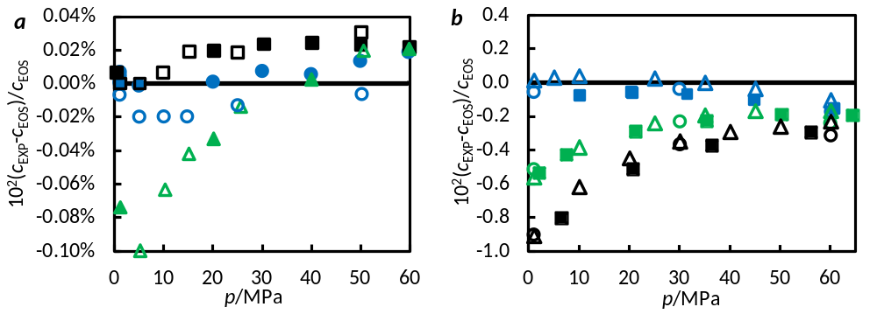
Figure 3: (a) Deviations of the experimental speed of sound c_{exp} in water from the values calculated from the IAPWS-95 EOS [12] (IAPWS-95 uncertainty is 0.1 %). Filled symbols: this work at temperatures of , T = 306 K; , T = 358 K; , T = 421 K. Open symbols: work of Lin and Trusler [16] at temperatures of , T = 303 K; , T = 373 K; , T = 453 K. (b) Deviations of the experimental speed of sound c_{exp} in methylbenzene (toluene) from the values calculated from the EOS of Lemmon and Span [19] (U_{r,EOS}(c) = 1 %). Filled symbols: this work at temperatures of , 323 K; , 373 K; and 423 K. Open symbols: work of Meier and Kabelac [20] at temperatures of , 320 K; , 380 K; , 420 K; work of Tay [21] at temperatures of , 323 K; , 373 K; , 423 K.
To validate the calibration and examine the use of Eq. (3) and Eq. (4) to model the pressure and temperature effects on the path length differences ΔL, the speed of sound in pure water was measured along three isotherms at temperatures of (306.1, 357.9 and 421.2) K and pressures up to 60 MPa. As shown in Figure 3 (a), the data are in agreement with values calculated from the IAPWS-95 EOS [12], which, for the high temperature and pressure conditions considered in this work, has a relative uncertainty of 0.1 %. The worst deviations from the EOS were observed for the highest temperature at lower pressures. Comparison with the data of Lin and Trusler [16] at similar temperatures showed qualitative agreement, indicating that the EOS can be improved at these conditions. Additional validation measurements were performed by measuring the speed of sound in pure methylbenzene (toluene) along three isotherms at temperatures T = (323.3, 373.8 and 422.9) K and pressures up to 65 MPa. The results obtained, together with the data reported by Meier and Kabelac [20] at T = (320, 380 and 420) K and by Tay [21] at T = (323, 373 and 423) K, are compared with the values calculated from the EOS of Lemmon and Span [19] in Figure 3 (b). This EOS is based on a shortened form of the Helmholtz equation and is stated to have a relative uncertainty up to 1 % for the temperature and pressure conditions considered in this work. Although there was a clear dependence on pressure and temperature not captured by the EOS, the new results exhibit consistent agreement with literature data over the temperature and pressure ranges investigated.

Experimental Uncertainty
The dominant sources of experimental uncertainty in this work arose from measurements of temperature, pressure, and time-delay as well as the underlying calibration of the sensor path length described above and temperature inhomogeneity across the sensor. Each of these have been analysed at each state point to arrive at the combined standard uncertainties shown in Figure 4 and listed in Table II. The uncertainty is dominated at high temperatures by non-uniformity of temperature across the cell. At low temperatures the uncertainty is dominated by the sensor path length calibration.
The PRTs were calibrated over a temperature range of (223 to 448) K against a reference SPRT (ASL-WIKA) with a standard uncertainty of 0.02 K. However, the total uncertainty of the temperature measurement must additionally include the stability of the temperature in the oven and the homogeneity of the temperature across the sound-speed sensor. The reported temperatures are taken as an average of the two sensors located at each end of the pressure vessel. At higher temperatures, temperature instability and non-uniformity was found to be higher. Taking this into consideration, the standard uncertainty in temperature measurements were estimated to be: 0.03 K for T = (306, 324, and 336) K; 0.04 K for T = (348 and 356) K; 0.05 K for T = 374 K; 0.06 K for T = 398 K; 0.07 K for T = 423 K; and 0.09 K for T = 447 K.
The pressure transducer (Keller PA-33X) has a manufacturer specified relative standard uncertainty of 0.05 MPa. The transducer’s calibration was validated against a calibrated hydraulic pressure balance (DH-Budenberg, EHX-580) with a relative standard uncertainty of 0.008 %, showing a maximum absolute deviation of 0.019 MPa. Taking into account the zero drift, hysteresis and the standard deviation of repeat measurements [22], the standard uncertainty in pressure measurements was estimated to be 0.02 MPa.

The standard uncertainty in the measurement of the speed of sound resulted from uncertainties in the time-difference measurement between echoes and determination of the acoustic path length (a detailed description of how to estimate the uncertainty of the acoustic path length measurements and the uncertainty of the time measurement can be found in the Ph.D. thesis of Karsten Meier [22]). In this work, the standard (relative) uncertainty of the time difference was estimated to be less than 0.3 ns (0.0015 %), while the standard uncertainty of the acoustic path length was estimated to vary between (0.55 and 0.72) µm, corresponding to a relative standard uncertainty of (0.0055 to 0.0072) %, depending on the system pressure.
The combined standard uncertainty u_{c} of the speed of sound was estimated using the following equation:
$u_{c}^{2}={\left(\frac{∂c}{∂T}\right)}_{p}^{2}u_{T}^{2}+ {\left(\frac{∂c}{∂p}\right)}_{T}^{2}u_{p }^{2}+ {\left(\frac{1}{∆L}\right)}^{2}u_{∆L}^{2}+ {\left(\frac{∆L}{{∆t}^{2}}\right)}^{2}u_{∆t}^{2}$ . (6)
The first two terms describe the influence of the temperature and pressure measurement uncertainties on the speed of sound. The partial derivatives (sensitivity coefficients) were estimated from the Helmholtz EOS of Zhou et al. [5] for every state point measured. The last two terms in Eq. (6) describe the contributions from the uncertainties of the acoustic path length difference ΔL and the time difference Δt. The combined standard uncertainty varied between (0.11 and 0.34) m·s⁻¹ over the entire temperature and pressure range considered. This corresponds to relative combined standard uncertainties of between (0.011 and 0.052) %. As shown in Figure 4, the highest uncertainty occurred at the lowest pressure and the highest temperature. This was mainly due to the non-uniformity and non-stability of the oven at higher temperatures (and thus increase in temperature measurement uncertainty). Therefore, the expanded uncertainty (k = 2) for the measurements presented was estimated to range from (0.023 to 0.104) %.

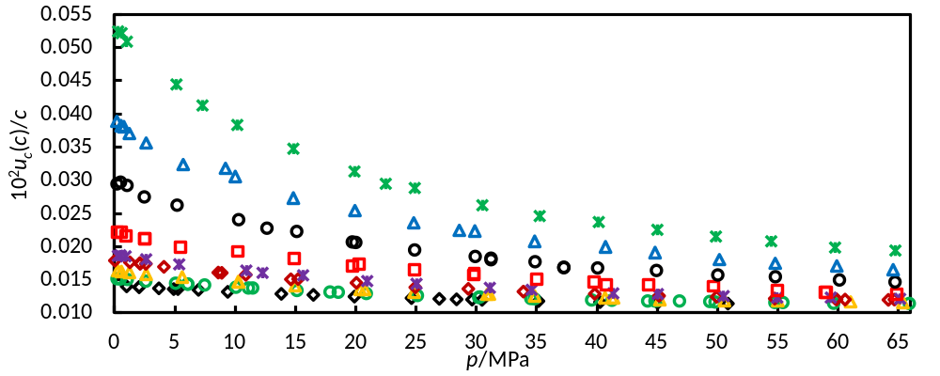
Figure 4: Relative combined standard uncertainty for the measured speed-of-sound data. , T = 306 K; , T = 324 K; , T = 336K; , T = 348 K; , T = 356 K; , T = 374 K; , T = 398 K; , T= 423 K; , T = 447 K.

Experimental Results

Experimental Results
The speed of sound in p-xylene was measured along nine isotherms at T = (306.0, 323.5, 336.0, 348.4, 356.0, 373.6, 398.2, 422.7 and 447.1) K and at pressures from just above the saturation pressure to around 66 MPa. The upper pressure bound at T = 306 K was limited by the freezing of p-xylene. The speeds of sound along each isotherm are given in Table II, together with the standard combined uncertainties.
The measurements started at the lowest temperature and proceeded in increments to the highest temperature, after which the temperature was returned again to selected values to check for repeatability of the results. On each given isotherm, the measurements started at the lowest pressure and proceeded in increments to the highest pressure, after which the pressure was returned to selected values for repeatability checks. For some of these measurements, fresh samples of p-xylene were introduced into the high-pressure cell and selected measurement points were repeated to further check the stability and reproducibility. In all cases, the magnitude of the relative change in the speed of sound between the initial measurement and the final check measurements were found to be less than 0.01 %, confirming that the sensor and sample were stable to well within the estimated uncertainty.

Data Correlation
To facilitate the determination of thermodynamic properties, the extensive sound-speed data collected in the present work was correlated by means of the implicit equation:
$\left(p-p_{0}\right)=\sum_{i=1}^{3}{\sum_{j=0}^{3}{a_{ij}}}\left(c-c_{0,T}\right)/{\left(\frac{T}{T_{0}}\right)}^{j}$. (7)
Here, p₀ = 0.1 MPa and T₀ = 286.4 K, the triple point temperature of p-xylene obtained from the Helmholtz EOS of Zhou et al. [5], and c_{0,T} is the speed of sound at the reference pressure p₀ = 0.1 MPa, which was correlated as a function of temperature as follows:
$c_{0,T}=\sum_{j=0}^{3}{b_{j}}{\left(\frac{T}{T_{0}}\right)}^{j}$ . (8)
Initially, the parameters of Eq. (7) were fitted to each individual isotherm to determine c_{0,T} by means of minimizing the residual sum of squares. Then, Eq. (8) was fitted to the c_{0,T} values to obtain initial estimates for the b_{j} coefficients. Finally, all the parameters in Eq. (7) and Eq. (8) were regressed against the entire data set in a surface fit to minimize the overall residual sum of squares.

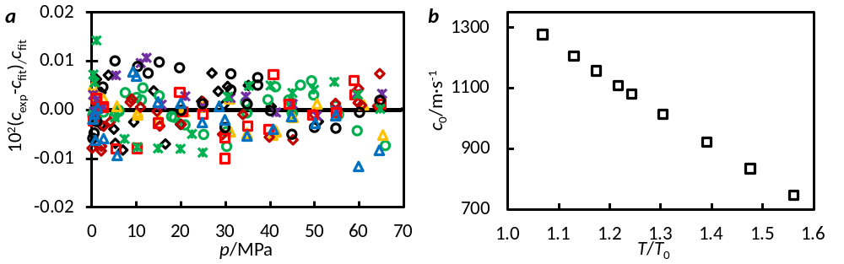
Figure 5: (a) Deviations of the experimental speed of sound c_{exp} in pure p-xylene from the values c_{fit} given by Eq. (7), and (b) the experimental speed of sound c_{0,exp} at reference pressure (0.1 MPa) as a function of temperature, obtained using Eq. (6)., T = 306 K; , T = 324 K; , T = 336K; , T = 348 K; , T = 356 K, , T = 374 K; , T = 398 K; , T = 423 K; , T = 447 K

The parameters of in Eq. (7) and Eq. (8) are given in Table III and resulting deviations of the data from the fit are shown in Figure 5. The majority of the points are fitted to within ±0.01 %, illustrating the high quality and consistency of the experimental data. Eq. (7) fitted the experimental speed-of-sound data with an average absolute relative deviation Δ_{AAD} = 0.0036 % and a maximum absolute relative deviation Δ_{MAD} = 0.014 %.

Derived Thermodynamic Properties

Additional thermodynamic properties of p-xylene were obtained by numerical integration of the following partial differential equations:
$c^{2}={\left[{\left(\frac{∂}{∂p}\right)}_{T}-\frac{T}{{}^{2}c_{p}}{\left(\frac{∂}{∂T}\right)}_{p}^{2}\right]}^{-1},$ (9)
$\left(\frac{∂c_{p}}{∂p}\right)=-\frac{T}{{}^{3}}\left[2{\left(\frac{∂}{∂T}\right)}_{p}^{2}-{\left(\frac{∂^{2}}{∂T^{2}}\right)}_{p}\right]$. (10)
This approach allows c(T, p) together with high-accuracy data for density and isobaric specific heat capacity available at low pressure to be integrated to high-pressure conditions. The analysis method used in this work follows the algorithm described previously by Davila and Trusler [23]. The solutions of Eq. (9) and Eq. (10) are subject to prescribing initial values for density ρ₀(T) = ρ (T, p₀) and isobaric heat capacity c_{p,0} = c_{p} (T, p₀), taken in this work to be values calculated at p₀ = 0.1 MPa from the Helmholtz EOS of Zhou et al. [5] which, at that pressure, have an uncertainty of 0.2 % in liquid density and 1 % in heat capacity over the temperature range considered. The data were then correlated as functions of temperature by means of the following equations:
${}_{0,T}/(kg·m^{-3})=\sum_{j=0}^{3}{d_{j}{\left(\frac{T}{T_{0}}\right)}^{j}},$ (11)
$c_{p,0,T}/(kJ·{kg}^{-1}·K^{-1})=\sum_{j=0}^{3}{e_{j}{\left(\frac{T}{T_{0}}\right)}^{j}},$ (12)
where T₀ = 286.4 K and the resulting coefficients for d_{j} and e_{j} are given in Table III. The resulting deviations of the data from the correlation of Eq. (11) for density ρ₀ exhibit an average and median absolute deviation of Δ_{AAD} = 0.0005 % and Δ_{MAD} = 0.0011 % respectively. For isobaric heat capacity c_{p,0}, the deviations are Δ_{AAD} = 0.0057 % and Δ_{MAD} = 0.0098 %. For both properties, the deviations are within or comparable to the uncertainty of the measurement. At temperatures above 411 K, the reference pressure is below the saturation pressure of p-xylene and the initial conditions are those of the metastable liquid.
The derived results for density and isobaric specific heat capacity are given in Table IV and Table V, respectively. The derivative properties of isothermal compressibility, k_{T}, and isobaric expansivity, α, were also calculated and are provided in Table VI and Table VII. To estimate the relative uncertainties of these derived properties, a detailed sensitivity analysis described in the work of Trusler and Lemmon [24] was used, which considers contributions arising from uncertainties in the speed of sound, the surface fit, and in the initial values of density and heat capacity. Using this method, the relative expanded uncertainties (k = 2) of derived properties in this work were approximately 0.2 % for ρ, 1.0 % for c_{p}, 1.0 % for k_{T}, and 1.0 % for α.

Discussion

Figure 6 shows the pressure and temperature dependence of the speed of sound in p-xylene as measured in the present work. The data are also compared with the Helmholtz EOS of Zhou et al. [5], which was developed from limited sound-speed data for saturated liquids, in contrast to the wide range of pressure and temperature studied here. At low temperatures and low pressures, the data are in reasonably good agreement with the EOS, the relative deviations being within the stated uncertainty of the latter (0.3 %). However, at higher pressures, the relative deviations increase, reaching 0.5 % at T = 306 K and p = 50 MPa. In the higher temperature region (T ≥ 373 K), larger relative deviations up to 1.1 % at T = 447 K were observed at low pressures close to saturation. However, the relative deviations decrease rapidly with pressure to values within the stated uncertainty of the EOS (0.3 %).

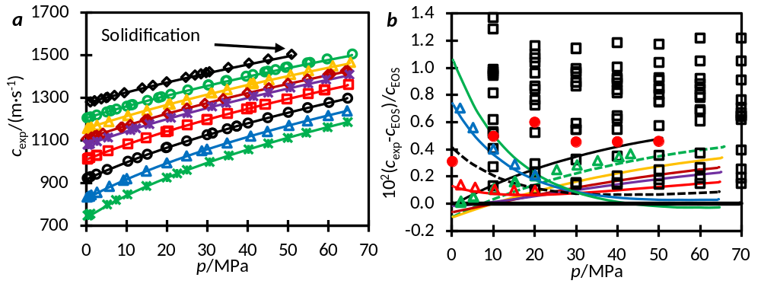
Figure 6: (a) The experimental speeds of sound c_{exp} in pure p-xylene as a function of pressure (lines represent values calculated from the correlation model (Eq. (7)), and (b) deviations from the Helmholtz EOS of Zhou et al. [5] for the experimental (solid and dotted lines, calculated from the correlation of Eq. (7)) and literature (symbols) speed of sound. This work: , T = 306 K; , T = 324 K; , T = 336K; , T = 348 K; , T = 356 K, , T = 374 K; , T = 398 K; , T = 423 K; , T = 447 K; ⎯, T = 306 K; , T = 324 K; ⎯, T = 336 K; ⎯, T = 348 K; ⎯, T = 356 K; ⎯, T = 374 K; , T = 398 K; ⎯, T = 423 K; ⎯, T = 447 K. , data of Zotov et al. [25] at temperatures between (303 to 433) K and pressures up to 70 MPa. , data of Takagi [10] at temperature of 303 K. Data of McLinden et al. (unpublished) [26]: , T = 324 K; , T = 374 K and , T = 423 K. The EOS uncertainty for sound speed is 0.3 %.

The measured speed-of-sound data are also compared with published data of Zotov et al. [25] and Takagi et al. [10], as well as unpublished data by McLinden et al. [26]. The comprehensive measurements on p-xylene by Zotov et al. [25], at temperatures between (303 to 433) K and pressures up to 70 MPa, exhibits larger scatter than the data presented here, with relative deviations higher than the stated uncertainty of the EOS (0.3 %) across the full range of pressure. The data of Takagi et al. [10], for T = 303 K and p ≤ 50 MPa, also exhibit deviations larger than the EOS uncertainty. To confirm the behaviour observed in this work, comparison was made with corroborating speed-of-sound data for p-xylene measured by McLinden et al. at NIST [26]. These data were measured at temperatures of (323, 374 and 424) K and pressures up to 43 MPa, using a dual-path pulse-echo ultrasonic cell fitted with a quartz disc transducer operating at its resonant frequency of 8 MHz. Our data exhibit consistent agreement with the NIST data over the temperature and pressure range investigated. As shown in Figure 6, the relative deviations of NIST data from the Helmholtz EOS of Zhou et al. [5] are consistent with the relative deviations observed in this work. The AAD and MAD of the NIST data from the correlation developed in this work are 0.062 % and 0.084 % respectively. This is within the sum of the relative expanded uncertainties of the two apparatuses of 0.15 % (the relative expanded uncertainty of the NIST data was estimated to be 0.045 % at a coverage factor of 2).
Overall, the deviations observed in the data of this work are generally lower than the literature data. Deviations in excess of the quoted uncertainty of the Helmholtz EOS at certain conditions can be attributed to the limited range of sound-speed data used in the development of the current Helmholtz EOS; only saturated liquid sound-speeds at temperatures from (288 to 323) K were used in the model development. Although the existing EOS performs reasonably well, its performance can be improved by including the sound-speed data acquired in this work.

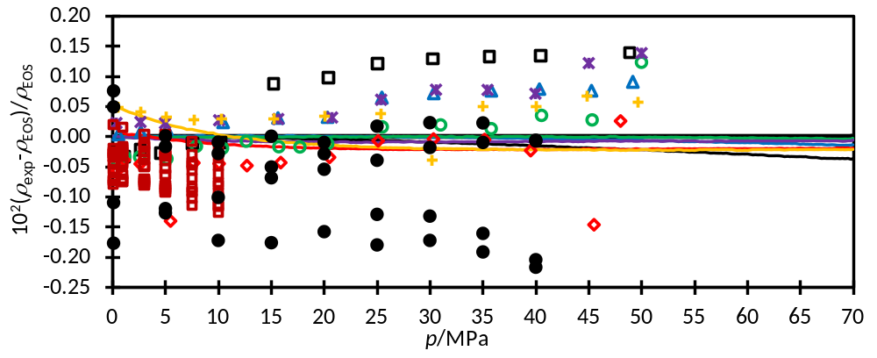
Figure 7: Deviations from the Helmholtz EOS of Zhou et al. [5] for liquid densities ρ_{exp}. Determined in this work (U(ρ) = 0.2 %, k = 2) (solid lines): ⎯, T = 306 K; ⎯, T = 323 K; ⎯, T = 348 K; ⎯, T = 373 K; ⎯, T = 398 K; ⎯, T = 423 K; ⎯, T = 448 K. Akhundov and Imanov [27]: , T = 323 K; , T = 348 K; , T = 373 K; , T = 398 K; , T = 423 K, , T = 448 K. Garg et al. [28]: , for temperatures between (318 and 373) K. Et-Tahir et al. [29]: , for temperatures between (313 and 363) K. The EOS uncertainty for liquid densities was 0.2 %.

From the experimental sound-speed data, derived properties were calculated at temperatures of (306.03, 323.15, 348.15, 373.15, 398.15, 423.15 and 448.15) K and pressures up to 70 MPa. The pressure and temperature dependence of the derived density as well as comparison with the Helmholtz EOS model is shown in Figure 7. The data reported by Akhundov and Imanov [27] are also plotted for comparison; it is the most extensive existing data set and covers the majority of the temperature and pressure range studied in this work. The deviations of the derived densities obtained in this work are all within ±0.05 %, while the absolute deviations of the literature data are up to 0.22 %, comparable within the stated uncertainty of the model for liquid densities of 0.2 %. Considering that the data of Akhundov and Imanov [27] were acquired through conventional p–ρ–T measurements, this suggests that liquid densities for p-xylene can be reliably derived from sound-speed data.
The derived isobaric heat capacity is compared with the values calculated by the Helmholtz EOS model in Figure 8, together with the data reported by Garg et al. [28] measured at temperatures from (318 to 373) K and pressures up to 10 MPa (these data were used in the development of the EOS). Both our results and the literature data are in good agreement with the EOS model to within the specified uncertainty of 1.0 %.
Finally, the derived isothermal compressibility is compared with the values calculated from the Helmholtz EOS model in Figure 9, together with the data measured by Kuss [30] at temperatures ranging from (328 to 353) K and pressures up to 70 MPa. The deviations of the derived isothermal compressibility from the EOS model are within 2 % while the deviations of the literature data are within 6 %.
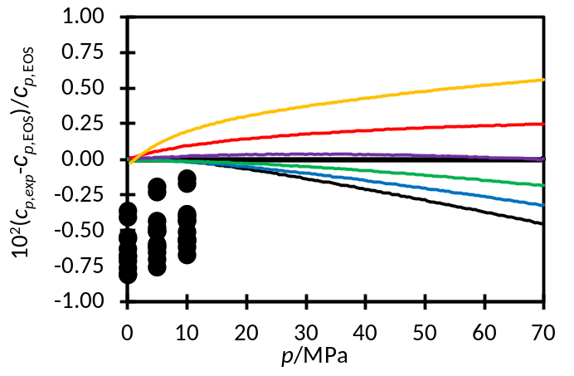
Figure 8: Deviations from the Helmholtz EOS of Zhou et al. [5] for isobaric specific heat capacity c_{p,exp} determined in this work (U(c_{p}) = 1.0 %, k = 2) (solid lines) and those measured by Garg et al. [28] (symbols): , data measured by Garg et al. over a temperature range from (318 to 373) K and pressures up to 10 MPa; ⎯, T = 306 K; ⎯, T = 323 K; ⎯, T = 348 K; ⎯, T = 373 K; ⎯, T = 398 K; ⎯, T = 423 K; ⎯, T = 448 K. The EOS uncertainty for isobaric specific heat capacity was 1.0 %.

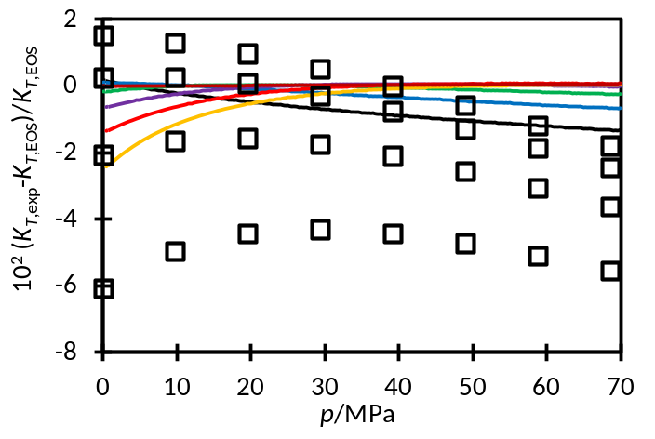
Figure 9: Deviations from the Helmholtz EOS of Zhou et al. [5] for isothermal compressibility k_{T,exp} determined in this work (U(k_{T}) = 1.0 %, k = 2) (solid lines) and those measured by Kuss [30] (symbols): , data measured by Kuss at temperature range (298 to 353) K and pressures up to 70 MPa; ⎯, T = 306 K; ⎯, T = 323 K; ⎯, T = 348 K; ⎯, T = 373 K; ⎯, T = 398 K; ⎯, T = 423 K; ⎯, T = 448 K.

Conclusion

The speed of sound in p-xylene has been measured at temperatures ranging from (306 to 447) K at pressures from just above saturation to 66 MPa using a new double-path pulse-echo device, calibrated with pure-water against the IAPWS-95 EOS. It has been shown that the temperature and pressure corrections for the sensor, fabricated from Invar-36, can be accounted for using material data for thermal expansion and compressibility. The sound-speed data have been compared to the Helmholtz EOS of Zhou et al. [5], the development of which included consideration of only a limited range of sound-speed data. In general, the EOS performs well with respect to its quoted uncertainty of 0.3 %, with larger deviations observed at higher pressures and lower temperatures as well as low temperatures and high pressures. The relatively low overall expanded relative uncertainties for the data presented here represents an opportunity to improve the performance of the EOS by capturing these temperature and pressure effects. Moreover, derivation of density, isobaric specific heat capacity, and other thermodynamic properties from sound-speed provides a rich data set for developing improved equations of state for p-xylene. Again, the EOS performed well with respect to its quoted uncertainty. However, the deviation of the derived data is 4 times lower than the EOS uncertainty for liquid density and 2 times lower for heat capacity, suggesting that refining the current EOS using the present data will significantly improve the EOS confidence. Finally, the technique and analysis described here can be readily deployed for other systems.

Acknowledgements

The authors gratefully acknowledge Gavin Barnes (Imperial College London) for his input on the design and fabrication of the cell. We also acknowledge Mark McLinden and Richard Perkins (NIST) for permission to quote their p-xylene data before publication as well as numerous valuable discussions regarding sound-speed measurements. This work was supported by a UWA Research Collaboration Award and the ARC Training Centre for LNG Futures (IC150100019).
References
[1] M. Minceva, A.E. Rodrigues, Modeling and Simulation of a Simulated Moving Bed for the Separation of p-Xylene, Ind. Eng. Chem. Res. 41 (2002) 3454-3461.
[2] J. Li, S.A. Ali, O. Bustos, M.J. Miller, Asphaltene removal composition and methods, in: U.S. Patent (Ed.), Schlumberger Technology Corporation, 2014.
[3] K. Akbarzadeh, A. Hammami, A. Kharrat, D. Zhang, S. Allenson, J. Creek, S. Kabir, A. Jamaluddin, A.G. Marshall, R.P. Rodgers, Asphaltenes—problematic but rich in potential, Oilfield Review 19 (2007) 22-43.
[4] M. Assael, M. Trusler, T. F Tsolakis, Thermophysical Properties of Fluids. An Introduction to Their Prediction, 1996.
[5] Y. Zhou, J. Wu, E.W. Lemmon, Thermodynamic Properties of o-Xylene, m-Xylene, p-Xylene, and Ethylbenzene, J. Phys. Chem. Ref. Data 41 (2012) 023103-023103-023126.
[6] J.A. Al-Kandary, A.S. Al-Jimaz, A.-H.M. Abdul-Latif, Viscosities, Densities, and Speeds of Sound of Binary Mixtures of Benzene, Toluene, o-Xylene, m-Xylene, p-Xylene, and Mesitylene with Anisole at (288.15, 293.15, 298.15, and 303.15) K, J. Chem. Eng. Data 51 (2006) 2074-2082.
[7] R. Gonzalez-Olmos, M. Iglesias, S. Mattedi, Influence of temperature on thermodynamics of ethanol + hydrocarbon gasoline additives, Phys. Chem. Liq. 48 (2010) 337-384.
[8] J. Nath, B. Narain, Binary systems of tetrachloroethylene with benzene, toluene, p-xylene, carbon tetrachloride, and cyclohexane. 1. Ultrasonic velocities and adiabatic compressibilities at 293.15 and 303.15 K, dielectric constants at 298.15 and 308.15 K, and refractive indexes at 298.15 K, J. Chem. Eng. Data 27 (1982) 308-312.
[9] M. Srilakshmi, T. Srinivasa Krishna, K. Narendra, R. Dey, A. Ratnakar, Influence of alkyl group and temperature on excess thermodynamic properties of diethyl carbonate and their binary mixtures at 0.1MPa, J. Mol. Liq. 211 (2015) 854-867.
[10] T. Takagi, Ultrasonic speeds and thermodynamics of (benzene+an isomeric xylene) under high pressures, J. Chem. Thermodyn. 13 (1981) 291-299.
[11] V.V.M. Zotov, Yu.F.;Mel'nikov,G.A.;Neruchev,Yu.A., Speed of sound in liquid hydrocarbons, Kurskii Gos Pedagog Universitet, 1995.
[12] W. Wagner, A. Pruß, The IAPWS Formulation 1995 for the Thermodynamic Properties of Ordinary Water Substance for General and Scientific Use, J. Phys. Chem. Ref. Data 31 (2002) 387-535.
[13] G. Benedetto, R.M. Gavioso, P.A.G. Albo, S. Lago, D.M. Ripa, R. Spagnolo, Speed of Sound in Pure Water at Temperatures between 274 and 394 K and at Pressures up to 90 MPa, Int. J. Thermophys. 26 (2005) 1667-1680.
[14] S.J. Ball, J.P.M. Trusler, Speed of Sound of n-Hexane and n-Hexadecane at Temperatures Between 298 and 373 K and Pressures up to 100 MPa, Int. J. Thermophys. 22 (2001) 427-443.
[15] P.J. Kortbeek, M.J.P. Muringer, N.J. Trappeniers, S.N. Biswas, Apparatus for sound velocity measurements in gases up to 10 kbar: Experimental data for argon, Rev. Sci. Instrum. 56 (1985) 1269-1273.
[16] C.-W. Lin, J.P.M. Trusler, The speed of sound and derived thermodynamic properties of pure water at temperatures between (253 and 473) K and at pressures up to 400 MPa, J. Chem. Phys. 136 (2012) 094511.
[17] Y. Tanji, Thermal Expansion Coefficient and Spontaneous Volume Magnetostriction of Fe-Ni (fcc) Alloys, J. Phys. Soc. Jpn. 31 (1971) 1366-1373.
[18] T. Y, S. Y, M. H, Bulk modulus of Fe-Ni35.7 Polycrystal, Sci. Rep. Res. Inst., Tohoku University 22 (1970) 84-92.
[19] E.W. Lemmon, R. Span, Short Fundamental Equations of State for 20 Industrial Fluids, J. Chem. Eng. Data 51 (2006) 785-850.
[20] K. Meier, S. Kabelac, Measurements of the Speed of Sound in Liquid Toluene, J. Chem. Eng. Data 58 (2013) 1398-1406.
[21] W.J. Tay, Thermophysical Properties of Hydrocarbons with Dissolved Carbon Dioxide, Department of Chemical Engineering, Imperial College London, London, UK, 2017.
[22] K. Meier, Das Puls-Echo Verfahren fÄur PrÄazisionsmessungen der Schallgeschwindigkeit in Fluiden, dem Fachbereich Maschinenbau, der Helmut-Schmidt-UniversitÄat - UniversitÄat der Bundeswehr Hamburg, Hamburg, 2006.
[23] M.J. Dávila, J.P. Martin Trusler, Thermodynamic properties of mixtures of N-methyl-2-pyrrolidinone and methanol at temperatures between 298.15K and 343.15K and pressures up to 60MPa, J. Chem. Thermodyn. 41 (2009) 35-45.
[24] J.P.M. Trusler, E.W. Lemmon, Determination of the thermodynamic properties of water from the speed of sound, J. Chem. Thermodyn. 109 (2017) 61-70.
[25] V.V. Zotov, Y.F. Melikhov, G.A. Mel'nikov, Y.A. Neruchev, Speed of sound in liquid hydrocarbons, Monograph (1995) 1-77.
[26] Unpublished data for the speed of sound of p-xylene., National Institute of Standards and Technology (NIST) (2019).
[27] T.S. Akhundov, S.Y. Imanov, Experimental observation of specific volumes of p-xylene at temperatures 50-400°C and pressures up to 500 bar, Izv.Vyssh.Uchebn.Zaved.Neft Gaz 66-68 (1969).
[28] S.K. Garg, T. Banipal, J.C. Ahluwalia, Heat capacities and densities of liquid o-xylene, m-xylene, p-xylene, and ethylbenzene, at temperatures from 318.15 K to 373.15 K and at pressures up to 10 MPa, J. Chem. Thermodyn. 25 (1993) 57–62.
[29] A. Et-Tahir, C. Boned, B. Lagourette, P. Xans, Determination of the viscosity of various hydrocarbons and mixtures of hydrocarbons versus temperature and pressure, Int. J. Thermophys. 16 (1995) 1309-1334.
[30] E. Kuss, DGMK-project 4510. PvT-data at high pressures, Ber. Bunsen-Ges. (1976) 1-69.

Table I: Provenance and purity of the samples
Chemical name | Source | Purity/mole fraction | Purification method
Methylbenzene | Sigma-Aldrich | 0.998 | None
Para-xylene | Sigma-Aldrich | 0.998ª | None
ª Impurities stated by the supplier: x(H₂O) = 0.0001

Table II: Speed of sound c in liquid p-xylene at temperatures T and pressures p.ª
T/K | p/MPa | c/(m∙s⁻¹) | u_{c}/(m∙s⁻¹) | T/K | p/MPa | c/(m∙s⁻¹) | u_{c}/(m∙s⁻¹)
305.99 | 1.00 | 1281.77 | 0.180 | 323.51 | 49.38 | 1443.50 | 0.169
306.07 | 2.05 | 1287.10 | 0.179 | 323.47 | 49.81 | 1445.32 | 0.169
306.02 | 2.05 | 1287.22 | 0.179 | 323.48 | 54.77 | 1464.84 | 0.169
305.93 | 3.69 | 1296.49 | 0.178 | 323.48 | 55.43 | 1467.39 | 0.170
306.00 | 4.90 | 1302.49 | 0.177 | 323.47 | 59.65 | 1483.53 | 0.170
305.98 | 5.25 | 1304.38 | 0.178 | 323.51 | 65.91 | 1506.74 | 0.172
306.05 | 6.96 | 1312.94 | 0.177
306.03 | 9.40 | 1325.57 | 0.175 | 335.99 | 0.28 | 1158.02 | 0.189
306.00 | 13.84 | 1347.72 | 0.174 | 335.99 | 0.57 | 1159.79 | 0.188
306.07 | 16.50 | 1360.11 | 0.173 | 335.98 | 1.23 | 1163.95 | 0.188
306.06 | 19.90 | 1376.19 | 0.172 | 335.98 | 2.63 | 1172.56 | 0.186
306.07 | 24.63 | 1397.78 | 0.171 | 335.98 | 5.60 | 1190.42 | 0.183
306.14 | 26.93 | 1407.80 | 0.171 | 336.00 | 10.27 | 1217.21 | 0.179
306.18 | 28.37 | 1413.93 | 0.171 | 335.99 | 10.30 | 1217.47 | 0.179
306.10 | 29.65 | 1419.72 | 0.171 | 336.01 | 14.98 | 1243.10 | 0.176
306.00 | 30.49 | 1423.77 | 0.171 | 335.99 | 20.37 | 1271.42 | 0.172
305.99 | 35.16 | 1443.56 | 0.171 | 336.01 | 20.75 | 1273.30 | 0.172
305.97 | 40.27 | 1464.54 | 0.171 | 336.00 | 24.83 | 1293.84 | 0.171
305.98 | 45.03 | 1483.47 | 0.171 | 336.00 | 30.89 | 1322.99 | 0.169
305.98 | 50.87 | 1505.99 | 0.172 | 336.06 | 31.08 | 1323.64 | 0.170
 |  |  |  | 336.00 | 34.84 | 1341.19 | 0.129
323.56 | 0.21 | 1206.43 | 0.183 | 336.02 | 40.67 | 1367.23 | 0.168
323.57 | 0.49 | 1208.10 | 0.183 | 336.05 | 41.27 | 1369.78 | 0.168
323.54 | 1.06 | 1211.51 | 0.182 | 336.03 | 41.38 | 1370.31 | 0.168
323.57 | 2.60 | 1220.40 | 0.180 | 335.98 | 45.23 | 1387.08 | 0.168
323.58 | 5.07 | 1234.53 | 0.179 | 335.97 | 50.59 | 1409.56 | 0.168
323.54 | 6.06 | 1240.28 | 0.178 | 335.95 | 55.00 | 1427.54 | 0.169
323.58 | 6.09 | 1240.29 | 0.178 | 335.96 | 61.04 | 1451.30 | 0.169
323.59 | 7.49 | 1248.03 | 0.177 | 335.95 | 65.38 | 1467.88 | 0.170
323.57 | 10.07 | 1262.13 | 0.175
323.58 | 11.11 | 1267.65 | 0.175 | 348.25 | 0.04 | 1108.83 | 0.199
323.53 | 11.47 | 1269.76 | 0.175 | 348.32 | 1.27 | 1116.85 | 0.197
323.60 | 15.13 | 1288.59 | 0.172 | 348.30 | 2.11 | 1122.26 | 0.197
323.59 | 17.89 | 1302.54 | 0.172 | 348.27 | 2.12 | 1122.47 | 0.196
323.55 | 18.57 | 1306.10 | 0.171 | 348.29 | 2.59 | 1125.51 | 0.196
323.57 | 20.90 | 1317.51 | 0.170 | 348.28 | 4.09 | 1135.15 | 0.193
323.59 | 25.13 | 1337.71 | 0.169 | 348.32 | 8.60 | 1162.90 | 0.187
323.59 | 30.21 | 1361.29 | 0.168 | 348.32 | 8.90 | 1164.69 | 0.187
323.52 | 30.29 | 1361.83 | 0.169 | 348.35 | 10.88 | 1176.32 | 0.185
323.48 | 34.54 | 1381.14 | 0.168 | 348.37 | 14.62 | 1197.72 | 0.181
323.58 | 34.83 | 1382.01 | 0.168 | 348.36 | 15.22 | 1201.14 | 0.182
323.57 | 39.58 | 1402.70 | 0.168 | 348.36 | 20.05 | 1227.60 | 0.179
323.47 | 41.26 | 1410.19 | 0.168 | 348.45 | 24.93 | 1252.90 | 0.174
323.54 | 44.23 | 1422.37 | 0.168 | 348.43 | 29.34 | 1275.02 | 0.174
323.57 | 44.83 | 1424.72 | 0.168 | 348.43 | 33.90 | 1297.21 | 0.172
323.54 | 45.01 | 1425.56 | 0.169 | 348.43 | 39.83 | 1324.82 | 0.171
323.49 | 46.87 | 1433.42 | 0.169 | 348.42 | 45.17 | 1348.71 | 0.170
348.42 | 49.93 | 1369.38 | 0.170 | 398.20 | 0.22 | 923.76 | 0.272
348.42 | 54.75 | 1389.61 | 0.169 | 398.21 | 0.50 | 926.17 | 0.275
348.39 | 59.82 | 1410.34 | 0.171 | 398.22 | 1.04 | 930.76 | 0.272
348.41 | 59.89 | 1410.60 | 0.170 | 398.25 | 2.49 | 942.77 | 0.259
348.37 | 60.58 | 1413.43 | 0.170 | 398.24 | 5.19 | 964.55 | 0.253
348.39 | 64.18 | 1427.64 | 0.171 | 398.25 | 10.30 | 1002.89 | 0.241
348.40 | 64.67 | 1429.60 | 0.172 | 398.26 | 12.65 | 1019.53 | 0.229
 |  |  |  | 398.24 | 15.11 | 1036.53 | 0.231
355.98 | 0.27 | 1081.04 | 0.201 | 398.25 | 19.72 | 1066.63 | 0.221
355.95 | 0.49 | 1082.63 | 0.202 | 398.22 | 20.01 | 1068.47 | 0.220
355.94 | 0.92 | 1085.65 | 0.201 | 398.22 | 24.89 | 1098.56 | 0.214
355.95 | 2.62 | 1097.05 | 0.198 | 398.20 | 29.92 | 1127.90 | 0.209
355.98 | 5.37 | 1115.13 | 0.194 | 398.25 | 31.22 | 1135.23 | 0.205
355.96 | 10.93 | 1149.89 | 0.189 | 398.24 | 31.22 | 1135.21 | 0.207
355.89 | 12.28 | 1158.25 | 0.186 | 398.21 | 34.89 | 1155.44 | 0.205
355.92 | 15.64 | 1177.67 | 0.185 | 398.19 | 37.26 | 1168.30 | 0.197
355.94 | 20.95 | 1207.26 | 0.179 | 398.20 | 37.27 | 1168.29 | 0.197
355.95 | 25.05 | 1229.15 | 0.177 | 398.20 | 40.07 | 1182.91 | 0.198
355.95 | 31.13 | 1260.21 | 0.174 | 398.21 | 44.95 | 1207.53 | 0.198
356.05 | 34.60 | 1276.89 | 0.172 | 398.23 | 50.04 | 1232.26 | 0.194
356.02 | 41.36 | 1308.87 | 0.170 | 398.20 | 54.81 | 1254.71 | 0.194
356.02 | 45.06 | 1325.70 | 0.170 | 398.20 | 60.13 | 1278.81 | 0.192
356.08 | 50.52 | 1349.51 | 0.169 | 398.21 | 64.73 | 1298.96 | 0.191
356.04 | 54.96 | 1368.53 | 0.169
356.00 | 59.39 | 1387.08 | 0.171 | 422.73 | 0.19 | 834.70 | 0.325
355.98 | 65.16 | 1410.32 | 0.171 | 422.72 | 0.55 | 838.30 | 0.249
 |  |  |  | 422.75 | 0.78 | 840.37 | 0.320
373.59 | 0.24 | 1014.61 | 0.225 | 422.74 | 1.23 | 844.88 | 0.313
373.58 | 0.57 | 1017.06 | 0.225 | 422.65 | 2.63 | 858.44 | 0.306
373.55 | 0.95 | 1020.07 | 0.220 | 422.57 | 5.69 | 886.27 | 0.287
373.53 | 2.52 | 1031.71 | 0.218 | 422.74 | 9.19 | 915.48 | 0.291
373.54 | 2.53 | 1031.73 | 0.218 | 422.75 | 10.02 | 922.14 | 0.282
373.53 | 5.45 | 1052.49 | 0.210 | 422.70 | 14.83 | 959.38 | 0.262
373.60 | 10.26 | 1084.60 | 0.209 | 422.75 | 19.94 | 995.75 | 0.253
373.61 | 14.92 | 1114.21 | 0.203 | 422.75 | 24.81 | 1028.16 | 0.242
373.60 | 19.75 | 1143.36 | 0.195 | 422.73 | 28.59 | 1052.11 | 0.236
373.62 | 20.29 | 1146.40 | 0.199 | 422.75 | 29.89 | 1060.03 | 0.237
373.63 | 24.92 | 1172.65 | 0.193 | 422.77 | 34.85 | 1089.33 | 0.227
373.60 | 29.80 | 1199.11 | 0.188 | 422.77 | 40.72 | 1122.29 | 0.224
373.60 | 29.85 | 1199.31 | 0.191 | 422.74 | 44.83 | 1144.36 | 0.219
373.60 | 35.00 | 1226.08 | 0.186 | 422.72 | 50.17 | 1171.80 | 0.211
373.62 | 39.79 | 1249.82 | 0.184 | 422.73 | 54.78 | 1194.57 | 0.209
373.62 | 40.80 | 1254.88 | 0.179 | 422.76 | 59.90 | 1218.69 | 0.208
373.57 | 44.34 | 1271.77 | 0.182 | 422.75 | 64.58 | 1240.21 | 0.205
373.58 | 49.64 | 1296.23 | 0.182
373.63 | 54.98 | 1319.83 | 0.177 | 447.07 | 0.30 | 748.43 | 0.393
373.62 | 58.97 | 1337.14 | 0.174 | 447.07 | 0.58 | 751.73 | 0.392
373.61 | 59.07 | 1337.54 | 0.175 | 447.02 | 1.02 | 756.94 | 0.385
373.64 | 64.88 | 1361.68 | 0.174 | 446.94 | 5.13 | 800.91 | 0.356
447.01 | 7.30 | 821.88 | 0.339 | 447.13 | 35.27 | 1030.41 | 0.254
446.99 | 10.18 | 848.37 | 0.325 | 447.12 | 40.15 | 1059.45 | 0.251
446.99 | 14.83 | 887.97 | 0.309 | 447.13 | 45.01 | 1086.93 | 0.245
447.00 | 19.89 | 927.32 | 0.291 | 447.08 | 49.88 | 1113.32 | 0.240
447.03 | 22.50 | 946.32 | 0.279 | 447.11 | 54.45 | 1136.99 | 0.237
447.02 | 24.90 | 963.22 | 0.278 | 447.13 | 59.76 | 1163.32 | 0.231
447.09 | 30.51 | 1000.66 | 0.263 | 447.08 | 64.75 | 1187.32 | 0.231
ª Standard uncertainties are u(T) ≤ 0.09 K, as described in the text, and u(p) = 0.02 MPa.

Table III: The coefficients of Eq. (7), Eq. (8), Eq. (11), and Eq. (12).
a₁₀ | -4.878988 × 10⁻¹ | a₂₂ | 9.817938 × 10⁻⁵ | b₀ | 3.137961 × 10³ | d₂ | 1.859547 × 10²
a₁₁ | 1.541894 | a₂₃ | 0.00000 | b₁ | -2.553306 × 10³ | d₃ | -6.239598 × 10¹
a₁₂ | -1.284057 | a₃₀ | -1.588887 × 10⁻⁷ | b₂ | 9.875413 × 10² | e₀ | 7.383741 × 10²
a₁₃ | 4.282079 × 10⁻¹ | a₃₁ | 4.840797 × 10⁻⁷ | b₃ | -2.136118 × 10² | e₁ | 1.035326 × 10³
a₂₀ | 9.605966 × 10⁻⁵ | a₃₂ | -3.042013 × 10⁻⁷ | d₀ | 1.176500 × 10³ | e₂ | -1.916872 × 10²
a₂₁ | -1.505298 × 10⁻⁵ | a₃₃ | 0.00000 | d₁ | -4.331078 × 10² | e₃ | 9.546926 × 10¹

Table IV: Derived density ρ of p-xylene at temperature T and pressure p.ª
T/K | 306.03 | 323.15 | 348.15 | 373.15 | 398.15 | 423.15 | 448.15
p/MPa | ρ/ (kg·m⁻³)
0.1 | 849.90 | 834.93 | 812.71 | 789.87 | 766.14
0.5 | 850.22 | 835.28 | 813.13 | 790.36 | 766.73 | 742.00 | 715.94
1 | 850.62 | 835.72 | 813.64 | 790.97 | 767.46 | 742.89 | 717.05
5 | 853.72 | 839.15 | 817.65 | 795.68 | 773.07 | 749.66 | 725.34
10 | 857.46 | 843.25 | 822.39 | 801.21 | 779.56 | 757.34 | 734.52
15 | 861.04 | 847.17 | 826.88 | 806.38 | 785.55 | 764.32 | 742.72
20 | 864.49 | 850.91 | 831.15 | 811.26 | 791.14 | 770.75 | 750.14
25 | 867.81 | 854.51 | 835.22 | 815.88 | 796.38 | 776.72 | 756.95
30 | 871.02 | 857.97 | 839.12 | 820.27 | 801.33 | 782.3 | 763.26
35 | 874.13 | 861.30 | 842.86 | 824.45 | 806.02 | 787.55 | 769.14
40 | 877.13 | 864.52 | 846.45 | 828.46 | 810.48 | 792.52 | 774.67
45 | 880.05 | 867.64 | 849.91 | 832.30 | 814.74 | 797.23 | 779.88
50 | 882.89 | 870.66 | 853.26 | 835.99 | 818.81 | 801.71 | 784.82
55 | 885.65 | 873.59 | 856.49 | 839.55 | 822.72 | 806.00 | 789.51
60 | 888.34 | 876.44 | 859.62 | 842.99 | 826.48 | 810.11 | 793.99
65 | 890.96 | 879.21 | 862.66 | 846.31 | 830.11 | 814.06 | 798.28
70 | 893.52 | 881.90 | 865.61 | 849.53 | 833.61 | 817.85 | 802.39
ª U(ρ)/ρ = 0.2 % (k = 2).
Table V: Derived isobaric specific heat capacity c_{p} of p-xylene at temperature T and pressure p.ª
T/K | 306.03 | 323.15 | 348.15 | 373.15 | 398.15 | 423.15 | 448.15
p/MPa | c_{p}/(J·Kg⁻¹·K⁻¹)
0.1 | 1742.3 | 1799.5 | 1885.2 | 1973.1 | 2063.7
0.5 | 1741.9 | 1799.1 | 1884.5 | 1972.2 | 2062.6 | 2156.0 | 2252.8
1 | 1741.5 | 1798.5 | 1883.8 | 1971.2 | 2061.2 | 2154.1 | 2250.4
5 | 1738.2 | 1794.2 | 1878.0 | 1963.5 | 2051.1 | 2141.0 | 2233.2
10 | 1734.5 | 1789.6 | 1871.6 | 1955.4 | 2040.8 | 2127.9 | 2216.6
15 | 1731.4 | 1785.6 | 1866.1 | 1948.5 | 2032.3 | 2117.4 | 2203.7
20 | 1728.6 | 1782.2 | 1861.3 | 1942.7 | 2025.3 | 2108.9 | 2193.4
25 | 1726.2 | 1779.2 | 1857.0 | 1937.6 | 2019.3 | 2101.8 | 2185.0
30 | 1724.1 | 1776.5 | 1853.2 | 1933.2 | 2014.1 | 2095.9 | 2178.1
35 | 1722.3 | 1774.2 | 1849.8 | 1929.3 | 2009.7 | 2090.8 | 2172.3
40 | 1720.8 | 1772.2 | 1846.8 | 1925.9 | 2005.8 | 2086.4 | 2167.5
45 | 1719.4 | 1770.5 | 1844.1 | 1922.8 | 2002.4 | 2082.7 | 2163.3
50 | 1718.3 | 1769.0 | 1841.6 | 1920.1 | 1999.4 | 2079.4 | 2159.7
55 | 1717.3 | 1767.6 | 1839.3 | 1917.6 | 1996.8 | 2076.5 | 2156.7
60 | 1716.4 | 1766.5 | 1837.3 | 1915.4 | 1994.4 | 2074.0 | 2154.0
65 | 1715.7 | 1765.4 | 1835.4 | 1913.4 | 1992.3 | 2071.8 | 2151.7
70 | 1715.2 | 1764.6 | 1833.7 | 1911.6 | 1990.4 | 2069.8 | 2149.7
ª U(c_{p})/c_{p} = 1.0 % (k = 2).

Table VI: Derived isothermal compressibility k_{T} of p-xylene at temperature T and pressure p.ª
T/K | 306.03 | 323.15 | 348.15 | 373.15 | 398.15 | 423.15 | 448.15
p/MPa | k_{T}/(10·GPa⁻¹)
0.1 | 9.39 | 10.60 | 12.78 | 15.60 | 19.36
0.5 | 9.35 | 10.55 | 12.70 | 15.49 | 19.19 | 24.21 | 31.27
1 | 9.30 | 10.49 | 12.61 | 15.36 | 18.98 | 23.88 | 30.72
5 | 8.94 | 10.02 | 11.95 | 14.38 | 17.49 | 21.55 | 26.97
10 | 8.53 | 9.49 | 11.22 | 13.33 | 15.97 | 19.29 | 23.53
15 | 8.16 | 9.03 | 10.58 | 12.45 | 14.72 | 17.50 | 20.94
20 | 7.83 | 8.62 | 10.03 | 11.69 | 13.67 | 16.05 | 18.92
25 | 7.52 | 8.25 | 9.53 | 11.03 | 12.78 | 14.85 | 17.29
30 | 7.25 | 7.91 | 9.09 | 10.44 | 12.01 | 13.83 | 15.94
35 | 6.99 | 7.61 | 8.69 | 9.93 | 11.34 | 12.96 | 14.81
40 | 6.76 | 7.33 | 8.33 | 9.47 | 10.75 | 12.20 | 13.84
45 | 6.54 | 7.07 | 8.00 | 9.05 | 10.22 | 11.53 | 13.00
50 | 6.34 | 6.83 | 7.70 | 8.67 | 9.75 | 10.94 | 12.26
55 | 6.15 | 6.61 | 7.43 | 8.33 | 9.32 | 10.41 | 11.61
60 | 5.98 | 6.41 | 7.17 | 8.01 | 8.93 | 9.94 | 11.04
65 | 5.81 | 6.22 | 6.94 | 7.72 | 8.58 | 9.51 | 10.52
70 | 5.66 | 6.04 | 6.72 | 7.46 | 8.25 | 9.12 | 10.05
ª U(k_{T})/k_{T} = 1.0 % (k = 2).

Table VII: Derived isobaric expansivity α of p-xylene at temperature T and pressure p.ª
T/K | 306.03 | 323.15 | 348.15 | 373.15 | 398.15 | 423.15 | 448.15
p/MPa | 10⁴·α/K⁻¹
0.1 | 10.25 | 10.53 | 11.07 | 11.77 | 12.66
0.5 | 10.22 | 10.50 | 11.03 | 11.72 | 12.59 | 13.67 | 14.98
1 | 10.19 | 10.46 | 10.98 | 11.66 | 12.51 | 13.55 | 14.82
5 | 9.94 | 10.15 | 10.62 | 11.20 | 11.89 | 12.72 | 13.70
10 | 9.66 | 9.82 | 10.22 | 10.69 | 11.24 | 11.88 | 12.62
15 | 9.41 | 9.51 | 9.86 | 10.25 | 10.70 | 11.20 | 11.77
20 | 9.17 | 9.24 | 9.54 | 9.87 | 10.23 | 10.63 | 11.08
25 | 8.96 | 8.99 | 9.25 | 9.53 | 9.83 | 10.15 | 10.50
30 | 8.76 | 8.76 | 8.99 | 9.22 | 9.47 | 9.73 | 10.01
35 | 8.58 | 8.55 | 8.74 | 8.94 | 9.15 | 9.36 | 9.58
40 | 8.40 | 8.36 | 8.52 | 8.69 | 8.86 | 9.04 | 9.21
45 | 8.24 | 8.17 | 8.32 | 8.46 | 8.60 | 8.74 | 8.88
50 | 8.09 | 8.00 | 8.13 | 8.25 | 8.37 | 8.48 | 8.59
55 | 7.95 | 7.84 | 7.95 | 8.05 | 8.15 | 8.24 | 8.32
60 | 7.82 | 7.69 | 7.78 | 7.87 | 7.95 | 8.02 | 8.08
65 | 7.69 | 7.55 | 7.63 | 7.70 | 7.77 | 7.82 | 7.86
70 | 7.57 | 7.41 | 7.48 | 7.54 | 7.59 | 7.63 | 7.66
ª U(α)/α = 1.0 % (k = 2).

