Implementation for a cloud battery management system based on the CHAIN framework
Shichun Yang,ª Zhengjie Zhang,ª Rui Cao,ª Mingyue Wang,ª Hanchao Cheng,ª Lisheng Zhang,ª Yinan Jiang,ª Yonglin Li,ª Binbin Chen,^{b} Heping Ling,^{b} Yubo Lian,^{b} Billy Wu,^{c,d} Xinhua Liu^{a,c,*}
ªSchool of Transportation Science and Engineering, Beihang University, Beijing, China
^{b}BYD Co. Ltd., 3009 BYD Road, Pingshan District, Shenzhen, China
^{c}Dyson School of Design Engineering, Imperial College London, London, United Kingdom
^{d}The Faraday Institution, Quad One, Harwell Science and Innovation Campus, Didcot, United Kingdom
Email: liuxinhua19@buaa.edu.cn

Context & Scale
There is an explosive growing interest in electric vehicles because of their great potential benefits to reduce greenhouse gas emissions up to ~43% as compared to diesel engine vehicles. However, the battery problem is the main bottleneck of electric vehicle implementation and grid integration, yet the power batteries and battery management systems remain strategically crucial problems concerning safety, reliability, longevity and economy. Toward innovative solution for battery full-lifespan management, cloud battery management system based on the Cyber Hierarchy and Interactional Network (CHAIN) framework is considered as the most promising approach to feature emerging industries. We proposed a cloud to things framework with four subsystems: end, edge, cloud and knowledge by combining digital twin with deep learning approaches, complex detection, prediction and optimization functions. Further, we demonstrated a general framework utilizing an end-edge-cloud architecture for a cloud-based battery management system with multi-scale data visualization from “cell-battery-system-vehicle-transportation system”. The proposed innovative framework of cloud battery management system leveraging from the CHAIN framework provides huge potentials for further improvement of battery and management system in a smart and sustainable manner.

SUMMARY
An intelligent battery management system is a crucial enabler for energy storage systems with high power output, increased safety and long lifetimes. With recent developments in cloud computing and the proliferation of big data, machine learning approaches have begun to deliver invaluable insights, which drives adaptive control of battery management systems (BMS) with improved performance. In this paper, a general framework utilizing an end-edge-cloud architecture for a cloud-based BMS is proposed, with the composition and function of each link described. Cloud-based BMS leverages from the Cyber Hierarchy and Interactional Network (CHAIN) framework to provide multi-scale insights, more advanced and efficient algorithms can be used to realize the state-of-X estimation, thermal management, cell balancing, fault diagnosis and other functions of traditional BMS system. The battery intelligent monitoring and management platform can visually present battery performance, store working-data to help in-depth understanding of the microscopic evolutionary law, and provide support for the development of control strategies. Currently, the cloud-based BMS requires more researches on the multi-scale integrated modeling methods and remote upgrading capability of the controller, these two aspects are very important for the precise management and online upgrade of the system. The utility of this approach is highlighted not only for automotive applications, but for any battery energy storage system, providing a holistic framework for future intelligent and connected battery management.
Keywords：Battery, CHAIN, cloud, battery management system, SOX estimation, end-edge-cloud architecture

INTRODUCTION
The energy crisis and environmental pollution are two major global problems that are currently undermining the sustainable development of the whole world. An EU research report highlighted that approximately 27% of carbon dioxide emissions came from the transportation industry, of which motor vehicles accounted for more than 70%[1]. In recent years, electric vehicles (EVs) have been increasingly deployed due to their high-efficiency, low-noise and zero local emission characteristics. The lithium-ion battery is currently the preferred power source for EVs, and has ignited research activities in both academia and industry. Key considerations for the successful deployment of the technology spans its complete life cycle value chain, including: raw material mining, cell component manufacturing, cell assembling, battery pack manufacturing, EV manufacturing and recycling[2]. During the usage of the lithium-ion battery, degradation processes occur which increase internal resistance and decrease capacity retention, compounding existing concerns around "range anxiety" and safety. This performance loss also restrict the potential utilization of the batteries after retirement in 2nd life applications[3][4]. Therefore, a sophisticated battery management system (BMS) capable of: data processing, analysis, modeling, state estimation, thermal management, fault diagnosis and communication with other controllers is crucial to ensure the efficiency, safe and reliable operation of the battery pack.
In traditional electricity grids, energy generation and consumption are directly linked, which requires the need for dynamic balancing of supply and demand to maintain power quality. Issues with this electrical system architecture include: transmission inefficiencies, reliability and security, each of which is increasingly important as the proportion of intermittent renewables increases[5]. Grid scale energy storage systems, are one way to balance these supply and demand issues, and with the continued development of connected devices and artificial intelligence, the merits of having intelligently controlled energy storage systems is becoming increasingly apparent. This shift in the automotive power source has profound implications on the electrical grid, not only due to the need to provide increased amounts of electricity for the vehicles, but also from the potential to utilize the energy storage capabilities in these vehicles to balance the grid. This interaction is called vehicle-to-grid (V2G) which is an active area for both academic and industrial research[6].
Yet, to fully realize the real-world potential of energy storage technologies, constant monitoring and control is needed, which has motivated various research efforts in connected EV and energy storage system applications. In 2013, Michael et al. [7] proposed an urban electrical system architecture whereby connected EVs with cloud-controlled battery charging strategies could optimize fleet charging for a resource constrained system. In 2018, researchers from Fujitsu developed a cloud-connected BMS monitor real time vehicle data and perfect state estimation, with key metrics including state-of-charge (SOC) and the states-of-health (SOH) which is an invaluable element of a shared battery swapping ecosystem[8]. Lifetime estimation is an especially critical metric as demonstrated by Baumann et al. [9] who used a electrothermal model with an empirical degradation model combined with measurement data to estimate SOH to assess battery suitability for second life applications.
Methods of fusing measurement data with models together is therefore an underpinning element of the emerging field of battery digital twins, which is a cyber-physical system with close interactions of the two. In 2020, Li et al. demonstrated the use of a Raspberry Pi as the main controller to this digital twin framework. Here accurate online estimation of the SOC and SOH was achieved with an equivalent circuit model derived parameterized with the Augmented extended Kalman Filter (AEKF) and Particle swarm optimization (PSO) algorithm[10]. Yet, whilst these approaches are promising the real potential of battery digital twins comes from the promise of using more physics informed models, new on-board diagnostic data and machine learning approaches, as suggested by Wu et al.[11]. This prognostic capability was demonstrated by Li et al.[12] in 2021 who used deep long short-term memory networks embedded into a Processor-in-the-loop (PIL) system leveraging off an Nvidia Jetson Nano system was able to predict lifetime to with an error between 0.7-4.5% using charging data.
In addition to the research based on the battery system itself, the investigation of how these intelligent systems can help manage distributed, multi-tasking and heterogeneous self-organizing electric vehicle scheduling has been investigated. Given the multiple agents in the system such a Internet of Things (IoT) approach is essential to ensure effective resource utilization which is underpinned by high quality network connection in mobile vehicle conditions[13][14]. However, security in such a connect system should not be overlooked. Sourabh et al.[15] studied the network security issues in cyber-physical systems and proposed corresponding solutions to ensure network security from a range of attack. These include: unauthorized cloud access, database attacks and unauthorized software updates with potential solutions ranging from authentication keys to use of distributed ledger technologies.
Thus, with new technologies such as: 5G, big data and artificial intelligence, a vehicle is no longer only a means of transportation, but is a technology which is increasingly integrated into a connected urban and electrical network. However, challenges remain in terms of how these potential functionalities will be implemented in a real world system, which provides the core motivation for this work.
Therefore, the organization of this article is arranged as follows: In Section 2, the cloud-to-things framework for cloud-based BMSs consisting of four subsystems: end, edge, cloud and knowledge was described. In Section 3, we review the key functions for high-precision state-of-X (SOX) estimation, thermal management, cell balancing, fault diagnosis for cloud-based BMSs. In Section 4, an observation cloud platform based on the Cyber Hierarchy and Interactional Network (CHAIN) multi-scale framework was proposed. In Section 5, we provide two prospects for the CHAIN architecture: multi-scale integrated modeling strategy for batteries and remote upgrade capability of the controller.

Cloud battery management system
With the advent of cloud computing, access to more computationally intensive software and data storage/access can be achieved anywhere with an internet connection. This allows for devices to deliver functionality that would normally only be possible with high end hardware and also the analysis of aggregated big data sets[10]. This connection between the physical and virtual world is often enabled by framework consisting of end, edge and cloud elements, the application of digital twin technology can better monitor battery states and improve battery performance [16][17]. When combining this digital twin and with deep learning approaches, complex detection, prediction and optimization functions can be achieved which is difficult with traditional BMSs[12]. A cloud-to-things framework is shown in Figure 1, and consists of four subsystems: end, edge, cloud and knowledge.

Figure 1 A cloud to things framework, which consists of four subsystems: end, edge, cloud and knowledge.

2.1 End sensing
Data acquisition depends on local end sensing hardware capabilities. Typical data types collected from BMSs include: current, voltage, time, location, ambient temperature, cell temperature and communication address of cell or module. Key decisions that a system developer needs to make includes the sampling frequency, where a higher resolution allows for greater fidelity of the data but at the cost of large data sets which need to be transmitted, stored and processed. The specification of data resolution will also define the hardware elements to be implemented, Many different micro-controllers exist, though the Raspberry Pi is one of the most widely used devices which can provide good computing, sensing and connectivity. This connectivity allows for system architectures such as mesh network clusters to be formed, in which nodes form connection with as many other nodes as possible in a dynamic and non-hierarchical form to efficiently transfer data. These can be centrally managed by a nominated controller or distributed to improve the overall performance. Mist computing, whereby processing of data occurs at the extreme edges of a network, can be implemented on a Raspberry Pi independently without communication with edge or cloud, which reduces communication requirements[18]. Clearly, various IoT frameworks have been developed for other connected devices and the ideal structure of energy storage applications yet to be matured.

2.2 Edge computing
In some cases, monitoring and estimation functions are time critical, such as monitoring overcharge and overdischarge of cells, and when compounded by bandwidth limitations, edge computing functionality is the most computationally efficiency structure to reduce cloud load. Edge computing embeds electronic devices which communicates and interacts with the battery systems that are monitored and controlled remotely. Here, this edge computing framework consisting of web servers, database servers, cache servers and micro data centers to ensure the reliability and fluency of the functions[18].
Having a stable network connection for data transmission is very important for effective real-time data transmission between the battery system and the digital twin. In order to improve the reliability of the whole system, the functions at each point in the operation process should be run locally. Then, data transmission, local update, data synchronization and local computing functions can be all realized in the edge computing.
To ensure higher accuracy, computationally intensive analysis requiring large amounts of data can be run in the cloud, with model parameters later being updated. This might include cloud-based training of neural network models from locally collected data, with weights and biases for these models being then loaded onto the edge computing nodes for state estimation which can be used to more effectively mitigate degradation. An example of this advanced functionality might be in the case of battery fast charging, where lithium plating is one of the key degradation modes[19]. Various strategies exist for avoiding this plating, where the driving force is when the anode potential drops below 0 V vs Li/Li⁺. In commercial cells, it is generally not possible to measure the anode potential directly, however various authors have suggested state-estimation approaches to monitor the anode potential and regulate the current to avoid plating[20]. However, these overpotentials change over the lifetime of operation and therefore, having a digital twin approach would allow for a more accurate representation of anode potential during lifetime use.
For data transmission, the cell data will be sent to the edge nodes through the end nodes using approaches such as on CAN (Controller Area Network) protocol. Processing of this data can then be done by using programs such as Python. The end component is also responsible for sending the generated data to the cloud with TCP / IP and Message Queuing Telemetry Transport (MQTT) protocols; ensuring its security and privacy [10].

2.3 Cloud computing
Cloud computing is a type of distributed computing. It decomposes a large data processing program into numerous small programs. These small programs are processed and analyzed through a system composed of multiple servers. The results will then be returned to the user. Due to the limited storage and computing capacity of edge devices, complex data processing is generally not possible. While, cloud computing with almost unlimited storage and processing capacity can realize the scalability and real-time data analysis of IoT devices. By coupling accurate algorithms, cloud connected BMSs can realize the functions such as state estimation, life prediction, adaptive control and safety early warning. It can also combine collected data and similar data sources with advanced deep learning algorithms to improve these functions[21]. Cloud BMSs can set a variety of Application Programming Interface (APIs) to connect with Python, Structured Query Language (SQL), etc. to upgrade its functions. The data will be finally connected to the user interface for visualization and will be fed back to the server for remote disaster recovery, which can also further calculate the data.
Compared with end and edge computing, cloud computing provides more durable data storage and more powerful computing resources. However, each element is required in this framework. Here, the end device is needed to collect the battery temperature, voltage and other information in real time. This is sent it to the permanent storage area in the cloud computing layer for evaluation and data mining. Moreover, latency is not a concern for cloud computing. In terms of persistent storage, cloud storage is preferred as it is usually cheaper and more reliable than edge and fog computing. Cloud computing itself can be divided into private, public, hybrid, single provider, multi-provider and joint cloud systems. Each cloud framework will have different performance metrics such as response time[22].

2.4 Knowledge repository
For processing and actioning insights from the collected data, a control schema known as the monitor-analyse-plan-execute over shared knowledge (MAPE-K) loop is one of the most promising routes for automatic and self-adaptive control, which was introduced by IBM. This MAPE-K loop is an orchestration process nominating almost all orchestration optimization techniques from the monitor to the executor. In this process, a monitor collects observed metrics ranging from application-level to system-level and hardware-level data in real time and updates the latest status of the whole system for the analysis phase[23]. The analyser is responsible for data analysis with insights leveraged from the use of machine learning methods. The planner given the optimization technique, decides on the adaptation of the application and underlying resources. For example, the load balancer decides where to offload the incoming task, either to end or to edge cloud layers to balance the load. Finally, the executor is authorized to implement the decision which can handle such actions through a gateway. The knowledge repository consists of all the monitored data and activities of the loop components in MAPE-K to optimize overall performance.

BMS key functions and algorithms
A battery is a complex nonlinear system with many state variables. Therefore, the establishment of an efficient and accurate BMS is the key to effective battery management and the basis for battery control. As shown in Figure 2, the basic functions of a BMS should include battery data acquisition, modeling and state estimation, charge and discharge control, fault diagnosis and alarm, thermal management, balance control and communication [24],BMSs have been applied in portable electronics, however, as the number of batteries in electric vehicles is more than 100 times that of portable devices which poses additional challenges. Furthermore, EVs are designed to provide high power, high voltage and high current, which makes the BMS more complex than those in portable electronic devices.
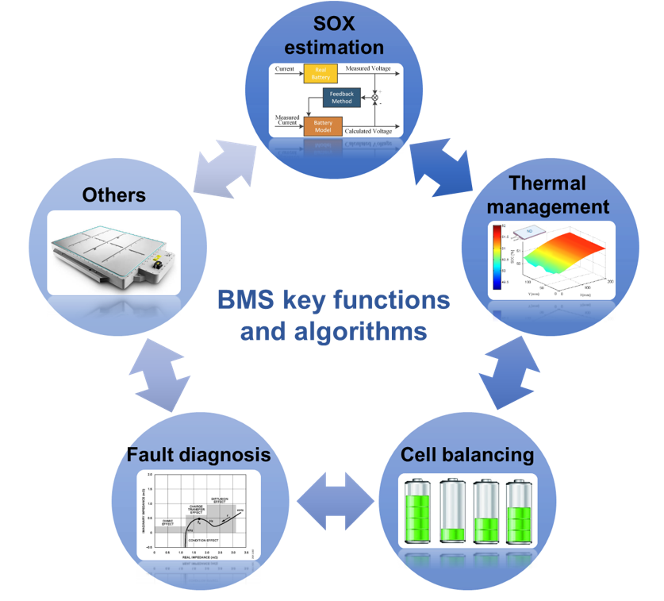
Figure 2 BMS key functions

3.1 SOX estimation methodologies
In order to achieve suitable system functionality and market acceptance, a more efficient BMS is needed with high-precision SOX estimation. Battery states including: state-of-charge (SOC), state-of-energy (SOE), state-of-power (SOP), state-of-function (SOF), state-of-health (SOH) and residual discharge time (RDT). All of these should be evaluated accurately and efficiently to prevent safety concerns, maximise performance and prolong lifetime[25]. However, complex non-linear behaviour, varying external conditions, cell-to-cell variations and challenges around parameterization pose challenges to high-precision SOX estimation, which can broadly be broken up into five categories, which are shown in Figure 3.
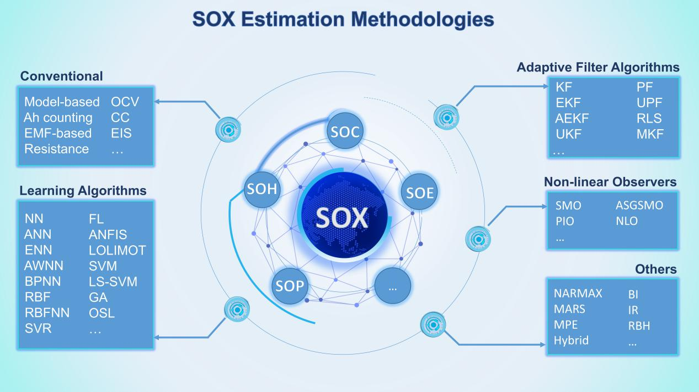
Figure 3 Categorization of SOX estimation methodologies
a) Conventional methodologies
Traditional methods use the metrics including: voltage, current and impedance to estimate the states of the battery[26–28]. Compared with other methods, the traditional approaches are generally easy to implement, with relatively small amounts of calculation. However, traditional approaches have many limitations. For example, the open circuit voltage (OCV) method for estimating the SOC requires a long rest time to reach the equilibrium state. Therefore, this method is only applicable to the vehicle under long static periods. Other approaches for estimation of the SOC include coulomb counting however, the cumulative effect caused by uncertainty in measurement may lead to inaccurate estimation results.
b) Adaptive filter algorithms
Adaptive filtering algorithms are an intelligent tool for predicting the dynamic state of batteries and adopts a variety of models and algorithms to calculate SOX[29–32]. It can filter parameters from uncertain and inaccurate observation results, and has the characteristics of self-correction and high precision. Adaptive filtering algorithm requires highly complex mathematical calculation, and the nonlinear degree of the system will affect the result of calculation. Whilst promising, the robustness of the method needs to be improved due to the uncertainty of modeling and the disturbance of the system.
c) Learning algorithms
Learning algorithms are able to achieve equivalent state estimation as other approaches without detailed understanding of the internal structure of the battery and the initial SOX by using training data[33–35]. The advantage of this method is that it can estimate SOX quickly and accurately under nonlinear conditions by using the correct training data, sometimes with improved robustness. However, the algorithm needs large amounts of training data, which is often costly and slow to acquire. In addition, the training process itself can be computationally intensive.
d) Non-linear observers
Nonlinear observers are used to deal with highly nonlinear system, which guarantees the stability and robustness of the system to environmental disturbance and model uncertainty. The nonlinear observer estimate state variables according to the measurements of the external variables, which not only provides the possibility for the realization of the state feedback, but also has been applied to many aspects of control engineering. Observer-based methods such as the sliding mode observer (SMO)[36], proportional integral observer (PIO)[37]. and adaptive switching gain sliding mode observer (ASGSMO)[38] have been widely used in battery state estimation in recent years.
e) Other algorithms
Other methods include the MARS, BI, IR and mixed method. MARS[39], BI[40], and IR[41] use an extended linear model, two linear interpolation, and the linear time invariant system respectively. MARS can be used for the extension of a linear model, which can build a non-linear model automatically and interact with the variables with the help of a nonparametric regression algorithm. Linear interpolation based SOC estimation can be performed using battery charge and discharge characteristics. The algorithm is valid until charge and discharge currents remain unchanged with the known value of SOC. IR is applied to determine the output of a linear time-invariant (LTI) system with a random output. The convolution of the input with impulse response defines the output of the system. Hybrid methods combine two or three SOX algorithms to estimate SOX.

3.2 Thermal management
The research in the thermal issues of Li-ion batteries under various conditions and the development of battery thermal management system (BTMS) have not been adequately addressed although they have a large impact on the performance, lifespan and security of battery [42]. If the temperature is too low, the available power and capacity of the battery will be significantly reduced, at the same time, the battery capacity will be irreversibly attenuated[43]; if the temperature is too high, it will speed up the battery's side reactions and performance degradation[19][44]; defects in the manufacturing process or improper use may cause partial overheating of the battery, which will eventually lead to battery thermal runaway, threatening the lives of electric vehicle drivers and passengers[45].The commonly used models for battery thermal management include thermal model, electrical-thermal coupled model，and equivalent circuit model[46]. Limited by the performance of BMS, the most commonly used in engineering is the thermal model which needs to solve finite element equations. Self-adaptive intelligent control strategy should be made to control the multi-physical BTMS including preheating system, cooling system and EBTB effectively and economically [47]. Efficient battery thermal management system is essential to keep battery temperature within the proper range and to decrease the temperature variance between cells[48,49]. Cloud-based BMS can provide computing power support for the identification of these parameters, a precise thermal management will be realized in the future.

3.3 Cell balancing
In the practical work process of battery pack, the inconsistency among lithium-ion cells may seriously restrict the pack’s capacity, lifetime and other important performance. The inconsistency is due to the accumulation of micro electrochemical reaction differences caused by the discrepancy of the initial state and the actual working condition among cells, which may bring hidden danger to the use of whole electric vehicles[50][51]. The equalization management systems (EMSs), one of a key portion of the BMS, is crucial to alleviate such inter-cell inconsistency by redistributing the energy among the cells that have too high or too low releasable capacities, whose main performance such as accuracy and stability, mainly depends on the setting of equalization control strategies and hardware system[52]. The essence of equilibrium is to solve the control problem where equalization control strategies are responsible for information receiving calculation and decision making and hardware system carries on data collection and implementation[53]. The equalization control strategies are set by specific equalization objective and algorithms. The common objectives of equalization control strategies contain the consistency of battery SOX, battery pack capacity maximum, time minimization and fused objective[54]. The equalization algorithms can be divided into three types: control algorithm-based, data driven-based and fusion-based, which can apply to the cloud computing[55]. Control algorithm-based equalization algorithms range from classical control theory such as proportion integration differentiation (PID) to the modern control theory including model predictive control and sliding mode control[56]. Data-driven equalization strategies are based on the dataset such as voltage, SOC, and capacity to implement data dimension reduction, feature extraction and regression analysis to judge the degree of battery pack imbalance and realize equalization while fusion-based equalization algorithms adopt multiple variable features and fusion algorithms to execute equalization operations and achieve accurate and stable EMS [11].

3.4 Fault diagnosis
Safety concerns are the main obstacle to large-scale application of batteries (LIBs), and thus, battery fault diagnosis has become a global research hotspot[57]. In the actual operation of the battery, the fault types can be divided into four categories: battery body, BMS, connector, and sensor according to the location. By upgrading the functional safety level to ASIL-D, the main fault problem of BMS can be solved[58]; for connection failure, FPC (flexible circuit board) can be used to avoid short circuit and open circuit of wiring harness connection[59]; sensor failure generally use redundant design to improve system reliability[60,61]. Because the battery itself is a dynamic and time-varying electrochemical system with nonlinear behavior and complicated internal mechanisms, the fault diagnosis of the battery is still a hot issue in research[62]. The faults of the battery itself mainly include state-of-health[63,64], internal short circuit fault(ISC) and external short circuit(ESC)[65,66], overcharge and overdischarge fault[67], thermal fault[68], etc. These faults occur inside the battery, and is difficult to achieve early detection and early warning. Cloud-based BMS can use big data analysis to extract fault features from historical data, and use data-driven algorithms to implement fault diagnosis.

Data Visualization
Visualization has become one of the indispensable functional aspects of big data analysis tools, especially for a large amount of constantly updated data. When converted into a visual form, the data collected from the battery system and the results obtained from complex calculations and analysis in the cloud can be more concisely and explicitly expressed. Meanwhile, synchronization and real-time updating of the database can be realized by using Java Database Connectivity(JDBC) or asynchronous javascript and XML (AJAX) technology. Figure 3 shows the user interface of the battery intelligent monitoring and management platform. To meet the needs of unique users and different management strategies, information from the database will be displayed hierarchically to improve its operational efficiency of the platform. In this framework, we propose that this is broken down into 4 main levels representing the transport system, vehicle, battery system and cell.

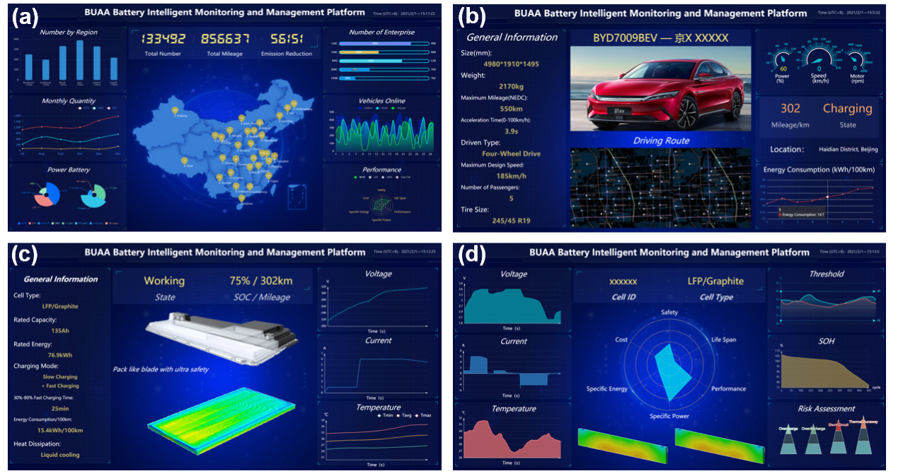
Figure 4 Battery Intelligent Monitoring and Management Platform. (a) User interface at transport system level. (b) User interface at vehicle level. (c) User interface at battery system level. (d) User interface at cell level.

4.1 Transport system level
To highlight key data in the transportation system, Figure 4a shows the statistical information of new energy vehicle nationwide. According to the classification of regions, models, brands and other bases, the distribution of new energy vehicles within the system is clear. The actual use of different types of batteries is also displayed in the user interface, and the evaluation and comparison are made considering factors such as loading capacity and functional safety factor, which provide data analysis foundation for the sales market and development trend of new energy vehicles and corresponding batteries.

4.2 Vehicle level
For enterprises and individual users, behavioral information and battery status of the designated vehicles provide important insights. As shown in Figure 4b, at the vehicle level, the user interface first displays basic information, including vehicle model, license plate number and maximum driving mileage. After analysis, calculation and dispatch in the cloud, the vehicle's driving route, working status, energy consumption, residual mileage and other information will also be fed back to the user interface to ensure that users can master the real-time status of the vehicle and provide drivers with targeted suggestions, such as energy management strategies and maximum cruising range.

4.3 Battery system level
At the battery system level, the management of EV battery is only carried out when the vehicle is activated. However, in any state, the battery system should be fully monitored and controlled to avoid unnecessary potential security hazards (Figure 4c). For the battery system of one designated vehicle, its basic information and real-time output are clearly visible, such as the usage status, real-time power consumption and working current, voltage, temperature. By analysis of historical data stored in the database and real-time operating data, and after effective analysis in the cloud, the platform can issue early warnings and remind users in a timely manner through the interface when the battery system has insufficient power, abnormal output or possible failures.

4.4 Cell level
The Cannikin law is applicable to battery systems, in that, once a cell behaves abnormally or fails, the system will be adversely affected, so it is of great significance to ensure accurate real-time monitoring of each cell to improve its output performance and the security of the vehicle. In Figure 4(d), more detailed data of cells in the battery system will be fed back to users, including various output indicators, safety thresholds and health status. At the same time, with the help of a large data comparisons and training in the cloud, the performance and risk prediction level of each cell can be evaluated, which will provide more targeted solutions and experience to users, extend the cycle life of the battery and guarantee the health management of the system.

Conclusion and perspectives
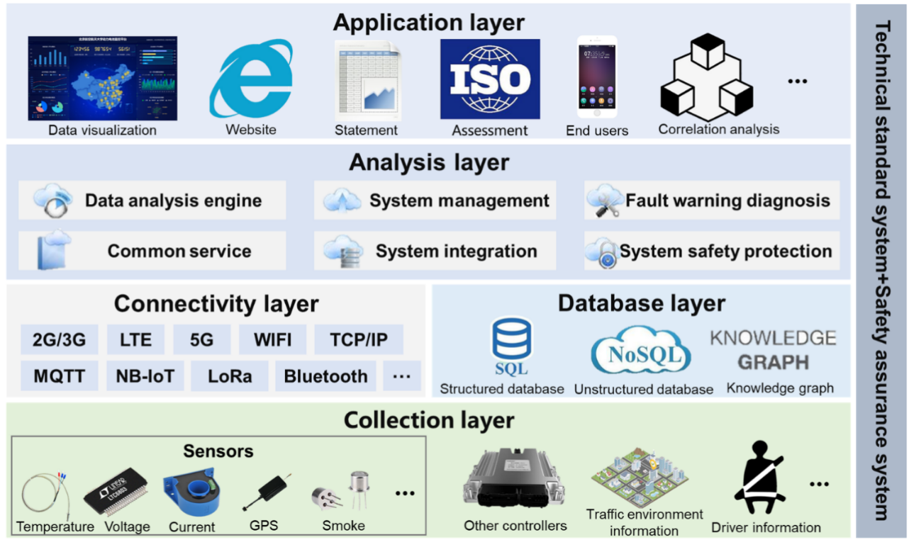
Figure 5 The functional architecture of the cloud-connected BMS
From the application perspective, the new generation of battery systems should be high-strength, lightweight, high-safety, low-cost and long lifespan with ease of recycling/repurposing. The CHAIN architecture proposed by Yang et al. is regarded as a promising solution for battery management systems, which can meet the requirements of complex modeling and interactional integration in Cyber-Physical systems for the 3Cs (computing, communication, control). The functionality of 3Cs will become the concept of cyber in CHAIN. The unique hierarchical network architecture of CHAIN comes bridges multiple length scales of interest[69]. From the aspect of battery packs, it meets the process flow of “cell-module-pack”. The full life cycle utilization is in line with the “material-battery-material” closed loop. In terms of battery cloud management, it is compatible with the “end-edge-cloud” multi-layer collaborative layout and the architecture of the Cloud-based BMS is given in Figure 5. The layered architecture can integrate existing multi-physics models, intelligent manufacturing, prognostic and health management (PHM) and data-driven algorithms. It has strong generalization ability, universality and inclusiveness, which can provide suitable functions for different levels of network configuration and hardware computing ability to maximize resource utilization and optimize management benefits. Under the interactional network framework of the CHAIN architecture, the battery system has evolved an ability of “feedback and adjustment” based on the digital twin model of “information perception”. It can not only complete the “Digital Twin” and “Digital Thread” in the Cyber-Physical system, but also integrate multi-source information better. CHAIN could improve the adaptability and the integration capability greatly, which meets the demand of the battery management system and the construction of the energy internet. This paper thus proposes three prospects based on the CHAIN architecture:
a) Multi-scale integrated modeling strategy for batteries
In view of the complex and non-linear internal reaction mechanisms in a battery, a promising choice is to consider multi-dimensional electrochemical thermal models which span multiple time scales. This includes short time scale processes such as charge transfer all the way to long term aging mechanism models. For problems that the solution function of traditional equivalent circuit model is single and the shortcomings of insufficient internal characteristic representation, the internal impedance characteristics of the battery will be analyzed through time-frequency characteristics analysis, and the corresponding circuit model will be adapted to various conditions, for which the electrical components will be reasonably introduced to improve the model accuracy. In view of the problems that the micro-macro mapping of batteries is fuzzy and a large amount of data has not been utilized, there are three methods proposed to improve the refinement of battery management, which are respectively the extract of massive data, in-situ non-destructive fault diagnosis and mechanism learning prediction performance. Since it is difficult to integrate the multi-scale models of the battery systems, the proposed CHAIN architecture will achieve multi-level closed-loop linkages, distributed joint simulation technology and the idea of co-evolution of the “terminal-edge-cloud”.
b) Remote upgrading capability of the controller
Due to advances in connectivity, electric vehicles can achieve real-time product updates through over-the-air downloads (OTA) based on the combination of BMS and cloud computing, including firmware over-the-air (FOTA), software over-the-air (SOTA), configuration over-the-air (COTA) and data over-the-air (DOTA) technologies. Furthermore, vehicle-based systems can keep updated to prevent information security accidents. What’s more, it can continuously adapt the internal algorithm of the controller to technology trends, provide customers with more value-added services, and realize the interactional networking technology in the CHAIN architecture at a deeper level. The development of the OTA technology needs to be compatible with local hardware devices and software architecture. At present, it requires a complete set of standards and development processes to be proposed to ensure overall compliance for this field. In addition, application development based on this system should be open source, which allows more engineers to participate in the formation of a software ecosystem with a larger scale and richer functions.
c) Integration with other fields
With the widespread application of batteries as energy storage devices in smart microgrid, Internet Data Center (IDC), aerospace and other fields, BMS have encountered greater challenges and more functional requirements. For example, batteries are the power source of electric vehicle, while in a microgrid, the battery play a role as energy storage and peak load shifting, which needs to have a high energy density and excellent power characteristics to meet the demand, the battery becomes parts of a microgrid system at this time. Therefore, BMS not only ensure the safety, reliability, and longevity of the battery, but also communicate and coordinate with other parts of the system. At this time, the concept of cloud-based BMS can be extended to the control unit of the entire system, which means the solution of the CHAIN architecture is universal in many fields.

ACKNOWLEDGMENT
This work was supported by National Key R&D Program of China (2018YFB0104001), the EPSRC Faraday Institution’s Multi-Scale Modelling Project (EP/S003053/1, grant number FIRG003).

AUTHOR CONTRIBUTIONS
S.Y. and X.L.conceived the research. S.Y., X.L., B.W., H. L., and Y. L. codirected the work. Z.Z., C.R., H.C., M.W., Y.J., Y.L.developed models and performed simulations. Z.Z., C.R., H.C., M.W., L.Z., Y.J., and Y.L. wrote the manuscript. S.Y., B.W., B.C. and X.L. revised the manuscript.

REFERENCES
[1] M.S.H. Lipu, M.A. Hannan, T.F. Karim, A. Hussain, M.H.M. Saad, A. Ayob, M.S. Miah, T.M.I. Mahlia, J. Clean. Prod. 292 (2021) 126044.
[2] H. He, R. Xiong, H. Guo, Appl. Energy 89 (2012) 413–420.
[3] W. Huang, X. Feng, X. Han, W. Zhang, F. Jiang, Cell Reports Phys. Sci. 2 (2021) 100285.
[4] A. Kwade, W. Haselrieder, R. Leithoff, A. Modlinger, F. Dietrich, K. Droeder, Nat. Energy 3 (2018) 290–300.
[5] Y. Saleem, N. Crespi, M.H. Rehmani, R. Copeland, ArXiv 7 (2017).
[6] K. Mahmud, G.E. Town, S. Morsalin, M.J. Hossain, Renew. Sustain. Energy Rev. 82 (2018) 4179–4203.
[7] M. Mierau, S. Fey, R. Kohrs, C. Wittwer, World Electr. Veh. J. 6 (2013) 1125–1135.
[8] T. Tanizawa, T. Suzumiya, K. Ikeda, Fujitsu Sci. Tech. J. 51 (2015) 27–35.
[9] M. Baumann, S. Rohr, M. Lienkamp, 2018 13th Int. Conf. Ecol. Veh. Renew. Energies, EVER 2018 (2018) 1–6.
[10] W. Li, M. Rentemeister, J. Badeda, D. Jöst, D. Schulte, D.U. Sauer, J. Energy Storage 30 (2020) 101557.
[11] B. Wu, W.D. Widanage, S. Yang, X. Liu, Energy AI 1 (2020) 100016.
[12] W. Li, N. Sengupta, P. Dechent, D. Howey, A. Annaswamy, D.U. Sauer, J. Power Sources 482 (2021) 228863.
[13] Z. Qin, G. Denker, C. Giannelli, P. Bellavista, N. Venkatasubramanian, IEEE/IFIP NOMS 2014 - IEEE/IFIP Netw. Oper. Manag. Symp. Manag. a Softw. Defin. World (2014).
[14] H. Qi, A. Gani, 2012 2nd Int. Conf. Digit. Inf. Commun. Technol. Its Appl. DICTAP 2012 (2012) 195–202.
[15] S. Kumbhar, T. Faika, D. Makwana, T. Kim, Y. Lee, 2018 IEEE Transp. Electrif. Conf. Expo, ITEC 2018 (2018) 761–766.
[16] R. Liu, B. Jia, W. Wang, Environ. Technol. Innov. 21 (2021) 101369.
[17] F. Tao, Q. Qi, Nature 573 (2019) 490–491.
[18] M.S. Aslanpour, S.S. Gill, A.N. Toosi, Internet of Things 12 (2020) 100273.
[19] A. Tomaszewska, Z. Chu, X. Feng, S. O’Kane, X. Liu, J. Chen, C. Ji, E. Endler, R. Li, L. Liu, Y. Li, S. Zheng, S. Vetterlein, M. Gao, J. Du, M. Parkes, M. Ouyang, M. Marinescu, G. Offer, B. Wu, ETransportation 1 (2019) 100011.
[20] S. Yang, X. Gao, Y. Li, W. Xie, B. Guo, L. Zhang, X. Liu, J. Power Sources 494 (2021) 229772.
[21] J. Spillner, J. Müller, A. Schill, Futur. Gener. Comput. Syst. 29 (2013) 1062–1072.
[22] P.J. Sun, J. Netw. Comput. Appl. 160 (2020) 102642.
[23] P. Arcaini, R. Mirandola, E. Riccobene, P. Scandurra, J. Syst. Softw. 164 (2020) 110558.
[24] L. Lu, X. Han, J. Li, J. Hua, M. Ouyang, J. Power Sources 226 (2013) 272–288.
[25] H. Kuusisto, T. Wik, 287 (2015) 448–457.
[26] J. Meng, M. Boukhnifer, D. Diallo, IET Electr. Syst. Transp. 10 (2020) 162–169.
[27] L. Teo, V.R. Subramanian, D.T. Schwartz, J. Electrochem. Soc. 168 (2021) 010526.
[28] S. Zhang, X. Guo, X. Dou, X. Zhang, Sustain. Energy Technol. Assessments 40 (2020).
[29] S. Wang, C. Fernandez, C. Yu, Y. Fan, W. Cao, D.I. Stroe, J. Power Sources 471 (2020) 228450.
[30] R. Zhu, B. Duan, J. Zhang, Q. Zhang, C. Zhang, Appl. Energy 277 (2020) 115494.
[31] P. Shrivastava, T. Kok Soon, M.Y.I. Bin Idris, S. Mekhilef, S.B.R.S. Adnan, IEEE Trans. Veh. Technol. 70 (2021) 1200–1215.
[32] L. Ling, Y. Wei, IEEE Access 9 (2021) 47588–47602.
[33] P. Fermín-cueto, E. Mcturk, M. Allerhand, E. Medina-lopez, M.F. Anjos, J. Sylvester, Q. Court, H. Watt, 1 (2020).
[34] P.M. Attia, A. Grover, N. Jin, K.A. Severson, T.M. Markov, Y.H. Liao, M.H. Chen, B. Cheong, N. Perkins, Z. Yang, P.K. Herring, M. Aykol, S.J. Harris, R.D. Braatz, S. Ermon, W.C. Chueh, Nature 578 (2020) 397–402.
[35] A. Gayon-lombardo, L. Mosser, N.P. Brandon, S.J. Cooper, Npj Comput. Mater. (2020) 1–11.
[36] B. Ning, B. Cao, B. Wang, Z. Zou, Energy 153 (2018) 732–742.
[37] X. Chen, W. Shen, Z. Cao, A. Kapoor, J. Power Sources 246 (2014) 667–678.
[38] J. Xu, S. Member, C.C. Mi, B. Cao, J. Deng, Z. Chen, S. Li, 63 (2014) 1614–1621.
[39] M. Technique, J.C. Alvarez, F. Javier, D.C. Juez, 28 (2013) 3798–3805.
[40] W. Liye, W. Lifang, L. Yong, (2013) 26–29.
[41] A.H. Ranjbar, A. Banaei, A. Khoobroo, B. Fahimi, 3 (2012) 360–367.
[42] H. Liu, Z. Wei, W. He, J. Zhao, Energy Convers. Manag. 150 (2017) 304–330.
[43] M. Lu, X. Zhang, J. Ji, X. Xu, Y. Zhang, J. Energy Storage 27 (2020) 101155.
[44] S. Arora, A. Kapoor, W. Shen, J. Power Sources 378 (2018) 759–775.
[45] G. Zhang, X. Wei, X. Tang, J. Zhu, S. Chen, H. Dai, Renew. Sustain. Energy Rev. 141 (2021) 110790.
[46] J. Chiew, C.S. Chin, W.D. Toh, Z. Gao, J. Jia, C.Z. Zhang, Appl. Therm. Eng. 147 (2019) 450–463.
[47] J. Lin, X. Liu, S. Li, C. Zhang, S. Yang, Int. J. Heat Mass Transf. 167 (2021) 120834.
[48] T. Liu, C. Tao, X. Wang, Appl. Energy 267 (2020) 115087.
[49] T. Liu, Y. Liu, X. Wang, X. Kong, G. Li, Energy Convers. Manag. 199 (2019) 111969.
[50] X. Liu, W. Ai, M. Naylor Marlow, Y. Patel, B. Wu, Appl. Energy 248 (2019) 489–499.
[51] J. Schmalstieg, S. Käbitz, M. Ecker, D.U. Sauer, J. Power Sources 257 (2014) 325–334.
[52] L. Hu, X. Hu, Y. Che, F. Feng, X. Lin, Z. Zhang, Appl. Energy 262 (2020) 114569.
[53] Y. Zheng, M. Ouyang, L. Lu, J. Li, X. Han, L. Xu, H. Ma, T.A. Dollmeyer, V. Freyermuth, Appl. Energy 111 (2013) 571–580.
[54] P. Ladpli, F. Kopsaftopoulos, F.K. Chang, J. Power Sources 384 (2018) 342–354.
[55] F. Feng, X. Hu, J. Liu, X. Lin, B. Liu, Renew. Sustain. Energy Rev. 116 (2019) 109464.
[56] C. Lin, H. Mu, R. Xiong, W. Shen, Appl. Energy 166 (2016) 76–83.
[57] X. Lai, C. Jin, W. Yi, X. Han, X. Feng, Y. Zheng, M. Ouyang, Energy Storage Mater. 35 (2021) 470–499.
[58] Y. Wang, J. Tian, Z. Chen, X. Liu, Meas. J. Int. Meas. Confed. 131 (2019) 443–451.
[59] M. Ma, Y. Wang, Q. Duan, T. Wu, J. Sun, Q. Wang, Energy 164 (2018) 745–756.
[60] J. Tian, Y. Wang, Z. Chen, Int. J. Electr. Power Energy Syst. 121 (2020) 106087.
[61] S. Dey, S. Mohon, P. Pisu, B. Ayalew, IEEE Trans. Control Syst. Technol. 24 (2016) 2141–2149.
[62] X. Hu, L. Xu, X. Lin, M. Pecht, Joule 4 (2020) 310–346.
[63] A. Nuhic, T. Terzimehic, T. Soczka-Guth, M. Buchholz, K. Dietmayer, J. Power Sources 239 (2013) 680–688.
[64] Y. Zhang, R. Xiong, H. He, M.G. Pecht, IEEE Trans. Ind. Electron. 66 (2019) 1585–1597.
[65] X. Kong, Y. Zheng, M. Ouyang, L. Lu, J. Li, Z. Zhang, J. Power Sources 395 (2018) 358–368.
[66] Z. Chen, R. Xiong, J. Tian, X. Shang, J. Lu, Appl. Energy 184 (2016) 365–374.
[67] A. Sidhu, A. Izadian, S. Anwar, IEEE Trans. Ind. Electron. 62 (2015) 1002–1011.
[68] H. Nordmann, M. Frisch, D.U. Sauer, Meas. J. Int. Meas. Confed. 114 (2018) 484–491.
[69] X. Gao, X. Liu, R. He, M. Wang, W. Xie, N.P. Brandon, B. Wu, H. Ling, S. Yang, Energy Storage Mater. 36 (2021) 435–458.

