Supporting Information
Subsurface Ag-modified Bi₃NbO₇: Kinetic Modulation of Photocatalytic Oxidation and Hydrogen Evolution

Tanachat Eknapakul^{a,b}, Nursabeelan Kadasae ^{a,b}, Andreas Kafizas^{c,d}, Choe Earn Choong^{e}, Theeranun Siritanon^{f}, Wutthigrai Sailuam^{g}, Suwilai Chaveanghong^{h}, Yuttanun Pansong^{i}, Napat Supmeak^{a,b}, Claire J. Carmalt^{j}, Arreerat Jiamprasertboon^{a,b,*}

ª Functional Materials and Nanotechnology Center of Excellence, School of Science, Walailak University, Thasala, Nakhon Si Thammarat, 80160, Thailand
^{b} Drug and Cosmetics Excellent Center, Walailak University, Thasala, Nakhon Si Thammarat, 80160, Thailand
^{c} Department of Chemistry, Molecular Science Research Hub, Imperial College London, White City, London, W12 0BZ, U.K.
^{d} London Centre for Nanotechnology, Imperial College London, London, SW7 2AZ, U.K.
^{e} Plasma Bioscience Research Center/Department of Electrical and Biological Physics, Kwangwoon University, Seoul 01897, Republic of Korea
^{f} School of Chemistry, Institute of Science, Suranaree University of Technology, 111 University Avenue, Muang, Nakhon Ratchasima, 30000, Thailand
^{g} Department of Applied Physics, Faculty of Engineering, Rajamangala University of Technology ISAN (Khon Kaen Campus), Khon Kaen, 40000, Thailand
^{h} Mahidol University Frontier Research Facility, Mahidol University, Salaya, Phuttamonthon, Nakhon Pathom, 73170, Thailand
^{i} Center for Scientific and Technological Equipment, Walailak University, Thasala, Nakhon Si Thammarat,80160, Thailand
^{j} Material Chemistry Centre, Department of Chemistry, University College London, 20 Gordon Street, London, WC1H 0AJ, U.K.

*Corresponding author’s email: jiampraa@gmail.com

Table of contents
- TEM-EDS images of Ag-BNO 02 and Ag-BNO 04
- Elemental composition of all samples obtained from SEM-EDS and TEM-EDS analyses
- Binding energy values derived from the deconvoluted core-level XPS spectra
- Calculated X-ray diffraction (XRD) patterns and corresponding optimized crystal structures
- Plots of reaction kinetics for photocatalytic Rh B degradation
- Crystal structures and physical properties of Ag-BNO 01 after photocatalytic H₂ evolution test
- Transient absorption spectroscopy

- TEM-EDS images of Ag-BNO 02 and Ag-BNO 04
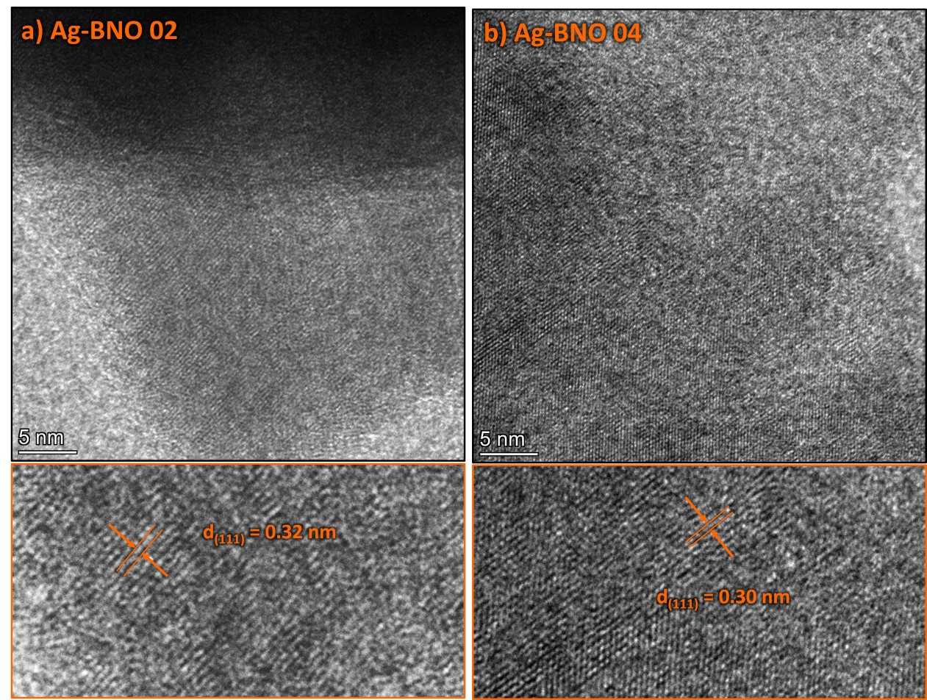
Figure S1. High resolution TEM images of Ag-BNO 02 (a) and Ag-BNO 04 (b).

- Elemental composition of all samples obtained from SEM-EDS and TEM-EDS analyses
Table S1. Average atomic percentages (at.%) of all constituent elements obtained from SEM-EDS and TEM-EDS analyses.
Sample | at.%
Sample | Bi | Nb | O | Ag
SEM-EDS
BNO | 18.50 ± 0.27 | 11.13 ± 0.24 | 70.37 ± 0.39 | -
Ag-BNO 01 | 21.44 ± 0.60 | 12.70 ± 0.28 | 65.86 ± 0.88 | -
Ag-BNO 02 | 22.25 ± 0.73 | 13.33 ± 0.22 | 64.42 ± 0.96 | -
Ag-BNO 03 | 23.02 ± 2.27 | 13.83 ± 1.90 | 63.15 ± 4.06 | -
Ag-BNO 04 | 21.68 ± 2.52 | 14.28 ± 1.62 | 64.03 ± 4.13 | 1.27 ± 0.50
TEM-EDS
BNO | 21.35 ± 0.62 | 14.63 ± 0.94 | 64.02 ± 1.48 | -
Ag-BNO 01 | 26.39 ± 1.52 | 15.98 ± 0.26 | 57.07 ± 1.42 | 0.56 ± 0.29
Ag-BNO 02 | 26.91 ± 1.38 | 15.56 ± 1.03 | 57.08 ± 0.31 | 0.45 ± 0.14
Ag-BNO 03 | 26.44 ± 2.96 | 16.47 ± 2.56 | 56.50 ± 5.38 | 0.59 ± 0.14
Ag-BNO 04 | 22.07 ± 4.56 | 14.23 ± 1.87 | 63.16 ± 6.39 | 0.54 ± 0.04

- Binding energy values derived from the deconvoluted core-level XPS spectra
Table S2. Binding energies correspond to constituent elements derived from the deconvolution of XPS core-level spectra.
Sample | Binding energy (eV)
Sample | Bi |  | Nb |  | O 1s |  |  | Ag
Sample | 4f_{5/2} | 4f_{7/2} | 3d_{3/2} | 3d_{5/2} | O_{I} | O_{II} | O_{III} | 3d_{3/2} | 3d_{5/2}
BNO | 163.94 | 158.62 | 208.96 | 206.24 | 529.46 | 531.97 | 533.44 | - | -
Ag-BNO 01 | 164.41 | 159.09 | 209.46 | 206.75 | 529.89 | 531.38 | 533.27 | None | None
Ag-BNO 02 | 164.16 | 158.84 | 209.24 | 206.49 | 529.67 | 530.28 | - | None | None
Ag-BNO 03 | 164.16 | 158.96 | 209.39 | 206.63 | 529.54 | 531.47 | 533.23 | None | None
Ag-BNO 04 | 164.41 | 159.09 | 209.43 | 206.70 | 529.86 | 531.71 | - | None | None

- Calculated X-ray diffraction (XRD) patterns and corresponding optimized crystal structures
Figure S2. Calculated X-ray diffraction (XRD) pattern and optimized crystal structure of pristine Bi₂₄Nb₈O₅₆ (a) and Ag₂Bi₂₄Nb₈O₅₆ (b).

- Plots of reaction kinetics for photocatalytic Rh B degradation
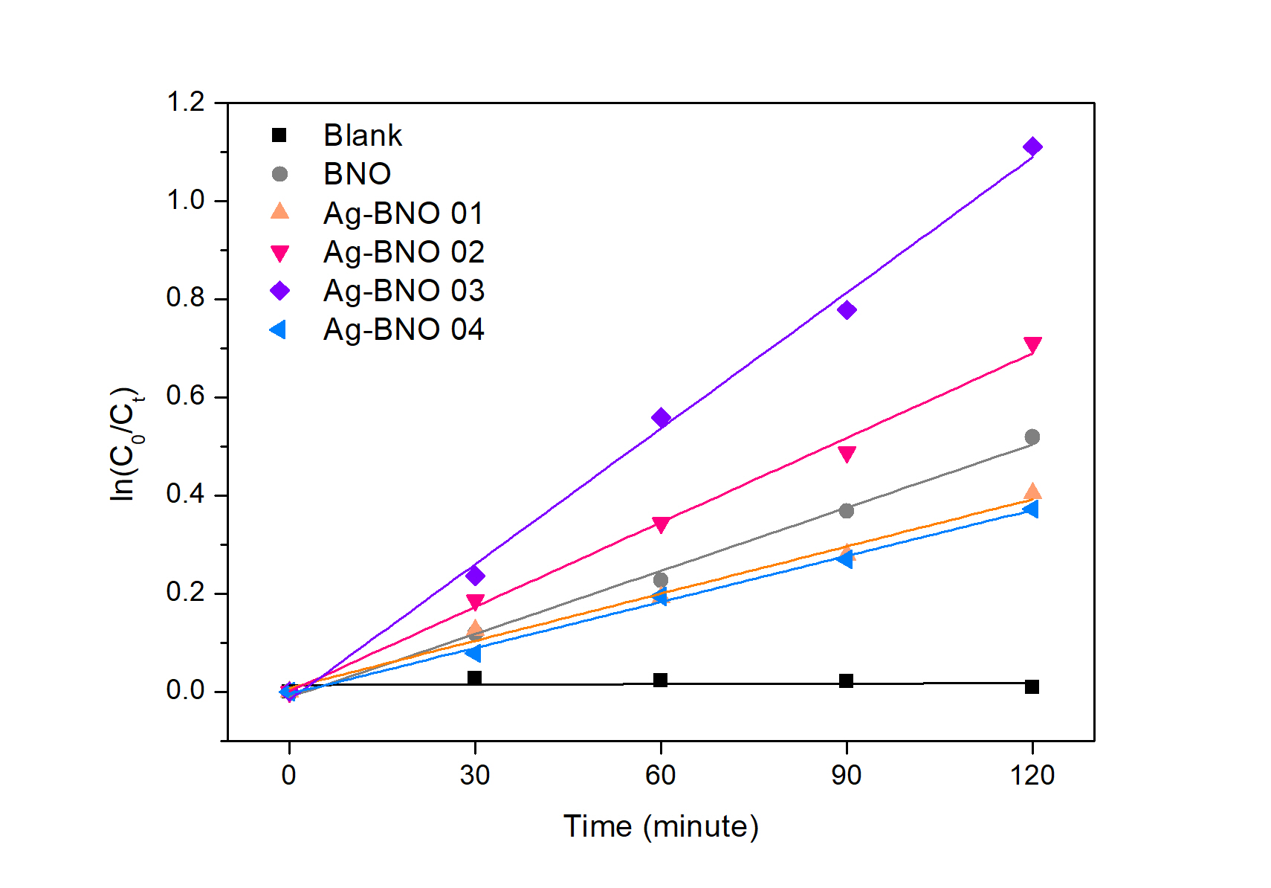
Figure S3. Plots of reaction kinetics for the photocatalytic degradation of Rhodamine B using BNO, Ag-BNO 01, Ag-BNO 02, Ag-BNO 03 and Ag-BNO 04.
- Crystal structures and physical properties of Ag-BNO 01 after photocatalytic H₂ evolution test
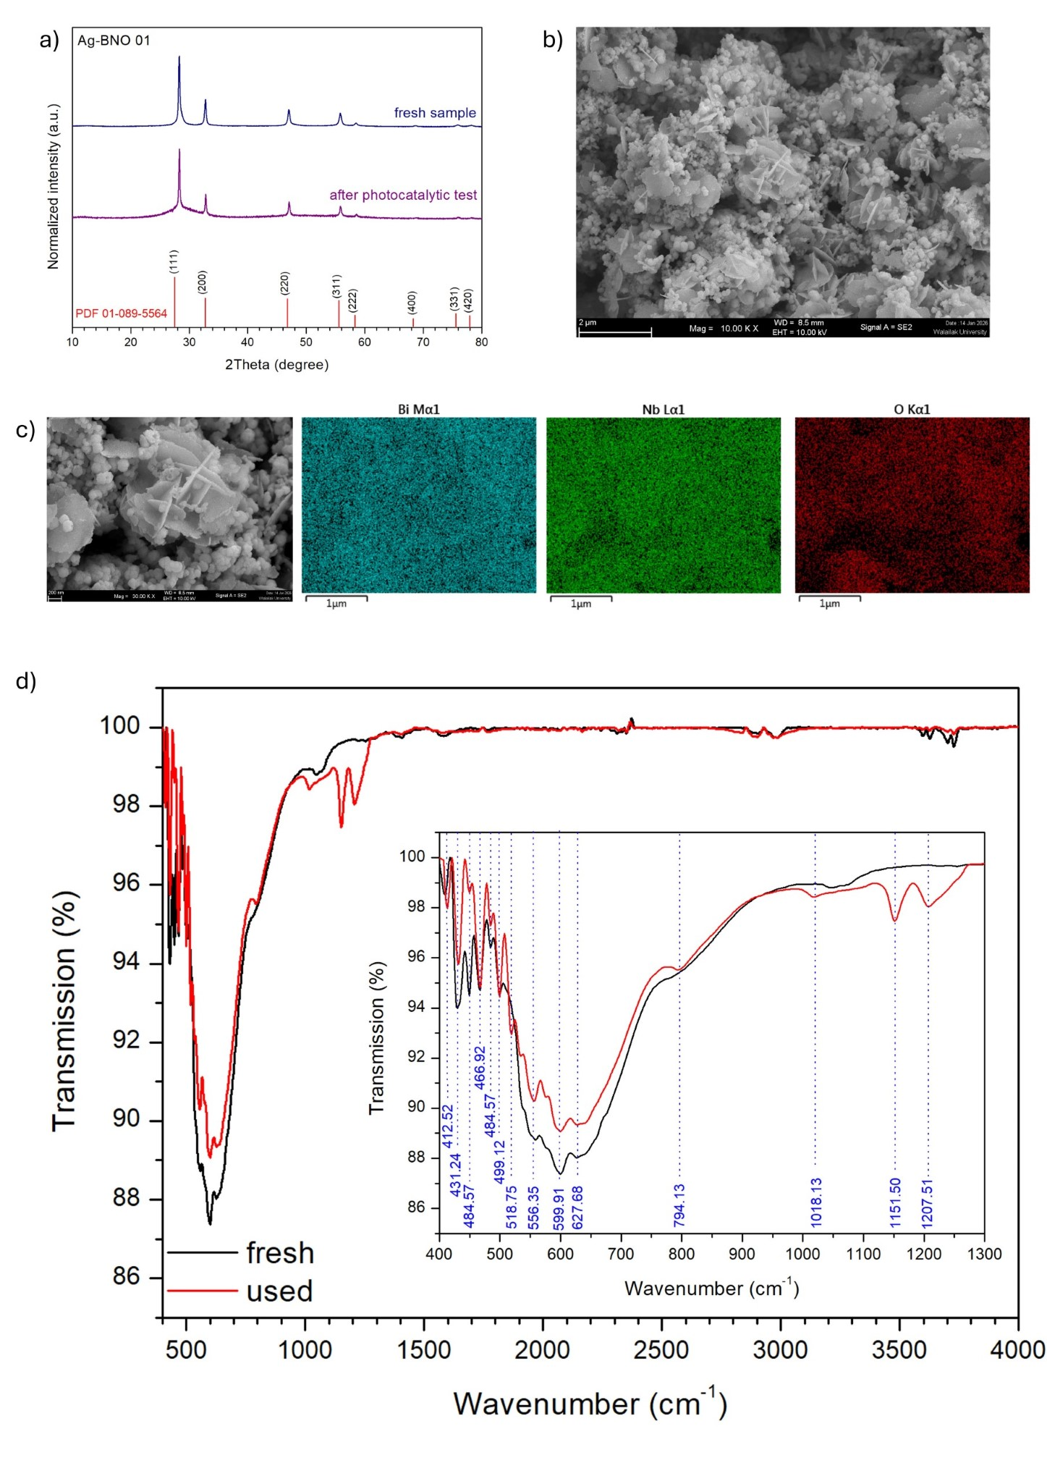
Figure S4. X-ray diffraction patterns of Ag-BNO 01 obtained before and after photocatalytic H₂ evolution experiments (a). SEM micrograph at low (b) and high magnification, along with the corresponding EDS elemental mapping (c), of Ag-BNO 01 following photocatalytic test. FT-IR spectra of fresh Ag-BNO 01 and the sample used after photocatalytic H₂ evolution experiments (d).
- Transient absorption spectroscopy

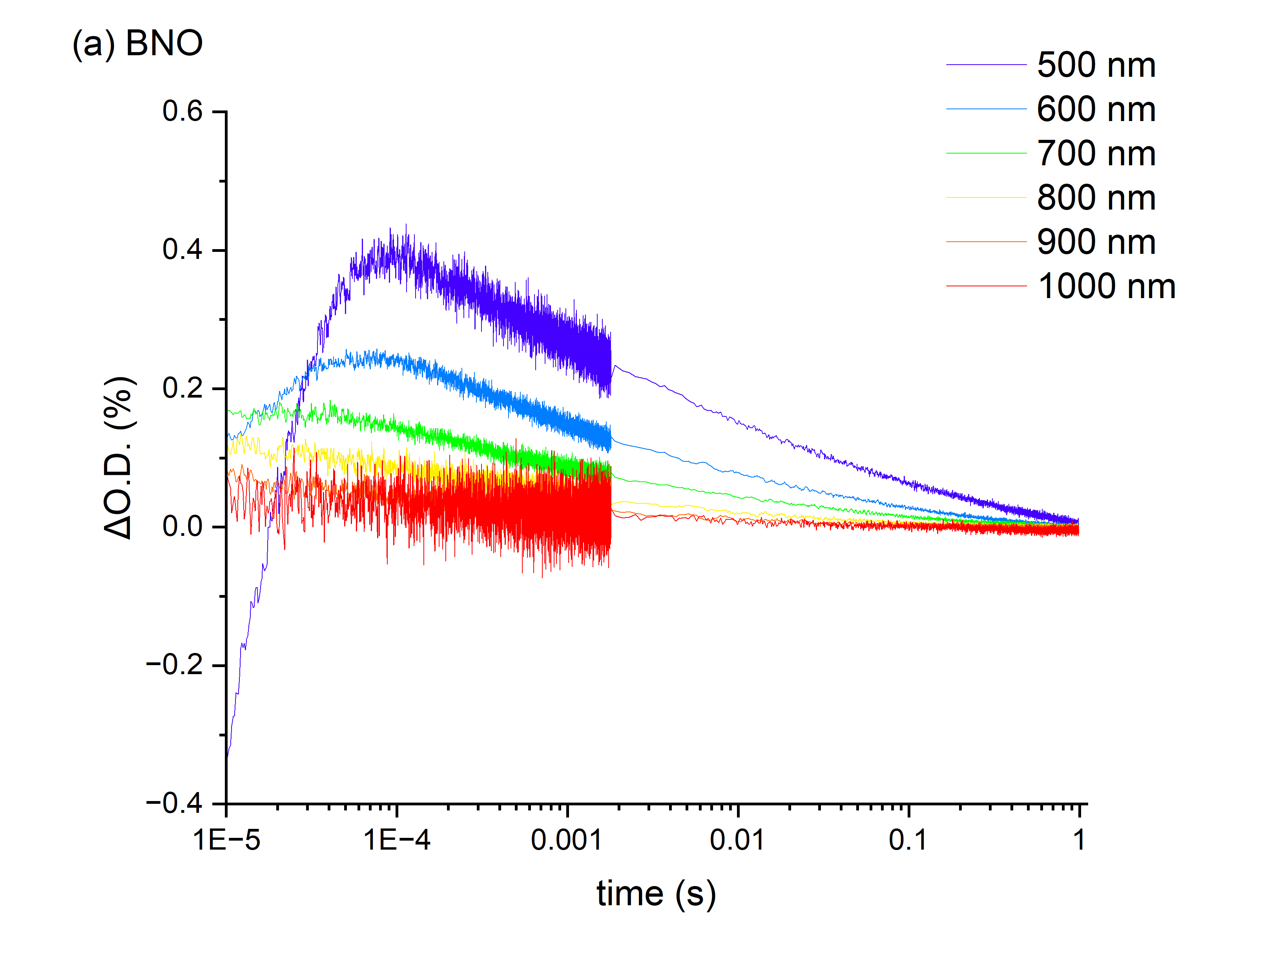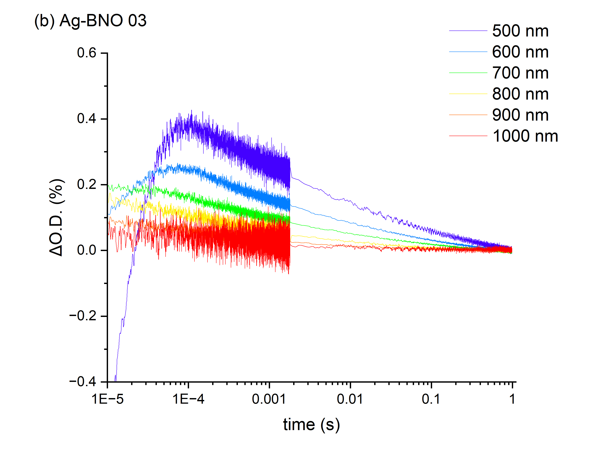
Figure S5. Transient absorption decay kinetics of (a) BNO and (b) Ag-BNO 03. Measurements were carried out at probe wavelengths from 500 to 1000 nm from the 10 μs to 1 s timescale. Samples were excited using a 355 nm laser pulse (~288 μJ.cm⁻² per pulse, repetition rate of 0.7 Hz, ~7 ns pulse width).

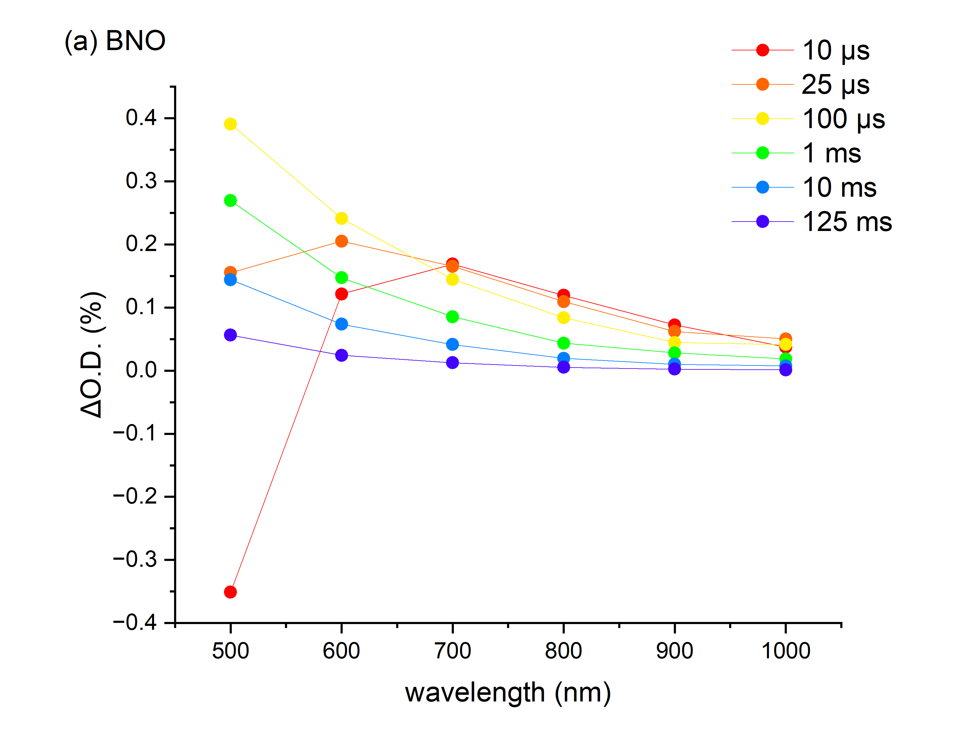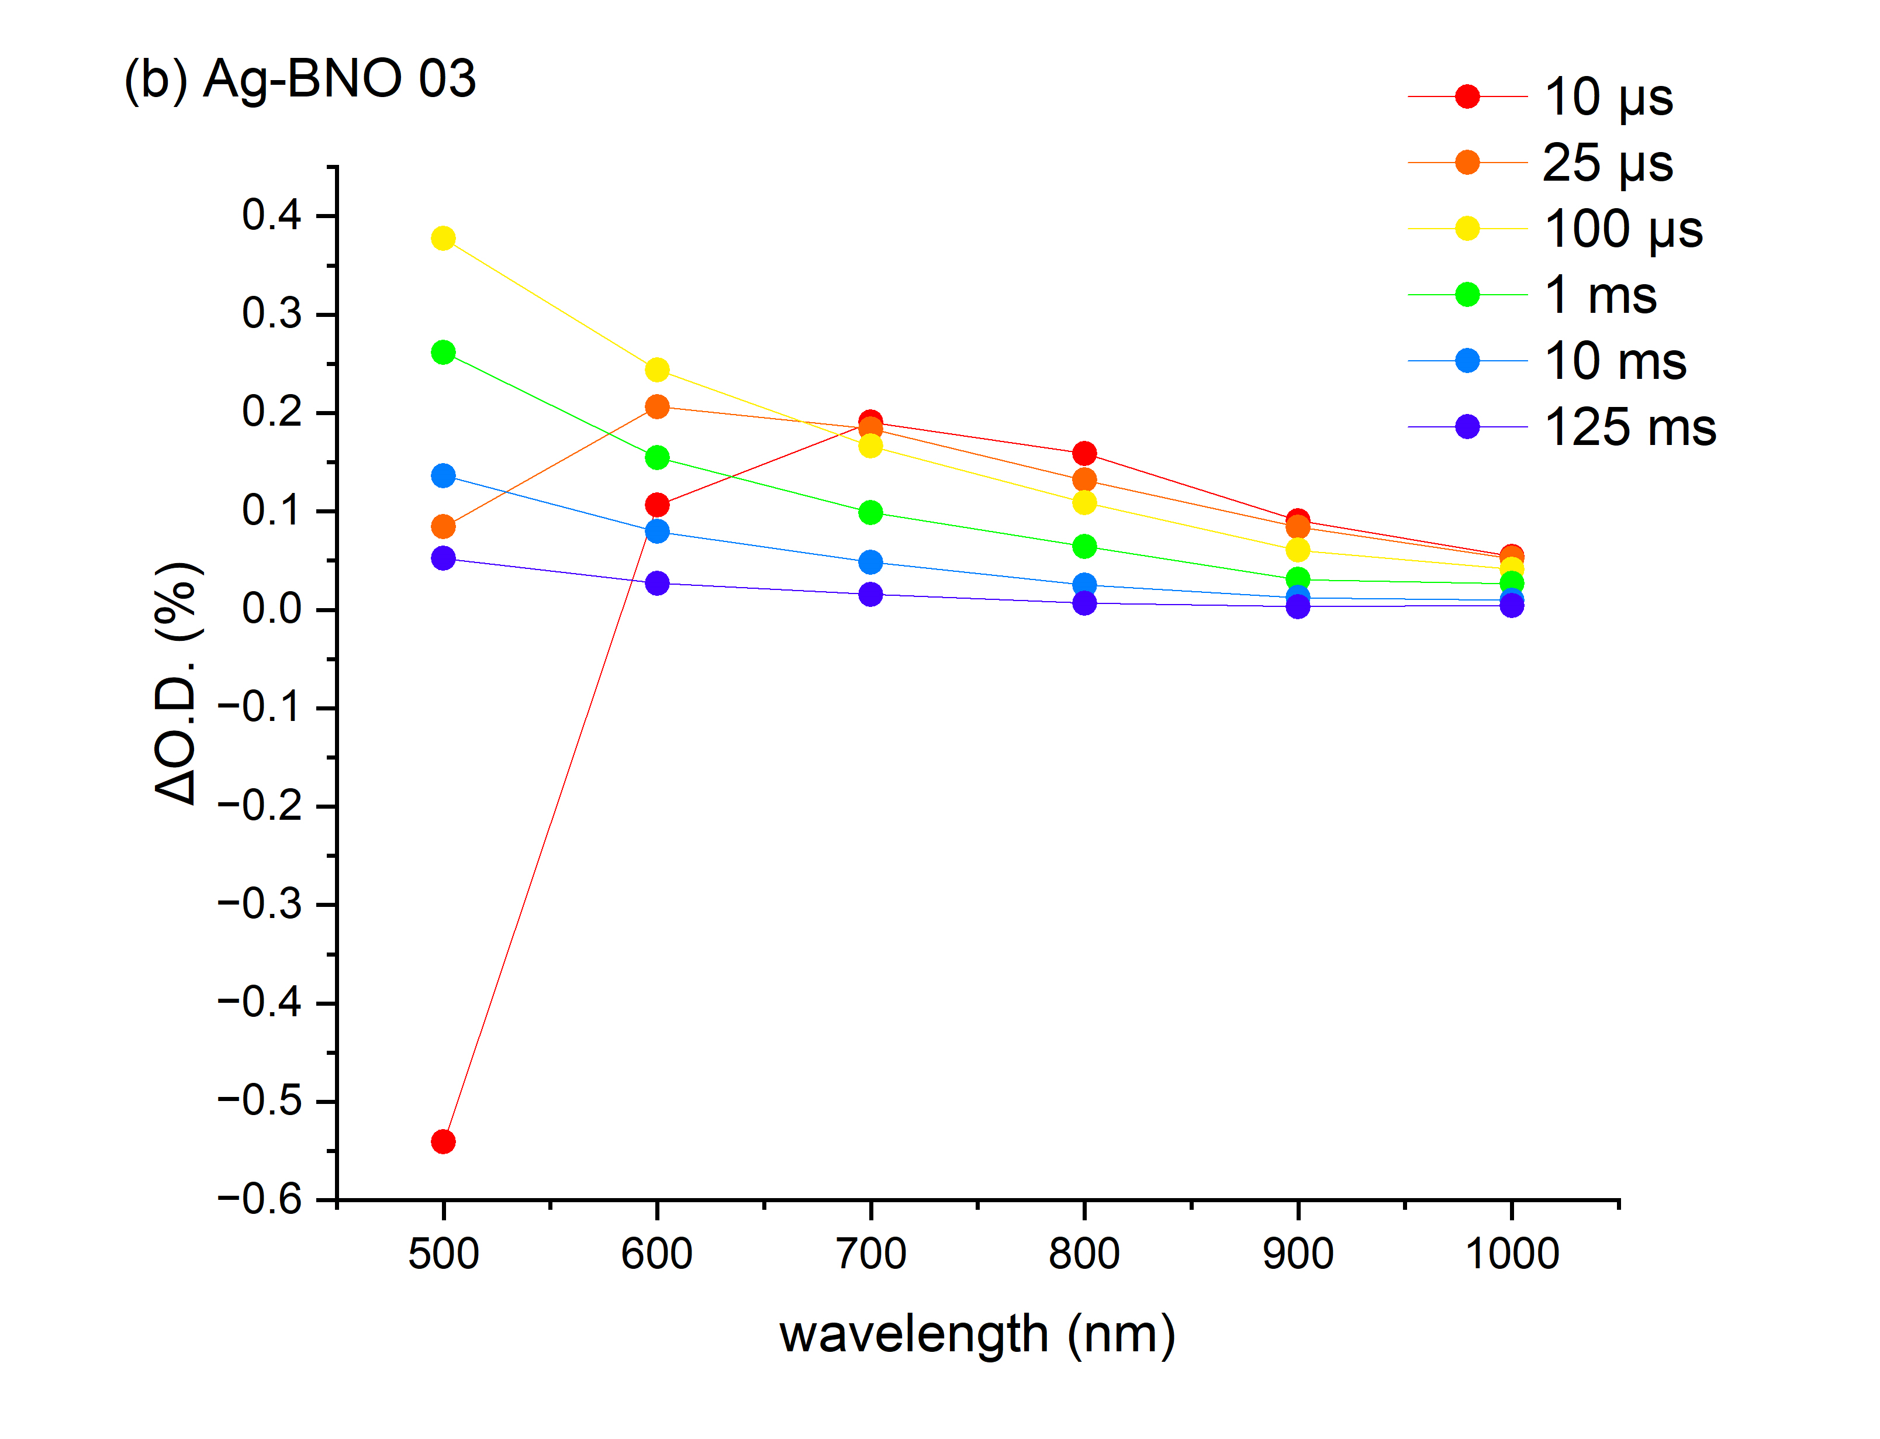
Figure S6. Transient absorption spectra of (a) BNO and (b) Ag-BNO 03. Spectra were measured from 500 to 1000 nm and are shown at select timescales from 10 μs to 125 ms. Samples were excited using a 355 nm laser pulse (~288 μJ.cm⁻² per pulse, repetition rate of 0.7 Hz, ~7 ns pulse width).

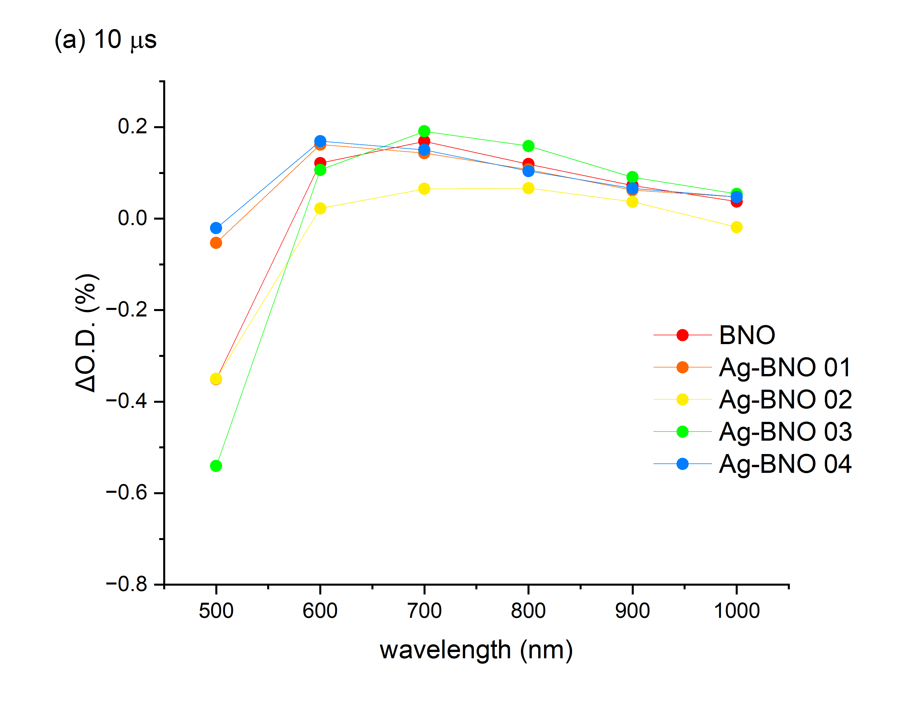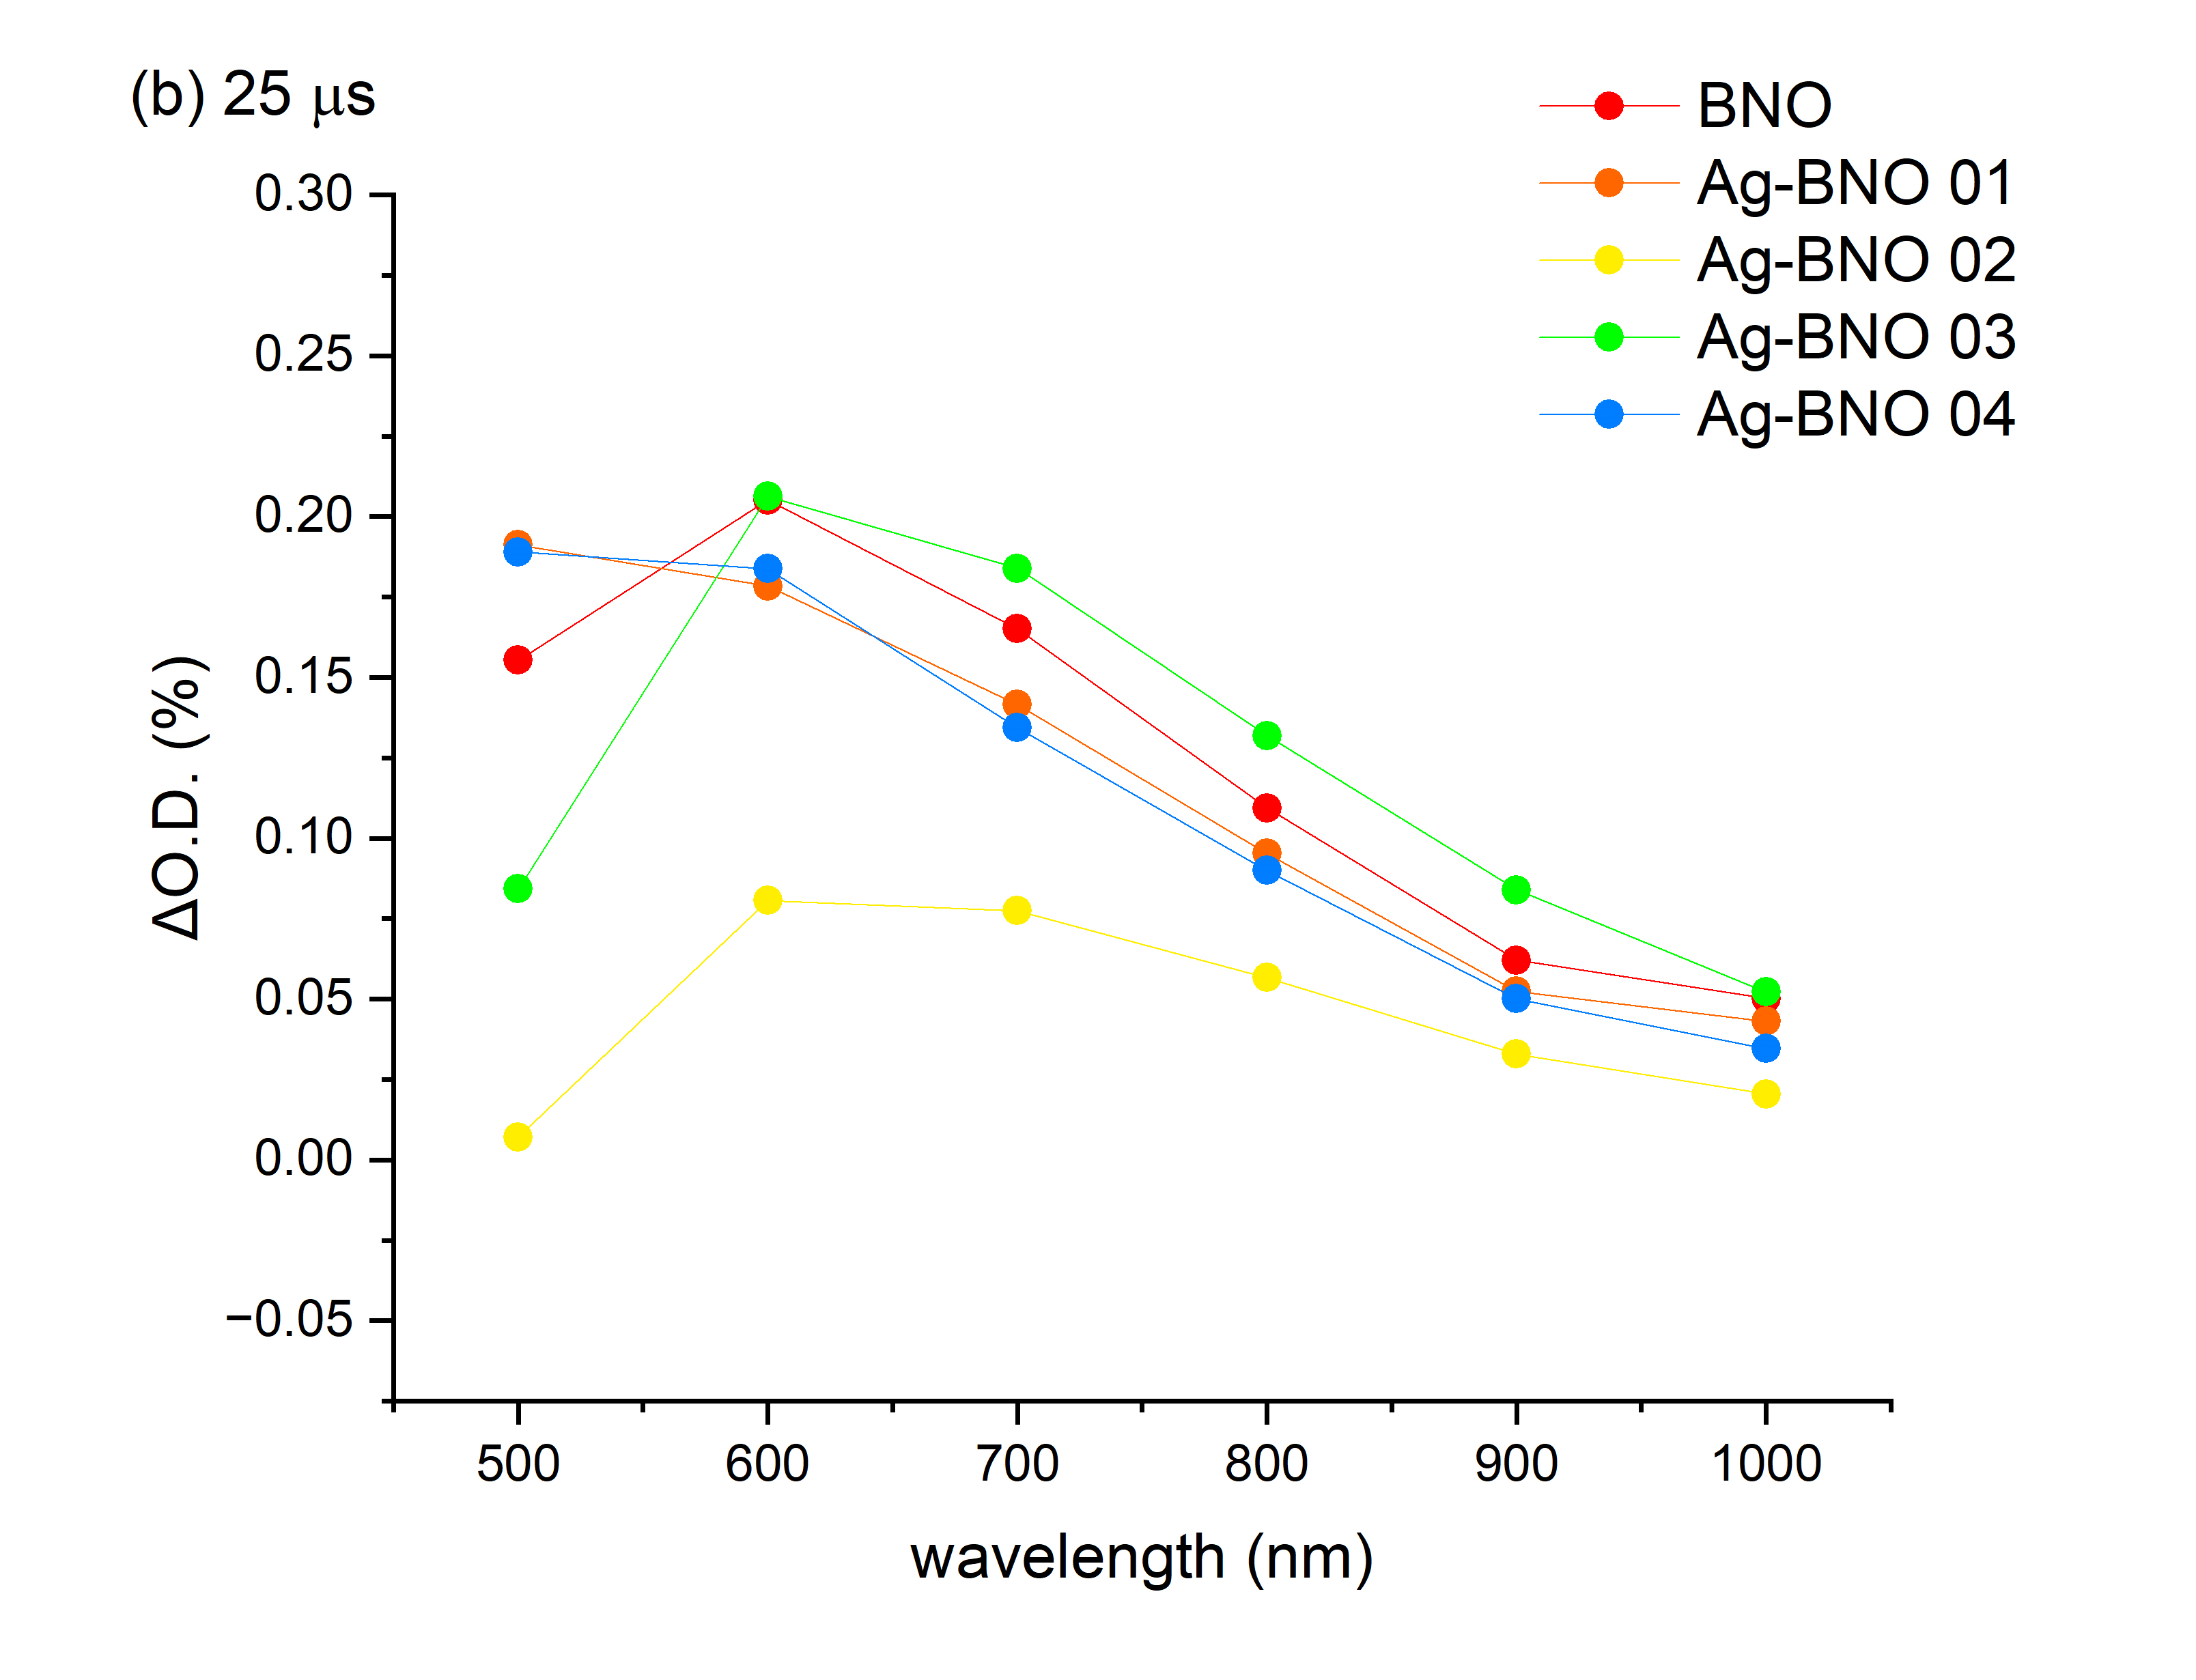
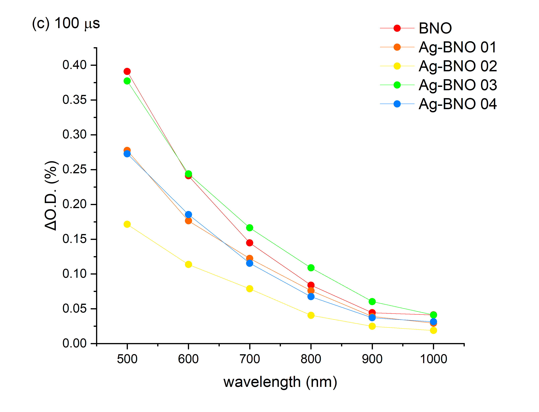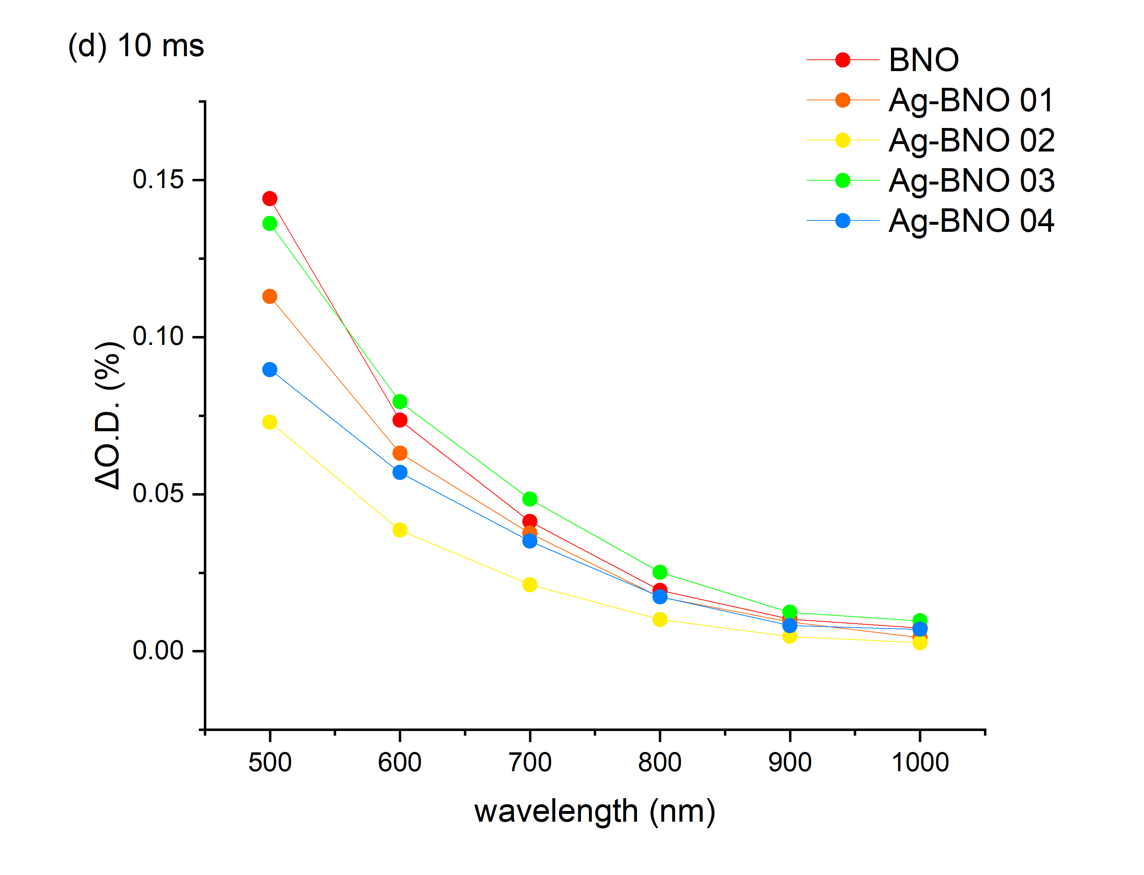
Figure S7. A comparison of the transient absorption spectra of all samples at select times (a) 10 μs, (b) 25 μs, (c) 100 μs and (d) 10 ms. Spectra were measured from 500 to 1000 nm and samples were excited using a 355 nm laser pulse (~288 μJ.cm⁻² per pulse, repetition rate of 0.7 Hz, ~7 ns pulse width).

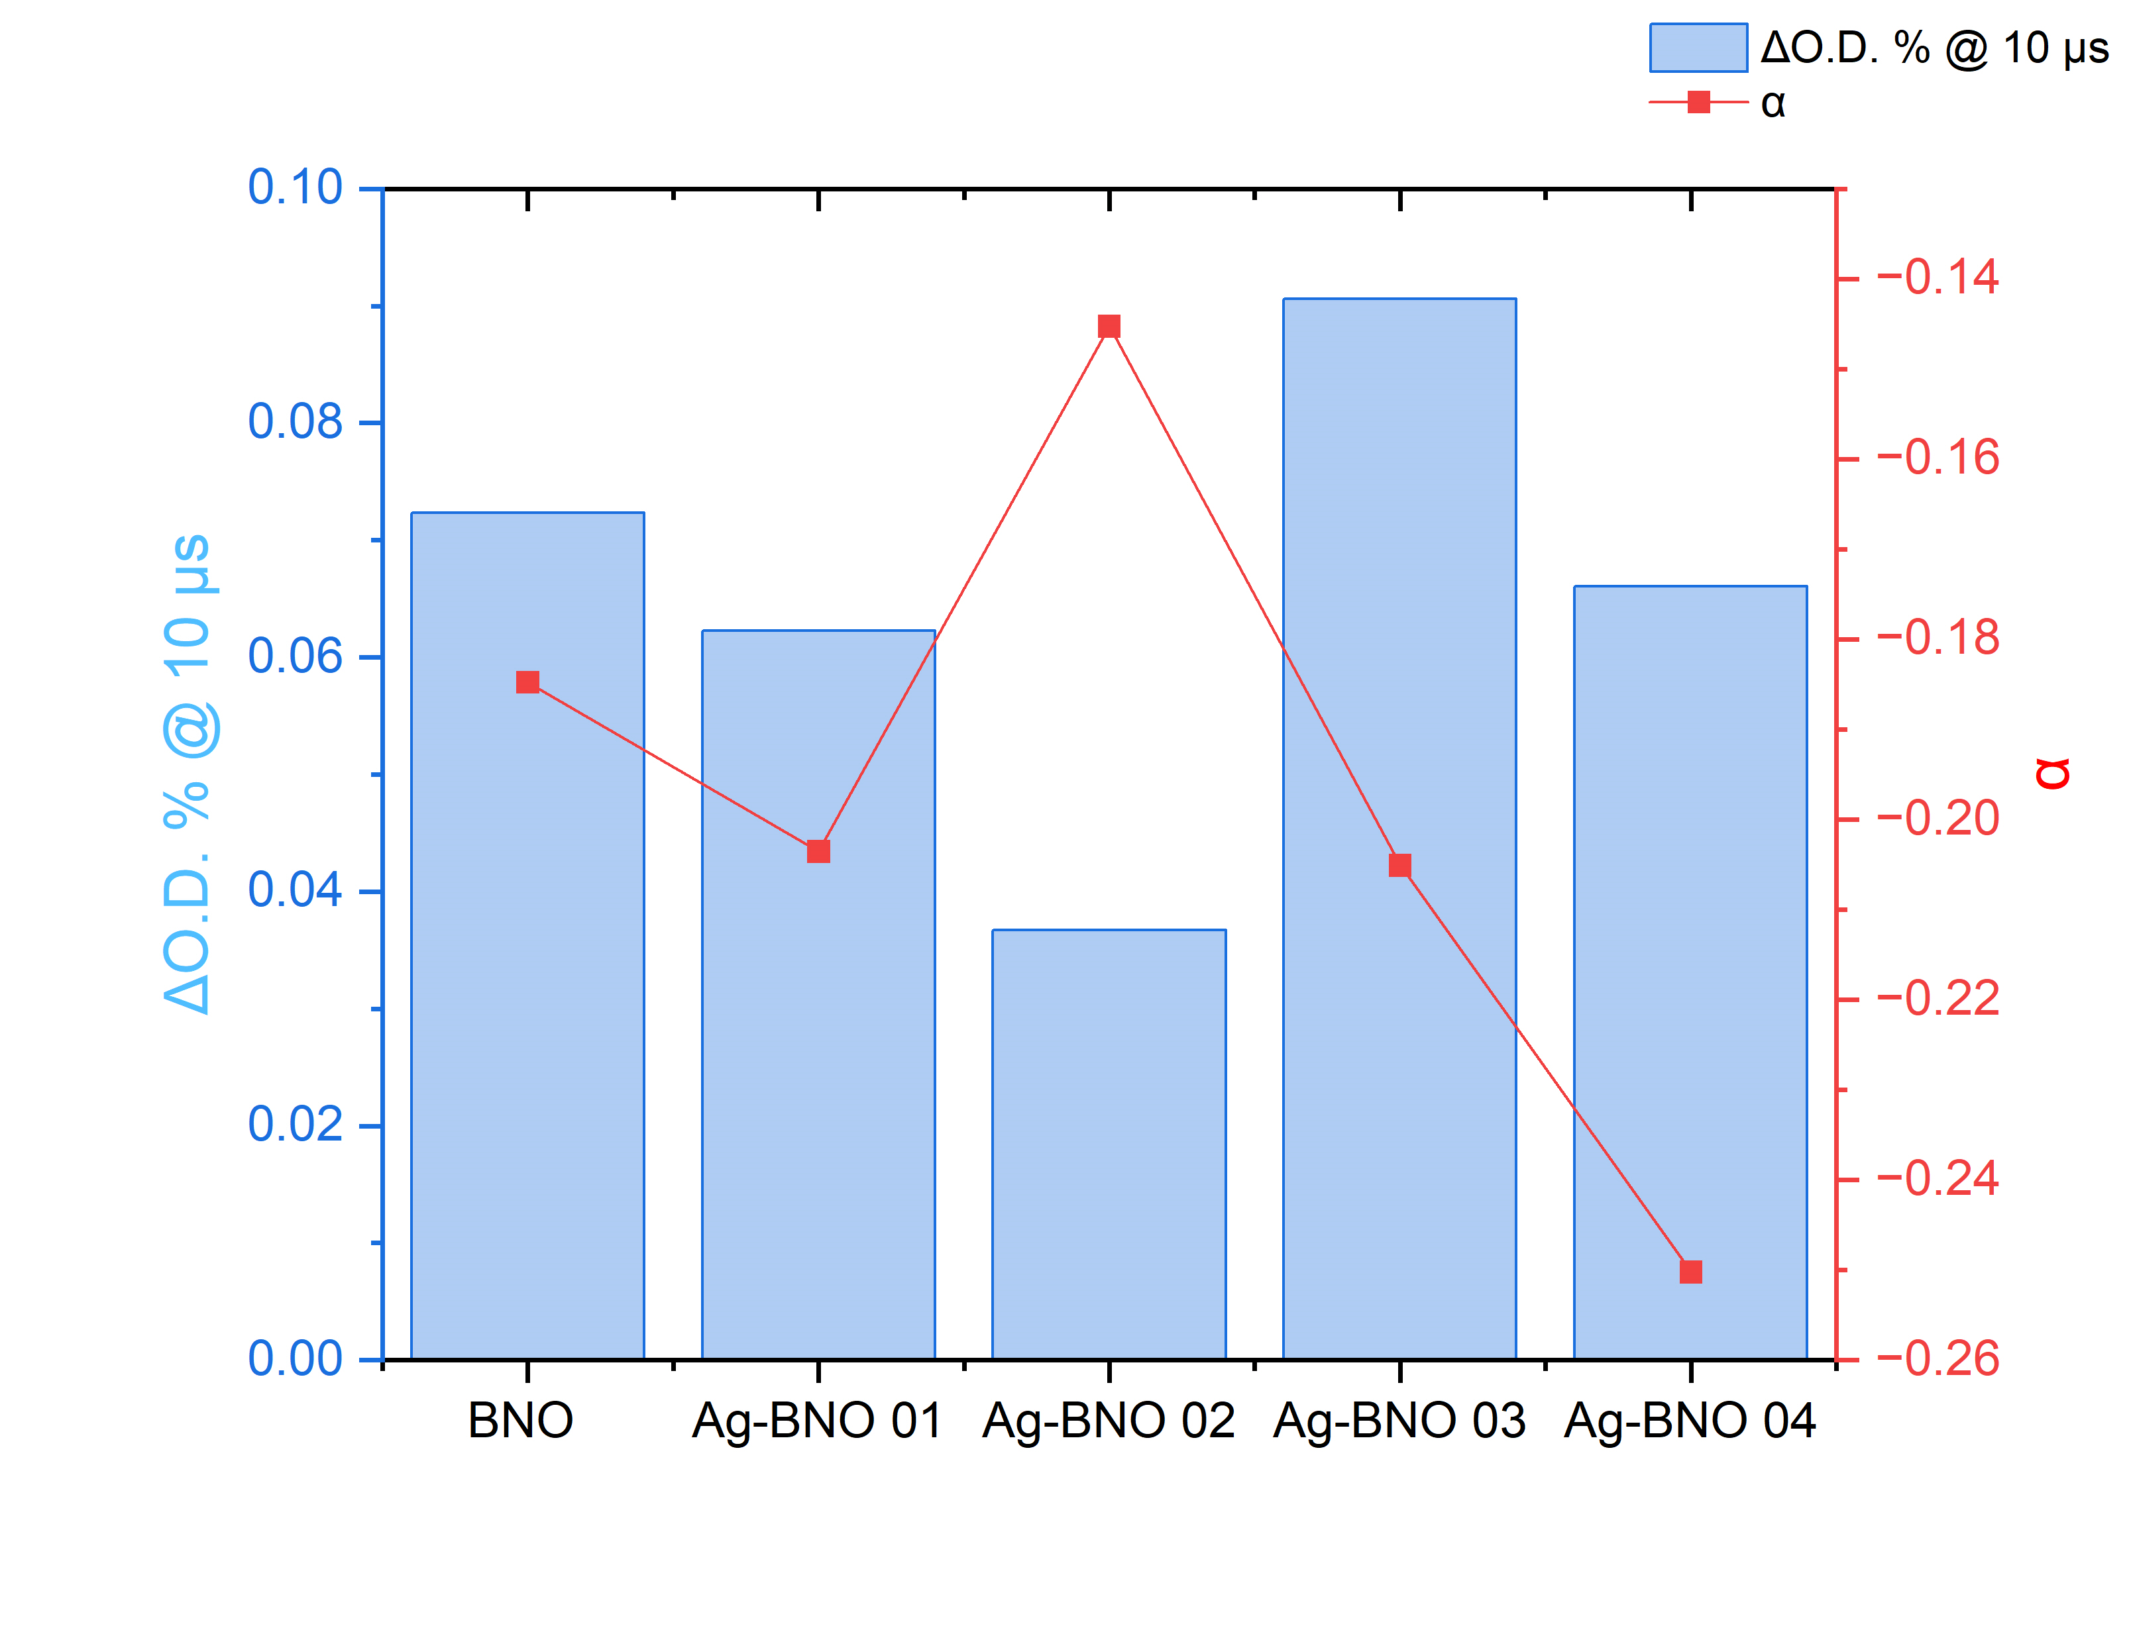
Figure S8. A comparison of the transient kinetics seen at the probe wavelength of 900 nm for all samples. The left y-axis (columns) shows the degree of transient absorption (ΔO.D. %) seen at 10 μs after the laser pulse and the right y-axis (scatter-line plot) shows the value of the fitting parameter α, when the transient decay kinetics was fit to a power law decay model ΔO.D. (%) = A.t^{α}, where t is the time after the laser pulse, and A and α are fitting constants. Samples were excited using a 355 nm laser pulse (~288 μJ.cm⁻² per pulse, repetition rate of 0.7 Hz, ~7 ns pulse width).

