Micromotion and Push Out Evaluation of an Additive Manufactured Implant for Above-the-Knee Amputees

Spencer C Barnes^{1,2,*}, Jon C Clasper^{1,3}, Anthony MJ Bull^{1,4}, Jonathan RT Jeffers²
¹The Royal British Legion Centre for Blast Injury Studies, Imperial College London, London, UK
²Department of Mechanical Engineering, Imperial College London, London, UK
³Defence Medical Group South East, Frimley Park Hospital, Portsmouth Road, Camberley, UK
⁴Department of Bioengineering, Imperial College London, London, UK

*Corresponding author. Tel: +44 (0)20 7594 1986. Address: Department of Mechanical Engineering, Imperial College London, Exhibition Road, South Kensington, London, SW7 2AZ, UK. Email address: spencer.barnes@imperial.ac.uk (Spencer C Barnes)

Running title: Implant micromotion for Above-the-Knee amputees
Authors’ Contributions: All authors engaged in the conception of the study, study design and review of the manuscript. SB performed the testing, analysed the data and wrote the manuscript.
Abstract
In comparison to through knee amputees the outcomes for above-the-knee amputees are relatively poor; based on this novel techniques have been developed. Most current percutaneous implant based solutions for transfemoral amputees make use of high stiffness intramedullary rods for skeletal fixation which can have risks including infection, femoral fractures and bone resorption due to stress shielding. This work details the cadaveric testing of a short, cortical bone stiffness matched subcutaneous implant, produced using additive manufacture, to determine bone implant micromotion and push out load. The results for the micromotions were all less than 20 microns and the mean push out load was 2099 Newtons. In comparison to a solid control, the stiffness matched implant exhibited significantly higher micromotion distributions and no significant difference in terms of push out load. These results suggest that, for the stiffness matched implant at time zero, osseointegration would be facilitated and that the implant would be securely anchored. For these metrics, this provides justification for the use of a short stem implant for transfemoral amputees in this subcutaneous application.

Keywords
Above-the-Knee Amputation, Implant, Additive Manufacture, Micromotion, Osseointegration

Introduction
Above-the-knee amputees experience poor outcomes, which has a detrimental effect on their quality of life¹. In contrast to through-knee amputees, end weight bearing is rarely possible due to the low surface area of the residual bone causing high pressure and the formation of bone spurs². Therefore, ischial weight bearing prostheses are used which can cause discomfort at this region of the hip, pressure sores, friction, bone mineral density loss in the residual femur and muscle atrophy^{2–7}.
However, amputation through the knee (or knee disarticulation amputation) has not been considered a good site for severe lower limb trauma⁸ and based on this UK guidelines for the management of severe lower limb trauma specifically discourage this site⁹. This is despite other evidence that whilst function is inferior to a trans-tibial amputation, through knee amputation is associated with better results than above-the-knee amputations¹⁰. Concerns have been raised about the cosmesis of through knee amputation, as well as the perceived difficulties of prosthetic fitting¹¹. Despite this, UK military surgeons supported amputation at this site based on the experience of the Defence Medical Rehabilitation Centre at Headley Court¹². It was felt that superior results might be related to the ability of through-knee amputees being able to end bear²; as such, the UK military consensus was that the distal femoral condyles should not be excised¹².
To alleviate some of the problems with the above-the-knee amputation site one option is percutaneous direct skeletal fixation, an example of which can be seen in figure 1. These procedures do not have the same socket related soft tissue issues, facilitate quick attachment of the amputee’s prosthesis, transfer load directly to the residual femur and enable osseoperception whereby the amputee can discern the type of surface they are walking on⁶. Downsides to direct skeletal attachment include a risk of superficial and deep infection through the skin opening, a risk of femoral fractures, implant extraction, high proximal revision and potential bone resorption due to stress shielding^{13–16}. Despite the variety of devices, it appears that many surgeons remain unhappy with the concept of a permanent percutaneous implant. Subcutaneous implants have been developed: in the 1960s Swanson et al. developed a mushroom shaped silicone implant in an attempt to improve end wearing bearing¹⁷. Another more recent variation is the subcutaneous multi-part ‘keep on walking implant’ which adds a bulbous polyethylene distal end onto a long stem similar to the direct skeletal attachment prostheses¹⁸. With this implant, improvements have been measured at 14 months in metrics such as 2 minute walking tests, pain scores and gait speeds but a complication rate of 17% has also been reported and the authors state the need for long term follow up studies^{18–20}. It is possible that surgeons would be more willing to use subcutaneous implants, if their reliability and effectiveness could be proved.
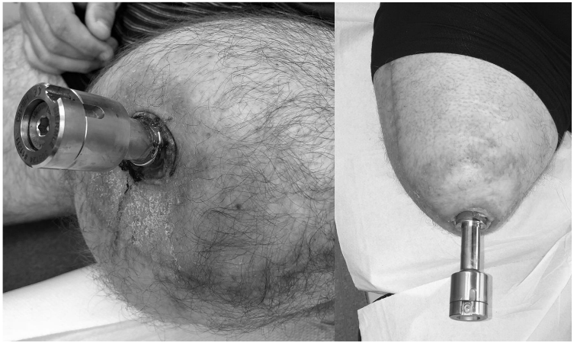
Figure 1 – Implanted direct skeletal fixation devices.
Metal additive manufacture (AM) is currently used to manufacture orthopaedic implants such as the 4Web spinal fusion cages and the distal portion of the Stryker triathlon tibial component^{21,22}. One advantage of AM is the ability to manufacture with lattice structures which enable structures from Stainless Steel, Titanium alloys and Tantalum with stiffness gradients from 0.5 GPa to 20 GPa, well in the range of human bone^{23–25}. We hypothesise that we can use AM technology to produce a cortical bone stiffness matched end bearing implant with a minimal fixation feature for above knee amputees. This would allow for easy installation during surgery, would generate physiological stresses in the femur, would potentially allow a sub ischial socket to be worn and could be more easily revised should it become necessary.
The primary aim of this study was to investigate whether this stiffness matched implant would provide a suitable environment for bone in growth and stable anchoring at the time of insertion. These parameters were investigated in terms of micromotion and push out load. A secondary aim of this study was to compare the results of the stiffness matched implant to that of a high stiffness solid implant, manufactured using the same process and of the same geometry, to ascertain any differences.
Materials and Methods
A subcutaneous cortical bone stiffness matched press fit implant comprising of a bone interface proximal section and a distal end bearing surface was manufactured in 316 Stainless Steel by an AM process. The solid control implant was solid in both proximal and distal sections, whereas the stiffness matched implant comprised of a lattice structure in the proximal bone interface section and was solid in the distal end bearing surface (Figure 2).
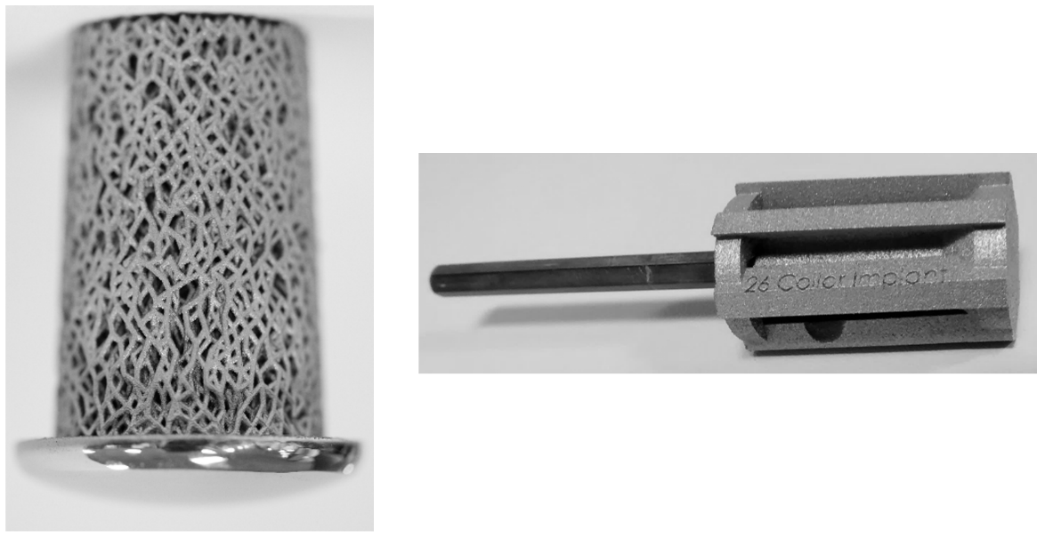
Figure 2 – Cortical bone stiffness matched transfemoral implant where top is proximal bone interface section and bottom is distal end bearing section (l). Associated additive manufactured conical reamer with hex bar driver attachment (r).

Specimens
Nine fresh frozen cadaveric proximal femurs from six donors (4 male and 2 female) were obtained with a mean age of 76 ± 9 years (± 1 standard deviation), individual patient characteristics can be seen in table 1. Ethical Approval had been obtained from the host institution’s tissue bank.
Table 1 – Specimen potting and loading parameters.
Specimen | Donor | Right/Left | Gender | Age | BMI | Potting Parameters |  | Loading Parameters
 |  |  |  |  |  | Flexion (mm) | Adduction (°) | Peak Load (N) | Trough Load (N)
S0 | 4 | L | MALE | 75 | 23.0 | 16 | 17 | 996 | 100
S1 | 6 | R | FEMALE | 74 | 24.0 | 19 | 16 | 872 | 87
S2 | 2 | R | MALE | 87 | 22.5 | 23 | 15 | 1003 | 100
S3 | 1 | R | MALE | 79 | 26.3 | 24 | 14 | 1277 | 128
S4 | 5 | L | FEMALE | 58 | 25.7 | 20 | 13 | 934 | 93
S5 | 3 | L | MALE | 80 | 23.9 | 24 | 17 | 1065 | 106
S6 | 4 | R | MALE | 75 | 23.0 | 18 | 16 | 996 | 100
S7 | 2 | L | MALE | 87 | 22.5 | 21 | 16 | 1003 | 100
S8 | 1 | L | MALE | 79 | 26.3 | 22 | 14 | 1277 | 128

Potting
The specimens were aligned according to a modified version of the International Society of Biomechanics (ISB) coordinate system²⁶ described below. The pre-cut specimens were aligned at flexions according to the average femoral anterior radius of curvature described by Egol et al.²⁷, a diagram of this can be seen in figure 3. The specimens were also aligned at adductions using the full leg AP X-Rays that accompanied the specimens. The adduction angles were calculated as the angle between the mechanical axis and the piriformis muscle attachment subtrochantic centre line, defined on the X-Ray using Solidworks (Dassault Systèmes, Vélizy-Villacoublay, France). A 3° correction was then added to this to account for the angle between the mechanical and vertical axes^{28,29}. The flexions and adductions for each specimen can be found in table 1.

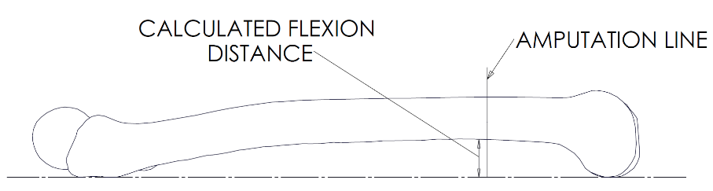
Figure 3 – Sagittal view of right femur representing the calculated flexions the pre-cut femurs were raised to.
The distal end of the femurs were raised to the calculated flexions by using Vernier callipers (RS Components, Corby, UK) to measure the vertical relative distance. The distal end of the femur was then adducted about a rod running through (anterior posterior) the proximal end of the sectioned femur. The rod was placed where the femoral head centre-femoral neck centre line crossed the piriformis muscle attachment-subtrochantic centre line. The adduction angle was measured using a protractor mounted around the rod. The specimens were then inserted into aluminium pots and fixed in place using poly-methylmethacrylate (Simplex Rapid, Kemdent, UK).
Implant Manufacture
Both solid and stiffness matched implants were designed in Rhinoceros 3D with its Grasshopper 3D extension (Robert McNeel & Associates, Seattle, USA). The stiffness matched implant used the stochastic structure previously described by Ghouse et al.²³. The parameters for manufacturing 20 GPa modulus stiffness matched implants, such as strut thickness, mean number of struts per unit area and mean number of strut connections had previously been validated with compression testing to BS ISO 13314 – 2011³⁰. The models were then converted to STLs and sliced with 25 μm layer thickness in preparation for additive manufacture using Magics software (Materialise, Leuven, Belgium). A Concept MLab cusing powder bed AM system (Lichtenfels, Germany) was used for manufacture using Stainless Steel 316L spherical powder (particle size range 10–45 μm, LPW Technology, Runcorn, UK). Five sizes of implant were manufactured to fit the range of diameters of the femurs between specimens and amputation levels.
Implant Insertion
The implants were inserted into the intramedullary canals of the femurs in four steps. Firstly the distal end of the femur was bevelled to create a flat surface and remove sharp edges, as is common practice in amputation surgery^{2,31–33}. The canals were then straight reamed using standard twist drill bits (RS Components, Corby, UK) and conical reamed using custom made instrumentation again produced using additive manufacture (Figure 2). These AM reamers comprised of 6 non-equally radially spaced conical cutting arms with both cutting and relief angles of 15°. Lastly, the implants were impacted into the canal using a surgical mallet (Surgical Holdings, Southend-on-Sea, UK). The implant was impacted until it was securely seated and the collar of the implant was sitting just proud of the distal surface of the amputated femur.
Micromotion Set-Up
The potted femur with inserted implant was secured to the base of a servohydraulic mechanical testing machine (Instron 8874, High Wycombe, UK) via an unconstrained horizontal table to remove any application of unwanted strains to the implanted bone to replicate expected in situ loading by affording some motion. The distal end of the femur and implant were then instrumented to measure micromotion with three linear variable differential transformers, (LVDTs – AX/1.5/s, Solartron Metrology, Bognor Regis, UK), in the posterolateral, anterior and posteromedial positions. The main body of the LVDTs were secured to the implant with a resin 3d printed housing (Form 2, Formlabs, Somerville, USA). The LVDT tips pressed against an aluminium ring secured to the femur with sharpened cap screws. The aluminium ring was situated approximately 5 mm proximal to the base of the 3d printed housing. The LVDTs were connected to a FE-MM40 Fylde datalogger which was then linked to MADAQ data acquisition software (both Fylde Electronic Laboratories, Preston, UK) which sampled data at 100Hz.
The bearing surface of the implant was loaded using a flat impactor connected to the actuator of the mechanical testing machine via a 10 kN load cell. The specimens were subjected to a 100 cycle 1 Hz sinusoidally varying loading regime, with an R-ratio of 0.1, where the peak load was equal to 1.4 times the body weight of the donor. This loading regime was quantified using a validated model (Freebody³⁴ version 2³⁵) applied to transfemoral amputees³⁶. The micromotion was measured from the last 90 cycles of the test and measured per LVDT as the mean difference between the peak and trough micromotion for the 90 cycles. Both mean and maximum micromotions of the three LVDTs are presented. Figure 4 presents a diagram of the micromotion testing set-up.

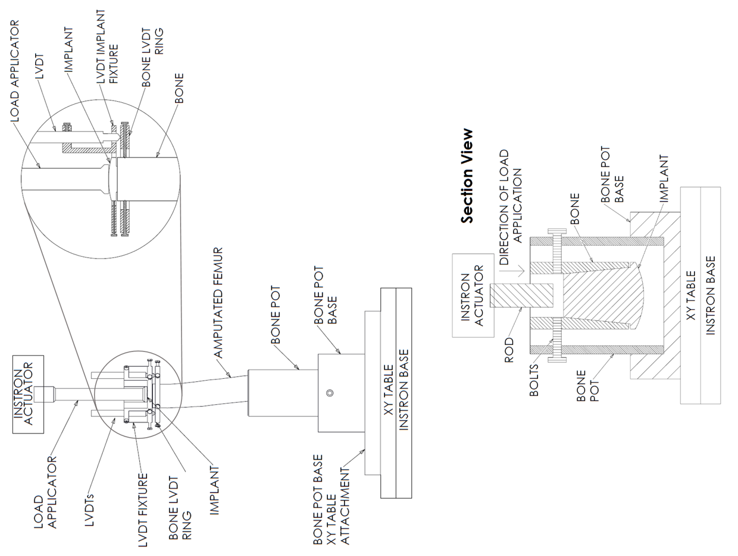
Figure 4 – Micromotion testing set-up with simplified detail section view of distal implant location in relation to load applicator and LVDT fixture (t). Push out test schematic (b). Both not to scale.
Push Out Set-Up
Once the micromotion test had been completed, the femur specimens were resected approximately 5 mm proximal to the implant, and a push-out test performed on an unconstrained horizontal table in order to ensure that there were no secondary out of plane forces induced. A rod was attached to the Instron actuator via the 10 kN load cell and pushed the implants out of the canal of the sectioned femur at 5mm/min. Data was collected at 100 Hz, the peak compressive load recorded by the load cell was defined as the peak push out load. The bone implant interface shear strength was calculated by dividing the peak push out load by the interface surface area. Figure 4 presents a diagram of the push out testing set-up.
Subsequent Tests
To make full use of the specimens and to test the implants at different amputation heights, multiple tests were performed on the same specimens within the middle third of the femur as defined by the anatomical axis. Once a push out test was performed another implant would be inserted in the remaining pre potted femur after which a micromotion test would occur at this new dissection level and then a push out test and so on. In total 12 stiffness matched implant tests and 13 solid implant tests were performed. All tests on the same specimen were performed in the same freeze thaw cycle, all specimens were subjected to three freeze thawing cycles in total.
Statistics
All statistical group analysis of the micromotion and push out data was performed using SPSS (IBM, New York, USA). Data was initially assessed for outliers by inspection of boxplots and, as the sample sizes were statistically low, assessed for normality using the Shapiro-Wilk test. If there were no outliers and the data was normal Levene's test was used to test for homogeneity of variances, then an independent-samples t-test was performed. If the assumption of normality was violated and there were outliers present a Mann-Whitney U test was used. The effect size for Mann-Whitney U test was calculated using Cohen’s r, where 0.5 denotes a large effect, 0.3 a medium effect and 0.1 a small effect.

Results
Micromotion
One outlier was found in the data for the maximum micromotion of the solid implant between 1.5 and 3 interquartile ranges away from the upper bound. For the stiffness matched implant both the mean and maximum micromotion data violated normality testing. The mean stiffness matched implant mean and maximum micromotions were 3.02 µm and 5.65 µm, respectively. These were higher than the means of the solid implant, which were 1.12 µm (mean) and 2.01 µm (maximum). The distributions for both micromotion measures for the stiffness matched implants were statistically significantly higher than for solid implants (mean micromotion p < .001, r = 0.71 & maximum micromotion p < .001, r = 0.69). The results for both the mean and maximum micromotion results can be seen in figure 5.
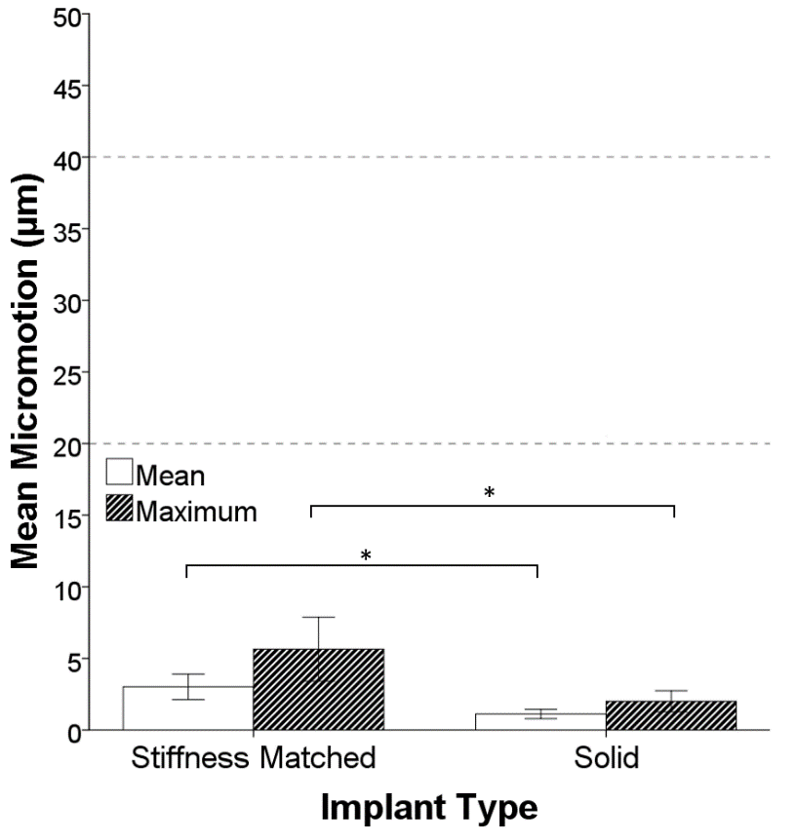
Figure 5 – Bar chart of the means for both the mean and maximum micromotions across all three LVDTs with 95% confidence interval error bars. Asterix denotes statistical significant difference with large effect size. Horizontal dashed lines at 20 µm and 40 µm are included for reference.
Push Out
There were no outliers in the data, the data for both implant types were normally distributed and there was homogeneity of variances. The mean (± standard deviation) push out load was 2248 N ± 398 N for the solid implant and 2099 N ± 499 N for the stiffness matched implant. The difference in means of 149 N was not statistically significant (p = .416). The mean shear strength for the stiffness matched implant bone interface was 1.19 MPa. An example push out load against time graph (specimen S5 - stiffness matched implant) and the bar chart of the mean push out load with 95% confidence intervals for both implant type can be seen in figure 6.

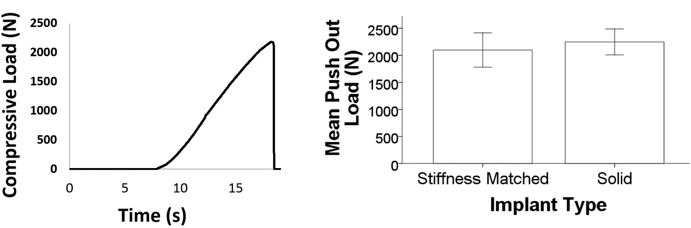Figure 6 – Example push out load against time graph where peak compressive load is defined as the push out load (l) & mean push out loads with 95% confidence interval error bars (r).
Discussion
The main finding of this in-vitro study is that at the time of implantation, when subject to a physiological loading regime, both the stiffness matched implant and the solid implant exhibited micromotions and push out loads that would facilitate osseointegration and stable anchoring. These findings indicate that a minimal fixation surface subcutaneous distal implant is capable of withstanding and transmitting physiological loading.
Jasty et al. have described 20 μm and less of micromotion as compatible with stable bone ingrowth and that bone formation around the implant was not detrimentally affected by this amount of motion³⁷. A study on retrieved femoral prostheses by Engh et al. found that in areas where osseointegration had taken place the relative motions were all less than 40 μm³⁸. All of the measured micromotions in this study were less than 20 μm which suggests that when subjected to equivalent loads of walking that osseointegration would be permitted.
The mean push out load for the stiffness matched implant was 2099 N which equated to 1.19 MPa in terms of average shear strength. In a study using a canine model, Cook et al. found the transcortical interface shear strength of a titanium implant which had been implanted for 3 weeks to be 1.44 MPa³⁹. Another canine study by Yang et al. established a shear strength of 1.41 MPa for an intramedullary femoral implant at 12 weeks⁴⁰. These investigations exhibit higher strengths than this study which may be due to osseointegration as the implants have been in-vivo for a period of time which will have increased the strength of the interface. An in-vitro study by van Arkel et al. found the mean pull out force of an additive manufactured solid tapered peg to be 535 N, which equates to a shear strength of 1.41 MPa and is higher than was found in this study⁴¹. A probable reason for the higher push out strengths of the referenced studies may be the higher comparative surface area in contact with the bone. In the shear strength calculation for this study the entire surface is assumed to have contact with bone, however as the surface is manufactured from a stochastic structure the actual contact surface area will be considerably lower. If the shear strength were to be calculated from only the lattice structure in contact with the bone then it follows that the strength would be higher. The van Arkel study also utilised a mechanical testing machine for the insertion of their peg, whereas this study made use of a surgical mallet to impact the implant into place in a more surgically realistic manner. This may have negatively affected the bone interface surface and further account for the differences seen. Push out load was used in this study as it was a good metric to determine the anchoring of the implant, in-vivo the implant would however only be subject to compressive loading, i.e. in the other direction.
The secondary finding of this study was that no significant difference was detected in the mean push out load for both types of implant. Another secondary finding was that the micromotions for the stiffness matched implant were higher than that of the solid implant. This is possibly due to the solid implant exerting a higher hoop strain on the surrounding bone and having a higher relative bone contact area than that of the lattice stiffness matched implant, meaning the frictional effect on the bone surface may have been lower.
Stiffness matched implants are desirable as they theoretically negate the effects of stress shielding. The presence of an implant reduces the stress and strains affecting certain areas of bone, disrupting the homeostatic process; stimulating bone resorption and suppressing formation⁴². Several studies have found that reducing the stiffness of implants can reduce the incidence of stress shielding^{43,44}. Indeed, Arabnejad et al. have presented an AM short hip stem with tuned mechanical properties and found a reduction in stress shielding compared to a solid control⁴⁵.
The main limitation of the study is that no bone healing or ingrowth was considered, which is the case for all cadaver models. However, we consider the cadaver model is the closest to the clinical environment, particularly for this study which will heavily depend on the bone-implant interface conditions created by the reaming and implantation process. Ideally the specimens used in this study would have been subjected to less than three freeze thawing cycles, however this was found to be best practice in our study protocol for making maximum use of donated specimens. Another limitation of this study was performing multiple tests on the same specimens and the use of specimens from the same donors. As the insertion level for this implant is in the middle third of the femur, as defined by the anatomical axis, we sought to collect as much data as was possible from the specimens of which we had limited number to access, and we considered that increasing the number of tests in our study would be beneficial.
It should be noted that the value of the outlier found in the maximum micromotion data for the solid implant was 4.81 μm and hence well below the bone-in-growth threshold values described earlier. Lastly, in this study no out of plane loads or bending moments were applied to the implant. As the part of the implant that is external to the bone, the bearing surface, is small and considering the presence of the soft tissue that would surround the implant, applying these other loading types is unlikely to be physiologically relevant.
Conclusions
The conclusions drawn from this study are as follows:
- In a cadaveric model a cortical bone stiffness matched short transfemoral implant is able to provide a stable environment for osseointegration (maximum micromotion of 11.90 µm) and anchoring (mean push out load 2099 N).
- There was no significant difference between the push out loads of both the stiffness matched and solid implant, however the micromotion distributions of the stiffness matched implant were significantly higher.
- For the two parameters investigated, this study demonstrates that lattice structure bone interface implants, produced using metal additive manufacture, are able to provide a suitable environment for anchoring a transfemoral implant for amputees.
Acknowledgements
The authors would like to thank the Royal British Legion for funding this work. We also wish to thank the Engineering and Physical Sciences Research Council for funding JJ. Both funding sources had no role in this investigation. All authors declare that our only conflict of interest is that we will be developing the implant for clinical use.
Demetrius Evriviades of University Hospitals Birmingham NHS Foundation Trust, UK is kindly acknowledged for providing images of implanted direct skeletal fixation devices. We also thank Richard van Arkel, Shaaz Ghouse and Umar Hossain for assistance in computer aided design and additive manufacturing, Geoffrey Ng, Jo Stephen, Hamidreza Alidousti and Kiron Athwal for support in cadaveric methods & Ruben Doyle and Phil Wilson for assistance in testing apparatus manufacture and signal processing (all Biomechanics Group, Department of Mechanical Engineering Imperial College London).
References
1. Hagberg K, Brånemark R. 2001. Consequences of non-vascular trans-femoral amputation: a survey of quality of life, prosthetic use and problems. Prosthet. Orthot. Int. 25(3):186–194.
2. Pinzur MS, Gottschalk FA, Pinto MAG de S, Smith DG. 2007. Controversies in lower-extremity amputations. J. Bone Jt. Surg. 89A(5):1118–1127.
3. World Health Organization United States Department of Defense MossRehab Amputee Rehabilitation Program MossRehab Hospital USA. 2004. The Rehabilitation of People with Amputations.
4. Penn-Barwell JG. 2011. Outcomes in lower limb amputation following trauma: A systematic review and meta-analysis. Injury 42(12):1474–1479.
5. Pitkin M. 2013. Design features of implants for direct skeletal attachment of limb prostheses. J. Biomed. Mater. Res. - Part A 101A(11):3339–3348.
6. Van De Meent H, Hopman MT, Frölke JP. 2013. Walking ability and quality of life in subjects with transfemoral amputation: A comparison of osseointegration with socket prostheses. Arch. Phys. Med. Rehabil. 94(11):2174–2178.
7. Brånemark R, Berlin Ö, Hagberg K, et al. 2014. A novel osseointegrated percutaneous prosthetic system for the treatment of patients with transfemoral amputation: A prospective study of 51 patients. Bone Jt. J. 96 B(1):106–113.
8. Smith JJ, Agel J, Swiontkowski MF, et al. 2005. Functional outcome of bilateral limb threatening: Lower extremity injuries at two years postinjury. J. Orthop. Trauma 19(4):249–253.
9. Nanchahal J, Nayagam S, Khan U, et al. 2009. Standards for the management of open fractures of the lower limb. London: Royal Society of Medicine Press.
10. Hagberg E, Berlin K, Renstrom P. 1992. Function after through-knee compared with below-knee and above-knee amputation. Prosthet. Orthot. Int. 16:168–173.
11. de Laat FA, van der Pluijm MJ, van Kuijk AA, et al. 2014. Cosmetic effect of knee joint in a knee disarticulation prosthesis. J. Rehabil. Res. Dev. 51(10):1545–1554.
12. Clasper J. 2007. Amputations of the lower limb: a multidisciplinary consensus. J. R. Army Med. Corps 153(3):172–174.
13. van Eck CF, Mcgough RL. 2015. Clinical outcomes of osseointegrated prostheses for lower extremity amputations: a systematic review of the literature. Curr. Othopaedic Pract. 26(4):349–357.
14. Maryniak A, Laschowski B, Andrysek J. 2018. Technical Overview of Osseointegrated Transfemoral Prostheses: Orthopedic Surgery and Implant Design Centered. J. Eng. Sci. Med. Diagnostics Ther. 1(2):020801.
15. Nebergall A, Bragdon C, Antonellis A, et al. 2012. Stable fixation of an osseointegated implant system for above-the-knee amputees: Titel RSA and radiographic evaluation of migration and bone remodeling in 55 cases. Acta Orthop. 83(2):121–128.
16. Tomaszewski PK, Verdonschot N, Bulstra SK, et al. 2012. Simulated bone remodeling around two types of osseointegrated implants for direct fixation of upper-leg prostheses. J. Mech. Behav. Biomed. Mater. 15:167–175.
17. Swanson AB. 1972. Silicone-gel pads to improve end-bearing tolerance in lower-extremity amputees. J. Assoc. Child. Prosthetic-Orthotic Clin. 11(9):13.
18. Guirao Cano L, Pastor BS, Garrido DM, et al. 2018. Evaluation of functional health and well-being in 23 transfemoral amputees after distal weight-bearing implant. J. Orthop. Res. Ther. 2018(04):1–11.
19. Guirao L, Samitier CB, Costea M, et al. 2017. Improvement in walking abilities in transfemoral amputees with a distal weight bearing implant. Prosthet. Orthot. Int. 41(1):26–32.
20. Guirao L, Samitier B, Tibau R, et al. 2018. Distance and speed of walking in individuals with transfemoral amputation fitted with a distal weight-bearing implant. Orthop. Traumatol. Surg. Res. In press.
21. Callanan TC, Walker B, Grinberg S, et al. 2016. Prospective, 88 patient series study of the use of a novel 3-D printed titanium truss system cage in anterior cervical spinal surgery. Spine J. 16(10):S318.
22. Smith L, Bhowmik-Stoker M, Stimac J. 2015. Early results of a highly porous titanium cementless tibial baseplate in TKA. In: International Congress for Joint Reconstruction.
23. Ghouse S, Babu S, Van Arkel RJ, et al. 2017. The influence of laser parameters and scanning strategies on the mechanical properties of a stochastic porous material. Mater. Des. 131:498–508.
24. Ghouse S, Babu S, Nai K, et al. 2018. The influence of laser parameters, scanning strategies and material on the fatigue strength of a stochastic porous structure. Addit. Manuf. 22(March):290–301.
25. Yan C, Hao L, Hussein A, Young P. 2015. Ti-6Al-4V triply periodic minimal surface structures for bone implants fabricated via selective laser melting. J. Mech. Behav. Biomed. Mater. 51:61–73.
26. Wu G, Siegler S, Allard P, et al. 2002. ISB recommendation on definitions of joint coordinate system of various joints for the reporting of human joint motion—part I: ankle, hip, and spine. J. Biomech. 35(4):543–548.
27. Egol KA, Chang EY, Cvitkovic J, et al. 2004. Mismatch of current intramedullary nails with the anterior bow of the femur. J. Orhopaedic Trauma 18(7):410–415.
28. Paley D. 2002. Normal lower limb alignment and joint orientation. In: Principles of Deformity Correction. Berlin: Springer. p 1–18.
29. Krackow KA. 1983. Approaches to planning lower extremity alignment for total knee arthroplasty and osteotomy about the knee. Adv Orthop Surg 7:69–88.
30. British Standards Institution. 2011. ISO 13314:2011 Mechanical testing of metals, ductility testing, compression test for porous and cellular metals. Br. Stand.
31. Tintle LSM, Keeling CJJ, Shawen LSB, et al. 2010. Traumatic and trauma-related amputations. J. Bone Jt. Surg. 92(17):2852–2868.
32. Perkins ZB, De’Ath HD, Sharp G, Tai NRM. 2012. Factors affecting outcome after traumatic limb amputation. Br. J. Surg. 99(S1):75–86.
33. Sugarbaker P, Bickels J, Malawer M. 2004. Above-knee Amputation. In: Musculoskeletal Cancer Surgery. Dordrecht: Springer. p 349–360.
34. Cleather DJ, Bull AMJ. 2015. The development of a segment-based musculoskeletal model of the lower limb: Introducing FREEBODY. R. Soc. Open Sci. 2(6).
35. Ding Z, Nolte D, Kit Tsang C, et al. 2016. In vivo knee contact force prediction using patient-specific musculoskeletal geometry in a segment-based computational model. J. Biomech. Eng. 138(2):021018.
36. Henson D, Ding Z, McGregor A, Bull A. 2018. Applications of amputee specific computational model. In: World Congress of Biomechanics.
37. Jasty M, Bragdon C, Burke D, et al. 1997. In vivo skeletal responses to porous-surfaced implants subjected to small induced motions. Am J Bone Jt Surg 79(May):707–714.
38. Engh CA, O’Connor D, Jasty M, et al. 1992. Quantification of implant micromotion, strain shielding, and bone resorption with porous-coated anatomic medullary locking femoral prosthesis. Clin. Orthop. Relat. Res. 285:13–29.
39. Cook SD, Thomas KA, Kay JF, Jarcho M. 1988. Hydroxyapatite-coated titanium for orthopedic implant applications. Clin. Orthop. Relat. Res. 232(225):225–243.
40. Yang CY, Wang BC, Lee TM, et al. 1997. Intramedullary implant of plasma-sprayed hydroxyapatite coating: An interface study. J. Biomed. Mater. Res. 36(1):39–48.
41. van Arkel RJ, Ghouse S, Milner PE, Jeffers JRT. 2017. Additive manufactured push-fit implant fixation with screw-strength pull out. J. Orthop. Res. :1–11.
42. Rodan GA. 1998. Bone homeostasis. Proc. Natl. Acad. Sci. U. S. A. 95(23):13361–2.
43. K­ärrholm J, Anderberg C, Snorrason Fi, et al. 2002. Evaluation of a femoral stem with reduced stiffness. J. Bone Jt. Surgery-American Vol. 84(9):1651–1658.
44. Glassman AH, Crowninshield RD, Schenck R, Herberts P. 2001. A low stiffness composite biologically fixed prosthesis. Clin. Orthop. Relat. Res. (393):128–136.
45. Arabnejad S, Johnston B, Tanzer M, Pasini D. 2017. Fully porous 3D printed titanium femoral stem to reduce stress-shielding following total hip arthroplasty. J. Orthop. Res. 35(8):1774–1783.

Figure Legends
Figure 1 – Implanted direct skeletal fixation devices.
Figure 2 – Cortical bone stiffness matched transfemoral implant where top is proximal bone interface section and bottom is distal end bearing section (l). Associated additive manufactured conical reamer with hex bar driver attachment (r).
Figure 3 – Sagittal view of right femur representing the calculated flexions the pre-cut femurs were raised to.
Figure 4 – Micromotion testing set-up with simplified detail section view of distal implant location in relation to load applicator and LVDT fixture (t). Push out test schematic (b). Both not to scale.
Figure 5 – Bar chart of the means for both the mean and maximum micromotions across all three LVDTs with 95% confidence interval error bars. Asterix denotes statistical significant difference with large effect size. Horizontal dashed lines at 20 µm and 40 µm are included for reference.
Figure 6 – Example push out load against time graph where peak compressive load is defined as the push out load (l) & mean push out loads with 95% confidence interval error bars (r).

