Supplement

Table of Contents
1. Study population 3
1.2 Quality control of genetic data 3
2. Genome-wide association studies (GWAS) 3
Figure 2.1 4
Table 2.1 4
3. Polygenic Risk Scores (PRS) 5
3.1 PRS Explanation 5
Table 3.1 5
3.2 Adjusting for PCs 5
3.3 Association between PRSs and questionnaire-based depression/anxiety 5
Figure 3.1 6
Figure 3.2 7
4. Primary analysis 7
Table 4.1 7
5. Sensitivity analysis 8
Table 5.1 8
Table 5.2 9
Figure 5.1 10
6. PRS validation 11
Table 6.1 11
Figure 6.1 12
Figure 6.2 13
Figure 6.3 14
Figure 6.4 15
Figure 6.5 16
Figure 6.6 17
Figure 6.7 18
Figure 6.8 19
Figure 6.9 20
Figure 6.10 21
Figure 6.11 22
Figure 6.12 23
References 24

Study population
The participants of this study are from the Avon Longitudinal Study of Parents and Children (ALSPAC), which followed pregnant women (and their newborns) resident in Avon, with expected delivery dates between April 1991 and December 1992 [1-3].
14,541 pregnancies were initially enrolled. Following an attempt to bolster the sample 7 years into the study, 906 new pregnancies were added to the study resulting in a total sample size of 15,447 pregnancies. Detailed information can be found at the cohort website (www.bristol.ac.uk/alspacwww.bristol.ac.uk/alspac), including a searchable data dictionary and variable search tool: http://www.bristol.ac.uk/alspac/researchers/our-data/.

Ethical approval for the study was obtained from the ALSPAC Ethics and Law Committee and the Local Research Ethics Committees. Consent for biological samples has been collected in accordance with the Human Tissue Act (2004). Informed consent for the use of data collected via questionnaires and clinics was obtained from participants following the recommendations of the ALSPAC Ethics and Law Committee at the time. Specific details on the ethics committees and institutional review boards are available here:
http://www.bristol.ac.uk/alspac/researchers/research-ethics/

1.2 Quality control of genetic data
PLINK v1.07 was used for quality control filtering. Specifically, individuals were excluded on the basis of the following filters: (1) gender mismatches; (2) undetermined X chromosome heterozygosity; (3) over 5% missingness; (4) evidence of crypted relatedness >12.5% of shared alleles identical by descent); (5) non-European ancestry, assessed by multidimensional scaling analysis compared with HapMap 2 individuals. SNPs were excluded on the basis of the following filters: (1) minor allele frequency < 1%; (2) call rate < 95%, (3) Hardy–Weinberg equilibrium (HWE) P < 5.0 × 10−7. Genotype data were imputed using Impute v.2.2.2 against 1000 Genomes reference panel (v.1, phase 3, December 2013 release).
After quality control and excluding participants who had withdrawn consent, genetic data were available for 7,728 women of European ancestry. Consent for biological samples was collected in accordance with the Human Tissue Act (2004).

Genome-wide association studies (GWAS)
GWASs test for associations between genetic variants and phenotypes in a population, in a hypothesis-free manner [4]. Typically, GWASs focus on single nucleotide polymorphisms (SNPs), which refer to a variation in a single base pair of the DNA and are common in the population (frequency >1%). Associations with the phenotypes of interest are assessed using linear (continuous phenotype) or logistic (binary phenotype) regression models and reported in blocks of SNPs (loci), i.e., SNPs that are co-inherited and correlated referred to as being in high linkage disequilibrium (LD). Loci that pass a p-value threshold ≤5*10-08 are typically considered to be associated with the phenotype of interest at genome-wide significance.

It is increasingly being recognised that for complex traits such as autism, schizophrenia and IQ, the genome-wide significant loci are of small effect size, explain only a small proportion of the genetic and phenotypic variance, and they span across the genome [5]. In fact, complex traits seem to be influenced by a large number of variants bellow the genome-wide threshold and of small effect size- these traits are referred to as polygenic [6]. In polygenic traits, liability to the trait is conceptualised to be normally distributed to the population and individuals are expected to express the phenotype after a threshold of genetic and environmental risk as well as chance, has been exceeded [7,8]. Individuals close but below the threshold are expected to present some sub-phenotypic features (the liability-threshold model of inheritance is visualised in Figure 2.1 below) [9].

Figure 2.1

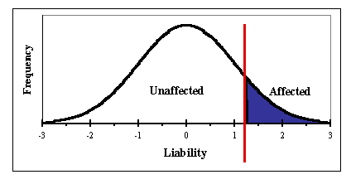

Previous GWASs were used to identify genetic variants associated with depression [10], anxiety [11], and neuroticism [12]. These are detailed in Table 2.1.

Table 2.1
Psychiatric trait | Method | Participants
Depression | GWAS meta-analysis of 6 datasets | N(case) = 371,184  N(control) = 978,703
Anxiety | UK Biobank GWAS | N(case) = 25,453  N(control) = 58,113
Neuroticism | UK Biobank GWAS | N = 329,821

Polygenic Risk Scores (PRS)

3.1 PRS Explanation

PRS approaches enable the estimation of an individual’s underlying genetic liability to a complex trait [13]. PRS require individual level genotype data and are calculated as the sum of the individual’s risk alleles, weighted by the effect sizes of each variant identified in the GWAS of the trait. PRS can be calculated for a subset of variants based on a p-value specified threshold, e.g., 5*10-08. Considering that variance in most polygenic traits is unlikely to be explained by genome-wide significant variants, PRS using subsets of variants meeting more relaxed association thresholds e.g., p≤0.05 might capture more variance in the phenotype- which is the case for polygenic traits.

An illustrative example is provided below using Table 3.1. Three SNPs are included in the PRS calculation:

Table 3.1
SNP | Effect size | Genotype | Number of risk alleles (G) | Effect size x No. of risk alleles
rs1 | 0.10 | AG | 1 | 0.10 x 1 = 0.10
rs2 | 0.20 | GG | 2 | 0.20 x 2 = 0.40
rs3 | 0.05 | AA | 0 | 0.05 x 0 = 0.00

PRS = 0.10 + 0.40 + 0.00 = 0.50

3.2 Adjusting for PCs
Principal Components (PCs) are derived from principal component analysis and summarise the genetic structure of individuals into a few dimensions. PCs are included in analysis models to account for population stratification [14]. This occurs when there are distinct subgroups within the population which differ genetically and may also have different environmental exposures. For example, people with different ancestries having different allele frequencies and different disease risks. This can lead to spurious associations if not corrected for.

3.3 Association between PRSs and questionnaire-based depression/anxiety

To assess the performance of depression and anxiety PRSs, we fitted regression models with PRS as the predictor, and questionnaire-based measures of depression and anxiety as the outcome. These models were fitted on all ALSPAC mothers with available genotype data and questionnaire-based measures of depression and anxiety, so that PRS performance could be assessed on the largest possible sample.

Depression:

Depression was measured at 18 weeks' gestation using the clinically validated Edinburgh Postnatal Depression Scale (EPDS) [15]. A binary indicator was derived from the EPDS, with a score of 12 or more indicating the presence of a depressive disorder [12]. Thirteen logistic regression models were fitted, one for each SNP-inclusion p-value threshold. All odds ratios (ORs) and associated 95% confidence intervals (CIs) were above 1, indicating strong associations between depression PRSs and questionnaire-based depression.

Figure 3.1
Associations between observed depression (Edinburgh post-natal depression score) and depression PRSs at each p-value threshold:

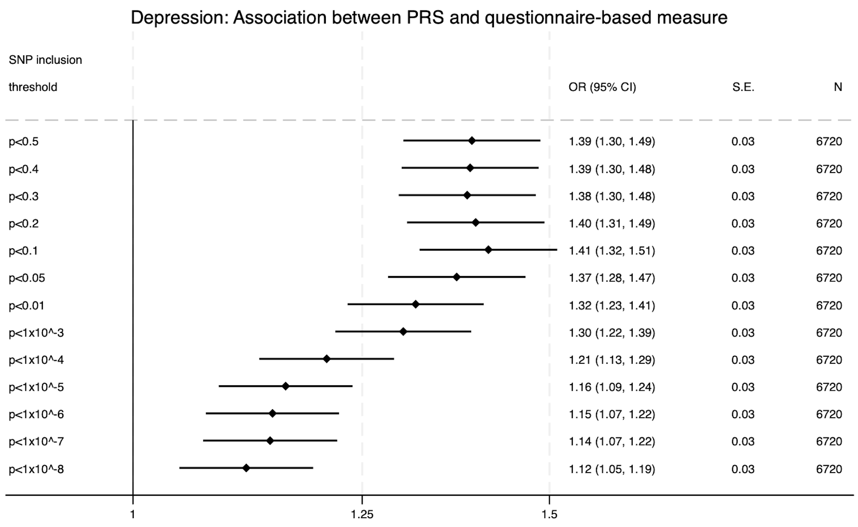

Anxiety:

Anxiety was measured at 18 weeks’ gestation using the anxiety subscale of the Crown-Crisp Experimental Index (CCEI) [16], a validated self-rating inventory. A binary indicator was derived from the CCEI anxiety score, with a score of 9 or more indicating a high level of anxiety [17]. Thirteen logistic regression models were fitted, one for each SNP-inclusion p-value threshold. All ORs and most of the associated 95% CIs were above 1, indicating strong associations between anxiety PRSs and questionnaire-based anxiety.

Figure 3.2
Associations between observed anxiety (CCEI) and anxiety PRSs at each p-value threshold:

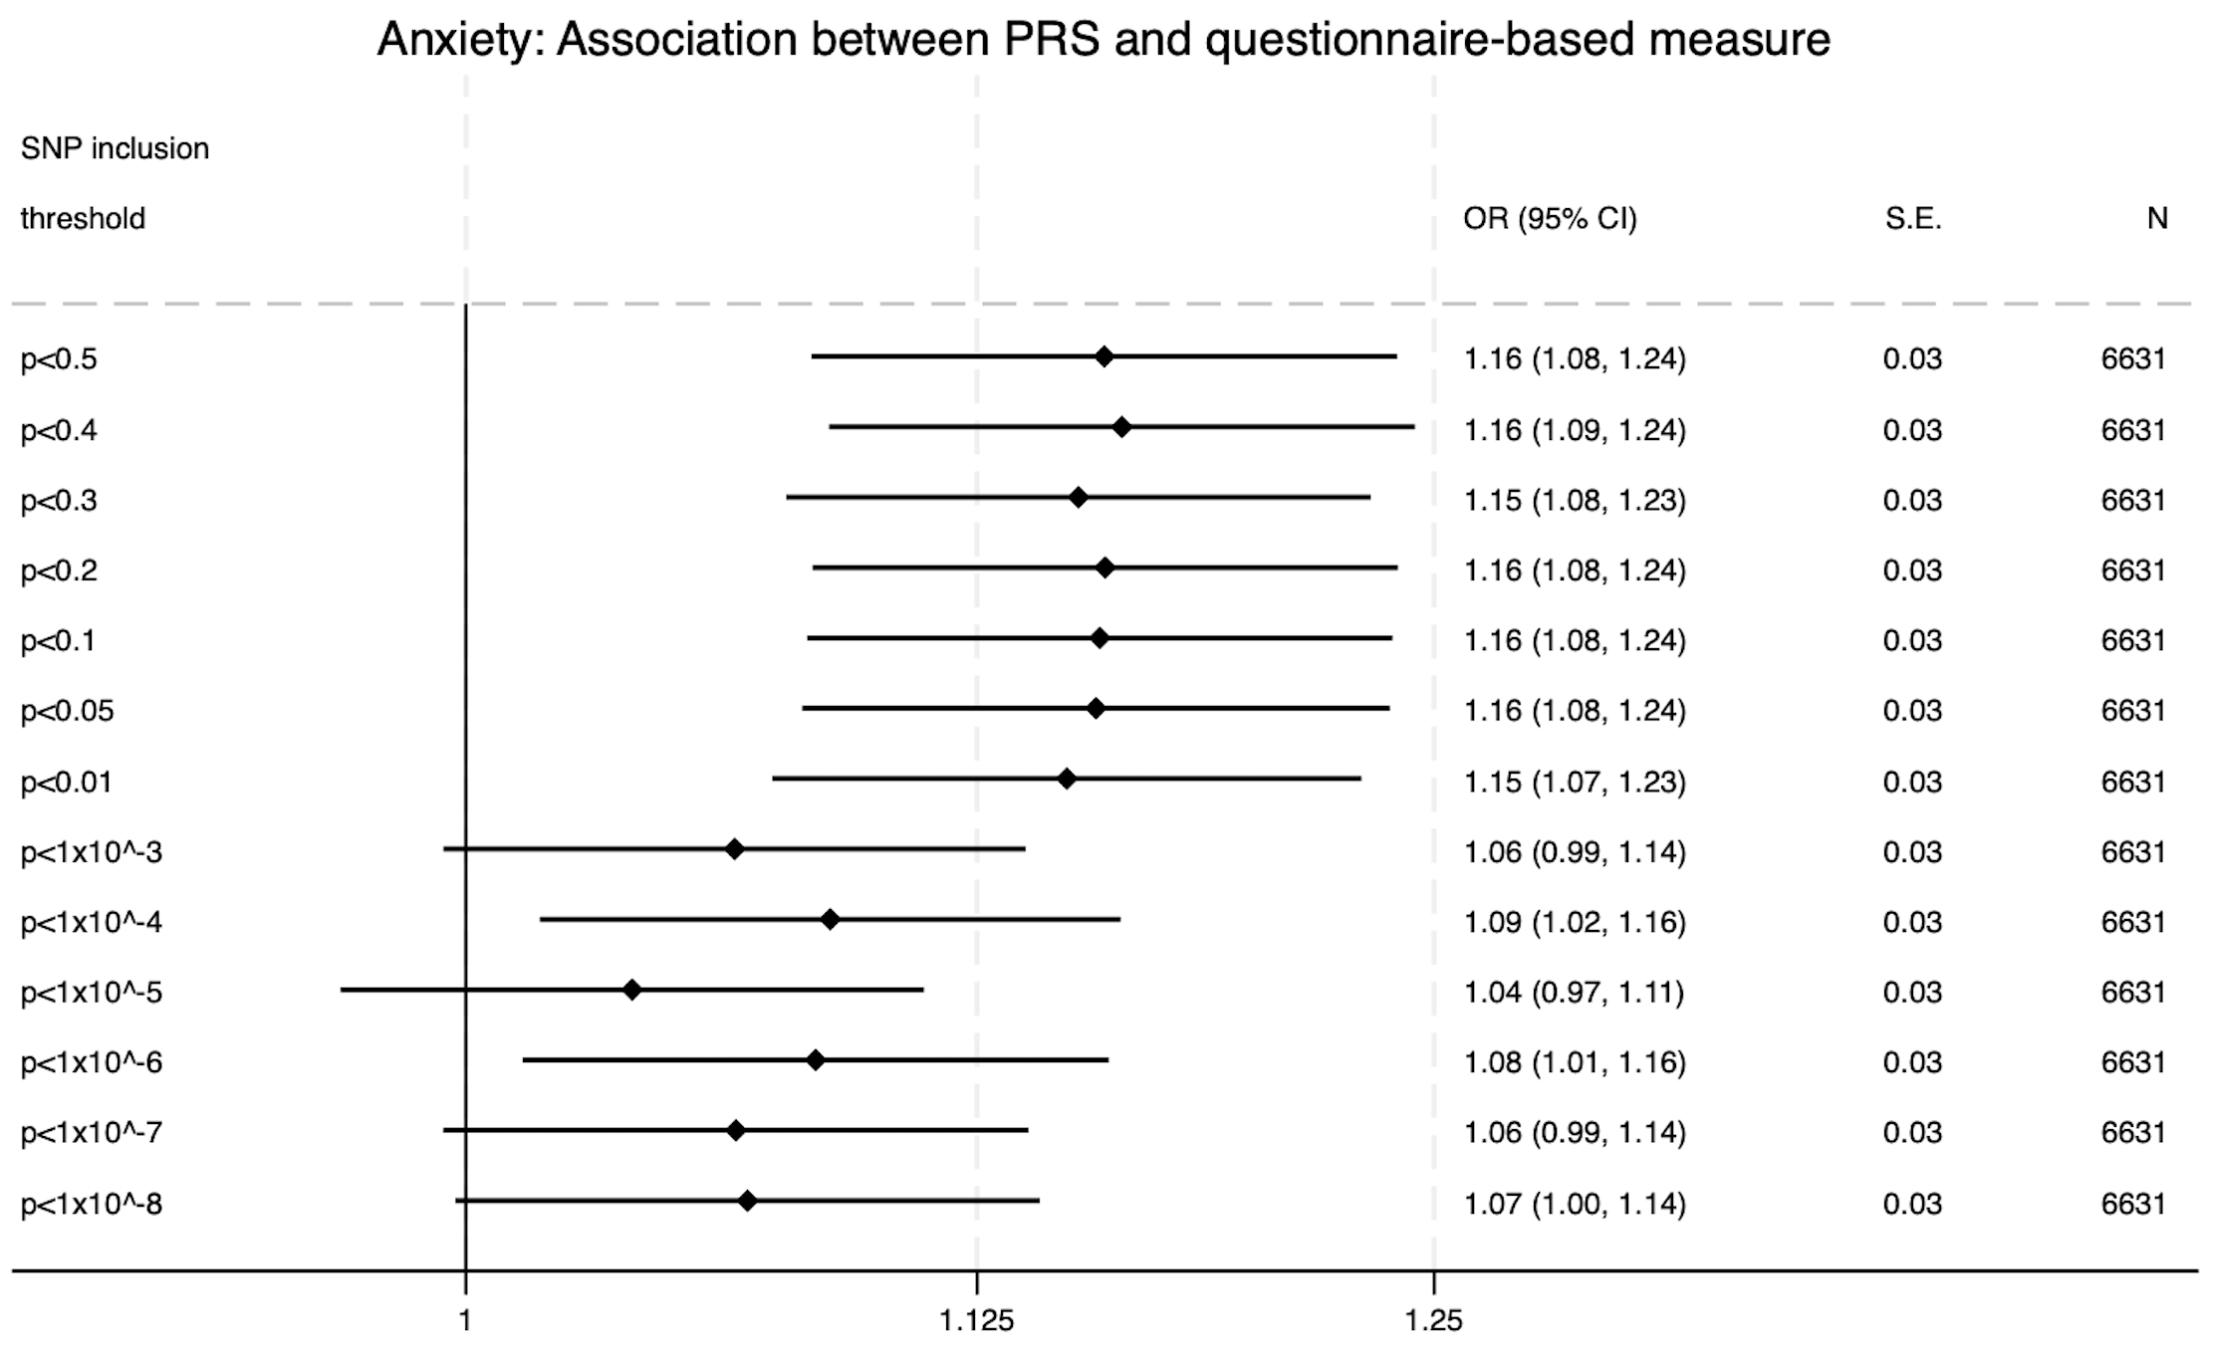

Primary analysis
Table 4.1 gives odds ratios (with 95% confidence intervals), unadjusted p-values, and FDR-adjusted p-values from the primary analysis.

Table 4.1
Primary analysis
PRS | Urinary symptom | 2002-04 |  |  | 2011-12
 |  | OR (95% CI) | p | p (FDR) | OR (95% CI) | p | p (FDR)
Anxiety | Any UI | 1.08 (1.00-1.17) | 0.05 | 0.15 | 1.07 (0.99-1.16) | 0.10 | 0.19
Anxiety | Any urgency | 1.08 (0.98-1.18) | 0.11 | 0.20 | 1.09 (0.99-1.19) | 0.08 | 0.19
Anxiety | Mixed UI | 1.20 (1.03-1.39)* | 0.02 | 0.06 | 1.04 (0.91-1.18) | 0.59 | 0.64
Anxiety | Nocturia | 1.12 (0.99-1.26) | 0.07 | 0.18 | 1.05 (0.93-1.18) | 0.46 | 0.54
Anxiety | Stress UI | 1.01 (0.92-1.11) | 0.80 | 0.82 | 1.06 (0.96-1.18) | 0.24 | 0.34
Anxiety | Urgency UI | 1.19 (0.94-1.51) | 0.16 | 0.26 | 1.12 (0.90-1.38) | 0.31 | 0.41
Depression | Any UI | 1.09 (1.01-1.18)* | 0.03 | 0.09 | 1.11 (1.02-1.20)* | 0.02 | 0.06
Depression | Any urgency | 1.08 (0.99-1.19) | 0.10 | 0.19 | 1.13 (1.03-1.24)** | 0.01 | 0.04
Depression | Mixed UI | 1.10 (0.95-1.28) | 0.20 | 0.30 | 1.05 (0.93-1.20) | 0.43 | 0.54
Depression | Nocturia | 1.33 (1.17-1.50)** | <0.01 | <0.01 | 1.24 (1.09-1.40)** | <0.01 | 0.01
Depression | Stress UI | 1.09 (0.99-1.20) | 0.08 | 0.19 | 1.08 (0.97-1.19) | 0.16 | 0.26
Depression | Urgency UI | 1.03 (0.81-1.31) | 0.82 | 0.82 | 1.24 (1.00-1.53) | 0.05 | 0.15
Neuroticism | Any UI | 1.14 (1.05-1.23)** | <0.01 | 0.01 | 1.03 (0.95-1.12) | 0.45 | 0.54
Neuroticism | Any urgency | 1.12 (1.02-1.23)* | 0.01 | 0.06 | 1.06 (0.97-1.17) | 0.19 | 0.29
Neuroticism | Mixed UI | 1.23 (1.07-1.43)** | <0.01 | 0.03 | 0.98 (0.86-1.11) | 0.75 | 0.80
Neuroticism | Nocturia | 1.24 (1.10-1.40)** | <0.01 | 0.01 | 1.21 (1.07-1.37)** | <0.01 | 0.02
Neuroticism | Stress UI | 1.08 (0.98-1.18) | 0.12 | 0.21 | 1.05 (0.95-1.16) | 0.36 | 0.46
Neuroticism | Urgency UI | 1.14 (0.90-1.44) | 0.27 | 0.37 | 1.07 (0.87-1.32) | 0.53 | 0.60

Key:
*Unadjusted p-value<0.05
**FDR-adjusted p-value<0.05

Sensitivity analysis
The sensitivity analysis investigated the same associations as the primary analysis but excluded subjects with organic causes of LUTS. Pelvic inflammatory disease, kidney disease, diabetes (non-gestational), and pregnancy were identified as organic causes of LUTS.

This data was available for 2002-04 so women with any of the above conditions were excluded for the sensitivity analysis. However, for the 2011-12 timepoint, the closest available data was collected in 2010. Data was collected on pregnancy and diabetes (not differentiating between gestational and non-gestational diabetes). Therefore, for the 2011-12 sensitivity analysis, women who were pregnant or diabetic as of 2010 were excluded.

190 subjects were excluded for the 2002-04 sensitivity analysis, whilst 103 subjects were excluded for the 2011-12 sensitivity analysis.

Table 5.1 and Table 5.2 give the breakdown of organic causes of LUTS for the subjects who were excluded at 2002-04 and 2011-12 respectively.

Table 5.1
Organic cause of LUTS* | Frequency (% out of N=190 excluded)
Pelvic inflammatory disease | 23 (12.1%)
Diabetes (non-gestational) | 69 (36.3%)
Kidney disease | 57 (30.0%)
Pregnancy | 49 (25.8%)

Table 5.2
Organic cause of LUTS* | Frequency (% out of N=103 excluded)
Diabetes | 92 (89.3%)
Pregnancy | 12 (11.7%)

*Note: Some subjects had more than one organic cause of LUTS

Figure 5.1 shows odds ratios, p-values and sample sizes for the analysis of PRS scores at the p<0.05 SNP-inclusion significance level, excluding subjects with organic causes of LUTS.

Figure 5.1
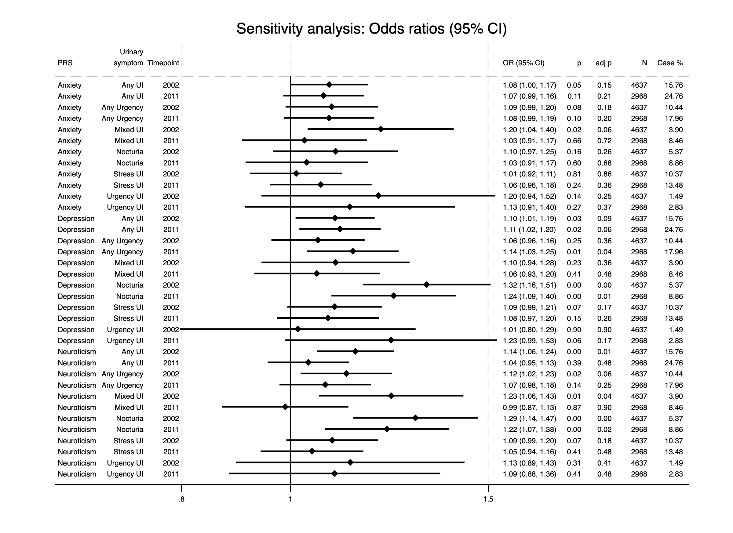

PRS validation

Figures 6.1-6.12 show associations between LUTS and PRSs at each of the SNP-inclusion significance thresholds ranging from p<0.5 to p<5x10⁻⁸ (S1 to S13). Results for the p<0.05 threshold (S6) are omitted as these form the primary results which are included in the main paper. Table 5 gives the key matching each analysis to its respective significance threshold.

Each figure reports odds ratios with 95% confidence intervals and unadjusted p-values. The figures also give the number of subjects in each model as well as the percentage of subjects who were positive cases for the urinary symptom.

Table 6.1
Analysis | SNP-inclusion significance threshold
S1 | p<0.5
S2 | p<0.4
S3 | p<0.3
S4 | p<0.2
S5 | p<0.1
S6* | p<0.05
S7 | p<0.01
S8 | p<1x10⁻³
S9 | p<1x10⁻⁴
S10 | p<1x10⁻⁵
S11 | p<1x10⁻⁶
S12 | p<1x10⁻⁷
S13 | p<5x10⁻⁸
*S6 analysis omitted from the supplement as this is the primary result which can be found in the main paper.

Figure 6.1
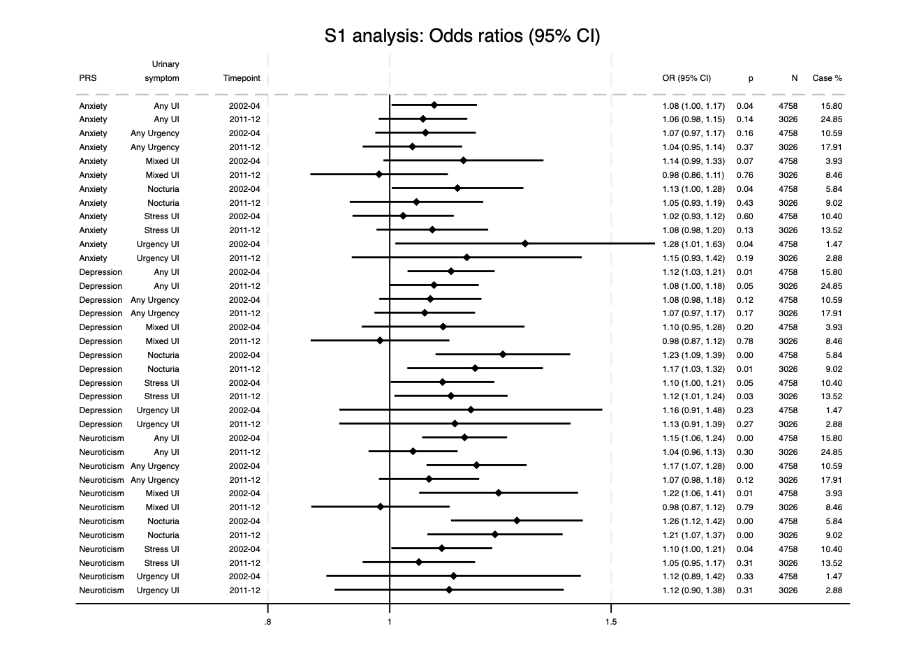

Figure 6.2
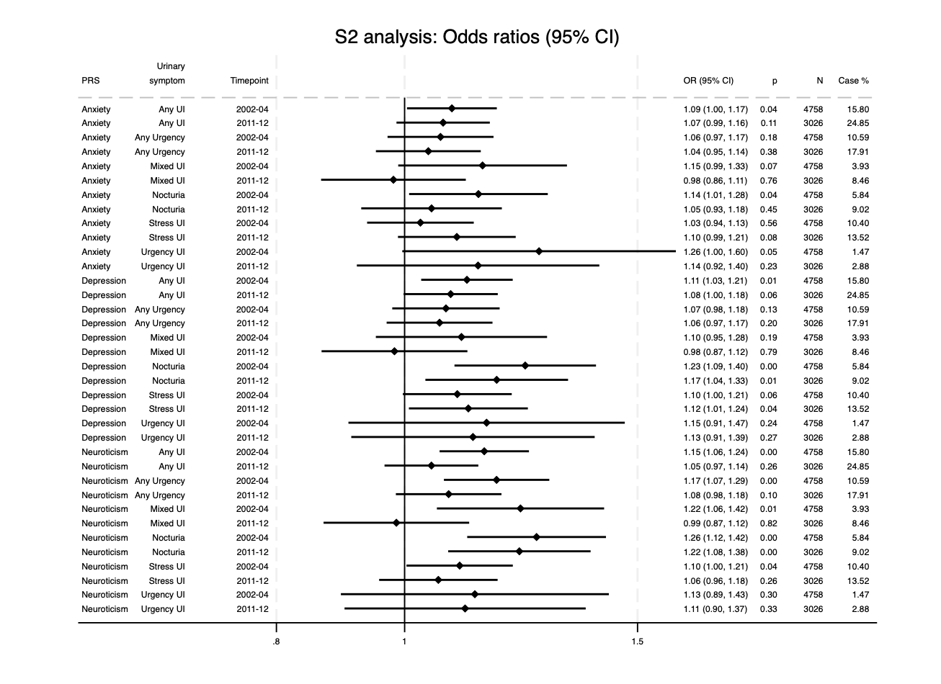

Figure 6.3
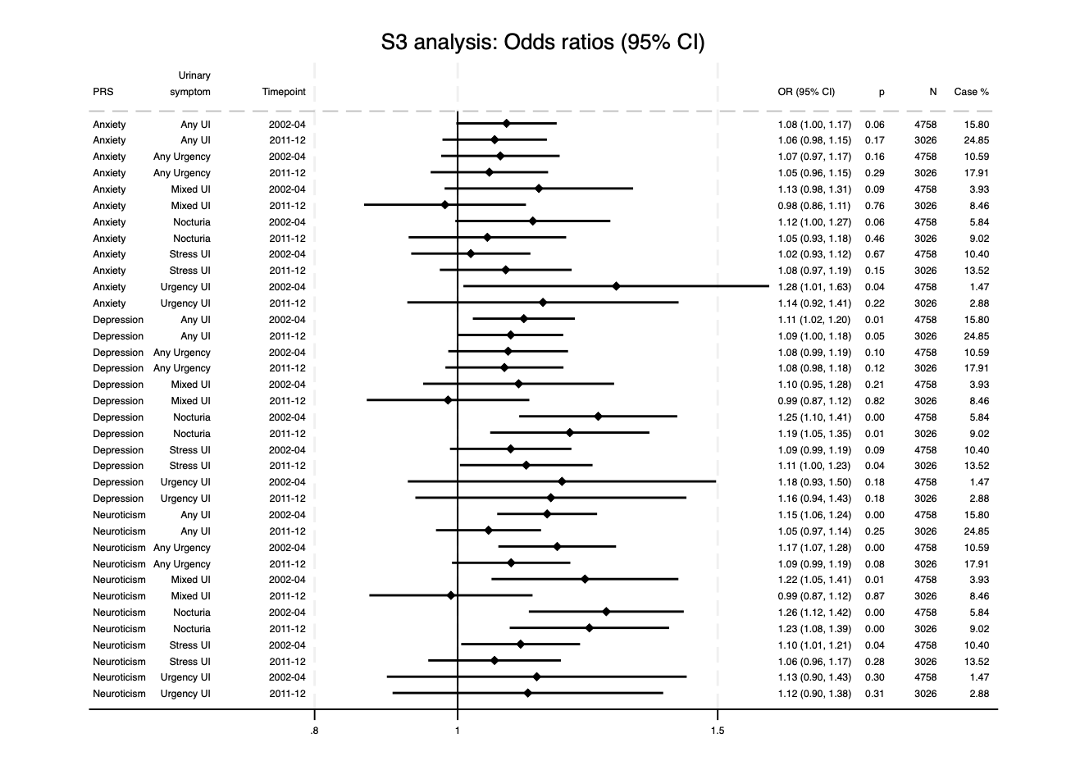

Figure 6.4
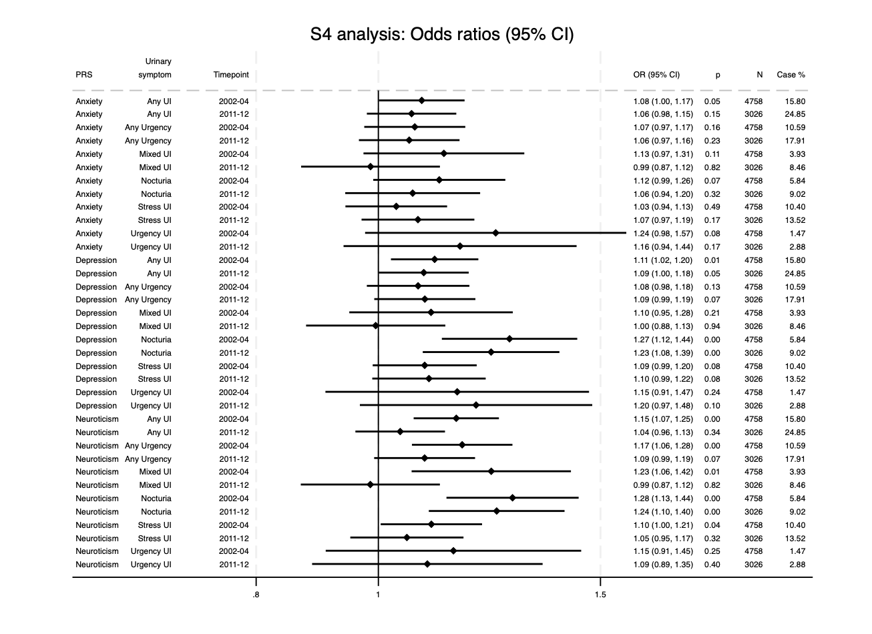

Figure 6.5
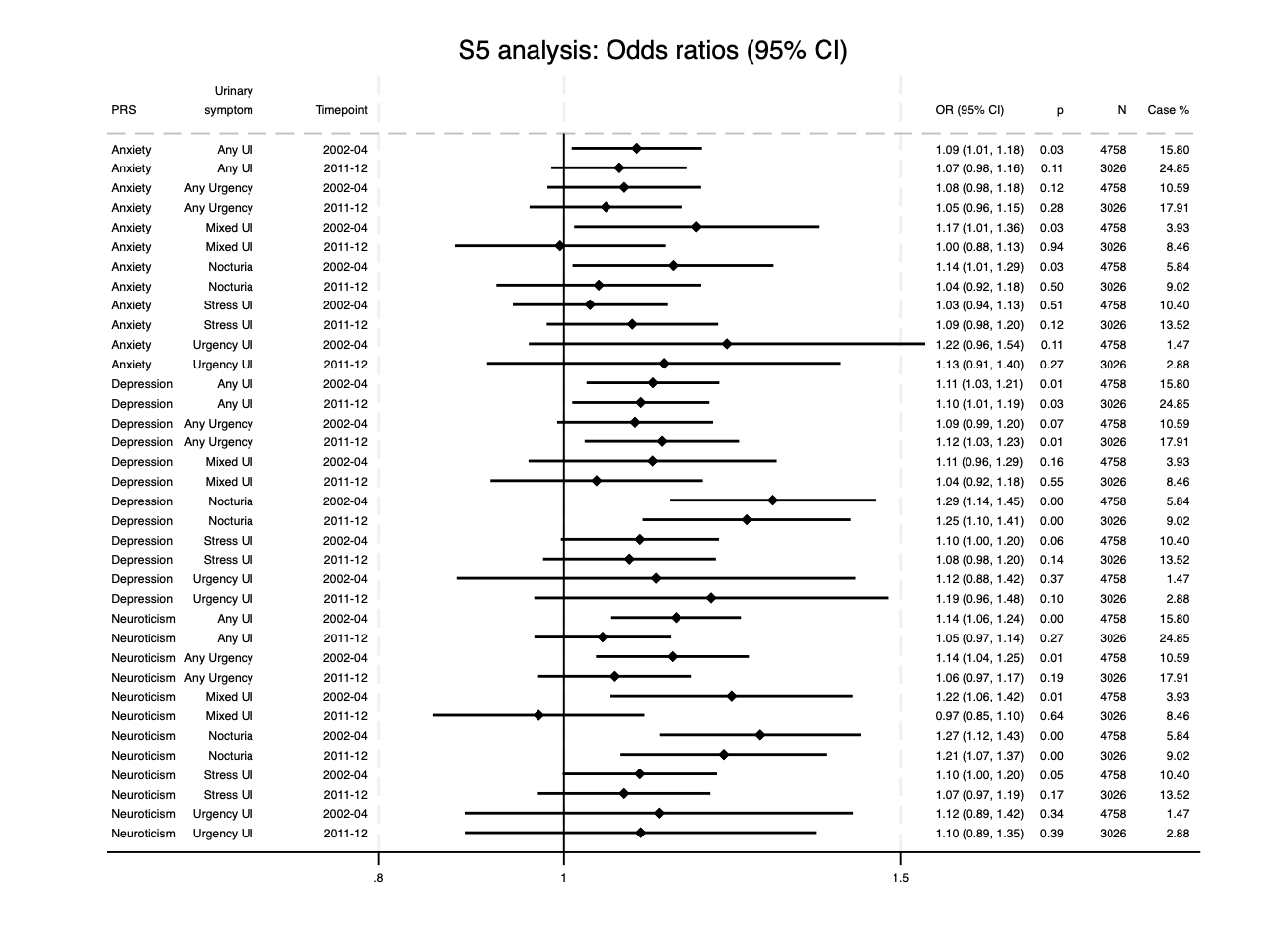

Figure 6.6
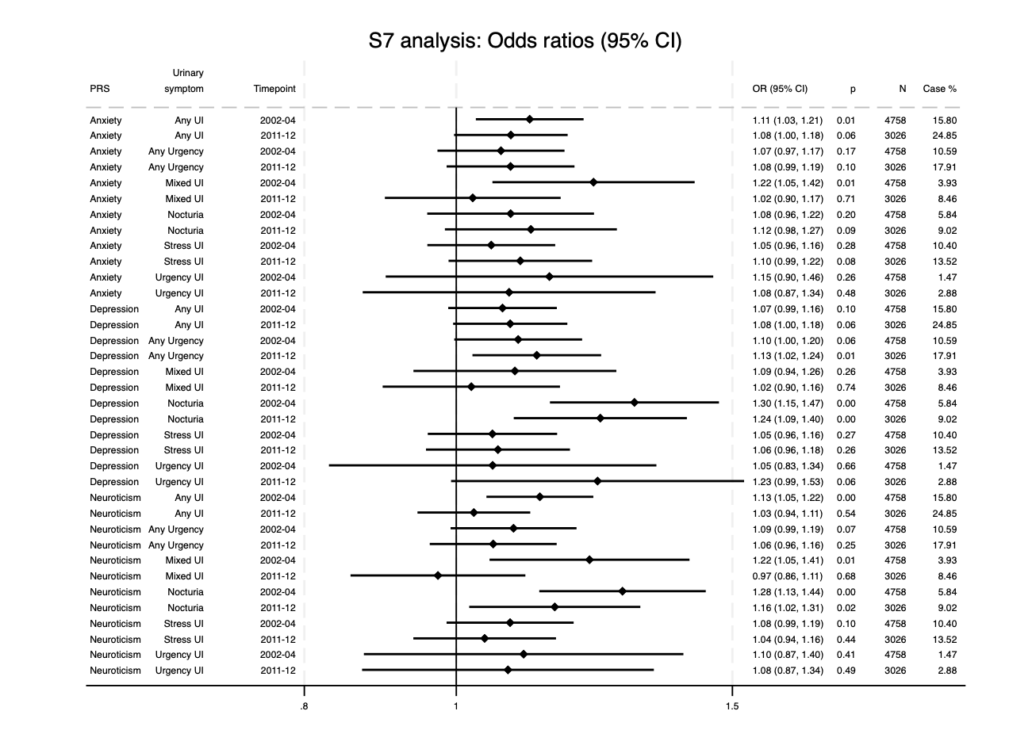

Figure 6.7
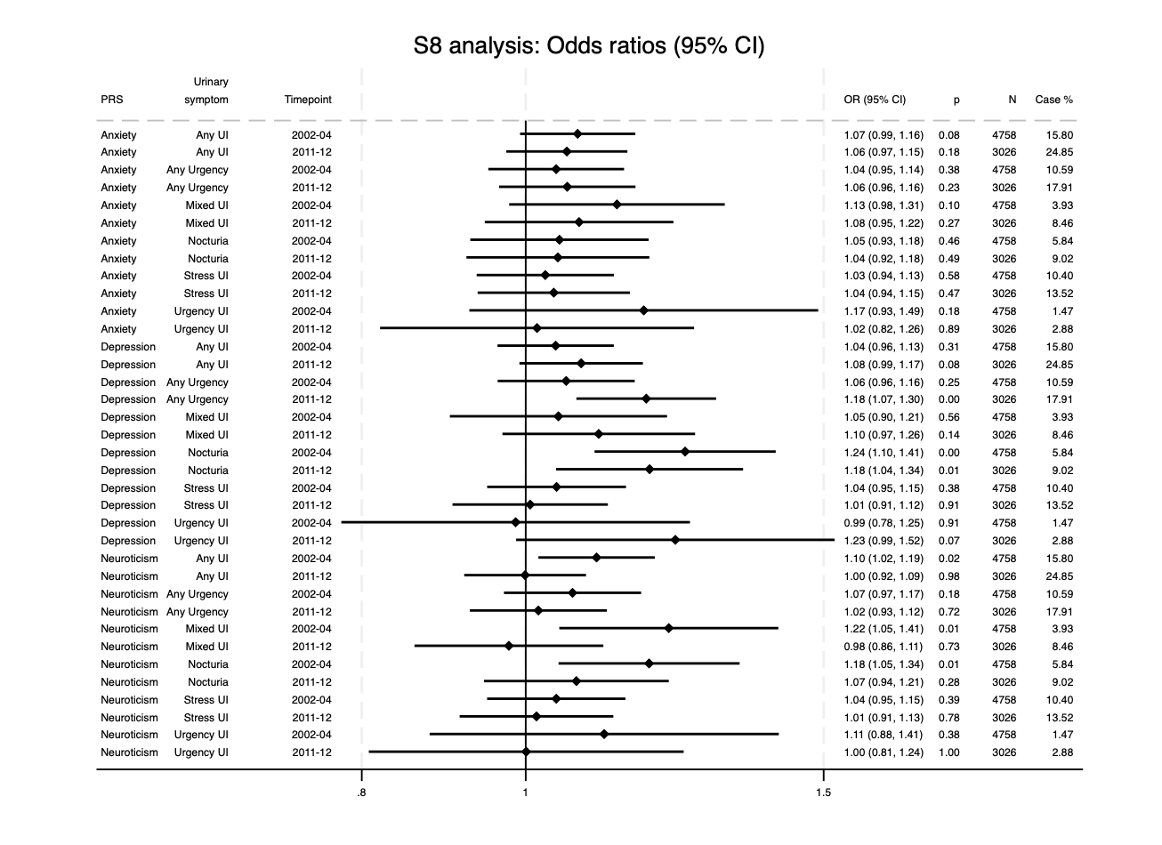

Figure 6.8
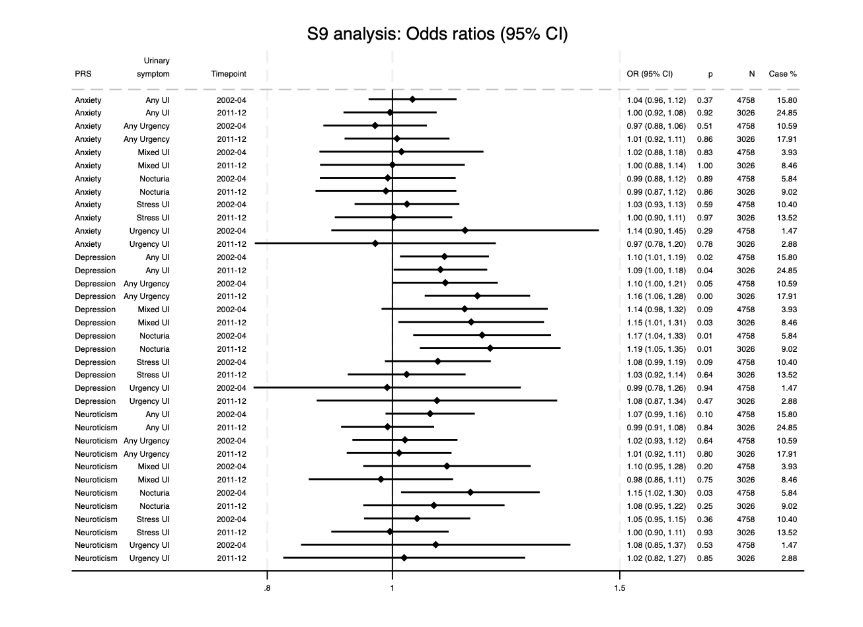

Figure 6.9
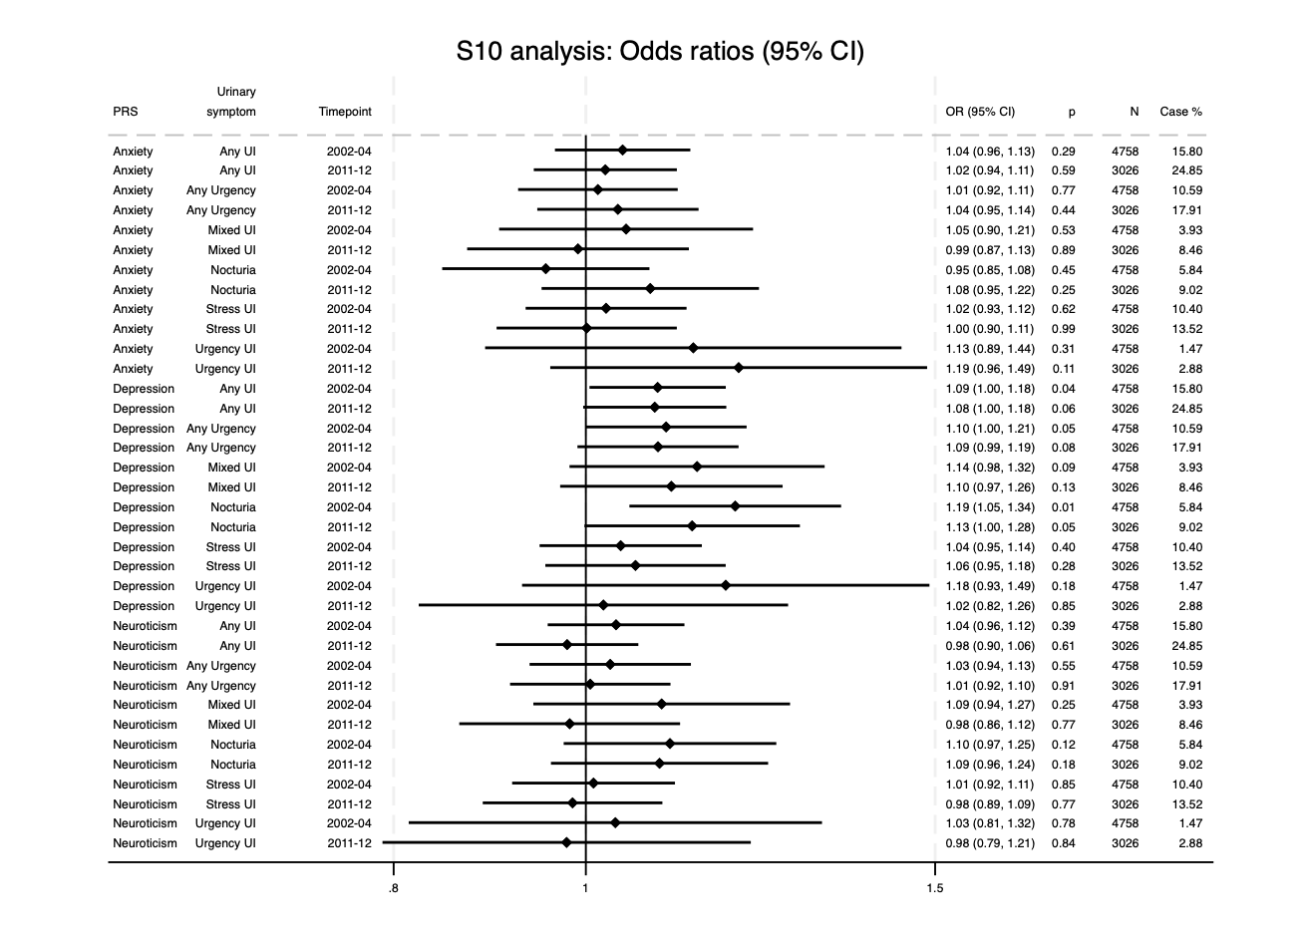

Figure 6.10
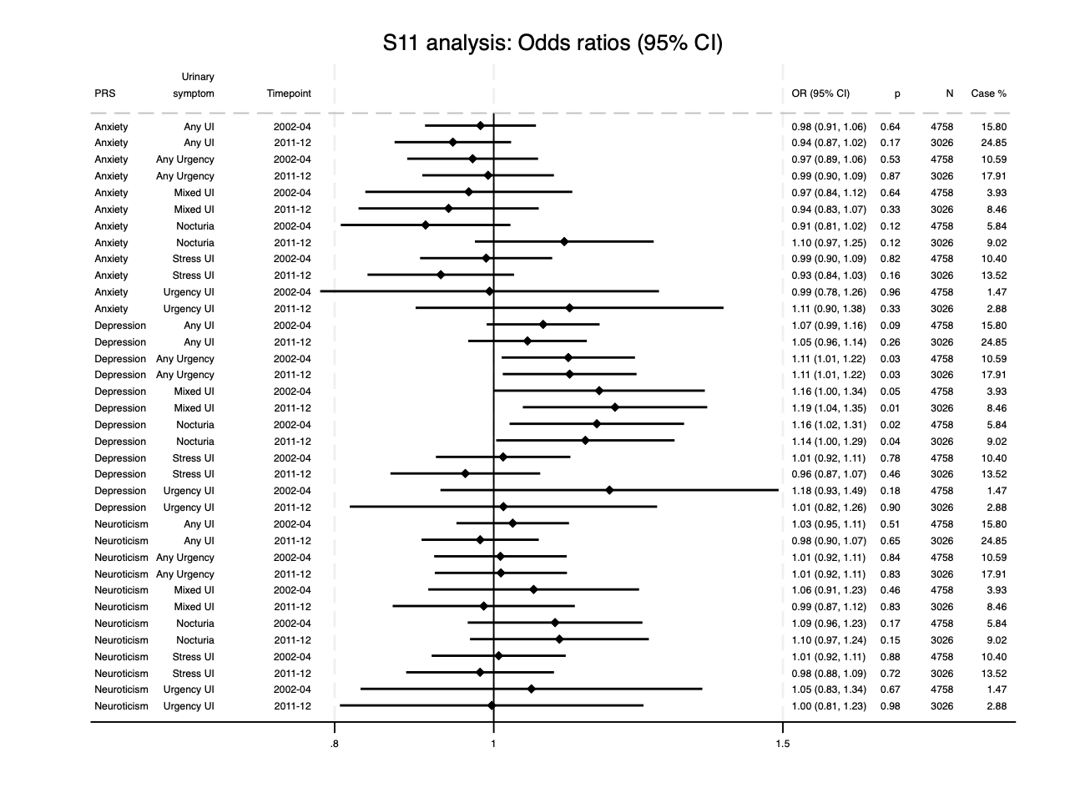

Figure 6.11
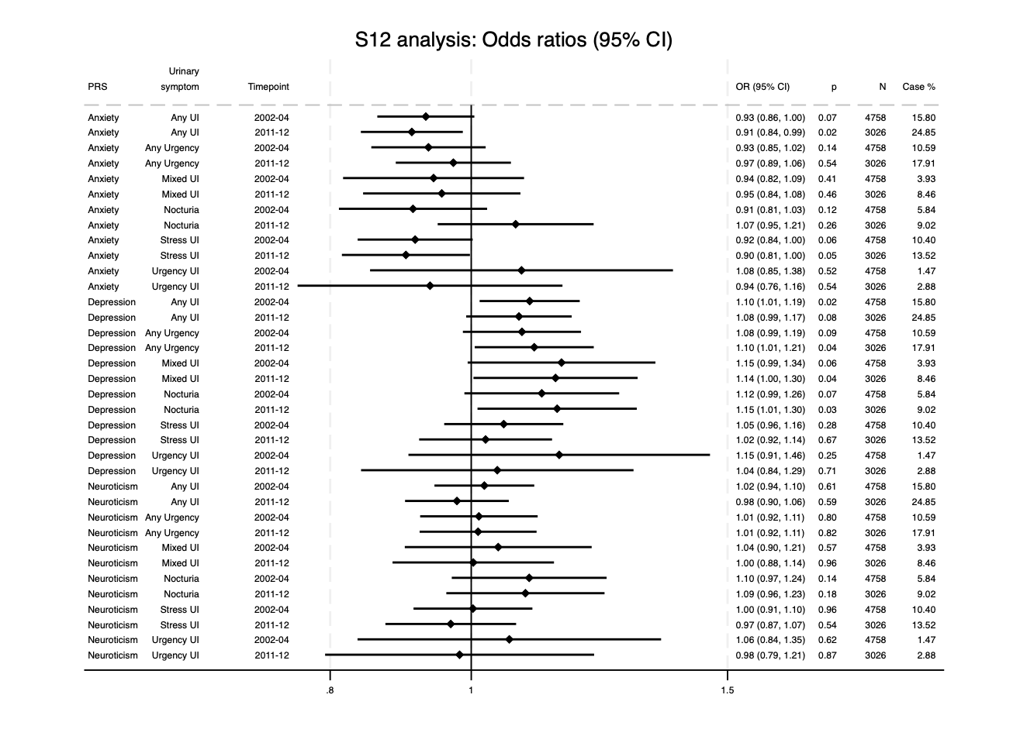

Figure 6.12
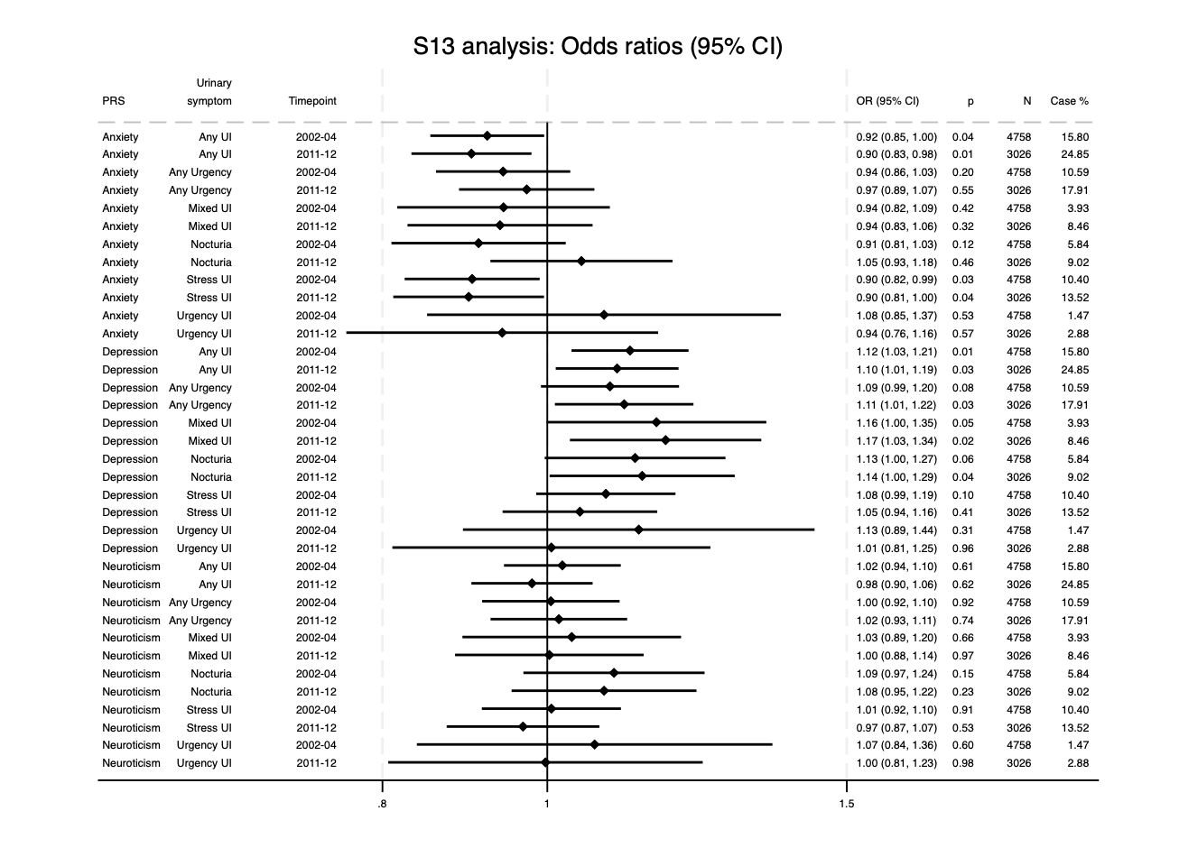

References
[1] Boyd A, Golding J, Macleod J, et al. Cohort Profile: The ‘Children of the 90s’; the index offspring of The Avon Longitudinal Study of Parents and Children (ALSPAC). Int J Epidemiol. 2013;42:111-127

[2] Fraser A, Macdonald-Wallis C, Tilling K, et al. Cohort Profile: The Avon Longitudinal Study of Parents and Children: ALSPAC mothers cohort. Int J Epidemiol. 2013;42(1):97-110.

[3]Major-Smith D, Heron J, Fraser A, et al. The Avon Longitudinal Study of Parents and Children (ALSPAC): a 2022 update on the enrolled sample of mothers and the associated baseline data. Wellcome Open Res. 2022;7:283.

[4] Uffelmann, E., Huang, Q. Q., Munung, N. S., De Vries, J., Okada, Y., Martin, A. R., ... & Posthuma, D. (2021). Genome-wide association studies. Nature Reviews Methods Primers, 1(1), 59.

[5] Boyle, E. A., Li, Y. I., & Pritchard, J. K. (2017). An expanded view of complex traits: from polygenic to omnigenic. Cell, 169(7), 1177-1186.

[6] Dudbridge, F. (2016). Polygenic epidemiology. Genetic epidemiology, 40(4), 268-272.

[7] Falconer, D. S. (1965). The inheritance of liability to certain diseases, estimated from the incidence among relatives. Annals of human genetics, 29(1), 51-76.

[8] Dempster, E. R., & Lerner, I. M. (1950). Heritability of threshold characters. Genetics, 35(2), 212.

[9] Carey, G. The threshold model. University of Colorado Boulder. http://ibgwww.colorado.edu/~carey/p4102dir/hgssfigures/dcg/dcg1.htm

[10] Als TD, Kurki MI, Grove J, et al. Depression pathophysiology, risk prediction of recurrence and comorbid psychiatric disorders using genome-wide analyses. Nat Med. 2023;29(7):1832-1844.

[11] Purves KL, Coleman JR, Meier SM, et al. A major role for common genetic variation in anxiety disorders. Mol Psychiatry. 2020;25(12):3292-3303.

[12] Luciano M, Hagenaars SP, Davies G, et al. Association analysis in over 329,000 individuals identifies 116 independent variants influencing neuroticism. Nat Genet. 2018;50(1):6-11.

[13] Choi, S. W., Mak, T. S. H., & O’Reilly, P. F. (2020). Tutorial: a guide to performing polygenic risk score analyses. Nature protocols, 15(9), 2759-2772.

[14] Bochud, M. (2012). Genetics for clinicians: from candidate genes to whole genome scans (technological advances). Best Practice & Research Clinical Endocrinology & Metabolism, 26(2), 119-132.

[15] Paul, E., & Pearson, R. M. (2020). Depressive symptoms measured using the Edinburgh Postnatal Depression Scale in mothers and partners in the ALSPAC Study: A data note. Wellcome Open Research, 5, 108.

[16] Crown, S., & Crisp, A. H. (1979). Manual of the crown-crisp experimental index. Hodder and Stoughton.

[17] Joinson, C., Drake, M. J., Fraser, A., Tilling, K., & Heron, J. (2025). Bidirectional relationships between depression, anxiety and urinary symptoms in women: A prospective cohort study. Journal of Affective Disorders, 369, 516-522.

