The future costs of OPV – a bottom-up model of material and manufacturing costs with uncertainty analysis

Authors

Corresponding author
Ajay Gambhir
Grantham Institute, Imperial College London, SW7 2AZ, UK
a.gambhir@imperial.ac.uk; +44 207 594 6363

Co-authors
Philip Sandwell
Department of Physics, Imperial College London, SW7 2AZ, UK
Grantham Institute, Imperial College London, SW7 2AZ, UK

Jenny Nelson
Department of Physics, Imperial College London, SW7 2AZ, UK
Grantham Institute, Imperial College London, SW7 2AZ, UK

Introduction
Solar PV is increasingly being seen as one of the most promising low-carbon technologies, with a potentially vast contribution to climate change mitigation scenarios [1], [2],[3], [4]. A large part of this enthusiasm stems from the reductions in PV module costs over the past few years. Recent estimates put silicon module costs at well below US$1/Wp [5], [6], a level which would have been seen as an optimistic target for 2020 or even 2030 when considering analysis from less than a decade ago [7], [8]. Other non-Si technologies, notably CdTe, are also competing for market share at around this level of cost [9], [10]. All of this has led to calls to “reconsider the economics of solar PV” [11].
Nevertheless, solar PV-generated electricity is still not that cheap in many (less sunny) locations, when considering the full levelised cost of electricity generated, and the picture is even less promising when considering the need to add storage in systems where grid backup cannot be relied upon [12]. Hence, if PV is to really compete with established electricity generation technologies, then further cost reductions are required. One potential route may be through the low-cost mass-production of PV technologies based on newer materials such as organic PV (OPV) using techniques adopted from existing printing processes [13], [14], [15], provided that their technical parameters (efficiency, lifetime) improve as hoped [16]. Projecting costs of such novel, emerging technologies is challenging for a range of reasons – lack of commercial-scale supply of many input materials, lack of commercial manufacturing equipment, and a large range of projected performance improvements.
There are, broadly speaking, three established methods of low-carbon technology cost projection, each of which has been applied to PV: using learning curves determined from historical relationships between cost or price and cumulative deployment, as well as other factors such as cumulative R&D expenditure (for a full summary see [17]); use of expert elicitations [7], [18], [19]; and bottom-up, engineering models of the technologies, as a basis for considering the potential costs of individual technology components and the manufacturing processes that combine these into the final technology product [8]. Previous analyses of OPV costs have predominantly used the third (bottom-up) method, since this lends itself to explicit analysis of key input component and/or manufacturing process cost assumptions. Some of these analyses include elicited values on material costs, and one study [18] uses an expert elicitation method to determine a range of technical and material cost inputs to arrive at a probabilistic cost estimate for OPV by 2050. Table 1 summarises these previous studies.

Table 1: Previous studies on OPV costs
Study | Approach | Findings
Machui et al. [14] | Material-based cost estimate for current production, up-scaling (100 MW production) and industrial-scale (100 GW production) production. Variety of module architectures and both single and tandem modules considered. | Current scale €1-8.4/Wp (US$1.2-10.1/Wp)  Up-scaling €0.08-0.9/Wp (US$0.10-1.08/Wp)  Industrial scale €0.05-0.6/Wp (US$0.06-0.72/Wp)
Mulligan et al. [20] | Projection of commercial scale manufacture using industry plant quotations and estimated and projected commercial scale material production costs. Single junction module of PET, Al, P3HT:PCBM, PEDOT, Ag, PET. Cell efficiency 5%, 76% photoactive area of module assumed. | US$7.85/m² (US$0.21/Wp)
Azzopardi et al. [13] | Recorded production costs for pilot plant (reel-to-reel). Single junction module of ITO, ZnO, P3HT:PCBM, PEDOT:PSS, Ag. Cell efficiency 7%, 67% photoactive area of module assumed. | €1.35-4.09/Wp  (US$1.62-4.91/Wp)
Roes et al. [21] | Preliminary cost estimate of polymer PV module on glass substrate, using materials inventory and estimates of inkjet printing costs. Singel junction module of PVF/PET, LiF/Al, P3HT:PCBM, PEDOT:PSS, ITO, Glass. Cell efficiency 5% assumed. | €2.80/Wp (US$3.36/Wp)
Kalowekamo and Baker [22] | Cost estimate based on material input costs and process costs from Dye Sensitised Solar Cell (DSSC) production. Single junction module of Flexible plastic, Al/Ag, C₆₀, CuPc and SnPc, flexible plastic/ITO. Cell efficiency 5% assumed. | US$1-2.83/Wp
Baker et al. [18] | Expert elicitations to determine probability of achieving target costs of US$50/m² with efficiency of 15-31%, by 2050 | US$0.16-0.33/Wp

A number of other studies have discussed OPV costs (as included in Mulligan et al.’s [20] summary), but are not included in Table 1. These studies either:
- focus on target costs (Dennler and Brabec [23]; Dennler et al. [24]; Nielsen et al. [25]);
- use costs from existing analyses to calculate financial indicators for OPV systems (Powell et al. [26], which uses OPV module costs from Kalowekamo and Baker [22]; Powell et al. [27], which uses cost estimates from Krebs [28]; Mulligan et al. [29], which calculates the OPV levelised cost of electricity using the OPV module cost from Mulligan et al. [20]);
- in the case of Krebs et al. [15], present a cost calculation which has been superceded by Azzopardi et al.’s [13] updated cost calculation of the same process.
This study uses a bottom-up, engineering method, to establish estimates for future OPV costs, but with two additional contributions compared to those bottom-up models used to date: the first to explicitly consider the impact of scale-up on manufacturing process costs, by examining the relationship between scale and cost for a range of comparable technologies; the second to introduce a stochastic (Monte Carlo) analysis of key input parameters to the cost calculation, so as to arrive at a distribution of potential OPV module costs, and the related levelised electricity costs. The motivation for a stochastic analysis, rather than an individual input-based sensitivity analysis, is that this allows a viable range of costs to be determined in light of a viable range of input parameters around which there is uncertainty. This is likely to be of particular importance to researchers, businesses and policy makers who need to consider the relative cost of OPV compared to other established PV technologies. It should be noted that uncertainty analysis has been applied to OPV considering a much longer timescale [30] (looking at 2050 rather than 2020, as in this paper) and considering much more speculative, dramatic improvements in OPV module efficiency and lifetime. This paper considers whether near-term cost reductions in OPV, driven by plausible scale-up and performance parameters, could make it a potential competitor with established PV technologies.
The rest of this paper is set out as follows: Section 2 details the methods used to project OPV costs; Section 3 presents the results of this cost analysis and highlights key sensitivities and uncertainties in the estimates, as well as comparing the levelised cost of electricity generated by OPV to that of more established PV technologies; Section 4 discusses the findings, in particular with regard to the potential role of policies in driving OPV costs down; and Section 5 concludes.

Methods
This section outlines the approach taken to formulate a probabilistic estimate of future OPV costs, using the following steps:
- Module architecture
- Commercial-scale material costs
- Commercial-scale manufacturing costs
- Probabilistic estimation of module costs
- Estimation of levelised cost of electricity

2.1 Module architecture
The majority of existing assessments of organic PV (OPV) module production costs are based on a typical configuration of single junction module as shown in table 2. In general a single junction module consists of a cell with an active layer (consisting of an electron donor and acceptor material), surrounded by electrodes, with the front electrode on a transparent substrate and the back electrode on a laminate. Within this basic configuration, a number of materials may be used and additional layers may be added such as electron and hole transport layers between the active layer and electrodes.
Table 2: Typical layers and materials in OPV modules
Layer | Example materials
Substrate | PET, Other flexible plastic, Glass
Front electrode | ITO, Ag, Graphite
Electron carrier | ZnO
Active layer | P3HT:PCBM
Hole carrier | PEDOT:PSS, PEDOT:PET
Back electrode | LiF/Ag, Al
Back laminate | PET, PET/PVF
Source: Azzopardi et al. [13], Mulligan et al. [20], Kalowekamo and Baker [22], Roes et al. [21], Machui et al. [14].
To assess the production cost of such a module, it is necessary to consider the material input costs, and the manufacturing process costs, as set out in the following sub-sections.

2.2 Commercial-scale material costs
The basic configuration shown in table 2 has been used to estimate total material input costs per m² of OPV module produced. As yet there is no commercial-scale production of OPV modules, so these material input costs have been derived from either supplier quotes, or in one case a fully simulated manufacturing process for PET [20]. Figure 1 shows the implication of these different assumptions on material costs for each of the most recent studies.
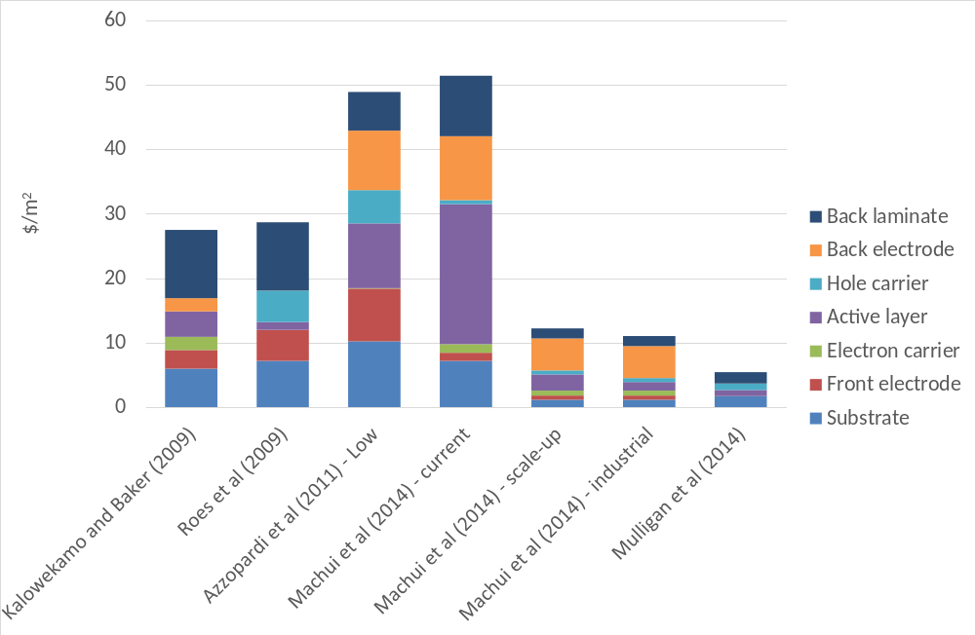
Figure 1: Material costs assumed in recent studies estimating the cost of OPV modules
Source: Azzopardi et al. [13], Mulligan et al. [20], Kalowekamo and Baker [22], Roes et al. [21], Machui et al. [14]
Notes: Machui et al. scale up scenario means production of ~100 MW per year, industrial scale ~ 100 GW per year [14]
Additional studies have been undertaken but not included here either because they discuss target costs rather than actual cost estimates [23], [24] or alternatively because they are based on the early roll-to-roll processes (known as “ProcessOne”)developed in the Risø National Laboratory for Sustainable Energy at the Technical University of Denmark [31], [25], [15], as more recently assessed in Azzopardi et al. [13] and Machui et al. [14]. The earlier estimates of Kalowekamo and Baker [22] and Roes et al. [21] are based on the production of other PV technologies, whereas the more recent estimates (Azzopardi et al. [13] onwards) use costs of actual equipment and material, or quotes and estimates from material and equipment suppliers. These more recent estimates are therefore taken as the basis for the ranges discussed in Section 2.4. Clearly if the commercial scale figures [14], [20] are to be believed then there is the potential for significant cost reductions in OPV materials – perhaps to one-fifth or one-tenth of the current costs (reflecting the supply costs for what at this stage are speciality chemicals supplied in small quantities).

2.3 Commercial-scale manufacturing costs
There are fewer available estimates of plant and other manufacturing process costs than material costs. Here we present actual data for the costs of equipment and other manufacturing-related activities for three different scales of OPV printing, ranging from pilot to large-scale commercial OPV printing. Azzopardi et al. [13] provide the cost of capital equipment in the pilot roll-to-roll printing plant used to produce OPV modules in 2010. This equipment, at €530,000, provides an output rate of 20,000 m²/year with assumed lifetime of 10 years. Mulligan et al. [20] provide printing and other capital equipment costs (based on anonymised quotes) for large-scale production of OPV, with a cost of US$11.7 million and output of 6.3 million m²/year. We have in addition spoken to an EU-based equipment manufacturer (hereafter denoted “EU manufacturer”) providing a printing line operating at 2.5-3 m²/minute, at a quoted cost of €1.5 million [32]. We use Mulligan et al’s [20] figures on the line run operation time (8 hours per day, 5 days per week, 44 weeks per year) to derive an output for this equipment of 264,000 m²/per year (assuming 2.5m²/minute, the lower end of the range). This gives us estimates for three different order-of-magnitude OPV production lines, ranging from pilot scale to full commercial scale. Figure 2 shows a log-log plot of unit capital cost (here defined as the initial equipment cost divided by the annual output of OPV modules measured in m²) and annual module output (again measured in m² per year). The plot shows the percentage unit capital cost reduction that results from each doubling of scale when increasing equipment size between the three different scales of equipment, in a range of 24% to 34%.
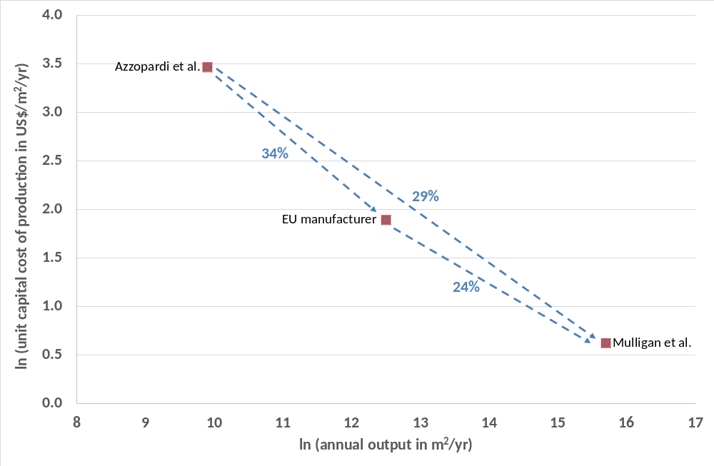
Figure 2: Unit equipment costs for production of OPV single junction modules
Notes: Percentage equipment cost reduction for each doubling of annual output is shown for each pair of data points.
In addition to equipment costs, Azzopardi et al. [13] and Mulligan et al. [20] provide energy, labour, and additional operational costs of production at pilot and commercial scale respectively. Figure 3 shows the comparative costs (on the same basis of US$/m² as for material costs) for these different estimates. The reduction in unit cost (expressed in US$/m² of module produced) for each doubling of scale for each major cost component (equipment, labour, overheads) is also shown in figure 3. O&M, energy and utilities have not been included in this scaling comparison, as the costs of energy and utilities as well as O&M in the much larger-scale plant reported in Mulligan et al. [20] are actually higher than in the pilot scale plant reported in Azzopardi et al. [13]. For energy/utilities this is likely to be because the Azzopardi et al. [13] figures are for electricity only, whereas those from Mulligan et al. [20] include other utilities such as water. For O&M the Azzopardi et al. [13] figures derive from a simple assumption that these will be 4% of annualised capital costs, whereas Mulligan et al.’s are more detailed specific cost estimates. In addition, Mulligan et al. [20] also includes a one-off factory set-up cost [20]– this is not included in the Azzopardi et al. figures [13]. In order to accommodate the non-comparability of these cost categories, and to err on the side of conservatism, the set-up cost, as well as higher energy/utilities and O&M costs from Mulligan et al. [20] are used (and it is assumed that unit costs for these categories do not vary with scale).

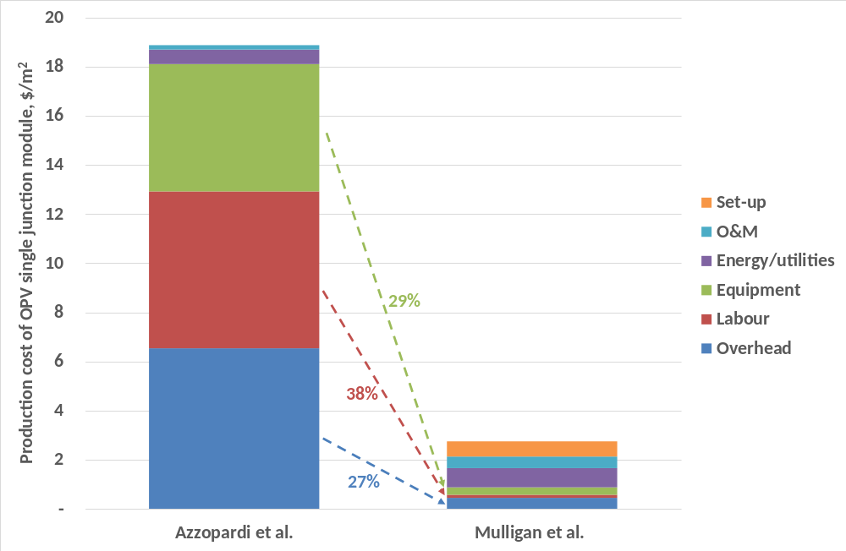
Figure 3: Unit equipment costs for production of OPV single junction modules
Notes: All costs have been converted to US$ using a $/Euro conversion rate of 1.2. In addition, capital equipment and (in the case of Mulligan et al. [20]) one-off set-up costs have been annualised using a financing rate of 10% and a plant lifetime of 10 years. The financing rate and plant lifetime are varied in the sensitivity analysis described in Section 2.4.
As well as the 29% unit equipment cost reduction for each doubling of output when increasing from the pilot to commercial scale (as shown in figure 2), figure 3 shows unit labour costs reducing at 38%, and overheads at 27%, for each doubling of output. This range of manufacture-related cost reduction rates is broadly in line with those for a number of other technologies, as shown in table 2 below. Those for PV technologies are all from engineering-based cost models, whilst those from other industries are empirical analyses of actual cost reductions. In general the modelled and empirical cost reduction ranges match reasonably closely in a range of 20-35%. These compare to the range of equipment cost reductions of 24-34% shown in figure 2, and the overhead and labour cost reductions of 27% and 38% shown in figure 3.
Based on the OPV estimates presented, and those in table 3, a range of cost reduction rates of 20-35% has been chosen for the stochastic analysis discussed in section 2.4. This range encompasses the value (24%) implied by the “0.6 power rule” of engineering and manufacturing industries first discussed in the mid-20th century with regard to chemical and other manufacturing industries [33], whereby as capital equipment capacity increases, its cost increases by the increase in capacity raised to the power 0.6 – a value less than 1 implying increasing economies of scale. Observations have determined a large range of exponents in practice [33], suggesting the validity of using a range in this analysis.
Table 2: Estimated cost reductions resulting from scale economies in manufacturing
Study | Details | Imputed unit cost reduction for doubling of plant size (measured in annual output)
PV (c-Si and thin-film inorganic)
Goodrich et al. [34] | Model of a fourfold increase in manufacturing plant size for c-Si PV | 29% (wafer manufacture capital equipment unit costs).
Kapur et al. [35] | Model of CIGS PV cost improvements from 2011, assessing inter alia scale-up | 21% (capital plus overhead unit cost reduction).
Nemet and Baker[30] | Assumption from semiconductor, PV and engineering equipment industries applied to OPV costs. | 20% (capital, labour and fixed overheads)
Semiconductors and other high-tech industries
Krick et al. [36] | Empirical analysis of flat panel display and semiconductor throughput with increasing capital equipment cost. | 35% (capital equipment unit costs)
Keshner and Arya [43] | Empirical analysis of increase in throughput of low emissivity glass sheet coaters between “early days” of industry and 2003. | 26% (equipment unit cost).
Keshner and Arya [43] | Empirical analysis of flat panel display dry etch equipment scale-up over period early 1990s (Gen II equipment) to early 2000s (Gen VI equipment) | 33% (equipment unit cost).

2.4 Probabilistic estimate of module costs
As demonstrated in sections 2.2 and 2.3, there are still large ranges of material and equipment costs and scaling factors. In addition, there is still considerable uncertainty around the ultimate performance of OPV modules, in terms of their power conversion efficiency. In order to produce a plausible range of future module cost estimates, it is therefore suitable to use a sampling method – in this case a Monte Carlo analysis. Stochastic analysis has previously been used to analyse uncertainty in the life cycle energy and environmental impact of OPV [37], as well as the levelised electricity cost implications spanning from given OPV module costs [26]. The process for undertaking the Monte Carlo analysis is outlined in figure 4.

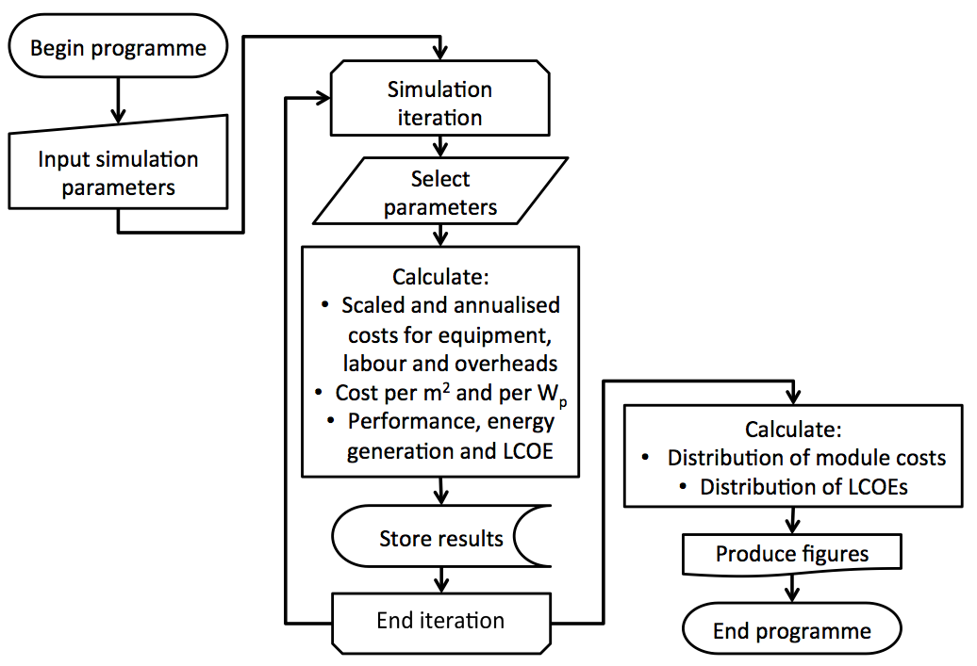
Figure 4: Schematic of process for calculating OPV module cost using Monte Carlo analysis
The analysis has been repeated for 100,000 realisations. For each Monte Carlo realisation i, OPV module cost C_{i} is calculated according to:
$C_{i}=\frac{E_{i}+P_{i}+L_{i}+V_{i}+M_{i}+U_{i}+O_{i}}{1000*{PCE}_{i}*{GFF}_{i}}$ (1)
Where for each realisation i:
- C_{i} = module cost, in US$/Wp
- E_{i} = annualised manufacturing equipment cost, in US$/m²
- P_{i} = annualised plant set-up cost, in US$/m²
- L_{i} = labour cost in US$/m²
- V_{i} = overhead cost, in US$/m²
- M_{i} = material cost, in US$/m²
- U_{i} = energy and other utility cost, in US$/m²
- O_{i} = operation and maintenance cost, in US$/m²
- PCE_{i} = module power conversion efficiency (in %) measured at irradiance of 1,000 W/m²
- GFF_{i} = geometrical fill factor (dimensionless ratio)
The annualised equipment cost E_{i} and annualised plant set-up cost P_{i} have been derived from the initial equipment cost EI_{i} and the initial set-up cost PI_{i} using the following formulae:
$E_{i}=\frac{{EI}_{i}d_{i}}{1-{(1+d_{i})}^{{-Y}_{i}}}$ (2)
$P_{i}=\frac{{PI}_{i}d_{i}}{1-{(1+d_{i})}^{{-Y}_{i}}}$ (3)
For each realisation this function calculates a constant stream of annual payments (E_{i}, P_{i}) over a lifetime Y_{i} at a discount rate d_{i} such that the discounted sum of the payments is equal to an initial payment of EI_{i} (in the case of equipment cost) and PI_{i} (in the case of plant set-up cost).
For each realisation, scaling factors have been applied to the initial equipment cost as well as annual labour and overhead costs according to the following respective formulae:
${EI}_{i}={EI}_{0}{\left(1-S_{i}\right)}^{{n(EI)}_{i}}$ (4)
$L_{i}=L_{0}{\left(1-S_{i}\right)}^{{n(L)}_{i}}$ (5)
$V_{i}=V_{0}{\left(1-S_{i}\right)}^{{n(O)}_{i}}$ (6)
Where by illustration EI_{i} is the initial equipment cost from realisation i derived from scaling up the smallest commercial equipment level (with cost EI₀) according to a scaling factor S_{i} (representing the % cost reduction per doubling of scale) and number of doublings n(EI)_{i}. Note that for each realisation the scaling factor and number of doublings have been applied in such a way that all three components subject to economies of scale (equipment, labour and overheads) are scaled to the same plant size. In addition, for each realisation, one-off costs which are annualised (equipment, plant set-up) are done so according to the same discount rate d_{i} and plant lifetime Y_{i}.
Table 3 shows the ranges of values for each parameter used in the analysis, as well as the values used for those parameters for which ranges are not available. We have implemented a uniform distribution for those parameters with ranges. This reflects that there is no clear indication of a most likely (mode) estimate for these parameters, but rather just a range. The stochastic analysis is therefore aimed primarily at providing a range of OPV module cost projections, rather than a most likely estimate. A sensitivity has been explored using a symmetric normal distribution with the range encompassing 95% of its cumulative probability, in order to explore the impact of a change in distribution type on the reported OPV module cost range.

Table 3: Parameters and ranges explored in sensitivity analysis
Parameter | Value | Rationale
Parameters for which ranges are used in the OPV module cost calculation
Material costs, M_{i} | US$5.46-12.24/m² | Higher end of the range from a scale-up scenario (of about 100 MW of production annually), as elicited from chemical suppliers (Machui et al. [14]). Lower end of the range from industrial-scale production cost model (Mulligan et al. [20]).
Capital equipment, labour, overhead unit cost reduction factor, S_{i} | 20-35% unit equipment cost reduction for each doubling of scale | Derived from a range of sources as discussed in See Section 2.3.
Number of doublings of equipment scale, n(EI)_{i} | 0.0-6.7 | 0 represents production at 10 MW scale; 6.7 represents approximate 1 GW scale production, which is assumed to be a maximum feasible near-term plant level.
Number of doublings of scale for labour n(L)_{i}, and overheads, n(V)_{i} | 3.7-10.4 | 3.7 implies production scale of ~10 MW per annum (as per EU Manufacturer production equipment quote [32]); 10.4 implies ~1GW scale.
Geometrical Fill Factor, GFF_{i} | 0.75-0.98 | Range taken from Machui et al. [14] based on currently achievable 0.75 and future envisaged 0.98.
Module Power Conversion Efficiency, PCE_{i} | 3.5%-7.0% | Bottom of range reflects best processed module in Machui et al. [14], top reflects own (conservative) estimate - highest measured module efficiencies of 9-11% in Green et al. [38]
Discount rate for manufacture plant, d_{i} | 7-15% | Range spanning assumptions in Azzopardi et al. [13] to Mulligan et al. [20].
Plant lifetime, Y_{i} | 10-20 years | Range spanning assumptions in Azzopardi et al. [13] to Mulligan et al. [20].
Parameters for which single point estimates used in the OPV module cost calculation
Initial capital equipment cost, EI_{O} | US$6.82/m²/year | Price for European commercially shipped small scale (~10 MW per annum) equipment [32].
Initial labour costs, L₀, | US$6.38/m² (labour) | Measured labour input for pilot OPV production, from Azzopardi et al. [13].
Initial overhead costs, V₀ | US$6.54/m² (overheads) | Measured overhead input for pilot OPV production, from Azzopardi et al. [13].
Energy and utility costs, U_{i} | US$0.59/m² | Actual measured electricity input for pilot OPV production, from Azzopardi et al. [13]. Constant returns to scale assumed.
Operation & Maintenance costs, O_{i} | US$0.47/m² | Detailed O&M costs from Mulligan et al. [20] used as no other data. Constant returns to scale assumed.
Set-up cost, PI_{i} | US$24 million for plant capacity 6.4 million m²/yr (US$3.8/m²/yr) | Amortised at plant lifetime and discount rate. Constant returns to scale assumed.

It is important to note that we have assumed that both PCE and GFF are independent of production scale and materials costs, whereas these parameters may in fact be correlated – with for example specific material combinations leading to specific efficiencies. Since OPV is still at a relatively early stage of manufacture, it is not yet possible to associate a precise efficiency with a precise combination of materials, and therefore with a precise manufacturing cost. As such, the analysis provides only an approximation of the future OPV module cost, assuming a viable range of PCEs and GFFs can be reasonably associated with the material combinations implied in the studies shown in figure 1.

2.5 Estimate of levelised costs of electricity
Given that OPV module lifetimes are still relatively short (with lifetimes of 10 years being aimed at but not yet achieved), a comparison with established (e.g. crystalline silicon, cadmium telluride) PV technology module costs (whose lifetimes are closer to 20 years) is not useful. We therefore also calculate the levelised cost of electricity (LCOE) for OPV, based on the range of module costs obtained from the Monte Carlo analysis described in section 2.4, as well as assumed module lifetimes, irradiance levels, balance of system costs and discount rates as shown in table 4. For simplicity, no projections are made of balance of system costs – rather current values are assumed. In addition, OPV replacement modules (either at 5 or 10 year intervals, depending on the assumed module lifetime) are assumed to cost the same as the initially-installed modules – a possibly conservative assumption given the potential for further cost reductions over time. The LCOE is calculated for a 20-year time horizon to aid comparability to the established PV technologies.
Table 4: Parameters for levelised cost of electricity (LCOE) calculation
Component | Assumption (for costs, present day costs assumed)
Module margin | Assumption of 10% (following Azzopardi et al. [13])
Installation costs (current costs assumed) | US$0.51/Wp [12], with OPV replacement of module cost US$0.26/Wp (estimated at half original installation cost [13])
Balance of System component costs (current costs assumed) | For roof-mounted: US$0.6/Wp (of which inverter US$0.55, energy meter US$0.04 [12])  For ground-mounted, US$0.3/Wp (combined) [39]
O&M costs | Annual cost of 0.5% of initial Module plus Balance of Systems cost [12]
System lifetime | 20 years for Balance of Systems components  20 years for c-Si, CIGS, CdTe modules  5-10 years for OPV modules
Module degradation rate | Linear 1% per year for c-Si, CIGS, CdTe modules  Linear 4% per year for OPV (5 year lifetime)  Linear 2% per year for OPV (10 year lifetime) [12]
Discount / finance rate | 10% (illustrative private borrowing rate)
Irradiance level | Assumed at 1,700 kWh/m²/yr with performance ratio of 0.8
Notes: Performance ratio refers to the ratio of the actual electricity yield and target yield from a given installed array of PV modules. Losses stem from array temperature, incomplete utilization of the irradiation, and system component inefficiencies or failures [40].
For the more established PV technologies (here taken as c-Si, CdTe, CIGS), for which cost reductions are continuing, a near-term (approximately 2020) estimate of their module costs is undertaken, resulting in a range of US$0.35-0.6/Wp. These costs have been arrived at through undertaking a detailed analysis of the material input cost reduction and manufacturing-related cost reductions that are possible over the coming years. Full details are given in Supplementary Information 1 and 2 (SI1 and SI2).
For both OPV and a representative more established PV technology with this cost range of US$0.35-0.6/Wp, we show two PV systems: the first using installation and balance of system (BoS) component costs for ground-mounted PV systems at scale [39]; the second with installation and BoS costs for a roof-mounted home system [12], [13]. For each PV technology the LCOE is determined according to the following formula (following [41]):
$LCOE= \frac{M_{0}+B_{0}+\sum_{t}{\frac{\left(M_{t}+{ B_{t}+ O}_{t}\right)}{{(1+d)}^{t}}}}{\sum_{t}{\frac{\left(E_{t}\right)}{{(1+d)}^{t}}}}$ (7)
Where:
- M₀ is the initial module price including margins, per Wp installed
- B₀ is the initial balance of system cost, per Wp installed
- M_{t} is the replacement module price in year t (for OPV systems with a 10-year lifetime, this is only relevant for OPV with a 5-year life)
- B_{t} is the balance of systems cost associated with replacing modules in year t (again, only relevant for OPV with a 5-year life)
- O_{t} is the operation and maintenance cost per Wp in year t
- E_{t} is the electricity generated by each Wp of installed module in year t
- d is the discount rate
- t is the year of lifetime.

Results of OPV cost analysis

3.1 OPV module cost
Figure 5 shows the outcome of the Monte Carlo analysis using the input assumptions shown in table 3. The median OPV module cost is US$0.28/Wp, with interquartile range US$0.23-0.34/Wp.
As a sensitivity, the Monte Carlo analysis is repeated using a normal distribution centred around the mean of the upper and lower estimates, with the estimates forming the boundaries within which 95% of the randomly selected values chosen will lie. This results in a median cost of US$0.27/Wp, with interquartile range US$0.23-0.32/Wp, which are reasonably close to the corresponding figures from the uniform distribution. 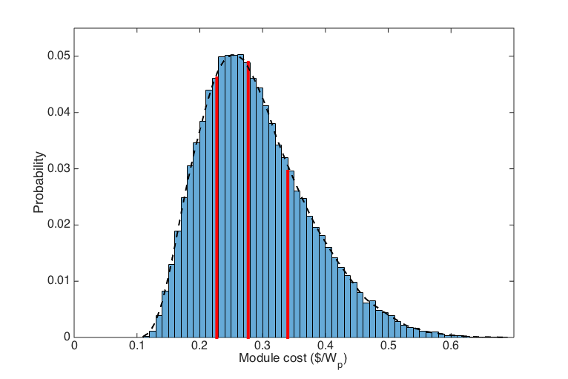
Figure 5: Distribution of module cost of single junction OPV manufactured at commercial scale
Notes: Red lines denote the lower quartile (US$0.23/Wp), median (US$0.28/Wp) and upper quartile (US$0.34/Wp) values
One benefit of such analysis is that it allows the examination of how sensitive the overall cost is to variations in each input factor – this is explored by calculating the module cost using the Monte Carlo approach but with each factor fixed to the upper or lower end of its range of values. In the case of manufacturing scale, this factor includes setting both the scaling factors and cost reductions per doubling of scale for the manufacturing-related costs that are subject to scale economies (equipment, labour, overheads). As shown in figure 6, manufacturing scale, material costs, geometrical fill factor (GFF) and module power conversion efficiency (PCE) are all significant determinants of the overall variation in module costs. With PCE being a key metric in the PV community, and the stated aim of reaching the “10-10 challenge” of a 10% efficient device with a lifetime of 10 years, it is conceivable that the PCEs at the higher end of the range used here (7%) will be achieved [42]. It is also clear that manufacturing scale will also be an important determinant of OPV economics, at least in the near-term as the industry scales up. It is therefore perhaps a little too early to assume such costs away, at least for anything other than very large scale production as discussed in Machui et al. [14].
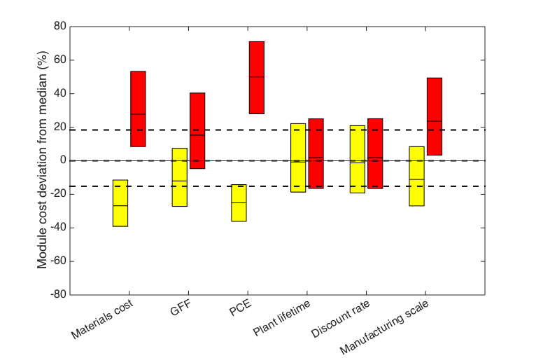
Figure 6: Sensitivity of OPV module cost to each input factor, as set to the upper and lower estimates of each parameter, with the median and interquartile range shown
Notes: Dashed lines denote the positions of the upper and lower quartiles of the original cost distribution. For each input factor into the OPV cost calculation, red bars represent the OPV module cost distribution (median and interquartile range) when this factor’s value is held at the higher end of its input range, and yellow bars the cost distribution when the factor’s value is held at the lower end of its range. These cost distributions are expressed as percentage differences compared to the median OPV cost calculated in the initial Monte Carlo analysis (i.e. with none of the input factor values shown held constant).

3.2 Levelised cost of electricity (LCOE)
Figure 7 shows the LCOE range of the more established PV module technologies as well as the LCOE distribution for 5- and 10-year lifetime OPV, which follows form the module range distribution reported in section 3.1. The LCOE range of established PV technologies is US$0.115-0.142/kWh for ground-mounted systems. By comparison, 10-year lifetime ground-mounted OPV has an LCOE inter-quartile range of US$0.123-0.139/kWh (median US$0.130/kWh). For roof-mounted systems, the established PV technologies have an LCOE range of US$0.144-0.170/kWh, compared to an inter-quartile range of US$0.152-0.169/kWh (median US$0.160/kWh) for 10-year roof-mounted OPV. Hence 10-year OPV has closely comparable LCOEs to established PV technologies, for both ground and roof-mounted systems, according to the calculations in this analysis. As is clear from figure 7, however, 5-year ground-mounted and roof-mounted OPV systems (with median LCOEs of US$0.177/kWh and US$0.207/kWh respectively) have rather higher LCOEs than the more established PV technology systems. This indicates that a further determinant of OPV’s success, as well as the key sensitivity factors highlighted in figure 6, is the module lifetime, with the 10-year target [42] an important one to achieve.
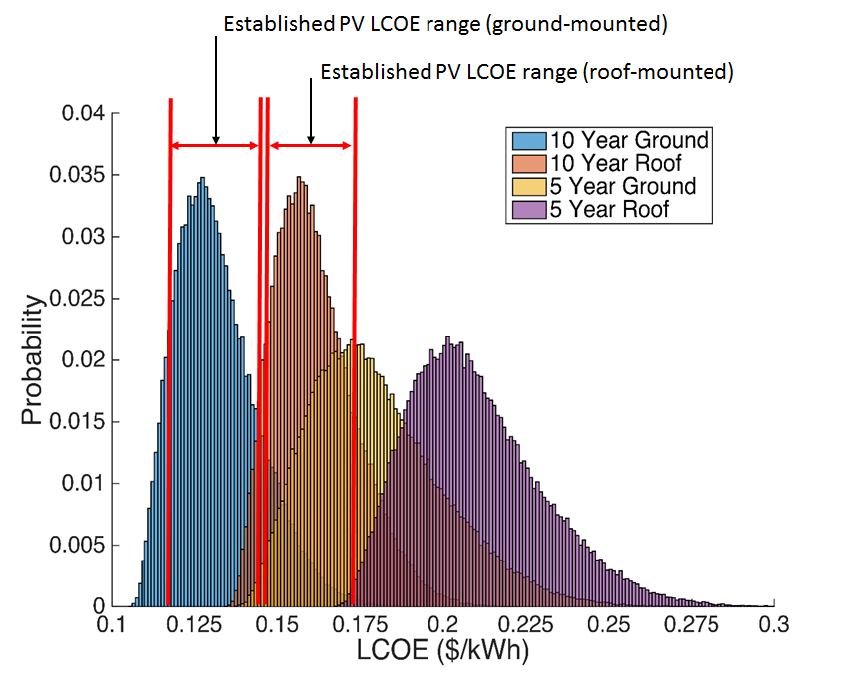
Figure 7: Levelised cost of electricity (LCOE) generated for roof- and ground-mounted OPV systems, using module cost ranges
By comparison, Mulligan et al.’s calculation of LCOE for roof-based OPV systems (with size 160 m², equivalent to a capacity of about 5 kW assuming 3% module efficiency) results in an LCOE of US$0.12/kWh for 10-year lifetime modules and US$0.13/kWh for 5-year lifetime modules. These compare to the median values of US$0.16/kWh for 10-year and US$0.21/kWh for 5-year roof-mounted modules represented in this analysis. Key differences are: the lower module cost in Mulligan et al., which assumes a US$7.85/m² module cost, equivalent to US$0.16/Wp when using an efficiency of 5%, which is approximately the median efficiency used in this analysis, compared to a module cost of US$0.30/Wp (including a 10% margin) as used here; the lower balance of systems cost, which – at about US$40/m² in Mulligan et al., equates to about US$0.8/Wp at 5% module efficiency. It is also of note that Mulligan et al.’s calculated LCOE is less sensitive to module lifetime than calculated in this study, since the module cost is only 16% of the initial system cost, whereas in this study the module cost (including retail mark-up) is 21% of initial balance of system costs and closer to 50% of replacement system costs (which are assumed to consist only of new modules and labour to install these). This indicates the degree of sensitivity of LCOE to OPV module performance (cost, efficiency, lifetime). It also suggests that the additional dominance of balance of system costs in Mulligan et al’s analysis is important in driving the relatively small difference in LCOE between their 5-year and 10-year lifetime systems.

Discussion
This analysis suggests there are likely to be four significant determinants of future OPV module cost in the near-term term: plant manufacturing scale; material costs; geometrical fill factor and power conversion efficiency. The first two factors (plant scale and material costs) are both likely to depend on industry scale – a larger OPV industry means higher throughput equipment, larger plants, and commercial-scale quantities of material inputs. This is just the type of cost reduction effect seen in the last two decades or so of c-Si PV development [17], and suggests that to some extent policies to help expand the PV market could be a critical determinant of OPV’s success. The latter two factors (geometrical fill factor and power conversion efficiency) are more dependent on design innovations, where further R&D and pilot-scale production (testing a variety of materials and printing processes) are likely to bear fruit. Here policy should support a targeted effort towards specific design improvements. In addition to these factors, the other key determinant of OPV’s ability to compete with the established PV technologies in levelised cost terms is the module lifetime – according to this analysis, 5 years does not make OPV competitive but 10 years does. Increased module lifetimes will also require further experimentation with materials and production processes, which will (as with efficiency and fill factor) require targeted research efforts.
An obvious question is why focus on making OPV competitive with established PV technologies at all, rather than simply directing policy effort and finance towards further lowering the costs of the established technologies? One response to this is that OPV offers performance benefits, in terms of much lower energy payback, a relatively simple manufacturing process with smaller plant set-up costs, as well as thin-film, flexible properties, with an abundance of input material availability. Another, perhaps more important factor, is that OPV’s future cost reduction potential beyond the median values projected in this study is significant. Estimates at the more optimistic end of the range are as low as $0.06/Wp (Machui et al. [14], based on multi-GW scale production, lowest material cost estimates and efficiencies around 10%) – an order of magnitude lower than the near-term projections of competing technologies. Even with more conservative assumptions on efficiency as used in this study (i.e. 7%) the lowest end of the range shown in figure 3 is around $0.1/Wp – still much less than the nearest competitor in the near-term (CIGS at $0.35/Wp). This makes OPV worth further investigating. Nevertheless, the increasing dominance of the balance of systems costs in levelised electricity costs means that an equal if not greater focus should now be placed on driving down the non-module components (inverters, meters, cabling and support structures) and PV system installation costs (essentially labour time).
A final consideration from this analysis is how the module cost and levelised cost of electricity estimates derived using the approach in this study compare to those produced through expert elicitations, which is an instructive way of informing how different approaches to projecting technology costs compare to each-other. Of the three major PV expert elicitation exercises so far produced, the most optimistic is that of Baker et al. [18] which uses expert assessments on the likelihood of key technical challenges being overcome so as to achieve “success”. Here the definition of success is to manufacture OPV modules with a 15-30 year life, 15-31% efficiency and $50/m² total manufacturing (including material) cost, leading to a levelised cost of $0.03-0.05/kWh. It is difficult to compare the results of this expert elicitation directly with the results presented here, because the focus is on long-term (by 2050) OPV potential, with significantly better performance parameters than assumed in this study. The probability of achieving these levels of OPV performance were assessed as very low by the experts questioned (with most probabilities less than 0.1, and in only one case – 15% efficient OPV with a 30-year lifetime and $50/m² manufacturing cost – one expert giving a probability greater than this, at 0.34). Nevertheless, the median manufacturing cost in the analysis presented here, at $12/m², is less than a quarter of that assumed in the Baker et al. [18] analysis, whose $50/m² is actually achievable today at pilot scales [13].
Curtright et al. [7], which focuses on module costs only (i.e. no estimation of levelised electricity costs), show that none of 18 PV experts gave a probability greater than 0.3 of OPV costs falling below $0.3/Wp before 2030. This study contends that, with a median near-term value of $0.28/Wp, that could be much more likely. In fact the Curtright et al [7] analysis may well reflect a degree of pessimism resulting from relatively high silicon prices in the mid-2000s when the elicitation was performed. Bosetti et al’s [19] expert elicitation of European experts, focusing on levelised costs of electricity for PV-generated electricity (rather than OPV specifically), suggests current (in this case 2011) R&D levels would see a median levelised cost of electricity by 2030 of $0.12/kWh, with increased R&D funding scenarios (at levels of an additional 50% and 100%) achieving $0.09/kWh and $0.08/kWh respectively. The LCOE deriving from the current R&D funding scenario figure broadly matches the near-term LCOE for ground-mounted PV in this study, as shown in figure 7. However, here we suggest that not just increased R&D funding but also increased industry (and therefore plant) scale could be key contributors to further PV electricity cost reductions.
This is one of the most important insights of a component and process-based cost projection approach such as that presented here, when compared to those expert elicitation approaches referred to above – those approaches either do not explicitly discuss the impact of different factors in driving down costs [7], or otherwise do not allow a comparative analysis of the cost impacts of performance improvements in PV modules with those impacts resulting from material input cost changes and manufacturing scale improvements [18], [19].

Conclusion
The use of a statistical analysis in order to combine multiple uncertain parameters affecting technology costs is a useful way of determining a range of plausible costs for emerging technologies, as well as highlighting those parameters to which overall technology costs are most sensitive. This helps identify which factors should be the focus of further cost reduction effort, as well as which policies (e.g. those that stimulate basic R&D, those that help increase market size) might help to achieve these cost reductions.
A comparative assessment of one emerging technology (OPV) has been undertaken using this approach, suggesting a module cost of $0.23-0.34/Wp (inter-quartile range) is achievable if it is manufactured at commercial scales, if material costs fall in line with the views of experts as elicited from the literature, and if particular performance parameters such as efficiency can be achieved. Further analysis shows that this means OPV could compete with established PV technologies in terms of levelised costs of electricity generated in the near-term (i.e. by 2020), provided that module lifetimes of the order of 10 years can be achieved through enhanced device stability. In policy terms, the analysis suggests that whilst fundamental R&D into increasing efficiency and stability of OPV is key, policies to support the increase of manufacturing scale are also very important to achieve OPV module cost reductions. The overall projections of utility-scale PV-generated electricity costs (within a range of about $0.11-0.17/kWh by 2020) appear to be in line with the most recent expert elicitation exercise which focused on levelised costs in 2030, suggesting that there can be some confidence around the attainment of PV-generated electricity costs of close to $0.10/kWh in the next decade.

Acknowledgements
The authors would like to thank the UK Engineering and Physical Sciences Research Council (EPSRC) for a Pathways to Impact grant supporting the project “Routes to accelerated deployment of solar photovoltaics: the role of innovation in module technology, innovation and policy” (PS8521_PHES). We would also like to thank Chris Emmott of Imperial College London for helpful comments on a draft of this paper. PS would like to acknowledge the Grantham Institute - Climate Change and the Environment, for a PhD studentship and support from Climate-KIC. JN would like to thank the Royal Society for a Wolfson Merit Award.

References
[1] International Energy Agency, Energy Technology Perspectives 2014: Harnessing Electricity’s Potential, IEA ; OECD, 2014.
[2] A. Gambhir, T.A. Napp, C.J.M. Emmott, G. Anandarajah, India’s CO2 emissions pathways to 2050: Energy system, economic and fossil fuel impacts with and without carbon permit trading, Energy. 77 (2014) 791–801. doi:10.1016/j.energy.2014.09.055.
[3] A. Gambhir, N. Schulz, T. Napp, D. Tong, L. Munuera, M. Faist, K. Riahi, A hybrid modelling approach to develop scenarios for China’s carbon dioxide emissions to 2050, Energy Policy. 59 (2013) 614–632. doi:10.1016/j.enpol.2013.04.022.
[4] IPCC, Climate Change 2014: Working Group III: Mitigation of Climate Change, IPCC, United Nations, 2014.
[5] ITRPV, International Technology Roadmap for Photovoltaic (2013 results), (2014).
[6] S. Mehta, PV Technology and Cost Outlook 2013-2017, (2013).
[7] A.E. Curtright, M.G. Morgan, D.W. Keith, Expert Assessments of Future Photovoltaic Technologies, Environ. Sci. Technol. 42 (2008) 9031–9038. doi:10.1021/es8014088.
[8] G.F. Nemet, Beyond the learning curve: factors influencing cost reductions in photovoltaics, Energy Policy. 34 (2006) 3218–3232. doi:10.1016/j.enpol.2005.06.020.
[9] T. de Jong, First Solar Analyst Day Manufacturing update, (2014). http://files.shareholder.com/downloads/FSLR/3810099415x0x735349/0BB4395A-4490-4511-8784-DEFF623B9205/FS_AnalystDay_ManufacturingUpdate.pdf.
[10] PVTech, First Solar hits Cost Reduction Milestone, (2013). http://www.pv-tech.org/news/has_first_solar_retaken_the_lowest_cost_pv_manufacturer_mantle.
[11] M. Bazilian, I. Onyeji, M. Liebreich, I. MacGill, J. Chase, J. Shah, D. Gielen, D. Arent, D. Landfear, S. Zhengrong, Re-considering the economics of photovoltaic power, Renew. Energy. 53 (2013) 329–338. doi:10.1016/j.renene.2012.11.029.
[12] P. Sandwell, N.L.A. Chan, S. Foster, D. Nagpal, C.J.M. Emmott, C. Candelise, S.J. Buckle, N. Ekins-Daukes, A. Gambhir, J. Nelson, Off-grid solar photovoltaic systems for rural electrification and emissions mitigation in India, Sol. Energy Mater. Sol. Cells. (2016). doi:http://dx.doi.org/10.1016/j.solmat.2016.04.030i.
[13] B. Azzopardi, C.J.M. Emmott, A. Urbina, F.C. Krebs, J. Mutale, J. Nelson, Economic assessment of solar electricity production from organic-based photovoltaic modules in a domestic environment, Energy Environ. Sci. 4 (2011) 3741. doi:10.1039/c1ee01766g.
[14] F. Machui, M. Hösel, N. Li, G.D. Spyropoulos, T. Ameri, R.R. Søndergaard, M. Jørgensen, A. Scheel, D. Gaiser, K. Kreul, D. Lenssen, M. Legros, N. Lemaitre, M. Vilkman, M. Välimäki, S. Nordman, C.J. Brabec, F.C. Krebs, Cost analysis of roll-to-roll fabricated ITO free single and tandem organic solar modules based on data from manufacture, Energy Environ. Sci. 7 (2014) 2792–2802. doi:10.1039/C4EE01222D.
[15] F.C. Krebs, T. Tromholt, M. Jørgensen, Upscaling of polymer solar cell fabrication using full roll-to-roll processing, Nanoscale. 2 (2010) 873–886. doi:10.1039/B9NR00430K.
[16] S.B. Darling, F. You, The case for organic photovoltaics, RSC Adv. 3 (2013) 17633–17648. doi:10.1039/C3RA42989J.
[17] A. Gambhir, R.J. Green, R.J.K. Gross, The impact of policy on technology innovation and cost reduction: a case study on crystalline silicon solar PV modules (Working Paper), (2014). http://www.imperial.ac.uk/media/imperial-college/grantham-institute/public/publications/working-papers/The-impact-of-policy-on-technology-innovation-and-cost-reduction-WP.pdf.
[18] E. Baker, H. Chon, J. Keisler, Advanced solar R&D: Combining economic analysis with expert elicitations to inform climate policy, Energy Econ. 31, Supplement 1 (2009) S37–S49. doi:10.1016/j.eneco.2007.10.008.
[19] V. Bosetti, M. Catenacci, G. Fiorese, E. Verdolini, The future prospect of PV and CSP solar technologies: An expert elicitation survey, Energy Policy. 49 (2012) 308–317. doi:10.1016/j.enpol.2012.06.024.
[20] C.J. Mulligan, M. Wilson, G. Bryant, B. Vaughan, X. Zhou, W.J. Belcher, P.C. Dastoor, A projection of commercial-scale organic photovoltaic module costs, Sol. Energy Mater. Sol. Cells. 120, Part A (2014) 9–17. doi:10.1016/j.solmat.2013.07.041.
[21] A.L. Roes, E.A. Alsema, K. Blok, M.K. Patel, Ex-ante environmental and economic evaluation of polymer photovoltaics, Prog. Photovolt. Res. Appl. 17 (2009) 372–393. doi:10.1002/pip.891.
[22] J. Kalowekamo, E. Baker, Estimating the manufacturing cost of purely organic solar cells, Sol. Energy. 83 (2009) 1224–1231. doi:10.1016/j.solener.2009.02.003.
[23] G. Dennler, C.J. Brabec, Socio-Economic Impact of Low-Cost PV Technologies, in: C. Brabec, V. Dyakonov, U. Scherf (Eds.), Org. Photovolt., Wiley-VCH Verlag GmbH & Co. KGaA, 2008: pp. 531–566. http://onlinelibrary.wiley.com/doi/10.1002/9783527623198.ch20/summary (accessed February 16, 2015).
[24] G. Dennler, M.C. Scharber, C.J. Brabec, Polymer-Fullerene Bulk-Heterojunction Solar Cells, Adv. Mater. 21 (2009) 1323–1338. doi:10.1002/adma.200801283.
[25] T.D. Nielsen, C. Cruickshank, S. Foged, J. Thorsen, F.C. Krebs, Business, market and intellectual property analysis of polymer solar cells, Sol. Energy Mater. Sol. Cells. 94 (2010) 1553–1571. doi:10.1016/j.solmat.2010.04.074.
[26] C. Powell, Y. Lawryshyn, T. Bender, Using stochastic models to determine financial indicators and technical objectives for organic solar cells, Sol. Energy Mater. Sol. Cells. 107 (2012) 236–247. doi:10.1016/j.solmat.2012.06.038.
[27] C. Powell, T. Bender, Y. Lawryshyn, A model to determine financial indicators for organic solar cells, Sol. Energy. 83 (2009) 1977–1984. doi:10.1016/j.solener.2009.07.009.
[28] F.C. Krebs, Fabrication and processing of polymer solar cells: A review of printing and coating techniques, Sol. Energy Mater. Sol. Cells. 93 (2009) 394–412. doi:10.1016/j.solmat.2008.10.004.
[29] C.J. Mulligan, C. Bilen, X. Zhou, W.J. Belcher, P.C. Dastoor, Levelised cost of electricity for organic photovoltaics, Sol. Energy Mater. Sol. Cells. 133 (2015) 26–31. doi:10.1016/j.solmat.2014.10.043.
[30] G.F. Nemet, E. Baker, Demand Subsidies Versus R&D: Comparing the Uncertain Impacts of Policy on a Pre-commercial Low-carbon Energy Technology, Energy J. 30 (2009) 49–80.
[31] A.J. Medford, M.R. Lilliedal, M. Jørgensen, D. Aarø, H. Pakalski, J. Fyenbo, F.C. Krebs, Grid-connected polymer solar panels: initial considerations of cost, lifetime, and practicality, Opt. Express. 18 (2010) A272–A285. doi:10.1364/OE.18.00A272.
[32] EU Manufacturer, Discussion with European printing and coating equipment manufacturer, (2014).
[33] F.T. Moore, Economies of Scale: Some Statistical Evidence, Q. J. Econ. 73 (1959) 232–245. doi:10.2307/1883722.
[34] A. Goodrich, P. Hacke, Q. Wang, B. Sopori, R. Margolis, T.L. James, M. Woodhouse, A wafer-based monocrystalline silicon photovoltaics road map: Utilizing known technology improvement opportunities for further reductions in manufacturing costs, Sol. Energy Mater. Sol. Cells. 114 (2013) 110–135. doi:10.1016/j.solmat.2013.01.030.
[35] V.K. Kapur, V.K. Kapur, A. Bansal, S. Roth, Roadmap for Manufacturing Cost Competitive CIGS Modules, (2011). http://ieeexplore.ieee.org/stamp/stamp.jsp?arnumber=06318289.
[36] D.T. Krick, H. Weinzerl, T. Behrens, PV manufacturing scaling to giga-watt capacity: Lessons learned from the semiconductor and flat panel display industries, in: IEEE, 2010: pp. 000736–000741. doi:10.1109/PVSC.2010.5617089.
[37] D. Yue, P. Khatav, F. You, S.B. Darling, Deciphering the uncertainties in life cycle energy and environmental analysis of organic photovoltaics, Energy Environ. Sci. 5 (2012) 9163–9172. doi:10.1039/C2EE22597B.
[38] M.A. Green, K. Emery, Y. Hishikawa, W. Warta, E.D. Dunlop, Solar cell efficiency tables (Version 45), Prog. Photovolt. Res. Appl. 23 (2015) 1–9. doi:10.1002/pip.2573.
[39] Parsons Brinckerhoff, Solar PV Cost Update (report for UK Deprtment of Energy and Climate Change), (2012). https://www.gov.uk/government/uploads/system/uploads/attachment_data/file/43083/5381-solar-pv-cost-update.pdf.
[40] IEC, Photovoltaic system performance monitoring––guidelines for measurement, data exchange and analysis, (1998).
[41] Fraunhofer Institute, Levelized Cost of Electricity, Renewable Energy Technologies, (2013). http://www.ise.fraunhofer.de/en/publications/veroeffentlichungen-pdf-dateien-en/studien-und-konzeptpapiere/study-levelized-cost-of-electricity-renewable-energies.pdf.
[42] R. Søndergaard, M. Hösel, D. Angmo, T.T. Larsen-Olsen, F.C. Krebs, Roll-to-roll fabrication of polymer solar cells, Mater. Today. 15 (2012) 36–49. doi:10.1016/S1369-7021(12)70019-6.

