Challenges on Primary Frequency Control and Potential Solution from EVs in the Future GB Electricity System

Fei Teng ^{a,}, Yunfei Mu^{b}, Hongjie Jia^{b}, Jianzhong Wu^{c}, Pingliang Zeng^{d} and Goran Strbac ª

ª Imperial College London, London, United Kingdom
^{b} Key Laboratory of Smart Grid of Ministry of Education, Tianjin University, China
^{c} Institute of Energy, Cardiff University, Cardiff, United Kingdom
^{d} China Electric Power Research Institute, Beijing, China

Highlights
- Analysis of the impact of reduced system inertia on primary frequency control
- Quantification of the primary frequency response requirements in the future GB low-inertia systems
- Assessment of the cost and emission driven by primary frequency control
- Evaluation of the benefits of EVs in providing primary frequency response
- Identification of the synergy between primary frequency response provision and “smart charging” strategy.

Abstract
System inertia reduction, driven by the integration of renewables, imposes significant challenges on the primary frequency control. Electrification of road transport not only reduces carbon emission by shifting from fossil fuel consumption to cleaner electricity consumption, but also potentially provide flexibility to facilitate the integration of renewables, such as supporting primary frequency control. In this context, this paper develops a techno-economic evaluation framework to quantify the challenges on primary frequency control and assess the benefits of EVs in providing primary frequency response. A simplified GB power system dynamic model is used to analyse the impact of declining system inertia on the primary frequency control and the technical potential of primary frequency response provision from EVs. Furthermore, an advanced stochastic system scheduling tool with explicitly modelling of inertia reduction effect is applied to assess the cost and emission driven by primary frequency control as well as the benefits of EVs in providing primary frequency response under two representative GB 2030 system scenarios. This paper also identifies the synergy between PFR provision from EVs and “smart charging” strategy as well as the impact of synthetic inertia from wind turbines.

1. Introduction
Due to variability, uncertainty and limited inertia capability of renewable energy resources (RES), the demand on ancillary services would increase significantly in the future low carbon systems. For example, variable speed wind turbines are currently unresponsive to the system frequency [1]. Therefore, as wind generation displaces conventional plants, system inertia provided by rotating mass reduces. This leads to accelerated decline of system frequency after generation outage [2] and hence imposes challenges on primary frequency control (PFC).
The authors in [3] summarise the challenges to control a system with low inertia. Moreover, the study on the evolution of PFC in GB [4] suggests that increased amount of primary frequency response (PFR) is required in order to maintain frequency nadir within the standards. These additional PFR will be primarily delivered through part-loaded plants, which not only lead to higher operation cost, but may also eventually compromise the capability of the system to absorb growing wind generation. The authors in [5] show that there is a maximum level of instantaneous wind penetration given a frequency deviation limit. However, the impact of reduced system inertia on the annual system operation cost and carbon emission have not yet been fully investigated.
Alternative measures have been proposed to tackle the challenges on PFC. Efficient algorithms are developed to optimize PFR provision through dynamically adjusting the droop coefficients of conventional plants [7] and simultaneously scheduling PFR and system inertia [8]. The possibility of frequency support from wind generation has also been analysed in [9] [10]. Electric vehicles (EVs), as an important subset of demand side response, are becoming as one of the key policy options to enable the decarbonisation of transport sector. Furthermore, as EVs are characterized by inherent storage capability, high penetration of EVs may provide benefits to the system by treating EV charging load as flexible demand [11] [12]. Extensive research have been carried out to analyse the impacts of EVs under different charging strategies on the utilization of RES [13], power loss [14] and distribution substation [15]. While the market designs to enable the flexibility provision from EVs are discussed in [16] [17]. In fact, EVs are also capable to quickly change the charging load to provide PFR [18] [19]. PFC support from EVs has been shown to effectively improve the system frequency performance in 2020 GB system by providing static frequency response [20] or dynamic frequency response [21]. The authors in [23] [24] analyse the impact of EVs charging strategies and generation system mixes on the benefits of EVs in providing primary reserve. The impacts of distribution network losses and constraints on the PFC support from EVs are studied in [25]. However, the above literatures do not explicitly consider the impacts of the reduced and varying system inertia in the future low carbon systems, which may lead to an underestimation on the benefits of PFR provision from EVs.
In this context, this paper firstly carries out dynamic simulations by using a simplified GB system model to demonstrate the impact of declining system inertia on PFC and the technical potential of EVs to provide PFR. Then an advanced stochastic scheduling tool with explicitly modelling of inertia reduction effect is applied to quantify the annual operation cost and carbon emission driven by PFC as well as the economic and environmental benefits of EVs in providing PFR in the future low inertia systems. The synergy between PFR provision from EVs and “smart charging” strategy as well as the impact of synthetic inertia provision from wind turbines are identified.
The structure of this paper is as follows. Section 2 describes PFC in GB electricity system and analyses the challenges on PFC in the future low-inertia system. Section 3 discusses and validates the technical potential of EVs in providing PFR. In Section 4, the annual operations of two representative GB 2030 electricity systems are simulated to assess the cost and emission driven by PFC as well as the benefits of PFR provision from EVs. Section 5 concludes the paper.

2. Primary Frequency Control in the Future Great Britain Electricity System
In this section we apply a simplified power system dynamic model to analyse the impact of declining inertia on the system frequency performance. The requirements on PFR are also quantified to maintain the post-fault frequency deviation within the statutory limits in the future low carbon system.

2.1 Impact of declining system inertia on the primary frequency control
An overriding factor in the power system operation is to maintain the security of supply, i.e. to supply customers with electricity while meeting the quality of supply requirements at all times. Therefore, the balance between demand and generation must be continually sustained in order to keep the system frequency within a narrow range around nominal frequency. As shown in Fig 1, GB Security and Quality of Supply Standard (GB-SQSS) [26] requires frequency change to be maintained within ±0.2 Hz of the nominal frequency under normal operating conditions, while for a sudden generation loss up to 1800 MW, the minimum frequency needs to be limited to 49.2 Hz with frequency restored to 49.5 Hz within 1 minute.
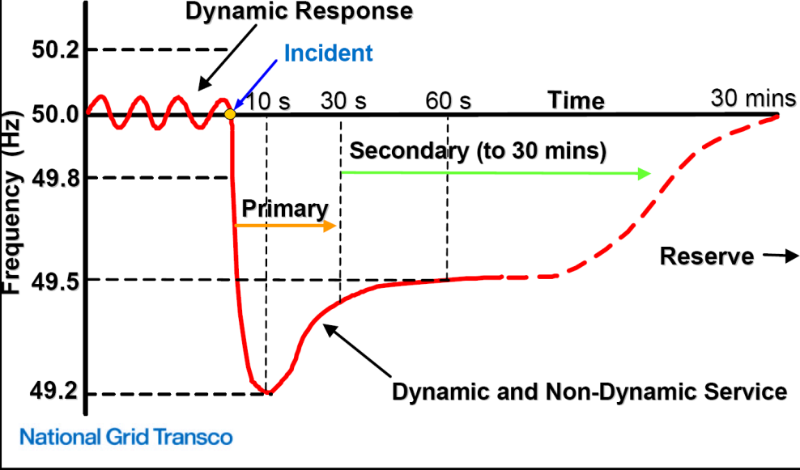
Fig 1 System frequency control (National Grid)
The system operator procures frequency response services to ensure that the system can withstand the largest credible outage. In particular, PFR is defined as the automatic increase in output or decrease in demand, in response to a fall in frequency that occurs in the period 0 to 10 seconds from the time of the frequency fall and is sustained for a further 20 seconds. The present requirements on PFR services are represented in the form of curves that specify the required amount for a given demand level and size of generation loss [27]. However, as the reduction of system inertia driven by the integration of RES, the present PFR requirements may not be sufficient to maintain the system security.
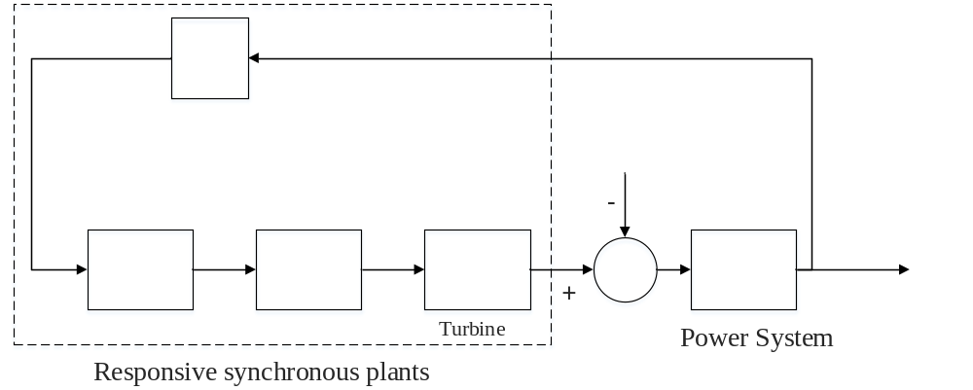Fig. 2 Simplified GB dynamic model
This sub-section therefore applies a simplified GB power system dynamic model [20] to demonstrate the impact of declining system inertia on PFC. The structure of the model is shown in Fig.2, which takes into account of frequency response characteristics of the generators and damping effect of the frequency-dependent loads. In this model synchronous thermal plants respond to a drop in frequency by increasing their power output. The speed control of the turbines is represented by a governor droop with an equivalent gain value, which depends on the combined effect of the droops of all generator speed governors. The typical governor actuator time constant, transient droop compensation and turbine time constant are also included in the model. The parameters of this simplified model are determined based on a severe frequency event that occurred in GB on 27th May 2008 [28].
A loss of 1.8 GW generation is applied in the system with 25 GW base demand and different equivalent inertia time constants. As shown in Fig.3, the system frequency declines much faster and reaches a lower level of frequency nadir in the case with lower inertia. In particular, the minimum frequency reaches 49.1 Hz in the case with 4s inertia time constant, which is out of the security boundary specified by GB SQSS. It is also worth pointing out that the steady-state frequency keeps constant regardless of the level of system inertia. In conclusion, declining system inertia would lead to a lower transient frequency nadir, but show no impact on the system frequency level in the steady state.
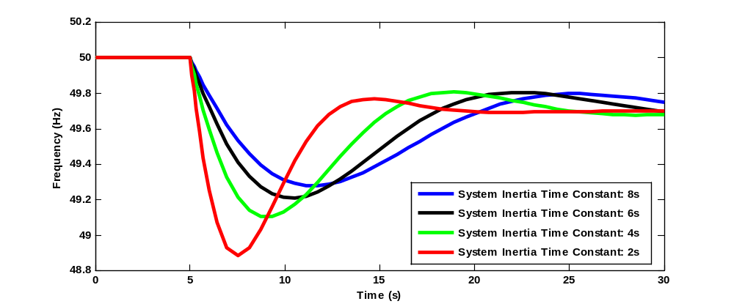
Fig. 3 Impact of declining system inertia on the primary frequency control
2.2 Quantifying the future requirements for primary frequency response
As shown in Section 2.1, the present requirement on PFR may lead to an unsecured frequency nadir in the future systems with declining inertia. This sub-section hence implements an analytical framework to dynamically quantify the needs for PFR to maintain the frequency deviation within the statutory limits.
The dynamic model in Fig 2 is further simplified by assuming the delivery of PFR to linearly increase with time and thus characterized by a fixed slope until scheduled amount of PFR is delivered at $T_{d}$ [4]. Therefore, the evolution of system frequency in time can be described by a first-order ordinary differential equation:
 | $$2*H*\frac{∂∆f(t)}{∂t}+D*P^{D}*∆f\left(t\right)=\frac{R}{T_{d}}*t-∆P_{L}$$ | (1)
where H [MWs/Hz] is the system inertia, D [1/Hz] represents the load damping rate, $P^{D}$[MW] is the load level and $R$ [MW] describes the total amount of scheduled PFR, $T_{d}$ [s] is the delivery time of PFR and $∆P_{L}$ [MW] is defined as the loss of generation.
As discussed in Section 2.1, GB SQSS explicitly requires frequency nadir and steady-state frequency above specified levels. According to our previous work in [8], these two standards could be reformed as the following constraints based on the system inertia ($H$) and the scheduled amount of PFR ($R$):
- Frequency constraint at nadir ($∆f_{min}$)
$$2*\frac{R}{T_{d}}*H⋅\log\left(\frac{2*\frac{R}{T_{d}}*H}{D*P^{D}*∆P_{L}+2*\frac{R}{T_{d}}*H}\right)≤-{\left(D*P^{D}\right)}^{2}*∆f_{min}-D*P^{D}*∆P_{L} (2)$$
- Frequency constraint at steady state ($Δf_{min}^{ss}$)
$$R≥∆P_{L}+D*P^{D}*Δf_{min}^{ss} (3)$$
While the present frequency response requirement is primarily driven by the steady state frequency threshold, the increased rating of the largest plant and the growing penetration of wind generation will make constraints associated with transient frequency evolution (frequency nadir) significantly more relevant. Assuming that inertia time constant of thermal plants is 5s, the demand damping rate is zero and the average loading level of conventional plants is 80%, the transient as well as steady-state driven PFR requirements are illustrated based on the proposed constraints (2) and (3).
Fig 4 presents the impact of the size of generator loss on the required volume of PFR, both in transient and steady-state timescales. The steady-state requirement is a linearly decreasing function of demand level. With larger size of generator loss, the steady-state requirement increases by exactly 480 MW for any demand level, i.e. by the difference between the loss sizes of 1.32 GW and 1.8 GW. On the other hand, the impact on the transient-state is profoundly different. At lower demand levels, the transient-state requirement for a 1.8 GW loss increases by more than 2 GW over the case with 1.32 GW loss. Although it diminishes at higher demand levels, it consistently remains significantly higher than in the case of 1.32 GW loss. Another observation is that the breakeven point where the transient-state requirement becomes lower than the steady-state moves from 25 GW of demand for 1.32 GW loss to 40 GW with 1.8 GW loss. This indicates that the transient requirement would be critical within a broader range of possible demand levels.
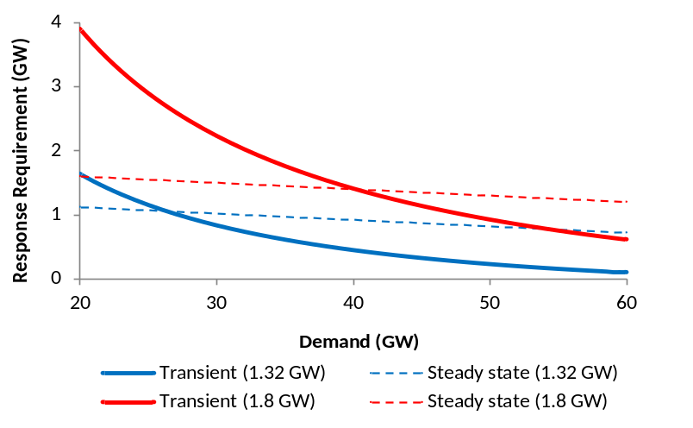
Fig.4 Transient and steady-state PFR requirements for different sizes of generation loss
Assuming a generation loss of 1.8 GW, the impact of instantaneous penetration level of wind generation on the PFR requirements is illustrated in Fig 5. Steady-state requirement is not affected by wind generation, and therefore only one steady-state characteristic is shown. In contrast, when wind contributes to 50% of electricity generation, and the system inertia $H$ effectively halves, the amount of PFR needed to cope with the transient frequency deviations almost doubles. Transient requirement at this level of wind penetration also becomes critical i.e. exceeds the steady-state requirement for the entire range of expected demand values. This increase is further exacerbated by the fact that there will be far fewer synchronised conventional generators that are capable of delivering PFR. As a result, without the support from alternative flexible resources, it might become inevitable to curtail wind generation in order to maintain the capability of the system to manage frequency deviation after generation outages.
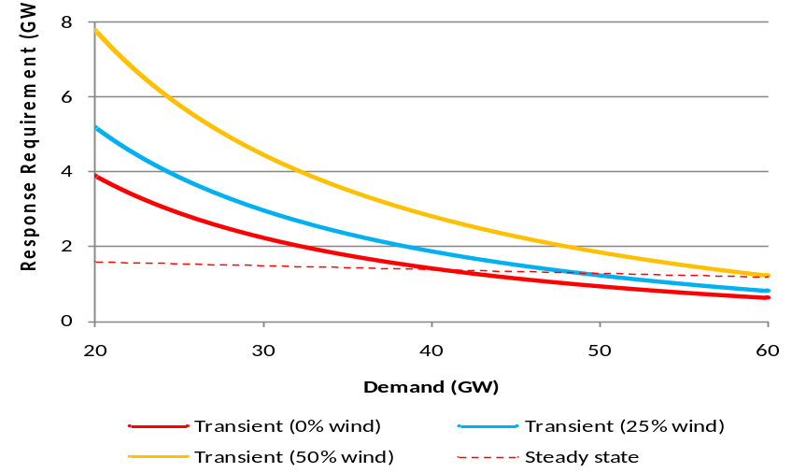
Fig 5 Transient and steady-state PFR requirements for different penetrations of wind

3. Primary Frequency Response Provision from Electric Vehicles
This section discusses the technical penitential of EVs to provide PFR under droop control strategy and analyse its impact on PFC in the future low inertia electricity system through dynamic simulations.

3.1 Potential of primary frequency response provision from EVs
Although the charging load of individual EV is highly unpredictable, it is possible to estimate the aggregated load of a population of EVs. Moreover, the charging of EVs only involves chemical and electromagnetic processes. Hence, EVs could rapidly change the charging power to provide PFR.
Different control strategies have been proposed to facilitate the provision of PFR from EVs [29]. In general, a droop control$\left(K_{drop}\right)$, that mimics the governor response of conventional plants, could be applied to change the charging power of EVs (${∆P}_{EV}^{PFR}$) proportionally to the frequency deviation ($∆f$):
$${∆P}_{EV}^{PFR}=-K_{droop}*∆f (4)$$
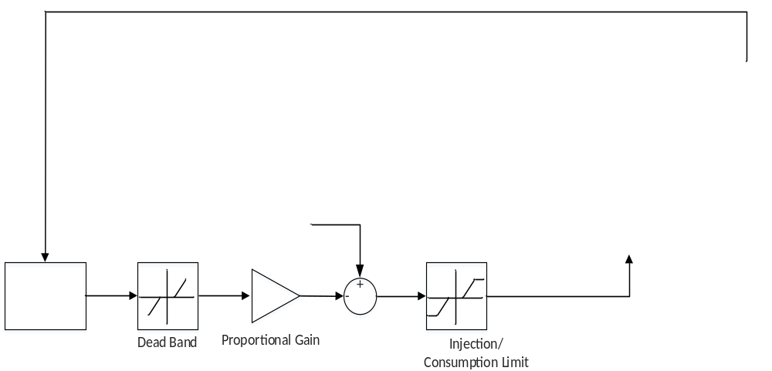Fig 6 Control strategy to facilitate the provision of PFR from EVs
As shown in Fig.6, a generic model could be used to describe EV charger [20], consisting of a DC-DC converter to step down the voltage to an appropriate level for the EV battery charging and an inverter connected to the grid through a small reactor. A droop control loop should be added into individual vehicle charger controller. Frequency deviations are measured locally and the reactions to frequency deviations are performed autonomously. Set-points for the electronic power converter are updated according to the frequency deviation. The change of EVs charging demand will be proportional to the actual deviation of system frequency. The power exchange between the inverter and the grid is assumed to be governed by a first order differential equation [20]. Therefore, a first order lag with a time constant is introduced for frequency studies. Moreover, a frequency dead-band could be included to prevent the frequent change of charging processes in order to maintain the lifetime of batteries. There are also some delay in the measurement due to the phase-locked loop in the power electronic interface, which, however, has been shown to be negligible [29] and therefore is not directly included in the model. The charging reference power (P^{EV} in Fig 6) could be set based on different charging strategies:
• “Dumb” charging: All EVs are assumed to start charging just after coming back from their daily trips until the batteries are fully charged.
• “Smart” charging: Set-point from system operator for EVs that adhere to smart charging schemes, which minimizes the whole system operation cost with the travel demand on EVs satisfied.

3.2 Impact of PFR provision from EVs on the system frequency performance
This sub-section presents the results of the dynamic simulations of the system post-fault frequency revolution with different levels of PFR provision from EVs. A similar case as in section 2.2 is applied, assuming 25 GW base demand and 2s inertia time constant. Fig 7 shows that the frequency nadir could be effectively improved with increased PFR contribution from EVs. In particular, with 0.5 GW PFR from EVs, the frequency nadir is enhanced from 48.85 Hz to 49.15 Hz. While in the case of 1 GW PFR from EVs, the frequency nadir is improved to 49.35, which becomes a secured operation state under GB-SQSS standards.
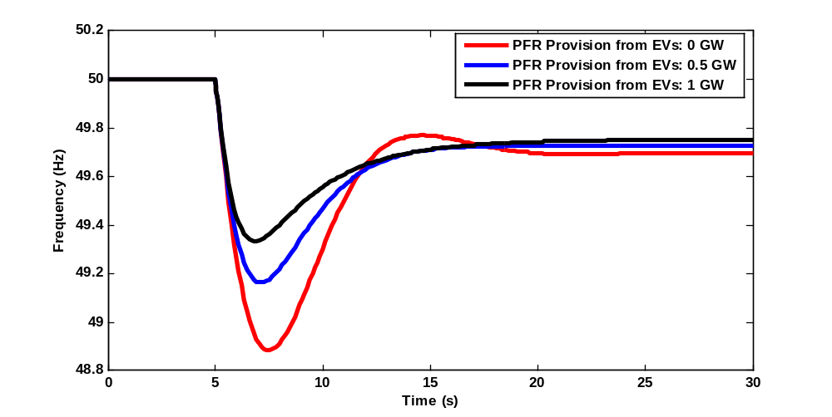
Fig. 7 Frequency evolution with different levels of PFR provision from EVs
In the case of 1GW PFR provision from EVs, Fig.8 shows the delivery of PFR from conventional plants as generation increase and from EVs as load reduction. The results suggest a similar pattern of PFR delivery for both conventional plants and EVs. In fact, as there is no mechanical process involved in the delivery of PFR from EVs, it is even capable to deliver PFR in a faster fashion than thermal plants. This will become more beneficial in the future low inertia systems.
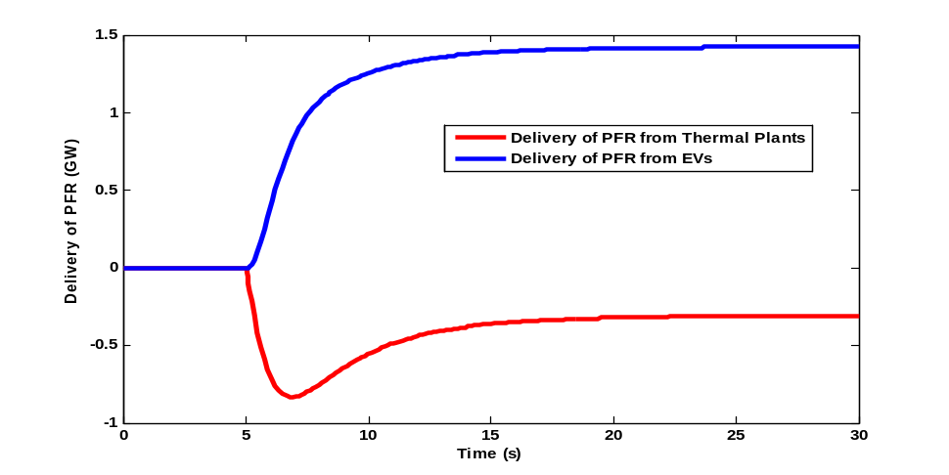
Fig. 8 Delivery of PFR from thermal plants and EVs
The frequency nadirs, under “dumb charging” and “smart charging” [20], are quantified for a typical day with varying levels of base demand. The equivalent system inertia time constant is assumed to be 2s. The profiles of base demand and EVs charging demands under two charging strategies are shown in Fig.9 (a). In the case without PFR provision from EVs, the results in Fig.9 (b) suggest that PFC challenges are more significant during low demand period. In particular, the system frequency nadir is below the low frequency limit from hour 0 to 8 and from hour 20 to 24.
Under “Dumb” charging strategy, EVs charging load is concentrated between hour 13 and 22 when the base demand is already high. Although the frequency nadirs during these peak base demand hours are further improved, the support from EVs in PFC is negligible from hour 0 to 8 when the frequency nadir stays below the limit.
On the other hand, “smart” charging strategy tends to schedule EVs to charge during the periods with low base demand, between 0 am and 6 am in this particular case. Therefore, the frequency nadirs during these critical hours could be secured with the PFR provision from EVs. In conclusion, EVs under smart charging strategy could lead to a better support for PFC by providing PFR during low demand period when the frequency nadirs are below the limit. The results demonstrate the synergy between PFR provision from EVs and “smart charging” strategy.
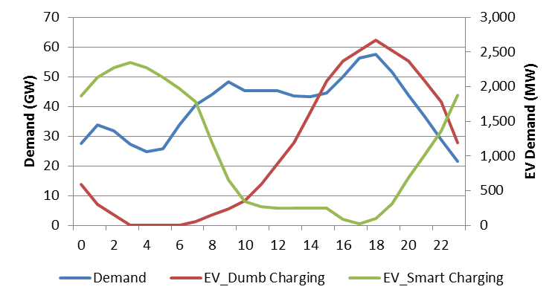
(a) Demand Profiles
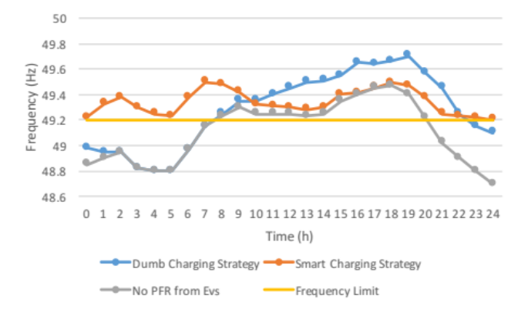
(b) Frequnecy Nadir under Different Charging Strategies
Fig. 9 Impact of charging strategy on the effectiveness of PFC support from EVs

4. Economic and Environmental Benefits of Primary Frequency Response Support from Electric Vehicles
In this section, the annual system operations with different levels of PFR provision from EVs are simulated by using an advanced stochastic unit commitment model with the future frequency response requirements developed in Section 3.2. The cost and carbon emission driven by PFC are first quantified over two representative GB 2030 system scenarios. Then, the economic and environmental benefits of PFR provision from EVs are assessed.

4.1 Methodology
This sub-section briefly introduces the advanced stochastic unit commitment model [2]. The scheduling model is formulated as a mixed integer linear programing (MILP) problem and solved over a multi-stage scenario tree as shown in Fig.10. The scenarios in the tree are selected based on user-defined quantiles and weighted according to their probability to realize. In each node of the tree, the frequency response requirements developed in Section 3.2 is imposed to maintain the system frequency stability. The simulations are carried out with rolling planning approach, performing a complete unit commitment and economic dispatch calculation with 24-h horizon in half-hourly time steps. At the next time step, an updated scenario tree, covering 24-h time horizon, is then built and applied to adjust commitment decisions, respecting intra-temporal constraints for both conventional plants (e.g. ramp rate) and demand side response (e.g. energy limits). The scheduling model optimizes the system operation by simultaneously scheduling energy production, operating reserves and PFR, in light of uncertainties associated with wind generation and generator outages. The optimal solution is a balance between the costs to commit additional generation against the benefit of reduced expected energy not supplied.

Future Primary Frequency Response Requirements with Contribution of EVs
Time ahead
Net Demand (MW)
Fig.10 Schematic of a typical scenario tree in SUC
Hence, the objective function is:
$$\sum_{n∈N}{π\left(n\right)\left(\sum_{gϵG}{C_{g}\left(n\right)+∆τ\left(n\right)\left(c^{LS}P^{LS}\left(n\right)\right)}\right) }(5)$$
The optimization subjects to the system-level constraints, including load balance constraint and fast frequency response constraints; local constraints for thermal units, such as minimum and maximum generation, commitment time, minimum up and down times, ramping rates, fast frequency response provision, as well as for storage units. Details on these constraints and the equations describing generation costs are presented in [8]. This model directly incorporates the inertia-dependent PFR requirements from equations (2) and (3). However, given a level of system demand, the relationship between the transient response requirement and the amount of synchronized system inertia as in (2) is a nonlinear function, while our scheduling model is based on MILP formulation. Considering the fact that constraint (2) is convex over the feasible range ($H≥0,R≥0$), it can be linearized using piecewise linear function. Therefore, nonlinear constraint (2) is replaced by three linear constraints.
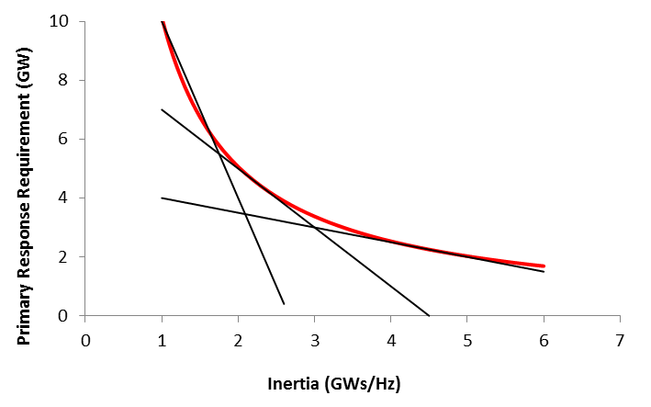
Fig.11 Linearized constraints on primary frequency response provision
Constraints associated with the operation of EVs are modelled as: a) Total shifted energy (6); b) Maximum percentage of demand can be shifted in/out in each hour (7); c) Maximum/minimum amount of total shifted energy (8); d) Daily balancing of energy shifting (9); e) Maximum PFR provision (10).
$$E\left(n\right)=E\left(a(n)\right)+\left(P^{c}\left(n\right)-H^{ORG}\left(n\right)\right)*t(n) (6)$$
$$(1-λ)H^{ORG}\left(n\right)≤P^{c}\left(n\right)≤(1+λ)H^{ORG}\left(n\right) \left(7\right)$$
$$E^{min}≤E\left(n\right)≤E^{max} \left(8\right)$$
$$E\left(n\right)=0 if t\left(n\right)=0 \left(9\right)$$
$$0≤R_{EV}(n)≤β^{max} P^{c}\left(n\right) \left(10\right)$$
where $H^{ORG}\left(n\right)$ is defined as unmodified demand for EVs, $E\left(n\right)$ is total shifted demand, $λ$ is the elasticity of EVs demand ($λ=0$ in the case of “dumb” charging), $E^{min}/E^{max}$ is the minimum/maximum amount of the shifted demand, t(n) is the time corresponding to node n, $R_{EV}(n)$ is PFR provision from EVs, $β^{max}$ is the maximum percentage of EVs demand that could contribute to frequency response.

4.2 Scenarios for the future GB electricity system
This paper implements two GB 2030 scenarios, representing different future low-carbon system development pathways [30]: nuclear-based system (2030NUC) and renewable-based system (2030RES). As shown in Fig.12, generation capacity in 2030NUC scenario is about 143 GW in total, of which 29 GW is wind generation and 27 GW is nuclear plant. On the other hand, total installed capacity in 2030RES scenario is around 176 GW, of which 77 GW is wind generation and 7.5 GW is nuclear plant. Economic and technical characteristics of the generators are specified in Table I.
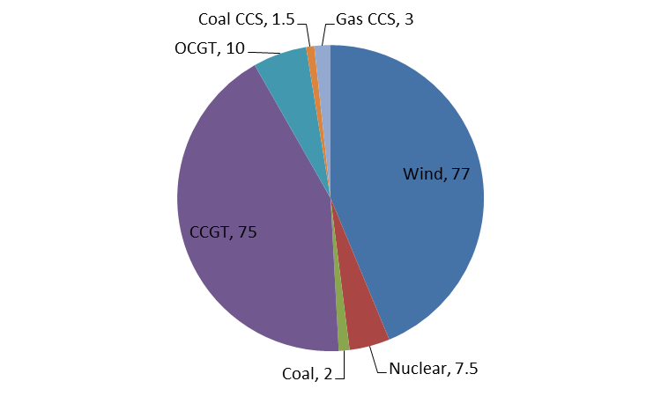 | 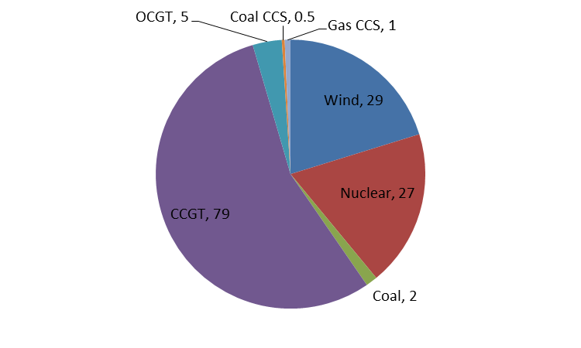
(a) 2030RES (GW) | (b) 2030NUC (GW)
Fig.12 Generation capacity mix for different GB scenarios in 2030
Table I Assumption on Economic and Technical Characteristics of Generators
 | Nuclear | Coal | CCGT | Coal CCS | Gas CCS | OCGT
Rated Power (MW) | 1000 | 500 | 500 | 500 | 500 | 200
Min Stable Gen (MW) | 600 | 200 | 200 | 200 | 200 | 50
No-load cost (£/h) | 606 | 3364 | 7809 | 1558 | 6314 | 0
Marginal cost (£/MWh) | 7.1 | 72.3 | 51.3 | 33.5 | 41.5 | 150
Start-up cost (£/start-up) | n/a | 89176 | 32243 | 44339 | 22370 | 0
Startup time (h) | n/a | 4 | 4 | 4 | 4 | 0
Min down time (h) | n/a | 4 | 4 | 4 | 4 | 0
Inertia Constant (s) | 5 | 5 | 5 | 5 | 5 | 5
Max Response (MW) | 0 | 50 | 50 | 50 | 50 | 20
Response Slope | 0 | 0.3 | 0.4 | 0.2 | 0.3 | 0.6
Emission (kgCO2/MWh) | 0 | 925 | 394 | 138 | 62 | 557

Demand data, including the assumptions on electrification of transport, is specified in the Table II. The base demand (excluding EV) for 2030 is with annual consumption of 414 TWh and peak demand of 99.8 GW. The EVs demand is assumed to be is with annual consumption of 19 TWh and peak demand of 5.3 GW. The same representative EV demand profile for GB as in [31] is used, which is constructed based on the EV trials conducted in Low Carbon London project [32].
Table II Demand Assumptions for the GB system in 2030
 | Base Demand (exclude EVs) | EV demand
Annual Consumption (TWh) | 414 TWh | 19 TWh
Peak Demand | 99.8 GW | 5.3 GW

4.3 Challenges on Primary Frequency Control in the Future GB systems
This sub-section quantifies economic and environmental impacts of PFC in the 2030 GB systems. As a comparison, the study is also carried out over 2015 GB system, which includes 12 GW wind generation and 10 GW nuclear plants. The annual system operations are simulated with and without PFR constraints and the differences on the operation cost and carbon emission are identified as the impact of PFC.
Table III shows the average amount of PFR provision is increased from 1835 MW in the current system to 1974 MW in 2030NUC and 2421 in 2030RES, which is driven by high penetration of inertia-less wind generation. The results also suggest that, compared with present case, the annual cost associated with PFC increases by 4.5 times in 2030NUC and 7.5 times in 2030RES. This increased cost is driven both by the increased amount of PFR requirement and by the reduced amount of synchronized frequency-responsive generation.
Table III Amount and cost of primary frequency response provision
 | 2015 | 2030NUC | 2030RES
Average amount of PFR provision (MW) | 1835 | 1974 | 2421
Annual cost of PFR provision (M£) | 202 | 899 | 1522
Moreover, the statistics of the amount of PFR provision is provided in Fig.13. In the present system, the amount of PFR provision is no more than 1800 MW for majority of the hours and maximum amount is less than 2200 MW. While in 2030, the amount of PFR provision varies significantly and spreads widely, depending on the actual levels of system demand and instant wind generation. In 2030RES scenario, the amount of PFR provision covers from more than 3000 MW down to less than 1800 MW. This result also demonstrates that PFR provision is more challenging and hence more valuable in some hours than others.
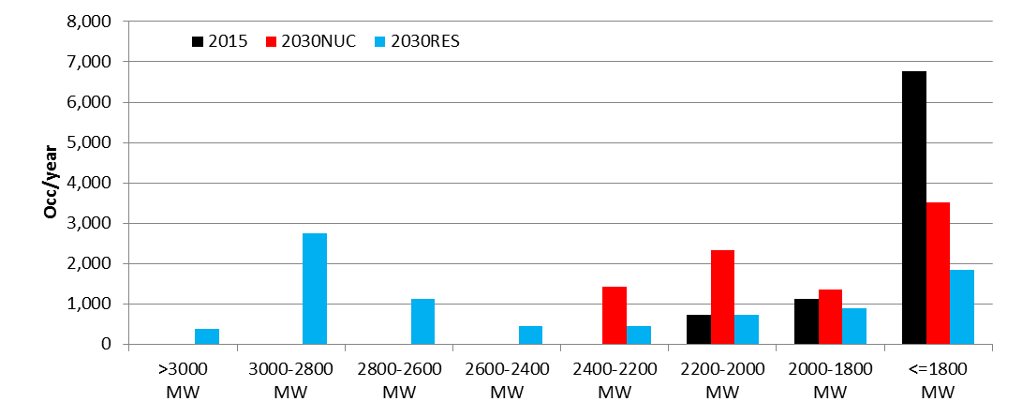
Fig.13 Statistical information of the amount of PFR provision
Table IV presents the environmental impact of PFC in the future systems. The impacts of PFC on the wind curtailment and carbon emission are shown to be negligible in the present system. However, 2 TWh and 16 TWh of wind generation are curtailed in 2030NUC and 2030RES due to the provision of PFR. As wind generation and nuclear plants are assumed not capable to provide PFR, large amount of conventional plants stay synchronized to provide PFR. Due to dynamic constraints, these plants needs to produce at least at MSG level, leading to reduced room to integrate wind generation. Combined with that fact that these part-loaded plants are running in a reduced efficiency, the annual CO2 emissions driven by PFC are 6 Mt in 2030NUC and 9 Mt in 2030RES.
Table IV Environmental impact of primary frequency control
 | 2015 | 2030NUC | 2030RES
Average wind Curtailment (TWh) | 0 | 2 | 16
Annual carbon emission (Mt) | 0 | 6 | 9

4.4 Economic and environmental benefits of PFR provision from EVs
As demonstrated in the last sub-section, PRC would lead to extremely high cost and increased carbon emission in the future systems, if conventional plants remain the only source to provide this service. Therefore, alternative sources of PFR provider needs to be developed in order to cost-efficiently achieve decarbonisation target. EVs are considered to be one of the potential solutions. This sub-section assesses the economic and environmental benefits of PFC support from EVs.
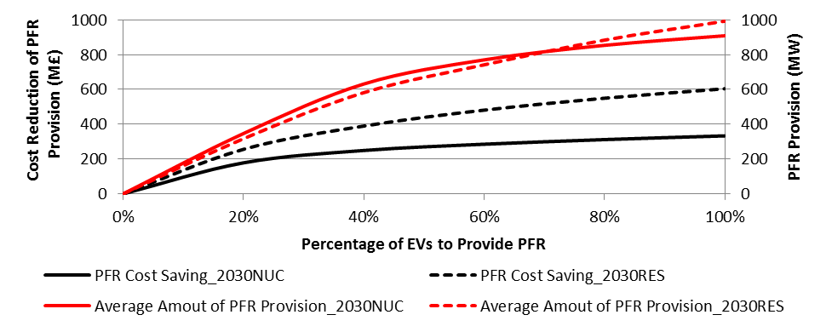
Fig.14 Amount of PFR provision from EVs and the associated PFR cost reduction
The study is carried out over 2030NUC and 2030RES. The percentages of EVs contributing to PFR are varied from 0%-100% and the impact on the cost associated with PFR provision is provided in Fig.14. The results demonstrate the effectiveness of PFR provision from EVs. In particularly, up to 370 M£ and 600 M£ reduction in the cost of PFR provision could be achieved in 2030NUC and 2030RES, respectively. As the increased percentage of EVs to provide PFR, the higher cost reduction is realized. However, there are clearly saturation effect after 20% of EVs contributing to PFR in 2030NUC scenario and 60% EVs contributing to PFR in 2030RES scenario. Fig.14 also shows the average amounts of PFR contribution from EVs, which are similar for both scenarios. In the case with 100% penetration, on average, nearly 1GW of PFR is provided by EVs.
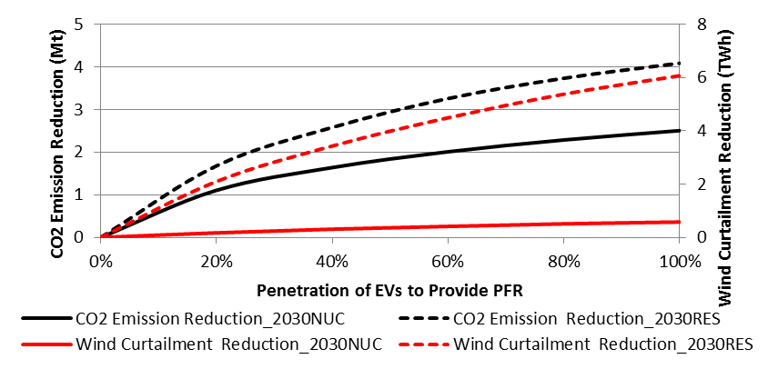
Fig.15 Impact of PFR provision from EVs on the emissions driven by PFR provision
The environmental impact of PFR provision from EVs are presented in Fig.15. In both scenarios, PFR provision from EVs could effectively reduce the carbon emission associated with PFC. This is due to the reduced amount of synchronized thermal plants running in the part-loaded mode, which not only increases the system operational efficiency but also allows more wind generation to be absorbed. In the 2030NUC case, the annual CO2 emission associated with PFC is reduced by up to 2.5 Mt, although no significant wind curtailment reduction is achieved. The main source of emission reduction is due to the increased load factor of nuclear plants. On the other hand, more than 6 TWh wind curtailment reduction is achieved in 2030RES case when 100% of EVs contributing to PFR. This reduces the annual CO2 emission by more than 4 Mt.
The main driver of increased PFR requirement is the low inertia capability of wind turbines. However, extensive research [33] has demonstrated that a supplementary control loop could be incorporated into the controller of wind turbine to provide synthetic inertia (SI) similar as conventional plants. Although there are still some obstacles for the large scale deployment of SI [10], it is important to investigate its potential impact on the benefits of PFR provision from EVs. Case study is carried in 2030RES with the assumption that wind generation contributes to system inertia in a similar manner as conventional plants. In the base case without PFR provision from EVs, the cost of PFR provision is reduced from 1.5 B£ in the case without SI to 650M£ in the case with SI. The results in Fig.16 show that synthetic inertia provision reduces the benefit of EVs by 250 M£ in the case with 100% of EVs contributing to PRC. However, it is interesting to see that synthetic inertia provision has negligible impact on the benefit of EVs if less than 20% of EVs contributing to PRC.
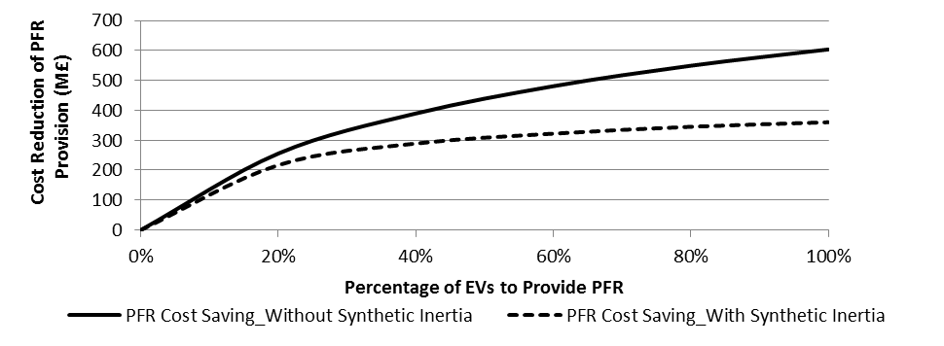
Fig.16 Impact of synthetic inertia provision from wind generation
As demonstrated in section 3.2 and section 4.3, the challenge and hence the value of PFR provision is varying from hour to hour. During the periods of low demand, the cost of PFR provision is much higher than that during the periods of high demand. However, under “dumb charging” strategy, EVs charging demand tends to be very low between 1am and 4am, when the demand valley incurs. The charging demand of EVs has been shown to be flexible to some extent. Therefore, we carried out analysis on the value of PFR provision from EVs under “smart charging” strategy, which allows the charging demand shift between hours, as long as the driving need satisfied. The analysis in [34] suggested that between 70% and 100% of EV demand can be shifted away from peak hours. Based on the results of that analysis, we assume that up to 80% of EV demand could be shifted away to other times of day while supporting the same journey patterns. The results are shown in Fig.17 assuming 100% of EVs to provide PFR. The annual cost of PFC is further reduced to less than 200 M£ in 2030NUC and less than 600 M£ in 2030RES if PFR provision from EVs is combined with “smart charging” strategy.
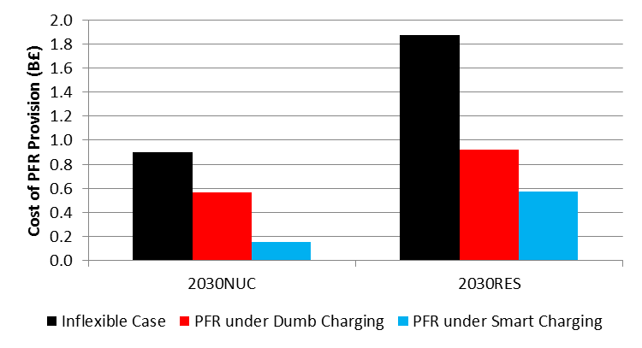
Fig.17 Cost of PFR provision under different EVs charging strategies
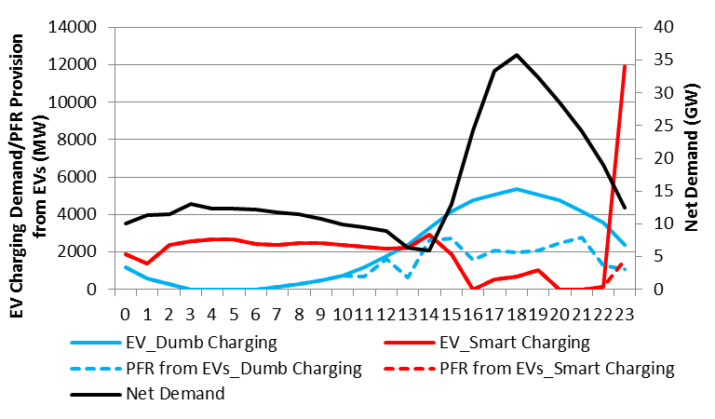
Fig.18 Scheduling of EVs charging and PFR provision under smart charging strategy
To further understand the additional benefits of combining PFR from EVs with “smart charging” strategy, a detailed schedule of EVs and its contribution to PFR for a reprehensive day is shown in Fig.18. During hours 0-11, the net demand (demand minus wind generation) is low and hence PFC is extremely challenging due to higher PFR requirements and less capacity of synchronized thermal plants. However, charging demand of EVs under “dumb charging” strategy is low and hence PFR provision from EVs is limited. On the other hand, “smart charging” strategy shifts EVs charging demand to periods with low net demand and enables a significant contribution of PFR from EVs during these critical hours. Although the PFR provision from EVs is reduced during hours 15-23, these periods face much less challenge on PFC. In fact, the results in Fig.18 demonstrates the synergy between PFR provision from EVs and “smart charging” strategy. During low net demand periods, to charge EVs is incentivized by both low marginal energy cost and high benefit of PFR provision.

5. Conclusions
This paper develops a techno-economic modelling framework to assess the challenges on PFC as well as the economic and environmental benefits of PFC support from EVs in the future GB low inertia electricity system. A simplified GB dynamic simulation model and an advanced stochastic system scheduling model are applied in this paper. The reduced system inertia is shown to cause faster decline of system frequency after generation outage. Due to the limited speed of governor response, the present PFR requirements are not sufficient to maintain the system frequency within the limits. Therefore, the inertia-dependent PFR requirements are proposed and incorporated into system scheduling tool to ensure the system security in the future GB low inertia systems. The simulation of annual system operation shows that if conventional plants remain the only provider of PFR, the cost associated with PFC would increase from 202 M£ in the current system to 899 M£ in 2030NUC system and 1522 M£ in 2030RES system. Moreover, PFC would drive 6 Mt - 9 Mt carbon emission in 2030 systems. The study suggests PFC may impose significant challenges in the future low-inertia systems and alternative providers of PFR needs to be developed in order to cost-effectively achieve decarbonisation.
As one of the potential mitigation measures, the capability of EVs to provide PFR under droop control strategy is discussed and validated in the dynamic simulations. Under different assumptions, 100% of EVs to provide PFR could reduce the cost of PFC by 300M£ - 720 M£ in 2030NUC and by 350 M£ - 1200 M£ in 2030RES. The results from annual system operation clearly demonstrate the effectiveness of EVs as an alternative source to support PFC. In the base case study, the annual cost and carbon emission driven by PFR provision is reduced by up to 370 M£ and 2.5 Mt in 2030NUC system, while the benefits are increased to 600 M£ cost saving and 4 Mt emission reduction in the 2030RES system. Moreover, although the benefits of PFR provision from EVs increases along with the increased percentage of EVs to provide PFR, there are some saturation effect after certain percentage. SI from wind generation potentially reduces the benefits of PFR from EVs, but only when high penetration of EVs to provide PFR. This paper also identifies the synergy between PFR provision from EVs and “smart charging” strategy. PFC support from EVs is shown to be more effective under “smart charging” strategy.
Acknowledgements
This work was supported by UK-China NSFC/EPSRC EV Project (Nos.51361130152 & EP/L001039/1).

Reference

[1] | C. Seneviratne and C. Ozansoy, “Frequency response due to a large generator loss with the increasing penetration of wind/PV generation – A literature review,” Renewable and Sustainable Energy Reviews, vol. 57, p. 659–668, 2016.
[2] | National Grid frequency response working group, “Frequency Response report,” 2013.
[3] | T. Pieter and D. V. Hertem, “The relevance of inertia in power systems,” Renewable and Sustainable Energy Reviews, vol. 55, pp. 999-1009, 2016.
[4] | P. J. Vogler-Finck and W.-G. Früh, “Evolution of primary frequency control requirements in Great Britain,” Electrical Power and Energy Systems, vol. 73, pp. 377 - 388, 2015.
[5] | N. Nguyen and J. Mitra, “An Analysis of the Effects and Dependency of Wind Power Penetration on System Frequency Regulation,” IEEE Trans on Sustain. Energy, vol. 7, no. 1, pp. 354-363, 2016.
[6] | J. O’Sullivan, A. Rogers, D. Flynn, P. Smith and M. O’Malley, “Studying the Maximum Instantaneous Non-Synchronous Generation in an Island System—Frequency Stability Challenges in Ireland,” IEEE Trans. Power Syst., vol. 29, no. 6, pp. 2943 - 2951, 2014.
[7] | Y. Dvorkin, P. Henneaux, D. S. Kirschen and H. Pandžić, “Optimizing Primary Response in Preventive Security-Constrained Optimal Power Flow,” IEEE Systems Journal, 2016.
[8] | F. Teng, V. Trovato and G. Strbac, “Stochastic Scheduling with Inertia-dependent Fast Frequency Response Requirements,” IEEE Trans. Power Syst., vol. In Press.
[9] | Y. Dvorkin, M. A. Ortega-Vazuqez and D. S. Kirschen, “Wind generation as reserve provider,” Generation, Transmission & Distribution, IET, vol. 9, no. 8, pp. 779-787, 2015.
[10] | F. Teng and G. Strbac, “Assessment of the Role and the Value of Frequency Response Support from Wind Plants,” IEEE Trans on Sustain. Energy, 2015, In press.
[11] | D. B. Richardson, “Electric vehicles and the electric grid: A review of modeling approaches, Impacts, and renewable energy integration,” Renewable and Sustainable Energy Reviews, vol. 19, pp. 247 - 254, 2013.
[12] | F. Mwasilu, J. J. Justo, E.-K. Kim, T. D. Do and J.-W. Jung, “Electric vehicles and smart grid interaction: A review on vehicle to grid and renewable energy sources integration,” Renewable and Sustainable Energy Reviews, vol. 34, pp. 501-516, 2014.
[13] | A. Schuller, C. M. Flath and S. Gottwalt, “Quantifying load flexibility of electric vehicles for renewable energy integration,” Applied Energy, vol. 151, pp. 335-344, 2015.
[14] | S. Deilami, A. S. Masoum, P. S. Moses and M. A. S. Masoum, “Real-time coordination of plug-in electric vehicle charging in smart grids to minimize power losses and improve voltage profile.,” IEEE Trans. Smart Grids, vol. 2, no. 3, pp. 456-467, 2011.
[15] | F. Salah, J. P. Ilg, C. M. Flath, H. Basse and C. v. Dinther, “Impact of electric vehicles on distribution substations: A Swiss case study,” Applied Energy, vol. 137, pp. 88-96, 2015.
[16] | D. Papadaskalopoulos, G. Strbac, P. Mancarella, M. Aunedi and V. Stanojevic, “Decentralized participation of flexible demand in electricity markets—Part II: Application with electric vehicles and heat pump systems.,” IEEE Trans. Power Syst., vol. 28, no. 4, pp. 3667-3674, 2013.
[17] | R. Sioshansi, “OR Forum-Modeling the impacts of electricity tariffs on plug-in hybrid electric vehicle charging, costs, and emissions,” Operations Research, vol. 60, no. 3, pp. 506-516, 2012.
[18] | J. A. P. Lopes, M. R. Almeida and F. J. Soares, “Using Vehicle-to-Grid to Maximize the Integration of Intermittent Renewable Energy Resources in Islanded Electric Grids,” in Clean Electrical Power, International Conference on. IEEE, 2009.
[19] | H. Liu, Z. Hu, Y. Song and J. Lin, “decentralized vehicle to grid control for primary frequency regulation considering charging demands,” IEEE Trans. on Power Syst., vol. 28, no. 3, pp. 3480 -3489, 2013.
[20] | Y. Mu, J. Wu, J. Ekanayake, N. Jenkins and H. Jia, “Primary Frequency Response From Electric Vehicles in the Great Britain Power System,” IEEE Trans. Smart Grid, vol. 4, no. 2, pp. 1142 - 1150, 2013.
[21] | J. Meng, Y. Mu, H. Jia, J. Wu, X. Yu and B. Qua, “Dynamic frequency response from electric vehicles considering travelling behavior in the Great Britain power system,” Applied Energy, vol. 162, p. 966–979, 2016.
[22] | E. Sortomme and M. A. El-Sharkawi, “Optimal Scheduling of Vehicle-to-Grid Energy and Ancillary Services,” IEEE Trans. Smart Grid, vol. 3, no. 1, pp. 351 - 359, 2012.
[23] | I. Pavic, T. Capuder and L. Kuzle, “Value of flexible electric vehicles in providing spinning reserve services,” Applied Energy, vol. 157, pp. 60 - 74, 2015.
[24] | I. Pavić, T. Capuder and I. Kuzle, “Low carbon technologies as providers of operational flexibility in future power systems,” Applied Energy, vol. 168, pp. 724-738, 2016.
[25] | S. Izadkhast, P. Garcia-Gonzalez and P. Frias, “An Aggregate Model of Plug-in Electric Vehicles Including Distribution Network Characteristics for Primary Frequency Control,” IEEE Trans. Power Syst., vol. 30, no. 3, pp. 1475-1482, 2015.
[26] | National Grid, “Security and Quality of Supply Standards,” [Online]. Available: http://www2.nationalgrid.com/UK/Industry-information/Electricity-codes/System-Security-and-Quality-of-Supply-Standards/.
[27] | A. A. Shakoor, “Security and cost evaluation of power generation systems with intermittent energy sources,” PhD thesis, University of Manchester, 2005.
[28] | “Report of the investigation into the automatic demand disconnection following multiple generation losses and the demand control response that occurred on the 27th May 2008,” [Online]. Available: http://www.nationalgrid.com/NR/rdonlyres/D680C70A-F73D-4484-BA54-95656534B52D/26917/PublicReport-Issue1.pdf. [Accessed 6 3 2016].
[29] | P. R. Almeida, F. J. Soares and J. P. Lopes, “Electric vehicles contribution for frequency control with inertial emulation,” Electric Power Systems Research, vol. 127, pp. 141 - 150, 2015.
[30] | M. Aunedi, P.-A. Kountouriotis, J. E. O. Calderon, D. Angeli and G. Strbac, “Economic and Environmental Benefits of Dynamic Demand in Providing Frequency Regulation,” IEEE Trans. Smart Grids, vol. 4, no. 4, pp. 2036 - 2048, Dec 2013.
[31] | F. Teng, M. Aunedi and G. Strbac, “Benefits of flexibility from smart electrified transportation and heating in the future UK electricity system,” Applied Energy, 2015 In press.
[32] | M. Aunedi, M. Woolf, G. Strbac, O. Babalola and M. Clark, “Characteristic demand profiles of residential and commercial EV users and opportunities for smart charging,” in CIRED, Lyon, 2015.
[33] | O. Anaya-Lara, F. Hughes, N. Jenkins and G. Strbac, “Contribution of DFIG-based wind farms to power system short-term frequency regulation,” IEE Proceedings Generation, Transmission and Distribution, vol. 153, pp. 164 - 170, 2006.

* Corresponding author, E-mail address: fei.teng09@imperial.ac.uk. The short version of the paper was presented at CUE2015 on Nov. 15-17, Fuzhou, China. This paper is a substantial extension of the short version

