Tracking metal ion-induced organic membrane fouling in nanofiltration by adopting spectroscopic methods: Observations and predictions
Zhaoyang Su^{a, b, d}, Ting Liu^{b, c}, Xing Li^{d}, Nigel J. D. Graham^{b} and Wenzheng Yu^{a, b*}
ª Key Laboratory of Drinking Water Science and Technology, Research Centre for Eco-Environmental Sciences, Chinese Academy of Sciences, Beijing, 100085, China
^{b} Department of Civil and Environmental Engineering, Imperial College London, South Kensington Campus, London, SW7 2AZ, UK
^{c} School of Chemistry and Chemical Engineering, Beijing Institute of Technology, Beijing, 100081, China
^{d} College of Architecture and Civil Engineering, Beijing University of Technology, Beijing, 100024, China
zysu@rcees.ac.cn, liuting@bit.edu.cn, lixing@bjut.edu.cn, n.graham@imperial.ac.uk, wzyu@rcees.ac.cn
*Corresponding author: Tel: +86-010-62910878

Abstract
Natural organic matter (NOM) with the size approaching to membrane pore size is commonly considered as the crucial component leading to severe pore blocking and superfluous energy consumption. Aquatic metal ions coexisting with this NOM constituent (target NOM) exert a significant influence on membrane filtration performance; however, little work elucidated their interactions and the impacts on nanofiltration (NF). Therefore, we systematically investigated this issue by titrating three environmentally-relevant metal ions (Al³⁺, Fe³⁺ and Cu²⁺) into the target NOM sample obtained by pre-filtering using NF membrane. Fast spectrophotometric techniques were employed to observe the interactive performance. Results suggested that all metal ions at their critical concentrations caused severe flux decline; Cu²⁺ at a very low concentration of 5 μM, Al³⁺ and Fe³⁺ at 20 μM. NF performance recovered when the concentrations were beyond their critical values, and was improved at excessive concentration when flocs formed. Relationship between spectroscopic characteristics and NF performance was particularly addressed. UV-vis spectrum can be expected to be useful and predictive in membrane fouling control when Al³⁺ or Fe³⁺ presented. However, fluorescence fingerprint was not likely that effective since fluorescence intensity continuously reduced with the increasing metal ion concentration, attributed to their quenching effect on NOM fluorophores.
Keywords: natural organic matter; metal ions; complexation; nanofiltration; spectrophotometric method
1. Introduction
Nanofiltration (NF) is widely considered to be a more welcome choice for water supply and wastewater treatment in recent years, benefited from its better energy-saving than reverse osmosis (RO) and the improved effluent quality compared with ultrafiltration (UF) (Hong and Elimelech, 1997; Liang et al., 2018; Alvarez et al., 2018). With the increasing scale of nanofiltration application, drinking water production is still the dominant (Chang et al., 2017). A documented plant based on NF technique was first constructed in France in the second half of the 1990s (Ventresque and Bablon, 1997). However, in 21st century, its wide application in more demand currently still faces challenges arising from the dwindling water resources and more stringent standard of water supply. Membrane fouling, particularly the organic fouling, was ascertained to be the ‘bottleneck’ as indicated by numerous researchers (Tang et al., 2011; Hong and Elimelech, 1997; Ling et al., 2017).
Natural organic matter (NOM) is ubiquitous in natural waters, derived from the breakdown of terrestrial plants as well as the metabolic products of microorganism, and aquatic plants (Lynch et al., 2019). Compared to the commonly used coagulation and MIEX, a hydrophobic NF membrane also shows superior rejection capability of neutral, hydrophilic NOM surrogates which contributed to the formation of disinfection by-products during disinfection process (Bond et al., 2010). Therefore, to improve the understanding of organic fouling of NF membrane seems to be more important during the production of potable water from surface water. The mechanisms of membrane fouling (as well as flux decline) are generally classified as pore blocking, adsorption, and cake formation (Ho and Zydney, 2000; Broeckmann et al., 2006). In particular, the constituents of organic pollutants with size approaching to membrane pore size are believed to be the key components which can lead to complete blocking and the possible irreversible fouling (Yuan et al., 2002). For instance, macromolecules-biopolymers were found to be the major contributor in UF membrane fouling (Liu et al., 2011; Yu et al., 2016b); organic matter with smaller size (~ 1 nm) was verified to be prone to block NF membrane pores (Mustafa et al., 2014). In consideration of the complicated matrix of organic matter in natural waters, therefore, to have a further understanding of the fouling mechanism is known to be the essential approach in finding the solution, especially in NF process which always needs much more energy input (Nilsson et al., 2008).
Furthermore, the presence of metal ions in the feed water can also exert a significant influence on membrane fouling. Li and Elimelech (2004) reported that more severe membrane fouling, resulted from a more compact cake layer, was found when complexes formed by divalent cations (e.g., Ca²⁺ and Mg²⁺) and humic acid (HA). Similar result was obtained by Imbrogno et al., who suggested that NF membrane fouling caused by coexistence of Ca²⁺ and HA can be mitigated by minimizing the Ca²⁺-HA complexation using MIEX in advance (Abrahamse et al., 2008). In addition, other aquatic metal ions (e.g., Al³⁺ and Mg²⁺) were also reported to exert various influences on the NF performance as well as organic membrane fouling (Listiarini et al., 2009; Zhao et al., 2016).
There are originally numerous kinds of metal ions in the pool of earth, which have been confirmed to react with NOM (Riedel et al., 2012). It is worthwhile to point out that a relatively large body of literature is available, up to date, on interactions between metal ions and organic matter (Poulin et al., 2014; Ohno et al., 2008; Liu et al., 2018; Fujii et al., 2018). In this regard, the complexation between model NOM (Suwannee River Humic acid/Fulvic acid) and several environmentally-relevant metals have been investigated in previous studies (Yan et al., 2015; Gao et al., 2015). The result indicated that these complexation processes can be well fitted into NICA-Donnan model and further evaluated using the specific parameters including the change of the spectral slope in the range of wavelengths 325 nm – 375 nm (DSlope₃₂₅₋₃₇₅) and differential logarithm of DOM absorbance at 350 nm (DLnA₃₅₀) which are considered as valuable indexes in analyzing complexation (Yan et al., 2013b). In addition, size exclusion chromatography (SEC) method was also effective in characterizing the formation of complexes in terms of the changes of their molecular weight (MW) distribution (Ma et al., 2013; García-Otero et al., 2013). García-Otero et al. revealed marine NOM bound with various metals by using SEC followed by anion exchange chromatography (AEC) hyphenated with inductively coupled plasma-mass spectrometry (ICP-MS). Results showed four groups of marine NOM ranging from 6.5 kDa to 16 kDa, which are bounded with strontium, zinc, manganese and cobalt respectively as indicated by AEC coupled with ICP-MS. Particularly, the possible complexation was suggested to be stronger between low MW organic molecules (e.g., humic acid) and metal ions, in comparison with that between macromolecular organics (e.g., bovine serum albumin) and metal ions (Kim and Dempsey, 2013; Huang et al., 2019). However, little research reveals the interactions between metal ions and these NOM with low MW in natural waters (a complex cocktail of NOM), and especially their potential effects on NF membrane fouling are still to be discovered. This subject should be highly paid attention to, since it would be an essential factor determining the effluent quality and of course energy costs as previously indicated (Speth et al., 1998).
Therefore, we tried to provide answers to this issue in the present study. Three environmentally relevant metal ions (Al³⁺, Fe³⁺ and Cu²⁺) were added to react with a specific component (after NF, cut off: 1 kDa) of complicated NOM in pre-filtered samples, which can easily block membrane pore with the similar size, using raw water collected from Hyde Park lake. These pre-filtered samples containing metal ions at various target concentrations were used as the feed of nanofiltration. Moreover, spectroscopic techniques were first adopted to characterize the interactions between metal ions and NOM, aiming at providing a feasible explanation for the NF fouling phenomena. Importantly, the expectation of this work was also to seek a fast and simple route to evaluate membrane nanofiltration performance, hopefully predictive in the intractable organic fouling.
2. Materials and methods
2.1 Raw water and chemicals
Water sample was collected from Hyde Park lake over 3 months between January and March, 2017. Each sample was collected at the same site and 0.3 m below water surface, representing typical characteristics of urban lakes. The sample was placed in the laboratory overnight (about 15 h) before trial in order to keep water temperature consistent to the room temperature (~25 ºC). The characteristics of the collected water were analyzed in the laboratory before the following experiments, and details were summarized in Tables S1 and S2 and Figure S1.
All the chemicals used in this study were at analytical grade. Specifically, copper (II) chloride dehydrate (CuCl₂·H₂O; Fisher Chemicals, 99.99%), aluminum (III) sulfate hydrate (Al₂(SO₄)₃·16H₂O; Fisons, >96%) and iron (III) chloride (FeCl₃; Acros, 98%) were employed and dissolved using deionized (DI) water as stock solutions of 0.1 M, and renewed every two weeks to avoid ageing effect.
2.2 Preparation of feed water
Raw water was firstly filtered using a dead-end filtration apparatus (Amicon 8400, Millipore, USA). Flat sheet PES NF membranes (cut off: 1 kDa, Ande Membrane Separation Technology & Engineering (Beijing) Co., Ltd, China) were employed to remove macromolecular organic matters as indicated in Figure S1, and renewed every 200 mL. The collected filtrate (~ 800 mL) which contains low MW organic matter with smaller size than membrane pore was employed for the following experiments. In addition, all the new membranes before use were placed in DI water for at least 24 h to remove organic residues left after the production. The predetermined amount of metal ion was added into 50 mL filtrate simultaneously with intense magnetic stirring lasting for 30 min. Then the prepared sample was either used as the feed water for the following nanofiltration or for further spectroscopic measurement.
2.3 Nanofiltration experiments
NF tests were conducted using a similar system which has been reported in detail in our previous study (Yu et al., 2018). In order to measure the real-time flux precisely, these NF membranes (PES membranes, 1 KDa) were tested using DI water prior to use. The prepared water sample was transferred into the filtration cell immediately.
NF process was driven by the constant pressure mode (0.4 MPa) which was consistently provided by nitrogen gas. More specifically, membrane fouling was evaluated based on the flux decline as indicated by normalized flux (J/J₀). ‘J’ is the real-time membrane flux, and ‘J₀’ is the initial flux which is logged immediately after a few seconds when the effluent reaches steady. The membrane flux was determined by the difference of the monitored weight of filtrate every 1 second using an electronic balance, and all the data were automatically recorded by a commercial software.
2.4 SEM observations on the membrane
SEM images of membranes were taken using a high-resolution cold field emission scanning electron microscope (FE-SEM, SU 8000, HITACHI, Japan). Prior to observation, both samples of the fouled and backwashed membranes were initially glued onto a silicon plate and then platinum-coated for 30 s. SEM images were scanned at an accelerating voltage of 3 keV, and the contrasting voltage of 15 keV was used in energy dispersive spectrometer (EDS) mapping.
2.5 Analytical methods
To explain the observed NF phenomena, various analytical techniques were designed and employed. As mentioned in the Section 2.2, the obtained water samples (feed water and effluent) were transferred into a 1 cm pathlength quartz cuvette and measured on a UV-vis spectrometer (U-3010, Hitachi High Technologies Co., Japan) scanning in a range from the wavelength 200 nm to 600 nm. In addition, fluorescence characteristics of the same sample was also examined by three-dimensional excitation-emission matrix (EEM) fluorescence spectroscopy (FluoroMax Series, HORIBA, Japan).
Molecular weight (MW) distribution of organic matter was characterized using size exclusion chromatography (SEC) method. The used SEC system (HPLC, Alliance 2695, Waters corp., USA) contains a Dual Absorbance Detector (DAD) detector (2487, Waters corp., USA) and a BIOSEP-SEC-S3000 column (Phenomenex, UK) equipped with a Security Guard column (a GFC-3000 disc). 100 μL sample was injected into the system, and more details about operational procedure can be found in our previous work (Yu et al., 2015).
In addition, Fourier Transform Infrared spectroscopy (FTIR, Nicolet 6700, Thermo, USA) equipped with Quest ATR Accessory (SPECAC Ltd, UK) was employed to analyze the changes of functional groups between the feed and the finished samples. All samples were freeze-dried prior to measurement.
3. Results and discussion
3.1 NF performance
Previous studies reported that the presence of environmentally-relevant metal ions in feed water exerted obvious influences on ultrafiltration and microfiltration performance, particularly from the aspects of organic membrane fouling (Abrahamse et al., 2008; Ma et al., 2014). However, the influence of these metal ions on nanofiltration performance still remains an issue need to be further explored. Figure 1 displays the variation of NF membrane flux affected by low MW (~ 1 kDa) NOM (after NF, denoted as ‘target NOM’) with three metal ions (Al³⁺, Fe³⁺ and Cu²⁺) separately at various concentrations ranging from 2 µM – 100 µM.
As shown in Figures 1a – 1c, the general trends in flux changes along with increasing metal ion concentration were observed to be similar, initially declined within a certain range of concentration. In this regard, there was a ‘critical value’ corresponding to the lowest membrane flux, although these critical values were different, 20 µM for both Al³⁺ and Fe³⁺, and 5 µM for Cu²⁺. And the permeability was found to be gradually recovered and even improved when the concentration of metal ion exceeded its critical value. What to be noticed is that the critical concentration of Cu²⁺ was significantly lower than that of Al³⁺ and Fe³⁺, as indicated in Figure 1d; in accordance, the filterability fully recovered in the presence of 20 µM Cu²⁺ (Figure 1c), while that for Al³⁺ and Fe³⁺ were at least 100 µM (Figures 1a and 1b). This phenomenon was likely attributed to the distinct hydrolyzation efficiencies of different metal ions and their binding capabilities with NOM (Yan and Korshin, 2014).
In addition, as to the fouling degree in these series of tests (Figure 1d), it can be found that the most serious membrane fouling can be reached at the coexistence of 20 µM Al³⁺ and the target NOM in the source water, in terms of J/J₀ of 0.43, obviously lower than that achieved by the existence of Fe³⁺ and Cu²⁺ of 0.53 and 0.62 respectively. Similarly, the recovery of filterability, indicated by the final flux at the concentration of 100 µM, followed the sequence same to the lowest final normalized flux, i.e., Al³⁺ of 0.65 < Fe³⁺ of 0.71 < Cu²⁺ of 0.74 (Figure 1d). Moreover, there is an interesting finding that the gap between the lowest and recovered value of J/J₀ within the investigated range showed a reverse trend (Al³⁺ > Fe³⁺ > Cu²⁺). This consequence suggested that Al-based coagulants should be better carefully used in the pretreatment prior to NF owing to the possible serious flux decline. Choi et al (Choi et al., 2013) also reported the similar results indicating the unexpected flux decline in a wide range of Al³⁺ concentration. However, the result derived from Cu²⁺ tests demonstrated that the contribution of Cu²⁺ to NF performance was minimum from aspects of flux decline as Cu²⁺ concentration. To further investigate the underlying mechanisms of the observed phenomena, multiple measurements based on fast spectroscopic techniques were carried out and discussed in the following sections.
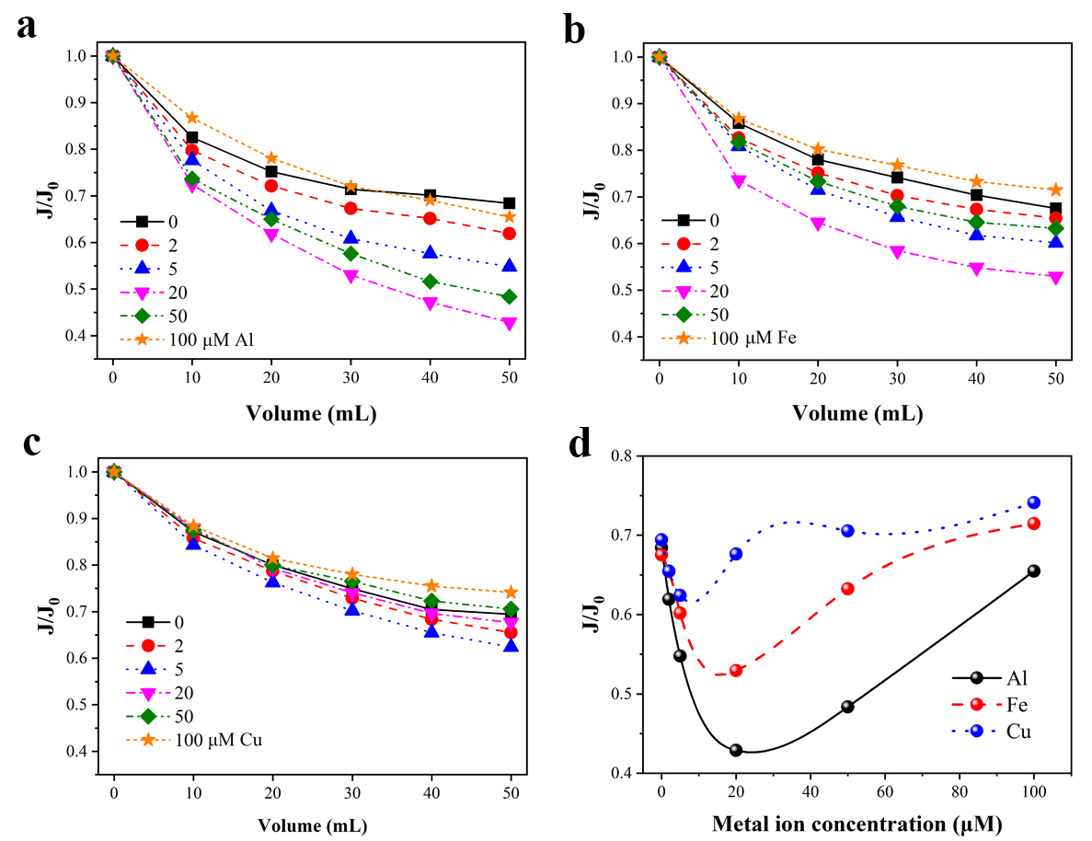
Figure 1. Effects of metal ion concentration on normalized NF flux (J/J₀) decline: (a) Al (III), (b) Fe (III), (c) Cu (II), and (d) summary of the final flux (J₀ = 10.13 ± 0.25 L/m² h bar). Metal concentration shown in the legend is in µM. The NF pre-filtered samples with metal ions at various concentrations were adopted as the feed of nanofiltration.
3.2 Observations on UV-vis spectra
UV-vis absorbance spectrum has been successfully used to examine the reaction between metal ions and model organic matter, such as Suwannee River Humic Acid (SRHA), and confirmed to be sensitive to the changes caused by complexation, even at a very low responsive intensity (Yan et al., 2013b). However, little study reported the interaction between metal ions and NOM in surface water. Accordingly, in order to provide a plausible explanation for the former observations, series of UV spectra were measured at an incremental concentration of these three metal ions, as shown in Figures 2-4.
Figure 2 shows the UV-vis absorbance spectra of the interaction caused by the addition of Al³⁺ at varying concentration ranging from 2 µM to 100 µM. The absorbance spectra of different Al³⁺ concentration follows a nearly exponentially decreasing trend with the increasing scanning wavelength, and seems to be much identical (Figure 2a). It was evidently difficult to identify the difference between the results of control group (raw water without addition metal ion) and these finished samples directly. Moreover, the unexpected display was also seen from the differential absorbance spectra (Figure 2b). Enlightened by the success of further analysis reported elsewhere (Yan et al., 2013a), the log-transformed absorbance spectra (LAS) and the corresponding differential spectra (denoted as ‘DLAS’) were additionally processed here (Figures 2c and 2d). In Figure 2d, the unambiguous characters can be easily identified. In this regard, the value of the DLAS continuously grew when the added Al concentration increased up to 20 µM. Nevertheless, a significant reduction was found when the concentration of Al was beyond 20 µM, defined as ‘critical value’ here. These results were partially same as the findings of Yan et al. (2016), especially at the low concentration (< 20 µM). This might indicate complexes formed when Al concentration was below 20 µM, and aqueous colloids/precipitate began to occur when Al concentration continued to increase. And the aqueous colloids or precipitate might be the reason for the decline of spectra due to the adsorption effect of UV-active NOM. In particular, there was a very interesting coincidence that 20 µM Al lead to the strongest absorbance spectrum (Figure 2d) and the most severe flux decline (Figure 1a) simultaneously. In addition, the overall conclusion derived from the analysis of absorbance spectra (seen in Figures 2 and 3) in combination with the nanofiltration performance (Figure 1b) were considered to be identical. This is attributed to the similar chemical characteristics of Al³⁺ and Fe³⁺ metal ions.
In contrast, the series of absorbance spectra of Cu, shown in Figure 4, were obviously different with that of Al and Fe (Figures 2 and 3), and the distinct difference was visible even in the direct observation of the absorbance spectra (Figure 4a). The similar finding, indicating a stronger complexation ability, was also confirmed in the previous study, in a comparison of the spectra obtained from the interactions of Cu/Al and model organic matter (SRHA) (Yan et al., 2016). In particular, there were conspicuous peaks at the wavelength 280 nm, and the absolute intensity enhanced with the increasing Cu²⁺ concentration (2 µM – 100 µM). This phenomenon differed with the results of Al and Fe which indicated an obvious reduction when their concentration was beyond 20 µM. Additionally, an attractive result in flux decline (Figure 1) demonstrated that the less ‘gap’ among the final values of membrane flux of Cu, shown in Figure 1d, as compared to the results of Al and Fe. Therefore, it can be primarily concluded that the stronger complexation between Cu²⁺ and low MW NOM lead to the less variation in the final flux at a lower concentration (< 5 µM). And the metal ions (e.g., Al³⁺ and Fe³⁺) with weaker interaction with the target NOM should be better carefully noticed in consideration of the prominent features of severe membrane fouling across a wider range of metal ion concentration (2 µM – 20 µM). More specifically, different membrane fouling mechanisms can provide answer to this finding; more serious flux decline at 20 µM Al³⁺/ Fe³⁺ was arised from pore blocking, however 5 µM Cu²⁺ might lead to adsorption filtration associated with shrinkage of flow channel (Sanaei and Cummings, 2018). There might be different transformation processes when the concentrations of metal ions were beyond their critical values. For Cu²⁺, most of the target NOM directly complexed with Cu²⁺; for both Al³⁺ and Fe³⁺, these NOM may be bridged by metal hydrolyzates to form micro-flocs/flocs.
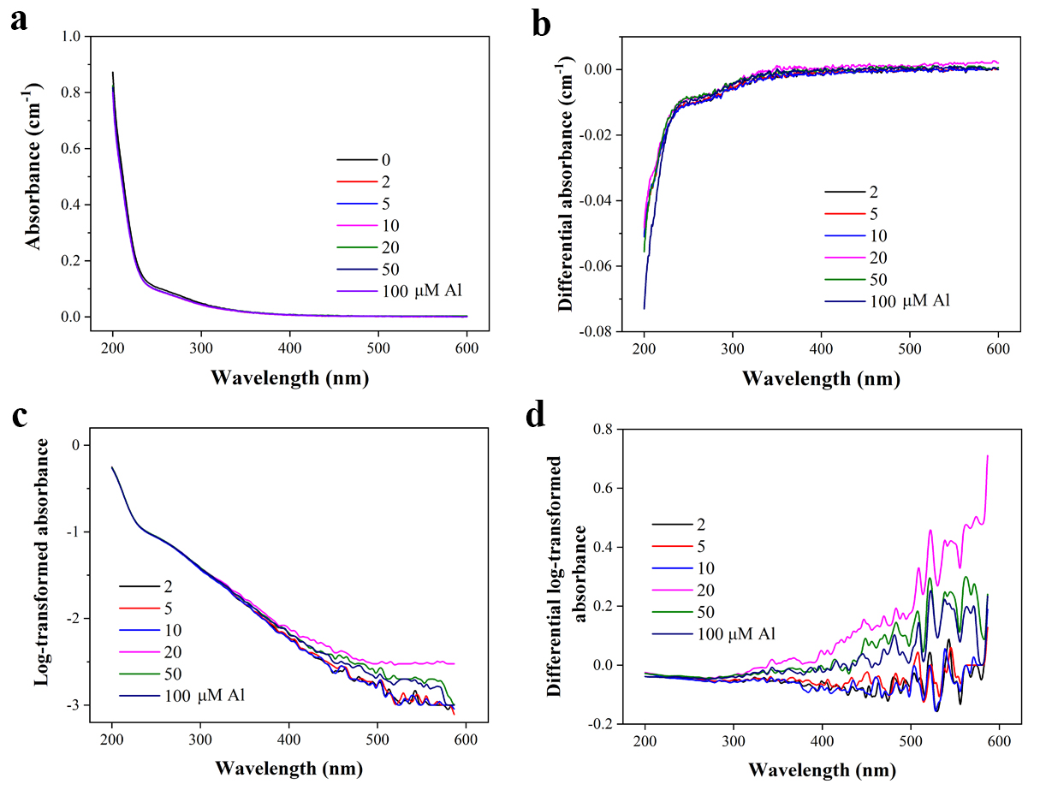
Figure 2. Absorbance spectra of feed recorded at varying concentrations of aluminum: (a) zero-order spectra, (b) differential spectra, (c) log-transformed spectra, and (d) differential log-transformed spectra. The NF filtrate containing specific constituent of low MW organic matter with different concentrations of Al³⁺ was employed as the feed for NF tests. The apparent MW distribution of organic matter in the NF feed can be found in Figure S2 and this was also applicable to the tests in Figures 3 and 4.
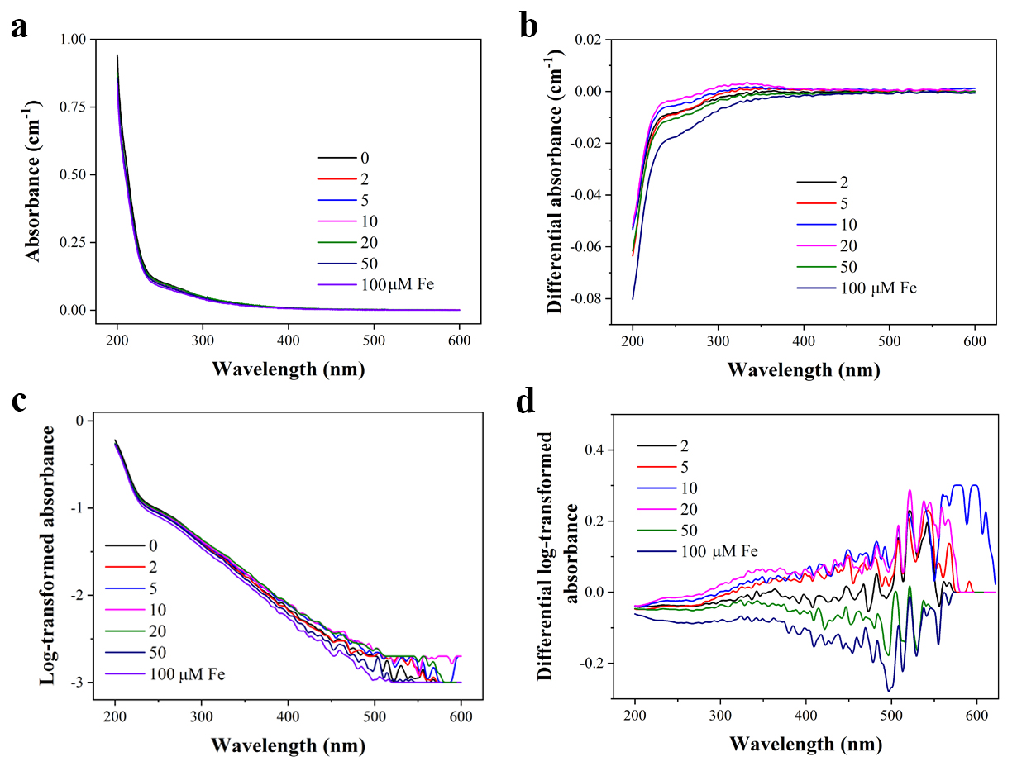
Figure 3. Absorbance spectra of feed recorded at varying concentrations of iron: (a) zero-order spectra, (b) differential spectra, (c) log-transformed spectra, and (d) differential log-transformed spectra.
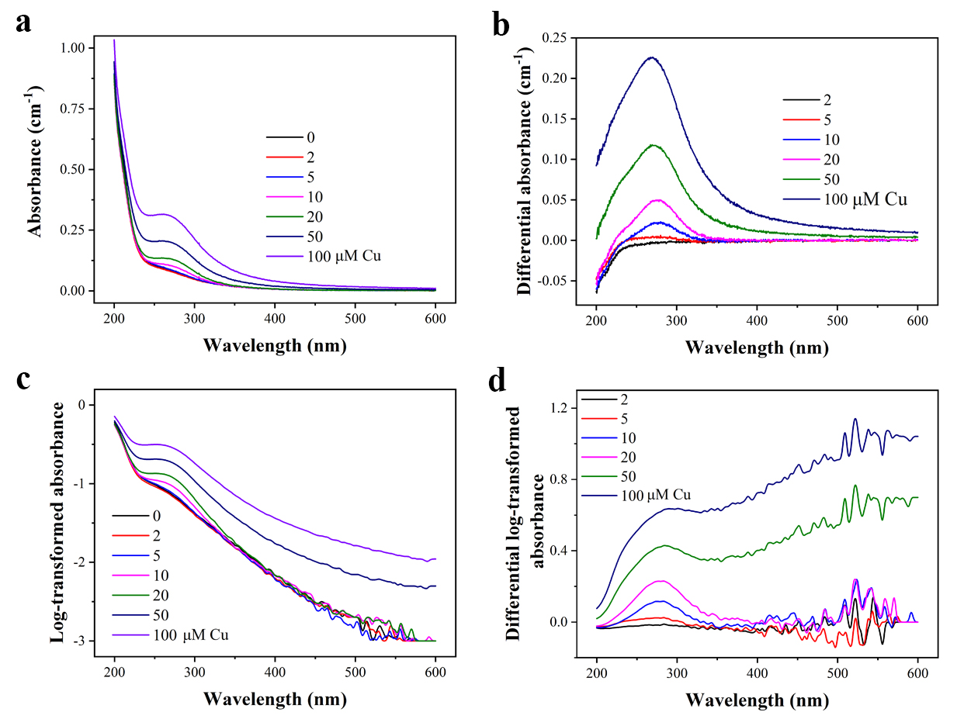
Figure 4. Absorbance spectra of feed recorded at varying concentrations of copper: (a) zero-order spectra, (b) differential spectra, (c) log-transformed spectra, and (d) differential log-transformed spectra.
3.3 Binding characteristics between metal ions and the target NOM
Figure 5 illustrates the responsive 2-D fluorescence intensity (FI) occurred at the excitation wavelength of 350 nm. The pronounced peak was observed at the emission wavelength between 480 nm and 500 nm, where has been defined as the peak C in Figure S3, associated with humic-like fluorophores (Shutova et al., 2014). This 2-D fluorescence scanning is much faster than obtaining 3-D fluorescence mapping and expected to be feasible in membrane process study. And the peaks location of these metal ions at different concentrations did not shift along the scanning wavelength, as shown in Figures 5a – 5c. This indicates the binding sites might be identical between the different metal ions and the target organic matter (Ohno et al., 2008). However, there was little changes can be noted when the concentration of Al³⁺ ion increased from 2 μM to 100 μM (Figure 5a). Contrasting fluorescence intensity showed a descending trend with the continuous addition of Fe³⁺. Similarly, a significant decrease in peak height was also found for Cu²⁺ in Figure 5c. These results were consistent with the findings derived from UV spectral analyses, i.e., the complexation reaction between organic matter and Cu²⁺ was most significant, following the sequence: Cu²⁺ > Fe³⁺ > Al³⁺; the stronger interaction (with increasing metal ion concentration) also related to a further decrease in fluorescence intensity (Figure 5). These phenomena were similar to the previous observations and can be attributable to the quenching effect of metal ions on the fluorescence intensity of organic matter (Poulin et al., 2014; Yan et al., 2013a). However, this finding was partially opposite to the trend in the UV spectra (Figures 2 – 4). We found that the height of peaks decreased continuously with the increasing concentration of Al³⁺ and Fe³⁺ ions (Figures 5a and 5b) while the trends of peaks were different in UV-visible scanning. It can be deduced that the continuous decrease in fluorescence intensity might be caused by the sorption of organic matter on the surface of Al/Fe-NOM aqueous colloids or participation in floc formation at a relatively higher concentration (Ohno et al., 2008; Zhang et al., 2011), which have been confirmed in the reduction of the responsive UV value when the concentration of the both ions exceeded 20 μM. Also the measurements of ZP (Figure 5e) suggested flocs formation with the increasing concentration of Fe³⁺ and Al³⁺ concentration (e.g., 100 μM) at which a certain quantity of negatively charged NOM was gradually absorbed onto the surface of more newly formed flocs (positively charged), and thus to prevent pore blocking. More evidence related to flocs formation are recommended to observe in the following SEM images (Figure 7). However, the function of Cu²⁺ on NOM fluorescence intensity was mainly attributed to complexation effect owing to the relative weaker hydrolyzation ability of Cu²⁺ at neutral pH.
For better understanding of these observed changes of organic matter, FTIR spectra were processed in transmission mode and adopted to examine the nature of these changes by exemplifying the presence of 10 μM metal ion individually, as shown in Figure 5f. It can be found that the intensity of peaks of metal-NOM existed at the wavenumber of 3350 cm⁻¹ obviously enhanced, compared to the sample without metal ion addition. This demonstrated that metal ions were likely binding on O-H/N-H band (Her et al., 2004). In addition, the intensity of peaks at 1620 cm⁻¹ wavenumber, which is indicator of –COOH, also decreased by reacting with metal ion (Yu et al., 2016a). Although the similar findings derived from the results of FTIR spectra in the presence of 10 μM metal ion individually, the NF performance (Figure 1) was distinct. This may be attributed to the different complexation/flocculation abilities (the size of complex/floc) of the used three metal ions, and need to be considered from the aspects of MW change of organic matter.
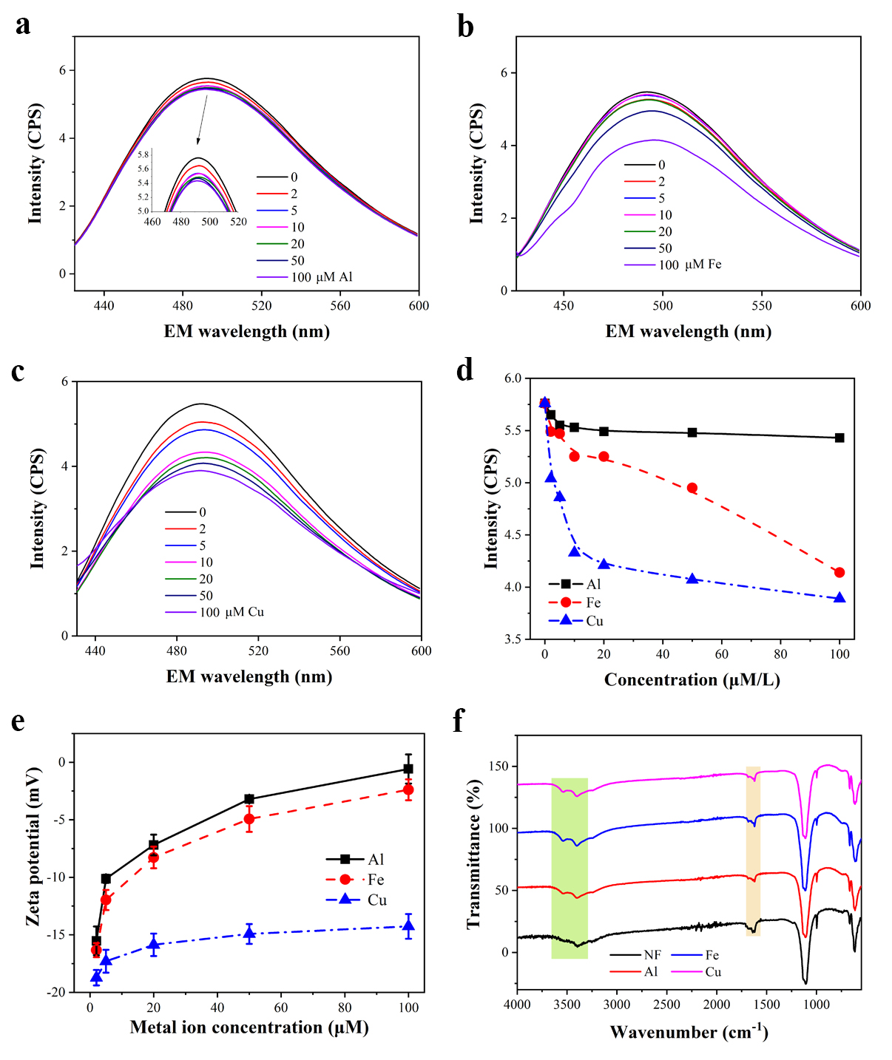
Figure 5. Two-dimensional fluorescence emission 420 nm − 600 nm of the feed of NF at various concentrations: (a) Al (Ⅲ), (b) Fe (Ⅲ), (c) Cu (Ⅱ), and (d) summarization of fluorescent intensity as a function of metal ion concentration; (e) zeta potential changes and (f) representative FTIR spectra of the feed recorded at each metal concentration of 10 μM after freeze-dried. Offsets in transmission spectra were intentionally made for clarity.
3.4 Identification on organic matter MW changes
The structure and components of organic matter were found to be changed when metal ion coexisted in aquatic system, and MW analyses were effective in characterizing this transformation process (Ma et al., 2014; Lin et al., 2015). As indicated in Figures 6a − 6c, MW distribution of the target organic matter under the minimum (2 μM) and maximum (100 μM) concentration as well as their ‘critical values’ of metal ion concentration were presented. A commonality of peak shift can be seen obviously regardless of the type of metal ion, and the variation degree of organic matter MW differed. This result demonstrated that the components of organic matter with 0.3 kDa – 1 kDa are easily to form complexes with metal ion. In particular, the proportion of organic matter (0.7 kDa – 1 kDa) was increased under the critical concentrations of each metal ion, as indicated by the peak shifting to left. Furthermore, the overall increased MW of organic matter approaching to the membrane pore size (1 kDa approximately equal to 1 nm) shown in Figure 6d was always suggested to be the main contributor of membrane pore blocking (Yu et al., 2016b), and also demonstrated in the current work (Figure 1d). Additionally, the direct information of size of these complexes need further consideration in future studies due to the current limit of size measurement techniques of complexes without particles inside. As for Cu²⁺ with stronger complex ability, the prominent peak continuously shifted to left with the increasing concentration up to 100 μM; however, for Al³⁺ and Fe³⁺ (Figures 6a and 6b), the peak intensity obviously decreased mostly due to the formation of flocs, which can be beneficial to the mitigation of membrane fouling via the deposited cake layer (Yu et al., 2013). More evidently, zeta potential of Al³⁺ and Fe³⁺ titrated at 100 μM approaching to 0 mV (Figure 5e) additionally demonstrated the floc formation attributed to their charge neutralization and hydrolyzation effect (Su et al., 2017). In contrast, zeta potential of Cu²⁺-NOM complexes relatively remained stable regardless of the higher concentration.
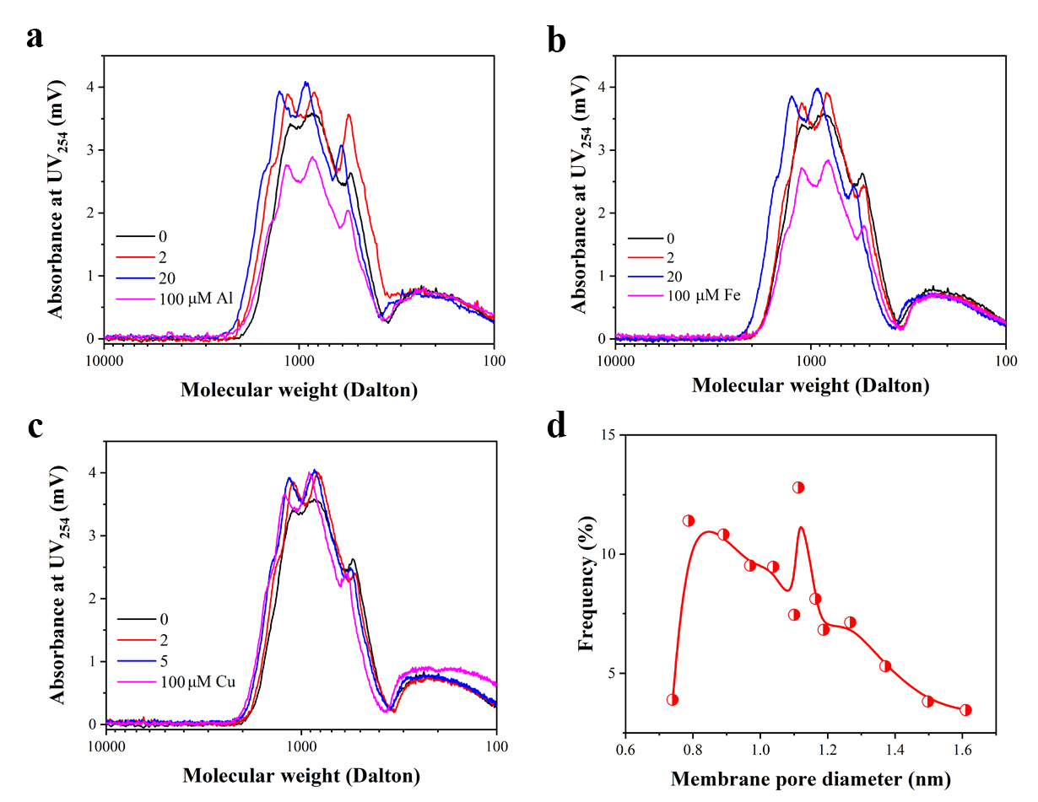
Figure 6. SEC spectra of the feed as a function of metal ion concentration: (a) Al, (b) Fe and (c) Cu, and (d) distribution of membrane pore of pristine NF membrane (MW cutoff: 1kDa). Results for SEC measurements were selected at the wavelength of 254 nm.
3.5 Mechanism and implications
As observed in section 3.1, significant flux decline during membrane nanofiltration was confirmed to be caused by metal-NOM complexes or micro-flocs; however, metal ion at higher or lower concentration led to the less membrane fouling. A previous study in membrane ultrafiltration indicated that a certain dose of Al-salt coagulant led to the most severe membrane fouling since the size of formed flocs was close to the size of membrane pore (Ma et al., 2014). Furthermore, we further explored this fouling process not only by membrane pore analysis (Figure 6d), but also by SEM images (coupled with SEM-EDS mapping) of the fouled membranes (Figures 7 and 8) at both critical and excessive metal ion concentrations. As shown in Figures 7a and 7b, cake layer can be obviously seen when Al³⁺ and Fe³⁺ were at excessive concentration (100 μM) in the feed, and backwashing was effective in removing these deposited flocs (Figures 7d and 7e). In contrast, the membrane fouled by Cu²⁺ at concentration of 100 μM (a much thinner cake layer) and after backwash were displayed in Figures 7c and 7f separately. The light dots in the magnified images (insets) indicated the little sticky flocs left on the membrane surface.
Many studies reported that pore blocking is the major contributor to the membrane fouling during filtration, especially operated in a dead-end mode (Miller et al., 2014; Saksena and Zydney, 1997). In this work, we also obtained the comparative SEM-EDS mapping images of the selected groups at their respective critical concentrations and the excessive concentration of 100 μM (Figure 8). From these images, we can easily further verify that membrane pore blocking by metal-NOM complexes /micro-flocs and the protective effect of cake layer provided by flocs (the schematic diagram seen in Figure 9), given that the distinct observations between fouled (left) and backwashed (right) membrane at critical concentration (Figures 8a, 8c and 8e) and excessive concentration (Figures 8b, 8d and 8f) separately.
In general, the obtained phenomena were tried to be explained by using the different absorbance spectra caused by the interplay between NOM and metal ions at various concentrations. In particular, the lowest flux (Figures 1a and 1b) was found to be simultaneously obtained when the corresponding intensity of DLAS was strongest in the presence of Al³⁺ and Fe³⁺ (Figures 2d and 3d), respectively. Then the membrane flux gradually recovered while the intensity began to decline. This is believed to be a novel finding in the application of absorbance spectra, even though there was an exception of Cu²⁺, since little precipitate formed. More importantly, this finding could also be expected to predict and avoid the severe membrane blocking caused by a certain range of coagulant dose in advance during the nanofiltration process.
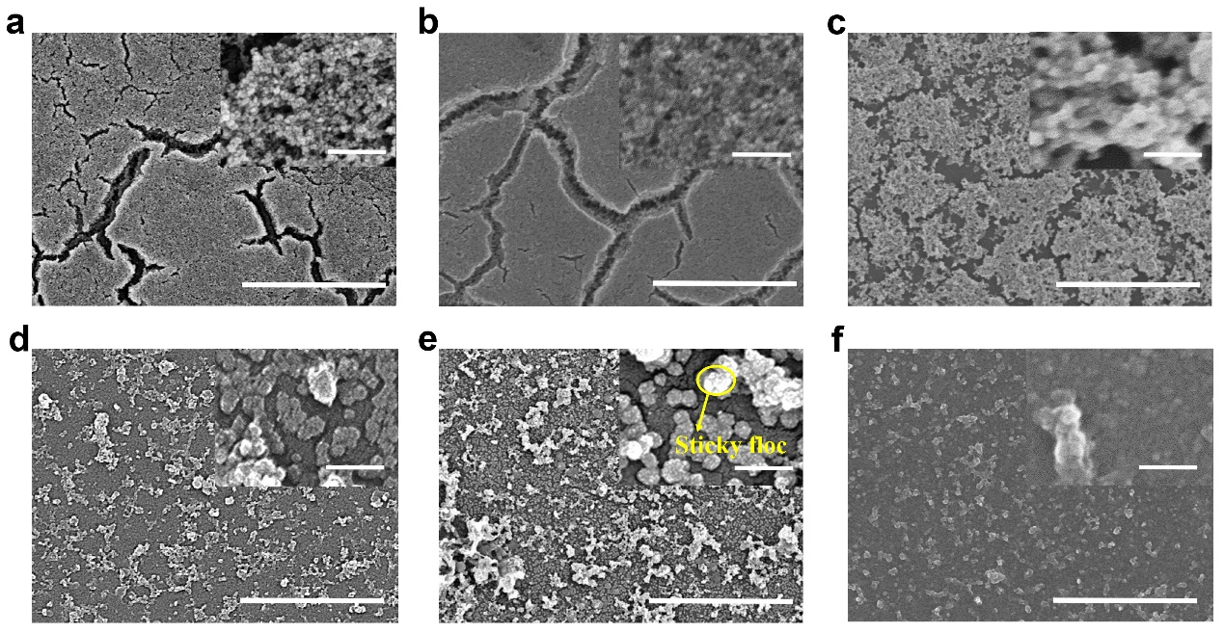
Figure 7. SEM images of fouled and backwashed membrane at an excessive concentration of 100 µM: (a) and (d) Al³⁺; (b) and (e) Fe³⁺; (c) and (f) Cu²⁺. The fouled membrane (a), (b) and (c); the backwashed membrane (d), (e) and (f). The scale bar in the membrane images (10k ×) is 5 μm and in the inset for magnification (100k ×) is 500 nm.
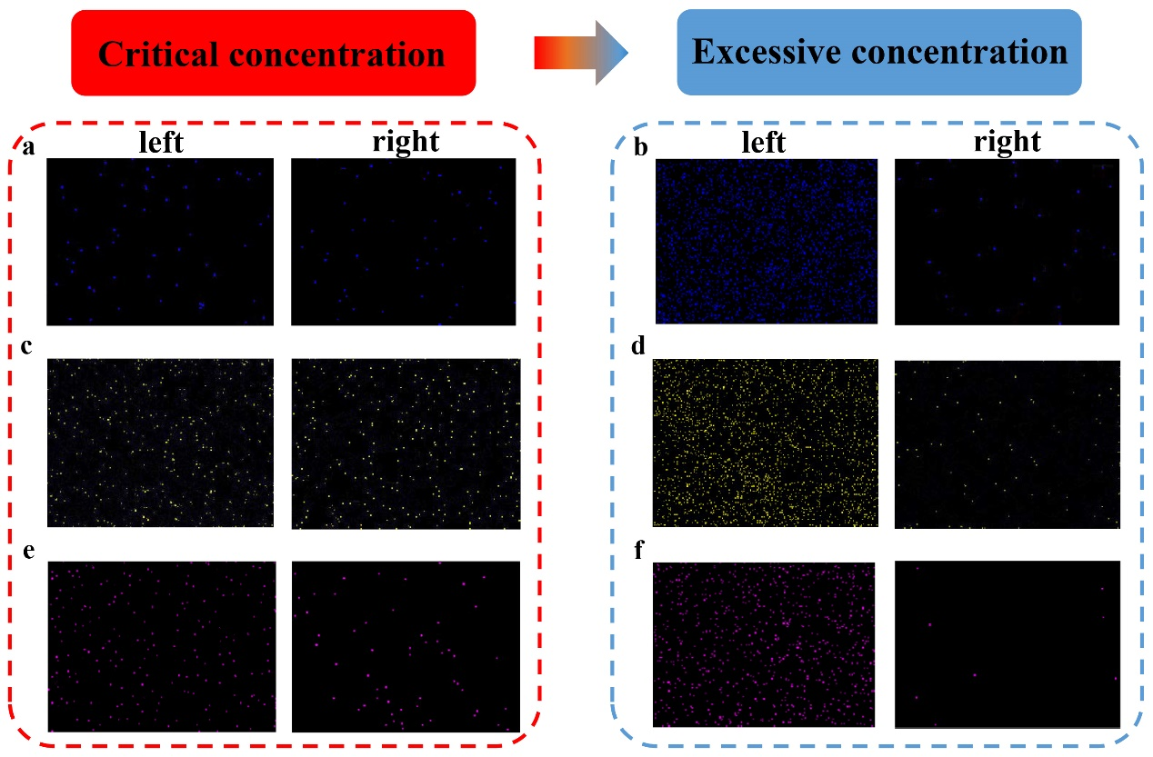
Figure 8. SEM-EDS mapping of fouled and backwashed membrane at critical concentration and excessive concentration (100 µM). (a) and (b) Al³⁺; (c) and (d) Fe³⁺; (e) and (f) Cu²⁺. The images in left indicate the fouled membranes; in right are the membranes after backwashing. The critical concentration for each metal ion was determined previously, Al³⁺ and Fe³⁺ for 20 µM, while Cu²⁺ for 5 µM. EDS mapping was conducted under a unique predetermined duration of 15 min.

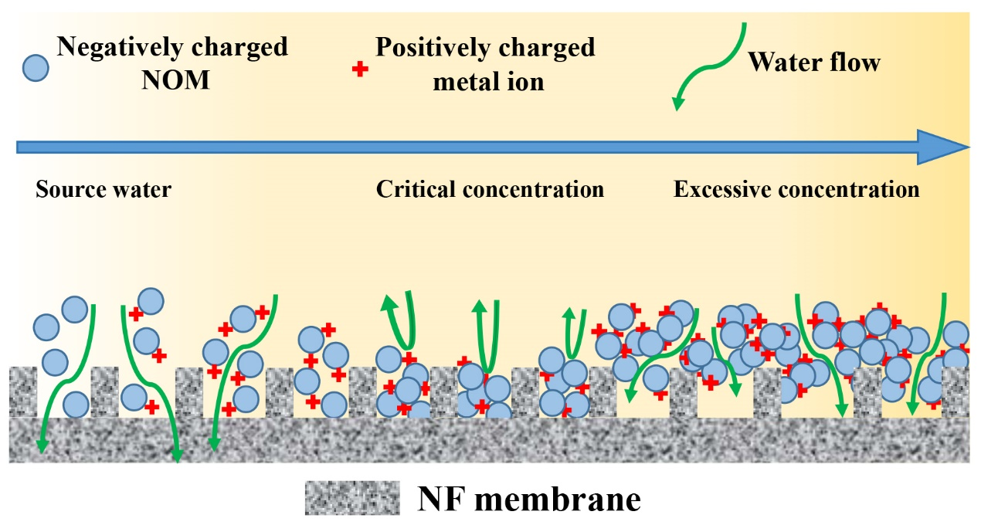
Figure 9. Schematic diagram of the membrane fouling mechanism influenced by the increasing metal concentration.
4. Conclusions
In this study, the novel findings on nanofiltration performance was presented by investigating the interactions between organic matter and metal ions using spectrophotometric techniques including fluorescence fingerprint and UV-vis absorbance spectra. The main conclusions were as follows:
- Metal ion (Cu²⁺) with strong complexation ability induced visible flux decline caused by shrinkage of flow channel during nanofiltration at a low concentration of 5 μm; metal ions (Al³⁺ and Fe³⁺) characterized by relatively weaker complexation ability caused much more severe flux decline at higher concentration of 20 μm when micro-flocs formed which lead to complete pore blocking.
- Membrane flux began to recover when the concentration of these metal ions exceeded their ‘critical values’, and ended up with better levels at certain higher concentration.
- The complexes formed by metal ions and low MW organic matter with the size approaching to the diameter of membrane pore (cut off: 1 kDa in this study) were believed to be the dominant contributor to NF membrane flux decline.
- UV-vis absorption spectra can be expected to be predictable in nanofiltration performance as a function of Al³⁺ and Fe³⁺ concentration, aside from Cu²⁺. However, fluorescence fingerprint was likely not effective in seeking the ‘critical value’.

Acknowledgements
This work was financially supported by Beijing Natural Science Foundation (No. 8192042), China Postdoctoral Science Foundation (No. 2018M641497), and National Natural Science Foundation of China (No. 51478010) was also acknowledged.

Reference
Abrahamse, A.J., Lipreau, C., Li, S., Heijman, S.G.J., 2008. Removal of divalent cations reduces fouling of ultrafiltration membranes. J. Memb. Sci. 323, 153–158. https://doi.org/10.1016/j.memsci.2008.06.018
Alvarez, P.J.J., Chan, C.K., Elimelech, M., Halas, N.J., Villagrán, D., 2018. Emerging opportunities for nanotechnology to enhance water security. Nat. Nanotechnol. 13, 634–641. https://doi.org/10.1038/s41565-018-0203-2
Bond, T., Goslan, E.H., Parsons, S.A., Jefferson, B., 2010. Disinfection by-product formation of natural organic matter surrogates and treatment by coagulation, MIEX® and nanofiltration. Water Res. 44, 1645–1653. https://doi.org/10.1016/j.watres.2009.11.018
Broeckmann, A., Busch, J., Wintgens, T., Marquardt, W., 2006. Modeling of pore blocking and cake layer formation in membrane filtration for wastewater treatment. Desalination 189, 97–109. https://doi.org/10.1016/j.desal.2005.06.018
Chang, H., Liang, H., Qu, F., Liu, B., Yu, H., Du, X., Li, G., Snyder, S.A., 2017. Hydraulic backwashing for low-pressure membranes in drinking water treatment: A review. J. Memb. Sci. https://doi.org/10.1016/j.memsci.2017.06.077
Choi, Y.H., Nason, J.A., Kweon, J.H., 2013. Effects of aluminum hydrolysis products and natural organic matter on nanofiltration fouling with PACl coagulation pretreatment. Sep. Purif. Technol. 120, 78–85. https://doi.org/10.1016/j.seppur.2013.09.016
Fujii, M., Ono, K., Yoshimura, C., Miyamoto, M., 2018. The role of autochthonous organic matter in radioactive cesium accumulation to riverine fine sediments. Water Res. 137, 18–27. https://doi.org/10.1016/j.watres.2018.02.063
Gao, Y., Yan, M., Korshin, G. V., 2015. Effects of Ionic Strength on the Chromophores of Dissolved Organic Matter. Environ. Sci. Technol. 49, 5905–5912. https://doi.org/10.1021/acs.est.5b00601
García-Otero, N., Bermejo-Barrera, P., Moreda-Piñeiro, A., 2013. Size exclusion and anion exchange high performance liquid chromatography for characterizing metals bound to marine dissolved organic matter. Anal. Chim. Acta 760, 83-92. https://doi.org/10.1016/j.aca.2012.11.024
Her, N., Amy, G., Park, H.R., Song, M., 2004. Characterizing algogenic organic matter (AOM) and evaluating associated NF membrane fouling. Water Res. 38, 1427–1438. https://doi.org/10.1016/j.watres.2003.12.008
Ho, C.C., Zydney, A.L., 2000. A combined pore blockage and cake filtration model for protein fouling during microfiltration. J. Colloid Interface Sci. 232, 389–399. https://doi.org/10.1006/jcis.2000.7231
Hong, S., Elimelech, M., 1997. Chemical and physical aspects of natural organic matter (NOM) fouling of nanofiltration membranes. J. Memb. Sci. 132, 159–181. https://doi.org/10.1016/S0376-7388(97)00060-4
Huang, W., Qin, X., Dong, B., Zhou, W., Lv, W., 2019. Fate and UF fouling behavior of algal extracellular and intracellular organic matter under the influence of copper ions. Sci. Total Environ. 649, 1643–1652. https://doi.org/10.1016/j.scitotenv.2018.08.077
Kim, H.C., Dempsey, B.A., 2013. Membrane fouling due to alginate, SMP, EfOM, humic acid, and NOM. J. Memb. Sci. 428, 190–197. https://doi.org/10.1016/j.memsci.2012.11.004
Li, Q., Elimelech, M., 2004. Organic fouling and chemical cleaning of nanofiltration membranes: Measurements and mechanisms. Environ. Sci. Technol. 38, 4683–4693. https://doi.org/10.1021/es0354162
Liang, B., Wang, H., Shi, X., Shen, B., He, X., Ghazi, Z.A., Khan, N.A., Sin, H., Khattak, A.M., Li, L., Tang, Z., 2018. Microporous membranes comprising conjugated polymers with rigid backbones enable ultrafast organic-solvent nanofiltration. Nat. Chem. 10, 961–967. https://doi.org/10.1038/s41557-018-0093-9
Lin, T., Lu, Z., Chen, W., 2015. Interaction mechanisms of humic acid combined with calcium ions on membrane fouling at different conditions in an ultrafiltration system. Desalination 357, 26–35. https://doi.org/10.1016/j.desal.2014.11.007
Ling, S., Qin, Z., Huang, W., Cao, S., Kaplan, D.L., Buehler, M.J., 2017. Design and function of biomimetic multilayer water purification membranes. Sci. Adv. 3, 1DUMMY. https://doi.org/10.1126/sciadv.1601939
Listiarini, K., Chun, W., Sun, D.D., Leckie, J.O., 2009. Fouling mechanism and resistance analyses of systems containing sodium alginate, calcium, alum and their combination in dead-end fouling of nanofiltration membranes. J. Memb. Sci. 344, 244–251. https://doi.org/10.1016/j.memsci.2009.08.010
Liu, H., Chen, G., Liu, L., Yan, M., 2018. Influence of ultrasound on the properties of dissolved organic matter with regards to proton and metal ion binding moieties. Water Res. 145, 279–286. https://doi.org/10.1016/j.watres.2018.08.008
Liu, T., Chen, Z. lin, Yu, W. zheng, You, S. jie, 2011. Characterization of organic membrane foulants in a submerged membrane bioreactor with pre-ozonation using three-dimensional excitation-emission matrix fluorescence spectroscopy. Water Res. 45, 2111–2121. https://doi.org/10.1016/j.watres.2010.12.023
Lynch, L.M., Sutfin, N.A., Fegel, T.S., Boot, C.M., Covino, T.P., Wallenstein, M.D., 2019. River channel connectivity shifts metabolite composition and dissolved organic matter chemistry. Nat. Commun. 10. https://doi.org/10.1038/s41467-019-08406-8
Ma, B., Yu, W., Liu, H., Qu, J., 2014. Effect of low dosage of coagulant on the ultrafiltration membrane performance in feedwater treatment. Water Res. 51, 277–283. https://doi.org/10.1016/j.watres.2013.10.069
Miller, D.J., Kasemset, S., Paul, D.R., Freeman, B.D., 2014. Comparison of membrane fouling at constant flux and constant transmembrane pressure conditions. J. Memb. Sci. 454, 505–515. https://doi.org/10.1016/j.memsci.2013.12.027
Mustafa, G., Wyns, K., Vandezande, P., Buekenhoudt, A., Meynen, V., 2014. Novel grafting method efficiently decreases irreversible fouling of ceramic nanofiltration membranes. J. Memb. Sci. 470, 369–377. https://doi.org/10.1016/j.memsci.2014.07.050
Nilsson, M., Lipnizki, F., Trägårdh, G., Östergren, K., 2008. Performance, energy and cost evaluation of a nanofiltration plant operated at elevated temperatures. Sep. Purif. Technol. 60, 36–45. https://doi.org/10.1016/j.seppur.2007.07.051
Ohno, T., Amirbahman, A., Bro, R., 2008. Parallel factor analysis of excitation-emission matrix fluorescence spectra of water soluble soil organic matter as basis for the determination of conditional metal binding parameters. Environ. Sci. Technol. 42, 186–192. https://doi.org/10.1021/es071855f
Poulin, B.A., Ryan, J.N., Aiken, G.R., 2014. The effects of iron on optical properties of dissolved organic matter. Environ. Sci. Technol. 48, 10098–10106. https://doi.org/10.1021/es502670r
Riedel, T., Biester, H., Dittmar, T., 2012. Molecular fractionation of dissolved organic matter with metal salts. Environ. Sci. Technol. 46, 4419–4426. https://doi.org/10.1021/es203901u
Saksena, S., Zydney, A.L., 1997. Influence of protein-protein interactions on bulk mass transport during ultrafiltration. J. Memb. Sci. 125, 93–108. https://doi.org/10.1016/S0376-7388(96)00132-9
Sanaei, P., Cummings, L.J., 2018. Membrane filtration with complex branching pore morphology. Phys. Rev. Fluids 3. https://doi.org/10.1103/PhysRevFluids.3.094305
Shutova, Y., Baker, A., Bridgeman, J., Henderson, R.K., 2014. Spectroscopic characterisation of dissolved organic matter changes in drinking water treatment: From PARAFAC analysis to online monitoring wavelengths. Water Res. 54, 159–169. https://doi.org/10.1016/j.watres.2014.01.053
Speth, T.F., Summers, R.S., Gusses, A.M., 1998. Nanofiltration foulants from a treated surface water. Environ. Sci. Technol. 32, 3612–3617. https://doi.org/10.1021/es9800434
Su, Z., Li, X., Yang, Y., 2017. Regrowth ability and coagulation behavior by second dose: Breakage during the initial flocculation phase. Colloids Surfaces A Physicochem. Eng. Asp. 527, 109–114. https://doi.org/10.1016/j.colsurfa.2017.05.034
Tang, C.Y., Chong, T.H., Fane, A.G., 2011. Colloidal interactions and fouling of NF and RO membranes: A review. Adv. Colloid Interface Sci. 164, 126–143. https://doi.org/10.1016/j.cis.2010.10.007
Ventresque, C., Bablon, G., 1997. The integrated nanofiltration system of the Mery-sur-Oise surface water treatment plant (37 mgd). Desalination 113, 263–266. https://doi.org/10.1016/S0011-9164(97)00138-0
Yan, M., Benedetti, M.F., Korshin, G. V., 2013a. Study of iron and aluminum binding to Suwannee River fulvic acid using absorbance and fluorescence spectroscopy: Comparison of data interpretation based on NICA-Donnan and Stockholm humic models. Water Res. 47, 5439–5446. https://doi.org/10.1016/j.watres.2013.06.022
Yan, M., Korshin, G. V., 2014. Comparative Examination of Effects of Binding of Different Metals on Chromophores of Dissolved Organic Matter. Environ. Sci. Technol. 48, 3177–3185. https://doi.org/10.1021/es4045314
Yan, M., Lu, Y., Gao, Y., Benedetti, M.F., Korshin, G. V., 2015. In-Situ Investigation of Interactions between Magnesium Ion and Natural Organic Matter. Environ. Sci. Technol. 49, 8323–8329. https://doi.org/10.1021/acs.est.5b00003
Yan, M., Ma, J., Ji, G., 2016. Examination of effects of Cu(II) and Cr(III) on Al(III) binding by dissolved organic matter using absorbance spectroscopy. Water Res. 93, 84–90. https://doi.org/10.1016/j.watres.2016.02.017
Yan, M., Wang, D., Korshin, G. V., Benedetti, M.F., 2013b. Quantifying metal ions binding onto dissolved organic matter using log-transformed absorbance spectra. Water Res. 47, 2603–2611. https://doi.org/10.1016/j.watres.2013.02.044
Yu, W., Brown, M., Graham, N.J.D., 2016a. Prevention of PVDF ultrafiltration membrane fouling by coating MnO2 nanoparticles with ozonation. Sci. Rep. 6, 30144. https://doi.org/10.1038/srep30144
Yu, W., Campos, L.C., Graham, N., 2016b. Application of pulsed UV-irradiation and pre-coagulation to control ultrafiltration membrane fouling in the treatment of micro-polluted surface water. Water Res. 107, 83–92. https://doi.org/10.1016/j.watres.2016.10.058
Yu, W., Graham, N., Yang, Y., Zhou, Z., Campos, L.C., 2015. Effect of sludge retention on UF membrane fouling: The significance of sludge crystallization and EPS increase. Water Res. 83, 319–328. https://doi.org/10.1016/j.watres.2015.06.049
Yu, W., Liu, T., Crawshaw, J., Liu, T., Graham, N., 2018. Ultrafiltration and nanofiltration membrane fouling by natural organic matter: Mechanisms and mitigation by pre-ozonation and pH. Water Res. 139. https://doi.org/10.1016/j.watres.2018.04.025
Yu, W. zheng, Graham, N., Liu, H. juan, Li, H., Qu, J. hui, 2013. Membrane fouling by Fe-Humic cake layers in nano-scale: Effect of in-situ formed Fe(III) coagulant. J. Memb. Sci. 431, 47–54. https://doi.org/10.1016/j.memsci.2012.12.035
Yuan, W., Kocic, A., Zydney, A.L., 2002. Analysis of humic acid fouling during microfiltration using a pore blockage-cake filtration model. J. Memb. Sci. 198, 51–62. https://doi.org/10.1016/S0376-7388(01)00622-6
Zhang, Y., Yin, Y., Feng, L., Zhu, G., Shi, Z., Liu, X., Zhang, Y., 2011. Characterizing chromophoric dissolved organic matter in Lake Tianmuhu and its catchment basin using excitation-emission matrix fluorescence and parallel factor analysis. Water Res. 45, 5110–5122. https://doi.org/10.1016/j.watres.2011.07.014
Zhao, C., Tang, C.Y., Li, P., Adrian, P., Hu, G., 2016. Perfluorooctane sulfonate removal by nanofiltration membrane-the effect and interaction of magnesium ion / humic acid. J. Memb. Sci. 503, 31–41. https://doi.org/10.1016/j.memsci.2015.12.049

