Two-Dimensional Organic Tin Halide Perovskites with Tunable Visible Emission and Their Use in Light Emitting Devices

Luis Lanzetta¹, Jose Manuel Marin-Beloqui¹, Irene Sanchez-Molina¹, Dong Ding¹ and Saif A. Haque¹*

¹Department of Chemistry and Centre for Plastic Electronics, Imperial College London, South Kensington Campus, London SW7 2AZ, U.K.
AUTHOR INFORMATION
Corresponding Author
* s.a.haque@imperial.ac.uk

Supporting Information

Materials and Methods

Methylammonium iodide, phenylethylammonium iodide and phenylethyammonium bromide synthesis: methylammonium iodide, phenylethylammonium iodide and phenylethylammonium bromide were synthesised as reported elsewhere^{1,2}. All precursors were purchased from Sigma-Aldrich and used as received. SnBr₂ was purchased from Alfa-Aesar.
Sample preparation: prior to film deposition, 1 cm × 1 cm glass substrates were washed consecutively in an ultrasonic bath with acetone and isopropanol for 10 min in each repetition and treated with UV/ozone for 15 min. Under inert atmosphere, 20% wt. (PEA)₂SnI_{x}Br_{4-x} or CH₃NH₃SnI₃ perovskite precursor solutions were prepared by dissolving stoichiometric amounts of PEAI/PEABr and SnI₂/SnBr₂ ((PEA)₂SnI_{x}Br_{4-x}) or MAI and SnI₂ (CH₃NH₃SnI₃) in anhydrous DMF (VWR) and deposited onto substrates by spin-coating at 4000 rpm for 45 s. Concentration of perovskite solutions for stability studies was 0.888 M. Annealing of perovskite films was performed at 80ºC for 10 min. In case of processing samples onto metal oxide substrates, TiO₂ or Al₂O₃ nanoparticle dispersions were spread on glass before perovskite deposition. TiO₂ paste (DyeSol) was diluted with ethanol (2:7 w/w) and applied by spin-coating at 5000 rpm for 30 s, followed by annealing at 500ºC for 1 h. An Al₂O₃ nanoparticle dispersion (20% wt. in isopropanol, Sigma-Aldrich) was diluted with isopropanol (1:1 v/v) and deposited at 3000 rpm for 30 s. Solvent elimination was performed at 100ºC for 10 min. All samples used for material characterisation were coated at 1000 rpm for 30 s with a PMMA solution (10 mg/mL in chlorobenzene, polymer purchased from Sigma-Aldrich) before being exposed to ambient conditions. Samples for stability studies were not coated with PMMA.
Material characterisation: absorbance spectra were registered with a Shimadzu UV-2600 integrating sphere spectrophotometer. Steady-state photoluminescence spectra were acquired with a Horiba Jobin–Yvon Fluorolog-3 spectrofluorometer, using different excitation wavelengths ((PEA)₂SnI₄, CH₃NH₃SnI₃: 500 nm; (PEA)₂SnI₃Br, (PEA)₂SnI₂Br₂: 450 nm; (PEA)₂SnIBr₃, (PEA)₂SnBr₄: 400 nm) and a slit width of 5 nm. In both cases, the glass side of samples was exposed to the probe/excitation light. X-Ray Diffraction patterns of (PEA)₂SnI₄ were obtained with a PANalytical X’Pert Pro MRD diffractometer using Ni-filtered Cu (Kα) X-rays at 40 kV and 40 mA. Scanning Electron Microscopy images were acquired with a LEO 1525 Field Emission Scanning Electron Microscope operated at 10 kV using an In Lens detector. Samples were coated with chromium (10 nm) by sputtering prior to performing the SEM characterisation.
Transient Absorption Spectroscopy: microsecond Transient Absorption Spectroscopy studies were performed by placing samples in quartz cuvettes sealed in a nitrogen glovebox and exciting them with a dye laser (Photon Technology International Inc. GL-301) pumped by a nitrogen laser (Photon Technology International Inc. GL-3300) with a fluence of 7 µJ/cm². In a different optical axis, a probing light beam (100 W quartz halogen lamp, Bentham IL 1; power source: Bentham 605) was directed to the sample and detected with a silicon photodiode (Hamamatsu Photonics, S1722-01). The diode signal was amplified and filtered (Costronics Electronics) before reaching a digital oscilloscope (Tektronics DPO3012), which was synchronized with the pump laser pulse signals via a photodiode (Thorlabs Inc., DET210).
Time-Resolved Photoluminescence Spectroscopy: Time-correlated single-photon counting measurements were performed using a Horiba Deltaflex Modular Fluorescence Lifetime System equipped with a PPD 900 detector. The excitation source was a 404 nm peak wavelength nanoled (Model N-07), with a maximum repetition rate of 1MHz and <200 ps pulse duration.
Photoluminescence Quantum Efficiency (PLQE): PLQE was measured with a Jobin Ybon Horiba Fluoromax-3 spectrofluorometer connected to a diffusely reflecting integrating sphere. Excitation wavelengths were selected as 500 nm ((PEA)₂SnI₄), 450 nm ((PEA)₂SnI₃Br, (PEA)₂SnI₂Br₂) and 400 nm ((PEA)₂SnIBr₃, (PEA)₂SnBr₄, CH₃NH₃SnI₃). PLQE values were calculated by using the following equation: PLQE(%) = [A_{emission} /(A_{blank} – A_{sample})]·100. A_{emission} is the area under the perovskite emission peak, A_{blank} is the area under the excitation peak with a blank sample and A_{sample} is the area under the excitation peak with a perovskite sample.
Device fabrication: ITO substrates (Psiotec, 12x12mm substrates, 15 Ohm/cm² with 8mm wide stripe photomask) were washed with acetone and isopropanol in the ultrasonic bath as detailed above for glass substrates and exposed to UV/ozone for 15 min. PEDOT:PSS (Heraeus Clevios GmbH) was deposited onto ITO via spin-coating at 6000 rpm for 30 s, followed by annealing at 140ºC for 30 min as reported by Tan et al³. From this step onwards, device fabrication was carried out under inert atmosphere. (PEA)₂SnI₄ thin films were deposited as explained above, using a 5% wt. perovskite precursor solution. F8 (Ossila) was dissolved in anhydrous chlorobenzene (VWR; 10 mg/mL) upon heating at 70ºC and applied via spin-coating at 3000 rpm for 30 s. Top LiF/Al contacts were processed through vacuum thermal evaporation.
Device characterisation: electroluminescence spectra of (PEA)₂SnI₄ LEDs were acquired by using the same setup described for steady-state photoluminescence spectroscopy measurements with the aid of a homemade holder (sealed under inert atmosphere) connected to a Keithley 2400 source meter. Current-voltage and luminance voltage characteristics were acquired by combining the same source meter with a Konica Minolta LS-110 luminance meter.

References

(1) Aristidou, N.; Sanchez-Molina, I.; Chotchuangchutchaval, T.; Brown, M.; Martinez, L.; Rath, T.; Haque, S. A. The Role of Oxygen in the Degradation of Methylammonium Lead Trihalide Perovskite Photoactive Layers. Angew. Chemie Int. Ed. 2015, 54, 8208–8212.
(2) Smith, I. C.; Hoke, E. T.; Solis-Ibarra, D.; McGehee, M. D.; Karunadasa, H. I. A Layered Hybrid Perovskite Solar-Cell Absorber with Enhanced Moisture Stability. Angew. Chemie 2014, 126, 11414–11417.
(3) Tan, Z.-K.; Moghaddam, R. S.; Lai, M. L.; Docampo, P.; Higler, R.; Deschler, F.; Price, M.; Sadhanala, A.; Pazos, L. M.; Credgington, D.; et al. Bright Light-Emitting Diodes Based on Organometal Halide Perovskite. Nat. Nanotechnol. 2014, 9, 1–6.

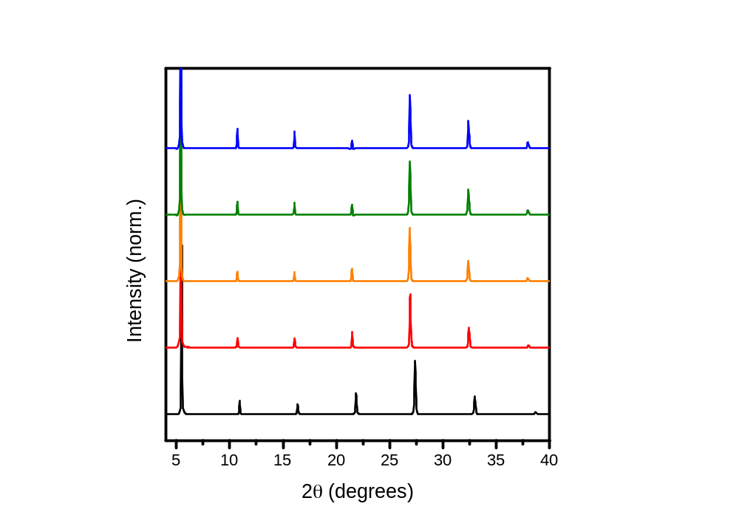
Figure S1. P-XRD patterns of (PEA)₂SnI₃Br (red line), (PEA)₂SnI₂Br₂ (orange line), (PEA)₂SnIBr₃ (green line) and (PEA)₂SnBr₄ (blue line) thin films processed on glass.

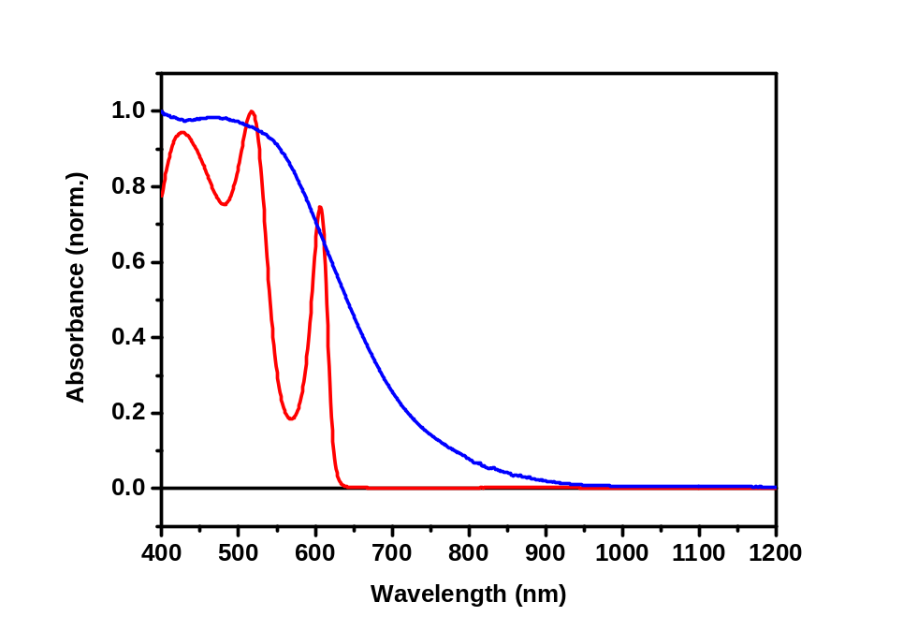
Figure S2. Absorbance spectra of 2D (PEA)₂SnI₄ (red line) and 3D CH₃NH₃SnI₃ (blue line) perovskites processed on mp-TiO₂ substrates. Optical band gaps were estimated to be 1.97 eV and 1.26 eV, respectively.

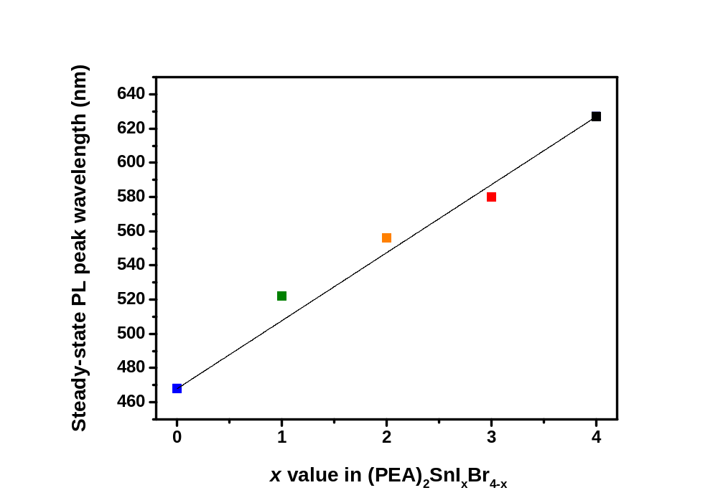
Figure S3. Steady-state PL peak wavelengths of synthesised (PEA)₂SnI_{x}Br_{4-x} perovskites (black square: x = 4; red square: x = 3; orange square: x = 2; green square: x = 1; blue square: x = 0) as a function of the aimed x value in the formula. The linear trend seen in the data points confirms that this system follows Vegard’s law. The black line represents a linear fitting between the two end compositions x = 4 and x = 0 (y = 39.75x + 468) and allows to estimate the experimental values of x in our mixed-halide perovskites as 2.82 (3), 2.21 (2) and 1.36 (1), being these fairly close to the aimed compositions.

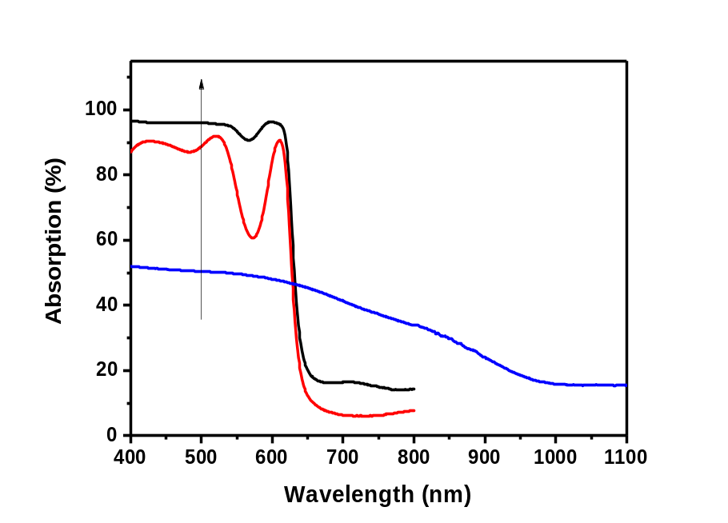
Figure S4. Absorption spectra of (PEA)₂SnI₄ (red line), mp-TiO₂/(PEA)₂SnI₄ (black line) and CH₃NH₃SnI₃ (blue line) thin films. Figure 2a (inset) steady-state PL spectra were normalised to the excitation wavelength (500 nm, shown in graph with the black arrow).

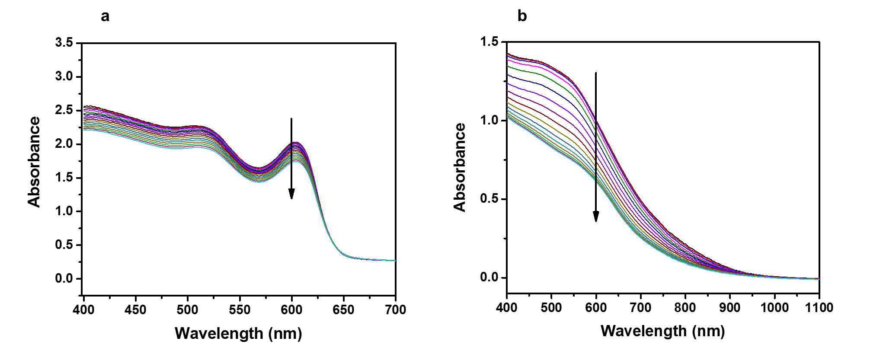
Figure S5. Absorbance time evolution of a, (PEA)₂SnI₄ and b, CH₃NH₃SnI₃. Arrows indicate the time drop in absorbance at 600 nm. Perovskite thin films were processed on mp-Al₂O₃ and measured under dark and air conditions.

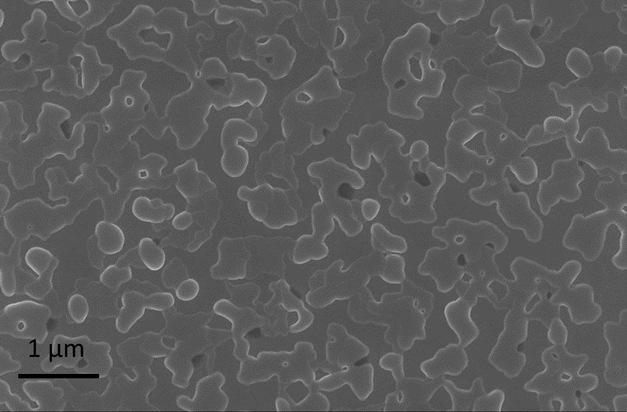
Figure S6. Top-view Scanning Electron Microscopy image of a (PEA)₂SnI₄ emitter layer in a device. Scale bar: 1 µm.

Sample | A₁ | τ₁ (ns) | A₂ | τ₂ (ns) | A₃ | τ₃ (ns) | R²
(PEA)₂SnI₄ | 0.12158±  0.00295 | 8.85143±  0.17559 | 0.43777±  0.00583 | 1.66842±  0.03077 | 0.44408±  0.00708 | 0.32336±  0.00639 | 0.99942
mpTiO₂/(PEA)₂SnI₄ | 0.03965±  0.00625 | 1.52851±  0.64394 | 1.04353±  0.01062 | 0.12703±  0.00261 |  |  | 0.99357
(PEA)₂SnI₃Br | 0.10567±  0.00425 | 5.99253±  0.18354 | 0.40417±  0.00459 | 1.25203±  0.02741 | 0.49228±  0.00594 | 0.19635±  0.00344 | 0.99944
(PEA)₂SnI₂Br₂ | 0.07354±  0.00346 | 5.52310±  0.21018 | 0.37505±  0.00934 | 0.96628±  0.02907 | 0.55582±  0.01103 | 0.22419±  0.00459 | 0.99936
(PEA)₂SnIBr₃ | 0.01208±  0.00382 | 5.23689±  1.57068 | 0.28013±  0.00973 | 0.84139±  0.03788 | 0.71338±  0.01164 | 0.17670±  0.00325 | 0.99904
(PEA)₂SnBr₄ | 0.01761±  0.00453 | 1.83525±  0.68727 | 1.10100±  0.00918 | 0.11660±  0.00191 |  |  | 0.98437
CH₃NH₃SnI₃ | 1.00882±  0.01978 | 0.10887±  0.00498 |  |  |  |  | 0.99451
Table S1. Fitting parameters of PL decays in Figures 1d and 2a. A₁exp(t/τ₁) + A₂exp(t/τ₂) + A₃exp(t/τ₃) ((PEA)₂SnI₄, (PEA)₂SnI₃Br, (PEA)₂SnI₂Br₂, (PEA)₂SnIBr₃), A₁exp(t/τ₁) + A₂exp(t/τ₂) (mp-TiO₂/(PEA)₂SnI₄, (PEA)₂SnBr₄) or A₁exp(t/τ₁) (CH₃NH₃SnI₃) functions were employed.

