Additional file 2. Further details on Methods, Results and Analyses.

Heterogeneity in Trypanosoma cruzi infection in triatomine vectors and animal reservoirs in Colombia: a systematic review and meta-analysis

Eliana Rodríguez-Monguí¹, Omar Cantillo-Barraza ², Franklin-Edwin Prieto¹, Zulma M. Cucunubá³
- Facultad de Medicina, Universidad El Bosque, Bogotá, Colombia.
- Laboratorio Biología y Control de Enfermedades Infecciosas (BCEI), Universidad de Antioquia, Medellín, Colombia.
- Department of Infection Disease Epidemiology, Imperial College London, London, United Kingdom.

Authors e-mail addresses:
Eliana Rodríguez-Monguí eliana.rodmon@gmail.com
Omar Cantillo-Barraza omarcantillo@gmail.com
Franklin Prieto franklynprieto@yahoo.com
Zulma M. Cucunubá zulma.cucunuba@imperial.ac.uk

Corresponding author: Zulma M. Cucunubá, Department of Infection Disease Epidemiology, Imperial College London. zulma.cucunuba@imperial.ac.uk

Additional Text on Quality Assessment 2
Additional Tables 3
Additional Figures 21

Text 1. Additional text on Quality Assessment

An evaluation matrix was designed for content quality assessment [1], where the following items were examined:
- Was the research question/objective clearly described and stated?
- Was the sampling method described in detail?
- Was the period of study clearly stated?
- Was the serological test method clearly pointed out?
- Were the subjects categorized into different subgroups?

To each item, a score was given based in these criteria:
2= low risk "yes"
0= high risk "no"
1= unclear risk "unsure"

Did the study address a clearly described and focused question / problem?
The method of selection of the subjects described in detail, including the protocol method of search and capture of triatomine bugs and reservoirs (study design), is it appropriate to answer the research question? (selection and information bias)

Was the diagnostic test method for T. cruzi infection in vectors and / or animal reservoirs clearly informed and adequate to answer the research question? (information bias)
Was the study period clearly established? (selection bias)
Were the subjects categorized into different subgroups; Could there be confounding factors that have not been taken into account? (confusion)

Table S1. Boolean algorithms for literature search as of 5th of April 2018.

Database | Algorithm | Number of titles | Filter
Web of knowledge | (((trypanosomiasis OR trypanosoma cruzi OR Chagas disease) AND (transmission OR cycle OR ecoepidemiology OR ecology OR triatominae OR vector OR reservoir OR mammals*) AND colombia)) | 189 | None
PubMed | ("trypanosomiasis"[MeSH Terms] OR ("trypanosoma cruzi"[MeSH Terms] OR ("trypanosoma"[All Fields] AND "cruzi"[All Fields]) OR "trypanosoma cruzi"[All Fields]) OR "trypanosomiasis"[All Fields] OR "Chagas disease"[All Fields] OR "Chagas disease"[MeSH Terms])
LILACS | (tw:((Chagas Disease OR Enfermedad de Chagas OR Doença de Chagas OR Trypanosomiasis OR Tripanosomiasis OR Tripanossomíase OR Trypanosoma cruzi)))  AND (tw:(Colombia OR Colômbia ))  AND tw:(transmission OR transmisión OR transmissão OR Disease Vectors OR Vectores de Enfermedades OR Vetores de Doenças OR Triatominae OR Triatominae OR Triatominae OR mammals OR mamíferos)) | 290 | None
EMBASE | 1. 'trypanosoma cruzi'/exp OR 'trypanosoma cruzi'  2. 'chagas disease'/exp OR 'chagas disease'  3. 'trypanosomiasis'  4. #1 OR #2 OR #3  5. 'disease transmission'  6. 'disease carrier'  7. 'triatominae'  8. 'ecology'  9. cycle AND transmission  10. 'mammal'  11. #5 OR #6 OR #7 OR #8 OR #9 OR #10  12. #4 AND #11  13. 'colombia'  14. #12 AND #13 | 227 | None
Google  Scholar | NA | 3 | None
Digital Repository National university | NA | 4 | None
Total |  | 960

Table S2. Pooled prevalence estimates of Trypanosoma cruzi infection in both triatomines and potential animal reservoirs by departments (firs administrative units) in Colombia
Locations | Number of studies | Reservoirs (n) | Reservoirs (+) | Pooled Prevalence  (%) | 95%CI | I²  (%) | τ² | p-Value
Potential Reservoirs
Various* | 2 | 20228 | 983 | 9.0 | (2-22) | 98 | 0.02 | <0.01
Antioquia | 1 | 70 | 5 | 7.1 | (2-15) | ---- | ---- | ----
Boyacá | 2 | 140 | 34 | 17.0 | (0-57) | 80 | 0.01 | 0.03
Bolívar | 2 | 294 | 205 | 75.0 | (58-89) | 72 | 0.01 | 0.06
Casanare | 3 | 387 | 75 | 14.0 | (2-32) | 94 | 0.03 | <0.01
Córdoba | 2 | 99 | 14 | 17.0 | (0-57) | 94 | 0.09 | <0.01
Guajira | 1 | 12 | 2 | 16.6 | (0-44) | ---- | ---- | ----
Meta | 2 | 999 | 142 | 17.0 | (5-34) | 97 | 0.02 | <0.01
Magdalena | 1 | 115 | 20 | 17.4 | (11-25) | ---- | ---- | ----
Nariño | 1 | 325 | 24 | 7.4 | (5-11) | ---- | ---- | ----
SNSM** | 1 | 151 | 72 | 48.0 | (40-56) | ---- | ---- | ----
Triatomine bugs
Antioquia | 1 | 124 | 12 | 11.0 | (6-18) | ---- | ---- | ----
Atlántico | 1 | 12 | 0 | 0.0 | (0-14) | ---- | ---- | ----
Arauca | 1 | 29 | 13 | 44.8 | (27-63) | ---- | ---- | ----
Bolívar | 4 | 244 | 168 | 68.8 | (61-76) | 34 | 0.00 | 0.21
Boyacá | 1 | 4579 | 197 | 4.3 | (0-14) | ---- | ---- | ----
Caquetá | 1 | 18 | 9 | 50.0 | (27-73) | ---- | ---- | ----
Casanare | 5 | 604 | 351 | 46.0 | (23-71) | 97 | 0.08 | <0.01
Cesar | 3 | 3286 | 295 | 24.0 | (0-65) | 99 | 0.14 | <0.01
Córdoba | 1 | 22 | 18 | 81.8 | (63-96) | ---- | ---- | ----
Guajira | 3 | 444 | 128 | 42.0 | (13-76) | 97 | 0.08 | <0.01
Magdalena | 3 | 167 | 96 | 58.0 | (50-65) | 0 | 0.00 | 0.61
Meta | 1 | 384 | 51 | 13.2 | (10-17) | ---- | ---- | ----
Norte de Santander | 1 | 123 | 0 | 0.0 | (0-1) | ---- | ---- | ----
Santander | 1 | 17 | 9 | 52.9 | (29-76) | ---- | ---- | ----
Vichada | 1 | 28 | 18 | 64.2 | (45-81) | ---- | ---- | ----
SNSM | 3 | 740 | 67 | 9.1 | (7-11) | 0 | 0.00 | 0.89
Various* | 2 | 470 | 221 | 46.0 | (18-75) | 98 | 0.05 | <0.01

*Non-disaggregated results
**SNSM: Sierra Nevada de Santa Marta

Table S3. Detailed data for the 18 studies chosen for potential Trypanosoma cruzi reservoirs in Colombia

Reference | Study period | Departament  (first administrative unit) | Order | Species | No. of animals | No. of infected animals | Prevalence for  order  % | Diagnostic methods | Quality Score | Ref
D'Alessandro 1971 | 1968 | Casanare,Vichada,Meta | Artiodactyla | O. virginianus | 9 | 2 | 27.27 | Non-serological | 3 | [2]
 |  |  |  | M. gouazoubira medemi | 2 | 1
Marinkelle 1982 (a) | 1961-1972 | Colombia | Primates | ---- | 343 | 53 | 15.45 | Non-serological | 5 | [3]
Marinkelle 1982 (b) | 1961-1972 | Colombia | Chiroptera | ---- | 19885 | 930 | 4.67 | Non-serological | 9 | [4]
D'Alessandro et al. 1984 | 1978-1979 | Meta | Cingulata | D. kappleri | 7 | 2 | 19.04 | Non-serological | 8 | [5]
 |  |  |  | D. sabanicola | 10 | 1
 |  |  |  | P. giganteus | 4 | 1
D'Alessandro et al. 1984 | 1978-1979 | Meta | Pilosa | M. tridactyla | 1 | 0 | 16.66 | Non-serological | 8 | [5]
 |  |  |  | T. tetradactyla | 5 | 1
D'Alessandro et al. 1984 | 1978-1979 | Meta | Didelphimorphia | D. marsupialis | 62 | 25 | 18.97 | Non-serological | 8 | [5]
 |  |  |  | Marmosa s.p. | 4 | 1
 |  |  |  | M. murina | 32 | 0
 |  |  |  | M. nudicaudatus | 37 | 0
 |  |  |  | Monodelphis s.p. | 1 | 0
 |  |  |  | L. crassicaudata | 1 | 0
D'Alessandro et al. 1984 | 1978-1979 | Meta | Carnivora | C. thous | 6 | 0 | 18.75 | Non-serological | 8 | [5]
 |  |  |  | F. concolor | 1 | 0
 |  |  |  | F. pardalis | 2 | 0
 |  |  |  | P. flavus | 7 | 3
D'Alessandro et al. 1984 | 1978-1979 | Meta | Rodentia | C. porcellus | 1 | 0 | 8.63 | Non-serological | 8 | [5]
 |  |  |  | H. hydrochaeris | 57 | 5
 |  |  |  | R. rattus | 1 | 0
 |  |  |  | Z. brevicauda | 43 | 0
 |  |  |  | N. spinosus | 7 | 0
 |  |  |  | N. squamipes | 19 | 0
 |  |  |  | S. alstoni | 1 | 0
 |  |  |  | Coendou s.p | 1 | 0
 |  |  |  | Proechymis s.p | 224 | 23
 |  |  |  | O. concolor | 15 | 1
 |  |  |  | O. delicates | 1 | 0
 |  |  |  | O. fulvescens | 11 | 0
 |  |  |  | C. paca | 74 | 10
 |  |  |  | D. fuliginosa | 8 | 1
D'Alessandro et al. 1984 | 1978-1979 | Meta | Chiroptera | Artibeus s.p. | 11 | 1 | 3.84 | Non-serological | 8 | [5]
 |  |  |  | A. jamaicensis | 2 | 1
 |  |  |  | P. discolour | 2 | 0
 |  |  |  | E. furinalis | 3 | 1
 |  |  |  | L. borealis | 1 | 0
 |  |  |  | M. nigricans | 2 | 0
 |  |  |  | E. perotis | 1 | 0
 |  |  |  | M. major | 33 | 0
 |  |  |  | M. ater | 20 | 1
 |  |  |  | N. labialis | 29 | 0
D'Alessandro et al. 1984 | 1978-1979 | Meta | Artiodactyla | O. virginianus | 6 | 2 | 22.22 | Non-serological | 8 | [5]
 |  |  |  | Tayassu s.p. | 2 | 0
 |  |  |  | T. albirostris | 1 | 0
Travi et al. 1994 | 1991 | Narino, Cordoba | Cingulata | D. novemcinctus | 1 | 1 | 100 | Non-serological | 4 | [6]
Travi et al. 1994 | 1991 | Narino, Cordoba | Pilosa | B. variegatus | 45 | 0 | 0 | Non-serological | 4 | [6]
 |  |  |  | C. hoffmanni | 1 | 0
 |  |  |  | C. Didactylus | 4 | 0
 |  |  |  | T. tetradactyla | 7 | 0
Travi et al. 1994 | 1991 | Narino, Cordoba | Didelphimorphia | D. marsupialis | 40 | 16 | 26.22 | Non-serological | 4 | [6]
 |  |  |  | P. opossum | 21 | 0
Travi et al. 1994 | 1991 | Narino, Cordoba | Carnivora | P. flavus | 2 | 1 | 50.0 | Non-serological | 4 | [6]
Travi et al. 1994 | 1991 | Narino, Cordoba | Rodentia | R. rattus | 87 | 4 | 3.29 | Non-serological | 4 | [6]
 |  |  |  | T. mirae | 23 | 3
 |  |  |  | P. semiespinosus | 163 | 2
Wolff et al. 2001 | 1997-1999 | Antioquia | Cingulata | D. novemcinctus | 10 | 1 | 20.0 | Non-serological | 9 | [7]
Wolff et al. 2001 | 1997-1999 | Antioquia | Didelphimorphia | D. marsupialis | 10 | 1
 |  |  |  | P. opossum | 10 | 0
 |  |  |  | Marmosa cf. Robinsoni | 10 | 0
Wolff et al. 2001 | 1997-1999 | Antioquia | Rodentia | H. gimnurus | 10 | 0
 |  |  |  | Proechymis sp | 10 | 0
 |  |  |  | Oryzomis sp | 10 | 0
Wolff et al. 2001 | 1997-1999 | Antioquia | Carnivora | C. lupus | 60 | 3 | 5.0 | Serological | 9 | [7]
Manrique et al.2012 | 2009 | Boyaca | Carnivora | C. lupus | 60 | 9 | 15.0 | serological | 7 | [8]
Ramírez et al. 2013 | 2012 | Boyaca | Carnivora | C. lupus | 80 | 25 | 31.25 | Non-serological | 7 | [9]
Ramírez et al. 2014 | 2010 | Casanare | Chiroptera | A. planirostris | 16 | 55 | 31.42 | Non-serological | 5 | [10]
 |  |  |  | A. fuliginosus | 18
 |  |  |  | C. perspicillata | 83
 |  |  |  | D. rotundus | 22
 |  |  |  | M. oxyotus | 23
 |  |  |  | R. naso | 13
Vásquez et al. 2013 | 2003-2004 | Momposina | Carnivora | C. lupus | 66 | 10 | 15.15 | mixed | 9 | [11]
Vásquez et al. 2013 | 2003-2004 | Momposina | Cingulata | D. novemcinctus | 3 | 1 | 33.33 | mixed | 9 | [11]
Vásquez et al. 2013 | 2003-2004 | Momposina | Pilosa | V. gryphus | 4 | 1 | 25.0 | mixed | 9 | [11]
Vásquez et al. 2013 | 2003-2004 | Momposina | Rodentia | M. musculus | 1 | 0 | 0 | mixed | 9 | [11]
 |  |  |  | Rattus sp | 1 | 0 |  | mixed | 9 | [11]
 |  |  |  | D. punctate | 3 | 0 |  | mixed | 9 | [11]
Vásquez et al. 2013 | 2003-2004 | Momposina | Primate | A. caraya | 1 | 0 | 0 | mixed | 9 | [11]
Vásquez et al. 2013 | 2003-2004 | Momposina | Lagomorpha | O. cuniculus | 9 | 2 | 22.22 | mixed | 9 | [11]
Vásquez et al. 2013 | 2003-2004 | Momposina | Chiroptera | Glossophaga s.p | 4 | 2 | 18.51 | mixed | 9 | [11]
 |  |  |  | Sturnira s.p | 1 | 0 |  | mixed | 9 | [11]
 |  |  |  | M. nigricans | 4 | 0 |  | mixed | 9 | [11]
 |  |  |  | Molossus s.p | 6 | 2 |  | mixed | 9 | [11]
 |  |  |  | M. molossus | 4 | 0 |  | mixed | 9 | [11]
 |  |  |  | M. bondae | 7 | 1 |  | mixed | 9 | [11]
 |  |  |  | N. leporinus | 1 | 0 |  | mixed | 9 | [11]
Peña-García et al. 2014 | 2010-2011 | Guajira | Didelphimorphia | D. marsupialis | 1 | 1 | 100 | Non-serological | 10 | [12]
 |  |  |  | M. nudicaudatus | 1 | 1
Peña-García et al. 2014 | 2010-2011 | Guajira | Carnivora | C. lupus | 10 | 0 | 0 | Non-serological | 10 | [12]
Cantillo-Barraza et al. 2014 | 2011 | Isla margarita | Didelphimorphia | D. marsupialis | 22 | 19 | 86.95 | Non-serological | 7 | [13]
 |  |  |  | Marmosa cf. Robinsoni | 1 | 1
Cantillo-Barraza et al. 2014 | 2011 | Isla margarita | Rodentia | R. rattus | 1 | 0 | 75.0 | Non-serological | 7 | [13]
 |  |  |  | Oecomys s.p | 1 | 1
 |  |  |  | Z. brunneus | 1 | 1
 |  |  |  | Diplomys s.p | 1 | 1
Mejia-Jaramillo et al. 2014 | 2011 | Sierra Nevada de Santa Marta | Didelphimorphia | D. marsupialis | 2 | 1 | 50.0 | Non-serological | 6 | [14]
Mejia-Jaramillo et al. 2014 | 2011 | Sierra Nevada de Santa Marta | Carnivora | C. lupus | 126 | 63 | 49.61 | Non-serological | 6 | [14]
 |  |  |  | F. silvestris catus | 5 | 2
Mejia-Jaramillo et al. 2014 | 2011 | Sierra Nevada de Santa Marta | Rodentia | C. porcellus | 3 | 0 | 35.29 | Non-serological | 6 | [14]
 |  |  |  | H. anomalus | 7 | 3
 |  |  |  | P. semiespinosus | 6 | 3
 |  |  |  | D. punctate | 1 | 0
Mejia-Jaramillo et al. 2014 | 2011 | Sierra Nevada de Santa Marta | Artiodactyla | S. scrofa | 1 | 0 | 0 | Non-serological | 6 | [14]
Rendón et al. 2015 | 2012 | Casanare | Pilosa | T. tetradactyla | 2 | 2 | 100 | Non-serological | 7 | [15]
Rendón et al. 2015 | 2012 | Casanare | Didelphimorphia | D. marsupialis | 24 | 5 | 13.15 | Non-serological | 7 | [15]
 |  |  |  | M. andersoni | 52 | 5
Rendón et al. 2015 | 2012 | Casanare | Carnivora | C. lupus | 17 | 0 | 0 | Non-serological | 7 | [15]
Rendón et al. 2015 | 2012 | Casanare | Rodentia | Undentified | 23 | 4 | 11.11 | Non-serological | 7 | [15]
 |  |  |  | H. anomalus | 2 | 0
 |  |  |  | P. oconnelli | 9 | 0
 |  |  |  | D. fuliginosa | 2 | 0
Rendón et al. 2015 | 2012 | Casanare | Chiroptera | Undentified | 39 | 2 | 6.52 | Non-serological | 7 | [15]
 |  |  |  | A. lituratus | 7 | 1
Cantillo-Barraza et al. 2015 | 2010-2012 | Isla margarita | Didelphimorphia | D. marsupialis | 13 | 8 | 61.53 | serological | 10 | [16]
Cantillo-Barraza et al. 2015 | 2010-2012 | Isla margarita | Carnivora | C. lupus | 244 | 174 | 71.31 | serological | 10 | [16]
Cantillo-Barraza et al. 2015 | 2010-2012 | Isla margarita | Rodentia | R. norvegicus | 10 | 0 | 0 | serological | 10 | [16]
Angulo-Silva et al. 2016 | 2008 | Casanare | Carnivora | C. lupus | 24 | 1 | 2.85 | Non-serological | 7 | [17]
 |  |  |  | F. silvestris catus | 11 | 0
Delgado-Sarmiento et al. 2016 | 2013 | Cordoba | Chiroptera | Carolia perspicillata y Dermanura phaeotis (frugívoro) y Molossus molossus (insectívoro) | 30 | 11 | 36.66 | Non-serological | 5 | [18]
Zuleta-Dueñas et al. 2017 | 2014 | Casanare | Didelphimorphia | D. marsupialis | 2 | 2 | 100 | Non-serological | 9 | [19]
Zuleta-Dueñas et al. 2017 | 2014 | Casanare | Carnivora | C. lupus | 2 | 1 | 50.0 | Non-serological | 9 | [19]
Jaimes-Dueñez et al. 2017 | 2015 | Meta | Carnivora | C. lupus | 242 | 62 | 25.61 | mixed | 9 | [20]
Parra et al. 2004 | 1999 | Sierra Nevada de Santa Marta | Carnivora | C. lupus | 1 | 1 | 100 | Non-serological | 8 | [21]
Sotoet al. 2014 | 2010 | Cesar | Didelphimorphia | D. marsupialis | 2 | 1 | 50.0 | Non-serological | 7 | [22]
Reyes et al. 2017 | 2014 | Santander | Didelphimorphia | D. marsupialis | 1 | 1 | 100 | Non-serological | 9 | [23]

Non-serological: includes parasitological methods (blood smears hemoculture and xenodiagnostic) and molecular methods (PCR).
Serological: includes ELISA, Immunofluorescence Tests (IFAT) or Rapid Tests based on whole parasite or recombined antigens.

Table S4. Detailed data for the 28 studies chosen for Trypanosoma cruzi triatomine vectors in Colombia

Reference | Study period | Department | Genus | Species | No. of Triatomine bugs | No. of Triatomine bugs infected | Diagnostic methods | Quality Score | Ref
D'Alessandro et al. 1984 | 1978-1979 | Meta | Rhodnius | R. prolixus | 254 | 42 | No species-specific | 8 | [5]
D'Alessandro et al. 1984 | 1978-1979 | Meta | Panstrongylus | P. geniculatus | 2 | 2 | No species-specific | 8 | [5]
D'Alessandro et al. 1984 | 1978-1979 | Meta | Panstrongylus | P. lignarius | 8 | 5 | No species-specific | 8 | [5]
D'Alessandro et al. 1984 | 1978-1979 | Meta | Triatoma | T. maculate | 14 | 0 | No species-specific | 8 | [5]
D'Alessandro et al. 1984 | 1978-1979 | Meta | Cavernicola | C. pilosa | 28 | 2 | No species-specific | 8 | [5]
D'Alessandro et al. 1984 | 1978-1979 | Meta | Psammolestes | P. arthuri | 78 | 0 | No species-specific | 8 | [5]
Wolff et al. 2001 | 1997-1999 | Antioquia | Panstrongylus | P. rufotuberculatus | 86 | 4 | Species-specific | 9 | [7]
Wolff et al. 2001 | 1997-1999 | Antioquia | varios | P.geniculatus,T.dispar | 38 | 10 | Species-specific | 9 | [7]
Sandoval et al. 2004 | 2001 | Cesar | Belminus | B. herreri | 44 | 4 | Species-specific | 9 | [24]
Parra et al. 2004 | 1999 | Sierra Nevada de Santa Marta | Rhodnius | R. prolixus | 30 | 6 | No species-specific | 8 | [21]
Parra et al. 2004 | 1999 | Sierra Nevada de Santa Marta | varios | R.prolixus, T.dimidiata, P. geniculatus, T. maculata | 40 | 0 | No species-specific | 8 | [21]
Cortéz et al. 2005 | 2003 | Bolivar | Triatoma | T. maculata | 28 | 16 | No species-specific | 9 | [24]
Cortéz et al. 2005 | 2003 | Bolivar | Eratyrus | E. cuspidatus | 2 | 0 | No species-specific | 9 | [24]
Dib 2009 | 2006 | Magdalena | Rhodnius | R. pallescens | 10 | 8 | Species-specific | 7 | [25]
Dib 2009 | 2006 | Magdalena | Panstrongylus | P. geniculatus | 6 | 5 | Species-specific | 7 | [25]
Dib 2009 | 2006 | Magdalena | Triatoma | T. maculate | 3 | 0 | Species-specific | 7 | [25]
Dib 2009 | 2006 | Magdalena | Eratyrus | E. cuspidatus | 16 | 9 | Species-specific | 7 | [25]
Parra-Henao et al. 2009 | 2006-2008 | Cesar, Guajira, Magdalena | Rhodnius | R. prolixus | 73 | 5 | Species-specific | 9 | [26]
Parra-Henao et al. 2009 | 2006-2008 | Cesar, Guajira, Magdalena | Rhodnius | R. pallescens | 11 | 0 | Species-specific | 9 | [26]
Parra-Henao et al. 2009 | 2006-2008 | Cesar, Guajira, Magdalena | Panstrongylus | P. geniculatus | 3 | 0 | Species-specific | 9 | [26]
Parra-Henao et al. 2009 | 2006-2008 | Cesar, Guajira, Magdalena | Triatoma | T. maculata | 9 | 0 | Species-specific | 9 | [26]
Parra-Henao et al. 2009 | 2006-2008 | Cesar, Guajira, Magdalena | Triatoma | T. dimidiata | 111 | 12 | Species-specific | 9 | [26]
Cantillo-Barraza et al. 2010 | 2006-2008 | Isla margarita | Rhodnius | R. pallescens | 2 | 2 | Species-specific | 10 | [27]
Cantillo-Barraza et al. 2010 | 2006-2008 | Isla margarita | Triatoma | T. maculata | 41 | 27 | Species-specific | 10 | [27]
Sandoval et al. 2010 | 2004-2006 | Norte de Santander | Belminus | B. ferroae | 123 | 0 | Species-specific | 8 | [28]
Montilla et al. 2011 | 2006 y 2007 | Cesar | varios | R.prolixus, T.maculata, T.dimidiata | 3107 | 280 | Species-specific | 8 | [29]
Angulo et al. 2012 | 2003-2006 | Llanos Orientales (Casanare-Arauca) | various | Various | 113 | 33 | Species-specific | 7 | [30]
Vásquez et al. 2013 | 2003-2004 | Momposina | Rhodnius | R. pallescens | 66 | 39 | Species-specific | 9 | [11]
Castro-Salaset al. 2013 | 2010 | Vichada | Rhodnius | R. prolixus | 24 | 15 | Species-specific | 10 | [31]
Castro-Salaset al. 2013 | 2010 | Vichada | Panstrongylus | P. geniculatus | 2 | 2 | Species-specific | 10 | [31]
Castro-Salaset al. 2013 | 2010 | Vichada | Triatoma | T. maculate | 2 | 1 | Species-specific | 10 | [31]
Parra-Henao et al. 2015 | 2000,2008,2010,2013 | Atlantico, Boyaca, Caqueta, Guajira | Panstrongylus | P. geniculatus | 368 | 10 | No species-specific | 4 | [32]
Parra-Henao et al. 2015 | 2000,2008,2010,2013 | Atlantico, Boyaca, Caqueta, Guajira | Eratyrus | E. cuspidatus | 1 | 0 | No species-specific | 4 | [32]
Parra-Henao et al. 2015 | 2000,2008,2010,2013 | Atlantico, Boyaca, Caqueta, Guajira | Eratyrus | E. mucronatus | 1 | 0 | No species-specific | 4 | [32]
Parra-Henao et al. 2015 | 2000,2008,2010,2013 | Atlantico, Boyaca, Caqueta, Guajira | Rhodnius | R. prolixus | 566 | 20 | No species-specific | 4 | [32]
Parra-Henao et al. 2015 | 2000,2008,2010,2013 | Atlantico, Boyaca, Caqueta, Guajira | Rhodnius | R. pictipes | 12 | 1 | No species-specific | 4 | [32]
Parra-Henao et al. 2015 | 2000,2008,2010,2013 | Atlantico, Boyaca, Caqueta, Guajira | Rhodnius | R. pallescens | 2 | 0 | No species-specific | 4 | [32]
Parra-Henao et al. 2015 | 2000,2008,2010,2013 | Atlantico, Boyaca, Caqueta, Guajira | Rhodnius | Rhodnius spp | 31 | 0 | No species-specific | 4 | [32]
Parra-Henao et al. 2015 | 2000,2008,2010,2013 | Atlantico, Boyaca, Caqueta, Guajira | Panstrongylus | P. rufotuberculatus | 74 | 1 | No species-specific | 4 | [32]
Parra-Henao et al. 2015 | 2000,2008,2010,2013 | Atlantico, Boyaca, Caqueta, Guajira | Panstrongylus | Panstrongyluss spp | 12 | 0 | No species-specific | 4 | [32]
Parra-Henao et al. 2015 | 2000,2008,2010,2013 | Atlantico, Boyaca, Caqueta, Guajira | Triatoma | T. maculate | 87 | 0 | No species-specific | 4 | [32]
Parra-Henao et al. 2015 | 2000,2008,2010,2013 | Atlantico, Boyaca, Caqueta, Guajira | Triatoma | T. dimidiate | 2671 | 222 | No species-specific | 4 | [32]
Parra-Henao et al. 2015 | 2000,2008,2010,2013 | Atlantico, Boyaca, Caqueta, Guajira | Triatoma | T. venosa | 1115 | 5 | No species-specific | 4 | [32]
Parra-Henao et al. 2015 | 2000,2008,2010,2013 | Atlantico, Boyaca, Caqueta, Guajira | Triatoma | Triatoma spp | 3 | 0 | No species-specific | 4 | [32]
Peña-García et al. 2014 | 2010-2011 | Guajira | Rhodnius | R. prolixus | 71 | 43 | Species-specific | 10 | [12]
Peña-García et al. 2014 | 2010-2011 | Guajira | Triatoma | T. dimidiate | 7 | 0 | Species-specific | 10 | [12]
Gómez-Melendro et al. 2014 | 2013 | Guajira | Triatoma | T. maculata | 32 | 19 | Species-specific | 9 | [33]
Mejia-Jaramillo et al. 2014 | 2011 | Sierra Nevada de Santa Marta | Rhodnius | R. prolixus | 393 | 34 | Species-specific | 7 | [14]
Mejia-Jaramillo et al. 2014 | 2011 | Sierra Nevada de Santa Marta | Rhodnius | R. pictipes | 10 | 0 | Species-specific | 7 | [14]
Mejia-Jaramillo et al. 2014 | 2011 | Sierra Nevada de Santa Marta | Panstrongylus | P. rufotuberculatus | 2 | 0 | Species-specific | 7 | [14]
Mejia-Jaramillo et al. 2014 | 2011 | Sierra Nevada de Santa Marta | Panstrongylus | P. geniculatus | 2 | 0 | Species-specific | 7 | [14]
Mejia-Jaramillo et al. 2014 | 2011 | Sierra Nevada de Santa Marta | Triatoma | T. dimidiate | 56 | 10 | Species-specific | 7 | [14]
Soto et al. 2014 | 2010 | Cesar | Rhodnius | R. pallescens | 135 | 84 | Species-specific | 7 | [22]
Rendón et al. 2015 | 2012 | Casanare | Rhodnius | R. prolixus | 269 | 162 | Species-specific | 7 | [15]
Urbano et al. 2015 | 2012 | Casanare | Rhodnius | R. prolixus | 169 | 144 | Species-specific | 10 | [34]
Escalante et al. 2015 | 2013 | Region Caribe: Atlantico, Bolivar, Cordoba, Sucre | Panstrongylus | P. geniculatus | 9 | 6 | Species-specific | 9 | [35]
Escalante et al. 2015 | 2013 | Region Caribe: Atlantico, Bolivar, Cordoba, Sucre | Rhodnius | R. pallescens | 58 | 44 | Species-specific | 9 | [35]
Escalante et al. 2015 | 2013 | Region Caribe: Atlantico, Bolivar, Cordoba, Sucre | Rhodnius | R. prolixus | 21 | 17 | Species-specific | 9 | [35]
Escalante et al. 2015 | 2013 | Region Caribe: Atlantico, Bolivar, Cordoba, Sucre | Triatoma | T. dimidiate | 1 | 1 | Species-specific | 9 | [35]
Cantillo-Barraza et al. 2015 | 2010-2012 | Isla margarita | Rhodnius | R. pallescens | 6 | 3 | Species-specific | 10 | [35]
Cantillo-Barraza et al. 2015 | 2010-2012 | Isla margarita | Triatoma | T. maculate | 106 | 76 | Species-specific | 10 | [35]
Cantillo-Barraza et al. 2015 | 2010-2012 | Isla margarita | Eratyrus | E. cuspidatus | 1 | 0 | Species-specific | 10 | [35]
Parra et al. 2015 | 2007-2008 | SNSM, Antioquia, Magdalena, Santander, Boyacá, Huila, Bolívar y Sucre | Triatoma | T. dimidiate | 225 | 70 | Species-specific | 9 | [36]
Jácome et al. 2015 | 2012 | Casanare | Rhodnius | R. prolixus | 20 | 3 | Species-specific | 8 | [37]
Jácome et al. 2015 | 2012 | Casanare | Panstrongylus | P. geniculatus | 2 | 2 | Species-specific | 8 | [37]
Jácome et al. 2015 | 2012 | Casanare | Triatoma | T. maculate | 2 | 1 | Species-specific | 8 | [37]
Jácome et al. 2015 | 2012 | Casanare | Psammolestes | P. arthuri | 2 | 0 | Species-specific | 8 | [37]
Angulo-Silva et al. 2016 | 2008 | Casanare | Rhodnius | R. prolixus | 56 | 19 | Species-specific | 7 | [17]
Hernández et al. 2016 | 2013 | Meta, Guajira, Cesar,Antioquia, Norte de Santander, Casanare y Huila | Rhodnius | R. prolixus | 77 | 43 | Species-specific | 7 | [38]
Hernández et al. 2016 | 2013 |  | Rhodnius | R. pictipes | 8 | 7 | Species-specific | 7 | [38]
Hernández et al. 2016 | 2013 |  | Rhodnius | R. pallescens | 37 | 17 | Species-specific | 7 | [38]
Hernández et al. 2016 | 2013 |  | Panstrongylus | P. geniculatus | 85 | 60 | Species-specific | 7 | [38]
Hernández et al. 2016 | 2013 |  | Triatoma | T. maculata | 34 | 23 | Species-specific | 7 | [38]
Hernández et al. 2016 | 2013 |  | Triatoma | T. dimidiata | 4 | 1 | Species-specific | 7 | [38]
Reyes et al. 2017 | 2014 | Santander | Rhodnius | R. pallescens | 8 | 4 | Species-specific | 9 | [23]
Reyes et al. 2017 | 2014 | Santander | Panstrongylus | P. geniculatus | 9 | 5 | Species-specific | 9 | [23]
Salazar et al. 2003 | 2002 | Region momposina (Magdalena y bolivar) | Rhodnius | R. pallescens | 66 | 35 | No species-specific | 9 | [39]
Salazar et al. 2003 | 2002 | Region momposina (Magdalena y bolivar) | Triatoma | T. dimidiate | 5 | 0 | No species-specific | 9 | [39]
Salazar et al. 2003 | 2002 | Region momposina (Magdalena y bolivar) | Eratyrus | E. cuspidatus | 2 | 0 | No species-specific | 9 | [39]

*Specie specific: includes all T. cruzi specific methods (culture, PCR and mice inoculation)
* No species-specific: includes non-species-specific diagnostic methods (microscopic examination of extruded faeces)

Table S5. Results of point or pooled prevalence estimates (meta-analysis using random effects model) by detailed diagnostic methods for the different orders of potential Trypanosoma cruzi animal reservoirs studied in Colombia.

Order/Family | Diagnostic subgroup | N° of studies | Reservoirs (n) | Reservoirs (+) | Pooled Prevalence  (%) | 95%CI | I^{2 (%)} | τ² | p-Value
Cingulata | Parasitological | 1 | 21 | 4 | 19 | (5-39) | ---- | ---- | ----
Pilosa | Parasitological | 1 | 46 | 0 | 0 | (0-4) | ---- | ---- | ----
Chiroptera | Total | 6 | 20267 | 1010 | 15 | (5-29) | 96 | 0.04 | <0.01
Chiroptera | Parasitological | 2 | 19989 | 936 | 4 | (4-6) | 0 | 0.00 | 0.5
Chiroptera | Molecular | 3 | 251 | 69 | 23 | (8-44) | 88 | 0.03 | <0.01
Chiroptera | Mixed | 1 | 27 | 5 | 19 | (6-36) | ---- | ---- | ----
Rodentia | Total | 5 | 799 | 59 | 6 | (2-12) | 77 | 0.01 | <0.01
Rodentia | Parasitological | 2 | 473 | 40 | 7 | (4-9) | 0 | 0.00 | 0.35
Rodentia | Molecular | 3 | 326 | 19 | 8 | (0-21) | 83 | 0.03 | <0.01
Carnivora | Total | 11 | 961 | 352 | 19 | (7-35) | 96 | 0.08 | <0.01
Carnivora | Serological | 4 | 430 | 196 | 24 | (1-64) | 98 | 0.17 | <0.01
Carnivora | Parasitological | 2 | 28 | 0 | 0 | (0-7) | 0 | 0.00 | 0.89
Carnivora | Molecular | 4 | 238 | 90 | 17 | (1-42) | 93 | 0.07 | <0.01
Carnivora | Mixed | 1 | 242 | 62 | 26 | (2-31) | ---- | ---- | ----
- Familly Canidae  (domestic dog) | Total | 10 | 929 | 344 | 19 | (7-36) | 96 | 0.08 | <0.01
- Familly Canidae  (domestic dog) | Serological | 4 | 430 | 196 | 24 | (1-64) | 98 | 0.17 | <0.01
- Familly Canidae  (domestic dog) | Parasitological | 1 | 17 | 0 | 0 | (0-10) | ---- | ---- | ----
- Familly Canidae  (domestic dog) | Molecular | 4 | 238 | 90 | 17 | (1-42) | 93 | 0.07 | <0.01
- Familly Canidae  (domestic dog) | Mixed | 1 | 242 | 62 | 26 | (2-31) | ---- | ---- | ----
- Family Felidae (domestic cat) | Total | 1 | 11 | 0 | 0 | 0-15 | ---- | ---- | ----
- Family Felidae (domestic cat) | Parasitological | 1 | 11 | 0 | 0 | (0-15) | ---- | ---- | ----
Didelphimorphia | Total | 5 | 310 | 80 | 35 | 16-57 | 92 | 0.06 | <0.01
Didelphimorphia | Parasitological | 3 | 173 | 54 | 55 | (9-87) | 96 | 0.19 | <0.01
Didelphimorphia | Molecular | 2 | 137 | 26 | 19 | (8-34) | 69 | 0.01 | 0.04
-D. marsupialis | Total | 5 | 161 | 73 | 48 | 26-71 | 88 | 0.07 | <0.01
-D. marsupialis | Parasitological | 3 | 97 | 52 | 63 | (31-90) | 87 | 0.07 | <0.01
-D. marsupialis | Molecular | 2 | 64 | 21 | 34 | (5-70) | 88 | 0.86 | <0.01
- Other Didelphidos | Total | 3 | 148 | 6 | 3 | 0-10 | 62 | 0.09 | 0.07
- Other Didelphidos | Parasitological | 1 | 75 | 1 | 1 | (0-6) | ---- | ---- | ----
- Other Didelphidos | Molecular | 2 | 73 | 5 | 4 | (0-18) | 66 | 0.02 | 0.09
Primates | Parasitological | 1 | 343 | 53 | 15 | (12-19) | ---- | ---- | ----
Other (non-classified) | Parasitological | 1 | 10 | 2 | 20 | (1-51) | ---- | ---- | ----

Serological: methods that include ELISA, Immunofluorescence Tests (IFAT) or Rapid Tests based on whole parasite or recombined antigens.
Mixed: methods, when a combination of the previous methods is conducted

Table S6. Results of point or pooled prevalence estimates (meta-analysis using random effects model) of Trypanosoma cruzi infection by detailed diagnostic methods for the different orders of triatomines studied in Colombia.
Genus/Species | Diagnostic method | N° of studies | Triatomine bugs (n) | Triatomine bugs (+) | Pooled Prevalence  (%) | 95%CI | I²  ^{(%)} | τ² | p-Value
Belminus herreri | MxMo | 1 | 44 | 4 | 9.1 | (2-20) | ---- | ---- | ----
Belminus ferroae | MxMo | 1 | 123 | 0 | 0 | 0-1 | ---- | ---- | ----
Cavernicola pilosa | NM | 1 | 28 | 2 | 7 | 0-20 | ---- | ---- | ----
Eratyrus cuspidatus | MxMo | 1 | 16 | 9 | 56 | 31-80 | ---- | ---- | ----
Psammolestes arthuri | NM | 1 | 78 | 0 | 0 | 0-2 | ---- | ---- | ----
Pasntrongylus. Rufotuberculatus | Total | 2 | 160 | 5 | 3 | 0-7 | 22 | 0.001 | 0.26
Pasntrongylus. Rufotuberculatus | NM | 1 | 74 | 1 | 1 | (0-6) | ---- | ---- | ----
Pasntrongylus. Rufotuberculatus | MxNM | 1 | 86 | 4 | 5 | (1-10) | ---- | ---- | ----
Panstronglylus. Geniculatus | Total | 2 | 453 | 70 | 17 | 0-78 | 99 | 0.30 | <0.01
Panstronglylus. Geniculatus | NM | 1 | 368 | 10 | 1 | (0-3) | ---- | ---- | ----
Panstronglylus. Geniculatus | Mo | 1 | 85 | 60 | 71 | (6-8) | ---- | ---- | ----
Rhodnius prolixus | Total | 13 | 2023 | 556 | 34 | 17-53 | 99 | 0.13 | <0.01
Rhodnius prolixus | NM | 3 | 850 | 71 | 13 | (3-27) | 95 | 0.04 | <0.01
Rhodnius prolixus | Mo | 4 | 539 | 364 | 67 | (50-82) | 93 | 0.03 | <0.01
Rhodnius prolixus | MxMo | 5 | 561 | 116 | 38 | (11-69) | 97 | 0.11 | <0.01
Rhodnius prolixus | MxNM | 1 | 73 | 5 | 7 | (2-14) | ---- | ---- | ----
-R. prolixus (domestic) | Total | 6 | 606 | 105 | 27 | (7-54) | 97 | 0.13 | <0.01
-R. prolixus (domestic) | NM | 3 | 440 | 44 | 19 | (1-51) | 97 | 0.11 | <0.01
-R. prolixus (domestic) | Mo | 1 | 22 | 13 | 59 | (38-79) | NA
-R. prolixus (domestic) | MxMo | 1 | 71 | 43 | 61 | (49-72) | ---- | ---- | ----
-R. prolixus (domestic) | MxNM | 1 | 73 | 5 | 7 | (2-14) | ---- | ---- | ----
-R. prolixus (sylvatic) | Total | 4 | 640 | 334 | 49 | (15-83) | 99 | 0.17 | <0.01
-R. prolixus (sylvatic) | NM | 1 | 170 | 13 | 8 | (4-12) | ---- | ---- | ----
-R. prolixus (sylvatic) | Mo | 1 | 429 | 301 | 74 | (47-93) | 97 | 0.04 | <0.01
-R. prolixus (sylvatic) | MxMo | 2 | 41 | 20 | 47 | (0-10) | 95 | 0.22 | <0.01
-R. prolixus (peridomestic) | Total/NM | 1 | 10 | 0 | 0 | 0-17 | ---- | ---- | ----
-R. prolixus (not specified) | Total | 4 | 746 | 107 | 22 | (6-45) | 97 | 0.06 | <0.01
-R. prolixus (not specified) | NM | 1 | 220 | 11 | 5 | (2-8) | ---- | ---- | ----
-R. prolixus (not specified) | Mo | 1 | 77 | 43 | 56 | (45-67) | ---- | ---- | ----
-R. prolixus (not specified) | MxMo | 2 | 449 | 53 | 19 | (1-49) | 95 | 0.05 | <0.01
Rhodnius. Pallescens | Total | 7 | 383 | 227 | 54 | 40-68 | 84 | 0.02 | <0.01
Rhodnius. Pallescens | NM | 1 | 66 | 35 | 53 | (41-65) | ---- | ---- | ----
Rhodnius. Pallescens | Mo | 2 | 103 | 56 | 54 | (41-66) | 38 | 0 | 0.2
Rhodnius. Pallescens | MxMo | 3 | 203 | 136 | 70 | (58-81) | 50 | 0 | 0.13
Rhodnius. Pallescens | MxNM | 1 | 11 | 0 | 0 | (0-15) | ---- | ---- | ----
Rhodnius pictipes | Total | 2 | 21 | 1 | 3 | 0-18 | 0 | 0 | 0.34
Rhodnius pictipes | NM | 1 | 11 | 1 | 9 | (0-5) | ---- | ---- | ----
Rhodnius pictipes | MxMo | 1 | 10 | 0 | 0 | (0-17) | ---- | ---- | ----
Triatoma maculate | Total | 7 | 342 | 161 | 33 | (8-65) | 97 | 0.19 | <0.01
Triatoma maculate | NM | 3 | 129 | 16 | 6 | (0-38) | 94 | 0.14 | <0.01
Triatoma maculate | Mo | 1 | 34 | 23 | 68 | (51-82) | ---- | ---- | ----
Triatoma maculate | MxMo | 3 | 179 | 122 | 68 | (61-75) | 0 | 0 | 0.4
Triatoma dimidiate | Total | 4 | 3063 | 314 | 21 | (7-40) | 98 | 0.05 | <0.01
Triatoma dimidiate | NM | 1 | 2671 | 222 | 25 | (0-74) | ---- | ---- | ----
Triatoma dimidiate | MxMo | 2 | 281 | 80 | 25 | (14-39) | 75 | 0.01 | 0.05
Triatoma dimidiate | MxNM | 1 | 111 | 12 | 11 | (6-17) | ---- | ---- | ----
Triatoma venosa | NM | 1 | 1115 | 5 | 0.004 | 0-1 | ---- | ---- | ----
Non-classified | Total | 4 | 3293 | 320 | 17 | (7-30) | 89 | 0.03 | <0.01

NM: non-molecular methods
Mo: molecular methods
MxMo microscopic examination of extruded faeces and PCR
MxNM: microscopic examination of extruded faeces and mice inoculation
Table S7. Results of Eggerʼs test for publication bias assessment for estimates of Trypanosoma cruzi infection rates in animal reservoirs and triatomine vectors in Colombia.
 | Taxonomic classification | Diagnostic subgroup | N° of studies | Pooled Prevalence(%) | 95%CI | p-value Egger test
Potential Reservoirs | - Family Canidae | Serological | 4 | 24 | (1-64) | ----
Potential Reservoirs | - Family Canidae | Non-serological | 5 | 14 | (1-37) | 0.013
Potential Reservoirs | - Family Canidae | Mixed | 1 | 26 | (2-31) | ----
Potential Reservoirs | - Family Felidae | Non-serological | 1 | 0 | (0-15) | ----
Potential Reservoirs | Chiroptera | Non-serological | 6 | 15 | (5-29) | 0.10
Potential Reservoirs | Didelphimorphia | Non-serological | 5 | 35 | (16-57) | 0.16
Potential Reservoirs | -D. marsupialis | Non-serological | 5 | 48 | (26-71) | 0.60
Potential Reservoirs | - Other Didelphidos | Non-serological | 3 | 3 | (0-10) | ----
Potential Reservoirs | Rodentia | Non-serological | 5 | 6 | (2-12) | 0.86
Triatomines | R. pallescens | T.cruzi | 6 | 54 | (37-71) | 0.91
Triatomines | R. pallescens | T.spp | 1 | 53 | (41-65) | ----
Triatomines | R. prolixus | T.cruzi | 10 | 46 | (23-69) | 0.50
Triatomines | R. prolixus | T.spp | 3 | 13 | (3-27) | ----
Triatomines | -R. prolixus (domestic) | T.cruzi | 3 | 39 | (4-82) | ----
Triatomines | -R. prolixus (domestic) | T.spp | 3 | 19 | (1-51) | ----
Triatomines | -R. prolixus (sylvatic) | T.cruzi | 4 | 62 | (38-84) | ----
Triatomines | -R. prolixus (sylvatic) | T.spp | 1 | 8 | (4-12) | ----
Triatomines | -R. prolixus (peridomestic) | T.spp | 1 | 0 | (0-17) | ----
Triatomines | -R. prolixus (not specified) | T.cruzi | 3 | 30 | (5-66) | ----
Triatomines | -R. prolixus (not specified) | T.spp | 1 | 5 | (2-8) | ----
Triatomines | T. dimidiate | T.cruzi | 3 | 20 | (8-35) | 0.48
Triatomines | T. dimidiate | T.spp | 1 | 25 | (0-74) | ----
Triatomines | T. maculate | T.cruzi | 4 | 68 | (62-74) | 0.12
Triatomines | T. maculate | T.spp | 3 | 6 | (0-38) | ----
Table S8. Results of point or pooled prevalence estimates (meta-analysis using random effects model) for the different orders of potential Trypanosoma cruzi reservoirs studied in Colombia, using only high-quality reports.
Order/Family | Diagnostic subgroup | N° of studies | Reservoirs (n) | Reservoirs (+) | Pooled Prevalence  (%) | 95%CI | I²  ^{(%)} | τ² | p-Value
Carnivora | Non-serological | 6 | 638 | 252 | 20 | (3-47) | 98 | 0.11 | <0.01
- Family Canidae | Serological | 1 | 60 | 3 | 5 | (1-12) | ---- | ---- | ----
- Family Canidae | Non-serological | 2 | 254 | 174 | 30 | (0-100) | 97 | 0.35 | <0.01
- Family Canidae | Mixed | 2 | 308 | 72 | 21 | (12-32) | 69 | 0.01 | 0.07
- Family Felidae | Non-serological | 1 | 11 | 0 | 0 | (0-15) | ---- | ---- | ----
Chiroptera | Non-serological | 3 | 20016 | 941 | 6 | (2-12) | 71 | 0.00 | 0.03
Didelphimorphia | Non-serological | 2 | 150 | 34 | 37 | (3-79) | 89 | 0.09 | <0.01
-D. marsupialis | Non-serological | 2 | 75 | 33 | 47 | (28-66) | 46 | 0.01 | 0.17
- Other didelphis | Non-serological | 1 | 75 | 1 | 1 | (0-6) | ---- | ---- | ----
Rodentia | Non-serological | 2 | 473 | 40 | 7 | (4-9) | 0 | 0.00 | 0.35
Non-serological: includes parasitological methods (blood smears hemoculture and xenodiagnostic) and molecular methods (PCR).
Serological: includes ELISA, Immunofluorescence Tests (IFAT) or Rapid Tests based on whole parasite or recombined antigens.

Table S9. Results of point or pooled prevalence estimates (meta-analysis using random effects model) of Trypanosoma cruzi infection for the different orders of triatomines studied in Colombia, using only high-quality reports.
Genus/Species |  | N° of studies | Triatomine bugs (n) | Triatomine bugs (+) | Pooled Prevalence (%) | 95%CI | I²  ^{(%)} | τ² | p-Value
Belminus ferroae | T.cruzi | 1 | 123 | 0 | 0 | (0-1) | ---- | ---- | ----
Belminus herreri | T.cruzi | 1 | 44 | 4 | 0 | (2-20) | ---- | ---- | ----
Cavernicola pilosa | T.spp | 1 | 28 | 2 | 7 | (0-20) | ---- | ---- | ----
Psammolestes arthuri | T.spp | 1 | 78 | 0 | 0 | (0-2) | ---- | ---- | ----
P. rufotuberculatus | T.cruzi | 1 | 86 | 4 | 5 | (1-10) | ---- | ---- | ----
R. pallescens | T.cruzi | 3 | 135 | 83 | 43 | (11-79) | 94 | 0.09 | <0.01
R. pallescens | T.spp | 1 | 66 | 35 | 53 | (41-65) | ---- | ---- | ----
R. pictipes | T.spp | 1 | 11 | 1 | 9 | (0-35) | ---- | ---- | ----
R. prolixus | T.cruzi | 6 | 378 | 227 | 51 | (19-83) | 97 | 0.17 | <0.01
R. prolixus | T.spp | 2 | 284 | 48 | 17 | (12-21) | 0 | 0.00 | 0.57
-R. prolixus (domestic) | T.cruzi | 3 | 166 | 61 | 39 | (4-82) | 97 | 0.15 | <0,01
-R. prolixus (domestic) | T.spp | 2 | 114 | 34 | 29 | (16-43) | 53 | 0.01 | 0.14
-R. prolixus (sylvatic) | T.cruzi | 3 | 210 | 164 | 62 | (20-96) | 95 | 0.14 | <0,01
-R. prolixus (sylvatic) | T.spp | 1 | 170 | 13 | 8 | (4-12) | ---- | ---- | ----
-R. prolixus (peridomestic) | T.spp | 1 | 10 | 0 | 0 | (0-17) | ---- | ---- | ----
-R. prolixus (not specified) | T.cruzi | 1 | 56 | 19 | 34 | (22-47) | ---- | ---- | ----
T. dimidiate | T.cruzi | 2 | 336 | 82 | 20 | (5-43) | 95 | 0.03 | <0.01
T. maculate | T.cruzi | 3 | 179 | 122 | 68 | (61-75) | 0 | 0 | 0.4
T. maculate | T.spp | 2 | 42 | 16 | 21 | (0-89) | 95 | 0.25 | <0.01
Non-classified vectors | T.cruzi | 2 | 3145 | 290 | 16 | (3-36) | 89 | 0.03 | <0.01
Non-classified vectors | T.spp | 1 | 40 | 0 | 0 | (0-4) | ---- | ---- | ----
T. cruzi: includes all T.cruzi specific methods (culture, PCR and mice inoculation)
T. spp: includes non-species-specific diagnostic methods (direct observation based on microscopic examination of extruded faeces)

Figure S1. Content quality assessment of the 39 studies used in the meta-analysis.
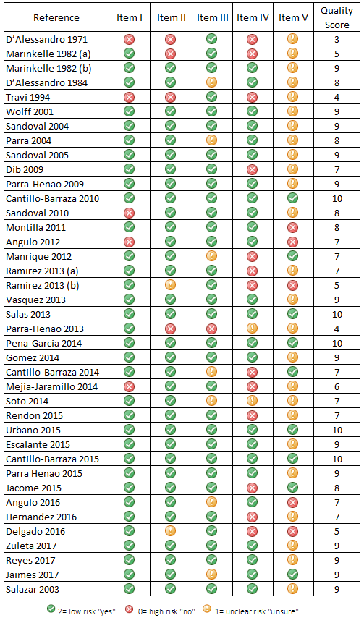

Figure S2. Funnel plot of the 95%CI pseudo limits for the estimates of Trypanosoma cruzi prevalence in animal reservoirs in Colombia
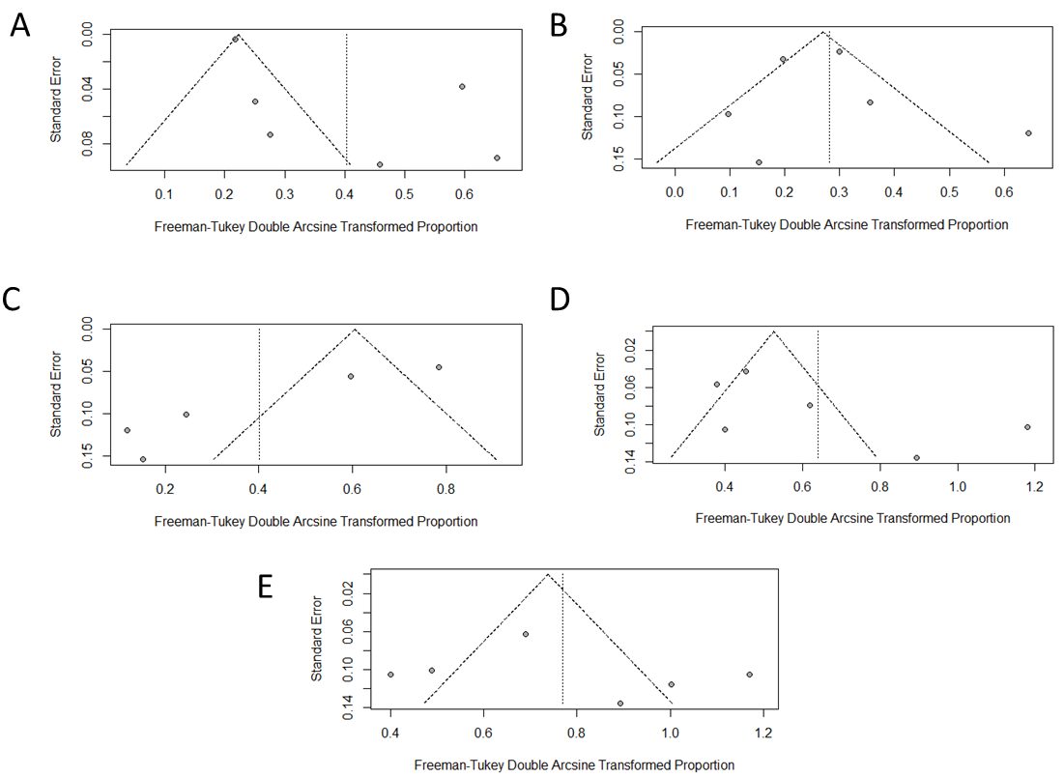
Order Chiroptera (Panel A), Order Rodentia (Panel B), Family Canidae diagnostic subgroup non-serological methods (Panel C), Order Didelphimorphia (Panel D), Didelphis masupialis (Panel E). On the right axis of the log (prevalence) from each study is plotted against its corresponding standard error). Lines represented pseudo 95% confidence limits.
Figure S3. Funnel plot of the 95%CI pseudo limits for the estimates of Trypanosoma cruzi prevalence in family Canidae in Colombia

On the right axis of the log (prevalence) from each study is plotted against its corresponding standard error. Filled circles represented the studies included in the meta-analysis and the empty circles represent the hypothetically missing studies. Lines represented pseudo 95% confidence limits for the re-estimate using the 'filled' studies

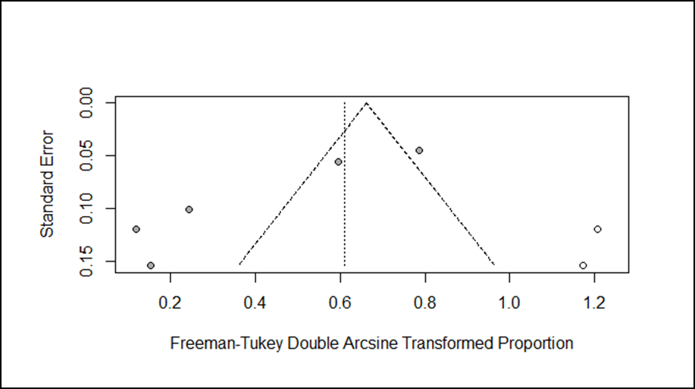

Figure S4. Funnel plot of the 95%CI pseudo limits for the estimates of Trypanosoma cruzi prevalence in triatomine species in Colombia

On the right axis of the log (prevalence) from each study is plotted against its corresponding standard error. Lines represented pseudo 95% confidence limits.
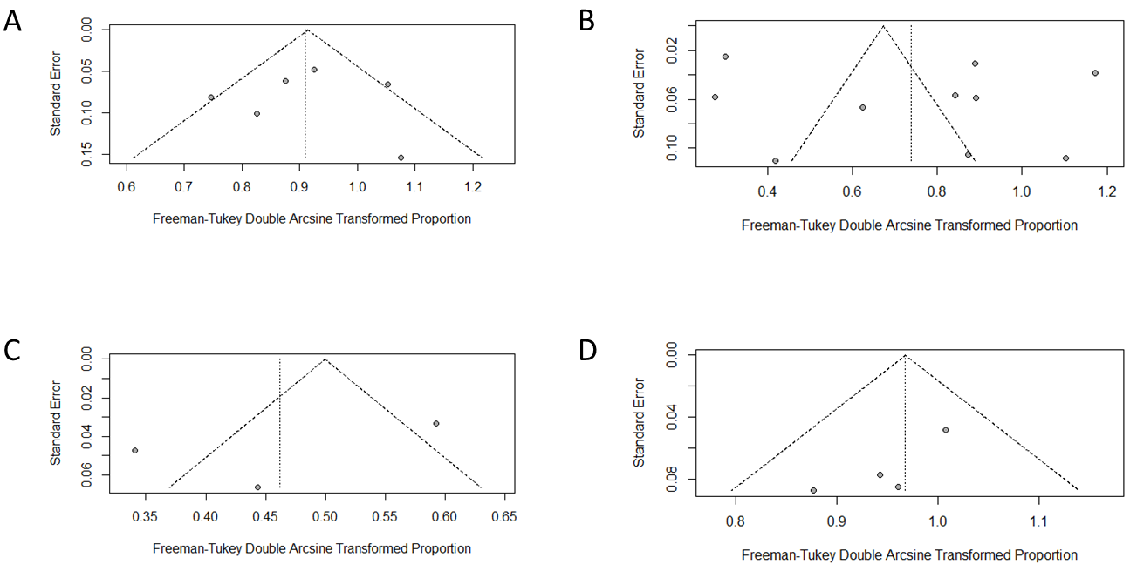
Rhodnius pallescens (Panel A), Rhodnius prolixus (Panel B), Triatoma dimidiate (Panel C), Triatoma maculata (Panel D).

Figure S5. Sensitivity analyses for estimates of the prevalence of Trypanosoma cruzi in potential animal reservoirs in Colombia, by omitting one study at a time.
The figure shows the forest plot re-estimated effect after removing one single study
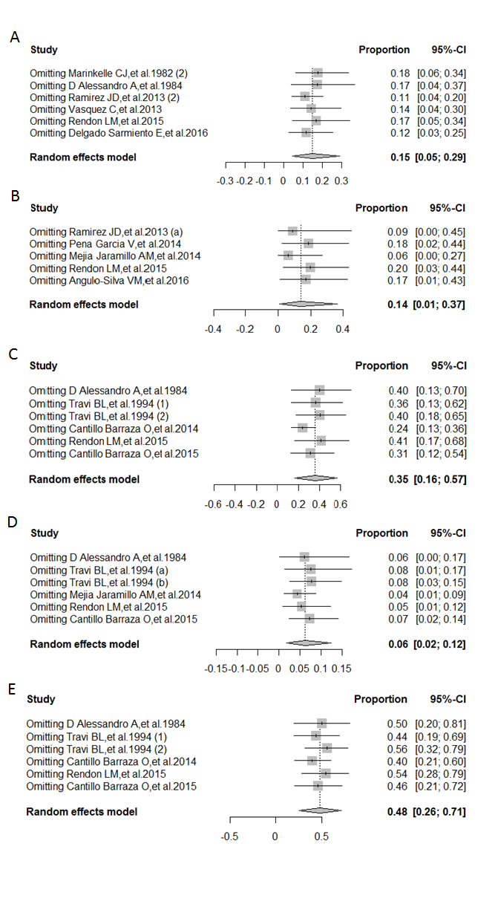
Order Chiroptera (Panel A), Order Rodentia (Panel B), Family Canidae diagnostic subgroup no serological (Panel C), Order Didelphimorphia (Panel D), Didelphis masupialis (Panel E).

Figure S6. Sensitivity analyses for estimates of the prevalence of Trypanosoma cruzi in triatomine vectors in Colombia, by omitting one study at a time.
The figure shows the forest plot re-estimated effect after removing any single study
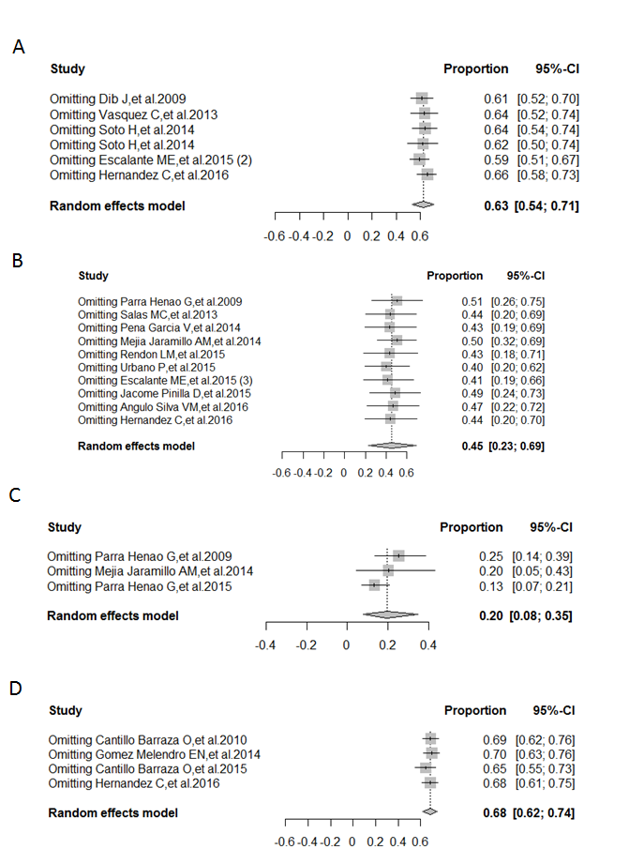
Rhodnius pallescens (Panel A), Rhodnius prolixus (Panel B), Triatoma dimidiate (Panel C), Triatoma maculata (Panel D).
Figure S7. Distribution of the quality assessment scores among the 39 studies included in the meta-analysis.

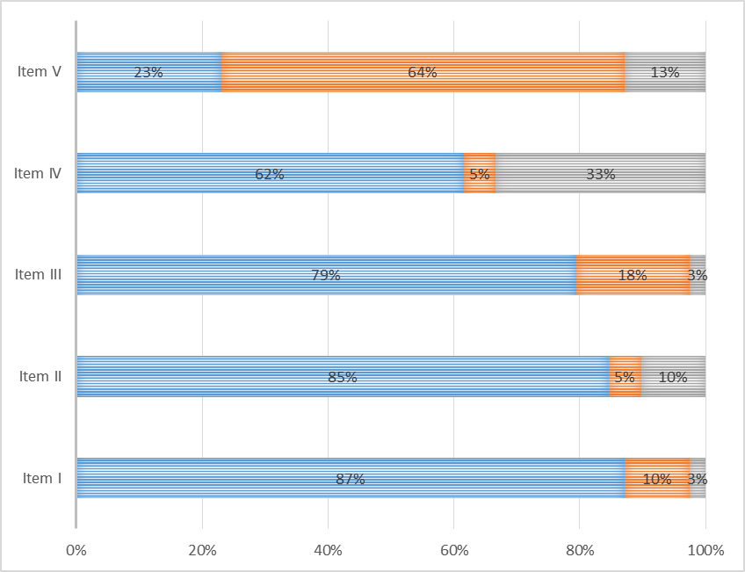
- Low risk of bias
- Unclear risk "unsure"
- High risk of bias

References
1. Ding H, Gao Y-M, Deng Y, Lamberton PHL, Lu D-B. A systematic review and meta-analysis of the seroprevalence of Toxoplasma gondii in cats in mainland China. Parasit Vectors. BioMed Central; 2017;10:27.
2. D’Alessandro A, Wells EA. Trypanosome infections in the family Cervidae. Trans R Soc Trop Med Hyg. 1971;65:845.
3. Marinkelle CJ. The prevalence of Trypanosoma cruzi infection in Colombia monkey and marmosets. Ann Trop Med Parasitol. 1982;76:121–4.
4. Marinkelle CJ. Prevalence of Trypanosoma cruzi-like infection of Colombian bats. Ann Trop Med Parasitol. 1982;76:125–34.
5. D’Alessandro A, Barreto P, Saravia N, Barreto M. Epidemiology of Trypanosoma cruzi in the oriental plains of Colombia. Am J Trop Med Hyg. 1984;33:1084–95.
6. Travi BL, Jaramillo C, Montoya J, Segura I, Zea A, Goncalves A, et al. Didelphis marsupialis, an important reservoir of Trypanosoma (Schizotrypanum) cruzi and Leishmania (Leishmania) chagasi in Colombia. Am J Trop Med Hyg. 1994;50:557–65.
7. Wolff M, Castillo D, Uribe J, Arboleda JJ. American trypanosomiasis: determination of epidemiologic transmission risk in Amalfi, Antioquia, Colombia. Iatreia. 2001;14:111–21.
8. Manrique-Abril D, Manrique-Abril F, Lorca MH, Ospina JD. Prevalencia de anticuerpos para Trypanosoma cruzi en caninos de dos municipios endémicos de Boyacá Prevalence of antibodies for Trypanosoma cruzi in canines from two endemic municipalities of Boyacá. 2012;17.
9. Ramírez JD, Turriago B, Tapia-Calle G, Guhl F. Understanding the role of dogs (Canis lupus familiaris) in the transmission dynamics of Trypanosoma cruzi genotypes in Colombia. Vet Parasitol. 2013;196:216–9.
10. Ramírez JD, Tapia-Calle G, Muñoz-Cruz G, Poveda C, Rendón LM, Hincapié E, et al. Trypanosome species in neo-tropical bats: biological, evolutionary and epidemiological implications. Infect Genet Evol. 2014;22:250–6.
11. Vásquez C, Robledo S, Calle J, Triana O. [Identification of new epidemiological scenarios for Chagas disease in the Momposina region, North of Colombia]. Biomedica. Instituto Nacional de Salud; 2013;33:526–37.
12. Peña-García VH, Gómez-Palacio AM, Triana-Chávez O, Mejía-Jaramillo AM. Eco-Epidemiology of Chagas Disease in an Endemic Area of Colombia: Risk Factor Estimation, Trypanosoma cruzi Characterization and Identification of Blood-Meal Sources in Bugs. Am J Trop Med Hyg. 2014;91:1116–24.
13. Cantillo-Barraza O, Chaverra D, Marcet P, Arboleda-Sánchez S, Triana-Chávez O. Trypanosoma cruzi transmission in a Colombian Caribbean region suggests that secondary vectors play an important epidemiological role. Parasit Vectors. 2014;7:381.
14. Mejía-Jaramillo AM, Agudelo-Uribe LA, Dib JC, Ortiz S, Solari A, Triana-Chávez O. Genotyping of Trypanosoma cruzi in a hyper-endemic area of Colombia reveals an overlap among domestic and sylvatic cycles of Chagas disease. Parasit Vectors. 2014;7:108.
15. Rendón LM, Guhl F, Cordovez JM, Erazo D. New scenarios of Trypanosoma cruzi transmission in the Orinoco region of Colombia. Mem Inst Oswaldo Cruz. 2015;110:283–8.
16. Cantillo-Barraza O, Garcés E, Gómez-Palacio A, Cortés LA, Pereira A, Marcet PL, et al. Eco-epidemiological study of an endemic Chagas disease region in northern Colombia reveals the importance of Triatoma maculata (Hemiptera: Reduviidae), dogs and Didelphis marsupialis in Trypanosoma cruzi maintenance. Parasit Vectors. 2015;8:482.
17. Angulo-Silva VM, Castellanos-Domínguez YZ, Flórez-Martínez M, Esteban-Adarme L, Pérez-Mancipe W, Farfán-García AE, et al. Human trypanosomiasis in the eastern plains of Colombia: New transmission scenario. Am J Trop Med Hyg. 2016;94:348–51.
18. Delgado-Sarmiento E, Herrera-Sepúlveda M-T, Pavía P, Pérez-Torres J, Cuervo CL. Trypanosoma cruzi infection in the heart of Colombian wild bats. Int J Infect Dis. 2016;45:356–7.
19. Zuleta-Dueñas LP, López-Quiroga ÁJ, Torres-Torres F, Castañeda-Porras O. Possible oral transmission of Chagas disease among hydrocarbons sector workers in Casanare, Colombia, 2014. Biomedica. 2017;37:218–32.
20. Jaimes-Dueñez J, Triana-Chávez O, Cantillo-Barraza O, Hernández C, Ramírez JD, Góngora-Orjuela A. Molecular and serological detection of Trypanosoma cruzi in dogs (Canis lupus familiaris) suggests potential transmission risk in areas of recent acute Chagas disease outbreaks in Colombia. Prev Vet Med. 2017;141:1–6.
21. Parra GJ, Restrepo Isaza M, Restrepo BN, Domínguez J de D. Estudio de tripanosomiasis americana en dos poblados indígenas de la Sierra Nevada de Santa Marta, Colombia. CES Med. 2004;18:43–50.
22. Soto H, Tibaduiza T, Montilla M, Triana O, Suárez DC, Torres MT, et al. Investigación de vectores y reservorios en brote de Chagas agudo por posible transmisión oral en Aguachica, Cesar, Colombia. Cad Saude Publica. 2014;30:746–56.
23. Reyes M, Torres Á, Lyda E, Flórez M, Angulo V. Riesgo de transmisión de la enfermedad de Chagas por intrusión de triatominos y mamíferos silvestres en la ciudad de Bucaramanga (Santander, Colombia). Biomédica Rev del Inst Nac Salud. 2013;33:24.
24. Sandoval CM, Duarte R, Gutíerrez R, Rocha D da S, Angulo VM, Esteban L, et al. Feeding sources and natural infection of Belminus herreri (Hemiptera, Reduviidae, Triatominae) from dwellings in Cesar, Colombia. Mem Inst Oswaldo Cruz. 2004;99:137–40.
25. Dib J, Barnabe C, Tibayrenc M, Triana O. Incrimination of Eratyrus cuspidatus (Stal) in the transmission of Chagas’ disease by molecular epidemiology analysis of Trypanosoma cruzi isolates from a geographically restricted area in the north of Colombia. Acta Trop. 2009;111:237–42.
26. Parra-Henao G, Angulo V, Jaramillo N, Restrepo M. Triatominos (Hemiptera: Reduviidae) de la Sierra Nevada de Santa Marta, Colombia. Aspectos epidemiológicos, entomológicos y de distribución. Rev CES Med. 2009;23:17–26.
27. Cantillo-Barraza O, Gómez-Palacio A, Salazar D, Mejía-Jaramillo AM, Calle J, Triana O. Distribution and ecoepidemiology of the triatomine fauna (Hemiptera: Reduviidae) in Margarita Island, Bolívar, Colombia. Biomedica. 2010;30:382–9.
28. Sandoval CM, Ortiz N, Jaimes D, Lorosa E, Galvão C, Rodriguez O, et al. Feeding behaviour of Belminus ferroae (Hemiptera: Reduviidae), a predaceous Triatominae colonizing rural houses in Norte de Santander, Colombia. Med Vet Entomol. 2010;24:124–31.
29. Montilla M, Soto H, Parra E, Torres M, Carrillo P, Lugo L, et al. Infestation by triatomine bugs in indigenous communities of Valledupar, Colombia. Rev Saude Publica. 2011;45:773–80.
30. Angulo VM, Esteban L, Luna KP. Attalea butyracea palms adjacent to housing as a source of infestation by Rhodnius prolixus (Hemiptera: Reduviidae). Biomedica. 2012;32:277–85.
31. Castro-Salas M. Aspectos ecoepidemiológicos en la transmisión de la enfermedad de chagas en Santa Rosalia , Vichada Aspectos ecoepidemiológicos en la transmisión de la enfermedad de chagas en Santa Rosalía , Vichada. 2013;1–101.
32. Parra-Henao GJ, Florez M, Ángulo VM, Red Chagas Colombia, editores. Vigilancia de Triatominae (Hemiptera: Reduviridae) en Colombia. In: Memorias del Curso de Capacitación Métodos Básicos en Epidemiología y Redacción Científica. Bogotá: Sic Editorial; 2015.
33. Gómez-Melendro EN, Hernández C, González-Uribe C, Brochero H. First Record of Triatoma maculata (Erichson, 1848) (Hemiptera: Reduviidae: Triatomini) in the Municipality of Riohacha, La Guajira - Colombia. Front public Heal. 2014;2:219.
34. Urbano P, Poveda C, Molina J. Effect of the physiognomy of Attalea butyracea (Arecoideae) on population density and age distribution of Rhodnius prolixus (Triatominae). Parasit Vectors. 2015;8:199.
35. Escalante ME, Gomez D, Silvera LA, Sánchez G, Venegas J. Detection of high percentage of Trypanosoma cruzi infection, the etiologic agent of Chagas disease, in wild populations of Colombian Caribbean triatomines. Acta Parasitol. 2015;60:315–21.
36. Parra-Henao G, Angulo VM, Osorio L, Jaramillo-O N. Geographic Distribution and Ecology of Triatoma dimidiata (Hemiptera: Reduviidae) in Colombia. J Med Entomol. 2016;53:122–9.
37. Jácome-Pinilla D, Hincapie-Peñaloza E, Ortiz MI, Ramírez JD, Guhl F, Molina J. Risks associated with dispersive nocturnal flights of sylvatic Triatominae to artificial lights in a model house in the northeastern plains of Colombia. Parasit Vectors. 2015;8:600.
38. Hernández C, Salazar C, Brochero H, Teherán A, Buitrago LS, Vera M, et al. Untangling the transmission dynamics of primary and secondary vectors of Trypanosoma cruzi in Colombia: Parasite infection, feeding sources and discrete typing units. Parasites and Vectors [Internet]. 2016 [cited 2017 Oct 2];9:620.
39. Salazar DA, Calle J. Caracterización ecoepidemiológica de Rhodnius pallescens en la palma Attalea butyracea en la región Momposina (Colombia). Actual Biológicas Univ Antioquia. Veterinaria Organización; 2003;25:31–8.

