Extra-fine inhaled corticosteroids are better for asthma control: A systematic review and meta-analysis of observational real-life studies

Samatha Sonnappa, FRCPCH, PhD,^{1,2} Brett McQueen, PhD,³ Dirkje S. Postma, MD⁴, Richard J. Martin, MD,⁵ Nicolas Roche, MD,⁶ Jonathan Grigg, MD, FRCPCH,⁷ Theresa Guilbert, MD, MS,⁸ Caroline Gouder, MD,⁹ Emilio Pizzichini, MD,¹⁰ Akio Niimi, MD, PhD,¹¹ Wanda Phipatanakul, MD, MS,¹² Alison Chisholm, MSc¹³ Ronald J. Dandurand, MD,¹⁴ Alan Kaplan, MD,¹⁵ Elliot Israel, MD,¹⁶ Alberto Papi, MD,¹⁷ Willem M.C. van Aalderen, MD¹⁸ Omar S. Usmani, FRCP, PhD,¹⁹ David B. Price, FRCGP^{2,20}

- Observational and Pragmatic Research Institute Pte Ltd, Singapore
- Department of Respiratory Paediatrics, Rainbow Children’s Hospital, Bengaluru, India
- University of Colorado Denver, Skaggs School of Pharmacy and Pharmaceutical Sciences, Aurora, Denver, CO, USA
- Dept. of Pulmonary Medicine and Tuberculosis, University of Groningen, University Medical Center Groningen, The Netherlands
- National Jewish Health and the University of Colorado Denver, Denver, CO, USA
- Respiratory and Intensive Care Medicine, Cochin Hospital (APHP), University Paris Descartes (EA2511), Paris, France
- Blizard Institute, Queen Mary University London, London, UK
- Division of Pulmonology Medicine, Cincinnati Children's Hospital & Medical Center, Cincinnati, USA
- Department of Respiratory Medicine, Mater Dei hospital , Msida, Malta
- Department of Medicine, Universidade Federal de Santa Catarina, Santa Catarina, Brazil
- Department of Respiratory Medicine, Allergy and Clinical Immunology, Nagoya City University Graduate School of Medical Sciences, Nagoya, Japan
- Department of Pediatrics, Boston Children’s Hospital, Boston, USA
- Respiratory Effectiveness Group, Oakington, Cambridge, United Kingdom
- Montreal Chest Institute, Meakins-Christie Laboratories and the McGill University Health Centre Research Institute, McGill University, Montreal, Canada
- Family Physician Airways Group of Canada, University of Toronto, Ontario, Canada
- Pulmonary and Critical Care Division, Brigham & Women's Hospital, Harvard Medical School, Boston, MA, USA
- Department of Respiratory Medicine, University Hospital S.Anna, Ferrara, Italy
- Department of Pediatric Respiratory Diseases, Emma Children’s Hospital AMC, Amsterdam, The Netherlands
- National Heart and Lung Institute, Imperial College London & Royal Brompton Hospital, London, UK
- Academic Primary Care, Division of Applied Health Sciences, University of Aberdeen, Aberdeen, UK

Corresponding author:
Prof David Price
dprice@opri.sg

Funding: This systematic review and meta-analysis was jointly supported by the Respiratory Effectiveness Ltd, the Observational and Pragmatic Research Institute Ltd and Chiesi Farmaceutici SpA on behalf of the Respiratory Effectiveness Group's Small Airways Working Group.

Abstract:

Background: The particle size of inhaled corticosteroids (ICS) may affect airway drug deposition and effectiveness.

Objective: To compare the effectiveness of extra-fine ICS [mass median aerodynamic diameter<2 µm) vs. fine-particle ICS administered as ICS monotherapy or ICS-long acting β-agonist combination therapy by conducting a meta-analysis of observational real-life asthma studies in order to estimate the treatment effect of extra-fine ICS.

Methods: MEDLINE and EMBASE databases were reviewed for asthma observational comparative effectiveness studies from Jan 2004-June 2016. Studies were included if they reported odds and relative risk ratios and met all inclusion criteria (REG/EAACI quality standards, comparison of extra-fine ICS with same or different ICS molecule, ≥12m follow-up). Endpoint data (asthma control, exacerbations, prescribed ICS dose) were pooled. Random effects meta-analysis modelling was used. The study protocol is published in the PROSPERO register CRD42016039137.

Results: Seven studies with 33,453 subjects aged 5-80 years met eligibility criteria for inclusion. Six studies used extra-fine beclometasone propionate (efBDP) and one study both efBDP and extra-fine ciclesonide as comparators with fine-particle ICS. The overall odds of achieving asthma control were significantly higher for extra-fine ICS compared with fine-particle ICS (OR [95% CI]) 1.34 (1.22, 1.46). Overall exacerbation rate ratios (95% CI) 0.84 (0.73, 0.97) and ICS dose (weighted mean difference, 95% CI) -170 mcg (-222 mcg, -118 mcg), were significantly lower for extra-fine ICS compared to fine-particle ICS.

Conclusions: This meta-analysis demonstrates that ef-ICS have significantly higher odds of achieving asthma control with lower exacerbation rates at significantly lower prescribed doses than fine-particle ICS.

Key Messages:
- Extra-fine particle ICS are better than fine-particle ICS for achieving asthma control with lower exacerbation rates at significantly lower prescribed ICS doses
- Physicians should consider the potential benefits of prescribing extra-fine formulations of ICS to asthmatics

Capsule Summary:
This meta-analysis demonstrates that extra-fine particle ICS are better than fine-particle ICS for achieving asthma control with lower exacerbation rates at significantly lower prescribed ICS doses. This study is representative of real-life effectiveness of extra-fine ICS in asthmatics.

Key Words:
Asthma control; conventional ICS; extra-fine beclomethasone dipropionate; extra-fine ciclesonide; extra-fine particle ICS; fine-particle ICS; inhaled corticosteroids; observational studies; real-life

Abbreviations:
ef: extra-fine
BDP: beclmetasone dipropionate
BUD: budesonide
CFC: chlorofluorocarbon
CIC: ciclesonide
FLU: fluticasone propionate
HFA: hydrofluoroalkane
ICS: inhaled corticosteroids
LABA: long acting β-agonist
pMDI: pressurised metered-dose inhaler
RCT: randomised controlled trial

Introduction:

Several hydrofluoroalkane (HFA) propellant formulations of inhaled corticosteroids (ICS) have been developed in response to the required phasing out of ozone-depleting chlorofluorocarbon (CFC) propellants. Some HFA products are formulated with the same particle size and administered at the same dose as the original CFC product with a mass median aerodynamic diameter (MMAD) of 2-4 microns, but some formulations have been produced with a particle MMAD of 1.1 microns resulting in extra-fine particle HFA ICS (extra-fine ICS).⁽¹⁻⁴⁾ Two such ICS currently available are extra-fine HFA-beclometasone dipropionate (efBDP) and extra-fine HFA-ciclesonide (efCIC),⁽⁵⁾ and the only extra-fine ICS/LABA (long acting β-agonist) combination available is efBDP-formoterol (efBDP-FOR).⁽⁶⁾

ICS are effective anti-inflammatory agents for asthma therapy that work at the site of deposition in the lung.⁽⁷⁾ As airway inflammation in asthma involves both large and small airways,⁽⁸⁻¹¹⁾ increasing the total lung deposition of an ICS, as well as its deposition throughout large and small airways, could improve the anti-inflammatory effect of ICS and thus improve asthma outcomes. Apart from the smaller size which increases airway deposition, extra-fine ICS when administered by pressurised metered-dose inhaler (pMDI) are purported to have a softer spray, warmer spray temperature, and longer spray duration than traditional, larger-particle CFC pMDIs.^{(3;12)} These characteristics result in increased total and peripheral lung deposition and decreased oropharyngeal deposition of extra-fine ICS compared to conventional ICS.^{(4;11-14)} The importance of this for asthma treatment in clinical practice is unclear; however given the evidence of persistent small airways dysfunction in a large proportion of asthmatics on conventional ICS, a cohort of asthmatics may benefit from better peripheral deposition of extra-fine ICS.^{(10;12;15-17)}

Randomised controlled trials (RCTs) comparing the short-term efficacy of efBDP and efCIC to that of conventional ICS found that the extra-fine formulation offered equivalent efficacy when administered at half the dose of conventional ICS.⁽¹⁸⁻²¹⁾ Indeed, a rigorous dose response study has confirmed that efBDP provides significantly greater effects on lung function than comparable doses of CFC-BDP⁽²²⁾ and the improvements in asthma symptoms and quality of life recorded in 6- and 12-month RCTs although not statistically significant tended to be better with efBDP than CFC-BDP at twice the dose,⁽²³⁻²⁵⁾ suggesting that there may be clinically meaningful differences between the extra-fine particle and larger particle formulations.

Equivalent, or better, effectiveness outcomes (at appreciably lower doses) with efBDP and efCIC administered as ICS monotherapy or ICS-LABA combination therapy compared with larger particle ICS have been reported in observational asthma studies across all age groups.⁽²⁶⁻³³⁾ However, these studies were performed in different databases and patient populations, with some variations in endpoints, analytic strategies (e.g., regarding matching and adjustment processes) and magnitude as well as statistical significance of observed differences. Therefore, we aimed to perform a meta-analysis of their results to assess the overall effectiveness of extra-fine particle HFA ICS compared to fine-particle ICS in real-life patients with asthma, and to examine the degree of heterogeneity of study results.

Methods:

Literature search: Published studies limited to the English language indexed in the PubMed and Embase databases from January 2004 to June 2016 were searched. The search terms were compiled from terms for asthma and inhaled corticosteroids in conjunction with the terms for observational studies suggested by Furlan et al,⁽³⁴⁾ (the search terms and algorithms used for the review of the literature can be accessed in the online supplement). A manual search of references cited in selected retrieved articles was also performed. This meta-analysis was planned, conducted and reported in adherence with the Preferred Reporting Items for Systematic Reviews and Meta-Analyses (PRISMA) guidelines.⁽³⁵⁾ The study protocol is published in the PROSPERO register CRD42016039137.

Eligibility Criteria
Studies were included in the data analysis if they met the following criteria: (1) studies had to be observational (case-control or cohort studies) and (2) the authors provided relative risk (RR) or odds ratios (OR) with 95% confidence intervals (CI) for asthma control measures and exacerbation rates for fine-particle and extra-fine particle ICS. Published articles were excluded according to the following criteria: (1) the study was a conference proceeding and or abstract only and (2) the study was not an observational study including literature review, clinical trial, case study and/or cross-sectional survey. Once eligible papers had been identified (i.e. selected using the search terms and following application of the exclusion criteria, detailed above), they were further screened to ensure they addressed the PICOT format⁽³⁶⁾ question detailed below:
Population (P) - Asthmatics of all ages prescribed regular maintenance ICS
Intervention (I) - Effectiveness of fine vs. extra-fine size ICS particles in maintaining asthma control
Comparison (C) - Comparison of outcomes between groups using the same or different molecules administered as extra-fine or fine-particle. Mean prescribed drug doses were calculated in terms of nominal dose (i.e. the dose indicated on the product label).
Outcomes (O) - The primary measure of asthma control was a composite measure defined as (i) no recorded hospital attendance for asthma (including admission or emergency department visit, out of hours, or outpatient attendance); (ii) no prescription for oral corticosteroid and (iii) no consultation, hospital admission or emergency department attendance for lower respiratory tract infection requiring antibiotics. The secondary composite measure where available was asthma control plus short acting β- agonist use which included an average prescribed daily dose of salbutamol of 200 mcg or less or terbutaline 500 mcg or less. Severe asthma exacerbation was defined as a course of oral corticosteroids, hospital admission, or emergency hospital attendance for asthma.
Time (T) - 12 months

Data Extraction and quality assessment:
The quality of each study was independently determined by two Respiratory Effectiveness Group (REG) taskforce members or collaborators using the quality criteria for observational database comparative studies developed by the REG in collaboration with the European Academy of Allergy and Clinical Immunology.⁽³⁷⁾ A paper had to be assessed by two raters as having fulfilled all of the primary quality criteria pre-specified by the REG taskforce,⁽³⁷⁾ to be considered of sufficient quality to be included in the meta-analysis. The tool includes seven key quality domains (i.e. background, design, measures, analysis, results, description, conflict of interests) and a number of primary (mandatory) and supporting (recommended, but optional) quality criteria.⁽³⁷⁾ If both raters felt that at least one of the primary criteria was not fulfilled, the paper was not considered to be of sufficient quality to be included in the meta-analysis. A difference in opinion between two raters resulted in a third rater being assigned to offer an adjudicating assessment. In instances where a paper was assessed by three raters, the majority assessment (2:1) was taken to be the overall assessment. Two authors extracted the following information from each included study: first author’s name, year of publication, study design, sample size, study population, names of evaluated ICS, duration of follow-up, endpoints, effect estimates with 95% confidence intervals (CI). Any discrepancy was resolved by referring back to the original study.

Statistical analysis:
All effect estimates and 95% confidence intervals were pooled into three outcomes: asthma control, exacerbations, and ICS dosing. Rate ratios (RR) and odds ratios (OR) were log transformed prior to analysis. We used Stata’s metan command to estimate random-effects models for each outcome,⁽³⁸⁾ incorporating an estimate of between-study variation in the weighting using the default DerSimonian & Laird method.⁽³⁹⁾ Statistical heterogeneity was assessed using I² statistic, the percentage variation attributable to heterogeneity with larger values indicating greater heterogeneity. The potential for publication bias was assessed using funnel plots and formal tests for asthma control and exacerbation outcomes. Studies lying outside the region of the 95% limit in the funnel plot indicate heterogeneity while asymmetry indicates publication bias. Final effect estimates and 95% confidence intervals for extra-fine vs. fine-particle ICS are reported as odds ratios for asthma control, rate ratios for exacerbations and mean difference in ICS dosing expressed as beclometasone dipropionate equivalent. All statistical analyses were conducted with Stata (version 14; StataCorp, College Station, TX, USA). Statistical analysis and results for the whole group are presented in the main text and subgroup analysis which includes analysis of adult studies only and separate analysis for initiation (those who received a first prescription for an ICS) and step-up (those who received their first increase in dose of ICS either as fine-particle ICS or ef-particle ICS) cohorts are presented in the online supplement.

Results: Seven studies ^{(26;27;31;32;40-42)} with 33,453 subjects aged 5-80 years met all eligibility criteria and were included in this meta-analysis. Six studies used efBDP^{(26;27;32;40-42)} and one study both efBDP and efCIC⁽³¹⁾ as comparators with fine-particle ICS (either fluticasone propionate, budesonide or BDP). Five studies used ICS monotherapy^{(26;27;31;41;42)} and two studies used ICS-LABA combination therapy.^{(32;33)} Detailed study procedure and flow of literature search is shown in Figure 1. The characteristics of the included studies are summarised in Table 1. Six were database studies^{(26;27;31;40-42)} and one was an observational prospective cohort study.⁽³²⁾

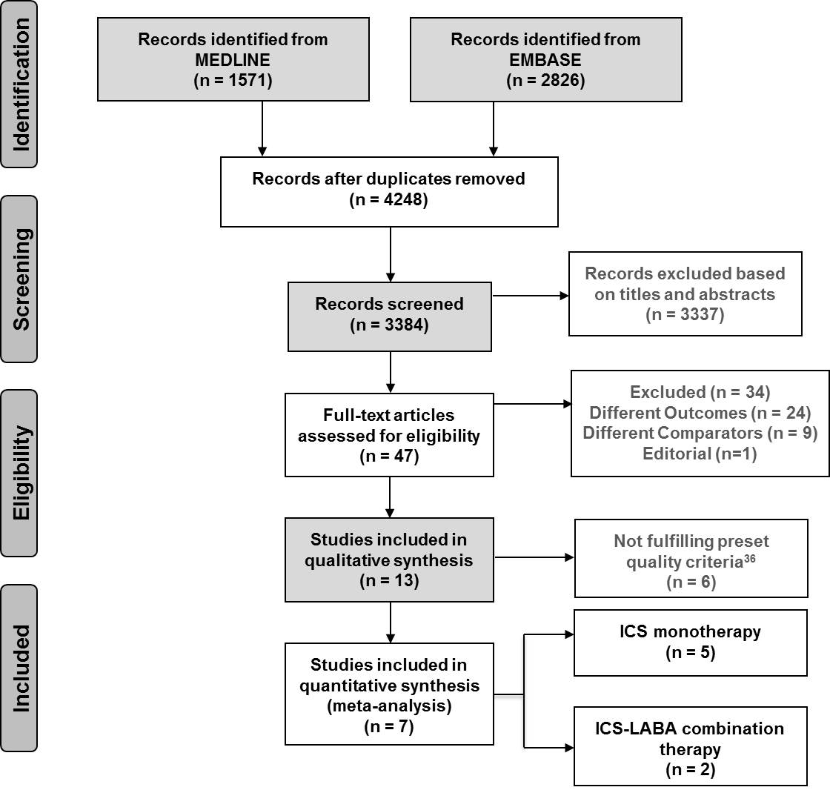
Figure 1: PRISMA flowchart showing the step-by-step process of the application of inclusion and exclusion criteria to generate the final number of studies included in the meta-analysis

Table 1: Characteristics of studies included in data synthesis
Study | Year | Age group | Outcome Measure | Population | EFP  No. of subjects | FP  No. of subjects | EFP  ICS dose  Mean (SD) | FP  ICS dose  Mean (SD)
ICS Monotherapy
Price et al⁽²⁶⁾ | 2010 | 5-60y | Primary measure of asthma control | Initiation efBDP vs. FLU | 1319 | 1319 | NA | NA
Price et al⁽²⁶⁾ | 2010 | 5-60y | Asthma control plus SABA use | Initiation efBDP vs. FLU | 1319 | 1319 | NA | NA
Price et al⁽²⁶⁾ | 2010 | 5-60y | Severe exacerbations | Initiation efBDP vs. FLU | 1319 | 1319 | NA | NA
Price et al⁽²⁶⁾ | 2010 | 5-60y | Primary measure of asthma control | Step-up efBDP vs. FLU | 250 | 250 | NA | NA
Price et al⁽²⁶⁾ | 2010 | 5-60y | Asthma control plus SABA use | Step-up efBDP vs. FLU | 250 | 250 | NA | NA
Price et al⁽²⁶⁾ | 2010 | 5-60y | Severe exacerbations | Step-up efBDP vs. FLU | 250 | 250 | NA | NA
Barnes et al⁽²⁷⁾ | 2011 | 5-60y | Primary measure of asthma control | Initiation efBDP vs. fBDP | 2882 | 8646 | 82 (82) | 137 (162)
Barnes et al⁽²⁷⁾ | 2011 | 5-60y | Asthma control plus SABA use | Initiation efBDP vs. fBDP | 2882 | 8646 | 82 (82) | 137 (162)
Barnes et al⁽²⁷⁾ | 2011 | 5-60y | Severe exacerbations | Initiation efBDP vs. fBDP | 2882 | 8646 | 82 (82) | 137 (162)
Barnes et al⁽²⁷⁾ | 2011 | 5-60y | Primary measure of asthma control | Step-up efBDP vs. fBDP | 258 | 516 | 165 (132) | 329 (284)
Barnes et al⁽²⁷⁾ | 2011 | 5-60y | Asthma control plus SABA use | Step-up efBDP vs. fBDP | 258 | 516 | 165 (132) | 329 (284)
Barnes et al⁽²⁷⁾ | 2011 | 5-60y | Severe exacerbations | Step-up efBDP vs. fBDP | 258 | 516 | 165 (132) | 329 (284)
Colice et al⁽⁴¹⁾ | 2013 | 12-80y | Primary measure of asthma control | Initiation efBDP vs. FLU | 2578 | 7734 | 320 (119) | 440 (196)
Colice et al⁽⁴¹⁾ | 2013 | 12-80y | Asthma control plus SABA use | Initiation efBDP vs. FLU | 2578 | 7734 | 320 (119) | 440 (196)
Colice et al⁽⁴¹⁾ | 2013 | 12-80y | Severe exacerbations | Initiation efBDP vs. FLU | 2578 | 7734 | 320 (119) | 440 (196)
van Aalderen et al⁽⁴²⁾ | 2015 | 5-11y | Primary measure of asthma control | Initiation efBDP vs. FLU | 797 | 797 | NA | NA
van Aalderen et al⁽⁴²⁾ | 2015 | 5-11y | Asthma control plus SABA use | Initiation efBDP vs. FLU | 797 | 797 | NA | NA
van Aalderen et al⁽⁴²⁾ | 2015 | 5-11y | Severe exacerbations | Initiation efBDP vs. FLU | 797 | 797 | NA | NA
van Aalderen et al⁽⁴²⁾ | 2015 | 5-11y | Primary measure of asthma control | Step-up efBDP vs. FLU | 206 | 206 | NA | NA
van Aalderen et al⁽⁴²⁾ | 2015 | 5-11y | Asthma control plus SABA use | Step-up efBDP vs. FLU | 206 | 206 | NA | NA
van Aalderen et al⁽⁴²⁾ | 2015 | 5-11y | Severe exacerbations | Step-up efBDP vs. FLU | 206 | 206 | NA | NA
van der Molen et al⁽³¹⁾* | 2016 | 12-60y | Primary measure of asthma control | Initiation EF vs. FLU | 1399 | 1399 | 185 (117) | 272 (172)
van der Molen et al⁽³¹⁾* | 2016 | 12-60y | Asthma control plus SABA use | Initiation EF vs. FLU | 1399 | 1399 | 185 (117) | 272 (172)
van der Molen et al⁽³¹⁾* | 2016 | 12-60y | Severe exacerbations | Initiation EF vs. FLU | 1399 | 1399 | 185 (117) | 272 (172)
ICS-LABA Combination Therapy
Allegra et al⁽³²⁾ | 2012 | 18-80y | Primary measure of asthma control | efBDP/For vs. all combinations | 452 | 917 | NA | NA
Allegra et al⁽³²⁾ | 2012 | 18-80y | Primary measure of asthma control | efBDP/For vs. BUD/For | 452 | 447 | 312 (110) | 590 (242)
Allegra et al⁽³²⁾ | 2012 | 18-80y | Primary measure of asthma control | efBDP/For vs. FLU/Sal | 452 | 470 | 312 (110) | 675 (343)
Price et al⁽⁴⁰⁾ | 2013 | 18-80y | Primary measure of asthma control | efBDP-FOR vs. FLU-Sal | 1146 | 382 | 325 (159) | 455 (304)
Price et al⁽⁴⁰⁾ | 2013 | 18-80y | Asthma control plus SABA use | efBDP-FOR vs. FLU-Sal | 1146 | 382 | 325 (159) | 455 (304)
Price et al⁽⁴⁰⁾ | 2013 | 18-80y | Severe exacerbations | efBDP-FOR vs. FLU-Sal | 1146 | 382 | 325 (159) | 455 (304)
Legend: EFP - extra-fine particle; FP – fine-particle; BDP - Beclometasone diproprionate; BUD - Budesonide; FLU - fluticasone propionate; FOR -formoterol; Sal - salmeterol; SABA – short acting β-agonist; LABA – long acting β-agonist; ICS dose is in mcg. * Initiation EF was either ef-BDP or ef-ciclesonide; NA – not available
Pooled estimates for measures of asthma control:
The overall (ICS monotherapy and ICS-LABA combination therapy inclusive) odds for achieving asthma control were significantly higher for extra-fine ICS compared with fine-particle ICS, OR (95% CI) 1.34 (1.22, 1.46), p<0.0001 with considerable heterogeneity (I² = 74%, p<0.0001) (Figure 2).
The odds for achieving asthma control were significantly higher for extra-fine ICS compared with fine-particle ICS for both ICS monotherapy OR (95% CI) 1.33 (1.20, 1.48), p<0.0001 with considerable heterogeneity (I² = 79%; p<0.0001) and ICS-LABA combination therapy, 1.36 (1.20, 1.55), p<0.0001 with no heterogeneity (I² = 0.0%, p=0.646), respectively (Figure 2).
Pooled estimates for asthma control were similar to the above results when only adult studies were included (please refer online supplement for details, Figure E1).

Pooled estimates for measures of exacerbation:
The overall (ICS monotherapy and ICS-LABA combination therapy inclusive) exacerbation rate ratios were significantly lower for extra-fine ICS compared with fine-particle ICS, RR (95% CI) 0.84 (0.73, 0.97), p=0.016 with considerable heterogeneity (I² = 73%, p<0.0001) (Figure 3).
The exacerbation rate ratios were significantly lower for extra-fine ICS compared with fine-particle ICS for ICS monotherapy RR (95% CI) 0.82 (0.70, 0.96) p=0.011 with considerable heterogeneity (I² = 76%, p<0.0001). This could not be assessed for combination therapy as only one study was available (Figure 3).
When only adult studies were included, pooled estimates for exacerbation rate ratios did not differ between fine-particle ICS and extra-fine ICS (please refer online supplement for details, Figure E2).

Pooled mean difference in ICS dosing:
Overall, extra-fine ICS were prescribed at a significantly lower prescribed dose than fine-particle ICS mean (SD) 256mcg (116 mcg) vs. 428mcg (237 mcg). The pooled weighted mean difference (WMD) (95% CI) between extra-fine ICS and fine-particle ICS was -170 mcg ( -222 mcg, -118 mcg), , p<0.0001, with considerable heterogeneity (I² = 99.4%, p<0.0001), in favour of extra-fine ICS.
The pooled WMD (95% CI) between extra-fine ICS and fine-particle ICS for ICS monotherapy was -87 mcg (-132 mcg, 42 mcg) p<0.0001 with considerable heterogeneity (I² = 99.3%, p<0.0001) and for ICS-LABA combination therapy -257 mcg (-389 mcg, -125 mcg), p<0.0001 with considerable heterogeneity (I² = 98.6%, p<0.0001), in favour of extra-fine ICS, respectively.

Heterogeneity and publication bias
The I² for asthma control and exacerbations was 74% and 73%, respectively with by far the most heterogeneity among the ICS monotherapy groups for both outcomes. The funnel plots for measures of asthma control and exacerbation rates (Figure 4) indicate asymmetry with smaller studies (i.e., studies with larger standard errors) having more beneficial effects (larger ORs for asthma control, lower RRs for exacerbations). A small-study Begg rank correlation test⁽⁴³⁾ was performed and for both outcomes the null hypothesis of no small-study effects was rejected or trending (p<0.10). Additionally, the funnel plots indicated some level of asymmetry. Therefore, as a sensitivity analysis we performed the non-parametric “trim and fill” method proposed by Duval and Tweedie to calculate overall adjusted intervention effects based on a symmetric funnel plot.^{(44;45)} Results from the “trim and fill” method stayed statistically significant with higher odds of achieving asthma control for extra-fine ICS compared with fine-particle, and significantly lower rate ratios for exacerbation rates for extra-fine ICS compared with fine-particle ICS.

Sub-group analysis:
This was undertaken separately in the initiation and step-up cohorts for all outcome measures. Extra-fine particle ICS demonstrated significantly higher odds for achieving asthma control compared with fine-particle ICS in both the initiation and step-up cohorts. Lower exacerbation rate ratios were seen with extra-fine particle ICS compared with fine-particle ICS in the initiation cohort but not in the step-up cohort (please refer online supplement for details, Figures E3-E6).

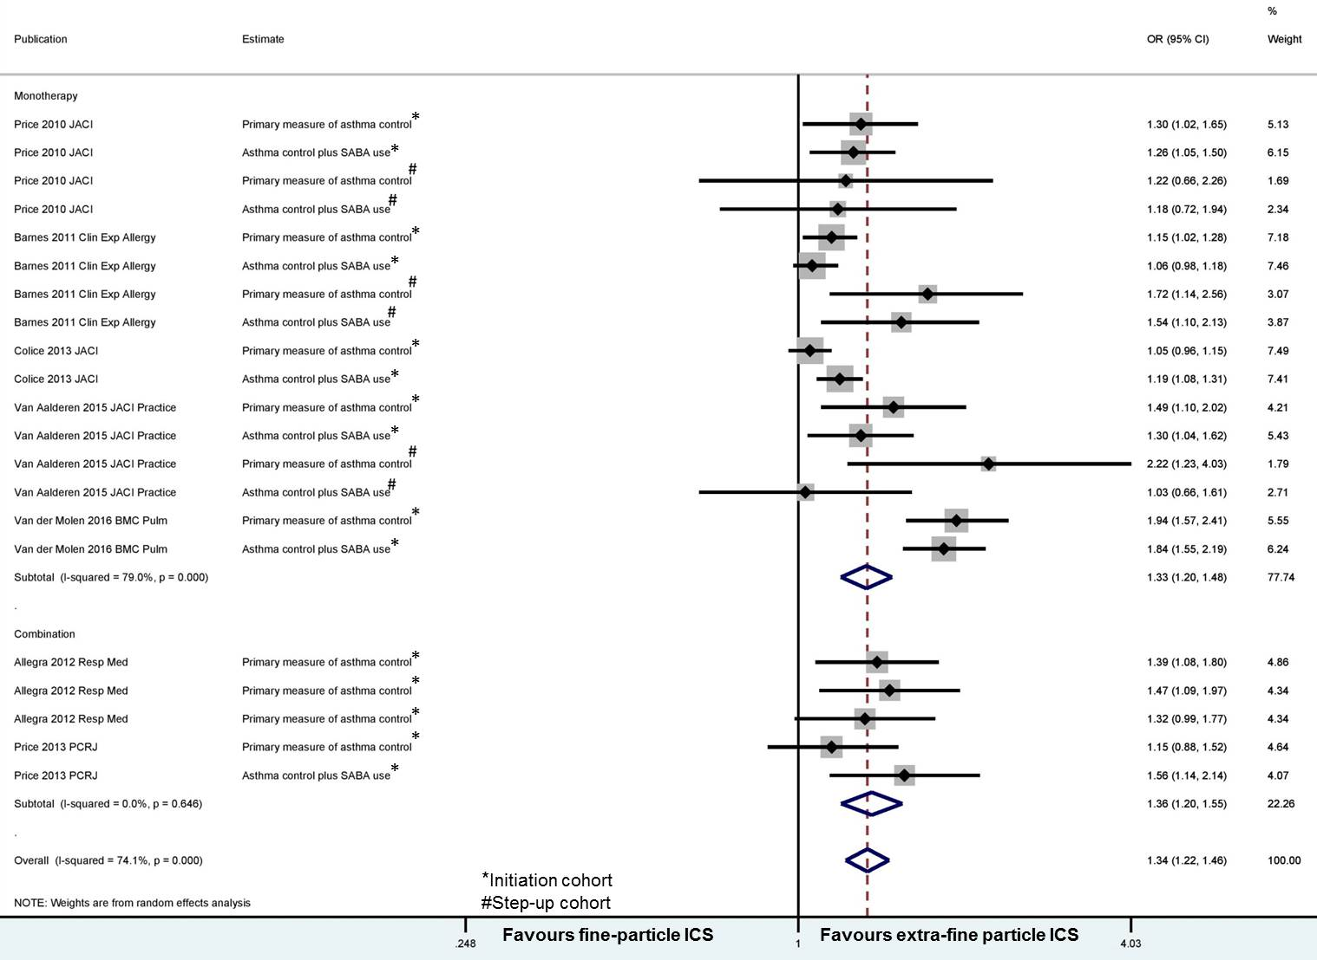
Figure 2: Forest plot of meta-analysis on the relationship between extra-fine ICS and measures of asthma control (all studies)
Legend: Squares indicate study-specific risk estimates (size of the square reflects the study-specific statistical weight); horizontal lines indicate 95% CIs; the diamond indicates the pooled odd ratio with its 95% CI.

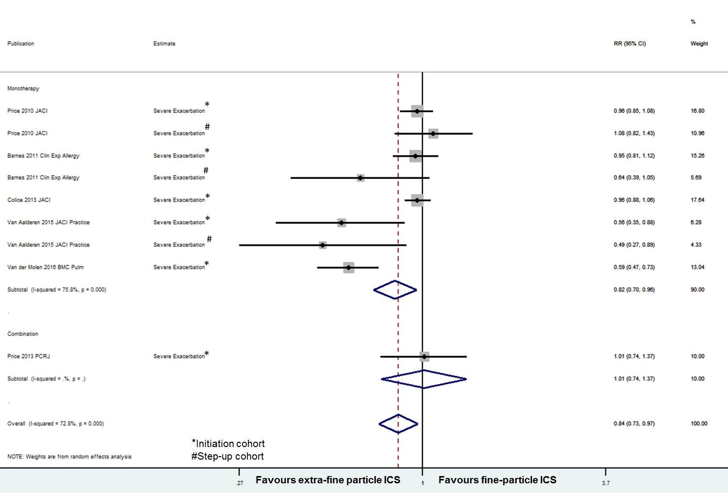

Figure 3: Forest plot of meta-analysis on the relationship between extra-fine ICS and measures of asthma exacerbations (all studies)
Legend: Legend: Squares indicate study-specific risk estimates (size of the square reflects the study-specific statistical weight); horizontal lines indicate 95% CIs; the diamond indicates the pooled odd ratio with its 95% CI.
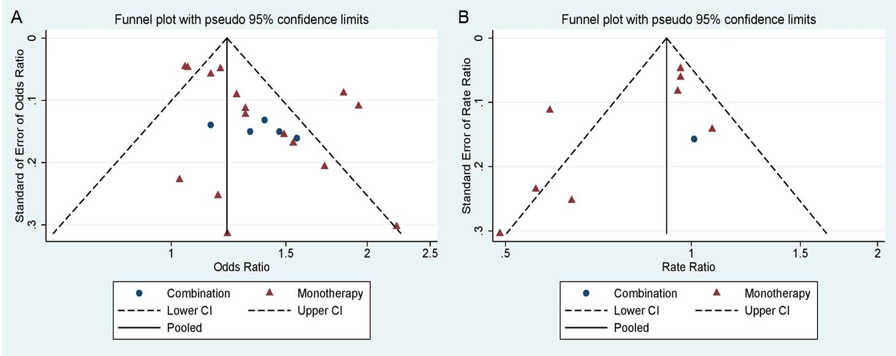
Figure 4: Funnel plots corresponding to the random-effects meta-analysis of the relationship between (A) measures of asthma control and (B) exacerbation rates with extra-fine particle ICS relative to fine-particle ICS (all studies)
Legend: Data points correspond to individual study endpoints from the 7 studies: 21 for asthma control and 9 for exacerbations as elucidated in Table 1. The outer dashed lines indicate the triangular region within which 95% of studies are expected to lie in the absence of heterogeneity. The plots shows clear asymmetry from Begg's rank correlation small study effects test (p<0.10), indicating a likelihood of publication bias.

Discussion:
We found that extra-fine particle ICS have significantly higher odds of achieving asthma control, with lower exacerbation rates at significantly lower prescribed doses in this meta-analysis of real-life studies comparing the effectiveness of extra-fine particle ICS and fine-particle ICS.
These findings are clinically important since in real life asthma control still remains poor in a significant proportion of patients despite available therapies.⁽⁴⁶⁾ There continues to be an unmet need for patients taking ICS monotherapy at step-2 and those taking ICS-LABA combination at step 3 or 4 of current asthma guidelines.⁽⁴⁷⁻⁵⁰⁾ Several factors contribute to poor levels of asthma control, including comorbid disease and environmental exposures, but the dysfunction of the small peripheral airways (<2 mm in diameter) is gaining greater recognition with regard to their involvement in the disease process of persistent asthma across all severities.⁽⁵⁰⁻⁵³⁾ Extra-fine ICS by treating small airways dysfunction and inflammation more effectively, may achieve greater asthma control and reduced risk of acute exacerbations.⁽⁵⁴⁾

Subgroup analysis in adult studies, initiation and step-up cohorts also showed similar results except for exacerbation rate ratios in the adult only studies and in the step-cohort cohort where no difference was noted between the fine-particle ICS and extra-fine ICS groups. This perhaps is due to the lower number of studies and subjects in the step-up cohort.

Of clinical importance is the finding that better asthma control was achieved with significantly lower prescribed ICS doses, i.e. with lower overall ICS exposure for the patient. efBDP is licensed to be prescribed at half the dose of conventional BDP formulations.⁽¹⁾ The amount of ICS depositing in the lungs determines the clinical efficacy and for ICS the dose-response reaches a plateau around 800-1000 mcg BDP equivalent, beyond which increasing the ICS dose does not improve lung function or reduce symptoms.⁽⁵⁵⁾ The increased dose can potentially result in increased systemic adverse effects due to an increase in the oral and pulmonary bioavailability. Lower dosing is safer and the particle size influences ICS efficacy and safety which are affected by the lung/ oropharyngeal deposition ratio. Pharmacokinetic features that can augment the safety of ICS include on-site activation in the airways, low oropharyngeal deposition and consequent negligible oral bioavailability, high protein-binding and rapid systemic clearance.⁽⁵⁶⁾ Excessive oropharyngeal deposition results in local side-effects, such as oropharyngeal candidiasis, dysphonia and coughing, which can reduce compliance leading to poor control of asthma. Systemic side effects include ICS-induced hypothalamic–pituitary–adrenal axis suppression and cortisol suppression resulting in reduced growth velocity and bone density, fractures, and skin bruising and thinning.⁽⁵⁶⁾ Although it is still deemed controversial, several studies have shown a favourable safety profile with decreased local and systemic exposure with extra-fine particle ICS when compared to equivalent prescribed ICS doses of larger aerosols.^{(14;18;23;25;57-60)}

Strengths and Limitations
Our meta-analysis has several strengths. First, to the best of our knowledge, this is the most comprehensive review and meta-analysis that evaluates the comparative effectiveness of different particle sizes of ICS in achieving asthma control. Second, the meta-analysis of seven studies included 33,453 subjects with a follow-up period of at least 12 months provides sufficient power to detect any associations. Third, including patients and their ecology of care may be more representative of what happens in real-life than what is observed in RCTs. In asthma as in many other disease areas, RCTs involve carefully selected patients fulfilling specific inclusion and exclusion criteria that are often not representative of the heterogeneity of asthma observed in ‘real-life’ unselected patients seen in daily clinical practice.⁽⁶¹⁾ While classic RCTs have high internal validity, they often represent fewer than 5% of patients treated in routine care.⁽⁶²⁾ As such, the extent to which RCT efficacy can be extrapolated to indicate outcomes achievable in real-life respiratory populations and routine care settings is often unclear. In contrast, real-life research (pragmatic, or naturalistic trials and observational studies) are designed to better reflect aspects of routine care than most RCTs⁽⁶³⁾ so that they provide evidence that is more generalizable to the wide range of patients managed in routine care. Recently the United States Food and Drug Administration has released a report recommending the use of real-world data to support RCTs.⁽⁶⁴⁾
Nonetheless, it must be stated that all,^{(26;27;31;40-42)} but one study⁽³²⁾ were performed by the same team of researchers. While this provides consistency and strong methodological approach as potential strengths, there is the potential limitation of a systematic bias and residual confounding. Even though the primary studies included in this meta-analysis are of high quality, several potential limitations should be acknowledged. First, all the studies were conducted using a coding-based medical database, raising the potential of coding inaccuracy and incompleteness. The included studies also relied on prescription information from the database, which does not assure consumption of the medications. We did not search for unpublished data; therefore publication bias might have been present. It should be noted that evaluation of publication bias was relatively unreliable in this study, as the number of included studies was small. Finally, this is a meta-analysis of observational studies, which, by study design, are at risk for several types of bias. For example, some studies have required matching and/or adjustment for confounding factors, with some variations in the corresponding statistical strategies; some have performed comparisons in first/initiation prescription cohorts vs. step-up/dose-increase cohorts. The studies had some methodological heterogeneity as asthma control was defined in different ways, usually as a composite measure incorporating a number of outcomes. Nevertheless, all the included studies showed significantly higher levels of asthma control and lower daily prescribed ICS dose with extra-fine formulations. Current asthma treatment guidelines rely on a simple historical approach to dose equivalence of ICS which is the characterisation used in this meta-analysis too. However, we acknowledge that this is not appropriate for the wider range of ICS molecules, potencies and devices/formulations now available. We undertook a random-effects meta-analysis to incorporate unexplained heterogeneity among studies. Some heterogeneity of results among studies was observed, and a publication bias is possible. However, clinical diversity among studies may also be a driver of heterogeneity. We did not attempt to exclude studies since there was no one or two clear outliers and any removal of studies could have introduced a subjective bias.⁽⁶⁵⁾
In conclusion, we show that extra-fine ICS have significantly higher odds of achieving asthma control with lower exacerbation rates at significantly lower prescribed doses than fine-particle ICS, in this meta-analysis of real-life studies. Whether our findings are the result of the broader distribution of the extra-fine formulation through the airways or whether it is due to increased deposition in the small airways is still largely unknown and appropriately designed studies are warranted. Physicians should consider the potential benefits of prescribing extra-fine formulations of ICS to asthmatics. There is even a potential to change ICS from fine-particle to extra-fine particle as a step-up therapy before adding LABAs, which is currently not recognised in asthma guidelines.

Acknowledgements: Our sincere thanks to Ms. Katy Gallop, Acaster Consulting Ltd., for conducting the literature search.
References

(1) Switching to CFC-free beclometasone for asthma. Drug Ther Bull 2008; 46(6):46-8.
(2) Vanden Burgt JA, Busse WW, Martin RJ, Szefler SJ, Donnell D. Efficacy and safety overview of a new inhaled corticosteroid, QVAR (hydrofluoroalkane-beclomethasone extrafine inhalation aerosol), in asthma. J Allergy Clin Immunol 2000; 106(6):1209-26.
(3) Leach CL, Davidson PJ, Hasselquist BE, Boudreau RJ. Influence of particle size and patient dosing technique on lung deposition of HFA-beclomethasone from a metered dose inhaler. J Aerosol Med 2005; 18(4):379-85.
(4) Leach CL, Davidson PJ, Boudreau RJ. Improved airway targeting with the CFC-free HFA-beclomethasone metered-dose inhaler compared with CFC-beclomethasone. Eur Respir J 1998; 12(6):1346-53.
(5) Gentile DA, Skoner DP. New asthma drugs: small molecule inhaled corticosteroids. Curr Opin Pharmacol 2010; 10(3):260-5.
(6) Fabbri LM, Nicolini G, Olivieri D, Papi A. Inhaled beclometasone dipropionate/formoterol extra-fine fixed combination in the treatment of asthma: evidence and future perspectives. Expert Opin Pharmacother 2008; 9(3):479-90.
(7) Lawrence M, Wolfe J, Webb DR, Chervinsky P, Kellerman D, Schaumberg JP et al. Efficacy of inhaled fluticasone propionate in asthma results from topical and not from systemic activity. Am J Respir Crit Care Med 1997; 156(3 Pt 1):744-51.
(8) Carroll N, Cooke C, James A. The distribution of eosinophils and lymphocytes in the large and small airways of asthmatics. Eur Respir J 1997; 10(2):292-300.
(9) Haley KJ, Sunday ME, Wiggs BR, Kozakewich HP, Reilly JJ, Mentzer SJ et al. Inflammatory cell distribution within and along asthmatic airways. Am J Respir Crit Care Med 1998; 158(2):565-72.
(10) van den Berge M, ten Hacken NH, Cohen J, Douma WR, Postma DS. Small airway disease in asthma and COPD: clinical implications. Chest 2011; 139(2):412-23.
(11) Woolcock AJ. Effect of drugs on small airways. Am J Respir Crit Care Med 1998; 157(5 Pt 2):S203-S207.
(12) Leach C, Colice GL, Luskin A. Particle size of inhaled corticosteroids: does it matter? J Allergy Clin Immunol 2009; 124(6 Suppl):S88-S93.
(13) Leach CL, Davidson PJ, Hasselquist BE, Boudreau RJ. Lung deposition of hydrofluoroalkane-134a beclomethasone is greater than that of chlorofluorocarbon fluticasone and chlorofluorocarbon beclomethasone : a cross-over study in healthy volunteers. Chest 2002; 122(2):510-6.
(14) Newman S, Salmon A, Nave R, Drollmann A. High lung deposition of 99mTc-labeled ciclesonide administered via HFA-MDI to patients with asthma. Respir Med 2006; 100(3):375-84.
(15) Yamaguchi M, Niimi A, Ueda T, Takemura M, Matsuoka H, Jinnai M et al. Effect of inhaled corticosteroids on small airways in asthma: investigation using impulse oscillometry. Pulm Pharmacol Ther 2009; 22(4):326-32.
(16) Farah CS, King GG, Brown NJ, Downie SR, Kermode JA, Hardaker KM et al. The role of the small airways in the clinical expression of asthma in adults. J Allergy Clin Immunol 2012; 129(2):381-7, 387.
(17) Shi Y, Aledia AS, Galant SP, George SC. Peripheral airway impairment measured by oscillometry predicts loss of asthma control in children. J Allergy Clin Immunol 2013; 131(3):718-23.
(18) Davies RJ, Stampone P, O'Connor BJ. Hydrofluoroalkane-134a beclomethasone dipropionate extrafine aerosol provides equivalent asthma control to chlorofluorocarbon beclomethasone dipropionate at approximately half the total daily dose. Respir Med 1998; 92 Suppl A:23-31.
(19) Gross G, Thompson PJ, Chervinsky P, Vanden Burgt J. Hydrofluoroalkane-134a beclomethasone dipropionate, 400 microg, is as effective as chlorofluorocarbon beclomethasone dipropionate, 800 microg, for the treatment of moderate asthma. Chest 1999; 115(2):343-51.
(20) Vermeulen JH, Gyurkovits K, Rauer H, Engelstatter R. Randomized comparison of the efficacy and safety of ciclesonide and budesonide in adolescents with severe asthma. Respir Med 2007; 101(10):2182-91.
(21) von BA, Engelstatter R, Minic P, Sreckovic M, Garcia Garcia ML, Latos T et al. Comparison of the efficacy and safety of ciclesonide 160 microg once daily vs. budesonide 400 microg once daily in children with asthma. Pediatr Allergy Immunol 2007; 18(5):391-400.
(22) Busse WW, Brazinsky S, Jacobson K, Stricker W, Schmitt K, Vanden Burgt J et al. Efficacy response of inhaled beclomethasone dipropionate in asthma is proportional to dose and is improved by formulation with a new propellant. J Allergy Clin Immunol 1999; 104(6):1215-22.
(23) Fireman P, Prenner BM, Vincken W, Demedts M, Mol SJ, Cohen RM. Long-term safety and efficacy of a chlorofluorocarbon-free beclomethasone dipropionate extrafine aerosol. Ann Allergy Asthma Immunol 2001; 86(5):557-65.
(24) Juniper EF, Price DB, Stampone PA, Creemers JP, Mol SJ, Fireman P. Clinically important improvements in asthma-specific quality of life, but no difference in conventional clinical indexes in patients changed from conventional beclomethasone dipropionate to approximately half the dose of extrafine beclomethasone dipropionate. Chest 2002; 121(6):1824-32.
(25) Boulet LP, Cartier A, Ernst P, Larivee P, Laviolette M. Safety and efficacy of HFA-134a beclomethasone dipropionate extra-fine aerosol over six months. Can Respir J 2004; 11(2):123-30.
(26) Price D, Martin RJ, Barnes N, Dorinsky P, Israel E, Roche N et al. Prescribing practices and asthma control with hydrofluoroalkane-beclomethasone and fluticasone: a real-world observational study. J Allergy Clin Immunol 2010; 126(3):511-8.
(27) Barnes N, Price D, Colice G, Chisholm A, Dorinsky P, Hillyer EV et al. Asthma control with extrafine-particle hydrofluoroalkane-beclometasone vs. large-particle chlorofluorocarbon-beclometasone: a real-world observational study. Clin Exp Allergy 2011; 41(11):1521-32.
(28) Martin RJ, Price D, Roche N, Israel E, van Aalderen WM, Grigg J et al. Cost-effectiveness of initiating extrafine- or standard size-particle inhaled corticosteroid for asthma in two health-care systems: a retrospective matched cohort study. NPJ Prim Care Respir Med 2014; 24:14081.
(29) Postma DS, Roche N, Colice G, Israel E, Martin RJ, van Aalderen WM et al. Comparing the effectiveness of small-particle versus large-particle inhaled corticosteroid in COPD. Int J Chron Obstruct Pulmon Dis 2014; 9:1163-86.
(30) Roche N, Postma DS, Colice G, Burden A, Guilbert TW, Israel E et al. Differential effects of inhaled corticosteroids in smokers/ex-smokers and nonsmokers with asthma. Am J Respir Crit Care Med 2015; 191(8):960-4.
(31) van der Molen T, Postma DS, Martin RJ, Herings RM, Overbeek JA, Thomas V et al. Effectiveness of initiating extrafine-particle versus fine-particle inhaled corticosteroids as asthma therapy in the Netherlands. BMC Pulm Med 2016; 16(1):80.
(32) Allegra L, Cremonesi G, Girbino G, Ingrassia E, Marsico S, Nicolini G et al. Real-life prospective study on asthma control in Italy: cross-sectional phase results. Respir Med 2012; 106(2):205-14.
(33) Price D, Thomas M, Haughney J, Lewis RA, Burden A, von ZJ et al. Real-life comparison of beclometasone dipropionate as an extrafine- or larger-particle formulation for asthma. Respir Med 2013; 107(7):987-1000.
(34) Furlan AD, Irvin E, Bombardier C. Limited search strategies were effective in finding relevant nonrandomized studies. J Clin Epidemiol 2006; 59(12):1303-11.
(35) Moher D, Liberati A, Tetzlaff J, Altman DG. Preferred reporting items for systematic reviews and meta-analyses: the PRISMA statement. BMJ 2009; 339:b2535.
(36) Rios LP, Ye C, Thabane L. Association between framing of the research question using the PICOT format and reporting quality of randomized controlled trials. BMC Med Res Methodol 2010; 10:11.
(37) Roche N, Reddel H, Martin R, Brusselle G, Papi A, Thomas M et al. Quality standards for real-world research. Focus on observational database studies of comparative effectiveness. Ann Am Thorac Soc 2014; 11 Suppl 2:S99-104.
(38) Stata Statistical Software. College Station, TX: StataCorp LP, 2015.
(39) DerSimonian R, Laird N. Meta-analysis in clinical trials. Control Clin Trials 1986; 7(3):177-88.
(40) Price D, Small I, Haughney J, Ryan D, Gruffydd-Jones K, Lavorini F et al. Clinical and cost effectiveness of switching asthma patients from fluticasone-salmeterol to extra-fine particle beclometasone-formoterol: a retrospective matched observational study of real-world patients. Prim Care Respir J 2013; 22(4):439-48.
(41) Colice G, Martin RJ, Israel E, Roche N, Barnes N, Burden A et al. Asthma outcomes and costs of therapy with extrafine beclomethasone and fluticasone. J Allergy Clin Immunol 2013; 132(1):45-54.
(42) van Aalderen WM, Grigg J, Guilbert TW, Roche N, Israel E, Martin RJ et al. Small-particle Inhaled Corticosteroid as First-line or Step-up Controller Therapy in Childhood Asthma. J Allergy Clin Immunol Pract 2015; 3(5):721-31.
(43) Begg CB, Mazumdar M. Operating characteristics of a rank correlation test for publication bias. Biometrics 1994; 50(4):1088-101.
(44) Duval S, Tweedie R. Trim and fill: A simple funnel-plot-based method of testing and adjusting for publication bias in meta-analysis. Biometrics 2000; 56(2):455-63.
(45) Duval S, Tweedie R. A nonparametric "trim and fill" method of accounting for publication bias in meta-analysis. Journal of the American Statistical Association 2000; 95:89-98.
(46) Demoly P, Annunziata K, Gubba E, Adamek L. Repeated cross-sectional survey of patient-reported asthma control in Europe in the past 5 years. Eur Respir Rev 2012; 21(123):66-74.
(47) British Thoracic Society, Scottish Intercollegiate Guidelines Network. British Guideline on the Management of Asthma. Thorax 2008; 63 Suppl 4:iv1-121.
(48) Bateman ED, Boushey HA, Bousquet J, Busse WW, Clark TJ, Pauwels RA et al. Can guideline-defined asthma control be achieved? The Gaining Optimal Asthma ControL study. Am J Respir Crit Care Med 2004; 170(8):836-44.
(49) Thomas M, von ZJ, Lee AJ, Price D. High-dose inhaled corticosteroids versus add-on long-acting beta-agonists in asthma: an observational study. J Allergy Clin Immunol 2009; 123(1):116-21.
(50) Anderson WJ, Zajda E, Lipworth BJ. Are we overlooking persistent small airways dysfunction in community-managed asthma? Ann Allergy Asthma Immunol 2012; 109(3):185-9.
(51) Hamid Q. Pathogenesis of small airways in asthma. Respiration 2012; 84(1):4-11.
(52) Perez T, Chanez P, Dusser D, Devillier P. Small airway impairment in moderate to severe asthmatics without significant proximal airway obstruction. Respir Med 2013; 107(11):1667-74.
(53) Scichilone N, Battaglia S, Taormina S, Modica V, Pozzecco E, Bellia V. Alveolar nitric oxide and asthma control in mild untreated asthma. J Allergy Clin Immunol 2013; 131(6):1513-7.
(54) Usmani OS. Small-airway disease in asthma: pharmacological considerations. Curr Opin Pulm Med 2015; 21(1):55-67.
(55) Kankaanranta H, Lahdensuo A, Moilanen E, Barnes PJ. Add-on therapy options in asthma not adequately controlled by inhaled corticosteroids: a comprehensive review. Respir Res 2004; 5:17.
(56) Derendorf H, Nave R, Drollmann A, Cerasoli F, Wurst W. Relevance of pharmacokinetics and pharmacodynamics of inhaled corticosteroids to asthma. Eur Respir J 2006; 28(5):1042-50.
(57) Derom E, Van DV, V, Marissens S, Engelstatter R, Vincken W, Pauwels R. Effects of inhaled ciclesonide and fluticasone propionate on cortisol secretion and airway responsiveness to adenosine 5'monophosphate in asthmatic patients. Pulm Pharmacol Ther 2005; 18(5):328-36.
(58) Xu J, Nave R, Lahu G, Derom E, Derendorf H. Population pharmacokinetics and pharmacodynamics of inhaled ciclesonide and fluticasone propionate in patients with persistent asthma. J Clin Pharmacol 2010; 50(10):1118-27.
(59) van Schayck CP, Donnell D. The efficacy and safety of QVAR (hydrofluoroalkane-beclometasone diproprionate extrafine aerosol) in asthma (Part 2): Clinical experience in children. Int J Clin Pract 2004; 58(8):786-94.
(60) Randell TL, Donaghue KC, Ambler GR, Cowell CT, Fitzgerald DA, van Asperen PP. Safety of the newer inhaled corticosteroids in childhood asthma. Paediatr Drugs 2003; 5(7):481-504.
(61) Roche N, Reddel HK, Agusti A, Bateman ED, Krishnan JA, Martin RJ et al. Integrating real-life studies in the global therapeutic research framework. Lancet Respir Med 2013; 1(10):e29-e30.
(62) Herland K, Akselsen JP, Skjonsberg OH, Bjermer L. How representative are clinical study patients with asthma or COPD for a larger "real life" population of patients with obstructive lung disease? Respir Med 2005; 99(1):11-9.
(63) Price D, Chisholm A, van der Molen T, Roche N, Hillyer EV, Bousquet J. Reassessing the evidence hierarchy in asthma: evaluating comparative effectiveness. Curr Allergy Asthma Rep 2011; 11(6):526-38.
(64) FDA. Using Real-World Evidence to Accelerate Safe and Effective Cures. http://cdn.bipartisanpolicy.org/wp-content/uploads/2016/06/BPC-Health-Innovation-Safe-Effective-Cures.pdf . 2016.
Ref Type: Electronic Citation
(65) Higgins JPT, Green S. Cochrane Handbook for Systematic Reviews of Interventions Version 5.1.0. The Cochrane Collaboration, 2011.

1. What is already known about this topic?

- Inhaled corticosteroids (ICS) are the mainstay in asthma treatment
- ICS are available in differing particle sizes which may impact airway drug deposition and consequently efficacy and safety

2. What does this article add to our knowledge?

- Extra-fine particle ICS have significantly higher odds of achieving asthma control, with lower exacerbation rates at significantly lower prescribed doses compared to fine-particle ICS

3. How does this study impact current management guidelines?

- There are potential benefits of prescribing extra-fine ICS to asthmatics
- Physicians should perhaps consider stepping-up ICS from fine-particle to extra-fine particle before adding long acting beta-agonists, which is currently not recognised in asthma guidelines

