Properties and Degradation of Manganese (III) Porphyrin Thin Films Formed by High Vacuum Sublimation
Hsiang-Han Tsengª, Michele Serri^{a†}, Nicholas Harrison^{b} and Sandrine Heutz^{*ac}
a Department of Materials and London Centre for Nanotechnology, Imperial College London, London SW7 2AZ, UK
b Department of Chemistry, Imperial College London, London SW7 2AZ, UK
c Centre for Plastic Electronics, Imperial College London, London SW7 2AZ, UK
Received date (to be automatically inserted after your manuscript is submitted)
Accepted date (to be automatically inserted after your manuscript is accepted)
ABSTRACT: Manganese porphyrins are of interest due to the optical, electronic and magnetic properties of the central metal ion, coupled to the low bandgap of the polyaromatic ring. These attractive characteristics are harnessed in solutions or in ultra-thin films, such as, for example, self-assembled monolayers. However, for devices, thicker films deposited using a controlled and reproducible method are required. Here we present the morphological, structural, chemical and optical properties of manganese (III) tetraphenylporphyrin chloride (MnTPPCl) thin films deposited using organic molecular beam deposition, typically employed to process analogue molecules for applications such as organic photovoltaics. We find, using a combination of UV-Vis and X-ray photoelectron spectroscopies, that the sublimation process leads to the scission of the Mn-Cl bond. The resultant film is a Mn(II)TPP:Mn(III)TPPCl blend where approximately half the molecules have been reduced. Following growth, exposure to air oxidises the Mn(II)TPP molecule. Through quantitative analysis of the time-dependent optical properties, the oxygen diffusion coefficient (D) ~ 1.9x10⁻¹⁷ cm²/s is obtained, corresponding to a slow bulk oxidation following fast oxidation of a 8 nm thick surface layer. The bulk diffusion D is lower than for analogous polycrystalline films and suggests that the grain boundaries, rather than the molecular packing, are the rate limiting steps in oxidation of molecular films. Our results highlight that the stability of the axial ligands should be considered when depositing metal porphyrins from the vapour phase, and offer a solvent-free route to obtain reproducible and smooth thin films of complex materials for engineering film functionalities.
KEYWORDS: manganese tetraphenyl porphyrin, thin film, OMBD, sublimation, axial ligand, oxygen diffusion, oxidation.
*Correspondence to: e-mail: s.heutz@imperial.ac.uk, phone: 0044 207 594 6727
†Current address: Italian Institute of Technology, Via Morego 30, 16163 Genoa, Italy.
INTRODUCTION
Transition metal phthalocyanines (MPcs) porphyrins (MPors) are archetypical small molecule semiconductors for organic (opto)electronic devices. The Pc macrocycle accommodates a variety of transition metal ions as spin-bearing groups, which stack within the molecular columns of MPcs in a chain-like structure, giving rise to intriguing magnetic properties observed in crystals [1,2] and films [3]. The charge transport properties, optical characteristics and magnetic couplings in MPcs all depend on the structure which in turn is dependent on the thin film processing conditions [4,5].
Structurally analogous to MPcs, MPors are well-known for their role in photosynthesis and oxygen transport. Due to the stability of several Mn oxidation states, MnTPPCl, shown in Fig. 1(a), is an excellent candidate for chemically responsive applications, e.g. gas sensors [6,7] and catalysis [8], and manganese porphyrin derivatives displayed increased selectivity or yields compared to other transition metal analogues for specific reactions such as for example the enantioselective oxidation of sulfides [9]. On surfaces, MnPor molecules adopt a range of structures and display a wide spectrum of functionalities, recently summarised by Auwäter et al. [10]. Crucially, both for isolated molecules and at an interface, porphyrin properties can be strongly affected by the presence of axial ligands as demonstrated for example by the changes in electronic structure upon adsorption of small molecules such as NO [11]. MnTPPCl also displays interesting characteristics in combination with magnetic substrates, e.g. Co/Au(111) [12] and Co(001) [13], exhibiting magnetic exchange bias. Furthermore MnTPP derivatives have been extensively investigated in combination with strong electron acceptors based on tetracyano molecules [14], creating a large portfolio of molecule-based ferrimagnets, e.g. [MnTPP][TCNE], with unique magnetic characteristics, such as coercivity above 2.5 T [14-16].
Despite the great potential of MnTPPCl for organic spintronics, fundamental studies on thin films beyond the monolayer regime, and their stability, are lacking. The latter is important for practical applications, in which molecular semiconductors can be subject to reactions with atmospheric moisture and oxygen. For instance, air causes changes of the device behaviour of CuPc-based transistors, toward positive-shifted threshold voltages [17], while exposure of NiPc to air increases its hole mobility as a result of oxygen-doped Pcs [18], with enhanced photoconductivity of TiOPc via formation of exciplexes of singlet Pc excitons with oxygen, (Pc^{δ+}O₂^{δ-})* upon oxygen exposure [19]. Spectroscopic [20] and theoretical investigations [21] have shown that exposure of MnPc films to oxygen leads to modification of the intrinsic properties of the molecule, mainly attributed to presence of the complex MnPc-O₂, resulting in appearance of new electronic states [20] with changes of the spin state [21]. These studies highlight the role of the presence of oxygen on the stability of small molecular semiconductors.
In this work, we present the properties of MnTPPCl thin films grown by organic molecular beam deposition (OMBD) and establish their morphological, structural, spectroscopic and chemical properties. In particular, we find that the process of thermal sublimation leads to the loss of the axial ligand in about half the molecules. This result is contrary to what is observed for the deposition of chemically analogous Cl-MPcs [22,23]. The change in optical properties highlights a fast and slow oxidation process of the MnTPP molecules, and provides a methodology to estimate the oxygen diffusion coefficient.

EXPERIMENTAL

MnTPPCl (C₄₄H₂₈ClMnN₄, purity 98%, Porphyrin Systems) was used as received and thoroughly degassed prior to film deposition. The MnTPPCl films were deposited in a, Kurt J. Lesker SPECTROS high vacuum organic molecular beam (OMBD) system with typical base pressure ~ 6x10⁻⁷mbar. A growth rate of 0.9 Å/s, corresponding to a sublimation temperature of ~ 315 °C, was used to obtain all the films in this study, with the substrate kept at room temperature. Before being introduced into the deposition chamber, the substrates, including microscopic glass slides and silicon covered with its native oxide, were cleaned by sonication in acetone followed by isopropanol for 15 min each, and blown dry using nitrogen. The optical properties of the films were studied by UV/Visible spectroscopy with a Perkin Elmer Lambda 25 UV-Vis spectrometer. A step size of 1 nm at a scan rate of 240 nm/min was used and the beam size was fixed at 0.54 mm². The optical spectrum of solutions was obtained by dissolving MnTPPCl in dichloromethane (DCM) with a concentration of 1x10⁻⁵ M. The film morphology was assessed by using atomic force microscopy (AFM) with a Veeco instrument (Dimension 3100, tapping mode), using a silicon probe (Mikromasch, HQ:NSC15/Al BS) with a resonance frequency of approximately 320 Hz. X-ray photoelectron spectroscopy (XPS) of the MnTPPCl powder and film was performed ex-situ with a Thermo Scientific k-Alpha XPS (typical base pressure of ~ 2x10⁻⁹ mbar), using a microfocused (spot size of 400 µm²) monochromated Al Kα (hν 1486.6 eV) photon source. Calibration for the XPS spectra was performed by using the known binding energy of C1s of benzene (284.4 eV), corresponding to the most abundant type of carbon contained in porphyrins [24]. Quantitative analysis was performed using the 2p peaks for Mn and Cl, and 1s peaks for C, N, and O, after correcting the background with the Shirley algorithm, with the photoemission signal in the respective element observed in the sample corrected by its sensitivity factor [25] and fitted with Voigt functions.

RESULTS AND DISCUSSION

Properties of as-deposited MnTPPCl films
The morphological properties of the 100 nm thick MnTPPCl films grown on glass are examined by AFM, see Fig. 1 (b). MnTPPCl forms a smooth and uniform layer, as indicated by the height profile (depicted in blue), giving rise to a low film roughness (RMS = 0.4 nm), very similar to that found for the amorphous substrates used (not shown). Analysis using lab-based X-ray diffraction in the θ-2θ mode does not reveal any diffraction peaks, indicating that the film is likely to be amorphous, though the presence of nanocrystallites with diameters below the detection limit of the diffractometer (~ 5 nm) [26] cannot be excluded.
The UV/Visible absorption spectrum of the as-deposited MnTPPCl film, with a thickness of 100 nm, Fig. 1 (c), exhibits several optical transitions between 300 and 700 nm, and is dominated by the split absorption band, with two sharp and intense peaks, observed at λ = 447 and 484 nm. The latter is assigned to the Soret band of Mn(III)TPPCl, arising from charge-transfer transitions (a_{1u}, a_{2u} → e_{g2π}) [27,28]. The prominent and broad feature between 367-395 nm corresponds to the B-band [27,28]. Beyond 500 nm, two relatively weak absorption bands in the Q-band region are found respectively at λ =624 nm (a_{1u}, a_{2u} → e_{g}) and 581 nm (a_{1u}, a_{2u} → e_{g}*) with its shoulder at λ =535 nm [27,28]. The strong difference between the oscillator strengths of the B- and Q-band absorbance is typical to porphyrins, and can be rationalised by Gourterman’s four-orbital theory [29].

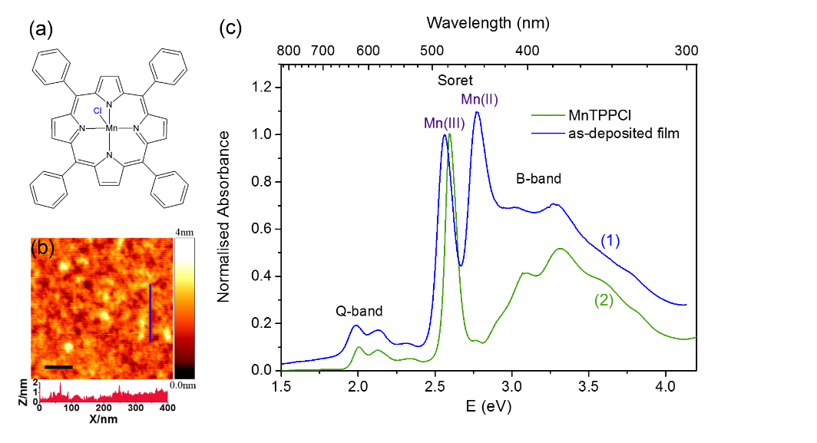
Fig. 1. (a) Molecular structure of MnTPPCl. (b) AFM micrograph of an as-deposited 100 nm thick MnTPPCl film on glass; the scale bar is 200 nm. The height profile corresponds to the blue vertical line in the micrograph. (c) UV/Visible absorption spectrum of (1) the 100 nm as-deposited MnTPPCl film on glass (blue), and (2) the MnTPPCl solution spectrum (green) in DCM.

Although the absorption peak at λ = 447 nm cannot be attributed to MnTPPCl, its energy and intensity are consistent with the characteristic Soret peak seen from the vapour-phase and solutions of Mn(II) porphyrins [28,30,31]. This optical feature is therefore indicative of the presence of Mn(II) in the as-deposited film. Hence, the UV/Visible spectroscopy results reveal that, whilst the main optical features of MnTPPCl are conserved in thin film form, a fraction of MnTPPCl molecules have reduced from originally +3 to +2 oxidation state during evaporation.

Table 1. Cl:Mn ratio, Mn(II) and Mn(III) transition and relative Mn(II) content observed in the MnTPPCl powder and as-deposited film, as deduced from XPS and UV-Visible spectroscopy (see Fig. 1 and text).

 | Cl/Mn ratio | Mn transition  λ/nm (E/eV) |  | % Mn(II)
MnTPPCl Powder | 1.3 | – | 484 (2.57) | 0 (–)
As-deposited MnTPPCl Film | 0.5 | 447 (2.77) | 484 (2.57) | 40(±0.5)

Changes to the chemical composition before and after evaporation were examined by XPS. Following quantitative analysis of the elemental peaks, the C:N:Mn:Cl ratio for MnTPPCl powder was found to me 67:5.6:1.0:1.3, in reasonable agreement with that expected from the bulk stoichiometry (44:4:1:1). The increased C and N content may be due to surface contamination, or the presence of metal-free TPP, and the slightly higher Cl:Mn ratio can be assigned to Cl-based residuals from synthesis [32]. The XPS therefore confirms that the composition of the powder used in this study is as expected. For the as-deposited films, a similar C:N:Mn ratio of 60:5.0:1.0 was found. However, the Cl:Mn ratio of 0.5:1 corresponds to only half of the expected value of 1:1, thus indicating removal of Cl for approximately 50% of the MnTPPCl molecules during deposition.
Based on the UV/Visible absorption and XPS data, summarised in Table 1, we can conclude that dissociation of the Cl ligand from Mn occurs with reduction in the nominal Mn oxidation state from +3 to +2 upon evaporation, giving rise to a mixture of Mn(III)TPPCl and Mn(II)TPP present in the film. The reduction of Mn has been previously observed at the interface with Co(001), and was attributed to the scission of the Mn-Cl bond [12], an interpretation that was later confirmed by elemental analysis [13]. The effect was also seen for FeTPPCl molecules [33], but was not observed for thicker films [12], or on less reactive surfaces, e.g. when the Co substrate was covered with a layer of oxygen [13]. Temperature also has a strong effect on whether the Mn-Cl bond remains intact. Previous reports indicated annealing to 510 K leads to complete Cl removal from Mn(III)TPPCl/Ag(111) [34], although the role of the charge transfer from the substrate was also highlighted.
As our substrates are chemically inert, and the chemical modification of MnTPPCl corresponds to a region that extends beyond the interface, we propose that the underlying mechanism for formation of Mn(II)TPP seen in our as-deposited film is thermally assisted [28]. The dissociation of Cl releases chloride (Cl⁻) which undergoes the reaction 2Cl⁻ → Cl₂ + 2e⁻, E = -1.36 V [35], forming gaseous Cl₂ ready to be desorbed. The Cl₋ oxidation can pair with the redox potential of Mn(III) [27], promoting its reduction to Mn(II).
It should be noted that the Cl ligand of chemically analogous non-planar Pcs, e.g. AlPcCl and BsubPcCl, is not removed by thermal evaporation [22,23]. This contrasting behaviour is in line with the higher stability of MPcs relative to MPors, owing to stronger metal to ligand charge transfer in Pc than Por [36].
Effects of evaporation on the coordination environment of the remaining Cl were analysed by high resolution XPS, comparing the Cl 2p spectrum of the as-deposited film, Fig. 2(a) (blue), with that from the powder (green) . The spectrum of the MnTPPCl film shows the distinctive Cl spin-orbit split 2p doublets at 197.4 eV (2p_{3/2}) and 198.9 eV (2p_{1/2}), close to those observed in the powder at 197.5 eV (2p_{3/2}) and 199.1 eV (2p_{1/2}). This indicates that only one chemical state is present for the remaining Cl, confirming its axial coordination to Mn.
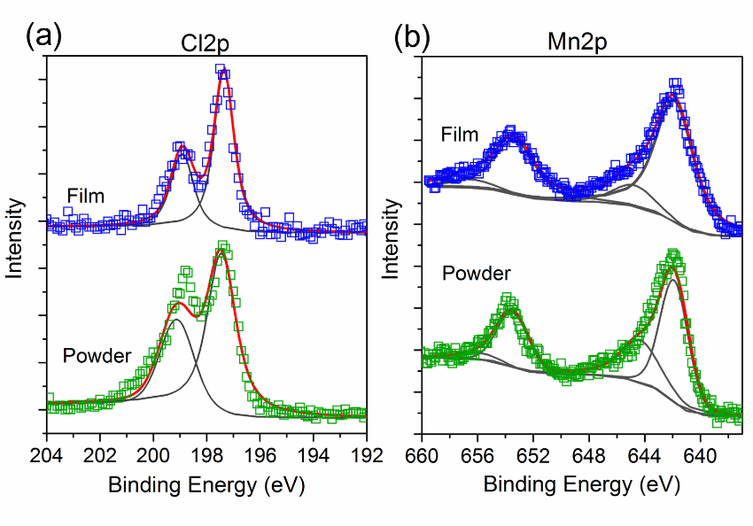

Fig. 2. High resolution (a) Cl2p and (b) Mn2p XPS spectra recorded from the MnTPPCl powder, and the as-deposited film with a thickness of 125 nm on silicon substrate. The raw data are normalised and plotted in green and blue squares respectively for the powder and film, shown with the Voigt functions (dark grey) and the fits (red) after subtraction of the Shirley algorithm.

To explore how evaporation influences the local chemical environment of Mn, the Mn2p spectrum obtained from the as-deposited film was compared with that of the powder in Fig. 2(b). In the powder, the Mn2p doublets arising from spin-orbit splitting (~11.6 eV) with peaks at 653.5 eV (2p_{1/2}) and 641.9 eV (2p_{3/2}) are observed, along with their low intensity satellites [37], close to literature values of 653.8 eV (2p_{1/2}) and 642.2 eV (2p_{3/2}) for Mn(III)TPPCl [38]. The oxidation state for the Mn ion in the powder is therefore assigned as +3, as expected. The as-deposited film exhibits similar Mn 2p doublet structures, with subtle variation in the line shape, and no significant shifts in the binding energies are found compared to the powder, with peaks at 653.3 eV (2p_{1/2}) and 641.9 eV (2p_{3/2}). The observed peak positions in the film can therefore be attributed to the Mn(III) state by comparison with both the powder and literature values for Mn(III)TPPCl [38]. This is apparently at odds with the UV-Vis results which identify a fraction of Mn(II) molecules, but can be explained by oxidation of the surface molecules that are probed by XPS. Furthermore variation of Mn2p peak positions in XPS cannot provide definitive proof of oxidation states, as differences of only 0.5 eV were reported for Mn 2p_{2/3} peak positions when the Mn oxidation state varied from +2 to +4 [39].

Evolution of optical response in MnTPPCl films
The as-deposited film contains a fraction of Mn(II)TPP formed upon evaporation, as shown by UV/Visible spectroscopy, whilst XPS indicates the Mn ions to be in +3 oxidation state, likely due to surface oxidation. This is consistent with the observation of Mn(II) porphyrins which oxidise in presence of air [27], mainly due to formation of oxygen adduct, e.g. Mn(III)(O₂)TPP [31,40]. The process of self-oxidation and ageing of our MnTPPCl films can therefore be expected following air exposure.
To establish the role of ambient oxygen on the film ageing, the UV/Visible absorption spectra of a 100 nm MnTPPCl film recorded as a function of air exposure time, shown in Fig. 3(a), are compared, included with a reference film, with the same thickness of 100 nm, stored in nitrogen atmosphere i.e. glovebox. Drastic changes to the split Soret feature, with peaks at 2.77 eV (447 nm) and 2.57 eV (484 nm) attributed to the Mn(II)- and Mn(III)-transition, are observed 7 days after the growth and are still detected upon prolonged air exposure. The Mn(II)-transition (2.77 eV) is the absorption maximum straight after deposition, but its intensity rapidly decreases within 28 days after growth, and is absent after approximately two years. Meanwhile, an increase in the absorption intensity is found in the Mn(III)-transition (2.57 eV), and 2 years after growth it is the sole Mn peak in the region. Air exposure also slightly affects the shape and intensity for the B-band region. However, any changes in the Q-bands are negligible. This is due to the Q-band transitions being mainly located on the porphyrin macrocycle, while both the B-band and Soret band arise from charge-transfer transitions [27] and are sensitive to electron density changes on the Mn centre.
This finding is similar to the behaviour previously reported for Mn(II) porphyrin solutions, with the Soret peak absorption intensity observed to move from the Mn(II) to Mn(III)-transition indicating the change of the Mn oxidation state from +2 to +3 [30,31]. By contrast, the reference film kept in the inert atmosphere, i.e. N₂ filled glovebox, undergoes only negligible changes, directly linking the appearance of Mn(III) to the presence of oxygen, i,e, formation of an oxygen adduct, Mn(O₂)TPP during air exposure [31]. The observed spectral changes can be entirely rationalised by the transition from Mn(II) to Mn(III), as confirmed by the isobestic point at 466 nm, marked by the asterisk in Fig. 3(a).

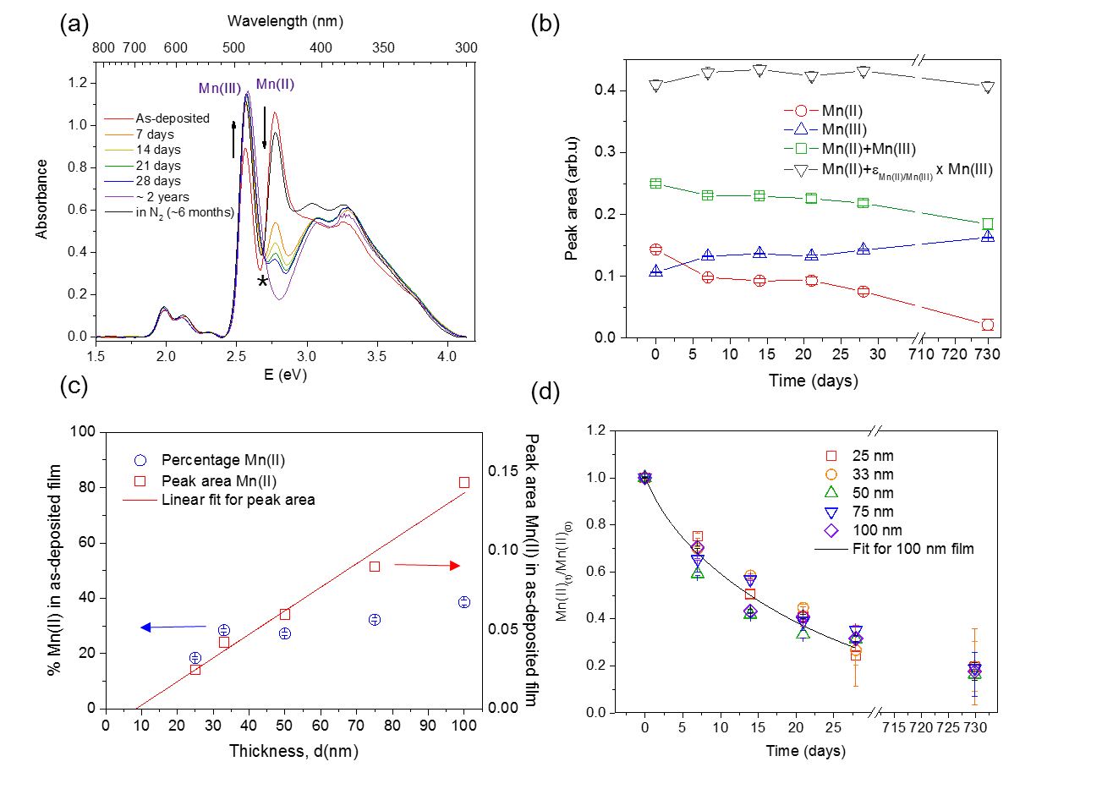
Fig. 3. (a) The UV/Visible absorption spectra of the MnTPPCl film with a thickness of 100 nm obtained during air exposure, with a 100 nm film stored in a N₂ filled glovebox included. The isobestic point is labelled by the asterisk. (b) Time dependence of the intensity in the Mn(II) and Mn(III) peak in the MnTPPCl film represented as integration of the peak area, and the sums of the two peaks areas, including the total corrected for the difference in extinction coefficients εMn(II)/Mn(III). (c) Thickness dependence of the relative Mn(II) content (%) with respect to total Mn ≈ Mn(II)+Mn(III), in the as-deposited films, and variation of the Mn(II) peak area, with the linear fit identifying the thickness of the “surface layer” of fully oxidised Mn at the surface and (d) the relative Mn(II) content represented as AMn(II)_{(t)}/AMn(II)₍₀₎, plotted as a function of air exposure time, shown with the numerical fit for the 100 nm film (black, see text). The error bars in (b), (c) and (d) are due to the fit parameters of the peak area.

Therefore, the changes of the respective Mn(II) and Mn(III) peak intensity correspond to the gradual uptake of the ambient oxygen into the permeable molecular films, and confirm that Mn(II) is present throughout the film thickness rather than at the interface with the substrate as in previous studies. To investigate quantitatively how oxygen influences the relative Mn(II) content in the MnTPPCl film, the Mn(II) and Mn(III) peak intensity (following integration of the area under the peaks at 2.77 and 2.57 eV) were monitored as a function of air exposure time, shown in Fig. 3(b), for a thickness of 100 nm. The relative oscillator strengths of the two Mn absorption bands can be estimated by recognising that the total Mn content in the film remains constant. We can therefore estimate a ratio of oscillator strengths, εMn(II)/Mn(III) such that:

${abs}_{Mn(II)}+ε_{Mn(II)/Mn(III)}*{abs}_{Mn\left(III\right)}=constant$ (1)

Where absMn(II) and absMn(III) are the measured absorption peak areas plotted in Fig. 3(b) and extracted from Fig. 3(a). By linear regression we find that εMn(II)/Mn(III)=2.14, which is similar to the smallest value found for the Mn(II)/Mn(III) transitions in solutions [41]. The relative Mn(II) and Mn(III) content present in the as-deposited film can be deduced from their peak intensities using the Beer-Lambert law [42] corrected for the ratio in oscillator strengths. A fraction of ~40% of Mn(II) content is found for the thickness of 100 nm (Fig. 3(c)), consistent with the ~ 50% Cl loss previously observed by XPS, which validates our assumptions. The low Mn(II) content (~ 20%) seen for the 25 nm film (Fig. 3(c)) is likely a consequence of Mn oxidation in the surface region, and is attributed to the large surface-to-volume ratio in contrast to thicker films. Indeed, the spectroscopic analysis of the films was performed in air, allowing fast oxidation processes to occur prior to the measurement. This surface region can be estimated as ~ 8 nm through linear regression of the thickness dependence of the Mn(II) peak area (Fig. 3(c)). This fully oxidised layer further rationalises the slightly lower Mn(II) content derived from UV-Vis spectroscopy compared to the Mn:Cl ratios from XPS. The high linearity of the absorption versus thickness despite slight differences in exposure time of the different samples prior to the UV-Vis measurements suggests that the thickness of the fast-oxidised surface layer is constant for all samples.
With these analyses, quantitative information on the further diffusion process of ambient oxygen into the MnTPPCl films can be obtained. The solutions to Fick’s law for various geometries and boundary conditions compiled by Crank [43] have been employed previously for studying the oxygen diffusion process in C₆₀ [44] and TiOPc [19]. We assume here that the increase observed in the Mn(III) peak intensity is proportional to the change of the concentration of oxygen in the film, which is taken to follow the standard distribution found for diffusion into an infinite plane sheet, due to a much larger film surface compared to that of the film edge. Since the total Mn species present in the film, comprised of only +2 and +3 oxidation state, can be approximated to be constant, as previously seen in Fig. 3(b), the reduction of the Mn(II) peak intensity also has a dependence on the oxygen concentration and thus the Mn(III) content. Considering the Mn(II) peak allows for more accurate and reliable quantitative analyses because the appearance of this peak purely originates from Mn(II)TPP. We can then rewrite the solution for diffusion in an infinite plane sheet from ref [43] to arrive at an expression for the time-dependent Mn(III) content represented by the absorption intensity of the Mn(II) peak, which follows:

$\frac{A_{Mn{(II)}_{(t)}}}{A_{Mn{(II)}_{(0)}}}≈\frac{8}{π^{2}}\sum_{n=0}^{∞}{\frac{1}{{\left(2n+1\right)}^{2}}} e^{\left\{-\frac{D{\left(2n+1\right)}^{2}π^{2}t}{{4l}^{2}}\right\}}$ (2)

where the concentration of the diffusing substance, i.e. oxygen, that enters into the film of thickness l after time t, can be directly related to the absorption intensities of the Mn(II) peak, denoted respectively as AMn(II)_{(t)} and AMn(II)₍₀₎, observed at time=t and 0, and D is the diffusion coefficient. The numerical fit obtained by using (equation 2) up to n=2 is presented for the thickest (and therefore most reliable) 100 nm film and we find D =1.9±0.3x10⁻¹⁷ cm²/s. This is more than one order of magnitude lower than what has been reported for TiOPc ((D) 8x10⁻¹⁶ cm²/s [19]), though much lower than the literature value of ZnPc (D=3x10⁻⁸ cm²/s) [45]. The large difference to the latter can be expected, since the diffusivity reported by Kerp et al. [45] was based on mass loading saturation of oxygen adsorption into μm films, with a time scale of minutes. Saturation of oxygen into the bulk of the film was shown occurs over several hours, with gas response time > ~1 hour following slow diffusion of the adsorbates, as previously reported for CuPc [46] and polyfluoro aluminium Pc [47].
The diffusivity derived here for a month-length timescale is much more relevant for the understanding of the stability of MPors in practical applications such as optoelectronicelectronic devices. The lower diffusion coefficient in our MnTPPCl-MnTPP system might be due to the absence of grain boundaries. Another factor is the reaction of oxygen with Mn(II), which can lead to immobilisation or capture and release of oxygen molecules depending on the reversibility of the reaction, and is not included in our model.

CONCLUSIONS
The properties of MnTPPCl thin films and the influence of air exposure on the optical properties are presented. The as-deposited film exhibits a smooth, uniform and featureless morphology, and consists of a fraction of Mn(II)TPP formed from evaporation, at a temperature much lower than that which decomposes the Por macrocycle, but high enough to cleave the Cl-Mn bond, with the Cl ligand removed as chloride (Cl⁻) to activate Mn(III) reduction. Air exposure results in ageing of the as-deposited films, as determined by their change in optical properties, and the oxidation of the Mn(II) species back to Mn(III). Quantitative analysis highlights that a fast degradation of a 8 nm thick surface layer is followed by slow diffusion of oxygen with a diffusion coefficient (D)=1.9±0.3x10⁻¹⁷ cm²/s. Formation of the divalent form Mn(II)TPP highlights the difference between the Pc and Por ligand in influencing the chemistry at the metal centre and axial interactions. Therefore, the ease of Cl removal and ability to undergo facile reduction are exemplar of the vapour-phase coordination chemistry of MnTPPCl. Our results uncover the challenges in maintaining ligand integrity when processing molecular films using vacuum sublimation, but also highlight opportunities for the growth of complex materials which could rely on redox-based interactions.

Acknowledgements
Funding from the Engineering and Physical Sciences Research Council (EPSRC) (EP/H002022/1) is gratefully acknowledged. We thank Professor Robert Palgrave for access to the XPS instrumentation.

REFERENCES
1. Barraclough CG, Martin RL, Mitra S and Sherwood RC. J. Chem. Phys. 1970; 53: 1638-1642.
2. Evangelisti M, Bartolomé J, de Jongh LJ and Filoti G. Phys. Rev. B 2002; 66: 144410.
3. Yamada H, Shimada T and Koma A. J. Chem. Phys. 1998; 108: 10256-10261.
4. Heutz S, Mitra C, Wu W, Fisher AJ, Kerridge A, Stoneham M, Harker AH, Gardener J, Tseng HH, Jones TS, Renner C and Aeppli G. Adv. Mater. 2007; 19: 3618-3622.
5. Serri M, Wu W, Fleet LR, Harrison NM, Hirjibehedin CF, Kay CWM, Fisher AJ, Aeppli G and Heutz S. Nat Commun 2014; 5.
6. Pinto SMA, Lourenço MAO, Calvete MJF, Abreu AR, Rosado MTS, Burrows HD and Pereira MM. Inorg. Chem. 2011; 50: 7916-7918.
7. Salleh MM, Akrajas and Yahaya M. Thin Solid Films 2002; 417: 162-165.
8. Zhou X-T, Yuan Q-L and Ji H-B. Tetrahedron Lett. 2010; 51: 613-617.
9. Barona-Castaño JC, Carmona-Vargas CC, Brocksom TJ and de Oliveira KT. Molecules 2016; 21: 310-310.
10. Auwärter W, Écija D, Klappenberger F and Barth JV. Nat. Chem. 2015; 7: 105.
11. Wäckerlin C, Tarafder K, Siewert D, Girovsky J, Hählen T, Iacovita C, Kleibert A, Nolting F, Jung TA, Oppeneer PM and Ballav N. Chem. Sci. 2012; 3: 3154-3160.
12. Scheybal A, Ramsvik T, Bertschinger R, Putero M, Nolting F and Jung TA. Chem. Phys. Chem. 2005; 411: 214-220.
13. Chylarecka D, Wäckerlin C, Kim TK, Müller K, Nolting F, Kleibert A, Ballav N and Jung TA. J. Phys. Chem. Lett. 2010; 1: 1408-1413.
14. Miller JS, Calabrese JC, McLean RS and Epstein AJ. Adv. Mater. 1992; 4: 498-501.
15. Rittenberg DK and Miller JS. Inorg. Chem. 1999; 38: 4838-4848.
16. Rittenberg DK, Sugiura K, Sakata Y, Mikami S, Epstein AJ and Miller JS. Adv. Mater. 2000; 12: 126-130.
17. Yan X, Wang H and Yan D. Thin Solid Films 2006; 515: 2655-2658.
18. Anthopoulos TD and Shafai TS. Appl. Phys. Lett. 2003; 82: 1628-1630.
19. Lüer L, Egelhaaf HJ, Oelkrug D, Winter G, Hanack M, Weber A and Bertagnolli H. Synthetic Met. 2003; 138: 305-310.
20. Haidu F, Fechner A, Salvan G, Gordan OD, Fronk M, Lehmann D, Mahns B, Knupfer M and Zahn DRT. AIP Adv. 2013; 3: 062124.
21. Friedrich R, Hahn T, Kortus J, Fronk M, Haidu F, Salvan G, Zahn DRT, Schlesinger M, Mehring M, Roth F, Mahns B and Knupfer M. J. Chem. Phys. 2012; 136: 064704.
22. Chauhan KV, Sullivan P, Yang JL and Jones TS. J. Phys. Chem. C 2010; 114: 3304-3308.
23. Sullivan P, Duraud A, Hancox l, Beaumont N, Mirri G, Tucker JHR, Hatton RA, Shipman M and Jones TS. Adv. Energy Mater. 2011; 1: 352-355.
24. Niwa Y, Kobayashi H and Tsuchiya T. J. Chem. Phys. 1974; 60: 799-807.
25. Wagner CD, Davis LE, Zeller MV, Taylor JA, Raymond RH and Gale LH. Surf. Interface Anal. 1981; 3: 211-225.
26. Warner M, Mauthoor S, Felton S, Wu W, Gardener JA, Din S, Klose D, Morley GW, Stoneham AM, Fisher AJ, Aeppli G, Kay CWM and Heutz S. ACS Nano 2012; 6: 10808-10815.
27. Boucher LJ. Coord. Chem. Rev. 1972; 9: 289.
28. Edwards L, Dolphin DH, Gouterman M and Adler AD. J. Mol. Spectrosc. 1971; 38: 16-32.
29. Gouterman M. J. Mol. Spectrosc. 1961; 6: 138-163.
30. Mu XH and Schultz FA. Inorg. Chem. 1992; 31: 3351-3357.
31. Hoffman BM, Weschler CJ and Basolo F. J. Am. Chem. Soc. 1976; 98: 5473-5482.
32. Mirafzal GA, Bosse HM and Summer JM. Tetrahedron Lett. 1999; 40: 623-626.
33. Wende H, Bernien M, Luo J, Sorg C, Ponpandian N, Kurde J, Miguel J, Piantek M, Xu X, Eckhold P, Kuch W, Baberschke K, Panchmatia PM, Sanyal B, Oppeneer PM and Eriksson O. Nat. Mater. 2007; 6: 516-520.
34. Murphy BE, Krasnikov SA, Sergeeva NN, Cafolla AA, Preobrajenski AB, Chaika AN, Luebben O and Shvets IV. ACS Nano 2014; 8: 5190-5198.
35. Atkins P and de Paula J. Atkins' Physical Chemistry; OUP Oxford, 2010
36. Liao M-S and Scheiner S. J. Comput. Chem. 2002; 23: 1391-1403.
37. Ewen RJ and Honeybourne CL. J. Phys.-Condens. Mat. 1991; 3: S303.
38. Sugiura K-i, Mikami S, Iwasaki K, Hino S, Asato E and Sakata Y. J. Mater. Chem. 2000; 10: 315-319.
39. Tan BJ, Klabunde KJ and Sherwood PM. J. Am. Chem. Soc. 1991; 113: 855-861.
40. Gonzalez B, Kouba J, Yee S, Reed CA, Kirner JF and Scheidt WR. J. Am. Chem. Soc. 1975; 97: 3247-3249.
41. Mu XH and Schultz FA. Inorg. Chem. 1995; 34: 3835-3837.
42. Skoog D, West D, Holler F and Crouch S. Fundamentals of Analytical Chemistry; Cengage Learning, 2013
43. Crank J. The Mathematics of Diffusion; Clarendon Press, 1979
44. Pevzner B, Hebard A and Dresselhaus M. Phys. Rev. B 1997; 55: 16439-16449.
45. Kerp HR, Westerduin KT, van Veen AT and van Faassen EE. J. Mater. Res. 2011; 16: 503-511.
46. Muckley ES, Miller N, Jacobs CB, Gredig T and Ivanov IN. J. Photon. Energy 2016; 6: 045501-045501.
47. Passard M, Pauly A, Blanc JP, Dogo S, Germain JP and Maleysson C. Thin Solid Films 1994; 237: 272-276.

Properties and Degradation of Manganese (III) Porphyrin Thin Films Formed by High Vacuum Sublimation
Hsiang-Han Tseng, Michele Serri, Nicholas Harrison and Sandrine Heutz

Smooth and homogeneous thin films of manganese (III) tetraphenyl porphyrin chloride (MnTPPCl) are prepared by high vacuum organic molecular beam deposition. The sublimation process leads to the loss of chlorine ligand and reduction of the metal to Mn(II) for about half the molecules. The diffusion coefficient of oxygen into the film can be derived by examining the oxidation back to Mn(III).

