Analysis of a closed-loop water-cooled refrigeration system in the food retail industry:
A UK case study

Marily Efstratiadi, Salvador Acha*, Nilay Shah, Christos N. Markides

Department of Chemical Engineering, Imperial College London, London SW7 2AZ, United Kingdom

N.B.: This is the ACCEPTED MANUSCRIPT version of this article. The final, published version of the article can be found at: https://doi.org/10.1016/j.energy.2019.03.004

Abstract
Refrigeration in supermarkets accounts between 30%-60% of total electricity demand in UK stores. The aim of this study is to conduct a pre-feasibility analysis of whether the use of a water-cooled configuration rejecting heat to the soil can improve the overall cooling performance of commercial refrigeration systems against air-cooled designs. In this work, a model simulating the operation of an existing refrigeration system is presented and validated against field data measurements taken from a supermarket. The examined system is used as a baseline and then modified to evaluate the impact of installing a water-cooled gas cooler. Results indicate that the use of water-cooled gas coolers has the potential to reduce electrical consumption of refrigeration systems by up to a factor of 5 when external temperatures are high. Overall, annual operation indicates the water-cooled alternative uses 3% less electricity than the air-cooled approach. A hybrid system is also considered consisting of coupled air-cooled and water-cooled units operating in parallel, for which an energy reduction of 6% is obtained compared against the baseline system. An economic evaluation of these systems shows promising results with a payback period of about 5 years for systems installed in new stores, although retrofits are costlier.

Keywords: compressor demand; energy efficiency; rejected heat; supermarkets; water-cooled refrigeration

* Corresponding author. E-mail address: salvador.acha@imperial.ac.uk (Salvador Acha).
Nomenclature
Abbreviations
BAU | Business as Usual
CAPEX | Capital Expenditure
COP | Coefficient of Performance
LT | Low Temperature
MT | Intermediate Temperature
NPV | Net Present Value
OPEX | Operational Expenditure

Symbols
d | Vertical distance from the surface level (m)
D | Diameter (m)
$$hc$$ | Convective heat transfer coefficient (W/m²K)
h | Specific enthalpy (J/kg)
k | Thermal conductivity (W/mK)
$$L$$ | Length (m)
$$\dot{m}$$ | Mass flow rate (kg/sec)
Nu | Nusselt number
Pr | Prandtl number
$$\dot{Q}$$ | Heat flow rate, or thermal power (W)
$$R$$ | Thermal resistance for a unit length of pipe (mK/W)
$$T$$ | Temperature (K)
$$\dot{W}$$ | Power consumption (W)
u | Velocity (m/s)
ρ | Density (kg/m³)
μ | Kinematic viscosity (m²/s)
$$η$$ | Efficiency

Subscripts
comp | Compressor
cool | Gas cooler
evap | Evaporator
i | Inside
In | Inlet
Is | Isentropic
o | outside
out | Outlet
rej | Rejected
w | Water

1. Introduction
The increasing awareness of depleting fossil-fuel reserves and of the adverse effects of the release of combustion products to the environment has driven many countries worldwide to set ambitious targets in emissions reductions. Under the Climate Change Act, the UK aims at reducing carbon emissions by at least 80% compared to 1990 levels, by 2050 (Committee on Climate Change, 2016). The food retail industry is currently one of the largest commercial energy consumers. The annual electricity consumption of stores ranges from 700 kWh/m² to 2,000 kWh/m², accounting for around 3% of UK’s total electricity consumption, with a modest annual growth rate of up to 4% (Tassou, et al., 2011). Despite efforts by the food retail industry, this consumption continues to result in very high emission levels (Acha, et al., 2015). One of the areas with a high potential for reducing these emissions is the improvement of refrigeration systems which currently account for 30% to 60% of the total energy used in stores (Tassou, et al., 2011). Furthermore, legislation relating to the use of refrigerants is becoming increasingly stringent, which has been acting to motivate the development and use of novel fluids, but also promoting the use of natural substances such as CO₂ as working fluids in various thermodynamic systems for heating, power, and also cooling (Handagama, et al., 2017).

1.1 Use of CO₂ in supermarket refrigeration systems
Many of the current refrigerants employed in supermarket refrigeration systems are blends, with two, or three components. The dominant refrigerants in the retail industry are R404A and R407A (Du, 2013), both of which are blends of non-ozone depleting HFC refrigerants with global warming potential (GWP) values of 3,922 and 2,107 respectively (ACRIB, 2014). The use of blends allows varying evaporating or condensing temperatures, referred as “temperature glides”, that allow improved system performance in conjunction with careful heat exchanger design. According to Wang (2000) a challenge associated with blends arises from changes to the composition that result in the case of refrigerant leakage. This, however, can be small if the changes in composition do not exceed 10% of the initial concentration.
In recent years, the use of CO₂ as a working fluid in refrigeration systems has been accelerating, thanks to its interesting thermophysical properties along with being a natural working fluid (Ge, et al., 2015). Tassou, et al. (2011) stated, based on recent developments, that CO₂ systems will likely become the preferred refrigeration solution in food retail buildings in the next few years due to its low GWP which leads to lower direct emissions and in some cases where weather conditions are adequate to lower energy consumption. This trend has been confirmed from discussions with industrial collaborators and their supply-chain providers. The major challenge of switching to CO₂ refrigeration systems at the moment is that these systems operate at far higher pressures than conventional R404A systems and require the use of components and assembly techniques that were not common in the supermarket refrigeration sector until recently (EMERSON, 2010). Nevertheless, retailers are gradually switching from using HFCs to natural refrigerants, such as CO₂ (Wallace, 2013).

1.2 Air-cooled versus water-cooled refrigeration
Most air-cooled supermarket refrigeration systems reject heat to the ambient air. When a water-cooled condenser is employed instead, this generally means that a liquid-vapour heat exchanger is used, which removes heat from the refrigerant vapour flow and transfers this to a cooling water flow. The vapour is condensed in this manner, and then returned to the throttle valve. This can lead to improved performance since water-based systems have much better heat transfer characteristics on the outside of the condensing coil, and are thus able to reject almost 24% more heat than systems relying on air cooling (Baxter, 2003).
Experiments conducted to assess the most common condenser types (air-cooled, water-cooled, and evaporative) indicated an increased refrigeration capacity of 31% by a system with an evaporative condenser, compared to an air-cooled one, and of 14.4% by a system with a water-cooled condenser (Hosoz & Kilicarsian, 2003). A further study by Baxter (2003) suggested that the energy consumption of a multiplex system can be reduced by approximately 8.2% when an air-cooled condenser is substituted by an evaporative one.
Despite the several advantages of water-cooled systems, some concerns remain related to their use in refrigeration applications which act as barriers to their widespread deployment in the food retail industry. From a technical perspective, careful consideration should be given to the source of water when designing a water-cooled system, as well as to the presence of air in the system, which can corrode the steel pipes. In general, dealing with dissolved impurities in the water, which cause corrosion and/or scaling, and the need to control algae, bacteria and fungi growth is also an issue in water-based systems (Wang, 2000). In addition to these issues, unpurified water may also contain suspended solids which, at high water velocities, can erode pipes and equipment, thereby increasing maintenance efforts and the associated costs. To deal with this problem, water systems typically recycle 95% of the total water, while the remaining 5% is lost by evaporation or bled from such systems to control the build-up of impurities (Wang, 2000). Water treatment, typically involving scale and corrosion control, microbiological control and chemical feeding, is thus necessary when operating liquid-cooled systems. Furthermore, the water velocity must be controlled and kept between 0.5 ms⁻¹ and 1.5 ms⁻¹ to ensure that mechanical integrity of the system is maintained over its life, since too high velocities can lead to erosion, sound/vibration, and air entrainment (ASHRAE, 2013), as well as high pressure drops and energy requirements.
One of the main reasons preventing the installation of water-cooled refrigeration systems in the food retail industry are the costs associated with their installation. Water-cooled condensers have higher initial costs than their air-cooled counterparts, while also having higher maintenance costs due to the continuous need for water treatment (Hosoz & Kilicarslan, 2003). While the capital investments of water-cooled systems do not significantly exceed those of air-cooled systems, annual operational costs are higher by about $1 for each 1,300 kg of water used and by $1 per month for each 1,000 kg of water used for full service water treatment (Vallabhaneni, n.d.). Similar costs are also stated in a study considering the economic characteristics of an air-cooled evaporative condenser (Clark & Gillies, 2014). Typically, the total refrigeration system maintenance costs amount to roughly 0.25% of supermarket revenues and the energy costs account for up to 85% of the total operation costs (Girotto, 2011).
In most refrigeration systems, the input data impose key limitations in the performance of these systems, and also have a strong influence on the development of the modelling approaches selected for these systems. The most important of those factors are the temperature and relative humidity of the ambient air, the thermal properties of refrigerant’s cooling medium and the heat rejection pressure (Arias, 2005). In general, water-cooled condensers are associated with better thermal and heat-transfer properties of the cooling medium (water over air), consequently resulting in improved overall refrigeration system performance. Surprisingly, few modelling efforts have incorporated a water-cooled condenser in a centralized refrigeration system thus far, indicating there is a research gap in the field of enhancing refrigeration system performance.
Therefore, the aim of this work is to analyse the potential benefits and viability of water-cooled refrigeration system. We present a high-level water-cooled condenser model with which to evaluate and quantify the techno-economic and environmental impacts on an overall refrigeration system relative to an air-cooled equivalent. The model hereby presented is structured based on the operating parameters of an existing refrigeration system, where the gas-cooler unit is substituted by a water-cooled condenser which rejects heat to the ground via an intermediate closed-loop water-circuit.
Most of the work that has been done around ground heat exchangers are in accordance to the operation of the ground source heat pumps, which use the ground as a heat source rather than a heat sink. However, in terms of heat transfer characteristics the main limitations remain unchanged in both applications. According to the literature, the main physical properties of the ground which affect the efficiency of the heat exchange are the thermal conductivity and the thermal diffusivity of the soil (Wu, 2009). The thermal conductivity represents the ability of a material to transfer heat per unit area and temperature gradient, but it also depends on the type of the soil and its moisture content. Meanwhile the thermal diffusivity is defined as the thermal conductivity divided by density and specific heat capacity at constant pressure (Wang, et al., 2016; Busby, et al., 2009), and becomes important in unsteady conduction problems (Mathie, et al., 2013). The highest these values are the better the effectiveness of the heat exchanger. Special consideration should also be given to the fact that in reality the ground is not an infinite heat sink. However, Darkwa, et al. (2013) and Dalpane (2015) both suggest that although the performance of a ground heat exchanger deteriorates over the years, the surrounding ground temperature also does not increase to a significant extent.
The paper is structured as follows. Section 2 presents the modelling approach of the air-cooled system currently used in the selected store, the equivalent water-cooled alternative system examined herein; in this section the model is described and validated. Section 3 presents technical and economical results from the analysis performed on the selected case study. Finally, Section 4 includes some additional discussion points and concludes the paper.

2. Modelling Approach
2.1 System model description
In order to predict the baseline performance of an existing air-cooled refrigeration system, a model was developed in MATLAB to simulate the operation of a supermarket’s direct-expansion CO₂ trans-critical booster refrigeration system using a gas cooler. The refrigerant used is R744 (CO₂) and the system operates in both subcritical and supercritical conditions depending on the weather conditions. The supermarket cabinets are connected to four recirculating refrigerant circuits, two low-temperature lines for the frozen products, and two intermediate-temperature lines for the chilled products. Specifically, the following components have been taken into consideration in the examined system:
- A compression pack which comprises a set of three low-pressure compressors and a set of four high-pressure compressors; one of the four high-pressure compressors has an inverter drive which allows power increments by a manufacturer-stated a ratio of 65/60, or ~8%.
- A gas cooler unit which can be described as a finned-tube coil heat exchanger; the total heat transfer area of the unit is 790 m² and has a total heat transfer capacity of 430 kW.
For the sake of simplicity, the low- and high-pressure sets of compressors in both air- and water-cooled systems where modelled as single compressors connected to two distinct evaporators, one at a low temperature (LT) and one at an intermediate temperature (MT); hence simulating the operation of cabinets connected to each of the two temperature lines. At the evaporator, the refrigerant absorbs heat from the cabinets, evaporates and flows to the suction lines of the compressors. The heat is then rejected to the environment through the gas cooler.
After establishing the baseline performance, the model can then be modified to simulate the operation of a system where a water-cooled condenser is employed, either replacing or operating in parallel to the existing air-cooled unit.
In the present model, the system is governed by a set of equations (Equations (1) to (7)), which define the thermodynamic properties of the refrigerant at each state of the cycle. According to the specifications set by the food retailer (see Section 2.2), the system operates in variable conditions primarily defined by the temperature of the external air, which acts as the cooling medium, with the temperature of the refrigerant leaving the gas cooler directly related to the air temperature (see Section 2.2). The food retailer also defines the level of superheating after the evaporator, as well as the level of sub-cooling after the gas cooler. The pressure at these points can be therefore specified along with the rest of the thermodynamic properties.
Given the isentropic efficiency, η_{is}, of the two compressors, the pressure drop in the evaporators and the gas cooler, and the conditions imposed above, the rest of the thermodynamic cycle can be specified. Specifically, the isentropic efficiency:
 | $$η_{is}=\frac{h_{is,comp,out}-h_{comp,in}}{h_{comp,out}-h_{comp,in}} ,$$ | (1)
is used to identify the state of the refrigerant leaving the compressors. In the expression above, h_{is,comp,out} is the enthalpy of the refrigerant at the outlet side of the compressor if the compression was isentropic, h_{comp,in,} is the enthalpy of the refrigerant entering the compressor and h_{comp,out}, is the actual enthalpy of the refrigerant leaving the compressor (Bergman, et al., 2011).
The heat absorbed in each evaporator, q, is calculated from:
 | $$q_{evap}=h_{evap,out}-h_{evap,in} ,$$ | (2)
where h is the specific enthalpy of the refrigerant flowing into or out of the component.
The mass flow rate of the recirculated refrigerant in each temperature line can therefore be specified by dividing the total thermal load of each evaporator by the above-calculated specific heat. The mass flow rate of the vapor refrigerant flowing from the flash tank to the suction line of the high pressure compressor is calculated by applying the principles of conservation of mass and energy to the system assuming no refrigerant leakage as shown in Equations (3) and (4):
 | $${\dot{m}}_{tot}={\dot{m}}_{MT}+{\dot{m}}_{LT}+{\dot{m}}_{vap}$$ | (3)
 | $${\dot{m}}_{tot}×h_{3}={\dot{m}}_{MT}×h_{4}+{\dot{m}}_{LT}×h_{4}+{\dot{m}}_{vap}×h_{10}$$ | (4)
The work done in each compressor is then calculated from:
 | $${\dot{W}}_{comp}={\dot{m}}_{comp}×(h_{comp,out}-h_{comp,in}) ,$$ | (5)
where $m_{comp}$ is the mass of the refrigerant through the suction line of the compressor, and $h_{comp,in}$, $h_{comp,out}$ are the specific enthalpies of the refrigerant at the compressor inlet and outlet, respectively.
The heat flow rate that needs to be rejected at the gas cooler is calculated from:
 | $${\dot{Q}}_{rej}={\dot{m}}_{cool}×\left(h_{cool,out}-h_{cool,in}\right) ,$$ | (6)
where $m_{cool}$ is the mass of the refrigerant through the gas cooler, and $h_{cool,in}$, $h_{cool,out}$ are the specific enthalpies of the refrigerant at the inlet and outlet of the gas cooler, respectively.
Finally, the COP of the system is calculated from:
 | $$COP=\frac{{\dot{m}}_{MT}×{∆h}_{MT}+{\dot{m}}_{LT}×{∆h}_{LT}}{{\dot{W}}_{MT}+{\dot{W}}_{LT}+{\dot{W}}_{fan}} ,$$ | (7)
where $\dot{m}$ _{MT} and$\dot{m}$ _{LT} are the mass flow rates of the recirculated refrigerant in each temperature line (MT, LT), Δh_{MT} and Δh_{LT} are the specific enthalpy changes due to the heat transfer in each evaporator (MT, LT), $\dot{W}$_{MT} and $\dot{W}$_{LT} are the power consumption of each compressor, and $\dot{W}$_{fan} the additional power required by the fans of the gas cooler, which are assumed to operate at a constant rotational speed (610 rpm) thereby consuming the design load specified by the manufacturing company (3.7 kW).
The alternative (water-cooled) refrigeration system of interest to the present study, follows similar design characteristics and a similar modelling approach, with the air-cooled heat exchanger replaced by a water-cooled equivalent. For the selection of the water-cooled condenser, the maximum amount of rejected heat from the system was identified and reduced by 30% based on literature data (Clark & Gillies, 2014) This level of reduction was used as a first assumption for the water-cooled condenser’s nominal capacity. After identifying the operating conditions of the system with the water-cooled unit (see Section 2.2 and 3.1), a plate heat exchanger with a total capacity of 200 kW_{th} was selected for closer examination in the present case study. The unit was selected after enquiring with water-cooled condenser manufacturers. Furthermore, a water pump of nominal capacity 2.2 kW which can circulate up to 1,000 L/min at a head of 10.5 m was also included in the model. The consumption of this pump was included in the calculation of the COP in Equation (7).
The same thermodynamic principles are applied to model the system only here, heat is transferred from the refrigerant to a water stream flowing in the heat rejection unit, and is consequently rejected by running the condenser’s outlet water flow through pipes beneath the soil. The water then returns in the inlet side of the condenser to continue the cooling process as shown in Figure 1.
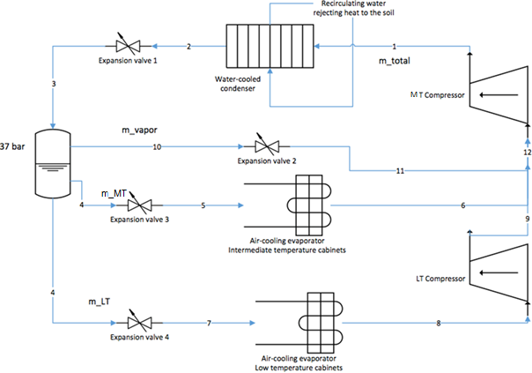
Figure 1. Schematic diagram of the modelled frozen and chilled supermarket refrigeration system.

The intermediate closed-loop water-circuit rejects heat to the soil, similar to ground source heat pump applications, although here the soil is used as a heat sink instead of a heat source. The analysis assumes that the water enters the ground source coil with the temperature it has when it leaves the condenser and returns to the condenser after rejecting the heat with the same temperature as the initial one used for the condensation calculations $T_{w,cool,in}$. A simple lumped steady-state analysis was employed to quantify the length of coil required for the heat rejection process to the soil, according to Leffler, et al. (2012):
 | $${\dot{Q}}_{rej}=\frac{L}{R}\left(T_{w,cool,in}-{ T}_{soil}\right) ,$$ | (8)
where L is the length of the underground pipework, R = 0.0234 mK/W is the lumped thermal resistance for a unit length of pipe of the heat rejection network which is a function of the convective heat transfer coefficient of water, ${hc}_{water},$ the inside$, D_{i}$, and outside$, D_{o},$diameters of the pipe and the thermal conductivities of the soil, $k_{soil}$, and the pipe,$k_{pipe}$, as shown in Equations (9)-(11).
 | $$R=\frac{1}{πD_{i}{hc}_{water}}+\frac{ln⁡({D_{o}}/{D_{i}})}{{2πk}_{pipe}}+\frac{1}{{Sk}_{soil}}$$ | (9)
The convective heat transfer coefficient in Equation (9), ${hc}_{water},$ is calculated from Equation (10), based on the Nusselt number, Nu, which describes the ratio of convective to conductive heat transfer in the fluid flow under the same conditions (Astakhov), and typically depends on the flow Reynolds number, Re, and fluid (here, water) Prandtl number, Pr. In turn, these two non-dimensional parameters depend on fluid (water) properties such as its density, ρ, dynamic viscosity, μ, thermal conductivity, k, and also the bulk velocity, u, of water inside the pipe under the given conditions and the pipe internal diameter, D_{i}. In our work, in Equation (10), we employ the Dittus-Boelter correlation for the Nusself number (for fully-developed, turbulent flow in a pipe) which is valid for: Re > 10,000, 0.6 < Pr < 160, and for relatively small temperature differences between the fluid and the wall:
 | $${hc}_{water}=\frac{k_{water}.Nu}{D_{i}}=\frac{k_{water}}{D_{i}}\left(0.023.{Re}^{0.8}.{Pr}^{0.3}\right);$$  $$Re=\frac{ρ_{water}.u.D_{i}}{μ_{water}} ;Pr={\left(\frac{μ{c.}_{p}}{k}\right)}_{water}$$ | (10)
 | $$S=\frac{2πL}{{ln(4d/D}_{o})}$$ | (11)
and where S is a geometrical shape factor relating to the thermal resistance of a cylindrical pipe, i.e., as it relates to the underground smooth pipeline considered here (Bergman, Lavine, Incopera, & Dewitt, 2011), where d is the vertical distance of the pipe from the surface level.
For the above described calculations and the validation of the simulation models built for the different scenarios examined, the data analyzed in the following section are used. The length of the pipe needed for the heat flow rate rejection of water is calculated solving iteratively Equations (8) to (11).
It is important to point out here, that the thermal conductivity of the soil is by far the most important item in Equation (9). Typically, the thermal conductivity of the soil needs to be determined in the field by the time response test at the site of interest. For the current study, such an analysis was not feasible, hence Campbell’s experimental curves were used to have an approximate value of the parameter (Cambell, 1985; Wang, et al., 2016). The moisture content of the soil in the area examined was assumed to be 20% based on research studies (UK Soil Observatory, 2017). The analysis assumes adiabatic conditions (Wang, et al., 2007) which implies no heat losses, such that the water enters the ground source coil with the temperature it has when it leaves the condenser, and returns to the condenser after rejecting heat with the same temperature as the temperature with which it leaves the coil, T_{w,cool,in}. The heat is rejected to the soil whose temperature is T_{soil}.
The approach presented above allows us to calculate the length and cost of the required underground pipework. Meanwhile, for the evaluation of a system where a gas cooler and a water-cooled condenser operate in parallel, the model functions by switching between the two independent systems according to pre-defined operating rules. Further details, along with the input data used for this analysis are given in the next sections.

2.2 Input data
The aforementioned models were established and used with different sets of data and assumptions regarding the operation of the components of the systems, as well as specifications and limitations set by food-retail engineering specifications. Weather and energy demand data were classified and used in the modelling process along with several cost characteristics of the examined systems, in the interest of evaluating and comparing the technical and economic performance of these systems.
The models are based on the technical characteristics of the system compressors and evaporators, which indicate the pressure and temperature levels at each stage of the cycle. The thermal loads of the evaporators are taken as equal to the capacity of the cabinets connected to each temperature line. This duty is specified using capacity figures ISO 23953 under ISO3 conditions (25 °C, 60% RH), provided by the manufacturers of the cabinets (WR, 2016). The cabinets are designed to keep frozen products at a temperature between -18 °C and -15 °C, while keeping chilled products between -1 °C and +5 °C (classifications L1 for freezers and M1 for chillers) (ISO, 2015). For the examined store, a total of 101 cabinets are considered which are connected to two refrigeration packs each one comprising an intermediate and a low temperature line. Table 1 indicates the total number and load of the four temperature lines.

Table 1. Number and designed thermal capacity of the cabinets under ISO 3.
 | LT1 | MT1 | LT2 | MT2
Number of cabinets | 17 | 40 | 13 | 31
Thermal capacity (kW) | 27.8 | 159.0 | 19.1 | 133.0

A cabinet’s load is primarily affected by the temperature of the cold aisle, which in turn ranges from a minimum of 12 °C to a maximum of 18 °C, depending on the conditions. To identify the evaporator load variations over the range of examined external/outdoor conditions, a correction factor that depends on the deviation of the actual cold-aisle temperature from its design point is applied to the design load in order to obtain the instantaneous load of the cabinets. The correction factor in relation to the cold-aisle and external temperature variations is shown in Figure 2. This factor is multiplied by the design load of each cabinet to estimate the instantaneous load of the low and intermediate temperature evaporators. Spatial variations in the cold aisle temperature of the store have been neglected for simplicity.

Figure 2. Measured average cold aisle temperature in the examined store, recorded from monitoring devices and correction factor of the cabinets’ duty in relation to external/outdoor temperature variations.

The food retailer’s specifications also indicate that the refrigerant should leave the evaporator in a superheated state (by +8 K) and the gas cooler in a saturated state (i.e. no sub-cooling). Based on these constraints and following the engineering design specifications from food retailers, we have assumed that a suitable control system can be designed to keep the temperature of the refrigerant leaving the gas cooler 3 K higher than the temperature of the cooling medium by suitably adjusting the operating points of the compressors and valves in order to achieve the desired performance. The minimum heat rejection pressure is limited to 45.0 bar, which corresponds to a saturation temperature of 10.9 °C. Based on the design specifications of the components of the system, a pressure drop of 1% is assumed to occur in both the gas coolers and the evaporators. Meanwhile, isentropic efficiencies of compressors typically range between 70%-90% (Turton, et al., 2008) and thus an isentropic efficiency value of $η_{is}$ = 0.8 is assumed for the compressors in both systems from discussions with industrial partners.
An important factor to consider in the operation of such refrigeration systems is the critical point of the working fluid. The critical pressure and temperature of CO₂ are 73.8 bar and 31 °C (Anwar & Carroll, 2011). When the pressure in the gas cooler exceeds this value, the gas cooler operates at supercritical conditions. This significantly affects the system’s performance, as the compressors need to run at a higher pressure, therefore increasing the total energy consumption of the system. In an air-cooled system, the temperature of the refrigerant leaving the gas cooler is directly related to external ambient conditions, which means that in warm ambient locations the system will operate in the supercritical region for a higher fraction of time than in colder locations. In order to simulate the operation of the system over a full year, the model was run for a range of external temperatures captured at 15-min intervals via sensors situated in the selected store.
For the water-cooled system, it is necessary to consider the temperature of the soil around the intermediate water loop (heat-rejection coil), which is used as the cooling medium at the condenser. The variation of the soil temperature depends on the ambient temperature, the heat injected into the soil by the coil, the design of the coil and its geometric arrangement within the soil which in turn depends on the space available on-site for heat rejection, as well as other environmental conditions such as irradiance, wind speed, precipitation and also the temperature of the soil itself (or the temperature difference between the soil and the ambient air). Given the complexity of this unsteady energy balance, it was decided not to analyse in depth in the present study the full details relating to the heat transfer process to the soil, and to assume that the coil layout is such that the temperature of the soil remains roughly constant regardless of the rejected heat, due to a large thermal inertia, but also due to the heat loss that would occur back to the environment at the higher temperatures and the rain fall that would act to stabilise the soil temperature. Since the water from the condenser rejects heat to the soil, a temperature difference of 3 K was applied between the coil exit water temperature and the soil temperature for the heat rejection to be feasible. Therefore, the temperature of the water leaving the coil was assumed to follow the same temperature variations as the soil. Data on the earth’s surface temperature from Berkley’s Earth laboratory (Berkley Earth laboratory, 2015) was used as a reference for this purpose. Furthermore, a temperature difference of 3 K between the water inlet and refrigerant outlet temperatures at the condenser was also applied. The resulting air and water temperature variations over a year are illustrated in Figure 3. In both air and water-cooled systems, the heat rejection pressure of the refrigeration system was adjusted to maintain the desired temperature difference at the outlet of the condenser, indicating a steadier operation in the case of the water-cooled condenser.

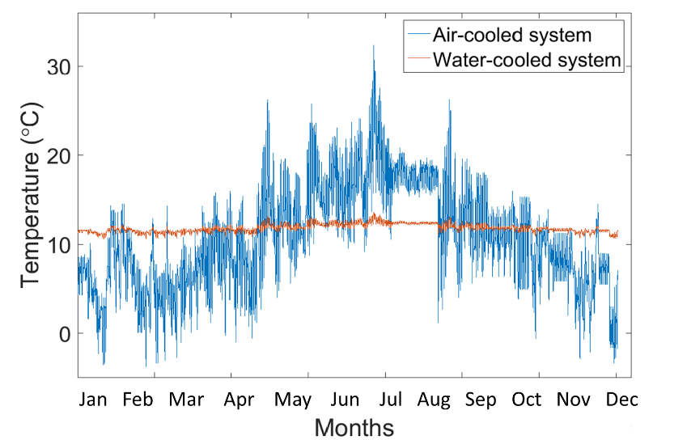
Water
Air
Figure 3. Yearly variation of the cooling-medium temperature for the air- and water-cooled systems.

In the context of this study, the heat rejection coil, is assumed to be installed 1 m below the surface level, in order to minimise the installation costs while reassuring the protection of the line from external conditions. The pipework nominal diameter was selected to be 4’’ (0.1 m) made of polyethylene, after checking that the velocity of the water circulated would not be higher than the acceptable limits described in Section 1.2.
For the calculation of the associated carbon emissions from operating refrigeration systems, the UK electricity carbon factor was assumed to be equal to the grid’s emission factor from 2018 set at 0.283 kgCO₂/kWh (GOV.UK, 2018).

2.3 Model validation
The modelling approach was validated by comparing the simulated performance of the existing system with half-hourly temperature and energy consumption measurements taken by monitoring devices positioned in the selected store. This analysis was conducted over the 7-month period between January and July 2016. The comparison indicated an error of less than 15% over the course of the day when the system operates under average external conditions. A snapshot of the system’s performance over a whole day in spring is illustrated in Figure 4, and suggests that the model behaves in a similar fashion to the existing refrigeration system.

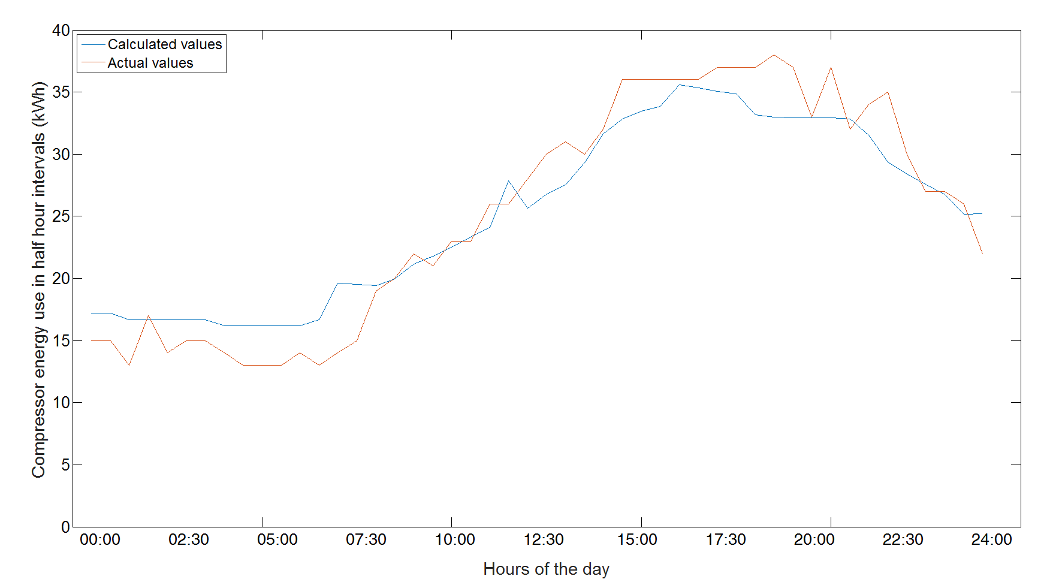
Actual
Calculated
Figure 4. Comparison of calculated and measured load variations of the air-cooled system for a spring day (6 June 2016) with average external temperature.

Similar snapshots were also taken on the warmest and coldest days of the examined period (January to July 2016), with deviations between the estimated and measured values within 20% at worst. Simulations of cold days were associated with larger deviations on average from actual performance, however, the average error over the course of the day never exceeded 10%. When the external temperatures were low, the model indicated near-steady electricity consumption, primarily due to the fact that the system operated at appropriate conditions (minimum heat rejection pressure, minimum cold-aisle temperature when the store is closed, etc.). In practice, the electricity consumption of the system on cold days fluctuates along with the operation of the variable speed fans of the air-coolers which were ignored in this exercise. Nonetheless, the largest deviation (20%) between the calculated and the measured load was found when modelling a warm day, indicating a higher demand in supercritical conditions than that registered by the meters.

3. Case study and results
3.1 Air- and water-cooled performance results
Based on data generated at a selected existing supermarket with a floor area of 1400 m² and situated in the area of Leicester in the UK, a case study is developed in order to examine the yearly operation of the existing refrigeration system and to then compare this to an equivalent water-cooled alternative. Both air-cooled and water-cooled systems models are run for a range of external temperatures from -5 °C to 35 °C with a view to identifying the energy demands and the rejected thermal loads for each system under different external conditions.
Figure 5 shows two important system performance indicators, namely the amount of rejected heat and refrigeration system COP. Figure 5(a) indicates that the water-cooled system shows steadier operation in comparison to the air-cooled one, by being less affected by the external temperatures rise. For external temperatures lower than 11 °C, the rejected heat from the water-cooled condenser is higher by approximately 10% relative to the gas cooler as it operates at the minimum heat rejection pressure. Above 11 °C the gas cooler operates at progressively higher temperatures than the water-cooled condenser. This fact implies that the heat rejection capacity of the gas cooler during the warmest external conditions should more than double to achieve the same refrigeration effect. A similar trend is also seen in the COP shown in Figure 5(b), where the performance of the air-cooled system is better under colder external conditions and drops significantly (compared to that of the water-cooled system) as the external temperature rises. The COP values resulted from the modelling come in accordance with the existing literature (Baheta, et al., 2015; Llopis, et al., 2016) on trans-critical CO₂ refrigeration cycles at these evaporation levels and given that the pressure in the gas cooler is set to a range of 75 to 90 bar for the trans-critical operation. Other studies indicate that the system could possibly show higher COPs if higher pressure levels were applied (Wang, et al., 2017).

Water  Air  (a) | Air  Water  (b)
Figure 5. Performance indicators for the air-cooled and water-cooled systems: (a) rejected heat flow rate at the gas cooler/water-cooled condenser; and (b) COP, as functions of the external temperature.

For a comparison of the two systems in terms of energy consumption, the yearly data of external and cold aisle temperatures were applied to the model, leading to the results shown in Figure 6. The compressors’ energy used is calculated for one year in half-hour intervals. As expected, the energy consumption of the water-cooled system is significantly lower than that of the air-cooled system during the warm periods of the year. However, during the colder periods the water-cooled system shows a slightly higher energy consumption. Larger differences between the two systems can be identified during the warmest hours of the year, which is when the air-cooled system operates in the supercritical region. Specifically, less energy is consumed by the water-cooled system during 4 months of the year (May to August). The higher the external temperature is, the more energy is saved when a water-cooled condenser is employed, reaching electricity savings of up to 20% during warm periods in July. The air-cooled system shows on average a 10% lower energy consumption than the water-cooled system for almost 60% of the year.
Overall, these seasonal dynamics lead to a marginal 3% annual reduction in electricity consumption when a water-cooled condenser is employed; corresponding to a savings of about 10 tCO₂. A total of 4,390 MWh of waste heat is rejected to the ground on an annual basis. This heat is rejected via a 735-m long polyethylene underground pipeline, which is expected to significantly increase the total installation cost of the underground heat rejection system.

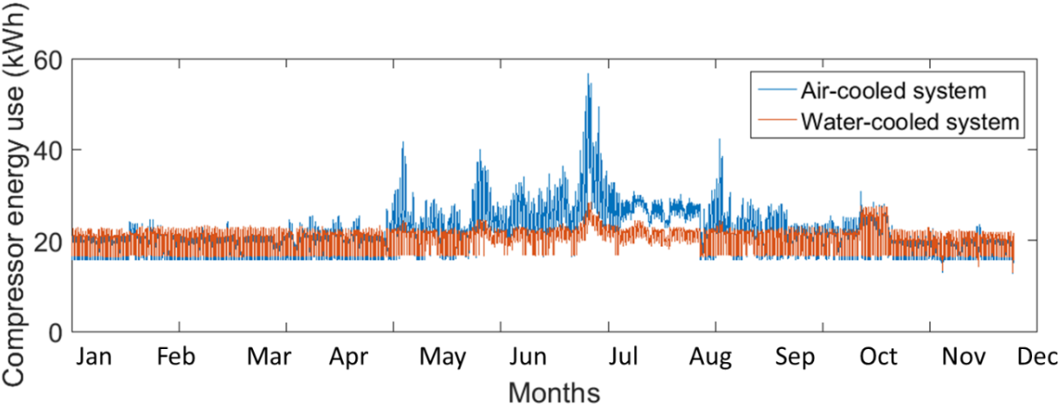
Water
Air
(a)
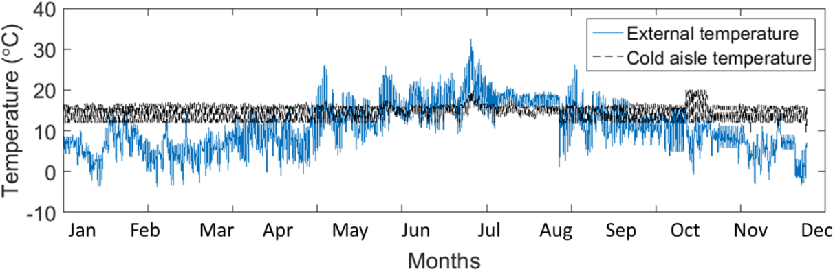
External
Cold aisle
(b)
Figure 6. Comparison of the operation of an air-cooled and a water-cooled refrigeration system installed in the examined store: (a) energy consumption; and (b) external and cold aisle temperature variation, in half-hour intervals.

3.2 Hybrid heat rejection system performance results
In an attempt to combine the advantageous characteristics of the gas cooler and water-cooled condenser units, the operation of a hybrid system was further examined. In this system, a water-cooled condenser was installed (retrofitted) and operated in parallel to an existing gas-cooler (along with the necessary heat rejection equipment). Based on the external heat-rejection temperature conditions, a bypass valve is assumed to divert the refrigerant either through the air-cooled or the water-cooled condenser with the purpose of achieving optimum performance. The predictions in the previous section (Section 3.1) were used to find the optimum switching point from one system to the other, which was identified as an external temperature of 12 °C (since above this temperature the water-cooled system operates more efficiently than the air-cooled system). In an actual system, this approach could be achieved through half hourly measurements of external temperatures, which would subsequently define the preferred time to operate the bypass valve. Figure 7 depicts the operation of a hybrid system in terms of COP and rejected heat, for a range of external temperatures.

Figure 7. Coefficient of performance and rejected heat of a system with coupled gas cooler and water-cooled condenser in relation to the external temperature.

As expected, a system with a coupled gas cooler and water-cooled condenser can achieve not only steadier levels of performance within the range of external temperature examined but can also operate at the optimum COP of both systems. In terms of energy consumption, the operation of the hybrid system in comparison to the operation of a stand-alone air-cooled and a stand-alone water-cooled system, on a monthly basis, is depicted in Figure 8.

Hybrid
Water
Air
Figure 8. Monthly averaged energy consumption of an air-cooled, a water-cooled and a coupled refrigeration system installed in the examined store.

The system with a coupled gas cooler and water-cooled condenser, shows the optimum overall performance, consuming the lowest possible amount of energy each month. Results indicate that the air-cooled unit operates for about 98% of the winter period (January to March, and November to December), as a direct result from the fact that the average external temperature during these periods, almost never exceeds the switch point of 12 °C. On the other hand, during the warmest summer months, the refrigerant is led through the water-cooled condenser during 89% of the operational time of the system, reaching 100% water-cooled operation in August. For May and September, both the water-cooled and the air-cooled unit are used, as the external temperature fluctuates above and under the switch point of the by-pass valve. A comparative annual performance of the three examined systems is provided in Table 2.

Table 2. Annual results for all three examined refrigeration systems.
Performance indicators | Air-cooled system (BAU) | Water-cooled system | Hybrid system
COP | 0.50 – 2.90 | 2.40 – 2.65 | 2.40 – 2.90
Rejected heat | 125 – 400 kW | 130 – 180 kW | 125 – 180 kW
Energy use | 696 MWh | 673 MWh | 656 MWh
Electricity costs | $72,900 | $70,800 | $68,850
Carbon emissions | 197 tCO₂ | 190 tCO₂ | 186 tCO₂

The use of both a gas cooler and a water-cooled condenser allows the system to achieve almost twice the savings compared to a stand-alone water-cooled condenser. Although the total energy consumption is reduced by almost 6% relative to the air-cooled system and 3% relative to the water-cooled system, the system does not fully take advantage of the water-cooled unit’s full potential due to the local climate conditions where the supermarket is located, with the water-cooled condenser only used for 34% of the year. These results suggest that the water-cooled systems could have greater benefits in locations with higher external temperatures.

3.3 Financial evaluation
When considering the capital expenditures of the air-cooled and water-cooled systems, the cost of the latter is found to be 3.5% higher than that of the former. Although the costs of the individual components of the system, such as compressors and heat rejection units, are lower in water-cooled systems, the installation costs of the heat rejection coil in the soil exceed the aforementioned reductions, and represent up to 36% of the total cost of the system. A breakdown of the total costs used in this case study is given in Table 3.
This information was obtained by engaging with refrigeration specialists working in the food-retail sector. Some of the main assumptions used in this study can be specified as follows:
- The cost of the gas cooler is provided by the food retailer’s engineers.
- The cost of the water-cooled condenser and the water pumps has been estimated upon the range of similar units in the existing market.
- The refrigerant and oil cost has been added to the current assessment because, as stated in the literature, it is reduced by approximately 10% when a water-cooled condenser is employed compared to the air-cooled system (Wang, 2000).
- For the heat rejection system costs, data from economic assessments of ground source heat pumps have been used. At present, UK costs for GSHP systems are approximately $1,100-$1,600 per kW of heating requirements, of which 30% to 50% is the installation and purchase cost of the ground coil (Centre of Alternative Technology, 2016). Given that the design of the heat rejection system is based on the operation of GSHPs, the average values of these costs have been used to estimate the installation costs of the ground coil, resulting to a cost of $500 per kW.
In this work, it is assumed that the land is owned by the food retailer (e.g. private parking area), hence no additional cost for this land is included in the financial evaluation.

Table 3. Total capital costs for an air-cooled and a water-cooled system in a supermarket operating under the conditions of the developed case study.
Air-cooled system |  | Water-cooled system
Fan-driven air coolers | $45,540 | Water-cooled condensers | $10,090
Refrigerant and oil | $8,710 | Refrigerant and oil | $7,840
Compressors | $180,930 | Compressors | $135,700
Installation costs | $2,460 | Water pumps | $3,690
 |  | Ground source coil | $88,620
Total | $237,640 | Total | $245,940

In terms of annual expenditure, assumptions needed to be made based on previous case studies identified by the literature in order to calculate annual operation and maintenance costs (Bagarella, et al., 2014; Hosoz & Kilicarsian, 2003; Vallabhaneni, n.d.; Wiryadinata, et al., 2016). As for the energy costs, real-time electricity prices in half hourly intervals have been applied to the model for the year of interest (Acha, et al., 2016), along with projections of the Department of Energy and Climate Change for energy prices until 2030 (DECC, 2012).
Using these data, three business case scenarios were conducted to examine the profitability of investing in a water-cooled condenser either for a new store or as a retrofit for a store of similar features to the one examined in the case study; the results are summarized in Table 4.
For the retrofit option, the annual running costs of the two systems are compared and the investment in a water-cooled condenser is evaluated from the Net Present Value (NPV) of the system in 10 years, and the payback period of the alternative system. The Net Present Value is the difference between the present value of cash inflows and the present value of cash outflows, and it is used to analyze the profitability of a projected investment or project. It is calculated using Equation (12), where C_{n}, is the value of the net cash flows each year, C₀, the capital investment in year 0 and r is the discount rate of the investment. In this study a discount rate of 8% has been used based on the existing literature (Garcia-Gusano, et al., 2016). The payback period can be defined as the time period n (years) which turns NPV to zero.
 | $$NPV=\sum_{0}^{n}{\frac{C_{n}}{{(1+r)}^{n}}}-C_{0}$$ | (12)
In the new store applications, only the capital and operating expenditure related to the operation of a water-cooled system, are compared to the equivalent costs of an air-cooled system in a new store in order to identify which solution would be more beneficial for a new store application. Equation 12 is used in this scenario as well to calculate the financial indicators of each approach.
In an aggregate economic analysis of the system, the inflows would be the annual benefits of the supermarket, and the outflows the total annual expenditure of the store. In the current study only the refrigeration system is examined with an emphasis on the heat rejection units, and there are no available data on the revenue streams of the store. As a result, the difference of the capital expenditure and the annual costs between the two systems is the only indicator used.

Table 4. Financial indicators for the business case scenarios.
Economic indices | Retrofit with a hybrid system | Water-cooled system in a new store | Hybrid system in a new store
Capital Expenditure (CAPEX) | $102,200 | -$49,300  (relative to BAU) | +$8,600  (relative to BAU)
Operational Expenditure (OPEX) relative to BAU | +200% | +150% | +200%
Annual energy costs relative to BAU | -$4,300 | -$2,200 | -$4,300
Total annual savings relative to BAU | $2,200 | $1,350 | $2,200
Payback period | >10 years | ≈ 0 (immediate payback) | 4.8 years

As indicated by the results of this exercise shown in Table 3, the high capital expenditure associated with the retrofit installation of a water-cooled condenser in parallel to the existing air-cooled unit cannot be paid-off by the marginal reduction in energy costs within a reasonable period of time. More specifically, although the energy costs of the hybrid system are reduced by 5.6% compared to the BAU scenario, the total annual savings do not exceed 3.3% over the course of the year resulting to a negative NPV of such an investment in 10 years’ time. These calculations also support the aforementioned statement that an investment in a water-cooled condenser could possibly be more beneficial if external temperature was higher where the higher reduction in energy costs could compromise the annual costs associated with the water treatment and use.
On the other hand, in a new store the water-cooled system has lower nominal capacities, resulting in an immediate payback for a stand-alone system and a payback period of less than 5 years for a hybrid system. The capital cost of water-cooled system in a new store is significantly reduced in accordance to the lower capacity requirements, leading to a reduced annual expenditure by almost 3%. Adding the extra capital to install a hybrid system could almost double this percentage while slightly reducing the carbon footprint of the total system. Depending on the priorities set by retail stakeholders and the business case developed it could be argued that a water-cooled refrigeration system should be feasible in an UK context, especially in the case of newly-built stores.

4. Conclusion and future work
This paper presented a high-level modelling framework that was developed in order to assess water-cooled refrigeration systems and to compare these against conventional air-cooled equivalents in UK supermarkets. The conventional refrigeration system of a representative supermarket was modelled and used in a case study to provide a benchmark system performance against which the performance of water-cooled and hybrid refrigeration system alternatives were compared. The systems were contrasted in terms of their energy consumption, carbon emissions associated with the electricity demand, and cost savings. The case study of a UK supermarket was selected in order to showcase the impact water-cooled systems could have in these commercial buildings.
It was found that the performance of an air-cooled refrigeration system is directly related to external temperature conditions in the area where the store is located. As a result, the use of a water-cooled condenser can lead to a reduction of up to 20% in the system’s energy consumption when external temperatures are higher than the temperature of the cooling stream of the water. Conversely, the gas cooler can achieve lower heat rejection temperatures in colder ambient conditions, resulting in a reduced energy consumption by the system of 10% compared to the water-cooled alternative. Therefore, it was hypothesized that a hybrid system with coupled air-cooled and water-cooled condensers could take advantage of both components’ optimum performance by becoming less dependent of external temperature variations.
Overall, the use of a water-cooled condenser in the examined store resulted in a marginal reduction in energy consumption, equivalent to an abatement of 7 tCO₂ per year, as opposed to approximately 11 tCO₂ by the hybrid system. Most of this energy is saved during the warmest periods of the year where the performance of a water-cooled system is significantly better. From an economic perspective, although the purchase cost of a water-cooled condenser is lower than the cost of a gas cooler, the installation of the underground heat-rejection pipework increases the total capital cost of the system by almost 3.5%. Similarly, the reduced energy consumed, leads to lower energy costs in the case of a water-cooled system, but the operation and maintenance costs related to the water treatment result in an overall marginal reduction of the annual expenditure, which is not capable of paying-off the initial capital investment for the retrofit solution. However, when considering the water-cooled condensers for a new store, results suggest that, since a fraction of the costs of the ground coil can be attributed to the total cost of construction of the store, a water-cooled or a hybrid system presents a more attractive investment.
Interesting avenues for further work include increasing the model complexity and relaxing certain simplifying assumptions, such as including system control, dynamics and details of the unsteady energy balance on the soil in order to capture its temperature variation and thermal interaction with the system. Emphasis can also be placed on the effectiveness of the heat exchanger performance in underground applications, which requires further exploration. For instance, although the 3 K temperature differential between coil exit water temperature and the soil temperature is not unreasonable, this requires further investigation as the trade-offs in heat exchanger design are outside the scope of this present work. In addition, considerations of optimal system design, control and operation that captures more accurately the potential of these refrigeration systems would also prove useful. Equally valuable would be sensitivity analyses, and studies aimed at examining supermarkets with different characteristics and in different climatic zones. Such studies would allow us to acquire a more general understanding of the operation of water-cooled refrigeration systems. Finally, for a holistic analysis of energy use in supermarkets, it would be interesting to link this model to the rest of the systems employed in a supermarket to validate their interaction in terms of energy consumption and capital expenditure.

Acknowledgements
This research was supported by funds provided via the Imperial College London – Sainsbury’s Supermarkets Ltd. Partnership. This work was also supported by the UK Engineering and Physical Sciences Research Council (EPSRC) [grant number EP/P004709/1]. Data supporting this publication can be obtained on request from cep-lab@imperial.ac.uk.

References
Acha, S., Bustos-Turu, G. & Shah, N., 2016. Modelling real-time pricing of electricity for energy conservation measurements in the UK commercial sector. Leuven, IEEE International.
Acha, S., Du, Y. & Shah, N., 2015. Enhancing Energy Efficiency in Supermarkets Refrigeration Systems through a robust energy performance indicator. International Journal of Refrigeration, Volumen 64, pp. 40-50.
ACRIB, 2014. F-gas regulation and GWP values, Surrey: Air Conditioning and Refrigeration Industry Board.
Anwar, S. & Carroll, J. J., 2011. Carbon Dioxide Thermodynamic Properties Handbook. 1st ed. s.l.:Wiley Online Library.
Arias, J., 2005. Energy Usage in Supermarkets - Modelling and field measurements, Stocholm: PhD Thesis, KTH - Royal Institute of Technology.
ASHRAE, 2013. Data Centre Essentials, Guidance on Energy Efficiency Design and Operation. 3rd ed. s.l.:ASHRAE.
Astakhov, V.P., 2012. Environmentally friendly near-dry machining of metals. Metalworking Fluids (MWFs) for Cutting and Grinding. Pages 135-200.
Bagarella, G., Lazzarin, R. & Norro, M., 2014. Annual Energy analysis of a water-loop self-contained refrigeration plant and comparison with multiplex systems in supermarkets. International Journal of Refrigeration, Volumen 45, pp. 55-63.
Baheta, A. T., Hassan, S., Reduan, A. & Woldeyohannes, A. D., 2015. Performance investigation of trans-critical carbon dioxide refrigeration cycle. s.l., 12th Global Conference on Sustainable Manufacturing.
Baxter, V. D., 2003. Advanced Supermarket Refrigeration/Heat recovery systems, s.l.: IEA.
Bergman, T. L., Lavine, A. S., Incopera, F. P. & Dewitt, D. P., 2011. Fundamentals of Heat and Mass Transfer. seventh ed. s.l.:John Wiley & Sons, Inc..
Berkley Earth laboratory, 2015. Berkley Earth. [Online]
Available at: http://berkeleyearth.lbl.gov/locations/52.24N-0.00W
[Accessed: 30 07 2016].
Busby, J., Lewis, M., Reeves, H. & Lawley, R., 2009. Initial geological considerations before installing ground source heat pump systems, Nottingham: British geological survey.
Cambell, G. S., 1985. Soil Physics with BASIC, New York: Elsevier.
Centre of Alternative Technology, 2016. CAT information centre. [Online]
Available at: http://info.cat.org.uk/questions/heatpumps/how-much-will-heat-pump-cost/
[Accessed: 12 08 2016].
Clark, J. & Gillies, A., 2014. Comparison of evaporative and air-cooled condensers in industrial applications, London: The Institute of Refrigeration.
Committee on Climate Change, 2016. Carbon Budgets and Targets. [Online]
Available at: https://www.theccc.org.uk/tackling-climate-change/reducing-carbon-emissions/carbon-budgets-and-targets
[Accessed: 24 08 2016].
Dalpane, P., 2015. Operational and economic analysis of GSHP coupled with refrigeration systems in UK supermarkets, London: MSc Thesis, Imperial College of London.
Darkwa, J., Su, W. & Chow, D., 2013. Heat dissipation effect on a borehole heat exchanger coupled with a heat pump. Applied Thermal Engineering, pp. 234-241.
DECC, 2012. UK Energy Market. [Online]
Available at: http://www.theventuringfirm.com/ideas/uk-energy-market
[Accessed: 30 08 2016].
EMERSON, 2010. Refrigerant Choices for Commercial Refrigeration, Finding the right balance, Aachen: Emerson Climate Technologies-European Headquarters.
Garcia-Gusano, D., Espegren, K., Lind, A. & Kirkengen, M., 2016. The role of discount rates in energy systems optimisation models. Renewable and Sustainable Energy Reviews, pp. 56-72.
Ge, Y., Tassou, S., Santosa, I. & Tsamos, K., 2015. Design and Optimisation of CO2 gas cooler/condenser in a refrigeration system. Applied Energy, Volumen 160, pp. 973-981.
Girotto, S., 2011. Refrigeration and heat pumps systems with CO2 as a refrigerant. Belgrade, Roundtable on Cimate and Ozone-friendly technologies in refrigeration and air-conditioning.
GOV.UK, 2012. GOV.UK. [Online]
Available at: https://www.gov.uk/government/statistics/the-uk-greenhouse-gas-inventory-carbon-emission-factors-and-calorific-values
[Accessed: 25 07 2016].
GOV.UK, 2018. GOV.UK. [Online]
Available at: https://www.gov.uk/government/publications/greenhouse-gas-reporting-conversion-factors-2018
[Accessed 25 01 2018].
Handagama, N., White, M. & Markides, C. N., 2017. Cooling with Carbon Dioxide. Energy Institure, July/August, pp. 28-29.
Hosoz, M. & Kilicarsian, A., 2003. Performance evaluations of refrigeration systems with air-cooled, water-cooled and evaporative condensers. International Journal of Energy Research, Volumen 20, pp. 683-696.
ISO, 2015. Refrigeration display cabinets - Part 2: Classification, requirements and test conditions, s.l.: International Organisation for Standardisation.
Leffler, R. A., Bradshaw, C. R., Groll, E. A. & Garimella, S. V., 2012. Alternative heat rejection methods for power plants. Applied Energy, Volumen 92, pp. 17-25.
Llopis, R. y otros, 2016. Experimental evaluation of a CO2 trans-critical refrigeration plant with dedicated mechanical sub-cooling. International Journal of Refrigeration, Volumen 26, pp. 361-368.
R. Mathie, C.N. Markides, Heat transfer augmentation in unsteady conjugate thermal systems – Part I: Semi-analytical 1-D framework, International Journal of Heat and Mass Transfer, Volume 56, Issues 1–2, 2013, Pages 802-818.
R. Mathie, Hajime Nakamura, C.N. Markides, Heat transfer augmentation in unsteady conjugate thermal systems – Part II: Applications, International Journal of Heat and Mass Transfer, Volume 56, Issues 1–2, 2013, Pages 819-833.
Tassou, S., Ge, Y., Hadawey, A. & Marriott, D., 2011. Energy Consumption and Conservation in Food Retail. Applied Thermal Engineering, Volumen 31, pp. 147-156.
Turton, R., Bailie, R. C. & Shaeiwitz, J., 2008. Analysis, Synthesis and Design of Chemical Processes. NJ, USA: Pearson Education.
UK Soil Observatory, 2017. Countryside Survey: Topsoil - Soil Moisture. [Online]
Available at: http://www.ukso.org/Cs/CS_Soil_Moisture.html
Vallabhaneni, K. A., s.f. Benefits of water-cooled systems VS air-cooled systems for air conditioning applications, s.l.: Cooling Technology Institute eti.org.
Wallace, K., 2013. Supermarkets for the future, Natural refrigeration and heat recovery, s.l.: Ken Dale Travel Bursary.
Wang, S. K., 2000. Handbook of Air Conditioning and Refrigeration. 2nd ed. s.l.:McGraw-Hill.
Wang, Z., Han, F. & Sunden, B., 2017. Parametric evaluation and performance comparison of a modified CO2 trans-critical refrigeration cycle in air-conditionng applications. Chemical Engineering Research and Design, Volumen In press, corrected proof.
Wang, Z., et al, 2016. Research of heat and moisture transfer influence on the characteristics of the ground heat pump exchangers in unsaturated soil.. Energy Buildings, pp. 140-149.
Wiryadinata, S., Mark, M., Bryan, J. & Kurt, K., 2016. Technical and economic feasibility of unitary, horizontal ground-loop geothermal heat pumps for space conditioning in selected California climate zones. Energy and Buildings, pp. 140-149.
WR - Wirth Research 2016. Refrigeration Products. [Online]
Available at: https://www.wirthresearch.com/products/refrigeration
[Accessed: 31 08 2016].
Wu, R., 2009. Energy efficiency technologies - Air source heat pump vs. ground source heat pump. Journal Sustainable Development, Volumen 2.

BAU: air-cooled system with the same refrigerating capacity.
Carbon emissions only consider direct emissions due to electricity consumption. Indirect emissions due to refrigerant leakages were not considered in this study.

