Article type: Perspective

Energy Conversion Based on Bio-inspired Superwetting Interfaces
Ming Li ^{1,*∔}, Chang Li ^{2,*∔}, Bamber R.K. Blackman ², Eduardo Saiz ^{1,*}

¹ Centre of Advanced Structural Ceramics, Department of Materials, Imperial College London, London, SW7 2AZ, UK.
² Department of Mechanical Engineering, City & Guilds Building, South Kensington Campus, Imperial College London, London SW7 2AZ, UK.
∔ The two authors contribute equally to this work.
* Corresponding authors: Chang Li (c.li19@imperial.ac.uk); Ming Li (m.li19@imperial.ac.uk); Eduardo Saiz (e.saiz@imperial.ac.uk)

Summary:
Bio-inspired superwetting interfaces can realize rapid transfer of liquid mass or momentum due to their unique surface structure and wetting characteristics. Combining with a suitably electrified material, these special interfaces can further promote generation or transmission of electrons. Herein, we summarize the latest developments in water-energy collection technologies based on these interfaces, such as piezoelectric/triboelectric/pyroelectric nanogenerators. When it comes to harvesting energy generated by salinity gradients, reverse electrodialysis based on ion channels are now widely investigated. We review the concept of “quantum-confined superfluids” on superwetting interfaces, and the conditions required to form a superfluid in molecular/ion channels. The applications of the superfluids in energy conversion are discussed, including the charging & discharging process of lithium batteries and harvesting salinity-gradients energy. This perspective identifies advantages, current challenges, and future directions in the development of energy-conversion devices using superwetting interfaces that could open the door for their broader application.
Keywords: energy conversion; bio-inspired; superwetting; ion channel; super fluid; quantun-confined; surfaces; interfaces

- Introduction
The engineering of surfaces or interfaces to improve the properties of functional and structural materials is the focus of ever increasing attention from interdisciplinary fields.^{1,2} Through research on the surface of natural organisms with superwetting properties, it has been confirmed that micro/nano-structures and chemistry determine this superwetting performance.³ Following this principle, micro- or nanoscale roughness is often used to build super-hydrophilic, super-oleophilic, super-hydrophobic or super-oleophobic surfaces.⁴ Researchers have further proposed a superwetting network system with 64 states by combining these 4 states in the environments of air, water and oil.⁴ This is achieved by the design of the arrangement, structural orientation and gradient distribution at the micro to nano-scale to affect the liquid movement and the wetting state. ⁵ Furthermore, by introducing responsive smart molecules, researchers have prepared materials that can switch between different superwetting states to create the biomimetic “binary cooperative complementary” interfaces, e.g., a slippery lubricant-infused porous surface (SLIPS).^{6,7}
Scientists and engineers are paying much attention to the development of superwetting interfaces in new devices for energy generation and storage (Figure 1). This area of research is emerging, and has seen a tremendous growth, especially in the last three years.^{8,9} Mechanical energy, thermal energy, and chemical energy can be converted into electricity. For example, researchers have developed diverse nanogenerators taking advantage of electrified interfaces with special wettability, i.e., piezoelectric nanogenerators (PENG), triboelectric nanogenerators (TENG), and pyroelectric nanogenerator (PyNG).^{10,11} Nanogenerators can use super-hydrophobic surfaces that promote mass transfer through spontaneous rapid liquid rolling to leave the surface. Wang et al found that appropriate liquid/solid contact frequency could improve the output, although the charge transfer on such surfaces is limited.¹² Others use super-hydrophilic surfaces that usually promote charge generation or spontaneous, rapid liquid/charge spreading. Recently, the binary cooperative complementary theory has been applied to the development of an energy conversion system based on rapid transmission of ions or different molecules through bio-inspired smart channels (i.e. ion channels) or water channels respectively.^{13,14} This kind of rapid transport of ions and molecules occurs in the form of a "quantum-confined superfluid" (QSF): an enthalpy-driven confined ordered fluid.¹⁵ It significantly increases the transmission rate of ions through the channel while reducing energy consumption by the process. Typical applications include Li-ion batteries and salinity gradient energy harvesting based on reverse electrodialysis (RED).
In this perspective, we review the emerging applications of superwetting surfaces in the field of energy conversion, including water-energy harvesting and thermal management (e.g., solar steam generation) utilizing super-hydrophobic or super-hydrophilic surfaces. Moreover, the concept of "quantum-confined superfluid" and how it influences energy conversion efficiency would be discussed together with the fabrication of bio-inspired membranes with smart ion channels. The work will finish with the main conclusions and future research suggestions on the application of superwetting interfaces applied to the energy field.
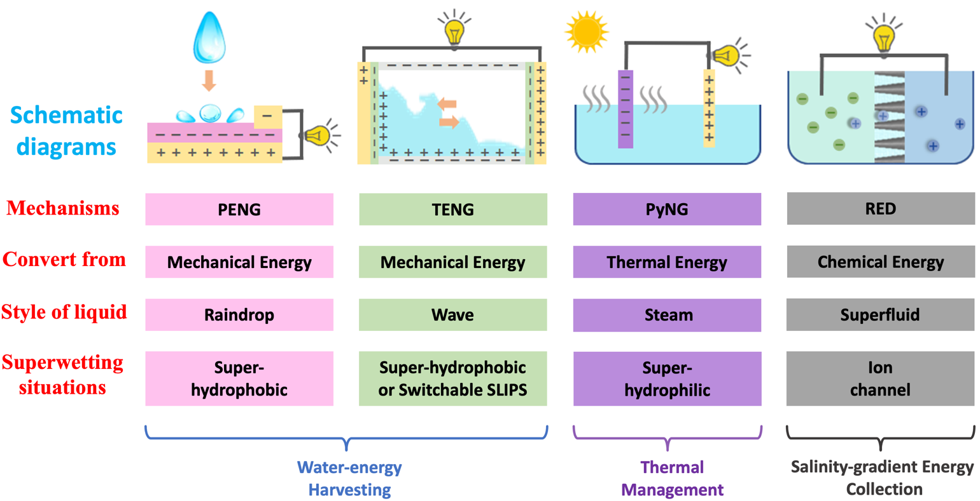
Figure 1. Superwetting Interfaces for Energy Conversion.
PENG: piezoelectric nanogenerator, TENG: triboelectric nanogenerator; PyNG: pyroelectric nanogenerator (PyNG); RED: reverse electrodialysis; SLIPS: slippery lubricant-infused porous surface.

- Water-energy Harvesting
Energy harvesting or conversion can be realized utilizing water dynamics. Water-energy harvesting includes transforming the mechanical energy (e.g., kinetic energy, and gravitational potential energy) of water into more practical energy such as electricity.¹⁶ As summarized in Table 1, this energy conversion can be achieved or improved using superwetting materials, on which water shows unique behavior. On a super-hydrophilic surface, water will spread quickly to form a film due to the high surface energy. On a super-hydrophobic or a slippery surface, it is easy to control droplet behavior such as splash, bounce, and directional motion. Both surfaces can be used to enhance the conversion of mechanical energy.
Superwetting materials are useful for harvesting the high mechanical energy of water from nature, e.g., from the raindrop or ocean wave. Transforming raindrop-energy to electricity is usually achieved using a piezoelectric material, e.g., polyvinylidene fluoride (PVDF), lead zirconate titanate (PZT) or ZnO, by means of a piezoelectric cantilever beam or a bridge under the impact of raindrops.¹⁷ Hao et al. concluded that super-hydrophobic surfaces can enhance the energy collection from waterdrop splashs.¹⁸ In comparison to other surfaces, they can usually produce electricity with higher efficiency (Figure 2A). The output voltage reached up to 6 V, which can potentially supply some small electronic apparatus.
The energy of waves can be transformed into electricity using the triboelectric effect.¹⁹ Elastic electroactive materials (i.e., dielectric elastomers) with high friction are often used, e.g., some rubbers. Zaltariov et al. studied the long-term stability of wetting on natural or synthetic rubbers in sea water/salt water and the influence of wave-energy harvester based on rubber on the marine environment.²⁰ Their research suggested that most rubber harvesters are stable in sea water and may not have deleterious effects on microorganisms. Li et al. developed a high-friction polypropylene (PP) film coating on an electrode and discovered that improving the hydrophobicity could increase the electrical output. They explained that it was due to less residual liquid left after the withdrawal of the waves, which benefits charge separation and accumulation (Figure 2B).²¹ Conversely, it is also true that during one wave action, a super-hydrophilic surface may theoretically generate more charge than a hydrophobic surface with the same topography.^{22,23} Water on super-hydrophilic surfaces exhibits a much larger contact area, increasing the friction to improve charge generation using triboelectric materials.²⁴ However, super-hydrophilicity can lead to a film or liquid residual on the surface, which has side effects on the subsequent electricity generation. To solve the dilemma, Xu et al. took advantage of a SLIPS which used polytetrafluoroethylene (PTFE) film covered with indium tin oxide (ITO) as substrate.²³ Using just one substrate, the switchable wetting of SLIPS can not only realize high friction for better charge generation, but also reduced liquid residual to improve charge accumulation. Recently, Xu et al. connected a similar material to an Al electrode.²⁵ This electrode can harvest the mechanical energy of raindrops, tap water, or sea water during charging to achieve an instantaneous power density hundreds of times greater than control electrodes which were limited by interfacial effects (Figure 2C). The output voltage was around 150 V, which can supply electricity for some household appliances. They also highlighted the combination of slippery interfaces with transistor-inspired architectures.¹¹ Such a combination can realize efficient energy harvesting in large and multiple scales, which will be a promising technology to address the problem of low output and durability in application.
Superwetting materials can also convert their own surface energy to liquid kinetic energy rather than utilizing external factors, after which this kinetic energy can be further transformed into electricity.^{26,27} For example, Milijkovic et al. utilizing the jumping of charged droplets between super-hydrophobic CuO and hydrophilic Cu surfaces to generate electric power.²⁸ Gao et al. used a similar principle of droplet jumping on super-hydrophobic Cu surfaces with geometry gradients and achieved an enhanced energy conversion rate than those without gradient.²⁹ Taking advantage of surface energy to manipulate liquids in energy devices is deemed to be a promising low-cost technology that is environment-friendly. We suggest that super-wetting surfaces in energy devices can be designed to realize multiple functions, e.g., anti-corrosion, anti-icing or fog-water collection, or/and water-oil separation.^{26,27,30}
In addition, superwetting micro/nano-structured interfaces can be further designed as generators to harvest any forms of mechanical energy by manipulating liquid dynamic, i.e., PENG and TENG. Another type of nanogenerator, the PyNG, that converts thermal energy into electricity, will be mentioned in section 3. Solid-liquid nanogenerators were invented around 2014, and have been developing rapidly in recent years.^{10,19,31,32}
Table 1. Summary of water-energy (mechanical energy) harvesting based on superwetting interface
Harvesting from | Superwetting material/surface feature | Advantages | Challenges | Ref.
Mechanical energy of raindrop | - Super-hydrophobic/slippery surface  - Piezoelectric material, e.g., PVDF, PZT, ZnO, further designed as PENG device | - Utilizing natural energy  - Relatively-high instantaneous power density | - To improve durability of the output  - To generate electricity in large amount | ^{17,18,25}
Mechanical energy of natural wave or similar artificial dynamic fluids | - Super-hydrophilicity to increase friction for better charge generation  - or Super-hydrophobicity to reduce water residual for better charge accumulation  - Dielectric elastomer (triboelectric), e.g., some rubbers, further designed as TENG device | - Relatively-stable output  - Power generation in relatively-large amount | - To improve durability of interface in sea water  - To simplify the device  - To increase conversion-rate | ^{20-23,25}
Surface energy of materials | - Two surfaces with wettability difference, e.g., one (super-)hydrophobic & another (super-) hydrophilic  - or One surface with surface energy gradient (a hybrid/Janus surface) | - Multifunction with low cost  - Precisely controlled liquid dynamic & power generation  - High conversion efficiency | - To manipulate liquids in large scale  - To increase output & generate electricity in large amount | ²⁶⁻²⁹

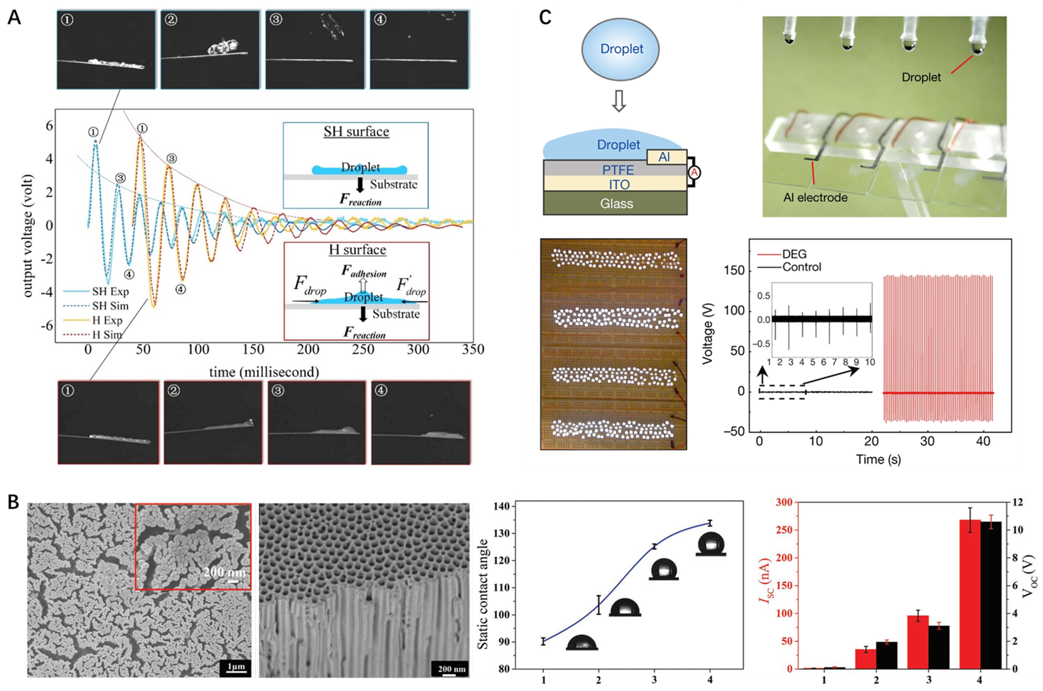
Figure 2. Design and Performance of Superwetting Interfaces which can Harvest Water Energy
(A) Electricity generation from raindrop using piezoelectric materials: better performance of SH (super-hydrophobic) surface compared with H (common hydrophobic) surface. Reproduced with permission from Hao et al.¹⁸ Copyright 2020, MDPI.
(B) Electricity generation from wave using triboelectric micro/nano-structured materials: improving the hydrophobicity can reduce water residual to increase electrical output. Reproduced with permission from Li et al.²¹ Copyright 2019, Wiley-VCH Verlag GmbH & Co. KGaA, Weinheim.
(C) A SLIPS PTFE/ITO-Al electrode which can harvest energy from raindrop, tap water, sea water: high and stable output that can light the bulbs. Reproduced with permission from Xu et al.²⁵ Copyright 2020, Springer Nature.

- Thermal Management
Thermal management is the ability to control temperature or thermodynamics (heat transfer). Water is deemed to be a good heat carrier as it has high specific heat capacity and high latent heat of vaporization. Therefore, employing superwetting surfaces in thermal-management (Table 2) has become a trend. Unexploited energy can be transformed into liquid kinetic energy. For example, the Leidenfrost effect can be used to move a droplet on an overheated surface, where its behavior is controllable via temperature, pressure, surface topography and wettability.³³
Condensation heat transfer is another important approach. Both drop-wise and film-wise condensation heat transfer are used. Super-hydrophilic interfaces promote the rapid formation of water films and film-wise condensation heat transfer, while super-hydrophobic interfaces generate drop-wise condensation transfer (Table 2).^{34,35} Latest studies concentrate on increasing the heat transfer efficiency by combining both types of surfaces (i.e., employing a Janus interface) and manipulating droplet behavior. Using the former approach, Lo et al. developed a 3D hybrid micro/nano-structured surface with a high heat transfer coefficient (up to 655 kW/m²) that overperforms single super-hydrophilic or super-hydrophobic surface (Figure 3A). ³⁶ Preston et al. demonstrated the effect of jumping droplets on enhanced condensation heat transfer.³⁷
Using pyroelectric materials, water behavior induced thermodynamics can be further utilized for electricity generation.³⁷ As superwetting interfaces develop rapidly, new opportunities for the generation of electricity using solar energy have captured attention in the last five years. Solar steam generation (or namely solar vapor generation) used to be primarily a technology for water purification.³⁸ Now the technology can be directly applied to the design of steam-electric power systems using pyroelectric materials (Figure 3B). Hence, we suggest that the word generation in this term can also refer to the generation of electricity.
Carbon nano-materials, e.g., carbon nanotube (CNT) and reduced graphene (rGO), are very useful in the conversion of solar energy due to their high specific surface area and solar/light absorption. Wang et al. developed a photothermal rGO-CNT based nano-composite for the solar-driven evaporation of water.³⁹ They found that hydrophilic micro/nano-structures can improve water spreading on the interfaces, contributing to a better evaporation performance (up to 65% efficiency, and 1.23 kg/m²/h rate under 1 sun irradiation) than other designs (usually 0.6~1.2 kg/m²/h rate under similar conditions). Mu et al. developed super-hydrophilic CNT aerogels with an even higher evaporation efficiency, i.e., up to 87% efficiency and 1.44 kg/m²/h under 1 sun irradiation.⁴⁰ They explained that super-hydrophilicity, rather than only hydrophilicity, had greater contribution to the rapid transport of water molecules (e.g., the duration of liquid impregnation process was reduced by at least 60%). In terms of further use of solar steam in electricity generation (Figure 3B), Zhang et al. have reviewed related technologies and summarized that water evaporation on carbon nano-materials can improve the output of PyNG.⁴¹ In addition, solar steam generation used to also be a technology for seawater desalination.^{42,43}
As shown in Table 2, some challenges remain on the development of heat transfer devices and PyNGs. As opposed to the PENGs and TENGs mentioned in section 2, the insufficient output of PyNGs is sometimes due to the poor performance of the functionalized materials themselves rather than the surface design. For example, in solar steam generation, high evaporation efficiency may fail to translate into a high electricity output due to the performance limitations of pyroelectric materials. Under such circumstances, further studies should focus on the development of functional materials with better pyroelectric effect compatible with steam/solar steam.
Table 2. Summary of superwetting interfaces for thermal management technologies.
Main usages | Superwetting system and materials feature | Advantages | Further directions | Ref.
Manipulating Leidenfrost droplet dynamics | - An overheat surface whose temperature is much higher than the boiling point of liquid (Leidenfrost temperature)  - Leidenfrost effect: a vapor layer caused by local boiling levitates the droplet | - Accurately controlled dynamic via multi-parameter  - No physical contact of surface with the Leidenfrost droplet | - Explore/extend practical usages of the droplet  - Enhance the duration of the Leidenfrost effect | ³³
Film-wise condensation heat transfer | - Super-hydrophilicity for water capture and fast spread to form a film | - More effective in capturing the condensate water molecule  - Low requirement for humidity | - Increase the coefficient  - Develop condensation on hybrid/Janus surface | ^{34,35}
Drop-wise condensation heat transfer | - Super-hydrophobicity to reduce the adhesion/friction to realize droplet fast transportation | - Easy to control drop coalescence  - Usually higher coefficient than the film-wise | - Develop condensation on hybrid/Janus surface  - Vary droplet behavior to improve performance | ³⁴⁻³⁷
Solar Steam Generation | - Usually carbon nano-materials (e.g., CNT, rGO) for high specific surface area and solar/light absorption  - Super-hydrophilicity to achieve rapidly spontaneous spreading for fast evaporation  - Pyroelectric materials for an additional electricity generation, designed as PyNG | - Utilizing natural energy  - High evaporation efficiency  - Can further realize generation of not only steam but also electricity | - Increase evaporation rate  - Store the steam/energy  - Increase the output of electricity generation | ³⁸⁻⁴³

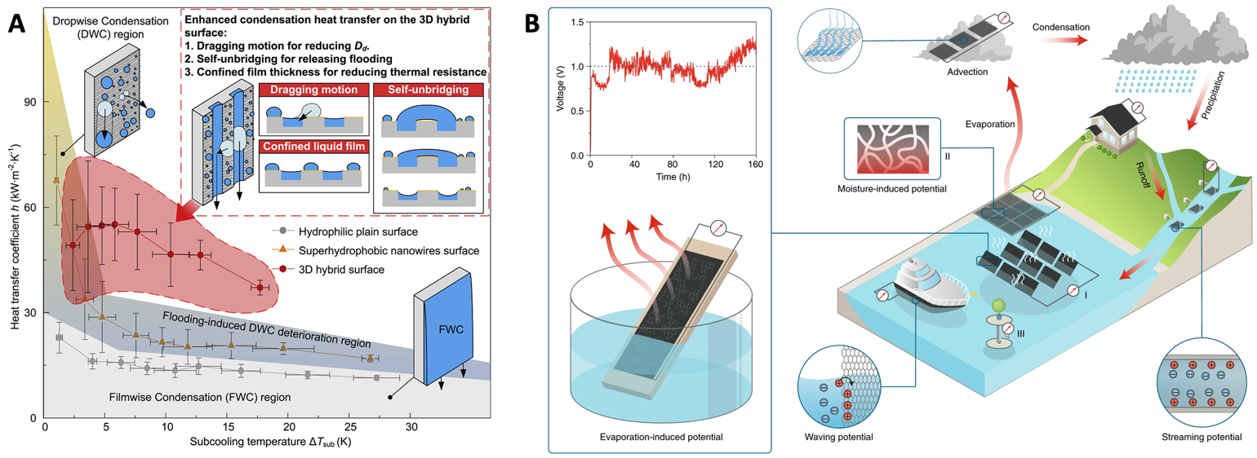
Figure 3. Superwetting systems for thermal-management technologies.
(A) A hybrid surface showing better condensed heat transfer. Reproduced with permission from Lo et al.³⁶ Copyright 2019, Elsevier BV.
(B) Solar steam generation: generation of not only steam but also electricity. Reproduced with permission from Zhang et al.⁴¹ Copyright 2018, Springer Nature.

- Quantum-confined Superfluid & Bio-inspired membrane with smart ion channels
4.1 Quantum-confined superfluid (QSF)
Special wettability in nanochannel surfaces also plays a vital role in driving the development of superwetting surfaces for energy storage and conversion, especially for the promotion of ultrafast mass transfer behavior with low energy consumption.¹⁴ Researchers have introduced the concept of “quantum-confined superfluids” (QSF) which is used to describe enthalpy-driven confined ordered fluids with the high flux, ultrafast transfer rate and low energy loss observed in biological nanochannels.⁴⁴ Although QSF were recently proposed, the earliest artificial molecular/atomic superfluid can be traced back to the 1930s. Kapitsa and Allen observed that when at temperatures lower than 2.17 K, fluid ⁴He has no kinetic energy loss during flow (near zero viscosity), and its speed through capillary tubes of different diameters would increase rapidly as the channel diameter decreases.⁴⁵ Allen further pointed out that when the diameter of the capillary is less than 100 nm, the velocity of ⁴He only depends on the environment temperature rather than pressure or channel length (Figure 4A).^{45,46} This kind of quantum-confined molecule superfluid can be achieved when the channel size is equal to the van der Waals equilibrium distance ($r_{0}$) between molecules.
When the size of the channel is close to the Debye length of the ion ($λ_{D}$), quantum-confined ion superfluids can be found in biological and artificial channels. A typical biological example is the electric eel. Their electric cells can generate a high potential of ~600 V and a current density of ~500 A/m² within 20 ms (Figure 4B). This is mainly because the ions in the electric cell can be efficiently and quickly transmitted through the Na⁺ and K⁺ channels on the cell surface in the form of a superfluid.^{13,47} On the other hand, the electric eel does not burn itself due to the high current density in this process, indicating that its channel resistance is very small, so the corresponding energy consumption is also very low.⁴⁷ An artificial system with ultra-fast ion transmission can be found in metal organic framework (MOF) channels. As shown in Figure 4C, a porous ZIF-8 [Zn(2-methylimidazolate)₂] membrane (~0.34 nm) with sub-nano ion-conducting pore structure could exhibit a high ion selectivity (LiCl/RbCl≈4.6) and an ultra-fast ion transmission rate (10⁶-10⁸ ions/s).⁴⁸ According to ion theory, in the liquid phase, transport of counter- and co-ions through microchannels is controlled by disordered entropy-driven ion diffusion.⁴⁹ However, if the channel diameter is reduced to about twice of the Debye length ($λ_{D}$), there will only be relatively ordered counter-ions in the channel, without co-ions.⁵⁰ If the channel diameter is further reduced to the Debye length ($λ_{D}$), the counter-ions in the channel would form of ordered chains, and can achieve ultra-fast transmission driven by enthalpy without energy loss.⁴⁶ Therefore, whether in biological or artificial channels, quantum-confined ion superfluids show the unique characteristics of high flux and low energy consumption.
The development of quantum-confined ion superfluids has played an increasingly important role in the field of energy conversion. A typical usage of superfluids is in lithium batteries, whose electrode interfaces are super-lyophilic to the electrolyte. During the charging and discharging process of lithium batteries, the redox reaction of lithium in the two-dimensional confined layered structure has the characteristics of superdense ordering and superfluidity, which generates high energy density and fast charge/discharge. Kühne et al. proved that the reversible ultradense ordering of lithium between the two graphene sheets in a lithium battery is the source of the high storage capacity of lithium battery through in-situ transmission electron microscopy (TEM) and density functional theory (DFT) calculations (Figure 4D).⁵¹ Moreover, during charging or discharging, the transmission of lithium ions in the two-dimensional confined channel with the Debye length ($λ_{D}$) of lithium ions occurs in the form of superfluid. The QSF ion transmission in this two-dimensional confined channel is the key factor to the rapid charge/discharge process of lithium batteries, which is significantly better than the charge/discharge process based on ion diffusion, thus ensuring high efficiency (Figure 4E). Based on this principle, related electrode materials that achieve low energy consumption and ultra-fast transmission of lithium ions through two-dimensional channels structure have also been developed. The specific properties are shown in Table 3. These findings suggest that high energy conversion efficiency can be achieved through the combination of superwetting interfaces with directional ion flow power generation (i.e. salinity gradient energy harvesting) by controlling the diameter of ion channels and forming high-flux and low-energy loss ionic superfluids.
Table 3. Anodes & cathodes with excellent performance due to the unique 2D channel structure
Type | Materials/structure feature | Advantages | Ref.
Anode  Materials | Layered rGO film with nanoscale gaps | - high capacity (∼3390 mA h g⁻¹);  - low overpotential (∼80 mV at 3 mA cm⁻²);  - exhibits a flat voltage profile in a carbonate electrolyte. | ⁵²
 | MoS₂ nanoparticles with an expanded atomic lamellar structure | - a maximum power density of 5.3 kW kg⁻¹, with 6 W h kg⁻¹ energy density;  - a maximum energy density of 37 W h kg⁻¹, with 74 W kg⁻¹ power density. | ⁵³
 | TiO₂–B nanowires with a length of several hundred nanometers and a width of approximately 10 nm | - excellent electron/ion transport properties and reaction kinetics in lithium intercalation  - extraordinary rate performance | ⁵⁴
Cathode Materials | LiMn₂O₄ nanochain with beads of 100 nm | - increased Li ion transport rate | ⁵⁵
 | LiFePO₄ nanoparticles wrapped with a N, S-co-doped graphene composite | - ultrahigh rate performance and long-life  - increased Li ion transport rate | ⁵⁶
 | Nanocrystalline LiCoO₂ | - high-rate Li-ion intercalation | ⁵⁷

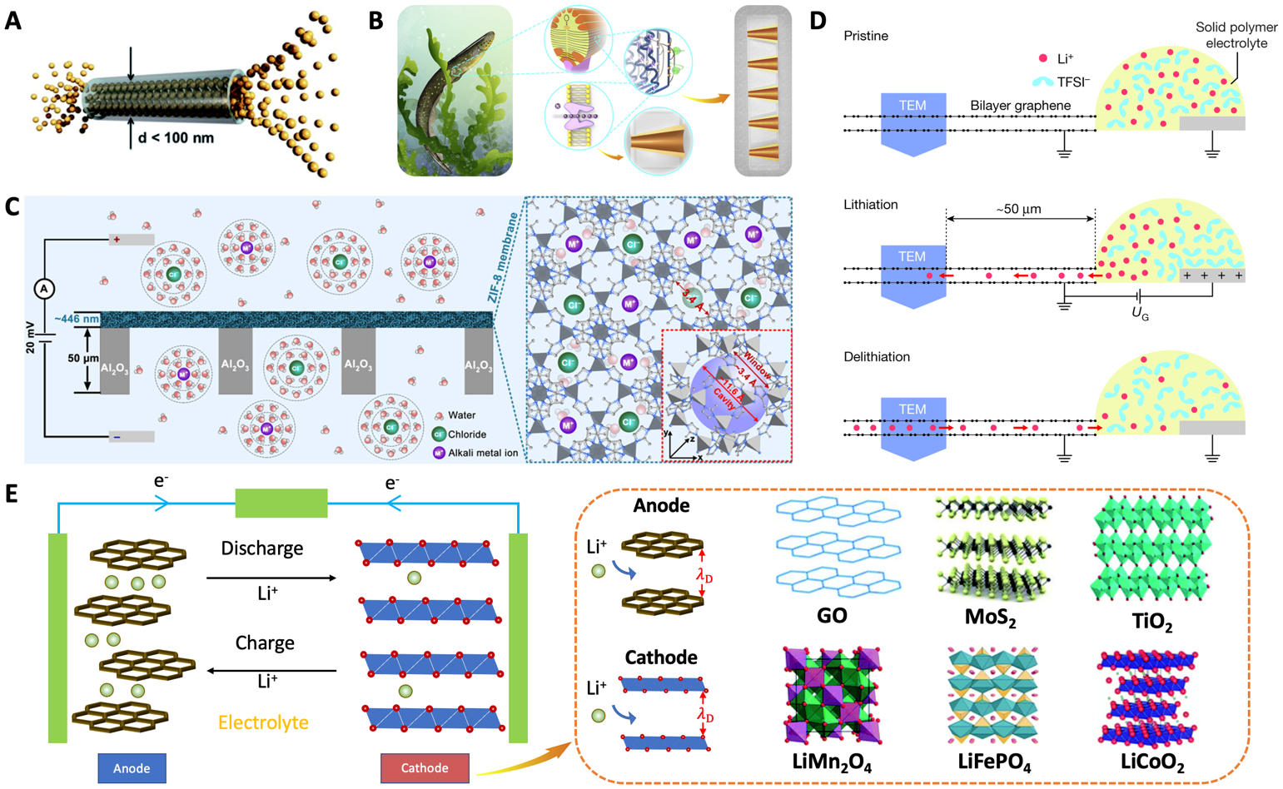
Figure 4. Quantum-confined Ion Superfluid and its Application in the Field of Energy Conversion
(A) Schematic representation of ⁴He superfluid transport across a channel with a diameter less than 100 nm, indicating highly ordered ⁴He molecules stacking and transport. Reproduced with permission from Hao et al.⁴⁶ Copyright 2020, The Royal Society of Chemistry.
(B) Potassium channels embedded in electrocytes have an asymmetric structure. Reproduced with permission from Zhou et al.¹³ Copyright 2020, Elsevier BV.
(C) MOFs with subnanometer pores as an artificial K⁺ channel for ultrafast transport of alkali metal ions with high selectivity. Reproduced with permission from Zhang et al.⁴⁸ Copyright 2018, Science.
(D) Schematic side view of the device during in situ TEM: top panel, the pristine device; middle and bottom panels, the device during lithiation (UG = 5 V at the counter electrode) and delithiation (UG = 0 V), respectively. Reproduced with permission from Kühne et al.⁵¹ Copyright 2018, Springer Nature.
(E) 2D layered structure anode and cathode materials. Reproduced with permission from Hao et al.⁴⁶ Copyright 2020, The Royal Society of Chemistry.

  - Bio-inspired membrane with smart ion channels for salinity gradient energy harvesting

Salinity gradients (blue energy) are a renewable energy source that exists in abundance at the interface between oceans and rivers.¹³ In recent years, researchers have converted salinity gradient energy into electrical energy through reverse electrodialysis (RED). Where two solutions with different salinity are connected by a selective ion permeation membrane, a net current is generated by the membrane which only allows ions with an oppositely charged polarity to pass (Figure 5A). The key structure is the ion channel on the membrane surface.⁵⁸ For ion channels with a symmetrical structure, the counter-ion will be enriched on the side of the dilute solution during the energy conversion process, which would inhibit effective transmission for co-ions, thereby reducing the efficiency. However, researchers have found that electric eels are not affected by this limitation during the electric shock. Further studies have shown that this is mainly caused by the asymmetric structure of the potassium ion channels embedded in the electric eel cells, where the opposite charge on the membrane can effectively prevent the accumulation of counter-ions in the dilute solution near it. This kind of structure allows the potassium ion channels on the cell membrane to continuously and rapidly rectify K⁺ inward, thereby generating a high current (Figure 4B).⁴⁷
Based on the asymmetric structure of ion channels, heterogeneous membranes with unidirectional ion transport characteristics of various sizes and materials have been developed one after another (Figure 5B-F). For example, Gao et al. used mesoporous carbon (pore diameter ~7 nm, negatively charged) and macroporous alumina (pore diameter ~80 nm, positively charged) to construct macroporous heterogeneous membranes (Figure 5B). This mesoporous/macroporous membrane can achieve continuous ion rectification in a high concentration or saturated salt solution with a ratio of ca. 450, and when seawater is introduced into river water through the membrane, a power density of up to 3.46 W/m² can be achieved.⁵⁹ To overcome bottlenecks such as high resistance of ion selective membranes and undesirable ion selectivity, Zhang et al. used the phase separation of two block copolymers to prepare ultra-thin (~500 nm) ion selective Janus membranes, their power density is about 2.04 W/m² (Figure 5C).⁶⁰ In addition, Zhu et al. fabricated a Janus membrane with adjustable surface charge density and porosity by compounding two ionomers (Figure 5D).⁶¹ This membrane achieved ion rectification in a high salinity environment for the first time, which effectively overcomes the difficulty that the selectivity and conversion efficiency of the membrane would decrease with the increase of the salinity gradient. The generator based on this membrane achieved output power densities up to 2.66 W/m² (mixed sea water and river water), and reached 5.10 W/m² under 500 times of the salinity gradient (the salt lake flows into the river water).⁶¹ To reduce the cost of selective ion membranes, Wu et al. developed a technology for preparing low-cost RED ion exchange membranes using natural wood. An output voltage of up to 9.8 V could be achieved through simple modification for the hydroxyl groups on the cellulose chain of the wood film (Figure 5E).⁵⁸ For the sake of improving the interface transmission efficiency of selective ion membranes, Zhang et al. realized the conversion of high-performance osmotic energy by mixing a polyelectrolyte hydrogel and an aramid nanofiber membrane, in this case the power density reached 5.06 W/m² (Figure 5F).⁶²
Despite the recent remarkable achievements in the design of high-performance membranes for energy harvesting based on salinity gradients, there are still some challenges, particularly, in the development of nanoporous membranes for large-scale industrial applications. The performance of the energy generators is limited by the ion selectivity, permeability, energy conversion efficiency and output power density of the membrane. In this regard, possible areas of investigation include: i) the construction of nano-scale ion channels (close to Debye length ($λ_{D}$)) with a large surface charge density to enhance the ion selectivity of the membrane, ii) the fabrication of ultra-thin films (<1 μm) to increase the output power density by enhancing the permeability while ensuring the selectivity of the membrane, (iii) the construction of nanoporous membranes with an asymmetric structure to suppress excessive shielding of surface charges caused by counter ions, thereby improving energy conversion efficiency, (iv) the use of two-dimensional materials with high surface charge (BN, MoS₂, and GO) to enhance the ion selectivity and fluidity of the membrane, and increase the output power density.
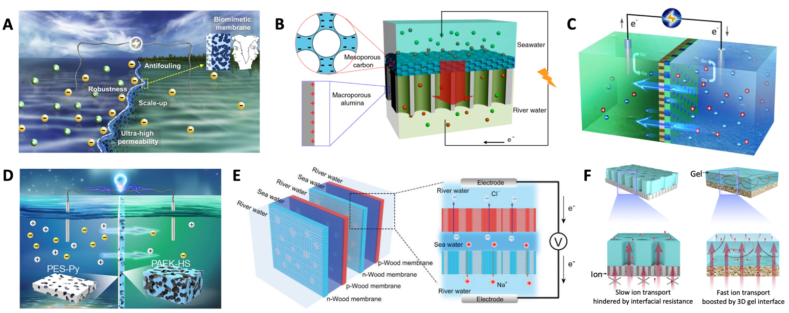
Figure 5.Bio-inspired Membrane with Smart Ion Channels for Salinity Gradient Energy Harvesting
(A) Schematic of ion selective exchange membrane with heterostructure. Reproduced with permission from Zhou et al.¹³ Copyright 2020, Elsevier BV.
(B) Mesoporous carbon (MesoC) and macroporous alumina (MacroA) heterogeneous ionic diode membrane for osmotic energy harvesting. Reproduced from Gao et al.⁵⁹ with permission. Copyright 2014, American Chemical Society.
(C) Ultrathin (~ 500 nm) and ion-selective Janus membrane with enhanced permeability. Reproduced from Zhang et al.⁶⁰ with permission. Copyright 2017, American Chemical Society.
(D) Janus membrane with asymmetrically rich charge density and unique ion rectification in hypersaline environment. Reproduced from Zhu et al.⁶¹ with permission. Copyright 2018, Science.
(E) Ion-selective wood membrane with high output voltage. Reproduced with permission from Wu et al.⁵⁸ Copyright 2020, Wiley-VCH Verlag GmbH & Co. KGaA, Weinheim.
(F) Three-dimensional hydrogel interface enhancing osmotic energy conversion. Reproduced from Zhang et al.⁶² with permission. Copyright 2020, Springer Nature.

- Conclusions and Outlooks
This perspective has evaluated systematically the progress in the use of superwetting interfaces in energy conversion, from the theory to the latest developments and practical applications. During the past few years, researchers have made great progress in converting the kinetic, thermal and chemical energy of liquids into electricity using superwetting surfaces. Generating electricity utilizing unexploited sources from nature remains an enticing idea. We have shown several examples such as harvesting mechanical energy from raindrops or ocean waves to the conversion of solar energy, or the generation of power utilizing salinity-gradients in seawater. However, there are still some challenges for practical application and room for new technologies (Figure 6).
Firstly, the challenge for most energy devices is to increase the output voltage or power density to the values required for practical usage. One barrier lies in the use of single super-hydrophobic or super-hydrophilic designs. Further studies should be carried out on interfaces with more complex micro/nano-structures and chemistry to further manipulate liquid dynamics. For example, many surfaces with wettability gradients (i.e., a Janus/anisotropic surface), or even stimuli-responsive switchable smart surfaces have been developed and have diverse applications; they could also be useful in energy conversion.⁶³
Secondly, the trade-off between selectivity and permeability of existing nanoporous membranes hinders their practical application. When the membrane is working under normal temperature and pressure, if the selectivity of the membrane is to be increased, its permeability tends to be decreased, and vice versa. However, biofilms can often achieve both high selectivity and high permeability at room temperature. For instance, the electric cells of an electric eel can transport 10⁹ ions within 20 ms.⁴⁷ Therefore, how to improve the efficiency and power density of the membrane by adjusting the structure and chemical composition of the ion channels to combine high selectivity and ultrafast permeability is a problem that researchers urgently need to solve.
Thirdly, the stability or long-term durability of the devices should be further investigated and improved. For example, the generators may contact corrosive raindrops, seawater, or steam. Superwetting interfaces which already have application in anti-corrosion could offer a solution.⁶⁴ As for the nanoporous membranes with ion channels, though the existing membranes have reached industrial output power density standards (5 W/m²), their energy output was unstable due to problems such as fouling and blockage of the channel.^{61,62} Besides, increasing the operation time leads to a reduction of the output energy and eventually to failure. To solve these problems, we need to further understand the functions of the ion channel structure and the mechanisms of ion transport in biofilms, so as to develop new nanoporous membranes that can reduce fouling. We suggest drawing inspiration from biological surfaces with low water friction or anti-fouling coatings to design anti-fouling nanoporous membranes.
Last but not least, new applications of superwetting in the energy field should be explored. Many superwetting interfaces can not only manipulate liquid droplets but also manipulate ice droplets or even control freezing.^{65,66} Combining the electrified materials mentioned in section 2 to harvest the mechanical energy of dynamic iced droplets (solidification form of water droplets), it is possible to generate electricity using ice. Combining the strategies of thermal management mentioned in section 3, heat transfer using ice or solar steam generation through sublimation of ice can be investigated. We suggest that energy conversion utilizing ice may become a promising and significant technology in the future as the iceberg is one of the commonest forms of water in nature. In addition, new multifunctional devices can be designed. For example, the uneven distribution of ions in organisms (section 4) can be used to generate a self-supply of energy in devices such as pacemakers. The same principle can be used to capture biological signals such as heart beats, body temperature, blood pressure, etc.
In summary, cooperation between scholars from different research fields, such as biology, chemistry, physics and materials science, is needed to achieve better performance and reduce the production cost of bio-inspired superwetting interfaces for energy conversion as it is required to reach large-scale application. We firmly believe that this is possible, and the progress of bio-inspired superwetting interfaces will promote the development of new smart, energy-harvesting devices.
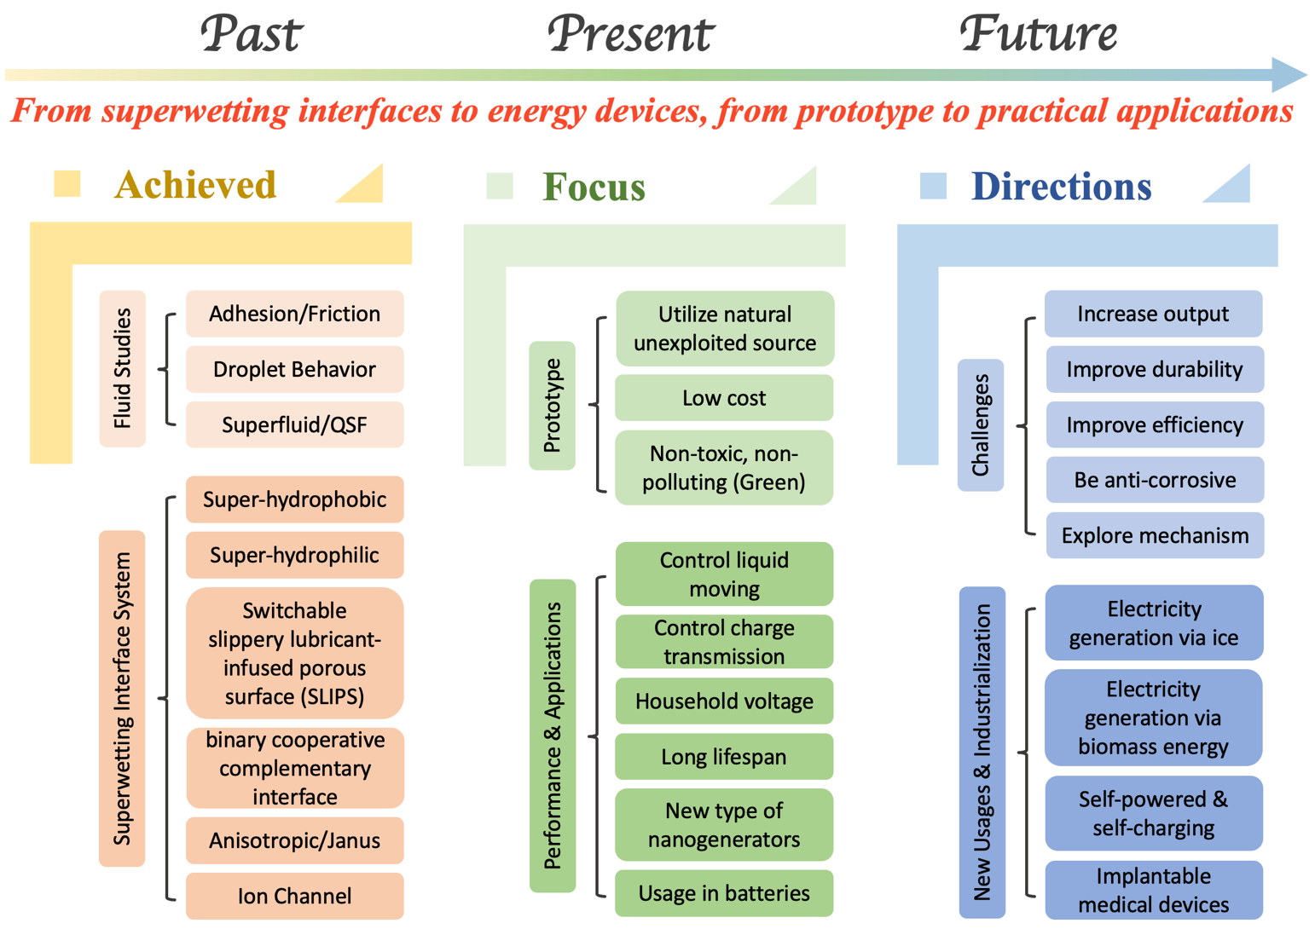
Figure 6. Roadmap of the Development for Energy Conversion Devices Based on Superwetting Interfaces, Past, Present and & Future.

Acknowledgments
This work was supported by the EPSRC Program Manufacture Using Advanced Powder Processes (MAPP)EP/P006566. Ming Li acknowledges financial assistance from Imperial College London and grants him the “President Scholarship”. Chang Li was supported by China Scholarship Council (No.202008060076). The strong support from the Aviation Industry Corporation of China (AVIC) Manufacturing Technology Institute (MTI) for this funded work is also much appreciated. Some parts of this work were performed at the AVIC Centre for Structural Design and Manufacture at Imperial College London. We are grateful to Prof. Lei Jiang (Technical Institute of Physics and Chemistry, Chinese Academy of Sciences) for his inspiration and assistance in this work.
Author contributions
Ming Li and Chang Li conceived, designed, and executed this project, they contribute equally to this work. Prof. Bamber R.K. Blackman and Prof. Eduardo Saiz guided and helped revise the content of article. All authors discussed the results and commented on the manuscript.

References:
1. Shen, P.-C., Su, C., Lin, Y., Chou, A.-S., Cheng, C.-C., Park, J.-H., Chiu, M.-H., Lu, A.-Y., Tang, H.-L., and Tavakoli, M.M. (2021). Ultralow contact resistance between semimetal and monolayer semiconductors. Nature 593, 211-217.
2. Li, J., Han, S., Li, H., Udeshi, N.D., Svinkina, T., Mani, D., Xu, C., Guajardo, R., Xie, Q., and Li, T. (2020). Cell-surface proteomic profiling in the fly brain uncovers wiring regulators. Cell 180, 373-386. e315.
3. Ge, P., Wang, S., Zhang, J., and Yang, B. (2020). Micro-/nanostructures meet anisotropic wetting: from preparation methods to applications. Materials Horizons 7, 2566-2595.
4. Liu, M., Wang, S., and Jiang, L. (2017). Nature-inspired superwettability systems. Nature Reviews Materials 2, 1-17.
5. Dai, H., Dong, Z., and Jiang, L. (2020). Directional liquid dynamics of interfaces with superwettability. Science Advances 6, eabb5528.
6. Fang, R., Liu, M., and Jiang, L. (2019). Progress of binary cooperative complementary interfacial nanomaterials. Nano Today 24, 48-80.
7. Li, C., Li, M., Ni, Z., Guan, Q., Blackman, B.R.K., and Saiz, E. (2021). Stimuli-responsive surfaces for switchable wettability and adhesion. Journal of The Royal Society Interface 18, 20210162. doi:10.1098/rsif.2021.0162.
8. Cheng, Q., Miao, Y., Wild, J., Min, W., and Yang, Y. (2021). Emerging applications of stimulated Raman scattering microscopy in materials science. Matter 4, 1460-1483.
9. Hu, H., Li, Q., Li, L., Teng, X., Feng, Z., Zhang, Y., Wu, M., and Qiu, J. (2020). Laser irradiation of electrode materials for energy storage and conversion. Matter 3, 95-126.
10. Wang, Y., Gao, S., Xu, W., and Wang, Z. (2020). Nanogenerators with superwetting surfaces for harvesting water/liquid energy. Advanced Functional Materials 30, 1908252.
11. Xu, W., and Wang, Z. (2020). Fusion of slippery interfaces and transistor-inspired architecture for water kinetic energy harvesting. Joule 4, 2527-2531.
12. Wang, L., Song, Y., Xu, W., Li, W., Jin, Y., Gao, S., Yang, S., Wu, C., Wang, S., and Wang, Z. (2021). Harvesting energy from high‐frequency impinging water droplets by a droplet‐based electricity generator. EcoMat.
13. Zhou, Y., and Jiang, L. (2020). Bioinspired Nanoporous Membrane for Salinity Gradient Energy Harvesting. Joule 4, 2244-2248.
14. Zhang, X., Liu, H., and Jiang, L. (2019). Wettability and applications of nanochannels. Advanced Materials 31, 1804508.
15. Hao, Y., Zhang, X., and Jiang, L. (2019). Quantum-confined superfluid. Nanoscale Horizons 4, 1029-1036.
16. Zhang, N., Gu, H., Lu, K., Ye, S., Xu, W., Zheng, H., Song, Y., Liu, C., Jiao, J., and Wang, Z. (2021). A universal single electrode droplet-based electricity generator (SE-DEG) for water kinetic energy harvesting. Nano Energy 82, 105735.
17. Wong, V.-K., Ho, J.-H., and Chai, A.-B. (2017). Performance of a piezoelectric energy harvester in actual rain. Energy 124, 364-371.
18. Hao, G., Dong, X., Li, Z., and Liu, X. (2020). Dynamic Response of PVDF Cantilever Due to Droplet Impact Using an Electromechanical Model. Sensors 20, 5764.
19. Yu, A., Zhu, Y., Wang, W., and Zhai, J. (2019). Progress in triboelectric materials: toward high performance and widespread applications. Advanced Functional Materials 29, 1900098.
20. Zaltariov, M.-F., Bele, A., Vasiliu, L., Gradinaru, L., Vornicu, N., Racles, C., and Cazacu, M. (2018). Assessment of chemicals released in the marine environment by dielectric elastomers useful as active elements in wave energy harvesters. Journal of hazardous materials 341, 390-403.
21. Li, X., Zhang, L., Feng, Y., Zhang, X., Wang, D., and Zhou, F. (2019). Solid–liquid triboelectrification control and antistatic materials design based on interface wettability control. Advanced Functional Materials 29, 1903587.
22. Farahani, E., and Mohammadpour, R. (2020). Fabrication of flexible self-powered humidity sensor based on super-hydrophilic titanium oxide nanotube arrays. Scientific Reports 10, 1-8.
23. Xu, W., Zhou, X., Hao, C., Zheng, H., Liu, Y., Yan, X., Yang, Z., Leung, M., Zeng, X.C., and Xu, R.X. (2019). SLIPS-TENG: robust triboelectric nanogenerator with optical and charge transparency using a slippery interface. National Science Review 6, 540-550.
24. Li, C., Liu, Y., Gao, C., Li, X., Xing, Y., and Zheng, Y. (2019). Fog harvesting of a bioinspired nanocone-decorated 3D fiber network. ACS applied materials & interfaces 11, 4507-4513.
25. Xu, W., Zheng, H., Liu, Y., Zhou, X., Zhang, C., Song, Y., Deng, X., Leung, M., Yang, Z., and Xu, R.X. (2020). A droplet-based electricity generator with high instantaneous power density. Nature 578, 392-396.
26. Luo, H., Lu, Y., Yin, S., Huang, S., Song, J., Chen, F., Chen, F., Carmalt, C.J., and Parkin, I.P. (2018). Robust platform for water harvesting and directional transport. Journal of Materials Chemistry A 6, 5635-5643.
27. Gurumukhi, Y., Chavan, S., Sett, S., Boyina, K., Ramesh, S., Sokalski, P., Fortelka, K., Lira, M., Park, D., and Chen, J.-Y. (2020). Dynamic Defrosting on Superhydrophobic and Biphilic Surfaces. Matter 3, 1178-1195.
28. Miljkovic, N., Preston, D.J., Enright, R., and Wang, E.N. (2014). Jumping-droplet electrostatic energy harvesting. Applied Physics Letters 105, 013111.
29. Gao, S., Hu, Z., Yuan, Z., and Wu, X. (2021). Flexible and efficient regulation of coalescence-induced droplet jumping on superhydrophobic surfaces with string. Applied Physics Letters 118, 191602.
30. Zhu, Y., Tso, C.Y., Ho, T.C., Leung, M.K., and Yao, S. (2021). Coalescence-Induced Jumping Droplets on Nanostructured Biphilic Surfaces with Contact Electrification Effects. ACS Applied Materials & Interfaces 13, 11470-11479.
31. Korkmaz, S., and KARİPER, İ.A. (2021). Pyroelectric nanogenerators (PyNGs) in converting thermal energy into electrical energy: Fundamentals and current status. Nano Energy, 105888.
32. Zhang, S., Bick, M., Xiao, X., Chen, G., Nashalian, A., and Chen, J. (2021). Leveraging triboelectric nanogenerators for bioengineering. Matter 4, 845-887.
33. Graeber, G., Regulagadda, K., Hodel, P., Küttel, C., Landolf, D., Schutzius, T.M., and Poulikakos, D. (2021). Leidenfrost droplet trampolining. Nature communications 12, 1-7.
34. Zhang, S., Huang, J., Chen, Z., Yang, S., and Lai, Y. (2019). Liquid mobility on superwettable surfaces for applications in energy and the environment. Journal of Materials Chemistry A 7, 38-63.
35. Edalatpour, M., Liu, L., Jacobi, A., Eid, K., and Sommers, A. (2018). Managing water on heat transfer surfaces: A critical review of techniques to modify surface wettability for applications with condensation or evaporation. Applied energy 222, 967-992.
36. Lo, C.-W., Chu, Y.-C., Yen, M.-H., and Lu, M.-C. (2019). Enhancing condensation heat transfer on three-dimensional hybrid surfaces. Joule 3, 2806-2823.
37. Preston, D.J., and Wang, E.N. (2018). Jumping droplets push the boundaries of condensation heat transfer. Joule 2, 205-207.
38. Song, L., Zhang, X.-F., Wang, Z., Zheng, T., and Yao, J. (2021). Fe3O4/polyvinyl alcohol decorated delignified wood evaporator for continuous solar steam generation. Desalination 507, 115024.
39. Wang, Y., Wang, C., Song, X., Megarajan, S.K., and Jiang, H. (2018). A facile nanocomposite strategy to fabricate a rGO–MWCNT photothermal layer for efficient water evaporation. Journal of Materials Chemistry A 6, 963-971.
40. Mu, P., Zhang, Z., Bai, W., He, J., Sun, H., Zhu, Z., Liang, W., and Li, A. (2019). Superwetting monolithic hollow‐carbon‐nanotubes aerogels with hierarchically nanoporous structure for efficient solar steam generation. Advanced Energy Materials 9, 1802158.
41. Zhang, Z., Li, X., Yin, J., Xu, Y., Fei, W., Xue, M., Wang, Q., Zhou, J., and Guo, W. (2018). Emerging hydrovoltaic technology. Nature nanotechnology 13, 1109-1119.
42. Li, T., Fang, Q., Lin, H., and Liu, F. (2019). Enhancing solar steam generation through manipulating the heterostructure of PVDF membranes with reduced reflection and conduction. Journal of Materials Chemistry A 7, 17505-17515.
43. Wang, S., Fan, Y., Wang, F., Su, Y., Zhou, X., Zhu, Z., Sun, H., Liang, W., and Li, A. (2021). Potentially scalable fabrication of salt-rejection evaporator based on electrogenerated polypyrrole-coated nickel foam for efficient solar steam generation. Desalination 505, 114982.
44. Liu, S., Zhang, X., and Jiang, L. (2019). 1D Nanoconfined Ordered‐Assembly Reaction. Advanced Materials Interfaces 6, 1900104.
45. Allen, J.F., and Misener, A. (1939). The properties of flow of liquid He ll. Proceedings of the Royal Society of London. Series A. Mathematical and Physical Sciences 172, 467-491.
46. Hao, Y., Pang, S., Zhang, X., and Jiang, L. (2020). Quantum-confined superfluid reactions. Chemical Science 11, 10035-10046.
47. Schroeder, T.B., Guha, A., Lamoureux, A., VanRenterghem, G., Sept, D., Shtein, M., Yang, J., and Mayer, M. (2017). An electric-eel-inspired soft power source from stacked hydrogels. Nature 552, 214-218.
48. Zhang, H., Hou, J., Hu, Y., Wang, P., Ou, R., Jiang, L., Liu, J.Z., Freeman, B.D., Hill, A.J., and Wang, H. (2018). Ultrafast selective transport of alkali metal ions in metal organic frameworks with subnanometer pores. Science advances 4, eaaq0066.
49. Schoch, R.B., Han, J., and Renaud, P. (2008). Transport phenomena in nanofluidics. Reviews of modern physics 80, 839.
50. Daiguji, H. (2010). Ion transport in nanofluidic channels. Chemical Society Reviews 39, 901-911.
51. Kühne, M., Börrnert, F., Fecher, S., Ghorbani-Asl, M., Biskupek, J., Samuelis, D., Krasheninnikov, A.V., Kaiser, U., and Smet, J.H. (2018). Reversible superdense ordering of lithium between two graphene sheets. Nature 564, 234-239.
52. Lin, D., Liu, Y., Liang, Z., Lee, H.-W., Sun, J., Wang, H., Yan, K., Xie, J., and Cui, Y. (2016). Layered reduced graphene oxide with nanoscale interlayer gaps as a stable host for lithium metal anodes. Nature nanotechnology 11, 626-632.
53. Cook, J.B., Kim, H.S., Lin, T.C., Lai, C.H., Dunn, B., and Tolbert, S.H. (2017). Pseudocapacitive Charge Storage in Thick Composite MoS2 Nanocrystal‐Based Electrodes. Advanced Energy Materials 7, 1601283.
54. Zhang, W., Zhang, Y., Yu, L., Wu, N.-L., Huang, H., and Wei, M. (2019). TiO 2-B nanowires via topological conversion with enhanced lithium-ion intercalation properties. Journal of Materials Chemistry A 7, 3842-3847.
55. Tang, W., Wang, X., Hou, Y., Li, L., Sun, H., Zhu, Y., Bai, Y., Wu, Y., Zhu, K., and Van Ree, T. (2012). Nano LiMn2O4 as cathode material of high rate capability for lithium ion batteries. Journal of Power Sources 198, 308-311.
56. An, C.-s., Zhang, B., Tang, L.-b., Xiao, B., and Zheng, J.-c. (2018). Ultrahigh rate and long-life nano-LiFePO4 cathode for Li-ion batteries. Electrochimica Acta 283, 385-392.
57. Okubo, M., Hosono, E., Kim, J., Enomoto, M., Kojima, N., Kudo, T., Zhou, H., and Honma, I. (2007). Nanosize effect on high-rate Li-ion intercalation in LiCoO2 electrode. Journal of the American chemical society 129, 7444-7452.
58. Wu, Q.Y., Wang, C., Wang, R., Chen, C., Gao, J., Dai, J., Liu, D., Lin, Z., and Hu, L. (2020). Salinity‐Gradient Power Generation with Ionized Wood Membranes. Advanced energy materials 10, 1902590.
59. Gao, J., Guo, W., Feng, D., Wang, H., Zhao, D., and Jiang, L. (2014). High-performance ionic diode membrane for salinity gradient power generation. Journal of the American Chemical Society 136, 12265-12272.
60. Zhang, Z., Sui, X., Li, P., Xie, G., Kong, X.-Y., Xiao, K., Gao, L., Wen, L., and Jiang, L. (2017). Ultrathin and ion-selective Janus membranes for high-performance osmotic energy conversion. Journal of the American Chemical Society 139, 8905-8914.
61. Zhu, X., Hao, J., Bao, B., Zhou, Y., Zhang, H., Pang, J., Jiang, Z., and Jiang, L. (2018). Unique ion rectification in hypersaline environment: A high-performance and sustainable power generator system. Science advances 4, eaau1665.
62. Zhang, Z., He, L., Zhu, C., Qian, Y., Wen, L., and Jiang, L. (2020). Improved osmotic energy conversion in heterogeneous membrane boosted by three-dimensional hydrogel interface. Nature communications 11, 1-8.
63. Li, X., Zhang, L., Feng, Y., Zheng, Y., Wu, Z., Zhang, X., Wang, N., Wang, D., and Zhou, F. (2021). Reversible Temperature‐Sensitive Liquid–Solid Triboelectrification with Polycaprolactone Material for Wetting Monitoring and Temperature Sensing. Advanced Functional Materials 31, 2010220.
64. Long, Y., Yin, X., Mu, P., Wang, Q., Hu, J., and Li, J. (2020). Slippery liquid-infused porous surface (SLIPS) with superior liquid repellency, anti-corrosion, anti-icing and intensified durability for protecting substrates. Chemical Engineering Journal 401, 126137.
65. Lv, J., Song, Y., Jiang, L., and Wang, J. (2014). Bio-inspired strategies for anti-icing. ACS nano 8, 3152-3169.
66. Villegas, M., Zhang, Y., Abu Jarad, N., Soleymani, L., and Didar, T.F. (2019). Liquid-infused surfaces: a review of theory, design, and applications. Acs Nano 13, 8517-8536.

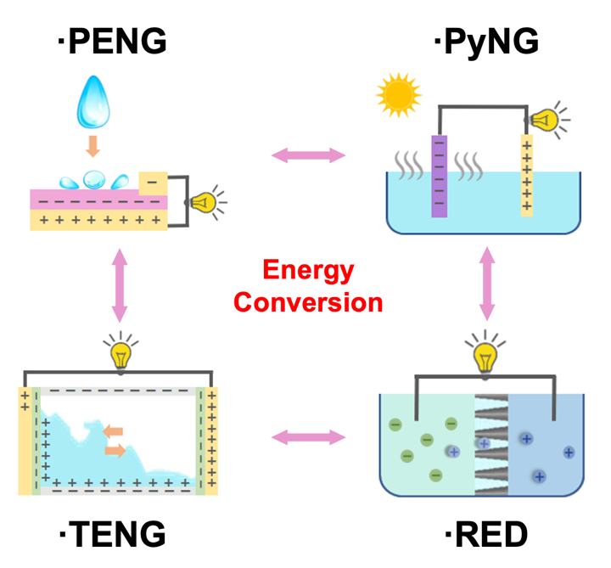
Graphical Abstract

