2021 Handbook of Disaster Risk Reduction for Resilience:

New Frameworks for Building Resilience to Disasters

**Background**

The United Nations (UN) System Chief Executives Board for Coordination, at the 2011 Spring Session, committed to mainstreaming disaster risk reduction in the programs and operations of the UN system through the development of a common agenda, to raise disaster risk reduction to the highest political support. United Nation Office for Disaster Risk Reduction (UNDRR) Strategic Framework (2016-2021) was guided by supporting countries and societies in its implementation, monitoring and review of progress; the prevention of new and reduction of existing disaster risk and strengthening resilience through successful multi-hazard disaster risk management.

Chapter 14

Disaster Risk Management a Resilient Health System

Myles Harris *Institute for Risk and Disaster Reduction, University College London*

Gina Charnley *Department of Infectious Disease Epidemiology, Imperial College London and Institute for Risk and Disaster Reduction, University College London*

**Contents**

Chapter aims 1

Abstract 2

Introduction 2

Issues in creating resilient health systems 4

What does a resilient health system look like? 7

Case Study 1 - Chernobyl Health Disaster 9

Case study 2 - Democratic Republic of Congo: Health systems, Conflict and Ebola 15

Health Systems Resilience Priorities: Sendai Framework 2015-2030 Mapping 20

Conclusion 23

References 24

Chapter aims

1. Define health resilience for disaster risk management
2. Explore disaster risk management health resilience contextually
3. Identify health resilience priorities for disaster risk management.

Abstract

Defining disasters and their impacts have several difficulties and limitations due to the complexity of the term. In this chapter, we focus on health disasters, including how disasters impact health systems and how widespread health emergencies can create disasters. A health disaster describes an event that has a direct or indirect negative impact on people’s physical and psychological health. Disasters of all kinds are most impactful to vulnerable groups both in developed and developing countries and it is important to implement effective disaster risk management to facilitate health systems resilience, mobilising them to resist, withstand and recover from disasters. Barriers and ways in which health systems are resilient are multi-faceted, some of which include; financing, human resources, management, infrastructure, access, trust and education. Two case studies illustrate how these barriers have played out in real-world contexts and historical lessons learnt. These including the Chernobyl nuclear and health disaster of 1986 and the 2018 Ebola outbreak in the Democratic Republic of Congo. This chapter identifies four priorities for action; understand risk, strengthen governance, invest in resilience and enhance preparedness and considers these on all levels from international to individual. Hazards themselves will not cause health disasters but instead how society reacts and the barriers to resilience. By moving health system resilience to the forefront of legislation and governance, disasters can be mitigated and promote sustainable development throughout the world.

Introduction

In his book, ‘Disasters by Choice,’ Professor Ilan Kelman defines disaster as an event which results in people declaring that they require additional help and support (Kelman, 2020). This definition can be applied to many disasters and is inclusive of different disaster severities. The COVID-19 pandemic beginning in 2019 is an example of a disaster which required an international effort to control the spread of a disease and support people at risk (Bedford et al., 2020). The Chernobyl disaster in 1986 is another example of a disaster which resulted in detrimental physical and mental health impacts in a smaller geographical area (this is explored in a case study within this chapter) (Bromet and Havenaar, 2007). In both examples, people required outside help and there was a declaration of disaster, thus Kelman’s definition is applicable. Having said this, there are limits to Kelman’s definition. The self-declaration of a disaster by local authorities or governments may expose people to disaster capitalism, driven by political sensitivity or opportunism (Patterson and Veenstra, 2016). There are many alternative definitions of disaster and Quarantelli (2005) argues there is a distinct lack of consensus. Some literature suggests there are two paradigms to disaster, rather than an overall definition. Firstly, the impacts of disasters are social phenomena and, secondly, disasters are embedded within societal systems (Quarantelli, 2005). In other words, the cause of disasters are not disasters themselves; disasters are the impact on people and societies. The two disaster paradigms correlate with the advocation that there are no such concepts as natural disasters - there are natural hazards that are caused by vulnerabilities. The complexity of defining disasters is a reflection of how convoluted disasters are and the many different categories that exist (Perry, 2007).

This chapter focuses on health disasters. Health disasters can be described as an event that has a direct or indirect negative impact on people’s physical or psychological health (Chan and Shaw, 2020). Disasters are complex and can have cascading effects (Davis and Alexander, 2016). In other words, any disaster can negatively impact health systems at the start of the disaster or at subsequent time. Health systems are services in a country, region or local community which meet the health and social care needs of the population. The availability and comprehensiveness of a health system is dependent on the wealth and inequalities of the country (Sun, 2020). Furthermore, health systems relate to two of the United Nations (UN) sustainable development goals - number 3, good health and well-being; and number 10, reduction in inequalities (United Nations, 2019a). However, all health systems are susceptible to damage caused by disaster. Some examples of impact are logistical limitations, damage to infrastructure or reduced availability of medicines (Sun, 2020). The majority of disasters, therefore, are a risk to health systems. On the other hand, there are many cases of health disasters, including the Swine Flu pandemic in 2009, Ebola outbreak in 2014 and Zika virus in 2015.

Health disasters (and all other disasters) disproportionately affect people in vulnerable groups in developed and developing countries (Chan et al., 2020). People living in developing countries have reduced access to robust health systems and, furthermore, the health systems are limited in resources, capacity and capability (Hanefeld et al., 2018). With this in mind, it is evident that the impact of disasters in developing countries is widespread, effects many people and communities. In developed countries, there is an unequal impact from a health disaster on the population, as people who have low socio-economic backgrounds are disadvantaged in comparison to those with more wealth. However, the available data about the impact of health disasters is dependent on reporting. Robust reporting of health disasters and their impacts is not always possible due to limited resources or political influence (Britton, 2007). The limited reliability of reporting suggests the true impact of health disasters is much worse than previously thought.

Disaster risk reduction is a phrase used in disaster research and management to describe strategies that are developed to reduce the likelihood of a hazard causing disasters (Samuel et al., 2019). In relation to health, disaster risk reduction aims to promote the wellbeing of people, protect mental and physical health, and contribute to sustainable development (James et al., 2019). Reducing the risk of health disaster can be achieved by implementing policy, using frameworks or guidelines and establishing strategies. Implementing initiatives to reduce the risk of disaster is known as disaster risk management - to manage hazards, exposure and vulnerability of disaster, thus strengthen resilience. Health disaster risk management aims to improve the resilience of health systems, or, in other words, the ability of health systems to resist, withstand and recover from a disaster (Aitsi-Selmi and Murray, 2015). Health disasters or disasters leading to health disaster can cause substantial damage to health systems, hence disaster risk management is required to mitigate this risk.

There are historical examples of disaster risk management guidelines. The Hyogo Framework for Action 2005-2015 (The Hyogo Framework) was an international strategy for reducing the risk of all categories of disasters. The overall aim was to strengthen resilience of countries and communities to disasters (United Nations Office for Disaster Risk Reduction, 2007). In The Hyogo Framework, concern is raised over the impact disasters have on the global population, particularly for people in vulnerable groups and low socio-economic backgrounds. The Hyogo Framework was one of the first international efforts to mitigate disaster risks, but it lacked focus on health disasters, for developing and developed countries. However, in 2015 The Sendai Framework for Disaster Risk Reduction 2015-2030 (The Sendai Framework) was published, which is the current UN endorsed strategy for reducing the risk of disasters internationally (United Nations Office for Disaster Risk Reduction, 2015).

The Sendai Framework was established following the UN third world conference, after three years of stakeholder and governmental collaboration, facilitated by the UN Office for Disaster Risk Reduction. In summary, The Sendai Framework is a movement from disaster management to focusing on disaster risk management (United Nations Office for Disaster Risk Reduction, 2015). There are multiple objectives set out to achieve this aim, foremost to no longer expect disaster to be inevitable. The creation of seven global targets to the prevent new risk, reducing existing risk and enhance resilience are objectives to proactively manage the impact of disasters. There is an emphasis on disaster risk management to strengthen the resilience of health systems, hence an objective of this chapter is to establish an evidence-based approach of disaster risk management for resilient health systems. The chapter compliments The Sendai Framework, focusing on resilient health systems, and will explore answers to the following questions:

1. What are the current barriers to achieving health system resilience?
2. What elements contribute to a resilient health system?
3. What can be learnt from contextual case studies?
4. What are the health resilient priorities for disaster risk management?

In the next section of the chapter, what constitutes a resilient health system will be discussed in more detail.

Barriers for creating resilient health systems

Resilient health systems are able to effectively prepare for, withstand the stress of and respond to the public health consequences of disasters. They can protect themselves and human lives from the impacts of disasters and produce good health outcomes both in good times and bad, an idea known as the *resilience dividend* (Olu, 2017)*.* For example, health issues in New Orleans after Hurricane Katrina were highly attributable to poor health care coverage of large portions of the population, an issue present well before the hurricane made landfall in August 2005 (Rudowitz et al., 2006). Resilient health systems are not a static construct and are highly productive and adaptive long before a disaster occurs (Kruk et al., 2015). Unfortunately, many countries do not have such systems in place, often for a variety of complex reasons. Issues with resilience are not limited to developing nations, with many countries across the globe falling short of system resilience, despite high gross domestic product (GDP) and economic resources. The fabric of health systems are highly politicised in many countries and often highlight both contemporary and historical social tensions. Due to these complexities, reasons for poor health system resilience are multi-faceted.

Health systems need to be resilient to a variety of disasters, some of which may strike simultaneously. The barriers for health system resilience have been grouped into seven main clusters, with several elements in **Table 1**. This is an illustrative list of common themes that appear throughout disaster and public health literature. Several individual elements also link with other clusters and have the potential to form cascades. They are also not considered a static construct and are likely to change over time as health system adapt, improve and are faced with new challenges.

|  |  |  |
| --- | --- | --- |
| **Table 1 - Health system resiliency issues** | | **Source** |
| **Financing & expenditure** | Poor health expenditure | WHO, 2015 |
| Multi-donor & multi-distribution leads to fracturing | WHO, 2015 |
| Disproportional management costs | WHO, 2015 |
| No context-specific cost comparisons or benchmarks | Kruk et al., 2017; WHO, 2015 |
| Not self-sustaining eg. require extensive external assistance | McKenzie et al., 2015 |
| Poor financial incentives to offer good services | Soeters et al., 2011 |
| **Human resources & capacity** | Little incentive to become a healthcare professional | WHO, 2015 |
| Education not meeting demand | WHO, 2015 |
| Ineffective workforce development/advancement | WHO, 2015 |
| **Management & governance** | Waste, duplication and ineffective services | WHO, 2015 |
| Lack of accountability | WHO, 2015 |
| Healthcare must compete with other programmes for funding and visibility | Dar et al., 2014; Martineau, 2016 |
| Lack of transparency | WHO, 2017 |
| Lack of communication between management/workforce towards a shared goal | WHO, 2017 |
| Workforce lack clear roles and responsibilities | WHO, 2017 |
| Legislation that is not measurable or unable to assess strengths and weaknesses | Kruk et al., 2017; Olu et al., 2016 |
| Lack of international support and agreements | Kruk et al., 2017 |
| Weak district healthcare makes them vulnerable to collapse and bypassing | Porignon et al., 1998 |
| Lack of flexibility and adaptability | Dar et al., 2014; Kruk et al., 2015 |
| **Supply chains, infrastructure & resources** | Lack of quality control | WHO, 2015 |
| Insufficient stockpiling | Kruk et al., 2015 |
| Poor technical assistance | McKenzie et al., 2015 |
| Healthcare facilities not being perceived as safe | Herp et al., 2003; Murray et al., 2015 |
| Poor water, gas, energy supply | Norazam, 2018 |
| Poor site selection | Norazam, 2018 |
| **Communication & information management** | Poor surveillance and understand of population risks | Kruk et al., 2017; WHO, 2015 |
| Not multi-sectoral or multi-disciplinary | WHO, 2015 |
| Lack of communication between regional, national and International levels | WHO, 2015 |
| No centralised data management system | Kruk et al., 2015; WHO, 2015 |
| Inability to disseminate information quickly | Okwuchukwu et al., 2016 |
| No multi-provider platforms to allow for collaboration and shared agenda setting | WHO, 2017 |
| **Healthcare access** | Poor everyday healthcare programmes eg. Obstetric and sexual health, vaccination, mental health services | Kruk et al., 2015 |
| Not accessible or cover a wide area | Admasu, 2016 |
| Discriminatory/barriers to health coverage | Kieny and Dovlo, 2015; Kutzin et al., 2016 |
| Inability to access care without fear of impoverishment | Kutzin et al., 2016 |
| **Community trust & education** | Not integrating people into healthcare systems, instead just seeing them as recipients of care | Kruk et al., 2015 |
| Mistrust due to poor dialogue and relationship building between healthcare providers and communities | Kieny and Dovlo, 2015; WHO, 2017 |
| Not tailoring systems to community needs | Admasu, 2016; Kieny and Dovlo, 2015; Martineau, 2016; Olu et al., 2016; Porignon et al., 1998 |
| Poor health education | Admasu, 2016 |
| Inability to reduce spread of misinformation | Sharma et al., 2017; Vinck et al., 2019 |
| Poor understanding of social determinants of health and vulnerable groups | Olu, 2017 |
| Not considering local culture and values | WHO, 2017 |

This section of the chapter presents some of the issues that prevent or hinder the creation of resilient health systems for disaster risk management. Improving the resilience of health systems is complex and requires long-term, strategic investment in thought and finance. The next section of the chapter aims to clarify how some of these issues may and are being addressed.

What does a resilient health system look like?

Gaining a clear understanding of the issues is an important first step in identifying solutions. The main clusters identified from the literature illustrate key areas of improvement; the salient points are shown below:

* *Financing and expenditure* - Multi-donor but single distribution systems that are self-sustaining, to improve longevity and stability (McKenzie et al*.*, 2015). These need to be implemented through novel and innovative systems, that encourage good performance for healthcare providers (Soeters et al*.*, 2011).
* *Human resource* - Strong, compassionate and committed workforce, through effective management and professional development (Kruk et al., 2015). Making the health care profession an attractive option for individuals, providing good pay, sufficient personal protective equipment and adequate benefits (Robertson et al.*,* 2016).
* *Management and governance* - Starting with a strong and fair political system, building social and economic resilience (Allenby and Fink, 2005), through political will and unwavering commitment (Admasu, 2016; Olu et al., 2016). Strong governance needs little andno fragmentation, running efficiently on both the national and regional levels, with clear roles, responsibilities and targets (Olu et al*.*, 2016).
* *Supply chains, infrastructure and resources* - Functional infrastructure need to be in place, retrofitted as needed, where communities feel safe using them (Herp et al., 2003; Norazam, 2018). A strong scientific community, driven by science-based solutions is needed to inform health providers with the correct technician assistance, stockpile of resources and sufficient time (McKenzie et al., 2015; Murray et al., 2015).
* *Communication* - Good national surveillance to understand population risks and identify issues quickly via benchmarks that account for local contexts. Information can then be discussed at meetings where all healthcare providers can be heard and share agendas (Kruk et al., 2017).
* *Healthcare access* - Good range of basic services for both communicable and non-communicable diseases, along with vaccination campaigns and strong family planning services. Where state-paid healthcare is not possible, prices are fair, with open communication between providers and recipients to negotiate price (Admasu, 2016; Kutzin and Sparkes, 2016).
* *Trust & education* - Bottom-up healthcare approaches that are built on a relationship with communities, respecting local values, needs and culture. Populations are strong actors in their own care, with a good understand of how to protect their health and support their families (Admasu, 2016; Olu et al.*,* 2016).

Disaster risk management also needs to be incorporated into healthcare legislations, to make sure the whole system is prepared and understands the risks during disasters. When crises do strike, systems need to be highly proactive and functioning long before and be able to quickly adapt (Olu, 2017), to reduce the likelihood of the hazard causing disaster. As aforementioned, health disaster risk management aims to promote wellbeing, protect physical and mental health and contribute to sustainable development (James et al., 2019). In order to achieve this a good understanding of vulnerable groups and the broad range of post-disaster issues is needed, from enhanced psychological problems to post-disaster violence (Fukuma et al., 2017; Kruk et al*.*, 2017). If systems do fall short, the disaster should be a catalysts of change to improve systems (Olu et al., 2016), to prevent similar damage to the health system in the future and mitigate against known risks.

At this point in the chapter, there has been an appraisal of what constitutes a resilient health system for disaster risk management and the potential barriers to resilience. The introduction highlighted each heath disaster is unique and forced comparison often does not accurately inform disaster risk reduction. The next section of the chapter will critically discuss two case studies, which will exemplify different perspectives of health system resilience for disaster risk management.

Case Study 1 - Chernobyl Health Disaster

**What happened during the Chernobyl incident?**

The Chernobyl disaster in 1986 has been described as the most devastating civilian nuclear incident is history, which required an international collaboration to manage the disaster (United Nations Scientific Committee, 2008). The long-term impacts of this disaster are still being researched, in particularly the affect on the environment, economy and society (Ostroumova,Schüz and Kesminiene, 2020; Jaworowski, 2010). Although Chernobyl was a nuclear disaster, it catalysed a health disaster for the local people of Ukrainian Union of Soviet Socialist Republic (USSR) and across Europe (Nussbaum, 2007). This case study will focus on the Chernobyl health disaster and critique the evidence of disaster risk management and health system resilience.

There are different types of nuclear power plants. One of the debated causes of the Chernobyl disaster is a fault with the design of the reactor, although human error is labelled as another influencing factor contributing to the incident (Stang, 1996). The type of nuclear power plant at Chernobyl generated 6% of the total energy output from residual heat, which continues to emit power after the chain reaction of the nuclear agent has stopped. As a result, a cooling agent must be used to control the temperature of the reactors; at Chernobyl, water is pumped from a reservoir underneath the reactor. One risk to Chernobyl’s nuclear reactors was if there is a power outage, water (the cooling agent) must still be pumped to the reactor to control the temperature. Three generators were in place to provide the energy required to pump the water to the reactors in the event of a power outage. However, the generators took up to 1 minute and 15 seconds to reach full output, thus the nuclear reactors would have uncontrolled temperature increase for too long. One hypothesis being tested in the 1970s and 1980s was residual nuclear power could be used as an interim power source to pump the water during the time it took the back-up generators to reach full capacity (ApSimon, Macdonald and Wilson 1986). In 1986, Chernobyl’s nuclear reactor Number 4 (No4) was to be the fourth test site to determine if this hypothesis was correct; all previous tests at different sites in USSR had failed.

To test this hypothesis, power to the nuclear plant needed to be gradually reduced and the back-up generators needed to be temporarily disabled to allow the residual nuclear power to be channeled to the emergency cooling system. A series of influencing factors caused two explosions at No4 reactor, causing the plant to be set on fire and expose the nuclear reactor core. Large quantities of nuclear material were emitted and spread across the continent by wind. The raging fire posed a secondary risk of a third, larger explosion of the water reservoir as pressure built up inside. This explosion could have catapulted substantially more radioactive material out of the reactor, but thanks to the work of local fire service the third explosion was averted. At this point in time, Chernobyl was the epicentre of a nuclear disaster. However, the radioactive mass bled into the atmosphere and into the homes of people living in neighbouring Pripyat. Initially, people were not evacuated. Some concern was raised, as the two explosions had woken some people and news quickly spread of a fire at the nuclear power plant. Many people soon developed Acute Radiation Sickness (ARS), thus Chernobyl’s health disaster began.

**How is the Chernobyl incident a health disaster?**

The International Nuclear and Radiological Event Scale (INES) is a standardised measure of how serious nuclear incidents are (International Atomic Energy Agency, 2019). INES has seven levels and each increase in level represents an impact increase of times ten; the Chernobyl disaster was graded the maximum, 7/7. Chernobyl is described as the worst nuclear event in history, which caused significant impact on the environment and people’s health. Early reports focused on identifying immediate lessons learnt and the short-term consequences of radiation exposure. The UN Scientific Committee on the Effects of Atomic Radiation (SCEAR) report in the year 2000 collated the early findings, which included the impact on emergency worker’s health, how monitoring systems can be introduced and potential long-term co-morbidities. There was consensus of all UN member states of the findings; however, the public of USSR states most effected by Chernobyl were rooted in deep mistrust of the scientific community. (This is an example of how a health system could be developed for greater resilience.) As a result, eight constituents of the UN bodies and Governments of Belarus, the Russian Federation and Ukraine were brought together to establish the Chernobyl Forum (International Atomic Energy Agency, 2005). The Chernobyl Forum wrote a report with an aim to authenticate statements on the environmental and health disasters, plus inform future health systems and research topics. The International Atomic Energy Agency (IAEA) led the investigations of the environmental impact, whereas the World Health Organization (WHO) focused on the health disaster. The Chernobyl Forum report (2005) reaffirmed the findings published in the UNSCEAR report (2000). The compilation of IAEA and WHO findings is important for health system resilience, as global health is interdependent on the environment. For example, **Figure 1** map illustrates the geographical areas effected by the spread of nuclear material, hence food and water sources needed to be monitored.

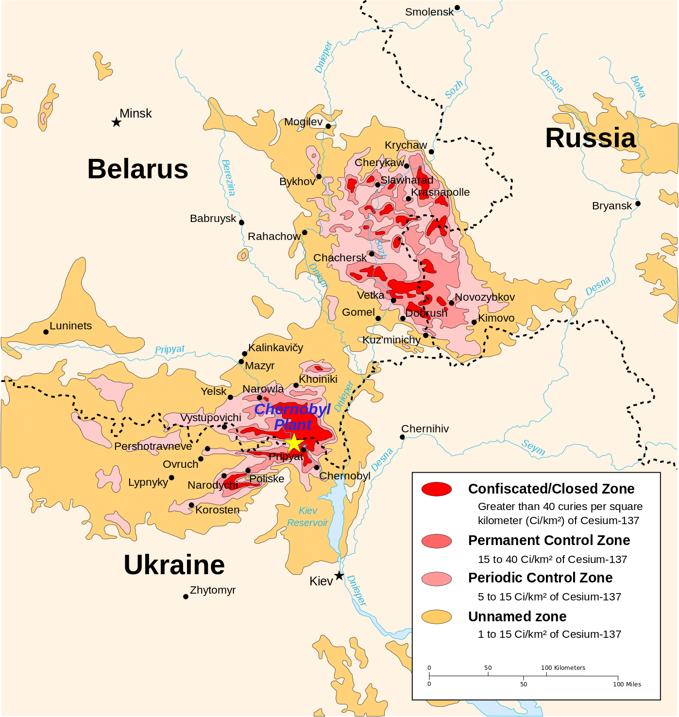

**Figure 1**: Radiation hotspots resulting from the Chernobyl nuclear power plant incident

(Source: Central Intelligence Agency, 1992).

In 2006, the WHO published its report on Chernobyl. The international collaborative effort to understand this disaster was applauded and the contribution to advancing nuclear science was recognised. However, public scepticism of the previously published consequences to health was also acknowledged. The WHO Radiation and Environmental Health Programme was tasked to research the health impact of Chernobyl and aimed to clarify the health disaster evidence. Research methodologies and health impacts were separately presented and critically appraised within the report: dosimetry, thyroid disease, leukaemia, other cancers, non-cancer and thyroid health impacts, mortality and regional public health systems (see **Figure 1** for geographical area). The primary methodology used to research the nuclear related health impact was epidemiology; the study of incidents and demographic spread of disease and health. Two methods were used -

1. Comparative modelling from data collected from people effected by the Hiroshima and Nagasaki atomic bombs during World War Two;
2. Empirical research with people effected by the Chernobyl disaster.

Both methods enabled the collection of data to understand the impact of the disaster and valuable information contributing to health systems resilience. However, each method had limitations. The first method is exposed to many independent variables; that is, the circumstances and contexts of Chernobyl incident and World War II atomic bombs are very different. Having said this, the differences can be accounted for, hence the statistical significance of comparative modelling is reliable. Notwithstanding, empirical studies provided the immediate collection of representative data, although this method takes longer to provide results. There is a place for both methods, but the WHO report on Chernobyl’s health effects focused predominantly on empirical evidence involving Belarusian, Russian and Ukrainian populations; however, other studies were taken into account (Bennett et al., 2006).

**What methods were used in researching the Chernobyl health disaster?**

Dosimetry is the measurement of absorbed ionising radiation. It is evident large amounts of nuclear material were released into the atmosphere but calculating the amount of absorption determined the severity of physical health effects. Doses of each radionuclide (different type of ionising radiation) were distinguished, as each elect has a different half-life; in other words, how long the radionuclide is radioactive for. Furthermore, identifying the sources of exposure to the radioactive material was equally as important and determining the quantity of absorption. For example, many children were exposed to the radiation as a result of drinking cow’s milk. Research highlighted children were drinking large amounts of milk (the same volume as adults), possibly due to the accessibility of family-owned cattle (Labunska et al., 2018). Many local communities had a low social-economic background; hence cow milk was an important source of calcium, protein and nutrition, which could be an explanation of why children were drinking so much cow’s milk. Thyroid glands in children are still developing, therefore, exposure to the same quantity of radioactive material in cow’s milk as adults led to a high incidence of childhood thyroid cancer. Establishing a holistic perspective of dosimetry, including the source of ingested radioactive material, informs and influences the short-term disaster management; public health advice was amended to educate people about about drinking cow’s milk from cattle within the contamination zone. However, long term monitoring is important for disaster risk management.

**What were the physical health impacts of Chernobyl’s health disaster?**

The thyroid gland is located in the throat, behind the larynx (Adam’s apple) and is a similar shape to a butterfly. The thyroid gland secretes a variety of hormones into the blood stream to regulate metabolism. The thyroid gland is very sensitive to exposure to ionising radiation, hence large numbers of children developed thyroid cancer as a result of eating and drinking local produce. The total number of children (in the three countries the WHO report focused on) who developed thyroid cancer between the years of 1986-2002 is 4,837 (Tuttle, Vaisman and Tronko, 2011). It is acknowledged this figure is disputed in various studies, but nevertheless, the agreed total number of reported cases is greater than 4,000 (Nikiforv, 2006). The age group of children with the largest increase in thyroid cancer is aged between 0-4 years at the time of Chernobyl disaster, which reaffirms the previous explanation of large consumptions of local cow’s milk being a significant cause of thyroid cancer. Adults did develop thyroid cancer too; however, the statistical significance of these studies is small, hence longitudinal studies of adults and thyroid cancers in the effected areas was a recommendation for future research.

Some studies investigated the incidence of leukaemia in children and adults (Howe, 2007). However, the results of these studies had poor statistical significance. In other words, leukaemia cannot be definitively ruled in or out as a health impact of the Chernobyl disaster. Other non-thyroidal cancers had low numbers of reporting, but this could be due to the small number of statistically significant epidemiological studies focusing on this topic; therefore, non-thyroidal cancers similarly cannot be ruled in or out as a health impact of Chernobyl, hence a WHO recommendation for research in the mid 2000s and early 2010s was continual monitoring. Results of these studies would inform the development of local and regional health systems to care for the effected communities and populations. It is important to note, however, an increase in cancers was not the only consequences of the Chernobyl health disaster.

Few studies investigated other health impacts of the Chernobyl disaster, therefore, the evidence is not conclusive. Furthermore, the studies had low academic rigour due to the presence of many uncontrolled variables. One example is the incidence of cardiovascular disease (CVD) (Cardis and Hatch, 2011). Some studies findings suggest CVD could have been caused by acute radiation sickness (ARS). Other studies suggest people who were exposed to the radiation felt their lives were permanently damaged, hence there was an increase in alcoholism, smoking and adoption of other poor lifestyle choices. It is, therefore, not possible to definitively claim ARS and, or poor lifestyle choices caused CVD; further study is required to provide clarity. A different example is a distinctive low birth rate in the regions effects. Another example is there is no evidence of birth defects or hereditary disease increase as a result of the Chernobyl disaster, but local communities and populations were scared of the effect on their fertility and the health of future children, which explains an increase in abortion rates in some areas. Although these findings are not conclusive, the findings are evidence for the requirement of public health and education initiatives, which needed to be managed by regional and local health systems.

**What were the other health impacts of the Chernobyl health disaster?**

Changes in health and social behaviours suggest the Chernobyl disaster had an effect on mental health (Havenaar et al., 1997). No psychological disorders were reported in the epidemiological studies focusing on Chernobyl, but there were many reports of psychological symptoms - anxiety, stress, depression and suicide. In fact, mental health symptoms is the largest public health issue caused by the Chernobyl disaster (Bromet, 2012). These findings lead to an increase in mental health services provision, including psycho-social counselling and health promotion campaigns by regional and local health systems to support those with mental health needs. Despite mental health being the most reported health effect caused by Chernobyl, it is important to note there is a limited number of rigorous studies in this area. WHO recommendations for research was to focus on long-term mental health effects and the provision of mental health training for health and social care practitioners to support those with mental health needs. In addition, the WHO recommended future research to be transparent, inclusive and collaborative, which is an important consideration for health system resilience. Both of these recommendations have significance for health system resilience and disaster risk management.

Although mental health was the most reported public health issue from the Chernobyl disaster, the mortality rate caused by exposure to radiation has been the most scrutinised. Fixation on Chernobyl’s mortality rate is likely to have been politically fuelled. Studies suggest life expectancy decreased whereas death rate increased in the three countries included in the WHO report on Chernobyl health effects. However, the true mortality rate of Chernobyl may have been masked by the paradigm shift of the political landscape, caused by the collapse of the USSR. One hundred and thirty four emergency workers were diagnosed with ARS, 28 of which died in 1986. People who were diagnosed with ARS, who were still alive after 1986, were known as ARS survivors. Nineteen ARS survivors died during the years 1987-2004. However, there is uncertainty of the ARS survivors’ causes of death, which could have been radiation related or due to other co-morbidities. The exposure of radiation to the wider populations was not enough to cause ARS, but the mortality rate is higher in comparison to neighbouring countries with similar economic backgrounds and health systems. 49,000 Russian emergency workers were present in 1986 and 61,000 were involved in total during the international response; 4,995 deaths were reported during the years 1991-1998. There is a similar challenge to determining the root cause of death for this population when considering the demographics, although, radiation exposure is a definite possibility. In the 2006 WHO report, the small statistical significance of mortality rate studies limits the representativity of results. However, the highly reported mortality rate is acknowledged as having significance for health systems providing services to those with long-term physical and psychological conditions.

**How does disaster research inform disaster risk management for health system resilience?**

Research is of significant importance to public health systems within the Chernobyl region. Studies were initiated in the early stages of the disaster, without inhibiting the immediate contamination procedures for those who were exposed to the nuclear material (shower, change of clothes and evacuation). Initial data informed the major incident triaging system, thus ensuring people were referred to appropriate health and social care services that met their needs, both physical and psychological. The long-term care and recovery was divided into three categories - clinical, monitoring and epidemiological. Clinical data of how ionising radiation exposure effected health was collected during annual health assessments and informed the wider body of health disaster evidence. Cancer screening and monitoring of other health effects informed the provision of services, hence financial forecasts can be provided for regional health systems. Epidemiological studies strengthen the evidence-based for clinical practice within health systems. Moreover, the WHO endorse services based on rigorous evidence and recommend annual health assessments for people with a history of at risk to health exposure to radiation. Radiation-exposure related health assessments for people not at risk of radiation related health effects remove financial resources from other services and could induce unnecessary fear. In other words, the monitoring and provision of health and social care services within health systems should be informed by valid and reliable evidence to those who are in need. This is an example of how health systems resilience can be enhanced.

In 2016 the WHO published another report, reviewing the previous 30 years of research. The findings in this report reaffirmed the findings and predictions published in the original 2006 report. For example, there has been an increase in incidents of thyroidal cancer, but at a similar rate to the predicted age-related increase. This suggests the original findings are accurate and reliable. Monitoring of health and wellbeing is ongoing, continuing approximately until the year 2065 to inform health systems. Psycho-social impacts have similarly been monitored closely. Up to date studies confirm mental health is the largest public health impact; some studies suggest anxiety rates of people effected by the Chernobyl disaster are double in comparison to populations not effected. High levels of anxiety correlate with the 2011 nuclear disaster in Fukushima, Japan (this incident was less severe that Chernobyl, but still comparable in scale). Thus, a holistic perspective of health and social care services is required for health systems. Lastly, the WHO emphasise an efficient dissemination of research findings and education of the population is paramount for long-term physical and psychological care of those effected by nuclear disaster.

The Chernobyl incident is one example of how a disaster (nuclear event) catalysed a health disaster. The UN Human Development Programme publishes reports on measurements of quality life expectancy, knowledge accessibility and standards of living. Modern day Ukraine is not a developed country according to the UN Human Development Index but does rank 88/189 in the world (United Nations, 2019b). Comparing this case study with another from a country with a lower HDI value provides a different perspective of health system resilience for disaster risk management. The next case study will focus on the Democratic Republic of Congo, which is ranked 179/189 on the UN HDI (United Nations, 2019c).

Case study 2 - Democratic Republic of Congo: Health systems, Conflict and Ebola

The Democratic Republic of Congo (DRC) is the second-largest country in Africa and situated centrally on the continent, bordering nine countries (**Figure 2**). The DRC is both land and resource-rich, with over 80 million hectares of arable land, >1,100 listed mineral and precious metals and a population of over 81 million (2018). The DRC has the potential to be one of the richest and most rapidly growing economies in the region. Recent growth in gross domestic output (GDP) and its comparatively good recovery (compared to other sub-Saharan African nations) from the global financial crash in 2008, have shown promising signs for the country’s economy. Despite this, and the cancellation of 90% of its external debt as part of the Heavily Indebted Poor Countries initiative (World Health Organization, 2015), the World Bank (2020) has listed the DRC’s extreme poverty rate at 73%, the second-highest in sub-Saharan Africa.

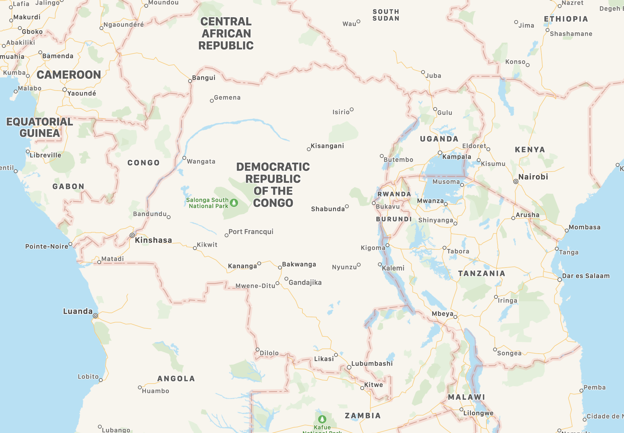

**Figure 2**: Map showing central Africa and the flag of the DRC (Source**:** Apple Maps, 2020).

Reasons for this growth stagnation and its inability to infiltrate the general population has resulted from decades of unrest and upheaval. From the 16th century to the large scale decolonisation of Africa in the 1960s, the DRC has received centuries of European involvement from Britain, the Netherlands, Portugal, France and Belgium. As with many other nations, this created social, political and economic struggles, namely a power vacuum and economic collapse. The 1990s were particularly unstable with several conflicts erupting, namely the First and Second Congo War (1996-2003), which was further complicated by the Rwandan genocide of 1994. The conflict resulted in the dissolution of Zaire, and the birth of the DRC (BBC News, 2020). After more than three decades of autocratic rule, the DRC adopted a constitution and held its first democratic elections in 2006 and again in 2011. Despite the signing of a peace agreement though, fighting has continued, funded by the vast natural resources, resulting in millions of deaths (World Health Organization, 2015). The social unrest and lack of a clear political direction has made the DRC particularly vulnerable to health disaster, as it meets several of the barriers discussed earlier including lack of financing, governance, access and education.

**Current Health Situation in the DRC**

Much of this unrest, poor governance and extreme poverty has been felt by the health sector in the DRC and is presenting through devastating national health indicators, high levels of maternal and infant mortality and poor healthcare coverage (~37%) (**Figure 3 & Table 2**) (Herp et al., 2003; World Health Organization, 2016.). Conflicts, refugee crises (from Congo, Angola and Rwanda) and disease outbreaks such as measles and Ebola have stretched the healthcare system and led to near collapse, along with several other healthcare challenges including malaria, diarrhoeal disease, protein malnutrition, respiratory tract infections, HIV/AIDS and tuberculosis. The burden of conflict has also resulted in significant mental health challenges in the country, including the mentally traumatic experience for those fighting and use of sexual violence and rape as a weapon (World Health Organization, 2015) and health disaster risk reduction is desperately needed to promote wellbeing, protect mental and physical health and enable sustainable development (James et al., 2019).

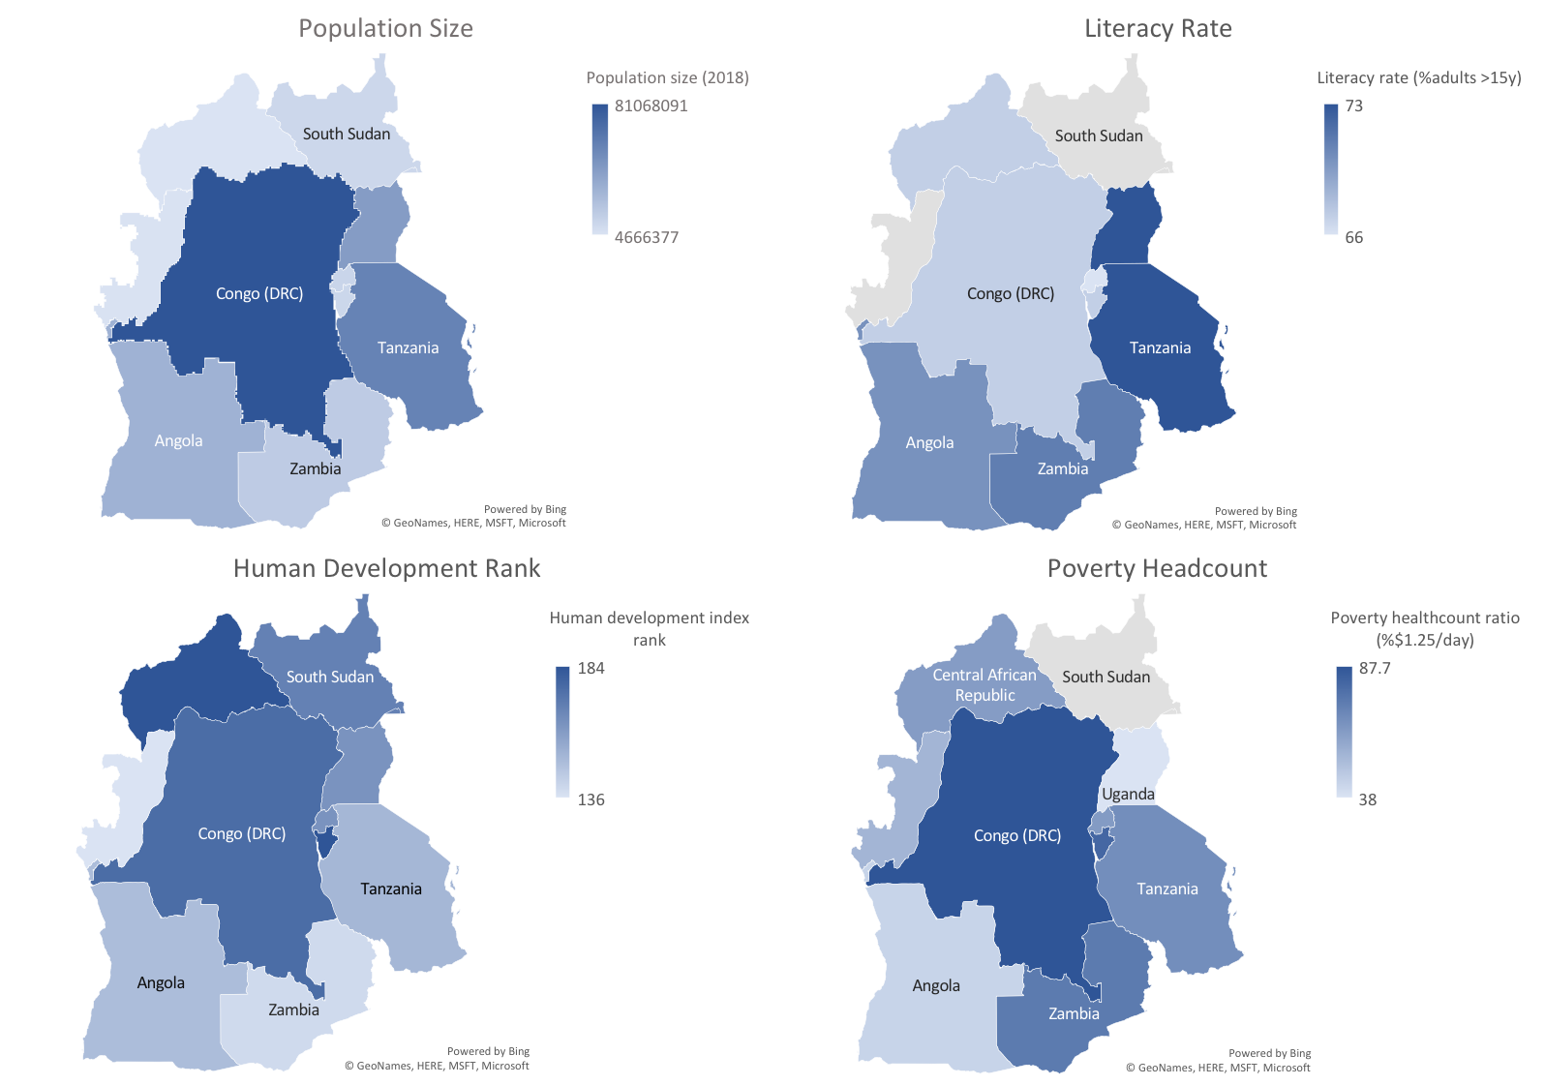

**Figure 3**: Development indicators for central Africa (Source: World Health Organization, 2016).

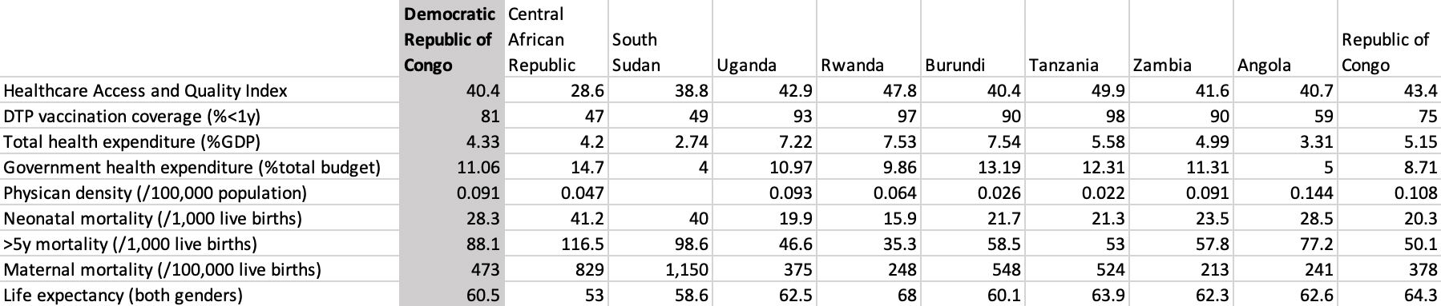

**Table 2**: Health indicators for central Africa (Source: World Health Organization, 2016).

The DRC health system is currently split into three levels;

* District level - Split into 516 health districts, each with several health centres and one district hospital to serve around 100,000-200,000 people
* Intermediate level - 26 provincial health departments providing technical and logistical support
* Central level - Mainly a normative role.

Currently, government health expenditure is low at 11% and a large proportion comes from external aid. The reliance on external funding reduces self-sufficiency and therefore makes the system prone to economic collapse and fluctuations (World Health Organization, 2015). Examples of this instability include:

* *Financing and expenditure* - Declines in aid contribution have occurred between Belgium and the DRC, due to diplomatic breakdown (Porignon et al., 1998)
* *Management & governance* - Poor organisation and fragmentation of services such as duplication and waste
* *Management & governance* - Disproportionate management costs, for example the EU Development Fund between 2006-2009 paid out €30.5 million in management costs, 38% of the total programme budget
* *Community trust & education* -Lack of accountability for international aid organisations and workers (World Health Organization, 2015).

This lack of central funding also leads to corruption and informal taxation, resulting in many healthcare workers not being paid and decreasing the quality of care. Coupled with poor workforce development and a surplus in private sector health and education, certain professionals are in excess while there are deficiencies in others (World Health Organization, 2015).

**The 2018 Ebola Outbreak**

To complicate the DRC’s current resiliency issues, North Kivu in eastern DRC was hit by an Ebola epidemic in 2018, which is still ongoing. It is now the second-largest Ebola epidemic ever recorded (after the 2014-2016 West Africa outbreak), with over 3,000 cases (Médecins sans Frontières, 2020). Médecins sans Frontières (MSF) and the WHO has been working together with the DRC Ministry of Health (MoH) to help tackle the outbreak. MSF is one of the few NGOs still working in the area with several others withdrawing assistance and aid, primarily due to safety concerns and cost savings (The Guardian, 2018). Several lessons were learnt from the West Africa outbreak, which acted as a catalyst and resulted in better technology, better treatments and an experimental vaccine. These lessons have played a role in the current crisis and the DRC can help strengthen these further, by identifying insufficiencies in the system and acting to build a more resilient programme (Kieny and Dovlo, 2015).

Conflict, highly mobile populations, nosocomial transmission and difficulties accessing certain populations have made outbreak control challenging. For example:

* Closing of the Congo River and destruction of roads has led to the isolation of many communities (Herp et al., 2003)
* Several confirmed cases reported visiting healthcare centres, putting patients and healthcare workers at risk (Ilunga Kalenga et al., 2019)
* Isolating contacts has been near impossible, due to frequent border crossing and movements of people displaced by conflict (Médecins sans Frontières, 2020)
* Studies have shown that conflict events repeatably hampered declining incidence, dampening Ebola vaccine effectiveness to a minimum of 4.8% (Wells et al*.*, 2019).

The crisis has shown a significant lack of trust between the population and healthcare workers, resulting in several attacks on workers and infrastructure, disrupted operations and many not seeking official care. Even the best biomedical response required social traction to work and, in this case, has resulted in the rejection of risk reduction strategies (Ilunga Kalenga et al., 2019). Reasons for this mistrust are largely related to the barrier of community mistrust and education and has steamed from (Médecins sans Frontières, 2020):

* Communities being irritated by the attention Ebola receives compared to other illness that kill more people. For example, between 2010-2013 a measles outbreak resulted in 294,455 cases and 5,045 deaths (Mancini et al.*,* 2014)
* Human rights abuses and perceived compliance has fostered mistrust in NGOs and the government, made worse by the militarisation of the Ebola response team (Ilunga Kalenga et al., 2019)
* Several negative and factually inaccurate rumours have been spread rapidly via mobile phones and social media (Moran, 2018)
* Overall the trust of how authorities represented the interests of the people are considered low (Vinck et al.*,* 2019).

**Ways forward in the DRC**

In a country the size of western Europe, there is a need for flexibility and tailoring to specific area requirements (Herp et al., 2003). Policies need to work for everyone in the country and rapidly increase access to healthcare (World Health Organization, 2015). Through several regional and national initiatives, common themes to improve health system resiliency in the DRC have emerged. These initiatives include the Health System Strengthening Strategy (2005) and the five year Nation Health Sector Development Plan (2010), set out by the DRC (World Health Organization, 2015). Along with the Paris Declaration (2005) and the Accra Agenda for Action (2008) set across Africa (Kieny and Dovlo, 2015). Key areas coming out of these plans and how they can be applied to the barriers implicated in the DRC are as follows:

1. *Develop health districts* - District health systems can often be unstable and prone to abandonment due to inadequate resources. Therefore, districts need improved leadership, distribution of resources and health coverage (Porignon et al*.*, 1998)

1. *Staff and education* - Improve training and staff development by enhancing human resources. Staff needed to be paid on time to form a committed workforce ready to respond to a crisis

1. *Pharmaceutical reform* - To guarantee a constant supply of high-quality medicines via stronger regulation and quality assurance

1. *Health financing* - Increase budget allocations, reduce management costs and prevent waste and fragmentation. Suggested methods for this are a single operational multi-donor plan and pooling of regional resources

1. *Collaboration* - Pathogens do not respect boundaries and therefore regional, national and international partnerships are needed to improve knowledge and expertise, helping to create a multi-disciplinary workforce

1. *Accountability* - Both for external aid and government organisations such as the MoH. This includes both the quality of the services offered and the management of resources and finances. This should also help foster community trust if accountability for actions are made clear

1. *Community/government dialogue* - Do not view communities as just recipients of care but instead active members of their health and the system. Build education programmes to show people how to improve their health and make healthcare workers more visible through consultations, to understand healthcare issues and what services are needed (World Health Organization, 2015)

1. *Data collection and surveillance* - A central reporting system is needed to help disease surveillance but also to monitor the health of the general population. For example, calculating vaccination coverage is currently difficult as census data is from 1984 (Mancini et al*.*,2014)

1. *A moving construct* - The health systems need to be flexible and tailored to a large diverse country. They must be flexible to adapt in unprecedented circumstances and address a wide range of health challenges (Kruk et al., 2015)

1. *Improve access* - Large areas of the country are currently cut off, either through infrastructure damage or conflict. This needs to be addressed both for the rights of these people but also to prevent health blind-spots. Urban-centric policies will not work in a country where >60% of the population live in rural communities (World Health Organisation, 2015).

Financing these systematic changes will be a significant barrier and increasing government expenditure will be an important first step, along with improving efficiency. A pilot performance-based financing programme has been carried out in South Kivu, showing promising results. Although spending was only $2/capita/year compared to $9-12/capita/year in control districts, the participating district still outperformed the control districts, mainly through improved efficiencies and better use of resources. Improved transparency and reduced corruption came out of open dialogue between patients and healthcare managers and uptake of services was high (Soeters et al., 2011). Although this shows promising early results in addressing financing, management and trust barriers, there is still a lack of capacity to roll this out country-wide but the results suggest an expansion would be beneficial. It also shows how new and experimental ideas will be required to help execute the ten points above and how such policies can help to practically implement change.

The two case studies represent how health disasters are unique and require specific interventions to improve the resilience of health systems for disaster risk management. In practice, achieving this aim can be challenging due to many influencing contextual factors. The next section of this chapter maps the priorities for health system resilience with the UN Sendai Framework (2015) and is applicable for all levels of society across the world.

Health Systems Resilience Priorities: Sendai Framework 2015-2030 Mapping

So far in this chapter, the principles of how health systems are or are not resilient have been critically discussed and explored through two case studies. The case studies have distinctive contexts and impacts. The differences between the two case studies are representative of how each disaster is incomparable to others. Furthermore, the necessary responses to manage the disaster are bespoke, relative to the context. Bespoke disaster response links with the discussion in the introduction about how there is no consensus definition, but two schools of thought - the impacts of disasters are social phenomena and disasters are within societal systems. The impact on health systems is one example of how disasters impact society, rather than the route cause event. Strengthening systems resilience is a disaster risk management initiative and should be informed by robust evidence. However, disaster managers and those effected by disaster, benefit from guidelines to channel research findings as it is disseminated. The Sendai Framework is a widely transferable resource to inform Governments and local authorities decisions about disasters, but it is not specific to health systems resilience. The aim of this section correlates with The Sendai Framework and complements its goal; to present evidence-based priorities, mapped to The Sendai Framework, to increase health systems resilience for disaster risk management (United Nations Office for Disaster Risk Reduction, 2015).

**Expected Outcome and Aim.**

Disaster risk management and health system resilience should have measurable outcomes to ensure evaluations are evidence-based. In relation to health systems resilience for disaster risk management, all initiatives should aim to reduce the risk of disaster, vulnerability and exposure of risk to people, personal and community infrastructure, and promote physical and mental wellbeing. Disaster risk management should be a proactive process to reduce the risk of health disaster.

**Priorities for Action.**

1. *Understanding disaster risk* - Each health disaster is unique. Forcing a health disaster into a generalised definition increases the risk of misunderstanding the hazards and risks to the disaster, thus any disaster risk management strategies are vulnerable to misjudgment and error. Initiating empirical study will establish an evidence-based understanding of a health disaster, which can be supplemented by secondary research of similar, historic events. A holistic understanding of a health disaster and the impacts is needed to inform health system resilience enhancement for disaster risk management.

1. *Strengthening disaster risk governance to manage disaster risk* - Evidence-based disaster risk management for health system resilience requires governance at all levels of society: international, national, regional, local and individual citizens. Legislation, policy and guidelines need to promote collaboration between public and private industries and explicitly define accountability and responsibility at all levels of society.
2. *Investing in disaster risk reduction for resilience* - Investment in disaster risk reduction is needed from public and private industries to strengthen health systems resilience, to reduce extended socio-economic, infrastructural and environmental impact. Investment in preparatory disaster risk management for health system resilience ultimately reduces the financial impact of natural hazards and disasters.

1. *Enhancing disaster preparedness for effective response, and to ‘build back better’ in recovery, rehabilitation and reconstruction* - Proactive disaster risk management for health system resilience establishes capacity to manage disasters and enhances the ability of convalescence. Recovery, rehabilitation and reconstruction preparation provides an opportunity to “build back better.” The principles of equality and inclusivity should inform disaster risk management for health system resilience.

**Targets.**

The following targets based on The Sendai Framework (2015) are integral to disaster risk management for health system resilience:

1. Substantially reduce mortality in health disasters
2. Minimise the incidences of people negatively affected by health disasters
3. Mitigate the damage of health disasters to GDP and local economies
4. Reduce health disaster impact to health systems infrastructure and disruption of health and social care services at all levels of society
5. Establish health disaster risk reduction strategies at all levels of society
6. Enable national and regional collaboration, including international support of developing countries, to implement evidence-based health disaster risk management initiatives
7. Widen accessibility to multi-hazard early warning systems and disaster research findings.

**Guiding principles.**

Disaster risk management is an inclusive principle. In other words, the responsibility of preparing for disasters and mitigating the risk is not one person, organisation, local authority or Government. All evidence suggests a collaborative approach is paramount to effective disaster risk management for health system resilience (and all other categories of disaster risk management). The following subsections are guiding principles at various societal levels. It is important to note, guiding principles are not rules, instructions, or a guarantee of reducing the risk of disaster. An evidence-based approach is most effective, as advocated in The Sendai Framework (2015). The following guideline principles are listed to inform disaster risk management for health system resilience at all levels of society.

**International guiding principles**

* Empower people to develop, improve their quality of life and protect all human rights
* Enhance international collaboration in the interests of all global citizens
* Provide bespoke support to developing countries for the improvement of resilience health systems for disaster risk management.

**National guiding principles.**

* Lead national disaster risk management initiatives for health system resilience
* Establish inclusive and fair responsibility of Government, private and public industries and key stakeholders in disaster risk management for health system resilience
* Promote financially sustainable investment, from public and private industries, in health system resilience for disaster risk management response and recovery
* Adopt The Sendai Framework (2015) philosophy of “build back better” for disaster risk reduction.

**Regional guiding principles.**

* Engage cooperatively with national disaster risk management strategy and initiatives for health system resilience
* Ensure holistic, evidence-based disaster risk reduction strategy development and policy making, including key regional stakeholders
* Across all sectors and industries, establish coherent disaster risk reduction guidelines, policy and strategy for disaster risk reduction and disaster risk management for health system resilience

**Local area and communities guiding principles.**

* Specifically risk assess disaster hazards and the impact on local communities and health systems, to be used in disaster risk management strategy and planning
* Enable local authorities and communities to access disaster risk reduction resources
* Involve local stakeholders in disaster risk management planning and decision making for health system resilience

**Individuals guiding principles.**

* Have ownership of promoting and maintaining the health and wellbeing of self and dependents
* Ensure awareness of individual roles and responsibilities in health disaster, informed by education, research and international, national, regional and local disaster risk management initiatives
* Proactively prepare for appropriate response to health disasters within the scope of accessibility
* Cooperatively engage in and constructively contribute to the evaluation of disaster risk reduction policy, guidelines and initiatives.

This section of the chapter presents the priorities of health system resilience for disaster risk management at all levels of society. The aim of this chapter is not to instruct, but to inform disaster risk reduction for health resilience from a global scale to individuals within local communities. The previous case studies represent disaster risk management for health system resilience is bespoke to each situation and area of the world. The current disparity of resources and divide between the developing and developed world requires proactive and collaborative disaster risk management for health system resilience to protect the interests of all global citizens.

Conclusion

The aim of this chapter was to provide a broad overview of the issues of health system resilience and how they can potentially be improved via disaster risk management frameworks, such as The Sendai Framework (2015). This issue is hugely convoluted and difficult to compare across countries due to societal, political and economic differences. Despite this, some building blocks of resilience health systems have been provided, which can be tailored to individual nations, to make sure they are prepared for health disasters and can serve their population, reducing mortality and morbidity.

It has been highlighted how resilient health systems can effectively work before, during and after a disaster and should be functioning in both good times and bad. There are many barriers that health systems face around the world, from poor management to a lack of financial resources. Two case studies have been provided as examples of health emergency contexts, including the 1986 Chernobyl nuclear disaster and the 2018 DRC Ebola outbreak. Both these examples showed the very different consequences of disasters and how several impacts can strike at the same time, causing cascading disasters. The case studies highlight the need to consider both communicable and non-communicable diseases and to make sure psychological wellbeing is addressed. Both disasters show the need for tailored training and a strong, committed workforce to provide expertise. Furthermore, the case studies illustrate the need for rapid health assessment, as no two disasters or societies are the same, therefore, the implications of a disaster and the groups at risk will often be different and difficult to predict without robust assessment. Hence, Governments and local authorities need to understand those at risk and how people will be effected by the heath disaster.

Health system resilience priorities have been mapped to The Sendai Framework, establishing a specific perspective on health disasters. Implementing these priorities improves risk response and preparedness, through substantially increasing capacity and commitment. The need for a proactive, holistic and collaborative approach to disaster risk management for health systems resilience has been emphasised. International, national, regional and local cooperation can lead to benefitting economies, the environment and society at large. By prioritising health preparedness and response at all levels, loss of life and livelihoods can be reduced, improving health and wellbeing.

The stakes have never been higher for more resilient health systems. Disaster will inevitably strike, as they have throughout history. However, Kelman’s (2020) definition reaffirms it is how society responds to hazards that determines disasters. It is important to learn from disaster and use this as a catalyst for change. To improve the visibility of health in societies and stress the need for a global understanding and agreement on how to contain these emergencies. The COVID-19 pandemic has highlighted pathogens do not discriminate or respect national boundaries, therefore, we must work together, viewing the planet as one, to contain these crises and protect human life and wellbeing. Health systems that are not resilience contribute to loss of life, suffering and societal tension and mistrust. This chapter has shown that these issues are not limited to developing nations, regardless of GDP, and all countries could benefit from investing in the resilience of their health systems for disaster risk management.

References

|  |
| --- |
| Admasu, K.B., 2016. Designing a resilient National health system in Ethiopia: the role of leadership. *Health Systems & Reform*, 2(3), pp.182-186. |
| Aitsi-Selmi, A. and Murray, V., 2015. Protecting the health and well-being of populations from  disasters: health and health care in The Sendai Framework for disaster risk reduction 2015-2030. *Prehospital and Disaster Medicine,* 31 (1), pp. 74-79. |
| Allenby, B. and Fink, J., 2005. Toward inherently secure and resilient societies. *Science*, 309(5737), pp.1034-1036. |
| ApSimon, H., Macdonald, H. and Wilson, J., 1986. An initial assessment of the Chernobyl-4 reactor accident release source, Journal of the Society for Radiological Protection, 6 (3), pp. 109-119. |
| BBC News, 2020. *DRC Congo country profile*. [Online]. London, UK; BBC. Available at:https://www.bbc.co.uk/news/world-africa-13283212 [Accessed 17 Apr 2020]. |
| Bedford, J., Enria, D., Giesecke, J., Heymann, D., Ihekweazu, C., Kobinger, G., Lane, H., Memish, Z., Oh, M., Sall, A., Schuchat, A., Ungchusak, K. and Wieler, L., 2020. COVID-19: towards controlling of a pandemic. *The Lancet,* 395 (10229), pp. 1015-1018. |
| Bennet, B., Repacholi, M. and Carr, Z., 2006. *Health effects of the Chernobyl accident and special health care programmes: report of the UN Chernobyl forum expert group “health”.* [Online]. Geneva: World Health Organisation. Available at: https://www.who.int/ionizing_radiation/pub_meet/chernobyl-accident-health-effects/en/ [Accessed 06 May 2020]. |
| Britnell, M., 2015. *In search of the perfect health system.* London: Macmillan International Higher Education. |
| Britton, N., 2007. National planning and response: national systems, in: Rodríguez, H., Quarantelli, E. and Dynes, R. (eds.) *Handbook of Disaster Research.* New York, NY: Springer. |
| Bromet, E., 2012. Mental health consequences of the Chernobyl disaster, Journal of Radiological Protection, 32, pp. 71-75. |
| Bromet, E. and Havenaar, J., 2007. Psychologcal and perceived health effects of the Chernobyl disaster: a 20-year review. *Health Physics,* 93 (5), pp. 516-521. |
| Central Intelligence Agency, 1992. Handbook of International Economic Statistics. Oakland, California: University of California. |
| Chan, E. and Shaw, R., 2020. Overview of health-EDRM and health issues in DRR: practices and challenges, in: Chan, E. and Shaw, R. (eds.) *Public health and disasters.* Singapore: Springer. |
| Chan, E., Ho, J., Wong, C. and Shaw, R., 2020. Health-EDRM in international policy agenda III: 2030 sustainable development goals and new urban agenda (habit III), in: Chan, E. and Shaw, R. (eds.) *Public health and disasters.* Singapore: Springer. |
| Cardis, E. and Hatch, M., 2011. The Chernobyl accident – an epidemiological perspective, *Clinical Oncology*, 23 (4), pp. 251-260. |
| Dar, O., Buckley, E.J., Rokadiya, S., Huda, Q. and Abrahams, J., 2014. Integrating health into disaster risk reduction strategies: Key considerations for success. *American journal of public health*, 104(10), pp.1811-1816. |
| Davis, I. and Alexander, D., 2016. *Recovery from disaster.* London: Routledge. |
| Fukuma, S., Ahmed, S., Goto, R., Inui, T.S., Atun, R. and Fukuhara, S., 2017. Fukushima after the Great East Japan earthquake: lessons for developing responsive and resilient health systems. *Journal of global health,* 7(1). |
| Hanefeld, J., Mayhew, S., Legido-Quigley, H., Martineau, F., Karanikolos, M., Blanchet, K., Liverani, M., Mokuwa, E., McKay, G. and Balabanova, D., 2018. Towards an understanding of resilience: responding to health systems shocks. *Health Policy and Planning,* 33 (10), pp. 355-367. |
| Havenaar, J., Rumyantzeva, G., Kasyanenko, A., Kaasjager, K., Westermann, A., Van Den Brink, W., Van Den Bout, J. and Savelkoul, J., 1997. Health effects of the Chernobyl disaster: illness or illness behaviour? A comparative general health survey in two former Soviet regions, Environmental Health Perspectives, 105 (6), pp. 1533-1537. |
| Herp, M.V., Parqué, V., Rackley, E. and Ford, N., 2003. Mortality, violence and lack of access to healthcare in the Democratic Republic of Congo. *Disasters*, 27(2), pp.141-153. |
| Howe, G., 2007. Leukemia following the Chernobyl accident, *Health Physics*, 93 (5), pp. 512-515. |
| Ilunga Kalenga, O., Moeti, M., Sparrow, A., Nguyen, V.K., Lucey, D. and Ghebreyesus, T.A., 2019. The ongoing Ebola epidemic in the Democratic Republic of Congo, 2018–2019. *New England Journal of Medicine,* 381(4), pp.373-383. |
| International Atomic Energy Agency, 2005. *Chernobyl’s legacy: health, environmental and sociology-economic impacts and recommendations to the governments of Belarus, the Russian Federation and Ukraine.* [Online]. Vienna: International Atomic Energy Agency. Available at: https://inis.iaea.org/search/search.aspx?orig_q=RN:36093263 [Accessed 06 May 2020]. |
| International Atomic Energy Agency, 2019. *International nuclear and radiological event scale.* [Online]. Vienna: International Atomic Energy Agency. Available at: https://www.iaea.org/resources/databases/international-nuclear-and-radiological-event-scale [Accessed 06 May 2020]. |
| James, L., Welton-Mitchell, C., Noel, J. and James, A., 2019. Integration mental health and disaster prep-a redness in intervention: a randomised controlled trial with earthquake and flood-affect communities in Haiti. *Psychological Medicine,* 50 (2), pp. 342-352. |
| Jaworowski, Z. (2010) Observations on the Chernobyl disaster and LNT, Dose-Response*, 8,* pp.148-171. |
| Kelamn, I. (2020) *Disasters by choice: how our actions turn natural hazards into catastrophes.* Oxford: Oxford University Press. |
| Kieny, M.P. and Dovlo, D., 2015. Beyond Ebola: a new agenda for resilient health systems. *The Lancet*, 385(9963), pp.91-92. |
| Kruk, M.E., Ling, E.J., Bitton, A., Cammett, M., Cavanaugh, K., Chopra, M., El-Jardali, F., Macauley, R.J., Muraguri, M.K., Konuma, S. and Marten, R., 2017. Building resilient health systems: a proposal for a resilience index. *BMJ*, 357, p.j2323. |
| Kruk, M.E., Myers, M., Varpilah, S.T. and Dahn, B.T., 2015. What is a resilient health system? Lessons from Ebola. *The Lancet*, 385 (9980), pp.1910-1912. |
| Kutzin, J. and Sparkes, S.P., 2016. Health systems strengthening, universal health coverage, health security and resilience. *Bulletin of the World Health Organization,* 94(1), p.2. |
| Lubunska, I., Kashparov, V., Levchuk, S., Saltillo, D., Johnston, P., Polishchuk, S., Lazarev, N. and Khomutinin, Y., 2018. Current radiological situation in areas of Ukraine contaminated by the Chernobyl accident: part 1. human dietary exposure to Caesium-137 and possible mitigation measures, *Environmental International*, 117, pp. 250-259. |
| Mancini, S., Coldiron, M.E., Ronsse, A., Ilunga, B.K., Porten, K. and Grais, R.F., 2014. Description of a large measles epidemic in Democratic Republic of Congo, 2010–2013. *Conflict and health*, 8(1), p.9. |
| Martineau, F.P., 2016. People-centred health systems: building more resilient health systems in the wake of the Ebola crisis. *International health*, 8 (5), pp.307-309. |
| McKenzie, A., Abdulwahab, A., Sokpo, E. and W Mecaskey, J., 2015. Building a resilient health system: lessons from northern Nigeria. |
| Médecins sans Frontières, 2020. *Democratic Republic of Congo*. [On-line]. Geneva, Switzerland: Doctors Without Borders (Médecins sans Frontières). Available at: https://www.msf.org/democratic-republic-congo-drc [Accessed 17 Apr 2020]. |
| Moran, B., 2018. Fighting Ebola in conflict in the DR Congo. *The Lancet,* 392(10155), pp.1295-1296. |
| Murray, V., Aitsi-Selmi, A. and Blanchard, K., 2015. The role of public health within the United Nations post-2015 framework for disaster risk reduction. *International Journal of Disaster Risk Science*, 6(1), pp.28-37. |
| Nikiforov, Y., 2006. Radiation-induced thyroid cancer: what we have learned from Chernobyl, Endocrine Pathology, 17 (4), pp. 307-317. |
| Norazam, A.S., 2018. Resilient Health Infrastructure: strengthening hospitals’ capacity to respond effectively during disasters and crises. *Procedia engineering,* 212, pp.262-269. |
| Nussbaum, R., 2007. The Chernobyl nuclear catastrophe: unacknowledged health detriment, *Environmental Health Perspectives,* 115 (5), p. 238. |
| Okwuchukwu, O.G., Uche, N.I., Perpetual, O.N. and Onyebuchi, O.G., 2016. Health information dissemination in an era of globalization among the Igbos of southeast Nigeria: Harvesting resilient traditional mass media systems to advantage. *Advances in Research*, pp.1-7. |
| Olu, O., 2017. Resilient health system as conceptual framework for strengthening public health disaster risk management: An african viewpoint. *Frontiers in public health*, 5, p.263. |
| Olu, O., Usman, A., Manga, L., Anyangwe, S., Kalambay, K., Nsenga, N., Woldetsadik, S., Hampton, C., Nguessan, F. and Benson, A., 2016. Strengthening health disaster risk management in Africa: multi-sectoral and people-centred approaches are required in the post-Hyogo Framework of Action era. *BMC Public Health*, 16(1), p.691. |
| Ostroumova, E., Schüz, J., and Kesminie, A., 2020. Future of Chernobyl research: the urgency for consolidated action, The Lancet, 395 (10229), pp. 1037-1038. |
| Patterson, A. and Veenstra, G., 2016. Politics and population health: testing the impact of the electoral democracy. *Health and Place,* 40, pp. 66-75. |
| Perry, R., 2007. What is disaster?, in: Rodríguez, H., Quarantelli, E. and Dynes, R. (eds.) *Handbook of Disaster Research.* New York, NY: Springer. |
| Porignon, D., Porignon, D., Mugisho Soron ‘Gane, E., Elongo Lokombe, T., Katulanya Isu, D., Hennart, P. and Van Lerberghe, W., 1998. How robust are district health systems? Coping with crisis and disasters in Rutshuru, Democratic Republic of Congo. *Tropical Medicine & International Health*, 3(7), pp.559-565. |
| Quarantelli, E., 2005. A social science research agenda for the disasters of the 21st century, in: Perry, R. and Quarantelli, E. (eds.), *What is a disaster? New answers to old questions.* Bloomington, IN: Xlibris. |
| Robertson, H.D., Elliott, A.M., Burton, C., Iversen, L., Murchie, P., Porteous, T. and Matheson, C., 2016. Resilience of primary healthcare professionals: a systematic review. *British Journal of General Practice*, 66(647), pp.e423-e433. |
| Rudowitz, R., Rowland, D. and Shartzer, A., 2006. Health Care In New Orleans Before And After Hurricane Katrina: The storm of 2005 exposed problems that had existed for years and made solutions more complex and difficult to obtain. *Health Affairs*, 25(Suppl1), pp.W393-W406. |
| Samuel, K., Aronsson-Storrier, M. and Bookmiller, K., 2019. *The Cambridge handbook of disaster risk reduction and international law.* Cambridge: Cambridge University Press. |
| Sharma, M., Yadav, K., Yadav, N. and Ferdinand, K.C., 2017. Zika virus pandemic—analysis of Facebook as a social media health information platform. *American journal of infection control*, 45(3), pp.301-302. |
| Soeters, R., Peerenboom, P.B., Mushagalusa, P. and Kimanuka, C., 2011. Performance-based financing experiment improved health care in the Democratic Republic of Congo. *Health Affairs*, 30(8), pp.1518-1527. |
| Stang, E. (1996) Chernobyl - system accident or human error?, Radiation Protection Dosimetry, 68 (4), pp 197-201. |
| Sun, X., 2020. *World health systems.* Hoboken, NJ: John Wiley & Sons. |
| The Guardian, 2018. *'The wars will never stop' - millions flee bloodshed as Congo falls apart.* [On-line]. London, UK: The Guardian. Available at: https://www.theguardian.com/world/2018/apr/03/millions-flee-bloodshed-as-congos-army-steps-up-fight-with-rebels-in-east [Accessed 17 Apr 2020]. |
| Tuttle, R., Vaisman, F. and Tronko, M., 2011. Clinical presentation and clinical outcomes in Chernobyl-related paediatric thyroid cancers: what do we know? what can we expect in the future?, Clinical Oncology, 23, pp. 268-275. |
| United Nations Office for Disaster Risk Reduction, 2007. *Hyogo framework for action 2005-2015: building the resilient of nations and communities to disasters.* [Online]. Hyogo: United Nations Office for Disaster Risk Reduction.Available at: https://www.undrr.org/publication/hyogo-framework-action-2005-2015-building-resilience-nations-and-communities-disasters [Accessed 24 April 2020]. |
| United Nations Office for Disaster Risk Reduction, 2015. *The Sendai Framework for Disaster Risk Reduction 2015-2030.* [Online]. Sendai: United Nations Office for Disaster Risk Reduction. Available at: https://www.undrr.org/publication/sendai-framework-disaster-risk-reduction-2015-2030 [Accessed 24 April 2020]. |
| United Nations Scientific Committee, 2008. *Sources and effects of ionising radiation.* [Online]. New York, NY: United Nations Scientific Committee on the Effects of Atomic Radiation. Available at: https://www.unscear.org/unscear/en/chernobyl.html [Accessed 04 May 2020]. |
| United Nations, 2019a. *Sustainable development goals.* [Online]. Geneva: United Nations. Available at: https://www.un.org/sustainabledevelopment/news/communications-material/ [Accessed 08 May 2020]. |
| United Nations, 2019b. *Human development reports: Ukraine.* [Online]. Geneva: United Nations. Available at: http://hdr.undp.org/en/countries/profiles/UKR [Accessed 12 May 2020]. |
| United Nations, 2019c. *Human development reports: Congo (Democratic Republic of the).* [Online]. Geneva: United Nations. Available at: http://hdr.undp.org/en/countries/profiles/COD [Accessed 12 May 2020]. |
| Vinck, P., Pham, P.N., Bindu, K.K., Bedford, J. and Nilles, E.J., 2019. Institutional trust and misinformation in the response to the 2018–19 Ebola outbreak in North Kivu, DR Congo: a population-based survey. *The Lancet Infectious Diseases*, 19(5), pp.529-536. |
| Wells, C.R., Pandey, A., Mbah, M.L.N., Gaüzère, B.A., Malvy, D., Singer, B.H. and Galvani, A.P., 2019. The exacerbation of Ebola outbreaks by conflict in the Democratic Republic of the Congo. *Proceedings of the National Academy of Sciences,* 116(48), pp.24366-24372. |
| World Health Organization, 2015. *Improving health system efficiency: Democratic Republic of the Congo: improving aid coordination in the health sector* (No. WHO/HIS/HGF/CaseStudy/15.4). World Health Organization. |
| World Health Organization. 2016. *Key country indicators. Country summaries.* [On-line]. Geneva, Switzerland: World Health Organisation. Available at:https://apps.who.int/gho/data/node.cco.keyind?lang=en [Accessed 17 Apr 2020]. |
| World Health Organization, 2017. *WHO community engagement framework for quality, people-centred and resilient health services* (No. WHO/HIS/SDS/2017.15). World Health Organization. |
| WorldBank, 2020. *The World Bank in DRC*. [On-line]. Washington DC, USA: WorldBank. Available at: https://www.worldbank.org/en/country/drc/overview [Accessed 17 Apr 2020]. |
| Yasobant, S., Bruchhausen, W., Saxena, D. and Falkenberg, T., 2019. One health collaboration for a resilient health system in India: Learnings from global initiatives. *One Health*, p.100096. |