A-site acceptor-doping strategy to enhance oxygen transport in sodium bismuth titanate perovskite

*Duke P.C Shih, Ainara Aguadero, Stephen J. Skinner\**

Department of Materials, Imperial College London, Exhibition Road, London SW7 2AZ, UK

* Author to whom correspondence should be addressed.

E-mail: s.skinner@imperial.ac.uk (Stephen J. Skinner).

# X-ray diffraction (XRD) and scanning electron microscopy (SEM) analysis

The phase purity of K-doped NBT was confirmed by XRD. All the samples show a clear perovskite phase and are indexed in the rhombohedral space group *R*3*c,* Figure S1 and Table S1. Each of the XRD patterns were analysed by Rietveld refinement using the Fullprof software suite. Goodness of fit parameters are included in Table S1.

A screenshot of a cell phone

Description generated with very high confidence

A screenshot of a cell phone

Description generated with very high confidence

*Figure S1*. XRD patterns and Rietveld refinement results of K-doped NBT ceramics where a) 2% b) 4% and c) 5% K substitution. The cross symbols represent the observed pattern and the solid line shows the calculated fit. The reflection marker for the *R*3*c* structure is shown as vertical lines with the difference pattern below the diffraction pattern.

*Table S1*. Refined lattice parameters of K-doped NBT ceramics compared with literature data for the parent phase. Rwp, Rp and χ2 are the refinement reliability factors.

|  |  |  |  |  |
| --- | --- | --- | --- | --- |
|  | Lattice Parameters | | |  |
| a/b (Å) | c (Å) | V (Å3) | RWP, RP, χ2 |
| NBT 5 | 5.4882(3) | 13.502(1) | 352.21(2) |  |
| 2% K-NBT | 5.4890(5) | 13.500(2) | 352.26(6) | 7.20, 5.60, 2.16 |
| 4% K-NBT | 5.4885(3) | 13.500(2) | 352.19(5) | 8.30, 5.66, 1.63 |
| 6% K-NBT | 5.4880(2) | 13.504(4) | 352.23(5) | 7.80, 5.04, 1.45 |

SEM images on thermally-etched surface revealed dense bodies and an average grain size of 5-10 μm. EDX characterization on K-doped NBT shows the content of K increases proportionally with increasing K doping level. The measured composition of K-doped NBT ceramics was in excellent agreement with the nominal cation ratio within instrument resolution and standard deviations. This confirms the doping mechanism

|  |  |  |
| --- | --- | --- |
|  |  |  |

A picture containing outdoor object, honeycomb, building

Description generated with very high confidence

*Figure S2*. SEM micrographs of thermally-etched surfaces showing the reduction in grain size due to the K doping.

*Table S2*. Analyzed composition of un-doped and K-doped NBT ceramics determined by EDX, including associated error. The cation ratio of A-site to B-site is also reported.

|  |  |  |  |  |  |
| --- | --- | --- | --- | --- | --- |
|  | Na (at%) | Bi (at%) | K (at%) | Ti (at%) | A/B Ratio |
| NBT | 25.0 (± 0.4) | 25.2 (± 0.2) | - | 49.8 (± 0.4) | 1.01 |
| 2% K-NBT | 25.1 (± 0.5) | 23.8 (± 0.4) | 0.9 (± 0.4) | 50.2 (± 0.2) | 0.99 |
| 4 % K-NBT | 25.1 (± 0.4) | 22.6 (± 0.2) | 2.0 (± 0.1) | 50.3 (± 0.3) | 0.99 |
| 6 % K-NBT | 25.0 (± 0.4) | 22.1 (± 0.1) | 2.5 (± 0.6) | 50.4 (± 0.2) | 0.99 |

*Table S3*: Theoretical and measured densities of the K substituted Na0.5Bi0.5TiO3

|  |  |  |  |
| --- | --- | --- | --- |
|  | **Density** | | |
|  | ρtheoretical (g cm-3) | ρmeasured (g cm-3) | Relative (%) |
| **NBT** | 5.98 | 5.77 | 96.5 |
| **2% K-NBT** | 5.96 | 5.80 | 97.3 |
| **4% K-NBT** | 5.99 | 5.74 | 97.3 |
| **6 % K-NBT** | 5.99 | 5.72 | 96.9 |

# Electrochemical Impedance Spectroscopy (EIS)

An equivalent circuit of three resistor-constant phase elements (R-CPE) connected in series was used to analyze the EIS data presented in Figure 1and is shown in Figure S3 for the 2at% K substitution. Impedance measurements were also performed in dry and wet air atmospheres. The moisture-independent conductivity supports the suggestion that the possibility of proton conduction is excluded in the K-doped NBT materials (Figure S4). A comparison of bulk conductivity for acceptor-doped NBT at 500 oC is shown in Table S5.

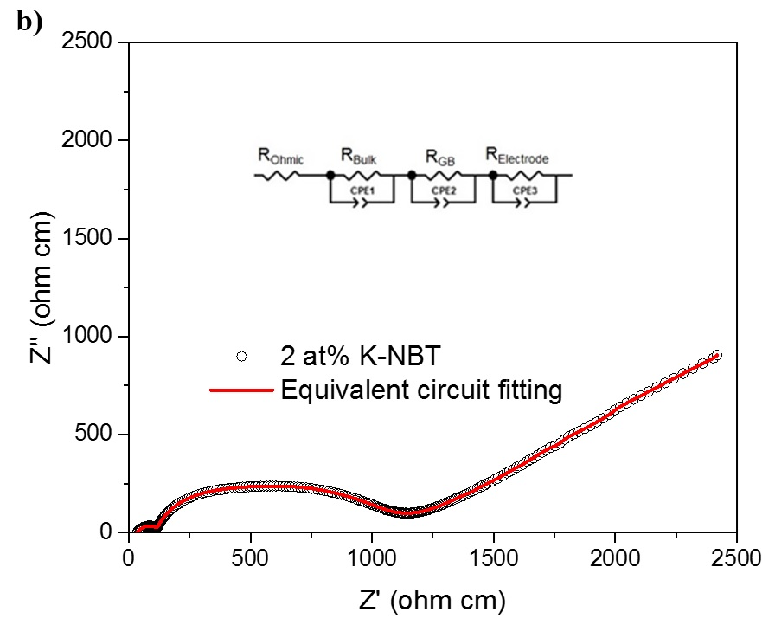

*Figure S3*. Impedance spectra for K-doped NBT ceramics measured at 600 oC in air. Equivalent circuit fitting for a 2% K-doped NBT ceramic demonstrates the quality of fitting. The open circles are the experimental data and the red line is the fitting result.

*Table S5*. Bulk conductivity (σbulk) and tracer diffusion coefficient (*D\**) of acceptor-doped NBT.

|  |  |  |  |  |
| --- | --- | --- | --- | --- |
|  | σbulk (S cm-1) | | *D\** (cm2 s-1) | |
| 500 oC | 600 oC | 500 oC | 600 oC |
| NBT 6 | 4.55 x 10-5 | 1.25 x 10-3 |  |  |
| 4% K-NBT | 3.18 x 10-3 | 4.74 x 10-3 | 5.95 x 10-10 | 3.01 x 10-9 |
| 4% Li-NBT | 8.35 x 10-3 | 1.26 x 10-2 | 1.68 x 10-9 | 7.04 x 10-9 |
| 2% Sr-NBT | 4.95 x 10-3 |  |  |  |
| 2% Mg-NBT | 4.06 x 10-3 | 8.00 x 10-3 |  | 1.17 x 10-8 |

# 18O Tracer Diffusion Measurements

The improvement of oxide-ion conduction in 4% K-doped samples was confirmed by 18O tracer diffusion measurement using isotopic exchange and Secondary Ion Mass Spectrometry (SIMS). The diffusion profiles obtained in the temperature range (450-650 oC) are shown in Figure S4. No grain boundary diffusion was observed in the diffusion profiles. The diffusion coefficients obtained from the diffusion profiles are summarized in Table S6. It is clear that the diffusion length is increasing with the electrical conductivity. Surface exchange coefficients are not discussed because the surface was modified by the Pt coating.

A picture containing text, map

Description generated with very high confidence

*Figure S4*. Diffusion profiles of the 4% K-doped NBT samples at selective temperatures.

*Table S6*. Calculated oxygen diffusion coefficients (*D\**) of the 4% K-doped NBT samples at different exchange temperatures. The *D\** of the 4% Li-doped NBT is provided for a comparison of oxygen transport property.

|  |  |  |  |  |  |
| --- | --- | --- | --- | --- | --- |
| *D\** (cm2 s-1) | Exchange Temperature (oC) | | | | |
| 450 | 500 | 550 | 600 | 650 |
| NBT |  |  |  | 5.24 x 10-10 |  |
| 4% K-NBT | 1.14 x 10-10 | 5.95 x 10-10 | 2.01 x 10-9 | 3.01 x 10-9 | 5.16 x 10-9 |
| 4% Li-NBT | 4.95 x 10-10 | 1.68 x 10-9 | 2.96 x 10-9 | 7.04 x 10-9 | 5.62 x 10-9 |

A screenshot of a cell phone

Description generated with very high confidence

*Figure S5*. Calculated and experimental activation energies for oxygen migration in NBT. Colors represent the temperature ranges of the cubic (C), tetragonal (T), orthorhombic (O) and rhombohedral (R) (adapted from ref. 1). The activation energy of *D\** of 4% K-NBT is added for comparison.

A close up of a map

Description generated with very high confidence

*Figure S6*. Arrhenius plot of total conductivity for 4% K-doped NBT ceramic measured in dry and wet air

# Durability and Stability Test in the Oxidizing Atmosphere

Here, a test of durability and stability was performed to study the lifespan of these three compounds in different atmospheres. In this test, the fluctuation in electrical behavior was monitored for 100 hours at 600 oC in both flowing air and oxygen atmospheres. The dependence of electrical performance on the oxygen partial pressure (pO2) can be comprehended. The surface morphology and crystal structure of the samples were investigated after annealing.

A picture containing photo

Description generated with high confidence

*Figure S6* SEM micrographs of 4% K-doped NBT samples after annealing at 600 oC in air and oxygen: cross-section (top) and surface (bottom).

### *Ionic size of the dopant*

From structural considerations for perovskite materials, oxide-ion conductivity is often estimated by the following empirical parameters:

1. Goldschmidt tolerance factor, *t* 2:

|  |  |  |
| --- | --- | --- |
|  |  | (S1) |

where *rA* and *rB* are the mean ionic sizes of the A- and B-site cation(s) (12- and 6-fold coordination, respectively); *rO* is the ionic size of the oxygen ion (6-fold coordination, *rO* = 1.40 Å).

1. The lattice free volume, *Vsf* 3:

|  |  |  |
| --- | --- | --- |
|  |  | (S2) |

where *V* and *Vion* are the volume of the unit cell volume and the volume of each constituent ion, respectively. *V* 4 can be determined by

|  |  |  |
| --- | --- | --- |
|  |  | (S3)5 |

where

|  |  |  |
| --- | --- | --- |
|  |  | (S4) |

where *rA\** is the ionic radius of the A-site cation in 8-fold coordination (not 12) and *rB* is the ionic radius of the B-site cation in 12-fold coordination (not 6-fold coordination).

1. The critical radius, *rC*, defined by Kilner and Brook4:

|  |  |  |
| --- | --- | --- |
|  |  | (S5) |

where a0 is the pseudo cubic lattice parameter.

# References

1. Meyer, K.-C.; Albe, K., Influence of phase transitions and defect associates on the oxygen migration in the ion conductor Na1/2Bi1/2TiO3. *J. Mater. Chem. A* **2017,** 5, 4368-4375.

2. Goldschmidt, V. M., Die Gesetze der Krystallochemie. *Die Naturwissenschaften* **1926,** 14, (21), 477-485.

3. Hayashi, H., Structural consideration on the ionic conductivity of perovskite-type oxides. *Solid State Ionics* **1999,** 122, 1-15.

4. Kilner, J.; Brook, R., A study of oxygen ion conductivity in doped non-stoichiometric oxides. *Solid State Ionics* **1982,** 6, 237-252.

5 Fukunaga, O.; Fujita, T., The relation between ionic radii and cell volumes in the perovskite compounds. *J. Solid State Chem.* **1973,** 8, 331-338.