SUPPLEMENTAL MATERIALS
Contents
Tables
- eTable 1. Post-training transition probabilities stratified by stage and HPV-status
- eTable 2. Performance of Reimbursement-Based Schedule (RBS) vs Optimized Regimens
- eTable 3. Modified Stage IVA HPV-positive Cohort Performance
- eTable 4: Python Packages Used in Model Development
Figures
- eFigure 1. Flowchart of model training.
- eFigure 2. Recurrence Model Training Algorithm
- eFigure 3A. Test characteristics of PET-CT scan for recurrent head and neck disease.
- eFigure 3B. Test characteristics of CT scan for recurrent head and neck disease
- eFigure 4. Comparison between training cohort (NCDB) and external validation cohort (ICON-S).
- eFigure 5. Cohort-specific comparison of overall survival
- eFigure 6. Disease-free survival stratified by stage and HPV-status and disease state (locoregional and distant metastasis)
- eFigure 7. Model based recommendations adapt to minimize latency based on overall number of scans.
- eFigure 8. Modified Stage IVA HPV-positive cohort compared to ICON-S counterpart

Tables
eTable 1. Post-training transition probabilities stratified by stage and HPV-status
Stage | HPV-status | Year-1 |  | Year-2 |  | Year-3+
 |  | P(LR) | P(mets) | P(LR) | P(mets) | P(LR) | P(mets)
III | + | .093% | .13% | .093% | .13% | .093% | .13%
 | - | 1.3% | .38% | 1.3% | .38% | .17% | .013%
IVA | + | .29% | .41% | .29% | .41% | .012% | .17%
 | - | 1.7% | .51% | 1.7% | .51% | .73% | .16%
IVB | + | .88% | 1.2% | .88% | 1.2% | .18% | .24%
 | - | 4.1% | 1.2% | 2.9% | .88% | .84% | .062%
P(LR): per month probability of locoregional recurrence
P(mets): per month probability of metastatic disease

eTable 2. Performance of Reimbursement-Based Schedule (RBS) vs Optimized Regimens
cohort | RBS |  |  | optimized
 | Sensitivity | Mean Latency | False Positives | Sensitivity | Mean Latency | False Positives
III HPV+ | .58* | 9.2‡ | 4223 | .52* | 8.3‡ | 4277
IVA HPV+ | .59* | 10.9‡ | 3673 | .57* | 9.4‡ | 3714
IVB HPV+ | .61* | 11.4‡ | 2623 | .63* | 9.2‡ | 2579
III HPV- | .61* | 11.4‡ | 3012 | .67* | 8.9‡ | 2999
IVA HPV- | .61 | 10.6‡ | 2398 | .61 | 8.8‡ | 2457
IVB HPV- | .66* | 10.5‡ | 1343 | .69* | 8.7‡ | 1394
* Denotes sensitivities that are significantly different (z score for population proportions, alpha=0.0083)
‡ Denotes latencies that are significantly different (unpaired t-test, alpha=0.0083).
Number of false positives was not significantly different across all cohorts (z score for population proportions, alpha=0.0083)

eTable 3. Modified Stage IVA HPV-positive Cohort Performance
Regimen | Months | Sensitivity | Latency (months) | Total false positives per 10,000 patients
PET | 3 | .12 | 18.2 | 1111
+1 CT | 3,18 | .31 | 14.6 | 1936
+2 CT | 3,12,22 | .44 | 12.1 | 2770
+3 CT | 3,8,14,23 | .50 | 10.3 | 3443
+4 CT | 3,8,14,20,26 | .58 | 9.4 | 4035
+5 CT | 3,7,12,17,22,27 | .62 | 8.2 | 4519
+6 CT | 3,7,11,15,19,23,31 | .67 | 7.7* | 4935
Standard | 3,6,9,12,18,24,36 | .68 | 8.5* | 5094
Standard refers to a PET at month 3, CT neck/chest at 6,9,12,18,24,36. Latency for radiologically discovered disease is defined: latency=month of radiologic disease discovery – month of recurrence onset; Latency for radiologically missed disease is defined: latency= 36 – month of recurrence onset
* Denotes when there is a significant difference between latency of PET+6CT and Standard regimens (unpaired t-test, alpha=0.0083). There were no significant differences in sensitivity or false positives between these regimens across all cohorts (z score for population proportions, alpha=0.0083).

eTable 4. Python Packages Used in Model Development
Package Name | Purpose
numpy | Array data structure implementation
pandas | Data input and output; Data manipulation
scikit-learn | Model training and testing
seaborn | Data visualization

Figures
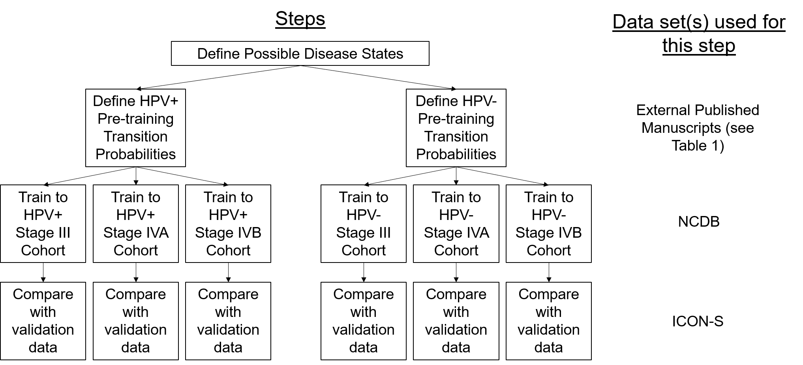
eFigure 1. Flowchart of model training.
NCDB=National Cancer Database; ICON-S refers to the 2016 International Collaboration on Oropharyngeal cancer Network for Staging manuscript by O’Sullivan et al²⁷.

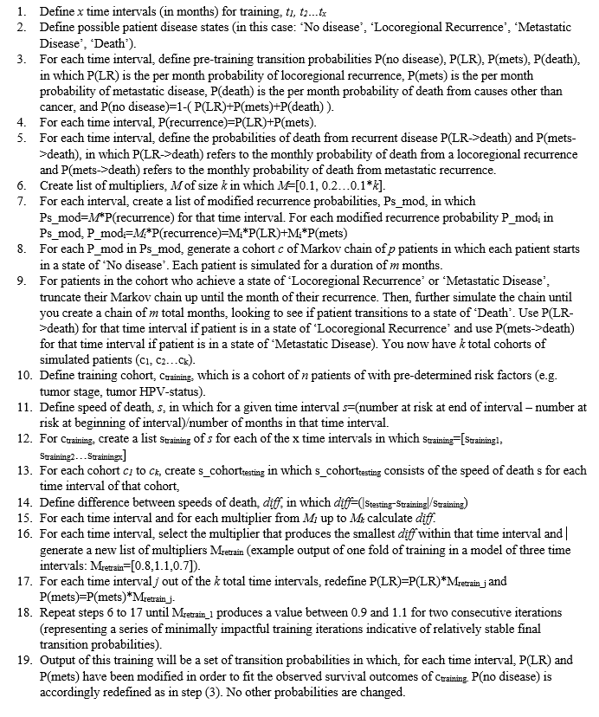
eFigure 2. Recurrence Model Training Algorithm

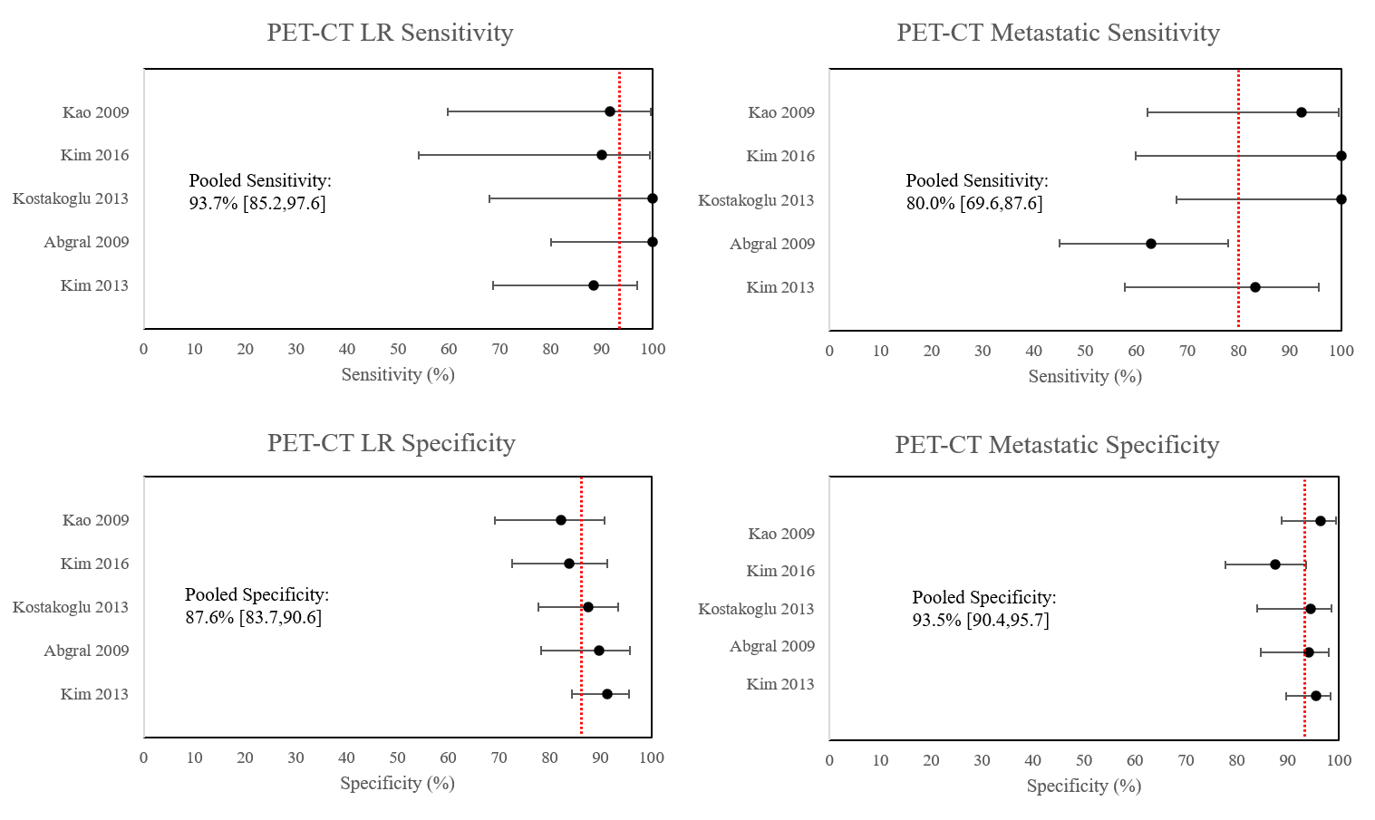eFigure 3A. Test characteristics of PET-CT scan for recurrent head and neck disease. LR=locoregional recurrence, red line=pooled mean value. Test characteristics given in the form of pooled mean[95% confidence interval]

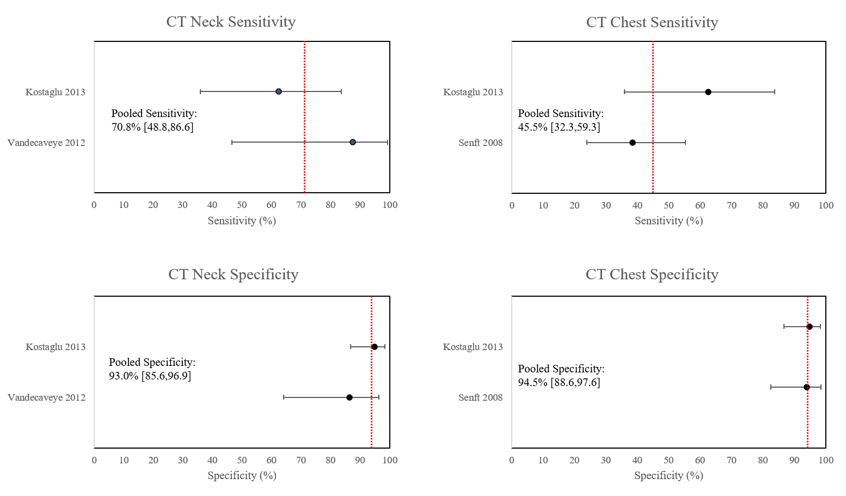
eFigure 3B. Test characteristics of CT scan for recurrent head and neck disease. CT Neck test characteristics were used in the simulation for detection of locoregional recurrence. CT Chest test characteristics were used in the simulation for detection of metastatic recurrence. Red line=pooled mean value. Test characteristics given in the form of pooled mean[95% confidence interval]

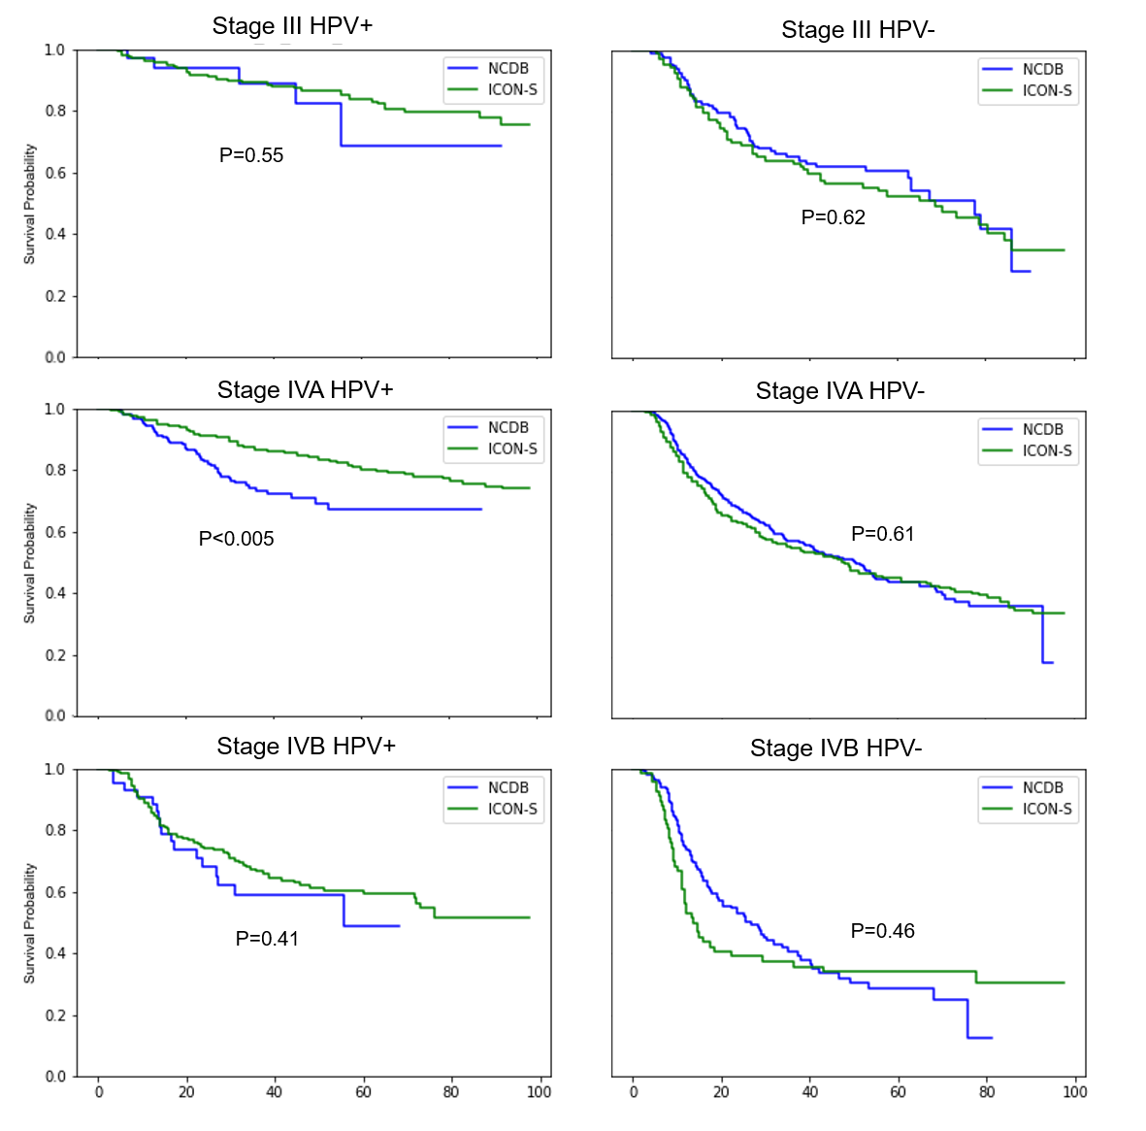
eFigure 4. Comparison between training cohort (NCDB) and external validation cohort (ICON-S).
All p-values refer to log-rank test between cohorts of interest.

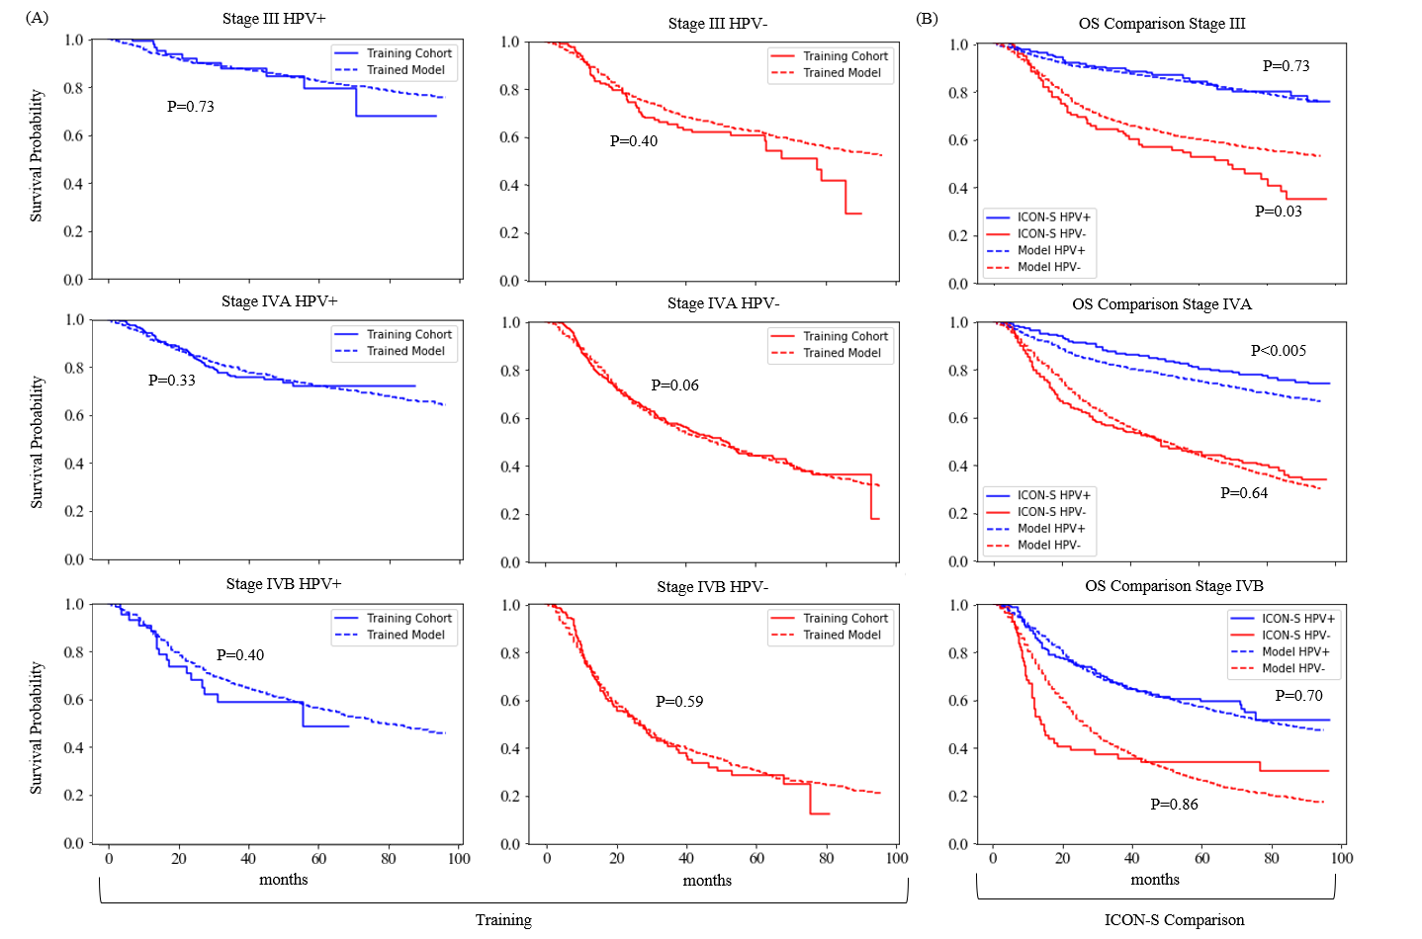
eFigure 5. Cohort-specific comparison of overall survival
(A) Comparison of the modified base model (trained model) and the training NCDB cohort. (B) External validation of trained model using ICON-S cohorts. Comparison using log-rank test.

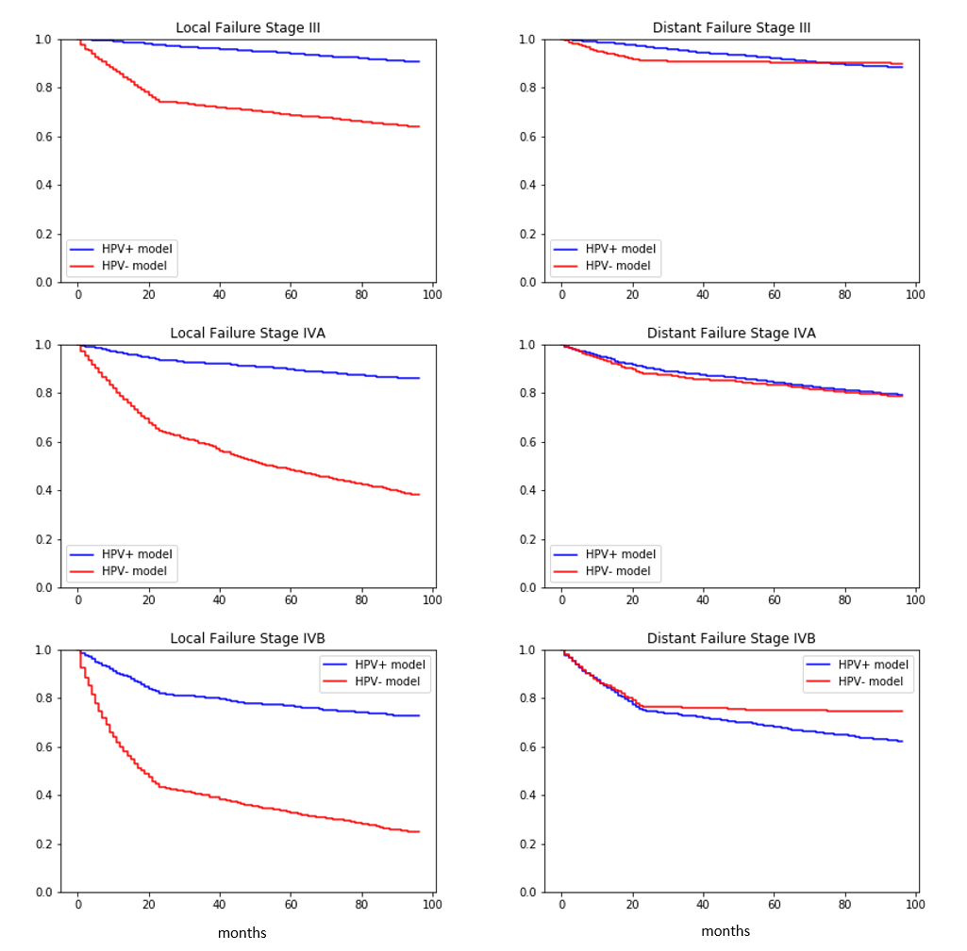
eFigure 6. Disease-free survival stratified by stage and HPV-status and disease state (locoregional and distant metastasis)

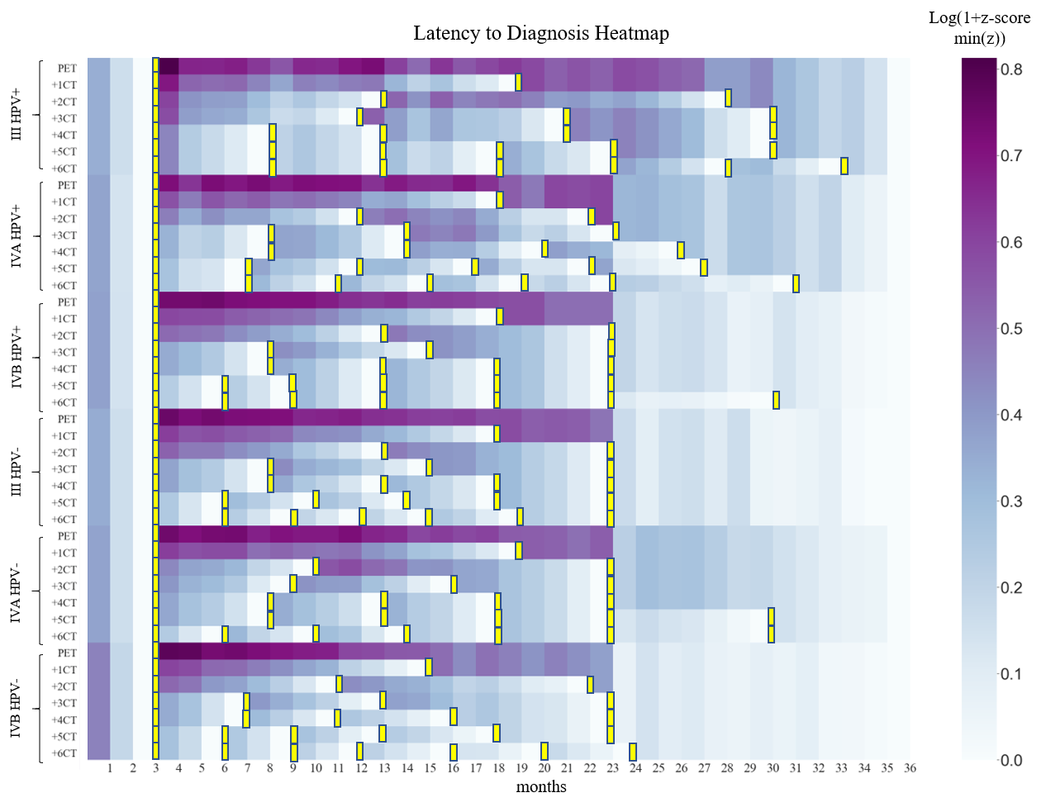
eFigure 7. Model based recommendations adapt to minimize latency based on overall number of scans.
Regimen latency was normalized using the log(1+z-score- (minimum z-score of all latencies)). Darker colors correspond to greater latency. Each block represents one month. Each yellow bar represents the timing of a single scan.
PET=regimen with only a single PET-scan at month 3; +1CT, +2CT etc. indicates how many additional scans were allowed on top of the PET at month 3

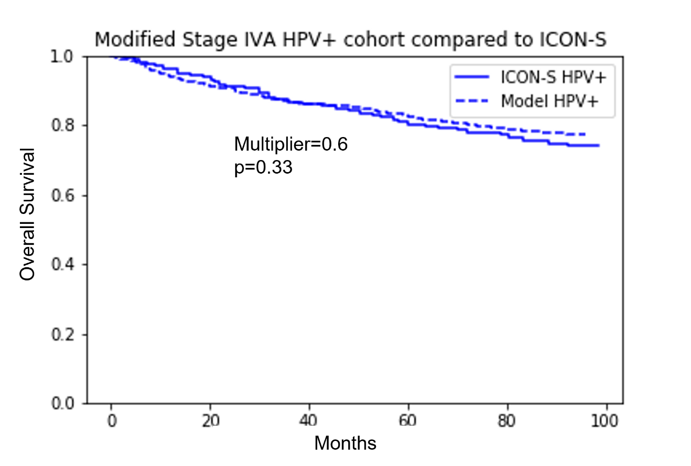
eFigure 8. Modified Stage IVA HPV-positive cohort compared to ICON-S counterpart

