- Fast redox kinetics in SrCo_{1-x}Sb_{x}O_{3-δ} perovskites for thermochemical energy storage and oxygen separation
- George E. Wilson¹, Ieuan D. Seymour¹, Andrea Cavallaro¹ Stephen J. Skinner*¹, Ainara Aguadero^{1*}
¹Department of Materials, Imperial College London, Exhibition Road, London, SW7 2AZ, UK
* Correspondence:
Stephen Skinner
s.skinner@imperial.ac.uk

Supplementary Material

Supplementary Table 1. Further DFT results comparing the undoped and 3.125% doped tetragonal structures.
 | SrCoO₃ | SrCo_{0.96875}Sb_{0.03125}O₃
Possible Decomposition Products | SrCo₆O₁₁  Sr₆Co₅O₁₅  O₂ | SrCo₆O₁₁  Sr₂Sb₂O₇  Sr₆Co₅O₁₅  O₂
Fermi Energy  (eV) | 2.79 | 2.82

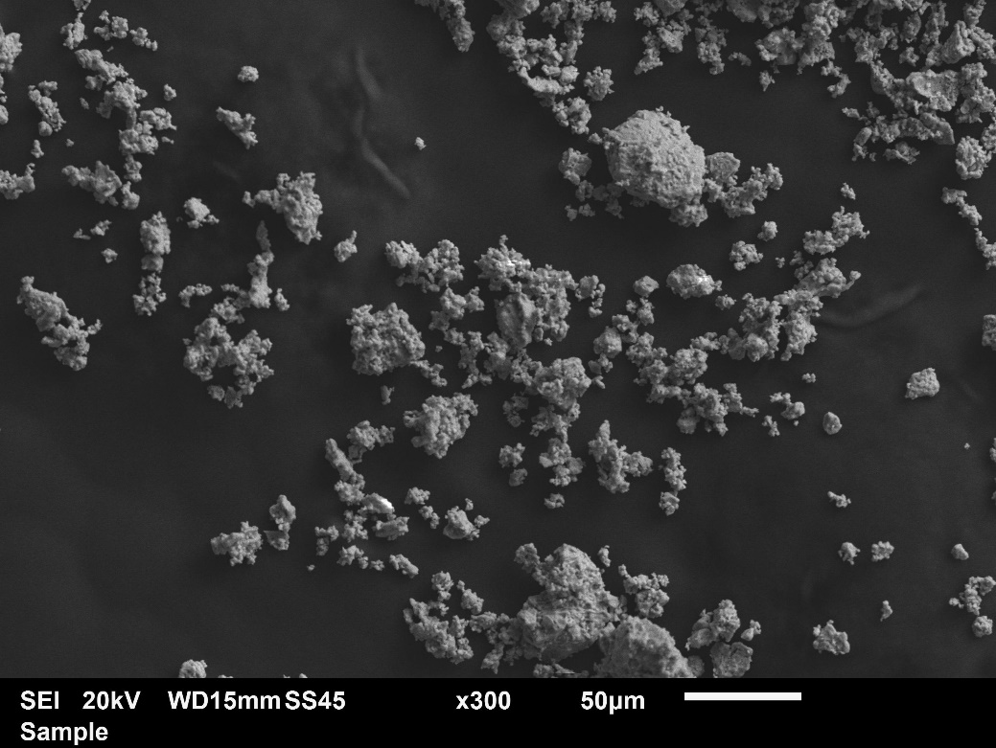

Supplementary Figure 1. Scanning electron microscopy secondary electron images for Sb = 0.05 powder.
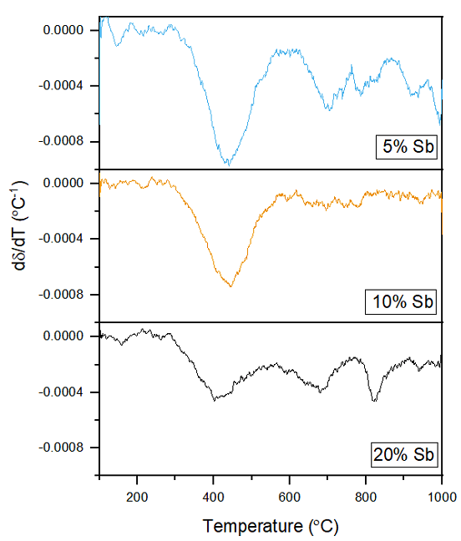
Supplementary Figure 2. Derivative of oxygen stoichiometry with respect to temperature for each of the Sb powders tested.

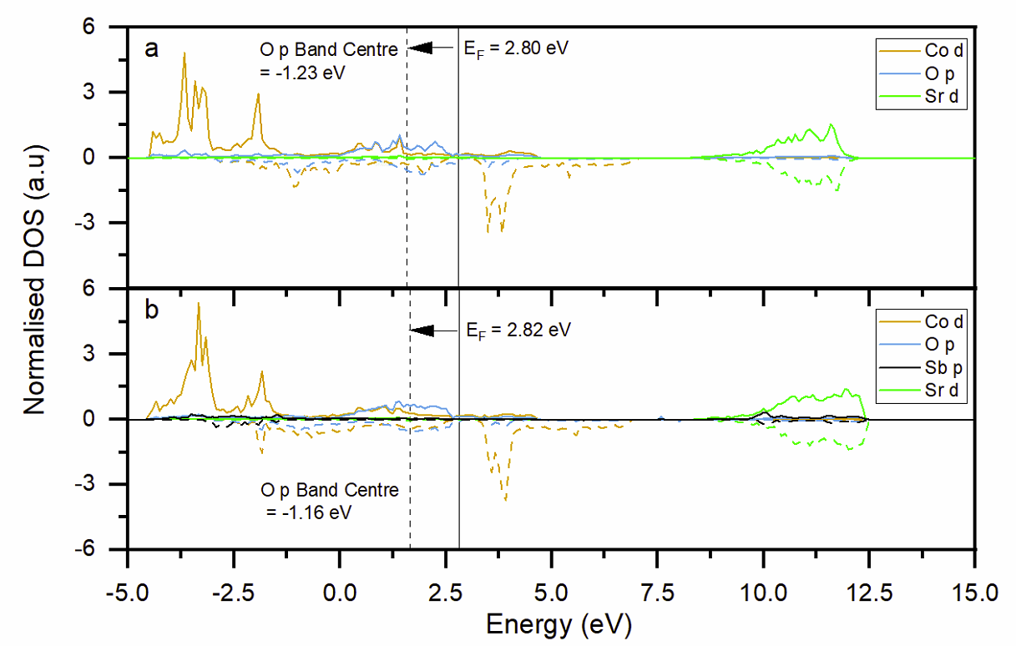

Supplementary Figure 3. Density of states plots for a) undoped and b) 3.125% doped
SrCoO_{3-d} structures.

a)
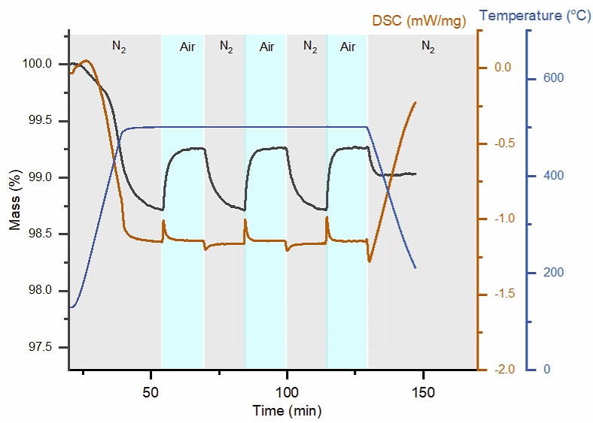
b)
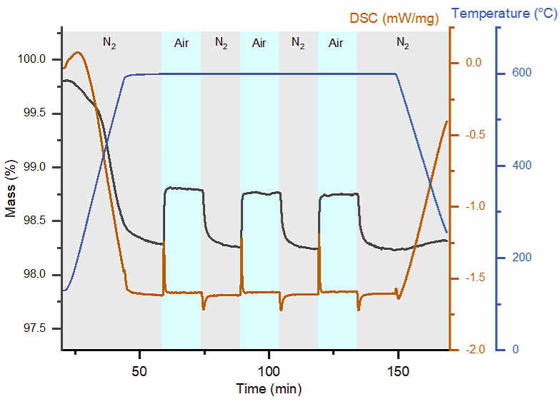
c)
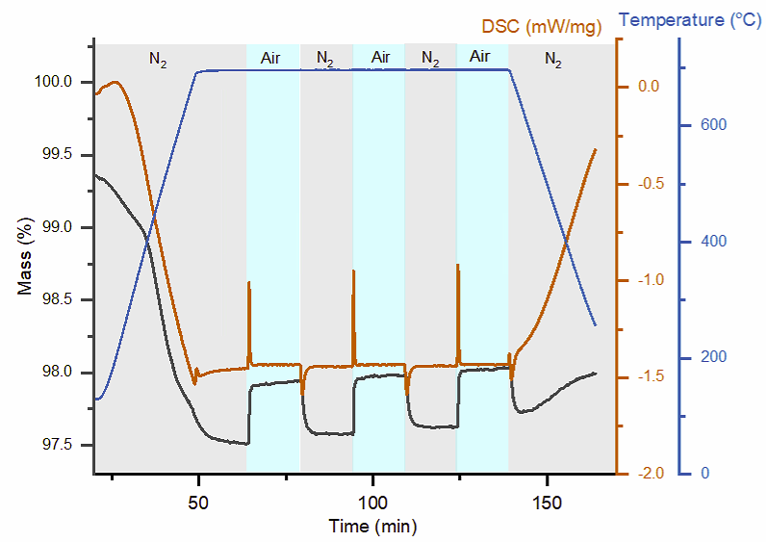
d)
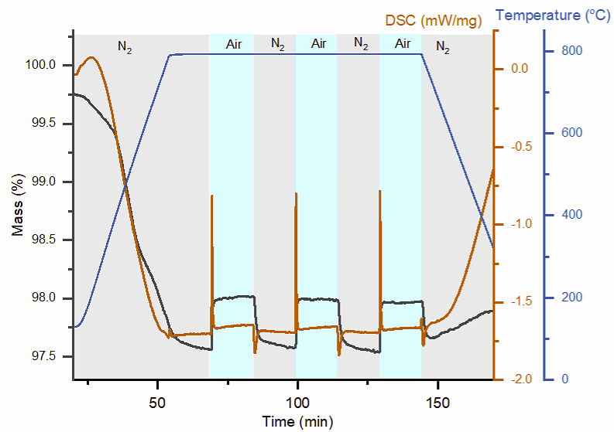

Supplementary Figure 4. Isothermal cycling data for SrCo_{0.95}Sb_{0.05}O_{3-δ} at a) 500 °C, b) 600 °C, c) 700 °C and d) 800 °C.
a)
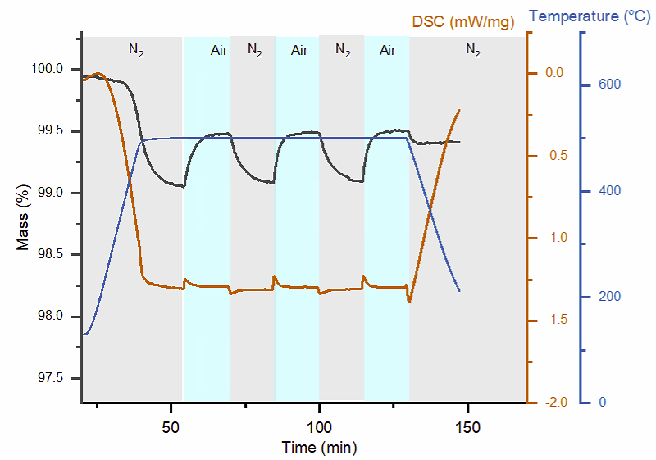
b)
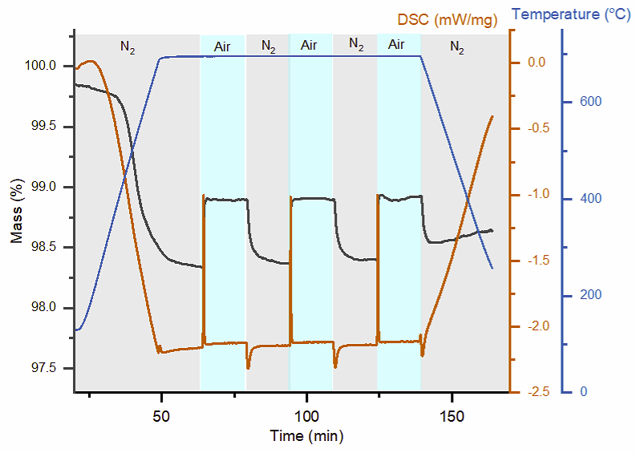
c)
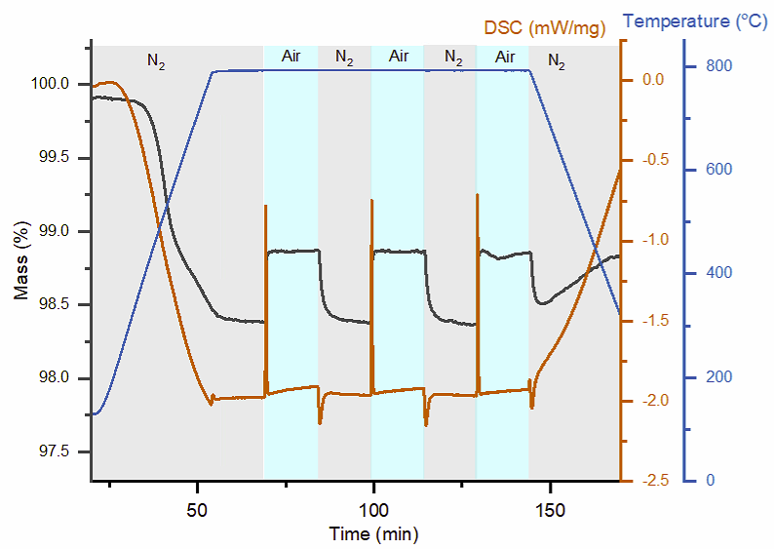

Supplementary Figure 5. Isothermal cycling data for SrCo_{0.9}Sb_{0.1}O_{3-δ} at a) 500 °C, b) 700 °C and c) 800 °C.

a)
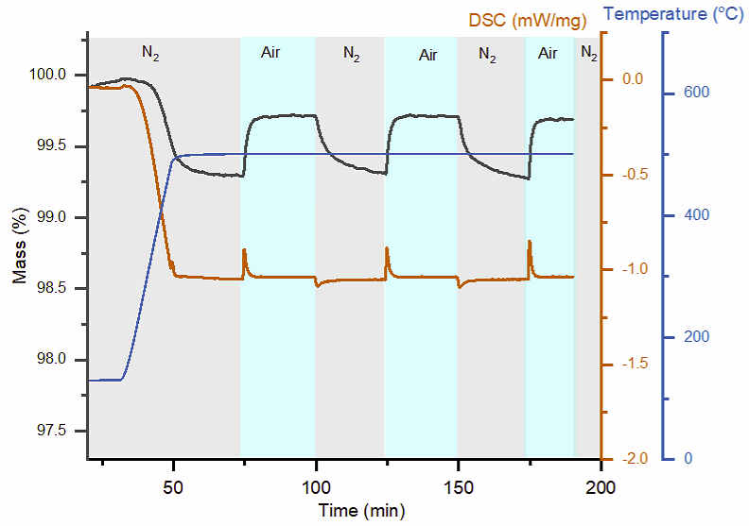
b)
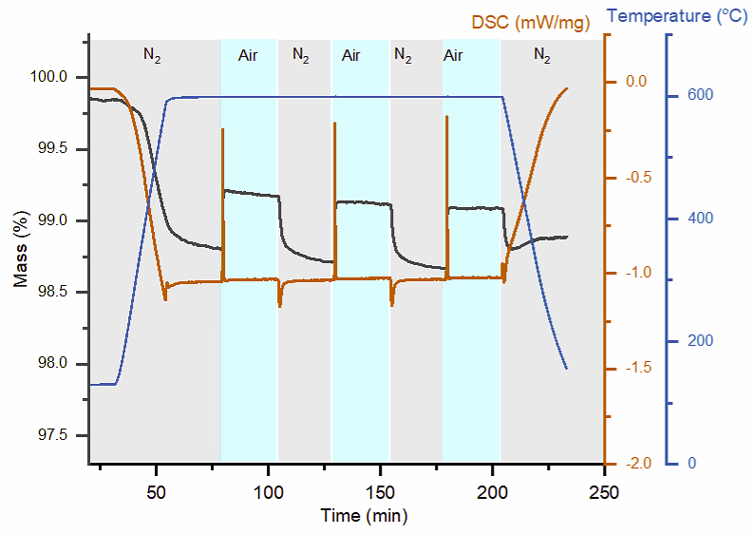
c)
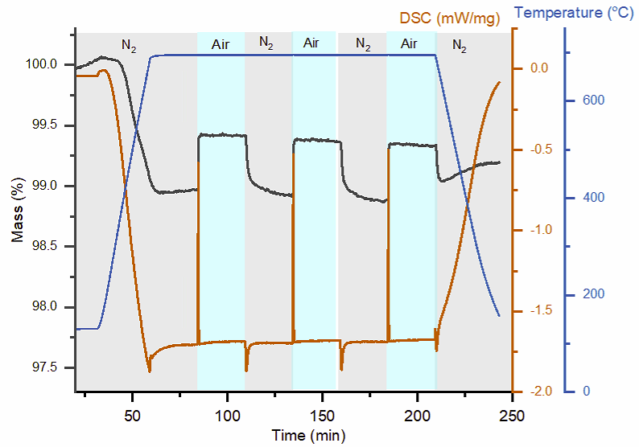
d)
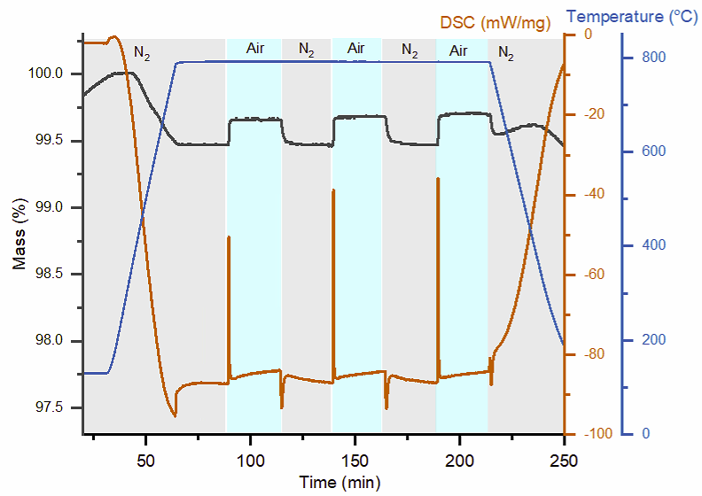
Supplementary Figure 6. Isothermal cycling data for SrCo_{0.80}Sb_{0.20}O_{3-δ} at a) 500 °C, b) 600 °C, c) 700 °C and d) 800 °C.

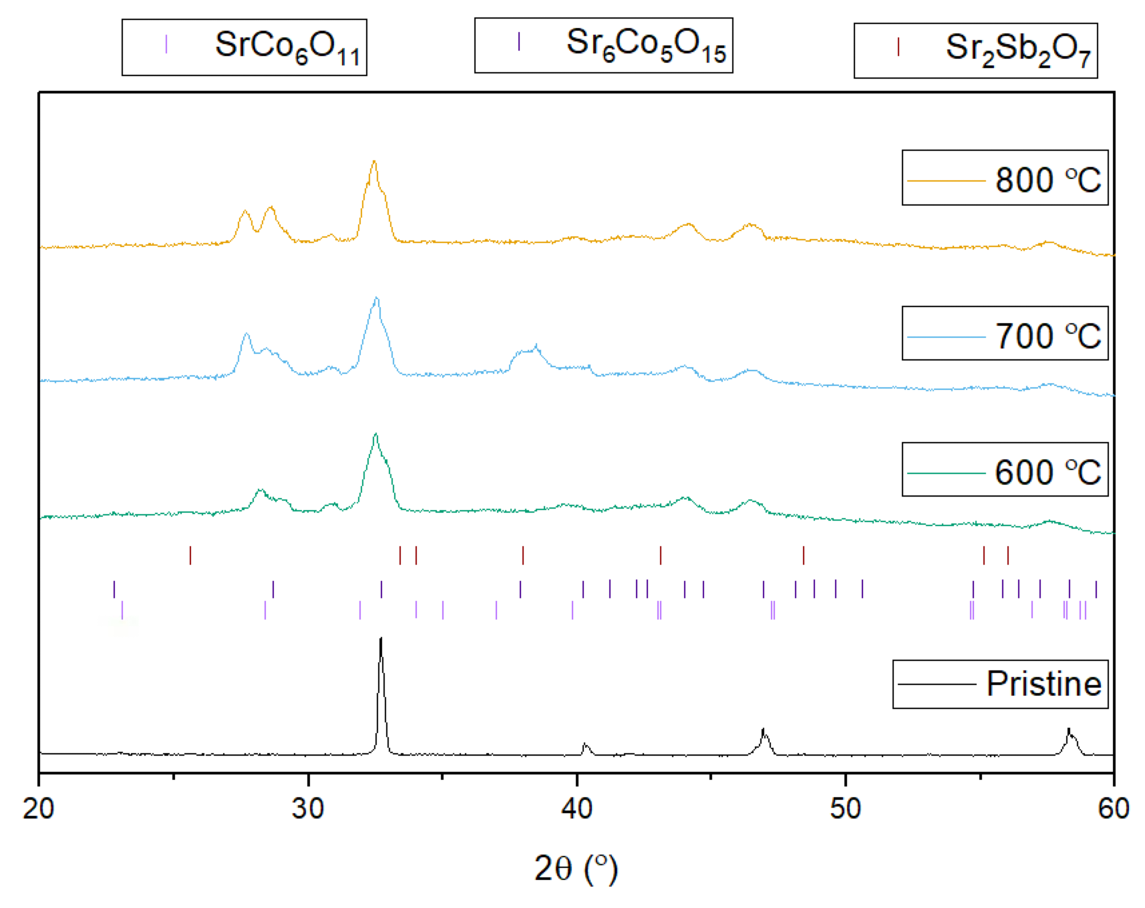
Supplementary Figure 7. Comparison between XRD patterns of 5% Sb compound after 3 redox cycles.
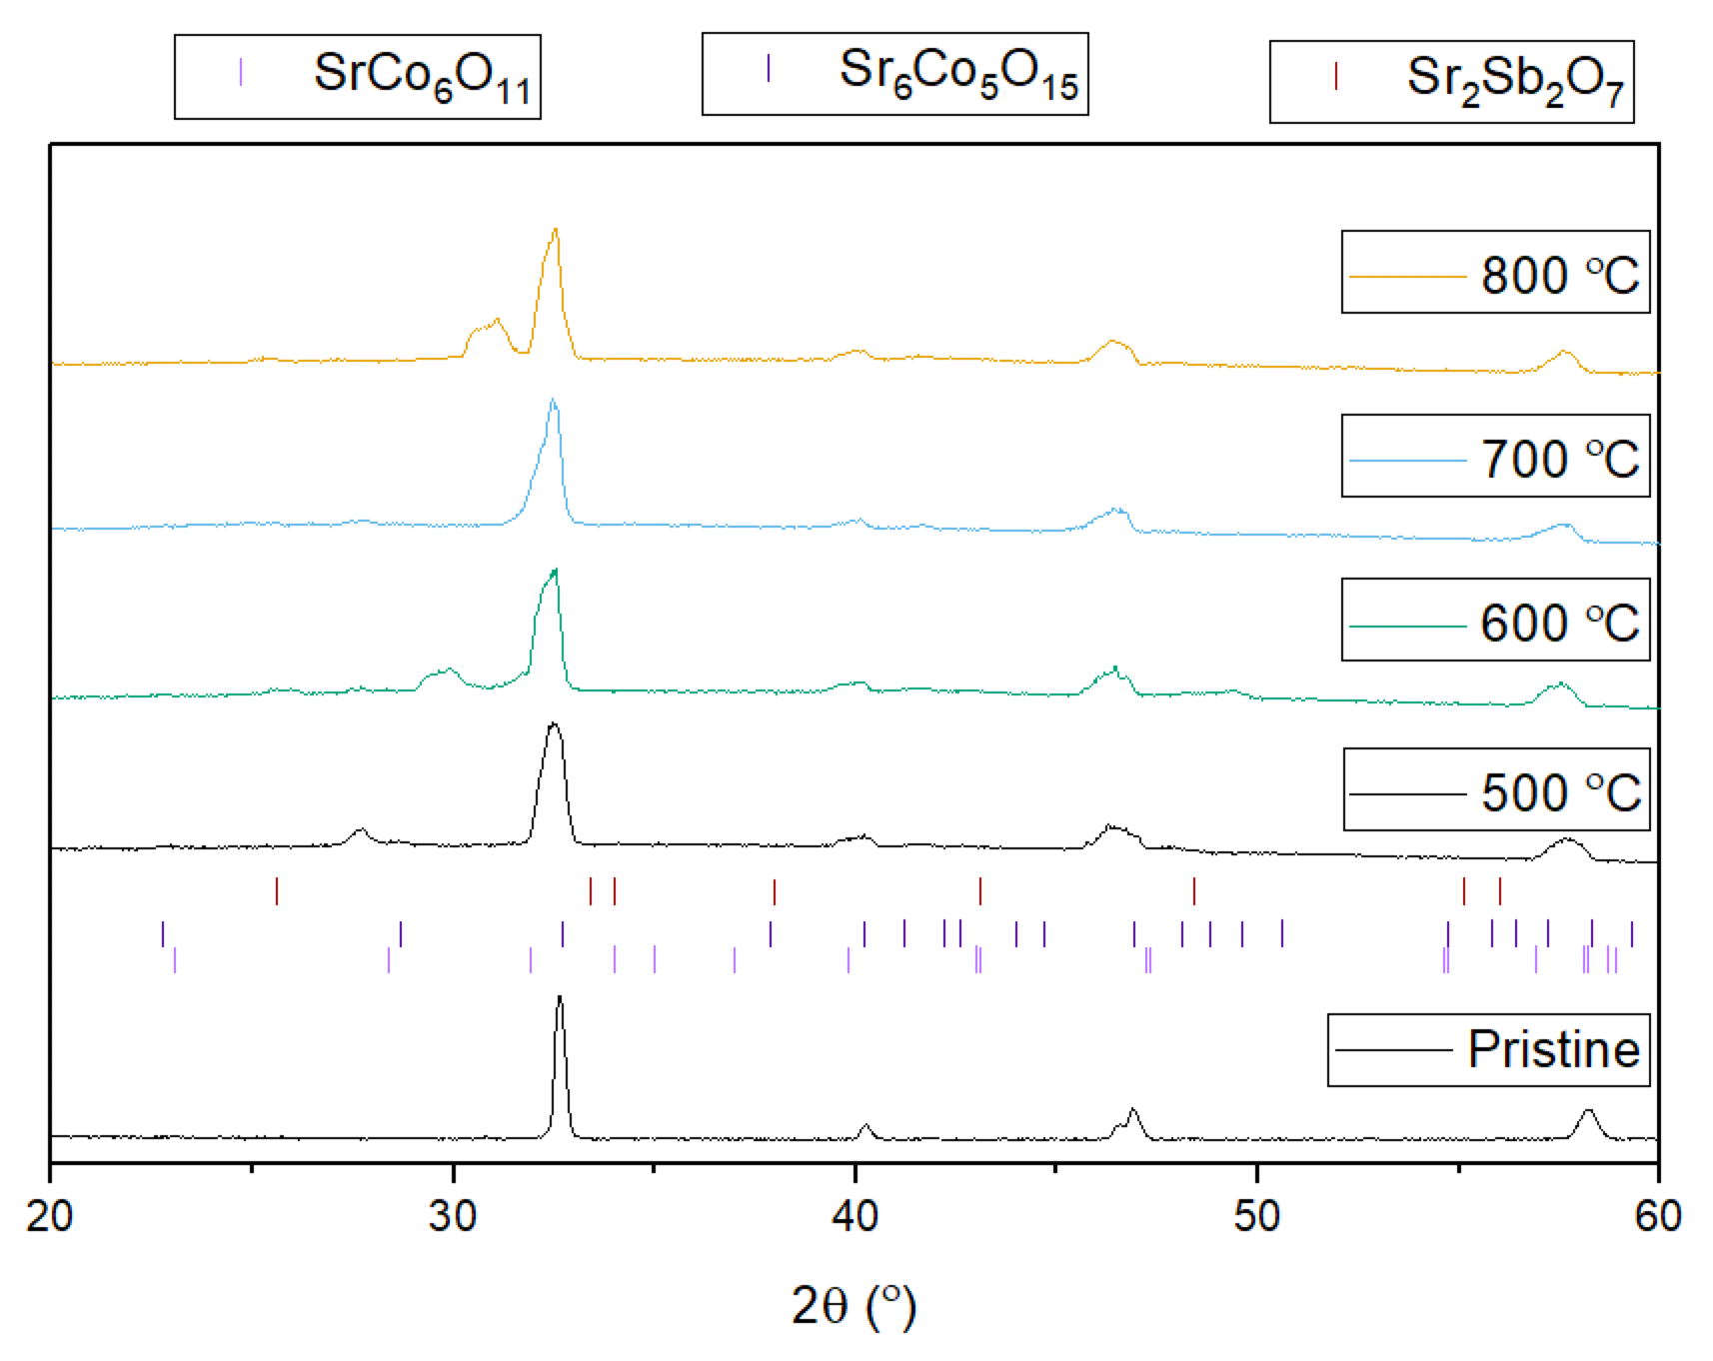

Supplementary Figure 8. Comparison between XRD patterns of 10% Sb compound after 3 redox cycles.
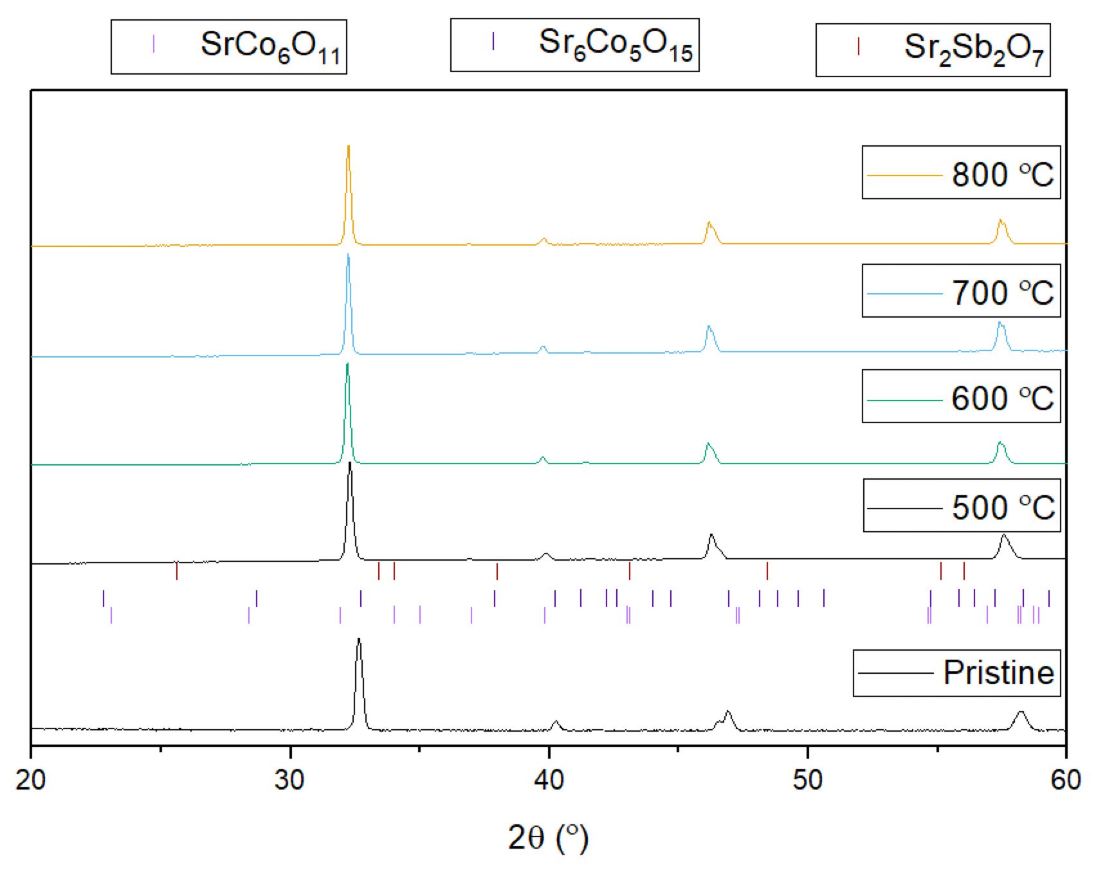
Supplementary Figure 9. Comparison between XRD patterns of 20% Sb compound after 3 redox cycles.

