Performance of Ti/Zr and silane coating pretreatments on adhesive bonding of an automotive aluminium alloy produced using the Hot Form Quench (HFQ®) process
Fengzhen Sun ª, Michael Kenyon ^{b}, Chris Pargeter ^{b}, Junjie Wang ^{b}, Ceri Williams ^{b}, Catalin I. Pruncu ª, Bamber R. K. Blackman ª*, Adrian Tautscher ^{c}
a. Department of Mechanical Engineering, Imperial College London, Exhibition Road, London SW7 2AZ, UK.
b. Innoval Technology Ltd, Beaumont Close, Banbury, Oxfordshire OX16 1TQ, UK.
c. Impression Technologies Ltd, Unit E Lyons Park, 46 Sayer Drive, Coventry CV5 9PF, UK

* Correspondence to: b.blackman@imperial.ac.uk (B.R.K.B.)

Abstract
Surface pretreatments of an automotive aluminium alloy delivered in F temper and subsequently processed using Hot Form Quench (HFQ®), a novel press forming technique combining solution heat treatment, press forming and in-die quenching to produce high-strength aluminium alloys, for adhesive bonding have been explored. The performance of two commercial pretreatments including Ti/Zr and silane coatings, with either acid spray or alkaline immersion cleaning, was investigated. Scanning electron microscopy (SEM), Fourier-transform infrared spectroscopy (FTIR) and transmission electron microscopy (TEM) were employed to characterize the surface chemistry and topography of the alloy after pretreatments. Adhesively bonded aluminium-aluminium single lap shear joints and double cantilever beam specimens were tested to evaluate the performance of the pretreatments on the bonding strength and fracture resistance, respectively. The FTIR and TEM techniques show that the natural oxides and near-surface deformed layer have been successfully removed, but the surface cleanliness level was sensitive to the cleaning approach adopted. New Ti/Zr oxide layers or silane films have been built upon the aluminium surfaces, which confirms that sound surface conditions for adhesive bonding can be obtained for parts produced using HFQ® from F temper input material.
Keywords: Surface pretreatments, Ti/Zr coating, Silane coating, Hot stamping, Adhesive bonding

1. Introduction
Adhesive bonding is a reliable light-weighting technique for joining metals, plastics, composites, etc., which has been extensively used in automotive sectors to join a variety of components including closures and structural modules [1], realising a significant weight reduction, an increase of the body stiffness and an enhancement of the crash performance [2]. In order to create strong and durable bonds between the components, it is essential to apply effective and reliable pretreatments to the surfaces of components, with the aims of: (1) removal of contaminants and oxides formed during component manufacturing or exposure to a humid atmosphere; (2) protecting the substrate surface prior to bonding and maximising the degree of intimate molecular contact between adhesives and substrates; (3) generation of a stable surface topography for optimum mechanical interlocking; (4) formation of a passive barrier to improve the durability and corrosion resistance of the bonded interfaces.
For automotive applications, aluminium surfaces are mainly treated using chemical conversion coating methods, which generally can be classified into (i) chromate-based and phosphate-based, (ii) titanium and/or zirconium oxide based, and (iii) silicon-based pretreatments [3]. The Cr-based pretreatments have excellent properties against corrosion but now are restricted worldwide and are largely phased-out due to the toxic and carcinogenic nature of the Cr⁺⁶ ions. The Ti/Zr based pretreatments (contains hexafluorotitanic acid (H₂TiF₆) and/or hexafluorozirconic acid (H₂ZrF₆) [4]) belong to the most important alternative systems that have achieved a maturity level for commercial utilization and are becoming increasingly favoured as stabilizing treatments for automotive inners and outers [5]. The Si-based pretreatments (silanes, silanols), which are being exploited for applications requiring full structural adhesive bonding and have emerged as a potentially valuable alternative to the use of phosphates and chromates [6]. Silanes (the general formula is R’–(CH₂)_{n}–Si–(OR)₃, where R’ is the organofunctional group and OR is the hydrolysable alkoxy group [7]) can be converted to hydrophilic silanol groups (Si-OH) after hydrolysis in the presence of water, which present in the adsorbed structure and form siloxane chains (Si-O-Si) to hinder the penetration of aggressive agents towards the substrate [8].
Recently, a novel rapid forming technique termed hot form quench (HFQ®) has been developed for manufacturing high-strength AA2xxx, AA6xxx and AA7xxx aluminium alloys for automotive and aeronautical applications [9–12]. This hot stamping technique combines solution heat treatment (SHT), press forming and simultaneous in-die quenching in one operation [12]. As illustrated in Fig. 1, in this process the aluminium blank is firstly heated to the SHT temperature to allow the alloying elements (or precipitates) to dissolve in the aluminium matrix, achieving the maximum ductility for forming. The hot blank is then transferred to cold dies, formed at a high speed and quenched within the cold dies immediately, generating the microstructure of a supersaturated solid solution. The formed components can be artificially aged to allow the formation of finely dispersed precipitates to improve the mechanical strength. This technique has gained favour over conventional cold forming, for instance the high formability and the elimination of spring-back problems, which enables the replacement of ferrous materials by high-strength aluminium alloys. However, surface pretreatments of aluminium alloys produced by HFQ® for adhesive bonding is so far unclear as most existing pretreatments deal with the alloys formed by conventional cold press forming. The HFQ® process requires lubrication of the press forming tools to facilitate the large deformations occurr in the work material, which brings new challenges for the surface pretreatment and adhesive bonding. The main challenges include: (i) removal of the near-surface deformed layer on the rolled sheets [2,13], which has nano-sized grains with their grain boundaries decorated and pinned by rolled-in oxide particles and lubricant residues; (ii) removal of the residual lubricant, which acts as weak boundary layers in adhesive joints, and (iii) the generation of a surface highly amenable to adhesive bonding. Although some modern adhesives (particularly acrylics, hot-cured epoxies and solvent-based formulations) will dissolve or displace the lubricants [14,15], the absorbed organic contaminants can degrade the polymer next to the interface, potentially leading to a loss of the mechanical performance [16]. HFQ® formed components usually have varying amounts of residual lubricant across the surfaces, imposing extra challenges for the surface pretreatment as intensive cleaning may be needed. However, excessive cleaning can also cause many problems, such as the copper re-deposition/enrichment on the surface of AA6xxx alloys, which is detrimental to the corrosion resistance [17]. Due to these abovementioned difficulties, it is quite challenging to pretreat the aluminium alloys produced using the HFQ® process. To the authors’ knowledge, there has not been any published work reporting on the surface pretreatment and adhesive bonding of aluminium alloys produced using the HFQ® process. It is therefore important to explore environment-friendly pretreatments for aluminium alloys produced using HFQ®, paving the way for this novel forming technology to be exploited in the manufacturing of lightweight structures.
In this work, surface coating pretreatment and adhesive bonding of an automotive aluminium alloy produced using HFQ® have been conducted, which is the first study reporting on these aspects, with the aim being to explore the potential of commercial Ti/Zr and silane based pretreatments on aluminium alloy specimens produced using this novel technique. The formed aluminium alloy components were cleaned by either acid spray or alkaline immersion approaches, and then were pretreated with either Ti/Zr or silane coatings. The surface topography and chemistry of the alloy after pretreatments were characterized using scanning electron microscopy (SEM), Fourier-transform infrared spectroscopy (FTIR) and transmission electron microscopy (TEM). The effects of the pretreatments on the strength and fracture resistance of bonded surfaces were examined. Finally, the performance of the selected pretreatments for adhesive bonding of aluminium alloys produced by HFQ® technique were discussed.
Fig. 1. Schematic of the HFQ® process for manufacturing sheet aluminium alloys.

2. Experimental
2.1. HFQ® forming
AA6111 - F temper rolled sheets (Novelis UK) with a gauge thickness of 2.5 mm, in mill finish surface condition, were chosen to fabricate components using the HFQ® technique. The HFQ® forming was conducted using a tool with a large flat surface, which was suitable for making test coupons. Firstly, the trimmed AA6111 blank was heated to the target SHT temperature in a furnace and held for sufficient time to allow the alloying elements (or precipitates) to dissolve in the aluminium matrix, the resulting solid solution having the maximal ductility for forming. A water-based lubricant was applied to the dies using an automated spray system. Secondly, the hot blank was quickly placed in the forming tool using a transfer robot. The top die moved downwards rapidly and pressed the blank to form the component. The component was then held in the cold die immediately to quench below the Guinier-Preston (GP) solvus temperature. After quenching, the dies were separated to allow the component to be removed. Finally, the panels were artificially aged in a furnace to form finely dispersed precipitates to improve the overall mechanical properties, i.e., the T6 heat treatment.
2.3 Surface pretreatments
2.3.1 Test matrix
The bonding performance of aluminium alloys produced using HFQ® depends upon many factors such as the forming parameters and surface pretreatments. The HFQ® processing parameters are usually optimized for the specific manufacturing tasks, and thus their effects are not considered. The main interests in this study are the surface cleaning and coating applied to the formed components.
The pretreatment study involves multistage processes of alkaline/acid cleaning, deoxidation and deposition of conversion coatings, as summarized in Table 1. The cleaning processes used were either a phosphoric acid (PA) spray followed with a PA immersion etch, or an alkaline (ALK) immersion cleaning with a following PA etch. The chemical solutions (supplied by Chemetall Ltd) and the processing times used are given in Table 2. The processing time was pre-determined through an optimization study, with a target of giving the surfaces a sufficient and thorough cleaning, without causing over cleaning (by analysing the content of Cu).
Table 1. Test matrix for the surface pretreatment.
 | Cleaning processes | Coating processes
1 | PA spray + PA etch | Ti/Zr
2 | PA spray + PA etch | Silane
3 | ALK immersion + PA etch | Ti/Zr
4 | ALK immersion + PA etch | Silane

Table 2. The chemical solutions used for the cleaning and coating processes.
Process | Chemical solutions  (commercial name) | Physical and chemical property | Processing time
PA spray | ITL acid washing solution (Impression Technologies Ltd) |  | 2 mins
ALK immersion | Gardoclean® T 5281 (60g/L, 55°C; Chemetall) | Density (20°C): ~1.1 g/cm³,  pH (50 g/L, 20°C): ~9.6 | 15 mins
PA etch | Gardoclean® S 5243 (140 g/L, 50°C; Chemetall) | Density (20°C): ~1.43 g/cm³,  pH (250 g/L, 20°C): ~1 | 4 mins immersion etch after PA spray;  2 mins immersion etch after ALK immersion
Ti/Zr | Gardobond® X 4591 (50g/L, 50°C; Chemetall) | Density (20°C): ~50 g/L³  pH (20°C, glass electrode): 3.6-4.2 | 30 s
Silane | Oxsilan® AL 0510 (11g/L, ambient; Chemetall) | Density (20°C): ~1.0 g/cm³,  pH (10 g/L, 20°C, glass electrode): ~4.3 | 2 mins

2.3.2 Pretreatment procedures
The pretreatment sequences are illustrated in Fig. 2. The PA spray cleaning was performed in an industrial high-pressure washing system using a phosphoric acid solution (ITL acid; Impression Technologies Ltd). The ALK immersion cleaning was performed in a recirculating tank filled with a NaOH based solution (Gardoclean® T 5281; Chemetall). These two cleaning processes were expected to attack the original aluminium oxide/hydroxide layers, removing the stubborn oils, greases and lubricants introduced during manufacturing. The subsequent PA etch was conducted by immersing the component in a phosphoric acid solution (Gardoclean® S 5243; Chemetall), aiming at a thorough removal of the natural oxides and near-surface deformed layer generated during sheet rolling. After the etching process, the specimens were cleaned in a de-smut system (Gardacid P 4403; Chemetall) to remove oxides, hydroxides and intermetallic compounds (smut) formed on the aluminium surfaces in the above processes. The Ti/Zr coating was conducted with the Gardobond® X 4591 solution (Chemetall), which consists mainly of hexafluorozirconates and hexafluorotitanates [18].The silane coating was processed with the Oxsilan® AL 0510 solution (Chemetall), which is a surface coating system for sheet material and profiles made from aluminium and its alloys, containing 2-aminoethyl-3-amino-propyltrimethoxysilane and bis(trimethoxysilylpropyl)amine (the bath make-up also contains 11.2 g/L Oxsilan® Additive 9905, a replenisher solution for the Oxsilan® bath, which contains fluoride, a zirconium compound and a manganese compound). Prior to the coating, the silane bath was allowed to age for 2 hours to be able to ensure that a chemical equilibrium was established. After the coating processes, the specimens were dried at 100°C for 5 minutes in a forced-air drying oven. The two conversion coatings were expected to build up uniform inorganic and organic layers respectively on the aluminium surface to improve the adhesion to adhesives/paints and the corrosion resistance.
Fig. 2. The pretreatment processes applied to the aluminium alloy produced by HFQ®.
2.4. Surface characterization
After surface pretreatments, the samples were cut from the components for surface analysis. The pretreatment films were examined using a Nicolet iZ10 FTIR with a grazing angle (80°) surface reflectance accessory, coupled with a ZnSe polariser. SEM was used to initially investigate the surface condition between the “PA spray + PA etch” and “ALK immersion + PA etch” cleaning. Secondary electron images of the surface in planar view were taken at a voltage of 8 kV in a JEOL 5600F microscope. Electron transparent cross-sections with a nominal thickness of 15 nm were produced by ultramicrotomy. The cross-sections were analysed using a Jeol 2100 TEM at an accelerating voltage of 200 kV to examine the thickness, continuity and morphology of the pretreatment film. The near-surface microstructure of the aluminium substrate was also characterised to evaluate the surface cleanliness, i.e., by successfully removing the majority of the near-surface deformed layer.
2.5. Adhesive bonding and mechanical testing
An epoxy based structural adhesive used widely in the automotive industry, SikaPower®-497 (Sika AG, Switzerland), was chosen to bond the pretreated aluminum substrates. The performance of surface pretreatments on adhesive bonding was evaluated by single lap shear (SLS) and double cantilever beam (DCB) tests, which measure the shear strength and the mode I (opening mode) fracture resistance (fracture toughness) of the bonded joint, respectively.
The ASTM D1002 standard [19] was followed to make the SLS joints. The substrate of the joint was of a length of 101.6 mm, a width of 25.4 mm, and the joining overlap length of 12.5 mm. The thickness of bondline was kept constant at 0.35 mm using glass beads. The substrates were assembled in a jig to make joints, with end tabs being attached simultaneously to reduce the specimen rotation during loading due to the configurational asymmetry. Five replicates were manufactured for each surface pretreatment. The tests were performed on a servo hydraulic InstronTM 8801 machine, at a loading rate of 1.3 mm/min, and the load-displacement measurements were recorded.
The DCB specimens were prepared and tested by following the ISO 25217 standard [20]. To ensure the validity of Linear Elastic Fracture Mechanics in the DCB tests, the formed AA6111 substrates (150 mm × 20 mm × 2.5 mm) were reinforced by bonding 10 mm thick AA6082 backing beams to avoid plastic deformation of the sheet substrates. The bondline thickness of the joint was controlled at 0.31 mm by inserting copper wires at each end of a joint during manufacture. An initial crack was introduced in the joint by placing a PTFE foil (thickness of 12.5 µm) on the adhesive surface, with the initial crack length being 40 mm from the load-line. Aluminium blocks (13 mm × 20 mm × 20 mm) were bonded to the pre-cracked end of the joint for load application. One lateral side of each joint was painted with fine white and black sprays to make trackable patterns for digital image correlation (DIC) analysis. For each surface pretreatment, 3 replicates were made for the determination of the fracture toughness. The DCB tests were performed on an InstronTM 5584 machine installed with a 10 kN load cell, and the loading rate employed was 0.5 mm/min. The J-integral approach was adopted to measure the mode I fracture toughness [21,22], i.e., $J_{I}={P\left(ω_{u}+ω_{l}\right)}/b$, where P is the external load, b is the width of the joint, ω_{u} and ω_{l} are the in-plane rotations of the upper and lower substrates of the joint at the load points respectively. More details about the determination of the values of ω can be found in Ref [23].
Fig. 3. (a) The SLS test for the measurement of the shear strength, and (b) the DCB test for the measurement of the fracture toughness.
3. Results and discussion
3.1. Surface chemistry and morphology
3.1.1. FTIR analysis
Analysis of the surface chemistry of the as-received sample after HFQ® forming is shown in Fig. 4a, together with the analysis result of the lubricant used in the forming process. The FTIR spectra of the as-received sample showed absorbance peaks mainly associated with C-H, Si-O-Si, Si-CH₃, C=O and O-H groups, all of which were present in the forming lubricant. The presence of silicon and carbon containing groups on the as-received surface, which are potential surface contaminants from mould release compounds [24], clearly indicated surface contamination due to the lubricants applied in the forming process. Hydroxyl (O-H) groups are frequently observed on metal surfaces. It is well known that the rapid oxidation of the freshly generated aluminium surfaces provides a protective layer of alumina (Al₂O₃) to prevent the surface from atmospheric degradation. Alumina surfaces exposed to atmospheric moisture are terminated by a densely packed monolayer of hydroxyl (O-H) groups [25], which are strongly bound via Al-O bonds to the alumina surface providing a hydrogen bond (H-bond) donor function for chemical bonding to H-bond receptor groups such as the hydroxyl groups and ether groups in an epoxy resin [26]. The oxygen containing groups of carbonyl (C=O), originated from the lubricants as affirmed by the spectra, are typical functional groups associated with the improvement of surface energy and wettability [13]. The peak at ~1710 cm⁻¹ related to the presence of carboxylic acid, while the doublet at ~1640 cm⁻¹ and ~1560 cm⁻¹ corresponded to carboxylate soap, a known constituent of the forming lubricant. The C-H bonds at lower wavenumber (~1450 cm⁻¹ and ~1375 cm⁻¹) were characteristic of all hydrocarbons. After surface cleaning and application of the Ti/Zr based pretreatment, there was no evidence of silicon-based peaks detected on the surface, indicating effective removal of the residual lubricant layer by all the cleaning regimes, as shown in Fig. 4b. Compared to the as-received surface, the pretreated surface had a high hydroxyl group (O-H) peak absorbance. This indicates that a more hydrophilic surface has been generated since hydrophilic surfaces can essentially be characterized by the concentration of surface hydroxyl groups [27]. Hydrocarbon peaks (C-H bonds) were observed on the pretreated surface. It is worth noting that the carbon content can be originated from (1) the Ti/Zr coating solution, which usually contains organic additives and surfactants to assist surface wetting and promote the adhesion of organic coatings applied on top of the pretreatment layer [28], and (2) the adsorbed atmospheric contamination occurring after coating. In particular, zirconium is known to form oxy-hydroxy polymers across a wide range of pH that bind effectively with the freshly cleaned aluminium surface. Most importantly, peaks relating to Ti-O and Zr-O were clearly detected in the surface layer, indicating that a Ti/Zr oxide film may have been successfully built on the aluminium surfaces. For these types of pretreatment peaks due to Ti-O generally appeared in the range 500 -1000 cm⁻¹, with the most prominent at ~720 cm⁻¹, while the peak due to Zr-O was located at ~680 cm⁻¹.
The FTIR spectra of the surfaces with the silane based pretreatment are displayed in Fig. 4c. Again, the pretreated surface had a high hydroxyl group (O-H) peak absorbance compared to the as-received surface. The spectra also confirmed the presence of Si-O-Si and Si-CH₃ groups located at ~1160 cm⁻¹ and ~1320 cm⁻¹ respectively, the single, broad Si-O-Si peak shape points to it being due to silane and not siloxane (doublet). As mentioned in the Introduction, the general formula of silanes is R’–(CH₂)_{n}–Si–(OR)₃ (R’= organofunctional group, and OR = hydrolysable alkoxy group). The (OR)₃ groups are capable of hydrolysing, generating silanol (Si–OH) and reacting with the hydroxyl groups on the alloy substrate. Therefore, the Si-O-Si and Si-CH₃ groups on the pretreated surfaces indicated that a substantial silane-based layer may have been built on the aluminium surfaces as anticipated. It is noted that the commercial silane based pretreatment liquid usually contains zirconium, in the form of hexafluorozirconic acid and this is confirmed by the presence of the Zr-O bond and elevated O-H bond vibrations in Fig. 4c.
Compared to the surfaces given the “ALK immersion + PA etch” cleaning, the surfaces that underwent the “PA spray + PA etch” cleaning appeared to result in marginally more effective pretreatment layers, with slightly higher peak absorbance of Ti-O bonds from the Ti/Zr pretreatment in Fig. 4b and of Si-O-Si bonds from the silane pretreatment (Fig. 4c). This implies that the “PA spray + PA etch” cleaning probably would lead to a more favourable surface condition for adhesive bonding compared to the “ALK immersion + PA etch” cleaning.
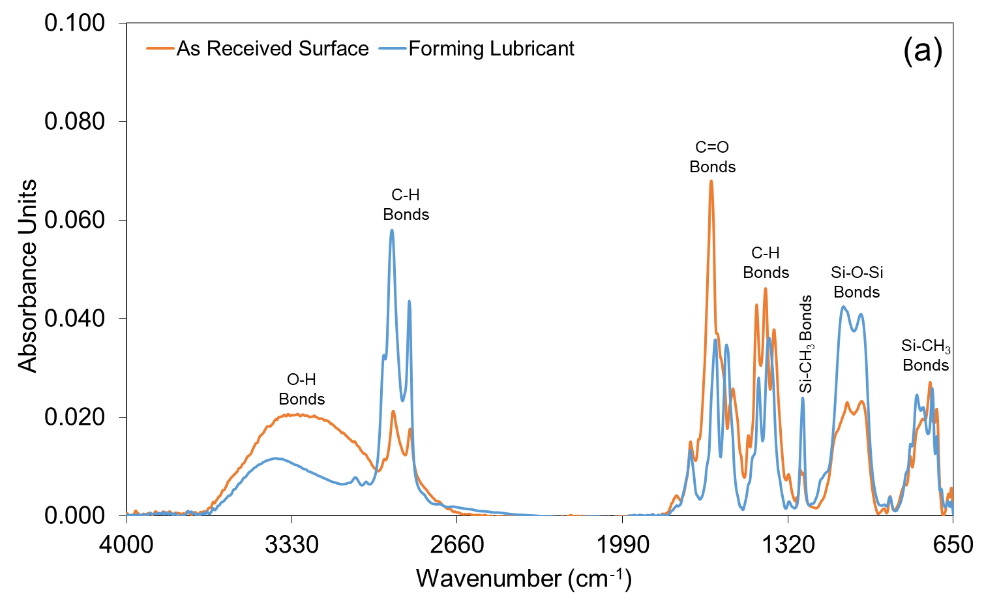
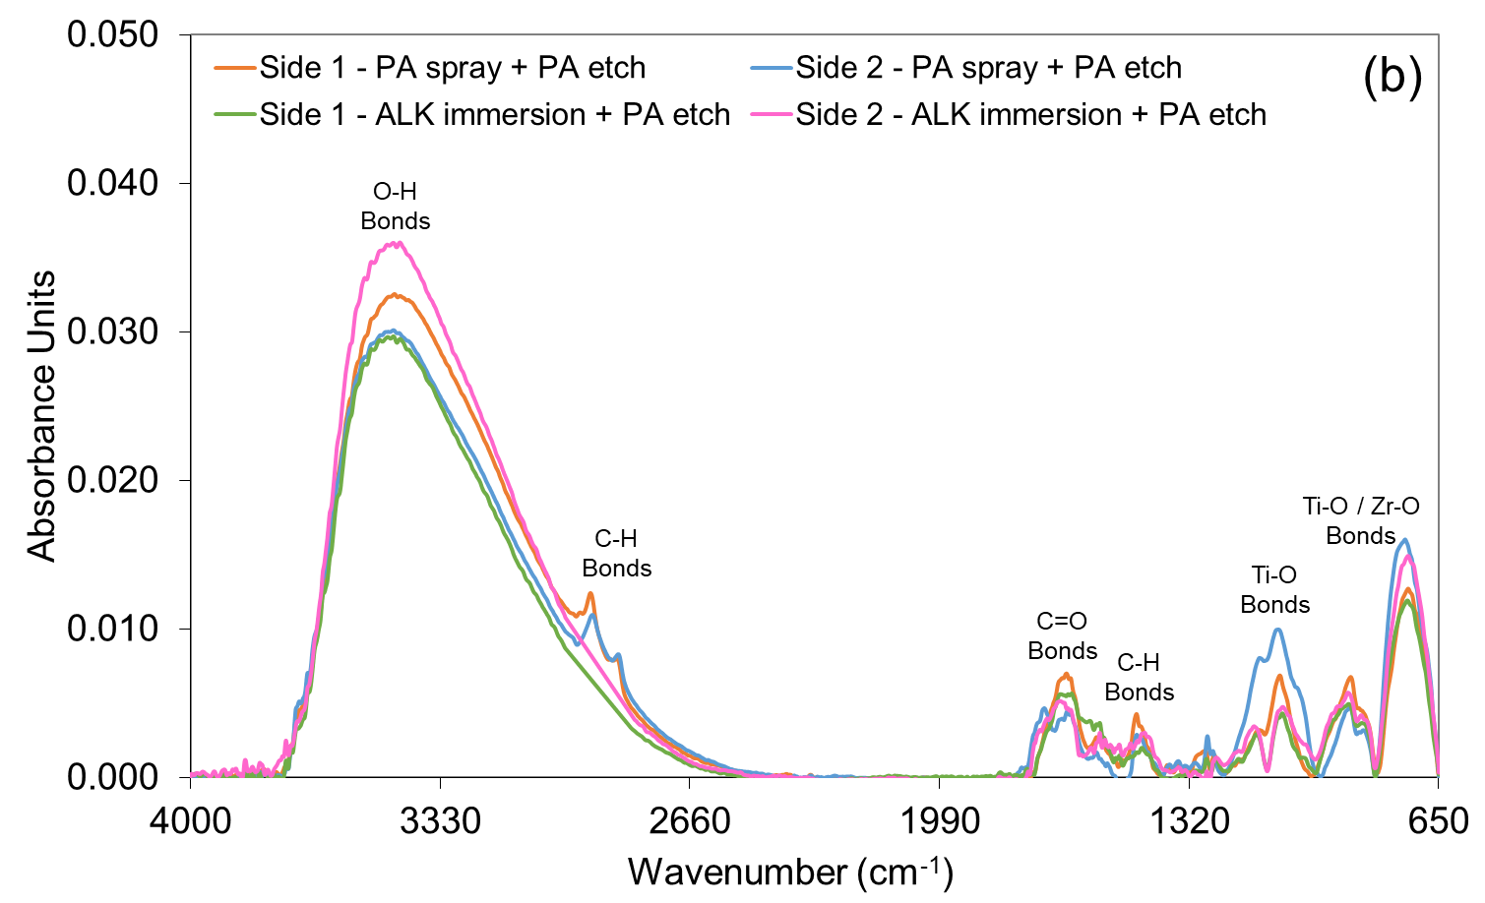
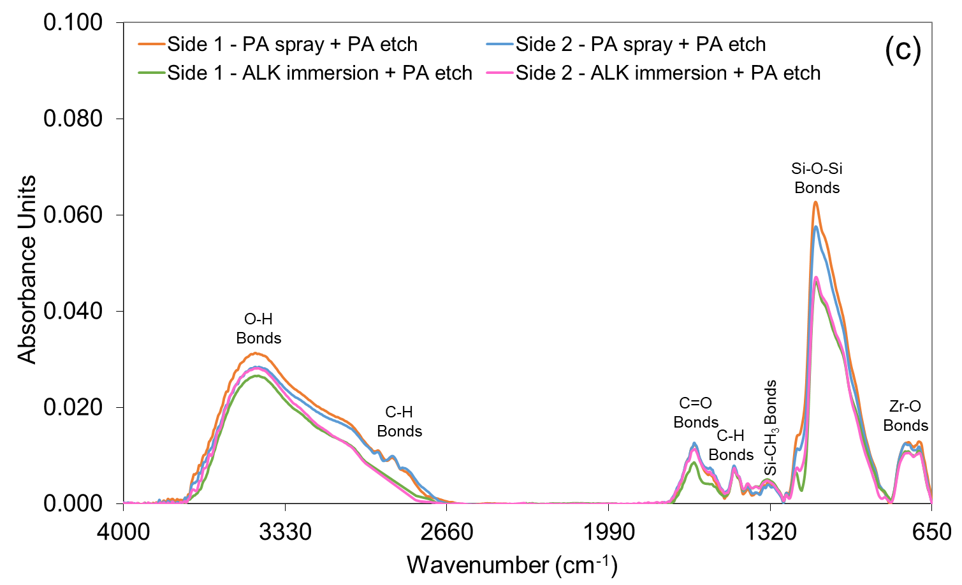
Fig. 4 FTIR spectra of the aluminium surfaces with (a) lubricant residue after HFQ® forming, (b) the Ti/Zr pretreatment and (c) the silane pretreatment.
3.1.2. SEM analysis
Fig. 5 shows the difference in surface finish of the aluminium alloy with different cleaning and coating processes. For the “PA spray + PA etch” and “ALK immersion + PA etch” cleaning, both samples showed an attack of the surface with the presence of surface pores. This indicates a reaction with and potential removal of the near surface deformed layer on the rolled sheet.
The majority of the relatively coarse pores were associated with the intermetallic particles in the AA6111 substrate, especially cathodic intermetallic particles, such as iron bearing Al(FeMn)Si, etc. These cathodic particles formed micro-galvanic couples with the surrounding aluminium matrix (which act as the anode). During chemical etching, the aluminium matrix was etched preferentially around the cathodic particles, trenching around particles, as can be seen from Fig. 5a. Once all the surrounding Al matrix had been consumed, the particle was released to the solution, leaving a pore on the etched surface. The very fine pores can be seen from Fig. 5c resulted from the removal of oxide particles by the acid etching. A high population density of aluminium oxide particles with the size of 30 – 150 nm could be incorporated into the surface/near-surface region of the aluminium sheet during upstream manufacturing of the sheet material, i.e., the rolling process. Aluminium oxide particles are preferentially removed by acid etching compared to the aluminium matrix, leaving nano-sized pores on the sheet surface.
Between the two cleaning processes, the “PA spray + PA etch” cleaning method visually exhibited a higher level of surface attack as shown in Fig. 5a. This probably was due to the use of the high-pressure spray and the longer duration of acid etching, both of which facilitated the removal of the surface oxides. After either the Ti/Zr or silane coating, all the “PA spray + PA etch” cleaned samples showed a higher level of surface attack compared to those underwent the “ALK immersion + PA etch” cleaning, as shown in Fig. 5(c-f). According to the Fig. 5, the “PA spray + PA etch” cleaned surfaces appeared to be rougher than the “ALK immersion + PA etch” cleaned surfaces. The rougher surface generated could potentially hold more coatings due to its increased surface area as well as providing additional mechanical interlocking, both of which would promote the adhesion between the adhesive and substrate.
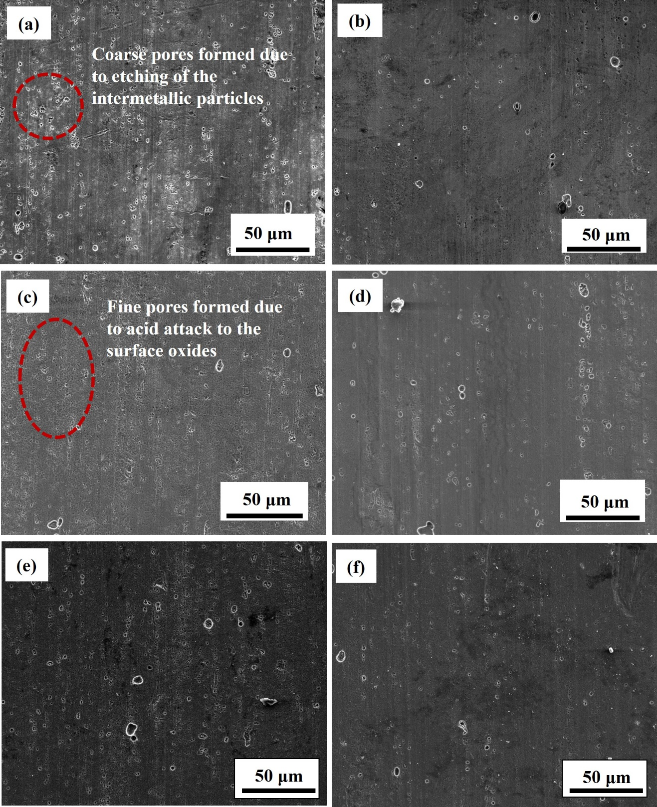
Fig 5. Secondary electron micrographs showing the sample surface following (a) “PA spray + PA etch” cleaning, (b) “ALK immersion + PA etch” cleaning, (c) “PA spray + PA etch + Ti/Zr”, (d) “ALK immersion + PA etch + Ti/Zr”, (e) “PA spray + PA etch + Silane”, and (f) “ALK immersion + PA etch + Silane”.
3.1.3 TEM analysis
TEM micrographs in Fig. 6 show the surface region of ultramicrotomed cross-sections of the aluminium samples in various surface conditions. A near-surface deformed layer with a thickness up to 300-400 nm was found as expected on the HFQ® processed and aged substrate, shown in Fig. 6a. After the “PA spray + PA etch” cleaning, all of the near-surface deformed layer was removed. There was only a 6 nm thickness oxide film formed naturally on the alloy surface after cleaning as shown in Fig. 6b. There was no evidence of any significant Cu redeposition that would indicate over cleaning of the surface. In general, the cleaning in all samples removed the near-surface deformed layer from the alloy surface.
The “PA spray + PA etch + Ti/Zr” pretreated surface showed that part of the alloy surface was covered by the Ti/Zr film with the thickness about 40 nm (Fig. 6c). The EDX analysis affirmed the presence of Ti/Zr elements in the pretreatment film (Fig. 7). However, the reminder surface was associated with natural oxide films, which could be an indication of either poor formation of the pretreatment film or poor adhesion of the film to the alloy substrate (the film might have detached from the substrate during the ultramicrotomy process during cross-section preparation). The “PA spray + PA etch + Silane” pretreated surface in Fig. 6d shows a continuous barrier film on the alloy surface with 20 - 30 nm thickness. However, a pretreatment layer up to 300 nm in thickness with a porous structure and agglomerates was found on top of the barrier film. This could have resulted from preservation of excessive pretreatment solution on the alloy surface during the pretreatment process. The presence of such a porous structured pretreatment layer and agglomerates is detrimental to the bond strength and durability. The “ALK immersion + PA etch + Ti/Zr” pretreated surface showed a continuous pretreatment film with varying thickness in the range of 30 – 120 nm (Fig. 6e). The “ALK immersion + PA etch + Silane” pretreated surface (Fig. 6f) showed similar film morphology as the “PA spray + PA etch” variant (Fig. 6d).
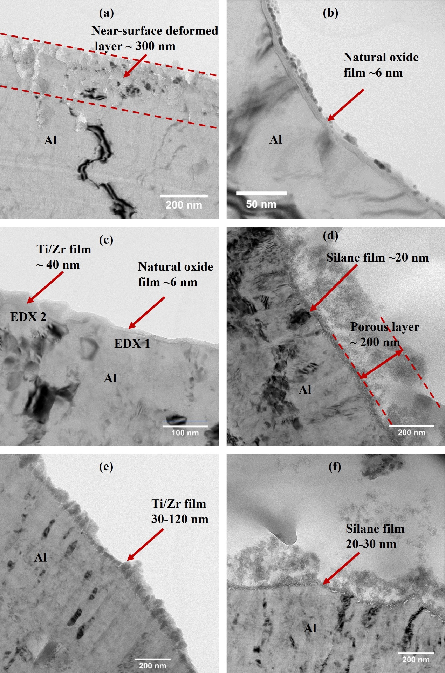

Fig. 6. Bright field TEM images showing the aluminium surface in various surface conditions: (a) “HFQ® + T6”, (b) “PA spray + PA etch”, (c) “PA spray + PA etch + Ti/Zr”, (d) “PA spray + PA etch + Silane”, (e) “ALK immersion + PA etch + Ti/Zr”, (f) “ALK immersion + PA etch + Silane”.
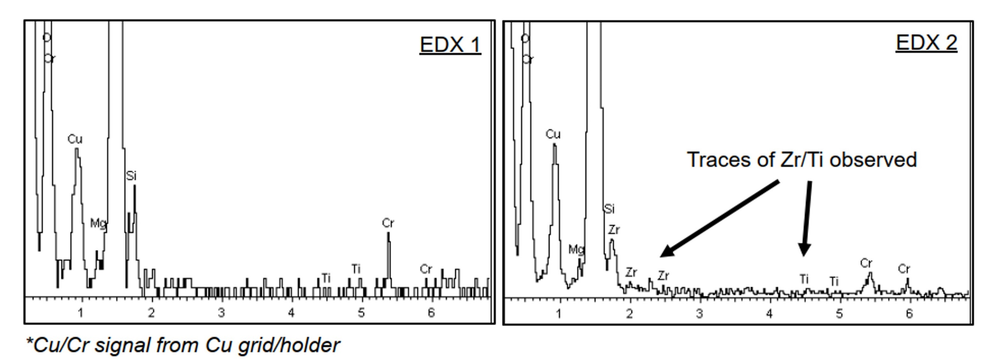
Fig. 7. EDX analysis of the local film on the “PA spray + PA etch + Ti/Zr” treated alloy surface, with the analysis positions shown in Fig. 6c.
The TEM analysis results suggest that the near-surface deformed layers were effectively removed, with no apparent over-etching, and the Ti/Zr and silane films were successfully built on the surfaces. Further optimisation of the pretreatment application could be conducted to improve the uniformity of the layer which would improve the bond strength further. These results indicate that the aluminium surface produced by HFQ® from an F temper sheet can be effectively cleaned and pretreated to provide excellent bonding morphologies.
3.2. Mechanical properties
3.2.1 SLS strength
The SLS strengths for the Al-Al joints with different pretreatments are presented in Fig. 8. It is found that the “ALK immersion + PA etch + Silane” process produced the greatest shear strength, about 36 ± 1 MPa. The “PA spray + PA etch + Silane” and the “ALK immersion + PA etch + Ti/Zr” processes led to very similar strength values, around 34 ± 1 MPa. The lowest strength appeared in the specimens subjected to the “PA spray + PA etch + Ti/Zr” process, with a value of 32 ± 1 MPa, close to the adhesive manufacturer’s test data (32 MPa for H420 ZE 75/75 1.5 mm, 2 g/m² Anticorit PL 3802-39 S). The strength results were also close to the SLS tests performed on the AA6111-T4 (3 mm gauge thickness) substrates that were pretreated with the Permatreat® coating process and bonded with the same adhesive, which had a strength value about 33.8 ± 1.5 MPa.
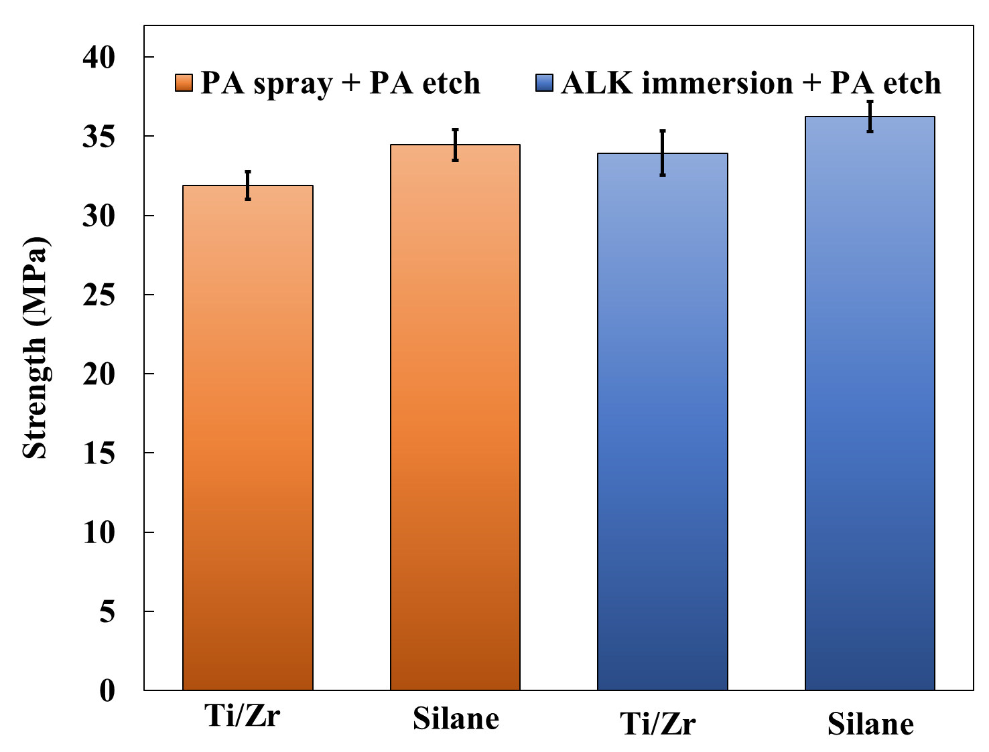
Fig. 8. The bonding strengths of Al-Al joints with different surface pretreatments.
The macroscopic features of the fracture surfaces of the Al-Al joints are shown in Fig. 9. It is observed that the fracture surfaces of the “PA spray + PA etch + Ti/Zr” joints were rather flat and smooth, and the adhesive mainly remained on one substrate, indicting a brittle failure mechanism. On the contrary, the joints that underwent other pretreatments were associated with rough fracture surfaces, with adhesive presenting on both substrates. The failure was of a mixed cohesive-interfacial mode and only a small difference was observed among these pretreated joints.
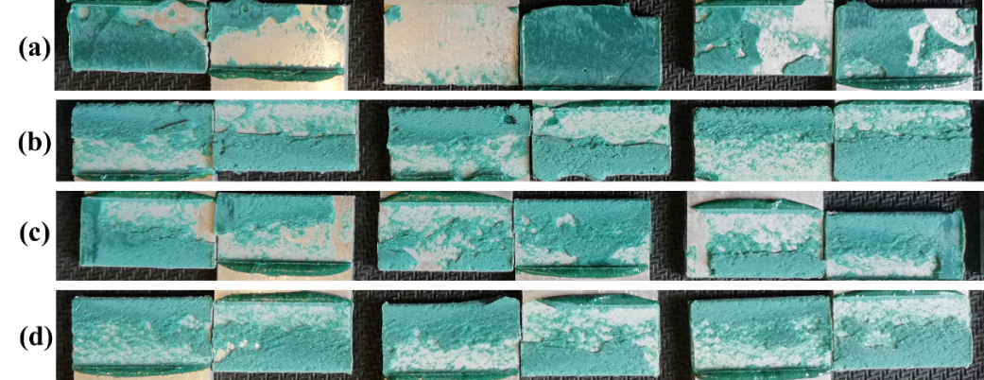
Fig. 9. Fracture surfaces of Al-Al joints with surface pretreatment: (a) “PA spray + PA etch + Ti/Zr”, (b) “PA spray + PA etch + Silane”, (c) “ALK immersion + PA etch + Ti/Zr”, and (d) “ALK immersion + PA etch + Silane”.
It can be observed that under the same surface coating pretreatment, the “ALK immersion + PA etch” cleaning gave a relatively greater shear strength than the “PA spray + PA etch” cleaning. Under the same cleaning process, the silane coating yielded a greater shear strength in comparison with the Ti/Zr pretreatment. The results also suggest that the silane treatment was less sensitive to the cleaning process as both “ALK immersion + PA etch” and “PA spray + PA etch” cleaning yielded expected strengths. In this work, the AA6111 alloy produced by HFQ® also has been adhesively bonded with an automotive grade boron steel to evaluate the pretreatment and bonding performance, and the result is presented in the Appendix.
3.2.2 Fracture toughness
In a DCB test, the J value increased with the loading displacement and then remained nearly constant, i.e., the fracture toughness J_{c}. The J_{c} values for the HFQ® produced AA6111 with different pretreatments are shown in Fig. 10. The “PA spray + PA etch + Ti/Zr” and “PA spray + PA etch + Silane” processes led to very similar J_{c} values, 2.9 ± 0.4 kJ/m² and 3.1 ± 0.6 kJ/m², respectively, the maximum among the four methods. In contrast, the “ALK immersion + PA etch + Ti/Zr” and “ALK immersion + PA etch + Silane” led to much lower J_{c} values, falling within the range of 2.0-2.5 kJ/m². This indicates that the surface cleaning is a very critical process for achieving high fracture toughness. A high-pressure PA spray cleaning and longer etching was found to be more effective in removing the lubricant residues and surface oxides for the subsequent conversion coating process. The fracture surfaces of the joints exhibited mixed cohesive-interfacial failure features. The data deviation in these results was due to the varying cohesive/interfacial ratios in the joints.
Our earlier study provided a reference toughness value for the joints bonded with this adhesive (bondline thickness: 0.4 mm), 3.94 ± 0.19 kJ/m² (cohesive failure) [29], in which the tests were performed on AW6082-T6 substrates pretreated with grit blasting followed by chromic acid etching. The results presented in this study were smaller than the reference value, which was reasonable as (1) the grit blasting process can significantly roughen the surfaces to make additional contact areas and interlocking microstructures on the adhesive-substrate interface to enhance the fracture toughness, and (2) this work adopted a thinner bondline thickness, which may reduce the level of the plastic deformation in the adhesive layer.
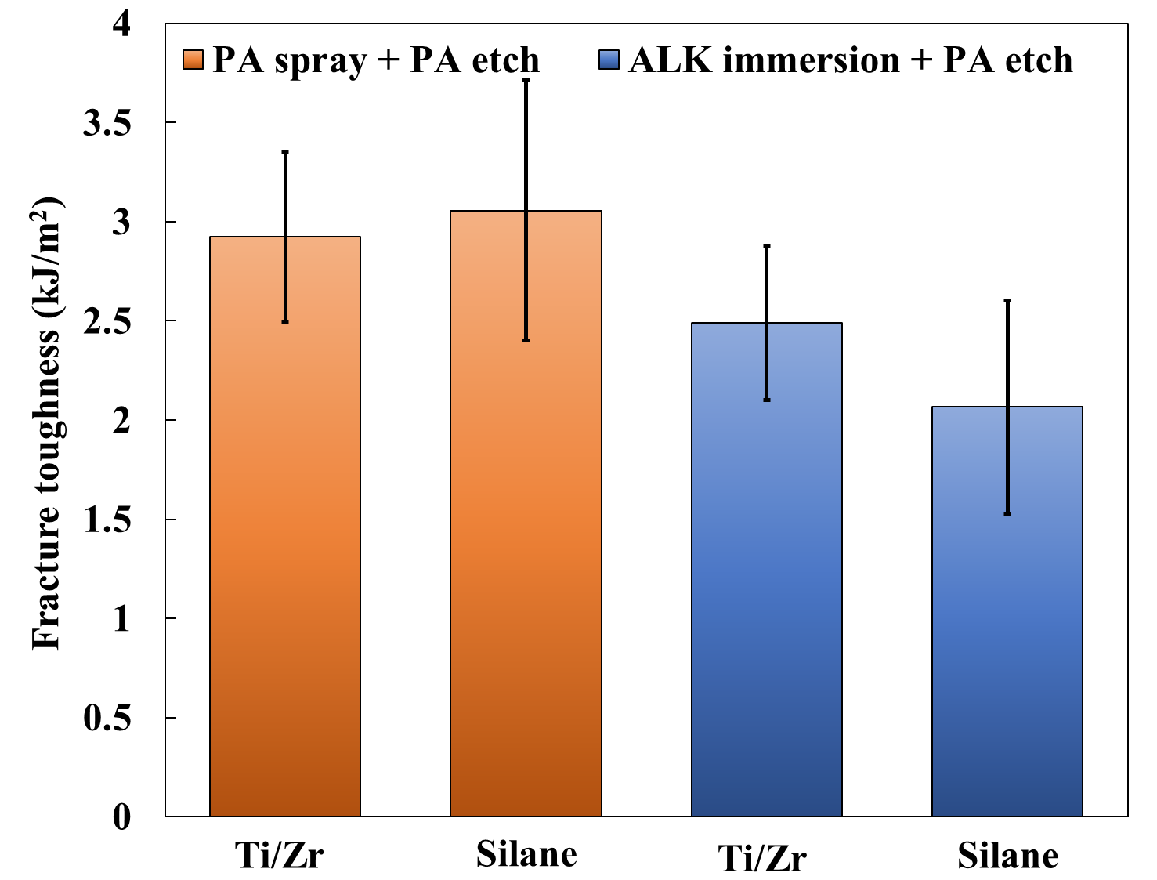
Fig. 10. Fracture toughness J_{c} for Al-Al adhesive joints treated with different methods.
The SLS and DCB tests seemed to lead to a contradictory conclusion on the performance of the selected surface pretreatments. The SLS test indicates that the “ALK immersion + PA etch” cleaning process is generally superior to the “PA spray + PA etch” process in achieving high bonding strength when using the Ti/Zr and silane coating. However, the DCB test shows the latter is more favourable for toughening the adhesive bonding. This result is very similar to the finding on the P2 etch pretreatment (a sulphuric acid-ferric sulphate-based treatment). The P2 etch provides strength results comparable to those of chromic-sulphuric acid treatment in both lap shear and peel tests [30,31], but it behaves worse in the wedge tests [32]. Some studies reported that the DCB test was very sensitive to surface modifications such as the contaminations or deficiencies of surface pretreatment, whilst the SLS test was not as high shear strength still can be obtained under low and intermediate levels of contamination [33–35]. From this point of view, the DCB test is a more accurate tool to discriminate the surface conditions after various pretreatments.
According to the SLS and DCB tests, the “PA spray + PA etch + Silane” is found to be the most promising method, which produced high shear strength and fracture toughness simultaneously. The “PA spray + PA etch + Ti/Zr” led to a high toughness and a relatively low, but still acceptable, shear strength. However, although the “ALK immersion + PA etch + Ti/Zr or Silane” methods produced satisfactory shear strengths, neither yielded expected fracture toughness. The mechanical results are consistent with the FTIR and SEM analyses in Figs. 4 and 5, in which the “PA spray + PA etch” cleaned surfaces appeared to be associated with more effective pretreatment coating and rougher profiles than the “ALK immersion + PA etch” cleaned surfaces. This probably was due to the high-pressure spray and longer acid etching, both of which facilitated the removal of the surface oxides. A relatively more effective pretreatment is associated with there being more active and favourable sites for adhesive bonding, while a rougher surface allows more molecular contact and provides additional interlocking microstructures (the tensile loading may be converted to shear to increase the load-bearing capacity). All these mechanisms would contribute to the enhancement of the mechanical properties of the bonded joints.
The above results show that all four pretreatments led to generally successive adhesive bonding, and the bonding strengths are greater than the adhesive manufacturer’s data. These results indicate that the aluminium panels produced using HFQ® can be successively pretreated to provide excellent bonding performances. Prior to final acceptance, more industry representative tests such as the T-peel and the environmental durability tests of the joints would also need to be evaluated following the proposed cleaning and pretreatment methods using industry standards e.g., stress tube tests.

4. Conclusions
In this work, the surface pretreatments of an automotive aluminium component produced by a novel forming process, Hot Form Quench (HFQ®), from F temper input material for adhesive bonding have been explored and analysed. Surface pretreatment processes including Ti/Zr coating and silane coating, in combination with either acid spray or alkaline immersion cleaning, were investigated. The surface analysis by FTIR, SEM and TEM confirmed that the lubricant, natural oxides and near-surface deformed layer had been successfully removed after cleaning, and either a new Ti/Zr oxide layer or a silane film had been formed on the aluminium surfaces.
The shear strength test and fracture-mechanics test show that the “PA spray + PA etch + Silane” produced high strength values for aluminium-aluminium joining and also a high fracture toughness. The “PA spray + PA etch + Ti/Zr” produced high fracture toughness and slightly low, but still acceptable, bonding strengths. However, the “ALK immersion + PA etch + Ti/Zr or Silane” pretreatments led to high bonding strength but low fracture toughness values. The work affirms that the commercial Ti/Zr and silane based pretreatments are potentially effective for the adhesive bonding of the aluminium alloy produced by HFQ®, provided the cleaning solution is applied using a high-pressure spray.
The main limitation of this work is that some pretreatment layers were not uniform across the substrate surfaces. Further optimisation of the pretreatment application should be conducted to improve the uniformity of the layers, which would further improve the bonding properties of HFQ® formed alloys. In addition, to finalize the surface pretreatments for the aluminium surfaces produced using the HFQ® processes, other industry representative tests such as the durability tests of the adhesive joints under various environments should be conducted, which will be the main work in the near future.

Acknowledgements
This work was funded under Innovate UK’s APC7 “RACEForm” grant (No. 113153). Impression Technologies Ltd, the exclusive holder of the HFQ® know-how and patents, was acknowledged for manufacturing the aluminium alloy using the HFQ® technology. Chemetall Ltd (UK) was acknowledged for the assist on the surface pretreatments. FS and BRKB would like to acknowledge Sika AG (Switzerland) for supplying the adhesives. Innoval acknowledge the Warwick University EMRTP for access to their electron microscopy facilities.

Appendix: Shear strengths of Al-Steel adhesive joints
The zinc coated 22MnB5 boron steel with a gauge thickness of 1.5 mm (Tata Steel UK) was chosen as the steel substrates for the manufacturing of hybrid Al-Steel joints. This grade steel is widely adopted to produce A pillars, B pillars and side impact beams in vehicles by hot stamping (press hardening) as the tensile strength can be up to 1500 MPa [36,37]. The as-received boron steel consists of ferrite and pearlite microstructures, and it has a relatively low strength and high ductility. The steel substrates were wiped with acetone prior to adhesive bonding. The epoxy based structural adhesive, SikaPower®-498/3 (Sika AG, Switzerland), was chosen to bond the aluminum and steel substrates.
The shear strengths for the Al-Steel joints with aluminium substrates pretreated with four methods are displayed in Fig. A1. There was no significant difference among the shear strengths of the hybrid joints treated using different pretreatments. The shear strengths of the joints ranged from 29-30 MPa, close to the adhesive manufacturer’s data (about 30 MPa).
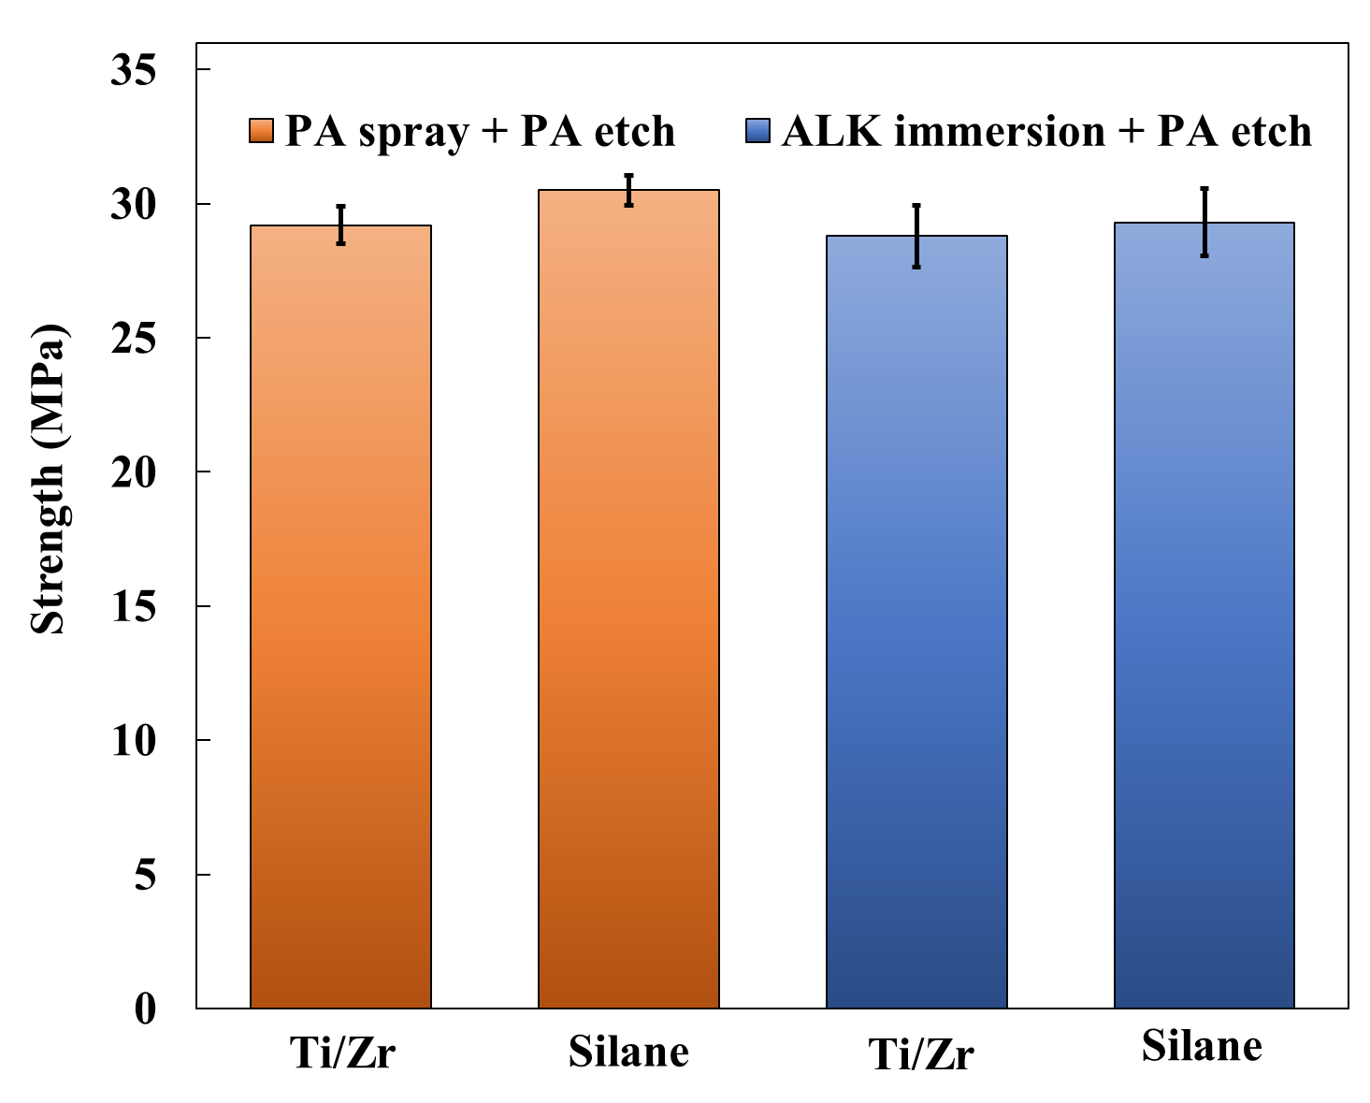
Fig. A1. The bonding strengths of Al-Steel joints with the aluminium substrates underwent different surface pretreatments.
The fracture surfaces of the Al-Steel joints are shown in Fig. A2. It indicates that the joints underwent “PA spray + PA etch + Silane” were associated with cohesive dominated failure. The fracture surfaces of the joints were rough, indicating the occurrence of ductile failure. In contrast, other joints exhibited a certain amount of interfacial failure initiated from the steel-adhesive interfaces. It also noticed that the steel substrates have been plasticly deformed due to the thin thickness and low yield stress, while the aluminium substrates remained elastic. Adams et al. [38] pointed out if the adhesive was very ductile (typically with more than 20% shear strain to failure) and the substrates were elastic, the joint strength was governed by the load corresponding to the total plastic deformation in the adhesive; if the substrates yielded, the joint strength was governed by the substrates yielding independently of the type of adhesive. This may be the reason for the hybrid Al-steel joints being not sensitive to the surface pretreatment of the aluminium alloy in this work as the steel substrates were plastically deformed during loading.
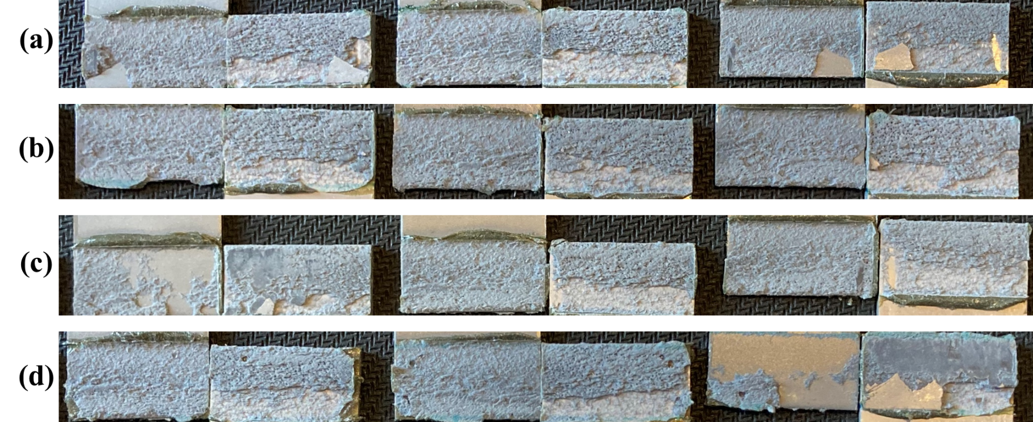
Fig. A2. Fracture surfaces of Al-Steel joints with the aluminium substrates treated with: (a) “PA spray + PA etch + Ti/Zr”, (b) “PA spray + PA etch + Silane”, (c) “ALK immersion + PA etch + Ti/Zr”, and (d) “ALK immersion + PA etch + Silane”.

References
[1] European Aluminium Association, EAA Aluminium Automotive Manual – Joining: Adhesive Bonding, 2015.
[2] F. Cavezza, M. Boehm, H. Terryn, T. Hauffman, A review on adhesively bonded aluminium joints in the automotive industry, Metals (Basel). 10 (2020) 1–32. https://doi.org/10.3390/met10060730.
[3] O. Lunder, C. Simensen, Y. Yu, K. Nisancioglu, Formation and characterisation of Ti-Zr based conversion layers on AA6060 aluminium, Surf. Coatings Technol. 184 (2004) 278–290. https://doi.org/10.1016/j.surfcoat.2003.11.003.
[4] A. Yi, W. Li, J. Du, S. Mu, Preparation and properties of chrome-free colored Ti/Zr based conversion coating on aluminum alloy, Appl. Surf. Sci. 258 (2012) 5960–5964. https://doi.org/10.1016/j.apsusc.2011.12.045.
[5] M. Becker, Chromate-free chemical conversion coatings for aluminum alloys, Corros. Rev. 37 (2019) 321–342. https://doi.org/10.1515/corrrev-2019-0032.
[6] B. Chico, D. De La Fuente, M.L. Pérez, M. Morcillo, Corrosion resistance of steel treated with different silane/paint systems, J. Coatings Technol. Res. 9 (2012) 3–13. https://doi.org/10.1007/s11998-010-9300-3.
[7] M. Pantoja, B. Díaz-Benito, F. Velasco, J. Abenojar, J.C. del Real, Analysis of hydrolysis process of γ-methacryloxypropyltrimethoxysilane and its influence on the formation of silane coatings on 6063 aluminum alloy, Appl. Surf. Sci. 255 (2009) 6386–6390. https://doi.org/10.1016/j.apsusc.2009.02.022.
[8] N. Parhizkar, B. Ramezanzadeh, T. Shahrabi, Corrosion protection and adhesion properties of the epoxy coating applied on the steel substrate pre-treated by a sol-gel based silane coating filled with amino and isocyanate silane functionalized graphene oxide nanosheets, Appl. Surf. Sci. 439 (2018) 45–59. https://doi.org/10.1016/j.apsusc.2017.12.240.
[9] R.P. Garrett, J. Lin, T.A. Dean, An investigation of the effects of solution heat treatment on mechanical properties for AA 6xxx alloys: Experimentation and modelling, Int. J. Plast. 21 (2005) 1640–1657. https://doi.org/10.1016/j.ijplas.2004.11.002.
[10] K. Omer, A. Abolhasani, S. Kim, T. Nikdejad, C. Butcher, M. Wells, S. Esmaeili, M. Worswick, Process parameters for hot stamping of AA7075 and D-7xxx to achieve high performance aged products, J. Mater. Process. Technol. 257 (2018) 170–179. https://doi.org/10.1016/j.jmatprotec.2018.02.039.
[11] L. Wang, M. Strangwood, D. Balint, J. Lin, T.A. Dean, Formability and failure mechanisms of AA2024 under hot forming conditions, Mater. Sci. Eng. A. 528 (2011) 2648–2656. https://doi.org/10.1016/j.msea.2010.11.084.
[12] O. El Fakir, L. Wang, D. Balint, J.P. Dear, J. Lin, T.A. Dean, Numerical study of the solution heat treatment, forming, and in-die quenching (HFQ) process on AA5754, Int. J. Mach. Tools Manuf. 87 (2014) 39–48. https://doi.org/10.1016/j.ijmachtools.2014.07.008.
[13] J. Wang, P. Andrews, C. Butler, E. McAlpine, G. Scamans, X. Zhou, Optical cleanliness measurement methods for aluminium sheet surfaces, Surf. Interface Anal. 51 (2019) 1144–1153. https://doi.org/10.1002/sia.6566.
[14] M. Debski, M.E.R. Shanahan, J. Schultz, Mechanisms of contaminant elimination by oil-accommodating adhesives Part 1: Displacement and absorption, Int. J. Adhes. Adhes. 6 (1986) 145–149. https://doi.org/10.1016/0143-7496(86)90017-5.
[15] M. Greiveldinger, M.E.R. Shanahan, D. Jacquet, D. Verchère, Oil-covered substrates: A model study of the evolution in the interphase during cure of an epoxy adhesive, J. Adhes. 73 (2000) 179–195. https://doi.org/10.1080/00218460008029305.
[16] G.W. Critchlow, K.A. Yendall, D. Bahrani, A. Quinn, F. Andrews, Strategies for the replacement of chromic acid anodising for the structural bonding of aluminium alloys, Int. J. Adhes. Adhes. 26 (2006) 419–453. https://doi.org/10.1016/j.ijadhadh.2005.07.001.
[17] N.L. Sukiman, X. Zhou, N. Birbilis, A.E. Hughes, J.M.C. Mol, S.J. Garcia, X. Zhou, G.E. Thompson, Durability and Corrosion of Aluminium and Its Alloys: Overview, Property Space, Techniques and Developments, in: Alum. Alloy. - New Trends Fabr. Appl., InTech, 2012. https://doi.org/10.5772/53752.
[18] P. Laha, T. Schram, H. Terryn, Use of spectroscopic ellipsometry to study Zr/Ti films on Al, Surf. Interface Anal. 34 (2002) 677–680. https://doi.org/10.1002/sia.1386.
[19] ASTM D1002-10, Standard Test Method for Apparent Shear Strength of Single-Lap-Joint Adhesively Bonded Metal Specimens by Tension Loading (Metal-to-Metal), West Conshohocken, PA, 2019.
[20] ISO 25217:2009. Adhesives-Determination of the mode I adhesive fracture energy of structural adhesive joints using double cantilever beam and tapered double cantilever beam specimens.
[21] J.G. Williams, Large Displacement and End Block Effects in the “DCB” Interlaminar Test in Modes I and II, J. Compos. Mater. 21 (1987) 330–347. https://doi.org/10.1177/002199838702100403.
[22] J. Anthony, P.C. Paris, Instantaneous evaluation of J and C, Int. J. Fract. 38 (1988) R19–R21. https://doi.org/10.1007/BF00034281.
[23] F. Sun, R. Zhang, B.R.K. Blackman, Determination of the mode I crack tip opening rate and the rate dependent cohesive properties for structural adhesive joints using digital image correlation, Int. J. Solids Struct. 217–218 (2021) 60–73. https://doi.org/10.1016/j.ijsolstr.2021.01.034.
[24] R. Tao, M. Alfano, G. Lubineau, Laser-based surface patterning of composite plates for improved secondary adhesive bonding, Compos. Part A Appl. Sci. Manuf. 109 (2018) 84–94. https://doi.org/10.1016/j.compositesa.2018.02.041.
[25] J.H. Cantrell, Determination of absolute bond strength from hydroxyl groups at oxidized aluminum-epoxy interfaces by angle beam ultrasonic spectroscopy, J. Appl. Phys. 96 (2004) 3775–3781. https://doi.org/10.1063/1.1787144.
[26] T. Semoto, Y. Tsuji, K. Yoshizawa, Molecular understanding of the adhesive force between a metal oxide surface and an epoxy resin: Effects of surface water, Bull. Chem. Soc. Jpn. 85 (2012) 672–678. https://doi.org/10.1246/bcsj.20120028.
[27] S. Nakamura, Y. Tsuji, K. Yoshizawa, Role of Hydrogen-Bonding and OH-πInteractions in the Adhesion of Epoxy Resin on Hydrophilic Surfaces, ACS Omega. 5 (2020) 26211–26219. https://doi.org/10.1021/acsomega.0c03798.
[28] I. Milošev, G.S. Frankel, Review—Conversion Coatings Based on Zirconium and/or Titanium, J. Electrochem. Soc. 165 (2018) C127–C144. https://doi.org/10.1149/2.0371803jes.
[29] F. Sun, C.I. Pruncu, P. Penchev, J. Jiang, S. Dimov, B.R.K. Blackman, Influence of surface micropatterns on the mode I fracture toughness of adhesively bonded joints, Int. J. Adhes. Adhes. 103 (2020) 102718. https://doi.org/10.1016/j.ijadhadh.2020.102718.
[30] S.G. Prolongo, A. Ureña, Effect of surface pre-treatment on the adhesive strength of epoxy-aluminium joints, Int. J. Adhes. Adhes. 29 (2009) 23–31. https://doi.org/10.1016/j.ijadhadh.2008.01.001.
[31] R.P. Digby, D.E. Packham, Pretreatment of aluminium: topography, surface chemistry and adhesive bond durability, Int. J. Adhes. Adhes. 15 (1995) 61–71. https://doi.org/10.1016/0143-7496(95)98739-9.
[32] G.W. Critchlow, D.M. Brewis, Review of surface pretreatments for aluminium alloys, Int. J. Adhes. Adhes. 16 (1996) 255–275. https://doi.org/10.1016/S0143-7496(96)00014-0.
[33] D. Blass, S. Kreling, K. Dilger, A contribution to the qualification process of surface pretreatment methods: Sensitivity of mechanical tests to adhesion and delamination, J. Adhes. 94 (2018) 294–312. https://doi.org/10.1080/00218464.2016.1276453.
[34] M. Wetzel, J. Holtmannspötter, H.-J. Gudladt, J.V. Czarnecki, Sensitivity of double cantilever beam test to surface contamination and surface pretreatment, Int. J. Adhes. Adhes. 46 (2013) 114–121. https://doi.org/10.1016/j.ijadhadh.2013.06.002.
[35] D. Yavas, X. Shang, A.F. Bastawros, Contamination-induced degradation/enhancement of interfacial toughness and strength in polymer-matrix composite interfaces, Conf. Proc. Soc. Exp. Mech. Ser. 7 (2018) 73–78. https://doi.org/10.1007/978-3-319-62831-8_10.
[36] H. So, D. Faßmann, H. Hoffmann, R. Golle, M. Schaper, An investigation of the blanking process of the quenchable boron alloyed steel 22MnB5 before and after hot stamping process, J. Mater. Process. Technol. 212 (2012) 437–449. https://doi.org/10.1016/j.jmatprotec.2011.10.006.
[37] M. Merklein, M. Wieland, M. Lechner, S. Bruschi, A. Ghiotti, Hot stamping of boron steel sheets with tailored properties: A review, J. Mater. Process. Technol. 228 (2016) 11–24. https://doi.org/10.1016/j.jmatprotec.2015.09.023.
[38] A. RD, C. J, W. WC, Structural Adhesive Joints in Engineering, 2nd ed., Chapman & Hall, London, 1997.

