*Letter to the Editor*

**Characterising differential antibody relationship is integral to future SARS-CoV-2 serostudies**

Scott JC Pallett,1,2

Rachael Jones,1

Mitchell A Pallett,3

Michael Rayment,1

Nabeela Mughal,1,4

Gary W Davies,2

Luke SP Moore.2,4,5

**Affiliations***:*

1. Chelsea and Westminster Hospital NHS Foundation Trust, 369 Fulham Road, London, SW10 9NH, UK.

2. Centre of Defence Pathology, Royal Centre for Defence Medicine, Queen Elizabeth Hospital Birmingham, Mindelsohn Way, Edgbaston, Birmingham, B15 2WB.

3. Department of Infectious Disease, MRC Centre for Molecular Bacteriology and Infection,

Imperial College London, SW7 2AZ, UK.

4. North West London Pathology, Fulham Palace Road, London, W6 8RF, UK.

5. Imperial College London, NIHR Health Protection Research Unit in Healthcare Associated

Infections and Antimicrobial Resistance, Du Cane Road, London, W12 0NN, UK.

**\*Corresponding author:**

Captain SJC Pallett RAMC, Centre of Defence Pathology, Royal Centre for Defence

Medicine, Queen Elizabeth Hospital Birmingham, Mindelsohn Way, Edgbaston, Birmingham,

B15 2WB. Email: scott.pallett@nhs.net Telephone: 0203 315 7264.

|  |
| --- |
| **Highlights**   * SARS-CoV-2 antibody target details are crucial to interpretation of comparative serostudies. * Comparison studies between non-neutralizing and neutralizing assays are urgently required. * The majority of available assays provide only limited information on assay targets. * Robust messaging on limited interpretation around immunity must remain a mainstay in the meantime. |

We read with interest data reported in this Journal by Tré-Hardy *et al.*,1 where they provide timely insight to challenges associated with implementing serological testing as an adjunct to SARS-CoV-2 surveillance. In areas where reporting of new cases has declined, consideration is being given to relaxation of social-distancing restrictions and considerable attention has been given to the supportive potential of serological testing in delayed identification of cases.

Tré-Hardy *et al.* demonstrate the urgent need to determine the optimal time from symptom onset for individual serological assays in order to develop suitable guidance on interpretation of results. As part of this process, we highlight further concerns around the potential interpretation of positive and negative results alike. A plethora of tests, designed for use as either point-of-care or laboratory-based assays have rapidly been developed, many having undergone limited validation in cases of severe, hospital infection and information around potentially inferred immunity has been at times vague. Increasing access to serological testing for SARS-CoV-2 has been available not only through private medical practices but also via high street providers, online, and in some cases via postal services. While national guidelines have gone some way to reduce the risk of confused messaging where clinicians are not directly involved in the resulting process, delayed reporting risks misinterpretation that may affect social-distancing behaviours.

The degree of immunity conferred from infection with SARS-CoV-2 remains unclear. Four major viral structural proteins have been identified (spike, envelope, nucleocapsid, and membrane).2 Initial B cell response in SARS-CoV-2 infection appears to occur prior to the recovery phase,3 and while antibody responses are thought to arise first to the nucleocapsid (NP) in SARS-CoV-1, it is the spike protein (essential in virus attachment and cell entry) and specifically the receptor-binding-domain (RBD) for which neutralizing antibodies have been identified.4 Early work has also shown anti-RBD antibodies have some correlation with neutralization in SARS-CoV-2.5 In addition to this humoral response, there is evidence of a multi-faceted reaction in the early phase of SARS-CoV-2 infection involving not only antibody-secreting B cells, but also follicular T helper cells, activated CD4+ cells and CD8+ T cells prior to the recovery of symptoms.3

In addition to observations by Tré-Hardy *et al.* we would further state that the antibody target employed is integral to the potential interpretation of results. Currently available serological assays tend to target either non-neutralizing antibodies or rarely the likely neutralizing anti-RBD antibody. Differentiation between test targets by the wider public is an unrealistic expectation. Using an online repository of available assays,6 and cross-referencing against regulatory body and advisory lists, we identified 284 currently available assays (Figure 1). Having analysed product descriptions and, where available, instruction leaflets and regulatory documentation submitted for approvals we find that the majority (168/284, 59.2%) make only vague reference to SARS-CoV-2 antigens or antibodies and some no reference whatsoever (49/284, 17.3%). Where manufacturers specify antibody targets, this is most commonly to the NP (36/284, 12.7%). 19/284 (6.7%) specify spike protein targets, 12/284 (4.2%) specify combination targets, with only five (1.8%) providing clear descriptions of targeting the (tentatively neutralising) anti-RBD antibody. The secondary structure of the highly conserved NP protein also raises the possibility of identifying cross-reactive results 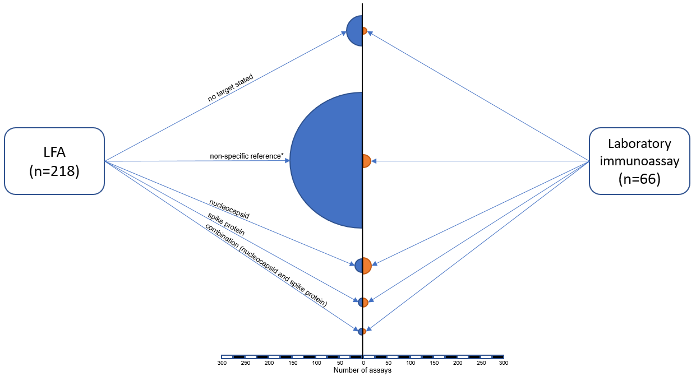with other known coronaviruses.

**Figure 1. Information available on serological targets from commercially available lateral flow serological assays (LFA) and laboratory immunoassays (enzyme-linked immunosorbent assays or chemiluminescence immunoassays) for SARS-CoV-2.** Assays identified via an online repository6 and cross referenced with regulatory and advisory body online lists for current commercially available serology-based tests for SARS-CoV-2 (US Food and Drugs Administration, Australian Therapeutic Goods Administration, Health Information and Quality Authority, World Health Organisation). Information was taken directly from product listings and inserts on manufacturer and/or distributor sites and cross-referenced against documentation available for product regulatory approval. Circle size is relative to number of assays found within that category and recorded as:

1. no identifiable reference to any target found
2. non-specific reference to assay targets including SARS-CoV-2 antigens, recombinant proteins, SARS-CoV-2 peptides, SARS-CoV-2 antibodies
3. nucleocapsid protein
4. spike protein, including specifically the S1 protein, N-terminus and RBD separately specified and
5. combination targets including to both nucleocapsid and spike proteins.

Further, indiscriminate screening among low seroprevalence populations has a poor positive predictive value.7,8 Among healthcare workers seroconversion is seen in those with and without symptoms,8 with a greater titre response seen in those with symptomatic, and specifically, severe illness. Longitudinal studies are now needed to determine the comparative persistence of neutralizing antibodies in mild and severe illness as well as determine the degree to which any sterilizing effect is provided. A failure to identify seroconversion in a proportion of PCR positive cases should demand further caution in serology interpretation.9 A surge in uptake of serological testing among the general public is likely to ensue if neutralizing antibodies are further characterised *in vitro*, yet mapping of long-term *in vivo* immune protection is still required. As the current wave of SARS-CoV-2 declines, opportunity to assess assay performance, and concordance across different targets, is limited. If, for example, the anti-RBD antibodies are confirmed as having neutralizing activity and direct comparison finds complete concordance with anti-nucleocapsid assays then this concern becomes less immediately urgent. If considerable variation between assays exists however, then it is crucial for assay manufacturers to be more explicit in their target design and more specific in advice around test utility. Those assays utilizing non-neutralizing targets could then have limited utility in delayed case identification but should never then confer a sense of immunity. Regardless, it must be remembered that these tests primarily offer a qualitative detection of antibody at a single time point and are unable to infer any sense of memory, or whether the humoral response to the primary infection is sufficient to lead to any level of protection. Even assays that do detect anti-RBD antibodies, presuming they are shown to have some lasting neutralizing effect *in vivo*, could only be considered a suggestion of immunity. Observation of reduced levels of neutralizing antibody in convalescent patients at just 2-3 months precludes antibody detection testing as a form of ‘immunity passport’.10 Where the rate of acute infection is significantly declining in some areas, longitudinal studies characterizing the immune response in both symptomatic and asymptomatic individuals with confirmed infection is now urgently required. Full benefit of antibody screening programmes will only be realised where clear information is available for researchers around assay targets.

We further calls by Tré-Hardy *et al.* for the need to establish appropriate timeframes for serological testing in order to minimise misinterpretation but also feel better understanding of the differential antibody response and transparent assay target information is essential to inform this process. While comparative, longitudinal studies between assay targets are urgently required, messaging on social-distancing and the appropriate use of personal protective equipment, regardless of a result, must remain a mainstay. If this is unable to be effectively delivered where kits are being used in the community, then testing for the purposes of delayed case identification alone should be limited to where direct clinical counselling can be undertaken.

**References**:

1. Tre-Hardy M, Blairon L, Wilmet A, Beukinga I, Malonne H, Dogne JM *et al*. The role of serology for COVID-19 control: Population, kinetics and test performance do matter. [J Infect](https://www.ncbi.nlm.nih.gov/pmc/articles/PMC7228733/). 2020. doi: [10.1016/j.jinf.2020.05.019](https://dx.doi.org/10.1016%2Fj.jinf.2020.05.019) [Epub ahead of print]
2. Jiang S, Hilyer C, Du L. Neutralizing Antibodies against SARS-CoV-2 and Other Human Coronaviruses. Trends Immunol. 2020; 41(5):355-359. doi: [10.1016/j.it.2020.03.007](https://doi.org/10.1016/j.it.2020.03.007).
3. Thevarajan I, Nguyen THO, Koutsakos M, Druce J, Caly L. Breadth of concomitant immune responses prior to patient recovery: a case report of non-severe COVID-19. Nat Med. 2020; 26(4):453-455.
4. Tay MZ, Poh CK, Renia L, MacAry PA, Ng LFP. The trinity of COVID-19: immunity, inflammation and intervention. [Nat Rev Immunol](https://www.ncbi.nlm.nih.gov/pmc/articles/PMC7187672/). 2020; 28:1–12. doi: [10.1038/s41577-020-0311-8](https://doi.org/10.1038/s41577-020-0311-8).
5. Quinlan BD, Mou H, Zhang L, Guo Y, He W *et al*. The SARS-CoV-2 receptor-binding domain elicits a potent neutralizing response without antibody-dependent enhancement. 2020. bioRxiv preprint doi: https://doi.org/10.1101/2020.04.10.036418. Accessed May 21, 2020.
6. Finddx. <https://www.finddx.org/covid-19/pipeline/?section=immunoassays#diag_tab>. Accessed 03 June 2020.
7. Pallett SJC, Denny SJ, Patel A, Charani E, Mughal N et al. Point-of-care serological assays for SARS-CoV-2 in a UK hospital population: potential for enhanced case finding. Preprint at researchsquare. doi: 10.21203/rs.3.rs-28006/v1
8. Pallett SJC, Rayment M, Patel A, Fitzgerald-Smith SAM, Denny SJ *et al*. Point-of-care serological assays for delayed SARS-CoV-2 case identification among UK healthcare workers. Lancet Respir Med. 2020. [doi: 10.1016/S2213-2600(20)30315-5](https://doi.org/10.1016/S2213-2600(20)30315-5). Online ahead of print.
9. Brandstetter S, Roth S, Harner S, Buntrock-Dopke H, Toncheva A *et al.* Symptoms and immunoglobulin development in hospital staff exposed to a SARS-CoV-2 outbreak. Pediatr Allergy Immunol. 2020. doi: 10.1111/pai.13278. Online ahead of print.
10. Long QX, Tang XJ, Shi QL, Li Q, Deng HJ *et al.* Clinical and immunological assessment of asymptomatic SARS-CoV-2 infections. Nat Med. 2020. doi.org/10.1038/s41591-020-0965-6.

**Declarations**

**Acknowledgements**

LSPM acknowledges support from the National Institute of Health Research (NIHR) Imperial Biomedical Research Centre (BRC) and the National Institute for Health Research Health Protection Research Unit (HPRU) in Healthcare Associated Infection and Antimicrobial Resistance at Imperial College London in partnership with Public Health England. MAP acknowledges support from the Wellcome Trust Grant to Prof D.W. Holden. The authors thank Surgeon Commander Matthew O’Shea for his helpful comments in development of the final manuscript. The views expressed in this publication are those of the authors and not necessarily those of the NHS, Defence Medical Services, the National Institute for Health Research, or the UK Department of Health.

**Authors’ contributions**

SJCP & LSPM designed the methodology. SJCP & MAP collected the data. All authors reviewed the results and data analysis and contributed comments. SJCP drafted the initial manuscript with all authors contributing significantly to revising this for submission. All authors agreed on the final version for submission to the journal.

**Funding**

This research did not receive any specific grant from funding agencies in the public, commercial, or not-for-profit sectors.

**Consent**

No patient information is involved in this submission.

**Potential conflicts of interests**

LSPM has consulted for bioMerieux (2013), DNAelectronics (2015-18), Dairy Crest (2017–2018), Umovis Lab (2020), and Pfizer (2018-2020), received speaker fees from Profile Pharma (2018), received research grants from the National Institute for Health Research (2013-2020), CW+ Charity (2018-2019), and Leo Pharma (2016), and received educational support from Eumedica (2016–2018). NM has received speaker fees from Beyer (2016) and Pfizer (2019) and received educational support from Eumedica (2016) and Baxter (2017). RJ has received honoraria, speaker fees, travel support and/or research grant funding from Gilead, ViiV Healthcare, BMS, Abbvie, Janssen and Merck. SJCP has received a research grant from the Scientific Exploration Society. All other authors have no conflicts of interest to declare.

**Availability of data and materials**

The data analysed during the current study and further details on the assays are available from the corresponding author (SJCP; scott.pallett@nhs.net) on reasonable request, as long as this meets local ethical and research governance criteria.