A MARKET ASSESSMENT OF ADDITIVE MANUFACTURING POTENTIAL FOR THE AEROSPACE INDUSTRY

Sadettin Cem Altıparmak^{1,2}*, Bowen Xiao³

¹Department of Mechanical Engineering, Imperial College London,
London SW7 2AZ, United Kingdom
²Mechanical Engineering Department, Engineering Faculty, Marmara University, Göztepe Campus, 34722 Istanbul, Turkey
³Department of Mechanical, Aerospace and Civil Engineering, The University of Manchester, Manchester M13 9PL, United Kingdom

Abstract: The additive manufacturing (AM) process, also known as 3D printing, is a process of layer-by-layer material deposition to produce desired parts from 3D model data, as opposed to formative manufacturing methodologies and subtractive manufacturing processes. The AM is one of the most well-suited manufacturing technologies for the aerospace industry where lightweight and unique-shaped components are demanded as this technology produces lightweight and cost-efficient aircraft components with unique geometries. The AM also allows manufacturers to release products with a smaller number of components onto the market; enabling rapid prototyping with less material waste compared to subtractive manufacturing processes. Therefore, during the last two decades, this technology has received research interest and has been adopted by the aerospace industry, resulting in a significant AM market share compared to other sectors. The aerospace industry has been one of the dominant sectors of the global AM market and is forecasted to be one of the leading contributors to the rapidly changing and competitive global AM market. This study reviews the assessment of the recent and forecasted future global aerospace AM market, linked with the historic and forecasted data, and the adoption of this technology, historic and forecasted global aerospace AM market trends, and the impact of Covid-19 pandemic on the current state of the global aerospace sector. Related charts based on historic and forecasted data are given to summarise the global AM market trends and assessment of AM potential for the aerospace industry in this study.

Keywords: Global Aerospace Additive Manufacturing Market; Additive Manufacturing Market Assessment; Global Aerospace Market Trend; Aerospace Industry; Covid-19 Impact

*Corresponding Author: s.altiparmak19@imperial.ac.uk (S.C. Altıparmak)

1. Introduction
Additive manufacturing (AM) technology is classified by The International Standards Organization/American Society for Testing and Materials Standards (ISO/ASTM 52900:2015) as a process of material joining to achieve 3D parts with desired geometries, typically layer by layer as opposed to formative manufacturing methodologies and subtractive manufacturing process [1]. The ISO/ASTM 52900:2015 standard identifies all the commercially released AM processes into seven main categories. These categories are directed energy deposition (DED), vat photopolymerisation (VP), powder bed fusion (PBF), binder jetting (BJ), material jetting (MJ), sheet lamination (SL), and material extrusion (ME) [2, 3]. In detail, all the AM processes can be categorised as solid, liquid and powder-based on the basis of the physical state of raw materials being used [4, 5]. The categorisation and types of the AM process and main comparison among AM processes regarding building volume, material options, and characteristic merits and limitations, in this order, are given in Figure 1 (Note that the categorisation of AM based on materials being used (solid-based, liquid-based and powder-based) is a broad categorisation that cannot be applied consistently due to the use of different materials in some AM processes at the same time. For instance, in these three AM categories "solid filaments or wires", "molten metals and photopolymers" and "metal powders" can be referred to the solid-based, liquid-based and powder-based AM processes respectively. However, this rephrasing has some inconsistency. In other words, the first category (solid-based) does not only include "solid filaments or wires", but also solid sheet material as used in sheet lamination (SL), in laminated object manufacturing (LOM) or ultrasonic-based AM (US-AM). The second category (molten metals and photopolymers) may be also rephrased to "liquid metals and photopolymers" because the photopolymers used in stereolithography (SLA) are "liquid polymers", not "molten polymers". The third category, "liquid/molten metals", is also inconsistent as it probably refers to droplet or inkjet-based AM processes, not to selective laser melting (SLM) or electron beam melting (EBM) that better fits the third category (i.e. powder-based processes), though the latter are also used to melt the metal powder material. This category may also cover wire+arc AM (WAAM) or wire direct energy deposition (wire-DED) or powder direct energy deposition (powder-DED), where metallic wires or powders are molten and deposited. However, WAAM and wire-DED may rather fit the first category (i.e. "solid filaments or wires"), while powder-DED rather fits the third category (i.e. "metal powders"). The three cited categories only refer to two material classes, being "photopolymers" (liquid) and "metal" (powder), not to other types of material such as thermoplastic or thermosetting polymers, elastomers, ceramics (including sand, etc.), or cellulose/paper as used in the original LOM process. Because of these reasons, AM categories should be defined in detail to make a more consistent categorisation of recent AM processes. The AM process allows freedom not only in the design but also in the fabrication stage of the production. Unlike conventional manufacturing process, deep channels, complex shapes, enhanced strength-to-weight ratios, blind holes and components requiring multiple assemblies or joining steps can be produced using AM process [6]. The AM process offers almost 40% reduction in raw material waste compared to the conventional manufacturing process and 95-98% of the waste material can be recycled [7]. The AM process is an automated and less complex system that only requires CAD software, software for build preparation (parser/postprocessors generating instructions files for the AM machine, STL converters, hatching software, slicers), and less chain management and workforce to produce physical objects layer by layer, as opposed to detailed chain management and large workforce required for conventional manufacturing [8].
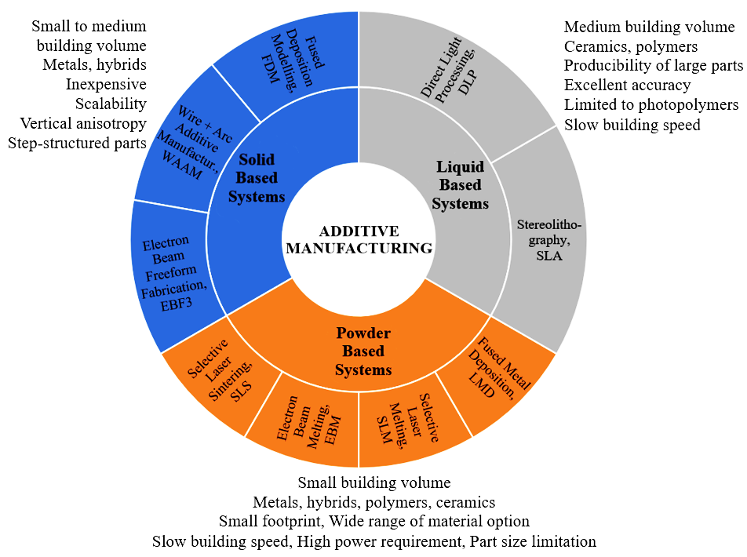
Fig. 1: Classification and comparison of AM processes
Even highly intricate parts with complex geometry can be produced using this technology, it is applicable to a wide range of materials with minimal material waste and post-processing necessity. As a result of these capabilities, the AM process can be referred as a tool to increase design freedom allowing manufacturers to design unique-shaped consolidated parts at low volume cost-effectively. Another driver of this technology is that the AM process is ecologically and environmentally friendly thanks to the production capability of lightweight components with high structural integrity [9, 10]. This technology can be easily combined with any other conventional subtractive manufacturing and/or AM processes developing a hybrid-AM solution to improve the properties of the final products produced only using either the conventional subtractive manufacturing or AM process [11]. The AM process is in demand in several sectors, such as transportation, aerospace, medical and automotive. In particular, the AM process has recently attracted interest from the aerospace industry, where lightweight aircraft components with unique shapes are in high demand [12]. The AM process allows manufacturers in the aerospace industry to: (i) eliminate production steps, except the process planning, both for the AM process used and downstream processes, (ii) enable potential cost and fuel efficiency for active aircrafts, (iii) decrease the energy consumption minimising raw material waste and environmental footprint of each aircraft, and (iv) shorten the lead time of aircraft [12–15]. Therefore, the adoption of AM technology has resulted in a significant continuous growth in the global aerospace AM market. On the other hand, the AM has some limitations in addition to the large range of merits, such as the lack of the globally accepted certification and standardisation, high material cost, limited component size and relatively slow production speed [13, 16, 17]. The main merits and limitations of the AM process, which are given in Table 1, are likely to affect the adoption of this technology in the aerospace industry.
Table 1. Characteristic features of AM process
Merits | Limitations
- Production cost minimisation | - High first time buy cost of AM equipment, material and software
- Nearly net shape production
- Production of unique and complex shapes (design freedom) | - Low reliability regarding mass production
 | - Lack of global certifications and standardisations
- Reduced part assembly necessity | - Limited component size and building volume
- Material waste minimisation | - Low production speed compared to the subtractive manufacturing process
- Short time to market (reduced lead time)
- Green manufacturing capability | - Costly for high-volume production
- Lightweight production possibility | - Limited material option
- Tooling and fixturing elimination | - Metallurgical defects, e.g. porosity, hot cracking
- Reduced scrap | - Unsatisfactory dimensional accuracy

The overall market trend of AM for the aerospace industry can be associated with the ‘significant growth rates’ regarding market share and applications categorised into several manufacturing divisions, e.g. automotive and medical. The AM revenue for the aerospace industry, including AM systems, and aerospace equipment and materials, has increased steadily. During the last two decades, the AM market has experienced a significant increase in the global AM market until the recent steep drop due to the Covid-19 pandemic. From this point of view, this paper introduces a review of the past, recent and forecasted data of the global aerospace AM market, mainly focusing on the benefits, limitations, Covid-19 pandemic and its effects on the adoption of this technology and global aerospace sector. Charts and statistical data representing historic and forecasted trends are created to summarise the related trends and forecasts. This review consists of five sections. The following section covers an overview and classification of AM process, and affecting factors that promote and hinder the adoption and market size of this technology for the aerospace industry. Subsequently, Section 3 presents the past, recent and forecasted global aerospace AM market trends by dividing the period covered into historic (2013-2019) and forecasted (2019-2025). The recent impacts of Covid-19 pandemic on the global aerospace sector is also reviewed in Section 4 in conjunction with corresponding data and statistical charts. Lastly, the major conclusions of this review are summarised regarding the evolution and future trend of the global aerospace AM market.

2. Factors Affecting Market Growth and Adoption of Additive Manufacturing in the Aerospace Industry
The AM process has several merits leading to a significant adoption of this technology in the aerospace industry. This is expected to result in a continuous growth in the global aerospace AM market. New developments and innovations in material science and AM technology can be addressed to overcome the limitations mentioned in the previous section, thus enlarging the recent and potential applications of this technology (Table 2) in the aerospace industry.
Table 2: Recent and forecasted AM applications for the aerospace and space industries [18]
 | Recent Applications | Potential Applications
Aerospace Industry | - Prototyping and modelling of concepts  - Fabrication of replacement parts  - Fabrication of low-volume aerospace components with complex geometry | - Embedment of AM processed electronics on aerospace components  - Fabrication of the whole aircraft wings regardless of size limitation  - Production of more complex-shaped engine parts while achieving enhanced part consolidation  - Repair part production on the battlefield

2.1. Factors Promote the Adoption
The benefits of AM process are some of the key drivers in the adoption of this technology resulting in growth in the aerospace AM market. Figure 2 depicts some benefits delivered by the AM process for performance enhancement in aerospace applications. Aerospace companies are at different stages of adopting the AM process. The aerospace companies that have already adopted the AM process have benefited from this technology in several ways. The four tactical ways in the adoption of this technology according to Deloitte University Press [18] are: (i) exploring the AM process in order to enhance the value delivery of existing products in supply chains, (ii) utilising scale economics achieved using the AM process facilitating supply chain transformation, (iii) achieving a better level of innovation and performance of the products that companies offer, and (iv) altering existing products and supply chains.
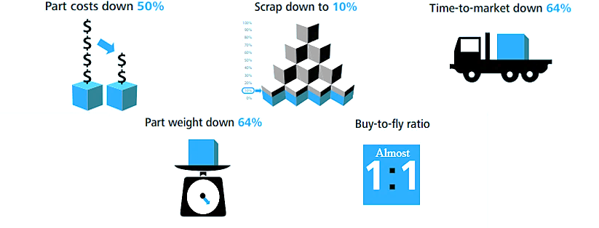
Fig. 2: Some benefits delivered by AM process regarding performance enhancement in aerospace applications [18]

The AM process offers the flexibility to design/create aerospace components designing of components can be achieved [12, 19] and the capability of creating components with lattice structures and internal cavities can reduce the weight without compromising the mechanical performance of these components [20]. The reduction in the total aircraft mass because of the use of AM processed lightweight components leads to a decrease in the cradle-to-gate environmental footprints (total energy consumed during production) of each active aircraft [21]. Another example is that European Aeronautic Defence and Space (EADS) company used direct metal laser sintering AM process for producing Airbus A320 nacelle hinge brackets, thus achieving 64% reduction in part weight while maintaining the same performance and strength [18]. The use of AM process can also result in a considerable decrease in CO₂ emissions and energy requirement of aircraft [22, 23].
General Electric achieved a reduction in the number of components by adopting the AM process. The company reported a reduction in the number of 885 conventionally produced component after adopting AM process [21, 24]. To put this in perspective, 1-kilogram weight reduction on a 600 aircraft fleet results in savings of approximately 90,000 litres of fuel and 230 tonnes of CO₂ [22]. Reducing 1 pound of weight from every aircraft of 600 fleet can also save nearly 11,000 gallons of fuel per year thanks to the reduction in the annual fuel cost [25]. Moreover, the AM process allows aerospace companies to build fast prototypes with a demanded level of functionality; therefore, time to market and can be reduced accelerating the competitiveness of companies [26]. According to Lyons [27], several aerospace companies that adopted the AM process benefited from the reduced time required to prototype ranging between 43% and 75% dependent on the previous subtractive manufacturing process used. As an example of this, the Boeing company reduced the prototyping time from several months to only less than a month by building an AM processed prototype [27].
Aerospace parts are generally produced by using relatively expensive raw materials [8]. After producing these parts, recycling of the scrap formation is costly and necessitates a significant effort. Conventional machining applications can necessitate 80-90% scrap ratio of the original billet, whereas AM process can lower the scrap ratio down to 10% [18]. This capability of AM process is particularly significant when using expensive aerospace materials, e.g. titanium. The AM process is also capable of creating free-form design that helps to produce tooling fixtures. In this context, only straight-lined cooling channels can be produced using a conventional manufacturing method, which complicates the fluid flow optimisation of aerospace components. On the other hand, the AM process can produce these channels with complex geometry conforming to the part curvature, which is significantly beneficial for engine parts experiencing elevated temperature levels [25, 28, 29]. AM process enables flexibility in testing and designing AM processed products as many times as demanded with the help of rapidity and easily modifiability of creating prototypes, which reduces the uncertainties and risks that aerospace companies face. This flexibility can be achieved by repeatedly modifying the design files of design software, thus multiple design iterations can be conducted without relatively expensive retooling. AM process also helps to reduce the cost of fixtures and tooling [12, 30]. An example of this benefit is that Advanced Composite Structures (ACS) company switched most of the conventionally manufactured tools with AM processed tools, resulting in 96% reduced lead time and 79% overall tooling cost reduction [3].
The AM process is capable of producing multiple aerospace components as a single component; therefore, product enhancement can be attained by decreasing assembly effort and evolving the uncertainty as more manageable and modifiable. General Electricity reduced the number of parts in their fuel nozzle from 20 different parts to one part weighing 25% less by using the AM process [31]. The embedment of electronics in AM processed parts promises some opportunities in product innovation, in particular for unmanned aerial vehicles. However, the fully integration between the AM process and embedded electronics is still not efficiently completed. The AM process can also save changeover time and effort required for developing new products or existing customised products. This benefit enables relatively fast translation from customised products to customers, which then can increase the market responsiveness of aerospace companies. Therefore, enhanced production functionality results in product innovation and a growth in the revenue of new and current market segments [18, 32].
The economic characteristics of the AM process largely fit aerospace applications compared to other industries involving mass production, which eases customised production [33]. The proportional ratio of raw material weight over finalised component weight (fly-to-buy ratio) for aerospace components is generally between 20:1 and 40:1 [20]. This high fly-to-buy ratio can be associated with the significant amount of raw material waste affecting the total cost of production. This ratio can be nearly decreased to the ideal 1:1 by adopting the AM process [5, 24]. It is reported in a case study [34] that the fly-to-buy ratio of bleed air leak detector by the Lockheed Martin company decreased from 33:1 to almost 1:1 using the electron beam melting AM process. In the previous example, the potential production cost saving of brackets was determined as 50% when using AM processed titanium alloy used without compromising the mechanical properties of the brackets [35]. As a summary of this section, the main motivations for adopting the AM process in the aerospace industry are to achieve lightweight aerospace components leading to potentially greater fuel and cost efficiency, and decrease the cradle-to-gate and CO₂ footprint levels of each active aircraft. Forecasts for the potential benefits of AM process in the aerospace industry regarding the market potential, cost and energy saving, and CO₂ reduction are given in Figure 3.
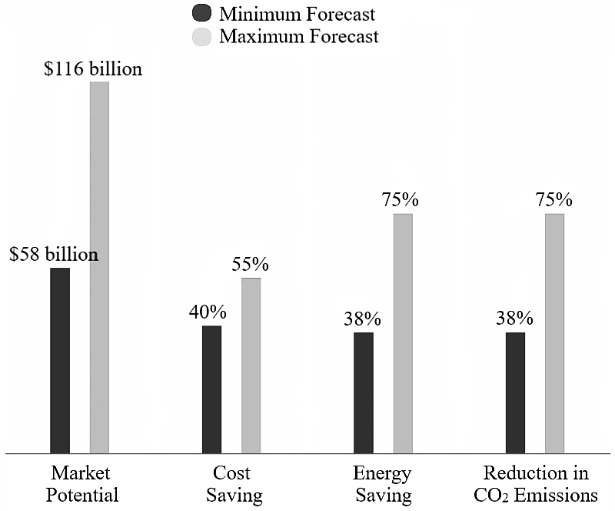
Fig. 3: Expected benefits of AM process in the aerospace industry until 2025 (Data from: [36])

2.2. Factors Hinder the Adoption
AM technology is still not fully mature. This technology is currently facing several limitations restraining the current adoption and wide use in the aerospace industry. The main limitations can be associated with high cost of aerospace materials, limited range of material option, scalability and size, consistency of quality, repeatability and unachievable dimensional accuracy demanded by aerospace companies, limited capability of multi-material printing, and the lack of qualifications and certification for additively manufactured aerospace components (Fig. 4). The AM process comparatively underperforms in the fabrication of large aerospace components [37]. AM companies are currently making research and development efforts to overcome this limitation. The Lockheed Martin company in collaboration with Oak Ridge National Laboratory investigated the development of a new AM system with multiple print heads called ‘big-area AM system’ to produce large aerospace components in an open building volume where desired parts are fabricated [36]. As a well-known example of large volume production of aerospace components, BAE Systems fabricated a 1.2-meter long titanium wingspar after a collaboration with Cranfield University in 2013 [37]. It is worth mentioning that some AM limitations, such as size limitation and cost, are not an issue in some of the AM processes. As an example of this situation, the maximum dimension that can be printed is not an issue for WAAM processed parts (as the authors show in Ref. [37]), and consumable cost and porosity are restrictive issues in powder-based AM processes, but less so in wire-feed AM processes. Aerospace companies that have not adopted AM technology have so far suffered from the challenge of stocking large inventories. Nonetheless, AM system generally may not scale up the production in a necessity. AM providers are recently endeavouring to increase the building speed of AM process to meet the bulk requirements of the aerospace industry [38]. Since the production speed of AM process in the aerospace industry is only around 40 mm³/hour [39], the production speed of AM process is classified as slow production speed when compared with the conventional manufacturing process. Moreover, other limitations are the limited range of metal powders and polymers to be used in AM process and the high cost of these raw materials. For example, the cost of stainless steel being used in AM process is nearly 100 times more costly ($8 per square centimetre) compared to commercial-grade stainless steel being used in the conventional manufacturing process [40].
New advancements in material science are highly associated with the solution to overcome the cost and limited material option limitations. Until now, very few AM systems are capable of multi-material printing [8]. Overcoming this limitation can enable a significant design flexibility by allowing designers to use localised varying materials with different mechanical properties. Thanks to the developments in this limitation, different locations of aerospace components can be printed according to the specific mechanical requirement derived from the work environment while actively in service. Gibson et al. [3] reported the possibility of multi-material printing of a wire sensor located in a turbine blade structure. The lack of quality consistency for aerospace components is another limitation when considering the production of fully dense (without any metallurgical defect due to the elevated heat applied) metal parts. The applied heat generally results in voids and local stresses mostly along the grain boundaries of AM processed aerospace parts. The repeatability, which is the degree of alignment of several measurements applied for the same property using same equipment [1], and dimensional accuracy, which is the closeness of agreements between accepted reference value and achieved results [1], demanded by aerospace companies, i.e. <10 micron (μm), cannot be achieved using recent AM process [42]. In this context, embedded controls located in AM machines can enhance the repeatability of aerospace components.
Additively manufactured aerospace components should meet the rigorous safety requirements, especially mission-critical aerospace components such as turbine blades and engine parts. For this reason, additively manufactured aerospace components are strictly obliged to ensure the qualifications and certifications developed by the aviation authorities. However, the qualifications and certifications of additively manufactured aerospace components is limited by several factors, which affects the adoption of this technology in the aerospace industry significantly. The main factors preventing the aviation authorities from developing necessary qualifications and certification are that AM technology also suffers from anisotropy in additively manufactured aerospace components. In AM applications, the mechanical properties obtained from the printing axis (generally Z-axis), which is perpendicular to the print bed, is lower than those of other axes due to the nature of layer-by-layer fabrication in which raw materials are successively deposited by either lowering the computer-controlled print bed or elevating the print head in every pass [43]. This issue leading to anisotropy is mostly associated with insufficient bonding conditions and low mechanical properties achieved from the printing axis of extrusion-based and powder-based AM processed parts. The main reason of the anisotropy occurring in extrusion-based AM process is uniaxial directions of bonding interfaces, while the main reason in powder-based AM process is the nonuniform heat transfer from the melt pool to the air as heat transfers from the melted regions of powder beds to the air (through the Z-axis) more than to the other axes (X and Y-axes of the melt pool covered by powders). In this regard, all the recent verification and mechanical testing methods cannot be applied for AM processed aerospace components consistently due to the lack of anisotropy. For example, non-destructive testing, which is used to investigate metallurgical defects such as microcracking and void formation occurring during AM processing, can be inconsistently applied because of the anisotropy of AM processed aerospace components as the metallurgical defects and mechanical properties vary in different regions and directions. Moreover, as the possible criticality of several additively manufactured aerospace components is expected to increase, more efforts need to be made to overcome the anisotropy issue occurring in additively manufactured aerospace components [44]. Moreover, metallurgical surface defects and limitation in achieving sufficient surface finish lead to decrease in the fatigue life of aerospace components. This issues also limit the qualification and certification of additive manufacturing processed aerospace components extensively [31].
Fig. 4: Main reasons of limited AM adoption in the aerospace industry

3. Global Aerospace Additive Manufacturing Market

3.1. Overview of the Global Aerospace Additive Manufacturing Market
The global market trend and data of AM process can be summarised by the phrase ‘considerable growth rate’ [45], which comprises total revenue including AM services, materials, software and equipment. The main drivers of the global AM market for the aerospace industry are green manufacturing targeting to reduce the carbon footprint and potential cost efficiency demanded by major contributors to the aerospace industry. The improvable efficiency in critical aerospace components, e.g. turbine blades and engine parts, offered by AM process is also a notable driver affecting the AM market [18]. Some of the predominant aerospace companies and AM equipment builders serving the aerospace companies are: 3D Systems, Inc. (US), Concept Laser GmbH I (Germany), CRS Holdings Inc. (US), EOS (Germany), Stratasys Ltd (US), Arcam AB (Sweden), ExOne (US), SLM Solution Group AG (Germany), Optomec (US) and CRP Technology SRL (Italy) [46, 50]. The global market can be mainly categorised into platform, application, region, material type and technology segments as detailed later in Section 3.3. The market has various opportunities to grow in the recent situation, e.g. an increase in the demand of modern aircrafts and air passenger traffic. However, potential technological developments in AM materials to be used in the aerospace industry are anticipated to drive the market growth predominantly [47].

3.2. Historic Data for the Market (2015-2019)
Since 2015, the aerospace industry has become one of the leading sectors of the global AM market [48]. Some of the main AM revenue subcategories including AM systems, equipment and materials have continuously grown following the 2008 world financial crisis [49], surpassing $5 billion in total revenue in 2015 [50]. The AM system segment involves software, while the equipment segment involves 3D printer machines and scanners. The material segment of the global market for AM processed aerospace components comprises metallic and non-metallic materials. These materials are generally used for critical and non-critical aircraft components respectively. More than 20,000 non-metallic AM processed aerospace components were reported as installed in airplanes until 2018 [50]. In 2016, the aerospace industry recorded the highest growth compared to other sectors, recording a 1.6% annual increase in compound annual growth rate (CAGR). In this year, the global aerospace AM revenue was determined as $6.7 billion, showing 12.9% growth in comparison with data collected from the previous year [48]. The aerospace industry has kept being one of the contributors leading the market of 2017 as depicted by the market share in 2017 compared to various industries seen in Figure 5. Among all the industries depicted in this figure, the aerospace industry is reported to be the fastest growing sector, experiencing a 1.6% annual increase and almost 13% AM revenue growth compared to that of the previous year, recording $7.3 billion in revenue [47]. This interest in the AM has led to an upward market trend, and increase in the total revenue and market growth of AM-based applications [50].
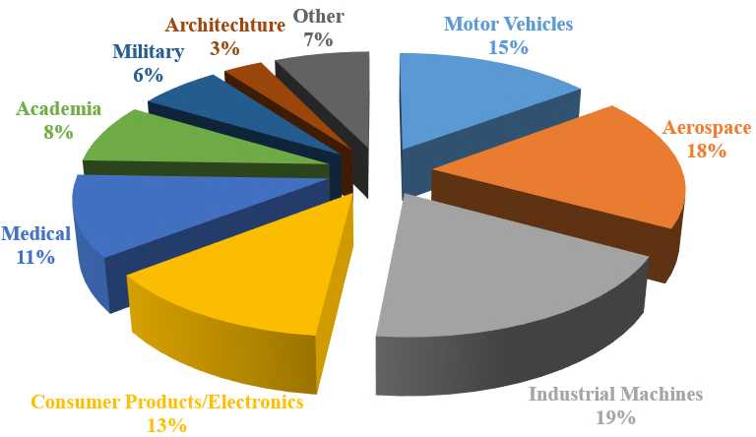
Fig. 5: Global AM market share by industries in 2017 (Data from: [50])

3.3. Forecast Data for the Market (2019-2025)
The global AM market is expected to reach more than $3,000 million by the year 2025, expanding at 20.24% CAGR throughout the forecast period, i.e. from 2019 to 2025 [47]. The total revenue of the AM market includes materials, equipment, software and services. To illustrate the forecast data representing the global aerospace AM market and its anticipated growth, the following graphs and charts are given in this section. According to Liu et al. [19], the global aerospace AM market including AM revenue subcomponents, i.e. AM service, software, aerospace materials and equipment, is anticipated to triple between 2014 and 2023 reaching $1,200 million total AM market volume as shown in Figure 6. According to a forecast made by Market Research Future [47] regarding the global aerospace AM market, the market is anticipated to be increasingly expanded at nearly 21% between 2016 and 2021. The primary factor behind this growth was associated with the merits and capabilities of AM process leading the adoption, such as reduction in fuel consumption and weight, increase in design freedom and eco-friendly manufacturing.
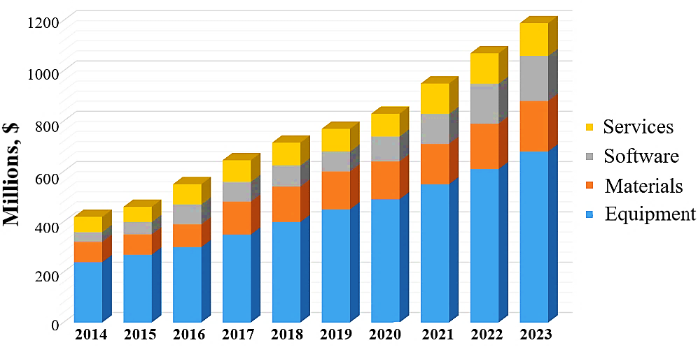
Fig. 6: Aerospace AM market summary and forecast between 2014 and 2023 (Data from: [51])
The forecasts for the recent global aerospace AM market can be mainly divided into platform, application, region, material type and technology segments as schematised in Figure 7. On the basis of the platform, the global aerospace AM market includes unmanned aerial vehicles, spacecrafts and aircrafts. The aircraft category can be then subdivided into rotary-wing and fixed-wing aircrafts. The aircraft market has dominated the market in 2019; however, the unmanned aerial vehicle subcategory is forecast to record the highest CAGR in the AM market by 2025. Regarding the application segment, the global market is categorised into engine, structural and others. The engine category has dominated the AM market until 2019 and is forecast to continuously show the highest CAGR throughout the forecast period, i.e. from 2019 until 2025. In the current situation, the effort made by aerospace companies to develop aircraft engines is expected to drive the AM market, thus possibly resulting in the highest CAGR in the following years [47].
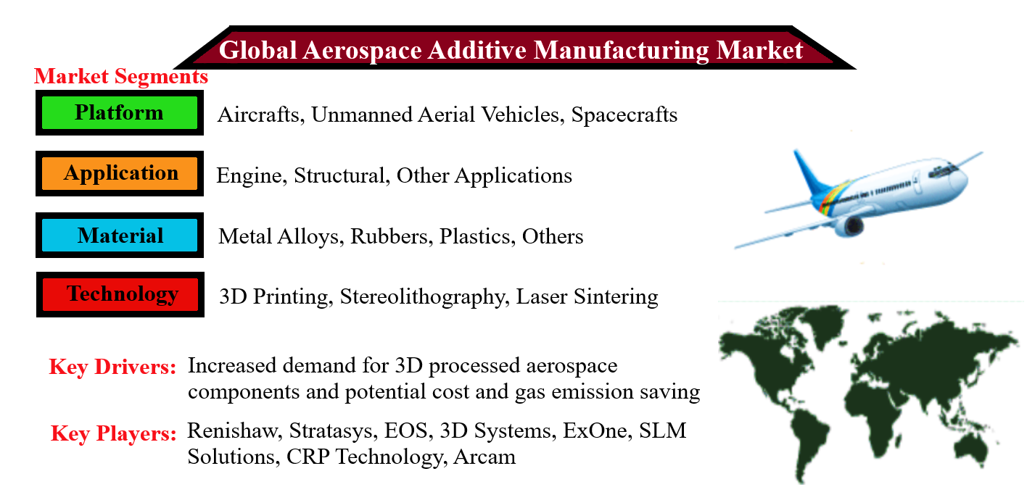
Fig. 7: Segments of the recent global AM Market (Adapted from: [47])
On the basis of material being used in the aerospace industry, the AM market can be categorised as metal alloys, plastics, rubber and other materials. The segment of metal alloys dominated the AM market with a 58.25% market share in 2018 and is anticipated to still have the highest CAGR by 2025. The main metal alloys being used in the aerospace industry are aluminium, nickel and titanium alloys. These alloys are mostly used for producing engine injectors and nozzles, and propulsion hardware. Moreover, fused deposition modelling, laser sintering, 3D printing, electron beam melting and stereolithography are the subcategories of the AM market considering the AM technology used in the AM market. Among these subcategories, 3D printing is expected to show the highest CAGR thanks to the capability of this technology for lightweight and raw material-effective manufacturing throughout the forecast period. The main subcategories of the region-based AM market are Europe, Latin and North America, Africa, Middle East, and Asia-Pacific. In 2018, North America, followed by Europe, dominated the AM market recording 38.86% market share and is expected to have the highest CAGR until 2025. In this region, some of the key players, such as 3D Systems and Stratasys Ltd, are expected to lead the significant growth in the AM market [47].

4. Impact of COVID-19 on the Global Aerospace Market and Sector
The world has been recently experiencing an unpredictable global pandemic disease named the novel coronavirus (Covid-19) which has spread across the massive human population all over the world. While the first Covid-19 case was detected at the Wuhan province of China in December 2019 [52], the virus has affected almost every part of the world even though the spread of the virus has been lately detected in South America and United State of America (USA) [53, 54]. During only the following three months, the number of Covid-19-infected people around the world reached to 5 million until May 2020 and more than 90% confirmed cases were recorded outside China [55]. As an outcome of this situation, the first global alert has been issued by the World Health Organization (WHO) on the 30th of January 2020. Then, the WHO announced Covid-19 disease as a globally pandemic threat on the 11th of March 2020 due to the soared case numbers confirmed [56].
The global economy has been affected by several factors because of problems in banking and energy, such as the oil crisis, Iran-Iraq war, gulf crisis, asian crisis, SARS and 2008 financial crisis. However, the current Covid-19 crisis, which is classified as a pandemic health crisis deriving from the Covid-19 pandemic, has inevitably impacted the global economy involving several subsectors, e.g. aerospace, automotive and tourism. The loss of the global economy due to the Covid-19 pandemic was estimated by the Asian Development Bank on the 15th May 2020 as: ‘’The global economy could suffer between $5.8 trillion and $8.8 trillion in losses—equivalent to 6.4% to 9.7% of global gross domestic product (GDP)—as a result of the novel coronavirus disease (Covid-19)‘’ [57]. Therefore, several global supply chains, e.g. manufacturing and transportation sectors, have been significantly affected by the disease [58]. The impact of Covid-19 varies in different sectors resulting from differences in the level of supply patterns and demand [59]. From this perspective, the international transportation sector that can be directly associated with the aerospace sector was impacted relatively first as the profits of these companies are highly dependent on movement. The aerospace industry was mainly restricted by the extensive restrictions in aviation activities, national lockdowns and tight border precautions leading to several detrimental outcomes as given in Figure 8 [60, 61]. An example of the impact on the movement is that International Air Transportation Association (IATA) anticipated $113 billion lost in the aerospace industry revenue because of a nearly 55% decrease in the revenue passenger kilometres (RPKs). Note that RPKs term is described as a measurement of airline traffic determined by multiplying the number of revenue-paying passenger in domestic and international routes [62].
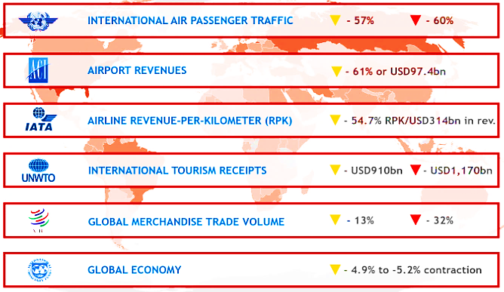
Fig. 8: Summary of the outcomes of the Covid-19 pandemic on the global aerospace sector [63]
The incurred loss of the aerospace industry caused by Covid-19 have been reported in several research. According to Airports Council International (ACI) [64], 40% lost in passenger traffic and more than $76 billion lost regarding airport revenues all worldwide airports in this year were reported as comparison to the data collected in 2019. International Civil Aviation Organization (ICAO) [65] also projected a decline ranging between 44% and 80% in the number of international passengers in 2020 compared to the previous year. As seen in Figure 9, the world passenger traffic has increased gradually although several crisis and pandemics experienced from 1945 until today. However, the aerospace industry and sector have never experienced such dramatic decline caused by Covid-19 as can be seen from the data of world passenger traffic reported by ICAO [66].
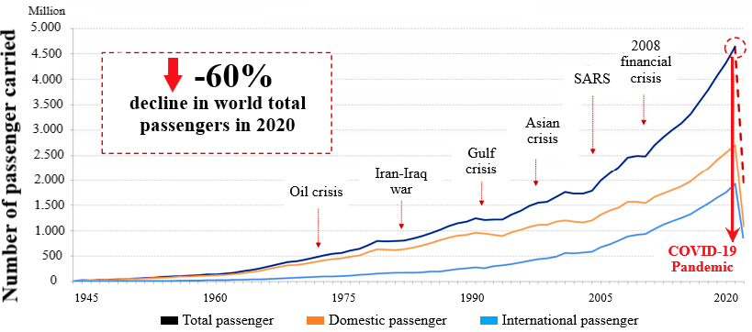
Fig. 9: Evolution of world passenger traffic between 1945 and 2020 [67]
There are several sectors that the aerospace industry has a wide range of collaboration and interaction with regarding to the supply chain and interactions of this sector. As a result of this, Covid-19-based impacts in the aerospace industry has, in turn, resulted in an immense negative influence on related sectors, such as manufacturing (aerospace application, AM) and tourism (air travel) [68]. The region-based changes regarding the seat offered (capacity), passenger flown, and airline revenue drop due to Covid-19 are given in Figure 10, note that yellow arrows represent the most optimistic scenario, while red arrows represent the most pessimistic scenario [63]. The 7-13% of total Covid-19-based job losses can be linked with job losses in large aerospace companies. Several experts asserted that the impact of the pandemic can be recovered in the aerospace industry at least six years later [69]. The Covid-19 pandemic, on the other hand, caused some positive effects in addition to the detrimental impacts mentioned in this section. Some examples of the positive impacts of the Covid-19 pandemic are decreased CO₂ emission in the atmosphere, reduced primary energy use and environmental noise, and improved air quality [70].
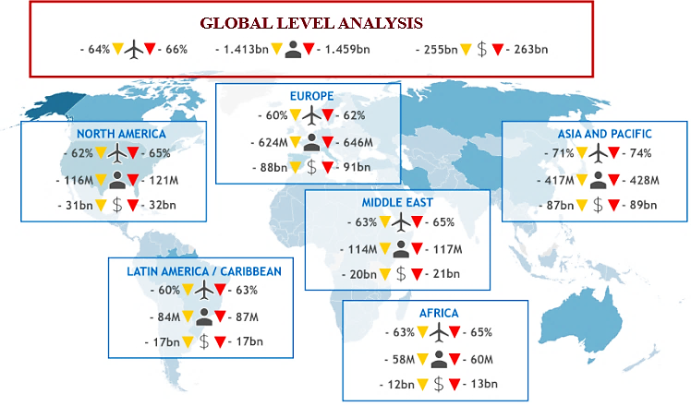
Fig. 10: Economic impacts of Covid-19 on the global aerospace sector [63]

5. Conclusions
This study presents a review of the historic and forecasted market trends of the global aerospace AM market, factors affecting the adoption of AM process in the aerospace industry that lead to a growth in the market, and the effects of Covid-19 pandemic on the adoption and aerospace sector. From this study, these conclusions have been deduced by the authors:
- The global aerospace AM market is significantly affected by the adoption and innovative developments of AM technology and materials science. The positive forecasts regarding the potential of the global AM market have mainly been based on anticipated future developments in AM technology aiming to extend the adoption of AM in the aerospace industry and innovations in materials science.
- Although the forecast for the global aerospace AM market had notably decreased due to the impacts of the Covid-19 pandemic on the global aerospace industry and sector, the overall future forecasts are reaching a consensus, mainly anticipating a long-term recovery in the market. The long-term recovery is anticipated by the main aerospace authorities to last longer than six years; however, the recovery is expected to spread over the following ten years due to the delay in the adoption of AM technology in the aerospace industry during the pandemic.
- The aerospace industry is forecasted to keep being one of the major contributors to the AM market, almost tripling its market revenue until 2025. This forecast can be surpassed by eliminating the most impactful limitations of AM technology for the aerospace industry as these limitations can accelerate the adoption of this technology to a great extent. The main limitations that need to be overcome to accelerate the adoption are: (i) the lack of globally accepted certification and standardisation particularly for mission-critical aerospace components, (ii) the high cost of aerospace materials for AM applications, (iii) limited component size that can be printed, and (iv) the slow fabrication speed of AM process for the aerospace applications.
- Aerospace companies can achieve the maximum potential cost reduction in the manufacturing of aerospace components and progressive improvement in the aerospace industry by implementing new technologies to some extent together. In this regard, the AM technology is one of the essential technologies, such as digital control, lean manufacturing and Industry 4.0., that can contribute the cost reduction and progressive improvement.

Conflicts of interest
The authors declare that there is no conflict of interest.

Acknowledgements
The authors gratefully acknowledge the financial support of The Republic of Turkey, Ministry of National Education.

References
- ASTM. ISO/ASTM 52900:2015(E) Standard Terminology for Additive Manufacturing – General Principles – Terminology (2015)
- ASTM. International. Standard Terminology for Additive Manufacturing Technologies,
http://web.mit.edu/2.810/www/files/readings/AdditiveManufacturingTerminology.pdf (accessed 17 May 2021)
- I. Gibson, D. Rosen, B. Stucker. Additive Manufacturing Technologies: 3D Printing, Rapid Prototyping, and Direct Digital Manufacturing. 2nd ed. New York: Springer 2015.
- C.K. Chua, K.F. Leong. 3D Printing and Additive Manufacturing: Principles and Applications (with Companion Media Pack) of Rapid Prototyping Fourth Edition. World Scientific Publishing Company, 2014.
- S.C. Joshi, A.A. Sheikh. 3D printing in aerospace and its long-term sustainability. Virtual. Phys. Prototyp. 10 (4) (2015), pp. 175–185. https://doi.org/10.1080/17452759.2015.1111519
- E. Atzeni, A. Salmi. Economics of additive manufacturing for end-usable metal parts. Int. J. Adv. Manuf. Technol. 62 (9) (2012), pp. 1147–1155. https://doi.org/10.1007/s00170-011-3878-1
- V. Petrovic, J.V.H. Gonzalez, O.J. Ferrando, J.D. Gordillo, J.R.B. Puchades, L.P. Griñan. Additive layered manufacturing: sectors of industrial application shown through case studies. Int. J. Prod. Res. 49 (4) (2011), pp. 1061–1079. https://doi.org/10.1080/00207540903479786
- B. Berman. 3-D Printing: the new industrial revolution. Bus. Horiz. 55 (2012), pp. 155–162. https://doi.org/10.1016/j.bushor.2011.11.003
- G. Li, S. Lyu, R. Zheng, Q. Li, K. Ameyama, W. Xiao, C. Ma. Strengthening 2024Al alloy by novel core-shell structured Ti/B4C composite particles. Mater. Sci. Eng. A. 755 (2019), pp. 231–234. https://doi.org/10.1016/j.msea.2019.04.021
- H. Bikas, P. Stavropoulos, G. Chryssolouris. Additive manufacturing methods and modelling approaches: a critical review. Int. J. Adv. Manuf. Technol. 83 (1-4) (2016), pp. 389–405. https://doi.org/10.1007/s00170-015-7576-2
- S.C. Altıparmak, V.A. Yardley, Z. Shi, J. Lin. Challenges in additive manufacturing of high-strength aluminium alloys and current developments in hybrid additive manufacturing. Inter. J. Lightweight Mater. Manuf. 4 (2) (2021), pp. 246-261. https://doi.org/10.1016/j.ijlmm.2020.12.004
- A.A. Shapiro, J.P. Borgonia, Q.N. Chen, R.P. Dillon, B. McEnerney, R. Polit-Casillas, L. Soloway. Additive manufacturing for aerospace flight applications. J. Spacecr. Rockets. 53 (5) (2016), pp. 952–959. https://doi.org/10.2514/1.A33544
- S. Ford, M. Despeisse. Additive manufacturing and sustainability: an exploratory study of the advantages and challenges. J. Clean Prod. 137 (2016), pp. 1573–1587. https://doi.org/10.1016/j.jclepro.2016.04.150
- A. Grigoriev, I. Polozov, V. Sufiiarov, A. Popovich. In-situ synthesis of Ti2AlNb-based intermetallic alloy by selective laser melting. J. Alloys. Compd. 704 (2017), pp. 434–442. https://doi.org/10.1016/j.jallcom.2017.02.086
- H. Kim, Y. Lin, B. Tseng. A review on quality control in additive manufacturing. Rapid Prototyp. J. 24 (3) (2018), pp. 645–669. https://doi.org/10.1108/RPJ-03-2017-0048
- A. Uriondo, M. Esperon-Miguez, S. Perinpanayagam. The present and future of additive manufacturing in the aerospace sector: A review of important aspects. Proc. Inst. Mech. Eng. G J. Aerosp. 229 (11) (2015), pp. 2132–2147. https://doi.org/10.1177/0954410014568797
- M. Javaid, A. Haleem. Using additive manufacturing applications for design and development of food and agricultural equipments. Int. J. Mater. Prod. Technol. 58 (2/3) (2019), pp. 225–238. https://doi.org/10.1504/IJMPT.2019.097662
- Deloitte University Press, Additive manufacturing takes flight, 3D opportunity in aerospace and defense, USA, 2014.
- R. Liu, Z. Wang, T. Sparks, F. Liou, J. Newkirk. Aerospace applications of laser additive manufacturing. In Laser Additive Manufacturing; Elsevier: Amsterdam, The Netherlands. (2017), pp. 351–371. https://doi.org/10.1016/B978-0-08-100433-3.00013-0
- J. Plocher, A. Panesar. Review on design and structural optimisation in additive manufacturing: Towards next-generation lightweight structures. Mater. Des. 183 (2019), p. 108164. https://doi.org/10.1016/j.matdes.2019.108164
- R. Huang, M. Riddle, D. Graziano, J. Warren, S. Das, S. Nimbalkar, J. Cresko, E. Masanet. Energy and emissions saving potential of additive manufacturing: the case of lightweight aircraft components. J. Clean Prod. 135 (2016), pp. 1559–1570. https://doi.org/10.1016/j.jclepro.2015.04.109
- M. Kreiger, J.M. Pearce. Environmental life cycle analysis of distributed three-dimensional printing and conventional manufacturing of polymer products. ACS Sustain. Chem. Eng. 1 (12) (2013), pp. 1511–1519. https://doi.org/10.1021/sc400093k
- L. Nickels. AM and aerospace: an ideal combination. Met. Powder Rep. 70 (6) (2015), pp. 300–303. https://doi.org/10.1016/j.mprp.2015.06.005
- T. Kellner. An epiphany of disruption: GE additive chief explains how 3D printing will upend manufacturing. GE Reports, 13.
https://www.ge.com/news/reports/epiphany-disruption-ge-additive-chief-explains-3d-printing-will-upend-manufacturing, 2017 (accessed 17 May 2021)
- J.C. Najmon, S. Raeisi, A. Tovar. Review of additive manufacturing technologies and applications in the aerospace industry. In Additive manufacturing for the aerospace industry (pp. 7 – 31). Elsevier, 2019. https://doi.org/10.1016/B978-0-12-814062-8.00002-9
- K. Taylor-Smith. The Benefits of Additive Manufacturing for the Aerospace Industry.
https://www.azonano.com/article.aspx?ArticleID=5345, 2019 (accessed 17 May 2021)
- B. Lyons. Additive manufacturing in aerospace: Examples and research outlook, Bridge Linking Eng. Soc. 42 (1) (2012), pp. 13–19.
- Stratasys Inc. A new mindset in product design. (2012).
- F.H. Froes, R. Boyer, B. Dutta. Additive manufacturing for aerospace applications-part II. Adv. Mater. Process. 175 (6) (2017), pp. 18–22.
- J.H. Zhu, W.H. Zhang, L. Xia. Topology optimization in aircraft and aerospace structures design. Arch. Comput. Methods Eng. 23 (4) (2016), pp. 595–622. https://doi.org/10.1007/s11831-015-9151-2
- S. Singamneni, L.V. Yifan, A. Hewitt, R. Chalk, W. Thomas, D. Jordison. Additive manufacturing for the aircraft industry: a review. J. Aeronaut. Aerospace Eng. 8 (214) (2019). DOI: 10.4172/2329-6542.1000214
- G.J. Schiller. Additive manufacturing for aerospace. in 2015 IEEE Aerospace Conference, AERO2015, March 7, 2015–March 14, 2015, Big Sky, MT, IEEE Computer Society, 2015.
- Stratasys Inc. Additive manufacturing reduces tooling cost and lead time to produce composite aerospace parts, 2013.
- R. Dehoff, C. Duty, W. Peter, Y. Yamamoto, W. Chen. Case study: Additive manufacturing of aerospace brackets. Adv. Mater. Process. (2013), p. 171.
- W.E. Frazier. Metal additive manufacturing: a review. J. Mater. Eng. Perform. 23 (6) (2014), pp. 1917–1928. https://doi.org/10.1007/s11665-014-0958-z
- M. Gebler, A.J.M.S. Uiterkamp, C. Visser. A global sustainability perspective on 3D printing technologies. Energy Policy. 74 (2014), pp. 158–167. https://doi.org/10.1016/j.enpol.2014.08.033
- R.R. Dehoff, C. Tallman, C.E. Duty, W.H. Peter, Y. Yamamoto, W. Chen, C.A. Blue. Case study: additive manufacturing of aerospace brackets. Adv. Mater. Process. 171 (3) (2013).
- M.P. Samuel, A.K. Mishra, R.K. Mishra. Additive Manufacturing of Ti-6Al-4V Aero Engine Parts: Qualification for Reliability. J. Fail. Anal. Prev. 18 (2018), pp. 136–144. https://doi.org/10.1007/s11668-018-0393-9
- C. Holshouser, C. Newell, S. Palas, C. Duty, L. Love, V. Kunc, R. Lind, P. Lloyd, J. Rowe, R. Dehoff, W. Peter, et al. Out of bounds additive manufacturing Adv. Mater. Process., 171 (2) (2013 Mar), pp. 15-17 C.
- S. Williams. Large Scale Metal Wire + Arc Additive Manufacturing of Structural Engineering Parts – Slide Presentation, Cranfield University, U.K., 13th July 2016.
https://waammat.com/documents/s-williams-large-scale-metal-wire-arc-additive-manufacturing-of-structural-engineering-parts, 2016 (accessed 17 May 2021)
- S.L.N. Ford. Additive manufacturing technology: potential implications for U.S. manufacturing competitiveness, J. Int. Commer. Econ. Washington DC, US: United States International Trade Commission (2014)
- J. Coykendall, M. Cotteleer, J. Holdowsky, M. Mahto. 3D opportunity in aerospace and defense: Additive manufacturing takes flight. A Deloitte series on additive manufacturing, Westlake, TX, Deloitte University Press (2014).
- N.T. Aboulkhair, I. Maskery, C. Tuck, I. Ashcroft, N.M. Everitt, On the formation of AlSi10Mg single tracks and layers in selective laser melting: microstructure and nano-mechanical properties, J. Mater. Process. Technol. 230 (2016), pp. 88–98, https://doi.org/10.1016/j.jmatprotec.2015.11.016
- Structures CoS, Standard: Space SystemsdStructures, Structural Components, and Structural Assemblies (AIAA S-110-2005), American Institute of Aeronautics and Astronautics, Reston, VA, USA, 2014, https://doi.org/ 10.2514/4.477713.001
- W.E. Spreen. Marketing in the international aerospace industry. Routledge. (2016)
- S.C. Ligon, R. Liska, J. Stampfl, M. Gurr, R. Mülhaupt. Polymers for 3D printing and customized additive manufacturing. Chem. Rev. 117 (15) (2017), pp. 10212–10290. https://doi.org/10.1021/acs.chemrev.7b00074
- Market Research Future, Aerospace Additive Manufacturing Market.
https://www.marketresearchfuture.com/reports/aerospace-additive-manufacturing-market-1551, 2019 (accessed 17 May 2021)
- L.J. Kumar, K. Nair. Current trends of additive manufacturing in the aerospace industry, in: D.I. Wimpenny, P.M. Pandey, L.J. Kumar, L.J. (Eds.), Advances in 3D Printing & Additive Manufacturing Technologies, Springer, Singapore (2017), pp. 39–54.
- T. Wohlers, T. Caffrey. Wohlers Report 2013: Additive Manufacturing and 3D Printing State of the Industry–Annual Worldwide Progress Report, Wohlers Associates. Fort Collins, CO, 2013.
- Wohlers Associates. Wohlers Report: 3D Printing and Additive Manufacturing State of the Industry, Annual Worldwide Progress Report, Wohlers Associates: Fort Collins, CO, 2017.
- Markets Smartech. Additive manufacturing in aerospace: Strategic implications. White paper.
https://www.smartechanalysis.com/wp-content/uploads/2017/11/aerospacewp.pdf, 2014 (accessed 17 May 2021)
- WHO, Public health emergency of international concern declared.
https://www.who.int/emergencies/diseases/novel-coronavirus-2019/situation-reports, 2020 (accessed 17 May 2021)
- Q. Sun, H. Qiu, M. Huang, Y. Yang. Lower mortality of COVID-19 by early recognition and intervention: experience from Jiangsu Province. Ann. Intensive Care. 10 (1) (2020), pp. 1–4. https://doi.org/10.1186/s13613-020-00650-2
- S. Popescu. Roadblocks to Infection Prevention Efforts in Health Care: SARS-CoV-2/COVID-19 Response. Disaster Med. Public Health Prep. 14 (4) (2020), pp. 1–3. https://doi.org/10.1017/dmp.2020.55
- L. Boone, D. Haugh, N. Pain, V. Salins. Tackling the fallout from COVID-19, R. Baldwin, B.W. di Mauro (Eds.), Economics in the time of COVID-19, a VoxEU.org eBook, CEPR Press (2020).
- WHO, World Health Organization characterizes COVID-19 as a pandemic.
https://www.who.int/docs/default-source/coronaviruse/transcripts/who-audio-emergencies-coronavirus-press-conference-full-and-final-11mar2020.pdf?sfvrsn=cb432bb3_2, 2020 (accessed 17 May 2021)
- Asian Development Bank, COVID-19 Economic Impact Could Reach $8.8 Trillion Globally — New ADB Report. https://www.adb.org/news/covid-19-economic-impact-could-reach-8-8-trillion-globally-new-adb-report, 2020 (accessed 17 May 2021)
- H. Nakamura, S. Managi. Airport risk of importation and exportation of the COVID-19 pandemic. Transp. Policy. 96 (2020), pp. 40–47. https://doi.org/10.1016/j.tranpol.2020.06.018
- R. Sharma, A. Shishodia, S. Kamble, A. Gunasekaran, A. Belhadi. Agriculture supply chain risks and COVID-19: mitigation strategies and implications for the practitioners. Int. J. Logist. Res. Appl. (2020), pp. 1–27. https://doi.org/10.1080/13675567.2020.1830049
- J. Amankwah-Amoah. Stepping up and stepping out of COVID-19: new challenges for environmental sustainability policies in the global airline industry. J. Clean Prod. 271 (2020), p. 123000. https://doi.org/10.1016/j.jclepro.2020.123000
- S. Muhammad, X. Long, M. Salman. COVID-19 pandemic and environmental pollution: A blessing in disguise? Sci. Total Environ. 728 (2020) 138820. https://doi.org/10.1016/j.scitotenv.2020.138820
- J.B. Sobieralski. COVID-19 and airline employment: insights from historical uncertainty shocks to the industry. Transp. Res. Interdiscip. Perspect. 5 (2020) 100123. https://doi.org/10.1016/j.trip.2020.100123
- ICAO, Economic Impacts of COVID-19 on Civil Aviation. https://www.icao.int/sustainability/Pages/Economic-Impacts-of-COVID-19.aspx, 2020 (accessed 17 May 2021)
- ICAO. Effects of novel coronavirus (COVID-19) on civil aviation: economic impact analysis. Unit. Aviat. 2020.
https://www.aaco.org/Library/Files/Uploaded%20Files/Economics/Corona%20studies/3dec%20ICAO_Coronavirus_Econ_Impact.pdf, 2020 (accessed 17 May 2021)
- IATA. Air transport & COVID-19 coronavirus. Int Air Transp Assoc 2020. www.airlines.iata.org
- Air Transport Bureau Effects of Novel Coronavirus (COVID‐19) on Civil Aviation: Economic Impact Analysis International Civil Aviation Organization (ICAO), Montréal, Canada (2020).
- ICAO. Effects of Novel Coronavirus (COVID‐19) on Civil Aviation: Economic Impact Analysis.
https://www.icao.int/sustainability/Documents/COVID-19/ICAO_Coronavirus_Econ_Impact.pdf, 2020 (accessed 17 May 2021)
- ACI Policy Brief – COVID-19: Relief measures to ensure the survival of the airport industry Airport Council Int. (2020).
- A. Martin, M. Markhvida, S. Hallegatte, B. Walsh. Socio-Economic Impacts of COVID-19 on Household Consumption and Poverty. Econ. Disasters Clim. Change. 4 (2020), pp. 453–479. https://doi.org/10.1007/s41885-020-00070-3
- T. Ibn-Mohammed, K.B. Mustapha, J. Godsell, Z. Adamu, K.A. Babatunde, D.D. Akintade, A. Acquaye, H. Fujii, M.M. Ndiaye, F.A. Yamoah, S.C.L. Koh. A critical review of the impacts of COVID-19 on the global economy and ecosystems and opportunities for circular economy strategies. Resour. Conserv. Recycl. 164 (2021) 105169. https://doi.org/10.1016/j.resconrec.2020.105169

