**Supplementary Information**

**Ethyl Methacrylate Diblock Copolymers as Polymeric Surfactants: Effect of Molar Mass and Composition**

Birsen Somuncuoğlu, Yu Lin Lee, Anna P. Constantinou, David L. M. Poussin

and Theoni K. Georgiou*

*Department of Materials, Imperial College London, South Kensington Campus, Royal School of Mines, Exhibition Road, SW7 2AZ, London, United Kingdom*

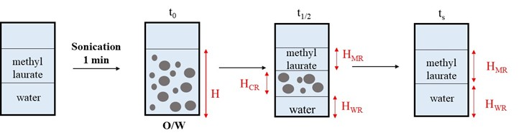

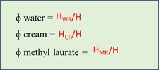

**Figure S1.** Method of visual observations to study emulsion stability.

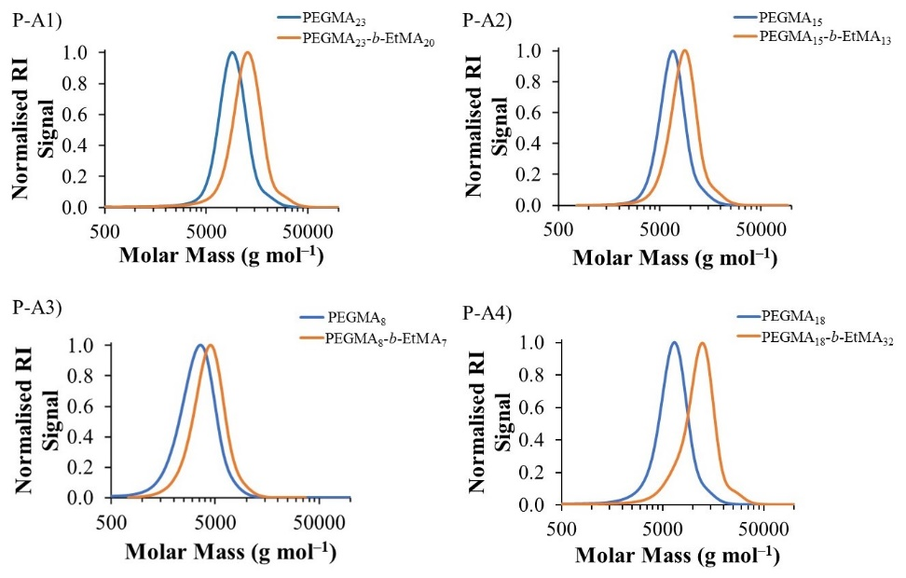

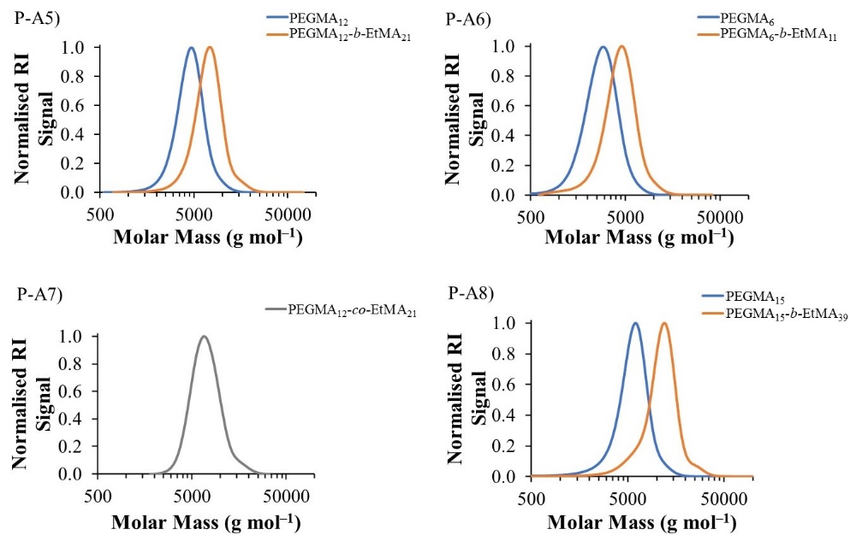

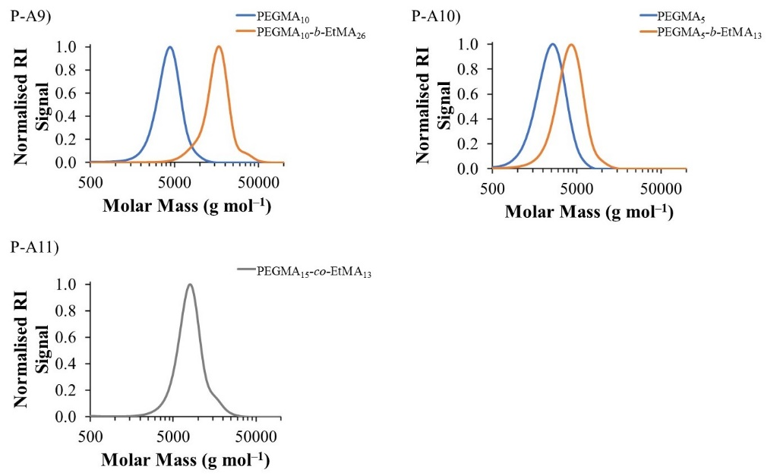

**Figure S2.** GPC chromatograms of PEGMA-EtMA based copolymers of Polymer series 1. The blue and orange lines represent the PEGMAhomopolymers and the diblock copolymers, respectively. The grey lines represent statistical copolymers.

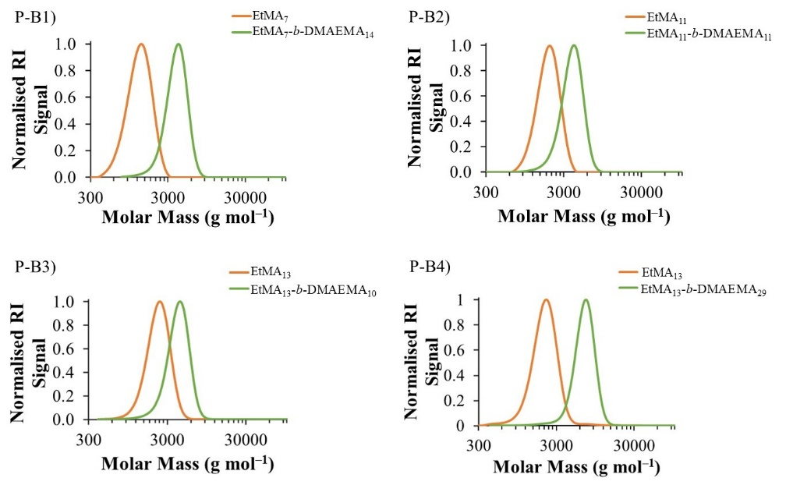

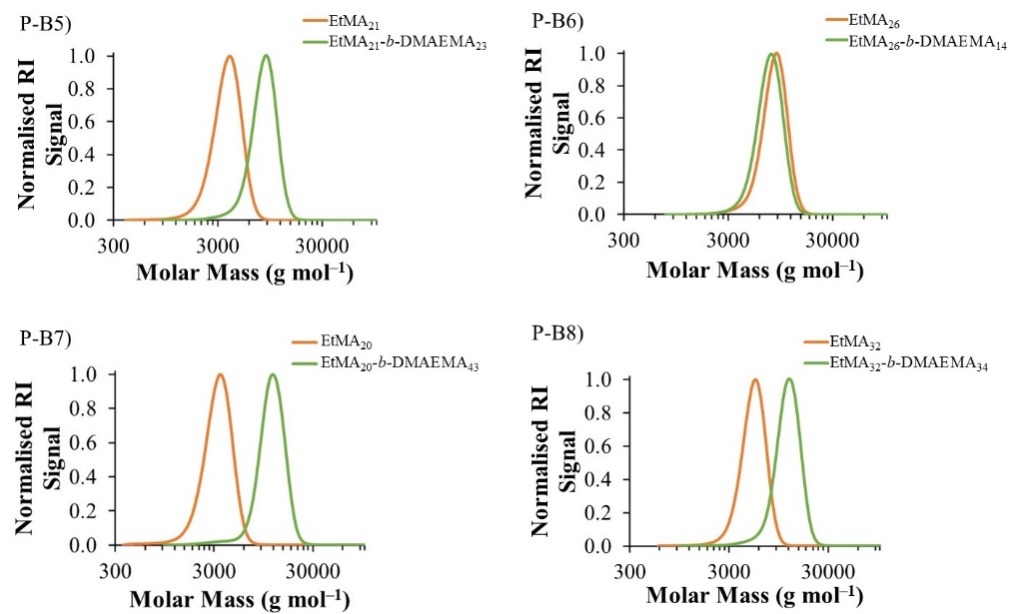

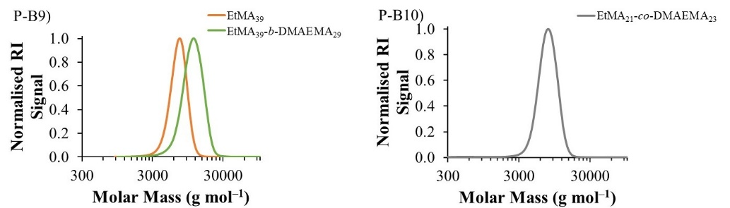

**Figure S3.** GPC chromatogram of EtMA-DMAEMA based copolymers of Polymer series 2. The orange and green lines represent the EtMAhomopolymers and the diblock copolymers, respectively. The grey lines represent statistical copolymers.

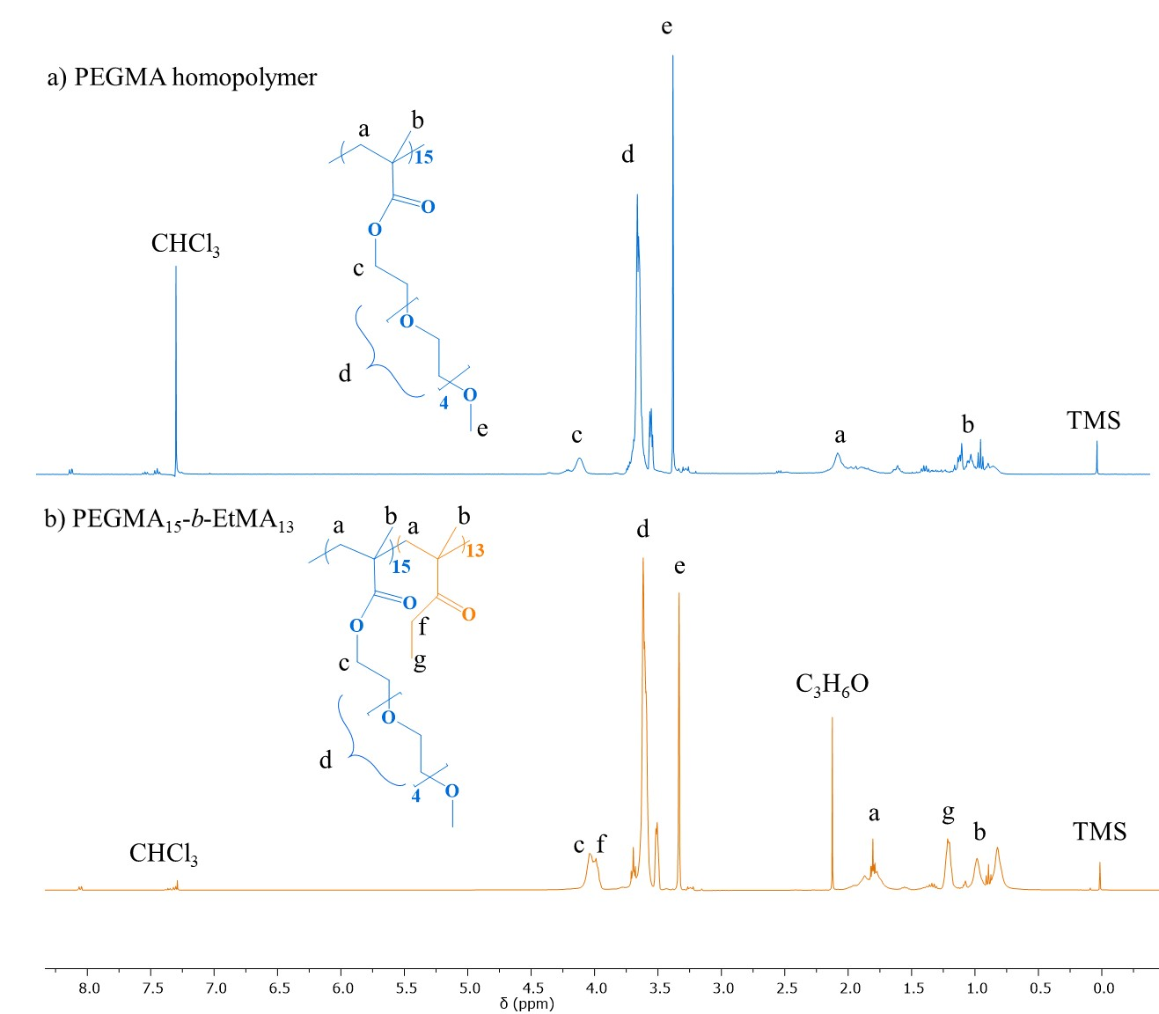

**Figure S4.** The 1H NMR spectra of (a) PEGMA homopolymer and (b) diblock copolymer, P-A2: PEGMA15-*b*-EtMA13 shown in blue and orange, respectively. The chemical structures of PEGMA and EtMA are also coloured in blue and orange, respectively.

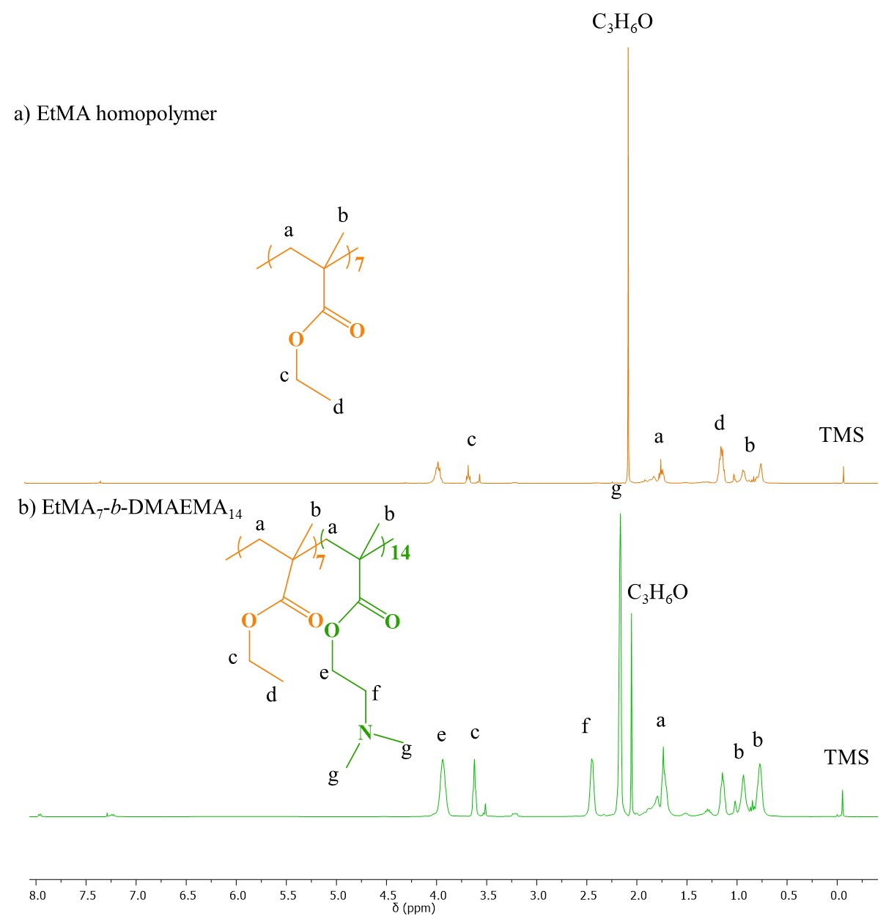

**Figure S5.** The 1H NMR spectra of (a) EtMA homopolymer and (b) diblock copolymer, P-B1: EtMA7-*b*-DMAEMA14 shown in orange and green, respectively. The chemical structures of EtMA and DMAEMA are also coloured in orange and green, respectively.

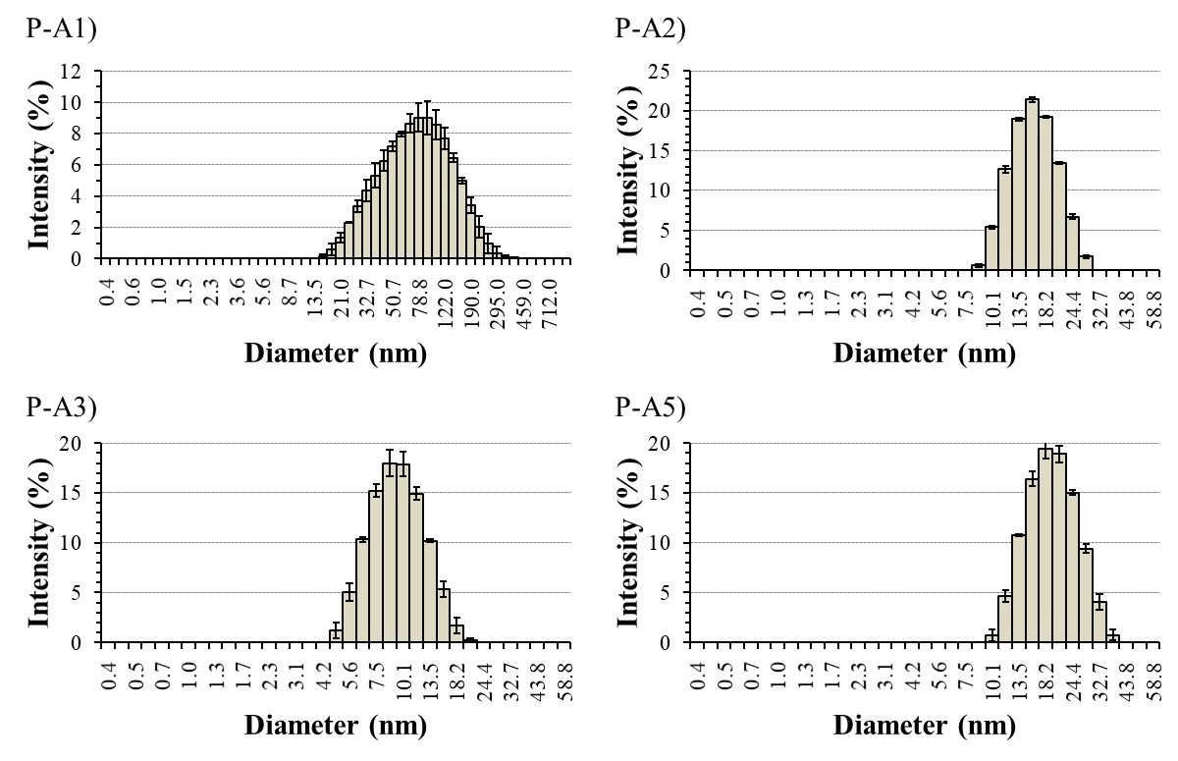

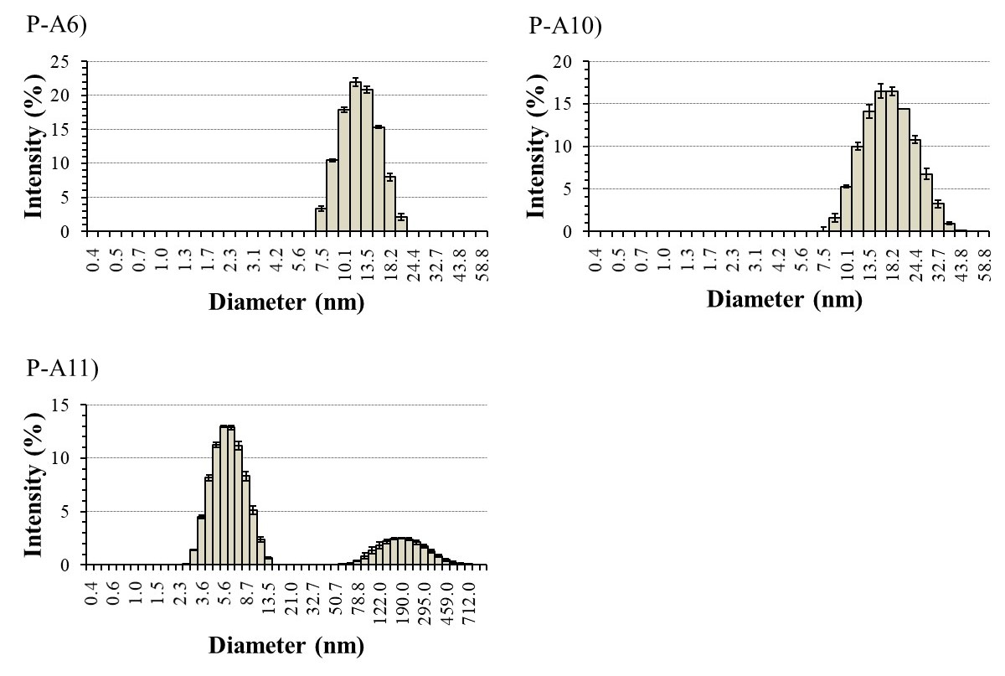

**Figure S6.** DLS histograms of PEGMA-*b*-EtMA based diblock copolymers of Polymer series 1, obtained by analysing 1 w/w% solution in deionised water.

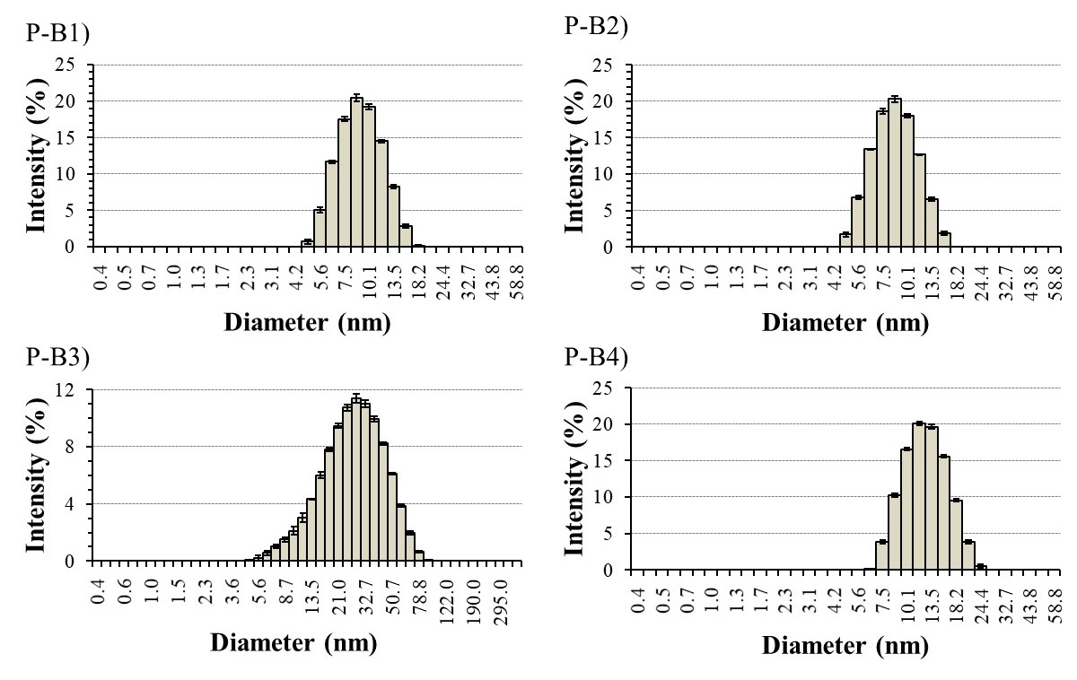

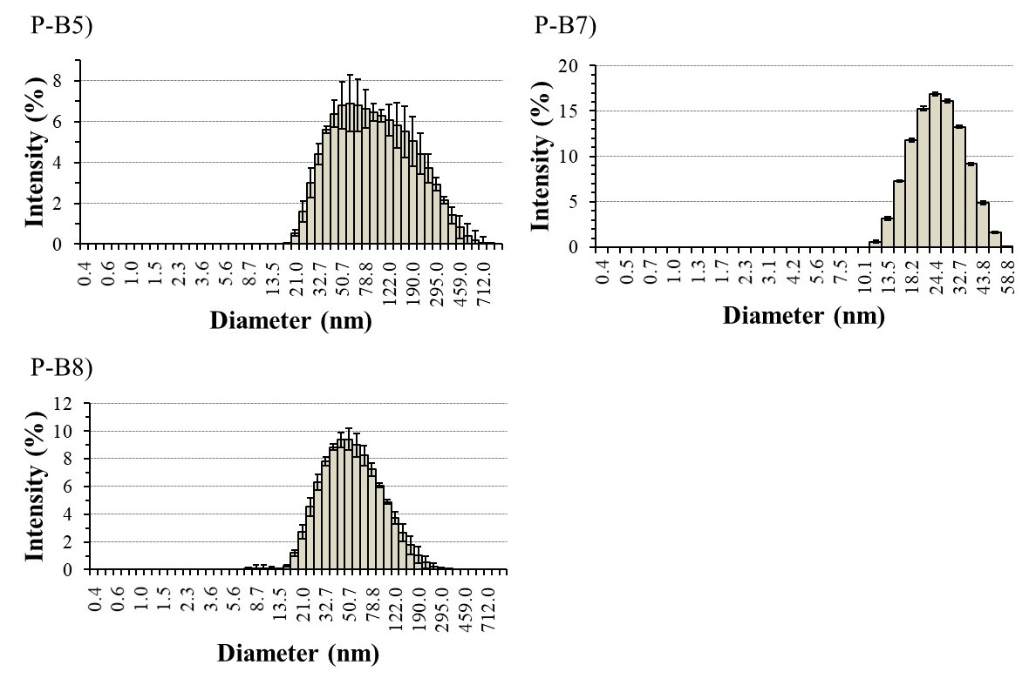

**Figure S7.** DLS histograms of EtMA-*b*-DMAEMA based diblock copolymers of Polymer series 2, obtained by analysing 1 w/w% solution in deionised water.

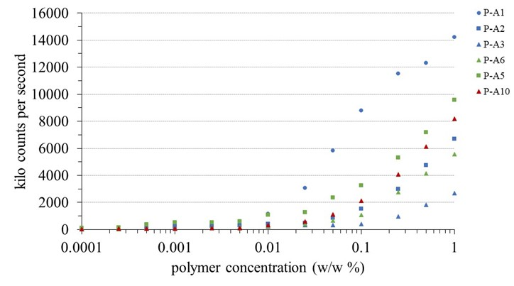

**Figure S8.** Graph shows the kilo counts per second versus polymer concentration. The targeted compositions of diblock copolymers; 75-25, 60-40 and 50-50 w/w% are represented in blue, green and red, respectively. The circle (•), square (⏹) and triangle (⏶) polymers of different MMs; 9000, 6000 and 3000 g mol-1 are represented, respectively.

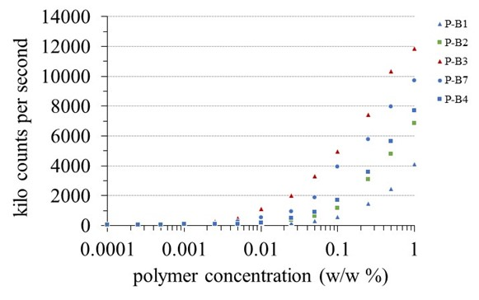

**Figure S9.** Graph shows the kilo counts per second versus polymer concentration. The targeted compositions of diblock copolymers; 75-25, 60-40 and 50-50 w/w% are represented in blue, green and red, respectively. The circle (•), square (⏹) and triangle (⏶) polymers of different MMs; 9000, 6000 and 3000 g mol-1 are represented, respectively.

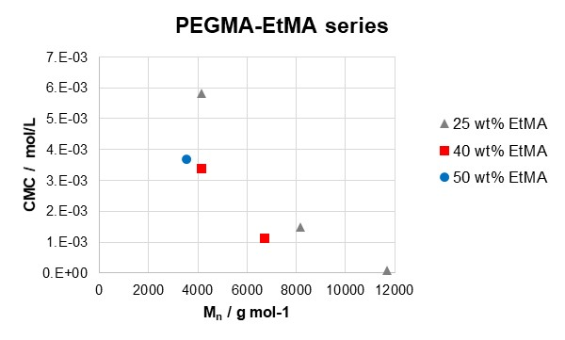

**Figure S10.** CMC (in mol L-1) versus Mn of all water soluble PEGMA-EtMA copolymers. The circle (•), square (⏹) and triangle (⏶) polymers of 30, 40 and 50 wt% are represented, respectively.

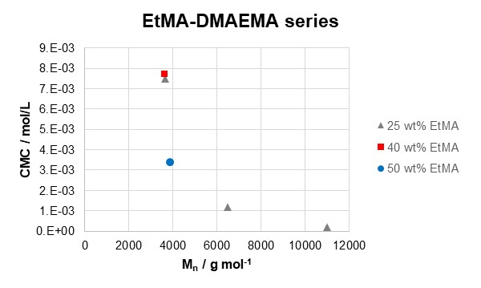

**Figure S11.** CMC (in mol L-1) versus Mn of all water soluble DMAEMA-EtMA copolymers. The circle (•), square (⏹) and triangle (⏶) polymers of 30, 40 and 50 wt% are represented, respectively.

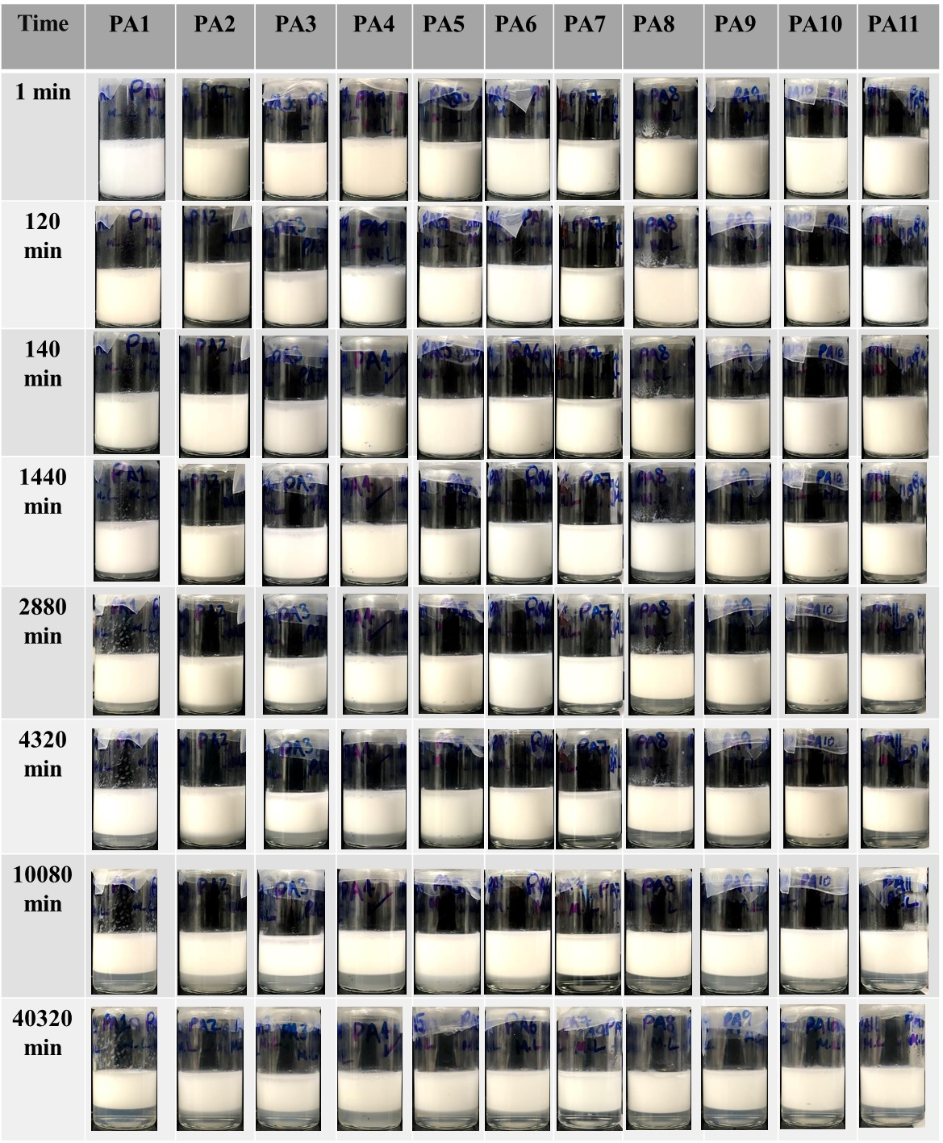

**Figure S12.** Images of emulsions taken at different time scales. Polymeric surfactants from Polymer series 1 were used as emulsifiers. 1 w/w % of each copolymer was mixed with equal weights of methyl laurate and water.

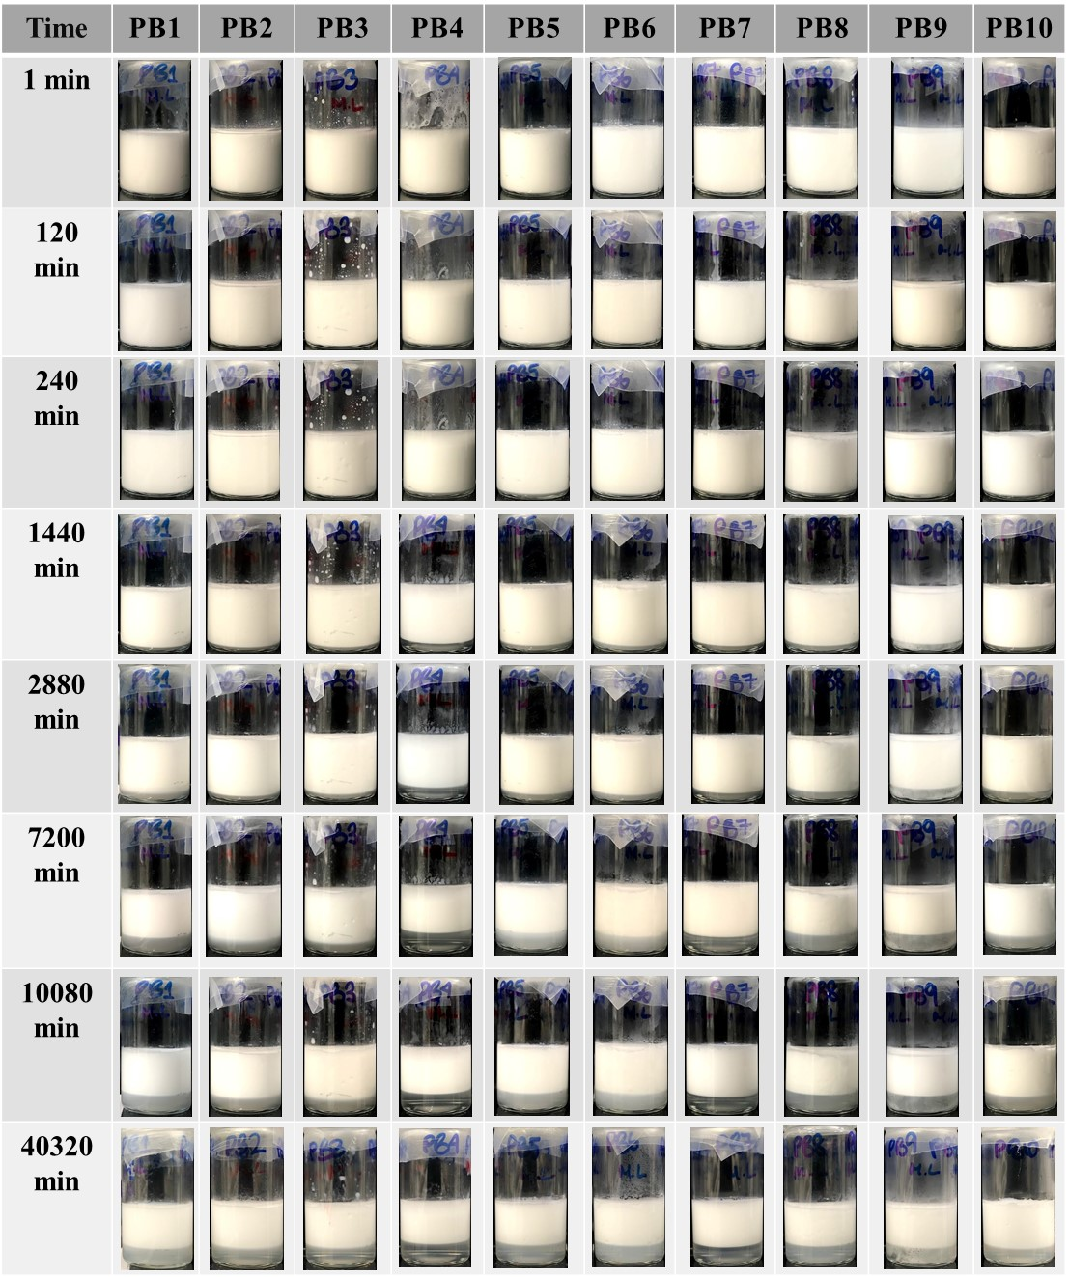

**Figure S13.** Images of emulsions taken at different time scales. Polymeric surfactants from Polymer series 2 were used as emulsifiers. 1 w/w % of each copolymer was mixed with equal weights of methyl laurate and water.

**Table S1.** The fraction of the cream phase-resolved for Polymer series 1 atdifferent times.

|  |  |  |  |  |  |  |  |  |  |  |  |
| --- | --- | --- | --- | --- | --- | --- | --- | --- | --- | --- | --- |
|  | **ɸ cream** | | | | | | | | | | |
| **time (min)** | **P-A1** | **P-A2** | **P-A3** | **P-A4** | **P-A5** | **P-A6** | **P-A7** | **P-A8** | **P-A9** | **P-A10** | **P-A11** |
| 1 | 0.831 | 0.845 | 0.86 | 0.922 | 0.879 | 0.926 | 0.820 | 0.941 | 0.924 | 0.903 | 0.934 |
| 120 | 0.817 | 0.835 | 0.851 | 0.880 | 0.874 | 0.924 | 0.816 | 0.915 | 0.901 | 0.903 | 0.921 |
| 240 | 0.811 | 0.817 | 0.840 | 0.865 | 0.852 | 0.914 | 0.812 | 0.895 | 0.897 | 0.893 | 0.915 |
| 1440 | 0.787 | 0.749 | 0.769 | 0.803 | 0.822 | 0.876 | 0.796 | 0.813 | 0.861 | 0.878 | 0.853 |
| 2880 | 0.758 | 0.713 | 0.699 | 0.751 | 0.788 | 0.865 | 0.742 | 0.783 | 0.833 | 0.838 | 0.833 |
| 4320 | 0.701 | 0.673 | 0.626 | 0.686 | 0.757 | 0.836 | 0.674 | 0.776 | 0.786 | 0.813 | 0.754 |
| 10080 | 0.616 | 0.612 | 0.601 | 0.637 | 0.641 | 0.761 | 0.634 | 0.694 | 0.700 | 0.794 | 0.713 |
| 20160 | 0.595 | 0.600 | 0.58 | 0.623 | 0.621 | 0.668 | 0.622 | 0.661 | 0.656 | 0.694 | 0.670 |
| 30240 | 0.579 | 0.597 | 0.576 | 0.611 | 0.615 | 0.648 | 0.621 | 0.657 | 0.644 | 0.676 | 0.670 |
| 40320 | 0.570 | 0.576 | 0.575 | 0.605 | 0.613 | 0.640 | 0.620 | 0.644 | 0.632 | 0.672 | 0.630 |

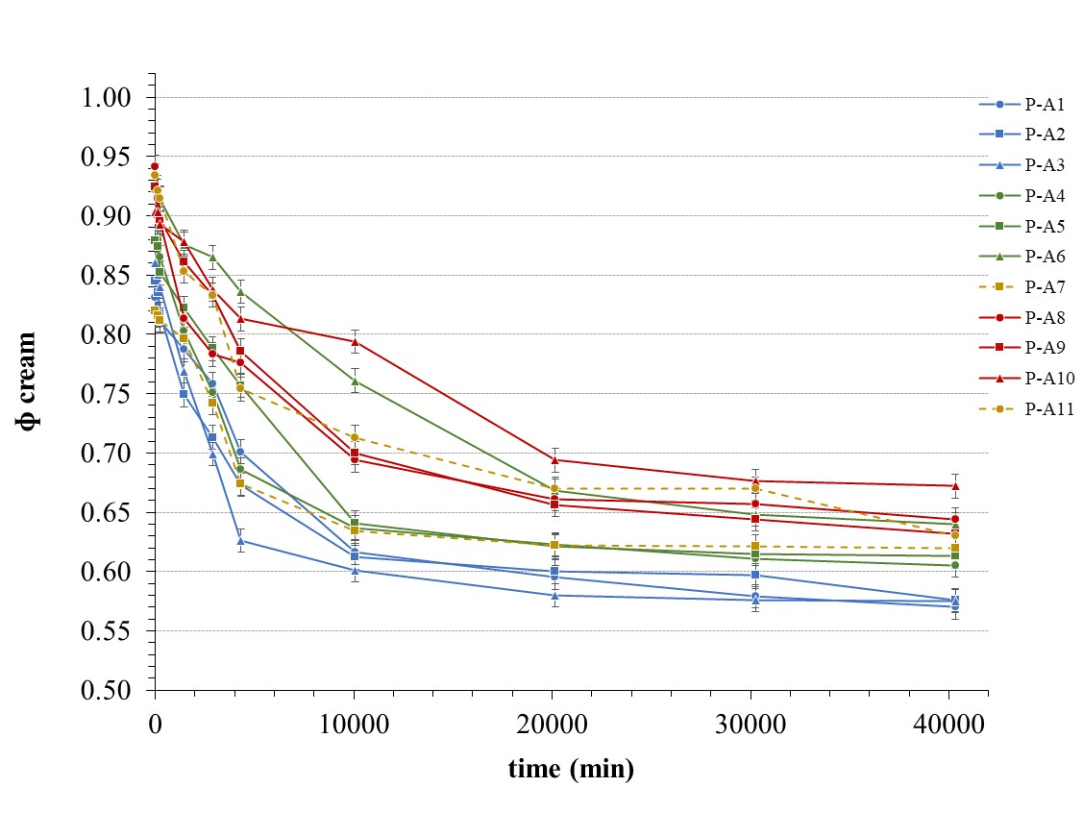

**Figure S14.** Graph shows the fraction of cream phase resolved for Polymer series 1 over time. The targeted composition of diblock copolymers; 75-25, 60-40 and 50-50 w/w % are represented in blue, green and red, respectively. The random copolymers with composition 75 -25 and 60-40 w/w % are represented in dark yellow. The circle (•), square (⏹) and triangle (⏶) polymers of different MMs; 9000, 6000 and 3000 g mol-1 are represented, respectively.

**Table S2.** The fraction of the cream phase-resolved for Polymer series 2 atdifferent times.

|  |  |  |  |  |  |  |  |  |  |  |
| --- | --- | --- | --- | --- | --- | --- | --- | --- | --- | --- |
|  | **ɸ cream** | | | | | | | | | |
| **time (min)** | **P-B1** | **P-B4** | **P-B7** | **P-B6** | **P-B8** | **P-B2** | **P-B3** | **P-B5** | **P-B9** | **P-B10** |
| 1 | 1.002 | 1.000 | 0.953 | 0.943 | 0.925 | 0.907 | 0.948 | 0.941 | 0.919 | 0.980 |
| 120 | 0.961 | 0.960 | 0.927 | 0.939 | 0.869 | 0.907 | 0.946 | 0.932 | 0.883 | 0.960 |
| 240 | 0.950 | 0.953 | 0.907 | 0.922 | 0.858 | 0.897 | 0.950 | 0.896 | 0.867 | 0.917 |
| 1440 | 0.895 | 0.885 | 0.900 | 0.823 | 0.848 | 0.878 | 0.890 | 0.865 | 0.779 | 0.888 |
| 2880 | 0.856 | 0.833 | 0.898 | 0.801 | 0.763 | 0.873 | 0.865 | 0.836 | 0.734 | 0.815 |
| 7200 | 0.700 | 0.726 | 0.763 | 0.686 | 0.639 | 0.731 | 0.821 | 0.694 | 0.645 | 0.811 |
| 10080 | 0.679 | 0.715 | 0.734 | 0.682 | 0.634 | 0.697 | 0.734 | 0.684 | 0.638 | 0.737 |
| 20160 | 0.676 | 0.712 | 0.700 | 0.675 | 0.634 | 0.677 | 0.644 | 0.680 | 0.636 | 0.672 |
| 30240 | 0.666 | 0.708 | 0.686 | 0.670 | 0.628 | 0.663 | 0.632 | 0.672 | 0.626 | 0.668 |
| 40320 | 0.653 | 0.702 | 0.684 | 0.658 | 0.623 | 0.635 | 0.615 | 0.658 | 0.623 | 0.651 |

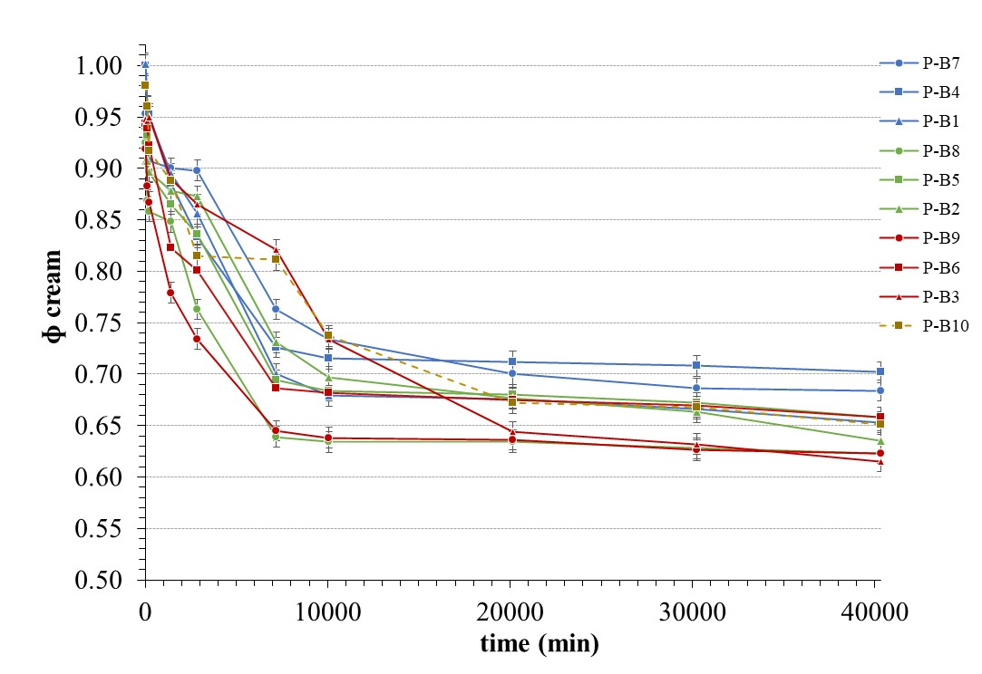

**Figure S15.** Graph shows the fraction of cream phase resolved for Polymer series 2 over time. The targeted composition of diblock copolymers; 75-25, 60-40 and 50-50 w/w % are represented in blue, green and red, respectively. The random copolymer is represented in dark yellow. The circle (•), square (⏹) and triangle (⏶) polymers of different MMs; 9000, 6000 and 3000 g mol-1 are represented, respectively.