**Ethyl Methacrylate Diblock Copolymers as Polymeric Surfactants: Effect of Molar Mass and Composition**

Birsen Somuncuoğlu, Yu Lin Lee, Anna P. Constantinou, David L. M. Poussin

and Theoni K. Georgiou*

*Department of Materials, Imperial College London, South Kensington Campus, Royal School of Mines, Exhibition Road, SW7 2AZ, London, United Kingdom*

**Abstract**

Well-defined amphiphilic diblock copolymers and statistical copolymers were synthesised and investigated as polymeric surfactant. Specifically, two series of linear diblock copolymers-totaling 21 copolymer-were studied. In both series, the same hydrophobic monomer (ethyl methacrylate, EtMA) was used, whereas the hydrophilic monomer was changed. The first series was based on the non-ionic hydrophilic monomer, poly(ethylene glycol) methyl ether methacrylate (PEGMA, 300 g/mol), while the second series was based on the ionic, hydrophilic monomer, 2-(dimethylamino)ethyl methyl methacrylate (DMAEMA). The molar mass (MM) and compositions were systematically varied to investigate their effect on the final properties of the polymer. The aqueous solution properties of the copolymers such as their cloud points, effective p*K*a, hydrodynamic diameters, critical micelle concentrations and hydrophile-lipophile balances were determined. The hydrophobic content affected the thermoresponsive ability and the p*K*a of the polymer solutions significantly. Finally, the emulsifying properties of block copolymers were studied by preparing emulsions containing 1 w/w% of the polymer at the same water to methyl laurate ratio and observing their stability for 1 month. The stability of the emulsions was affected by both the MM and composition of the polymers but to different extents for the non-ionic compared to the ionic series of polymeric macrosurfactants.

**Keywords:** 2-(dimethylamino)ethyl methacrylate, poly(ethylene glycol) methyl ether methacrylate, diblock copolymers, polymeric surfactants, group transfer polymerisation (GTP)

*Corresponding author.

*E-mail address:* [t.georgiou@imperial.ac.uk](mailto:t.georgiou@imperial.ac.uk)

**Introduction**

Amphiphilic block copolymers have gained great interest over the last 40 years due to their fascinating self-assembly properties in aqueous media.1-4 They can self-assemble to particles of various morphologies; for example, core-shell spherical micelles,5 polymersomes,6-8 and worm- or cylindrical- like structures.5, 7, 9-12 Amphiphilic block copolymers also assist in stabilising or/and fabricating other particles,13-15 like latex16-18 and silica19 particles. Furthermore, the block copolymers or their corresponding formed particles can be used as surfactants to stabilise emulsions.12, 20-29 Emulsions can be used in a variety of products and applications in pharmaceutics,30-37 cosmetics31, the food industry38-43, agriculture,44-47 coatings,31 electronics31 and oil recovery48, 49. Emulsions can also be used to fabricate porous materials,50, 51 that also have further applications as reaction supports, tissue engineering scaffolds, separation membranes, controlled release matrices, responsive and smart materials, and templates for porous ceramics and porous carbon. The block ratio of the hydrophilic to hydrophobic block, also called hydrophile-lipophile balance (HLB), has been identified as being significant for the stability of the emulsion or/and particle.37, 43, 52-56 However, it can be challenging to vary the HLB when using traditional small surfactants and commercially available polymeric surfactants (i.e. amphiphilic copolymers) while keeping the molar mass (MM) constant. Keeping the MM constant is crucial since it also affects the interfacial and emulsification properties of the surfactant.46, 57-59 Finally, the chemistry (polarity, charges) of the surfactant and the two immiscible phases also play important roles in the emulsification process.

When considering oil in water (O/W) or water in oil (W/O) emulsions, the most common non-ionic, hydrophilic block for polymeric surfactants is poly(ethylene glycol) (PEG),22, 35, 44-46, 60-71 while thermoresponsive components like *N*-isopropylacrylamide (NIPAM)19, 71-73 and 2-(dimethylamino)ethyl methacrylate (DMAEMA) 16, 26, 73-79 have also been investigated in some cases to de-emulsify the emulsions. In this study, we used two different hydrophilic blocks to fabricate two different series of polymers. Specifically, for the first series we selected a PEG based methacrylate monomer, specifically poly(ethylene glycol) methyl ether methacrylate (PEGMA, 300 g/mol), which has a cloud point of around 70 °C (depending on the MM and and volume fraction of the polymer in the medium) as a homopolymer, but when combined with a hydrophobic monomer forms copolymers with lower cloud points depending on the block ratio.21, 80 For the second series, DMAEMA was chosen as the hydrophilic component which has a cloud point of around 40°C (depending on the MM80 and pH of the solution) as a homopolymer, and compared to NIPAM offers the advantage of pH-responsiveness.81-86 On the other hand, ethyl methacrylate (EtMA) was selected as the hydrophobic block. To the best of our knowledge this is the first time that EtMA amphiphilic copolymers with these comonomer combinations are reported. Thus, we fabricated novel diblock copolymers and investigated their ability to stabilise water/methyl laurate emulsions. Methyl laurate was chosen as the oil because it is of special interest in the pharmaceutical industry.87

We wanted to systematically investigate how the MM as well as the HLB ratio (i.e. polymer composition) affect the polymers’ emulsifying ability. Thus, for each copolymer series--PEGMA-EtMA and DMAEMA-EtMA--nine diblock copolymers of varying compositions and MMs are reported. Furthermore, statistical copolymers were also synthesised for comparison. The polymers were characterised in aqueous solutions and in terms of their ability to stabilise water/methyl laurate. Finally, the thermo-responsiveness of the copolymers were used to destabilise the emulsions.

**Experimental**

**Materials and Methods**

Monomers: PEGMA (MM: 300 g/mol, 94%), DMAEMA (98%) and EtMA (99%), initiator: methyltrimethylsilyl dimethylketene acetal (MTS, 95%), polymerisation solvent and GPC solvent: tetrahydrofuran THF (HPLC grade, ≥ 99.9%), triethylamine (Et3N, HPLC grade), free-radical inhibitor: 2-diphenyl-1-picrylhydrazyl hydrate (DPPH), deuterated chloroform (chloroform-*d*, 99.8 atom % D), aluminium oxide activated basic (Al2O3∙KOH) and calcium hydride (CaH2, ≥90%) were purchased from Sigma Aldrich. The oil phase: methyl laurate (214.35 g mol-1, > 98 %) was purchased from Tokyo Chemical Industry. The solvent used for polymer recovery is *n*-hexane, and it was purchased from VWR chemicals. The purified THF (polymerisation solvent) was obtained from a Pure Solv Micro 100 Liter solvent purification system containing an activated alumina column obtained from Sigma Aldrich.

The catalyst, TBABB, was synthesised by following the procedure performed by Dicker et al.88 Monomers with low MM, DMAEMA and EtMA were purified by passing twice through columns that contain basic aluminium oxide. This step was performed in order to remove the presence of any acidic impurities and the free-radical inhibitor. It was followed by the addition of DPPH to prevent free-radical polymerisation, then CaH2 was added and stirred for 3 hr in order to eliminate humidity. The monomers were kept in a fridge until use. High MM PEGMA could not be distilled and was instead diluted with freshly purified THF (50 v/v %) and passed twice through basic aluminium oxide and stirred for 3 hr under CaH2 (without DPPH), and placed in the fridge until polymerisation. Prior to polymerisation, DMAEMA, EtMA and MTS were distilled under vacuum (to remove DPPH and CaH2) and purged with argon to remove residual moisture. Distillation was not performed for PEGMA and it was filter directly into the polymerisation flask by using 0.45 µm PTFE filters in order to remove CaH2. All glassware used in polymerisation and distillation was placed into the oven (140 °C) overnight before usage. The chemical structures of the three monomers are shown in Figure 1.



**Figure 1.** Chemical structures and names of monomers used in this study.

**Diblock Copolymers Synthesis and Recovery**

In this study, two different series of copolymers were synthesised using Group Transfer Polymerization (GTP). The synthetic procedure of the diblock copolymer, PEGMA6-*b*-EtMA11 is described as an example. Firstly, to a 250 mL round bottom flask, approximately 10 mg of TBABB (20μmol) was added, then a rubber septum was fitted and the flask was purged with argon to provide an inert atmosphere. The freshly purified anhydrous THF (31 mL) was syringed into the polymerisation flask and it was followed by the addition of MTS (0.8 mL, 0.69 g, 0.004 moL) under stirring. PEGMA (13.5 mL, 7.09 g, 0.024 moL) was syringed dropwise into the polymerisation flask and the initial temperature, 24.0°C of the reaction was recorded. An exothermic reaction was observed with a temperature increase to 38.0 °C. 15 minutes after monomer addition, approximately 0.1 mL of sample was withdrawn from the polymerisation flask for characterisation using gel permeation chromatography (GPC) and proton nuclear magnetic resonance (1H NMR) spectroscopy. The second monomer, EtMA (5.1 mL, 4.73 g, 0.041 moL) was syringed into the polymerisation flask and a change in the temperature was observed. Once the reaction finished, 0.1 mL was extracted for characterisation. In this study, all diblock copolymers followed the same procedure, only the amount of monomer, initiator and polymerisation solvent varied. The same procedure was followed for the synthesis of the statistical copolymer. The only difference was, after adding the polymerisation solvent, monomers were added first and the initiator MTS was added last. All polymers were collected by precipitation in cold *n*-hexane and left in the vacuum oven for a week at room temperature in order to remove remaining traces of *n*-hexane and THF.

Please note that when synthesising the block copolymers with sequential polymerisation the less reactive monomer was added first. So PEGMA was added first for the PEGMA-EtMA series while EtMA was added first for the DMAEMA-EtMA series.

**Characterisation in Organic Solvents**

**Gel Permeation Chromatography (GPC)**

GPC was used to determine the MM and molar mass distribution (MMD) of all synthesised polymers and their precursors. The GPC system was purchased from Agilent technologies UK Ltd., Shropshire, UK. It is a SECurity GPC system containing Polymer Standard Service (PSS) SDV with an analytical linear M column (SDA083005LIM), “1260 Iso” isocratic pump equipped with an Agilent 1260 refractive index (RI) detector. The mobile phase of the GPC column was THF with 5% vol of Et3N and the flow rate was 1 mL.min-1. The GPC was calibrated using six well-defined poly (methyl methacrylate) (PMMA) standard samples with MM 2000, 4000, 8000, 20000, 50000, and 100000 g/mol, purchased from Fluka, Aldrich, UK.

**Proton Nuclear Magnetic Resonance (1H NMR) Spectroscopy**

The final composition of all copolymers and their linear precursors were determined using a 400 MHz Avance Bruker NMR Spectrometer (Bruker UK Ltd., Coventry, UK). The samples were prepared by dissolving 10 mg of polymer in 600 μl of chloroform-*d*.

**Characterisation in Aqueous Solvents**

1 w/w % aqueous polymer solutions were prepared to characterise the properties of their aqueous solutions such as cloud points, effective dissociation constants (p*K*a), hydrodynamic diameters (*d*h) and critical micelle concentrations (CMC). Some polymers have poor solubility; therefore, their aqueous characterisation could not be investigated.

**Cloud Points**

The cloud points of 1 w/w% aqueous polymer solutions were determined by visual tests. The visual tests were performed by using an IKA RCT stirrer hotplate and IKA ETS-D5 temperature controller, and they were purchased from IKA® England Ltd., Oxford. The thermal responsiveness of aqueous polymer solutions was observed by immersing glass vials inside the water bath and increasing the temperature from 20°C to 80°C under continuous stirring. The clarity of the solution was observed and recorded whenever the temperature of the water bath increased by one degree. The cloud point of a polymer was determined when the solution turned cloudy.

**Potentiometric Titrations**

The hydrogen ion titrations of 1 w/w % aqueous polymer solutions were performed using a portable pH checker (HI98103) and it was calibrated to pH 4 and pH 7 before measurements. The polymer solutions were titrated from pH 2 to 12, using 0.26 M NaOH under continuous stirring. The p*K*a value is the pH when 50 mol% of DMAEMA units are protonated.

**Dynamic Light Scattering (DLS)**

A Zetasizer Nano ZSP instrument from Malvern Instruments Ltd., UK was used for dynamic light scattering (DLS) measurements in order to determine hydrodynamic diameters (*d*h) and critical micelle concentrations (CMC) of polymer solutions in DI water. The measurements were performed at room temperature.

1. **Hydrodynamic Diameter**

1 w/w % polymer solutions in DI water were prepared, and prior to the DLS measurements, they are filtered through 0.45 µm nylon syringe filters in order to remove large aggregates and dust. Each sample was run 3 times and the average size by maximum intensity and number was recorded as experimental *d*h.

The theoretical *d*h values of diblock copolymers were calculated by the equation;

*d*h= (DPEtMA +2 x DPPEGMA or DMAEMA) x 0.254 nm Equation 1

The above equation assumes fully stretched polymers chains forming a micelle. Within the micelle the hydrophilic block will be in the corona of the micelle and the hydrophobic will be in the core and fully overlapped. So the DP of the hydrophobic is only taken into account once.

The theoretical *d*h values of the statistical copolymer were calculated by using the equation that assumes a random coil configuration;

*d*h = 2 x [2.20 x 2 x (DPEtMA + DPPEGMA or DMAEMA)/3]1/2 x 0.154 nm Equation 2

In theoretical *d*h calculations, the DP values were calculated by using the MM values after precipitation, as resulted by GPC, and the composition values by 1H NMR.

1. **Critical Micelle Concentration**

13 different concentrations of aqueous polymer solutions; 0.0001, 0.00025, 0.0005, 0.001, 0.0025, 0.005, 0.01, 0.025, 0.01, 0.1, 0.25, 0.5 and 1 w/w % were prepared. Before DLS measurements, each aqueous polymer solution was filtered through 0.45 µm PTFE syringe filters to remove large aggregates and dust particles. In all measurements, the attenuation, type and position of the cuvette were kept constant and kilo counts per second (kcps) were recorded. The graph of kcps versus polymer concentrations were plotted and the CMCs of the polymers were calculated by drawing a tangent line.

**Stabilisation of Emulsions using Polymeric Surfactants**

**Hydrophile-Lipophile Balance (HLB)**

The hydrophile-lipophile balance (HLB) of each polymer series was calculated using the Equation 3 shown below. It was calculated from the weight fraction of the lyophilic (*W*l) and weight fraction of the hydrophilic (*W*h) components.

Equation 3

$$HLB=\frac{W_{h}}{W_{h}+W_{l}} x 20$$

**Preparation of Emulsions**

In this study, the concentration of the polymer was kept constant at 1 w/w% in the total volume of the emulsion, and the weight ratio of methyl laurate and water were kept equal at 1:1. As an example preparation process: firstly, a polymer was dissolved in methyl laurate followed by the addition of DI water. Emulsification was performed for 1 minute using a Hielscher UP50H Ultrasonic Processor set to 100% amplitude and 1 full cycle.

**Stability Measurements of Emulsions**

Once emulsification is completed, the glass vials were placed to a stand with a black background. The stability and phase separation of these emulsions were observed by taking photographs using Apple 7 iPhone at a fixed distance.

**Determination of the type of Emulsions**

Drop tests were performed in order to observe the type of the emulsions (O/W or W/O). O/W-type of emulsionis observed if the emulsion droplets are uniformly dispersed in water, thus forming homogeneous clear or slightly cloudy solution, while the emulsion droplets precipitate in the form of coagulated spherical drops in the oil. On the other hand, W/O-type of emulsion is observed if the emulsion droplets are dispersed in the oil phase, but precipitate in the water. Therefore, in order to determine the type of emulsion, two drops of freshly made emulsion was added into 3 mL of DI water and methyl laurate for each polymer emulsion.

**Results and Discussion**

**Synthesis of Diblock copolymers and Confirmation of their Structure**

**Synthetic Strategy**

In this study, two series of copolymers, including block and random copolymers, which are named Polymer series 1 and Polymer series 2, were synthesised by GTP. Polymer series 1, includes the PEGMA unit, which is non-ionic, hydrophilic, and thermoresponsive. Polymer series 2, includes DMAEMA units which is hydrophilic, ionic, thermoresponsive, and pH-responsive. In both polymer series, EtMA was used as a hydrophobic monomer. The MM and composition of the copolymers were varied systematically in order to observe the effect of MM and composition on the properties of the polymers. The MM was targeted to 9100, 6100 and 3100 g/mol and the composition was targeted to 75-25, 60-40 and 50-50 hydrophilic-hydrophobic w/w %. In total, 18 diblock and 3 statistical copolymers (with an intermediated MM) were synthesised in this project. The schematic representation of Polymer series 1 and 2 are shown in Figures 2.

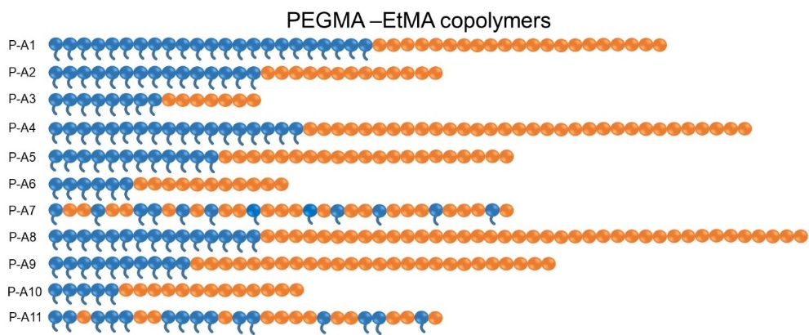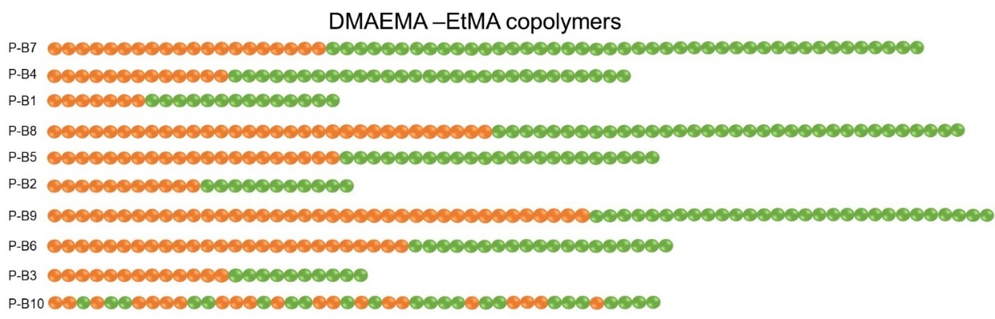

**Figure 2.** Schematic representation of all synthesisedPEGMA-EtMA and DMAEMA-EtMA copolymers. The PEGMA, EtMA and DMAEMA units are represented by blue, orange, and green respectively.

**Structural Properties**

The structural properties of final copolymers and their linear precursors for Polymer series 1 and 2 are summarised and shown in Table 1 and 2, respectively. The experimental number-average MMs (*M*n) values and MMD (dispersity, *Ð*) values of final copolymers and their linear precursors were determined by GPC, and the experimental composition was determined by 1H NMR.

**Molar Mass and Molar Mass Distribution**

As shown in Table 1, *Ð* values of all resulting copolymers for Polymer series 1 were between 1.11 and 1.18, which indicates the synthesis of well-defined copolymers and successful “living” polymerisation, which is also observed in previous GTP studies.84-86 Successful polymerisation was also observed for Polymer series 2 due to narrow *Ð* values between 1.09 and 1.15. It was observed that the *Ð* values for Polymer series 2 are slightly lower than Polymer series 1. The reason for this was, the DMAEMA monomer has well-defined MM and structure, whereas the PEGMA macromonomer has an average MM and wider MMD, which is also observed in previous GTP studies.15, 44-46, 80-83, 89

**Table 1**. Molar masses, molar mass distributions and compositions of the all synthesised copolymers and their precursors.

|  |  |  |  |  |  |  |  |
| --- | --- | --- | --- | --- | --- | --- | --- |
|  | No. | Theoretical Polymer Structure | MMtheor. a  (g/mol) | *M*n b  (g/mol) | *Ð*c | w/w% PEGMA-EtMA | |
| Theoretical | 1H NMR |
| Polymer Series 1 | P-A1 | PEGMA23  PEGMA23-*b*-EtMA20 | 6850  9100 | 8580  11700 | 1.13  1.16 | 100-0  75-25 | 100-0  74-26 |
| P-A2 | PEGMA15  PEGMA15-*b*-EtMA13 | 4600  6100 | 6410  8180 | 1.11  1.12 | 100-0  75-25 | 100-0  74-26 |
| P-A3 | PEGMA8  PEGMA8-*b*-EtMA7 | 2350  3100 | 3160  4150 | 1.13  1.11 | 100-0  75-25 | 100-0  73-27 |
| P-A4 | PEGMA18  PEGMA18-*b*-EtMA32 | 5500  9100 | 5860  10800 | 1.17  1.13 | 100-0  60-40 | 100-0  59-41 |
| P-A5 | PEGMA12  PEGMA12-*b*-EtMA21 | 3700  6100 | 4290  6700 | 1.13  1.13 | 100-0  60-40 | 100-0  59-41 |
| P-A6 | PEGMA6  PEGMA6-*b*-EtMA11 | 1900  3100 | 2550  4130 | 1.18  1.15 | 100-0  60-40 | 100-0  58-42 |
| P-A7 | PEGMA12-*co*-EtMA21 | 6100 | 6560 | 1.15 | 60-40 | 58-42 |
| P-A8 | PEGMA15  PEGMA15-*b*-EtMA39 | 4600  9100 | 5240  10600 | 1.15  1.13 | 100-0  50-50 | 100-0  50-50 |
| P-A9 | PEGMA10  PEGMA10-*b*-EtMA26 | 3100  6100 | 3970  7100 | 1.13  1.13 | 100-0  50-50 | 100-0  48-52 |
| P-A10 | PEGMA5  PEGMA5-*b*-EtMA13 | 1600  3100 | 2270  3830 | 1.17  1.15 | 100-0  50-50 | 100-0  55-45 |
| P-A11 | PEGMA15-*co*-EtMA13 | 6100 | 7350 | 1.16 | 75-25 | 73-27 |
|  |  |  |  |  |  | **w/w% DMAEMA-EtMA** | |
| Polymer Series 2 | P-B7 | EtMA20  EtMA20-*b*-DMAEMA43 | 2350  9100 | 3080  11000 | 1.11  1.09 | 0-100  75-25 | 0-100  73-27 |
| P-B4 | EtMA13  EtMA13-*b*-DMAEMA29 | 1600  6100 | 1990  6490 | 1.12  1.09 | 0-100  75-25 | 0-100  73-27 |
| P-B1 | EtMA7  EtMA7-*b*-DMAEMA14 | 850  3100 | 1180  3650 | 1.15  1.10 | 0-100  75-25 | 0-100  73-27 |
| P-B8 | EtMA32  EtMA32-*b*-DMAEMA34 | 3700  9100 | 5090  11200 | 1.08  1.08 | 0-100  60-40 | 0-100  59-41 |
| P-B5 | EtMA21  EtMA21-*b*-DMAEMA23 | 2500  6100 | 3480  7860 | 1.10  1.08 | 0-100  60-40 | 0-100  58-42 |
| P-B2 | EtMA11  EtMA11-*b*-DMAEMA11 | 1300  3100 | 1760  3600 | 1.13  1.10 | 0-100  60-40 | 0-100  58-42 |
| P-B9 | EtMA39  EtMA39-*b*-DMAEMA29 | 4600  9100 | 6670  10500 | 1.08  1.11 | 0-100  50-50 | 0-100  48-52 |
| P-B6 | EtMA26  EtMA26-*b*-DMAEMA19 | 3100  6100 | 4120  7110 | 1.09  1.09 | 0-100  50-50 | 0-100  49-51 |
| P-B3 | EtMA13  EtMA13-*b*-DMAEMA10 | 1600  3100 | 2180  3850 | 1.11  1.11 | 0-100  50-50 | 0-100  49-51 |
| P-B10 | EtMA21 *co*- DMAEMA23 | 6100 | 7200 | 1.09 | 60-40 | 58-42 |

a The theoretical MM (MMtheor.) was calculated using the equation: MMtheor. (g/mol) = (Σi MMi x DPi) + 100. b and c Determined using GPC was calibrated using six poly (methyl methacrylate) (PMMA) standard samples; 2000,4000,8000, 20 000 and 50 000 g/mol.

The experimental *M*n values of copolymers of Polymer series 1 and series were between 3650–11700 g/mol, which is reasonably close and slightly higher than the theoretical MM values. The reason for higher experimental *M*n values could be partial deactivation of the initiator (MTS) or presence of impurities in the polymerisation flask which is also observed in previous GTP studies. 15, 81-83 One should of course take into account also that the calibration was performed using PMMA standards and especially for the PEGMA macromonomer based polymers there will be a discrepancy.

Figure 3 shows the GPC traces of P-A5, PEGMA12-*b*-EtMA21 and its precursor PEGMA12. As it can be seen, the peak shifts to higher MW with the addition of the second monomer, which proves successful sequential polymerisation. There is an absence of shoulder peak which indicates that no deactivation between the first and second step occurred and that all homopolymer chains grew to produce the diblock copolymer. All copolymers studied in this project show similar GPC chromatogram profiles and they are available in the Supplementary Information in Figures S2 and S3. Note that a small shoulder is observed at higher MM for PEGMA containing polymers. This is due to the dimethacrylate impurity that is in the PEGMA and has been observed before in PEGMA based polymers.80, 90

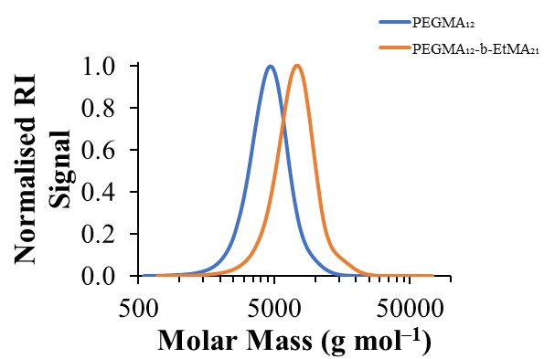

**Figure 3.** The GPC chromatogram of the diblock copolymer PEGMA12-*b*-EtMA21 and its precursor PEGMA12.

**Composition**

As shown in Table 1 the experimental weight percentages of the final copolymers and their linear precursors were determined using 1H NMR and compared with their theoretical compositions. The weight percentages of the copolymers were determined by taking the integral ratio of the distinct peaks that belong to that monomer. For instance, the distinctive peak of PEGMA corresponds to three methoxy protons, and it appears at 3.35 ppm. The distinctive peak of EtMA corresponds to methyl protons, and the peak appears at 1.25 ppm. The characteristic peak for DMAEMA corresponds to six methyl protons that are next to the amine group, and the peak appears at 2.25 ppm. Example of the 1H NMR spectra for Polymer series 1 and 2 are shown in Supplementary Information Figures S4 and S5, respectively.

The theoretical (targeted) composition and the experimentally predicted composition are in good agreement and within the error of the NMR machine, but of course one should keep into consideration that what has been determined is the average composition and similar to the MMD there is also a composition distribution.

**Aqueous Solution Properties**

1 w/w% aqueous polymer solutions were prepared in order to determine their aqueous solution properties such as cloud points, dissociation constants, hydrodynamic diameters and critical micelle concentration. Please note that the aqueous properties of polymers: P-A4, P-A7, P-A8, P-A9, P-A11, P-B5, P-B6, P-B8, P-B9 and P-B10 due to their poor solubility in water could not be investigated.

**Cloud Point**

The cloud points of 1 w/w% polymer solutions in DI water were determined by visual tests. Results for Polymer series 1 and 2 are represented in Tables 2. For both series the cloud point decreases as the wt% EtMA content increases, as it was expected and observed in previous studies.15, 85, 86, 89, 91 2-4,10 This is because smaller hydrophilic chains are presented to stabilise the micelle in solution.

On the other hand the results between the two series when the MM increased have opposite trends. For the non-ionic, PEGMA containing series (Figure 4a) the cloud point increases when the MM is increased while for the ionic DMAEMA containing series (Figure 4b) the cloud point decreases when the MM is decreased. The latter has been observed for DMAEMA based copolymers86 and PEGMA homopolymers,80 but when amphiphilic comb like copolymers were investigated as Polymer Series 1 the opposite trend was observed.21 This may be attributed to the comb like structure and different self assembly due to the long side groups. Also, the difference in DP is more pronounced in the DMAEMA copolymers, thus as the MM increases, the cloud point decreases, which is not the case in either the DP or the cloud point values for the PEGMA copolymers.

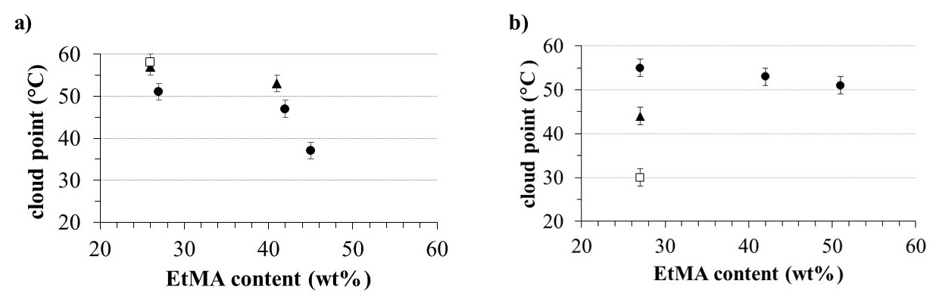

**Figure 4.** The effect of experimental EtMA content on cloud point of A) PEGMA-EtMA based copolymers (Polymer series 1) and B) EtMA-DMAEMA based copolymers (Polymer series 2). With circle (•), triangle (⏶) and square (□) polymers of different MMs; 3000, 6000 and 9000 g mol-1 are represented, respectively. The pH of all DMAEMA-EtMA solutions was around 8.

**Effective p*K*as**

The effective p*K*a values of D based copolymers (Polymer series 2) were determined by performing hydrogen ion titrations. The effective p*K*a values of copolymers varied between 6.6-7.1, and they are listed on Table 2. As it can be clearly be observed in Figure 5, when hydrophobic EtMA content increases, the p*K*a values decrease for all copolymers, which is reported by previous studies.81, 86

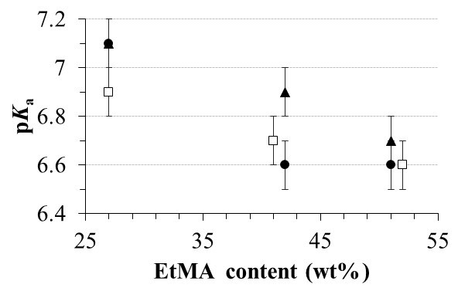

**Figure 5.** The effect of experimental EtMA content on effective p*K*a values of Polymer series 2. With circle (•), triangle (⏶) and square (□) polymers of different MMs; 3000, 6000 and 9000 g mol-1 are represented, respectively.

**Table 2.** The theoretical polymer structure, wt% EtMA content as determined by NMR, theoretical MM, experimental and theoretical hydrodynamic diameters, PDI, cloud points, HLB and CMC of Polymer Series 1 and 2, as well as the p*K*as for Polymer Series 2.

|  |  |  |  |  |  |  |  |  |  |  |  |
| --- | --- | --- | --- | --- | --- | --- | --- | --- | --- | --- | --- |
| **No.** | **Theor.**  **Polymer**  **Structure** | **EtMA**  **wt%**  **by NMR** | **MMtheor.**  **g/mol** | **Hydrodynamic Diameter (*d*h, nm)** | | | **PDI** | **Cloud**  **Points**  **± 2 °C** | **p*K*as**  **± 0.1** | **HLB d** | **CMCe**  **x10-5**  **mol L-1** |
| **Theo.a** | **Exp. ± 0.5 b** | **Exp. ± 0.5 c** |
| **P-A1** | P23-*b*-E20 | 26 | 9100 | 20.8 | 21.0 | 78.8 | 0.260 | 58 | - | 14.8 | 7.7 |
| **P-A2** | P15-*b*-E13 | 26 | 6100 | 17.0 | 11.7 | 15.7 | 0.034 | 57 | - | 14.8 | 149 |
| **P-A3** | P8-*b*-E7 | 27 | 3100 | 7.4 | 5.6 | 8.7 | 0.068 | 51 | - | 14.6 | 580 |
| **P-A4** | P18-*b*-E32 | 41 | 9100 | 23.8 | NS | NS | NS | NS | - | 11.8 | NS |
| **P-A5** | P12-*b*-E21 | 41 | 6100 | 15.6 | 13.5 | 18.2 | 0.071 | 53 | - | 11.8 | 112 |
| **P-A6** | P6-*b*-E11 | 42 | 3100 | 8.3 | 8.7 | 11.7 | 0.031 | 47 | - | 11.6 | 339 |
| **P-A7** | P12-*co*-E21 | 42 | 6100 | 2.6 | NSf | NS | NS | NS | - | 11.6 | NS |
| **P-A8** | P15-*b*-E39 | 50 | 9100 | 23.8 | NS | NS | NS | NS | - | 10 | NS |
| **P-A9** | P10-*b*-E26 | 52 | 6100 | 16.6 | NS | NS | NS | NS | - | 9.6 | NS |
| **P-A10** | P5-*b*-E13 | 45 | 3100 | 8.2 | 10.1 | 15.7 | 0.137 | 37 | - | 11 | 368 |
| **P-A11** | P15-*co*-E13 | 27 | 6100 | 2.4 | 5.4 | 5.9 | 0.298 | 35 | - | 14.6 | NS |
|  |  |  |  |  |  |  |  |  |  |  |  |
| **P-B7** | E20-*b*-D43 | 27 | 9100 | 33.2 | 15.7 | 24.4 | 0.076 | 30 | 6.9 | 14.6 | 20 |
| **P-B4** | E13-*b*-D29 | 27 | 6100 | 20.8 | 8.7 | 11.7 | 0.068 | 44 | 7.1 | 14.6 | 119 |
| **P-B1** | E7-*b*-D14 | 27 | 3100 | 11.9 | 5.6 | 8.7 | 0.065 | 55 | 7.1 | 14.6 | 748 |
| **P-B8** | E32-*b*-D34 | 41 | 9100 | 31.5 | NS | NS | NS | NS | 6.7 | 11.8 | NS |
| **P-B5** | E21-*b*-D23 | 41 | 6100 | 22.1 | NS | NS | NS | NS | 6.9 | 11.6 | NS |
| **P-B2** | E11-*b*-D11 | 42 | 3100 | 11.4 | 5.6 | 8.7 | 0.066 | 53 | 6.6 | 11.6 | 722 |
| **P-B9** | E39-*b*-D29 | 48 | 9100 | 30.8 | NS | NSe | NS | NS | 6.6 | 9.6 | NS |
| **P-B6** | E26-*b*-D19 | 48 | 6100 | 20.7 | NS | NS | NS | NS | 6.7 | 9.8 | NS |
| **P-B3** | E13-*b*-D10 | 49 | 3100 | 10.3 | 6.5 | 28.2 | 0.199 | 51 | 6.6 | 9.8 | 337 |
| **P-B10** | E21-*co*- D23 | 42 | 6100 | 3.0 | NS | NS | NS | NS | 6.8 | 9.6 | NS |

aTheoretical hydrodynamic diameter values based on the experimental degree of polymerisations (DPs) of EtMA (Et), PEGMA (P) and D (D) units. The DPs were calculated by using the MM of copolymers after precipitation and the experimental composition, which are obtained using GPC and 1H NMR. The equation used to calculate the theoretical hydrodynamic diameter is d*h=* (DPEtMA + 2 x DPhydrophilic) x 0.254 nm for block copolymers and dh = 2 x [2.20 x 2 x (DPA + DPB)/3]1/2 x 0.154 for the statistical copolymer .

b Experimental hydrodynamic diameter values are given by number as obtained by DLS.

c Experimental hydrodynamic diameter is given by intensity as obtained by DLS.

d Hydrophile-lipophile balance (HLB) was calculated using this equation by Griffin; HLB = (Wh/Wh+Wl) x 20.

e CMC represents the critical micelle concentration of polymer (in mol/L using the Mn for each polymer).

NS represents polymer is insoluble.

**Hydrodynamic Diameter**

The experimental and theoretical hydrodynamic diameters and PDI values of copolymers in an aqueous solution were determined and listed in Tables 2 for both polymer series. The theoretical (calculated) diameter values were calculated assuming that block copolymers form spherical core-shell micelles, where the hydrophobic EtMA block forms the core, and the hydrophilic PEGMA/DMAEMA block forms the shell of the micelles. In addition to this, it was assumed that polymer chains are fully stretched. The schematic representation of the core-shell micelles is shown in Figure 6a and 6c, in which orange, blue and green represent the EtMA, PEGMA and DMAEMA units, respectively. The theoretical hydrodynamic diameter of diblock copolymers was calculated using an equation, *d*h = (DPEtMA + 2 x DPhydrophilic) x 0.254 nm. For random copolymers in Polymer series 1 and 2, it was assumed that they form random coil configurations and they are schematically represented in Figures 6c and 6d, respectively. The theoretical hydrodynamic diameters of random copolymers were calculated using the equation, *d*h = 2 x [2.20 x 2 x (DPEtMA + DPhydrophilic)/3]1/2 x 0.154 nm.

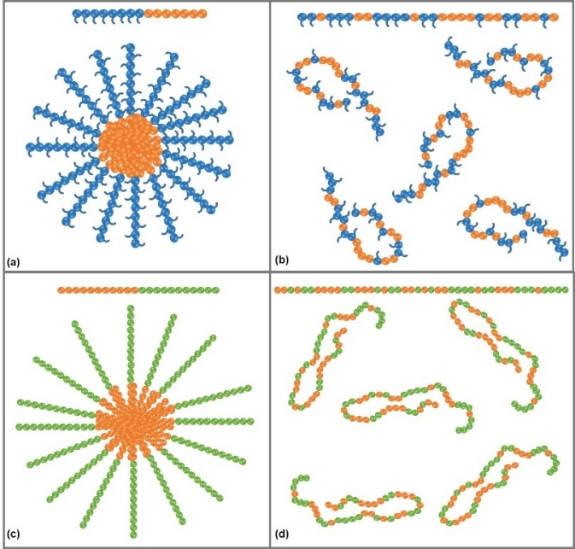

**Figure 6.** Schematic representations of: (a) and (c) spherical micelles adopted by the diblock copolymers (P-A1-6 and P-A8-10), (P-B1-P-B9) and (b) random coil configuration adopted by random copolymers (P-A7 and P-A11) and P-B10. The hydrophilic PEGMA, EtMA and DMAEMA are coloured blue, orange and green, respectively. The hydrophobic EtMA units are coloured orange.

In general, it can be concluded that all water soluble block copolymers were able to self assemble and form micelles and the size of these micelles follows the theoretically predicted trend. Specifically, as the MM increases the size of the micelles also increases. Overall it was expected that the theoretical diameters would be bigger than the experimental values as the theoretical calculation assumes fully stretched chains. This was true for most polymers besides some PEGMA based polymers that the long PEG side group was not taken into account in the theoretical calculation. Furthermore, the statistical copolymer P-A11 had a slightly higher diameter than the theorectical prediction for a random coil likely due to the bulky PEG side groups. This may also be attribute to some minor aggregation that has been observed in comb-like polymers.92-94 Finally, it can also be observed that when polymers of similar MM are compared from the two different series the PEGMA based polymers have bigger micelle sizes, due to the presence of the PEG side group.

**Critical Micelle Concentration**

The CMC of diblock copolymers for Polymer series 1 and 2, were determined in DI water with a wide range of concentrations using DLS, and they are summarised in Tables 2 and 3, respectively. All the CMC graphs for the polymers in the PEGMA and DMAEMA based polymer series are available in Supplementary Information Figures S8 and S9, respectively.

The CMC values of polymer series 1 and 2 were found to be between 7.7 to 580 ×10-5 moL L-1 and 20 to 338 ×10-5 moL L-1, respectively. Similar CMC values (10-5 moL L-1) were observed for methacrylate-based diblock copolymers by Patrickios and co-workers and more recently by our group.46, 90 Note that the CMCs decrease as the Mn increases (see Supplementary Information Figures S10 and S11) as expected and observed before. 46, 90

**Diblock Copolymers as Polymeric Emulsifiers**

All polymeric surfactants from both Series 1 and 2, PEGMA-EtMA and DMAEMA-EtMA, respectively were evaluated in terms of their ability to stabilise methyl laurate / water emulsions.

**Type of Emulsions**

First it was investigated if the polymeric surfactants form oil in water (o/w) or water in oil (w/o) emulsions. To investigate this, a drop test was performed and the HLB values were calculated, for each series respectively. Specifically the HLB values of non-ionic polymeric surfactants were determined using the equation introduced by Griffin.21, 95 When the HLB value of surfactants is lower than ~6, it means that it is oil-soluble; hence, they tend to stabilise water-in-oil (W/O) emulsions. On the other hand, surfactants with higher HLB values are normally water-soluble and tend to stabilise oil-in-water (O/W) emulsions when the water to oil ratio is 1:1. As can be seen from Tables 3 and 4, the HLB values of all synthesised polymeric surfactants varied between 9.6 and 14.8, which indicate they should stabilise O/W type emulsions. This was confirmed experimentally using a drop test. Specifically, all emulsions were tested in both methyl laurate and water. It was observed that all copolymer emulsions disperse in water while they precipitated in the form of coagulated spherical drops in methyl laurate. Therefore, all copolymers stabilise O/W type emulsions, as expected.

**Emulsion Stability**

The stability of the emulsions were monitored over a period of a month. Pictures were taken at regular intervals and the volume fraction of the cream phase (ɸcream) was determined and monitored over time. The images of the emulsions and the plots of ɸcream over time for both series are shown in the supporting information (Figures S14 and S15). As expected the stability of the emulsions decreases with time.

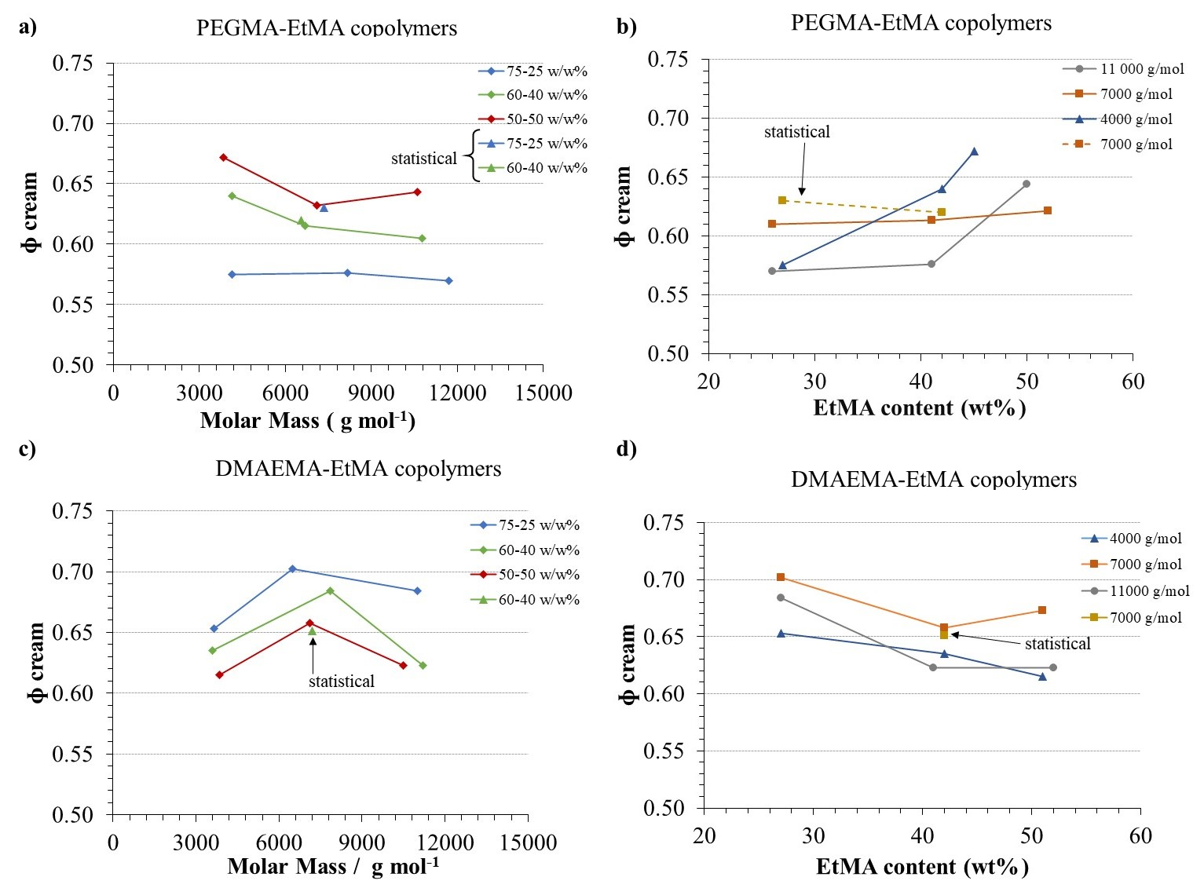

**Figure 7. a and c)** The effect of copolymers' molar mass on the fraction of the cream phase resolved. The cream phase fraction for PEGMA-EtMA and DMAEMA-EtMA series is represented as A and C, respectively. **b and c)** The effect of weight percentage of EtMA on the fraction of the cream phase resolved. The cream phase fraction for PEGMA-EtMA and DMAEMA-EtMA are represented in B and D, respectively. In graphs **a** and **b**, diblock copolymers are represented by a circle (•), and random copolymers are represented by a triangle (⏶). In graphs **b** and **d**, the diblock copolymers are represented by grey, orange and navy. The random copolymers are represented by dark yellow.

The stability of the emulsions prepared using the different polymeric macrosurfactants was very similar but some trends were observed. In Figure 7 the ɸcream after a month was ploted for all emulsions. In Figures7 A and C (left column) the ɸcream is plotted versus the MM of the polymer for Series 1 (PEGMA-EtMA) and Series 2 (DMAEMA-EtMA), respectively. Different trends are observed for the two different series. For the D containing series it seems there is a maximum, and the optimum MM seems to be close to 7000 g/mol while for the PEGMA-EtMA series there is no maximum and the trend changes when the composition is varied. Specifically, for the 75-25 w/w% (PEGMA-EtMA) there is a no MM effect, for the 60-40 w/w% (PEGMA-EtMA) the stability decreases as the MM increases while for the 50-50 w/w% (PEGMA-EtMA) it seems there is a slight minimum. Interestingly, the statistical copolymers (shown in triangles) stabilised the emulsions as well as the corresponsing block couterparts (shown in circles). This is in constrast with a previous study on PEGMA-based copolymers where the hydrophobic monomer was *n*-hexyl methacrylate.21 However in that study the oil phase was tetradecane so caution should be taken when trying to compare the two studies. Furthermore, other PEGMA based random copolymers have been shown to stabilise emulsions where the oil phase was 1-bromo decane96 and tetradecane97 even though in those studies they were not compared to their block based couterparts.

In Figures 7B and D the stability of the emulsions versus the EtMA content was plotted for Series 1 (PEGMA-EtMA) and Series 2 (DMAEMA-EtMA), respectively. Again two opposite trends are observed for the two series demonstrating the importance of ionic charges in the stability of the emulsions. Specifically, for the non-ionic macrosurfactnts (PEGMA based) the stability of the emulsions seems to increase as the EtMA content increases while for the ionic (DMAEMA based) the stability of the emulsions decreases when the EtMA increases. Thus, it seems that the DMAEMA content is a more dominant factor and that can be explained by the fact that some DMAEMA groups will be charged and charges enhance the emulsion stability as they inhibit the coalescence of droplets.

**Using Temperature to Destabilise Emulsions**

In order to demonstrate that temperature can be used as a tool to destabilse emulsions, one emulsion from each polymer series was heated up at 60 °C that is above the cloud point of the polymers for 5 minutes. The emulsions were destabilsed as it can be observed in the images in Figure 8. Interestingly, the emulsions were not destabilised in the same way. In both, phase separation is clearly observed. However, in the case of the PEGMA-EtMA copolymer there is creaming between the two phases, while for the DMAEMA-EtMA copolymer only two phases are observed and the bottom phase remains cloudy (an emulsion) while the oil phase on the top is clear.

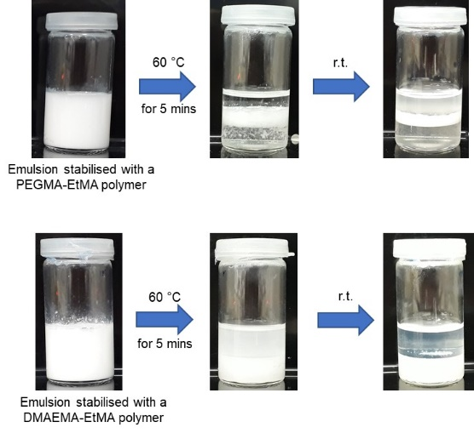

**Figure 8.** Images of emulsions stabilised by PA6: PEGMA-*b*-EtMA (top) and PB3 EtMA-*b*-DMAEMA right after emulsification, at 60 °C for 5 miniutes (middle) and at room temperature after the heating and destabilisation has occurred (right).

**Conclusions**

In this study, two polymer series, one on PEGMA-EtMA and one on DMAEMA-EtMA were synthesised. In total 18 diblock copolymers and 3 random copolymers were successfully synthesised via GTP, and their aqueous solution properties were investigated. By increasing the content of the hydrophobic monomer EtMA the cloud point decreased for both polymer series. On the other hand, it was observed for the PEGMA-based diblocks that increasing MM leads to higher cloud points, whereas the opposite trend was observed for DMAEMA-based diblock copolymers. The p*K*a values of DMAEMA based diblock copolymers were between 6.6 and 7.1 and decreased with increasing hydrophobic content. All block copolymers were able to self-assemble to form micelles and both block and statistical copolymers were able to stabilise methyl laurate in water emulsions. The stability of the emulsions over time was monitored. Both the MM and the composition affect the stability of the macrosurfactant emulsions. This effect is different between non-ionic to ionic polymeric surfactants. Finally, it was demonstrated that heat can be used as a stimuli to destabilise the emulsions.

**Declaration of Competing Interest**

The authors declare no competing interest.

**Acknowledgements**

Engineering and Physical Sciences Research Council (EPSRC) and Department of Materials at Imperial College London is acknowledged for funding B.S.’s and A.P.C.’s Ph.D. scholarships.

**References**

1. Velichkova, R. S.; Christova, D. C., Amphiphilic polymers from macromonomers and telechelics. *Prog. Polym. Sci.* **1995,** *20* (5), 819-887.

2. Mane, S. R.; Sathyan, A.; Shunmugam, R., Biomedical Applications of pH-Responsive Amphiphilic Polymer Nanoassemblies. *ACS Applied Nano Materials* **2020,** *3* (3), 2104-2117.

3. Wang, Y.; Grayson, S. M., Approaches for the preparation of non-linear amphiphilic polymers and their applications to drug delivery. *Adv. Drug Delivery Rev.* **2012,** *64* (9), 852-865.

4. Martin, C.; Aibani, N.; Callan, J. F.; Callan, B., Recent advances in amphiphilic polymers for simultaneous delivery of hydrophobic and hydrophilic drugs. *Therapeutic Delivery* **2016,** *7* (1), 15-31.

5. Ghasdian, N.; Buzza, D. M. A.; Fletcher, P. D. I.; Georgiou, T. K., ABC Triblock Copolymer Micelles: Spherical Versus Worm-Like Micelles Depending on the Preparation Method. *Macromol. Rapid Commun.* **2015,** *36* (6), 528-532.

6. Matoori, S.; Leroux, J.-C., Twenty-five years of polymersomes: lost in translation? *Materials Horizons* **2020,** *7* (5), 1297-1309.

7. Wong, C. K.; Stenzel, M. H.; Thordarson, P., Non-spherical polymersomes: formation and characterization. *Chem. Soc. Rev.* **2019,** *48* (15), 4019-4035.

8. Kauscher, U.; Holme, M. N.; Björnmalm, M.; Stevens, M. M., Physical stimuli-responsive vesicles in drug delivery: Beyond liposomes and polymersomes. *Adv. Drug Delivery Rev.* **2019,** *138*, 259-275.

9. Dreiss, C. A., Wormlike Micelles: An Introduction. In *RSC Soft Matter*, 2017; Vol. 2017-January, pp 1-8.

10. Ezrahi, S.; Tuval, E.; Aserin, A., Properties, main applications and perspectives of worm micelles. *Adv. Colloid Interface Sci.* **2006,** *128-130*, 77-102.

11. Thompson, K. L.; Fielding, L. A.; Mykhaylyk, O. O.; Lane, J. A.; Derry, M. J.; Armes, S. P., Vermicious thermo-responsive Pickering emulsifiers. *Chem. Sci.* **2015,** *6* (7), 4207-4214.

12. Thompson, K. L.; Mable, C. J.; Cockram, A.; Warren, N. J.; Cunningham, V. J.; Jones, E. R.; Verber, R.; Armes, S. P., Are block copolymer worms more effective Pickering emulsifiers than block copolymer spheres? *Soft Matter* **2014,** *10* (43), 8615-8626.

13. Fleischli, F. D.; Ghasdian, N.; Georgiou, T. K.; Stingelin, N., Tailoring the optical properties of poly(3-hexylthiophene) by emulsion processing using polymeric macrosurfactants. *Journal of Materials Chemistry C* **2015,** *3* (9), 2065-2071.

14. Feng, X.; Wang, X.; Zhang, D.; Feng, F.; Yao, L.; Ma, G., One-step Preparation of Monodisperse Multifunctional Macroporous Particles through a Spontaneous Physical Process. *Small* **2018,** *14* (10), 1703570.

15. Constantinou, A. P.; Marie-Sainte, U.; Peng, L.; Carroll, D. R.; McGilvery, C. M.; Dunlop, I. E.; Georgiou, T. K., Effect of block copolymer architecture and composition on gold nanoparticle fabrication. *Polym. Chem.* **2019,** *10* (34), 4637-4642.

16. Manga, M. S.; Cayre, O. J.; Biggs, S.; Hunter, T. N., Influence of pH-Responsive Monomer Content on the Behavior of Di-Block Copolymers in Solution and as Stabilizers of Pickering Latex Particle Emulsifiers. *Frontiers in Chemistry* **2018,** *6* (301).

17. Li, H.; Zhang, Y.; Liu, Y.; Sijbesma, R. P.; Heuts, J. P. A.; Zhang, Q., Preparation of mechanoresponsive hairy particles using polymeric surfactants in emulsion polymerization. *Polym. Chem.* **2017,** *8* (27), 3971-3976.

18. Gleede, T.; Rieger, E.; Blankenburg, J.; Klein, K.; Wurm, F. R., Fast Access to Amphiphilic Multiblock Architectures by the Anionic Copolymerization of Aziridines and Ethylene Oxide. *J. Am. Chem. Soc.* **2018,** *140* (41), 13407-13412.

19. Ranka, M.; Katepalli, H.; Blankschtein, D.; Hatton, T. A., Schizophrenic Diblock-Copolymer-Functionalized Nanoparticles as Temperature-Responsive Pickering Emulsifiers. *Langmuir* **2017,** *33* (46), 13326-13331.

20. Buzza, D. M. A.; Fletcher, P. D. I.; Georgiou, T. K.; Ghasdian, N., Water-in-Water Emulsions Based on Incompatible Polymers and Stabilized by Triblock Copolymers–Templated Polymersomes. *Langmuir* **2013,** *29* (48), 14804-14814.

21. Raduan, N. H.; Horozov, T. S.; Georgiou, T. K., “Comb-like” non-ionic polymeric macrosurfactants. *Soft Matter* **2010,** *6* (10), 2321-2329.

22. Legout, P.; Lefebvre, G.; Bonnin, M.; Gimel, J.-C.; Benyahia, L.; Colombani, O.; Calvignac, B., Synthesis of PDMS-b-POEGMA Diblock Copolymers and Their Application for the Thermoresponsive Stabilization of Water-Supercritical Carbon Dioxide Emulsions. *Langmuir* **2020,** *36* (43), 12922-12932.

23. Hunter, S. J.; Penfold, N. J. W.; Chan, D. H.; Mykhaylyk, O. O.; Armes, S. P., How Do Charged End-Groups on the Steric Stabilizer Block Influence the Formation and Long-Term Stability of Pickering Nanoemulsions Prepared Using Sterically Stabilized Diblock Copolymer Nanoparticles? *Langmuir* **2020,** *36* (3), 769-780.

24. Hunter, S. J.; Thompson, K. L.; Lovett, J. R.; Hatton, F. L.; Derry, M. J.; Lindsay, C.; Taylor, P.; Armes, S. P., Synthesis, Characterization, and Pickering Emulsifier Performance of Anisotropic Cross-Linked Block Copolymer Worms: Effect of Aspect Ratio on Emulsion Stability in the Presence of Surfactant. *Langmuir* **2019,** *35* (1), 254-265.

25. Thompson, K. L.; Cinotti, N.; Jones, E. R.; Mable, C. J.; Fowler, P. W.; Armes, S. P., Bespoke Diblock Copolymer Nanoparticles Enable the Production of Relatively Stable Oil-in-Water Pickering Nanoemulsions. *Langmuir* **2017,** *33* (44), 12616-12623.

26. Rizzelli, S. L.; Jones, E. R.; Thompson, K. L.; Armes, S. P., Preparation of non-aqueous Pickering emulsions using anisotropic block copolymer nanoparticles. *Colloid Polym. Sci.* **2016,** *294* (1), 1-12.

27. Wang, F.; Tang, J.; Liu, H.; Yu, G.; Zou, Y., Self-assembled polymeric micelles as amphiphilic particulate emulsifiers for controllable Pickering emulsions. *Materials Chemistry Frontiers* **2019,** *3* (3), 356-364.

28. Lotierzo, A.; Meaney, S. P.; Bon, S. A. F., Effect of the addition of salt to Pickering emulsion polymerizations using polymeric nanogels as stabilizers. *Polym. Chem.* **2019,** *10* (48), 6600-6608.

29. Lotierzo, A.; Longbottom, B. W.; Lee, W. H.; Bon, S. A. F., Synthesis of Janus and Patchy Particles Using Nanogels as Stabilizers in Emulsion Polymerization. *ACS Nano* **2019,** *13* (1), 399-407.

30. Lutz, R.; Aserin, A., Multiple Emulsions Stabilized by Biopolymers. In *Multiple Emulsions: Technology and Applications*, 2007; pp 85-120.

31. Raffa, P.; Wever, D. A. Z.; Picchioni, F.; Broekhuis, A. A., Polymeric Surfactants: Synthesis, Properties, and Links to Applications. *Chem. Rev.* **2015,** *115* (16), 8504-8563.

32. Liu, S.; Armes, S. P., Recent advances in the synthesis of polymeric surfactants. *Current Opinion in Colloid & Interface Science* **2001,** *6* (3), 249-256.

33. Haggag, Y. A.; Faheem, A. M.; Tambuwala, M. M.; Osman, M. A.; El-Gizawy, S. A.; O’Hagan, B.; Irwin, N.; McCarron, P. A., Effect of poly(ethylene glycol) content and formulation parameters on particulate properties and intraperitoneal delivery of insulin from PLGA nanoparticles prepared using the double-emulsion evaporation procedure. *Pharm. Dev. Technol.* **2018,** *23* (4), 370-381.

34. Haggag, Y.; Abdel-Wahab, Y.; Ojo, O.; Osman, M.; El-Gizawy, S.; El-Tanani, M.; Faheem, A.; McCarron, P., Preparation and in vivo evaluation of insulin-loaded biodegradable nanoparticles prepared from diblock copolymers of PLGA and PEG. *Int. J. Pharm.* **2016,** *499* (1), 236-246.

35. Chen, G.; Deng, H.; Song, X.; Lu, M.; Zhao, L.; Xia, S.; You, G.; Zhao, J.; Zhang, Y.; Dong, A.; Zhou, H., Reactive oxygen species-responsive polymeric nanoparticles for alleviating sepsis-induced acute liver injury in mice. *Biomaterials* **2017,** *144*, 30-41.

36. Zhu, K.; Deng, Z.; Liu, G.; Hu, J.; Liu, S., Photoregulated Cross-Linking of Superparamagnetic Iron Oxide Nanoparticle (SPION) Loaded Hybrid Nanovectors with Synergistic Drug Release and Magnetic Resonance (MR) Imaging Enhancement. *Macromolecules* **2017,** *50* (3), 1113-1125.

37. Schmidts, T.; Schlupp, P.; Gross, A.; Dobler, D.; Runkel, F., Required HLB Determination of Some Pharmaceutical Oils in Submicron Emulsions. *J. Dispersion Sci. Technol.* **2012,** *33* (6), 816-820.

38. Muschiolik, G., Multiple emulsions for food use. *Current Opinion in Colloid & Interface Science* **2007,** *12* (4), 213-220.

39. Mine, Y.; Shimizu, M.; Nakashima, T., Preparation and stabilization of simple and multiple emulsions using a microporous glass membrane. *Colloids Surf., B* **1996,** *6* (4), 261-268.

40. Vladisavljević, G. T.; Williams, R. A., Recent Developments in Manufacturing Particulate Products from Double-Emulsion Templates Using Membrane and Microfluidic Devices. In *Multiple Emulsions: Technology and Applications*, 2007; pp 121-164.

41. Garti, N.; Lutz, R., Chapter 14 - Recent progress in double emulsions. In *Interface Science and Technology*, Petsev, D. N., Ed. Elsevier: 2004; Vol. 4, pp 557-605.

42. Kentish, S.; Wooster, T. J.; Ashokkumar, M.; Balachandran, S.; Mawson, R.; Simons, L., The use of ultrasonics for nanoemulsion preparation. *Innovative Food Science & Emerging Technologies* **2008,** *9* (2), 170-175.

43. Niczinger, N. A.; Kállai-Szabó, N.; Dredán, J.; Budai, L.; Hajdú, M.; Antal, I., Application of droplet size analysis for the determination of the required HLB of lemon oil in O/W emulsion. *Curr. Pharm. Anal.* **2015,** *11* (1), 11-15.

44. Hadjiyannakou, S. C.; Triftaridou, A. I.; Patrickios, C. S., Synthesis, characterization and evaluation of amphiphilic star copolymeric emulsifiers based on methoxy hexa(ethylene glycol) methacrylate and benzyl methacrylate. *Polymer* **2005,** *46* (8), 2433-2442.

45. Kyriacou, M. S.; Hadjiyannakou, S. C.; Vamvakaki, M.; Patrickios, C. S., Synthesis, characterization, and evaluation as emulsifiers of amphiphilic-ionizable aromatic methacrylate ABC triblock terpolymers. *Macromolecules* **2004,** *37* (19), 7181-7187.

46. Hadjiyannakou, S. C.; Vamvakaki, M.; Patrickios, C. S., Synthesis, characterization and evaluation of amphiphilic diblock copolymer emulsifiers based on methoxy hexa(ethylene glycol) methacrylate and benzyl methacrylate. *Polymer* **2004,** *45* (11), 3681-3692.

47. Feng, J.; Chen, W.; Liu, Q.; Chen, Z.; Yang, J.; Yang, W., Development of abamectin-loaded nanoemulsion and its insecticidal activity and cytotoxicity. *Pest Manage. Sci.* **2020,** *76* (12), 4192-4201.

48. Taylor, K. C.; Nasr-El-Din, H. A., Water-soluble hydrophobically associating polymers for improved oil recovery: A literature review. *Journal of Petroleum Science and Engineering* **1998,** *19* (3), 265-280.

49. Druetta, P.; Raffa, P.; Picchioni, F., Chemical enhanced oil recovery and the role of chemical product design. *Appl. Energy* **2019,** *252*, 113480.

50. Silverstein, M. S., Emulsion-templated porous polymers: A retrospective perspective. *Polymer* **2014,** *55* (1), 304-320.

51. Kimmins, S. D.; Cameron, N. R., Functional Porous Polymers by Emulsion Templating: Recent Advances. *Adv. Funct. Mater.* **2011,** *21* (2), 211-225.

52. Martin, M. J.; Trujillo, L. A.; Garcia, M. C.; Alfaro, M. C.; Muñoz, J., Effect of emulsifier HLB and stabilizer addition on the physical stability of thyme essential oil emulsions. *J. Dispersion Sci. Technol.* **2018,** *39* (11), 1627-1634.

53. Hong, I. K.; Kim, S. I.; Lee, S. B., Effects of HLB value on oil-in-water emulsions: Droplet size, rheological behavior, zeta-potential, and creaming index. *Journal of Industrial and Engineering Chemistry* **2018,** *67*, 123-131.

54. Zafeiri, I.; Horridge, C.; Tripodi, E.; Spyropoulos, F., Emulsions Co-Stabilised by Edible Pickering Particles and Surfactants: The Effect of HLB Value. *Colloid and Interface Science Communications* **2017,** *17*, 5-9.

55. Baek, S.; Min, J.; Lee, J. W., Equilibria of cyclopentane hydrates with varying HLB numbers of sorbitan monoesters in water-in-oil emulsions. *Fluid Phase Equilib.* **2016,** *413*, 41-47.

56. García, M. C.; Muñoz, J.; Alfaro, M. C.; Franco, J. M., Physical characterization of multiple emulsions formulated with a green solvent and different HLB block copolymers. *Colloid Surf. A-Physicochem. Eng. Asp.* **2014,** *458*, 40-47.

57. Fang, X.; Zhao, X.; Yu, G.; Zhang, L.; Feng, Y.; Zhou, Y.; Liu, Y.; Li, J., Effect of molecular weight and pH on the self-assembly microstructural and emulsification of amphiphilic sodium alginate colloid particles. *Food Hydrocolloids* **2020,** *103*.

58. Fang, Q.; Yao, J.; Niu, K.; Tang, J.; Wei, Y.; Guo, Q.; Yang, C., Effect of molecular weight of self-emulsifying amphiphilic epoxy sizing emulsions on the carbon fibres and interfacial properties of their composites. *Polymers* **2020,** *12* (11), 1-15.

59. Shah, V.; Bharatiya, B.; Shah, D. O., Effect of molecular weight and diffusivity on the adsorption of PEO-PPO-PEO block copolymers at PTFE-water and oil-water interfaces. *Colloid Polym. Sci.* **2018,** *296* (8), 1333-1340.

60. Andersson Trojer, M.; Gabul-Zada, A. A.; Ananievskaia, A.; Nordstierna, L.; Östman, M.; Blanck, H., Use of anchoring amphiphilic diblock copolymers for encapsulation of hydrophilic actives in polymeric microcapsules: methodology and encapsulation efficiency. *Colloid Polym. Sci.* **2019,** *297* (2), 307-313.

61. Han, S.; Chen, S.; Li, L.; Li, J.; An, H.; Tao, H.; Jia, Y.; Lu, S.; Wang, R.; Zhang, J., Multiscale and Multifunctional Emulsions by Host–Guest Interaction-Mediated Self-Assembly. *ACS Central Science* **2018,** *4* (5), 600-605.

62. Khodabandeh, A.; Dario Arrua, R.; Mansour, F. R.; Thickett, S. C.; Hilder, E. F., PEO-based brush-type amphiphilic macro-RAFT agents and their assembled polyHIPE monolithic structures for applications in separation science. *Scientific Reports* **2017,** *7* (1).

63. Etienne, G.; Kessler, M.; Amstad, E., Influence of Fluorinated Surfactant Composition on the Stability of Emulsion Drops. *Macromol. Chem. Phys.* **2017,** *218* (2).

64. Ferji, K.; Hamouda, I.; Chassenieux, C.; Nadal, B.; Dubertret, B.; Gaillard, C.; Nicol, E., Fast and effective quantum-dots encapsulation and protection in PEO based photo-cross-linked micelles. *J. Colloid Interface Sci.* **2016,** *476*, 222-229.

65. Dong, X.; Zhang, W.; Zong, Q.; Liu, Q.; He, J., Physicochemical and emulsifying properties of “extended” triblock copolymers. *Colloid Polym. Sci.* **2015,** *293* (2), 369-379.

66. Li, W.; Yu, Y.; Lamson, M.; Silverstein, M. S.; Tilton, R. D.; Matyjaszewski, K., PEO-Based Star Copolymers as Stabilizers for Water-in-Oil or Oil-in-Water Emulsions. *Macromolecules* **2012,** *45* (23), 9419-9426.

67. Zhang, T.; Silverstein, M. S., Microphase-Separated Macroporous Polymers from an Emulsion-Templated Reactive Triblock Copolymer. *Macromolecules* **2018,** *51* (10), 3828-3835.

68. Xie, G.; Krys, P.; Tilton, R. D.; Matyjaszewski, K., Heterografted Molecular Brushes as Stabilizers for Water-in-Oil Emulsions. *Macromolecules* **2017,** *50* (7), 2942-2950.

69. Locatelli-Champagne, C.; Suau, J.-M.; Guerret, O.; Pellet, C.; Cloitre, M., Versatile Encapsulation Technology Based on Tailored pH-Responsive Amphiphilic Polymers: Emulsion Gels and Capsules. *Langmuir* **2017,** *33* (49), 14020-14028.

70. Saigal, T.; Yoshikawa, A.; Kloss, D.; Kato, M.; Golas, P. L.; Matyjaszewski, K.; Tilton, R. D., Stable emulsions with thermally responsive microstructure and rheology using poly(ethylene oxide) star polymers as emulsifiers. *J. Colloid Interface Sci.* **2013,** *394*, 284-292.

71. Ni, C.; Wang, Y.; Hou, Q.; Li, X.; Zhang, Y.; Wang, Y.; Xu, Y.; Zhao, Y., Phase transformation of thermoresponsive surfactant triggered by its concentration and temperature. *Journal of Petroleum Science and Engineering* **2020,** *193*, 107410.

72. Li, H.; Liu, P.; Yuan, J.; Si, J.; Liu, Y.; Li, H.; Gao, Y., Thermo-Responsive Brush Copolymers by “Grafting Through” Strategy Implemented on the Surface of the Macromonomer Micelles and Their High Emulsifying Performance. *Macromol. Chem. Phys.* **2017,** *218* (15), 1700131.

73. Shieh, Y.-T.; Tai, P.-Y.; Cheng, C.-C., Dual CO2/temperature-responsive diblock copolymers confer controlled reversible emulsion behavior. *Polym. Chem.* **2019,** *10* (21), 2641-2646.

74. Gao, Y.; Wu, X.; Qi, C., Janus-like single-chain polymer nanoparticles as two-in-one emulsifiers for aqueous and nonaqueous pickering emulsions. *Langmuir* **2020,** *36* (39), 11467-11476.

75. Azhar, U.; Huyan, C.; Wan, X.; Xu, A.; Li, H.; Geng, B.; Zhang, S., A cationic fluorosurfactant for fabrication of high-performance fluoropolymer foams with controllable morphology. *Materials & Design* **2017,** *124*, 194-202.

76. Protat, M.; Bodin, N.; Gobeaux, F.; Malloggi, F.; Daillant, J.; Pantoustier, N.; Guenoun, P.; Perrin, P., Biocompatible Stimuli-Responsive W/O/W Multiple Emulsions Prepared by One-Step Mixing with a Single Diblock Copolymer Emulsifier. *Langmuir* **2016,** *32* (42), 10912-10919.

77. Chen, Q.; Cao, X.; Liu, H.; Zhou, W.; Qin, L.; An, Z., pH-responsive high internal phase emulsions stabilized by core cross-linked star (CCS) polymers. *Polym. Chem.* **2013,** *4* (15), 4092-4102.

78. Li, H.; Yang, D.; Gao, Y.; Li, H.; Xu, J., Dual responsive macroemulsion stabilized by Y-shaped amphiphilic AB2 miktoarm star copolymers. *RSC Advances* **2015,** *5* (117), 96377-96386.

79. Chen, Q.; Deng, X.; An, Z., pH-Induced Inversion of Water-in-Oil Emulsions to Oil-in-Water High Internal Phase Emulsions (HIPEs) Using Core Cross-Linked Star (CCS) Polymer as Interfacial Stabilizer. *Macromol. Rapid Commun.* **2014,** *35* (12), 1148-1152.

80. Li, Q.; Constantinou, A. P.; Georgiou, T. K., A library of thermoresponsive PEG-based methacrylate homopolymers: How do the molar mass and number of ethylene glycol groups affect the cloud point? *Journal of Polymer Science* **2021,** *59* (3), 230-239.

81. Constantinou, A. P.; Sam-Soon, N. F.; Carroll, D. R.; Georgiou, T. K., Thermoresponsive Tetrablock Terpolymers: Effect of Architecture and Composition on Gelling Behavior. *Macromolecules* **2018,** *51* (18), 7019-7031.

82. Constantinou, A. P.; Zhao, H.; McGilvery, C. M.; Porter, A. E.; Georgiou, T. K., A comprehensive systematic study on thermoresponsive gels: Beyond the common architectures of linear terpolymers. *Polymers* **2017,** *9* (1).

83. Constantinou, A. P.; Georgiou, T. K., Thermoresponsive gels based on ABC triblock copolymers: Effect of the length of the PEG side group. *Polym. Chem.* **2016,** *7* (11), 2045-2056.

84. Ward, M. A.; Georgiou, T. K., Thermoresponsive gels based on ABA triblock copolymers: Does the asymmetry matter? *J. Polym. Sci., Part A: Polym. Chem.* **2013,** *51* (13), 2850-2859.

85. Ward, M. A.; Georgiou, T. K., Multicompartment thermoresponsive gels: Does the length of the hydrophobic side group matter? *Polym. Chem.* **2013,** *4* (6), 1893-1902.

86. Ward, M. A.; Georgiou, T. K., Thermoresponsive triblock copolymers based on methacrylate monomers: effect of molecular weight and composition. *Soft Matter* **2012,** *8* (9), 2737-2745.

87. Han, B.; Zhang, W.; Yin, F.; Liu, S.; Zhao, X.; Liu, J.; Wang, C.; Yang, H., Optimization and kinetic study of methyl laurate synthesis using ionic liquid [Hnmp]HSO4 as a catalyst. *Royal Society Open Science* **2018,** *5* (9).

88. Dicker, I. B.; Cohen, G. M.; Farnham, W. B.; Hertler, W. R.; Laganis, E. D.; Sogah, D. Y., Oxyanions Catalyze Group-Transfer Polymerization To Give Living Polymers. *Macromolecules* **1990,** *23* (18), 4034-4041.

89. Constantinou, A. P.; Zhan, B.; Georgiou, T. K., Tuning the Gelation of Thermoresponsive Gels Based on Triblock Terpolymers. *Macromolecules* **2021,** *54* (4), 1943-1960.

90. Constantinou, A. P.; Patias, G.; Somuncuoğlu, B.; Brock, T.; Lester, D. W.; Haddleton, D. M.; Georgiou, T. K., Homo- and co-polymerisation of di(propylene glycol) methyl ether methacrylate – a new monomer. *Polym. Chem.* **2021**.

91. Ward, M. A.; Georgiou, T. K., Thermoresponsive terpolymers based on methacrylate monomers: Effect of architecture and composition. *Journal of Polymer Science Part A: Polymer Chemistry* **2010,** *48* (4), 775-783.

92. Shibata, M.; Matsumoto, M.; Hirai, Y.; Takenaka, M.; Sawamoto, M.; Terashima, T., Intramolecular Folding or Intermolecular Self-Assembly of Amphiphilic Random Copolymers: On-Demand Control by Pendant Design. *Macromolecules* **2018,** *51* (10), 3738-3745.

93. Imai, S.; Hirai, Y.; Nagao, C.; Sawamoto, M.; Terashima, T., Programmed Self-Assembly Systems of Amphiphilic Random Copolymers into Size-Controlled and Thermoresponsive Micelles in Water. *Macromolecules* **2018,** *51* (2), 398-409.

94. Hattori, G.; Hirai, Y.; Sawamoto, M.; Terashima, T., Self-assembly of PEG/dodecyl-graft amphiphilic copolymers in water: Consequences of the monomer sequence and chain flexibility on uniform micelles. *Polym. Chem.* **2017,** *8* (46), 7248-7259.

95. Garnier, S.; Laschewsky, A., New Amphiphilic Diblock Copolymers:  Surfactant Properties and Solubilization in Their Micelles. *Langmuir* **2006,** *22* (9), 4044-4053.

96. Koh, A. Y. C.; Saunders, B. R., Thermally induced gelation of an oil-in-water emulsion stabilised by a graft copolymer. *Chem. Commun.* **2000,** (24), 2461-2462.

97. Shahalom, S.; Tong, T.; Emmett, S.; Saunders, B. R., Poly(DEAEMa-co-PEGMa):  A New pH-Responsive Comb Copolymer Stabilizer for Emulsions and Dispersions. *Langmuir* **2006,** *22* (20), 8311-8317.