MORPHOLOGY UPDATE

An aggressive NK-cell lymphoma with hemophagocytosis

Daire Quinn1 Katrina Farrell2 Mike Leach1 Barbara J. Bain3

1Beatson West of Scotland Cancer Centre, Glasgow G12 0YN, United Kingdom.

2Haematology department, Forth Valley Royal Hospital, Larbert FK5 4WR, United Kingdom.

3Centre for Haematology, St Mary’s Hospital campus of Imperial College Faculty of Medicine, St Mary’s Hospital, London W2 1NY, United Kingdom.

\*Correspondence to Barbara J. Bain, Department of Haematology, St Mary’s Hospital, Praed Street, London, W2 1NY. [b.bain@imperial.ac.uk](mailto:b.bain@imperial.ac.uk)

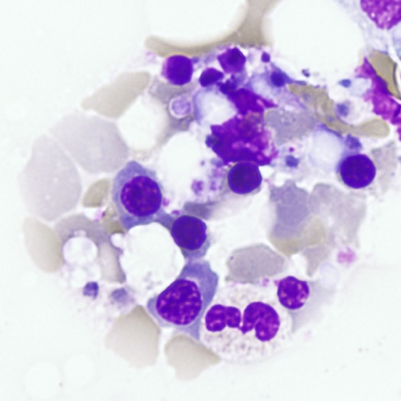 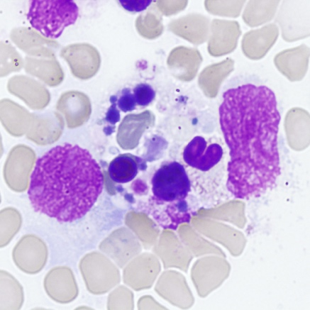 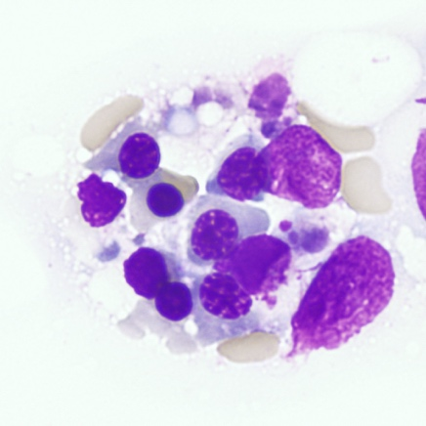

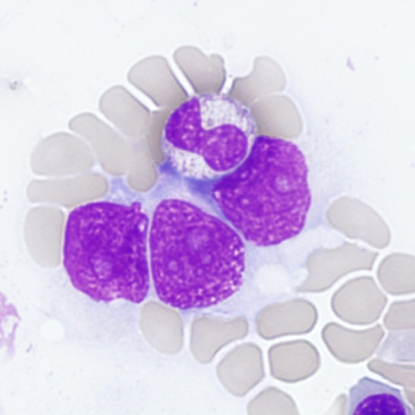 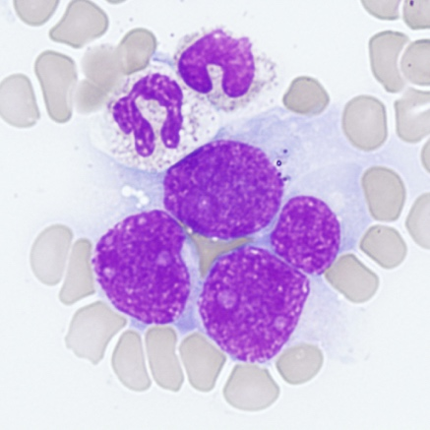 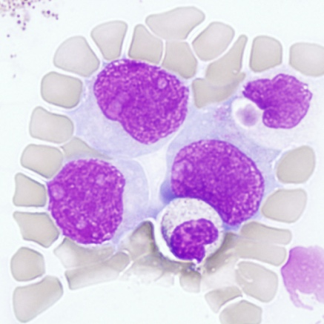

A previously fit 49-year-old man was admitted with a short history of drenching night sweats, fever and weight loss. On examination he looked unwell but no lymphadenopathy or organomegaly was detectable. His blood count showed Hb 133 g/L, WBC 4.3 × 109/L, and platelets 56 × 109/L. The blood film showed no specific features. He developed progressive liver failure, coagulopathy, hyperferritinemia, and hypertriglyceridemia. Serum lactate dehydrogenase was 4503 iu/L. Epstein–Barr virus (EBV) cell-free DNA was measured at 6.35 log 10 iu/ml. Computed tomography of neck, thorax, abdomen, and pelvis showed small bilateral pleural effusions with no evidence of lymphadenopathy, splenomegaly or hepatomegaly, although the liver had a diffusely abnormal texture. His clinical condition deteriorated rapidly, necessitating intubation, ventilation, and vasopressor support. A bone marrow aspirate showed markedly increased cellularity with prominent hemophagocytosis (upper images, ×100 objective). In addition there was a population of large, nucleolated lymphoid cells with finely granular, moderately basophilic cytoplasm (lower images, ×100). The latter were shown to have a CD45+, CD2+, CD56+ phenotype by flow cytometry; other surface T-cell markers and CD30 were not expressed. Cytogenetic analysis showed 92,XXYY,t(3;13)(q12;q14)[6]/46XY[4].

The diagnoses to be considered here are aggressive NK-cell leukemia and extranodal NK/T-cell leukemia/lymphoma. Some overlap between these diagnoses is recognized. We favor the diagnosis of aggressive NK-cell leukemia because of the bone marrow involvement and the associated hemophagocytosis. Both of these are rare in extranodal NK/T-cell leukemia/lymphoma, being seen in only one of 101 patients in one series.1 The patient was treated with high dose corticosteroids and cyclophosphamide but he developed multi-organ failure and died soon thereafter.

Aggressive NK-cell leukemia is a rare EBV-associated lymphoproliferative disorder, most prevalent in East Asian populations. Frequently, its presentation is complicated by multi-organ dysfunction, coagulopathy and hemophagocytosis. Numerical and structural cytogenetic abnormalities have been reported.  This neoplasm is frequently treatment refractory and the prognosis is dismal with a median survival of less than two months.

Conflict of interest

Nil

Orcid

0000-0003-3077-4579 Barbara Bain

REFERENCE

1. Su Y-J, Wang H, Chang H, et al. (2018) Extranodal NK/T‐cell lymphoma, nasal type: Clinical features, outcome, and prognostic factors in 101 cases. *Eur J Haematol*. 2018;101:379-388.

Emails for editorial purposes

[Daire.Quinn@ggc.scot.nhs.uk](mailto:Daire.Quinn@ggc.scot.nhs.uk)

[Katrina.Farrell1@nhs.scot](mailto:Katrina.Farrell1@nhs.scot)

[Mike.Leach@ggc.scot.nhs.uk](mailto:Mike.Leach@ggc.scot.nhs.uk)