**Title: “A multi-objective optimisation model to reduce greenhouse gas emissions and costs in offshore natural gas upstream chains”**

**Authors:** Ernesto Santibanez-Borda1, Anna Korre1,2, Zhenggang Nie1, Sevket Durucan1

1Department of Earth Science and Engineering, Royal School of Mines, 2Energy Futures Lab, Imperial College London, London SW7 2AZ, United Kingdom

**Corresponding author:** Ernesto Santibanez-Borda – ernesto.santibanez-borda15@imperial.ac.uk –Department of Earth Science and Engineering, Royal School of Mines, Imperial College London, London SW7 2AZ, United Kingdom – +44 7401814408

**Total words count:**

# **Highlights:**

* Offshore hydrocarbon networks were redesigned to reduce costs and emissions
* Energy generation options were analysed using a multi-objective optimisation model
* The methodology was applied to a case study in the UK Southern North Sea
* 25% of emissions reduction was obtained at an average cost of US$370.9/tonCO2e
* Integration with offshore wind farms provided the greatest benefits in the optima

# **Abstract**

The urgency of climate change, while the world economy is projected to depend on fossil fuels for some time, requires substantial reduction of greenhouse gas emissions in the oil and gas industry. This study proposes a methodology for the decarbonisation of offshore natural gas production networks through progressive electrification, either by connecting offshore platforms with nearby renewable energy sources, e.g. offshore wind farms, or by sharing resources so as to improve their energy generation efficiency. In this context, a novel multi-objective mixed-integer linear programming model is proposed to simultaneously minimise greenhouse gas emissions and associated costs from a determined offshore platform network, considering technical constraints, such as maintaining the energy balance of the network, ensuring that cables are installed to enable energy flows, and respecting the maximum generation capacities and minimum operating loads of turbines. For demonstration purposes, the proposed methodology was applied to a UK Southern North Sea network and optimised using the augmented $ϵ$-constraint method. The Pareto front approximation obtained suggests that the studied network’s cumulative greenhouse gas emissions can be reduced by 25% over the next 10 years at an average cost of US$370.9 per tonne CO2e. This study also explores the impact that uncertainties and postponing investment decisions may have in the set context.

**Graphical abstract**

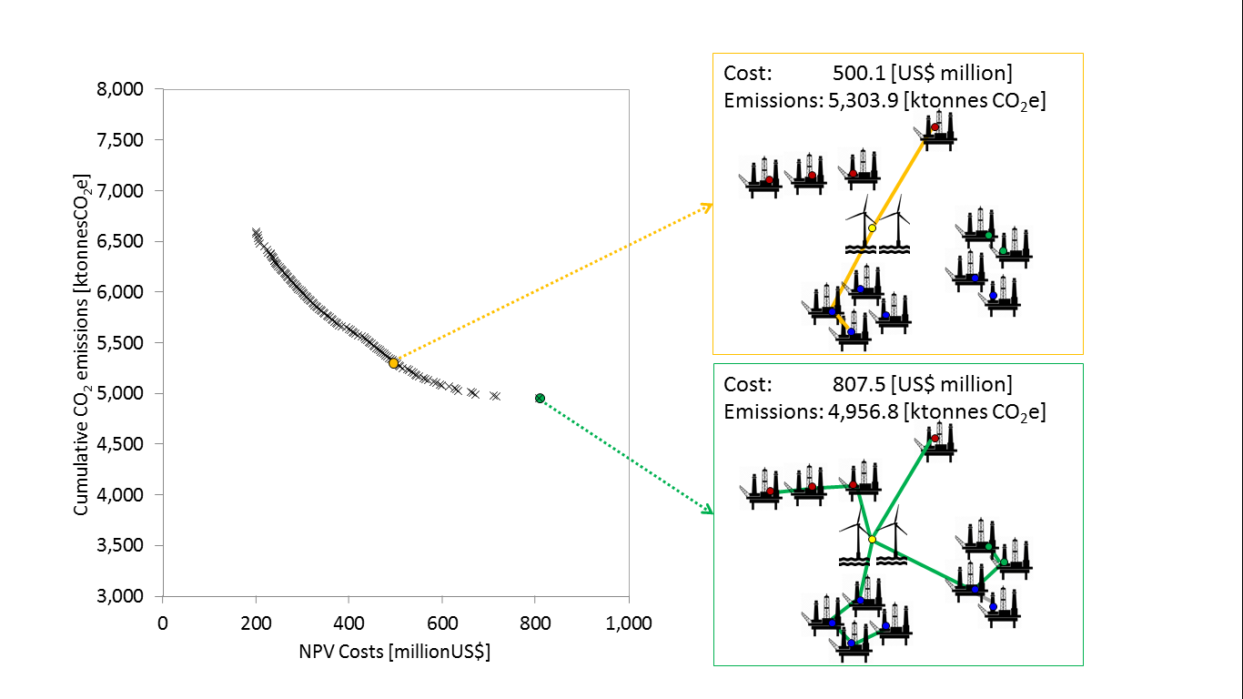

# **Keywords**

Multi-objective optimization;

Greenhouse gas emissions;

Natural gas supply chain;

Offshore platform;

Offshore wind;

Network integration;

1. **Introduction**

It is widely agreed that long-lasting or irreversible impacts are expected to take place on the earth, if global temperature increase exceeds 1.50C above the current (IPCC, 2018). To avoid this scenario, a large transformation of the energy system is required (Kriegler et al., 2014). In the short term, the world is projected to continue relying on fossil fuels; by 2030, between 63 and 78% of world’s primary energy demand is still expected to be supplied by fossil fuels (BP, 2020; IEA, 2020a).

Due to the urgency of climate change and the pressure exerted by international commitments such as the Paris agreement (United Nations, 2015), various studies have investigated means for reducing greenhouse gas emissions in the fossil fuel supply chain (EPA, 2002; IEA, 2020b). Renewable energy sources provide a means for decarbonising power grids, however, their integration at large scale poses technical challenges due to their intermittent nature (Ullah et al., 2020). The development of flexibility technologies is expected to mitigate this in the coming decades (Maeder et al., 2021; Zhang and Zheng, 2020). The decarbonisation opportunities renewable energy sources offer for industry is a relatively new area, that is attracting increasing attention (Endresen et al., 2017; Riboldi and Nord, 2018).

Offshore oil and gas operations, in particular, contributed to around a quarter of the global hydrocarbon production in 2016 (IEA, 2018). Many offshore facilities in the North and Norwegian Sea are under additional pressure as they produce fossil fuels from mature fields, experience production decay, and use long established and ageing infrastructure. Several facilities that are near their end of life operate at severe part-load conditions (Nguyen et al., 2014b; Voldsund et al., 2014), further reducing their environmental performance as turbines operating at lower loads account for important efficiency losses (GE Power Systems, n.d.). Furthermore, according to Nguyen et al., (2014a), off-design operation may require running gas recirculation cycles to secure the export flow in these facilities, resulting in an increased energy consumption per unit of throughput.

Notwithstanding hydrocarbon production reduction, there are different options available which may reduce greenhouse gas (GHG) emissions for currently operating offshore oil and gas facilities. At the moment, Marginal Abatement Cost (MAC) curves, such as those recently published by IEA (2020), are widely used to compare benefits between technologies in the fossil fuel industry. However, with these curves it is difficult to examine the environmental and economic impacts of simultaneously implementing two or more technology options that either target the same emission source(s), or have joint implementation synergies as their joint abatement effect would be different from the sum of their individual separate abatement effects. With MAC curves, it is also complex to analyse the impact of postponing investment decisions or implementing technologies at different times. Instead such decisions and choices can be better characterised if modelled mathematically and optimised in terms of economic and environmental targets.

Optimisation has been thoroughly applied in the literature to upstream oil and gas supply chains with the objective of maximising their associated NPV and economic performance at design stage; authors such as Aseeri et al. (2004), Carvalho and Pinto (2006) and Tarhan et al. (2009) proposed different mixed integer models to maximise the net present value (NPV) of a project, while deciding on platform and well sequencing, technology selection and well to platform allocation.

The optimisation of environmental objectives in the oil and gas supply chain, such as reducing GHG emissions, has been addressed later but with a greater focus on downstream rather than upstream activities; such is the case of the studies of Elkamel et al. (2008) and Wang et al. (2020) who optimised activities related to petroleum refining.

Reducing environmental impacts and costs have been observed as competing objectives in the hydrocarbon production context (Azadeh et al., 2015; Riboldi and Nord, 2018) and, thus, should be addressed using multi-objective optimisation (MOO) rather than single-objective optimisation. Studies addressing these objectives through MOO are more recent (Roudneshin and Azadeh, 2019; Zhou et al., 2020) focusing on downstream oil supply chains. Both used $ϵ$-constraint method variants to obtain the optimal Pareto fronts.

Peer-reviewed research addressing upstream oil and gas supply chains through MOO has focused mainly on designing new supply chain infrastructures and scheduling production flows. Sahebi et al. (2014) optimised upstream crude oil supply chains facility location and allocation, technology selection and production planning through a multi-objective mixed integer linear programming (MILP) model, which they solved using the weighted-sum technique. Later, Azadeh et al. (2015) optimised natural gas supply chains assessing production planning and flow allocation decisions across the whole supply chain and Azadeh et al. (2017) optimised decisions for the upstream and midstream crude oil supply chain.

The optimisation of new infrastructure designs, however, has limited application for the supply chains that already have their infrastructure in place and intend to reduce their GHG emissions. Nguyen et al. (2016, 2014a), Oil and Gas Facilities (2020), Riboldi et al. (2017) and TNO (2016) studied options to reduce GHG emissions in established offshore upstream hydrocarbon chains in the context of the industry operating in the North and Norwegian Sea; few of their suggested options are:

1. Platform integration: increase the load of natural gas turbines used by sharing power generation between platforms.
2. Integrate offshore wind farms with offshore hydrocarbon production networks.
3. Integrate offshore hydrocarbon production with onshore power grids.
4. Introduce Waste heat recovery (WHR) systems.
5. Introduce CO2 capture units.

Practically, the above options cannot be thoroughly assessed using MAC curves as they require detailed modelling specific to individual chains and some have bigger abatement impacts when implemented in offshore platform networks rather than individual platforms.

There are a limited number of studies addressing the implementation of the above options so far. Nguyen et al. (2014a) optimised the implementation of option (iv) in a single offshore platform and minimised costs and CO2 emissions while maximising net power capacity. The authors used a mixed integer nonlinear programming (MINLP) MOO approach and concluded that the integration of steam Rankine cycles could be more cost competitive than other technologies. Nguyen et al. (2016) later analysed the implementation of options (iii), (iv) and (v) on a single offshore platform in the North Sea using a MINLP multi-objective optimisation approach that maximised the power capacity and minimised CO2 emissions and investment costs; the authors concluded that all options reduced CO2 emissions by at least 15% for the platform considered. Riboldi and Nord (2018) then analysed the implementation of option (ii) on a single platform using a MOO approach to minimise lifetime CO2 emissions, investment costs and overall weight. Their results showed that lifetime CO2 emissions could be reduced by between 11.9-24.4% at an additional cost of $19-32 million compared to when energy is generated by combusting gas onsite.

Offshore hydrocarbon platforms, however, do not operate in isolation. Mature offshore hydrocarbon basins characteristically host a network of production platforms that exchange and transport the produced hydrocarbon flows between them. This feature offers additional opportunity to share power production facilities, as in option (i), which could be economically advantageous for a network of platforms in production.

Riboldi et al. (2017) may have been the first to optimise GHG emissions reduction in operating offshore platform networks; the authors analysed the implementation of options (i) and (iii) on a network of four hydrocarbon production platforms while considering the dynamic relation between turbine load and generation efficiency. Their results showed that 56% and 3% of lifetime CO2 reductions could be achieved when implementing options (i) and (iii) respectively. The analysis, however, was conducted using a single-objective optimisation approach which does not secure the Pareto optimality of the selected solutions in a multi-objective scenario.

In conclusion, although the simultaneous optimisation of economic and environmental objectives in the fossil fuel supply chain has been conducted on downstream processes and new infrastructure designs in the upstream segments of the chain, it has limited applicability for currently operating facilities. Although currently operating hydrocarbon production facilities contribute approximately a quarter of the global GHG emissions at the present, the authors found limited research conducted to optimise the implementation of GHG emissions reduction options. The few available studies either optimise offshore platforms individually or address this economic-environmental problem using single objective optimisation.

Specifically, until now, the degree to which interconnecting platforms (option i) and importing power from offshore wind farms (option ii) might help reduce GHG emissions in offshore platform networks has not been studied through a MOO approach. This study aimed to evaluate this and focused on upstream offshore natural gas production. For this purpose, the implementation of options (i) and (ii) in offshore platform networks was assessed through a newly proposed multi-objective multi-period mixed integer linear programming model (MOMILP) that allows minimising simultaneously the cumulative GHG emissions and costs associated with this implementation for a platform network. The benefits from the implementation of the methodology are evaluated for a real platform network located in the UK Southern North Sea (SNS) considering an investment horizon of 10 years, and solved using the augmented $ϵ$-constraint method in the GAMS optimisation software version 23.5. This is the first study to simultaneously model shared power generation between platforms and the integration of these networks with offshore wind farms when environmental and cost objectives are optimised.

Considering the projected dependence of our economies on fossil fuels for some time yet, the contributions of the proposed methodology are very significant in terms of climate change mitigation for the oil and gas industry and policy makers. The proposed model, firstly, allows planning the gradual electrification of offshore hydrocarbon production networks that are currently operating, while simultaneously minimising their associated costs and GHG emission, and secondly, allows exploring how offshore wind generated power price can impact the efforts to reduce GHG emissions on these networks.

The rest of this paper is structured as follows. Section 2 further describes the problem boundaries and assumptions and presents the proposed MOMILP model. Section 3 presents a real-world case study selected to apply the proposed methodology and illustrates how the developed model identifies optimal solutions. Section 4 discusses the results and Section 5 presents the research conclusions, limitations and recommendation for further research.

1. **Methods:**

## **2.1 Offshore oil and gas upstream chain characteristics**

The offshore oil and gas upstream chain includes the processes of hydrocarbon production, pre-processing and transport to onshore terminals. It is composed by:

* Offshore fields: comprising geological structures which, due to their unusually high hydrocarbon content, allow economically profitable hydrocarbon production.
* Surface production infrastructure: Located above sea level, these metallic structures are used to receive, treat and prepare hydrocarbon production flows for being exported to their onshore destination.
* Subsea production infrastructure: Located below sea, these include subsea well heads, infield flowlines and subsea manifolds which operate with the purpose of receiving and directing the production flow coming from the offshore wells to nearby surface infrastructure or to subsea export pipelines for being directed to onshore terminals.
* Offshore export pipelines: Tubular metallic flowlines, normally located on the seabed, used to export production hydrocarbon flows to onshore terminal destinations.

A group of offshore surface infrastructure interconnected by pipelines through which hydrocarbon flow is commonly referred to as an offshore infrastructure network; figure 1 presents the specific case of an offshore platform network.

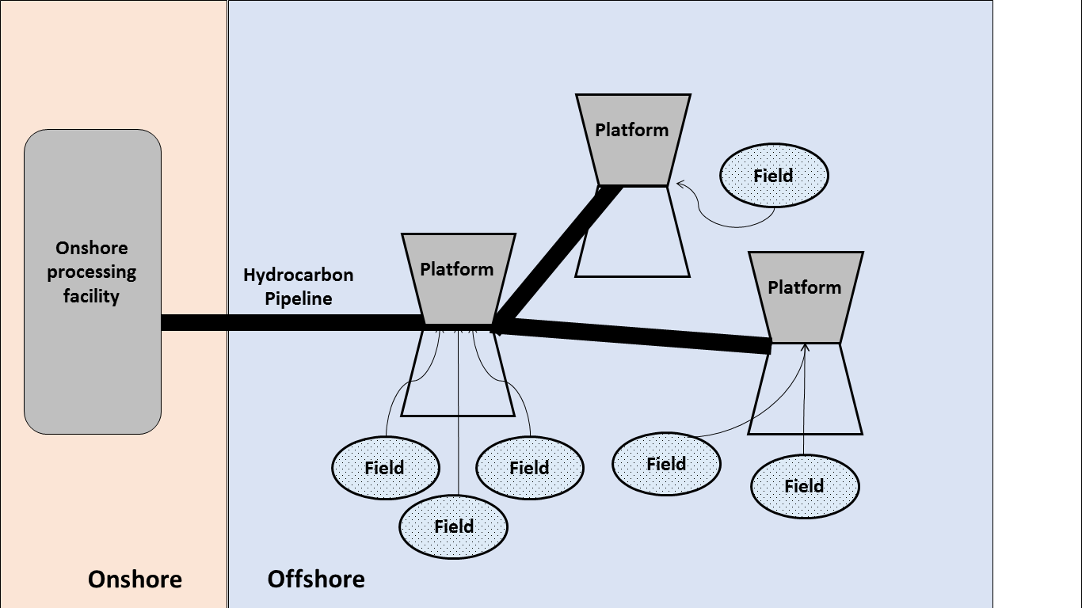

**Figure 1. Schematic representation of the upstream offshore oil and gas chain.**

Within the surface production infrastructures a series of processes are performed; after receiving the produced hydrocarbon flow, oil is separated from gas and water. While produced water is purified before being disposed at sea, oil and gas flows may or not be further purified to meet export pipeline specifications depending on their quality. Gas and oil may then need compression and pumping respectively to flow through offshore pipelines and reach their onshore destination.

The previous processes require power to operate; as surface production infrastructures are normally located far from onshore power grids, the most widely used methods to generate power offshore are:

* Combusting some of the natural gas these infrastructures produce. In this widely used method, natural gas is combusted in turbines whose generation efficiency depends on the load they are operated at, estimated as the fraction between the turbine energy demand and the turbine generation capacity (GE Power Systems, n.d.).
* Combusting diesel in generators; which is normally restricted to the minimum as companies have to buy and transport this fuel to each offshore location. This method is normally used to support the offshore infrastructure energy demand during start-ups, emergencies and maintenance activities.

## **2.2 Model formulation**

The proposed model considers offshore platforms as surface infrastructure for simplicity, but it can be easily extended to include other types of surface infrastructures.

The model represents the upstream offshore oil and gas chain as a network where nodes represent offshore platforms (op) and offshore wind farms (wf), and where arcs represent the subsea electricity cables necessary to allow electricity flow between offshore platforms and wind farms. In this approach, electricity would only flow between two nodes if a connected arc path exists between them.

Each platform is considered to have a set of gas turbines (gt) fixed at the time of its construction. This set is assumed as invariable during the life of the platform.

In this approach, in order to allow joint power generation between platforms, it is necessary that at least one arc connects two platform nodes (op), meaning that at least one cable connects two platforms; while in order to allow offshore wind generated power use in a platform network, it is necessary that at least one arc connects a platform node (op) with an offshore wind farm node (wf).

### **2.2.1 Variables**

The following decision variables are considered for this approach:

* $y_{ijt}$– Binary variable defining whether the arc between nodes ‘i’ and ‘j’ is installed in period ‘t’ or not.
* $x_{ijt}$– Electricity flow from node ‘i’ to ‘j’ in period ‘t’ in [GWh].
* $o_{it}$– Electricity generated by platform ‘i’ combusting diesel in period ‘t’ in [GWh].
* $u_{ikt}$– Electricity generated by platform ‘i’ combusting natural gas in its turbine ‘k’, during period ‘t’ in [GWh].
* $w_{ikt}$– Binary variable defining whether turbine ‘k’ from platform ‘i’ is used for electricity generation combusting natural gas in period ‘t’ or not.

Additional parameters used in the developed model are presented in table 1.

**Table 1**

Parameters used in the proposed model.

|  |  |  |  |
| --- | --- | --- | --- |
| $$EF_{diesel}$$ | GHG emissions associated with the combustion of 1 [GWh] of diesel equivalent; expressed in tonnes CO2 equivalent | $$a,b$$ | Linear fitting parameters used to model the gas turbine heat consumption |
| $$EF_{Owind}$$ | Life cycle GHG emissions of the power generated by offshore wind; expressed as tonnes of CO2 equivalent per [GWh] of generated energy | $$T$$ | Chosen investment horizon [years] |
| $$D_{eff}$$ | Diesel generator efficiency | $$r$$ | Interest rate |
| $${EF}_{gas}$$ | GHG emissions associated with the combustion of 1 tonne of natural gas; expressed as tonnes CO2 equivalent | $$c_{1}$$ | Installation cost of the subsea electricity cable [$USmillion/km] |
| $${GC}_{ikt}$$ | Gas combustion [tonnes/year] in turbine ‘k’ of platform ‘i’, period ‘t’. | $$d_{ij}$$ | Distance [km] separating nodes ‘i’ and ‘j’ |
| $$μ$$ | Gas turbine generation efficiency | $$Op$$ | Set of offshore platforms under consideration |
| $$CV$$ | Combusted gas calorific value [GWh/ton] | $$Wf$$ | Set of offshore wind farms under consideration |
| $$HR$$ | Gas turbine heat rate [Btu/GWh] | $${gt}_{i}$$ | Set of gas turbines associated to offshore platform ‘i’ |
| $$HC$$ | Gas turbine part load heat consumption rate [Btu/h] | $$c_{2,t}$$ | Price of the electricity generated by offshore wind [US$million/GWh] in period ‘t’ |
| $$HC_{0}$$ | Gas turbine base load heat consumption rate [Btu/h] | $$c_{3,t}$$ | Diesel price [US$million/GWh generated] in period ‘t’ |
| $$P$$ | Gas turbine power output [GW] | $${GP}_{t}$$ | Price paid [US$million/GWh] to the operating company for gas delivered in period ‘t’ |
| $$P_{0}$$ | Gas turbine maximum design power output [GW] | $$D_{it}$$ | Node ‘i’ electricity demand in period ‘t’ [GWh] |
| $$min_load$$ | Gas turbine minimum operating load | $$M$$ | Sufficiently large constant: $M≫x_{ijt}$ |
| $$OH$$ | Gas turbine operating hours [hours/year] |  |  |

### **2.2.2 Objective functions**

Two objective functions were considered. The first, presented in Eq. 1, minimises the net present value associated with the Capital expenditure (CAPEX), Operational expenditure (OPEX) and lost revenues (LOST_REV) for the whole evaluation period in ${\left[US\$ million\right]}_{2020}$. Eq. 2 to 6 further detail how this objective function is derived.

$Min: \sum{\left(CAPEX+OPEX+LOST_REV\right)}$ (1)

The CAPEX for the network level implementation of abatement options was calculated using Eq. 2 considering the cable installation costs, the installation timing and the discount rate ‘r’.

$CAPEX= \sum_{t}{\sum_{(i,j)}{\frac{y_{ijt}∙c_{1}∙d_{ij}}{{\left(1+r\right)}^{t}}}} ∀t∈\left\{1,..,T\right\}, ∀(i,j)∈\left\{op,wf\right\}$ (2)

The OPEX for the abatement options implementation (Eq. 3) was calculated considering the costs associated with electricity purchase from offshore wind farms ($WC_{jit}$) and diesel purchase ($DC_{it}$) for power generation within the offshore platforms defined in Eq. 4 and Eq. 5 respectively. This approach included diesel consumption in the OPEX as power generated by offshore wind and that higher generation efficiencies from joint power generation may reduce diesel consumption.

$OPEX=\sum_{t}{\sum_{i}{\left(\sum_{j}{WC_{jit}}+DC_{it}\right)}} ∀t∈\left\{1,..,T\right\}, ∀i∈\left\{op\right\}, ∀j∈\left\{wf\right\}$ (3)

$WC_{jit}=\frac{x_{jit}∙c_{2,t}}{{\left(1+r\right)}^{t}} ∀t∈\left\{1,..,T\right\}, ∀j∈\left\{wf\right\}, ∀i∈\left\{op\right\}$ (4)

$DC_{it}=\frac{o_{it}∙c_{3,t}}{{\left(1+r\right)}^{t}} ∀t∈\left\{1,..,T\right\}, ∀i∈\left\{op\right\}$ (5)

This approach modelled lost revenues as the income lost due to the natural gas that is combusted in the platforms and that can therefore not be sold. NPV was estimated using Eq. 6 as the market value of the natural gas combusted for power generation within the offshore platforms’ network. This value was optimised together with the diesel and offshore wind power costs as they are all used to meet the platforms’ power demand, impact negatively the operating companies’ economic flows and have different associated GHG emission footprints.

$LOST_REV= \sum_{t}{\sum_{i}{\sum_{k}{\frac{u_{ikt}∙{GP}_{t}}{{\left(1+r\right)}^{t}}}}} ∀t∈\left\{1,..,T\right\}, ∀i∈\left\{op\right\},∀k∈\left\{{gt}_{i}\right\}$ (6)

The second objective function (Eq. 7) minimises the greenhouse gas emissions (GHG) related to the cumulative energy consumption of the network; specifically, in this approach GHG emissions due to natural gas combustion in turbines (NGE), diesel combustion in engines (DE) and offshore wind generated power imports (OW) were minimised over the considered investment horizon. Eq. 8 to 14 further detail how this function was derived. This function considered the greenhouse gases of CO2, CH4 and N2O aggregated in terms of tonnes CO2 equivalent using a CO2 equivalent weight of 25 for CH4 and 298 for N2O, which relate to their impact on global warming over a 100-years’ time span (IPCC, 2007). The authors note that although the most up to date version of IPCC GPWPs (AR5) has a higher GWP for methane, the most up to date EF for offshore wind power (NREL, 2013) uses AR4; therefore, for consistency in calculations, AR4 was used in this study.

$Min: \sum_{t}{\left(NGE_{t}+DE_{t}+OW_{t}\right)} ∀t∈\left\{1,..,T\right\}$ (7)

Natural gas combustion associated GHG emissions, detailed in Eq. 8, were estimated following American Petroleum Industry (API), (2009) guidelines.

$NGE_{t}=\sum_{i}{\sum_{k}{{GC}_{ikt}∙EF_{gas}}} ∀t∈\left\{1,..,T\right\}, ∀i∈\left\{op\right\},∀k∈\left\{{gt}_{i}\right\}$ (8)

Eq. 9 relates the natural gas combusted in a turbine (${GC}_{ikt}$) with the energy demand of the turbine ($u_{ikt}$) and the combusted gas calorific value ($CV$).

${GC}_{ikt}=\frac{u_{ikt}}{μ∙CV}$ (9)

Gas turbine generation efficiency ($μ$) by definition can be expressed in terms of the heat rate ($HR$) (Eq. 10) or the heat consumption ($HC$) and turbine power ($P$) (Eq. 11); with the numerators in these equations referring to the conversion of 1 [GWh] into [Btu] units.

$μ=\frac{3.412∙{10}^{9}}{HR}$ (10)

$μ=\frac{3.412∙{10}^{9}}{HC/P}$ (11)

This study modelled the relation between turbine heat consumption ($HC$) and turbine load as linearly dependent (Eq. 12) following the gas turbine behaviour described in GE Power Systems (n.d.) allowing to express heat consumption through the linear relation showed in Eq. 13. Eq. 14 expresses part load turbine power output ($P$) in terms of the electricity produced by the turbine in a determined period ($u_{ikt}$) and the operating hours ($OH$) for the site.

$\frac{HC}{HC_{0}}=a+b∙\frac{P}{P_{0}}$ (12)

$HC=HC_{0}∙\left(a+b∙\frac{u_{ikt}}{P_{0}∙OH}\right)$ (13)

$P=\frac{u_{ikt}}{OH}$ (14)

By replacing Eq. 9 to 14 in Eq. 8, natural gas combustion GHG emissions can be expressed as shown in Eq. 15.

$NGE_{t}=\sum_{i}{\sum_{k}{\left(\frac{HC_{0}}{3.412∙{10}^{9}∙CV}\right)∙\left(a∙OH∙w_{ikt}+\frac{b∙u_{ikt}}{P_{0}}\right)∙EF_{gas}}}$

$∀t∈\left\{1,..,T\right\}, ∀i∈\left\{op\right\},∀k∈\left\{{gt}_{i}\right\}$ (15)

Diesel combustion GHG emissions were estimated depending on the diesel generated electricity ($o_{it}$) [GWh] and the diesel generation efficiency ($D_{eff}$) as shown in Eq. 16.

$DE_{t}=o_{it}∙EF_{diesel}/D_{eff} ∀t∈\left\{1,..,T\right\}, ∀i∈\left\{op\right\}$ (16)

While emissions associated with the purchased offshore wind generated power were estimated using Eq. 17.

$OW_{t}=\sum_{i}{\sum_{j}{x_{ijt}∙EF_{Owind}}} ∀t∈\left\{1,..,T\right\}, ∀i∈\left\{wf\right\}, ∀j∈\left\{op\right\}$ (17)

The authors note that Eq. 2, 3, 6, 15, 16 and 17 are linear to the decision variables.

### **2.2.3 Constraints**

The defined decision variables are submitted to the binary and non-negativity constraints described in Eq. 18 to 22.

$y_{ijt}∈\left\{0,1\right\} ∀\left(i,j\right)∈\left\{op,wf\right\}, ∀t∈\left\{1,..,T\right\}$ (18)

$w_{ikt}∈\left\{0,1\right\} ∀i∈\left\{op\right\}, ∀k∈\left\{{gt}_{i}\right\},∀t∈\left\{1,..,T\right\}$ (19)

$x_{ijt}≥0 ∀\left(i,j\right)∈\left\{op,wf\right\},∀t∈\left\{1,..,T\right\}$ (20)

$o_{it}≥0 ∀i∈\left\{op\right\},∀t∈\left\{1,..,T\right\}$ (21)

$u_{ikt}≥0 ∀i∈\left\{op\right\}, ∀k∈\left\{{gt}_{i}\right\},∀t∈\left\{1,..,T\right\}$ (22)

Eq. 23 secures that for all periods, the incoming, outgoing and self-generated electricity at each node is balanced with its energy demand. The present model does not consider the possibility of inventorying electricity for future periods.

$\sum_{j}{x_{jit}}-\sum_{l}{x_{ilt}}+\sum_{k_{i}}{u_{ikt}}+o_{it}=D_{it} ∀\left(i,j,l\right)∈\left\{op,wf\right\},∀k∈\left\{{gt}_{i}\right\}, ∀t∈\left\{1,..,T\right\}$ (23)

Eq. 24 requires a cable to be previously installed between two nodes to allow electricity flow between them. The proposed approach assumes that a cable takes one unit of time to be operative since the time the investment costs are assumed, meaning that if the investment costs for the cable are assumed in period ‘t’, this cable can be used from period ‘t+1’ on.

$x_{ijt}≤M∙\sum_{q}^{t-1}{\left(y_{ijq}+y_{jiq}\right)} ∀\left(i,j\right)∈\left\{op,wf\right\}, ∀t∈\left\{1,..,T\right\}$ (24)

Eq. 25 caps each network arc to be installed only once; it also allows electricity to flow in either direction. The present approach also considers that arcs do not suffer from degradation, so after installation they remain fully operative throughout the evaluation period.

$\sum_{t}{\left(y_{ijt}+y_{jit}\right)≤ 1} ∀\left(i,j\right)∈\left\{op,wf\right\}, ∀t∈\left\{1,..,T\right\}$ (25)

This methodology does not optimises the cable voltages and transmission losses for the network; instead, when optimising a particular offshore platform network, it chooses cable costs ($c_{1}$) from a comparable offshore cable installation project to secure that the voltage levels of the cable are adequate to the case study being optimised.

Eq. 26 and 27 limit the gas turbine generated electricity to the design capacity of the turbine and requires a minimum operating load for a turbine to operate in line with Riboldi et al. (2017). Eq. 28 limits the energy generated by combusting diesel to be below the natural gas turbine minimum operating range, so natural gas combustion is prioritised over diesel combustion.

$u_{ikt}≤P_{0}∙w_{ikt} ∀k∈\left\{{gt}_{i}\right\}, ∀i∈\left\{op\right\}, ∀t∈\left\{1,..,T\right\}$ (26)

$w_{ikt}∙min_load∙P_{0}≤u_{ikt} ∀k∈\left\{{gt}_{i}\right\}, ∀i∈\left\{op\right\}, ∀t∈\left\{1,..,T\right\}$ (27)

$o_{it}≤min⁡_load{∙P}_{0} ∀i∈\left\{op,wf\right\}, ∀t∈\left\{1,..,T\right\}$ (28)

Eq. 29 secures that no closed cycles are formed inside the network.

$\sum_{(i,j)}{y_{ijt}}≤\left|Op\right|-1 ∀(i,j)∈\left\{op,wf\right\}, ∀t∈\left\{1,..,T\right\}$ (29)

Lastly, Eq. 30 secures that at least 65% of the energy demand of an individual platform in a determined period is self-generated within each platform. Considering the intermittency of offshore wind generation and energy security reasons, a large portion of the energy demand for a platform has been required to be self-generated in similar projects in the North Sea. As an example, the Hywind Tampen project, which integrates floating offshore wind turbines with the Snorre and Gullfaks hydrocarbon offshore platforms, considered that only 35% of annual power demand of the platforms would be provided by offshore wind turbines (Equinor, 2019).

$0.65∙D_{it}≤\sum_{k}{u_{ikt}}+o_{it} ∀i∈\left\{op\right\},∀k∈\left\{{gt}_{i}\right\}, ∀t∈\left\{1,..,T\right\}$ (30)

1. **Case study**

In addition to having the highest installed offshore wind generation capacity in Europe, the UK continental shelf also produced 98.6% of the UK’s total hydrocarbon production in 2018 (UK Oil & Gas Authority, 2019a; Wind Europe, 2020) and emitted 13.2 million tonnes of CO2 to the atmosphere (OGUK, 2019). Moreover, recent UK government commitments of achieving net zero greenhouse gas emissions by 2050 have put significant pressure on this industry to reduce these emissions.

The present study chose three offshore platform clusters located in the UK Southern North Sea shown in figure 2. The number of platforms per cluster, fields per platform, and the operating state for each infrastructure - active (a) or inactive (n) - is presented in table 2. The analysed clusters are ideal to investigate the benefits of shared power generation and offshore wind energy integration due to their proximity to the Hornsea project – currently the largest operating offshore wind farm in the world (Wind Europe, 2020) – and because many of these platforms are currently experiencing production decline with the consequential generation efficiency loss.

The analysed platforms are not connected to the UK electricity grid, which is why they combust the same gas they produce to meet their energy demand. This demand was not publicly available at the time this manuscript was written, which is why it was estimated using the following stepwise approach:

* First, the future gas production per field was forecasted using the decline curve analysis concepts outlined by Arps (1944) and historical hydrocarbon production data (UK Oil & Gas Authority, 2019a).
* Second, the historical and future energy demand per field was estimated by multiplying the hydrocarbon production profile for each field with the energy intensity profile of the UK offshore gas fields Vanner (2005).
* Third, the energy demand for each field was allocated to different offshore platforms considering the network information made available by UK Oil & Gas Authority (2019b) and assuming that this demand can be separated into pre-processing and compression requirements, which can be allocated jointly to the same platform or separately into two different platforms. Pre-processing and compression requirements were assumed to be constant and respectively equivalent to 20 and 80% of the energy demand of the field, respectively, for simplicity. Further information on how this energy demand was allocated per platform is presented in table 2; table 3 presents a summary of the energy demand per platform estimated following this methodology.

Considering the hydrocarbon production forecasts estimated for this case, this study set an investment horizon of 10 years which was divided into 10 periods of 1 year on which investment decisions can be implemented.

**Table 2**

Composition of the analysed offshore hydrocarbon network and other relevant modelling parameters (UK Oil & Gas Authority, 2019b, 2019a). Note: (a) = active, (n) = inactive.

|  |  |  |  |  |  |  |  |  |  |  |  |  |  |  |  |  |
| --- | --- | --- | --- | --- | --- | --- | --- | --- | --- | --- | --- | --- | --- | --- | --- | --- |
| Cluster | Offshore platform | Connected fields | Number GT | Distance between operating platforms and Hornsea offshore wind farm [Km] / % of connected fields energy demand allocated to platform | | | | | | | | | | | | |
| (1) | (2) | (3) | (4) | (5) | (6) | (7) | (8) | (9) | (10) | (11) | (12) | (13) |
| 0 | (1) Hornsea connection point | | n/a | 0.0 | 101.405 | 80.330 | 72.099 | 142.471 | 135.099 | 121.112 | 86.599 | 98.043 | 90.886 | 60.015 | 140.369 | 114.358 |
| I | (2) Garrow (a) | Garrow (a) | Diesel | 101.405 | 0.0 / 20% | 37.992 / - | 73.990 / 80% | 155.564 / - | n/a / - | n/a / - | n/a / - | n/a / - | n/a / - | n/a / - | n/a / - | n/a / - |
| (3) Kilmar (a) | Kilmar (a) | Diesel | 80.330 | 37.992 / - | 0.0 / 20% | 36.018 / 80% | 119.657/ - | n/a / - | n/a / - | n/a / - | n/a / - | n/a / - | n/a / - | n/a / - | n/a / - |
| (4) Trent (a) | Trent (a) | 5 | 72.099 | 73.990 / - | 36.018 / - | 0.0 / 100% | 87.781 / - | n/a / - | n/a / - | n/a / - | n/a / - | n/a / - | n/a / - | n/a / - | n/a / - |
| (5) Cygnus (a) | Cygnus (a) | 11 | 142.471 | 155.564 / - | 119.657 / - | 87.781 / - | 0.0 / 100% | n/a / - | n/a / - | n/a / - | n/a / - | n/a / - | n/a / - | n/a / - | n/a / - |
| Tyne (n) | Tyne South (n), Tyne North (n) | 4 | n/a | n/a / - | n/a / - | n/a / 80% | n/a / - | n/a / - | n/a / - | n/a / - | n/a / - | n/a / - | n/a / - | n/a / - | n/a / - |
| II | (6) ST-1 (a) | Markham (n), Windermere (n) | 10 | 135.099 | n/a / - | n/a / - | n/a / - | n/a / - | 0.0 / 100% | 23.684 / - | 146.469 / - | 146.591 / - | 127.777 / - | 155.959 / - | 49.816 / - | 38.356 / - |
| (7) Chiswick (a) | Chiswick (a), Kew (a) | 1 | 121.112 | n/a / - | n/a / - | n/a / - | n/a / - | 23.684 / 100% | 0.0 / 20% | 144.575 / - | 147.181 / - | 128.625 / - | 148.463 / - | 67.561 / - | 48.220 / - |
| III | (8) Clipper PC (a) | Clipper North (a) | 16 | 86.599 | n/a / - | n/a / - | n/a / - | n/a / - | 146.469 / - | 144.575 / - | 0.0 / 100% | 11.925 / - | 21.497 / - | 35.743 / - | 119.686 / - | 108.096 / - |
| (9) Clipper South (a) | Clipper South (a) | 1 | 98.043 | n/a / - | n/a / - | n/a / - | n/a / - | 146.591 / - | 147.181 / - | 11.925 / 80% | 0.0 / 20% | 18.918 / - | 49.014 / - | 116.708 / - | 108.343 / - |
| (10) Galleon PN (a) | Galleon (a) | 2 | 90.886 | n/a / - | n/a / - | n/a / - | n/a / - | 127.777 / - | 128.625 / - | 21.497 / 80% | 18.918 / - | 0.0 / 20% | 52.306 / - | 99.009 / - | 88.405 / - |
| Skiff PS (n) | Skiff (n) | 1 | - | - / - | - / - | - / - | - / - | - / - | - / - | - / 80% | - / - | - / - | - / - | - / - | - / - |
| (11) Barque (a) | Barque (a) | 2 | 60.015 | n/a / - | n/a / - | n/a / - | n/a / - | 155.959/ - | 148.463 / - | 35.743 / 80% | 49.014 / - | 52.306 / - | 0.0/ 20% | 141.017 / - | 123.156 / - |
| (12) Carrack QA (a) | Carrack (a) | 2 | 140.369 | n/a / - | n/a / - | n/a / - | n/a / - | 49.816 / - | 67.561 / - | 119.686 / 80% | 116.708 / - | 99.009 / - | 141.017 / - | 0.0 / 20% | 29.775 / - |
| (13) Cutter (a) | Carrack (a) | 1 | 114.358 | n/a / - | n/a / - | n/a / - | n/a / - | 38.356 / - | 48.220 / - | 108.096 / 80% | 108.343 / - | 88.405 / - | 123.156 / - | 29.775 / - | 0.0 / 20% |

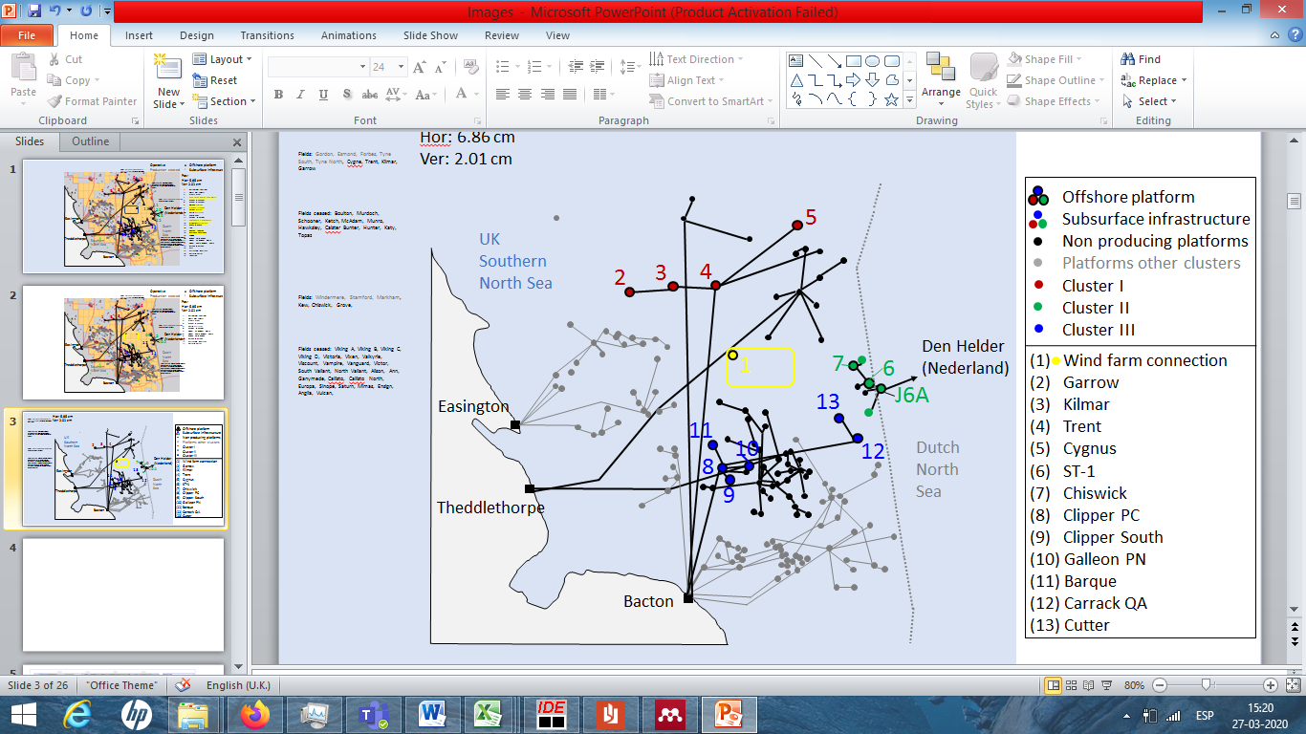

**Figure 2. Representative geographical location of the analysed gas production assets (coloured circles), non-producing platforms (black circles) and associated gas pipeline in the UK Southern North Sea.**

Each platform was modelled to be equipped with a number of simple cycle gas turbines (GT) model GE LM2500 DLE 50Hz to meet their energy demand; each of these turbines were considered to have a net power output ($P_{0}$) of 21.8 [MW], a heat rate ($HR_{0}$) of 9,835 [Btu/kWhLHV] (GE, 2019) and a recommended minimum operating load ($min_load$) of 10% (Subash, 2019). While other GT models are also used in the offshore oil and gas industry, the selected model is hugely popular in the North Sea area. This analysis estimated the number of gas turbines per platform (table 2) so that they are capable of handling their individual life cycle peak energy demand (Nguyen et al., 2014a).

**Table 3**

Estimated power demand per operating platform in the case study

|  |  |  |  |  |
| --- | --- | --- | --- | --- |
| Offshore Platform | Energy demand – Period 1 [GWh/year] | Energy demand – Period 10 [GWh/year] | Cumulative Energy demand – Periods 1 to 10 [GWh/year] | Last non-zero demand period |
| (2) Garrow | 1.151 | 0.678 | 9.567 | 10 |
| (3) Kilmar | 6.838 | - | 12.837 | 3 |
| (4) Trent | 57.944 | 2.711 | 167.238 | 10 |
| (5) Cygnus | 838.197 | 41.739 | 2,648.829 | 10 |
| (6) ST-1 | 103.580 | - | 231.001 | 4 |
| (7) Chiswick | 25.895 | - | 57.750 | 4 |
| (8) Clipper PC | 707.060 | 221.834 | 4,224.151 | 10 |
| (9) Clipper South | 38.690 | - | 204.556 | 9 |
| (10) Galleon PN | 23.679 | - | 69.355 | 5 |
| (11) Barque | 57.369 | 46.004 | 539.166 | 10 |
| (12) Carrack QA | 26.363 | 9.455 | 155.699 | 10 |
| (13) Cutter | 4.790 | - | 5.335 | 3 |

Gas turbines were considered to run 8,760 hours per year ($OH$) and have an associated carbon combustion efficiency of 99.9%. The relation between gas turbine heat consumption and power output was modelled as described in Eq. 12 with associated coefficients $a=2.171×{10}^{-1}$ and $b=7.753×{10}^{-1}$, which were obtained by regressing the experimental GT behaviour data made available by GE Power Systems (n.d.) with an associated R-squared coefficient of 0.997. These coefficients predict a maximum turbine efficiency of 34.96%, a value only 0.8% higher than the one specified by the manufacturer (GE Power Systems, n.d.).

This study considered that the natural gas fed to these turbines – the same these platforms produce and process – has an associated calorific value ($CV$) of $1.412×{10}^{-2}$ [GWh/tonne] and a combustion emission factor (${EF}_{gas}$) equivalent to of 3.373 [tons CO2 equivalent/ton NG] based on the latest data referring to natural gas combustion for energy generation in offshore hydrocarbon operations in the UK (National Atmospheric Emissions Inventory, 2017). Although the authors note that hydrocarbon composition changes from field to field, chose the EFs reported by the UK National Atmospheric Emissions Inventory were chosen because they provide a reasonable regional context and in order to enable the reproducibility of the results obtained in this research; these factors were derived using the calorific value of NG assumed for this case. After offshore use, the remaining natural gas throughput was considered to be delivered to an onshore destination plant and sold at a time dependent market price (${GP}_{t}$) equivalent to European natural gas price forecast (IEA, 2017) for the current policies scenario adjusted to 2020 values using the associated consumer price index for gas (BEIS, 2020a).

Offshore platforms with low peak energy demand, such as the Garrow and Kilmar platforms, were modelled to be powered by diesel engines only. The diesel engines considered in the network were modelled to operate at 40% efficiency ($D_{eff}$) and use diesel with a Lower Heating Value (LHV) of [J/m3] and a combustion emission factor ($EF_{diesel}$) equivalent to 669.184 [tonnes CO2 equivalent/GWh generated diesel] (API, 2009). The time dependent diesel price ($c_{3,t}$) used in this analysis was derived by projecting the 2019 UK average price, £1.315/L (BEIS, 2020b), to change proportionally to the current scenario forecast for crude oil price (IEA, 2017). An exchange rate of US$1.276 per £1, the 2019 average (UK HM Revenue & Customs, 2020), was used to convert these values to US dollars.

The analysed case considered the possibility of platforms purchasing power from the Hornsea One offshore wind farm project, this commenced operations in 2020 and is expected to be followed by phases two, three and four. Hornsea One consists in 174 offshore wind turbines installed in an area of 407 km2 and a total capacity of 1.2 [GW] (Orsted, 2020a, 2020b), this project could provide 4,068.144 [GWh] per year if a 38.7% load factor, equivalent to the UK’s offshore wind farm 2014-2018 average (BEIS, 2019a), and 8,760 operating hours per year are considered. It was assumed that this power could be purchased by the platforms at the same price ($c_{2,t}$) as the current £140/MWh initial strike price secured by the current 15-year subsidised contract for Hornsea One (Low Carbon Contracts Company, 2020), and that this power could be supplied from a location with coordinates 53°55’9.293’’N of latitude and 1°39’52.024’’E of longitude, equivalent to the point n°20 of the Work No.4 area defined for the installation of the HVAC collector substations in the project (UK Infrastructure Planning Statute, 2014). Emissions from the power purchased from this offshore wind project ($EF_{Owind}$) were considered to be equivalent to 11.0 [tonnes CO2 equivalent/GWh] after NREL (2013).

It was assumed that none of these platforms are electrically connected to each other, meaning that the initial condition of the modelled network would have zero existing arcs, like this, any electricity exchange between the platforms and the Hornsea One wind farm would require the installation of the appropriate power cables which were considered to take one year to be fully operative since the investment decision. A cost of 421.400 [kUS$/km] for cable installation ($c_{1}$) was estimated considering the cost for connecting Valhall with the shore in 2006 (Nexans, 2006) at the average conversion rate of USD$1.2556 per 1€ (European Central Bank, 2020) for that year. This is one of the few publicly available cable installation costs for these type of projects in Europe and excludes conversion platforms costs, which are assumed to be already installed by the Hornsea One project.

As noted in figure 2, cluster I is located at the north of the Hornsea project, while cluster II and III are located at the south and south-west of the wind farm, meaning that a connection between clusters I and II or III would require going through the Hornsea project. Considering the previous feasibility concerns, power cable connections were only allowed between:

* The Hornsea One offshore wind farm and all analysed platforms.
* Platforms within cluster I.
* Platforms within clusters II and III.

Distances between the allowed node connections are showed in table 2.

An interest rate ($r$) of 10% was used to calculate the Net Present Value of the project assuming it would be financed by fossil fuel companies.

## **3.1 Uncertainty**

It is recognised that the analysed case presents uncertainty in some of the key parameters used in the multi objective optimisation approach. As these have not been previously modelled in the context of offshore wind farm and hydrocarbon platforms integration, their impact in the optimal Pareto front was assessed by defining the following upper and lower uncertainty bounds:

1. Cost of electricity generated by offshore wind: As the base case assumed this parameter to be equal to the strike price agreed for the current Hornsea One project contract, but recent UK offshore wind farm Contract for Difference (CfD) rounds have assigned strike prices as low as 40.0 [£/MWh] in 2017 and 39.650 [£/MWh] in 2019 to other offshore wind projects (BEIS, 2017, 2019b); the present study defined a lower bound of 57.50 [£/MWh], equivalent to the Hornsea Phase Two strike price (BEIS, 2017) for this parameter. As offshore wind energy prices are decreasing with time in Europe, it was considered that it is not possible to have a higher price than in the base case.
2. Natural gas sales price: A lower bound was defined using the natural gas price forecast for Europe in the sustainable development scenario specified in IEA (2017); a higher bound was defined using the same percentage deviation between the base case and the defined lower bound.
3. Offshore cable costs: Proven to vary greatly depending on the cable route, type and installation method, few inter-array cable costs are publicly available for projects in Europe. This study used the offshore cable costs ratios published by the Danish Ministry of Energy Utilities and Climate (2018), Nieradzinska et al., (2016) and Edif ERA (2016) for European offshore wind farm projects to define a lower bound of 367.16 [kUS$/km] and an upper bound of 1,275.98 [kUS$/km].
4. Power demand of the network: As the energy demand per platform was estimated using decline curve analysis and energy intensity factors in this study; lower and upper uncertainty bounds were defined by varying the base case forecast by 20%.
5. Natural gas combustion associated GHG emissions: Being likely to change in time as hydrocarbon production streams change their hydrocarbon composition; this study defined a lower and upper uncertainty bound using the lowest and highest emission factors observed during the past 10 years in offshore hydrocarbon platforms in the UK (National Atmospheric Emissions Inventory, 2017), being these 3.076 and 3.455 [tonnes CO2 equivalent/tonne NG] respectively.
6. Interest rate: Although the case study was assumed to be financed by fossil fuel companies at a weighted average cost of capital (WACC) close to 10% (The Oxford Institute for Energy Studies, 2019), an interest rate of 5% was also tested to consider the lower WACC of renewable companies (WindEurope, 2020).

The optimisation approach was then solved by changing one parameter at the time within these bounds to assess the impact that these uncertainties have in the obtained Pareto front.

## **3.2 Solution methodology**

Considering that an investment horizon of 10 years was set, the present case study can be modelled through the proposed mathematical formulation (section 2.2) with 1,120 binary and 1,240 non-negative variables.

As Binary integer programming problems are proven to be NP-Hard (Karp, 1972) and also are a special case of Mixed Integer Linear Programming, the proposed MILP approach can be considered a NP-Hard type of problem.

Excluding meta-heuristic approaches, the $ϵ$-constraint and the weighted sum are the most popular multi-objective optimisation solution generation methods; however, the latter fails to produce unsupported efficient solutions with Mixed integer Programming problems, such as one defined in this study, while the $ϵ$-constraint method obtains those solutions (Miettinen, 1998; Steuer, 1986).

The present study used the augmented $ϵ$-constraint method defined by Mavrotas (2009), which, compared to the original $ϵ$-constraint, further focus the computational resources in generating optimal solutions in the Pareto front by, firstly, generating a pay-off table through lexicographic optimisation that secures Pareto optimality in the individual optima and, secondly, generating a set of efficient solutions within the defined pay-off table range. A grid of 130 points and a coefficient $ϵ={10}^{-3}$ accompanying the optimised objective function were used to run this method.

# **Results and discussion**

The results obtained for the defined base case and uncertainty scenarios are shown in the Pareto front approximations presented in figure 3. Obtaining each of these fronts following the methodology outlined in section 3.2 took approximately 2.2 hours of CPU time with an Intel Core i3-3110M 2.40 GHz CPu and 8.0 GB RAM using the GAMS optimisation software version 23.5; obtaining the Pareto Front approximation for the 10 cases analysed in this study took approximately 22 hours of CPU time. For the base case, a total of 125 efficient solutions were obtained with optimal associated cost-GHG emissions pairs ranging between 200.6 [US$ million] with associated emissions of 6,593.3 [ktonnes CO2e] and 807.5 [$US million] with associated emissions of 4,956.8 [ktonnes CO2 e]. These results imply that a reduction of 1,636.5 [ktonnes CO2e] would be possible over a period of 10 years at an additional cost of 607.0 [US$ million], which would be equivalent to an emissions reduction ratio of 370.9 [US$/ton CO2], a value 31% higher than the 284.03 [US$/tonne CO2] emissions reduction ratio for Hywind Tampen, calculated considering 200 ktonnes of annual CO2 reduction over a period of 10 years (Equinor, 2019) at an exchange rate of NOK$ 8.802/US$ (US Internal Revenue Service, 2020); with Hywind Tampen being one of the world’s first projects integrating offshore hydrocarbon operations with offshore wind generation.

**(a)**

**(b)**

**Figure 3. (a) Pareto front approximations obtained for the base case and defined uncertainty scenarios. (b) Enlarged section of the obtained Pareto front. Note: These images exclude some optimal solution points to facilitate the visualisation of the fronts**

By examining the distribution and spread quality indicators presented in table 4, it is possible to deduce that the obtained solutions appear to be fairly distributed across the generated Pareto front approximation. An average separation (HRS) of 6.53 in the [kUS$-tonne CO2e] space and a largest observed variation of 90.74 [US$ million] between individual objective function values (Γ) were observed in neighbouring solutions; furthermore, solutions presented a stable behaviour around the mean distance separating neighbouring solutions ($\overline{d}$) exhibiting a variation from this value, or Spacing (SP), of 7.65, and an average Euclidian difference from this value ($∆^{'}$) of 2.49 in the [kUS$-tonne CO2e] space. Further indications on how these parameters were estimated are presented in table 4.

**Table 4**

Quality indicators of the Pareto front approximation obtained for the base case. Notes: (1) S is the Pareto set approximation, (2) $d_{i}=\min_{\left(s_{i},s_{j}\right)ϵS, s_{i}≠s_{j}}\left|F\left(s_{i}\right)-F(s_{j})\right|$

|  |  |  |  |
| --- | --- | --- | --- |
| Classification | Indicator | Value | Formula |
| Cardinality | Overall Non-dominated vector generation (ONVG) | 125 |  |
| Distribution and spread | Spacing (SP) | 7.65 |  |
|  | Delta index ($∆^{'}$) (Deb et al., 2000) | 2.49 |  |
|  | Γ (Custódio et al., 2011) | 90.74 | Where $δ_{i,j}=f_{j}\left(s_{i+1}\right)-f_{j}(s_{i})$ |
|  | Hole relative size (HRS) (Collete and Siarry, 2011) | 6.53 |  |

When moving across the Pareto front, the obtained optimal solutions were observed to follow a progressive pattern in their associated network configuration. By analysing figure 4 it is possible to note that cases (I) and (V), which respectively correspond to the solutions associated to the far left and far right values of the Pareto front (figure 3), constrain the network configurations between which the optimal solutions vary. Case (I), with the lowest associated costs and highest associated emissions from all the obtained optimal solutions, is characterised for not using or installing any cable connections and by having each platform combusting individually diesel and/or self-produced natural gas to meet their power demand. Case (V), on the other hand, with the lowest supply chain cumulative emissions and the highest associated costs, is characterised for having all network nodes connected through a cable network and all platforms importing the maximum allowed offshore wind generated power from period two on -the earliest allowed- with no shared power generation taking place between platforms. When moving from case (I) to case (V) across the obtained front, solutions will progressively start connecting nodes at different periods until all nodes are connected in one network at the earliest allowed period. From case (I) also, when looking for Pareto optimal solutions with increasingly lower emissions, solutions would not only have higher associated costs, but would also start using an increasing number of cable connections and moving their associated investment costs closer to the present.

Even though shared power generation was observed across the obtained Pareto front, in the majority of the optimal solutions cables were predominantly used to transport offshore wind generated power, as observed in cases II to V (figure 4). The predominance of offshore wind power purchase over shared power generation was observed in the optimum even though this study considered the agreed strike price for Hornsea One, which is considerably higher than recently awarded offshore wind farm strike prices in the UK.

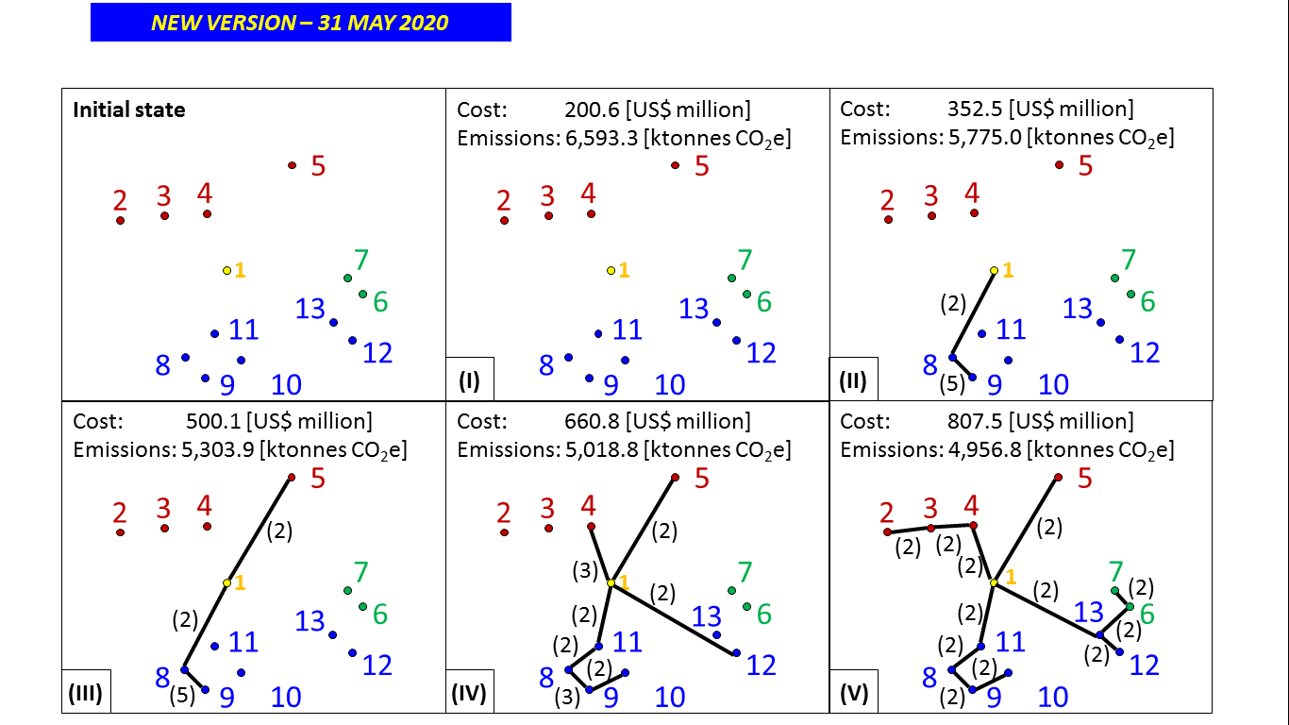

**Figure 4. Network representation of selected samples of obtained optimal solutions with the initial network state represented at the top left with no cable connections installed. The Hindu-Arabic numerals inside brackets indicate the year the adjacent cable connection starts being used.**

Platforms with strong energy demand (table 3), such as platforms 5, 8 and 11, were among the first to be connected to the offshore wind farm; while platforms with comparatively lower energy demand, such as platforms 2 and 3, or with energy demand ceasing early, such as platforms 3, 6, 7 and 13, were connected to the network only in the most expensive optimal solutions.

By calculating the differences between cost and emissions between neighbouring Pareto optimal solutions, it is possible to estimate the marginal abatement cost (MAC) for reducing GHG emissions at specific levels of network emissions. Using the obtained base case Pareto front approximation, these costs were calculated and plotted against their associated network emissions in figure 5. With an average of 388.3 [US$/tonCO2e], 66.9% of the obtained marginal abatement costs were under the estimated abatement cost of 284.03 [US$/tonne CO2] for Hywind Tampen. The small number of marginal abatement costs that presented abnormally high values were mostly associated to the connection of distant platforms or platforms with comparatively lower cumulative power demand profiles.

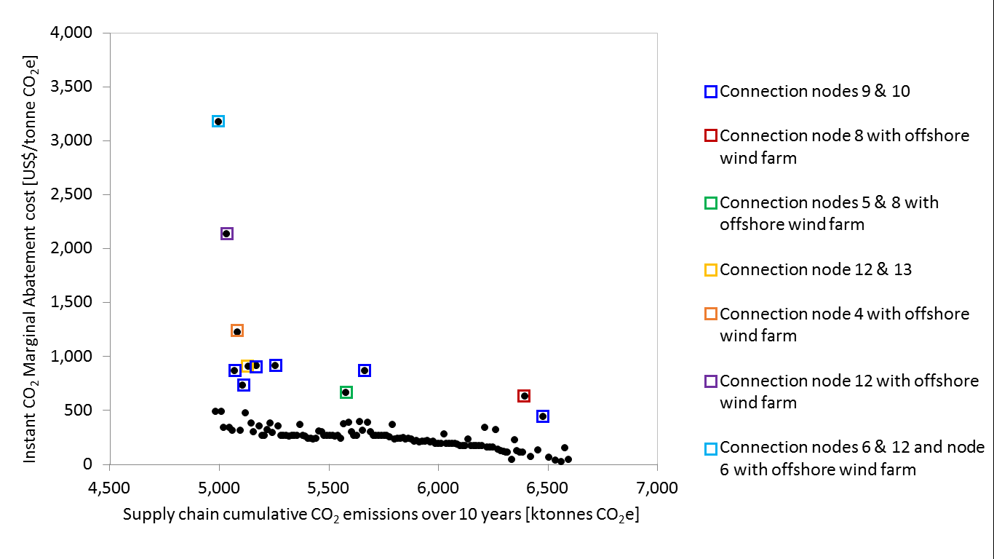

**Figure 5. Instant GHG Marginal Abatement Costs associated to the base case; derived from the obtained Pareto front approximation.**

From figure 3 it is also possible to analyse the impact that parameter uncertainty has in the Pareto front; while all the considered scenarios produced Pareto front approximations with identical extreme value network configurations, variations among the obtained optimal values were observed.

The most sensitive observed parameters were the platforms’ energy demand, natural gas associated emission factor, and cable costs.

When the network is submitted to a different energy demand configuration, the Pareto front was displaced vertically depending on whether energy demand is increased or decreased; by varying the energy demand by 20% the optimal solution with lowest emissions resulted to have associated emissions and costs with differences of 18 and 11% from their base case counterpart respectively. The previous can be explained by noting that higher or lower network energy demand will have associated higher and lower combustion rates and offshore wind generated power imports respectively.

The next parameter to which the Pareto front showed important sensitivity was the natural gas associated combustion emission factor, which is expected as this approach forced each platform to self-generate at least 65% of its own energy demand, while natural gas combustion was the preferred self-generation method set in this approach.

As the optimal solutions with lower GHG emissions relied heavily in offshore wind generated power imports to optimally reduce their emissions, and these imports were only possible after installing the network cables, higher cable costs increased the costs of the solutions with low GHG emissions in the Pareto front. Specifically, for network emission levels greater or equal than 5,150 ktonnesCO2, the high cable cost scenario had a NPV 50% higher than its base case counterpart when equal levels of network emissions are compared; additionally, the solution with the lowest GHG emissions resulted US$729.6 million more expensive than its base case counterpart.

Lower offshore wind energy prices didn’t impact the Pareto front emissions range but displaced it to the lower cost side reducing costs in the solutions with low GHG emissions. The solution with the lowest obtained GHG emissions resulted US$170.0 million cheaper than its base case counterpart when an offshore wind power price of 57. 50 [£/MWh] was used instead of 140.00 [£/MWh].

As observed in figure 3, the different scenarios tested for natural gas price and interest rate produced comparatively lower variations in the Pareto front approximations affecting respectively by 0.9% and 6.6% the overall emissions reduction cost.

As the present study constrained platforms to import external power up to 35% of their internal energy demand following similar projects under development, the impact of this constraint was analysed by allowing platforms to import all their energy demand. The previous resulted in potential emissions reduction for the analysed network of 5,054.0 [ktonnes CO2e] over a period of 10 years at an additional cost of 1,027.5 [US$ million], equivalent to an emissions reduction ratio of 203.3 [US$/tonne CO2], lower than the estimated abatement cost for Hywind Tampen this time. The option with the least GHG emissions in this case would purchase the totality of the power demand for the network from the Hornsea offshore wind farm from period two on.

As the world is very likely to continue depending on fossil fuels to meet its energy demand in the coming decade (BP, 2020; IEA, 2020a), reducing GHG emissions across currently operating hydrocarbon facilities has become increasingly relevant. To date, few studies have identified a single option that could reduce GHG emissions by more than 20% on these facilities; when studying the US and Canadian oil and gas supply chain. ICF International (2014a, 2014b) concluded that the options with the largest mitigation effects could reduce between 6.1 and 7.5% of the GHG emissions for the chain. Endresen et al., (2017), when analysing oil and gas operations in the Norwegian continental shelf, concluded that installing Combined Heat Power in platforms could potentially be the option with highest mitigation effect, in the order of 4-5% of the baseline GHG emissions. This study achieved a potential GHG emissions reduction of 25% by connecting different platforms between each other to share power generation and connecting these platforms to offshore wind farms. Among the studies addressing emissions mitigation on offshore platforms, Nguyen et al., (2016) achieved a 15% of emissions mitigation by studying the implementation of Waste Heat Recovery and Carbon Capture and Storage on an individual platform or by connecting the platform with onshore power grids. Riboldi and Nord, (2018) achieved between 11.9-24.4% of emissions mitigation by connecting an individual platform with an offshore wind farm. The mitigation achieved in this study compares favourably with most of the above; although notably, Riboldi et al., (2017) achieved a higher mitigation of up to 56% GHG emissions reduction when connecting an offshore platform network with onshore power grids.

## **4.1 Implications for theory and practice**

This study has shown that GHG emissions mitigation and cost reduction are competing objectives in the context of the electrification of offshore natural gas platforms. Therefore, the authors recommend addressing both objectives using multi-objective optimisation rather than single-objective optimisation approaches.

The significant GHG emission reduction (25%) achieved in this study highlights the important emissions mitigation opportunity that connecting offshore hydrocarbon networks with offshore wind farms presents. Higher mitigation rates have only been observed in published literature when platforms are connected with an onshore power grid. However, it is also noted that the effectiveness of the GHG mitigation is highly dependent on the level of decarbonisation of the onshore power grid. Other GHG mitigation options applicable to offshore natural gas production such as connecting platforms to each other, installing waste heat recovery systems and even carbon capture and storage have been reported to produce lower GHG emission reduction effects.

For the study analysed, connecting offshore platforms with offshore wind farms dominated the optimal Pareto front over connecting platforms to each other to share power generation. This suggests that the former is more effective. This is in line with the results obtained by Riboldi et al., (2017), who through a single-objective optimisation procedure concluded that shared power generation could provide lower GHG emissions reduction (3%), while connecting platforms with onshore grids could reduce GHG emissions, by up to 56%.

Although the obtained US$370.9/tonne CO2e average GHG emission reduction cost is well above the CO2 cost projected in Europe for the coming decade (IEA, 2017), the authors expect that the rapid fall of offshore wind prices projected will help to reduce the costs further. Offshore wind farm projects have been assigned strike prices as low as 39.650 [£/MWh] in recent years in the UK (BEIS, 2019b), this is 72% lower than the strike price used in this case study. The chosen case study also considered a network of platforms reaching their end of life with little production beyond 10 years. The electrification of younger platforms with longer operating lives could help to balance the capital expenditures associated to their electrification and further reduce costs. Finally, this study considered that only 35% of the power demand of each platform could the imported from other platforms or offshore wind farms. By relaxing this constraint this research showed that the GHG mitigation cost fell, highlighting another path to reduce this cost.

# **5. Conclusions**

This study presents a novel multi-objective mixed-integer linear programming (MOMILP) optimisation methodology developed to minimise greenhouse gas emissions and costs simultaneously in a portfolio of offshore hydrocarbon platforms when the integration of offshore wind farms and shared power generation between platforms is considered.

The proposed methodology was applied to a real offshore platform network located in the UK Southern North Sea and characterised for having several projects experiencing production decline, but can be applied to any installed offshore platform network. The applied model was solved using the augmented $ϵ$-constraint method, the Pareto front approximation obtained showed a clear trade-off between GHG emissions reduction and costs in the analysed context. The obtained results suggested that the analysed network had the potential of reducing its energy generation GHG emissions over the next 10 years by 25%, or 1,636.5 tons of CO2e, at an average reduction cost of 370.9 [US$/tonne CO2e]. This cost was shown to decrease to 203.3 [US$/ton CO2e] if the network was allowed to import the totality of its energy demand.

The obtained Pareto front was used to estimate the Marginal Abatement Cost curve for the network at different levels of GHG emissions; 66.9% of these costs resulted below the 284.03 [US$/tonne CO2] level estimated for Hywind Tampen.

By allowing the model to decide between shared power generation and offshore wind energy purchase in the multi-objective optimisation, this study showed the clear advantage of the latter mitigation option along the obtained Pareto front approximation in line with the observations of Riboldi et al. (2017). By allowing the implementation of the emissions reduction technologies at different points in time, a wider range of optimal solutions with different associated optimal costs and emissions to choose from are available.

The proposed model can be useful for industry and policy makers who wish to make offshore natural gas production cleaner. The technological options considered in this study are readily available, thus the GHG emissions mitigation indicated is realistically possible to achieve.

The 25% reduction on GHG emissions on the analysed offshore platform network indicates that connecting offshore wind farms with offshore platform networks could achieve one of the highest emissions mitigation potential reported in the literature for offshore hydrocarbon operations. Considering that our economies are projected to continue depending on fossil fuels in the coming decade and offshore natural gas contributes importantly to this consumption, the contributions of this model to climate change mitigation are therefore very significant.

Although the obtained GHG emissions reduction costs are higher than the projected price of CO2 in the European market for the coming decade, the authors expect that the estimated costs will decrease as the cost of several renewable sources, such as wind and solar energy, continues to fall, and carbon credits become scarcer; furthermore, electrification of younger platform networks could provide further opportunities for reducing these costs.

In the near future, it is likely that fossil fuel producers will continue exploring the use of renewable energy to make fossil fuel production cleaner and, therefore, that further platform electrification projects, such as Hywind Tampen, will continue to be announced. This can be particularly true for areas where renewable energy generation and hydrocarbon production operate in close proximity, and where renewable energy generation is being increasingly curtailed at peak times, such as in the North and Norwegian Sea.

# **Acknowledgements**

This work was generously supported by the BG Group/Shell funded Sustainable Gas Institute, London, UK (solely financial support), and the Minerals Energy and Environmental Engineering Research Group at Imperial College with a research fellowship for Mr Ernesto Santibanez Borda.

# **References**

API, 2009. Compendium of Greenhouse Gas Emissions Methodologies for the Oil and Natural Gas Industry. Washington. USA.

Arps, J.J., 1944. Analysis of Decline Curves. SPE-945228-G.

Aseeri, A., Gorman, P., Bagajewicz, M.J., 2004. Financial Risk Management in Offshore Oil Infrastructure Planning and Scheduling. Ind. Eng. Chem. Res. 43, 3063–3072. https://doi.org/10.1021/ie034098c

Azadeh, A., Raoofi, Z., Zarrin, M., 2015. A multi-objective fuzzy linear programming model for optimization of natural gas supply chain through a greenhouse gas reduction approach. J. Nat. Gas Sci. Eng. 26, 702–710. https://doi.org/https://doi.org/10.1016/j.jngse.2015.05.039

Azadeh, A., Shafiee, F., Yazdanparast, R., Heydari, J., Fathabad, A.M., 2017. Evolutionary multi-objective optimization of environmental indicators of integrated crude oil supply chain under uncertainty. J. Clean. Prod. 152, 295–311. https://doi.org/https://doi.org/10.1016/j.jclepro.2017.03.105

BEIS, 2020a. Consumer prices index: fuel components.

BEIS, 2020b. Typical retail prices of petroleum products and a crude oil price index.

BEIS, 2019a. Load factors for renewable electricity generation.

BEIS, 2019b. Contracts for Difference (CfD) Allocation Round 3: results.

BEIS, 2017. Contracts for Difference Second Allocation Round Results.

BP, 2020. Energy Outlook 2020 Edition.

Carvalho, M.C.A., Pinto, J.M., 2006. An MILP model and solution technique for the planning of infrastructure in offshore oilfields. J. Pet. Sci. Eng. 51, 97–110. https://doi.org/10.1016/J.PETROL.2005.11.012

Collete, Y., Siarry, P., 2011. Optimisatin multiobjectif: Algorithmes. Editions Eyrolles.

Custódio, A.L., Madeira, J.F.A., Vaz, A.I.F., Vicente, L.N., 2011. Direct Multisearch for Multiobjective Optimization. SIAM J. Optim. 21, 1109–1140. https://doi.org/10.1137/10079731X

Danish Ministry of Energy Utilities and Climate, 2018. Note on technology costs for offshore wind farms and the background for updating CAPEX and OPEX in the technology catalogue datasheets. Copenhagen, Denmark.

Deb, K., Agrawal, S., Pratap, A., Meyarivan, T., 2000. A Fast Elitist Non-dominated Sorting Genetic Algorithm for Multi-objective Optimization: NSGA-II BT - Parallel Problem Solving from Nature PPSN VI, in: Schoenauer, M., Deb, K., Rudolph, G., Yao, X., Lutton, E., Merelo, J.J., Schwefel, H.-P. (Eds.), . Springer Berlin Heidelberg, Berlin, Heidelberg, pp. 849–858.

Edif ERA, 2016. Economic Analysis of Large Submarine Cables. Leatherhead, Surrey.

Elkamel, A., Ba-Shammakh, M., Douglas, P., Croiset, E., 2008. An Optimization Approach for Integrating Planning and CO2 Emission Reduction in the Petroleum Refining Industry. Ind. Eng. Chem. Res. 47, 760–776. https://doi.org/10.1021/ie070426n

Endresen, O., Grimsrud, T.S., Hektor, E.A., Brown, J., Nissen-Lie, T., 2017. Pathways to a low Carbon Oil & Gas Industry – Abatement Potentials for Offshore Assets, in: 13th Offshore Mediterranean Conference and Exhibition. Ravenna, Italy.

EPA, 2002. Natural Gas STAR Program [WWW Document]. URL https://www.epa.gov/natural-gas-star-program/natural-gas-star-program (accessed 5.1.20).

Equinor, 2019. Investing in Hywind Tampen development [WWW Document]. URL https://www.equinor.com/en/news/2019-10-11-hywind-tampen.html (accessed 4.17.20).

European Central Bank, 2020. ECB euro reference exchange rate: US dollar (USD) [WWW Document]. URL https://www.ecb.europa.eu/stats/policy_and_exchange_rates/euro_reference_exchange_rates/html/eurofxref-graph-usd.en.html (accessed 3.30.20).

GE, 2019. LM2500 Power Plants.

GE Power Systems, n.d. Estimating Gas Turbine Performance.

ICF International, 2014a. Economic Analysis of Methane Emission Reduction Opportunities in the Canadian Oil and Natural Gas Industries. Fairfax, US.

ICF International, 2014b. Economic Analysis of Methane Emission Reduction Opportunities in the U.S. Onshore Oil and Natural Gas Industries. Fairfax, US.

IEA, 2020a. World Energy Outlook 2020. Paris, France.

IEA, 2020b. Methane Tracker [WWW Document]. URL https://www.iea.org/reports/methane-tracker/country-and-regional-estimates (accessed 5.7.20).

IEA, 2018. Offshore Energy Outlook.

IEA, 2017. World Energy Outlook 2017.

IPCC, 2018. Summary for Policymakers. In: Global Warming of 1.5°C. An IPCC Special Report on the impacts of global warming of 1.5°C above pre-industrial levels and related global greenhouse gas emission pathways, in the context of strengthening the global response to.

IPCC, 2007. Fourth assessment report AR4.

Karp, R.M., 1972. Reducibility among Combinatorial Problems BT - Complexity of Computer Computations: Proceedings of a symposium on the Complexity of Computer Computations, held March 20–22, 1972, at the IBM Thomas J. Watson Research Center, Yorktown Heights, New York, and, in: Miller, R.E., Thatcher, J.W., Bohlinger, J.D. (Eds.), Complexity of Computer Computations. Springer US, Boston, MA, pp. 85–103. https://doi.org/10.1007/978-1-4684-2001-2_9

Kriegler, E., Weyant, J.P., Blanford, G.J., Krey, V., Clarke, L., Edmonds, J., Fawcett, A., Luderer, G., Riahi, K., Richels, R., Rose, S.K., Tavoni, M., van Vuuren, D.P., 2014. The role of technology for achieving climate policy objectives: overview of the EMF 27 study on global technology and climate policy strategies. Clim. Change 123, 353–367. https://doi.org/10.1007/s10584-013-0953-7

Low Carbon Contracts Company, 2020. Hornsea Phase 1 [WWW Document]. URL https://www.lowcarboncontracts.uk/cfds/hornsea-phase-1 (accessed 3.27.20).

Maeder, M., Weiss, O., Boulouchos, K., 2021. Assessing the need for flexibility technologies in decarbonized power systems: A new model applied to Central Europe. Appl. Energy 282, 116050. https://doi.org/https://doi.org/10.1016/j.apenergy.2020.116050

Mavrotas, G., 2009. Effective implementation of the ε-constraint method in Multi-Objective Mathematical Programming problems. Appl. Math. Comput. 213, 455–465. https://doi.org/https://doi.org/10.1016/j.amc.2009.03.037

Miettinen, K.M., 1998. Nonlinear Multiobjective Optimization. Kluwer Academic Publishers, Boston.

National Atmospheric Emissions Inventory, 2017. UK emissions data [WWW Document]. URL https://naei.beis.gov.uk/data/data-selector (accessed 5.31.20).

Nexans, 2006. Nexans wins €98 million subsea power cable contract for BP’s Valhall Power from Shore project [WWW Document]. URL https://www.nexans.no/eservice/Norway-no_NO/navigatepub_142647_-3665/Nexans_wins_98_million_subsea_power_cable_contract.html (accessed 3.30.20).

Nguyen, T.-V., Fülöp, T.G., Breuhaus, P., Elmegaard, B., 2014a. Life performance of oil and gas platforms: Site integration and thermodynamic evaluation. Energy 73, 282–301. https://doi.org/https://doi.org/10.1016/j.energy.2014.06.021

Nguyen, T.-V., Jacyno, T., Breuhaus, P., Voldsund, M., Elmegaard, B., 2014b. Thermodynamic analysis of an upstream petroleum plant operated on a mature field. Energy 68, 454–469. https://doi.org/https://doi.org/10.1016/j.energy.2014.02.040

Nguyen, T.-V., Tock, L., Breuhaus, P., Maréchal, F., Elmegaard, B., 2016. CO2-mitigation options for the offshore oil and gas sector. Appl. Energy 161, 673–694. https://doi.org/10.1016/J.APENERGY.2015.09.088

Nieradzinska, K., MacIver, C., Gill, S., Agnew, G.A., Anaya-Lara, O., Bell, K., 2016. Optioneering analysis for connecting Dogger Bank offshore wind farms to the GB electricity network. Renew. Energy 91. https://doi.org/10.1016/j.renene.2016.01.043

NREL, 2013. Wind LCA Harmonization. Golden, USA.

OGUK, 2019. Environment Report 2019.

Oil and Gas Facilities, 2020. Oil majors seek sustainable power for North Sea projects.

Orsted, 2020a. Hornsea Project One [WWW Document]. URL https://hornseaprojectone.co.uk/About-the-project#0 (accessed 3.27.20).

Orsted, 2020b. Hornsea One and Two Offshore Wind Farms - February Newsletter.

Riboldi, L., Nord, L., 2018. Offshore Power Plants Integrating a Wind Farm: Design Optimisation and Techno-Economic Assessment Based on Surrogate Modelling. Processes 6, 249. https://doi.org/10.3390/pr6120249

Riboldi, L., Xiaomei, C., Farahmand, H., Korpas, M., Nord, L.O., 2017. Effective Concepts for Supplying Energy to a Large Offshore Oil and Gas Area under Different Future Scenarios. Chem. Eng. Trans. 61, 1597–1602.

Roudneshin, M., Azadeh, A., 2019. A novel multi-objective fuzzy model for optimization of oil sludge management by considering Health, Safety and Environment (HSE) and resiliency indicators in a gas refinery. J. Clean. Prod. 206, 559–571. https://doi.org/10.1016/J.JCLEPRO.2018.09.142

Sahebi, H., Nickel, S., Ashayeri, J., 2014. Environmentally Conscious Design of Upstream Crude Oil Supply Chain. Ind. Eng. Chem. Res. 53, 11501–11511. https://doi.org/10.1021/ie403492c

Steuer, R.E., 1986. Multiple Criteria Optimization Theory, Computation and Application. Krieger, Malabar, FL.

Subash, N., 2019. Peaking plant applications.

Tarhan, B., Grossmann, I.E., Goel, V., 2009. Stochastic Programming Approach for the Planning of Offshore Oil or Gas Field Infrastructure under Decision-Dependent Uncertainty. Ind. Eng. Chem. Res. 48, 3078–3097. https://doi.org/10.1021/ie8013549

The Oxford Institute for Energy Studies, 2019. Energy Transition, Uncertainty, and the Implications of Change in the Risk Preferences of Fossil Fuel Investors. Oxford, UK.

TNO, 2016. System Integration Offshore Energy: Innovation Project North Sea Energy. Ultrech, Netherlands.

UK HM Revenue & Customs, 2020. HMRC yearly average and spot rates.

UK Infrastructure Planning Statute, 2014. The Hornsea One Offshore Wind Farm Order 2014. The Stationary Office Limited, United Kingdom.

UK Oil & Gas Authority, 2019a. UKCS Production [WWW Document]. Oil Gas Auth. Open Data. URL https://data-ogauthority.opendata.arcgis.com/pages/production (accessed 12.17.19).

UK Oil & Gas Authority, 2019b. Offshore Oil and Gas Activity [WWW Document].

Ullah, S., Haidar, A.M.A., Hoole, P., Zen, H., Ahfock, T., 2020. The current state of Distributed Renewable Generation, challenges of interconnection and opportunities for energy conversion based DC microgrids. J. Clean. Prod. 273, 122777. https://doi.org/https://doi.org/10.1016/j.jclepro.2020.122777

United Nations, 2015. The Paris Agreement. Paris.

US Internal Revenue Service, 2020. Yearly Average Currency Exchange Rate [WWW Document]. URL https://www.irs.gov/individuals/international-taxpayers/yearly-average-currency-exchange-rates (accessed 4.16.20).

Vanner, R., 2005. Energy Use in Offshore Oil and Gas production: Trends and Drivers for Efficiency from 1975 to 2025.

Voldsund, M., Nguyen, T.-V., Elmegaard, B., Ertesvåg, I.S., Røsjorde, A., Jøssang, K., Kjelstrup, S., 2014. Exergy destruction and losses on four North Sea offshore platforms: A comparative study of the oil and gas processing plants. Energy 74, 45–58. https://doi.org/https://doi.org/10.1016/j.energy.2014.02.080

Wang, B., Van Fan, Y., Chin, H.H., Klemeš, J.J., Liang, Y., 2020. Emission-cost nexus optimisation and performance analysis of downstream oil supply chains. J. Clean. Prod. 121831. https://doi.org/https://doi.org/10.1016/j.jclepro.2020.121831

Wind Europe, 2020. Offshore Wind in Europe - Key trends and statistics 2019.

WindEurope, 2020. Financing andinvestment trends The European wind industry in 2019.

Zhang, J., Zheng, Y., 2020. The flexibility pathways for integrating renewable energy into China’s coal dominated power system: The case of Beijing-Tianjin-Hebei Region. J. Clean. Prod. 245, 118925. https://doi.org/https://doi.org/10.1016/j.jclepro.2019.118925

Zhou, X., Zhang, H., Xin, S., Yan, Y., Long, Y., Yuan, M., Liang, Y., 2020. Future scenario of China’s downstream oil supply chain: Low carbon-oriented optimization for the design of planned multi-product pipelines. J. Clean. Prod. 244, 118866. https://doi.org/https://doi.org/10.1016/j.jclepro.2019.118866