**Supplementary Information**

**Supplementary Video 1.** SEM video recorded during the fracture test of one of the transverse DCB samples showing immediate crack deflection. Video speed = 25 frame per second.

C:\Users\na4409\Desktop\RESULTS\overview\overview\3_.tif

**Supplementary Figure 1. Secondary Electron-SEM top view image of micropillars milled on cortical bone of the femoral mid-shaft of mouse model.** The image shows the anatomical location of the milled DCB and micro-compression pillars.

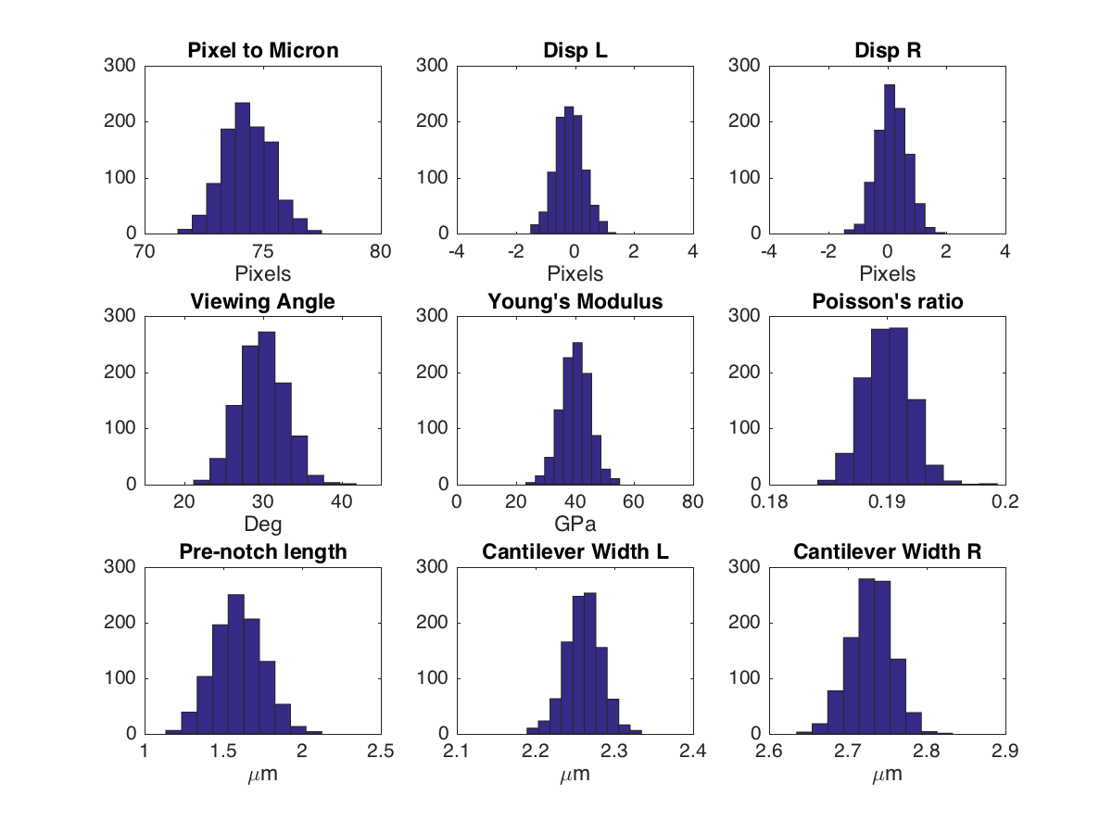

**Supplementary Figure 2. Gaussian distribution of different variables for one of the longitudinal DCBs**. The Monte Carlo error propagation method was applied to generate probability distributions after placing the random inputs used for the Monte Carlo error propagation analysis. Variables with uncertainty were analysed to obtain a Gaussian distribution with a standard deviation. For each test, the centre of each distribution is the average measurement, while the standard deviation is the margin of experimental error. The variable terms are defined as follows: Pixel to micron refers to the pixel to micron conversion ration from the scaled test image; Disp L and R refer to the left and right cantilever displacement factor that is used to account for the bending of the cantilever; Viewing angle refers to the correction factor for the recorded SEM images with respect to the axis of the mechanical stage; Young’s modulus refers to the uncertainty in the calculated elastic modulus in the micro-compression tests; Poisson’s ratio refers to the uncertainty in the reported ratio; Cantilever widths L and R refer to the measured cantilever thicknesses; Pre-notch length refers to the uncertainty associated with a chosen contact point between the wedge tip and the cantilever to obtain the real crack length.

**Supplementary Figure 3. Plastic zone measurements.** Maximum crack length of each tested longitudinal DCBs in comparison to the estimated size of plastic zone, with the ultimate stress for longitudinal orientation taken as .

**Supplementary Figure 4. Toughening mechanisms at the micrometre scale.** Longitudinal DCB samples show resistance mechanisms to fracture propagation by (a) fibril bridging in sample S4 and (b) structural features ahead of the crack path that hindered its progress in sample S3.

# **Numerical Simulations**

# **Phase-field Method**

For a domain $Ω⊂R^{n}$ we first introduce the free energy $F$ as the sum of the bulk stored energy $B$ and the surface energy $S$ required for creation of new cracks $Γ⊂Ω$:

$F\left(u,Γ\right)≔B\left(u,Γ\right)+S\left(Γ\right)$ (S.1)

Here, we assume a transversely isotropic linear elastic behaviour where the bulk energy is a function of the displacement field $u$:

$B\left(u,Γ\right)≔ \int_{Ω∖Γ}{W\left(u\right)dV}-\int_{∂_{N}Ω}{\left(f_{t}∙u\right) ds}$ (S.2)

$W\left(u\right)≔\frac{1}{2}σ_{ij}ϵ_{ij}$ (S.3)

where $σ_{ij}=C_{ijkl}(α)ϵ_{kl}$ is the Cauchy stress tensor, and $ϵ_{ij}=\left(u_{i,j}+u_{j,i}\right)/2$ is the linearized strain tensor. In this work we chose the fourth order constitutive tensor $C_{ijkl}$ as the transversely isotropic elasticity rotated at the fibrils angle $α$ versus the vertical direction.

Also, for a purely brittle fracture, the energy expenditure to form new cracks is a linear function of the aggregate length of the cracks in 2-D $H^{1}(Γ)$ or the aggregate surface of the cracks in 3-D $H^{2}(Γ)$:

$S\left(Γ\right)≔G_{c}(θ) H^{n-1}(Γ)$ (S.4)

where $G_{c}(θ)$ is the fracture energy of the material for a crack propagating at angle $θ$ with respect to the X-axis. Furthermore, to capture the effect of the fracture energy anisotropy, we assume a simple two-fold anisotropic fracture energy and write:

$G_{c}\left(θ\right)=G_{ct}{\left(A^{-2}\sin^{2}\left(θ\right)+\cos^{2}\left(θ\right)\right)}^{1/2}$ (S.5)

where we introduce the fracture anisotropy parameter $A={G_{ct}}/{G_{cl}}$ as the ratio of the fracture energy for cracks propagating perpendicular to fibrils over the fracture energy for cracks propagating parallel to them.

In this article, we used the phase-field method [1-3] to simulate the crack propagation in the specimens and validate the experimental observations. The phase-field method replaces the crack set $Γ$ with a smeared phase field $0≤φ≤1$ introducing the process zone length scale $ξ$. The phase-field is $φ\left(x\right)=1$ for the pristine material and $φ\left(x\right)→0, x∈Γ$. We write the approximate free energy $F_{ξ}$ as the sum of approximate bulk $B_{ξ}$ and surface energies $S_{ξ}$:

$F_{ξ}\left(u,φ\right)≔B_{ξ}\left(u,φ\right)+S_{ξ}\left(φ\right)$ (S.6)

To capture non-interpenetration at the crack tip and forbid crack formation due to pure compressive volume change, extending work by Amor et al. [4], we separate the approximate bulk energy into two parts and write:

$B_{ξ}\left(u,φ\right)≔ \int_{Ω}{\left(g\left(φ\right)W^{+}\left(u\right)+W^{-}\left(u\right)\right)dV}-\int_{∂_{N}Ω}{\left(f_{t}∙u\right) ds}$ (S.7)

$W^{+}\left(u\right)≔\frac{1}{2}σ_{ij}^{D}:ϵ_{ij}^{D}+\frac{1}{2n^{2}}\text{H}\left(σ_{kk}\right)σ_{kk}ϵ_{mm}$ (S.8)

$W^{-}\left(u\right)≔\frac{1}{2n^{2}}\text{H}\left(-σ_{kk}\right)σ_{kk}ϵ_{mm}$ (S.9)

where $x_{ij}^{D}=x_{ij}-x_{kk}δ_{ij}/n$ is the deviatoric part of the tensor x, and where $\text{H}(x)$ is the Heaviside function defined as:

$\text{H}(x)≔\left\{\begin{aligned}1 x≥0 \\ 0 x<0\end{aligned}\right.$ (S.10)

We also extend the original phase-field framework to account for the two-fold fracture energy anisotropy by writing the approximate surface energy for samples with fibrils orientation $α$ with respect to the horizontal axis as:

$S_{ξ}\left(φ\right)≔\frac{G_{c⊥}}{4C_{φ}}\int_{Ω}{\left(\frac{w\left(φ\right)}{ξ}+ξD_{ij}\left(A,α\right) ϕ_{,i}ϕ_{,j}\right)}dV$ (S.11)

where

$D_{ij}\left(A,α\right)=Q_{ik}{(α)Q}_{jl}(α)\left[\begin{matrix}A^{-2} & 0 \\ 0 & 1\end{matrix}\right]$ (S.12)

and where

$Q_{ij}\left(α\right)=\left[\begin{matrix}\cos{α} & \sin{α} \\ -\sin{α} & \cos{α}\end{matrix}\right]$ (S.13)

is the rotation matrix.

Similarly, for elastic constitutive tensor we have

$C_{ijkl}\left(α\right)=Q_{im}{\left(α\right)Q}_{jn}\left(α\right)Q_{ko}{\left(α\right)Q}_{lp}\left(α\right) {\hat{C}}_{mnop}$ (S.14)

Where $\hat{C}$ is elastic constitutive tensor for transverse samples.

In this article, we use the KKL model[3] *i.e., $g\left(φ\right)=3ϕ^{4}-4ϕ^{3}$* , $w\left(φ\right)=1-g(ϕ)$. We set $ϕ=0$ at both corners and the pre-crack tip to allow for initiation of the crack from any of these positions.

Finally, we pose the fracture propagation as a variational problem where at each time step we seek to find displacement field $u$ and the phase-field $φ$, such that they minimize the approximate free energy:

$u_{t}^{*},ϕ_{t}^{*}=\text{argmin} F_{ξ}\left(u,φ\right) ∀u∈K_{t},ϕ_{t}≥ϕ_{t-1}$ (S.15)

where $K_{t}$ is the admissible set of displacement satisfying the Dirichlet boundary conditions $u={\hat{u}}_{t}$ on $∂_{D}Ω$.

# **Implementation**

The minimization problem is solved using its first-order optimality conditions with respect to the displacement field $u$ and the phase field $ϕ$ [5]:

$\frac{∂F_{ξ}}{∂u}\left(\tilde{u},ϕ\right)=0 ∀\tilde{u}∈H^{1}\left(Ω\right)$ (S.16) $\frac{∂F_{ξ}}{∂φ}\left(u,\tilde{φ}\right)=0 ∀\tilde{φ}∈H^{1}(Ω)$ (S.17)

It is well known that the above governing equations are only convex when one of the fields is kept constant, thus we rely on the now classical alternate minimizations algorithm [3, 5, 6]. To perform the simulations, the displacement field and the phase field were discretized using piece-wise linear Legendre and first-order optimality conditions were solved using the Galerkin finite element method. Furthermore, both governing equations are nonlinear; the elasticity system is nonlinear due to the non-interpenetrations conditions and the phase-field equation is nonlinear due to the bounds on $φ$ (i.e., $0≤ϕ_{t}≤φ_{t-1}≤1$). The resulting systems of equations are very large since the process zone is small compared to the other dimensions of the problem, and this necessitates using a parallel programming paradigm. Our implementation uses PETSc [7] for linear and non-linear solvers and libMesh [8] for finite element data structures.

# **Sensitivity of the phase-field analysis to shear modulus**

Since the value of the shear modulus in the fibrils plane is unknown, we performed three series of numerical simulations to examine its effect on the initial kink angle. The crack path at different fracture energy anisotropies $1≤A≤4$ was simulated using the previously described boundary conditions and by setting $μ_{tl}=7.44, 10.16, 14.88 GPa$. Supplementary Figure 5 shows the initial kink angle as a function of varying shear modulus. Our simulations show that as the shear modulus is increased the initial kink angle becomes independent of it. We should note that this is also in line with the LEFM analysis of Sih et al. [9] where, as a function of increasing shear modulus the effective orthotropic elastic modulus converges to its isotropic value.



**Supplementary Figure 5. Shear modulus effect.** Initial kink angle for transverse (left) and ${60}^{∘}$ sample (right) as a function of shear modulus.

# **Accuracy of the Corrected Elasticity Analysis**

Accuracy of the Williams correction [10] to the elasticity theory analysis was assessed by comparing it to uncorrected Timoshenko and Euler-Bernoulli based beam theory analyses, and to an isotropic linear elastic finite element analysis conducted in Abaqus (see Supplementary Figure 6) using four-node bilinear plane strain elements with reduced integration (CPE4R); the convergent mesh is as depicted in Supplementary Figure 6. An isotropic analysis was used because accurate shear modulus data is currently unavailable, hence the effect of shear could be greater than depicted. The same material properties were used in all models, *E* = 480 GPa and *ν* = 0.18. The length of the sample was 10 μm, and the height of each beam arm was 1 μm. The right end of the finite element model was fixed in all degrees of freedom, and opening end displacements were applied symmetrically at the left end of the model. Assessment of the analytical models required pairs of crack length and beam end displacements corresponding to a prescribed fracture energy, in this case taken to be 6 J/m2. The virtual crack closure technique (VCCT), which computes the energy release rate as the work done by the stress ahead of the crack acting through the crack opening displacement that would occur if the crack were allowed to advance by a unit length, was used to determine pairs of crack length and beam displacement corresponding to stable crack growth at the prescribed fracture energy, 6 J/m2. These were subsequently applied to a finite element simulation using a standard J-integral method of calculating the energy release rate to determine the critical energy release rate *GIC* versus crack length *a* predicted by finite element analysis (to facilitate a direct comparison to the analytical models with the same crack length and beam end displacements input). Results are as shown in Supplementary Figure 7.

**Supplementary Figure 6. The finite element model**. Crack opening and contours of opening stress (MPa) are shown for the finite element model used in conjunction with the VCCT approach to determine crack length and beam end displacement pairs corresponding to a 6 J/m2 fracture energy, for input to analytical models and a separate finite element model using the J-integral approach, for comparison.



**Supplementary Figure 7. Analytical and finite element models compared**. Predicted critical energy release rate versus crack length is shown for the same pairs of applied beam end displacement and crack length corresponding to a 6 J/m2 fracture energy.

**Supplementary References**

[1] G.A. Francfort, J.-J. Marigo, Revisiting brittle fracture as an energy minimization problem, Journal of Mech Phys of Sol 46(8) (1998)1319-1342.

[2] A. Karma, D.A. Kessler, H. Levine, Phase-field model of mode III dynamic fracture, Phys Rev Lett 87(4) (2001) 045501.

[3] B. Bourdin, G.A. Francfort, J.-J. Marigo, The variational approach to fracture, J elasticity 91(1-3) (2008) 5-148.

[4] H. Amor, J.-J. Marigo, C. Maurini, Regularized formulation of the variational brittle fracture with unilateral contact: Numerical experiments, Journal of the Mechanics and Physics of Solids 57(8) (2009) 1209-1229.

[5] A. Mesgarnejad, B. Bourdin, M. Khonsari, Validation simulations for the variational approach to fracture, Computer Methods in Applied Mechanics and Engineering 290 (2015) 420-437.

[6] A. Mesgarnejad, B. Bourdin, M. Khonsari, A variational approach to the fracture of brittle thin films subject to out-of-plane loading, Journal of the Mechanics and Physics of Solids 61(11) (2013) 2360-2379.

[7] S. Balay, S. Abhyankar, M. Adams, J. Brown, P. Brune, K. Buschelman, L. Dalcin, V. Eijkhout, W. Gropp, D. Kaushik, M. Knepley, L.C. McInnes, K. Rupp, B.F. Smith, S. Zampini, H. Zhang, PETSc Users Manual Revision 3.6, Argonne National Lab.(ANL-95/11 ), Argonne, IL (United States), 2015.

[8] B.S. Kirk, J.W. Peterson, R.H. Stogner, G.F. Carey, libMesh: a C++ library for parallel adaptive mesh refinement/coarsening simulations, Engineering with Computers 22(3-4) (2006) 237-254.

[9] G.C. Sih, P.C. Paris, G.R. Irwin, On cracks in rectilinearly anisotropic bodies, Int J Fract Mech 1(3) (1965) 189-203.

[10] J.G. Williams, End corrections for orthotropic DCB specimens, Composit Sci Tech 35(4) (1989) 367-376.