# Title: A Guytonian explanation for hemodynamic responses to interventions in superficial venous disease

*1 Pasha Normahani BSc (Hons) MBBS MSc MRCS (Eng)

1 Joseph Shalhoub BSc MBBS FHEA PhD MEd FRCS FEBVS

2 Sriram Narayanan MBBS MS FRCS

1 Imperial Vascular Unit, Imperial College Healthcare NHS Trust, London, United Kingdom and Academic Section of Vascular Surgery, Department of Surgery & Cancer, Imperial College London, London, United Kingdom

2 The Harley Street Heart and Vascular Centre, Gleneagles Hospital, Singapore

*Corresponding author

**E**: p.normahani@imperial.ac.uk

**T**: +44 (0) 7983 402 262

**A**: Imperial Vascular Unit, QEQM Building, St Mary’s Hospital, Praed Street

London W2 1NY, UK

**Conflicts of interest:** None to declare

**Funding:** None to declare

**Key words**: Venous return, venous compliance, superficial venous ablation, chronic venous insufficiency, non-thrombotic iliac vein lesions, Guytonian model

**Category:**

**Word count**:

**Background**

We thank Franceschi et al for their letter entitled “Transmural pressure for conceptualisation of chronic venous insufficiency management” regarding our paper wherein we have repurposed a Guytonian model of systemic venous return to explain the hemodynamic changes that occur in lower limb venous disease 1. This model was developed using the non-thrombotic iliac vein lesion (NIVL) as the basis for the hemodynamic response.

Franceschi et al have raised queries in their communication that in our model, we have suggested venous stenting, compression therapy and superficial ablation as treatment options for the NIVL. Their concern is that superficial venous ablation will raise transmural pressures within the deep venous compartment, with a worsening of venous compliance, transmission of the higher pressures to the microcirculation leading to trophic changes of venous stasis, as well as recurrences.

It is important to state at the outset that we do not advocate superficial venous ablation as a treatment for an NIVL. The NIVL has been used by us purely to develop the model for venous return, not to suggest one form of therapy or another for superficial venous disease. A detailed explanation of the responses to different interventions for superficial venous disease based on our model is now presented to address the issues raised.

**Introduction**

Venous return from the lower limb is a complex hemodynamic phenomenon with superficial veins draining via perforating and communicating veins into the deep venous system and back to the right atrium. The equation for venous return from the lower limb as stated in our Guytonian model is as below1.

LLVR = PDV – POP / RV

*LLVR, lower limb venous return; PDV, transmural deep venous pressure; POP, outflow pressure; RV, resistance to venous return*

Venous drainage from the lower limb takes place against gravity in a manner such that the volume of arterial inflow to the limb is equal to the volume of venous return (LLVR in the equation above). This ensures a perfect physiological state with no venous stasis and physiological transmural pressures within the veins. Venous blood in the limb, however, must drain against the sum of the right atrial pressure, the intra-abdominal pressure, the gravitational pressure of the venous blood column and the outflow pressure created by the presence of an NIVL. The pressure gradient required for this is generated in the deep veins located within the closed fascial space of the lower limb2. Venous blood in the lower limb is distributed within the stressed (deep venous) and unstressed (superficial) volume compartments that are interconnected by a set of perforating and communicating veins2.

In a perfect physiological state, the transmural pressure in the unstressed compartment (superficial veins) is zero. The blood within this compartment drains into the stressed compartment (deep veins) via the connecting veins which have valves which maintain unidirectional flow and prevent retrograde transmission of pressure from the stressed to the unstressed compartment (pressure segmentation). The venous pressure in the stressed volume compartment (PDV) must be greater than the right atrial pressure to ensure a pressure gradient that facilitates venous return3. This hypothetical physiological state is shown in figure 1, and assumes no NIVL, healthy compliant vein walls and no positive intra-abdominal pressure that would increase the outflow pressure (POP) and add to resistance to venous return (RV).

**Venous compliance, resistance, and the volume-pressure relationship**

The ability of the vein wall to distend with increasing transmural pressure (net pressure exerted by the blood within the vein onto the vein wall) is its compliance, defined as the ratio of change in volume to change in transmural pressure (TMP)4. This is a non-linear relationship with an S-shaped curve (represented schematically in figures 2a and 2b by the unbroken blue line).

At physiological ranges of TMP, compliance in a healthy vein wall is high, and large increases in volume within the vein lead to only small rises in TMP (figure 2a). However, at very high levels of TMP, the curve flattens and small increases in volume lead to large increases in TMP. Conversely, if external pressure on the vein wall is higher than the internal pressure (negative TMP), the vein wall can collapse (zero volume). This does not usually happen in the deep veins (i.e. a negative PDV) unless there is cessation of arterial inflow to the limb. In other words, PDV usually positive.

Venous resistance (RV) is a measure of the energy required to maintain blood flow across that vein segment, and is the ratio of the energy gradient (∆E) across the segment over the flow rate through that segment (Q) 4 i.e RV =∆E/Q.

Venous resistance within a vein segment changes with the velocity of blood flow, blood viscosity, venous wall tone and changes in TMP4. The high compliance of the vein wall adjusts the RV to ensure adequate venous return. However, as TMP rises beyond physiological limits, venous wall compliance reduces, and RV rises rapidly with it. Thus, RV shows an inverse relationship with compliance, and this is shown in figure 2a, where the venous resistance curve in red has been superimposed on the schematic venous volume/ pressure (compliance curve) graph.

The compliance curve shifts to the right and resistance curve shifts to the left in post-thrombotic states, when fibrotic changes in the vein wall, persistent thrombus and synechiae within the lumen reduce compliance significantly (figure 2b). Smaller changes in venous volume now induce greater rises in TMP, and the overall increase in venous volume that the system can tolerate (the capacitance of the vein segment, shaded grey in figures 2a and 2b) decreases. RV also increases correspondingly with decreasing compliance, leading to a decrease in venous return (LLVR). Loss of valvular function from fibrotic change further affects pressure segmentation with a higher baseline TMP.

**Hemodynamic changes in venous insufficiency based on the Guytonian model**

Venous insufficiency is a result of two basic pathological processes, namely obstruction (to venous return) and valvular incompetence. These may well occur together in the same limb, and in turn lead to two fundamental derangements in venous hemodynamics – venous stasis or excess volume, and high transmural pressures. A variety of underlying conditions, ranging from the genetically-influenced valvular development, NIVL, right heart failure, pregnancy and obesity, thrombosis and post thrombotic states all essentially cause the clinical manifestations of venous insufficiency including varicose veins via these two alterations in hemodynamics.

Venous return depends upon the antegrade movement of blood from the superficial to the deep veins, and for pressures in the deep venous compartment to be higher than the outflow pressure (figure 1). In the absence of an NIVL and with intra-abdominal pressures being zero, this outflow pressure is the right atrial pressure in the supine position, and right atrial pressure plus the gravitational pressure of the blood column in the upright position.

The intra-abdominal pressure is normally about 5-7 mmHg, rising significantly with obesity, pregnancy, and in the upright position5. The NIVL is widely prevalent in the general population6 and causes varying degrees of outflow obstruction ranging from a minimal, hemodynamically insignificant compression to near total occlusion of the iliac vein. The upstream veins of the lower limb then must hemodynamically compensate for these increases in outflow pressures (POP).

As indicated by the Guytonian equation (LLVR = PDV – POP / RV), in the presence of raised POP, there need to be changes in the other 3 variables to balance the hemodynamic state. For LLVR to remain constant, either the transmural pressure in the deep veins (PDV) must rise or the venous resistance (RV) must fall. Alternatively, the system must accept a lower volume of venous return, which it does by transferring a proportion of venous blood from the stressed deep venous compartment to the unstressed superficial venous compartment. This transfer of venous volume from the deep to the superficial veins via the perforating and communicating veins leads to higher venous volumes in the superficial veins, causing them to progressively dilate and eventually turn varicose. The venous valves provide resistance to this hemodynamic change. Their failure to do so is determined by the extent to which PDV rises as well as the functional integrity of the valves. Thus, a rise in POP can manifest as deep venous hypertension. This causes upstream pressure effects on the microcirculation or valvular incompetence at sapheno-femoral or sapheno-popliteal junctions, perforator incompetence or at the “escape points” in the inter-connecting veins that have been described by Franceschi et al in the CHIVA (Cure conservatrice et Hemodynamique de l’Insuffisance Veineuse en Ambulatoire) method7.

**Hemodynamic responses to interventions in superficial venous disease**

Interventions for incompetence of the saphenous veins and their tributary veins consist broadly of 2 approaches

1. Saphenous ablation techniques, consisting of crossectomy and stripping of the veins or thermal and non-thermal endovenous ablations.
2. Saphenous sparing techniques, like the ASVAL (Ablation Sélective des Varices sous Anesthésie Locale)8 and CHIVA methods or variations thereof.

A schematic representation of these interventions in the presence of a functionally non-significant (sub-critical) stenosis is shown in figure 3.

Saphenous ablation techniques result in the closure of a segment of the unstressed compartment and transferring the proportion of blood volume held within it into the stressed compartment. The increased volume in the stressed (deep venous) compartment causes the PDV to rise. In the presence of a sub-critical stenosis, this increase in PDV can overcome the POP and adequate venous return is preserved to prevent venous stasis. The system however has changed in that the stressed volume is now greater than before, and the compliance curve has moved further up the slope and to the right in its pressure volume relationship (figure 2a), i.e compliance in the deep venous system is reduced. As long as the volume shifted does not exceed the capacitance that can be physiologically tolerated by the limb (shaded grey in figure 2a), venous return is maintained. The compliance of the veins ensures venous resistance (RV) remains low and the rise in deep venous TMP has little deleterious effect on the microcirculation. In such sub-critical outflow obstructions with varicose veins, saphenous ablation is indeed hemodynamically beneficial.

ASVAL and phlebectomies also have the same effect, which is to transfer some of the unstressed volume into the stressed volume compartment. The ASVAL technique involves careful excision of the visible varicose tributary veins, sparing the saphenous trunk (figure 3)8. It is likely to be successful only if the hemodynamic derangements are minimal, with a low pre-operative PDV, minimal or no outflow obstruction (low POP) and minimal or no truncal and saphenofemoral junctional (SFJ) incompetence. This really describes early disease, and the presence of a high BMI (high POP), major SFJ incompetence and more advanced stages of venous insufficiency can to lead to procedure failure9.

The CHIVA method, however, is based on very different principles. It aims to preserve the saphenous venous trunk by identifying escape points – interconnecting veins where deep venous blood flows retrogradely into the saphenous vein. These are disrupted by ligation, and blood returned to the deep system via re-entry points. In essence, CHIVA seeks to prevent the retrograde transfer of blood volume and pressure from the stressed to the unstressed compartment, whilst preserving antegrade flow from the unstressed to the stressed compartment. The CHIVA procedure requires extremely diligent hemodynamic mapping to identify all escape points, and to ensure that each saphenous segment also has a re-entry point to maintain antegrade venous return. It is also essential that the valves at the re-entry points have functional integrity and can remain competent when faced with the TMP in the deep veins acting against them. Leaving a segment of the saphenous vein isolated from flow with escape points disrupted and no re-entry points leads to thrombophlebitis in that segment. High post-operative deep venous pressures can also lead to incompetence at the re-entry points and procedure failure. A CHIVA procedure therefore also needs to be performed with the venous volumes and pressures being within the physiological range of the compliance curve (i.e. when the venous capacitance of the limb is within the grey zone in figure 2a) for it to be successful.

**Superficial interventions in the presence of a hemodynamically critical outflow obstruction**

Both saphenous ablation and saphenous sparing techniques can achieve hemodynamic success within the physiological range of the compliance curve (figures 2a and 3). However, if the degree of outflow obstruction is such that POP is too high for the PDV to overcome (critical outflow stenosis), the venous capacitance of the limb is overwhelmed (figure 4). Trans mural pressures in the stressed compartment are already high, venous compliance is low and resistance is now rising. Any superficial ablation that transfers blood volume from the unstressed to the stressed compartment would result in a rapid rise in deep venous pressure with retrograde transmission of that pressure to the microcirculation, causing edema and trophic skin changes.

The system will find ways to reverse this by opening new routes into the unstressed compartment via pelvic escape veins and hitherto competent tributary or accessory veins, causing recurrences to occur (figure 4). New perforator incompetence may ensue, with resulting venous ulceration. Venous stasis in a non-compliant, high resistance venous compartment also will increase the risk of deep venous thrombosis. Post-CHIVA too, new escape points causing recurrences will appear, and the direction of flow in the re-entry points may be reversed, with progressive stasis in the remnant saphenous vein and treatment failure.

**Critical outflow stenosis and its significance in the Guytonian model**

The critical outflow stenosis in our model refers to a hemodynamic situation where a combination of gravitational pressure of the blood column, the intra-abdominal pressure and the severity of the NIVL lead to a POP so high that the PDV required to overcome it falls outside the physiological capacitance of the limb. Superficial interventions in the presence of such stenoses should only be considered (if still required) after the outflow obstruction is relieved, usually by venous stenting. Indeed, the positive results of venous stenting in the obese confirm this10.

The issue however remains of how such a critical functional stenosis can be identified pre-operatively. The venous capacitance between different limbs varies greatly and an anatomical assessment of stenosis by cross-sectional imaging or intra-vascular ultrasound alone does not identify the hemodynamic changes occurring upstream in the limb. The degree of anatomical stenosis does not correlate with the severity of symptoms11. A cross sectional area reduction of 40% in an obese post-thrombotic patient with poorly developed valves may be functionally very significant, whilst a stenosis of 60% in a slim individual with primary varicose veins may not (figure 2b).

The plethysmographic measurement of a venous drainage index to quantify the degree of outflow obstruction may provide an answer12, but the technique is not widely available in clinical practice. The need for a simple, reproducible, widely validated and easily available method to identify a hemodynamically critical functional outflow obstruction before any superficial venous intervention is performed is thus needed to improve long term outcomes in venous disease.

**Summary response to letter from Francecshi et al.**

We agree with Francecshi et al that superficial ablation will not reduce the TMP. The Guytonian model shows that the TMP will in fact increase but will restore venous return in those with sub-critical or no outflow stenosis. We also agree that compliance will be reduced after a superficial ablation, as the volume/pressure curve progressively flattens. As discussed above, if these procedures are performed within the physiological capacitance of the system, the retrograde transmission of TMP to the microcirculation should not be functionally significant, as seen from numerous patients who do not develop trophic changes after an endovenous ablation. However, performing them in the setting of a critical outflow obstruction will indeed lead to the recurrences and trophic changes referred to in their letter.

The issue of preserving the saphenous trunk as a collateral pathway in the event of a stent occlusion is an interesting point raised. There is currently no evidence that stenting and superficial ablation should be combined or otherwise if a critical NIVL is identified. As discussed by us, a reliable and widely accepted method to identify such a critical outflow obstruction is yet to be universally available. However, if recurrences or trophic changes occur even after an adequate superficial venous intervention, an outflow lesion causing a high POP should be sought and treated to lower the deep venous pressures (PDV) by venous stenting.

**References**

1. Normahani P, Shalhoub J, Narayanan S. Repurposing the systemic venous return model for conceptualisation of chronic venous insufficiency and its management. Phlebology 2020:268355520932371.

2. Gelman S, Warner David S, Warner Mark A. Venous Function and Central Venous Pressure: A Physiologic Story. Anesthesiology 2008;108:735-48.

3. Magder S. Volume and its relationship to cardiac output and venous return. Crit Care 2016;20:271.

4. Lurie F. Physiology and Pathophysiology of the Venous System. In: Lanzer P, ed. PanVascular Medicine. Berlin, Heidelberg: Springer Berlin Heidelberg; 2015:4289-304.

5. De Keulenaer BL, De Waele JJ, Powell B, Malbrain ML. What is normal intra-abdominal pressure and how is it affected by positioning, body mass and positive end-expiratory pressure? Intensive Care Med 2009;35:969-76.

6. Raju S, Neglen P. High prevalence of nonthrombotic iliac vein lesions in chronic venous disease: a permissive role in pathogenicity. J Vasc Surg 2006;44:136-43; discussion 44.

7. Faccini FP, Ermini S, Franceschi C. CHIVA to treat saphenous vein insufficiency in chronic venous disease: characteristics and results. J Vasc Bras 2019;18:e20180099.

8. Pittaluga P, Chastanet S. Persistent incompetent truncal veins should not be treated immediately. Phlebology 2015;30:98-106.

9. Chastanet S, Pittaluga P. Influence of the competence of the sapheno-femoral junction on the mode of treatment of varicose veins by surgery. Phlebology 2014;29:61-5.

10. Raju S, Darcey R, Neglen P. Iliac-caval stenting in the obese. J Vasc Surg 2009;50:1114-20.

11. Jayaraj A, Buck W, Knight A, Johns B, Raju S. Impact of degree of stenosis in May-Thurner syndrome on iliac vein stenting. J Vasc Surg Venous Lymphat Disord 2019;7:195-202.

12. Lattimer CR, Doucet S, Geroulakos G, Kalodiki E. Validation of the novel venous drainage index with stepwise increases in thigh compression pressure in the quantification of venous obstruction. J Vasc Surg Venous Lymphat Disord 2017;5:88-95.

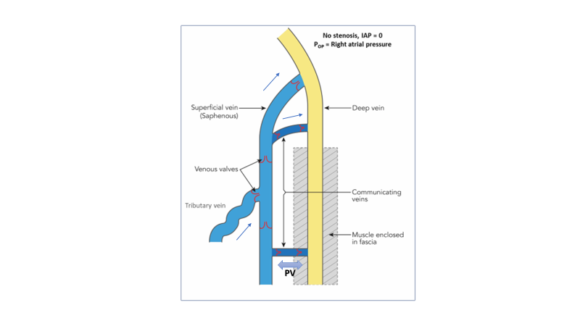

Figure 1. Schematic representation of the stressed and unstressed venous compartments with no outflow obstruction

*(Deep veins within the closed musculofascial space form the stressed compartment. Blue arrows indicate the physiological direction of flow from the unstressed to the stressed venous compartment. Flow in perforator veins [PV] can be bi-directional in a normal physiological state and maintains a dynamic pressure/ volume equilibrium between the two compartments)*

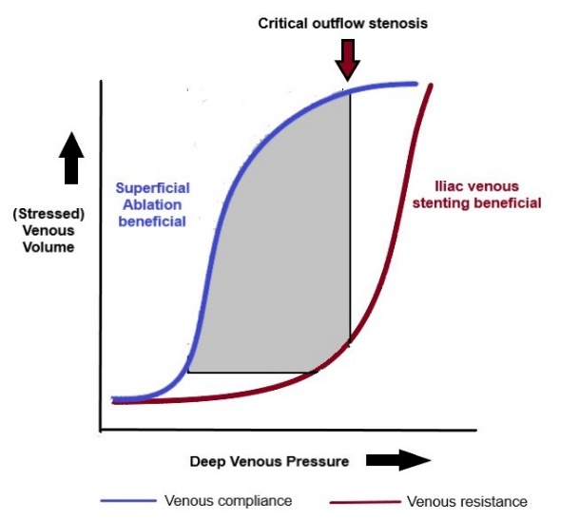

Figure 2a. Venous volume/pressure or compliance curve

*(The compliance curve in a healthy vein is shown in blue; the superimposed venous resistance curve is shown in red and indicates the inverse relationship between compliance and resistance. The shaded grey area represents venous capacitance – the capacity of the limb to respond to changes in pressure and volume)*

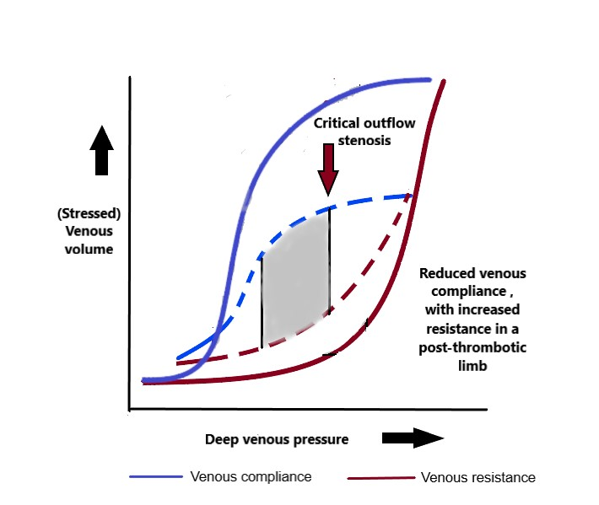

Figure 2b. Venous compliance curves in healthy and post-thrombotic veins

*(The compliance curve in a healthy vein is shown in blue; the superimposed venous resistance curve is shown in red. The dashed lines show the compliance and resistance curves in the post-thrombotic vein. The shaded grey area represents the reduced venous capacitance as compliance decreases and resistance increases in the post-thrombotic vein)*

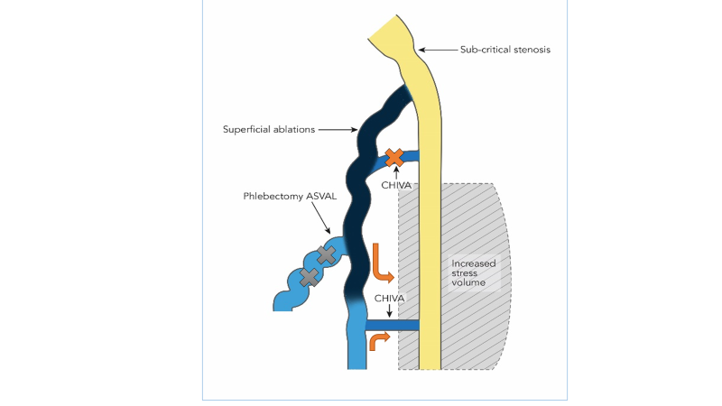

Figure 3. Schematic representation of the stressed and unstressed venous compartments following superficial venous intervention with sub-critical outflow obstruction

*(The ablated saphenous vein segment is shown in black, grey crosses represent varicose tributary veins excised in ASVAL; orange cross indicates escape point ligated in CHIVA and the orange arrows indicate direction of preserved flow and re-entry after CHIVA wherein the saphenous trunk is preserved.)*

Figure 4. Schematic representation of the stressed and unstressed venous compartments following superficial venous intervention with critical outflow obstruction

*(The ablated saphenous vein segment is shown in black. High outflow pressures lead to recurrence at various levels, the stressed volume is increased beyond the venous capacitance of the limb, and trophic changes may occur. IPV – incompetent perforator vein)*