**Fuel Cells as Combined Heat and Power Systems in Commercial Buildings: A Case Study in the Food-Retail Sector**

Salvador Achaa, Niccolo Le Bruna, Maria Damaskoub, Tekena Craig Fubarac, Vinay Mulgundmathc, Christos N. Markidesa and Nilay Shaha

a *Department of Chemical Engineering, Imperial College London, London, UK*

b *Department of Design, Manufacture & Engineering Management, University of Strathclyde, Glasgow, UK*

c *Doosan Babcock Ltd, Renfrew, UK*

N.B.: This is the ACCEPTED MANUSCRIPT version of this article. The final, published version of the article can be found at: <https://doi.org/10.1016/j.energy.2020.118046>

**Abstract**

This work investigates the viability of fuel cells (FC) used as combined heat and power systems (CHPs) in commercial buildings with a specific focus on supermarkets. Up-to-date technical data from a fuel cell manufacturing company was obtained and applied to evaluate their viability in an existing food-retail building. A detailed optimisation model described in previous works enhancing distributed energy system management is expanded upon to optimise the techno-economic performance of FC-CHP systems. The optimisations employ comprehensive techno-economic datasets that reflect current market trends. Outputs highlight the key factors influencing the economics of FC -CHP projects. Furthermore, a comparative analysis against a competing internal combustion engine (ICE) CHP system is performed to grasp the trade-offs of each system. Results indicate that FCs are becoming financially competitive although ICEs are still a more attractive option. For supermarkets, the payback period for installing a FC system is 4.7-5.9 years *vs.* 4.0-5.6 years for ICEs when policies are considered. If incentives are removed, FC-CHP systems have paybacks between 6-10 years *vs.* 5-8.5 years for ICE-based systems. A sensitivity analysis under different market and policy scenarios is performed, offering insights into the performance gap fuel cells face before becoming more competitive.

**Keywords:** combined heat and power system; commercial buildings; distributed generation; fuel cell; internal combustion engine; technology investment.

1. **Introduction**

The European Union (EU) and its member states have agreed to binding targets of 40% overall reductions in greenhouse gas emissions by 2030, and >80% by 2050 [1]. Decarbonising buildings will be a critical factor if these targets are to be met. Micro-scale (<50 kWe) and small-medium scale combined heat and power systems (CHP) systems (>50 kWe and <1 MWe), which have been identified as integral part of high-efficiency energy systems [2], are increasingly being installed in distributed energy applications across a wide range of buildings and urban centres [3]. The possibility to co-produce heat and power and achieve security of supply is an appealing option for organisations in an ever more cost intensive energy market resulting from the introduction of environmental policies [4]. By far, the main type of CHP system installed across the world is internal combustion engines (ICEs), usually fuelled by natural gas or diesel [5]. Nonetheless, different configurations fuelled by hydrogen or biofuels [6] have been reviewed and are being considered due to their environmental benefits. However, another alternative to conventional CHP systems is the transitional natural gas-powered fuel-cell (FC) CHP system. Small-scale non-combustion-based FC-CHP systems have certain benefits over combustion engines; these primarily are higher efficiencies, lower noise, lower carbon emissions, and a more compact physical footprint. However, they have not seen widespread use due to high capital costs [7].

Recent studies, though, show that the economics of FC-CHP system installations are gradually improving. Lazard LLC, who have been reviewing the general international economics of technologies for alternative energy generation, report declines in capital cost of FC stationary systems by $500-1000 per kWe between 2017 and 2018 [8, 9]. Furthermore, the U.S. Department of Energy reports a steady increase – around 15% annually – in the number and capacity of stationary FCs shipped worldwide from 2014 to 2016 [10]. Grand View Research Inc. and similar groups have estimated the future overall FC market size to be around $8 billion (USD) by 2022, with a forecasted Compound Annual Growth Rate (CAGR) between 17% and 24% from 2019 to 2025 [11]. Other reports on the global FC market suggests a FC market value of just over $20 billion (USD), with a CAGR of around 20% until 2024 [12]. The slight differences in the projections are attributable to the various applications being considered – transport, stationary, large-scale, small-scale, etc. Nevertheless, although FC market figures stated in reports vary across literature, an increasing trajectory is identified in all of them. These reports also suggest FC-CHP systems are increasingly being deployed in several stationary applications, such as supermarkets, warehouses, and data centres. For example, the “Price Chopper” supermarket chain boasts the installation of two 400-kWe FC-CHP systems at one of their stores in New York; these units have contributed to significant energy savings and reduction in CO2 and NOx emissions [13].

Asia and then North America have been leading FC manufacturing. The FC market is already well-developed in countries such as Japan, South Korea and the USA, where they benefit from Government subsidies to support their deployment [10]. For example, by including natural gas as an eligible fuel under the Renewable Portfolio Standard (RPS), South Korea has mandated the requirement of new energy emanating from FCs within the overall power production portfolio exceeding 200 MWe of power capacity [14]. Japan remains the leader in the development and deployment of small-scale CHP systems, tallying about 300,000 units as of 2018 thanks to a subsidy offered to domestic consumers; however, commercial scale systems lack support.

Meanwhile, Europe is forging ahead to become a leader in FC deployment with long-term policies supported by the European Commission & European Parliament, but without the level of ambition or consistency of Japan and Korea [15]. The 2020 Climate and Energy package recognises FC technology will play a pivotal role in achieving a 60% to 80% reduction in greenhouse gases by 2050, but without stating the scale of its role [16]. Nevertheless, the above policies are enabling the transformation of the European FC sector. Specifically, FC-CHP system applications have an increasing potential in domestic and non-domestic buildings, especially in countries with comprehensive natural gas infrastructure. Wang et al. have presented the breakdown and contribution of the stack system and its components in the costs of an 80 kWe proton exchange membrane fuel cell (PEMFC) system [17]. They illustrate that 50% of the cost is the stack and about 20% consists on the thermal, fuel, and water management components. Under current conditions, the UK and Germany are markets with the most developed and highest value add-on services for FC systems; nonetheless barriers such as cost and maturity still need to be overcome [18]. Overall, favourable government regulations, and technology costs, and more focus on higher conversion efficiency rates, and environmental benefits are all additional key factors likely to propel the demand for hydrogen power-based generation systems in the upcoming years [19].

In some decarbonisation scenarios, hydrogen is expected to play a pivotal role as a fuel in future energy systems with a possible conversion of the gas network to a hydrogen carrier for low-carbon transport systems and heating applications [20]. The drive towards establishing a hydrogen supply-chain is another justification that makes fuel cell technology attractive in the not so distant future. Storage of hydrogen to generate electricity when there is a need to balance the intermittency of other renewable sources and the potential of hydrogen production from biofuels with a parallel carbon capture system are also promising applications [21]. The environmental advantages have been scarcely applied so far due to economic challenges. However, research on the potential of hydrogen is on-going and abundant in the literature, since it is a promising energy carrier that can assist in transitioning towards a low-carbon economy [22]. In particular, the introduction of EU directives to improve air quality in urban areas by decreasing NOx emissions will favour FC systems over competing CHP technologies, such as internal combustion engines [23, 24]. It is projected that shipment of FC systems in Europe for CHP installations could reach 500 per year by 2025 [25].

Despite the positive projections, FC-CHP systems still have several challenges that must be addressed before they can gain the trust and confidence of decision-makers; otherwise their prospects could be hampered substantially. These challenges are technical, financial, and regulatory in nature, including (but not limited to):

* Limited production output;
* Maintaining uniform flow distribution to avoid cell degradation;
* The sourcing of ‘renewable’ hydrogen;
* A robust hydrogen infrastructure;
* Capital technology costs;
* Influx of cheaper combustion-based CHP technologies;
* Reluctance from policy makers to act against air and noise pollution in urban environments and densely populated cities;
* Lack of public outreach – although a growing interest has been identified with increasing research efforts, budget and publications, especially in the USA and EU [26].

Aside from the challenges above, environmental impact assessments are also a valuable field of research to understand the unattended consequences of increasing the deployment of fuel cell systems. For example, environment life cycle assessments can be performed and are popular in the literature. The methodology analyses the materials, products and services involved for each component and life cycle phase throughout the whole life cycle of a technology commonly referred to as the “cradle-to-grave approach” [27]. For instance, phosphoric acid fuel cell (PAFC) stacks contribute half of the environmental footprint in the manufacturing phase, whereas natural gas fuel during the system’s full-life operation is responsible for 98% of the total environmental impact [28]. Furthermore, usually the catalyst, steel and most other materials are recycled, whereas graphite plates are wasted in the absence of alternative options [29].

Although the challenges are diverse and complex, momentum has been gathering as a result of attempting to address climate change. For example, strategies with long-term targets to improve air quality have been suggested by both the UK Government [30] and the Mayor of London [31]. The “UK Clean Air Strategy” has proposed a 46% reduction of greenhouse gas emissions until 2030. Specifically, with regards to London, the Greater London Authority (GLA) energy strategy to meet environmental objectives includes support for the following actions [32]:

* A decentralised energy focus on heat networks and on-site generation systems;
* High electrification of heating via heat pumps or small-scale embedded generators;
* Decarbonised gas by increasing hydrogen uptake; replacing natural gas in the gas grid.

Most likely a combination of all the above solutions will feature in environmentally friendly cities like London by 2050. Given the fervent but challenging landscape, this study analyses the recent progress in the commercialisation of stationary FC-CHP systems by conducting a detailed techno-economic appraisal of a commercial 460 kWe phosphoric acid fuel-cell (PAFC) system [33, 34] in UK supermarkets. Several factors affecting the economics of FC-CHP system projects, for example installation costs and energy costs are included in this techno-economic analysis; hence, giving a more holistic view of the project pre-feasibility of such systems. Furthermore, a comparative analysis against an internal combustion engine CHP unit is conducted to contrast performance gaps among market-leading competing technologies, and to help indicate if food-retail buildings can act as a beachhead market for FC-CHP systems.

This paper is composed of five sections. The current section has provided the background and purpose of this work. The second section provides a detailed explanation on how the data for the case study was obtained and analysed. The third section provides the mathematical formulation of the problem, while the fourth section describes and discusses the results. Lastly, the final section provides concluding remarks.

1. **Case Studies and Data Collection**

**2.1 Supermarket data**

Food-retail buildings present a high variability in size, ranging from convenience stores (sales area < 1,000 m2) up to large supermarkets (sales area >3,500 m2). Large stores in the UK consume around 4 GWh of electricity and 2 GWh of heating annually usually via natural gas boilers. In general, large stores are better suited for a CHP system than smaller stores as these consume more energy and thus have higher energy bills. Large size CHP systems can then benefit from economies of scale offering a lower cost per kWe produced, which makes the investment more attractive. Hence, in this work, an existing large supermarket (sales area >3,500 m2) in Scotland was selected for the case study as FCs would be better suited for this type of applications. The energy attributes of the supermarket case study are shown in Table 1.

*Table 1: Key performance indicators of the supermarket case study.*

|  |  |
| --- | --- |
| **Parameters** | **Values** |
| Peak/average electricity load | 645/494 kWe |
| Annual electricity demand | 4.37 GWh |
| Peak/average heat load | 619/217 kWth |
| Annual heat demand | 1.89 GWh |
| Heat-to-Power ratio | 0.43 |

A year’s worth of historical data related to the electrical and space heating demand was gathered for the supermarket case study. The data was made up of half-hourly (HH) intervals and was post-processed to account for missing values; employing a similar approach as to the one described by Mavromatidis et al. [35]. The analysis of the energy demand data allows us to present daily and seasonal variations to grasp with greater ease the load variability in the supermarket. The electricity demand profiles are similar throughout the year, although in the summer they are slightly higher because refrigeration load is increased since it is highly dependent on the ambient external temperature. Meanwhile, the space heating demand is quite high and does not fluctuate considerably in the winter period, however in the summer period this load is quite low as the store does not require a lot of heat to reach an adequate room temperature. This is clear by what seems to be a considerable peak supply of heat provided by the boiler in the early morning when the supermarket opens for business. The space temperature is raised to create a comfortable environment and after that the boiler is no longer required until the next morning. The heat produced by the boiler is connected to a centralised HVAC system in which a hot water coil transfers the heat to an air handling unit which then distributes the warm air via mechanical ventilation. The flow temperature of the supply water circuit is 80 °C, while the return temperature is 60 °C. Figure 1 portrays one week worth of HH electricity and space heating data during winter and summer periods.

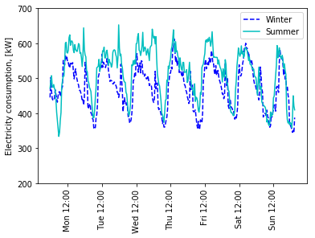 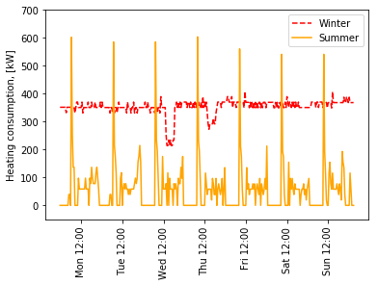

*Figure 1. Typical electricity (left) and heating (right) half-hourly demand profiles for winter and summer weeks in the supermarket considered.*

**2.2 Energy cost data**

For utility prices, just as for demand data, HH energy price data was collected for the supermarket facility. The price of utilities, especially electricity, is strongly affected by the network charges and government tariffs, such as distribution and transmission use of system charges as well as environmental charges supporting the transition towards a low carbon energy system. The methodology used to calculate price data considers the variability of these tariffs with time and location in the UK and has been described by Acha et al. [36]. For example, electricity prices are very volatile through the day ranging from 7 p/kWh to more than 30 p/kWh during peak hours. Figure 2 reports a typical half-hourly daily profile for electricity price for both a weekday in a) winter and b) summer periods. The curves reflect the volatility when combining both the commodity (a.k.a. wholesale) price, as given by the British power exchange N2EX day-ahead index [37], and the pass-through charges (e.g. network charges and environmental tariffs). Both plots show peak costs taking place early in the evening (the time of the day when the system is most stressed), however this peak is more prominent in the winter period due to the increased seasonal demand and the Triad charges that supports the transmission network operator (National Grid) [38]. The way these tariff variations interact with the energy demand profiles in facilities, affect strongly the economics of distributed energy system investments as explored by Mariaud et al. [39]. Since the complete information on prices and tariffs is available only up to the time this paper was written, future prices and tariffs were forecasted. A 6% increase in the average total electricity price was assumed and HH profile trends were based on those seen observed in 2017-2018 UK data. Overall, the analysis on prices gives an average electricity cost of 10.6 p/kWh, 11.2 p/kWh and 11.9 p/kWh respectively for years 2018-2019, 2019-2020 and 2020-2021. The annual price mean used for natural gas in 2018-2019 was 2.48 p/kWh, with a 2% increase each year thereafter. This energy price differential between grid sourced electricity and natural gas is what makes producing electricity on-site so attractive for large energy consumers, particularly in industrial and commercial buildings, as it may allow end-users to source and control their energy resources more cost-effectively [40].

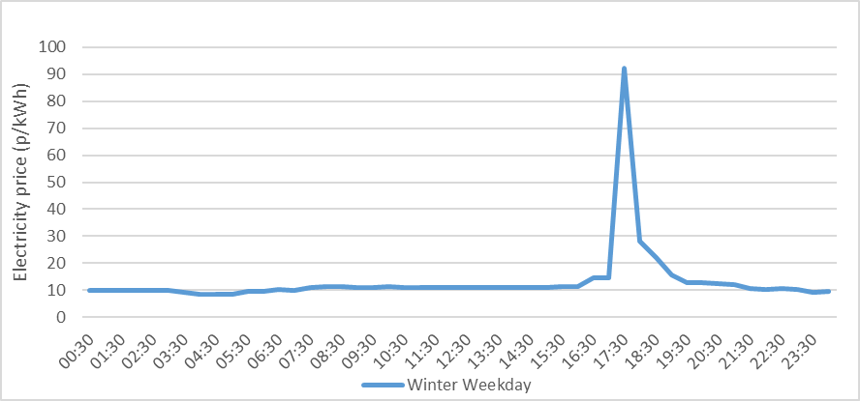

*Figure 2a. Half-hourly winter weekday electricity prices in Scotland for the case study considered, year 2018-19.*

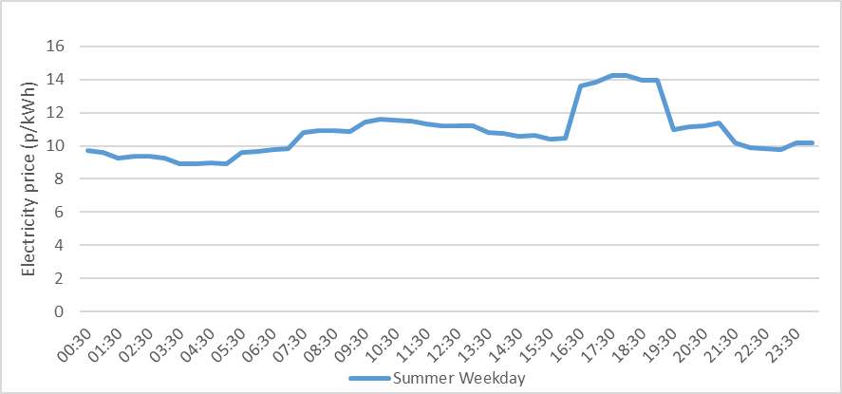

*Figure 2b. Half-hourly summer weekday electricity prices in Scotland for the case study considered, year* 2018*-19.*

**2.3 Policy support**

UK government policies can have a significant impact on low carbon investments by offering tax reductions and incentives. With respect to CHP installations, the current policy is dependent on the unit running efficiently according to the CHP quality index (CHPQI) [41]. If this indicator is met (i.e. higher than 105 in the first year of operation) then benefits can apply. In this regard, Doosan Babcock’s FC-CHP unit has managed to obtain a Combined Heat and Power Quality Assurance (CHPQA) Certificate for installations.

The benefits considered for this study were: 1) enhanced capital allowance (ECA), which entails a 100% first year tax relief on the capital cost discount on the CHP (using the corporate tax rate, hereby taken as 26%); and 2) carbon climate levy (CCL) exemption, which excludes the CCL tax from the cost of natural gas (approximately 0.2 p/kWh consumed). In particular, the ECA tax relief was applied in the present study as a discount on the capital cost of the unit. Another benefit in having a good quality CHP index is the business rate exemption on the building(s) (hereditament) that incorporates the CHP unit; this incentive applies as a further tax relief in the UK [42]. However, since it is highly dependent on several factors determined by the Evaluation Office, the exemption was not considered in this study.

**2.4 Economic challenges of FC-CHP commercialization**

Apart from the energy markets and policies, many other factors affect the cost of the investment. When considering a CHP project, it is important to consider all costs for installation, commissioning and, later, maintenance. These costs can include the installation of a gas connection to the CHP, the space preparation and builders’ work, upgrade of the heating system, etc., and can be of the order of £250k up to £450k for larger sites. These costs vary significantly from case to case and generally increase with the area of the stores. Fuel cell system installation costs considered include for instance: site survey, grid connections, mechanical and electrical connections, containerised acoustic box, ventilation heat recovery and exhaust systems, control and monitoring hardware as well as testing and commissioning time. The installation costs used in this study were calculated utilising information from previous projects delivered by Doosan Babcock and totalled an estimated £330,000 for the FC-CHP system considered in a supermarket site.

Although in this work we solely focus on analysing costs related to the capital, installation, maintenance and operation of cogeneration systems it is worth mentioning there are alternative approaches considering further aspects. Manufacturing, decommissioning and transport entail additional items if a life cycle costing analysis is to be performed. Existing literature indicates that FC-CHP systems have been lacking reliable operation, which hinders the scaling-up of their commercialisation and potential cost reduction through mass manufacturing [43].

**2.** **5** **Fuel cell system data**

Indicative technical data for a 460 kWe PAFC were provided by Doosan Babcock through various interviews undertaken with key staff in their engineering team and these are detailed in Table 2.

*Table 2: Indicative technical data for a 460 kWe phosphoric acid fuel-cell (PAFC) system taken from “High Efficiency Mode” and “Grid Connected” specification sheets of the manufacturer of the FC system considered in this work [34].*

|  |  |
| --- | --- |
| **Parameters** | **Values** |
| Nominal net electrical efficiency (LHV) | 44.5% |
| Nominal net thermal efficiency (LHV) | 45.5% |
| Gas consumption (HHV) (kW) | 1,104 |
| High-grade heat output @ up to 121 °C (kW) | 162 |
| Low-grade heat output @ up to 60 °C (kW) | 292 |
| Minimum part load | 10% |
| Lifetime of fuel cell stack | 10 years |
| Availability | 98% |
| Start-up time | 4 hours |
| Start-up electricity consumption | 180 kWe |
| Investment cost (GBP/USD = 1.32) | £2,170/kWe |
| Other installation costs | £330,000 |
| Maintenance cost per kWh produced | £0.017/kWh |

The efficiency values reported in Table 2 use the natural gas lower heating value (LHV) as commonly found in CHP technical data. The LHV of a fuel sets the fuel flow rate going into the engine, this is because the total quantity of energy input necessary for the engine to produce a specific output power is defined and fixed. Consequently, the gas flow rate must fulfil the required energy input [44]. However, gas metering at the consumption point is usually based on gas higher heating values (HHV) because fuel suppliers usually quote the HHV and it will be this measure that will be used when kWh unit charges are applied for fuel use. Hence, when performing a cost benefit analysis for a CHP application, it is the HHV figure which should be employed. Therefore, in order to calculate the electricity produced, the LHV efficiency was converted to the (lower) HHV efficiency by multiplying it against the corresponding heating value ratio of 0.896 (~36/40) [45]. Both values of the thermal and electrical efficiency are reported assuming full load operation. At part load, the efficiency can change considerably. For the FC-CHP system model considered in Table 2, the part-load profiles are plotted in Figure 3. The electrical efficiency slightly increases up to 46.5% at 60% part-load, then drops to 39% at 50% part-load, and then decreases linearly to around 7% at 10% part-load. The high-grade heat output (HG in Figure 4) has a temperature of up to 120 °C and linearly decreases from 200 kWth (at full load) to 0 kWth at 60% part-load, where the total heat output is entirely low-grade heat.

The fuel cell system has a rated electrical efficiency during the first year of operation 44.5±2%, based on the lower heating value (LHV) of the natural gas. System electrical efficiency is rated at ISO conditions: 15 °C ambient temperature, at sea level elevation, and 60% relative humidity. However, it must be noted that the power output will be derated at high ambient temperatures (e.g. >30 °C) and above high sea level elevations (e.g. >600 m) [34]. The nominal efficiency rating includes the electrical load of the air-cooling module. Operating without full heat recovery will result in a slight decrease in electrical efficiency within the rated efficiency range. The FC stack degrades over time and this aspect was considered in the model. Here the electrical efficiency (at full load) was assumed to decline from 46% at installation down to 42% at year 10 of its life; meanwhile thermal efficiency was assumed to increase from 46% at installation to 49% in Year 10. After ten years, when the power output declines, a fuel cell stack replacement is to take place and the performance of the FC-CHP system is reset to original electrical and thermal efficiencies matching the original values of the system. The stack replacement and associated components, including the reformer, auxiliary pumps, and catalyst, accrue costs of approximately £350,000-£380,000 and were obtained from interviewing industry expert Vinay Mulgundmath from Doosan Babcock Ltd (personal communication, October 24, 2018). The FC-CHP system was assumed to have 98% availability with maintenance and servicing costs totalling £0.017/kWh of electricity produced; these costs include the system overhaul in Year 10.

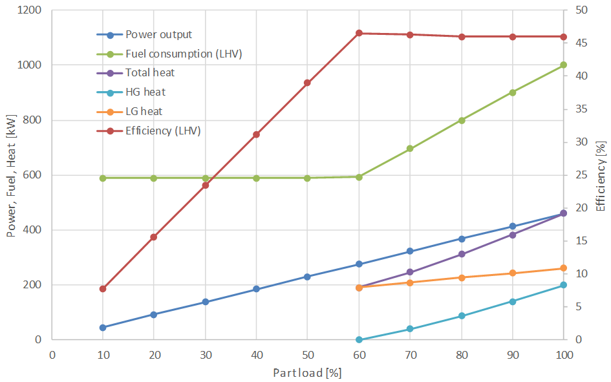

*Figure 3. FC-CHP system part-load curves employed in the model.*

PAFCs need to have their fuel processor and cell stacks heated before operation, and this constraint was included as a 4-hour start-up time consuming 180 kWh of electricity as parasitic load. The nominal specific capital cost for a FC-CHP system was taken to be £2,170/kWe for a system in the ~500 kWe output range. However, it should be noted that FC-CHP system costs tend to be higher when scaled down (e.g. micro-FCs), with costs expected to be in the vicinity of £4,500/kWe or higher [46]. In comparison with the FC-CHP system, a 500 kWe ICE-CHP engine costs around £820/kWe. If the ECA benefits arising from good quality CHPQI are included, the FC-CHP system was assumed to receive a 26% capital discount bringing the price down to £1,600/kWe.

The FC-CHP system was also assumed to be equipped with a smart control system capable of following an optimised operating strategy by taking multiple data streams as suggested by Acha et al. [47]. The optimal operating strategy is decided daily depending on the energy prices (day-ahead electricity price and cash-out/imbalance price), load profiles, weather forecast, and supermarket operation. Normally, this sort of capabilities are seldom in place in standard CHP systems leading to sub-optimal control strategies that are default approaches in industry (i.e. electricity load following, heating load following, etc.) [48], leaving room for improvement through cloud-based solutions for enhanced management of technologies; usually referred to as ‘internet of things’. This is because advanced control systems based on model predictive controls are a mature technology [49] and could be easily installed in CHP systems with a modest investment. The FC-CHP system analysed in this work has load-following control capabilities, accommodating output changes at rates of up to 10 kW/s and go from minimum to maximum load in less than 40 seconds as suggested by the manufacturer [34]. Utilising heuristic control strategies results in a worse economic performance. The difference in operational savings between other strategies and an optimised one is usually not more than 20% (unless the CHP control strategy adopted is very inefficient) which results in a payback period longer by about 0.5-1.5 years. The results reported in this study assume an optimal operating strategy unless mentioned otherwise. The operating strategy applied is derived from the model described in the next section.

1. **Techno-economic Modelling Framework**

In order to simulate the performance of CHP systems in supermarkets, a techno-economic optimisation model was adopted. The modelling framework is based on the “TSO model” which has been described in previous publications addressing the characterisation and evaluation of various distributed technologies in commercial buildings [47, 50]. We advise revising these works as they detail in-depth the data-driven energy systems optimisation approach that in this paper is summarised.

The techno-economic model optimises the operation of a FC-CHP system which is theoretically controlled via a cloud-based optimiser, such as the one described by Olympios et al. [40] and illustrated in Figure 4. The objective of the optimiser is to determine the operating strategy for the CHP system which results in minimising operational and maintenance costs. The operational strategy can then be implemented with a programmable logic controller, which receives the information from the optimiser. The results presented in this study have been derived by back testing the optimiser on the historical energy demand data of a supermarket.

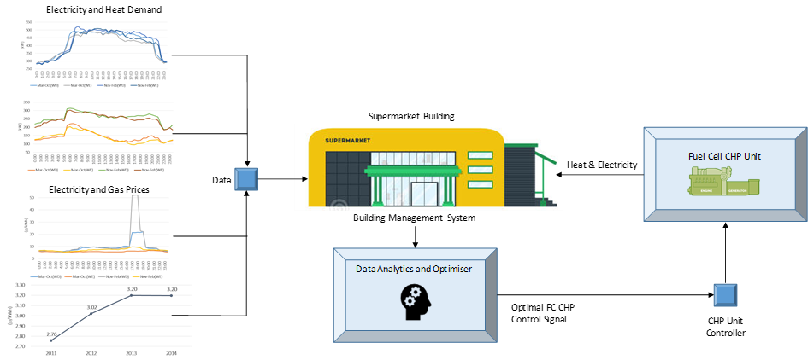

*Figure 4. Schematic and interactions of the FC-CHP system controller with its environment.*

We proceed here to provide details of the operating strategy of the optimiser. At each half-hour time instant *t*, the optimiser finds the part load of the CHP system *x* so that the operational cost for the time interval *C*(*t*) is minimised as expressed by Eq. 1 with the total operational cost at each time step calculated from:

|  |  |  |
| --- | --- | --- |
|  | *Min $C\left(t\right)=g\left(t\right)p_{g}\left(t\right)+e_{imp}\left(t\right)p_{imp}\left(t\right)-e_{exp}\left(t\right)p_{exp}\left(t\right)+e_{chp}\left(t\right)p_{m}$* | (1) |

where *g*, *eimp* and *eexp* are respectively the amount of gas imported, electricity imported and electricity exported, with *pg*, *pimp* and *pexp* being the respective prices; *echp* is the electricity produced by the FC-CHP system, and *pm* is the maintenance cost.

Each of the terms in Eq. 1 is linked to the electricity and heat generated by the FC-CHP system through the following energy balances:

|  |  |  |
| --- | --- | --- |
|  | $$g\left(t\right)=g_{chp}\left(t\right)+g_{b}\left(t\right)$$ | (2) |
|  | $$e_{chp}\left(t\right)+e_{imp}\left(t\right)=e_{exp}\left(t\right)+e_{store}(t)$$ | (3) |

where *gchp* and *gb* are respectively the gas required by the CHP and the boiler, and *estore* is the electrical demand of the store. The heat and electricity generated by the CHP are linked to the part-load *x* by the curves shown in Figure 4.

Additional constraints hold, such as the need to satisfy the heating requirement of the building:

|  |  |  |
| --- | --- | --- |
|  | $$h_{store}\left(t\right)=h_{chp}\left(t\right)+g_{b}\left(t\right)η_{b}$$ | (4) |

where *η*bis the boiler efficiency (assumed here to be 87%), and *h*store and *h*chpstand for the heat required by the store and provided by the CHP, respectively.

If the FC-CHP system overproduces electricity it is exported to the grid, whereas if it does not meet the building demand, additional electricity is imported. The imported gas is used both to run the FC-CHP system and the back-up boiler when the heat produced is not enough to satisfy the demand of the building. All the information other than the electricity export prices are expected to be known with high levels of certainty as the energy demands and natural gas prices are more predictable. The electricity export price based on the system sell price is known [51], and in the simulations, it is assumed that 80% of the value in exporting electricity is captured. The value in exporting electricity refers to the absolute amount of money that could be made by exporting electricity when it is economically viable.

1. **Results and Discussion**

**4.1 FC-CHP system operation**

The optimal operational schedule of the FC-CHP system is reported in Figure 5 for representative weeks in winter and summer periods. The strategy for the winter period covers all the heating demand of the supermarket as the heating provided by the FC-CHP system is similar to the electricity output. The generation system baseline produces about 360 kWe but ramps up to full load in those periods when the electricity price is particularly high (usually between 17:00 and 19:00 hrs.) as shown in Figure 2. Overall, the optimiser choses to operate the FC-CHP system at the point of highest overall efficiency if the electricity price is not too high and thus runs at part-load accordingly. In the summer period, when the heating demand of the building is rather low, the FC-CHP system operates at full load only in those periods of high electricity price s which are more sporadic. At all the other times, the FC-CHP system operates at a lower base part-load than in the winter (approximately 280 kWe), which still results in an efficient operation of about 60%. As seen in the part-load curves plotted in Figure 3, below 60% the FC-CHP system operation becomes considerably more inefficient. Although one might be led to believe that during some periods it would be more economical to switch off the FC-CHP system and just import electricity from the grid, this is generally not the case. This is due to a combination of factors; such as: a) the electricity base load of the supermarket is high, b) the FC-CHP system capability to operate at low part-loads without forsaking too much efficiency, c) the high fuel cell start-up time. These aspects make switching off the FC-CHP system infrequent, naturally resulting in periods of energy surplus in terms of both electricity and heat. The electricity exported to the grid can be sold to the utility, the excess heat, however, is underutilised if the building has no demand in those specific times or if it can’t share with to adjacent commercial buildings through a heat network system.

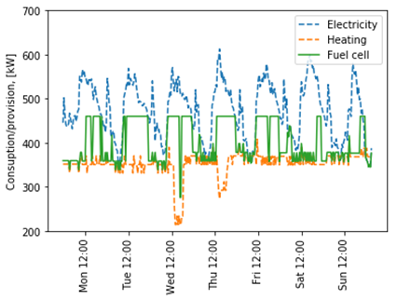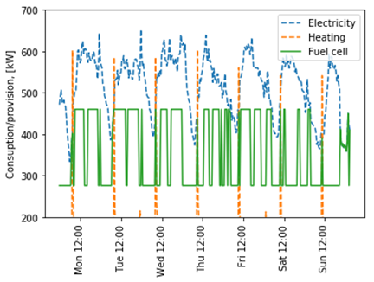

*Figure 5. One-week operational strategy for a 460 kWe FC-CHP unit along with the electrical and gas demand of the supermarket for respectively winter (left) and summer (right).*

As shown in Figure 5, the optimised operation of the FC-CHP system is different from standard operation strategies such as “electrical load following”. In this case, the difference in savings between the two strategies is not significant and around £9,800 per annum, representing approximately 5% of annual savings in the first year. The difference between an optimised operation and a standard one increases when the FC-CHP system can export electricity. In the present case, this is seldom a possibility as the electrical demand of the building is usually higher than the maximum electricity generated by the FC-CHP system.

**4.2 Comparison against alternative ICE-CHP systems**

The techno-economic specification performance sheet of a standard 500 kWe ICE-CHP engine, of roughly the same capacity as the FC-CHP system, was simulated with costs and data validated from previous cogeneration research projects [50]. The main parameters utilised to model the ICE-CHP unit are summarised in Table 3 and part-load performance of the engine is illustrated in Figure 6. As a “like for like” analysis is sought in contrasting FC-CHP and ICE-CHP systems this implies that the engine efficiency values reported in Table 3 also use the lower HHV just as the FC-CHP engine efficiency reported in Table 2. Both values of the thermal and electrical efficiency (LHV) are reported assuming full load operation. The higher installation costs (£350k *vs.* £330k) reflect the fact that an ICE-CHP engine needs to be equipped with a flue gas catalytic converter to comply with recent European legislation in limiting NOx emissions to 240 mg/kWh [23]. ICE maintenance costs were found to be slightly higher than FC-CHP systems mainly due to the presence of moving parts. However, these maintenance costs exclude major overhauls involving piston/liner replacement, crankshaft inspection, bearings, and seals that usually take place between 50,000 and 70,000 hours of operation [52].

*Table 3: Technical data for a 500 kWe ICE-CHP system [50, 52, 53].*

|  |  |
| --- | --- |
| **Parameters** | **Values** |
| Nominal net electrical efficiency (LHV) | 38% |
| Nominal net thermal efficiency (LHV) | 45% |
| Minimum part load | 50% |
| Lifetime before major overhaul | 10 years |
| Availability | 98% |
| Start-up time | < 30 min |
| Start-up electricity consumption | 180 kWe |
| Investment cost (GBP/USD = 1.32) | £826/kWe |
| Other installation costs | £350,000 |
| Maintenance cost per kWh produced | £0.02/kWh |

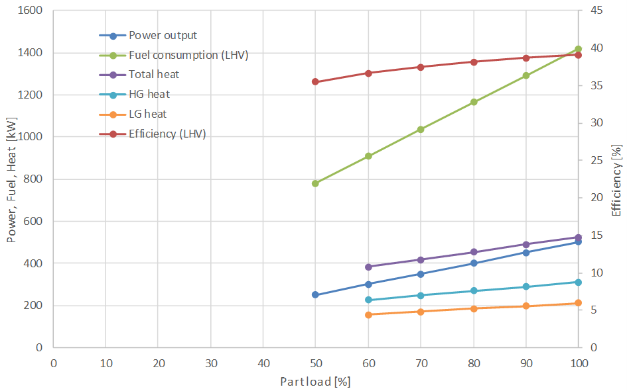

*Figure 6. ICE-CHP system part-load curves employed in the model.*

**4.3 FC-CHP system economic performance**

The performance of the FC-CHP system was simulated over the course of its 10-year cell stack lifetime. A breakdown of the expected operational performance and costs are detailed in Tables 4 and 5 for year 2018-2019. Scenarios considered include no generator (i.e. business as usual) or the presence of either a FC-CHP or ICE-CHP system. The CHP systems displace most of the electricity imported by the supermarket, which represents the major source of economic savings for the project. The cogeneration of heat adds a further £50k to the savings and, even though this amount is less than the electricity savings, it is still essential to make the project economically viable. The carbon emissions are also slightly reduced by 15.2%. This is caused by the low heating demand of the building which affects the load factor and, hence, reduced the overall efficiency of the FC-CHP system (70% average efficiency *vs.* 92% of maximum efficiency).

*Table 4: Supermarket operational performance for 2018-2019 subject to different energy supply scenarios: business as usual, FC-CHP system or ICE-CHP system.*

|  |  |  |  |
| --- | --- | --- | --- |
| **Parameter** | **Business as usual** | **FC-CHP system** | **ICE-CHP system** |
| Boiler gas use (MWh) | 2,380 | 88 | 36 |
| CHP system gas use (MWh) | - | 8,247 | 10,529 |
| Grid imported electricity (MWh) | 4,527 | 759 | 971 |
| Grid exported electricity (MWh) | - | 1.2 | 2.1 |
| CHP system LHV efficiency (%) | - | 70% | 59% |
| CHP system average part-load output (%) | - | 92% | 83% |
| CHP system availability (%) | - | 98% | 98% |
| Carbon emissions (tCO2e) | 2,303 | 1,987 | 2,344 |

*Table 5: Supermarket financial performance for 2018-2019 subject to different energy supply scenarios: business as usual, FC-CHP system or ICE-CHP system.*

|  |  |  |  |
| --- | --- | --- | --- |
| **Parameter** | **Business as usual** | **FC-CHP system** | **ICE-CHP system** |
| Boiler gas use (GBP) | £59,224 | £2,208 | £890 |
| CHP system gas use (GBP) | - | £224,225 | £261,905 |
| CHP system maintenance cost (GBP) | - | £64,081 | £72,987 |
| Imported electricity from grid (GBP) | £486,175 | £78,819 | £89,682 |
| Exported electricity to grid (GBP) | - | £178 | £408 |
| Total energy operation cost (GBP) | £582,484 | £401,149 | £463,200 |

The 10-year cash flow results of the project are shown in Figure 7 (with and without UK policies). The simple payback time when policies are included is 4.7 years. Not including the government policies increases the payback time by more than 1 year to 5.9 years. Overall, it appears that the FC-CHP unit presents a payback time which has decreased from the 8-10 years reported in earlier studies of this technology [48]. This has been mainly achieved by a reduction in the unit price, increase in reliability and the introduction of government support schemes. Even if the payback time indicates that the FC-CHP systems are becoming economically viable, it is important to compare the FC-CHP technologies with market leading stationary ICE-CHP technologies in order to fully understand their commercial potential and performance gaps. In the following section a comparison with an ICE-CHP system is portrayed and discussed.

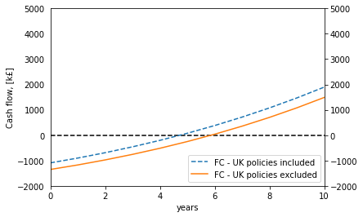

*Figure 7. 10 years cash flow of a 460 kWe FC-CHP system installed in a supermarket (with and without UK policies).*

The results of the ICE-CHP system cash flow optimisation are shown in Figure 8 along with the results for the FC-CHP system for comparison. The ICE-CHP system cash flow provides better returns in the first few years, but the FC-CHP system catches-up and outperforms financially after year 8.

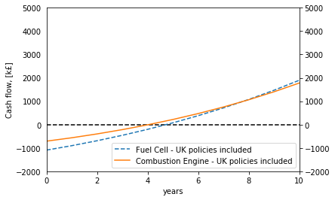

*Figure 8. 10-year cash flow of 500 kWe ICE and 460 kWe FC-CHP systems installed in a supermarket.*

The payback time of the ICE-CHP system is 4 years when policies are included, which is lower than the 4.7 years of the FC-CHP system. The higher cost of FC-CHP systems is offset by their higher efficiency compared to ICE-CHP systems, which results in greater savings per year. However, the main factor which reduces the economic gap between FC-CHP and ICE-CHP systems are the project installation costs (i.e. mechanical and electrical engineering works). These costs play a significant role and they must be included even in the installation of a very low-cost CHP system. In the case of ICE-CHP systems, installation costs can represent 50% of the total investment cost. Therefore, the hidden costs almost double the payback time that would otherwise be present if the capital cost of the system was the sole factor considered.

Compared to the FC-CHP system, the optimal operation of the ICE-CHP system is more dynamic and sometimes the unit stays off while electricity is imported from the grid. The flexibility of the gas engine to start-up and shut down is important as otherwise the lower efficiency of the ICE-CHP system would make on-site production more expensive than importing from the grid. In the present case, the effect of utilising an optimal control on the ICE-CHP system is more significant, leading to about £14k extra savings with respect to a standard operational strategy (10% of the operational savings).

It is also important to discuss the effect that current UK policies have on these CHP projects. The high efficiency of FC-CHP systems allows the unit to easily meet the CHPQI threshold and therefore achieve benefits on ECA; such a benefit is key to make the investment viable. Without such benefits the payback time would increase by more than 1 year. ICE-CHP systems are less dependent on such policies due to their lower capital costs.

**4.4 Sensitivity analysis and FC-CHP system prospects**

A sensitivity analysis was conducted across different parameters to understand their impact on FC-CHP system investments and how their attractiveness may vary under possible future scenarios. For industrial and commercial consumers electricity prices are expected to increase in the UK by 2026 by 20% to 40% according to BEIS [54]. Similarly, natural gas price increments of 20% to 100% were explored. Hence, it is possible to consider a wide range of energy cost scenarios according to the most promising and pessimistic projections. Figures 9 and 10 show the energy prices communicated by BEIS in their reports.

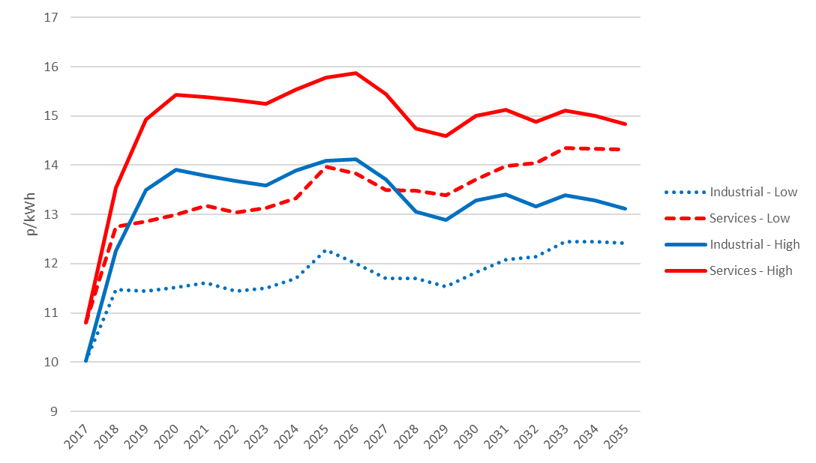

*Figure 9. Projected electricity prices per sector until 2035, dependent on assumed low or high fossil fuel prices [54].*

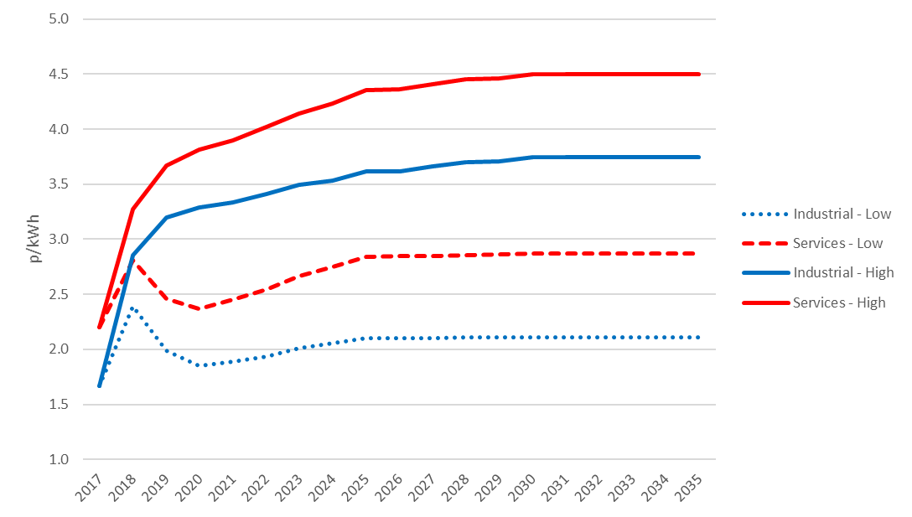

*Figure 10. Projected gas prices per sector until 2035, dependent on assumed low or high fossil fuel prices [54].*

This uncertainty regarding electricity prices has also been observed in other European countries (e.g. Germany), due to the intermittency of renewable sources and especially the energy generated by wind and solar power [55]. Given the prominence of the UK towards renewable solutions and their supporting subsidies a rise in energy prices should be the expected trend [36].

Figures 11 and 12 report the variation in annual savings and payback time as a function of natural gas and electricity prices, which are the main factors affecting operational costs and thus potential savings influencing the CHP system investment. Figure 11 gives a clear picture of the expected annual saving that can be expected under a wide range scenario of energy prices. For this case study, as Table 5 shows, in order to achieve an attractive payback period (e.g. 3 years), an annual savings of about £200k would be preferred. Figure 12 indicates with respect to payback periods that once the electricity price exceeds 16 p/kWh the FC-CHP payback time is lower than 4 years irrespective of the natural gas cost. The reason is that the large spread between the values of the two commodities makes gas a low-value commodity and therefore has less weight on the overall project viability.

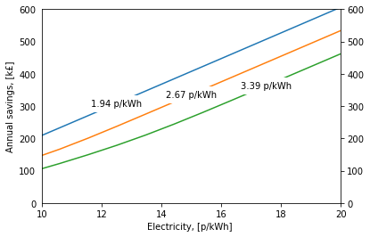

*Figure 11. Simulated annual savings of a 460 kWe FC-CHP system into a large supermarket as a function of the electricity and natural gas prices. UK policies are not considered.*

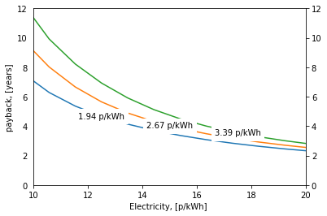

*Figure 12. Simulated payback of a 460 kWe FC-CHP system into a large supermarket as a function of the electricity and natural gas prices. UK policies are not considered.*

Figure 13 shows the payback time contour lines as a function of gas and electricity price for ICE- (blue) and FC- (black) CHP systems. As the figure shows, the ICE-CHP engine system always presents a lower payback time than the FC-CHP system for all values considered. The difference between the payback of the two technologies decreases as the natural gas price increases; making fuel utilisation efficiency an increasingly important factor (of which FC technology has an edge on ICEs). From this analysis, changes in the energy market alone are not enough to make FC-CHP systems an appealing alternative against ICE-CHP systems in the food-retail sector. It seems that for FC-CHP systems to be adopted, further technological development and capital cost reduction through increased volume production is required.

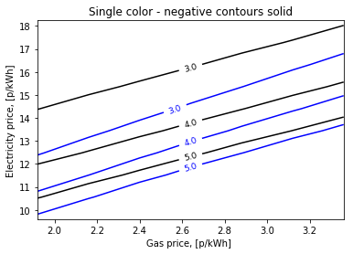

*Figure 13. Simulated payback regions of a 460 kWe FC-CHP system (black lines) and corresponding 500 kWe ICE-CHP systems (blue lines) into a large supermarket as a function of the electricity price and gas price when CHPQI policies are considered.*

As mentioned above, a reduction in capital costs is key for the uptake of FC-CHP systems. Figure 14 shows the results of the sensitivity analysis conducted on an increase in FC-CHP system efficiency and a decrease in capital cost. Results indicate that an increase in efficiency does not play a significant role in affecting the economics of FCs, despite higher efficiencies implying that less fuel is used to power the unit. However, the efficiency of the FC is sufficiently high making fuel consumption not that influential to improve investment viability. The reasonable argument suggests that the efficiency of a CHP system is an important factor affecting its business case but not under the current UK market conditions. However, the efficiency of the FC-CHP system is so high that slight improvements would not reduce the payback periods considerably. Meanwhile, a reduction in capital costs does have a more profound impact on project viability; analysis suggests that at a cost of £1,821/kWe the systems would provide payback lower than 5 years. It is estimated that if a 15-20% capital cost reduction is achieved, then FC-CHP systems might become competitive against stationary market leading CHP technologies in the UK market.

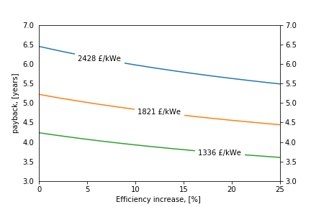

*Figure 14. Simulated payback of a 460 kWe FC-CHP system into a large supermarket as a function of increase in electrical efficiency and capital cost. UK policies are not considered.*

Steep cost reductions, though, will be achieved if the production volumes of FC systems increase; this is possible if the right combination of regulatory and policy tools are introduced. Figure 15 shows the decrease in cost per kWe for PAFC systems against the increased cumulative installed capacity for the year 2001-2018. The calculated learning rate is 9.3% which is close to the previous set of data (2001-2013) reported by Wei et al. [56]. Furthermore, the potential establishment of hydrogen infrastructure can also lead to a further reduction in FC system manufacturing costs along with footprint reduction; since there will no longer be a requirement for a steam-methane reformer system for reforming pipeline natural gas into hydrogen; this stage is currently associated with 10-15% of project costs [57]. Therefore, FC manufacturers and suppliers are projecting considerable cost reduction in the technology due to improvements in the manufacturing process and reducing supply-chain costs, thus, significantly influencing the outlook of stationary FC-CHP systems.

*Figure 15. FC-CHP system costs as a function of cumulative installations from 2001 to 2018 [56].*

**4.5 Discussion of findings against integrated ICE-ORC CHP systems**

It is necessary to discuss the findings from this work in the context of recent efforts in the literature that have considered higher electrical-efficiency CHP systems for the same type of applications. Especially with regards to integrating ICEs with organic Rankine cycle (ORC) engines in CHP systems where the latter engines are used to recover and convert heat in the exhaust-gas and/or jacket-water streams from the former. Recent studies [58] into such ICE-ORC CHP systems have shown, for example, that ORC engines can account for up to 15% of the total power generated by a combined, integrated ICE-ORC CHP system and that careful design and optimisation of such systems can lead to power output increases of up to 30%, efficiency improvements of up to 20% or fuel consumption reductions of close to 10% relative to standalone ICE-CHP engines. Although these results arise from steady-state, design point estimations, follow-on studies have also confirmed that these gains can remain or even increase for operation in time-varying, off-design conditions if the ORC engine is correctly designed, with appropriate working-fluid and component selection, and whole-system optimisation [59, 60]. Specifically, [59] shows that at reduced ICE loads, the ORC power output also decreases, but by less than that experienced by the ICE. For one working fluid it was shown that, the ORC engine operated at its nominal power without appreciable drop in its electrical output at an ICE part load of 90%, while at an ICE part-load setting of 60%, the ORC engine generated 77% of its own nominal power. [60] reports that the power output reduction of ORC engines with piston expanders does not exceed 25%, even as the ICE part load reduces by 40%. These characteristics allowed optimised ORC engines at off-design conditions to deliver electrical power with efficiencies that are higher by 5-10% at part-load ICE operation, and therefore at the same conditions at which the electrical efficiency of a standalone ICE-CHP system would be expected to drop by between 5% and 10% depending on ICE capacity. Naturally, the integrated solutions offer an improved efficiency on electrical output, but they would usually come at a higher capital cost. Nonetheless, under certain circumstances, combined ICE-ORC CHP systems have shown they can sometimes achieve lower payback periods than conventional standalone ICE-CHP systems [61, 62]. Therefore, the results in this present work should be seen in light of the fact that in parallel to CHP systems with FCs as prime movers, which have higher electrical-efficiency alternatives to conventional ICE CHP systems, there are options for achieving higher electrical-efficiency through technology combinations like ORC engines.

1. **Conclusions**

In most energy transition scenarios, hydrogen is expected to play a pivotal role in future energy systems and fuel cells (FCs) appear as a key technology that will play a prominent role in decarbonising energy use at the building, district and city level. To understand the current viability of stationary FC projects for cogeneration applications, a techno-economic study was conducted optimising the performance of a PAFC unit into a large supermarket utilising up-to-date historical and market data within an UK market context. An actual 460 kWe FC-CHP system technology was contrasted against a 500 kWe ICE-CHP engine on a “like for like” basis to understand performance gaps. After conducting a sensitivity analysis of key parameters, findings indicate FC-CHP systems underperform between 15-20% financially against mature ICE-CHP alternatives. The optimisations employ comprehensive energy market costing data and practical information to evaluate project feasibility such as installation work costs.

The results of the research can be summarised as follows:

* The case study considered in this analysis shows a payback time of 4.7 years when UK policies are included in the analysis and a payback time of 5.9 years when policies are not included. It can be expected that FC-CHP systems might become more attractive if payback times continue to shorten.
* FC-CHP systems roughly present payback times 7 months higher than ICE-CHP engines. The main aspects causing such relatively small gap, notwithstanding the large difference in capital costs, were found to be: 1) higher energy conversion efficiency; 2) lower installation costs as it does not require a flue gas catalytic converter; and 3) government policies and supporting schemes such as the CHPQI.
* An increase in electricity prices will decrease the payback time of FC-CHP systems. However, ICE-CHP systems will always be slightly more economical for the range of utility variation considered due as high electricity prices drive most of the savings.
* If policy subsidies such as CHPQI are removed it makes FC-CHP systems less attractive, with an expected payback above 6-10 years. Meaning policy support for capital intensive generators is key to increase the uptake of on-site generation projects.
* A 15-20% further cost reduction is needed before FC-CHP systems can achieve the same payback as ICEs. Cost reductions might be achieved via: 1) continual capital cost reduction through mass production, and/or 2) support through government policies.
* The engine efficiency (using the lower heating value of the fuel) in a large supermarket for FC-CHP systems is 70%, while for ICE-CHP systems it is 59%.
* FC-CHP system uses 22% less fuel than the ICE-CHP system in the case study. This suggests a significant reduction in the use of natural gas resources and associated carbon emissions in commercial building settings; particularly if all or most of the heat output is utilised for space or water heating services.
* The capacity of the FC-CHP to run at a lower part-load levels reduces the amount of energy imported from the grid when compared to ICE-CHP systems as it can adapt with greater ease to low demand conditions in the building; making a case that if the end-user has a large load variability fuel cell systems are more attractive for off-grid and resilient applications.
* The waste heat from cogeneration technologies in buildings such as supermarkets is considerable because in such sites electricity demand exceeds thermal demand; in such circumstances integration with technologies such be explored, such as ORC engines as mentioned earlier, but also many other alternative systems based on competing generation technologies [63], absorption chillers [64], and/or thermal storage [65].

The modelling outputs from this work suggest FC-CHP system installations are more expensive than the incumbent technologies but are still profitable if payback periods are relaxed. If electricity costs continue to rise, these systems will have a role to play in the future particularly when set against plans to decarbonise and improve air quality. Because its emissions for CO2, NOx, SOx and particulates are much lower than the incumbent technologies

Further work in this field should try to account more accurately for the different costs and barriers CHP technologies face with the goal of enhancing the cost-effectiveness of such investments. Focus on reformer and stack replacement costs would help in providing a clearer picture for decision makers. For instance, ORC engines coupled to ICEs have been analysed in supermarkets and have also shown promise in terms of delivering higher electrical efficiencies, reduced fuel consumption and lower payback periods than conventional, standalone ICE-CHP systems. Similarly, further work on control strategy optimisation, integration with complimentary technologies (e.g. heat pumps, batteries, ORC engines, etc.) and analysis on a diverse range of stationary applications should allow us to identify under what context and in which facilities FC-CHP systems are most likely to be implemented.

**Acknowledgements**

This research was supported by funds provided via the Imperial College London – Sainsbury's Supermarkets Ltd. Partnership. The authors would like to acknowledge the support from Doosan Babcock Ltd. This work was also supported by the UK Engineering and Physical Sciences Research Council (EPSRC) [grant number EP/P004709/1]. Data supporting this publication can be obtained on request from [cep-lab@imperial.ac.uk](mailto:cep-lab@imperial.ac.uk).

**Abbreviation List**

CCL = Climate change levy

CHP = Combined heat and power

CHPQI = Combined heat and power quality index

CRC = Carbon reduction commitment

FC = Fuel cell

GBP = Great Britain pound sterling

HVAC = Heating, ventilation and air conditioning

HH = Half-hourly

HHV = Higher heating value

kW = kilowatt

kWe = kilowatt electric

kWth = kilowatt thermal

kWh = kilowatt-hour

ICE = Internal combustion engine

LHV = Lower heating value

ORC = Organic Rankine cycle

PAFC = Phosphoric acid fuel cell

USD = United Stated Dollar

**References**

1. European Commission, “International Action on Climate Change: Energy”, <https://ec.europa.eu/clima/policies/international/paris_protocol/energy_en> (accessed September 1, 2019).
2. Acha S. “Modelling Distributed Energy Resources in Energy Services Networks”. The Institution of Engineering and Technology; 2013. ISBN-10: 1-84919-559-5.
3. Department for Business Energy & Industrial Strategy (BEIS), “Digest of United Kingdom Energy Statistics (DUKES) 2019”. Gov.uk 2019. <https://assets.publishing.service.gov.uk/government/uploads/system/uploads/attachment_data/file/822305/DUKES_2019_MASTER_COPY.pdf> (accessed August 10, 2019).
4. Wu DW, Wang RZ. “Combined cooling, heating and power: A review”, Progress in Energy and Combustion Science 2006, Vol. 32, Issue 5-6, pp. 459-495. <https://doi.org/10.1016/j.pecs.2006.02.001>
5. Wang J, You S, Zong Y, Træholt C, Yang Dong Z, Zhou Y. “Flexibility of combined heat and power plants: A review of technologies and operation strategies”, Applied Energy 2019, Vol. 252, 113445. <https://doi.org/10.1016/j.apenergy.2019.113445>
6. Arsalis A. “A comprehensive review of fuel cell-based micro-combined-heat-and-power systems”, Renewable and Sustainable Energy Reviews 2019, Vol. 105, pp. 391–414. <https://doi.org/10.1016/j.rser.2019.02.013>
7. McLarty D, Brouwer J, Ainscough C. “Economic analysis of fuel cell installations at commercial buildings including regional pricing and complementary technologies”, Energy and Buildings 2016, Vol. 113, pp. 112–122. <https://doi.org/10.1016/j.enbuild.2015.12.029>
8. Lazard, “Lazard’s Levelized Cost of Energy Analysis - Version 11.0”, 2017. <https://www.lazard.com/media/450337/lazard-levelized-cost-of-energy-version-110.pdf> (accessed August 1, 2019).
9. Lazard, “Lazard’s Levelized Cost of Energy Analysis - Version 12.0”, 2018. <https://www.lazard.com/media/450784/lazards-levelized-cost-of-energy-version-120-vfinal.pdf> (accessed August 2, 2019).
10. U.S. Department of Energy - Office of Energy Efficiency & Renewable Energy, “Fuel Cell Technologies Market Report 2016”, 2017. <https://www.energy.gov/sites/prod/files/2017/10/f37/fcto_2016_market_report.pdf> (accessed July 31, 2019).
11. Grand View Research Inc., “Fuel Cell Market Size, Trends Report By Raw Material, By Product (PEMFC, PEFC, SOFC, MCFC), By Application (Stationary, Transportation, Portable), And Segment Forecasts, 2019 – 2025”, 2019. <https://www.grandviewresearch.com/industry-analysis/fuel-cell-market> (accessed May 4, 2019).
12. Allied Market Research, “Fuel Cell Market by Type (Solid Oxide Fuel Cells, Proton Exchange Membrane Fuel Cell, Molten Carbonate Fuel Cell, Phosphoric Acid Fuel Cells, and Others), and by Application (Portable, Stationary, Transport) - Global Opportunity Analysis and Industry Forecast, 2014-2022”, 2016. <https://www.alliedmarketresearch.com/fuel-cell-market> (accessed May 8, 2019).
13. Curtin S, Gangi J. “The business case for FCs: delivering sustainable value”, 2017. Argonne National Laboratory. Report ANL-17/08 7794. <https://www.osti.gov/biblio/1413893-business-case-fuel-cells-delivering-sustainable-value> (February 21, 2019).
14. Export.Gov, “Korea - Energy New and Renewable”, Korea Country Commercial Guide, 2019. <https://www.export.gov/article?id=Korea-Energy-New-and-Renewable> (accessed May 4, 2019).
15. E4tech, “The Fuel Cell Industry Review”, 2018. <http://www.fuelcellindustryreview.com> (accessed August 8, 2019).
16. European Commission, “Hydrogen and fuels cells for transport”, 2018. <https://ec.europa.eu/clima/policies/international/paris_protocol/energy_en> (accessed September 1, 2019).
17. Wang J, Wang H, Fan Y. “Techno-Economic Challenges of Fuel Cell Commercialization”, Engineering, 2018, vol. 4, Issue 3, pp. 352-360. <https://doi.org/10.1016/j.eng.2018.05.007>
18. FCH JU, “Advancing Europe’s energy system: Stationery fuel cells in distributed generation”. A study for the Fuel Cells and Hydrogen Joint Undertaking, 2015. <https://www.fch.europa.eu/sites/default/files/FCHJU_FuelCellDistributedGenerationCommercialization_0.pdf> (accessed January 30, 2019).
19. Delta Energy & Environment, “Business models and financing arrangements for the commercialisation of stationary applications of fuel cells: A study for the FCH JU”, 2017. <https://www.fch.europa.eu/sites/default/files/S6_P3_Pres3_DWYER_Business%20Models%20%28ID%202910320%29.pdf> (accessed June 10, 2019).
20. E4tech and Element Energy, “Hydrogen and fuel cells: Opportunities for growth a roadmap for the UK”, 2016. <http://www.e4tech.com/wp-content/uploads/2016/11/UKHFC-Roadmap-Final-Main-Report-171116.pdf> (accessed September 11, 2019).
21. Moriarty P, Honnery D. “Intermittent renewable energy: The only future source of hydrogen?”, International Journal of Hydrogen Energy 2007, Vol. 32, Issue 12, pp. 1616–1624. <https://doi.org/10.1016/j.ijhydene.2006.12.008>
22. Mazloomi K, Gomes C. “Hydrogen as an energy carrier: Prospects and challenges”, Renewable and Sustainable Energy Reviews 2012, Vol. 16, pp. 3024–3033. <https://doi.org/10.1016/j.rser.2012.02.028>
23. European Commission, “Environment – Air Quality Standards”, 2008. <https://ec.europa.eu/environment/air/quality/standards.htm> (accessed July 9, 2019).
24. Department for Environment Food and Rural Affairs (DEFRA), “Nitrogen Dioxide in the United Kingdom Summary”, Air Quality Expert Group, 2004. <https://uk-air.defra.gov.uk/assets/documents/reports/aqeg/nd-summary.pdf> (accessed April 8, 2019).
25. 4th Energy Wave, “The Fuel Cell and Hydrogen Annual Review”, 2017. <https://static1.squarespace.com/static/59f093254c0dbf084e7c521b/t/5a34089971c10b467be38de0/1513359529546/FuelCellandHydrogenAnnualReview2017.pdf> (accessed August 13, 2019).
26. Seymour EH, Borges FC, Fernandes R. “Indicators of European public research in hydrogen and fuel cells—An input–output analysis”, Int. J. Hydrogen Energy, 2007, Vol. 32, Issue. 15, pp. 3212–3222. <https://doi.org/10.1016/j.ijhydene.2007.02.031>
27. Pehnt M. “Life-cycle assessment of fuel cell stacks”, Int. J. Hydrogen Energy, 2001, Vol. 26, Issue. 1, pp. 91–101. <https://doi.org/10.1016/j.ijhydene.2007.02.031>
28. Staffell I, Ingram A. “Life cycle assessment of an alkaline fuel cell CHP system”, Int. J. Hydrogen Energy, 2010, Vol. 35, Issue. 6, pp. 2491–2505. <https://doi.org/10.1016/j.ijhydene.2009.12.135>
29. Handley C, Brandon N.P., van der Vorst R. “Impact of the European Union vehicle waste directive on end-of-life options for polymer electrolyte fuel cells”, Journal of Power Sources, 2002, Vol. 106, Issues. 1-2, pp. 344–352. <https://doi.org/10.1016/S0378-7753(01)01019-9>
30. Department for Environment Food & Rural Affairs (DEFRA), “Clean Air Strategy 2019”, <https://assets.publishing.service.gov.uk/government/uploads/system/uploads/attachment_data/file/770715/clean-air-strategy-2019.pdf> (accessed May 1, 2019).
31. Healthy London Partnership, “The London Plan: The Spatial Development Strategy For Greater London”, 2017. <https://www.healthylondon.org/wp-content/uploads/2017/12/In_focus-The-London-Plan-7-December-2017.pdf> (accessed August 14, 2019).
32. Greater London Authority, “Zero carbon London: A 1.5 °C compatible plan”, 2018. <https://www.london.gov.uk/sites/default/files/1.5c_compatible_plan.pdf> (accessed February 19, 2019).
33. Doosan Fuel Cell America Inc., “PureCell ® Model 400: Technical Specification Sheet”, 2018. <http://www.doosanfuelcell.com/download/pdf/catalog/pafc-400kw_us_en.pdf> (accessed June 2, 2018).
34. Doosan Babcock, “Green Power Solutions: Urban friendly, clean energy”, 2017. <http://www.doosanbabcock.com/download/pdf/media/brochures/GreenPowerSolutions.pdf> (accessed June 17, 2018).
35. Mavromatidis G, Acha S, Shah, N. “Diagnostic Tools of Energy Performance for Supermarkets using Artificial Neural Network Algorithms, Energy and Buildings”, 2013, Vol. 62, July 2013, pp. 304-314. <https://doi.org/10.1016/j.enbuild.2013.03.020>
36. Acha, S., Bustos-Turu, G. and Shah, N. “Modelling Real-Time Pricing of Electricity for Energy Conservation Measures in the UK Commercial Sector”, IEEE Energycon 2016, 4-8 April 2016 Leuven, Belgium. <https://doi.org/10.1109/ENERGYCON.2016.7514090>.
37. Nord Pool Group, “UK Day Ahead Auction Prices”. <https://www.nordpoolgroup.com/Market-data1/GB/Auction-prices/UK/Hourly/> (accessed June 1, 2018).
38. National Grid ESO, “Charging and Billing Timeline For Transmission Network Use of System Charges”. <https://www.nationalgrideso.com/document/130636/download> (accessed April 12, 2020).
39. Mariaud A, Acha S, Ekins-Daukes N, Shah N, Markides CN. “Integrated optimisation of photovoltaic and battery storage systems for UK commercial buildings.” Applied Energy, 2017, Vol. 199, pp. 466-478. <https://doi.org/10.1016/j.apenergy.2017.04.067>
40. Olympios AV, Le Brun N, Acha S, Shah N, Markides CN. “Stochastic real-time operation control of a combined heat and power (CHP) system under uncertainty”, Energy Conversion and Management, 2020, Vol. 216, 112916 <https://doi.org/10.1016/j.enconman.2020.112916>
41. UK Government, “Combined Heat and Power Quality Assurance Programme”, 2014. <https://www.gov.uk/guidance/combined-heat-power-quality-assurance-programme> (accessed May 31, 2018).
42. UK Government, “Combined heat and power quality assurance (CHPQA) guidance notes”, 2014. <https://www.gov.uk/guidance/chpqa-guidance-notes> (accessed May 31, 2018).
43. Wang J. “Barriers of scaling-up fuel cells: Cost, durability and reliability”, Energy, 2015, Vol. 80, pp. 509–521 <https://doi.org/10.1016/j.energy.2014.12.007>
44. Clarke Energy, “Heating Value”, 2020. <https://www.clarke-energy.com/heating-value> (accessed April 29 2020).
45. Onovwiona HI, Ugursal VI, Fung AS. “Modeling of internal combustion engine based cogeneration systems for residential applications”, Applied Thermal Engineering 2007, vol. 27, issues 5-6, pp. 848–861. <https://doi.org/10.1016/j.applthermaleng.2006.09.014>
46. Fubara TC, Cecelja F, Yang A. “Modelling and selection of micro-CHP systems for domestic energy supply: The dimension of network-wide primary energy consumption,” Applied Energy 2014, vol. 114, pp. 327–334. <https://doi.org/10.1016/j.apenergy.2013.09.069>.
47. Acha S, Mariaud A, Shah N, Markides CN. “Optimal design and operation of distributed low-carbon energy technologies in commercial buildings”, Energy, 2018, Vol. 142, pp. 578–591. <https://doi.org/10.1016/j.energy.2017.10.066>
48. Ito H. “Economic and environmental assessment of phosphoric acid fuel cell-based combined heat and power system for an apartment complex”, International Journal of Hydrogen Energy 2017, Vol. 42, No. 23, pp. 15449–15463. <https://doi.org/10.1016/j.ijhydene.2017.05.038>
49. Amin, Bambang RT, Rohman AS, Dronkers CJ, Ortega R, Sasongko A. “Energy Management of Fuel Cell/Battery/Supercapacitor Hybrid Power Sources Using Model Predictive Control”, IEEE Transactions on Industrial Informatics 2014, Vol. 10, Issue 4, pp. 1992–2002. <https://doi.org/10.1109/TII.2014.2333873>
50. Cedillos Alvarado D, Acha S, Shah N, Markides CN. “A Technology Selection and Operation (TSO) optimisation model for distributed energy systems: Mathematical formulation and case study”, Applied Energy 2016, Vol. 180, pp. 491–503. <https://doi.org/10.1016/j.apenergy.2016.08.013>
51. Elexon, “Imbalance Pricing.” <https://www.elexon.co.uk/operations-settlement/balancing-and-settlement/imbalance-pricing/> (accessed September 15, 2018).
52. US Environmental Protection Agency Combined Heat and Power Partnership. “Catalog of CHP Technologies: Section 2 Technology Characterization – Reciprocating Internal Combustion Engines”. [www.epa.gov/sites/production/files/2015- 07/documents/catalog_of_chp_technologies_section_2._technology_characterization_-_reciprocating_internal_combustion_engines.pdf](http://www.epa.gov/sites/production/files/2015-%2007/documents/catalog_of_chp_technologies_section_2._technology_characterization_-_reciprocating_internal_combustion_engines.pdf) (accessed 17 February, 2020).
53. Ricardo-AEA. “Review of the Reference Values for High Efficiency Cogeneration”. <https://ec.europa.eu/energy/sites/ener/files/documents/review_of_reference_values_final_report.pdf> (accessed 29 April, 2020).
54. Department for Business Energy & Industrial Strategy (BEIS), “Updated energy and emissions projections: 2018 [Annex M: Growth assumptions and prices],” Gov.uk 2019. <https://www.gov.uk/government/publications/updated-energy-and-emissions-projections-2018> (accessed September 10, 2019).
55. Rintamäki T, Siddiqui AS, Salo A. “Does renewable energy generation decrease the volatility of electricity prices? An analysis of Denmark and Germany”, Energy Economics 2017, vol. 62, pp. 270–282. <https://doi.org/10.1016/j.eneco.2016.12.019>
56. Wei M, Smith SJ, Sohn MD. “Experience curve development and cost reduction disaggregation for fuel cell markets in Japan and the US”, Applied Energy 2017, Vol. 191, pp. 346–357. <https://doi.org/10.1016/j.apenergy.2017.01.056>.
57. FCH JU, “Development of Business Cases for Fuel Cells and Hydrogen Applications for Regions and Cities,” Consolidated Technology Introduction Dossiers, 2017. <https://www.fch.europa.eu/sites/default/files/FCH%20Docs/171127_FCH2JU_BCs%20Regions%20Cities_Consolidated%20Tech%20Intro_Rev.%20Final%20FCH_v11%20%28ID%202910585%29.pdf> (accessed May 25, 2019).
58. Chatzopoulou, MA, Markides, CN. “Thermodynamic optimisation of a high-electrical efficiency integrated internal combustion engine–organic Rankine cycle combined heat and power system”, Applied Energy 2018, vol. 226, pp. 1229-1251. <https://doi.org/10.1016/j.apenergy.2018.06.022>
59. Chatzopoulou MA, Simpson MC, Sapin P, Markides CN. “Off-design optimisation of organic Rankine cycle (ORC) engines with piston expanders for medium-scale combined heat and power applications”, Applied Energy 2019, vol. 238, pp. 1211-1236. <https://doi.org/10.1016/j.apenergy.2018.12.086>
60. Chatzopoulou MA, Lecompte L, De Paepe M, Markides CN. “Off-design optimisation of organic Rankine cycle (ORC) engines with different heat exchangers and volumetric expanders in waste heat recovery applications”, Applied Energy 2019, vol. 253, p. 113442. <https://doi.org/10.1016/j.apenergy.2019.113442>
61. Simpson MC, Chatzopoulou MA, Oyewunmi OA, Le Brun N, Sapin P, Markides CN. “Technoeconomic analysis of internal combustion engine – organic Rankine cycle systems for combined heat and power in energy-intensive buildings”, Applied Energy 2019, vol. 253, pp. 113462. <https://doi.org/10.1016/j.apenergy.2019.113462>.
62. Le Brun N, Simpson M, Acha S, Shah N, Markides CN. (in press). “Techno-economic potential of low-temperature, jacket-water heat recovery from stationary internal combustion engines with organic Rankine cycles: A cross-sector food-retail study”, Applied Energy, 2020.
63. Pantaleo AM, Fordham J, Oyewunmi OA, De Palma P, Markides CN. “Integrating cogeneration and intermittent waste-heat recovery in food processing: Microturbines vs. ORC systems in the coffee roasting industry”, Applied Energy 2018, vol. 225, pp. 782-796. <https://doi.org/10.1016/j.apenergy.2018.04.097>
64. Suamir IN, Tassou SA, Marriot D. “Integration of CO2 refrigeration and trigeneration systems for energy and GHG emission savings in supermarkets”, International Journal of Refrigeration 2012, vol. 35, issue 2, pp. 407-417. <https://doi.org/10.1016/j.ijrefrig.2011.10.008>
65. Maouris G, Sarabia EJ, Acha S, Shah N, Markides CN. “CO2 refrigeration system heat recovery and thermal storage modelling for space heating provision in supermarkets: An integrated approach”, Applied Energy, 2020, Vol. 264, pp. 114722. <https://doi.org/10.1016/j.apenergy.2020.114722>