**Abatement of the Membrane Biofouling: Performance of an *in-situ* Integrated Bioelectrochemical-Ultrafiltration System**

Lei Xu†, Nigel J. D. Graham‡, Chaocheng Wei†, Li Zhang†, Wenzheng Yu†*

† Key Laboratory of Drinking Water Science and Technology, Research Centre for Eco-Environmental Sciences, Chinese Academy of Sciences, Beijing, 100085, China

‡ Department of Civil and Environmental Engineering, Imperial College London, South Kensington Campus, London SW7 2AZ, United Kingdom.

**Abstract**

The practical applications of membrane-based water treatment techniques are constrained by the problem of membrane fouling. Various studies have revealed that interactions between extracellular polymeric substances (EPS) and the membrane surface determine the extent of irreversible fouling. Herein, we describe a novel bioelectrochemical system (BES) integrated with an ultrafiltration (UF) membrane in order to provide an enhanced antifouling property. It was found that the integrated BES membrane system had a superior performance compared to a conventional (control) UF system, as manifested by a much lower development of transmembrane pressure. The BES significantly reduced microbial viability in the membrane tank and the imposed electrode potential contributed to the degradation of biopolymers, which favoured the alleviation of membrane fouling. Notably, the electron transfer between the acclimated microorganisms and the conductive membrane in the BES integrated system exhibited an increasing trend with the operation time, indicating a gradual increase in microbial electrical activity. Correspondingly, the accumulation of extracellular polymeric substances (EPS) on the membrane surface of the BES integrated system showed a substantial decrease compared to the control system, which could be attributed to a series of synergistic effects induced by the BES integration. The differences in the microbial diversity between the control and the BES integrated system revealed the microbial selectivity of the poised potential. Specifically, microbial strains with relatively high EPS production, like the genus of *Zoogloea* and *Methyloversatilis*, were reduced significantly in the BES integrated system, while the expression of the electroactive bacteria was promoted, which facilitated extracellular electron transfer (EET) and therefore the bioelectrochemical reactions. Overall, this study has presented a feasible and promising new approach for membrane fouling mitigation during the process of water treatment.

**Keywords**

Membrane fouling; Ultrafiltration; Bioelectrochemical system; Electron transfer; Extracellular polymeric substance; Electroactive bacteria

**1. Introduction**

Water shortage is becoming one of the greatest environmental challenges nowadays and it has been estimated that nearly two-thirds of the world population will face water-stress by 2025 (Service, 2006). As a gradually maturing process, membrane separation is efficient in removing contaminants from micrometer-scale, down to molecular-level, and is being used increasingly to address the global challenges of water scarcity and aquatic pollution (Werber et al., 2016). One of the factors restricting the practical application of membrane technologies is their propensity for fouling, resulting in low sustainability. Hence, new approaches for the avoidance or mitigation of membrane fouling need to be explored and implemented, in order to improve the reliability and performance of the process during its operation.

Previous studies have indicated that biopolymers present in natural water, or which are secreted by microbes, are a major cause of irreversible membrane fouling (Desmond et al., 2018; Howe and Clark, 2002). Appropriate pre-treatment processes can reduce substantially the concentration of dissolved organic matter (DOM) and therefore alleviate membrane fouling (Gao et al., 2011). Coagulation has been shown to be an effective pre-treatment method for reducing DOM, but its performance is limited in terms of its ability to remove specific biopolymers (Ding et al., 2018), and reduce the accumulation of biopolymers in the membrane tank or on the membrane surface after long-term operation (Yu et al., 2014b). Alternatively, oxidation or disinfection has been applied to degrade biopolymers and inactivate microbes, in order to reduce membrane fouling (Barry et al., 2014; Yang et al., 2014). However, reliance on laboratory-scale trials often leads to overestimation of the benefits of these methods in real situations, owing to the development of antibiotic resistant genes (Liu et al., 2018; Meister et al., 2018), which might even boost the secretion of biopolymers and therefore induce even worse membrane fouling (Wang et al., 2019).

An bioelectrochemical system (BES) relies on exoelectrogens or electrotrophs to complete the bi-directional electron exchange between microorganisms and an electrode (Logan et al., 2019). Several pathways have been proposed to describe the regimes regarding the electron transfer in a BES, including the direct interspecies electron transfer (DIET) via self-produced outer membrane cytochromes or conductive nanowires and mediated electron transfer (MET) through self-generated mediators, such as flavins or quinones (Lovley, 2017; Reguera et al., 2005; Xiao et al., 2017). By means of the synergistic effects between a BES and other traditional water treatment processes, these electroactive microbes can be utilized as the bio-catalysts to enhance the removal of organic pollutants (Kiely et al., 2011; Wang and Ren, 2013). However, EPS production under anodic respiration of exoelectrogens, compared to anaerobic respiration, remains a controversial topic and completely opposite conclusions have been drawn recently by two different groups: Ishizaki et al. found that the anodic respiration of exoelectrogens produced fewer EPS compared to the anaerobic respiration metabolism pathway (Ishizaki et al., 2019; Ishizaki et al., 2016), while Stöckl et al. reported that anodic respiration secreted significantly more EPS than anaerobic respiration (Stockl et al., 2019). Additionally, Borea et al. showed that anodic respiration can oxide the soluble microbial products (SMP), increase of the SMPp (proteins)/SMPc (carbohydrates) ratio and sludge hydrophobicity, contributing to low membrane fouling (Borea et al., 2017). Therefore, the suitability of applying a BES into a membrane assembly for fouling mitigation remains unclear, since the amount of EPS relates directly to the development of membrane fouling.

In a BES, it can be speculated that the applied potential can drastically influence the microbial activity, since the extracellular redox states have shown significant influence on intracellular redox homeostasis and consequently the metabolism pathways (Liu et al., 2013). Ishii et al. showed that a higher anodic potential could stimulate the expression of respiratory genes, including the outer membrane cytochromes (Ishii et al., 2013), and the development of the extracellular electron transfer (EET) active community of the electrode surface respirators was also found to be strongly influenced by the electrode potential (Ishii et al., 2014). In addition, Hirose et al. found that a high potential can upregulate the NADH oxidation and ATP generation during respiration, and the electrode potential can regulate the intracellular catabolic pathways, and therefore conserve energy, in order to thrive in redox stratified habitats (Hirose et al., 2018). Furthermore, it has been revealed that an increased total level of intracellular NADH/NAD+ contributed to the transfer of electrons from the oxidized electron donor to the extracellular matrix, and thereby enhanced the EET rate (Li et al., 2018). Moreover, Sun et al. found that a greater applied voltage could provide the biofilm with a high electrochemical pressure and therefore inhibit the accumulation of dead cells (Sun et al., 2015). On the other hand, Wang et al. revealed that the imposed voltage on bacteria could disturb the electron transfer between the microbes and the charged electrode, inducing oxidative stress and reactive oxygen species (ROS) burst (Wang et al., 2018), and the release of ROS, like H2O2 or •OH etc. could contribute to membrane fouling alleviation (Xu et al., 2015b). The high potential was also found to cause excessive accumulation of NADH and therefore inhibit part of oxidative metabolic pathways and cell growth (Hirose et al., 2018). Moreover, Cho and Ellington found that when the electrode potential was greater than 750 mV vs Ag/AgCl, the cell growth of *S.oneidensis* MR-1 could be suppressed (Cho and Ellington, 2007). Therefore, it is reasonable to believe that the metabolic activities of the acclimated biofilm can be strongly influenced by BES integration, with variations among different microbial species.

Long term membrane filtration will inevitably result in biofilm formation, which can be described as a self-produced matrix of hydrated EPS (Flemming and Wingender, 2010). The excessive propagation of microbes can induce a substantial accumulation of EPS on the membrane surface and therefore cause severe irreversible membrane fouling. A BES enables the regulation of the microbes’ metabolic pathways via manually controlled electron transfer. Thus, in this paper we report an investigation of a BES that was integrated into an ultrafiltration (UF) membrane system *in-situ*, for the treatment of a contaminated natural (lake) water and its performance in mitigating the development of membrane fouling. The results, as described subsequently, show that the BES integration can significantly reduce the accumulation of EPS on the membrane surface, which could be ascribed to its contribution to the manipulation of electron transfer among the microorganisms. Microbial diversity within the biofilm showed a major shift from strains with comparatively high EPS secretion to electrically-active bacteria, revealing the microbial selectivity of the BES integrated system, which facilitated the bioelectrochemical reactions occurring on the conductive membrane surface. Overall, this study has demonstrated a feasible strategy for mitigating the development of membrane fouling during the operation of a membrane-based water purification process.

**2. Materials and methods**

**2.1. BES integrated UF system**

A plexiglass, custom built UF system (with cut-off size of ~ 100 kDa) was used to evaluate the impact of the new BES integration on membrane fouling phenomena (Figure S1, Supporting Information (SI)). Details of the fabrication of the conductive UF membrane and the system operation are described in the SI. Briefly, the BES integrated system consisted of a PVDF membrane with a coating of multiwall carbon nanotubes (MWCNTs) to form a conductive layer and a stainless steel mesh (SSM) current collector (SI, Figure S1). The conductive UF membrane (working as anode) was then poised at +1.0 V vs Ag/AgCl (KCl saturated, +197 mV vs. standard hydrogen electrode (SHE)) by using an electrochemical workstation (CHI 660E, Chenhua, China) during the operation. The samples of influent water for the tests were sourced from a local lake (Olympic Park, Beijing, China; main parameters of the lake water quality can be found in SI, Table S1). A constant-level tank was used to maintain the water head for the membrane units and a constant permeate flux (around 3.5 LMH) was maintained during the UF operation by adjusting a downstream peristaltic pump (SI, Figure S1). All the mentioned systems operated in parallel and fed with the same influent provided via the constant-level tank. The trans-membrane pressure (TMP) was continuously monitored by pressure gauges. The total membrane resistance (TMR) was calculated by the equation: *TMR $=\frac{TMP}{μ_{T}∙J_{T}}$* , where μT and JT represent the viscosity (cP) and the flux at temperature T, respectively.

**2.2. Electrochemical tests**

A three-electrode system was used to perform the cyclic voltammetry (CV) analysis, where Ag/AgCl and a carbon fiber brush were used as the reference and counter electrode, respectively. Detailed information about the electrochemical measurements can be found in the SI.

**2.3. Water quality analysis and membrane characterization**

Size exclusion chromatography (SEC) (Waters, USA) and 3D excitation-emission matrix (EEM) spectrofluorometry (F-4600FL, Hitachi, Japan) were used to characterize the water quality before and after the membrane filtration. Total organic carbon (TOC) was determined via a TOC analyser (TOC-Vwp, Shimadzu, Japan). NH4+-N and PO43--P were measured according to the APHA Standard Methods. The heterotrophic plate count (HPC) method was utilized to determine the bacteria abundance in water samples and the apparent contact angle (CA) was characterized using a goniometer (OCA 15EC, Dataphysics, Germany) (see SI for the details).

At the end of the experiment, the fouled membrane was carefully taken out from the respective membrane tank and cut into several pieces for further analyses. Water samples from the membrane tank and permeates, together with the fouled membranes (after biofilm formation), were freeze-dried and analysed by Fourier Transform Infrared Spectroscopy (FTIR, Spectrum TWO, PerkinElmer, USA) with Quest ATR Accessory, to elucidate details of the chemical bonding of substrates. The content of protein, polysaccharide and DNA within the biofilm accumulated on the membrane surface of respective systems were measured in triplicate, as per our previous study (Yu et al., 2014a). In addition, the EPS extracted from the biofilms were also analysed by SEC to determine the apparent molecular weight (MW) distribution of UV-active substances within the biofilms. Confocal laser scanning microscopy (CLSM, TCS SP5, Leica, Germany) was utilized to visualize the distribution of polysaccharides, proteins and cells within the biofilm formed on the surface of the membrane. Details of the methods can be sourced from our previous work (Yu et al., 2014a). Before taking images by scanning electron microscopy (SEM), the fouled membrane pieces from the respective systems were immersed in 2.5% glutaraldehyde overnight and treated with gradient alcohol (10, 30, 50, 70, 90 and 100%, each for 10 min) for dehydration before they were dried (Wang et al., 2018). The samples were then platinum-coated by a sputter and observed under a field SEM (SU8000, Hitachi, Japan).

**2.4. DNA extraction and microbial community analysis**

At the end of the membrane operation, the biofilm on the respective membrane surfaces were collected and the total genome DNA was extracted using a protocol similar to that described by Yuan et al. (2015). Briefly, DNA was extracted using proteinase K and SDS-based lysis, then purified with DNA Clean & Concentrator-25 Kit (ZYMO RESEARCH) according to the manufacturer’s protocol. The extracted DNA was stored at -20 0C until PCR amplification. For microbial community analysis, the 16S rRNA V3-V4 regions were amplified using a specific primer with a barcode for high-throughput sequencing. Details of the procedures can be found at the company website (https://en.novogene.com/next-generation-sequencing-services/microbial genome/amplicon-sequencing/, Novogene Co., Ltd).

**3. Results and discussion**

**3.1. TMP development**

The effect of BES integration on the development of membrane fouling was investigated via the monitoring of TMR, and the results are summarized in Figure 1a. These show clearly that the poised potential greatly alleviated the development of membrane fouling with operating time, during the treatment of the lake water samples. Specifically, the TMR of the control system (pristine PVDF membrane) increased to over 7.5 Kpa/LMH/cP by the end of the operation (around 650 h), compared to around 4.8, and less than 2.3, Kpa/LMH/cP for the MWCNT modified membrane and the BES integrated system, respectively. Thus, it was evident that both the MWCNT modification and BES integrated system mitigated the membrane fouling to a substantial degree, and especially the BES integrated system, which appeared to show a stabilization of the TMR in the latter period of operation. Though the MWCNT layer itself was believed to have an antibacterial effect (Kang et al., 2008), it has also been utilized widely as a biocompatible electrode amender to facilitate the electron transfer between bacteria and electrode (Liu et al., 2014; Zou et al., 2016). Therefore, the fouling alleviation via the MWCNT modified membrane here can be speculated to be mainly physically induced and the effects of the BES integration on membrane fouling reduction are the main focus of this study.

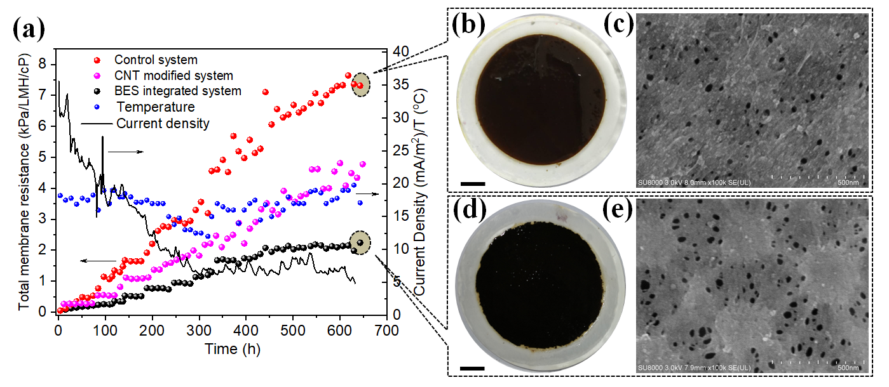

**Figure 1.** Temporal variation of TMR for the respective systems and of the current density of the BES integrated system (a); Pictures of the fouled membranes and SEM images of the membrane surface after removing the biofouling layer from the control (b, c) and the BES integrated (d, e) systems (scale bar: 1cm).

The change of the current density in the BES integrated system was also monitored via the electrochemical workstation (Figure 1a). A gradual decrease in the current density from over 35 mA/m2 (normalized to the membrane surface area) to less than 10 mA/m2 after 300 hours operation was observed, but was then relatively unchanging at around 7.5 mA/m2 for the remaining 300 hours. Before the formation of a biofilm, it can be assumed that oxidation reactions on the anode surface, due to the poised potential, contributed to the faradic current production. Subsequently, the gradual formation of a biofilm on the conductive membrane surface likely impeded this process. However, after the biofilm formation, the electron transfer between the biofilm and the electrode contributes to the current production, and therefore presents an equalizing current.

The surface morphology of the membranes after removal of the fouled layer was observed via SEM at the end of the period of operation (Figure 1c and 1e). As expected, in comparison to the control system, which displayed many agglomerations on the membrane surface and likely blockages of the membrane pores (Figure 1c), the membrane pores of the BES integrated system were clearer (Figure 1e), which was consistent with the lower TMR of the BES integrated system compared to the control system. In one respect, the CNT layer can act as a physical barrier avoiding the direct contact of the biofilm with the membrane surface, and thus reducing the interactions between the EPS and the membrane surface. In addition, Pinto et al. showed that the applied potential can influence the electron exchange between the acclimated microbes and the electrode (Pinto et al., 2018), while the catabolic pathways of electrochemically active bacteria were also shown to be regulated by the electrode potentials (Hirose et al., 2018). Therefore, it is reasonable to believe that the poised potential can not only influence the viability of the microbes, but can also affect the EPS secretion and metabolism via the adjustment of metabolic pathways, according to the electrode potential changes, and therefore affect the development of membrane fouling.

**3.2. Microbial electron transfer in the BES integrated system**

The evolution of the redox reactions of the conductive membrane in the BES integrated system was electrochemically evaluated via CV tests (Figure 2a). The oxidation peak was observed once the electrode potential of 1.0 V was poised at the first week, with a blue shift of the anodic potential from around 212 mV to approximately 73 mV after 4 weeks of operation, which may have resulted from the peak superposition and the changes of the surrounding microenvironment. However, no obvious corresponding peak reduction was obtained until the end of the second week and the currents of the redox peaks revealed an increasing trend thereafter, indicating the increased involvement of electron transfer activities on the surface of the conductive membrane with the operation time. In comparison, the system using the MWCNT modified membrane but without the poised potential showed no redox peak even at the end of the operation (Figure S4). To further interpret the nature of these redox species, CV tests at different scan rates were conducted at the end of the experiment (Figure 2b). It can be seen that the apparent anodic potential was around -245 mV (vs Ag/Ag/Cl), which could partially result from the oxidation of the Fe(s) from the SSM current collector via reaction (1) (Mansoorian et al., 2014; Ramasubramanian et al., 1985):

$Fe\left(s\right)+6H_{2}O→Fe{(H_{2}O)}_{4}{(OH)}_{2}\left(aq\right)+{2H}^{+}+2e^{-}$ (1)

In the bulk solution at neutral pH, the oxidized iron will form amorphous precipitates via reactions (2) and (3):

$$Fe{(H_{2}O)}_{4}{(OH)}_{2}\left(aq\right)→amFe{(H_{2}O)}_{4}{(OH)}_{2}\left(s\right) (2)$$

$$4Fe{(H_{2}O)}_{4}{(OH)}_{2}\left(aq\right)+O_{2}→4amFe{{\left(H_{2}O\right)}_{3}\left(OH\right)}_{3}(s)+2H_{2}O (3)$$

The formation of the precipitates will interfere with the reduction of Fe2+ or Fe3+, which could be the reason for the negligible reduction peak during the first week of operation. However, after two weeks of operation, the reduction peak gradually appeared with the reduction potential at around -230 mV (vs Ag/AgCl) and the consequent blue shift of the oxidation peak. The appearance of the reduction effect could be ascribed to the gradual formation of a biofilm on the conductive membrane surface, since the microbes accumulated within the biofilm could facilitate the reduction of amorphous ferric precipitation via an outer-membrane *c*-type cytochrome mediated reaction, through extracellular electron transfer (Hernandez and Newman, 2001):

${cyt}_{ox}+e^{-}↔{cyt}_{red}$ (4)

${cyt}_{red}+{Fe}^{3+}/(amFe{\left(OH\right)}_{3\left(s\right)}+{3H}^{+})→{cyt}_{ox}+{Fe}^{2+}/{(Fe}^{2+}+3H_{2}O)$ (5)

Outer-membrane *c*-type cytochromes, like octoheme OmcZ, hexaheme OmcS, decaheme OmcA, dodecaheme  OmcB and MtrC, facilitating both DIET and MET (as shown in Figure 2e, pathway 1 and 2), have different macroscopic redox potentials, with the centered potential varying from -420 to -130 mV (vs Ag/AgCl) (Carmona-Martinez et al., 2011; Liu et al., 2011a; Liu et al., 2011b).[45] Moreover, the reduction of Fe (III) via cytochromes was observed among different bacteria species: Eggleston et al. showed that Fe (III) reduction on a hematite electrode via OmcA from *Shewanella oneidensis* MR-1 had a midpoint potential of around -210 mV (vs Ag/AgCl, pH 7.0, scan rate, 50 mV/s) (Eggleston et al., 2008), and Venkidusamy et al. found that the reduction of Fe (III) by strain *Citrobacter* sp. KVM11 had a reduction potential of around -250 mV (vs Ag/AgCl, pH 7.0, scan rate 5 mV/s) (Venkidusamy et al., 2018). In addition, it can be seen that the redox peaks showed a shift when the scan rate increased, indicating that the equilibria (electron exchange) between the microbes within the biofilm and the electrode interface cannot be rapidly established (due to the lower reaction kinetics) compared to the fully reversible system, and therefore presented a sluggish increment of current with a corresponding shift of the maximum current peaks. Similar results were also observed during the EET between the *S. woodyi* and an indium tin oxide (ITO) electrode, which was primarily directed by the cytochromes located on the outer membrane surface (Tian et al., 2017).

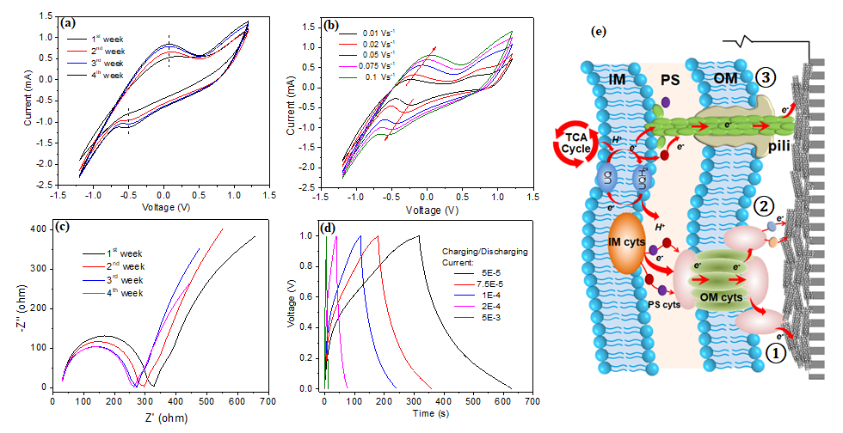

**Figure 2.** CV curves of the MWCNT modified membrane in the BES integrated system at different periods during the operation (a) and at various scan rates from 0.01 V/s to 0.1 V/s at the end of the operation (b). Comparison of EIS spectra of the MWCNT modified membrane at different periods during the operation (c). Galvanostatic charge/discharge curves of the MWCNT modified membrane at the end of the operation (d). Potential electron transfer pathways between the formed biofilm and conductive membrane (e): electron transfer via outer membrane surface bounded cytochromes (1), self-produced redox mediators (2) and nanowires (3) (IM cyts: inner membrane cytochromes; PS cyts: Periplasm cytochromes; OM cyts: outer membrane cytochromes; UQ: oxidized form of ubiquinone; UQH2: reduced form of ubiquinone).

The results from EIS (electrochemical impedance spectroscopy) also showed clearly the decrement of interfacial charge transfer resistance (Figure 2c), indicating an enhanced electron transfer with the biofilm formation. In addition to the cytochromes, microbial nanowires, also known as pili (a kind of metallic-like conductor formed within the biofilm), can also contribute to the decrement of charge transfer resistance due to the ability for long range EET within the conductive biofilm (Malvankar et al., 2012; Malvankar et al., 2011) (as shown in Figure 2e, pathway 3). In addition, EPS were also recently found to be a transient media facilitating the microbial EET processes with a combined pair of CV peaks after EPS depletion (anodic peak at -270 mV and cathodic peak at -205 mV, versus Ag/AgCl), and it was shown that the electrochemically active substances, such as flavins and cytochromes, can be stored within EPS and responsible for the EET (Xiao et al., 2017). GCD (galvanostatic charge-discharge) tests were further conducted to investigate the influence of exoelectrogens acclimation on the capacitance of the conductive membrane (Figure 2d). Practically symmetric rather than ideal triangular curves were observed, especially at low charge/discharge currents. Specifically, the curves firstly showed a steep increase which represented the energy dissipation in the equivalent series resistance Rs, followed by a quasi-linear stage, indicating the existence of pseudo-capacitance. In one respect, the porous structure of the CNT layer and electrically conductive biofilm performed like a porous electrode and therefore didn’t follow a RsC model during the charge/discharge period (Conway and Pell, 2002). Furthermore, it has also been proposed that the electrical activity of the cytochromes within exoelectrogens in the biofilm formed on the electrode surface will also bring microbial faraday processes involving EET, and therefore confer large pseudo-capacitance (Malvankar et al., 2012).

**3.3. EPS accumulation on the membrane surface**

The operation of UF processes is inevitably accompanied by the formation of a biofilm on the membrane surface, and the biofilm will gradually be maturing after long-term operation. EPS are important self-produced components of the biofilm which provide a scaffold structure that helps the biofilm adhere to the membrane surface and contribute to the cohesion and maturation of the biofilm (Flemming and Wingender, 2010). Various studies have demonstrated that the amount of EPS directly determines the extent and rate of fouling during the membrane operation (Desmond et al., 2018; Kimura et al., 2004). Therefore, distinguishing the circumstance of the accumulated EPS on the membrane surface will help further interpretation of the behaviour of the BES integrated system in moderating membrane fouling. With the utilization of CLSM, the distribution and amount of EPS within the biofilm matrix can be easily visualized. As shown in Figure 3a, 3b and 3e, 3f, proteins and polysaccharides can be observed in both systems. However, the quantity of proteins and polysaccharides in the BES integrated system were clearly less than in the control system, which is consistent with their measured concentrations in each case (Figure 3i). More significantly, it was evident that the proteins and polysaccharides of the control system existed in a “larger cluster” form, while in the BES integrated system, discrete bacteria colonies were more likely to be formed. The DNA results (DAPI stained images; Figures 3c and 3g) also showed a similar trend to the proteins and polysaccharides, with the DNA concentration in the control system around 74% higher than in the BES integrated system (Figure 3j).

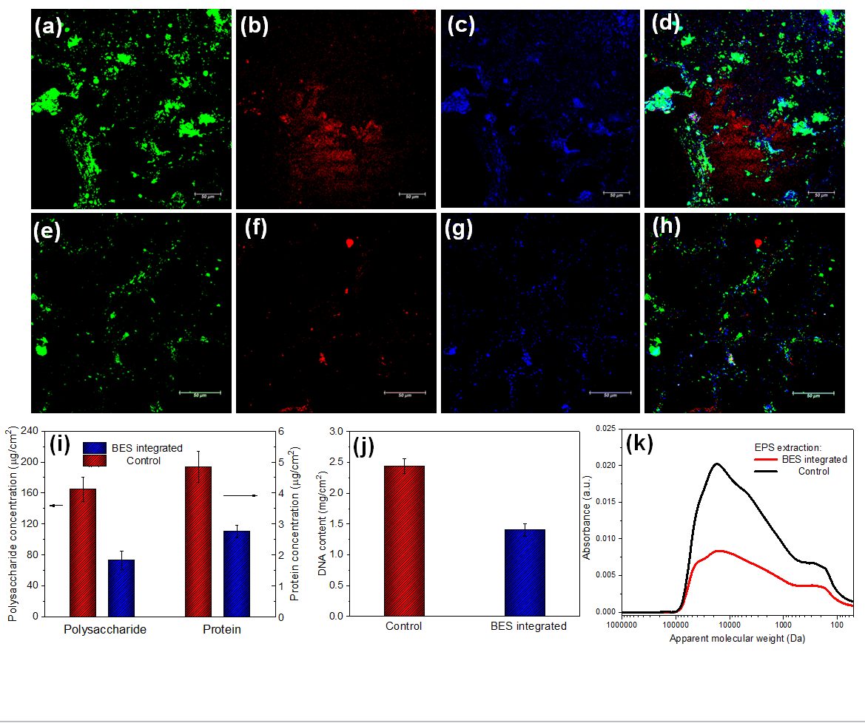

**Figure 3.** Influence of BES integrated system on the accumulation of EPS on the membrane surface. CLSM images of biofilm formed on control (a, b, c and d), and BES integrated (e, f, g and h), membrane surfaces stained with FITC (proteins and amino-sugars of cells and EPS, green), ConA (α-mannopyranosyl and α-glucopyranosyl sugar residues, red) and DAPI (DNA, blue). Polysaccharides, proteins and DNA concentration extracted from the biofilm of respective systems (i and j). MW distributions of the EPS extracted from the respective systems (k).

To further validate these observations, EPS extracted from the biofilm on the surface of respective membranes were analyzed by SEC to investigate the MW distribution of the organic matter (Figure 3k). It can be seen that the DOM concentration in the biofilm of the BES integrated system was substantially less than the control system, which included both biopolymers (apparent MW range of 10-100 kDa) and humic substances (MW range lower than 10 kDa). This was also indicated visually by combining the CLSM pictures of protein, polysaccharides and DNA, from the respective system biofilms (Figure 3d and 3h). In addition, the FTIR spectra of the pristine and bio-fouled membranes from the respective systems also indicated, indirectly, that lower amounts of EPS accumulated on the membrane surface of the BES integrated system, and that the interactive forces between the biopolymers and membrane surface were stronger in the control system than the BES integrated system (SI, Figure S5). Overall, these results clearly revealed that BES integrated system has the ability to substantially reduce the accumulation of EPS on the membrane surface, and thereby reduce the increase in TMR.

Typically, bacteria have resting potential values ranging from -140 to -75 mV (Stratford et al., 2019), and an imposed external voltage can disturb the intracellular electron transfer with subsequent oxidative stress lifting and inducing ROS burst in the bacteria (Wang et al., 2018), which could be mediated by enzymes such as NAD(P)H oxidase, xanthine oxidase and superoxide dismutase (Droge, 2002). In eukaryotic cells, mitochondria are the major sources of ROS, which can produce H2O2, for example, via the leakage of O2•- from their respiratory chain through:

$O_{2}^{•-}+2H^{+}+e^{-}→H_{2}O_{2}$ (6)

The production of Fe (II) via the microbial reduction (Eq. 5) can therefore induce extra oxidation stress and initiate Fe-catalysed autoxidation, which is driven by the Fenton reaction:

${Fe}^{2+}+H_{2}O_{2}→{Fe}^{3+}+{OH}^{-}+$•OH (7)

The production of hydroxyl radicals is extremely toxic and lethal to microbes, resulting in impairment of the morphology and killing of bacteria. In addition, the hydroxyl radical can also contribute to the degradation (oxidation) of biological macromolecules (including proteins, polysaccharide, lipid and DNA etc.) (Duan and Kasper, 2011; Valko et al., 2007), and therefore alleviate membrane fouling. Furthermore, it has also been shown previously that the microbes will produce fewer EPS under anodic respiration compared to anaerobic respiration, and thereby lower external fouling (Ishizaki et al., 2016). In contrast, for the control membrane, owing to the lack of external electron acceptors, more biomass associated products (BAP) (mostly consisting of high MW OMs with molecular size >10 kDa) are expected to be generated from the decay of biomass (Boero et al., 1996), which can induce severe membrane fouling (Jiang et al., 2010). Moreover, it has also been found that under the stimulation of the electricity, some specific bacteria will have higher activity, which can contribute to a higher EPS degradation rate and lead to reduced membrane fouling (Tian et al., 2015).

**3.4. Influence of BES integration on biofilm formation**

**3.4.1. Surface morphology**

SEM images of the biofilm formed on the membrane surface of respective systems at the end of the operation were taken, to reveal visually the effect of the BES integration on the biofilm formation (Figures 4a, 4b, 4d and 4e). Significant differences can be observed in terms of the bacterial accumulation. It can be seen that the membrane surface of the control system was occupied by a high density of microbes (Figures 4a and 4b), which is consistent with the “larger cluster” - like EPS, as revealed by the CLSM observations (Figures 3j and 4c). In contrast, the bacterial growth on the surface of the BES integrated membrane surface was much less than on the control system membrane and bacteria lysis or morphology impairment also can be observed (Figures 4d and 4e), resulting in a comparatively small amount of EPS accumulation, as shown in Figure 4f. Additionally, it is noticeable that the cross-section of biofilm-derived from the z-stack of respective CLSM images also showed significant differences. More specifically, it can be seen that the distribution of EPS in the biofilm of the control system was concentrated in a thin layer of around 6 μm (Figure 4c). However, for the BES integrated system, a vertical directed structure of EPS within the biofilm matrix along the z-axis can be observed (Figure 4f). This distinctive distribution of EPS within the biofilm formed on the membrane surface with BES integration also indicated the different EPS secretion regime compared to the control system.

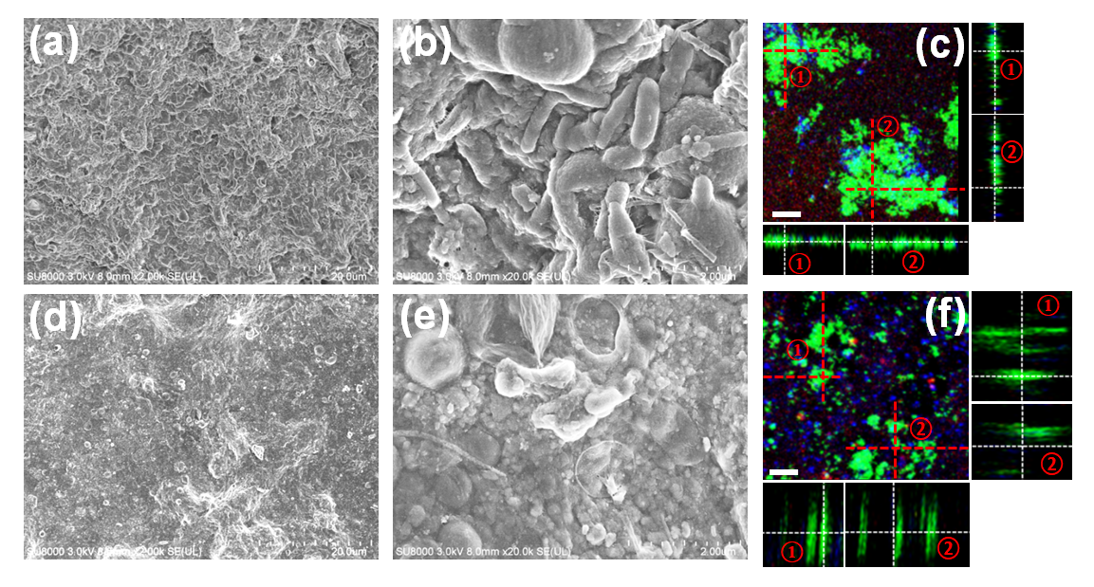

**Figure 4.** SEM observations of the biofilm formed on the control (a, b) and BES integrated (d, e) membranes. CLSM images and the corresponding side views of the biofilm formed on the membrane surface of the respective systems (c, f) (scale bar: 10 μm).

Read et al. found that the species within the biofilm will have a higher viability adjacent to the electron acceptor (either the electrode or the soluble electron acceptors in solution) (Read et al., 2010). Therefore, it can be assumed that the microbes acclimated on the membrane surface of the control system can only utilize the oxidized substances existing in the membrane tank as the electron acceptor, and this results in a higher viability in the outer layer of the biofilm. In contrast, the bacteria in the BES integrated system might prefer to use the electrode as the electron acceptor and this therefore may induce a higher viability inside the biofilm. Many studies have focused on the electron transfer between the electrically conductive biofilm and the electrode (Lovley, 2017), and supposed that the transport of electrons from bacteria to the electrode can be facilitated via self-produced redox-active proteins, for example, the cytochromes as mentioned above. In addition, the nanowires (or pili) were also verified as having the ability for long distance EET. Therefore, the green colour stained proteins could be partially ascribed to the formation of electron transport pathways within the biofilm linking the microbes and electrode (Figure 4f).

**3.4.2. Cross-section**

The cross-section of the biofilm attached to the membrane surfaces of the respective systems was also observed via SEM after air-drying. The double-layer structure of the MWCNT modified membrane can be easily identified in the BES integrated system with the MWCNT thickness of around 1.62 μm (Figure 5f). In terms of the biofilm layer, the thickness of the control system layer (2.96 μm) appeared to be greater than the layer of the BES integrated system (2.35 μm) (Figure 5c and 5f). It was reported by many studies that the EPS acts as the scaffold for the biofilm formation and a higher concentration of EPS will facilitate the biofilm formation and adhesion on the membrane surface (Flemming and Wingender, 2010), and therefore produce a thicker accumulation. Moreover, the thicker biofilm that forms on the pristine membrane could contain more internal spaces and therefore induce a slightly faster decrease of the CA with time (SI, Figure S6). It was also evident that the inner side of the membranes displayed significant differences (Figure 5b and 5e), where the inner void spaces of the BES integrated system appeared much cleaner than the control system, indicating less accumulation of foulants in the inner structure of the membrane, and which corresponded to the lower observed TMR development.

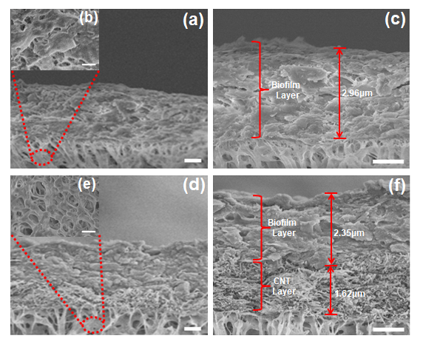

**Figure 5.** SEM images of the cross-section of the bio-fouled membrane from the control (a-c) and BES integrated (d-e) systems (scale bar: 1 μm).

**3.5. Microbial diversity shift induced by the BES integration**

To investigate the influences of the poised potential on microbial diversity, DNA extracted from the biofilm accumulated on the membrane surface of respective systems was analysed via 16s rRNA amplicon sequencing technique. It was observed that the microbial diversity was slightly influenced by the poised potential at the phylum level, with *Proteobacteria* and *Bacteroidetes* as the two most abundant phyla in both systems (Figure 6a). For these, the *Proteobacteria* of the control system was about 5.9% higher (65.98% vs 60.11%), and the *Bacteroidetes* was around 4.3% lower (18.99% vs 24.26%), than the BES integrated system. Further elucidation of the microbial differences between the control and the BES integrated systems was achieved via subdivisions at class, order and family levels (Figure 6b and Figure S7). It was found that *Cytophagaceae* in the BES integrated system was 5.8% higher (22.2% vs 16.4%) than the control system, which could facilitate EPS digestion within the biofilm, since the family *Cytophagaceae* is characterized as being able to metabolize macromolecules such as polysaccharides, proteins and cellulose (McBride et al., 2014). Significantly, the family *Rhodocyclaceae*, which consists of the genus *Zoogloea* and *Methyloversatilis*, was substantially higher in the control system (Figure 6c). It is well known that the genus of *Zoogloea* has an ability to produce prolific quantities of EPS using different carbon sources (Parsons and Dugan, 1971), and *Methyloversatilis* is a salinity tolerant bacteria, also with high soluble microbial product production (Luo et al., 2018). Therefore, it is reasonable to believe that the reduction of family *Rhodocyclaceae* can greatly contribute to the decrease of EPS accumulation on the membrane surface and therefore a lower extent of membrane fouling.

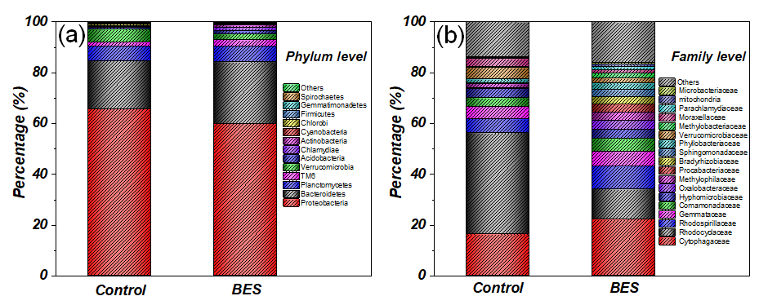

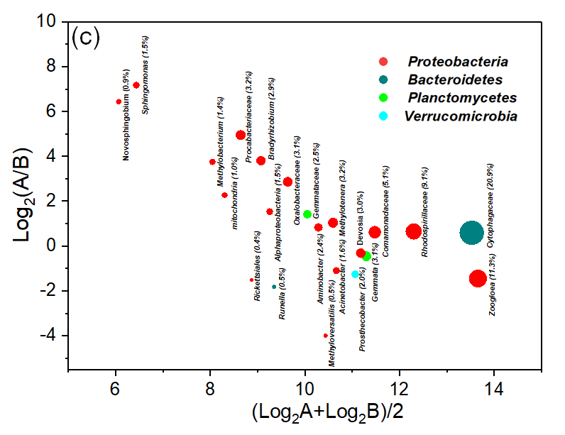

**Figure 6.** Taxonomic composition of the microbial community within the biofilm formed on the membranes of the control and BES integrated systems, at phylum (a) and family (b) levels. Differences in the microbial community at the genus level between the control and BES integrated systems (c). X-coordinate reflects the relative abundance of bacteria and y-coordinate indicates the different genus abundance between the control and BES integrated systems. A positive value represents the high abundance of the genus in the BES applied system and vice versa. The shadow area represents the relative abundance of the genus in the BES integrated system (as shown in each bracket). A and B represent the number of OTUs representing each genus for the BES integrated and control systems, respectively.

Correspondingly, the reduced presence of *Rhodocyclaceae* in the BES integrated system favored the appearance and increment of some electroactive microbes (Figure 6c, Table S2). *Oxalobacteraceae*, for instance, which has been shown to play a role in anodic transfer (Mohottige et al., 2018), had a substantial increase from 0.4% to 3.1%, while*Comamonadaceae* and *Rhodospirillaceae*, which are both electroactive bacteria (Hassan et al., 2018; Matturro et al., 2017), increased from 3.2% to 5.1% and 5.6% to 9.1%, respectively, after BES integration. *Bradyrhizobium*, another type of electrogenic bacteria which was found to be the dominant population in an oligotrophic bioelectrochemical system, also had a significant increase from 0.2% to 2.9% (Barbato et al., 2017; Phung et al., 2004). More significantly, the (Operational Taxonomic Units) OTUs of the ferric reducing related bacteria *Sphingomonas* and the electro-biocatalytic microbe *Methylobacterium* (Ding et al., 2015; Hwang et al., 2015) had a notable increase from less than 0.1% to 1.5% and 0.1% to 1.4%, respectively, both of which could contribute to the bio-reduction of Fe (III) (Hu et al., 2014). In addition to the increase of these electrical related bacteria, it is noteworthy that the *Mitochondria* also showed a significant increase from only 0.2% to 1.0%. It is well known that the *Mitochondria* play a significant role in proton pumping and ATP production, which could enhance the electron transfer from intracellular to extracellular via the tricarboxylic acid (TCA) cycle and therefore facilitate the electron transfer between the bacteria and electrode (Xu et al., 2015a; Zhang et al., 2017). Furthermore, they are also the major sources of ROS, which can facilitate the production of ROS when the bacteria were under oxidative stress (Droge, 2002), with imposed external voltage, for example. Overall, it can be seen that the BES integration facilitated the acclimation of electroactive bacteria on the membrane surface, which was believed to be one of the phenomena leading to lower membrane fouling.

**4. Conclusions**

BES integrated systems are wildly utilized in wastewater treatment and biosynthesis but rarely in drinking water treatment, mainly due to the limitation of carbon sources within the natural water. However, in terms of membrane processes, they provide a barrier to separate not only suspended solids but also the microorganisms from influent waters. The accumulation of the microbes, together with the low concentrations of biopolymers present in the raw water, can gradually lead to severe irreversible membrane fouling if no action is taken. Here, in this study, the *in-situ* integration of BES with UF has been shown to be effective in mitigating membrane fouling. The selectivity of the potential poised conductive membrane on microbial diversity is considered to be the main reason for the membrane fouling alleviation, by which the microbes which cannot adapt to the redox stratified environment are prone to inactivation or even lysis. In contrast, the growth of electrically active microbes, which can gain energy via the electrode as the electron acceptor, are favored. In addition, it was also found that the poised potential could stimulate the microbes to degrade high MW biopolymers to low MW substances, through biological or biochemical degradation, which benefits the reduction of irreversible membrane fouling from a long-term operational perspective. Further study of the electron transfer regimes between the microbes and the conductive membrane under different poised potentials, and the corresponding metabolic pathways or synergistic biochemical degradation of the biopolymers, are required in order to fully establish the potential of BES integrated systems in practical applications.

**Declaration of competing interest**

The authors declare that they have no known competing financial interests or personal relationships that could have appeared to influence the work reported in this paper.

**Acknowledgments**

This research was supported by a Marie Curie International Incoming Fellowship (FP7-PEOPLE-2012-IIF-328867) within the 7th European Community Framework Programme. This work was also supported by National Natural Science Foundation of China (Grants No. 51908537 and 51108444) and Key Research and Development Plan of the Ministry of Science and Technology (2019YFD1100104 and 2019YFC1906501) for the financial support of the work.

**Appendix A. Supplementary data**

The following is the Supplementary data to this article:

Schematic diagram of the laboratory-scale BES integrated UF system;main parameters of the lake water quality; experimental procedures and analytical methods; characteristics of the DOM in the control and the BES integrated systems; nutrients removal by the control and the BES integrated systems throughout the operation; CV curves of the MWCNT modified membrane without poised potential at various scan rates; FTIR spectra of pristine and bio-fouled membranes from control and BES integrated systems**;** initial and dynamic values of the membrane contact angle (CA) in the control and BES integrated systems; SEM-EDS results of the biofilm formed on the membrane surface of control and BES integrated system; taxonomic composition of the microbial community within the biofilm formed in the control and the BES integrated systems at class and order level**;** distribution of microbial species in respective systems at genus level.

**References**

Barbato, R.A., Foley, K.L., Toro-Zapata, J.A., Jones, R.M. and Reynolds, C.M. 2017. The power of soil microbes: Sustained power production in terrestrial microbial fuel cells under various temperature regimes. Appl Soil Ecol 109, 14-22.

Barry, M.C., Hristovski, K. and Westerhoff, P. 2014. Membrane Fouling by Vesicles and Prevention through Ozonation. Environ. Sci. Technol. 48(13), 7349-7356.

Boero, V.J., Bowers, A.R. and Eckenfelder, W.W. 1996. Molecular weight distribution of soluble microbial products in biological systems. Water Science and Technology 34(5-6), 241-248.

Borea, L., Puig, S., Monclus, H., Naddeo, V., Colprim, J. and Belgiorno, V. 2017. Microbial fuel cell technology as a downstream process of a membrane bioreactor for sludge reduction. Chemical Engineering Journal 326, 222-230.

Carmona-Martinez, A.A., Harnisch, F., Fitzgerald, L.A., Biffinger, J.C., Ringeisen, B.R. and Schroder, U. 2011. Cyclic voltammetric analysis of the electron transfer of Shewanella oneidensis MR-1 and nanofilament and cytochrome knock-out mutants. Bioelectrochemistry 81(2), 74-80.

Cho, E.J. and Ellington, A.D. 2007. Optimization of the biological component of a bioelectrochemical cell. Bioelectrochemistry 70(1), 165-172.

Conway, B.E. and Pell, W.G. 2002. Power limitations of supercapacitor and capacitance distribution operation associated with resistance in porous electrode devices. Journal of Power Sources 105(2), 169-181.

Desmond, P., Best, J.P., Morgenroth, E. and Derlon, N. 2018. Linking composition of extracellular polymeric substances (EPS) to the physical structure and hydraulic resistance of membrane biofilms. Water Res. 132, 211-221.

Ding, J., Zhang, Y.B., Quan, X. and Chen, S. 2015. Anaerobic biodecolorization of AO7 by a newly isolated Fe(III)-reducing bacterium Sphingomonas strain DJ. Journal of Chemical Technology and Biotechnology 90(1), 158-165.

Ding, Q., Yamamura, H., Yonekawa, H., Aoki, N., Murata, N., Hafuka, A. and Watanabe, Y. 2018. Differences in behaviour of three biopolymer constituents in coagulation with polyaluminium chloride: Implications for the optimisation of a coagulation-membrane filtration process. Water Res. 133, 255-263.

Droge, W. 2002. Free radicals in the physiological control of cell function. Physiol. Rev. 82(1), 47-95.

Duan, J.Y. and Kasper, D.L. 2011. Oxidative depolymerization of polysaccharides by reactive oxygen/nitrogen species. Glycobiology 21(4), 401-409.

Eggleston, C.M., Voros, J., Shi, L., Lower, B.H., Droubay, T.C. and Colberg, P.J.S. 2008. Binding and direct electrochemistry of OmcA, an outer-membrane cytochrome from an iron reducing bacterium, with oxide electrodes: A candidate biofuel cell system. Inorg. Chim. Acta 361(3), 769-777.

Flemming, H.C. and Wingender, J. 2010. The biofilm matrix. Nature Reviews Microbiology 8(9), 623-633.

Gao, W., Liang, H., Ma, J., Han, M., Chen, Z.L., Han, Z.S. and Li, G.B. 2011. Membrane fouling control in ultrafiltration technology for drinking water production: A review. Desalination 272(1-3), 1-8.

Hassan, M., Fernandez, A.S., San Martin, I., Xie, B. and Moran, A. 2018. Hydrogen evolution in microbial electrolysis cells treating landfill leachate: Dynamics of anodic biofilm. International Journal of Hydrogen Energy 43(29), 13051-13063.

Hernandez, M.E. and Newman, D.K. 2001. Extracellular electron transfer. Cell. Mol. Life Sci. 58(11), 1562-1571.

Hirose, A., Kasai, T., Aoki, M., Umemura, T., Watanabe, K. and Kouzuma, A. 2018. Electrochemically active bacteria sense electrode potentials for regulating catabolic pathways. Nature Communications 9.

Howe, K.J. and Clark, M.M. 2002. Fouling of microfiltration and ultrafiltration membranes by natural waters. Environ. Sci. Technol. 36(16), 3571-3576.

Hu, C.H., Zhang, Y.C., Zhang, L. and Luo, W.S. 2014. Effects of Microbial Iron Reduction and Oxidation on the Immobilization and Mobilization of Copper in Synthesized Fe(III) Minerals and Fe-Rich Soils. Journal of Microbiology and Biotechnology 24(4), 534-544.

Hwang, H., Yeon, Y.J., Lee, S., Choe, H., Jang, M.G., Cho, D.H., Park, S. and Kim, Y.H. 2015. Electro-biocatalytic production of formate from carbon dioxide using an oxygen-stable whole cell biocatalyst. Bioresour. Technol. 185, 35-39.

Ishii, S., Suzuki, S., Norden-Krichmar, T.M., Phan, T., Wanger, G., Nealson, K.H., Sekiguchi, Y., Gorby, Y.A. and Bretschger, O. 2014. Microbial population and functional dynamics associated with surface potential and carbon metabolism. ISME Journal 8(5), 963-978.

Ishii, S., Suzuki, S., Norden-Krichmar, T.M., Tenney, A., Chain, P.S.G., Scholz, M.B., Nealson, K.H. and Bretschger, O. 2013. A novel metatranscriptomic approach to identify gene expression dynamics during extracellular electron transfer. Nature Communications 4.

Ishizaki, S., Papry, R.I., Miyake, H., Narita, Y. and Okabe, S. 2019. Membrane Fouling Potentials of an Exoelectrogenic Fouling-Causing Bacterium Cultured With Different External Electron Acceptors. Frontiers in Microbiology 9.

Ishizaki, S., Terada, K., Miyake, H. and Okabe, S. 2016. Impact of Anodic Respiration on Biopolymer Production and Consequent Membrane Fouling. Environ. Sci. Technol. 50(17), 9515-9523.

Jiang, T., Kennedy, M.D., De Schepper, V., Nam, S.N., Nopens, I., Vanrolleghem, P.A. and Amy, G. 2010. Characterization of Soluble Microbial Products and Their Fouling Impacts in Membrane Bioreactors. Environ. Sci. Technol. 44(17), 6642-6648.

Kang, S., Herzberg, M., Rodrigues, D.F. and Elimelech, M. 2008. Antibacterial effects of carbon nanotubes: Size does matter. Langmuir 24(13), 6409-6413.

Kiely, P.D., Regan, J.M. and Logan, B.E. 2011. The electric picnic: synergistic requirements for exoelectrogenic microbial communities. Curr. Opin. Biotechnol. 22(3), 378-385.

Kimura, K., Hane, Y., Watanabe, Y., Amy, G. and Ohkuma, N. 2004. Irreversible membrane fouling during ultrafiltration of surface water. Water Res. 38(14-15), 3431-3441.

Li, F., Li, Y.X., Cao, Y.X., Wang, L., Liu, C.G., Shi, L. and Song, H. 2018. Modular engineering to increase intracellular NAD (H/(+)) promotes rate of extracellular electron transfer of Shewanella oneidensis. Nature Communications 9.

Liu, C.G., Xue, C., Lin, Y.H. and Bai, F.W. 2013. Redox potential control and applications in microaerobic and anaerobic fermentations. Biotechnol. Adv. 31(2), 257-265.

Liu, H.A., Matsuda, S., Kawai, T., Hashimoto, K. and Nakanishi, S. 2011a. Feedback stabilization involving redox states of c-type cytochromes in living bacteria. Chemical Communications 47(13), 3870-3872.

Liu, S.S., Qu, H.M., Yang, D., Hu, H., Liu, W.L., Qiu, Z.G., Hou, A.M., Guo, J.H., Li, J.W., Shen, Z.Q. and Jin, M. 2018. Chlorine disinfection increases both intracellular and extracellular antibiotic resistance genes in a full-scale wastewater treatment plant. Water Res. 136, 131-136.

Liu, X.W., Chen, J.J., Huang, Y.X., Sun, X.F., Sheng, G.P., Li, D.B., Xiong, L., Zhang, Y.Y., Zhao, F. and Yu, H.Q. 2014. Experimental and Theoretical Demonstrations for the Mechanism behind Enhanced Microbial Electron Transfer by CNT Network. Scientific reports 4.

Liu, Y., Kim, H., Franklin, R.R. and Bond, D.R. 2011b. Linking Spectral and Electrochemical Analysis to Monitor c-type Cytochrome Redox Status in Living Geobacter sulfurreducens Biofilms. Chemphyschem : a European journal of chemical physics and physical chemistry 12(12), 2235-2241.

Logan, B.E., Rossi, R., Ragab, A.a. and Saikaly, P.E. 2019. Electroactive microorganisms in bioelectrochemical systems. Nature Reviews Microbiology, 1.

Lovley, D.R. 2017. Happy together: microbial communities that hook up to swap electrons. ISME Journal 11(2), 327-336.

Luo, G., Wang, Z., Li, Y., Li, J. and Li, A.-M. 2018. Salinity stresses make a difference in the start-up of membrane bioreactor: performance, microbial community and membrane fouling. Bioprocess Biosystems Eng., 1-10.

Malvankar, N.S., Mester, T., Tuominen, M.T. and Lovley, D.R. 2012. Supercapacitors Based on c-Type Cytochromes Using Conductive Nanostructured Networks of Living Bacteria. Chemphyschem : a European journal of chemical physics and physical chemistry 13(2), 463-468.

Malvankar, N.S., Vargas, M., Nevin, K.P., Franks, A.E., Leang, C., Kim, B.C., Inoue, K., Mester, T., Covalla, S.F., Johnson, J.P., Rotello, V.M., Tuominen, M.T. and Lovley, D.R. 2011. Tunable metallic-like conductivity in microbial nanowire networks. Nature nanotechnology 6(9), 573-579.

Mansoorian, H.J., Mahvi, A.H. and Jafari, A.J. 2014. Removal of lead and zinc from battery industry wastewater using electrocoagulation process: Influence of direct and alternating current by using iron and stainless steel rod electrodes. Separation and Purification Technology 135, 165-175.

Matturro, B., Viggi, C.C., Aulenta, F. and Rossetti, S. 2017. Cable Bacteria and the Bioelectrochemical Snorkel: The Natural and Engineered Facets Playing a Role in Hydrocarbons Degradation in Marine Sediments. Frontiers in Microbiology 8.

McBride, M.J., Liu, W., Lu, X., Zhu, Y. and Zhang, W. 2014. The family cytophagaceae. The Prokaryotes: Other Major Lineages of Bacteria and The Archaea, 577-593.

Meister, S., Verbyla, M.E., Klinger, M. and Kohn, T. 2018. Variability in Disinfection Resistance between Currently Circulating Enterovirus B Serotypes and Strains. Environ. Sci. Technol. 52(6), 3696-3705.

Mohottige, T.N.W., Ginige, M.P., Kaksonen, A.H., Sarukkalige, R. and Cheng, K.Y. 2018. Rapid start-up of a bioelectrochemical system under alkaline and saline conditions for efficient oxalate removal. Bioresour. Technol. 250, 317-327.

Parsons, A.B. and Dugan, P.R. 1971. Production of Extracellular Polysaccharide Matrix by Zoogloea-Ramigera. Appl. Microbiol. 21(4), 657-&.

Phung, N.T., Lee, J., Kang, K.H., Chang, I.S., Gadd, G.M. and Kim, B.H. 2004. Analysis of microbial diversity in oligotrophic microbial fuel cells using 16S rDNA sequences. FEMS Microbiology Letters 233(1), 77-82.

Pinto, D., Coradin, T. and Laberty-Robert, C. 2018. Effect of anode polarization on biofilm formation and electron transfer in Shewanella oneidensis/graphite felt microbial fuel cells. Bioelectrochemistry 120, 1-9.

Ramasubramanian, N., Preocanin, N. and Davidson, R.D. 1985. Analysis of Passive Films on Stainless-Steel by Cyclic Voltammetry and Auger-Spectroscopy. Journal of the Electrochemical Society 132(4), 793-798.

Read, S.T., Dutta, P., Bond, P.L., Keller, J. and Rabaey, K. 2010. Initial development and structure of biofilms on microbial fuel cell anodes. BMC Microbiology 10.

Reguera, G., McCarthy, K.D., Mehta, T., Nicoll, J.S., Tuominen, M.T. and Lovley, D.R. 2005. Extracellular electron transfer via microbial nanowires. Nature 435(7045), 1098-1101.

Service, R.F. 2006. Desalination freshens up. Science 313(5790), 1088-1090.

Stockl, M., Teubner, N.C., Holtrnann, D., Mangold, K.M. and Sand, W. 2019. Extracellular Polymeric Substances from Geobacter sulfurreducens Biofilms in Microbial Fuel Cells. ACS applied materials & interfaces 11(9), 8961-8968.

Stratford, J.P., Edwards, C.L.A., Ghanshyam, M.J., Malyshev, D., Delise, M.A., Hayashi, Y. and Asally, M. 2019. Electrically induced bacterial membrane-potential dynamics correspond to cellular proliferation capacity. Proceedings of the National Academy of Sciences of the United States of America 116(19), 9552-9557.

Sun, D., Cheng, S.A., Wang, A.J., Li, F.J., Logan, B.E. and Cen, K.F. 2015. Temporal-Spatial Changes in Viabilities and Electrochemical Properties of Anode Biofilms. Environ. Sci. Technol. 49(8), 5227-5235.

Tian, X.C., Zhao, F., You, L.X., Wu, X.E., Zheng, Z.Y., Wu, R.R., Jiang, Y.X. and Sun, S.G. 2017. Interaction between in vivo bioluminescence and extracellular electron transfer in Shewanella woodyi via charge and discharge. PCCP 19(3), 1746-1750.

Tian, Y., Li, H., Li, L.P., Su, X.Y., Lu, Y.B., Zuo, W. and Zhang, J. 2015. In-situ integration of microbial fuel cell with hollow-fiber membrane bioreactor for wastewater treatment and membrane fouling mitigation. Biosensors & bioelectronics 64, 189-195.

Valko, M., Leibfritz, D., Moncol, J., Cronin, M.T.D., Mazur, M. and Telser, J. 2007. Free radicals and antioxidants in normal physiological functions and human disease. Int. J. Biochem. Cell Biol. 39(1), 44-84.

Venkidusamy, K., Hari, A.R. and Megharaj, M. 2018. Petrophilic, Fe(III) Reducing Exoelectrogen Citrobacter sp KVM11, Isolated From Hydrocarbon Fed Microbial Electrochemical Remediation Systems. Frontiers in Microbiology 9.

Wang, G.M., Feng, H.Q., Hu, L.S., Jin, W.H., Hao, Q., Gao, A., Peng, X., Li, W., Wong, K.Y., Wang, H.Y., Li, Z. and Chu, P.K. 2018. An antibacterial platform based on capacitive carbon-doped TiO2 nanotubes after direct or alternating current charging. Nature Communications 9.

Wang, H.M. and Ren, Z.Y.J. 2013. A comprehensive review of microbial electrochemical systems as a platform technology. Biotechnol. Adv. 31(8), 1796-1807.

Wang, Y.H., Wu, Y.H., Tong, X., Yu, T., Peng, L., Bai, Y., Zhao, X.H., Huo, Z.Y., Ikuno, N. and Hu, H.Y. 2019. Chlorine disinfection significantly aggravated the biofouling of reverse osmosis membrane used for municipal wastewater reclamation. Water Res. 154, 246-257.

Werber, J.R., Osuji, C.O. and Elimelech, M. 2016. Materials for next-generation desalination and water purification membranes. Nat Rev Mater 1(5).

Xiao, Y., Zhang, E.H., Zhang, J.D., Dai, Y.F., Yang, Z.H., Christensen, H.E.M., Ulstrup, J. and Zhao, F. 2017. Extracellular polymeric substances are transient media for microbial extracellular electron transfer. Sci Adv 3(7).

Xu, C., Poon, K., Choi, M.M.F. and Wang, R.H. 2015a. Using live algae at the anode of a microbial fuel cell to generate electricity. Environmental Science and Pollution Research 22(20), 15621-15635.

Xu, L., Zhang, G.Q., Yuan, G.E., Liu, H.Y., Liu, J.D. and Yang, F.L. 2015b. Anti-fouling performance and mechanism of anthraquinone/polypyrrole composite modified membrane cathode in a novel MFC-aerobic MBR coupled system. RSC Advances 5(29), 22533-22543.

Yang, R., Jang, H., Stocker, R. and Gleason, K.K. 2014. Synergistic Prevention of Biofouling in Seawater Desalination by Zwitterionic Surfaces and Low-Level Chlorination. Advanced Materials 26(11), 1711-1718.

Yu, W.Z., Xu, L., Graham, N. and Qu, J.H. 2014a. Pre-treatment for ultrafiltration: effect of pre-chlorination on membrane fouling. Scientific reports 4.

Yu, W.Z., Xu, L., Qu, J.H. and Graham, N. 2014b. Investigation of pre-coagulation and powder activate carbon adsorption on ultrafiltration membrane fouling. Journal of Membrane Science 459, 157-168.

Yuan, J., Li, M.Z. and Lin, S.J. 2015. An Improved DNA Extraction Method for Efficient and Quantitative Recovery of Phytoplankton Diversity in Natural Assemblages. PLoS ONE 10(7).

Zhang, Q.Q., Li, X.L., Chen, Y., Zhang, Q., Liu, H.X., Zhai, J. and Yang, X.D. 2017. High-Performance Respiration-Based Biocell Using Artificial Nanochannel Regulation. Advanced Materials 29(24).

Zou, L., Qiao, Y., Wu, X.S. and Li, C.M. 2016. Tailoring hierarchically porous graphene architecture by carbon nanotube to accelerate extracellular electron transfer of anodic biofilm in microbial fuel cells. Journal of Power Sources 328, 143-150.