**A DIC method to determine the Mode I energy release rate *G,* the *J*-integral and the traction-separation law simultaneously for adhesive joints**

F. Sun *, B.R.K. Blackman *

*Department of Mechanical Engineering, Imperial College London, Exhibition Road, London SW7 2AZ, UK*

Corresponding to:

Department of Mechanical Engineering, Imperial College London, Exhibition Road, London SW7 2AZ, UK

f.sun@imperial.ac.uk (F.S.)

b.blackman@imperial.ac.uk (B.R.K.B.)

**Abstract**

The quasi-static Mode I fracture behaviour of joints bonded with either a brittle or toughened epoxy adhesive or a ductile polyurethane adhesive has been investigated by means of digital image correlation (DIC). A novel method to measure the crack length using DIC analysis is proposed. By measuring the crack tip separation, beam rotation and crack length, the energy release rate *G* and the *J*-integral are obtained and are compared to analyse the validity of Linear Elastic Fracture Mechanics (LEFM) methods. Simultaneously the traction-separation laws (TSLs) for the adhesive joints were measured. The TSLs were then used as input data for FE modelling to evaluate their accuracy by comparing with experimental results. It is shown that LEFM is valid for the joints bonded with either the brittle or toughened epoxy adhesives but is invalid for joints bonded with the polyurethane adhesive. The procedure proposed here to measure the crack length via DIC shows great promise and can be automated readily in practice.

**Keywords**: Traction-separation law (TSL), *G* and *J*-integral, Crack length measurement, Validity of LEFM methods, Digital image correlation, Adhesive joint

**Nomenclature**

*English alphabet*

*a* crack length

*a*0 initial crack length

*a*e total effective crack length

*a*equ equivalent crack length in CBBM method

*b* width of a specimen

*C* compliance of a joint

*C*0 initial compliance of a joint

*E* Young’s modulus

*E*f corrected flexural modulus

*F* large displacement correction

*G*C critical energy release rate determined using LEFM methods

*G*f shear modulus of the substrate

GIC Mode I critical energy release rate

*h* height of a beam

*I* area moment of inertia of the beam

*J J*-integral value

*J*C fracture toughness determined using *J*-integral approach

*J*ext *J* value along the exterior boundary of the specimen

*J*tip *J* value along the cohesive zone

*l*FPZ length of fracture process zone

*N* load block correction

*P* external load

*q* distributed load per unit length of a beam

*t* time

*w* beam deflection ahead of the crack tip

*Greek alphabet*

*δ* load point displacement

*δ*n, *δ*t normal and tangential characteristic lengths of the crack separation

∆ initial crack tip opening displacement

Δ*'* crack tip sliding displacement

|∆| effective increase in the crack length in CBT method

*∆*0 crack tip opening displacement to failure

∆*a* increase in the crack length due to the beam deflection ahead of the crack tip

Δ*t* time increment

 dimensionless constant related to rotation angle

*σ*cohesive stress

cohesive strength

*ϕ* potential of the cohesive failure

*ϕ*n, *ϕ*t work of separation in the normal/tangential direction

*ω* load rotation

*ω*l, *ω*u rotation angle of the lower/upper beam

*Acronyms*

CBBM compliance based beam method

CBT corrected beam theory

CZM Cohesive Zone Model

DCB double cantilever beam

DIC digital image correlation

ECM experimental compliance method

FPZ fracture process zone

LEFM Linear Elastic Fracture Mechanics

SBT simple beam theory

TSL traction-separation law

**1. Introduction**

Adhesive bonding is extensively used in the aeronautical and automotive industries, as it is an efficient and lightweight joining technique with many advantages, e.g. the ability to join dissimilar materials and the ability to avoid introducing stress concentrations. In the characterization of the Mode I (tensile opening mode) fracture toughness of adhesive joints, researchers usually employ the double cantilever beam (DCB) test to measure the critical energy release rate, *G*C. To date, many data reduction methods have been developed to determine *G*C from DCB tests [1–6], such as the simple beam theory (SBT), corrected beam theory (CBT), experimental compliance method (ECM) and the compliance based beam method (CBBM) [2,3]. These methods are based on Linear Elastic Fracture Mechanics (LEFM), with an assumption of small scale yielding at the crack tip. When this condition is not valid or the material is not linear elastic, the fracture toughness should be characterized using the more general *J*-integral method, i.e. measuring *J*C. The value of *J*C can be measured using the beam rotation instead of the crack length, and therefore it does not require the measurement of crack length, which is one main advantage over LEFM methods. Although LEFM is widely adopted in international standards for the measurement of fracture toughness of adhesive joints, there are few experimental studies reporting their validity and accuracy. Sarrado et al. [7] recently reported that LEFM methods were not suitable for characterizing the toughness of joints bonded with an FM-300 epoxy-film adhesive. Teixeira et al. [8] reported that LEFM methods applied to the tapered DCB tests tended to underestimate the toughness of joints bonded with ductile adhesives. As LEFM methods are very sensitive to the crack length, the deviation between the measured *G*C and *J*Cvalues from one DCB test may be due to the errors in the measurement of crack length. Although there are some theoretical methods that provide an equivalent crack length (in which crack length does not need to be measured), e.g. the CBBM method, the deduction of the crack length is still based on LEFM theory. Therefore, an accurate experimental method for measuring crack length is required before conducting the comparison between the values of *G*C and *J*C for a given joint.

The Cohesive Zone Model (CZM) has become a very popular approach to analyse for example, the fracture of adhesive joints, the delamination of composites and the debonding of reinforcements. Over the last few decades, many CZMs have been successively developed [9–15]. The main difference among the various CZMs proposed lies in the shape of their assumed traction-separation law (TSL). Proposed shapes include polynomial, exponential, trapezoidal, constant stress, rigid linear and bilinear forms [16,17]. With regard to the modelling of interface problems using CZMs, many researchers have concluded that the fracture toughness and cohesive strength are more important than the shape of TSL [14,18]. This conclusion may be valid for some cases, such as for the Mode I test [11,12], but may lead to significant errors for others [19–21], such as for fibre push-out [16] and for block peel tests [22]. Therefore, the determination of the TSL with an accurate shape and parameters remains the key issue for investigating interfacial problems using CZMs. Among the three popular methods for the determination of the TSL, namely, the property identification method [20,21], the inverse method [23,24] and the direct method [25,26], only the direct method can provide a realistic TSL as it does not predefine the specific shape. The direct method is based on the assumption that during stable crack growth, the fracture process zone (FPZ) simply translates along the specimen ahead of the crack in a self-similar manner [25,27], and the TSL is deduced by differentiating the fracture resistance with respect to the separation at the initial crack tip. As the digital image correlation (DIC) technique can provide the full sequence of the displacement field of an object during loading, it enables a direct measurement of the TSL. Although much work has been conducted to quantify the TSL using DIC [28–32], there are few experimental studies investigating whether CZMs are sufficient to describe the failure behaviour of various adhesive joints. Another issue is the difference in TSL for brittle, tough and ductile adhesives. In addition, although recommendations have been made concerning the shape selection of the TSL employed for adhesive joints [21], more experimental and numerical studies are required before this is fully understood.

Based on the above arguments, the present work reports an investigation into the Mode I fracture behaviour of three types of adhesive joint, i.e., aluminium alloy substrates were bonded with either a brittle or a toughened epoxy adhesive or were bonded with a ductile polyurethane (PU) adhesive. DIC measurements were made to analyse the fracture process, and a new method to measure the crack length is proposed. The fracture toughness, *G*Cand *J*C, have been measured and are compared to investigate the validity of LEFM methods for the joints bonded with adhesives with very different properties*.* The TSLs of the joints have been determined and are used as input data for FE modelling. The modelling results have been compared with experiments and the shape of TSL and its influence on the modelling results are analysed.

**2. Theoretical**

**2.1. *G* deduced by LEFM**

There are many popular LEFM methods for the determination of the critical energy release rate, *G*C. Most LEFM methods stem from the Irwin-Kies equation, in which *G*C of a cracked body is deduced from

 (1)

where *P* is the load, *b* is the width of the specimen, *C* is the compliance (displacement/load) and *a* is the crack length. In this study, four commonly adopted LEFM analysis methods of *G*C are used.

(1) Simple beam theory (SBT) method

The SBT method considering the deflection of the beam due to bending and shear is a straightforward approach, but it ignores the important contribution from the beam root rotation. For the Mode I test, the fracture toughness is expressed as

 (2)

where *E* is the Young′s modulus and *h* is the height of the beam respectively.

(2) Corrected beam theory (CBT) method

By treating the resultant effects of beam shear and root rotation as an increase in the crack length, the CBT method gives an expression for the fracture toughness

 (3)

where *δ* is the load point displacement, and |∆| is the effective increase in the crack length. The value of |∆| can be determined by plotting the cube root of the compliance, $C^{1/3}$, as a function of *a*. Extrapolation of a linear fit through the data yields the value of |∆| as the absolute value of the negative *x*-intercept. The large displacement correction, *F*, and the load block correction, *N*, can be found in [2].

(3) Compliance based beam method (CBBM)

The advantage of the CBBM method lies in the use of a calculated equivalent crack length, which accounts for the effect of the FPZ. For an isotropic material, *G*IC is expressed as

 (4)

where *a*equ is the equivalent crack length, *E*f is the corrected flexural modulus and *G*f is the shear modulus of the substrate. In this method, *a*equ is formulated as

 (5)

where *A*, *α* and *β* are parameters defined in [3]. *E*f which includes the effect of stress concentration and material properties is formulated using the measured initial compliance, *C*0, and the corrected initial crack length, *a*0 + |∆|, as

 (6)

For isotropic substrate beams, |∆| ≈ 0.67*h* [33].

(4) Thouless′s solution

Thouless [34] proposed a solution to the fracture energy of a DCB specimen loaded by a transverse force, in which the effects of shear and beam root rotation are expressed in terms of a resultant root rotation angle

 (7)

where the dimensionless constant  = 5.44 for isotropic specimens. The second term in the bracket is equivalent to the commonly known concept of the effective increase in the crack length, |∆|.

**2.2. *J*-integral and TSL**

The *J*-integral along the contour of cohesive zone in the DCB specimen is

 (8)

where *σ* is the normal traction across the interface, Δ is the normal opening of the interface and Δ0 is the limiting end-opening at which the traction vanishes. Therefore, the TSL can be deduced as

 (9)

For a Mode I fracture problem, the value of *J* along the exterior boundary of the DCB specimen is

 (10)

where *ω*p = *ω*u + *ω*l is the sum of the load point rotations on the upper and lower beams. For linear and nonlinear elastic materials, the *J*-integral is a path independent value. Therefore, if the region outside of the FPZ remains elastic during fracture, the relation *J*tip = *J*ext exists. By measuring the value of *J*ext and the evolution of Δ during loading, the Mode I TSL can be obtained by Eq. (9).

**3. Materials and methods**

This section describes the types of adhesive joint investigated in this study and the process of DCB testing. It also presents the main principles of the determination of the crack tip separation, beam rotation, crack length from DIC data, and the methods used to deduce the TSLs.

**3.1. Adhesive joints**

3.1.1. Substrates and adhesives

The substrate material selected for this study was aluminium alloy grade AW6082-T6. The substrates were flat bars produced by extrusion, with a length of 150 mm, a width of 20 mm and a height of 10 mm. Three commercial adhesives were selected for this study, based upon their differing mechanical behaviour. These were an epoxy-paste adhesive (Loctite ESP-110), a toughened and crash optimised epoxy-paste adhesive (SikaPower-497), and a ductile polyurethane adhesive (Araldite-2028) from Huntsman.

3.1.2. Joint manufacturing

The substrates were abraded with alumina grit, degreased in an ultra-sonic vapour wash system before being etched in a solution chromic acid. Immediately following the etch, the substrates were held in a tank of cold running water to allow a stable oxide layer to form. Finally, the substrates were dried in an air circulating oven. Adhesive was applied to each substrate and a bondline thickness of 0.4 mm was achieved with the insertion of steel wires at each end of the joint. The initial crack was achieved by placing a 12.5 µm thick PTFE film at the end of one substrate, prior to forming the joint, yielding *a*0 = 50 mm. The joints were heat cured under pressure in a jig placed into an air circulating oven. After curing, any excess adhesive was removed with a grinder and end-blocks were bonded onto one end of the joint. The lateral sides of the joints were painted with a fine dark spray to form a thin background layer. A white spray was then used to make discrete speckles on the dark layer to provide a good contrast for point tracking.

**3.2. DCB testing**

The DCB tests were performed on a screw-driven tensile test machine (Instron 5584) installed with a 5 kN load cell. The specimen was mounted onto the tensile machine by connecting the end-blocks to the fixing shackles with stiff pins that were lubricated to reduce the rotational friction. A Canon camera (EOS 60D) was placed in front of the joint, with its lens perpendicular to the observation surface of the joint. The loading rate for all the tests was 0.1 mm/min. For each test, the tensile machine and camera started simultaneously, and the duration of the image recording was about 30 minutes, during which the crack propagated about 20-25 mm from its initial position.

**3.3. Data processing**

The acquired images were processed by GOM Correlate to obtain the displacement data. The displacement resolution of the DIC analysis was about 2 µm, and a pixel in the image represented a length of 0.035 mm on the joint surface. The initial crack tip separation, the rotation angles of the load points and the crack lengths were extracted from the DIC analysis.

3.3.1. Initial crack tip opening, Δ

As suggested by Gorman and Thouless [29], a reliable and accurate way to measure Δ is through inspecting the displacement in the upper and lower substrates. In this study, a set of points (A1, A2, …, C1, C2, …) aside the initial crack tip, i.e. the end of the PTFE film, were generated symmetrically on the substrates as crack tip inspection points, as illustrated in Fig. 1. The vertical displacement of these points during loading, d*y*, were extracted from the displacement field. For stiff substrates, the separation distance between two symmetric inspection points, for example d*y*A1−d*y*A2, gives the value of Δ [29]. In the analysis, the mean of the Δ data from all the inspection point pairs was taken as the finally measured value. An example of the determination of Δ is shown in Fig. S1 in the supplementary data. The limiting end-opening displacement Δ0 can be determined directly by reading out the Δ attained when the initial crack tip in the image is observed to fail.

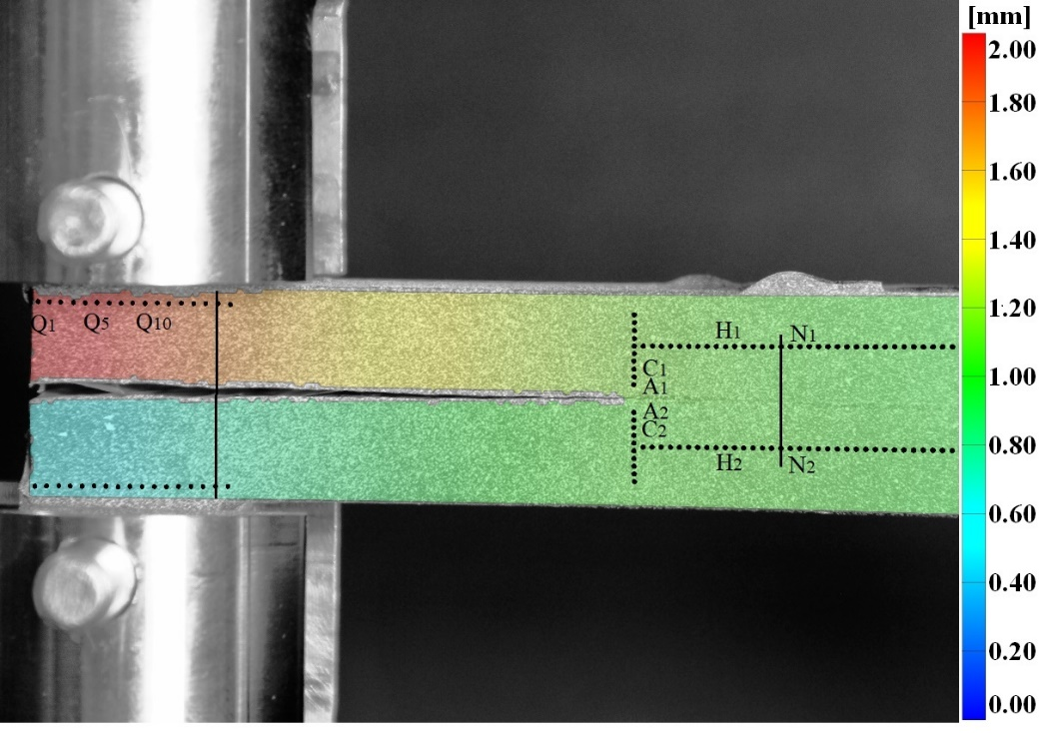

**Fig. 1** Displacement in *y* on the DCB specimen.

3.3.2. Load rotation, *ω*

To determine the load rotation, *ω*, a series of horizontal inspection points were generated near the upper and lower load edges, as indicated by Q1, ..., Q5, etc. in Fig. 1. The displacement data of these inspection points in the *x* and *y* directions were extracted from the DIC analysis. It is possible to correlate the (*x,y*) relationship in the substrate beams, which usually exhibits a linear relationship. Therefore, the load rotation can be easily obtained by calculating the slopes of the linear plots, d*y*/d*x*. An example of the determination of *ω* is shown inFigs. S2 and S3 in the supplementary data.

3.3.3 Crack length, *a*

Generally, the crack length, *a*, is measured by tracking the crack tip from a travelling microscope or from the images recorded by a camera. However, the observation methods are rather inaccurate, and it is difficult to obtain the full history of *a* during testing. In this study, a local fitting method using DIC data is proposed to accurately determine the value of *a* during the loading process. Prior to determining *a*, it is necessary to analyse the interface traction and displacement in front of a crack tip as illustrated in Fig. 2, with an initial crack length of *a*0. According to the CZM theory, the crack tip point O corresponds to the complete de-cohesion, and point A is the onset of material damage in the cohesive zone. The distance from the point O to A is the region where damage processes are active within the cohesive zone and is designated as the FPZ. The region AB is subjected to elastic tension. Since the adhesive layer is usually more compliant than the aluminium substrate, the region in front of OB is subjected to a compressive load due to the substrate rotation at the crack tip, leading to a compressive region BD. The existence of the compressive region has also been reported by Gorman and Thouless [29]. In principle, the total effective length of the crack is *a* = *a*0 + *l*FPZ. However, at point A, neither the beam deflection, *w*, nor the deflection angle, d*w*/d*x*, are zero. Since most LEFM methods for *G* measurement are derived from the compliance method and assume that the crack ends at a position where *w* = d*w*/d*x* = 0, therefore the crack length should be extended to a further position. As the deflection angle has a more significant contribution to the compliance of an adhesive joint than the deflection, i.e., *a*×(d*w*/d*x*)vs*.* d*w* in the load point displacement*,* it is reasonable to extend the crack length to point C where d*w*/d*x* = 0. As illustrated in Fig. 2, the total crack length therefore becomes *a*e = *a*0 + ∆*a*, where ∆*a* is the length of OC. Assuming the beam deflection in front of the crack tip obeys simple beam theory, then it can be formulated by *EI*d4*w/*d*x*4 = *q*(*x*), where *q*(*x*) is the distributed load per unit length of the beam (*q* = *bσ*) and *I* is the area moment of inertia of the beam. For the easiest case, the beam deflection ahead of the crack tip can be fitted using a quartic equation. The point C can be determined by solving d*w*/d*x* = 0.

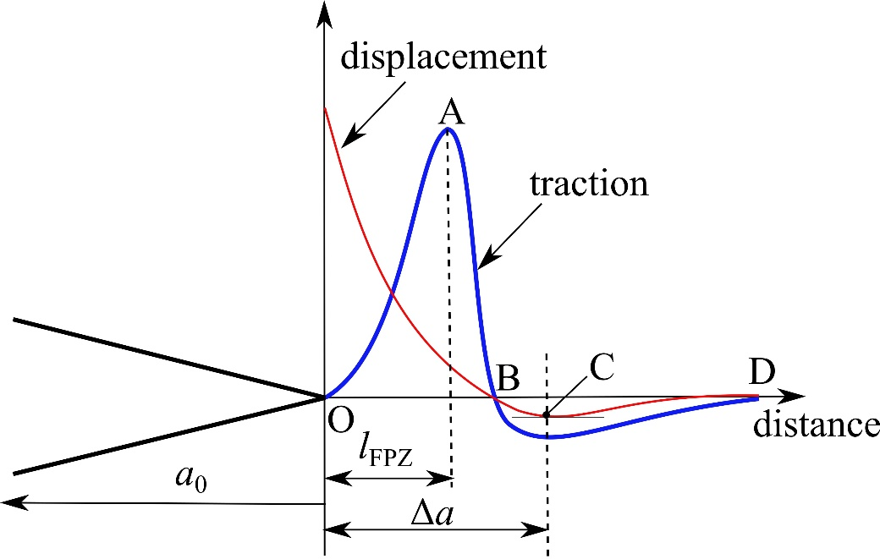

**Fig. 2** The surface traction and displacement in front of a crack tip.

In the DIC analysis, two symmetrical rows of points were created along the mid-planes of the substrate beams, e.g., points N1 and N2 illustrated in Fig. 1. The vertical displacements, d*y*, and the horizontal positions, *x*, of the points were obtained from every frame of the image. The position of point C in each frame was then calculated in Matlab using a two-step process. Firstly, the deflection of each beam at a given time was achieved by fitting the d*y* and *x* data of the created points using a quartic equation. The crack tip point O and the compression vanishing position (point D) were calculated by solving *w*(*x*) = Δ0 and *w*(*x*) = 0 respectively (the determination of the Δ0 corresponding to the failure of the initial crack tip was described in Section 3.3.1). Secondly, in order to further improve the measurement accuracy of the crack length, within OD the quartic equation was applied again to fit the beam deflection, and the position of point C was obtained by solving d*w*/d*x* = 0. By repeating this process in all the images, the effective crack lengths at different times were obtained. Fig. 3 gives an example of the values of *a*e obtained in a joint bonded with the SikaPower-497 adhesive using this DIC based technique. The results are very similar to the CBBM equivalent crack lengths determined by Eq. (5) and the theoretical crack lengths determined by simple beam theory (SBT), i.e. *a* = (3*E*f*Iδ*/2*P*)1/3. By contrast, the crack length determined by visual observation of the DIC images, i.e. by tracking the new crack tip in the DIC images and measuring the distance between the load line and the crack tip, is 13 mm less than *a*e. It is also notable that as the crack propagates close to the boundary of the surface of interest in the DIC analysis, e.g. the load point displacement ≥ 2.6 mm in Fig. 3, the crack length may be underestimated due to the fewer points available for fitting. Therefore, a large surface of interest and sufficient inspection points ahead of the crack tip are recommended for the crack length determination.

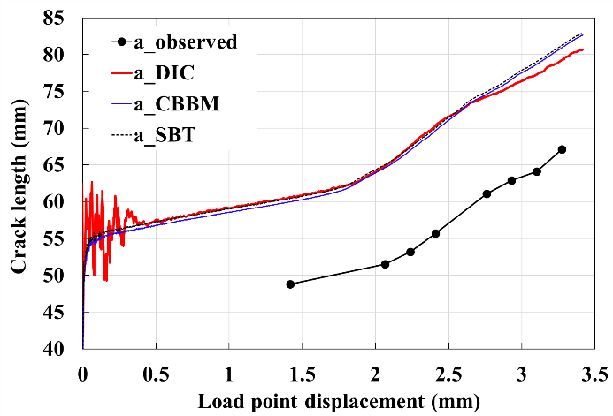

**Fig. 3** Comparison of the values of crack length for a joint bonded with Sikapower-497 adhesive determined by visual observation, DIC, CBBM and SBT methods. The data scatter at the beginning of loading for the DIC method was caused by the small displacement values in front of the crack tip. As the loading processed, the scatter disappeared.

**3.4. Determining the TSL**

The *J* values for the joint during DCB testing were calculated according to Eq. (10). In order to deduce the TSL by Eq. (9), the *J* and the Δ values need to be correlated, which is usually accomplished by curve fitting. In this section, four methods were applied and the TSL for these adhesive joints were deduced.

(1). Direct differentiation

This method does not need to quantify the relationship between the *J* and Δ. The traction is calculated directly using the raw data of the experiment as,

 (11)

where *t* is time and ∆*t* is the time increment between two measurements. Eq. (11) can be regarded as the experimental method. The TSL so determined can be used as a benchmark for comparison purposes. However, care must be taken as the time increment ∆*t* influences the TSL result. In this study, ∆*t* = 60 s was adopted as it gave a rather accurate result.

(2). Polynomial fitting

In this approach, *J* and Δ are globally fitted using high order polynomial equations. A 6th order polynomial function that provides a sufficiently accurate result was chosen,

 (12)

where *pi*(*i* = 1-7) are fitting coefficients. The derivative of *J* with respect to Δgives the TSL.

(3). Exponential fitting

A widely used TSL is an exponential form proposed by Xu and Needleman [15,35] based on potential theory. Here we only consider the simple case of the original potential equation in [35], with the coupling parameter *q* = 1, which implies that the normal work of separation, *ϕ*n, is identical to the shear work of separation, *ϕ*t. Following Xu and Needleman [35], the other coupling parameter *r* = 0. In this case, the potential of the cohesive failure becomes

 (13)

where Δ*'* is the crack sliding in the tangential direction and Δ*'* = 0 for the pure Mode I case, *δ*n and *δ*t are the characteristic lengths of the crack separation in the normal and tangential directions respectively. By conducting *σ* = *∂ϕ/∂∆*, the normal traction is obtained as

 (14)

(4). Piecewise curve fitting

A local curve fitting method, which divides the domain of Δ into many subdomains and conducts the fitting within each subdomain, was adopted to correlate *J* and Δ as it could give more details of the cohesive relation than the global polynomial and exponential fitting methods. In the study, the well-known locally weighted regression (LOESS) approach [36] was employed to fit the local *J* and Δ with a quadratic polynomial,

 (15)

where *p*1, *p*2 and *p*3 are the local fitting parameters in the local domain of [Δ*i*,Δ*i+j*]. The TSL was deduced by differentiating *J* with respect to Δin local domains*.*

**4. *G* and *J***

The values of *G* and *J* for the adhesive joints were determined using LEFM and the *J*-integral methods respectively. In the analysis, effective crack lengths, *a*e = *a*0 + ∆*a*, as illustrated in Fig. 2, were determined and were used. Therefore, the (*a*+|∆|) term in Eq. (3) and the () term in Eq. (7) were replaced by *a*e.

**4.1. Joints bonded with the brittle adhesive**

In the ESP-110 joints, unstable cohesive failure was observed in all tests, i.e. the crack arrested and propagated in bursts, and stick-slip patterns formed on the fracture surface. Fig. 4 shows the values of *G* and *J* determined just before the crack propagated, and the results of the three repeat tests are shown in Fig. S4. Prior to crack propagation, the *J* increases to a maximum value with increasing displacement. This value is regarded as *J*C and it ranged from 1.2-1.4 kJ/m2. The *G*C values determined by LEFM methods are slightly larger than the *J*C values, and the maximum relative difference (*G*C−*J*C)/*J*C ≈ 6%. The length of the FPZ, *l*FPZ, as illustrated in Fig. 2 was determined using the method described in Section 3.3.3 but with the damage onset opening obtained from the TSL presented in Section 5. For these joints, *l*FPZ = 3.5 mm. Based on the calculation result using a trapezoidal TSL, Li et al. [4] pointed out that if the ratio of the theoretical size of cohesive zone to the beam height,  ( is the cohesive strength given in Section 5), is greater than 0.4, LEFM methods may not be valid. However, whether this criterion is valid for other types of adhesive joint is unknown as the prediction of the size of cohesive zone using  does not account for the beam thickness effect [37]. Although the value of  for this adhesive is ~0.9, two times of the critical value 0.4, the experimental value *l*FPZ/*h* = 0.35, which is smaller than 0.4. Hence for this adhesive, LEFM methods are valid to characterize the fracture toughness.

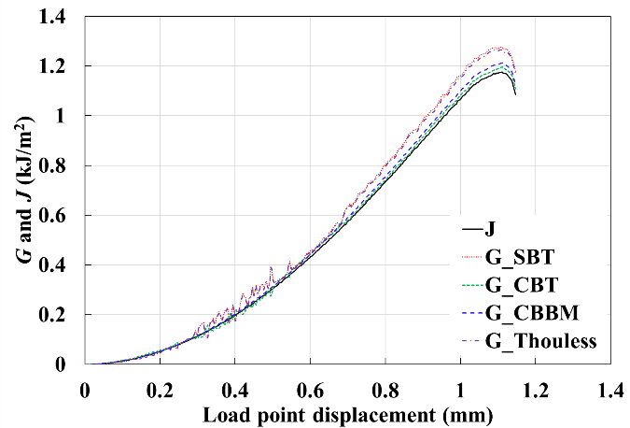

**Fig. 4** *G* and *J* of ESP-110 adhesive determined by different methods.

**4.2. Joints bonded with tough adhesive**

Stable cohesive failure within adhesive was observed in all SikaPower-497 joints. Fig. 5 shows the values of *G* and *J* as a function of the load-point displacement, and the results of the three repeat tests can be seen in Fig. S5. The values of *G* and *J* increase continuously as the displacement increases and then remain approximately constant, i.e. at the values of *G*C and *J*C. For this type of adhesive, *J*C ranged from 3.7 to 3.95 kJ/m2. The *J*C values are slightly greater than the *G*C values, with a maximum difference (*G*C−*J*C)/*J*C ≈ −8%. This difference was partially caused by the errors in the crack length. As discussed earlier, the crack length will be underestimated when the crack propagates close to the boundary of the surface of interest in the DIC analysis. The value of *l*FPZ = ~10 mm, and thus *l*FPZ/*h* = 1. In these joints, the mean value of  is ~4.8, one order of magnitude larger than the critical value 0.4. Considering the experimental value of *l*FPZ/*h* = 1, which is still close to 0.4, and the values of the *J*-integral and *G* are very similar, one can conclude that LEFM methods are still generally valid for these joints.

Figs. 4 and 5 suggest that by using the effective crack length measured by DIC, the valid LEFM methods yield similar fracture toughness results, which verifies the reliability of the proposed DIC method for crack measurement. As the values of *G* and Δ are available, the TSL can also be determined by differentiating *G* with respect to Δ.

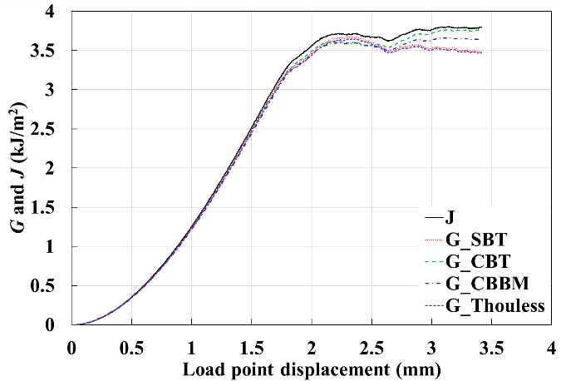

**Fig. 5** *G* and *J* of SikaPower-497 adhesive determined by different methods.

**4.3. Joints bonded with ductile adhesive**

In the ductile Araldite-2028 joints, stable crack propagation was observed in all tests. The joints failed by a dominant interfacial failure mechanism, accompanied by a small amount of cohesive failure. Fig. 6 shows the values of *G* and *J* for one adhesive joint, and the results of the three repeat tests are shown in Fig. S6. Flat *J* curves are obtained for all the joints, with *J*C values ranging from 1.4-1.65 kJ/m2. The SBT method yields the highest values, followed by the CBBM (*E*f *= E* was used in this case due to the difficulties in determining *C*0 from the nonlinear load-displacement curve) and CBT methods. The *J*-integral method leads to the most conservative values. The maximum value of (*G*C−*J*C)/*J*C is about 15%, and *l*FPZ = ~18 mm. Since the values of *l*FPZ/*h* = 1.8 and  = 50, which are much larger than the critical value 0.4, LEFM methods are seen to be invalid and are unable to characterize the fracture toughness of this adhesive.

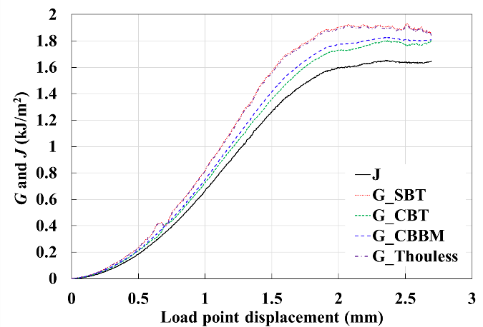

**Fig. 6** *G* and *J* of Araldite-2028 adhesive determined by different methods.

**5. Results of TSL**

For all the adhesive joints tested, straight crack fronts were observed on the fracture surfaces, which indicate that the assumption of plane strain in the analysis is valid. As the ESP-110 adhesive joints exhibited unstable cracking behaviour, only the stage of crack initiation prior to the abrupt propagation was analysed. Using the fitting methods, the TSL curve of one joint was obtained and plotted in Fig. 7 (the results of the three repeat tests are shown in Fig. S7). It is found that the exponential TSLs are associated with the highest cohesive strength, , among the results determined by fitting. For this type of joint,  is around 90-120 MPa and Δ0 is 0.025 mm.



**Fig. 7** *J* and TSL curves for ESP-110 joints under Mode I loading.

The TSL obtained for the SikaPower-497 adhesive joints are shown in Fig. 8 (the results of the three repeat tests are shown in Fig. S8). The TSL deduced by the piecewise method has a trapezoidal shape, and it most closely resembles the direct differentiation result. At small *∆*, *σ* is linearly proportional to *∆* until the maximum value (the cohesive strength) is attained. As *∆* increases further, the TSL enters the softening stage until complete failure. Compared to the piecewise TSL, the exponential TSL shows a more compliant initial relationship, while the polynomial fitting cannot give an initial relationship at small *∆*. Among the three types of TSLs determined using curve fitting, there is no significant difference in the value of Δ0, but the value of  differs. For this adhesive,  falls in the range 40-50 MPa and Δ0 is around 0.2 mm.



**Fig. 8** *J* and TSL curves for SikaPower-497 joints under Mode I loading.

Fig. 9 shows the TSLs measured for the ductile PU Araldite-2028 joint (the results of the three repeat tests are shown in Fig. S9). There is no marked difference in the shapes of TSLs determined using different methods. For this adhesive, below ∆ ≈ 0.04 mm, *σ* shows an uptrend with increasing ∆, above which itdecreases. It is found that  ranges from 10-18 MPa and Δ0 ranges from 0.3-0.35 mm.



**Fig. 9** *J* and TSL curves for Araldite-2028 joints under Mode I loading.

The representative TSLs determined for the adhesive joints are presented in Fig. 10. For SikaPower-497 joints, the piecewise TSL is chosen as it most closely resembles the direct differentiation result which is regarded as a benchmark for the TSL determination, and it is simplified as a multilinear law to facilitate its implementation in FE analysis. For the Araldite-2028 and ESP-110 joints, the TSLs deduced using polynomial fitting are plotted as no apparent differences in the shape were observed among different fitting methods and the polynomial form is more convenient to implement. It is found that these adhesive joints have substantial differences in the TSL. The ESP-110 adhesive joints have the greatest , about 95 MPa, but also have the smallest Δ0, 0.03 mm. The SikaPower-497 adhesive joints have a moderate , ranging from 40 to 55 MPa, with a Δ0 about 0.2 mm. The area under the TSL curve of the SikaPower-497 adhesive joints is much larger than that for the ESP-110 adhesive joints, consistent with it being a much tougher adhesive. The Araldite-2028 adhesive joints have the smallest , 10-20 MPa, but are associated with the largest Δ0, about 0.23-0.3 mm. This property clearly shows that it is a rather ductile adhesive.

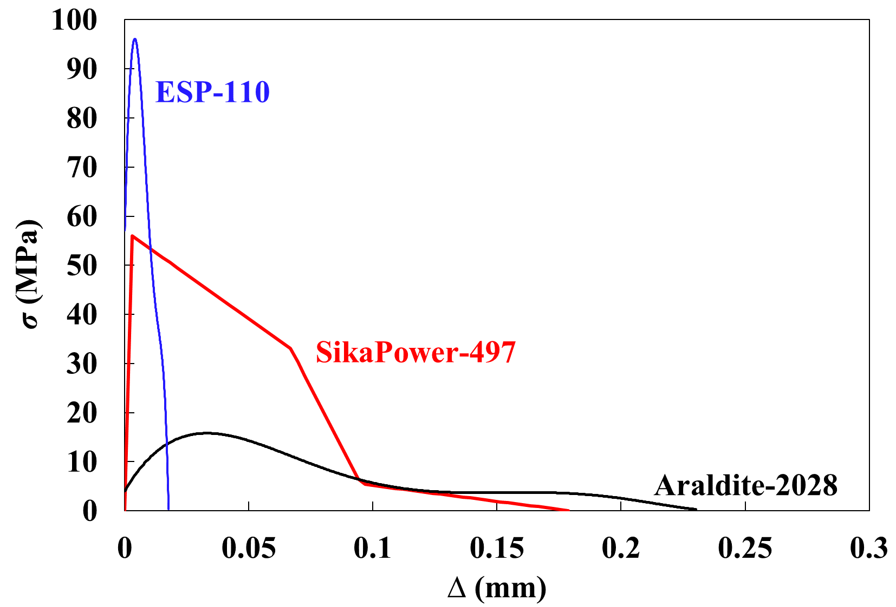

**Fig. 10** The TSLs for ESP-110, SikaPower-497 and Araldite-2028 adhesive joints.

**6. FE analysis**

**6.1. DCB modelling**

The TSLs measured were implemented in an FE analysis by defining a user element (UEL) in Abaqus/Standard (2017). The UEL element was a linear rectangular element, i.e. four nodes and two Gaussian integration points. A 2D plane strain DCB model was generated to simulate the failure process. The configuration of the model was identical to that of the adhesive joints tested. The substrates and end-blocks were represented by four-node bilinear elements, with reduced integration and hourglass control (CPE4R). The aluminium remained linear elastic during loading, with the elastic modulus *E* = 70 GPa and Poisson’s ratio *ν* = 0.33. A layer of UEL elements were embedded in between the aluminium substrates to represent the adhesive layer in the joint. In order to diminish the effects of element size, a mesh sensitivity study was firstly conducted to identify the optimum mesh size.

**6.2. FE results**

Fig. 11 displays the FE modelling and experimental load-displacement results for the brittle ESP-110 joints. Only the polynomial and exponential TSLs were implemented as the piecewise TSL curves obtained were very similar to the polynomial curves. The experimental load-displacement plot has an abrupt drop after the peak load, followed by another increase cycle, which indicates an unstable crack propagation in the joint. On the contrary, the modelling load exhibits a continuous and smooth decrease with increasing displacement, usually corresponding to a stable crack growth event. Therefore, the modelling does not reproduce the unstable crack propagation. Generally, the FE modelling of ESP-110 joints using the extracted TSLs can only reproduce the mechanical behaviour in the stage of crack initiation, and it is unable to model the unstable crack propagation (the stick-slip jumps).

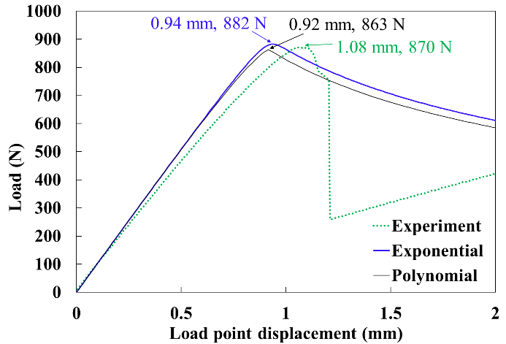

**Fig. 11** FE modelling results of ESP-110 joint.

Fig. 12 shows the modelling and experimental load-displacement results for the tough SikaPower-497 joints. With increasing displacement, the load increases to a peak value and then decreases slowly, indicating a stable crack propagation. All the modelling results using different TSLs agree with the experiment very closely. This confirms that, for this type of adhesive joint, the shape of the TSL does not significantly affect the modelling results, consistent with the conclusion in [38]. The result also confirms that the CZM can accurately represent the failure behaviour, which implies that the main energy dissipation mechanism is due to crack growth.

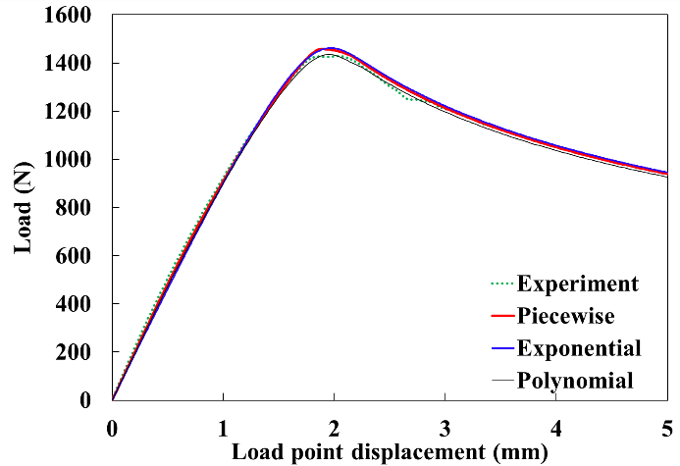

**Fig. 12** FE modelling results of SikaPower-497 joint.

Fig. 13 shows the representative modelling and experimental results for the Araldite-2028 joints. Only the polynomial and exponential TSLs were implemented as the piecewise TSL in Fig. 9 was very similar to that obtained from the polynomial. The modelling overestimates the peak load by 2-7.5% compared to the experiment, whilst it underestimates the corresponding displacements at the peak load by 10-20%. This indicates that in the modelling, prior to the crack propagation, the joint was assumed to be stiffer than it was in the experiment. The two types of TSLs yields similar modelling results, which again suggests that the shape of TSL does not significantly influence the results. For the Araldite-2028 adhesive, although the CZM can capture the basic features of the load-displacement curve, it cannot predict the failure process very precisely. In this case, a CZM is not able to describe the fracture behaviour.

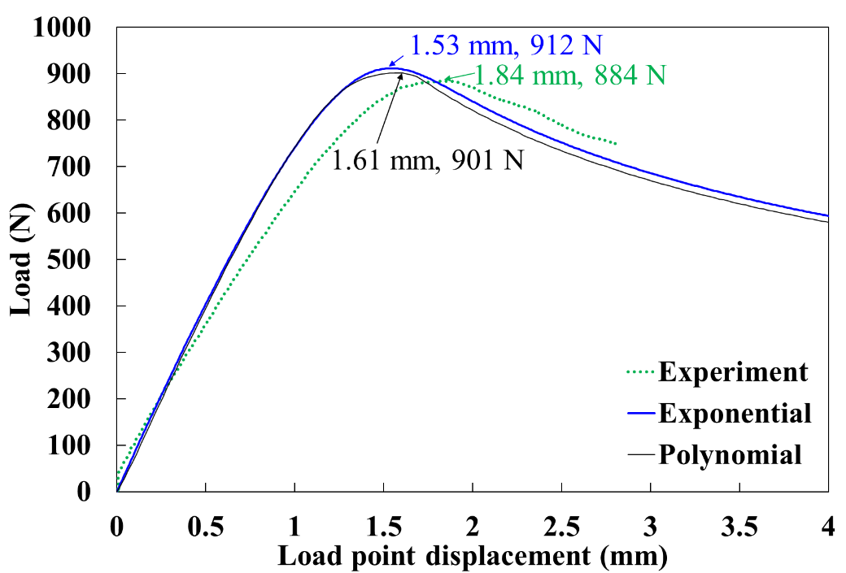

**Fig. 13** FE modelling results of Araldite-2028 joint.

Regarding the CZM modelling, the above results reflect many important issues. For a toughened structural epoxy adhesive, such as SikaPower-497, the CZM approach together with the DIC determined TSL can reproduce the experimental failure process. For a ductile adhesive, such as Araldite-2028, the CZM modelling using the experimentally determined TSL can capture the main fracture features, but the modelling probably would overestimate the stiffness of the joint prior to fracture. For a brittle adhesive, such as ESP-110, unstable (or stick-slip) crack propagation may occur during loading, which cannot be reproduced using the CZM approach adopted in this study.

**7. Conclusions**

In this study, aluminium alloy substrates were bonded with a brittle epoxy adhesive (Loctite ESP-110), a toughened epoxy adhesive (SikaPower-497) and a ductile polyurethane adhesive (Araldite-2028). The Mode I fracture behaviour of the adhesive joints was investigated by performing quasi-static DCB tests with DIC analysis.

A novel DIC based method was proposed to measure the effective crack length during the fracture process. With this method, the fracture toughness *G*C and *J*C can be determined simultaneously, which also enables an analysis of the validity of LEFM methods.

For the brittle and toughened epoxy adhesives, all the *G*C values determined using LEFM methods were in very close agreement with the *J*C values, indicating that LEFM methods were valid. For the ductile polyurethane adhesive, the *G*C values were 15% greater than the *J*C values, indicating that LEFM methods were invalid.

The failure process for the toughened epoxy adhesive joints was accurately reproduced using the CZM approach with a TSL determined using the DIC technique. A piecewise trapezoidal TSL is suitable for the toughened epoxy adhesive joints. For the more ductile polyurethane adhesive joints, the CZM approach overestimated the joint stiffness prior to fracture. For brittle epoxy adhesive joints, the CZM approach can predict the mechanical behaviour in the stage of crack initiation, but was not able to predict the unstable propagation (stick-slip behaviour). Polynomial TSLs are recommended for both the ductile polyurethane and the brittle epoxy adhesive joints.

**Acknowledgements**

The research in this paper was funded by Innovate UK’s APC7 “RACEForm” grant (No. 113153). We acknowledge the kind support of SIKA (Switzerland) for adhesive supply. Bryan Lee from the Department of Mechanical Engineering, Imperial College London, is also greatly acknowledged for the assistance with the experiments.

**References**

[1] Williams JG. On the calculation of energy release rates for cracked laminates. Int J Fract 1988;36:101–19. https://doi.org/10.1007/BF00017790.

[2] Blackman BRK, Kinloch AJ, Paraschi M, Teo WS. Measuring the mode I adhesive fracture energy, GIC, of structural adhesive joints: The results of an international round-robin. Int J Adhes Adhes 2003;23:293–305. https://doi.org/10.1016/S0143-7496(03)00047-2.

[3] de Moura MFSF, Morais JJL, Dourado N. A new data reduction scheme for mode I wood fracture characterization using the double cantilever beam test. Eng Fract Mech 2008;75:3852–65. https://doi.org/10.1016/j.engfracmech.2008.02.006.

[4] Li S, Wang J, Thouless MD. The effects of shear on delamination in layered materials. J Mech Phys Solids 2004;52:193–214. https://doi.org/10.1016/S0022-5096(03)00070-X.

[5] Andrews MG, Massabò R. The effects of shear and near tip deformations on energy release rate and mode mixity of edge-cracked orthotropic layers. Eng Fract Mech 2007;74:2700–20. https://doi.org/10.1016/j.engfracmech.2007.01.013.

[6] Blackman BRK, Kinloch AJ, Rodriguez-Sanchez FS, Teo WS. The fracture behaviour of adhesively-bonded composite joints: Effects of rate of test and mode of loading. Int J Solids Struct 2012;49:1434–52. https://doi.org/10.1016/j.ijsolstr.2012.02.022.

[7] Sarrado C, Turon A, Costa J, Renart J. On the validity of linear elastic fractrue mechanics methods to measure the fracture toughness of adhesive joints. Int J Solids Struct 2016;81:110–6. https://doi.org/10.1016/j.ijsolstr.2015.11.016.

[8] Teixeira JMD, Campilho RDSG, da Silva FJG. Numerical assessment of the Double-Cantilever Beam and Tapered Double-Cantilever Beam tests for the GIC determination of adhesive layers. J Adhes 2018;94:951–73. https://doi.org/10.1080/00218464.2017.1383905.

[9] Barenblatt GI. The mathematical theory of equilibrium cracks formed in brittle frcature. Adv Appl Mech 1962;7:55–129. https://doi.org/10.1016/S0065-2156(08)70121-2.

[10] Dudgale DS. Yielding of steel sheets containing slits. J Mech Phys Solids 1960;8:100–4. https://doi.org/10.1016/0022-5096(60)90013-2.

[11] Camacho GT, Ortiz M. Computational modelling of impact damage in brittle materials. Int J Solids Struct 1996;33:2899–938. https://doi.org/10.1016/0020-7683(95)00255-3.

[12] Geubelle PH, Baylor JS. Impact-induced delamination of composites: A 2D simulation. Compos Part B Eng 1998;29:589–602. https://doi.org/10.1016/S1359-8368(98)00013-4.

[13] Rice JR, Wang JS. Embrittlement of interfaces by solute segregation. Mater Sci Eng A 1989;107:23–40. https://doi.org/10.1016/0921-5093(89)90372-9.

[14] Tvergaard V, Hutchinson JW. The relation between crack growth resistance and fracture process parameters in elastic-plastic solids. J Mech Phys Solids 1992;40:1377–97. https://doi.org/10.1016/0022-5096(92)90020-3.

[15] Xu XP, Needleman A. Void nucleation by inclusion debonding in a crystal matrix. Model Simul Mater Sci Eng 1993;1:111–32. https://doi.org/10.1088/0965-0393/1/2/001.

[16] Chandra N, Li H, Shet C, Ghonem H. Some issues in the application of cohesive zone models for metal-ceramic interfaces. Int J Solids Struct 2002;39:2827–55. https://doi.org/10.1016/S0020-7683(02)00149-X.

[17] Williams JG, Hadavinia H. Analytical solutions for cohesive zone models. J Mech Phys Solids 2002;50:809–25. https://doi.org/10.1016/S0022-5096(01)00095-3.

[18] Rahulkumar P, Jagota A, Bennison SJ, Saigal S. Cohesive element modeling of viscoelastic fracture: Application to peel testing of polymers. Int J Solids Struct 2000;37:1873–97. https://doi.org/10.1016/S0020-7683(98)00339-4.

[19] Alfano G. On the influence of the shape of the interface law on the application of cohesive-zone models. Compos Sci Technol 2006;66:723–30. https://doi.org/10.1016/j.compscitech.2004.12.024.

[20] Ridha M, Tan VBC, Tay TE. Traction–separation laws for progressive failure of bonded scarf repair of composite panel. Compos Struct 2011;93:1239–45. https://doi.org/10.1016/j.compstruct.2010.10.015.

[21] Campilho RDSG, Banea MD, Neto JABP, Da Silva LFM. Modelling adhesive joints with cohesive zone models: Effect of the cohesive law shape of the adhesive layer. Int J Adhes Adhes 2013;44:48–56. https://doi.org/10.1016/j.ijadhadh.2013.02.006.

[22] Volokh KY. Comparison between cohesive models. Commun Numer Meth Engng 2004;20:845–56. https://doi.org/0.1002/cnm.717.

[23] Fedele R, Raka B, Hild F, Roux S. Identification of adhesive properties in GLARE assemblies using digital image correlation. J Mech Phys Solids 2009;57:1003–16. https://doi.org/10.1016/j.jmps.2009.04.005.

[24] Xu Y, Li X, Wang X, Liang L. Inverse parameter identification of cohesive zone model for simulating mixed-mode crack propagation. Int J Solids Struct 2014;51:2400–10. https://doi.org/10.1016/j.ijsolstr.2014.03.008.

[25] Sørensen BF, Kirkegaard P. Determination of mixed mode cohesive laws. Eng Fract Mech 2006;73:2642–61. https://doi.org/10.1016/j.engfracmech.2006.04.006.

[26] Högberg JL, Sørensen BF, Stigh U. Constitutive behaviour of mixed mode loaded adhesive layer. Int J Solids Struct 2007;44:8335–54. https://doi.org/10.1016/j.ijsolstr.2007.06.014.

[27] Sørensen BF. Cohesive law and notch sensitivity of adhesive joints. Acta Mater 2002;50:1053–61. https://doi.org/10.1016/S1359-6454(01)00404-9.

[28] Wu C, Huang R, Liechti KM. Simultaneous extraction of tensile and shear interactions at interfaces. J Mech Phys Solids 2019;125:225–54. https://doi.org/10.1016/j.jmps.2018.12.004.

[29] Gorman JM, Thouless MD. The use of digital-image correlation to investigate the cohesive zone in a double-cantilever beam, with comparisons to numerical and analytical models. J Mech Phys Solids 2019;123:315–31. https://doi.org/10.1016/j.jmps.2018.08.013.

[30] Rajan S, Sutton MA, Fuerte R, Kidane A. Traction-separation relationship for polymer-modified bitumen under Mode I loading: Double cantilever beam experiment with stereo digital image correlation. Eng Fract Mech 2018;187:404–21. https://doi.org/10.1016/j.engfracmech.2017.12.031.

[31] Blaysat B, Alfano M, Hoefnagels JPM, Geers MGD, Lubineau G. Interface debonding characterization by image correlation integrated with Double Cantilever Beam kinematics. Int J Solids Struct 2014;55:79–91. https://doi.org/10.1016/j.ijsolstr.2014.06.012.

[32] Dias GF, de Moura MFSF, Chousal JAG, Xavier J. Cohesive laws of composite bonded joints under mode I loading. Compos Struct 2013;106:646–52. https://doi.org/10.1016/j.compstruct.2013.07.027.

[33] Williams JG. End corrections for orthotropic DCB specimens. Compos Sci Technol 1989;35:367–76. https://doi.org/10.1016/0266-3538(89)90058-4.

[34] Thouless MD. Shear forces, root rotations, phase angles and delamination of layered materials. Eng Fract Mech 2018;191:153–67. https://doi.org/10.1016/j.engfracmech.2018.01.033.

[35] Xu XP, Needleman A. Numerical simulations of fast crack growth in brittle solids. J Mech Phys Solids 1994;42:1397–434. https://doi.org/10.1016/0022-5096(94)90003-5.

[36] Cleveland WS, Devlin SJ. Locally weighted regression: An approach to regression analysis by local fitting. J Am Stat Assoc 1988;83:596–610. https://doi.org/10.2307/2289282.

[37] Harper PW, Hallett SR. Cohesive zone length in numerical simulations of composite delamination. Eng Fract Mech 2008;75:4774–92. https://doi.org/10.1016/j.engfracmech.2008.06.004.

[38] Blackman BR., Hadavinia H, Kinloch AJ, Williams JG. The use of a cohesive zone model to study the fracture of fibre composites and adhesively-bonded joints. Int J Fract 2003;119:25–46. https://doi.org/10.1023/A:1023998013255.