SUPPLEMENTARY MATERIAL

Residential greenspace and lung function up to 24 years of age:
the ALSPAC birth cohort

Elaine Fuertesª, Iana Markevych^{b,c}, Richard Thomas^{d}, Andy Boyd^{d}, Raquel Granell^{e}, Osama Mahmoud^{d,f}, Joachim Heinrich^{b,c,g}, Judith Garcia-Aymerich^{h,i,j}, Célina Roda^{h,i,j,k}, John Henderson^{d}, Debbie Jarvis^{a,l}

- National Heart and Lung Institute, Imperial College London, London, United Kingdom
- Institute and Clinic for Occupational, Social and Environmental Medicine, University Hospital, LMU Munich, Munich, Germany
- Institute of Epidemiology, Helmholtz Zentrum München - German Research Center for Environmental Health, Neuherberg, Germany
- Population Health Sciences, Bristol Medical School, University of Bristol, Bristol, United Kingdom
- MRC Integrative Epidemiology Unit, Population Health Sciences, Bristol Medical School, University of Bristol, Bristol, United Kingdom
- Department of Applied Statistics, Helwan University, Cairo, Egypt
- Allergy and Lung Health Unit, Melbourne School of Population and Global Health, the University of Melbourne, Melbourne, Australia
- ISGlobal, Barcelona, Spain
- Universitat Pompeu Fabra, Barcelona, Spain
- CIBER Epidemiología y Salud Pública, Barcelona, Spain
- However, as we used home addresses as our only
- MRC-PHE Centre for Environment & Health, Imperial College, London, United Kingdom
Table S1: Sources and characteristics of data used to derive greenspace measures
Greenspace metric | Website | Data/ Images used
Greenness (NDVI) | http://earthexplorer.usgs.gov/ | Landsat 5 Thematic Mapper satellite images.  All images taken for Path 203, Row 24 on the following dates:  Birth: 1st August, 1990  8 years: 19th May, 1998  15 years: 28th September, 2011  24 years: 30th October, 2017
Green spaces (urban, forests and agricultural) | http://www.eea.europa.eu/data-and-maps/data/urban-atlas | Images used from years 2005-2010  Final dataset approved in 2011
Table S2: Baseline characteristics of study population with (7,094) and without (N=7,377) available data on at least one lung function measurement and one greenspace metric

 |  | Included (7,094) |  | Excluded (7,377)
Characteristic |  | N | n (%) / mean ± SD | N | n (%) / mean ± SD | p-valueª
Male |  | 7094 | 3400 (47.9) | 7377 | 3986 (54.0) | <0.001
Birthweight (grams) |  | 6615 | 3436 ± 530 | 6820 | 3394 ± 550 | <0.001
Has older sibling |  | 6187 | 3383 (54.7) | 4932 | 2833 (57.4) | 0.004
Breastfeeding (> 3 months) |  | 6083 | 3371 (55.4) | 4571 | 2058 (45.0) | <0.001
Daycare attendance at 15 months |  | 6092 | 5691 (93.4) | 4600 | 4359 (94.8) | 0.004
Parental education | Low | 6209 | 846 (13.6) | 5383 | 1346 (25.0) | <0.001
 | Medium | 6209 | 1623 (26.1) | 5383 | 1429 (26.5)
 | High | 6209 | 3740 (60.2) | 5383 | 2608 (48.4)
Parental social class | Low | 5253 | 536 (10.2) | 4001 | 628 (15.7) | <0.001
 | Medium | 5253 | 1403 (26.7) | 4001 | 1148 (28.7)
 | High | 5253 | 3314 (63.1) | 4001 | 2225 (55.6)
Parental atopy^{b} |  | 5628 | 4760 (84.6) | 4743 | 3994 (84.2) | 0.625
Maternal smoking during pregnancy |  | 5945 | 1313 (22.1) | 5487 | 2119 (38.6) | <0.001
Furry pets (dog/cat) in home in early life |  | 6131 | 2683 (43.8) | 4848 | 2123 (43.8) | 0.990
Secondhand smoke in home in early life |  | 5645 | 1960 (34.7) | 3997 | 1840 (46.0) | <0.001
Mould in home in early life |  | 6121 | 2995 (48.9) | 4842 | 2235 (46.2) | 0.004

ª Comparing those included and excluded from the analysis (Student’s t-test for normally distributed continuous variables and chi-square test for categorical variables)
^{b} Yes if either parent reporting hayfever, asthma, eczema or allergies
N = 7,094 corresponds to the number of children with greenspace and lung function measurements at 8, 15 or/and 24 years who also have information on sex, age and height.

Table S3: Characteristics of study population with (N=1,763) and without (12,708) available data on lifetime average greenspace and lung function at 24 years

 |  |  | Included (1,763) |  | Excluded (12,708)
 |  |  | N | n (%) /  mean ± SD / median ± IQR | N | n (%) /  mean ± SD | p-valueª
At early-life | Male |  | 1763 | 699 (39.6) | 12708 | 6687 (52.6) | <0.001
 | Birthweight (grams)^{b} |  | 1658 | 3440 ± 508 | 11782 | 3411 ± 545 | 0.034
 | Has older sibling |  | 1623 | 843 (51.9) | 9496 | 5373 (56.6) | <0.001
 | Breastfeeding (> 3 months) |  | 1600 | 1011 (63.2) | 9054 | 4418 (48.8) | <0.001
 | Daycare attendance at 15 months |  | 1601 | 1476 (92.2) | 9091 | 8574 (94.3) | 0.001
 | Parental education | Low | 1622 | 143 (8.8) | 9970 | 2049 (20.6) | <0.001
 |  | Medium | 1622 | 372 (22.9) | 9970 | 2680 (26.9)
 |  | High | 1622 | 1107 (68.2) | 9970 | 5241 (52.6)
 | Parental social class | Low | 1427 | 100 (7.0) | 7827 | 1064 (13.6) | <0.001
 |  | Medium | 1427 | 370 (25.9) | 7827 | 2181 (27.9)
 |  | High | 1427 | 957 (67.1) | 7827 | 4582 (58.5)
 | Parental atopy^{c} |  | 1505 | 1302 (86.5) | 8866 | 7452 (84.1) | 0.017
 | Atopy^{d} |  | 1489 | 342 (23.0) | 5402 | 1115 (20.6) | 0.056
 | Maternal smoking during pregnancy |  | 1519 | 218 (14.4) | 9913 | 3214 (32.4) | <0.001
 | Furry pets (dog/cat) in home |  | 1613 | 676 (41.9) | 9366 | 4130 (44.1) | 0.108
 | Secondhand smoke in home |  | 1534 | 412 (26.9) | 8108 | 3388 (41.8) | <0.001
 | Mould in home |  | 1609 | 812 (50.5) | 9354 | 4418 (47.2) | 0.018
At 24 years | Age (years)^{b} |  | 1763 | 24.4 ± 0.8 | na | na
 | Height (cm)^{b} |  | 1763 | 171.6 ± 9.4 | na | na
 | Weight (kg)^{e} |  | 1763 | 70.7 ± 20.6 | na | na
 | Self-reported ever doctor diagnosed asthma |  | 1291 | 340 (26.3) | na | na
 | Personal smoking |  | 1369 | 153 (11.2) | na | na
 | Living in a city |  | 1593 | 1156 (72.6) | na | na
 | Moved between birth and 24 years |  | 1763 | 1291 (73.2) | na | na

ª Comparing those included and excluded from the analysis (Student’s t-test for normally distributed continuous variables, Mann-Whitney test for non-normally distributed continuous variables and chi-square test for categorical variables)
^{b} Mean and standard deviation presented as numeric variables are normally distributed
^{c} Yes if either parent reporting hayfever, asthma, eczema or allergies
^{d} Yes if sensitized to one or more of house dust mite (Dermatophagoides pteronyssinus), cat or grass pollen at 7.5 years of age
^{e} Median and interquartile range presented as numeric variables are skewed to the right
na = not available for most participants due to loss of follow-up
IQR = interquartile range; SD = standard deviation
N = 1,763 corresponds to the number of children with lifetime average greenspace information, with available sex, age, height and lung function data at 24 years.

Table S4: Standard deviation scores (z-scores) and percent of predicted values of the lung function variables

 |  | At 8 years | At 15 years | At 24 years
 |  | mean ± SD /  median ± IQR | mean ± SD /  median ± IQR | mean ± SD /  median ± IQR
Z-scores | FEV₁ | -0.1 ± (1.0) | -0.8 ± (1.3) | -0.5 ± (1.0)
 | FVC | -0.1 ± (1.0) | -1.0 ± (1.2) | -0.3 ± (1.0)
 | FEV₁/FVC | 0.1 ± (1.1) | 0.5 ± (1.2) | -0.4 ± (1.0)
 | FEF₂₅₋₇₅ | -0.2 ± (1.0) | -0.3 ± (1.1) | -0.6 ± (1.1)
 | FEF₇₅ | 0.2 ± (1.0) | 0.2 ± (1.0) | -0.2 ± (1.0)
Percent of predicted | FEV₁ | 99.0 ± (11.8) | 90.9 ± (15.1) | 94.0 ± (11.7)
 | FVC | 98.7 ± (12.2) | 88.3 ± (14.5) | 96.8 ± (11.7)
 | FEV₁/FVCª | 100.3 ± (9.1) | 103.5 ± (11.2) | 97.3 ± (9.3)
 | FEF₂₅₋₇₅ | 97.5 ± (23.9) | 94.2 ± (24.0) | 86.8 ± (22.2)
 | FEF₇₅ | 110.9 ± (35.9) | 110.8 ± (34.8) | 95.7 ± (31.0)

SD = standard deviation
ªMedian and interquartile range presented as numeric variables are skewed to the left.
Table S5: Pearson’s correlation coefficients between greenness variables
 |  | 100m buffer |  |  |  |  | 300m buffer |  |  |  |  | 500m buffer |  |  |  |  | 1000m buffer
 |  | Avg. | Birth | 8 yrs | 15 yrs | 24 yrs | Avg. | Birth | 8 yrs | 15 yrs | 24 yrs | Avg. | Birth | 8 yrs | 15 yrs | 24 yrs | Avg. | Birth | 8 yrs | 15 yrs | 24 yrs
100m buffer | Avg. | 1.00 | 0.65 | 0.75 | 0.78 | 0.71 | 0.90 | 0.62 | 0.76 | 0.75 | 0.69 | 0.84 | 0.60 | 0.75 | 0.73 | 0.66 | 0.76 | 0.57 | 0.69 | 0.67 | 0.60
100m buffer | Birth | - | 1.00 | 0.30 | 0.45 | 0.28 | 0.59 | 0.83 | 0.38 | 0.42 | 0.28 | 0.54 | 0.75 | 0.41 | 0.40 | 0.27 | 0.48 | 0.66 | 0.41 | 0.37 | 0.24
 | 8 yrs | - | - | 1.00 | 0.37 | 0.27 | 0.66 | 0.37 | 0.88 | 0.46 | 0.34 | 0.63 | 0.39 | 0.78 | 0.51 | 0.37 | 0.58 | 0.40 | 0.67 | 0.51 | 0.38
 | 15 yrs | - | - | - | 1.00 | 0.56 | 0.71 | 0.41 | 0.48 | 0.84 | 0.53 | 0.65 | 0.39 | 0.52 | 0.75 | 0.48 | 0.58 | 0.37 | 0.53 | 0.65 | 0.42
 | 24 yrs | - | - | - | - | 1.00 | 0.65 | 0.28 | 0.34 | 0.52 | 0.85 | 0.60 | 0.28 | 0.37 | 0.48 | 0.77 | 0.54 | 0.27 | 0.38 | 0.42 | 0.68
300m  buffer | Avg. | - | - | - | - | - | 1.00 | 0.69 | 0.81 | 0.86 | 0.78 | 0.96 | 0.69 | 0.82 | 0.86 | 0.76 | 0.87 | 0.65 | 0.77 | 0.78 | 0.69
300m  buffer | Birth | - | - | - | - | - | - | 1.00 | 0.45 | 0.48 | 0.32 | 0.66 | 0.94 | 0.49 | 0.48 | 0.32 | 0.59 | 0.81 | 0.49 | 0.45 | 0.30
 | 8 yrs | - | - | - | - | - | - | - | 1.00 | 0.58 | 0.42 | 0.79 | 0.49 | 0.95 | 0.63 | 0.46 | 0.73 | 0.49 | 0.83 | 0.64 | 0.47
 | 15 yrs | - | - | - | - | - | - | - | - | 1.00 | 0.64 | 0.82 | 0.48 | 0.63 | 0.94 | 0.60 | 0.72 | 0.45 | 0.63 | 0.81 | 0.52
 | 24 yrs | - | - | - | - | - | - | - | - | - | 1.00 | 0.75 | 0.33 | 0.46 | 0.61 | 0.94 | 0.67 | 0.31 | 0.46 | 0.53 | 0.82
500m  buffer | Avg. | - | - | - | - | - | - | - | - | - | - | 1.00 | 0.71 | 0.85 | 0.88 | 0.80 | 0.94 | 0.69 | 0.83 | 0.85 | 0.76
500m  buffer | Birth | - | - | - | - | - | - | - | - | - | - | - | 1.00 | 0.53 | 0.51 | 0.35 | 0.66 | 0.91 | 0.54 | 0.50 | 0.34
 | 8 yrs | - | - | - | - | - | - | - | - | - | - | - | - | 1.00 | 0.68 | 0.50 | 0.82 | 0.54 | 0.92 | 0.71 | 0.53
 | 15 yrs | - | - | - | - | - | - | - | - | - | - | - | - | - | 1.00 | 0.64 | 0.82 | 0.50 | 0.70 | 0.92 | 0.59
 | 24 yrs | - | - | - | - | - | - | - | - | - | - | - | - | - | - | 1.00 | 0.75 | 0.35 | 0.51 | 0.60 | 0.92
1000m buffer | Avg. | - | - | - | - | - | - | - | - | - | - | - | - | - | - | - | 1.00 | 0.73 | 0.89 | 0.90 | 0.81
1000m buffer | Birth | - | - | - | - | - | - | - | - | - | - | - | - | - | - | - | - | 1.00 | 0.58 | 0.54 | 0.38
 | 8 yrs | - | - | - | - | - | - | - | - | - | - | - | - | - | - | - | - | - | 1.00 | 0.77 | 0.56
 | 15 yrs | - | - | - | - | - | - | - | - | - | - | - | - | - | - | - | - | - | - | 1.00 | 0.65
 | 24 yrs | - | - | - | - | - | - | - | - | - | - | - | - | - | - | - | - | - | - | - | 1.00

Table S6: Minimally adjusted associations between repeated measures of greenspace and lung function through ages 8 to 24 years

 |  | Greenness in various buffersª |  |  |  |  | Presence in 300m buffer^{b} |  |  | Proportion in 300m buffer^{c}
 | Number of participants | 100m | 300m | 500m | 1000m | Number of participants | Urban green | Agricultural | Forest | Urban green | Agricultural
FEV₁ (ml) | 7041 | 18.5  (11.0, 26.1) | 19.2  (10.2, 28.2) | 17.7  (7.9, 27.5) | 16.6  (5.6, 27.5) | 6596 | 15.3  (-1.3, 31.9) | 17.8  (0.9, 34.6) | 11.7  (-13.9, 37.2) | 8.1  (1.2, 15.1) | 5.4  (0.5, 10.3)
FVC (ml) | 7094 | 26.0  (16.8, 35.2) | 26.8  (15.9, 37.7) | 23.9  (12.2, 35.7) | 20.3  (7.1, 33.4) | 6651 | 18.4  (-1.2, 38.0) | 9.2  (-10.7, 29.1) | 13.1  (-17.0, 43.1) | 9.3  (1.3, 17.4) | 5.1  (-0.6, 10.8)
FEV₁/FVC (%) | 7041 | -0.2  (-0.3, 0.0) | -0.2  (-0.4, 0.0) | -0.2  (-0.4, 0.0) | -0.1  (-0.3, 0.1) | 6596 | -0.1  (-0.3, 0.2) | 0.2  (-0.1, 0.5) | -0.1  (-0.5, 0.4) | 0.0  (-0.1, 0.1) | 0.0  (-0.1, 0.1)
FEF₂₅₋₇₅ (ml/s) | 7091 | 8.2  (-5.7, 22.1) | 7.1  (-9.5, 23.7) | 7.3  (-10.8, 25.5) | 7.5  (-13.0, 28.1) | 6649 | 14.5  (-16.8, 45.8) | 25.9  (-5.7, 57.4) | -2.7  (-49.9, 44.6) | 12.1  (-1.3, 25.5) | 5.3  (-3.6, 14.2)
FEF₂₅ (ml/s) | 7054 | 33.1  (12.6, 53.6) | 36.0  (11.2, 60.7) | 34.7  (7.5, 61.9) | 23.1  (-7.7, 53.9) | 6612 | 26.7  (-18.8, 72.2) | 41.4  (-4.7, 87.5) | -3.7  (-71.9, 64.5) | 11.0  (-7.7, 29.8) | 19.6  (6.6, 32.7)
FEF₅₀ (ml/s) | 7054 | 14.2  (-1.4, 29.8) | 14.6  (-4.0, 33.2) | 14.0  (-6.4, 34.3) | 13.7  (-9.6, 37.0) | 6612 | 17.7  (-17.5, 52.9) | 25.5  (-9.9, 60.9) | -3.7  (-57.3, 49.9) | 14.4  (-0.5, 29.2) | 7.9  (-1.9, 17.8)
FEF₇₅ (ml/s) | 7054 | -5.4  (-15.4, 4.6) | -7.2  (-19.1, 4.8) | -6.1  (-19.1, 7.0) | -2.7  (-17.4, 12.1) | 6612 | 10.3  (-12.3, 33.0) | 15.6  (-7.5, 38.6) | -2.2  (-37.2, 32.7) | 6.8  (-2.8, 16.4) | 1.0  (-5.4, 7.5)

Models were adjusted for sex, age and height.
ªA positive estimate represents the average increase in lung function per interquartile range increase in greenness.
^{b}A positive estimate represents the average increase in lung function comparing presence versus absence of green space.
^{c}A positive estimate represents the average increase in lung function per interquartile range increase in proportion of green space.
N values correspond to the number of children with greenspace and lung function measurements at 8, 15 or/and 24 years who have information on sex, age and height.
Table S7: Minimally adjusted associations between the lifetime average greenspace metrics and lung function at 24 years

 | Lifetime average greenness in various buffers |  |  |  |  | Lifetime average proportion in 300m buffer
 | Number of participants | 100m | 300m | 500m | 1000m | Number of participants | Urban green | Agricultural
FEV₁ (ml) | 1763 | 43.6 (14.8, 72.4) | 34.2 (5.7, 62.6) | 32.5 (2.7, 62.3) | 23.2 (-8.4, 54.7) | 1573 | 14.1 (-9.8, 37.9) | 29.4 (11.8, 46.9)
FVC (ml) | 1763 | 20.7 (-13.2, 54.6) | 12.5 (-20.9, 46.0) | 10.5 (-24.5, 45.6) | 2.4 (-34.7, 39.5) | 1573 | -1.0 (-29.2, 27.2) | 20.1 (-0.8, 40.9)
FEV₁/FVC (%) | 1763 | 0.6 (0.2, 1.0) | 0.5 (0.1, 0.9) | 0.5 (0.1, 0.9) | 0.5 (0.0, 0.9) | 1573 | 0.3 (0.0, 0.6) | 0.3 (0.0, 0.5)
FEF₂₅₋₇₅ (ml/s) | 1763 | 77.4 (19.1, 135.7) | 58.3 (0.7, 115.8) | 59.1 (-1.3, 119.4) | 42.1 (-21.7, 106.0) | 1573 | 43.2 (-5.1, 91.4) | 43.5 (7.8, 79.1)
FEF₂₅ (ml/s) | 1763 | 69.0 (-21.2, 159.3) | 53.3 (-35.7, 142.4) | 39.8 (-53.6, 133.2) | -5.2 (-104.0, 93.5) | 1573 | 49.1 (-25.7, 123.8) | 58.5 (3.3, 113.7)
FEF₅₀ (ml/s) | 1763 | 81.1 (12.7, 149.4) | 60.6 (-6.8, 128.1) | 61.5 (-9.2, 132.2) | 37.8 (-37.0, 112.7) | 1573 | 55.6 (-1.2, 112.4) | 50.9 (9.0, 92.9)
FEF₇₅ (ml/s) | 1763 | 53.1 (15.0, 91.2) | 41.6 (4.0, 79.2) | 44.5 (5.0, 83.9) | 37.8 (-3.9, 79.5) | 1573 | 23.1 (-8.1, 54.4) | 29.5 (6.5, 52.6)

Models were adjusted for sex, age and height. A positive estimate represents the increase in lung function at 24 years per interquartile range increase in lifetime average greenness or lifetime average proportion of green space.
N values correspond to the number of children with lifetime average greenspace information, with available sex, age, height and lung function data at 24 years.
Table S8: Associations between repeated measures of greenspace and lung function expressed as standard deviation scores (z-scores), through ages 8 to 24 years

 |  | Greenness in various buffersª |  |  |  |  |  |  | Presence in 300m buffer^{b} |  |  |  | Proportion in 300m buffer^{c}
 | Number of participants |  | 100m | 300m | 500m | 1000m | Number of participants |  |  | Urban green | Agricultural | Forest |  | Urban green | Agricultural
FEV₁ (ml) | 4730 |  | 0.03  (0.00, 0.06) | 0.02  (-0.01, 0.05) | 0.02  (-0.02, 0.05) | 0.01  (-0.02, 0.05) | 4413 |  |  | 0.04  (-0.01, 0.10) | 0.04  (-0.02, 0.09) | 0.06  (-0.02, 0.14) |  | 0.02  (0.00, 0.04) | 0.02  (0.00, 0.03)
FVC (ml) | 4775 |  | 0.03  (0.01, 0.06) | 0.03  (0.00, 0.06) | 0.03  (0.00, 0.06) | 0.03  (-0.01, 0.06) | 4459 |  |  | 0.03  (-0.02, 0.09) | 0.03  (-0.02, 0.08) | 0.08  (0.00, 0.16) |  | 0.02  (0.00, 0.04) | 0.01  (0.00, 0.03)
FEV₁/FVC (%) | 4730 |  | -0.02  (-0.04, 0.01) | -0.02  (-0.05, 0.01) | -0.03  (-0.06, 0.00) | -0.03  (-0.07, 0.00) | 4413 |  |  | 0.01  (-0.04, 0.06) | 0.00  (-0.06, 0.05) | -0.02  (-0.10, 0.06) |  | 0.00  (-0.02, 0.02) | 0.00  (-0.01, 0.02)
FEF₂₅₋₇₅ (ml/s) | 4775 |  | 0.01  (-0.02, 0.03) | 0.00  (-0.03, 0.02) | -0.01  (-0.04, 0.02) | -0.02  (-0.06, 0.01) | 4459 |  |  | 0.04  (-0.02, 0.09) | 0.00  (-0.05, 0.05) | -0.03  (-0.11, 0.04) |  | 0.01  (-0.01, 0.03) | 0.01  (-0.01, 0.02)
FEF₇₅ (ml/s) | 4763 |  | 0.00  (-0.03, 0.02) | -0.01  (-0.04, 0.01) | -0.02  (-0.05, 0.01) | -0.03  (-0.06, 0.00) | 4447 |  |  | 0.05  (0.00, 0.10) | 0.01  (-0.04, 0.06) | -0.01  (-0.08, 0.06) |  | 0.02  (-0.01, 0.04) | 0.00  (-0.01, 0.01)

Models adjusted for sex, age, age², height, weight, personal smoking at 15 and 24 years, older siblings, breast feeding, daycare attendance, parental education and maternal smoking during pregnancy.
ªA positive estimate represents the average increase in lung function per interquartile range increase in greenness.
^{b}A positive estimate represents the average increase in lung function comparing presence versus absence of green space.
^{c}A positive estimate represents the average increase in lung function per interquartile range increase in proportion of green space.
N values correspond to the number of children with greenspace and lung function measurements at 8, 15 or/and 24 years who also have complete covariate information.
Table S9: Associations between the lifetime average greenspace metrics and lung function at 24 years expressed as standard deviation scores (z-scores)

 | Lifetime average greenness in various buffers |  |  |  |  | Lifetime average proportion in 300m buffer
 | Number of participants | 100m | 300m | 500m | 1000m | Number of participants | Urban green | Agricultural
FEV₁ (ml) | 1097 | 0.08 (0.0, 0.15) | 0.05 (-0.02, 0.12) | 0.03 (-0.05, 0.11) | 0.00 (-0.08, 0.08) | 964 | 0.04 (-0.02, 0.11) | 0.06 (0.02, 0.11)
FVC (ml) | 1097 | 0.04 (-0.04, 0.11) | 0.01 (-0.07, 0.08) | -0.01 (-0.09, 0.07) | -0.03 (-0.11, 0.06) | 964 | 0.01 (-0.06, 0.07) | 0.02 (-0.02, 0.07)
FEV₁/FVC (%) | 1097 | 0.06 (-0.01, 0.14) | 0.06 (-0.01, 0.13) | 0.05 (-0.02, 0.13) | 0.03 (-0.05, 0.11) | 964 | 0.06 (-0.01, 0.12) | 0.06 (0.01, 0.10)
FEF₂₅₋₇₅ (ml/s) | 1097 | 0.07 (-0.01, 0.15) | 0.05 (-0.02, 0.13) | 0.04 (-0.04, 0.12) | 0.01 (-0.07, 0.10) | 964 | 0.05 (-0.01, 0.12) | 0.06 (0.01, 0.11)
FEF₇₅ (ml/s) | 1097 | 0.07 (0.00, 0.14) | 0.06 (-0.01, 0.13) | 0.04 (-0.03, 0.12) | 0.02 (-0.06, 0.10) | 964 | 0.04 (-0.02, 0.11) | 0.06 (0.01, 0.10)

Models were adjusted for sex, age, height, weight, personal smoking at 24 years, older siblings, breast feeding, daycare attendance, parental education and maternal smoking during pregnancy. A positive estimate represents the increase in lung function at 24 years per interquartile range increase in lifetime average greenness or lifetime average proportion of green space.
N values correspond to the number of children with lifetime average greenspace information, lung function data at 24 years and complete covariate information

Table S10: Associations between repeated measures of greenspace and lung function expressed as percent of predicted values, through ages 8 to 24 years

 |  | Greenness in various buffersª |  |  |  |  |  |  | Presence in 300m buffer^{b} |  |  |  | Proportion in 300m buffer^{c}
 | Number of participants |  | 100m | 300m | 500m | 1000m | Number of participants |  |  | Urban green | Agricultural | Forest |  | Urban green | Agricultural
FEV₁ (ml) | 4730 |  | 0.36  (0.06, 0.67) | 0.28  (-0.07, 0.63) | 0.18  (-0.19, 0.56) | 0.15  (-0.27, 0.56) | 4413 |  |  | 0.51  (-0.13, 1.16) | 0.43  (-0.22, 1.07) | 0.71  (-0.25, 1.67) |  | 0.22  (-0.05, 0.48) | 0.21  (0.03, 0.38)
FVC (ml) | 4775 |  | 0.40  (0.09, 0.70) | 0.36  (0.01, 0.71) | 0.32  (-0.06, 0.69) | 0.31  (-0.11, 0.73) | 4459 |  |  | 0.40  (-0.24, 1.03) | 0.37  (-0.27, 1.00) | 0.93  (-0.02, 1.89) |  | 0.21  (-0.05, 0.47) | 0.16  (-0.02, 0.33)
FEV₁/FVC (%) | 4730 |  | -0.10  (-0.28, 0.08) | -0.14  (-0.34, 0.06) | -0.17  (-0.39, 0.05) | -0.20  (-0.45, 0.04) | 4413 |  |  | 0.02  (-0.36, 0.39) | 0.05  (-0.34, 0.44) | -0.15  (-0.72, 0.43) |  | 0.00  (-0.17, 0.16) | 0.04  (-0.06, 0.14)
FEF₂₅₋₇₅ (ml/s) | 4775 |  | 0.11  (-0.44, 0.66) | -0.08  (-0.70, 0.54) | -0.31  (-0.98, 0.35) | -0.54  (-1.29, 0.20) | 4459 |  |  | 0.80  (-0.35, 1.95) | -0.01  (-1.16, 1.15) | -0.79  (-2.48, 0.89) |  | 0.29  (-0.20, 0.77) | 0.16  (-0.15, 0.46)
FEF₇₅ (ml/s) | 4763 |  | -0.13  (-0.96, 0.71) | -0.38  (-1.31, 0.56) | -0.68  (-1.68, 0.33) | -0.87  (-2.00, 0.25) | 4447 |  |  | 1.81  (0.11, 3.51) | 0.33  (-1.40, 2.07) | -0.33  (-2.91, 2.26) |  | 0.52  (-0.21, 1.25) | 0.09  (-0.38, 0.57)

Models adjusted for sex, age, age², height, weight, personal smoking at 15 and 24 years, older siblings, breast feeding, daycare attendance, parental education and maternal smoking during pregnancy.
ªA positive estimate represents the average increase in lung function per interquartile range increase in greenness.
^{b}A positive estimate represents the average increase in lung function comparing presence versus absence of green space.
^{c}A positive estimate represents the average increase in lung function per interquartile range increase in proportion of green space.
N values correspond to the number of children with greenspace and lung function measurements at 8, 15 or/and 24 years who also have complete covariate information.

Table S11: Associations between the lifetime average greenspace metrics and lung function at 24 years expressed as percent of predicted values

 | Lifetime average greenness in various buffers |  |  |  |  | Lifetime average proportion in 300m buffer
 | Number of participants | 100m | 300m | 500m | 1000m | Number of participants | Urban green | Agricultural
FEV₁ (ml) | 1097 | 0.08 (0.00, 0.15) | 0.05 (-0.02, 0.12) | 0.03 (-0.05, 0.11) | 0.00 (-0.08, 0.08) | 964 | 0.04 (-0.02, 0.11) | 0.06 (0.02, 0.11)
FVC (ml) | 1097 | 0.04 (-0.04, 0.11) | 0.01 (-0.07, 0.08) | -0.01 (-0.09, 0.07) | -0.03 (-0.11, 0.06) | 964 | 0.01 (-0.06, 0.07) | 0.02 (-0.02, 0.07)
FEV₁/FVC (%) | 1097 | 0.06 (-0.01, 0.14) | 0.06 (-0.01, 0.13) | 0.05 (-0.02, 0.13) | 0.03 (-0.05, 0.11) | 964 | 0.06 (-0.01, 0.12) | 0.06 (0.01, 0.10)
FEF₂₅₋₇₅ (ml/s) | 1097 | 0.07 (-0.01, 0.15) | 0.05 (-0.02, 0.13) | 0.04 (-0.04, 0.12) | 0.01 (-0.07, 0.10) | 964 | 0.05 (-0.01, 0.12) | 0.06 (0.01, 0.11)
FEF₇₅ (ml/s) | 1097 | 0.07 (0.00, 0.14) | 0.06 (-0.01, 0.13) | 0.04 (-0.03, 0.12) | 0.02 (-0.06, 0.10) | 964 | 0.04 (-0.02, 0.11) | 0.06 (0.01, 0.10)

Models were adjusted for sex, age, height, weight, personal smoking at 24 years, older siblings, breast feeding, daycare attendance, parental education and maternal smoking during pregnancy. A positive estimate represents the increase in lung function at 24 years per interquartile range increase in lifetime average greenness or lifetime average proportion of green space.
N values correspond to the number of children with lifetime average greenspace information, lung function data at 24 years and complete covariate information

Table S12: Associations between repeated measures of greenspace and lung function through ages 8 to 24 years additionally adjusted for asthma

 |  | Greenness in various buffersª |  |  |  |  | Presence in 300m buffer^{b} |  |  | Proportion in 300m buffer^{c}
 | Number of participants | 100m | 300m | 500m | 1000m | Number of participants | Urban green | Agricultural | Forest | Urban green | Agricultural
FEV₁ (ml) | 4342 | 11.0  (1.5, 20.6) | 8.0  (-3.8, 19.8) | 5.9  (-6.9, 18.7) | 3.8  (-10.4, 18.0) | 4047 | 17.6  (-4.4, 39.5) | 8.2  (-13.6, 30.0) | 13.1  (-19.5, 45.7) | 7.6  (-1.1, 16.4) | 4.8  (-1.3, 10.9)
FVC (ml) | 4386 | 13.7  (2.6, 24.9) | 12.3  (-1.5, 26.0) | 10.6  (-4.3, 25.4) | 9.2  (-7.4, 25.8) | 4089 | 18.1  (-6.8, 43.0) | 3.2  (-21.7, 28.0) | 19.8  (-17.2, 56.8) | 10.6  (0.7, 20.6) | 3.9  (-3.1, 10.9)
FEV₁/FVC (%) | 4342 | -0.1  (-0.3, 0.0) | -0.2  (-0.4, 0.0) | -0.2  (-0.4, 0.0) | -0.2  (-0.5, 0.0) | 4047 | 0.0  (-0.3, 0.4) | 0.0  (-0.3, 0.4) | -0.2  (-0.7, 0.3) | -0.1  (-0.2, 0.1) | 0.0  (-0.1, 0.1)
FEF₂₅₋₇₅ (ml/s) | 4386 | 3.5  (-13.8, 20.7) | -4.8  (-25.6, 16.1) | -8.6  (-31.6, 14.4) | -17.4  (-43.6, 8.8) | 4089 | 26.2  (-15.2, 67.6) | 2.5  (-38.1, 43.1) | -17.9  (-79.6, 43.7) | 7.0  (-9.8, 23.8) | 3.3  (-8.2, 14.7)
FEF₂₅ (ml/s) | 4372 | 11.5  (-13.1, 36.2) | 13.2  (-17.1, 43.5) | 10.0  (-23.7, 43.7) | -12.6  (-50.7, 25.6) | 4076 | 10.3  (-48.2, 68.8) | 25.8  (-32.4, 84.1) | 3.8  (-81.9, 89.6) | 16.2  (-7.8, 40.2) | 22.2  (6.5, 37.9)
FEF₅₀ (ml/s) | 4372 | 9.4  (-9.8, 28.7) | 2.7  (-20.6, 25.9) | -3.6  (-29.1, 22.0) | -15.0  (-44.2, 14.1) | 4076 | 25.7  (-20.2, 71.7) | 4.7  (-40.3, 49.8) | -21.7  (-89.9, 46.6) | 11.5  (-7.1, 30.2) | 6.9  (-5.4, 19.1)
FEF₇₅ (ml/s) | 4372 | -0.7  (-13.3, 11.9) | -7.6  (-22.7, 7.6) | -10.6  (-27.2, 6.0) | -14.9  (-33.6, 3.8) | 4076 | 25.7  (-3.6, 55.0) | 5.6  (-23.9, 35.1) | -9.0  (-54.1, 36.1) | 4.5  (-7.7, 16.7) | 0.6  (-7.5, 8.8)

Models were adjusted for sex, age, age², height, weight, personal smoking at 15 and 24 years, older siblings, breast feeding, daycare attendance, parental education, maternal smoking during pregnancy and self-reported ever doctor diagnosed asthma at 8, 15 and 24 years.
ªA positive estimate represents the average increase in lung function per interquartile range increase in greenness.
^{b}A positive estimate represents the average increase in lung function comparing presence versus absence of green space.
^{c}A positive estimate represents the average increase in lung function per interquartile range increase in proportion of green space.
N values correspond to the number of children with greenspace and lung function measurements at 8, 15 or/and 24 years who also have complete covariate information.
Table S13: Associations between the lifetime average greenspace metrics and lung function at 24 years additionally adjusted for asthma

 | Lifetime average greenness in various buffers |  |  |  | Lifetime average proportion in 300m buffer
 | Number of participants | 100m | 300m | 500m | 1000m | Number of participants | Urban green | Agricultural
FEV₁ (ml) | 901 | 32.0 (-8.2, 72.3) | 17.6 (-22.5, 57.6) | 6.7 (-35.5, 48.8) | -11.5 (-56.2, 33.3) | 797 | 19.3 (-15.1, 53.7) | 29.2 (4.1, 54.3)
FVC (ml) | 901 | 25.3 (-21.2, 71.9) | 9.3 (-36.9, 55.6) | -1.6 (-50.3, 47.0) | -18.5 (-70.2, 33.3) | 797 | 9.4 (-30.6, 49.4) | 17.7 (-11.6, 46.9)
FEV₁/FVC (%) | 901 | 0.3 (-0.2, 0.8) | 0.3 (-0.3, 0.8) | 0.2 (-0.3, 0.8) | 0.1 (-0.5, 0.7) | 797 | 0.3 (-0.2, 0.7) | 0.3 (0.0, 0.7)
FEF₂₅₋₇₅ (ml/s) | 901 | 47.2 (-31.9, 126.3) | 22.2 (-56.5, 100.8) | 17.3 (-65.5, 100.1) | -1.7 (-89.5, 86.2) | 797 | 38.1 (-28.7, 104.9) | 44.0 (-4.8, 92.8)
FEF₂₅ (ml/s) | 901 | 51.4 (-66.4, 174.5) | 40.2 (-79.5, 159.9) | 15.0 (-111.0, 141.1) | -40.2 (-173.9, 93.5) | 797 | 70.0 (-32.3, 172.4) | 59.8 (-15.1, 134.6)
FEF₅₀ (ml/s) | 901 | 51.9 (-40.6, 144.3) | 30.6 (-61.2, 122.5) | 27.8 (-69.0, 124.5) | 6.1 (-96.5, 108.7) | 797 | 51.7 (-27.0, 130.4) | 51.6 (-5.9, 109.2)
FEF₇₅ (ml/s) | 901 | 26.7 (-26.0, 79.4) | 9.7 (-42.7, 62.1) | 6.2 (-48.9, 61.4) | -5.6 (-64.1, 52.8) | 797 | 18.2 (-25.5, 61.9) | 30.3 (-1.6, 62.3)

Models were adjusted for sex, age, height, weight, personal smoking at 24 years, older siblings, breast feeding, daycare attendance, parental education, maternal smoking during pregnancy and self-reported ever doctor diagnosed asthma at 24 years. A positive estimate represents the increase in lung function at 24 years per interquartile range increase in lifetime average greenness or lifetime average proportion of green space.
N values correspond to the number of children with lifetime average greenspace information, lung function data at 24 years and complete covariate information
Table S14: Associations between repeated measures of greenspace and lung function through ages 8 to 24 years additionally adjusted for lifetime average PM₁₀ and degree of urbanisation

 |  | Greenness in various buffersª |  |  |  |  | Presence in 300m buffer^{b} |  |  | Proportion in 300m buffer^{c}
 | Number of participants | 100m | 300m | 500m | 1000m | Number of participants | Urban green | Agricultural | Forest | Urban green | Agricultural
Adjusted for PM₁₀^{d}
FEV₁ (ml) | 3915 | 14.5  (4.1, 24.9) | 10.2  (-2.9, 23.4) | 7.8  (-6.9, 22.6) | 4.7  (-12.1, 21.4) | 3903 | 23.2  (1.0, 45.3) | 8.7  (-15.3, 32.7) | 9.4  (-24.4, 43.3) | 9.0  (0.2, 17.7) | 7.3  (0.4, 14.1)
FVC (ml) | 3953 | 13.6  (1.4, 25.8) | 10.7  (-4.9, 26.4) | 8.8  (-8.6, 26.1) | 6.4  (-13.3, 26.2) | 3942 | 25.0  (-0.3, 50.2) | 0.7  (-27.1, 28.6) | 15.8  (-23.4, 55.0) | 10.7  (0.5, 20.9) | 4.6  (-3.5, 12.7)
FEV₁/FVC (%) | 3915 | 0.0  (-0.2, 0.1) | -0.1  (-0.3, 0.1) | -0.1  (-0.3, 0.1) | -0.1  (-0.4, 0.1) | 3903 | 0.1  (-0.3, 0.4) | 0.0  (-0.4, 0.4) | -0.2  (-0.8, 0.3) | 0.0  (-0.1, 0.2) | 0.1  (0.0, 0.2)
FEF₂₅₋₇₅ (ml/s) | 3953 | 13.1  (-6.0, 32.1) | 2.9  (-20.8, 26.6) | -1.2  (-28.0, 25.7) | -10.2  (-40.9, 20.5) | 3942 | 32.7  (-9.6, 75.0) | -0.3  (-45.3, 44.7) | -32.7  (-95.9, 30.4) | 10.4  (-6.5, 27.3) | 8.8  (-4.1, 21.6)
FEF₂₅ (ml/s) | 3942 | 36.7  (9.2, 64.2) | 31.8  (-3.2, 66.8) | 23.1  (-17.1, 63.3) | -6.7  (-53.2, 39.9) | 3931 | 30.4  (-30.1, 90.9) | 25.6  (-41.2, 92.3) | -13.6  (-103.4, 76.2) | 17.4  (-7.0, 41.9) | 26.6  (8.3, 44.8)
FEF₅₀ (ml/s) | 3942 | 22.1  (1.4, 44.0) | 14.8  (-11.8, 41.4) | 8.4  (-21.5, 38.3) | -4.7  (-38.9, 29.5) | 3931 | 32.9  (-14.1, 79.9) | 6.4  (-43.8, 56.5) | -36.3  (-107.3, 34.7) | 13.0  (-5.8, 31.7) | 15.7  (1.9, 29.5)
FEF₇₅ (ml/s) | 3942 | 3.9  (-9.7, 17.5) | -3.3  (-20.1, 13.5) | -6.7  (-22.5, 12.1) | -9.9  (-31.2, 11.4) | 3931 | 28.4  (-1.5, 58.2) | 4.2  (-28.1, 36.4) | -18.8  (-64.2, 26.5) | 7.9  (-4.3, 20.0) | 2.8  (-6.3, 11.9)
Adjusted for urbanisation^{e}
FEV₁ (ml) | 4412 | 14.9  (4.8, 24.9) | 8.9  (-4.1, 21.9) | 5.2  (-9.3, 19.8) | 2.6  (-14.0, 19.2) | 4412 | 22.7  (2.0, 43.5) | 11.0  (-11.5, 33.5) | 13.6  (-18.6, 45.8) | 6.7  (-1.5, 14.9) | 7.6  (0.5, 14.7)
FVC (ml) | 4458 | 13.3  (1.6, 25.1) | 8.6  (-6.5, 23.8) | 4.9  (-11.8, 21.7) | 2.6  (-16.4, 21.6) | 4458 | 27.2  (3.5, 51.0) | -0.1  (-26.3, 26.0) | 15.4  (-21.9, 52.7) | 8.5  (-1.1, 18.0) | 2.6  (-5.6, 10.9)
FEV₁/FVC (%) | 4412 | 0.0  (-0.2, 0.2) | 0.0  (-0.3, 0.2) | -0.1  (-0.3, 0.2) | -0.1  (-0.4, 0.2) | 4412 | 0.0  (-0.4, 0.3) | 0.2  (-0.2, 0.5) | 0.0  (-0.6, 0.5) | 0.0  (-0.2, 0.1) | 0.1  (0.0, 0.2)
FEF₂₅₋₇₅ (ml/s) | 4458 | 17.8  (-1.1, 36.6) | 8.3  (-15.6, 32.1) | 3.3  (-24.2, 30.9) | -5.1  (-37.5, 27.3) | 4458 | 25.8  (-14.0, 65.6) | 18.0  (-24.9, 61.0) | -13.4  (-74.7, 47.8) | 7.0  (-8.8, 22.8) | 16.3  (3.2, 29.4)
FEF₂₅ (ml/s) | 4446 | 35.4  (8.4, 62.4) | 28.9  (-5.2, 63.0) | 18.1  (-21.3, 57.4) | -13.3  (-59.8, 33.1) | 4446 | 25.6  (-30.8, 82.1) | 30.3  (-32.4, 92.9) | -13.1  (-99.0, 72.9) | 13.1  (-9.8, 35.9) | 34.4  (15.8, 53.0)
FEF₅₀ (ml/s) | 4446 | 28.1  (6.9, 49.3) | 21.6  (-5.3, 48.4) | 14.9  (-15.9, 45.6) | 2.5  (-33.5, 38.5) | 4446 | 23.1  (-21.2, 67.3) | 24.4  (-24.1, 73.0) | -18.0  (-85.9, 49.9) | 9.1  (-8.4, 26.6) | 24.8  (10.6, 39.1)
FEF₇₅ (ml/s) | 4446 | 5.3  (-8.0, 18.7) | -2.5  (-19.5, 14.4) | -6.9  (-26.5, 12.6) | -10.5  (-33.1, 12.0) | 4446 | 26.3  (-1.8, 54.4) | 15.6  (-15.8, 47.1) | -2.0  (-46.7, 42.7) | 5.8  (-5.7, 17.3) | 6.0  (-3.6, 15.5)

ªA positive estimate represents the average increase in lung function per interquartile range increase in greenness.
^{b}A positive estimate represents the average increase in lung function comparing presence versus absence of green space.
^{c}A positive estimate represents the average increase in lung function per interquartile range increase in proportion of green space.
^{d}Models were adjusted for sex, age, age², height, weight, personal smoking at 15 and 24 years, older siblings, breast feeding, daycare attendance, parental education, maternal smoking during pregnancy and cumulative PM₁₀ exposure (calculated between 1 and 15 years).
^{e}Models were adjusted for sex, age, age², height, weight, personal smoking at 15 and 24 years, older siblings, breast feeding, daycare attendance, parental education, maternal smoking during pregnancy and degree of urbanisation.
N values correspond to the number of children with greenspace and lung function measurements at 8, 15 or/and 24 years who also have complete covariate information.
Table S15: Associations between the lifetime average greenspace metrics and lung function at 24 years additionally adjusted for lifetime average PM₁₀ and degree of urbanisation

 | Lifetime average greenness in various buffers |  |  |  |  | Lifetime average proportion in 300m buffer
 | Number of participants | 100m | 300m | 500m | 1000m | Number of participants | Urban green | Agricultural
Adjusted for PM₁₀ª
FEV₁ (ml) | 988 | 52.8 (9.7, 95.8) | 37.8 (-6.0, 81.5) | 26.0 (-21.0, 72.9) | 7.5 (-42.6, 57.6) | 937 | 15.6 (-16.1, 47.3) | 42.7 (17.1, 68.2)
FVC (ml) | 988 | 21.6 (-29.1, 72.4) | 3.0 (-48.4, 54.5) | -9.5 (-64.7, 45.8) | -22.1 (-81.1, 36.8) | 937 | -4.0 (-41.6, 33.5) | 22.7 (-7.7, 53.1)
FEV₁/FVC (%) | 988 | 0.7 (0.1, 1.3) | 0.8 (0.1, 1.4) | 0.7 (0.1, 1.4) | 0.6 (-0.1, 1.3) | 937 | 0.5 (0.0, 0.9) | 0.5 (0.1, 0.9)
FEF₂₅₋₇₅ (ml/s) | 988 | 105.0 (18.0, 191.9) | 76.9 (-11.4, 165.2) | 65.8 (-29.0, 160.6) | 28.7 (-72.4, 129.8) | 937 | 47.9 (-15.6, 111.4) | 72.2 (20.9, 123.6)
FEF₂₅ (ml/s) | 988 | 86.8 (-46.0, 219.5) | 56.4 (-78.2, 191.1) | 21.6 (-123.0, 166.1) | -31.6 (-185.6, 122.5) | 937 | 68.8 (-28.4, 166.1) | 80.0 (1.3, 158.7)
FEF₅₀ (ml/s) | 988 | 125.4 (23.7, 227.1) | 96.6 (-6.6, 199.8) | 88.0 (-22.9, 198.8) | 49.0 (-69.3, 167.2) | 937 | 58.6 (-16.3, 133.4) | 91.8 (31.4, 152.3)
FEF₇₅ (ml/s) | 988 | 66.2 (9.5, 122.8) | 53.7 (-3.8, 111.2) | 47.7 (-14.1, 109.4) | 21.6 (-44.2, 87.5) | 937 | 27.8 (-13.1, 68.8) | 47.0 (13.9, 80.1)
Adjusted for urbanisation^{b}
FEV₁ (ml) | 978 | 32.8 (-9.8, 75.3) | 13.6 (-29.1, 56.3) | -3.2 (-48.4, 42.1) | -23.8 (-71.2, 23.5) | 963 | 18.4 (-12.8, 49.7) | 30.4 (3.6, 57.1)
FVC (ml) | 978 | 2.3 (-48.2, 52.7) | -17.7 (-68.2, 32.9) | -33.4 (-86.9, 20.2) | -46.1 (-102.2, 10.0) | 963 | 1.0 (-36.1, 38.1) | 9.0 (-22.8, 40.8)
FEV₁/FVC (%) | 978 | 0.7 (0.0, 1.3) | 0.6 (0.0, 1.2) | 0.5 (-0.1, 1.2) | 0.3 (-0.4, 1.0) | 963 | 0.4 (0.0, 0.9) | 0.5 (0.1, 0.9)
FEF₂₅₋₇₅ (ml/s) | 978 | 88.8 (3.6, 173.9) | 49.8 (-35.6, 135.3) | 28.4 (-62.2, 119.0) | -15.7 (-110.6, 79.2) | 963 | 45.5 (-16.9, 107.9) | 65.1 (11.7, 118.6)
FEF₂₅ (ml/s) | 978 | 43.7 (-87.8, 175.2) | 2.5 (-129.3, 134.3) | -46.8 (-186.4, 92.9) | -107.0 (-253.1, 39.1) | 963 | 74.8 (-21.2, 170.7) | 50.4 (-32.0, 132.8)
FEF₅₀ (ml/s) | 978 | 101.1 (0.7, 201.4) | 58.6 (-42.1, 159.4) | 36.4 (-70.4, 143.2) | -11.7 (-123.6, 100.1) | 963 | 57.7 (-15.8, 131.3) | 80.0 (17.0, 143.0)
FEF₇₅ (ml/s) | 978 | 52.6 (-2.4, 107.6) | 34.0 (-21.1, 89.2) | 22.7 (-35.8, 81.1) | -6.5 (-67.8, 54.7) | 963 | 26.4 (-13.8, 66.6) | 42.0 (7.5, 76.4)

A positive estimate represents the increase in lung function at 24 years per interquartile range increase in average lifetime greenness or average lifetime proportion of green space.
ª Models were adjusted for sex, age, height, weight, personal smoking at 24 years, older siblings, breast feeding, daycare attendance, parental education, maternal smoking during pregnancy and cumulative PM₁₀ exposure (calculated between 1 and 15 years).
^{b} Models were adjusted for sex, age, height, weight, personal smoking at 24 years, older siblings, breast feeding, daycare attendance, parental education, maternal smoking during pregnancy and degree of urbanisation at 24 years.
N values correspond to the number of children with lifetime average greenspace information, lung function data at 24 years and complete covariate information

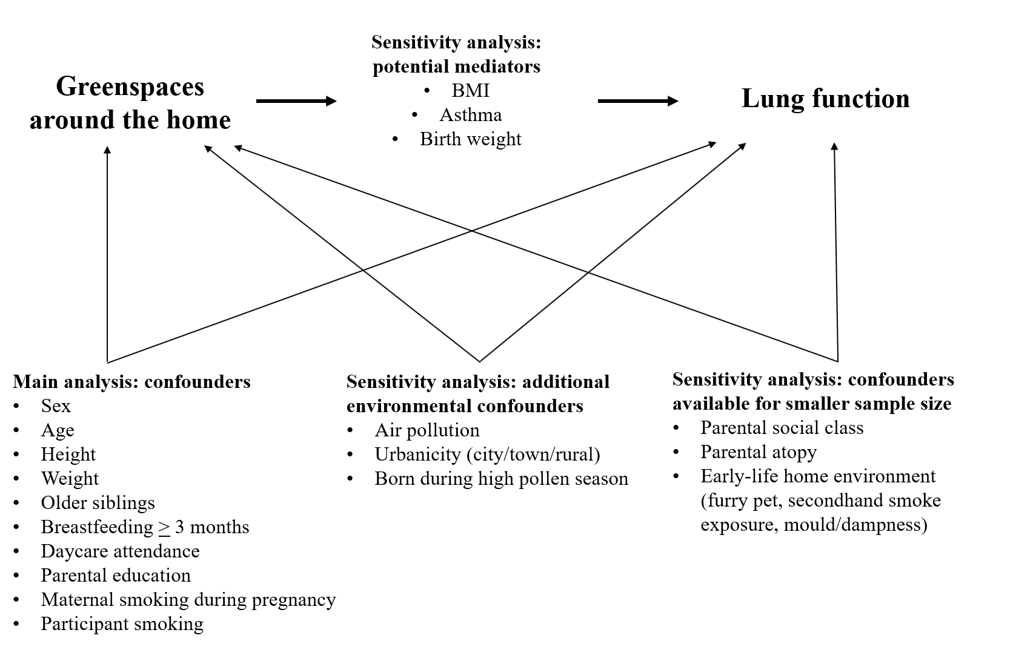
Figure S1: Hypothesized causal relationships between the greenspace exposures, lung function parameters, confounders and potential mediators.

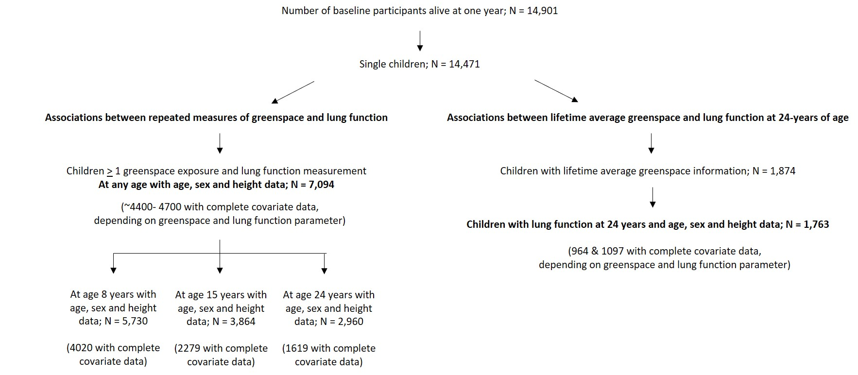
Figure S2: Flow chart of study population
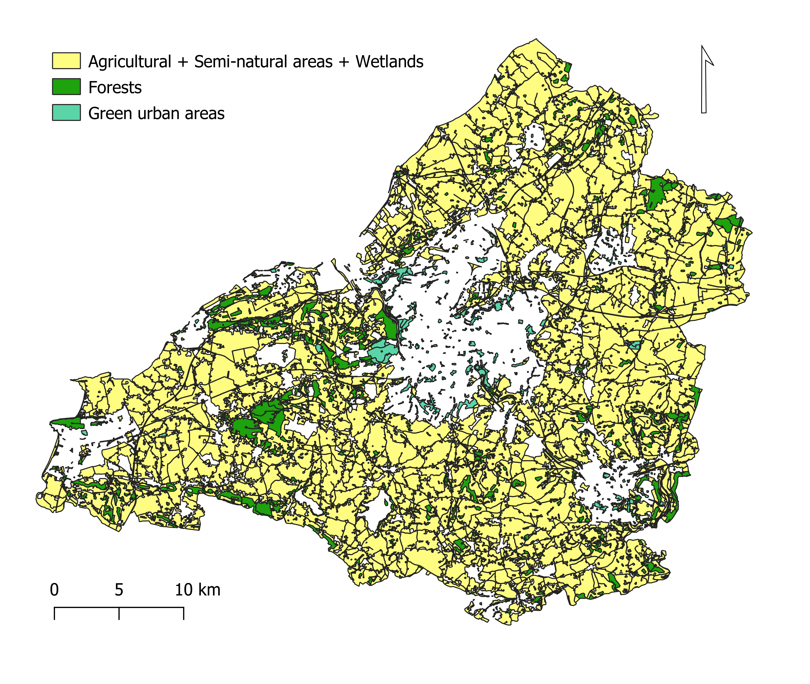
Figure S3: Spatial distribution of green spaces within a 300m buffer at the time of the 15-year clinic visit.
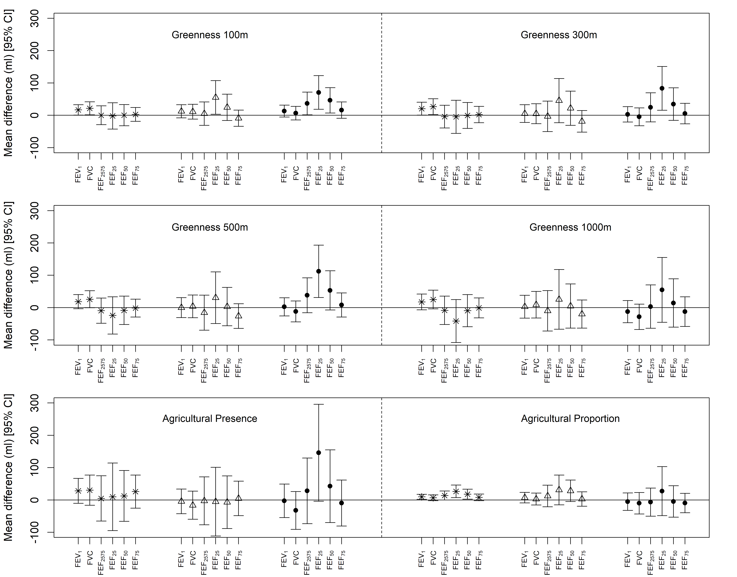

Figure S4: Estimated mean difference in lung function (ml) for greenness within 100m, 300m, 500m, 1000m buffers and the presence (yes versus no) and proportion (per interquartile range increase) of agricultural land in a 300m buffer. Associations presented by tertiles of PM₁₀ concentrations (low: stars; medium: open triangles; high: filled circles). Interaction terms were significant (p < 0.05) between PM₁₀ concentrations (high tertile versus low tertile) and greenness in a 100m and 500m buffer for FEF₂₅. Results for the FEV₁/FVC ratio are not presented (different y-axis range) nor for the presence of forests (small sample sizes).
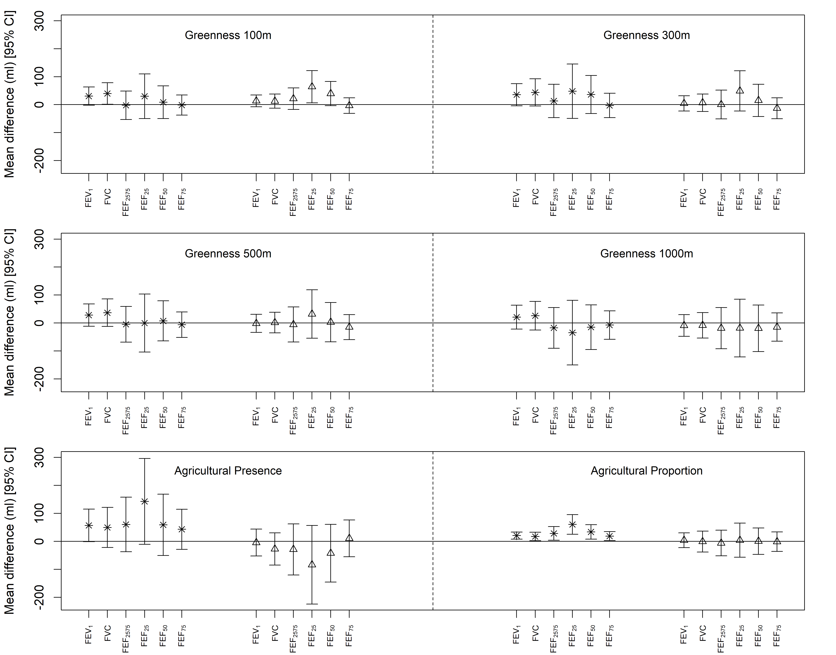

Figure S5: Estimated mean difference in lung function (ml) for greenness within 100m, 300m, 500m, 1000m buffers and the presence (yes versus no) and proportion (per interquartile range increase) of agricultural land in a 300m buffer. Associations presented by whether a participant always lived in a city from birth to 24 years (stars) compared to not (open diamonds). Results for the FEV₁/FVC ratio are not presented (different y-axis range) nor for the presence of forests (small sample sizes). Interaction terms were significant (p < 0.05) between always living in a city versus not and the presence of agricultural land for FEF₂₅.
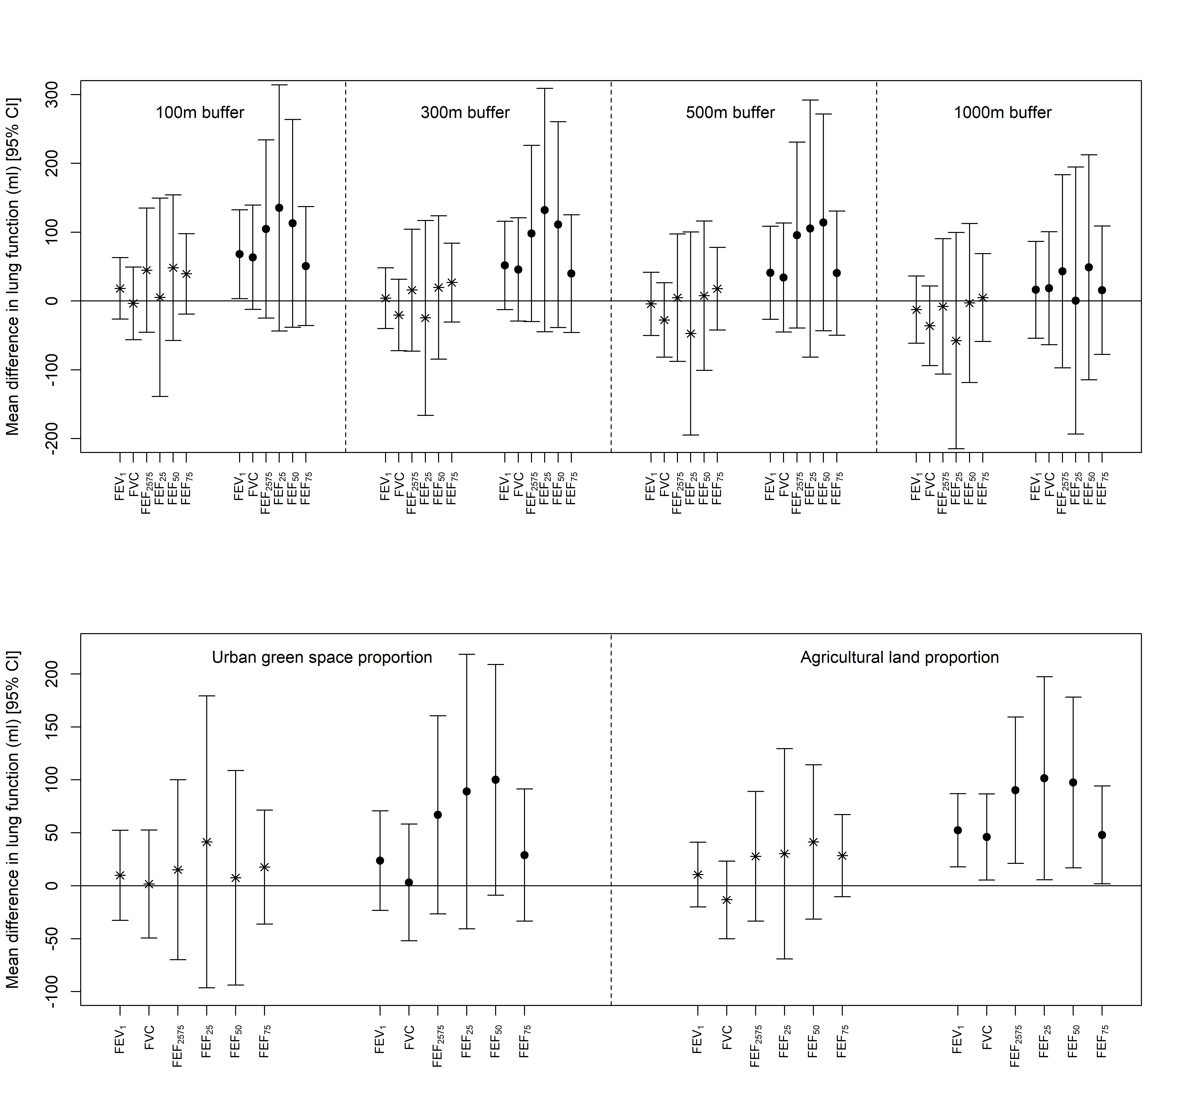
Figure S6: Estimated mean difference in lung function (ml) at 24 years per interquartile range increase in lifetime average greenness (top panel) and lifetime average proportion of green space (bottom panel). Associations presented for those who moved between birth and 24 years (stars) and those who did not (filled circles). Results for the FEV₁/FVC ratio are not presented. The interaction term between proportion of agricultural land and moving was significant (p <0.05) for FVC.

