# Implications of Future Natural Gas Demand on Sugarcane Production, Land Use Change and Related Emissions in Brazil

***Ivan Garcia Kerdan[[1]](#footnote-1)1, Sara Giarola2, Adam Hawkes3***

1Department of Chemical Engineering, Imperial College London, South Kensington Campus, London, SW7 2AZ, United Kingdom

e-mail: [i.garcia-kerdan@imperial.ac.uk](mailto:i.garcia-kerdan@imperial.ac.uk)

2Department of Earth Science & Engineering, Imperial College London, South Kensington Campus, London, SW7 2AZ, United Kingdom

e-mail: s.giarola10@imperial.ac.uk

3Department of Chemical Engineering, Imperial College London, South Kensington Campus, London, SW7 2AZ, United Kingdom

e-mail: [a.hawkes@imperial.ac.uk](mailto:a.hawkes@imperial.ac.uk)

Cite as: Garcia Kerdan, I., Giarola, S., Hawkes, A., Implications of Future Natural Gas Demand on Sugarcane Production, Land Use Change and Related Emissions in Brazil, J. sustain. dev. energy water environ. syst., DOI: https://doi.org/10.13044/j.sdewes.d7.0300

## ABSTRACT

Due to its low share of energy-related emissions, energy systems models have overlooked the implications of technological transition in the agricultural sector and its interaction in the wider energy system. This paper explores the role of agriculture intensification by using a novel agricultural-based energy systems model. The aim is to explore the future role of Brazil’s agriculture and its dynamics with other energy sectors under two carbon constraint scenarios. The main focus has been to study resource competition between sugarcane and natural gas at a country level. Results show that in order to meet the future food and bioenergy demand, the agricultural sector would start intensifying by 2030, improving productivity at the expense of higher energy demand, however, land-related emissions would be minimised due to freed-up pasture land and reduction in deforestation rates. Additionally, the development of balanced bioenergy and natural gas markets may help limit the sugarcane expansion rates, preserving up to 12.6 million hectares of forest land, with significant emissions benefits.

## KEYWORDS

*Energy system model, Agriculture, Land-use, Projections, Natural gas, Bioenergy, Brazil*.

## INTRODUCTION

At the COP21 conference, 195 countries have agreed to limit global warming to well below 2 °C [1]. Currently, there is a 50% chance that the remaining budget for an increase of 1.5 °C (~ 36 Gt CO2) will be depleted before the end of next decade, thus, cross-sectoral low-carbon strategies need to be implemented as soon as possible.

The Agriculture, Forestry and Land Use (AFOLU) is responsible for the demand of 8.2 EJ year−1 of energy, with diesel (4.1 EJ year−1) and electricity (2.0 EJ year−1) as the main energy sources [2]. However, if the whole supply chain is considered plus the effects of agricultural practices and land use, the AFOLU sector is directly responsible of 24% of anthropogenic Greenhouse Gas (GHG) emissions [3]. Thus, the introduction of modern technology and practices is central to limit the sector’s role in climate change [4]. With the aim of limiting an increase in temperature below 1.5 °C, the AFOLU sector could play an important role in achieving this target, mainly by:

* Reducing methane (CH4) and nitrous oxide (N2O) from agricultural practices;
* Reducing carbon dioxide (CO2) from direct energy use;
* Limiting deforestation rates;
* By large-scale implementation of carbon sequestration activities in soil and above ground biomass pools.

Uncertain future climate, increase in food demands (mainly meat-based), unsuitable biofuel programmes, and income inequality could pose a risk for the sustainable future of the agricultural sector [5, 6]. Abrupt changes and rise in agricultural commodity prices could also have major macroeconomic effects [7]. Due to high economic growth rates in developing countries, the AFOLU sector together with the energy system are experiencing abrupt transitions. Additionally, as emissions from developed economies are not being reduced rapidly enough to meet mitigation targets, together are causing major disruptions over terrestrial emissions, with high probability of being the main cause of global warming [8].

Nowadays, the average energy required to supply 1 kJ of food in developing countries, is approximately 1 kJ, while in modern economies is about 4 kJ to produce 1 kJ of food [9]. Projections in agricultural commodities (food, bioenergy and forestry products) suggest that either intensification/mechanisation or land use expansion aiming at higher productivity will be required to meet future demands [10].

### Review: agriculture, land use and energy systems models

For energy planning, energy system models are typically used to provide insights into energy technology implementation as well as socio-economic and environmental implications. Similar to other sectors, agricultural production and land use systems can be modelled as a collection of discrete physical processes [11]. On the other hand, several agricultural system models have been developed, with high multidisciplinary and impacts in policy-making [12]. Currently, there is a wide range of open source and commercially available agricultural and land use models (IMAGE [13], GLOBIOM [14], MAgPie [15]). Nevertheless, Integrated Assessment Models (IAM) and studies considering the synergy between agricultural productivity and land use dynamics combined with energy systems studies have been limited. These models have to be soft-linked to external energy systems models adding complexity and a fragile internal model coherence due to different technical and economic approaches between sectors. On the other hand, the Global Change Assessment Model (GCAM) [16], which provides an integration between energy and terrestrial systems, the agriculture sector lacks a representation of agricultural energy technologies.

Other models have been presented with limited development or just to answer specific questions. Elobeid *et al*. [17] presented a modelling framework based on CARD U.S. and MARKAL models to capture the links between agricultural and energy markets. They focused on bioenergy expansion and related environmental impacts and illustrated the importance of integrating agricultural systems into Energy System Model (ESM) to avoid an underestimation or overestimation of the impacts either from the energy or the agricultural sector. Rochedo [18] proposed an approach to integrate a land system model into the MESSAGE model aiming to assess the role of land use in a long-term carbon constrained world. Miljkovic *et al*. [19] developed a simplified two-input two-output model to study the effects of bioenergy policies on energy and land use. The authors reported an increase of energy consumption (gas and fertilizers) in the agriculture sector, especially for corn production, contrasting with the objectives of bioenergy policies to decarbonise the energy system. Al-Mansour and Jejcic [20] presented the AgrFootprint model, capable of calculating the carbon footprint of different agricultural commodities (such as fruits, grains, meats), by defining average of fuel consumption for the different processes found in the production of these commodities. Chiodi *et al*. [21] used TIMES to understand the role of bioenergy in meeting future demands for a low carbon Ireland economy. Although the authors envisioned that bioenergy could cover up to 40% of domestic energy demand, land use would have to increase 142-fold, posing severe risk to the country’s ecosystem. Gonzalez-Salazar *et al*. [22] presented an integrated model considering energy systems, land use, and climate modelling aiming at exploring the impacts of bioenergy production growth. The model, based on LEAP and Microsoft Excel, provided a robust framework to forecast the implications of bioenergy growth with the limitation of not being able to model explicit technological uptake as well as providing a full life cycle emissions assessment of the analysed scenarios.

Typically, the limited number of ESMs that model the agriculture sector, select energy services similar to those found in the building sector (e.g. heating, refrigeration, drying, lighting, etc.). In this way, although it is straightforward to establish processes that cover those service demands, this approach is incapable to properly establish a relationship between productivity and land use requirements as a function of the performance of the technologies. As novel technologies could easily impact the sectors land and energy dynamics [23], innovative modelling frameworks are needed to gain an understanding into the future role of the sector in the economy, the energy system and, more importantly, in the environment. Generally, agricultural models suffer from two main limitations: lack of robust data and ineffective communication of outputs to society [12]. Additionally, other issues remain in the field. The main one is the lack of formal procedure to establish a strong relationship between agricultural technologies and their impacts on agricultural service demands (mainly food demand) and land use.

To the best of the authors’ knowledge there is still a lack of appropriate, transparent and robust energy systems models that deliver more realistic interactions of agricultural energy technologies and their implications in the wider energy system. The objective of the paper is to apply a novel agricultural energy systems modelling framework (MUSE-Ag&LU) using Brazil as a case study. The model uses intensification/extensification processes, based on mechanisation levels, to calculate agricultural technology productivity. With special attention to study the dynamics between agriculture, land and energy, the study intends to identify the best uses of Brazilian gas reserves and sugarcane in a systems context as well as evaluate the effects of energy use and agricultural emissions under carbon constraint scenarios.

The paper is organized as follows. First, an overview of the materials and methods as well as the development of the MUSE-Ag&LU model will be presented. Secondly, to present the case study, Brazil’s energy, agriculture and land use context will be discussed alongside the proposed modelling scenarios. Then, the paper will show the results obtained for the selected case study, followed by discussions and conclusions.

## MATERIALS AND METHODS

MUSE is a new Python-based bottom-up energy system model developed at the Imperial College London, aiming to explore long-term decarbonisation scenarios of energy systems [24]. MUSE is a partial equilibrium simulation model with microeconomic foundations where equilibrium is reached via a Market Clearing Algorithm (MCA). The model includes all supply, conversion and demand sectors where the MCA iterates between sector modules until price and quantity of each energy and industrial commodity converge. MUSE’s main strength is its flexibility, allowing to represent each sector specific characteristics. Originally, MUSE is classified into 28 regions [24].

### MUSE agriculture and land use model

The MUSE-Ag&LU (agriculture and land use) [25] is a technology-rich bottom-up demand and supply model that spatially and timely simulates energy and land use demand in the medium and long-term (up to 2050 or 2100). Additionally, it endogenously simulates the supply of bioenergy determined by the requirements from the rest of the energy sectors (power, industry, transport, etc.). The model aims to produce a time series of fuel, agrochemicals and land demand to meet four general agricultural services: crops, animal food, forestry products and bioenergy. This first categorisation can be considered broad, as for example, meat-based products could be further separated into pasture based livestock vs. grain fed livestock, or crop production could be differentiated as rain-fed vs. irrigated production, however, this was done to reduce model complexities and computing times.

### Simulation workflow

Similar to other demand modules, MUSE-Ag&LU dynamically exchanges a set of variables (Figure 1) with the MCA by sending information regarding fuel demand and emissions per region, time period and timeslice.

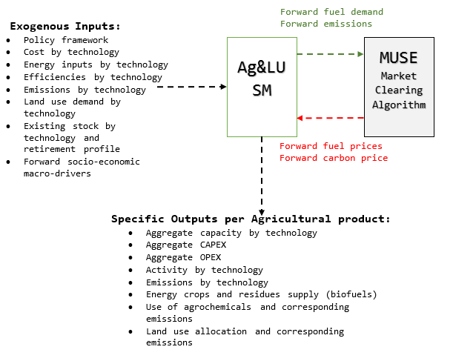

Figure 1. Integration of the Ag&LU module into MUSE and data flow with MCA [25]

The model is based on a two-step simulation approach:

* First, the demand for energy services demand is dynamically calculated using selected macrodrivers, such as GDP per capita and population. Then, exogenous parameters for the techno-economic and environmental characterisation of technologies are uploaded;
* Secondly, to model technological diffusion, a merit order approach based on   
  Net Present Value (NPV) is used to model investment decisions, thus defining the technological market share and the fuel mix.The model ranks technologies based on its capital and operational costs, efficiency and environmental impact.   
  Based on the market share, MUSE-Ag&LU would calculate per region, time period and timeslice the following metrics: fuel demand, agrochemicals demand, running operating costs (OPEX), land use demand, GHG emissions, and bioenergy and residual crop supply. At the next iteration, updated fuel and carbon prices information from the MCA will be receive by the module, thus repeating the simulation.

### Demand projection and data sources

The model projects the demand by energy content of crops, animal products, forestry products and bioenergy products in agreement with similar studies [6, 26, 27].   
As mentioned, the sector’s regional service demands are projected using regression models using GDP and population as macrodrivers [28]. For crops, meat and forestry products, the demands are projected based on historical regional diets and consumption trends [2]. From FAOSTAT [2], data for the period 1970-2010 for diets (kJ person−1 from crops and animal-based products), forestry products and bioenergy crops (tonnes of production) has been collected. After comparing a set of suggested models from the literature, the Engel’s function (log-log function) has been identified as the most convenient to estimate the agricultural services demand:

|  |  |
| --- | --- |
| $$\ln\left[d\left(T\right)\right]= a+b×ln⁡({GDP}_{cap})$$ | (1) |

The function shows that as income increases, demand for agricultural products would increase, nevertheless, the increase is under-proportional with income. Data from economies with high levels of income per capita show saturation level in demand, and in some extreme cases, a demand decrease, especially for meat-based products.   
For validation purposes, future projections have been cross-checked and validated against long-term projections reported from the FAO [29].

### Technology representation

In MUSE-Ag&LU, the energy consumption in agriculture is associated to a specific level of mechanisation of the technologies used to supply a specific service. The energy use share for each process (i.e. a combination of a technology and each mechanisation level) has been modelled, extending the qualitative method proposed by Opio *et al*. [30] and integrating it with data analysis techniques. First, data on yields were collected for every agricultural service (crops, animal, and forestry products) as well as on energy requirements and land use have been obtained for each region [2]. By relating service production to land demand, a region mechanisation level over different yields can be categorised. Appendix A (Figure A.1) shows the yield distribution per agricultural commodity on a global scale.

Based on these distributions, three mechanisation levels have been defined using the quartiles, as detailed in Table 1.

Table 1. Description of mechanisation levels in MUSE-Ag&LU

|  |  |  |
| --- | --- | --- |
| Mechanisation level | Quartile | Description |
| Traditional | Below the 1st quartile | Original method of farming with minimum mechanized equipment,  e.g. traditional cropping countries: Nicaragua, Cameroon, Haiti [2]. |
| Transitional | Between the 1st and 3rd quartiles | Mechanisation in some parts of the agricultural production chain.  Typical equipment examples are tractors, tilling, mechanical drying and irrigation. Also the use of agrochemicals is common practice,  e.g. transitional cropping countries: India, Russia, Brazil [2]. |
| Modern$ | Above the 3rd quartile | Most of the supply chain is fully mechanized supply chain, with high requirements in energy, water irrigation, and fertilizers,  e.g. modern cropping countries: United States, Netherlands, Japan [2]. |

$ Modern-renewable mechanisation level has added to represent renewable-based technology

Although the FAO [2] and IEA [31] energy balances provide energy demand and fuel share for the sector, there is no information separated by agricultural service (crops, animal, forestry and bioenergy). To provide a share of fuel per mechanisation level, the non-hierarchical method approach has been used [32]. The aim is to classify a country or region within a set of groups looking for high within-class homogeneity and as much variability as possible between groups. Therefore, country-level data by input/output ratio and yield have been grouped, and based on cluster segregation at different levels of distance between measurements, heterogeneous technological groups have been defined. For each mechanisation level, variation in energy use, agrochemicals demand, yields and investment parameters have been characterised. Based on the studied yields and the level of economic development, a different percentage of mechanisation level is allocated to every region. This means every country and region would have some level of mechanisation level to greater or lesser extent.

As previously mentioned, for the selection of future mechanisation adoption the model uses NPV as the main indicator for ranking technologies, therefore, cost values for each mechanisation level must be defined. For the definition of economic costs, Baruah and Bora [10] provided capital and operational costs (USD ha−1) for three strategic mechanisation scenarios. In the low-mechanisation scenario (traditional), more than 90% of the total cost is spent on muscle power, whereas in the partial mechanised scenario (transitional) this is about 59%. Machinery ownership and machinery operation including diesel are the major costs for the ‘transitional’ and ‘modern’ mechanisation scenarios (87% and 90% of the total operational cost) considered in the present study. Additionally, cost estimates data from the USDA [33] has been collected. This data details the cost per hectare for each agricultural product according to its yields. Based on the yields illustrated in Figure A.1, cost per mechanisation level for each agricultural product can be defined. The values used in this study are shown in Appendix B (Table B.1).

### Technology calibration

To obtain installed capacities for each mechanisation level per region and solve the calibration problem, an optimisation model has been implemented in GAMS [34].   
The model aims to minimise the gap between estimated emissions and the historical values for 2010. The problem has been formulated as follows:

|  |  |
| --- | --- |
|  | (2) |

subject to:

|  |  |
| --- | --- |
| $$\sum_{t∈{TS}_{s}}{{Capacity}_{r,t}}>{Demand}_{r,s}$$ | (3) |
|  |
| $$\sum_{t}{{Consumption}_{r,f,t}}< \left({Fuel demand}_{r,f}+{Slack}_{r,f}\right)$$ |

where r refers to region, f refers to fuel type, t to technology, s to service and TSs are the technologies available for service s. A slack variable has been added to fulfil fuel constraints. By solving the optimisation problem, all structural alternatives are evaluated and the capacities for each technology corresponding to the optimal solution are used as an estimate of the base year stock. In the periods after the base year, the MUSE-Ag&LU applies the simulation algorithm previously described to model capital and investment decisions in order to meet the demand and balance the decommissioned stock.

### Land use demand and land use change emissions

The integration of mechanisation levels into the agricultural production system provides a straightforward element to link installed capacity, commodity productivity and land demand per service (Figure 2). Depending on the demand and production levels per mechanisation level technology, MUSE will calculate the land requirement specifically for that process. Processes with a selected output service will require same type of land. This means that, for example, the cropping processes will be allocated to cropland only. Then, land values are aggregated per land type, region, and period to obtain a final agricultural land requirement.

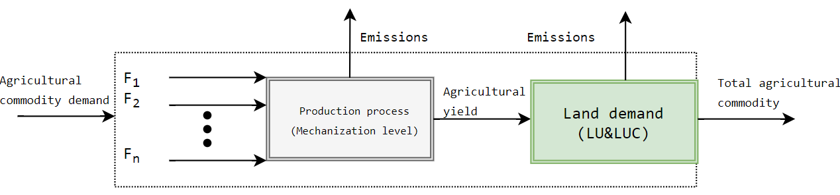

Figure 2. Basic representation of agricultural mechanization technology considering fuel input, production and land use demand

In MUSE-Ag&LU, seven different land types have been modelled:

* Cropland: land for crop cultivation;
* Pasture land: land for grazing livestock;
* Forestry products: land for silviculture;
* Energy crops: land for bioenergy crops;
* Natural forest: primary and secondary forest land;
* Non-arable land: unsuitable farming land (desert, ice, tundra, rock);
* Urban/Infrastructure: land for human settlements.

The model calculates land use change when the actual land to meet certain agricultural demand is not sufficient. Land becomes available either via deforestation or via a change in the destination of other land types in case of demand reduction or technology improvements (e.g. pasture land converted to energy crops).

To calculate land use emissions, the method is based on the non-spatially IPCC Tier 1 approach [35]. The approach calculates net land use changes over a period in time considering CO2 emissions based on disruptions from each pool for each land use category[[2]](#footnote-2). The four carbon pools considered are: above ground biomass, below ground biomass, Dead Organic Matter (DOM), and Soil Organic Carbon (SOC).

First, the stock-difference method is used to calculate carbon stocks differences for each carbon pool for a given land at two points of time:

|  |  |
| --- | --- |
| $$∆C_{l}=\frac{(C_{l,t2 }- C_{l, t1})}{(t_{2}- t_{1})}$$ | (4) |

where Δ*Cl* is the carbon change between periods for pool *l*, *Cl*,t1 is the carbon stock at period *l* and *Cl*,t2 is the carbon stock at the following period.

To account for carbon stock changes in each period:

|  |  |
| --- | --- |
| $$ΔC_{{LU}_{i} }= Δ{C_{AB}+ Δ{C_{BB}+ }_{ }Δ{C_{DOM}+ Δ{C_{SOC}}_{ }}_{ }}_{ }$$ | (5) |

where $ΔC_{{LU}_{i} }$ is the carbon stock change for land type *i*, and subscripts AB, BB, DOM to SOC refer to above ground biomass, below ground biomass, dead organic matter and soil organic carbon, respectively.

Finally, to account for AFOLU emissions, aggregated carbon stock changes is calculated as follows:

|  |  |
| --- | --- |
| $$∆C_{tot}= \sum_{i}{ΔC_{{LU}_{i} } }$$ | (6) |

where Δ*C*tot is the aggregated carbon stock change and Δ*Ci* is carbon stock difference land type *i*.

## CASE STUDY

Brazil, the world’s seventh largest economy and the eighth largest energy consumer (10.9 EJ year−1 in 2016 [36]) has been used as a case study. By 2026, energy use is expected to rise by 18.6% (12.9 EJ year−1) [37]. In the last years, the energy system has experience high dynamism. For example, on the demand side, the government has implemented large-scale programs improving electricity access to marginal groups, especially in regions such as the Amazons [38]. However, other sectors has experienced negative effects due to climate effects. For example, the power system, which mainly relies on hydroelectricity (> 60%), has become more vulnerable to blackouts due to water shortages [39, 40]. To minimise the blackout risks, other power sources, such as wind, have been extensively installed. For instance, wind installed capacity has grown from   
1.4 GW in 2011 to 8.1 GW in 2016, with important technical and socio-economic benefits [41].

### Brazil: agriculture energy use and land use demand

Specifically, the Brazilian agriculture sector represents about 4% of the national energy consumption (481 PJ year−1 and 31.1 Mt CO2 year−1), with diesel, firewood, and electricity responsible of 99.7% of the total sector energy share. In the last decades, due to a steady increase in per capita income, Brazil’s population has experienced major diet changes. According to data from the United Nations Food and Agriculture Organization (FAO) [2], between 1990 and 2015, per capita food energy consumption in Brazil grew from 9.5 MJ day−1 and 1.9 MJ day−1 from crop and animal-based products, to   
10.3 MJ day−1 and 3.2 MJ day−1, respectively. Combined with an increase in population of about 25%, this represented an increase from 622 to 1,016 PJ year−1 in total food energy content (an increase of 63.3%). In the same period, cropland has increased 50.8%, from 57.4 to 86.6 Mha (including 9.0 Mha for dedicated energy crops), while pasture land and secondary forest have increased by 6.4% (from 184 to 196 Mha) and 52.2% (from 4.9 to 7.6 Mha), respectively. Both food-related land use types (cropland and pasture) have lower percentage increase than total food demand due to intensification in agricultural systems. Nowadays, cropland and pasture land combined are accountable for 265 Mha or 31% of the country land (Figure 3a).

Conversely, Brazil is one of the biggest promoters of bioenergy production and utilisation in the world. In 2016, bioenergy (mainly ethanol and bagasse from sugarcane) represented 16.9% of the domestic energy supply (2,121 PJ) [36]. Although the South-East region is the area with the largest production, the Centre-West region has become the main place for sugarcane expansion where land use patterns have changed since the introduction of dedicated energy crops [5]. For example, between 2003 and 2013, only in Goias and the Federal District, sugarcane area expanded six-fold (from 0.14 to 0.85 Mha) [42], pushing food crops to new lands. However, outside the most developed regions in Brazil, information is still scarce about land use change dynamics of new sugarcane and other bioenergy cultivations [42].

Both, food and energy crops are the main drivers of deforestation in Brazil which has become critical to any decarbonisation scenario. High rates of deforestation can drastically alter the storage and cycles of carbon and nitrogen pools [43]. On a global scale, tropical deforestation alone is responsible between 7-14% of global GHG emissions [44]. Currently, 20% of the global tropical deforestation is located in Brazil and is responsible for 0.43 Gt CO2 year−1 [45]. Between 1990 and 2014, the forest area in Brazil went from 541.7 Mha to 486.9 Mha [2]. The loss of 54.8 Mha (including 37 Mha of the Amazon forest) represented 6.6% of total land, a size similar to France. On the positive side, in the last decade programmes and regulatory policies have been put in place to reduce deforestation rates, declining from an average rate of 2.7 Mha year−1 (1990-2004) to 1.6 Mha year−1 (2005-2014) [2]. If pre-2005 deforestation rates would not have been improved (combined with low agriculture intensification), by 2056, about   
62 Mha of forest would have been lost (Figure 3b).

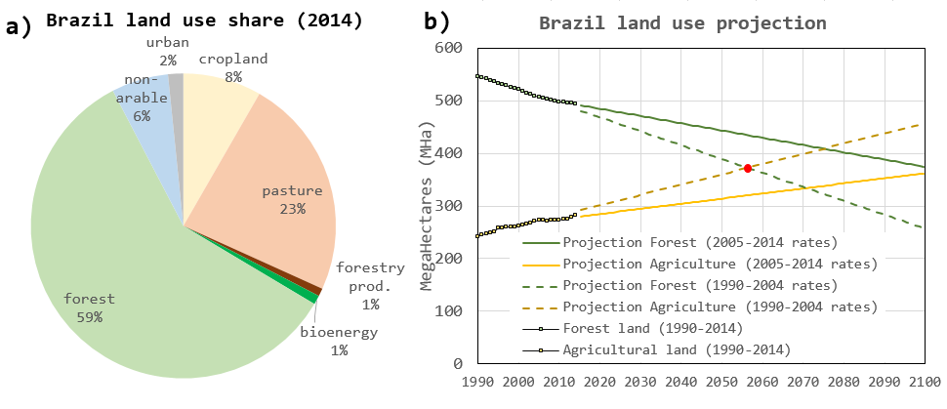

Figure 3. Current land share in Brazil (total: 836 Mha) (a) and Brazil land projection (b) for agricultural and forest land based on 1990-2004 and 2005-2014 deforestation rates [2]

### The role of sugarcane and natural gas in Brazil

Overall, sugarcane products and natural gas represent 16.9% and 13.7% of the gross domestic energy supply, respectively, with higher growing rates expected in the following decades. Brazil has a tradition of generating varieties of high-yielding sugarcane combined with expertise in process optimisation for ethanol production. As a matter of fact, it remains the largest producer of sugar ethanol with 29 billion L year−1, mainly coming from 9 Mha of sugarcane plantations [46]. Although bioenergy could simultaneously address energy security and climate change concerns, the associated global warming potential should account for LUC, agrochemical inputs, SOC changes, and the auxiliary energy consumption of processes [47]. Emissions from biofuel indirect Land Use Change (iLUC) is the most uncertain component when assessing emissions induced by the expansion of energy crops, for example, ethanol production estimated emissions from iLUC could be in the range of 10-340 g CO2 MJ−1 (central 95% interval: 21-142 g CO2 MJ−1) [48].

Although the country counts with large amounts of natural gas reserves   
[388-453 billion cubic meters (bcm)], with a current daily production of 103.8 mcm (million cubic meters) (1,477 PJ year−1) and imports of 32.1 mcm (456 PJ year−1) [36], natural gas still plays a modest role. Up to a quarter of the national gas production (mostly offshore associated gas) is consumed upstream, or either used for gas processing or fertiliser production. Power generation required around 716 PJ year−1. In the demand sectors, the industry is the highest consumer, with a demand of 417 PJ year−1, while the domestic and commercial sectors’ consumption (concentrated in the South-East region) is relatively low, accounting for only 19.6 PJ year−1 [36]. This low reliance on the use of gas is mainly due to the predominant role of hydroelectricity and sugarcane products, the underdeveloped gas infrastructure, the lack of heating demand, and high subsidies for Liquefied Petroleum Gas (LPG). The importance of natural gas in the Brazilian mix, though, is expected to grow considerably [49, 50] ensuring universal energy access to the population, and supporting the share increase of renewable energy and energy efficiency programmes in the country. Only in the last two decades, thanks to an increasing local production and imports from the Bolivian pipeline, natural gas consumption has seen a steady annual grow of 10.4% [51]. Between 1990 and 2013, gas users grew from   
0.5 million to 2.44 million, while energy consumption went from 40 PJ to 1,296 PJ.

## SCENARIOS

In this study, the model has been applied to simulate transitions in the Brazilian agricultural energy system and land use between 2010 and 2050 under two different two-degree scenarios (2DS). Based on the research from Rochedo *et al*. [52], a carbon budget of 40 Gt CO2 has been considered accounting only for the energy and land systems. The selected value is located on the higher end of the range proposed by the authors (16.0-41.4 Gt CO2), as in this study, carbon negative technologies such as carbon capture and storage, direct air capture, and/or reforestation have not been considered.   
The proposed two scenarios differ in terms of the assumptions made for the bioenergy production growth (Figure 4):

* Two degree scenario with sugarcane expansion (2DS + SugC): Explores a two-degree scenario that incentivises larger production of sugarcane and soybean assuming a blending mandate according to which the biofuels production grows steadily from a 2010 production rate of 0.59 EJ year−1 (0.54 PJ year−1 ethanol and 0.05 EJ year−1 biodiesel [53]) to 5.0 EJ year−1 in 2050 and the production of local natural gas is limited to current levels (around 100 mcm day−1). It is assumed that the same share ethanol-biodiesel is maintained through to the time analysed.   
  The assumed biofuels growth occurs by about 6% per year and in line with the “New Policies Scenario” from the 2010 IEA World Energy Outlook [53];
* Two degree scenario with natural gas expansion (2DS + NG): Explores a two-degree scenario that incentivises natural gas production and infrastructure expansion as well as limits bioenergy expansion by taxing land use emissions from bioenergy crops growth. It contemplates that biofuels would grow by about 3% per year. This means that bioenergy production will only increase from the current rate of 0.59 EJ year−1 in 2010 to 2.50 EJ year−1 in 2050.

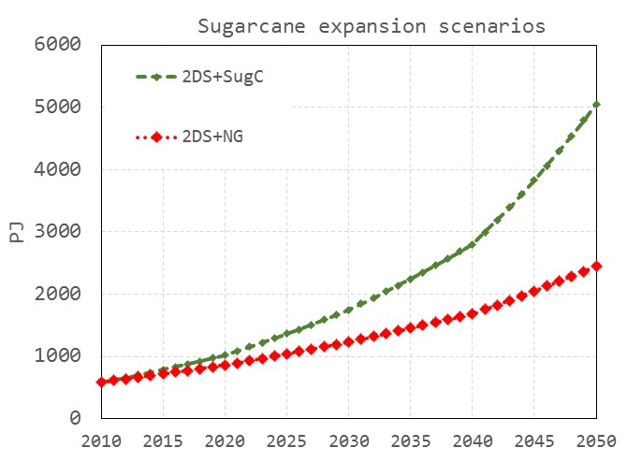

Figure 4. Projections of bioenergy production for both simulated scenarios

### Brazil agriculture demand projection

IIASA SSP2[[3]](#footnote-3) scenario on GDP and population has been used for food demand projections [54]. The data suggest that by 2050, Brazil will have a per capita income of about USD 22,617 (2005 USD) and a population of 232 million inhabitants.   
Using eq. (1), Figure 5 illustrates actual data for average daily food intake (both crop and meat based)[[4]](#footnote-4). The Engel’s curves shows that by 2050, each person in Brazil will consume about 10.5 MJ day−1 of crop-based diet and 3.6 MJ day−1 of meat-based diet.   
In aggregated values, this means that the total energy in food demand will grow from of 732 PJ year−1 and 229 PJ year−1 of crop and animal-based food respectively in 2010 to about 889 PJ year−1 and 308 PJ year−1 by 2050: a 25% increase in total food demand compared to 2010.

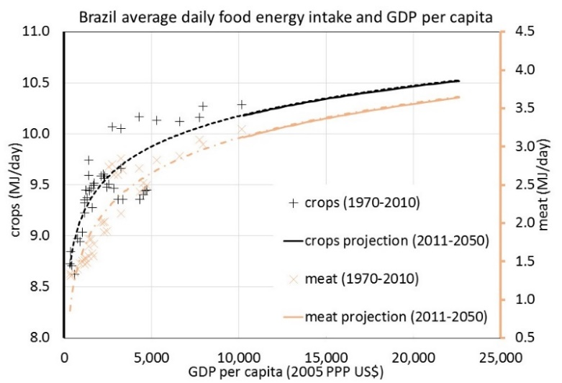

Figure 5. Projections between food intake and average GDP per capita in Brazil   
(source data: FAO [2])

For sugarcane, the model endogenously calculates its production based on the demand for sugarcane by products (ethanol, bagasse) from the transport, power and industry sectors. Finally, to account for agricultural commodities imports/exports, we have assumed that future trade is in a constant share with base year values.

### Technology characterisation and land use representation

Based on analysed global yields and mechanisation definitions, Brazil can be regarded as having mainly transitional mechanisation as it was found that crops have an average yield of 10.49 PJ Mha−1, while meat production of 1.16 PJ Mha−1 and silviculture of 7.66 PJ Mha−1 [2]. This could also be explained by the share of agricultural production to the national GDP, which stands at 4.3% [2]. By using the optimisation process   
[eq. (2) and eq. (3)], base-year installed capacities for each agricultural service have been obtained. The outputs are shown in Appendix C (Table C.1).

Conversely, regional land demand characterisation has been one of the most challenging task due to the lack of public available data at the desired granularity.   
Main data on land use demand from agricultural, pasture and urban land has been obtained from the Brazilian Institute of Geography and Statistics (IBGE) [55] and FAOSTAT [2]. Land demand for different Land data on Brazilian forest and forestry production by biome has been gathered from the Ministry of Environment (MME) [56]. Finally from the Sugar Cane Industry Union (UNICA) [57], regional land demand from sugarcane production has been collected. As shown in Figure 6, for the characterisation of the Brazilian forest land, all six biomes have been considered (Amazonia, Caatinga, Cerrado, Mata Atlántica, Pampa and Pantanal).

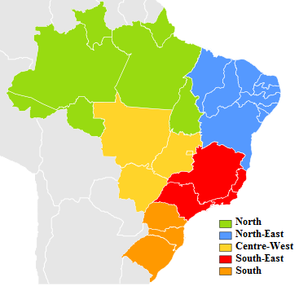 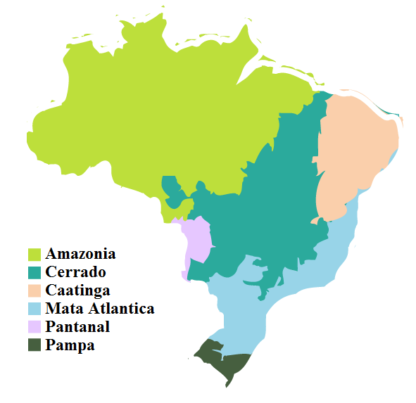

Figure 6. Brazil’s main geopolitical regions (left) and biomes (right)

Some biomes can be found in two or more regions. For instance, the Amazonas is located in the North (305.4 Mha), North-East (2.7 Mha) and Centre-West (33.4 Mha) regions. This data has been considered and separated between the different regions as necessary. This has implications in the assumed carbon pools of the different geopolitical regions, therefore, biome shares for each region and related C stocks per unit area have been considered to calculate regional C stocks. To account for carbon emissions or sequestration from land use, Brazil’s carbon densities have been taken from the IPCC [35] and other studies [30, 58, 59] (Table 2).

Table 2. Estimated Brazilian land area in 2010 [2] and stocks for each carbon pool

|  |  |  |  |  |  |  |
| --- | --- | --- | --- | --- | --- | --- |
| Land type | Land area  [Mha] | Above ground  [mg C ha−1] | Below ground  [mg C ha−1] | DOM  [mg C ha−1] | SOC&  [mg C ha−1] | Total  [mg C ha−1] |
| Cropland | 67.8 | 5.0 | 1.4 | 1.0 | 53.1 | 60.5 |
| Pasture | 277.0 | 7.6 | 1.1 | 0 | 78.9 | 87.6 |
| Forestry prod.+ | 6.7 | 62.0 | 12.8 | 1.8 | 42.0 | 118.6 |
| Bioenergy\* | 9.7 | 16.0 | 14.3 | 1.0 | 33.5 | 64.8 |
| Forest |  |  |  |  |  |  |
| Amazonia | 341.6 | 78.2 | 28.9 | 5.2 | 44.0 | 156.3 |
| Cerrado | 41.4 | 39.9 | 7.9 | 5.2 | 65.0 | 118 |
| Caatinga | 40.3 | 42.5 | 8.5 | 11.7 | 38.0 | 100.7 |
| Mata Atlántica | 24.1 | 61.8 | 14.8 | 4.1 | 47.0 | 127.7 |
| Pantanal | 2.8 | 60.2 | 15.2 | 5.2 | 44.0 | 124.6 |
| Pampa | 8.9 | 61.8 | 14.8 | 4.1 | 47.0 | 127.7 |
| Non- arable | 21.2 | - | - | - | - | 0 |
| Urban | 13.5 | - | - | - | - | 0 |

& Estimations from the topsoil layer (0-20 cm in depth)

\* Sugarcane, considering an average productivity (yield) of 60 ton/ha

+ Eucalyptus plantation

## RESULTS

The results section has been separated into three parts: technological diffusion and energy use in the agricultural sector, land demand projections and emissions related to land use and country-level primary energy use and emissions considering all sectors in the energy system as well as emissions from land and agricultural production.

### Agriculture technology diffusion and energy use

Figure 7 shows a projection for both scenarios of the aggregated agricultural service demand (crops, meat, forestry products and bioenergy) in energy units (PJ) highlighting the share of production in terms of mechanisation levels.

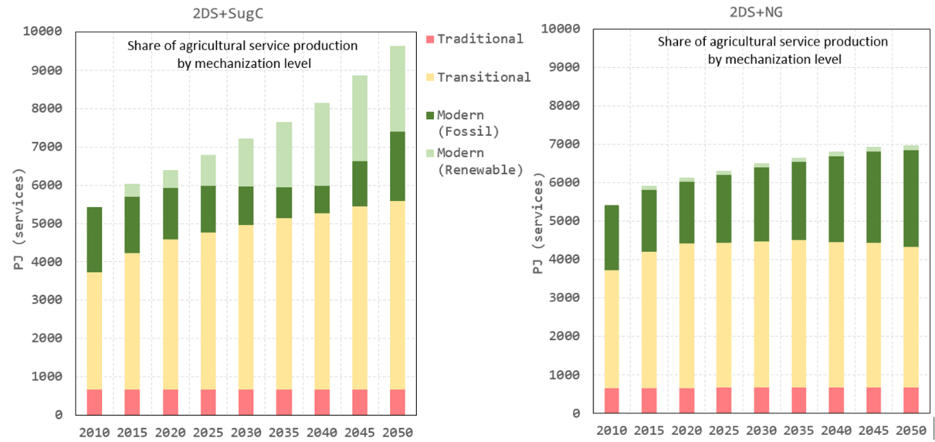

Figure 7. Share of different agriultural mechanisation levels for both scenarios

By 2050, service demand in 2DS + SugC is higher than 2DS + NG as sugarcane production increases to satisfy the higher assumed demand for biofuels in the transport sector. 2DS + SugC is expected to reach a total agricultural service demand of   
9,634 PJ year−1 (891 PJ year−1 for crops, 307 PJ year−1 for meat-based, 3,423 PJ year−1 for forestry products and 5,013 PJ year−1 for bioenergy), representing an increase of 78% compared to 2010 (5,425 PJ year−1). Results show that modern mechanisation is expected to increase its share from 31% in 2010 to 42% in 2050, with a high share of renewable-based modern mechanisation. A change in the technological preference can be noted as the model installs up till 2025 fossil-based modern technology. As soon as modern renewable technologies becomes more accessible after 2025 due to more competitive energy renewable prices, these technologies become the preferred choice over fossil-based modern mechanisation. If only the food production is considered, the food energy content (output) per energy input decreases due to a more mechanised and energy intensive sector, meaning than more energy is required to produce one unit of food. In the base year, this index is around 2.64 kJ/kJ, and by 2050 it reaches 2.11 kJ/kJ, approximating current energy output/input ratios of developed economies [32].

In 2DS + NG, the total service demand is expected to reach 6,974 PJ year−1, an increase of 29% compared to 2010. As mentioned, the service demand difference compared to 2DS + SugC mainly comes from the lower bioenergy production. In this scenario, modern mechanisation represents 38% of the total share by 2050, where renewable-based modern mechanisation is only responsible for 2%, due to the limit availability of bioenergy for renewable-based on-farm processes. By the end of the time horizon, the food energy output/input indicator reaches 2.26 kJ/kJ, which represents a 7.1% less mechanised sector compared to 2DS + SugC.

Figure 8 shows the energy demand by fuel projections as well as fuel-related emissions exclusively from the Brazilian agriculture sector.

By 2050, in 2DS + SugC, the agriculture sector is expected to consume 725 PJ year−1 (73% increase compared to 2010). Results show that diesel (282 PJ year−1), biodiesel (195 PJ year−1) and biomass (147 PJ year−1) are responsible of 86% of the total fuel share. On the other hand, the use of electricity grows from 64 to 85 PJ year−1, but its total share decreases from 15% to 12%. Direct energy-related emissions reach 37.8 Mt CO2 year−1 and the emissions intensity (emissions per unit service) decreases from   
5.54 Mt CO2 PJagr−1 in 2010 to 3.92 Mt CO2 PJagr−1 in 2050.

In 2DS + NG, the total energy demand is expected to reach 599 PJ year−1 by 2050. This is lower than 2DS + SugC (125 PJ year−1 lower) due to a smaller bioenergy industry. In this case, diesel (205 PJ year−1), and biomass (137 PJ year−1) are responsible for 57% of the total share. Biodiesel uptake occurs at a much slower rate compared to 2DS + SugC, only representing 96 PJ year−1 by 2050. Additionally, electricity grows from   
64 PJ year−1 to 111 PJ year−1 representing 19% of the total share, while demand for natural gas grows from 0.09 PJ year−1 to 42.3 PJ year−1 (supposedly to cover processes such as drying and machinery). In 2050, the direct energy-related emissions is lower than 2DS + SugC, reaching 33.2 Mt CO2, but the emission intensity is higher   
(4.77 Mt CO2 PJagr−1) due to higher demand of fossil fuels per unit of agricultural service.

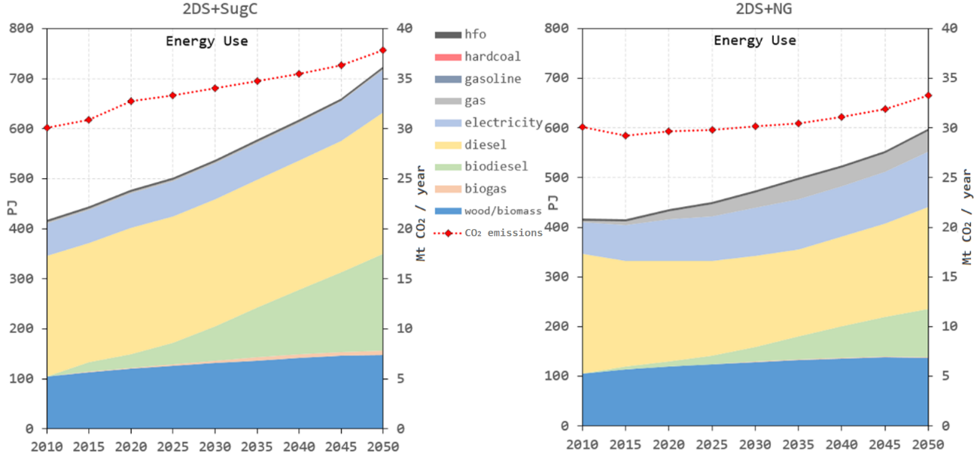

Figure 8. Fuel demand projections and aggregated energy-related emissions for both scenarios

### Land use and related emissions

Figure 9 illustrates land use requirements for both analysed scenarios. As seen, the amount of land devoted to growing all agricultural services increases by a simultaneous decrease in other lands such as forest.

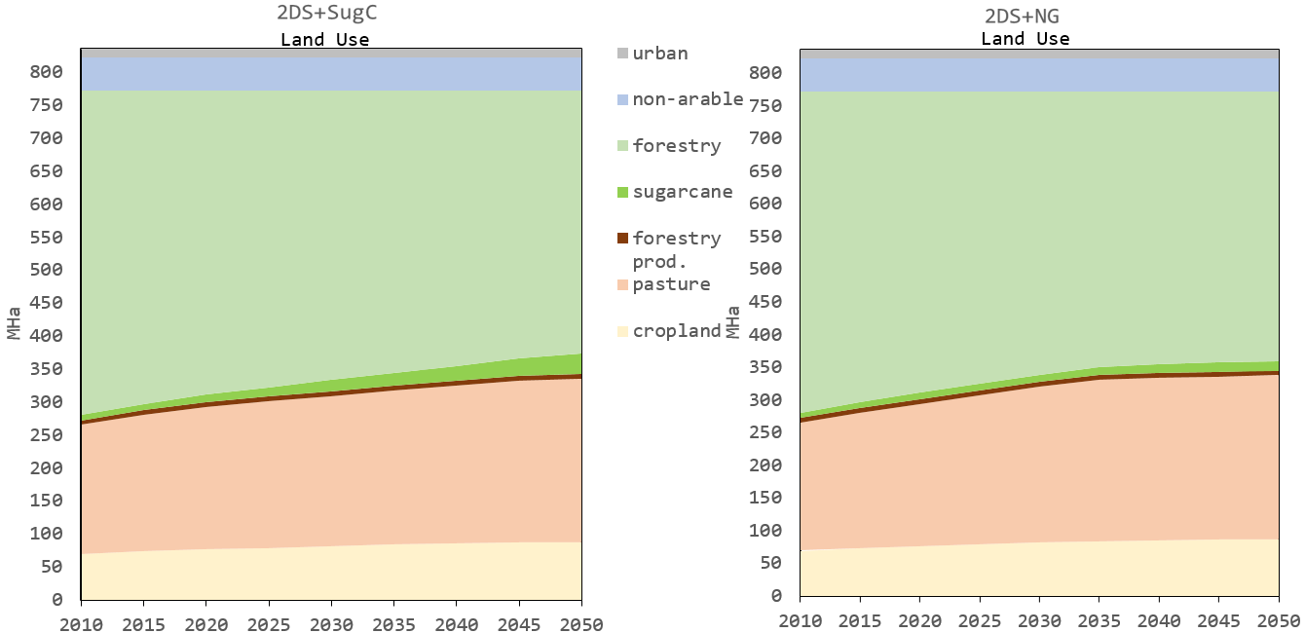

Figure 9. Land use demand projections for both scenarios

For both cases, a demand increase in meat-based products, causes a constant increase in pasture land until 2030, reaching around 228 Mha (+32 Mha) to later stabilise due to intensification of animal farming. On the other hand, crop land constantly increases until 2050. This takes place at an annual rate of 0.9% between 2010 and 2030, and reducing to 0.3% year−1 between 2030 and 2050. Crop land demand reaches around 87 Mha   
(+18 Mha) by 2050. The largest differences are in land dedicated to bioenergy. While for 2DS + SugC, growth rates were found at 5.3% between 2010 and 2030 and 4.5% between 2030 and 2050, reaching 31.0 Mha of land, for 2DS + NG, growth rates were at 2.1% between 2010 and 2030 and 1.4% between 2030 and 2050, reaching 14.5 Mha.   
In general, for 2DS + SugC, land demand to cover all four agricultural services grows from 280.4 to 351.7 Mha. Results suggest that future service demands will be met 66.6% by intensification implying improved mechanisation and 33.4% by land use increase.   
In 2DS + NG, land demand for agricultural services increases to 339.1 Mha, where the new future service demand will be covered 71.7% by intensification and 28.3% by land use increase. The results on land demand indicate that compared to 2DS + SugC   
(6% annual growth of bioenergy), 2DS + NG (developing gas infrastructure combined with 3% annual growth rate of bioenergy) could save around 12.6 Mha of forest by 2050 by limiting energy crops production that normally has an indirect land use change impact due to crop and pasture expansion in other land types.

Finally, by using eqs. (4-6) in the model, Figure 10 illustrates the projected Ag&LU sector CO2 flux estimations for both scenarios. Besides emissions from direct energy use, releases and uptake of C from land use and land use change have been calculated for all four carbon pools.

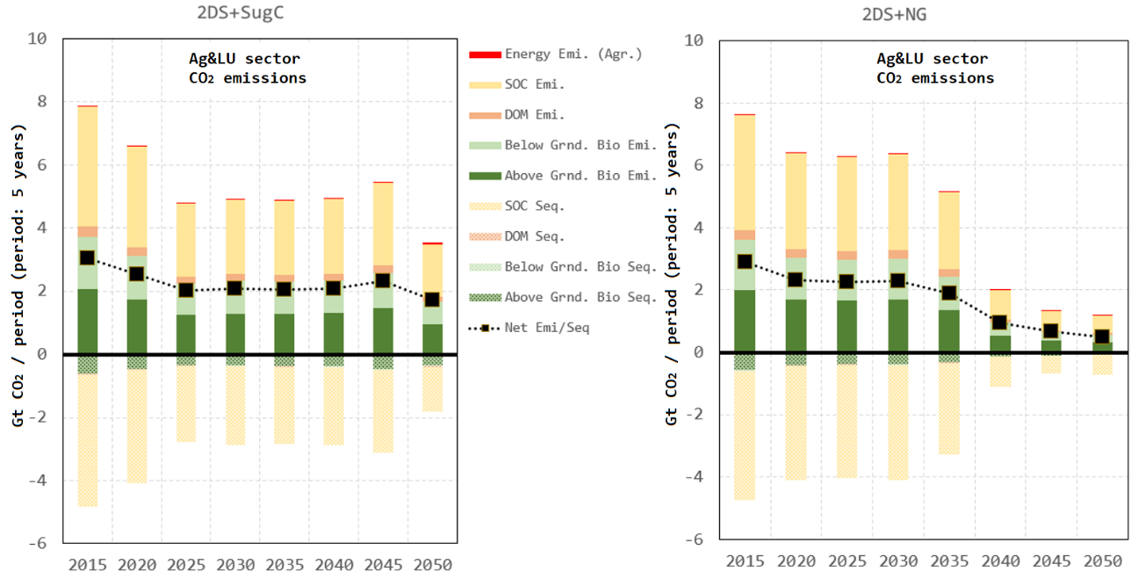

Figure 10. CO2 emissions/sequestration rates from energy consumption in agriculture and   
land use dynamics

If compared, emissions due to agricultural energy use are insignificant compared to emissions due to land use change. The largest emissions arise from above ground biomass and SOC pools removal due to deforestation, while the largest sequestration rates come from SOC pools turning land into pasture land. Results also demonstrate that by 2050, the carbon pool from forest could be reduced by almost 20%, mainly due to deforestation, but with high increases in the biomass carbon pools due to large bioenergy developments.

For 2DS + SugC, modelling results project a net release rate of about   
608 Mt CO2 year−1 in 2015 slowing to 344 Mt CO2 year−1 in 2050. By the end of the modelling period, 2DS + SugC would have released to the atmosphere 5.1% of the actual Brazilian land carbon stock (16.0 Gt CO2).

For 2DS + NG emissions rates have been found at 580 Mt CO2 year−1 in 2015 and reduced to 96 Mt CO2 year−1 in 2050. By 2050, 2DS + NG would have released 4.1% of the current Brazilian land carbon stock (12.8 Gt CO2). At the end of the modelling period, emissions’ rates are lower for the natural gas expansion scenario due to lower forest land conversion rates. Consequently, there is a more evident declining rate in carbon emissions, as less sugarcane lands are necessary and natural gas has a more important share in the energy system. It is important to mention that by having a much smaller bioenergy industry in 2DS + NG, the lower sectoral emissions compared to 2DS + SugC can be explained. If emissions from natural gas production, transportation and utilisation were to be considered, 2DS + NG would present higher values, however, this is out of the scope of this study as it is modelled in other modules in the MUSE framework.

### Country-level energy use and emissions

Figure 11 illustrates the projected primary energy supply for both scenarios. The main differences are defined by the contrasting share of bioenergy, natural gas and renewable energy sources. For instance, in the 2DS + SugC, bioenergy (considering both sugarcane and firewood/charcoal) would grow from 4,910 PJ year−1 in 2015 to 9,843 PJ year−1 by 2050. This would results in a share increase of bioenergy in the energy matrix from current 25% to about 49%. On the other hand, in this scenario natural gas is expected to decrease its share from 12% in 2015 to 8% in 2050, with an annual demand of   
1,586 PJ year−1. For the 2DS + NG scenario, bioenergy would increase at a lower rate, reaching 7,242 PJ year−1 in 2050, representing 36% of the country’s primary energy supply. However, natural gas demand would experience almost a four-fold increase, from 1,380 PJ year−1 in 2015 to 4,187 PJ year−1 in 2050, increasing its share in the energy matrix from 12% to 21%. One important difference between scenarios is the share of “other renewable” energy, mainly represented by solar and wind. As it is expected that the 2DS + SugC would have larger emissions from land use, this scenario would require a larger share of clean energy sources to lower its energy-related emissions. As illustrated (Figure 11), by 2050 energy-related emission from the 2DS + SugC (0.47 Gt CO2 year−1) would be 32% lower compared to those from the 2DS + NG (0.62 Gt CO2 year−1). In both scenarios, the combined share of coal and oil would be reduced from 55% in 2015 to 25% by 2050, with almost a complete retirement of coal from the energy matrix.

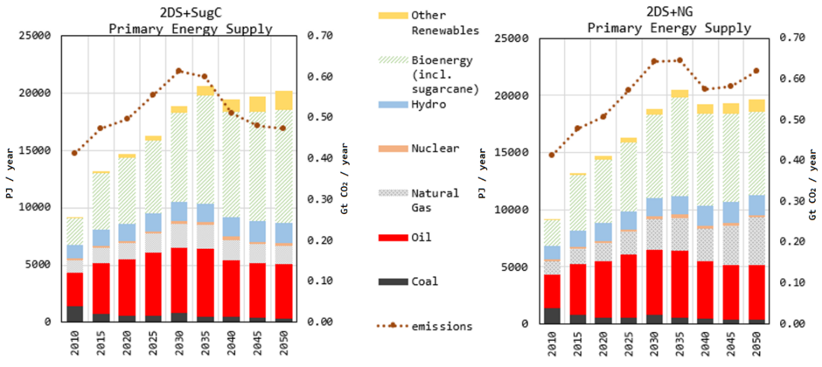

Figure 11. Brazil’s primary energy supply for both analysed scenarios

Finally, Figure 12 illustrates the aggregated GHG emmissions separated by source [energy, agriculture (non-CO2) and land use]. As aforementioned, the higher agricultural activity in the 2DS + SugC causes higher emissions from land use and agriculture.   
Only considering energy and land use emmisions, the 2DS + SugC depletes 38.8 Gt CO2 between 2015 and 2050, while for the 2DS + NG this value is around at 36.8 Gt CO2.   
By reducing land use emissions in the 2DS + NG by 2050, the total country’s emissions rate are found to be 6% lower compared to the 2DS + SugC (1.36 vs. 1.45 Gt CO2 year−1).

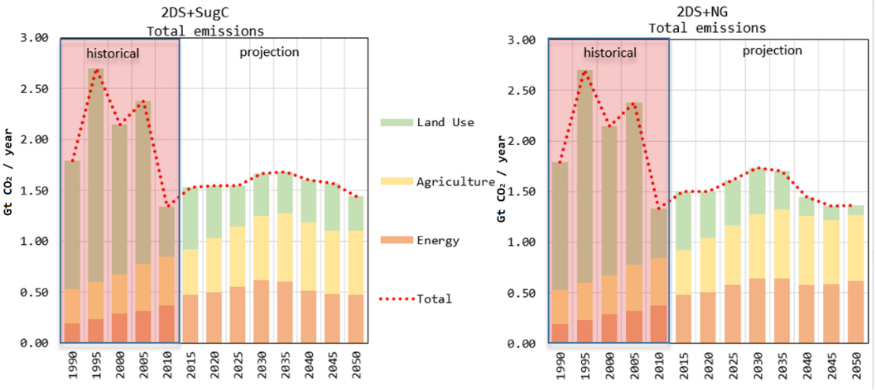

Figure 12. Brazil’s total GHG emissions projections for both analysed scenarios considering energy, agriculture and land use

## DISCUSSION

The results show the importance of the AFOLU sector in reaching carbon mitigation targets, especially by controlling emissions from land use. Modern technological diffusion is expected in the Brazilian agricultural sector in order to meet future demand for energy and food. Although energy demand and related emissions from farm equipment is minimal compared with the whole energy system, modern mechanisation levels could improve productivity rates, thus having a major impact in land use related emissions. In both scenarios, an increase in energy demand in agriculture would be required to produce a unit of agricultural product, bringing energy index values closer to those found in developed economies.

If biofuel production is to be increased ten-fold by 2050, increasing land productivity would be fundamental to keep a sustainable bioenergy policy that would have marginal implications on crop competition and deforestation rates. However, intensification comes with larger amounts of embodied emissions in the form of agrochemicals. Improved land productivity could also have an adverse reaction, as it could motivate producers to spread production to new lands, however, these land use dynamics are difficult to foresee in presence of different stakeholders.

Natural gas is abundant in Brazil, however, mechanisms must be put in place for a sustainable infrastructure development and use of this resource. Off-shore natural gas has the potential to significantly reduce Brazil’s demand for wood energy and promote a more sustainable production of sugarcane and land management. As shown by the   
2DS + NG, reducing sugarcane expansion and therefore deforestation would eventually minimise ecosystems depletion, with substantial socio-economic benefits. However, the analysis is incomplete if the whole energy system is not considered, as emissions from natural gas could be considerable in other sectors in the economy (e.g. power, industry, refinery, extraction and distribution) as well as leakage methane emissions from the supply chain.

Nevertheless, the analysis of both scenarios has shown that balancing resource utilisation and infrastructure development is necessary. As demonstrated in this study, new sugarcane lands, especially if their expansion comes from either direct or indirect deforestation, could have substantial impacts on regional carbon emissions.

## CONCLUSIONS

Decarbonisation pathways are not widely discussed in agricultural sector modelling due to its small direct energy consumption, however, the sector is of greater importance in the wider energy system. Integrating the agriculture and land use sector into ESMs is still a challenge. This paper has shown an application of the recently developed MUSE-Ag&LU model. The model has been able to characterise intensification processes while simulating mechanisation diffusion, including agrochemical inputs (fertilisers and pesticides), energy and land demand.

The presented case study explored the complex relationship between sugarcane production, deforestation and fossil fuel resource exploitation under two different two-degree scenarios for Brazil. One scenario explored the effect of sugarcane expansion (ten-fold production increase) by 2050, while limiting the production of natural gas to current levels. A second scenario explored a higher production and utilisation of natural gas while halving bioenergy production. Both scenarios have demonstrate the importance of agricultural technological investment and sector intensification in Brazil. Results have shown that the agriculture sector is likely to move from transitional to modern agricultural practices. This trend implies an increase in the energy consumption, but it is a necessary step to intensify the production processes, fulfil demands of food, forestry products and energy crops with limited amount of land. Also, depending on the chosen path, renewable energy sources could have a larger share in the energy system if emissions need to be reduced to reach pre-defined carbon abatement targets.

Deforestation still represent an important source of emissions. In both scenarios, deforestation occurs at different rates, however, the promotion of expanding natural gas while limiting bioenergy production to 2.5 EJ year−1 instead of 5.0 EJ year−1 by 2050, has resulted in forest land savings of 12.6 Mha, thus sequestering 3.2 Gt CO2 in wood and soil pools and reducing land use emissions rates to around 0.10 Gt CO2 year−1.   
Thus, emissions from natural gas can be compensated by the capture and sequestration potential of the Brazilian forests. Although the natural gas scenario showed that the resource could help manage deforestation rates, a large infrastructure with potentially high economic costs would be necessary. Policy targets have to be consistent considering energy and land use emissions. On one hand, future bioenergy production could lead to unfeasible land use demand aiming to reach fossil fuel displacement target. On the other hand, an over exploitation of fossil fuel resources such as natural gas could also lead to undesired environmental implications.

The proposed results are to be considered as scenarios of development of the domestic agricultural sector in Brazil dealing with a limited resource such as land.   
In doing so, the effect of trade was not considered. In the future work, the model will be expanded to consider different carbon abatement scenarios, providing an integrated view of the energy systems and the cross sectoral effects of agriculture and land use change.

## ACKNOWLEDGMENT

The authors would like to acknowledge the Sustainable Gas Institute, Imperial College London and the Natural Environment Research Council (NERC) under the Newton Fund (NERC reference: NE/N018656/1) for funding this work.

## REFERENCES

1. United Nations (UN), Framework Convention on Climate Change: Adoption of the Paris Agreement, United Nations: 21st Conference of the Parties, Paris, France, 2015.

2. Food and Agriculture Organization (FAO), FAOSTAT, 2017.

3. Intergovernmental Panel on Climate Change (IPCC), Climate Change 2014: Mitigation of Climate Change Working Group III Contribution to the Fifth Assessment Report of the Intergovernmental Panel on Climate Change (Edenhofer, O., Pichs-Madruga, R., Sokona, Y., Farahani, E., Kadner, S., Seyboth, K., Adler, A., Baum, I., Brunner, S., Eickemeier, P., Kriemann, B., Savolainen, J., Schlömer, S., von Stechow, C., Zwickel, T. and Minx, J. C., eds.), United Kingdom and New York, New York, USA, 2014.

4. Woods, J., Williams, A., Hughes, J. K., Black, M. and Murphy, R., Energy and the Food System, *Philosophical Transactions of the Royal Society B: Biological Sciences*, Vol. 365, No. 1554, pp 2991-3006, 2010, <https://doi.org/10.1098/rstb.2010.0172>

5. Rathmann, R., Szklo, A. and Schaeffer, R., Land Use Competition for Production of Food and Liquid Biofuels: An Analysis of the Arguments in the Current Debate, *Renewable Energy*, Vol. 35, No. 1, pp 14-22, 2010, <https://doi.org/10.1016/j.renene.2009.02.025>

6. Cirera, X. and Masset, E., Income Distribution Trends and Future Food Demand, *Philosophical Transactions of the Royal Society B: Biological Sciences*, Vol. 365, No. 1554, pp 2821-2834, 2010, <https://doi.org/10.1098/rstb.2010.0164>

7. Lamboll, R., Climate Change and Agricultural Systems A2 ‒ Snapp, Sieglinde, in: *Agricultural Systems* (2nd ed.), pp 441-490, Academic Press, San Diego, California, USA, 2017, <https://doi.org/10.1016/B978-0-12-802070-8.00013-X>

8. Intergovernmental Panel on Climate Change (IPCC), Climate Change 2014: Synthesis Report, Contribution of Working Groups I, II and III to the 5th Assessment Report of the Intergovernmental Panel on Climate Change, 2014.

9. Pimentel, D., Energy Inputs in Food Crop Production in Developing and Developed Nations, *Energies*, Vol. 2, No. 1, pp 1-24, 2009, <https://doi.org/10.3390/en20100001>

10. Baruah, D. C. and Bora, G. C., Energy Demand Forecast for Mechanized Agriculture in Rural India, *Energy Policy*, Vol. 36, No. 7, pp 2628-2636, 2008, <https://doi.org/10.1016/j.enpol.2008.03.030>

11. Walker, L. P., A Method for Modelling and Evaluating Integrated Energy Systems in Agriculture, *Energy in Agriculture*, Vol. 3, pp 1-27, 1984, <https://doi.org/10.1016/0167-5826(84)90002-0>

12. Jones, J. W., Antle, J. M., Basso, B., Boote, K. J., Conant, R. T., Foster, I., Godfray, H. C. J., Herrero, M., Howitth, R. E., Janssen, S., Keating, B. A., Munoz-Carpena, R., Porter, C. H., Rosenzweig, C. and Wheeler, T. R., Brief History of Agricultural Systems Modeling, *Agricultural Systems*, Vol. 155, pp 240-254, 2017, <https://doi.org/10.1016/j.agsy.2016.05.014>

13. IMAGE-contributors, Welcome to IMAGE 3.0 Documentation, 2019.

14. Krey, V., Havlik, P., Fricko, O., Zilliacus, J., Gidden, M., Strubegger, M., Kartasasmita, G., Ermolieva, T., Forsell, N., Gusti, M., Johnson, N., Kindermann, G., Kolp, P., McCollum, D. L., Pachauri, S., Rao, S., Rogelj, J., Valin, H., Obersteiner, M. and Riahi, K., MESSAGE-GLOBIOM 1.0 Documentation, International Institute for Applied Systems Analysis (IIASA), Laxenburg, Austria, 2016.

15. Dietrich, J., Bodirsky, B., Weindl, I., Humpenöder, F., Stevanovic, M.,   
Kreidenweis, U., Wang, X., Karstens, K., Mishra, A., Klein, D., Ambrósio, G., Araujo, E., Biewald, A., Lotze-Campen, H. and Popp, A., MAgPIE ‒ An Open Source Land-Use Modeling Framework, *Geoscientific Model Development Discussions*, pp 1-26, 2018, <https://doi.org/10.5194/gmd-2018-295>

16. Wise, M., Calvin, K., Kyle, P., Luckow, P. and Edmonds, J., Economic and Physical Modeling of Land Use in Gcam 3.0 and an Application to Agricultural Productivity, Land, and Terrestrial Carbon, *Climate Change Economics*, Vol. 5, No. 2, 1450003, 2014, <https://doi.org/10.1142/S2010007814500031>

17. Elobeid, A., Tokgoz, S., Dodder, R., Johnson, T., Kaplan, O., Kurkalova, L. and Secchi, S., Integration of Agricultural and Energy System Models for Biofuel Assessment, *Environmental Modelling & Software*, Vol. 48, pp 1-16, 2013, <https://doi.org/10.1016/j.envsoft.2013.05.007>

18. Rochedo, P. R. R., Development of a Global Integrated Energy Model to Evaluate the Brazilian Role in Climate Change Mitigation Scenarios, *Ph. D. Thesis*,   
Federal University of Rio de Janeiro, Rio de Janeiro, Brazil, 2016.

19. Miljkovic, D., Ripplinger, D. and Shaik, S., Impact of Biofuel Policies on the Use of Land and Energy in U.S. Agriculture, *Journal of Policy Modeling*, Vol. 38, No. 6,   
pp 1089-1098, 2016, <https://doi.org/10.1016/j.jpolmod.2016.10.001>

20. Al-Mansour, F. and Jejcic, V., A Model Calculation of the Carbon Footprint of Agricultural Products: The Case of Slovenia, *Energy*, Vol. 136, pp 7-15, 2017, <https://doi.org/10.1016/j.energy.2016.10.099>

21. Chiodi, A., Deane, P., Gargiulo, M. and O'Gallachoir, B., The Role of Bioenergy in Ireland’s Low Carbon Future – Is it Sustainable?, *Journal of Sustainable Development of Energy, Water and Environment Systems*, Vol. 3, No. 2, pp 196-216, 2015, <https://doi.org/10.13044/j.sdewes.2015.03.0016>

22. Gonzalez-Salazar, M. A., Venturini, M., Poganietz, W.-R., Finkenrath, M., Kirsten, T., Acevedo, H. and Spina, P. R., A General Modeling Framework to Evaluate Energy, Economy, Land-Use and GHG Emissions Nexus for Bioenergy Exploitation,   
*Applied Energy*, Vol. 178, pp 223-249, 2016, <https://doi.org/10.1016/j.apenergy.2016.06.039>

23. Wise, M., Calvin, K., Thomson, A., Clarke, L., Bond-Lamberty, B., Sands, R., Smith, S. J., Janetos, A. and Edmonds, J., Implications of Limiting CO2 Concentrations for Land Use and Energy, *Science*, Vol. 324, No. 5931, pp 1183-1186, 2009, <https://doi.org/10.1126/science.1168475>

24. Giarola, S., Budinis, S., Sachs, J. and Hawkes, A. D., Long-Term Decarbonisation Scenarios in the Industrial Sector, *Proceedings of the 2017 International Energy Workshop*, July 12-14, College Park, Maryland, USA, 2017.

25. García Kerdan, I., Giarola, S. and Hawkes, A., A Novel Energy Systems Model to Explore the Role of Land Use and Reforestation in Achieving Carbon Mitigation Targets: A Brazil Case Study, *Journal of Cleaner Production*, Vol. 232, pp 796-821, 2019, <https://doi.org/10.1016/j.jclepro.2019.05.345>

26. Bodirsky, B. L., Rolinski, S., Biewald, A., Weindl, I., Popp, A. and   
Lotze-Campen, H., Global Food Demand Scenarios for the 21st Century, *PLOS ONE*, Vol. 10, No. 11, e0139201, 2015, <https://doi.org/10.1371/journal.pone.0139201>

27. Zhang, W., Bai, C. and Liu, G., A Longer-Term Forecast on Global Supply and Demand of Food Products, *Journal of Food, Agriculture & Environment*, Vol. 5,   
No. 1, pp 105-110, 2007, <https://doi.org/10.1016/S0026-0576(07)80208-X>

28. World Bank, World Bank Open Data, 2017, https://data.worldbank.org/,   
[Accessed: 01-August-2017]

29. Food and Agriculture Organization (FAO), *World Agriculture: Towards 2015/2030 ‒ An FAO Perspective*, Earthscan Publications Ltd, London, UK, 2003.

30. Opio, C., Gerber, P., Mottet, A., Falcucci, A., Tempio, G., MacLeod, M., Vellinga, T., Henderson, B. and Steinfeld, H., Greenhouse Gas Emissions From Ruminant Supply Chains – A Global Life Cycle Assessment, Report, Food and Agriculture Organization of the United Nations (FAO), Rome, Italy, 2013.

31. International Energy Agency (IEA), World Energy Outlook 2014, Paris, France, 2014.

32. Conforti, P. and Giampetro, M., Fossil Energy Use in Agriculture: An International Comparison, *Agriculture, Ecosystems & Environment*, Vol. 65, No. 3, pp 231-243, 1997, <https://doi.org/10.1016/S0167-8809(97)00048-0>

33. United States Department of Agriculture (USDA), USDA Food Composition Databases, 2017, https://ndb.nal.usda.gov/ndb/, [Accessed: 06-June-2019]

34. GAMS Development Corporation, General Algebraic Modeling System (GAMS) Release 24.2.1., Washington, D.C., USA, 2013.

35. Intergovernmental Panel on Climate Change (IPCC), 2006 IPCC Guidelines for National Greenhouse Gas Inventories, 2006.

36. Energy Research Company (EPE), National Energy Balance 2016 (in Portuguese), Ministry of Mines and Energy, Rio de Janeiro, Brazil, 2017.

37. Energy Research Company (EPE), Ten Year Energy Expansion Plan 2026   
(in Portuguese), Ministry of Mines and Energy (in Portuguese),   
pp 264, Rio de Janeiro, Brazil, 2017.

38. Gómez, M. F., Sanches-Pereira, A. and Silveira, S., Technology for Social Inclusion: The Case of Electricity Access in the Brazilian Amazon, *Journal of Sustainable Development of Energy, Water and Environment Systems*, Vol. 1, No. 3, pp 237-259, 2013, <https://doi.org/10.13044/j.sdewes.2013.01.0018>

39. Semertzidis, T., Spataru, C. and Bleischwitz, R., Cross-Sectional Integration of the Water-Energy Nexus in Brazil, *Journal of Sustainable Development of Energy, Water and Environment Systems*, Vol. 6, No. 1, pp 114-128, 2018, <https://doi.org/10.13044/j.sdewes.d5.0169>

40. Semertzidis, T., Spataru, C. and Bleischwitz, R., The Nexus: Estimation of Water Consumption for Hydropower in Brazil, *Journal of Sustainable Development of Energy, Water and Environment Systems*, Vol. 7, No. 1, pp 122-138, 2019, <https://doi.org/10.13044/j.sdewes.d6.0229>

41. Simas, M. and Pacca, S., Socio-Economic Benefits of Wind Power in Brazil,   
*Journal of Sustainable Development of Energy, Water and Environment Systems*, Vol. 1, No. 1, pp 27-40, 2013, <https://doi.org/10.13044/j.sdewes.2013.01.0003>

42. Spera, S., VanWey, L. and Mustard, J., The Drivers of Sugarcane Expansion in Goiás, Brazil, *Land Use Policy*, Vol. 66, pp 111-119, 2017, <https://doi.org/10.1016/j.landusepol.2017.03.037>

43. Flint Hughes, R., Boone Kauffman, J. and Cummings, D. L., Dynamics of Aboveground and Soil Carbon and Nitrogen Stocks and Cycling of Available Nitrogen Along a Land-use Gradient in Rondônia, Brazil, *Ecosystems*, Vol. 5, No. 3, pp 244-259, 2002, <https://doi.org/10.1007/s10021-001-0069-1>

44. Harris, N. L., Brown, S., Hagen, S. C., Saatchi, S. S., Petrova, S., Salas, W., Hansen, M. C., Potapov, P. V. and Lotsch, A., Baseline Map of Carbon Emissions from Deforestation in Tropical Regions, *Science*, Vol. 336, No. 6088, pp 1573-1576, 2012, <https://doi.org/10.1126/science.1217962>

45. Zarin, D. J., Harris, N. L., Baccini, A., Aksenov, D., Hansen, M. C., Azevedo-Ramos, C., Azevedo, T., Margono, B. A., Alencar, A. C., Gabris, C., Allegretti, A., Potapov, P., Farina, M., Walker, W. S., Shevade, V. S., Loboda, T. V., Turubanova, S. and Tyukavina, A., Can Carbon Emissions from Tropical Deforestation Drop by 50% in 5 Years?, *Global Change Biology*, Vol. 22, No. 4, pp 1336-1347, 2016, <https://doi.org/10.1111/gcb.13153>

46. Salles-Filho, S. L. M., de Castro, P. F. D., Bin, A., Edquist, C., Portilho Ferro, A. F. and Corder, S., Perspectives for the Brazilian Bioethanol Sector: The Innovation Driver, *Energy Policy*, Vol. 108, pp 70-77, 2017, <https://doi.org/10.1016/j.enpol.2017.05.037>

47. Njakou Djomo, S., Witters, N., Van Dael, M., Gabrielle, B. and Ceulemans, R., Impact of Feedstock, Land Use Change, and Soil Organic Carbon on Energy and Greenhouse Gas Performance of Biomass Cogeneration Technologies,   
*Applied Energy*, Vol. 154, pp 122-130, 2015, <https://doi.org/10.1016/j.apenergy.2015.04.097>

48. Plevin, R. J., O'Hare, M., Jones, A. D., Torn, M. S. and Gibbs, H. K., Greenhouse Gas Emissions from Biofuels’ Indirect Land Use Change are Uncertain but May be Much Greater than Previously Estimated, *Environmental Science & Technology*, Vol. 44, No. 21, pp 8015-8021, 2010, <https://doi.org/10.1021/es101946t>

49. Chávez-Rodríguez, M. F., Dias, L., Simoes, S., Seixas, J., Hawkes, A., Szklo, A. and Lucena, A. F. P., Modelling the Natural Gas Dynamics in the Southern Cone of Latin America, *Applied Energy*, Vol. 201, pp 219-239, 2017, <https://doi.org/10.1016/j.apenergy.2017.05.061>

50. Campos, A. F., da Silva, N. F., Giannini Pereira, M. and Vasconcelos Freitas, M. A., A Review of Brazilian Natural Gas Industry: Challenges and Strategies,   
*Renewable and Sustainable Energy Reviews*, Vol. 75, pp 1207-1216, 2017, <https://doi.org/10.1016/j.rser.2016.11.104>

51. Gomes, I., *Brazil: Country of the Future or Has its Time Come for Natural Gas?*, Oxford Institute for Energy Studies, Oxford, United Kingdom, 2014, <https://doi.org/10.26889/9781784670047>

52. Rochedo, P. R. R., Soares-Filho, B., Schaeffer, R., Viola, E., Szklo, A., Lucena, A. F. P., Koberle, A., Leroy Davis, J., Rajão, R. and Rathmann, R., The Threat of Political Bargaining to Climate Mitigation in Brazil, *Nature Climate Change*, Vol. 8, No. 8,   
pp 695-698, 2018, <https://doi.org/10.1038/s41558-018-0213-y>

53. International Energy Agency (IEA), World Energy Outlook 2010, Paris, France, 2010.

54. Fricko, O., Havlik, P., Rogelj, J., Klimont, Z., Gusti, M., Johnson, N., Kolp, P., Strubegger, M., Valin, H., Amann, M., Ermolieva, T., Forsell, N., Herrero, M., Heyes, C., Kindermann, G., Krey, V., McCollum, D. L., Obersteiner, M., Pachauri, S., Rao, S., Schmid, E., Schoepp, W. and Riahi, K., The Marker Quantification of the Shared Socioeconomic Pathway 2: A Middle-Of-The-Road Scenario for the 21st Century, *Global Environmental Change*, Vol. 42, Suppl. C, pp 251-267, 2017, <https://doi.org/10.1016/j.gloenvcha.2016.06.004>

55. Brazilian Institute of Geography and Statistics (IBGE), Natural Resources and Environmental Studies ‒ Coverage and Land Use   
(in Portuguese), 2018, https://ww2.ibge.gov.br/home/geociencias/recursosnaturais/  
usodaterra/default.shtm, [Accessed: 01-April-2018]

56. Ministry of the Environment, PROBIO ‒ Project for the Conservation and Sustainable Use of Brazilian Biological Diversity (in Portuguese), Brasilia, Brazil, 2018.

57. Brazilian Sugarcane Industry Association (UNICA), Unicadata ‒ Brazilian Sugarcane Industry Association, Brasilia, Brazil, 2018.

58. Sallustio, L., Quatrini, V., Geneletti, D., Corona, P. and Marchetti, M.,   
Assessing Land Take by Urban Development and its Impact on Carbon Storage: Findings from Two Case Studies in Italy, *Environmental Impact Assessment Review*, Vol. 54, Suppl. C, pp 80-90, 2015, <https://doi.org/10.1016/j.eiar.2015.05.006>

59. Miteva, D. A., Kennedy, C. M. and Baumgarten, L., Carbon Biophysical Parameters Applied to the Brazilian Cerrado, The Nature Conservancy, 2014, https://conservationgateway.org/ConservationPractices/EcosystemServices/tnc\_dow\_collaboration/brazil/Documents/Carbon\_parameters\_documentation.pdf, [Accessed: 06-June-2019]

Paper submitted: 06.03.2019

Paper revised: 06.06.2019

Paper accepted: 13.08.2019

## APPENDIX

### Appendix A. Global yields distribution per agricultural service

|  |  |
| --- | --- |
| crop_final | animal_final |
| forest_final | |  |  |  |  | | --- | --- | --- | --- | | Summary | Crops  [PJ/Mha] | Animal  [PJ/Mha] | Forestry  [PJ/Mha] | | Min. | 2.06 | 0.11 | 0.23 | | 1st Qu. | 8.01 | 0.52 | 3.88 | | Median | 14.73 | 1.89 | 12.91 | | 3rd Qu. | 24.58 | 10.12 | 32.83 | | Max. | 91.41 | 67.46 | 68.40 | | Mean | 22.10 | 11.61 | 19.09 | | SD | 23.98 | 19.10 | 18.04 | |
| Figure A.1. Global distribution of agricultural services yields (2010) (source: FAO [2]) | |

### Appendix B. Mechanisation levels economic cost

Table B.1. Capital and operational cost per mechanisation level

|  |  |  |  |
| --- | --- | --- | --- |
| Service | Mechanisation | Capital cost  [MUS USD PJ−1] | Operational cost  [MUS USD PJ−1] |
| Crops | Traditional | 1.3 | 1.3 |
| Transitional | 2.2 | 1.1 |
| Modern (Fossil-based) | 2.8 | 1.0 |
| Modern (Renewable-based) | 2.9 | 0.8 |
| Meat-based | Traditional | 2.8 | 1.2 |
| Transitional | 6.3 | 2.0 |
| Modern (Fossil-based) | 6.6 | 2.1 |
| Modern (Renewable-based) | 6.9 | 1.8 |
| Forestry products | Traditional | 3.6 | 0.9 |
| Transitional | 14.4 | 1.8 |
| Modern (Fossil-based) | 13.5 | 2.3 |
| Modern (Renewable-based) | 18.0 | 3.0 |
| Bioenergy | Traditional | 3.8 | 2.1 |
| Transitional | 5.3 | 2.1 |
| Modern (Fossil-based) | 6.3 | 2.0 |
| Modern (Renewable-based) | 8.0 | 1.7 |

### Appendix C. Mechanisation levels baseline installed capacities

Table C.1. Installed capacity and fuel share for the calibration base year in Brazil

|  |  |  |  |  |  |  |  |  |  |  |
| --- | --- | --- | --- | --- | --- | --- | --- | --- | --- | --- |
|  | Mechanisation | Installed capacity  [GW] | Biomass [PJ/PJ] | Biogas  [PJ/PJ] | Biodiesel  [PJ/PJ] | Diesel  [PJ/PJ] | Electricity  [PJ/PJ] | Gas  [PJ/PJ] | Heavy fuel oil  [PJ/PJ] | Yield  [Mha/PJ] |
| Crops | Traditional | 3.49 | 0.090 | 0.000 | 0.000 | 0.000 | 0.000 | 0.000 | 0.030 | 0.173 |
| Transitional | 10.90 | 0.129 | 0.000 | 0.000 | 0.040 | 0.010 | 0.000 | 0.000 | 0.105 |
| Modern  (Fossil-based) | 8.72 | 0.000 | 0.000 | 0.000 | 0.200  (0.060)\* | 0.102  (0.142)\* | 0.010  (0.090)\* | 0.000 | 0.053 |
| Modern (Renewable-based) | 0.00 | 0.000 | 0.010 | 0.500 | 0.000 | 0.082 | 0.000 | 0.000 | 0.053 |
| Animal | Traditional | 0.69 | 0.245 | 0.000 | 0.000 | 0.000 | 0.000 | 0.000 | 0.016 | 3.599 |
| Transitional | 3.09 | 0.258 | 0.000 | 0.000 | 0.160 | 0.023 | 0.000 | 0.000 | 1.100 |
| Modern  (Fossil-based) | 3.46 | 0.000 | 0.000 | 0.000 | 1.198  (0.360)\* | 0.205  (0.564)\* | 0.001  (0.479)\* | 0.000 | 0.094 |
| Modern (Renewable-based) | 0.00 | 0.000 | 0.048 | 3.000 | 1.198 | 0.205 | 0.000 | 0.000 | 0.094 |
| Forestry products | Traditional | 1.29 | 0.006 | 0.000 | 0.000 | 0.000 | 0.000 | 0.000 | 0.001 | 0.004 |
| Transitional | 6.46 | 0.006 | 0.000 | 0.000 | 0.004 | 0.001 | 0.000 | 0.000 | 0.002 |
| Modern  (Fossil-based) | 3.23 | 0.000 | 0.000 | 0.000 | 0.012  (0.004)\* | 0.004  (0.008)\* | 0.001  (0.005)\* | 0.000 | 0.001 |
| Modern (Renewable-based) | 0.00 | 0.000 | 0.003 | 0.030 | 0.000 | 0.004 | 0.000 | 0.000 | 0.001 |
| Bioenergy | Traditional | 0.38 | 0.006 | 0.000 | 0.000 | 0.000 | 0.000 | 0.000 | 0.001 | 0.015 |
| Transitional | 1.89 | 0.006 | 0.000 | 0.000 | 0.004 | 0.001 | 0.000 | 0.000 | 0.009 |
| Modern  (Fossil-based) | 0.95 | 0.000 | 0.000 | 0.000 | 0.012  (0.004)\* | 0.004  (0.008)\* | 0.001  (0.005)\* | 0.000 | 0.004 |
| Modern (Renewable-based) | 0.00 | 0.000 | 0.003 | 0.030 | 0.000 | 0.004 | 0.000 | 0.000 | 0.004 |

\* Values for gas expansion scenario

1. Corresponding author [↑](#footnote-ref-1)
2. Changes in C stock are converted to CO2 emissions by multiplying by 44/12. This is based on the ratio of molecular weights. [↑](#footnote-ref-2)
3. The SSP2 narrative describes a middle-of-the-road development in mitigation and adaptation. [↑](#footnote-ref-3)
4. Same function has been used to regress forestry products and bioenergy crops. [↑](#footnote-ref-4)