**Origin of open circuit voltage enhancements in planar perovskite solar cells induced by addition of bulky organic cations**

Chieh-Ting Lina,b, Jinho Leeb,c, Jinhyun Kimb, Thomas J. Macdonaldd, Jonathan Ngiama, Bob Xua, Matyas Daboczie, Weidong Xub, Sebastian Pontb, Byoungwook Parkc, Hongkyu Kangc, Ji-Seon Kime, David J. Paynea, Kwanghee Leec, James R .Durrant*b,f and Martyn A. McLachlan*a

a Department of Materials and Centre for Plastic Electronics, Imperial College London, Exhibition Road, London SW7 2AZ, United Kingdom

b Department of Chemistry and Centre for Plastic Electronics, Imperial College London, Exhibition Road, London SW7 2AZ, United Kingdom

cHeeger Center for Advanced Materials, Research Institute of Solar and Sustainable Energies, Gwangju 61005, Republic of Korea

d Department of Chemistry, University College London, 20 Gordon St, London, WC1H 0AJ, United Kingdom

e Department of Physics and Centre for Plastic Electronics, Imperial College London, Exhibition Road, London SW7 2AZ, United Kingdom

f SPECIFIC IKC, College of Engineering, Swansea University, Bay Campus, Fabian Way, Swansea SA1 8EN, United Kingdom

**Abstract**

The origin of performance enhancements in p‑i‑n perovskite solar cells (PSCs) when incorporating low concentrations of the bulky cation 1‑naphthylmethylamine (NMA) are discussed. A 0.25 vol. % addition of NMA increases the open circuit voltage (Voc) of methylammonium lead iodide (MAPbI3) PSCs from 1.06V to 1.16V and their power conversion efficiency (PCE) from 18.7% to 20.1%. X-Ray photoelectron spectroscopy and low energy ion scattering data show NMA is located at grain-surfaces, not the bulk. Scanning electron microscopy shows combining NMA addition with solvent assisted annealing creates large grains that span the active layer. Steady-state and transient photoluminescence data show NMA is suppressing non‑radiative recombination resulting from charge trapping, consistent with passivation of grain‑surfaces. Increasing the NMA concentration reduces device short‑circuit current density and PCE, also supressing photoluminescence quenching at charge transport layers. Both Voc and PCE enhancements are observed when bulky cations (phenyl(ethyl/methyl)ammonium) are incorporated, but not smaller cations (Cs/MA) - indicating size is a key parameter. Finally, we demonstrate NMA also enhances mixed iodide/bromide wide bandgap PSCs (Voc of 1.22V with a 1.68eV bandgap). Our results demonstrate a facile approach to maximizing Voc and provide insights into morphological control and charge carrier dynamics induced by bulky cations in PSCs.

1. **Introduction**

Recently, organometal halide perovskites have demonstrated great potential in photovoltaic (PV) devices, attributed to their high charge carrier mobility, long carrier lifetimes, and tunable band gaps.[1–5] Over recent years, the power conversion efficiency (PCE) of single junction perovskite solar cells (PSCs) has increased from 3.8 to 23.7 %, enabled by a diverse range of strategies including interface passivation, compositional engineering and energy level tuning.[6–12] Moreover, organometal halide perovskites show promise in tandem solar cells, coupled with incumbent PV materials *i.e.* silicon and copper indium gallium diselenide (CIGS).[13,14] This versatility is due, in-part, to the ready tunability of the perovskite band gap – achieved by facile cation *e.g.* methylammonium (MA), formamidinium (FA); metal *e.g.* Pb2+, Sn2+ and halide *e.g.* I-, Br-, Cl- substitution.[3,5,15–17] Whilst advances in performance enhancement have been impressive, PSCs still suffer from significant bulk non-radiative recombination losses that prevent device performance reaching the Shockley‑Queisser limit. In this study, we focus on reducing open circuit voltage (Voc) losses in PSCs though the passivation of defect states in the perovskite active layer associated with this undesired non‑radiative recombination pathway.[18]

The development of PSCs has focused on the classical three-dimensional (3D) perovskite structure *i.e.* ABX3, although more recently there have been developments in devices employing mixed 2D/3D perovskite structures - motivated in particular by the promising stabilities observed for devices employing such mixed structures.[19,20] These are typically formed by combining bulky organic cations (R) into the ABX3 structure to drive the formation the 2D phases, generally represented as R2An-2BnX3n+1, where n is the number of layers between bulky cation layers. When n < 5, the properties of the perovskite can be easily tuned by varying the number of Pb‑X layers sandwiched by the bulky organic spacer layers.­[21] This class of perovskite films with the formation of a mixed 2D/3D phase, often referred to as quasi-2D Ruddlesden-Popper (RP) hybrid perovskites, has shown a rapid increase in PCE from 4 % to 13.7 % in only 4‑years.[22,23] However, this is still far lower than 3D systems, most probably owing to the organic spacer layer impeding charge transport in the material. When n > 5, the optical absorption properties *i.e.* band gap, are dominated by the properties of the 3D perovskite. This class of perovskite films were termed quasi 3D perovskites by Hu *et al*, with there being little evidence of 2D structure formation.[24] Studies of such perovskite devices, where a low concentration of bulky organic spacer cation is incorporated into the 3D structure, have reported both high performance and enhanced stability.[25–30] The enhanced performance of these devices has primarily been due to improved Voc,[26–30] whereas a reduced current density (Jsc) has also been observed in several studies.[26,29] Despite interest in these devices, the underlying origins of this enhanced performance in terms of charge carrier dynamics and structural analysis remains relatively unexplored.[31]

Here, we demonstrate that 1-naphthylmethylamine (NMA), previously used as a bulky organic cation in quasi-2D RP perovskite light-emitting diodes (LEDs), can, at low concentrations, terminate grain surfaces and effectively passivate defects in MAPbI3. As such, PSCs using an NMA-MAPbI3 light absorbing layer yield improvements in PCE from 18.7 % to 20.1 %, with an observed increase in Voc from 1.06 V to 1.16 V. Detailed structural and photophysical analyses are employed to elucidate the origin of this enhancement. We go on to extend this study to related bulky cations and from MAPbI3 to the wider band gap MAPb(I1-xBrx)3 demonstrating the broad applicability and versatility of this approach.

**2. Results and discussion**

**2.1 Solar cell performance**

A schematic illustration of the inverted p-i-n planar architectures employed in this study is shown in **Figure 1a**, accompanied by a representative scanning electron microscope (SEM) image of a device stack (**Figure 1b**). The device composition utilised, with layer thicknesses in parenthesis, was ITO (150 nm)/PTAA (10 nm)/ Poly [(9,9‑bis(3'‑(N,N‑dimethylamino) propyl)-2,7-fluorene)-alt-2,7-(9,9–dioctylfluorene (PFN) (<10 nm)/perovskite (~300 nm)/PCBM (60 nm)/BCP (<10 nm)/Cu (100 nm).  PFN is used as surface modifier to enhance the wettability of the perovskite solution on the hole transport material poly(triarylamine) (PTAA).[32] Here, NMA was chosen as a bulky cation to drive the formation of ‘quasi-3D’ structures [33] The perovskite absorber layers were prepared from MAI / PbI2 in DMSO/DMF solutions with and without the addition of 0.05 - 1 vol. % NMA. and were deposited using anti-solvent engineering with solvent-assisted thermal annealing to form a compact layer (details in ESI). **Figure 1c** shows typical absorption spectra of perovskite thin films prepared over a range of NMA concentrations, there is a consistent onset of absorption around 780 nm, indicating that the optical bandgap is insensitive to the addition of NMA over the conditions investigated.

The PCEs of devices prepared with a variety of NMA volume ratios are shown in **Figure 1d**, with the corresponding Voc and short-circuit current density (Jsc) values plotted in **Figure 1e**. The PCE is observed to rise steadily from 18.1 (± 0.6 %) to 19.5 (± 0.5 %) as the NMA concentration is increased to 0.25 vol %, above this concentration the PCE falls sharply to well below the value observed with no NMA added. Analysis of the Voc and Jsc data show the improvements in PCE are driven by an increase in Voc as NMA, up to 0.25 vol %, is added. Above this NMA concentration, there is a slight reduction in Voc but a rather more drastic reduction in Jsc; analogous Jsc reductions have been reported with different additives in PSCs with the behaviour attributed to impeded charge transport across passivated grain boundaries.[34] The current-voltage (J-V) characteristics of the champion devices are plotted in **Figure 1f**. In the absence of NMA our best devices show a stabilised PCE (**Figure S1a**) of 18.6% (18.8 % in reverse scan) , which are comparable to the best performing planar p-i-n MAPbI3 devices reported in the current literature.[32] With the addition of 0.25 vol.  % NMA the champion device has a stabilised PCE of 20.0% (20.1% in reverse scan) and a measured Voc of 1.16 V in addition to exhibiting minimal hysteresis, **Figure 3**. The external quantum efficiency (EQE) values of these devices are shown in **Figure S1b**, the integrated Jsc of MAPbI3 and 0.25 vol. % NMA in MAPbI3 are 21.5 mA/cm2 and 21.1mA/cm2, respectively, in reasonable agreement with the directly measured values. Representative J-V characteristics are given in Table S1. As an NMA concentration of 0.25 vol. % was determined to be optimum we focus on this composition, referred to as NMA-MAPbI3.

**2.2 Location of NMA within the absorber layer**

In the existing literature, where alternative bulky cation additives have been incorporated into various perovskite devices, the location of the additive remains poorly defined. Grancini *et al* proposed that the addition of 3 mol % of 5-aminovaleric acid (5-AVA) into MAPbI3 based n-i-p devices resulted in a 2D/3D interface at the perovskite‑metal oxide interface.[35] In planar devices, several reports suggest bulky cations are possibly located at grain surfaces or boundaries, however in the literature no direct evidence to support these claims has been presented.[7,26,36][28] Given the size of NMA we consider the molecule is too large to be incorporated into the bulk of MAPbI3, without at least causing significant structural distortion (XRD data shown in **Figure S2a**). To explore this, we employed X ‑ray photoelectron spectroscopy (XPS) to probe the surface composition of our NMA‑MAPbI3. Core level spectra for C 1s, I 3d and Pb 4f are shown in **Figures 2a-c** with a survey-spectra provided in **Figure S2b**. The C 1s signal shows a significant variation in the relative intensity and ratio of the peaks associated with C-C and C-N, centred around 284.8 and 286.1 eV respectively. In particular there is a distinct increase in the C-C signal, that we attribute to the presence of NMA at/near the film surface. No significant changes are seen in the I 3d or Pb 4f signals although a subtle reduction in signal intensities are observed, which can be attributed to the surface NMA attenuating the signal.

To investigate further the surface termination of these films, we implemented low-energy ion scattering (LEIS). Relatively unexplored in this research field, LEIS operates on the principle of low-energy primary ion (He+, Ne+, Ar+) bombardment on a surface resulting in surface scattering from the top atomic layer, producing characteristic backscattered ions, **Figure 2d**. Subsurface atoms do not produce scattering peaks under static conditions (non-destructive) contributing only to the overall background signal. Thus, LEIS provides an incredibly sensitive surface probe, which provides greater surface sensitivity that XPS alone[37], **Figure 2e**, capable of detecting subtle modulations in surface composition and termination. Comparison of scattering data obtained for MAPbI3 and NMA-MAPbI3 films, **Figure 2d**, show a reduction of ~ 40-50 % in the yield of backscattered peaks attributed to I and Pb, that we can explain as being due to the NMA being present as a partial covering on the grain surface, rather than being located within the bulk of the perovskite. Given that the NMA-MAPbI3 films are prepared by direct addition of NMA to the precursor solution we can speculate that NMA may also reside in the grain boundary regions, however the low ratio of grain boundary to bulk MAPbI3 means that signal attenuation, by XPS or LEIS, is not observed (**Figure S2c**).

The surface energetics were studied using ambient pressure photoemission spectroscopy and Kelvin probe analyses. The valence band edge (VBE) and work function (WF) data for MAPbI3 and NMA-MAPbI3 are plotted in **Figure 2f** and **Figure S3**. MAPbI3 has a measured VBE of 5.42 eV and WF of 4.90 eV, compared with NMA-MAPbI3 having a VBE of 5.13 eV and WF of 4.56 eV. It has been reported that the outermost layer of MAPbI3 can significantly shift the frontier electronic levels, where MAI terminated films have been shown to exhibit ~ 1 eV higher VBE than PbI terminated films, ascribed to their different dipole directions.[38] Here, the significant (0.3-0.4 eV) shift in both the VBE and work function of NMA-MAPbI3 compared to MAPbI3 indicates the presence of a thin interfacial dipole layer at the surface, further supporting the results of XPS and LEIS indicating NMA being located at the grain surface.

**2.3 Morphological Analysis**

There is a growing body of literature suggesting that perovskite active layers composed of large, continuous grains are beneficial for device performance.[39–41] However, the correlation between morphology and device performance when bulky organic cations are incorporated into active layers remains inconclusive.

To investigate how film morphology impacts device performance in PSCs employing NMA, we investigated two processing routes, namely thermal annealing (TA) and solvent-assisted thermal annealing (SA). In the former films are heated after spin-coating and in the latter case the films annealed in a solvent rich atmosphere. The SA method has been reported to promote the formation of single grains orientated along the charge-transport direction (*i.e.* perpendicular to the substrate).[41,42] **Figures 3 a-b** show typical cross-section and top-view SEM images of the NMA-MAPbI3 film prepared by TA. A polycrystalline structure can be seen both across and through the films. In contrast films prepared using SA, **Figures 3c-d**, show the anticipated large single grain structures and also a subtle enlargement of grain size as observed from the surface. The corresponding J-V characteristics of NMA-MAPbI3 devices prepared using TA and SA are presented in **Figures 3e-f** (measured device parameters given in **Table S2**). Those prepared using TA had measured PCEs of 14.3 and 13 % in reverse and forward scans with significant hysteresis observed. In contrast the PCEs of SA cells were 20.1 and 19.6 % in reverse and forward scans and showed reduced hysteresis. The PCE of NMA free MAPbI3 also increased with the SA method (17.3 to 18.5% in reverse scan and 17.0% to 18.3% in forward scan), Table S2. Thus it is clear that the SA treatment enhances efficiency and reduces hysteresis comparted with the TA treatment and is an essential step to producing more efficient devices that can be further enhanced by the incorporation of NMA.

These results are consistent with those of Tsai *et al,* who reported that high-quality perovskite films with large grains out-of-plane *i.e.* perpendicular to the substrate, are necessary to facilitate charge transport in 2D/3D PSCs; otherwise the bulky cation may function as charge transfer barrier inhibiting charge mobility.[20] However, Wang *et al* and Wolff *et al* have confirmed that tunnelling may occur through ultrathin polymer dielectrics located at the perovskite electron transport layer (ETL) interface, without sacrificing device performance.[43,44] Our results demonstrate the general importance of morphological control in PSCs and whilst NMA may be beneficial to device performance, the importance of morphological control cannot be overlooked, here we identify a synergy between the bulky additive and the processing methodology.

**2.4 Photoluminescence studies of charge trapping and transfer dynamics**

We now consider photoluminescence (PL) studies to investigate the impact of the NMA on charge trapping and transfer dynamics, and thus on device performance. As illustrated in **Figure 4a**, PL studies can probe charge trapping in deep, non-radiative trap states, as well as charge transfer to and surface recombination at the device HTL and ETL layers - all of which can result in quenching of PL intensity.[45–47] The steady state PL of MAPbI3 films prepared with different concentrations of NMA are shown in **Figure 4b**. It is apparent that the PL intensity increases as more NMA is added during processing - indicating NMA can suppress non‑radiative recombination, consistent with NMA passivating trap states at grain surface, as discussed further below. The same trend is also observed in films sandwiched between charge transport layers, **Figure 4c**, where again an increase in the quantity of NMA added results in an enhancement of PL. By comparing the data in **Figures 4b-c,** PL quenching efficiency (PLQE) resulting from the charge transport layers (CTLs) was determined, **Figure 4d**. The PLQE was calculated from PLQE ~ (I0 - I)/I0, where I0 is the peak intensity of PL intensity of the perovskite film alone, and I is the peak intensity of PL emission of perovskite with transport layers. [45] It is apparent that here PLQE is invariant (within error) for NMA concentrations up to 0.25 %, but reduces for higher concentrations, despite the inhibition of charge trapping. This loss of PLQE at high NMA concentrations is indicative of impeded charge transfer to the CTLs, consistent with the loss of Jsc observed in device J/V data.[45,48,49]

The observed trends of steady state PL intensity with NMA concentration and charge transport layer addition were further investigated using time-correlated single photon counting (TCSPC), **Figures 4e-f** on bare films and also films interfaced with CTLs (see Figure S5 for comparisons on longer timescales). The data for bare films (**Figure 4e**) were fitted to bi‑exponential decays (see Table S3 for fit parameters), where first fast decay phase is assigned to trapping into non-radiative deep traps, while the second decay phase is assigned to the bimolecular recombination of long-lived free charges.[50] Increasing NMA concentration resulted in a significant reduction of the fast decay phase with  the first decay phase lifetime, increasing from 1 to 13 ns and the relative amplitude of the slower decay phase increasing - indicative of slower and less charge trapping respectively, which is consistent with NMA passivating non-radiative trap states.

Transient PL data in the presence of CTLs are shown in **Figure 4f**. It is apparent that the addition of the CTLs results in a strong quenching of long-lived emission for NMA concentrations up to 0.25 % (relative to data without CTLs, **Figures 4e** and **S4**), but that this quenching is less pronounced for higher NMA concentrations (0.5 and 1 vol. %). This is indicative of high NMA concentrations impeding efficient transfer of free carriers to the CTLs, consistent with our discussion of the steady state PL data above. To quantify this effect, these data with CTLs were fit to triple exponential decays (see Table S4 for fit parameters, two exponential analyses gave poor fits), with the first and second decay phases assigned primarily to trap filling, and charge transfer respectively, and the third decay phase to long-lived carriers unable to transfer to the CTLs. To quantify these long-lived carriers, the third decay life time () was fixed as 300 ns, with its amplitude (A3) representing the proportion of non-collected charges. This amplitude is plotted in **Figure 4g** versus NMA concentration, overlaid with the corresponding Jsc values. It is apparent this amplitude increases for NMA concentrations > 0.25 %, correlated with a loss of Jsc, consistent with this loss of Jsc for high NMA concentrations resulting from impeded charge transfer to the CTLs. This explains why bulky organic cation additives enhance PSC performance only at low additive concentrations, as observed here and elsewhere.[26–30] Higher concentrations of bulky organic spacer cations impedes charge transfer to the CTL layers and thus confines charge in the active layer, lowering Jsc. We note this confinement may be beneficial for light-emitting diode (LED) applications, explaining why enhanced LED performance is observed at higher bulky cation concentrations, correlated with the formation of quasi 2D RP material morphologies. [33,51,52]

Passivation of non-radiative trap states by NMA, as indicated by both the steady state and transient PL data, is also supported by ambient pressure photoemission spectroscopy data. Photoemission signal observed below the extrapolated VBE can be attributed to sub-bandgap electronic trap states.[53] Integrating the photoemission signal for energies below the VBE (shaded areas in **Figure 2f**) indicate that this trap state density is some 70% larger for MAPbI3 compared to NMA‑MAPbI3 (0.25 % NMA), providing further evidence that NMA is efficient at trap state passivation. Increased trap state densities have been correlated with lower device Voc, as trapped charge functions as recombination centres reducing quasi-Fermi level splitting in the perovskite layer.[54] Supporting this correlation, **Figure 4h** plots (assigned primarily to charge trapping) determined from the perovskite film TCSPC data (Figure 4e) and device Voc versus NMA concentration. It is apparent that suppressed charge trapping (observed as a longer ) correlates with a higher device Voc (the small loss of Voc at high NMA concentrations most probably is associated with a loss of charge transfer efficiency). As we discuss above, NMA is primarily located at grain surface. There is extensive evidence for trap location at grain surface in MAPbI3.[55] We thus conclude that NMA is able to passivate grain surface trap states, resulting in the observed increase in device voltage with NMA concentration.

To summarise this collection of observations, we conclude that at low concentrations NMA primarily passivates trap states at grain surface, resulting in higher device Voc and PCE. However, higher NMA concentrations results in increasing inhibition of charge transfer to the transport layers, causing a loss of Jsc due to increased bimolecular recombination losses.

**2.5 Extension to alternative bulky cation additives and to mixed halide perovskites**

To validate our hypothesis and demonstrate the wider applicability of our results we turn to study to alternative bulky cation additives and to mixed halide perovskites, focusing on Voc enhancement by additive addition. **Figure 5a** shows the Voc valuesobtained following the addition of 0.05 vol. % each of NMA, phenylethylammonium (PEA) and phenylmethylammonium (PMA), as well as the small cations Cs and MA (details in ESI). The corresponding J‑V data are shown in Figure S6 and Table S5. It is apparent that adding the bulky cations, PEA and PMA, results in ~ 40 mV enhancement of Voc, similar to that observed for 0.05 vol. % NMA, and similar increases in PCE. In contrast, addition of either Cs and MA (*i.e*. MA over stoichiometry) did not result in significant Voc enhancement. It is evident that the trap state passivation resulting in enhanced performance is strongly dependent on cation size, most likely associated with the confinement of large cations at grain surface and boundaries, passivating trap states at these surface/boundaries.[51]

We note that the effect of excess MAI on device performance was found to be dependent on HTL employed. Using PEDOT:PSS as HTL, excess MAI results in enhanced device Voc,, as we have previously reported, [54] whilst with PTAA/PFN excess MAI did not enhance Voc. The origin of this dependence is unclear but may be associated with the differing impact of the HTL on the perovskite film morphology and crystallinity.

Mixed iodide / bromide perovskites are attracting extensive interest for tandem solar cells, due to their wider bandgap relative to iodide based perovskites. However, these wider band gap perovskite devices typically suffer from increased Voc losses, often attributed to increased non-radiative recombination losses.[28,56–58] We therefore investigated whether NMA addition could also suppress non-radiative recombination losses, and thus increase Voc, in mixed halide perovskite devices. Films and devices were fabricated with MAPb(I1-xBrx)3 absorber layers with and without 0.25 vol. % NMA, at x = 0, 0.1 and 0.2. The absorption spectra of the resultant films are shown in **Figure 5b**. The absorption onset of these films blue shifts with increasing Br content, from 1.59 to 1.63 and 1.68 eV for x = 0, 0.1 and 0.2 respectively. independent of NMA addition. It is apparent from **Figure 5c** that NMA addition increases device Voc (and device PCE, Table S6) for all three iodide / bromide ratios, indicative of passivation of trap states. The champion J-V performance of MAPb(I0.9Br0.1)3 and MAPb(I0.8Br0.2)3 devices with and without NMA are shown in Figure S7 and Table S6,. Average J-V parameters of MAPb(I0.9Br0.1)3 and MAPb(I0.8Br0.2)3 are listed in **Table S7**, with the MAPb(I0.8Br0.2)3 device with NMA yielding devices with a Voc of 1.21 (±0.01) V. It is therefore apparent that the use of NMA to suppress non-radiative recombination losses and enhance Voc is also applicable to mixed halide, wider bandgap perovskite devices.

Finally, we provide a brief comparison of our work to existing studies employing bulky cation additive-perovskite active layers. In the case of butylammonium (BA), phenylalkylamine (PEA) and choline salt enhancements in Voc (50-100 mV) in MAPbI3 or mixed cation/halide perovskites have been reported.[6,7,26,28] Such enhancements have been observed in both n‑i‑p (conventional)[28] and p-i-n (inverted) device archetectures,[6,7,26] consistent with these enhancements results from bulk grain surface/boundary trap passivation, independent of device architecture. Wang *et al* demonstrated that BA can drive the formation of 2D/3D grain boundaries orientated parallel to the charge transport direction, which may beneficial to charge transport.

We determine that at low concentrations, the bulky NMA cation is mostly primarily at grain surfaces and thus does not impede charge transport at an optimized NMA concentration (0.25 vol. %). Our observation agrees with Zheng *et al* and Wang *et al*, who deposited an additional bulky cation layer on perovskite films *i.e.* localised at the surface*,* demonstrating no reduction in photocurrent but rather a Voc enhancement,[6,7] Here we have demonstrated that NMA, at an optimised concentration of 0.25 vol. %, can be used to achieve one of the highest reported Voc values without reducing light absorption, and at higher concentrations the additive functions as a charge transfer barrier, evidenced by the reduction in measured current density.

**3. Conclusions**

The use of bulky organic amine additives in the processing of organometal halide perovskites has been shown to be a promising method to enhance photovoltaic device performance. However, the origins of this performance enhancement, in terms of charge carrier dynamics and morphological control is often still unclear. Here we have demonstrated how the bulky cation, 1‑naphthylmethylamine (NMA) can successfully passivate the surface of MAPbI3. Inverted p-i-n planar architecture devices using a NMA-MAPbI3 absorber layer yield power conversion efficiency of up to 20.1%. We show that NMA is located on grain surfaces rather than mixed into the MAPbI3 bulk phase, promoting, at low concentrations with solvent assisted thermal annealing, monolithic crystal growth perpendicular to the substrate, favourable for charge transport. Steady state and transient PL data, and photoemission spectra are all indicative of NMA passivating surface traps, resulting in a high open circuit voltage (Voc) of 1.16V at an optimum processing concentration of NMA of 0.25 vol. %. However higher concentrations of NMA (≥ 0.5 vol.  %) resulted in inhibition of charge transfer to charge transporting layers, resulting in a reduced Jsc and PCE. Analogous Voc enhancements are also observed by replacing NMA with other bulky cations, including as PEA or PMA, but are not observed for smaller cation replacement, showing cation size is crucial to increasing device Voc. Finally, we also show that this concept may also be applied to wide bandgap MAPb(I1-xBrx)3­ perovskites, where Voc is enhanced from 1.14V to 1.22V, of particular interest for application in tandem perovskite solar cells.

**Acknowledgments**

We thank the Global Research Laboratory (GRL) Program through the National Research Foundation of Korea (NRF) funded by the Ministry of Science and ICT (NRF-2017K1A1A2013153), EPSRC Plastic Electronics CDT ( EP/L016702/1), the UKRI Global Challenge Research Fund project SUNRISE (EP/P032591/1) for financial support, as well as Xiaoe Li for technical support. T.J.M would like to acknowledge the Ramsay Memorial Trust for their financial assistance

**References**

[1] C. Wehrenfennig, G. E. Eperon, M. B. Johnston, H. J. Snaith, L. M. Herz, *Adv. Mater.* **2014**, *26*, 1584.

[2] S. D. Stranks, G. E. Eperon, G. Grancini, C. Menelaou, M. J. P. Alcocer, T. Leijtens, L. M. Herz, A. Petrozza, H. J. Snaith, *Science (80-. ).* **2013**, *342*, 341.

[3] Q. A. Akkerman, V. D’Innocenzo, S. Accornero, A. Scarpellini, A. Petrozza, M. Prato, L. Manna, *J. Am. Chem. Soc.* **2015**, *137*, 10276.

[4] S. Pont, D. Bryant, C.-T. Lin, N. Aristidou, S. Wheeler, X. Ma, R. Godin, S. A. Haque, J. R. Durrant, *J. Mater. Chem. A* **2017**, *5*, 9553.

[5] G. E. Eperon, S. D. Stranks, C. Menelaou, M. B. Johnston, L. M. Herz, H. J. Snaith, *Energy Environ. Sci.* **2014**, *7*, 982.

[6] F. Wang, W. Geng, Y. Zhou, H.-H. Fang, C.-J. Tong, M. A. Loi, L.-M. Liu, N. Zhao, *Adv. Mater.* **2016**, *28*, 9986.

[7] X. Zheng, B. Chen, J. Dai, Y. Fang, Y. Bai, Y. Lin, H. Wei, X. C. Zeng, J. Huang, *Nat. Energy* **2017**, *2*, 17102.

[8] S. Colella, E. Mosconi, P. Fedeli, A. Listorti, F. Gazza, F. Orlandi, P. Ferro, T. Besagni, A. Rizzo, G. Calestani, G. Gigli, F. De Angelis, R. Mosca, *Chem. Mater.* **2013**, *25*, 4613.

[9] D. Bi, W. Tress, M. I. Dar, P. Gao, J. Luo, C. Renevier, K. Schenk, A. Abate, F. Giordano, J. P. Correa Baena, J. D. Decoppet, S. M. Zakeeruddin, M. K. Nazeeruddin, M. Grätzel, A. Hagfeldt, *Sci. Adv.* **2016**, *2*, e1501170.

[10] G. Yang, C. Wang, H. Lei, X. Zheng, P. Qin, L. Xiong, X. Zhao, Y. Yan, G. Fang, *J. Mater. Chem. A* **2017**, *5*, 1658.

[11] J. P. Correa Baena, L. Steier, W. Tress, M. Saliba, S. Neutzner, T. Matsui, F. Giordano, T. J. Jacobsson, A. R. Srimath Kandada, S. M. Zakeeruddin, A. Petrozza, A. Abate, M. K. Nazeeruddin, M. Grätzel, A. Hagfeldt, *Energy Environ. Sci.* **2015**, *8*, 2928.

[12] M. A. Green, Y. Hishikawa, E. D. Dunlop, D. H. Levi, J. Hohl-Ebinger, M. Yoshita, A. W. Y. Ho-Baillie, *Prog. Photovoltaics Res. Appl.* **2019**, *27*, 3.

[13] K. A. Bush, A. F. Palmstrom, Z. J. Yu, M. Boccard, R. Cheacharoen, J. P. Mailoa, D. P. McMeekin, R. L. Z. Hoye, C. D. Bailie, T. Leijtens, I. M. Peters, M. C. Minichetti, N. Rolston, R. Prasanna, S. Sofia, D. Harwood, W. Ma, F. Moghadam, H. J. Snaith, T. Buonassisi, Z. C. Holman, S. F. Bent, M. D. McGehee, *Nat. Energy* **2017**, *2*, 1.

[14] D. Zhao, C. Wang, Z. Song, Y. Yu, C. Chen, X. Zhao, K. Zhu, Y. Yan, *ACS Energy Lett.* **2018**, *3*, 305.

[15] S. A. Kulkarni, T. Baikie, P. P. Boix, N. Yantara, N. Mathews, S. Mhaisalkar, *J. Mater. Chem. A* **2014**, *2*, 9221.

[16] M. P. De Jong, L. J. Van Ijzendoorn, M. J. A. De Voigt, *Appl. Phys. Lett.* **2000**, *77*, 2255.

[17] W. Liao, D. Zhao, Y. Yu, N. Shrestha, K. Ghimire, C. R. Grice, C. Wang, Y. Xiao, A. J. Cimaroli, R. J. Ellingson, N. J. Podraza, K. Zhu, R. G. Xiong, Y. Yan, *J. Am. Chem. Soc.* **2016**, *138*, 12360.

[18] T. Leijtens, G. E. Eperon, A. J. Barker, G. Grancini, W. Zhang, J. M. Ball, A. R. S. Kandada, H. J. Snaith, A. Petrozza, *Energy Environ. Sci.* **2016**, *9*, 3472.

[19] P. Chen, Y. Bai, S. Wang, M. Lyu, J. H. Yun, L. Wang, *Adv. Funct. Mater.* **2018**, *28*.

[20] H. Tsai, W. Nie, J. C. Blancon, C. C. Stoumpos, R. Asadpour, B. Harutyunyan, A. J. Neukirch, R. Verduzco, J. J. Crochet, S. Tretiak, L. Pedesseau, J. Even, M. A. Alam, G. Gupta, J. Lou, P. M. Ajayan, M. J. Bedzyk, M. G. Kanatzidis, A. D. Mohite, *Nature* **2016**, *536*, 312.

[21] L. N. Quan, M. Yuan, R. Comin, O. Voznyy, E. M. Beauregard, S. Hoogland, A. Buin, A. R. Kirmani, K. Zhao, A. Amassian, D. H. Kim, E. H. Sargent, *J. Am. Chem. Soc.* **2016**, *138*, 2649.

[22] I. C. Smith, E. T. Hoke, D. Solis-Ibarra, M. D. McGehee, H. I. Karunadasa, *Angew. Chemie - Int. Ed.* **2014**, *53*, 11232.

[23] X. Zhang, X. Ren, B. Liu, R. Munir, X. Zhu, D. Yang, J. Li, Y. Liu, D. M. Smilgies, R. Li, Z. Yang, T. Niu, X. Wang, A. Amassian, K. Zhao, S. Liu, *Energy Environ. Sci.* **2017**, *10*, 2095.

[24] J. Hu, L. Yan, W. You, *Adv. Mater.* **2018**, *30*, 1.

[25] C. T. Lin, F. De Rossi, J. Kim, J. Baker, J. Ngiam, B. Xu, S. Pont, N. Aristidou, S. A. Haque, T. Watson, M. A. McLachlan, J. R. Durrant, *J. Mater. Chem. A* **2019**, *7*, 3006.

[26] Y. Bai, S. Xiao, C. Hu, T. Zhang, X. Meng, H. Lin, Y. Yang, S. Yang, *Adv. Energy Mater.* **2017**, *7*, 1701038.

[27] N. Li, Z. Zhu, C.-C. Chueh, H. Liu, B. Peng, A. Petrone, X. Li, L. Wang, A. K.-Y. Jen, *Adv. Energy Mater.* **2017**, *7*, 1601307.

[28] Z. Wang, Q. Lin, F. P. Chmiel, N. Sakai, L. M. Herz, H. J. Snaith, *Nat. Energy* **2017**, *2*, 1.

[29] T. Ye, A. Bruno, G. Han, T. M. Koh, J. Li, N. F. Jamaludin, C. Soci, S. G. Mhaisalkar, W. L. Leong, *Adv. Funct. Mater.* **2018**, *28*, 1.

[30] F. Wang, W. Geng, Y. Zhou, H.-H. Fang, C.-J. Tong, M. A. Loi, L.-M. Liu, N. Zhao, *Adv. Mater.* **2016**, *28*, 9986.

[31] Y. Chen, S. Yu, Y. Sun, Z. Liang, *J. Phys. Chem. Lett.* **2018**, *9*, 2627.

[32] J. Lee, H. Kang, G. Kim, H. Back, J. Kim, S. Hong, B. Park, E. Lee, K. Lee, *Adv. Mater.* **2017**, *29*, 1.

[33] N. Wang, L. Cheng, R. Ge, S. Zhang, Y. Miao, W. Zou, C. Yi, Y. Sun, Y. Cao, R. Yang, Y. Wei, Q. Guo, Y. Ke, M. Yu, Y. Jin, Y. Liu, Q. Ding, D. Di, L. Yang, G. Xing, H. Tian, C. Jin, F. Gao, R. H. Friend, J. Wang, W. Huang, *Nat. Photonics* **2016**, *10*, 699.

[34] B. Philippe, M. Saliba, J. P. Correa-Baena, U. B. Cappel, S. H. Turren-Cruz, M. Grätzel, A. Hagfeldt, H. Rensmo, *Chem. Mater.* **2017**, *29*, 3589.

[35] G. Grancini, C. Roldán-Carmona, I. Zimmermann, E. Mosconi, X. Lee, D. Martineau, S. Narbey, F. Oswald, F. De Angelis, M. Graetzel, M. K. Nazeeruddin, *Nat. Commun.* **2017**, *8*, 15684.

[36] D. S. Lee, J. S. Yun, J. Kim, A. M. Soufiani, S. Chen, Y. Cho, X. Deng, J. Seidel, S. Lim, S. Huang, A. W. Y. Ho-Baillie, *ACS Energy Lett.* **2018**, *3*, 647.

[37] H. Niehus, W. Heiland, E. Taglauer, *Surf. Sci. Rep.* **1993**, *17*, 213.

[38] C. Quarti, F. De Angelis, D. Beljonne, *Chem. Mater.* **2017**, *29*, 958.

[39] T. Du, C. H. Burgess, C. T. Lin, F. Eisner, J. Kim, S. Xu, H. Kang, J. R. Durrant, M. A. McLachlan, *Adv. Funct. Mater.* **2018**, *28*, 1.

[40] W. Nie, H. Tsai, R. Asadpour, J. C. Blancon, A. J. Neukirch, G. Gupta, J. J. Crochet, M. Chhowalla, S. Tretiak, M. A. Alam, H. L. Wang, A. D. Mohite, *Science (80-. ).* **2015**, *347*, 522.

[41] Z. Xiao, Q. Dong, C. Bi, Y. Shao, Y. Yuan, J. Huang, *Adv. Mater.* **2014**, *26*, 6503.

[42] Y. Numata, A. Kogo, Y. Udagawa, H. Kunugita, K. Ema, Y. Sanehira, T. Miyasaka, *ACS Appl. Mater. Interfaces* **2017**, *9*, 18739.

[43] C. M. Wolff, F. Zu, A. Paulke, L. P. Toro, N. Koch, D. Neher, *Adv. Mater.* **2017**, *29*, 1700159.

[44] Q. Wang, Q. Dong, T. Li, A. Gruverman, J. Huang, *Adv. Mater.* **2016**, *28*, 6734.

[45] J. Kim, R. Godin, S. D. Dimitrov, T. Du, D. Bryant, M. A. McLachlan, J. R. Durrant, *Adv. Energy Mater.* **2018**, *8*, 1802474.

[46] J. W. Lee, S. H. Bae, N. De Marco, Y. T. Hsieh, Z. Dai, Y. Yang, *Mater. Today Energy* **2018**, *7*, 149.

[47] D. Shi, V. Adinolfi, R. Comin, M. Yuan, E. Alarousu, A. Buin, Y. Chen, S. Hoogland, A. Rothenberger, K. Katsiev, Y. Losovyj, X. Zhang, P. A. Dowben, O. F. Mohammed, E. H. Sargent, O. M. Bakr, *Science (80-. ).* **2015**, *347*, 519.

[48] D. M. Stoltzfus, J. E. Donaghey, A. Armin, P. E. Shaw, P. L. Burn, P. Meredith, *Chem. Rev.* **2016**, *116*, 12920.

[49] B. Krogmeier, F. Staub, D. Grabowski, U. Rau, T. Kirchartz, *Sustain. Energy Fuels* **2018**, *2*, 1027.

[50] Y. Yamada, T. Yamada, A. Shimazaki, A. Wakamiya, Y. Kanemitsu, *J. Phys. Chem. Lett.* **2016**, *7*, 1972.

[51] X. Yang, X. Zhang, J. Deng, Z. Chu, Q. Jiang, J. Meng, P. Wang, L. Zhang, Z. Yin, J. You, *Nat. Commun.* **2018**, *9*, 2.

[52] G. Xing, B. Wu, X. Wu, M. Li, B. Du, Q. Wei, J. Guo, E. K. L. Yeow, T. C. Sum, W. Huang, *Nat. Commun.* **2017**, *8*.

[53] S. Lee, D. Bin Kim, I. Hamilton, M. Daboczi, Y. S. Nam, B. R. Lee, B. Zhao, C. H. Jang, R. H. Friend, J. S. Kim, M. H. Song, *Adv. Sci.* **2018**, *5*.

[54] T. Du, J. Kim, J. Ngiam, S. Xu, P. R. F. Barnes, J. R. Durrant, M. A. McLachlan, *Adv. Funct. Mater.* **2018**, *28*, 1801808.

[55] T. S. Sherkar, C. Momblona, L. Gil-Escrig, J. Ávila, M. Sessolo, H. J. Bolink, L. J. A. Koster, *ACS Energy Lett.* **2017**, *2*, 1214.

[56] Y. Lin, B. Chen, F. Zhao, X. Zheng, Y. Deng, Y. Shao, Y. Fang, Y. Bai, C. Wang, J. Huang, *Adv. Mater.* **2017**, *29*, 1.

[57] M. Liu, M. B. Johnston, H. J. Snaith, *Nature* **2013**, *501*, 395.

[58] M. Abdi-Jalebi, Z. Andaji-Garmaroudi, S. Cacovich, C. Stavrakas, B. Philippe, J. M. Richter, M. Alsari, E. P. Booker, E. M. Hutter, A. J. Pearson, S. Lilliu, T. J. Savenije, H. Rensmo, G. Divitini, C. Ducati, R. H. Friend, S. D. Stranks, *Nature* **2018**, *555*, 497.

[59] Y. Tian, M. Peter, E. Unger, M. Abdellah, K. Zheng, T. Pullerits, A. Yartsev, V.

**Figure 1**. (a) Schematic diagram showing the device architectures investigated, (b) Cross-section SEM image of a typical operational device. (c) UV-Vis spectrum of MAPbI3 with NMA from 0.05 vol. % to 1 vol. % and (d) representative PCE data, (e) typical Jsc and Voc data. (f) standard and NMA modified J-V curves for champion devices with inset table showing device characteristics.

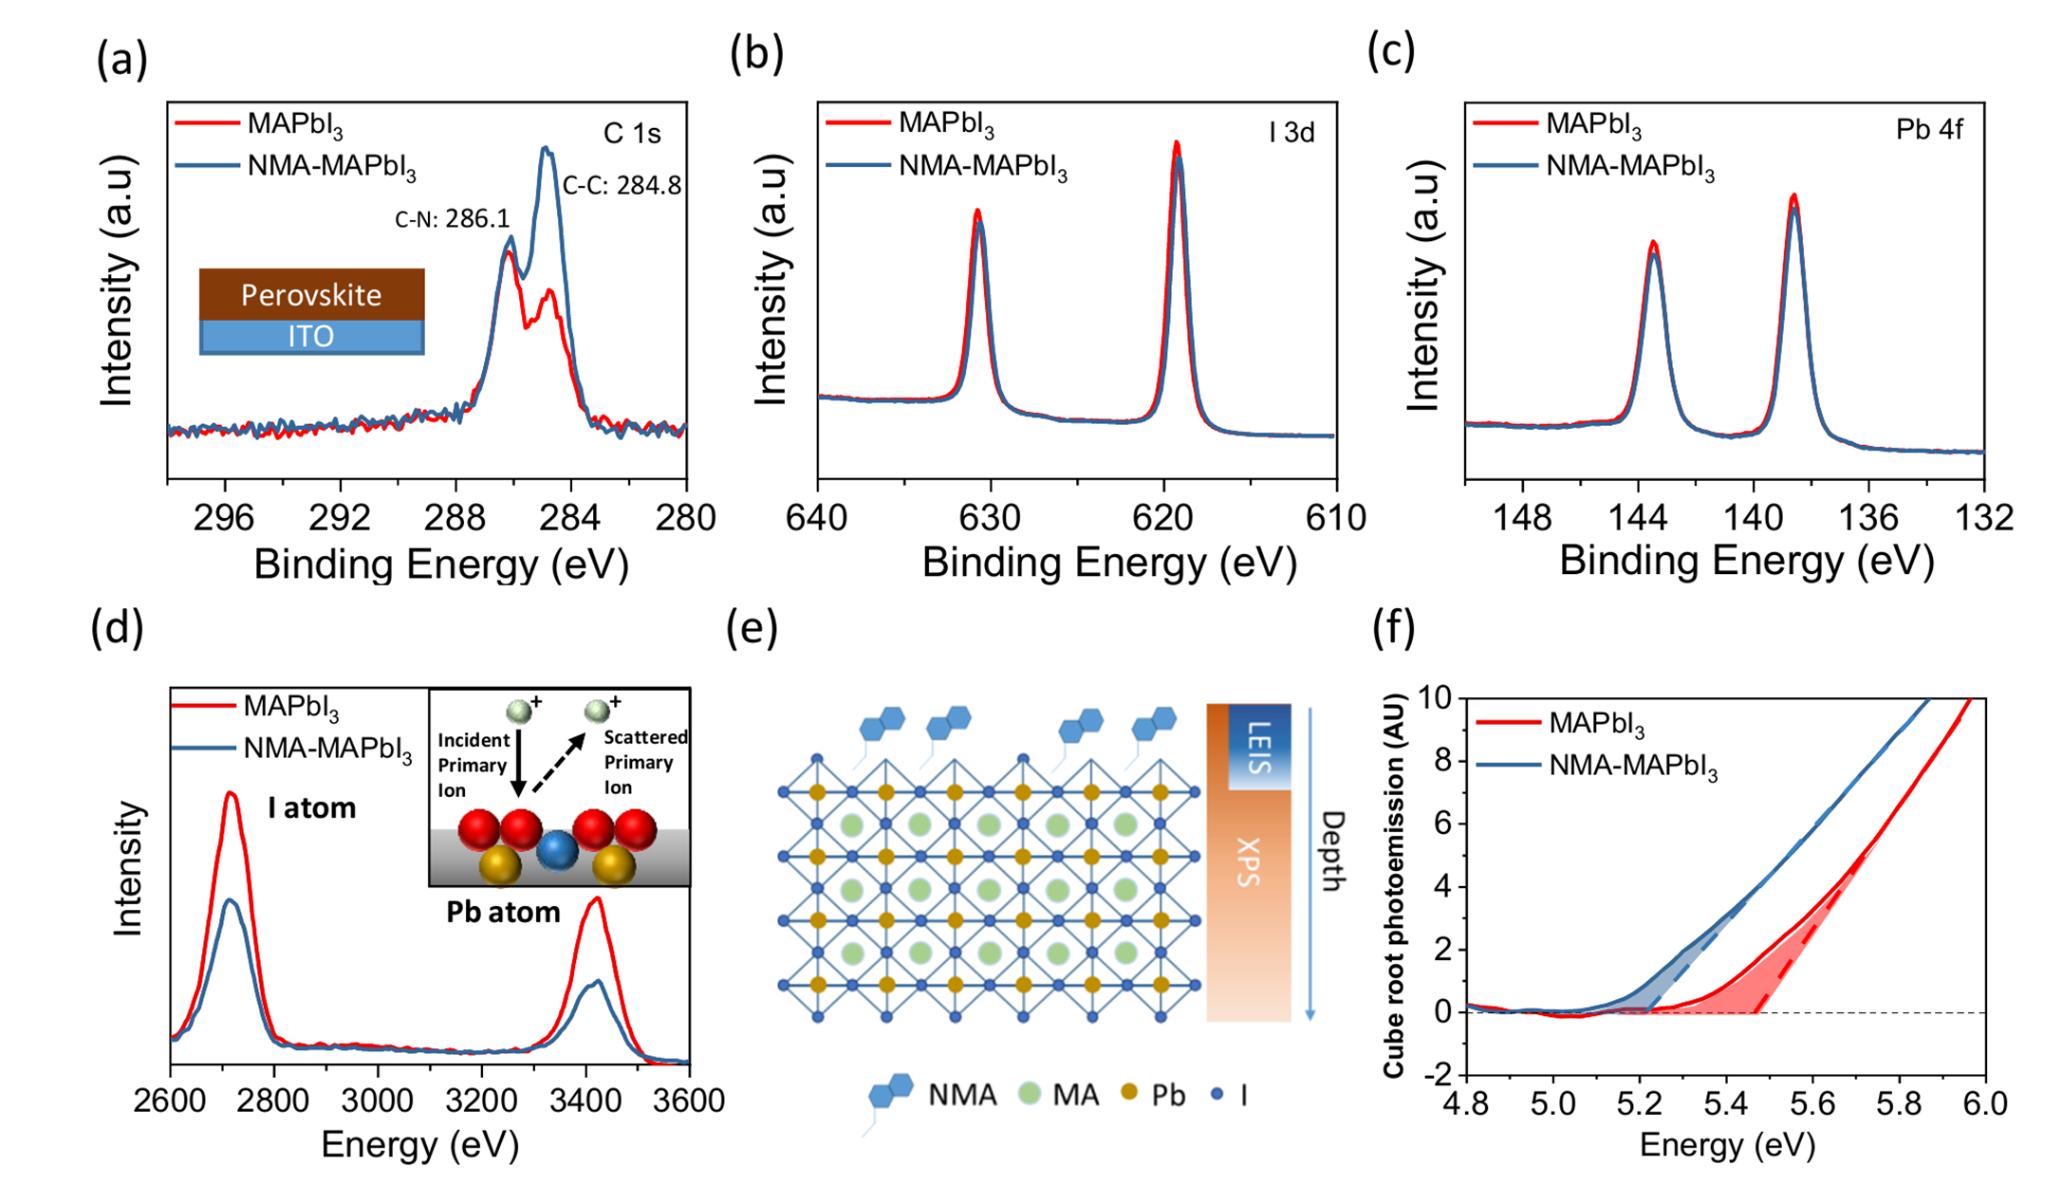

**Figure 2.** XPS spectra of (a) C 1s (b) I 3d (c) Pb 4f and (d) low-energy ion scattering (LEIS) spectra of the MAPbI3 and NMA-MAPbI3 films. The inserted figure is an Illustration of the LEIS measurement technique. (e) Schematic diagram of the sensitivity of the XPS and the LEIS measurement. (f) Ambient pressure photoemission spectroscopy (APS) spectra of the MAPbI3 and NMA-MAPbI3 films.

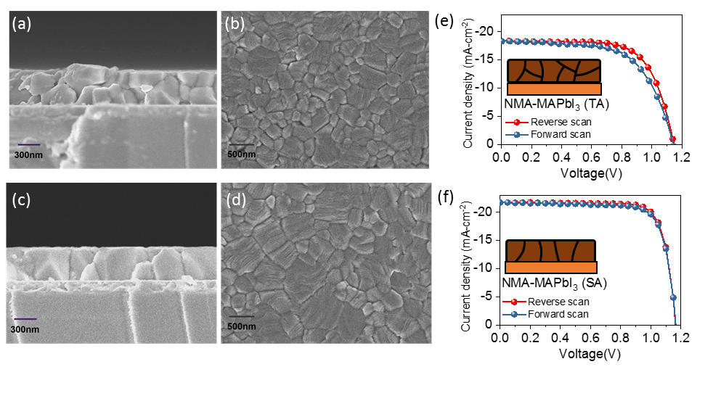

**Figure 3.** The cross section and surface SEM images of NMA-MAPbI3 films fabricated by (a-b) thermal annealing and (c-d) solvent annealing. The J-V characteristics of device fabricated by (e) thermal annealing and (f) solvent annealing. The forward and reverse scans are measured from -0.2 V to 1.2 V at a scan rate of 100 mV s-1.

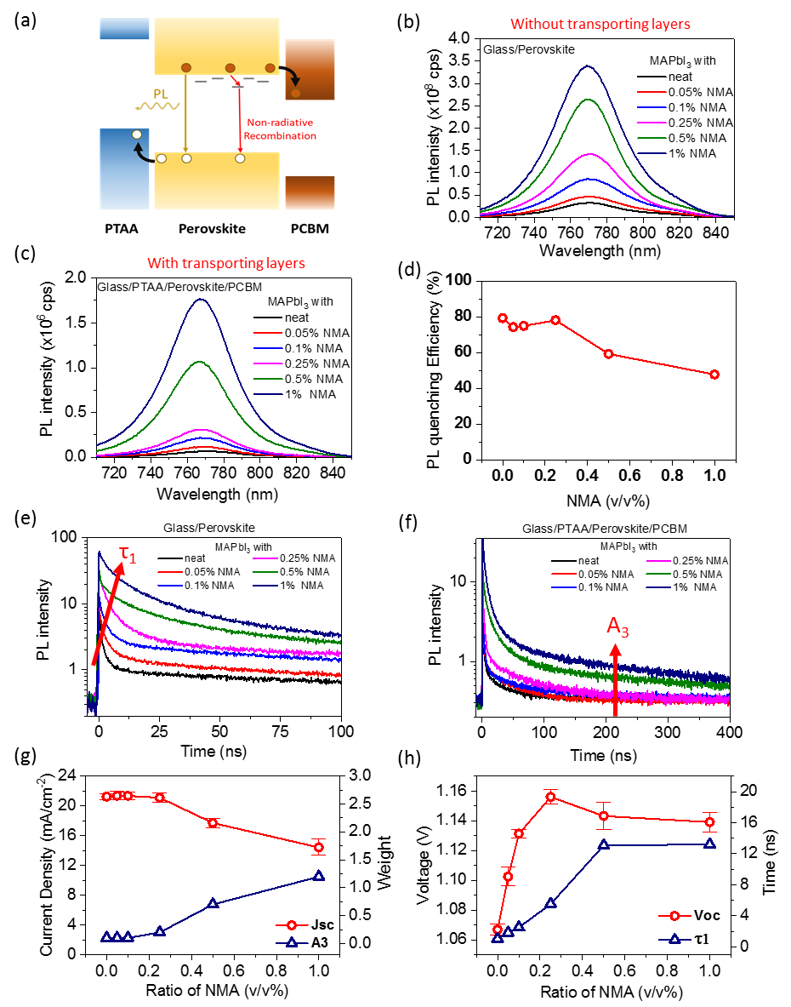

**Figure 4.** (a) Schematic diagram of recombination and charge transfer pathways in PTAA/perovskite/PCBM films. (b) Steady-state photoluminescence (PL) spectra of the MAPbI3 with NMA from 0.05 vol. % to 1 vol. % and (c) the corresponding PL spectra of films sandwiched by PTAA and PCBM transport layers. (d) The corresponding photoluminescence quenching efficiencies (PLQE) determined from the data in (b) and (c) (e) Time-correlated single photon counting (TCSPC) decays of MAPbI3 films with NMA from 0.05 vol. % to 1 vol. % without transport layers and (f) the corresponding TCSPC data for films sandwiched by the transport layers. (g) Plots vs NMA % of device Jsc (red) and the amplitude of the slowest decay phase (A3, blue) obtained from fits to the TCSPC data in (f) for PTAA/perovskite/PCBM films. (h) Plots vs NMA % of device Voc (red) and τ1 (blue) determined from fits of the TCSPC decays in (e) for perovskite films.



**Figure 5.** (a) Measured Voc of devices fabricated from MAPbI3 and cation doped MAPbI3. (b) UV-vis spectra of films and (c) the Voc of devices fabricated from MAPb(I(1-x)Brx)3 (x=0, 0.1, 0.2) with/without 0.25 vol. % NMA.