Title: A new generation of emissions scenarios should cover blind spots in the carbon budget space

**Authors:**

Shinichiro Fujimoria,b,c*, Joeri Rogeljc,d,e, Volker Kreyc,f, Keywan Riahic,g

Affiliations:

a Department of Environmental Engineering, Kyoto University, C1-3, Katsura Campus, Nishiko-ku, Kyoto, Japan

b National Institute for Environmental Studies (NIES), 16-2, Onogawa, Tsukuba, Japan

c International Institute for Applied Systems Analysis (IIASA), 2361 Laxenburg, Austria

d Grantham Institute for Climate Change and the Environment, Imperial College, London SW7 2AZ, UK

e Institute for Atmospheric and Climate Science, ETH Zurich, 8006 Zurich, Switzerland

f Industrial Ecology Programme and Energy Transitions Initiative, Norwegian University of Science and Technology (NTNU), 7491 Trondheim, Norway

g Graz University of Technology, Graz, Austria

* corresponding author: [fujimori.shinichiro.8a@kyoto-u.ac.jp](mailto:fujimori.shinichiro.8a@kyoto-u.ac.jp)

**Abstract:**

Future emissions scenarios for the IPCC sixth assessment report should explore the carbon budget space in a systematic manner, which would be robust to the updates of latest climate science so that policy implications can be adequately assessed.

**Main Text:**

The impacts of one degree of global warming are currently being experienced around the globe1. For some regions, communities, or ecosystems, these impacts are already devastating. Together with the certainty that unchecked climate change will bring much worse impacts, climate action is coming to the forefront of societal debate, be it through youth climate strikes, business initiatives, or government action. Understanding the requirements for keeping warming within acceptable limits has thus become essential. The state of scientific knowledge in this area has recently been assessed in the Special Report on Global Warming of 1.5°C (SR1.5) by the Intergovernmental Panel on Climate Change (IPCC)2. Besides an assessment of the amount of carbon-dioxide that can still be emitted while keeping warming to 1.5°C relative to preindustrial levels (so-called remaining carbon budgets), the report also describes pathways with long-term societal transformations that would be consistent with keeping to these carbon budgets. These pathways are explored by Integrated Assessment Models (IAMs) and the modelled transformations of the energy and land-use system depend critically on the assumed available carbon budgets. Carbon budget estimates come with an uncertainty range and their values are updated over time as scientific knowledge progresses3. Consequently, updated ex-post assessments of IAM scenarios can result in projected temperature outcomes that differ from the climate targets which they were originally designed for. This is a situation that is bound to repeat itself in the future as long as scenario modelling focuses on generating scenarios consistent with one specific or a limited set of carbon budgets. It can be avoided, however, by designing the next generation of IAM scenarios produced by the larger community in an appropriate way. We here suggest a community scenario effort that may help to systematically respond to the issue, and allow IAM scenarios to inform global climate policy based on the most recent climate science at any time.

The SR1.5 assessed emissions scenarios from the published literature that were created with ex-ante carbon budgets assumptions intended to be consistent with certain climate outcomes. Specifically, major model inter-comparison studies such as ADVANCE4, CD-LINKS5 and EMF336 contributed substantially to the SR1.5 database7 with a large number of scenarios. These studies focused on three levels of cumulative emissions of carbon dioxide from 2011 to 2100 (400, 1000 and 1600 GtCO2) and contributed a large number of scenarios with these specific characteristics to the literature (Fig. 1a). Based on the climate assessment of the IPCC Fifth Assessment (AR5) these budgets corresponded to limiting temperature change in 2100 below 1.5°C with a 50% chance, and below 2°C with a 66% and 50% chance, respectively8.

However, the emphasis on a limited set of carbon budgets is problematic since carbon budget estimates are expected to be refined and improved as time passes, and any limited set of carbon budgets will thus continuously run the risk of being outdated by the time that they are assessed as part of larger climate science assessments by the IPCC that take place every 6 to 7 years. This is important because even small revisions of carbon budget estimates can have big implications for associated insights from transformation pathways for stringent climate goals like limiting warming to 1.5°C. This is particularly the case because the absence of significant global greenhouse gas emissions reductions to date have resulted in a very small remaining carbon budget2,3,8. For example, a 200 to 300 GtCO2 update in the remaining carbon budget estimate for a given temperature limit (as was the case between AR59 and SR1.52) strongly affects the perception of the climate change mitigation challenge. This is illustrated by the variations in the modelled carbon prices that would be in line with achieving a specific updated remaining carbon budget and thus climate target. Carbon prices modelled by IAMs are often interpreted as a proxy for required stringency of climate policy. Figure 2 shows they can vary by 250US$/tCO2 in stringent mitigation scenarios when moving from a 600 to an 800 GtCO2 remaining carbon budget. For reference, a 250US$/tCO2 carbon price increase would be implicitly equivalent to an approximately tripling of the crude oil price from a 50US$/bbl reference price. This can result in quite different recommendations and conclusions about the feasibility of the long-term temperature goal of the UN Paris Agreement both in academic and climate policy circles.

Different aspects contribute to the current uncertainty surrounding carbon budget estimates and are discussed in detail elsewhere2,3. These uncertainties won’t be resolved entirely at any point in the near future, but continued improvements of these estimates should be anticipated as time, climate change, and our understanding of the physics of the climate change problem progresses. IAM scenario modelling exercises need to prepare for this certain evolution, and this poses a clear scientific challenge for the energy system and scenario modelling community. The traditional approach that has been followed by the community consists of pre-selecting a limited set of budgets. This approach runs the risk of missing the mark and is likely to result in a situation where the majority of available IAM scenarios do not match specific levels of global warming that are considered relevant to climate policy10.

We thus propose a different approach that could be followed by the scenario modelling community and which explores the carbon budget space in a more systematic manner in line with single-model studies published earlier11,12. This new approach permits to hedge against future budget uncertainties by not putting all eggs into one so-called ‘carbon budget basket’. We propose to explore 14 scenarios associated with remaining carbon budgets from 200 GtCO2 to 2000 GtCO2 starting from 2018 and counting until scenarios reach global net zero CO2 emissions. The domain between 200 and 1000 GtCO2 would be covered in 100 GtCO2 increments to explore the space that could be considered consistent with limiting warming well-below 2°C in detail; the domain between 1000 and 2000 GtCO2 would be covered with 200 GtCO2 increments to cover possible higher carbon budgets that are currently assessed to result in a low chance of limiting warming to well-below 2°C. In case a model was unable to create a scenario for a specific small carbon budget, this information would also be reported and taken into account in subsequent assessments13.

The benefits of the systematic exploration of the carbon budget in this scenario set are obvious. The risks that scenarios do not map to specific climate targets due to changes in carbon budgets or other issues related to the Earth-system response to greenhouse gases can be avoided. For instance, recent literature suggests that climate feedbacks have been underestimated in the past14,15, and non-CO2 contributions to mitigation pathways have been notoriously uncertain. Non-CO2 emissions abatement potential and associated costs differ widely across IAMs16. This has traditionally led to strong variations in carbon budgets across models, even when aiming for a similar climate outcome17. Our proposed scenario framework provides the advantage that temperature consequences of different CO2 and non-CO2 relationships can be assessed systematically across models. In other words, for assessing a certain temperature level, one may rely on different carbon budget runs from different models, depending on the specific non-CO2 emissions fingerprint of each respective model. At the same time, it would also improve the understanding of socio-economic uncertainties surrounding the climate outcome of a given CO2 budget as a result of the variation in associated non-CO2 emissions.

We also propose to apply carbon budgets until the time of global CO2 emissions becoming net zero in line with a recently published new scenario logic for achieving the Paris Agreement long-term temperature goal18. This logic differs from the usual IAM approach that applies carbon budgets until the end of the century and that results in pathways that are biased against near-term emissions reductions in favour of large-scale reliance on net carbon-dioxide emission removal in the second half of the century18. The use of a peak carbon budget that is defined until the time global carbon-dioxide emissions reach net zero makes peak warming and overshoot of a specific temperature target an explicit design choice18, in line with insights of the IPCC SR1.5.

A final question that the scenario design could help to address is the consistency of long-term carbon budgets with currently proposed near-term policies, such as the nationally determined contributions (NDC) under the UN Paris Agreement. To this purpose, we suggest to have the same carbon budgets scenarios but with different assumptions for near-term policies. For example, for each proposed long-term budget, one could run one scenario assuming the implementation of the NDCs, and another scenario assuming immediate action consistent with the overall carbon budget. Contrasting the two scenarios will help to understand whether the NDCs are consistent with a specific peak carbon budget, and would in addition help to understand in which areas further acceleration of actions beyond the NDC would be necessary. This would provide critical information for the Global Stocktake process that will be conducted as part of the implementation of the UN Paris Agreement.

We think that the proposed scenarios can assure consistency between the physical climate science and mitigation assessments across the different parts of the climate change research community, and can therefore be critical for the integration of work across the different Working Groups of the IPCC when they prepare their Sixth Assessment Report (AR6) over the coming years. Time, however, is running short, and publication deadlines for studies to be included in the AR6 are approaching quickly. At the latest by early summer in 2020, any new scenario runs should be ready and available for inclusion in the assessment, accompanied by a peer-reviewed publication in a scientific journal. Given the importance of ensuring that the latest insights in climate science are adequately reflected in assessments of climate change mitigation, we thus call upon the community to dedicate some time to this important new effort.

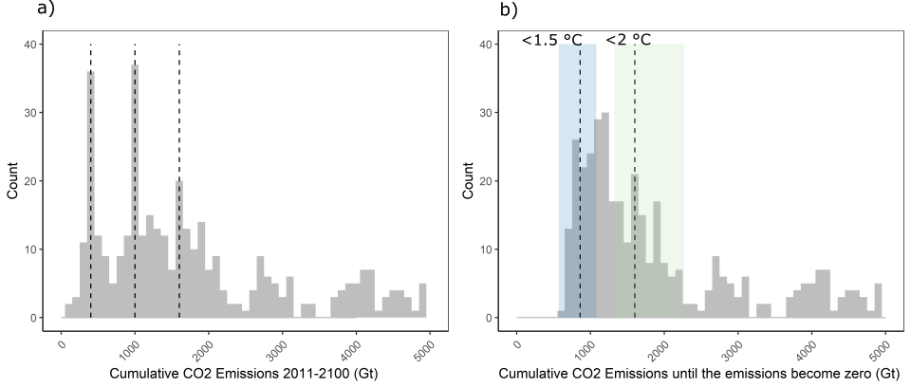

Figure 1 | Distribution of cumulative carbon emissions in IAM scenarios. Frequency distribution of cumulative carbon emissions from 2011 to 2100 (panel a) and cumulative carbon emissions until the emissions become zero (panel b). Dashed lines in panel a illustrate three levels of cumulative CO2 emissions that were used in the design of community scenario efforts over the past years4-6. The blue and green ranges in panel b show the range of remaining carbon budget consistent with limiting warming to 1.5 °C and 2 °C relative to preindustrial levels. The ranges span the 33th to 67th percentiles of the distribution of the transient climate response to cumulative emissions of carbon dioxide as assessed in IPCC SR1.5 (ref. 2). The dashed lines in panel b are the respective median estimates. Scenario data in both panels is based on data from the IPCC SR1.5 scenario database7.

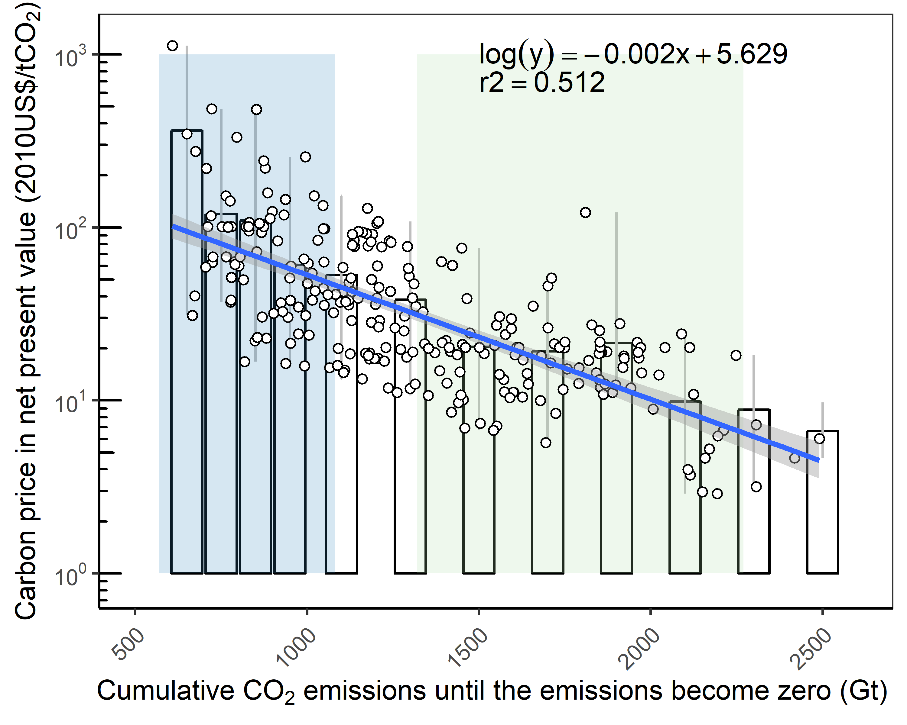

Figure 2 | Carbon price and cumulative CO2 emissions. The carbon price on the vertical axis is the net present value of the carbon price evolution over the course of the century, discounted to 2010 at 5% per year. The bars are the average carbon price per cumulative emissions level. 100 GtCO2 steps are taken for cumulative CO2 emissions in the 600–1000 GtCO2 range, 200 GtCO2 steps are taken for the 1000–2500 GtCO2 range. The error bar shows the minimum-maximum range of carbon prices for each bar. The log-linear regression results are shown as a blue line and the 90% confidence interval is represented as grey range. The blue and green ranges show the range of remaining carbon budgets consistent with limiting warming to 1.5 °C and 2 °C relative to preindustrial levels, respectively. The ranges span the 33th to 67th percentiles of the distribution of the transient climate response to cumulative emissions of carbon dioxide as assessed in IPCC SR1.5 (ref. 2). Scenario data is taken from the IPCC SR1.5 scenario database7.

**References:**

1. Intergovernmental Panel on Climate Change, (IPCC). *Global Warming of 1.5° C: An IPCC Special Report on the Impacts of Global Warming of 1.5° C Above Pre-industrial Levels and Related Global Greenhouse Gas Emission Pathways, in the Context of Strengthening the Global Response to the Threat of Climate Change, Sustainable Development, and Efforts to Eradicate Poverty*. Intergovernmental Panel on Climate Change, 2018.

2. Rogelj J, Shindell D, Jiang K, Fifita S, Forster P, Ginzburg V*, et al.* Mitigation pathways compatible with 1.5°C in the context of sustainable development. *Special Report on the impacts of global warming of 1.5 °C*. Intergovernmental Panel on Climate Change: Geneva, 2018.

3. Rogelj J, Forster PM, Kriegler E, Smith CJ, Séférian R. Estimating and tracking the remaining carbon budget for stringent climate targets. *Nature* 2019, **571**(7765)**:** 335-342.

4. Luderer G, Vrontisi Z, Bertram C, Edelenbosch OY, Pietzcker RC, Rogelj J*, et al.* Residual fossil CO2 emissions in 1.5–2 °C pathways. *Nature Climate Change* 2018.

5. McCollum DL, Zhou W, Bertram C, de Boer H-S, Bosetti V, Busch S*, et al.* Energy investment needs for fulfilling the Paris Agreement and achieving the Sustainable Development Goals. *Nature Energy* 2018.

6. Bauer N, Rose SK, Fujimori S, van Vuuren DP, Weyant J, Wise M*, et al.* Global energy sector emission reductions and bioenergy use: overview of the bioenergy demand phase of the EMF-33 model comparison. *Climatic Change* 2018.

7. Huppmann D, Kriegler E, Krey V, Riahi K, Rogelj J, Rose SK*, et al.* IAMC 1.5°C Scenario Explorer and Data hosted by IIASA. Integrated Assessment Modeling Consortium & International Institute for Applied Systems Analysis; 2018.

8. Rogelj J, Luderer G, Pietzcker RC, Kriegler E, Schaeffer M, Krey V*, et al.* Energy system transformations for limiting end-of-century warming to below 1.5°C. *Nature Clim Change* 2015, **5**(6)**:** 519-527.

9. Clarke L, Jiang K, Akimoto K, Babiker M, Blanford G, Fisher-Vanden K*, et al.* Assessing Transformation Pathways. In: Edenhofer O, Pichs-Madruga R, Sokona Y, Farahani E, Kadner S, Seyboth K*, et al.* (eds). *Climate Change 2014: Mitigation of Climate Change. Contribution of Working Group III to the Fifth Assessment Report of the Intergovernmental Panel on Climate Change*. Cambridge University Press: Cambridge, United Kingdom and New York, NY, USA, 2014, pp 413-510.

10. Schleussner C-F, Rogelj J, Schaeffer M, Lissner T, Licker R, Fischer EM*, et al.* Science and policy characteristics of the Paris Agreement temperature goal. *Nature Climate Change* 2016, **6:** 827.

11. Rogelj J, McCollum DL, Reisinger A, Meinshausen M, Riahi K. Probabilistic cost estimates for climate change mitigation. *Nature* 2013, **493:** 79-83.

12. Luderer G, Pietzcker RC, Bertram C, Kriegler E, Meinshausen M, Edenhofer O. Economic mitigation challenges: how further delay closes the door for achieving climate targets. *Environmental Research Letters* 2013, **8**(3)**:** 034033.

13. Tavoni M, Tol R. Counting only the hits? The risk of underestimating the costs of stringent climate policy. *Climatic Change* 2010, **100**(3)**:** 769-778.

14. Lowe JA, Bernie D. The impact of Earth system feedbacks on carbon budgets and climate response. *Philosophical Transactions of the Royal Society A: Mathematical, Physical and Engineering Sciences* 2018, **376**(2119).

15. Gasser T, Kechiar M, Ciais P, Burke EJ, Kleinen T, Zhu D*, et al.* Path-dependent reductions in CO2 emission budgets caused by permafrost carbon release. *Nature Geoscience* 2018, **11**(11)**:** 830-835.

16. Gernaat DEHJ, Calvin K, Lucas PL, Luderer G, Otto SAC, Rao S*, et al.* Understanding the contribution of non-carbon dioxide gases in deep mitigation scenarios. *Global Environmental Change* 2015, **33**(0)**:** 142-153.

17. Rogelj J, Popp A, Calvin KV, Luderer G, Emmerling J, Gernaat D*, et al.* Scenarios towards limiting global mean temperature increase below 1.5 °C. *Nature Climate Change* 2018.

18. Rogelj J, Huppmann D, Krey V, Riahi K, Clarke L, Gidden M*, et al.* A new scenario logic for the Paris Agreement long-term temperature goal *Nature* in press.

**Acknowledgements**

We acknowledge the International Institute for Applied Systems Analysis (IIASA) for hosting and maintaining the IPCC SR1.5 Scenario Database at <https://data.ene.iiasa.ac.at/iamc-1.5c-explorer/>. SF is supported JSPS KAKENHI Grant Number 19H02273, and the Environment Research and Technology Development Fund (2-1908) of the Environmental Restoration and Conservation Agency

of Japan. KR and VK received funding from the European Union’s Horizon 2020 research and innovation programme under grant agreement No 821471 (ENGAGE).

**Author Contributions**

All authors contributed to the development of the presented ideas. SF and JR led the writing of the paper. SF produced all figures. All authors contributing to the framing and finalization of the manuscript.

**Conflict of interest**

The authors declare no conflict of interest.