Conformable green bodies: plastic forming of robocasted advanced ceramics

Iuliia S Elizarova, Luc Vandeperre, Eduardo Saiz
Centre for Advanced Structural Ceramics, Department of Materials, Imperial College London, South Kensington Campus, SW7 2AZ, United Kingdom

Abstract

Robocasting, or the additive manufacturing of ceramics by continuous extrusion of a ceramic paste, has limited capabilities when printing complex unsupported structures such as overhangs or free standing thin artefacts. In this paper we address this limitation using a new type of paste, which allows for shaping of the green bodies after printing. To illustrate the flexibility of the paste, it was used to produce both alumina and silicon carbide parts. The paste consists of a solution of phenolic resin in methyl ethyl ketone and ceramic powders. Fabricated parts can be cut, bent, folded and draped over various objects. Once dry and fully solid, the parts become rigid and can be processed further by slow pyrolysis and sintering. Sintered samples exhibit flexural strength comparable to both conventionally produced and robocasted ceramics and shaping of the green bodies after printing does not affect the mechanical strength of the sintered parts.

Keywords: robocasting, direct ink writing, flexible, shaping, forming

Introduction

Ceramic materials find their use in a wide range of applications due to their inherent mechanical strength, hardness and other functional properties such as stability in corrosive and high temperature environments [1], electrical resistivity [2] or optical transmittance [3]. Alongside with the excellent characteristics, however, come the drawbacks. Due to a high hardness and brittle nature of ceramics these materials are usually difficult to process into arbitrary shapes, both while forming green bodies and by machining after sintering [1], [4]. Traditional technologies, such as die pressing and casting, are very limited in both shapes and microstructures of the produced parts, thus, when more intricate geometries are required, various additive manufacturing methods appear as a preferred option [1], [5].

Among other 3D printing techniques, robocasting, or direct ink writing, provides means for a highly controlled fabrication of variously shaped parts through extrusion of particle slurries in a layer-by-layer manner [6]. The slurry feedstocks, also called inks, must possess a shear-thinning rheology and can be prepared using a wide variety of materials – metals [7], polymers [8], ceramics [9]. While being versatile in a choice of suitable materials, robocasting does not provide complete freedom of achievable printing shapes. The building process requires that the printed filament is supported by the previously extruded layers; overhanging features and large unsupported areas are, therefore, hard to produce using the technique [6], [10].

One way to overcome this limitation is to take inspiration from tape casting and use robocasting with inks that produce flexible green bodies suitable for post-printing shaping [11]. Several studies have reported the use of such combination approach. Examples include hydroxyapatite[12], [13], titanium hydride [10] structures that can be assembled into intricate origami figurines, flexible α-Al2O3 [13] and YSZ [4] parts. While flexibility of the green bodies produced using the reported strategies is exceptional, much like in tape casting, they rely heavily on addition of often multiple organic plasticiser species or use of solvent mixtures in ink formulations. Such complexity in ink compositions requires precision in preparation, and, in some cases, additional post-printing treatment of fabricated parts, such as UV exposure, to preserve the newly-obtained shape [4], [13]. Moreover, silicon carbide presents a further challenge when considering production of conformable materials since utilisation of photocurable resins [4], [13] could be more difficult in the case of dark-coloured materials such as silicon carbide.

In this study we propose a new type of robocasting ink made of only three components – ceramic powder, phenolic resin and a solvent (methyl ethyl ketone). A highly concentrated solution of phenolic resin in MEK provides printable dispersion medium for the ceramic powder whereas the resin acts as a binder, plasticizer, and in some cases a source of carbon sintering aid. Two ceramic materials have been used for demonstration of the capabilities of the technique – α-Al₂O₃ (where resin acts solely as a binder and plasticizer and therefore there are no a priory limitations in the resin content), and SiC (where resin is converted to useful carbon and its concentration is limited by the amount of sintering aids required in the process).

Experimental

Novolac phenolic resin (Durez 13355, Sumitomo Bakelite) was dissolved in methyl ethyl ketone (Acros Organics, Technical Grade) at 37 °C overnight to form initial 66.5 wt% mixtures. 100 g of Al₂O₃ (Baikalox SMA6, Baikowski) and 80 g of a blend of α-SiC (Grade UF-25, H.C. Stark) / B₄C (Grade HS-A, H.C. Stark) at weight ratios 98:2 were added to the phenolic resin solutions and mixed using a planetary mixer (ARE-250, Thinky, Japan) at 2000 RPM for 1 minute as a first step. Mixtures were cooled to room temperature, and the solvent content was adjusted to form 59 vol% Al₂O₃ and 40 vol% α-SiC/B₄C inks. Further mixing was conducted using 2000 RPM 30 second steps with slow cooling between each step (to avoid rapid evaporation/condensation of the solvent) until homogeneous inks were obtained. Defoaming was performed at 2200 RPM for 5 minutes, and mixtures were left to cool down to room temperature. The resulting inks were loaded into syringe barrels (3 ml, Nordson) and immediately used for printing.

The rheology of the inks was assessed at 25 °C (printing temperature) using a 40 mm parallel plate geometry (Discovery HR-1, TA Instruments, Germany) and a solvent trap. Oscillating torque experiments were performed to obtain the storage and loss moduli coupled with strain rate ramp experiments to assess the shear thinning behaviour of the inks. Extrusion pressure (flowability) experiments were performed using 3ml printing syringes, ⌀0.61 mm nozzles, ⌀9.54 mm robocasting piston and Zwick/Roell Z010 mechanical tester as a controlled pressure source (piston displacement rate 1.2 mm/min).

Printing was conducted using a 3dInks direct ink writing system (USA) with conical syringe nozzles of 0.61 mm internal diameter (Nordson). Printing syringes were loaded by first filling a larger syringe with ink using a spatula, the ink was then transferred into the printing syringe using a syringe-syringe luer-lock connector; the inks were moved back and forth between syringes to eliminate as much air as possible. Samples were printed onto parchment paper (greased with oleomargarine) attached to a level steel plate. Nets and bars were printed at a speed of 10 mm·s⁻¹ using 0.46 mm X and Z axes extrusion spacing. A fraction of the printed samples was allowed to completely dry in air at room temperature for 2 days, while the remaining parts were partially air-dried for 10 minutes (α-SiC/B₄C) and 18 hours (Al₂O₃) to perform shaping/bending before the drying was complete. Intentionally irreversible shaping was performed on α-SiC/B₄C nets and mini-bars to observe the sturdiness of the shaped dry parts, while Al₂O₃ bars were bent to a 90° angle and put back to the original shape to assess the possible effects on mechanical properties after such bending.

Dry parts were pyrolised (to convert phenolic resin to carbon) in a tube furnace under argon flow using the following ramp/dwell temperature sequence: 10 °C/min to 400 °C, 0.1 °C/min to 500 °C with 1 hour dwell, 0.1 °C/min to 600 °C with 1 hour dwell, 0.1 °C/min to 700 °C with 1 hour dwell, 0.1 °C/min to 800 °C with 1 hour dwell, 10 °C/min to 1000 °C with 3 hour dwell followed by slow cooling down to a room temperature. Al₂O₃ samples were sintered at 1550 °C for 1.5 hours in air in a chamber lift furnace (with slow ramp of 5 °C/min to allow for a gradual carbon burn-out). α-SiC/B₄C samples were presureless sintered at 2000 °C for 1 hour in argon using a graphite furnace.

The density of the sintered samples was determined using the Archimedes’ method at 25 °C temperature. The flexural strength of the samples was assessed using a three-point bending flexural test (loading test speed of 0.1 mm·min⁻¹) with average sample sizes of 2.3 x 4.6 x 30.4 (±0.06) mm for α-SiC/B₄C and 1.8 x 5.4 x 32.3 (±0.09) mm for Al₂O₃; tensile surfaces were polished to a 6 µm finish, edges of the bars were bevelled. 11 samples were tested of both α-SiC/B₄C and non-pre-bent Al₂O₃ parts as well as 8 samples of pre-bent Al₂O₃. The microstructure of the printed samples and the fracture surfaces were observed using optical and Scanning Electron Microscopy (JEOL 5610LV). Porosity of the samples (size distribution, aspect ratios) was assessed using ImageJ software. A total of 158 pores was counted and analysed for Al₂O₃ samples, 300 for α-SiC/B₄C samples (errors in measurements were calculated accordingly). To determine pore aspect ratios in α-SiC/B₄C samples, 20 larger, non-circular pores were examined and measured.

Results and Discussion

Rheology, Printing and Shaping

Inks must comply with certain requirements to be successfully extruded during printing. Shear thinning behaviour, the decrease of viscosity under shear strain, is one of the key properties that defines suitability of the inks for the robocasting procedure [6], [9]. To be considered shear thinning, the mixture must be characterized by the shear thinning coefficient n < 1, where n can be found using the following equation:

$τ=τ_{y}+Kγ^{n}$ (1)

where $τ$ is the shear stress applied to the mixture, $τ_{y}$ is the yield point, K is a shear rate invariant (viscosity parameter) [6], [9]. Both Al₂O₃ and α-SiC/B₄C exhibit such behaviour as shown in Figure 1. The shear thinning coefficients of the inks were found to be n = 0.43 and 0.11 for Al₂O₃ and α-SiC/B₄C respectively.

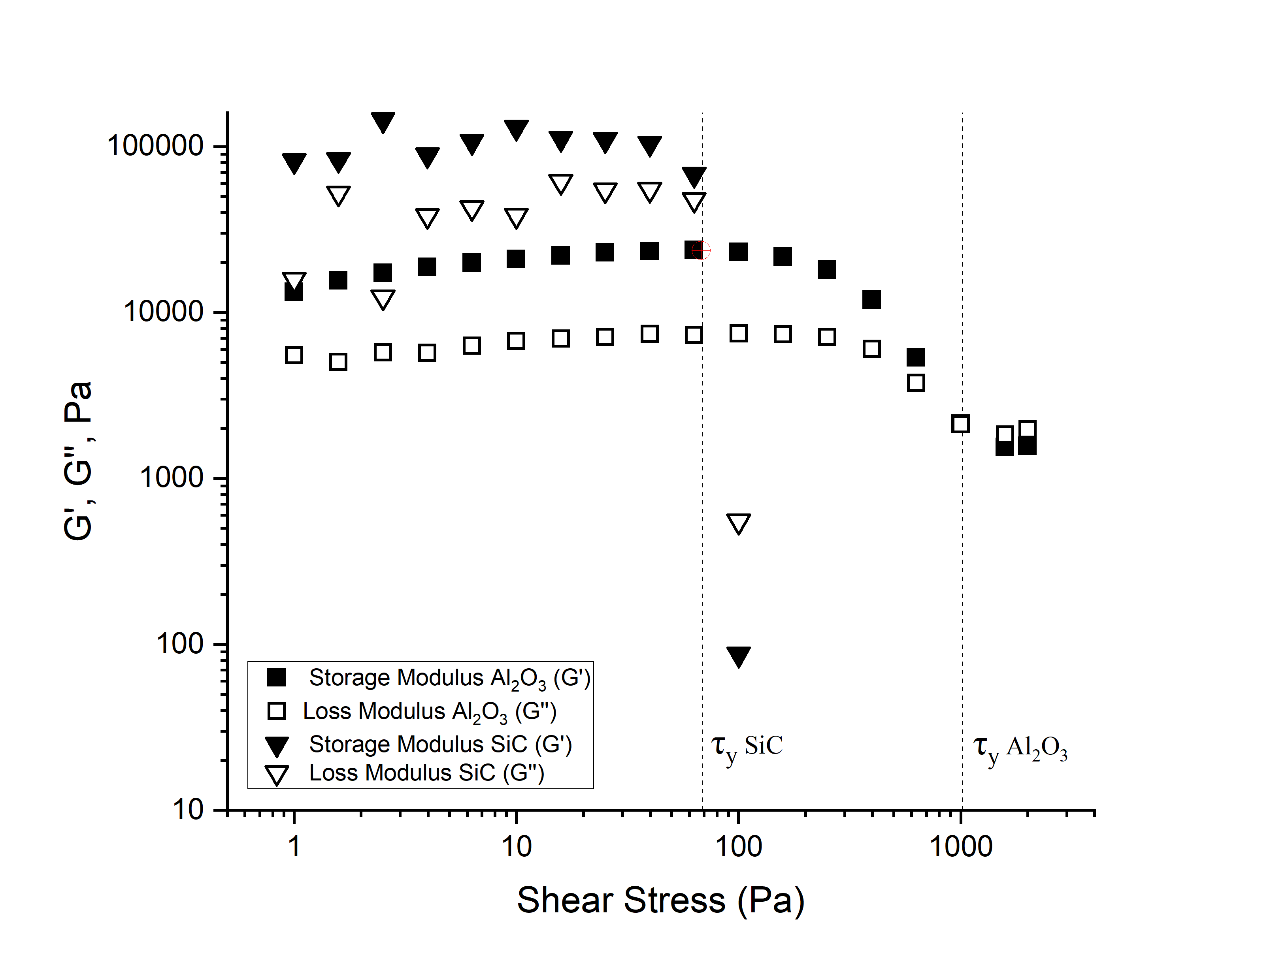
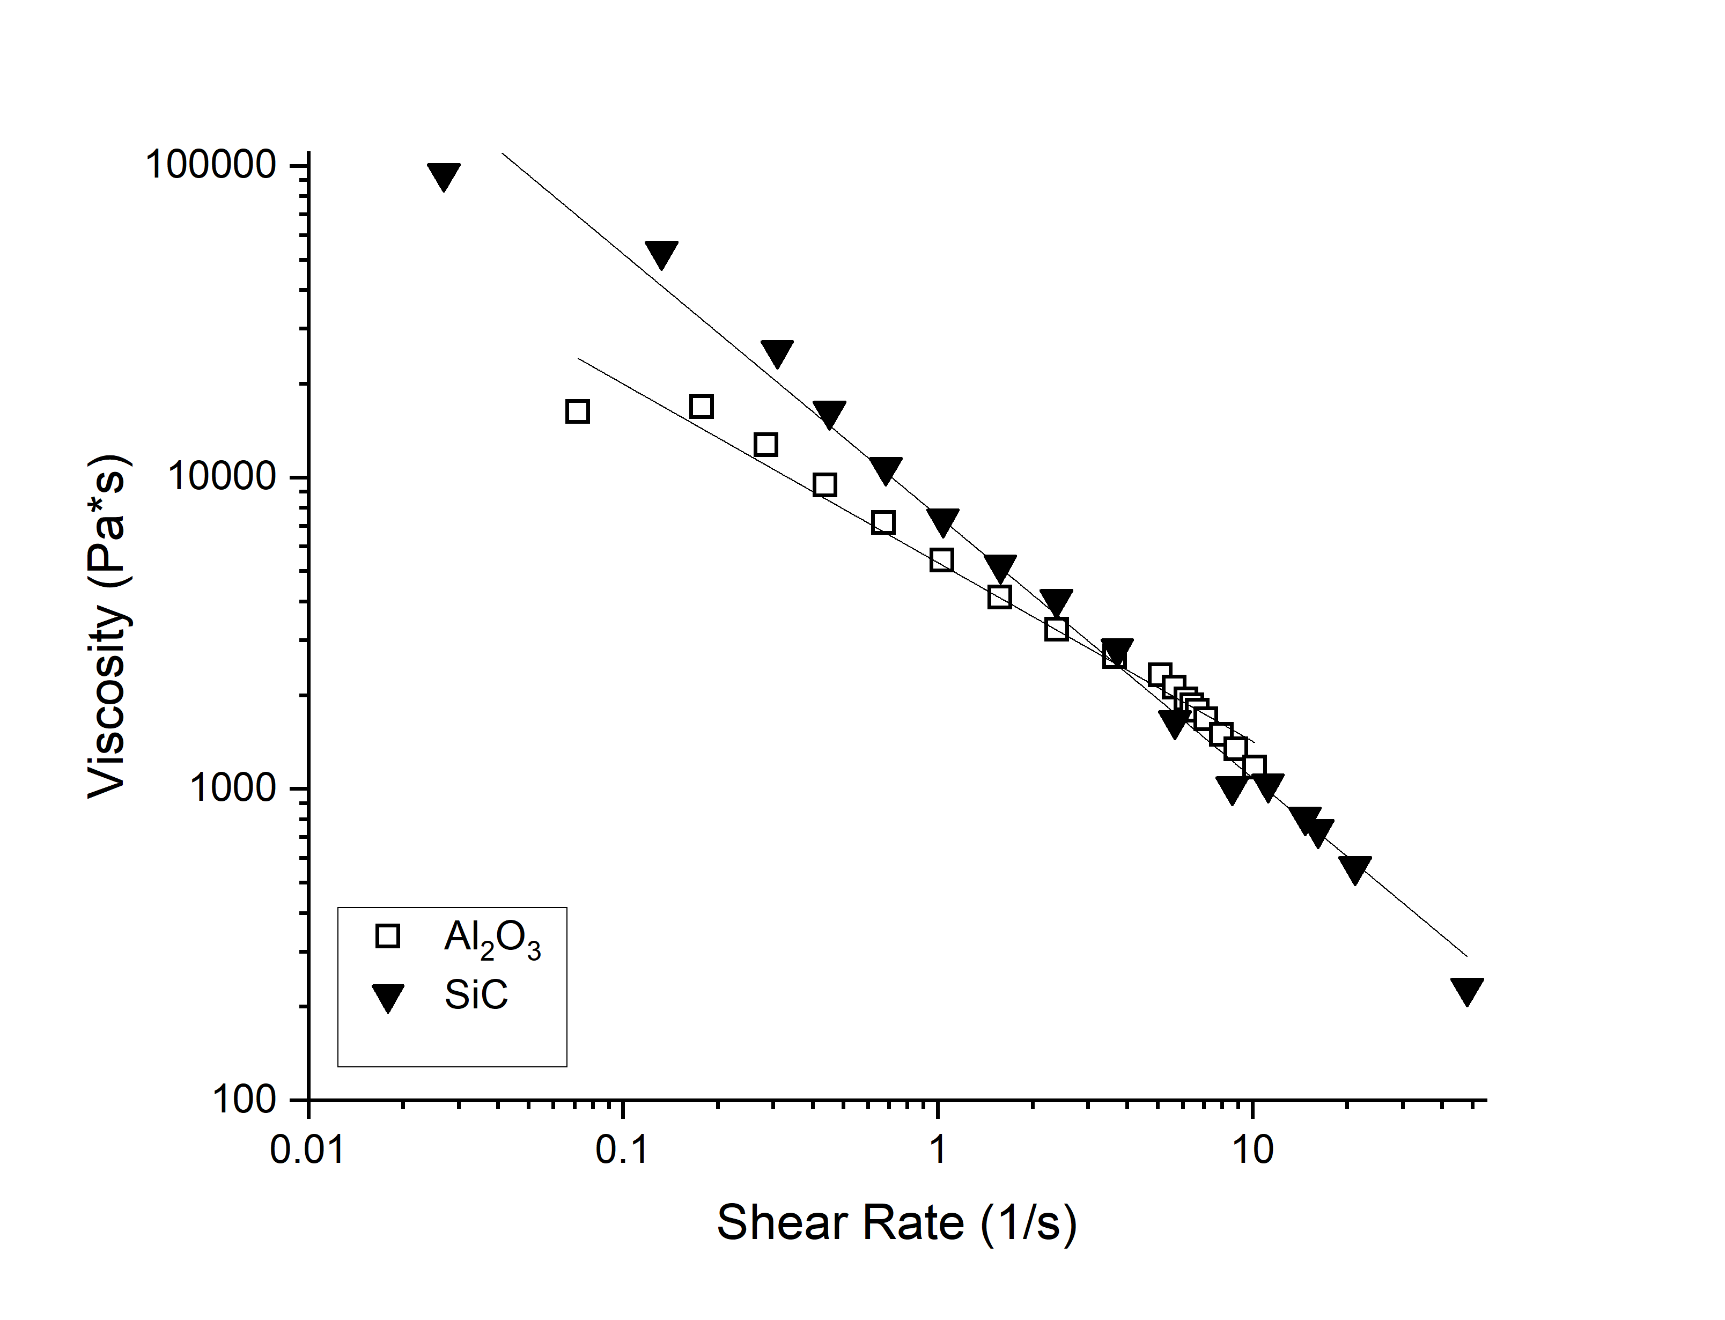
Figure 1. Rheological properties of the Al₂O₃ and α-SiC/B₄C phenolic resin inks.

Yield point value for the Al₂O₃ ink was found to be $τ_{y}$ = 1008.3 Pa, which is significantly higher than $τ_{y}$ = 67.9 Pa for α-SiC/B₄C ink. This indicates that the Al₂O₃ ink would require greater pressure to be extruded during printing, which is confirmed by the results of extrusion tests presented in Figure 2. It can be seen that extrusion of the α-SiC/B₄C ink stabilises at 700 kPa, while Al₂O₃ ink starts flowing steadily at 1995 kPa, which agrees with their higher yield stresses and viscosities. However, alumina inks seem to be more stable during extrusion (Figure 2) probably reflecting the fact that their resin/solvent content can be optimized for printing while in the silicon carbide ink it is limited by the amount of carbon that can be left as sintering aid after pyrolysis. It should be noted that consolidation of the parts printed using phenolic resin-based inks is most likely to occur through drying and adhesion of the printed filament, thus, as long as the inks can be extruded at reasonable pressures and exhibit shear-thinning behavior, they may be considered suitable for robocasting.

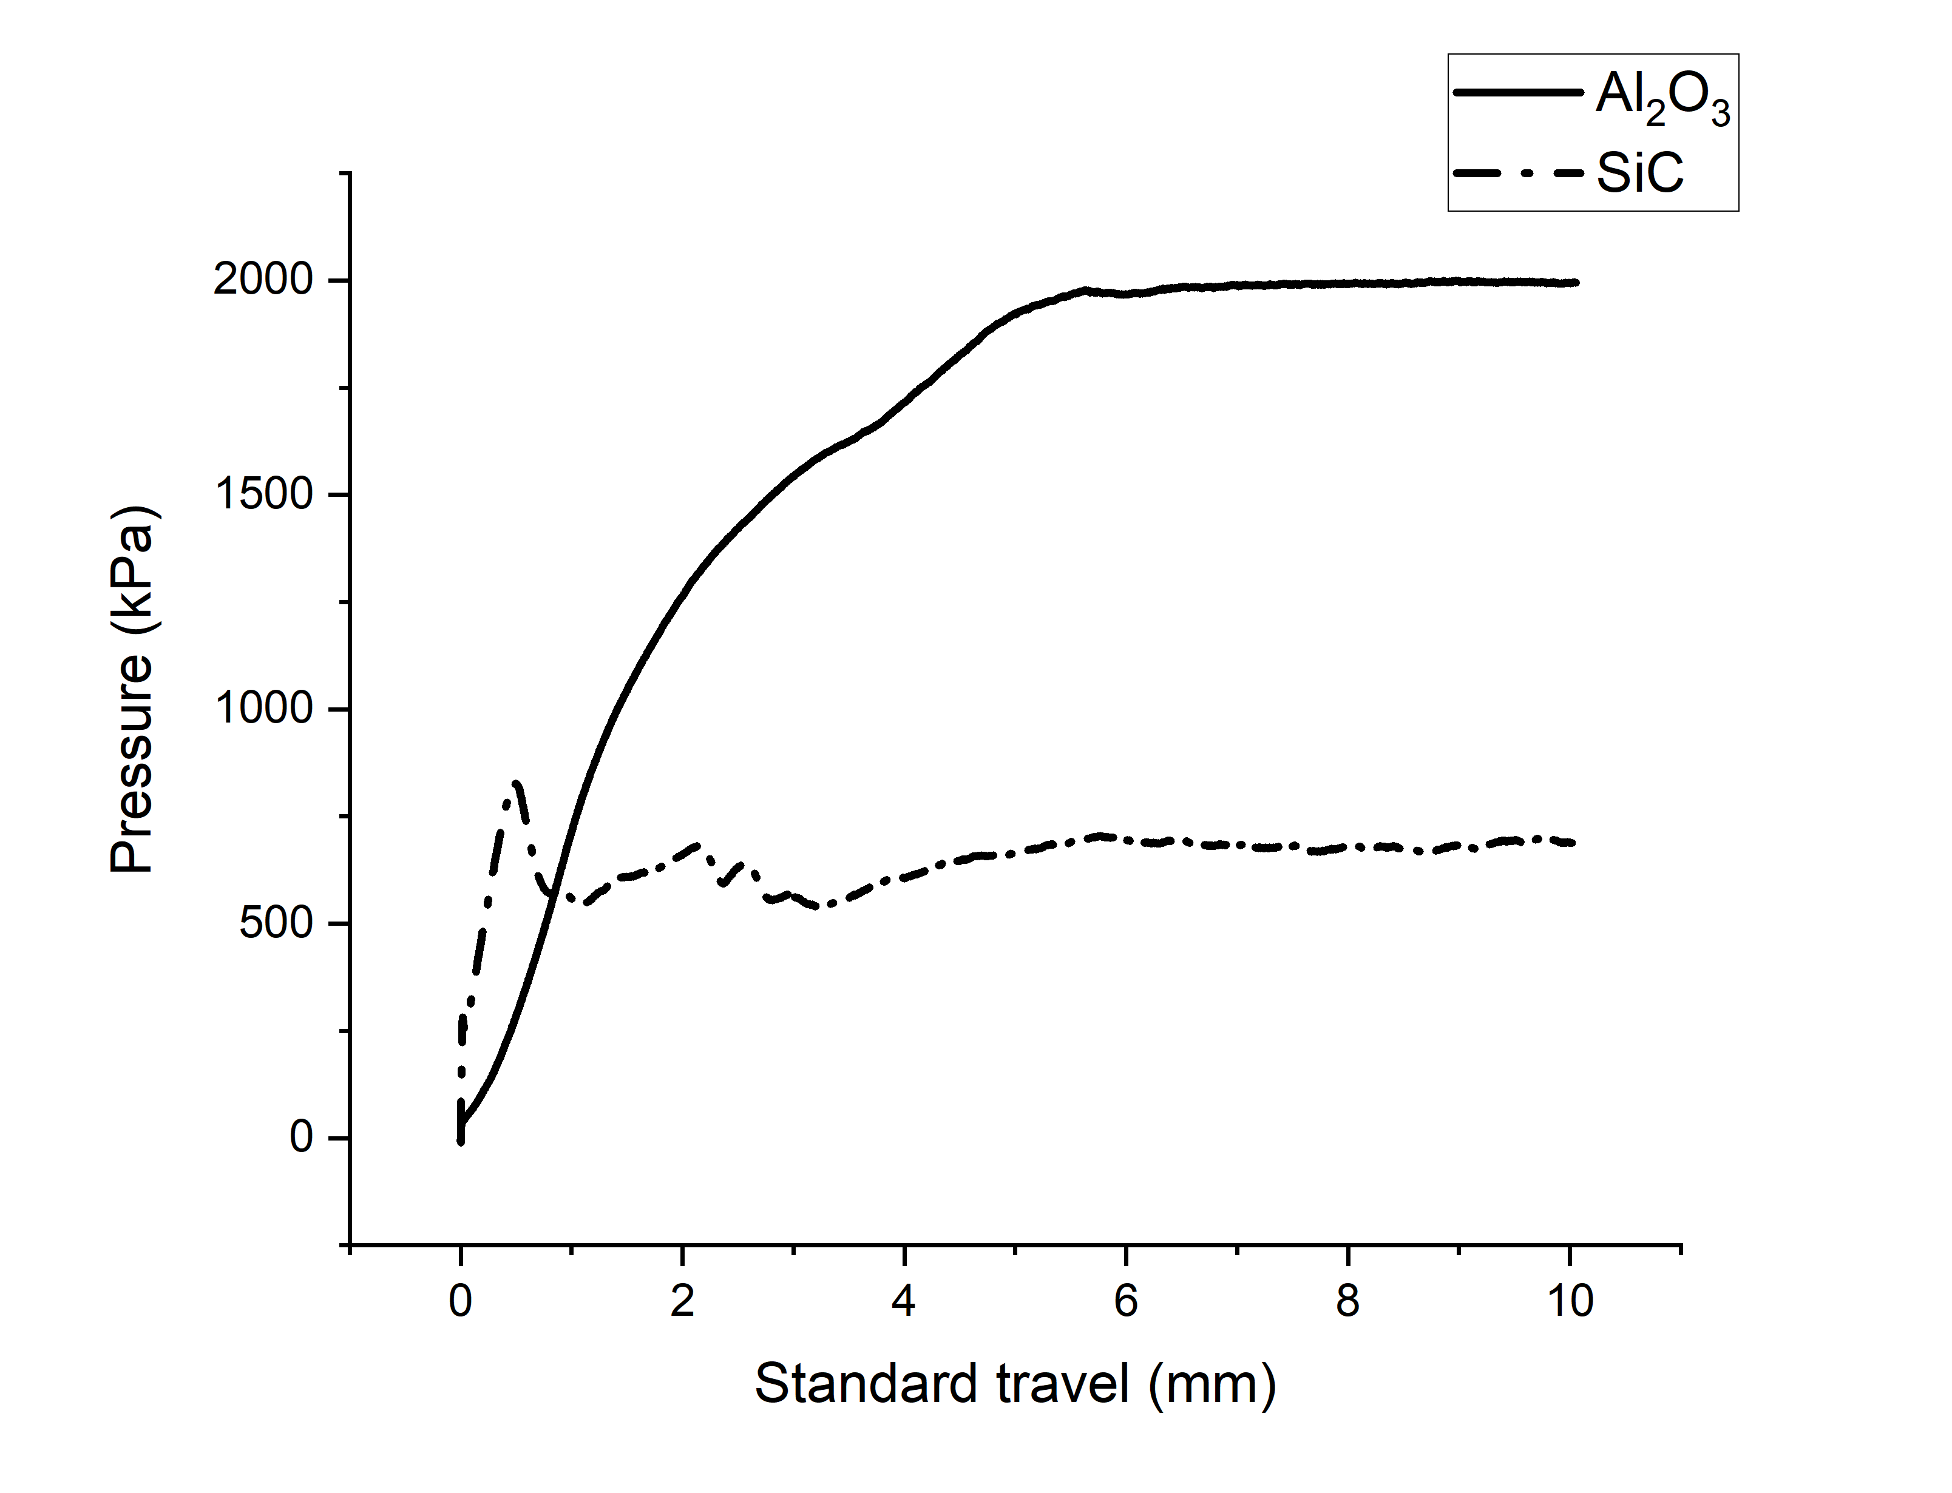
Figure 2. Extrusion pressure (flowability) tests for Al₂O₃ ink and α-SiC/B₄C ink. The pressure required for extrusion is larger but more stable for the alumina inks.

Both inks were used to print a range of net tapes and bars as shown in Figure 3. Nets printed with both Al₂O₃ and α-SiC/B₄C inks were successfully shaped over various objects as shown in Figure 3 (a), (b) and (d). It should be noted that the size of the gaps in the nets did not affect the conformability – both nets with large and small gaps could be shaped without breakage of the parts. Additionally it should be noted that the tape presented in Figure 2 (b) was cut out of a larger piece of tape, showing that parts produced using phenolic resin inks can be easily trimmed using common scissors or a scalpel.

The printing raster pattern for the bars was chosen to ensure the minimum distance between the extruded lines [6] and thus to achieve maximum density of the resulting parts (a hexagonal extrusion filament packing [5] of 0.46 mm in X and Z directions was employed). Al₂O₃ bars were bent (Figure 3 (c)) and put back into the original shape to later assess the influence of deformation onto their mechanical properties. Most of both bent bars and draped nets did not experience any breakage or cracking during shaping, and the minority that did has shown healing when either put back to the original shape or, in case of very fine micro-cracks, during subsequent sintering.

(a) | 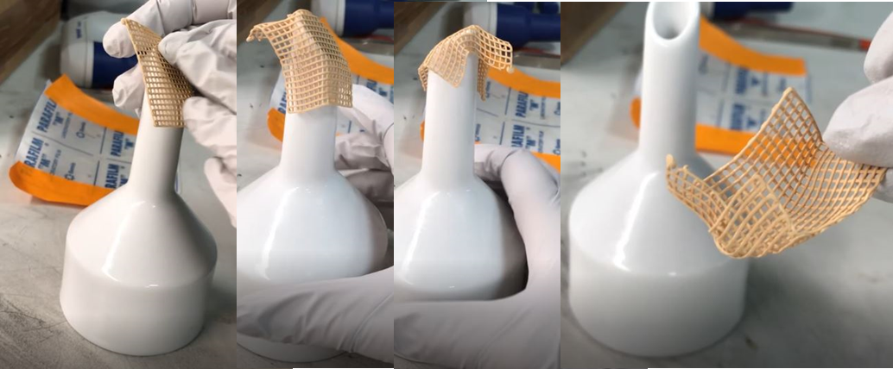
(b) | 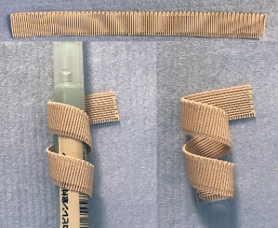 | (c) | 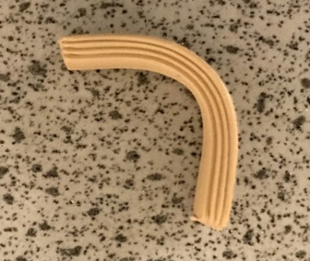 | (d) | 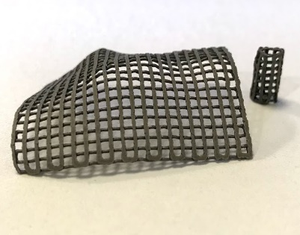
Figure 3. Showcase of the conformability of the printed parts - Al₂O₃ nets moulded against sharp (a) and rounded (b) objects after 7-hour air-drying, Al₂O₃ bar bent after 18-hour air-drying (c), α-SiC/B₄C nets shaped after 10-minute air-drying (d).

Samples exhibit the ability to be bent and shaped over various objects after and for a certain time period following printing. Both Al₂O₃ and α-SiC/B₄C parts can be shaped once they have been separated from the substrates; time required to allow for the separation depends on the ink composition and the thickness of the parts. Parts printed using Al₂O₃ inks can generally be shaped after 1 hour of air-drying at room temperature (2-3 hours for thick bars) for up to 18 hours after printing without any damage, while α-SiC/B₄C parts only preserve their conformability for minutes (parts detach easily from the oiled substrates due to rapid drying). Such difference might be attributed to the much higher solvent content of the latter ink required to properly disperse the powder, which leads to less viscous phenolic resin ink medium. Weakened intermolecular interactions within the less viscous liquid allow for a facilitated solvent escape and a more rapid drying as a result [14], [15].

Processing

Following printing and shaping, parts were dried in air at room temperature. Minor warping at the edges of the bars has been observed due to fast drying, however, no deformation of nets occurred at the same conditions. Once dry, all parts were sturdy enough to be handled with ease (green body flexural strength of 5 MPa). During pyrolysis, a very slow heating between the temperatures of 400 °C and 800 °C is important to allow the gaseous by-products of the pyrolyzed phenolic resin to escape; large amounts of methane, carbon monoxide, carbon dioxide and hydrogen are released in this temperature window causing a considerable and rapid mass loss [16] which in turn leads to the formation of open porosity structures within samples. The pyrolysis cycle used for all printed samples lasted 75 hours in total, after which the parts showed no noticeable macro-defects while preserving or even improving their stiffness.

Properties & Microstructure

Bent and sintered structures were characterised by optical and scanning electron microscopy to check for presence of micro-cracking in points of bending. The assessment of α-SiC/B₄C structures in Figure 4 shows that samples did not crack but that there is a limit in the degree of bending achievable. Micro-cracking indeed occurs in parts that underwent sharp bending and were not put back to their original shape. (Figure 4).

(a) | 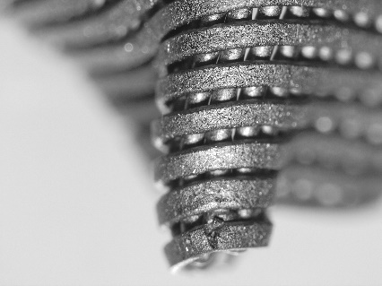 | (b) | 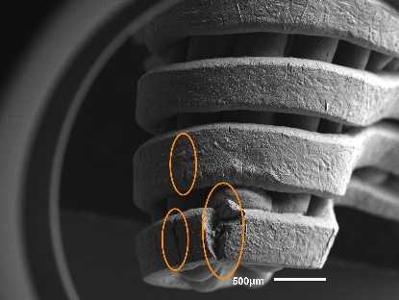 | (c) | 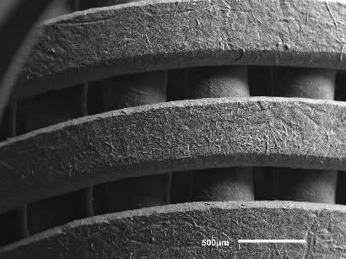
Figure 4. Optical (a) and SEM (b), (c) micrographs of bent α-SiC/B₄C nets with decreasing radius of curvature showcasing the limits of the material. As the radius of curvature decreases below 1 mm cracking occurs as a result of bending, highlighted in orange in (b). Other areas do not exhibit any micro-cracking after bending (c). Notice that SiC-based inks are less flexible that Al₂O₃ ones due to the limits in the phenolic resin content.

Densities and flexural strengths achieved for both sintered Al₂O₃ and α-SiC/B₄C bars produced using the set packing parameter (0.46 mm) are detailed in Table 1. It must be noted that the number of tested samples (11, 11 and 8 for α-SiC/B₄C, Al₂O₃ (non-bent) and Al₂O₃ (bent) respectively) does not allow for reliable Weibull modulus analysis; the calculated values are preliminary and are included in the Table 1 only to provide an estimate.

Table 1. Densities and mechanical properties of three types of samples.
Material | Relative density (th%) | Flexural strength, MPa | Weibull modulus
α-SiC/B₄C | 91.5 ± 0.7 | 369 ± 18 | 4.68
Al₂O₃ (non-bent) | 95.3 ± 0.4 | 353 ± 36 | 3.13
Al₂O₃ (bent) | 95.4 ± 0.5 | 360 ± 30 | 4.98

The alumina results demonstrate that that bending/re-shaping of green bodies printed using phenolic resin-based inks does not affect the sintered density or the strength. This is in agreement with the fact that cracking has not been observed in the bent samples. Flexural strength of the printed samples was assessed using a three-point bending flexural test. It can be noticed that the values achieved for α-SiC/B₄C, non-bent Al₂O₃ an bent and re-shaped Al₂O₃ parts are comparable with other robocasted Al₂O₃ (133-323 MPa) [6], [17] and SiC (305 MPa) [6] parts. Ceramics produced using other experimental methods and commercially range in flexural strength significantly depending on material compositions thus not allowing for a precise comparison of the mechanical properties, however, values for some of the standard materials such as α-Al₂O₃ (380 MPa) [18], and Hexoloy® SA SiC, Hexoloy® SE SiC, with strengths 280-550 MPa [19], [20] give an indication of possible suitability of the printed parts for commercial application.

In case of Al₂O₃ samples two additional important observations must be made. Firstly, bending and re-shaping of green bodies does not seem to affect the parts as evident from both density measurements and mechanical testing data. This provides a certain degree of reassurance that manufactured structures if shaped post-printing will retain their properties even if a shaping mistake is made and there is a necessity to bring the part back to its original state. Secondly, since this method can be used to shape ceramic in a manner similar to tape casting, important comparison is due with the parts fabricated by this method. Flexural strength of 311 MPa of the tape-casted Al₂O₃ parts reported in a study by Griffin [21] which is of a very similar value to the strength achieved for the parts produced using the phenolic resin inks.

Fracture surfaces are presented in Figure 5. It can be observed that the Al₂O₃ bars do not exhibit any printing gaps, but do have micropore defects ranging 6-135 ± 2 µm (27 µm mean) probably caused by the presence of air bubbles in the ink. Removal of air bubbles out of the inks prior to printing is problematic due to the high viscosity; air trapped in the slurry is transferred into printing syringes and subsequently into the printed samples. The same phenomenon can be observed in α-SiC/B₄C samples, perhaps to higher extent, with defects ranging 8-225 ± 2 µm (34 µm mean) in largest dimension (lengthwise) and with presence of a different, higher aspect ratio shapes in larger pores (on average 4-6 ± 0.5). Pore size distributions were assessed using ImageJ and are presented in Figure 6. There is no noticeable “periodicity” of the pores in α-SiC/B₄C samples, which suggests that they are not caused by setting the filament printing gap incorrectly. There are two possible explanations to this issue. Firstly, α-SiC/B₄C inks are significantly more viscous, making the defoaming procedure less efficient and leaving excess air pockets in the ink, which later result in porosity within the final parts. Secondly, accelerated drying of the parts during printing makes the extruded filament rougher and less adherent and does not allow for perfect packing overlay. Additionally, delamination of layers occurs at the edges of the samples that can be attributed to the uneven rates of drying of the middle and the outer parts of the printed bars. As edges of the bars are more exposed to air during printing than the middle part that is somewhat isolated by the surrounding filament, they dry faster and may experience delamination.

(a) | 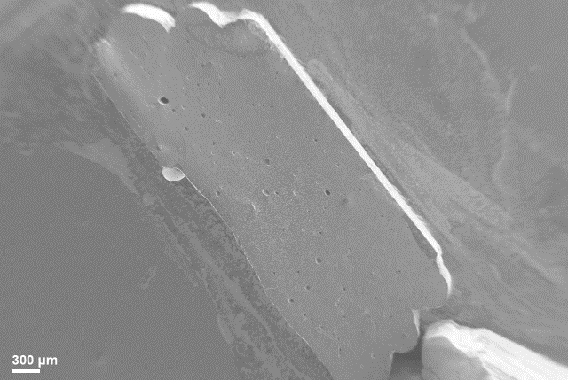 | (b) | 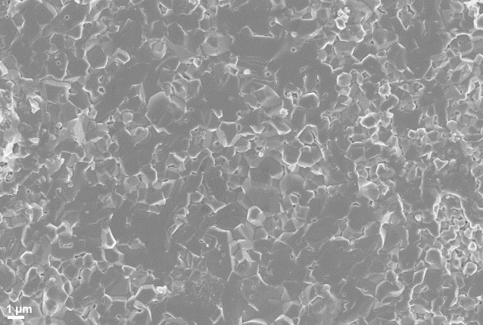
(c) | 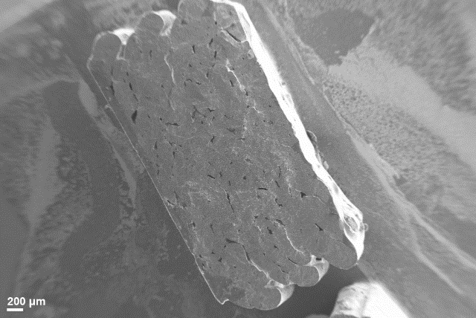 | (d) | 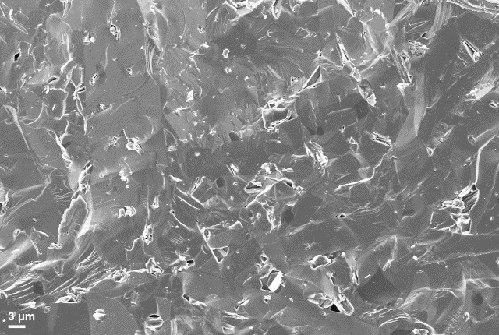
Figure 5. Fracture surfaces of Al₂O₃ (a, b) and α-SiC/B₄C (c,d) printed samples

(a) | 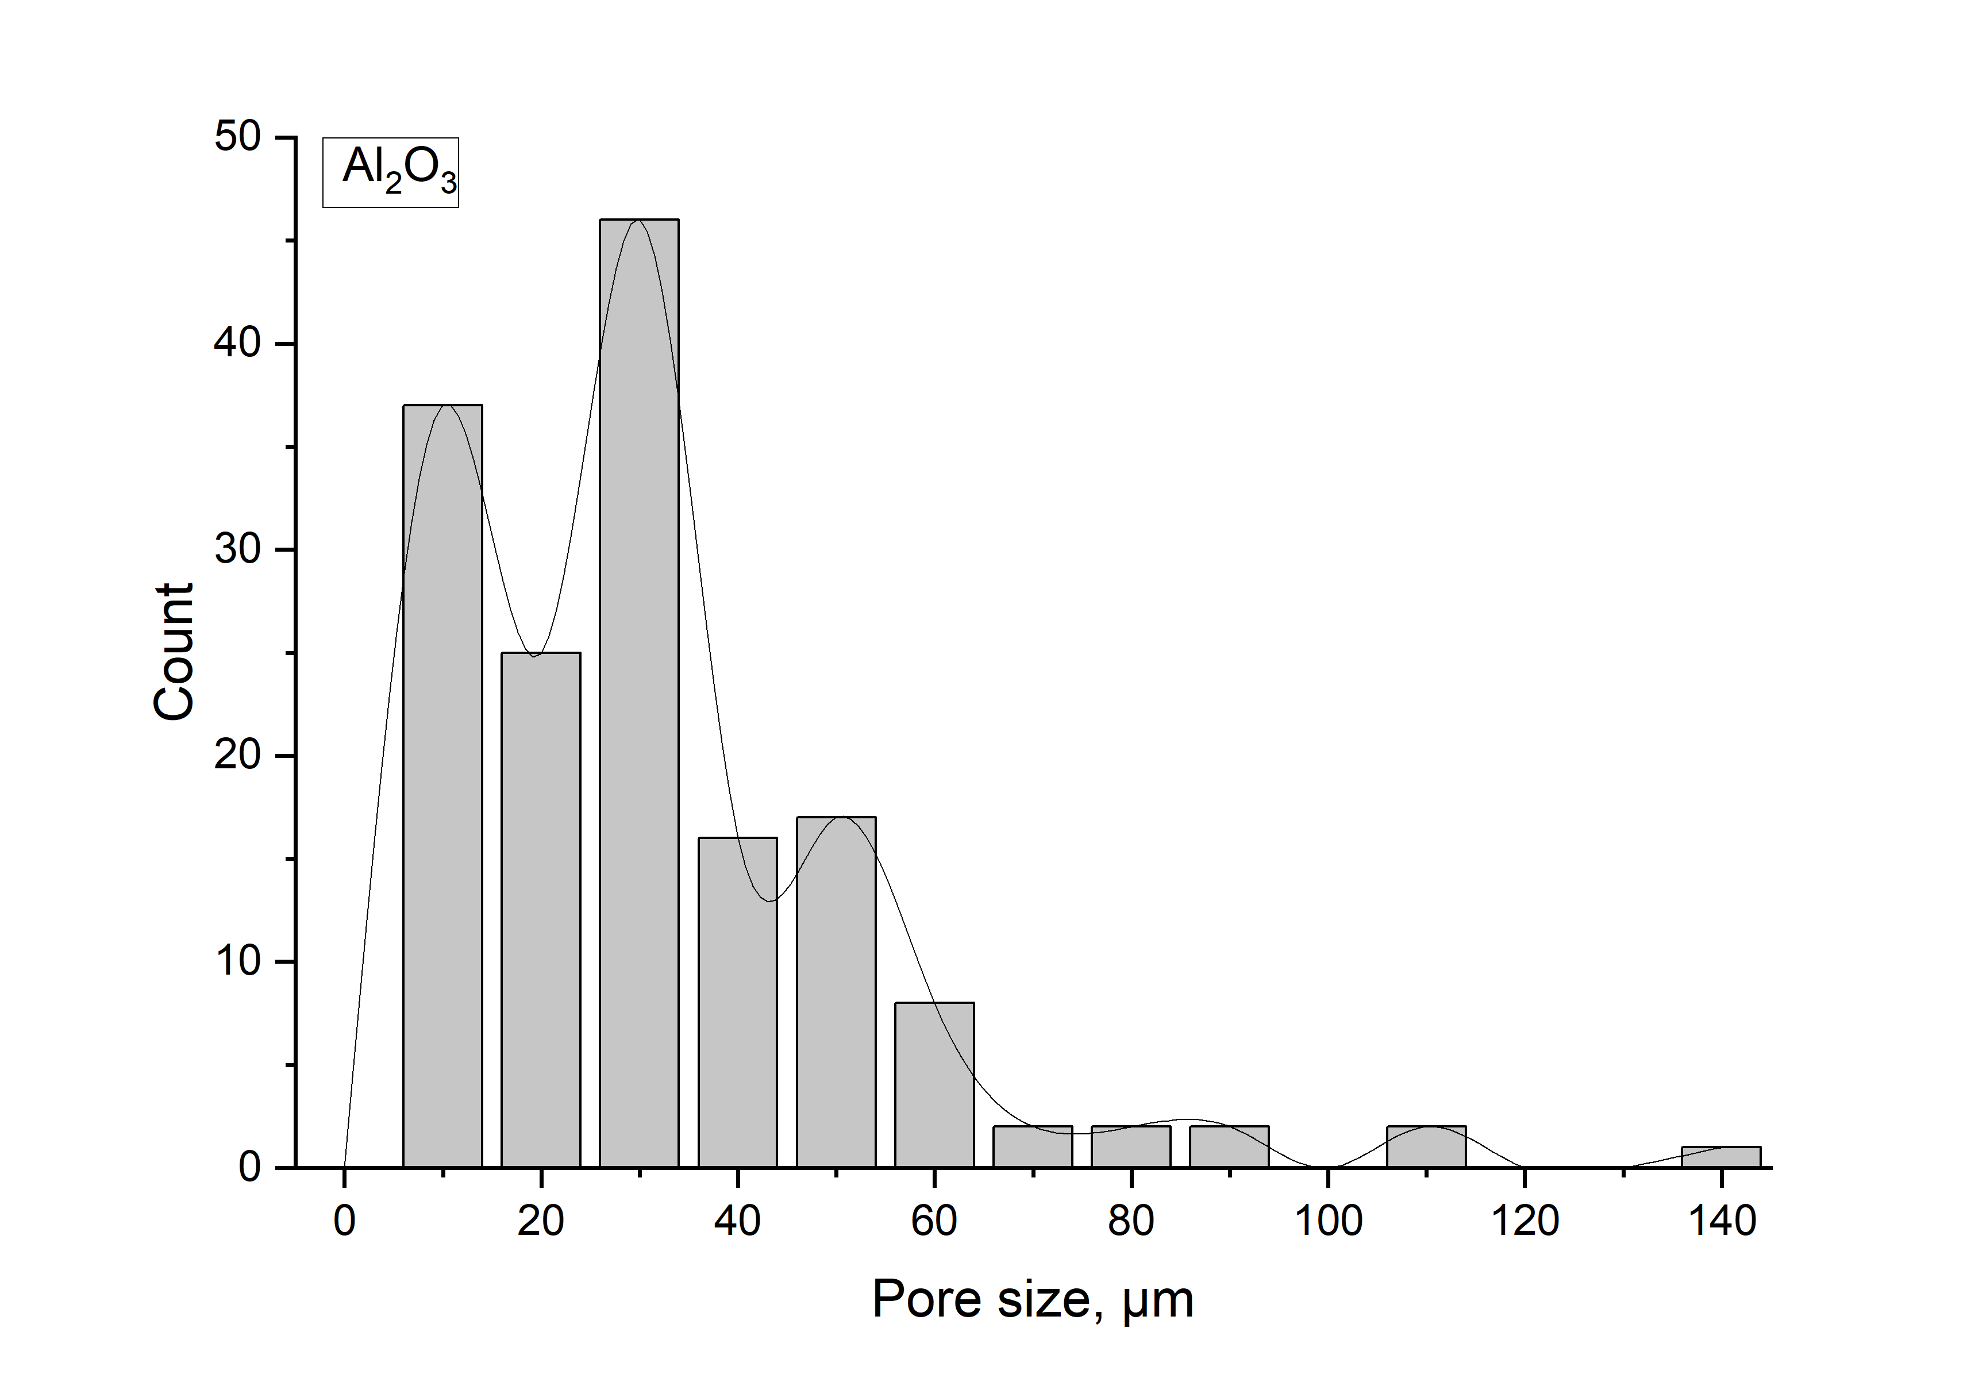 | (b) | 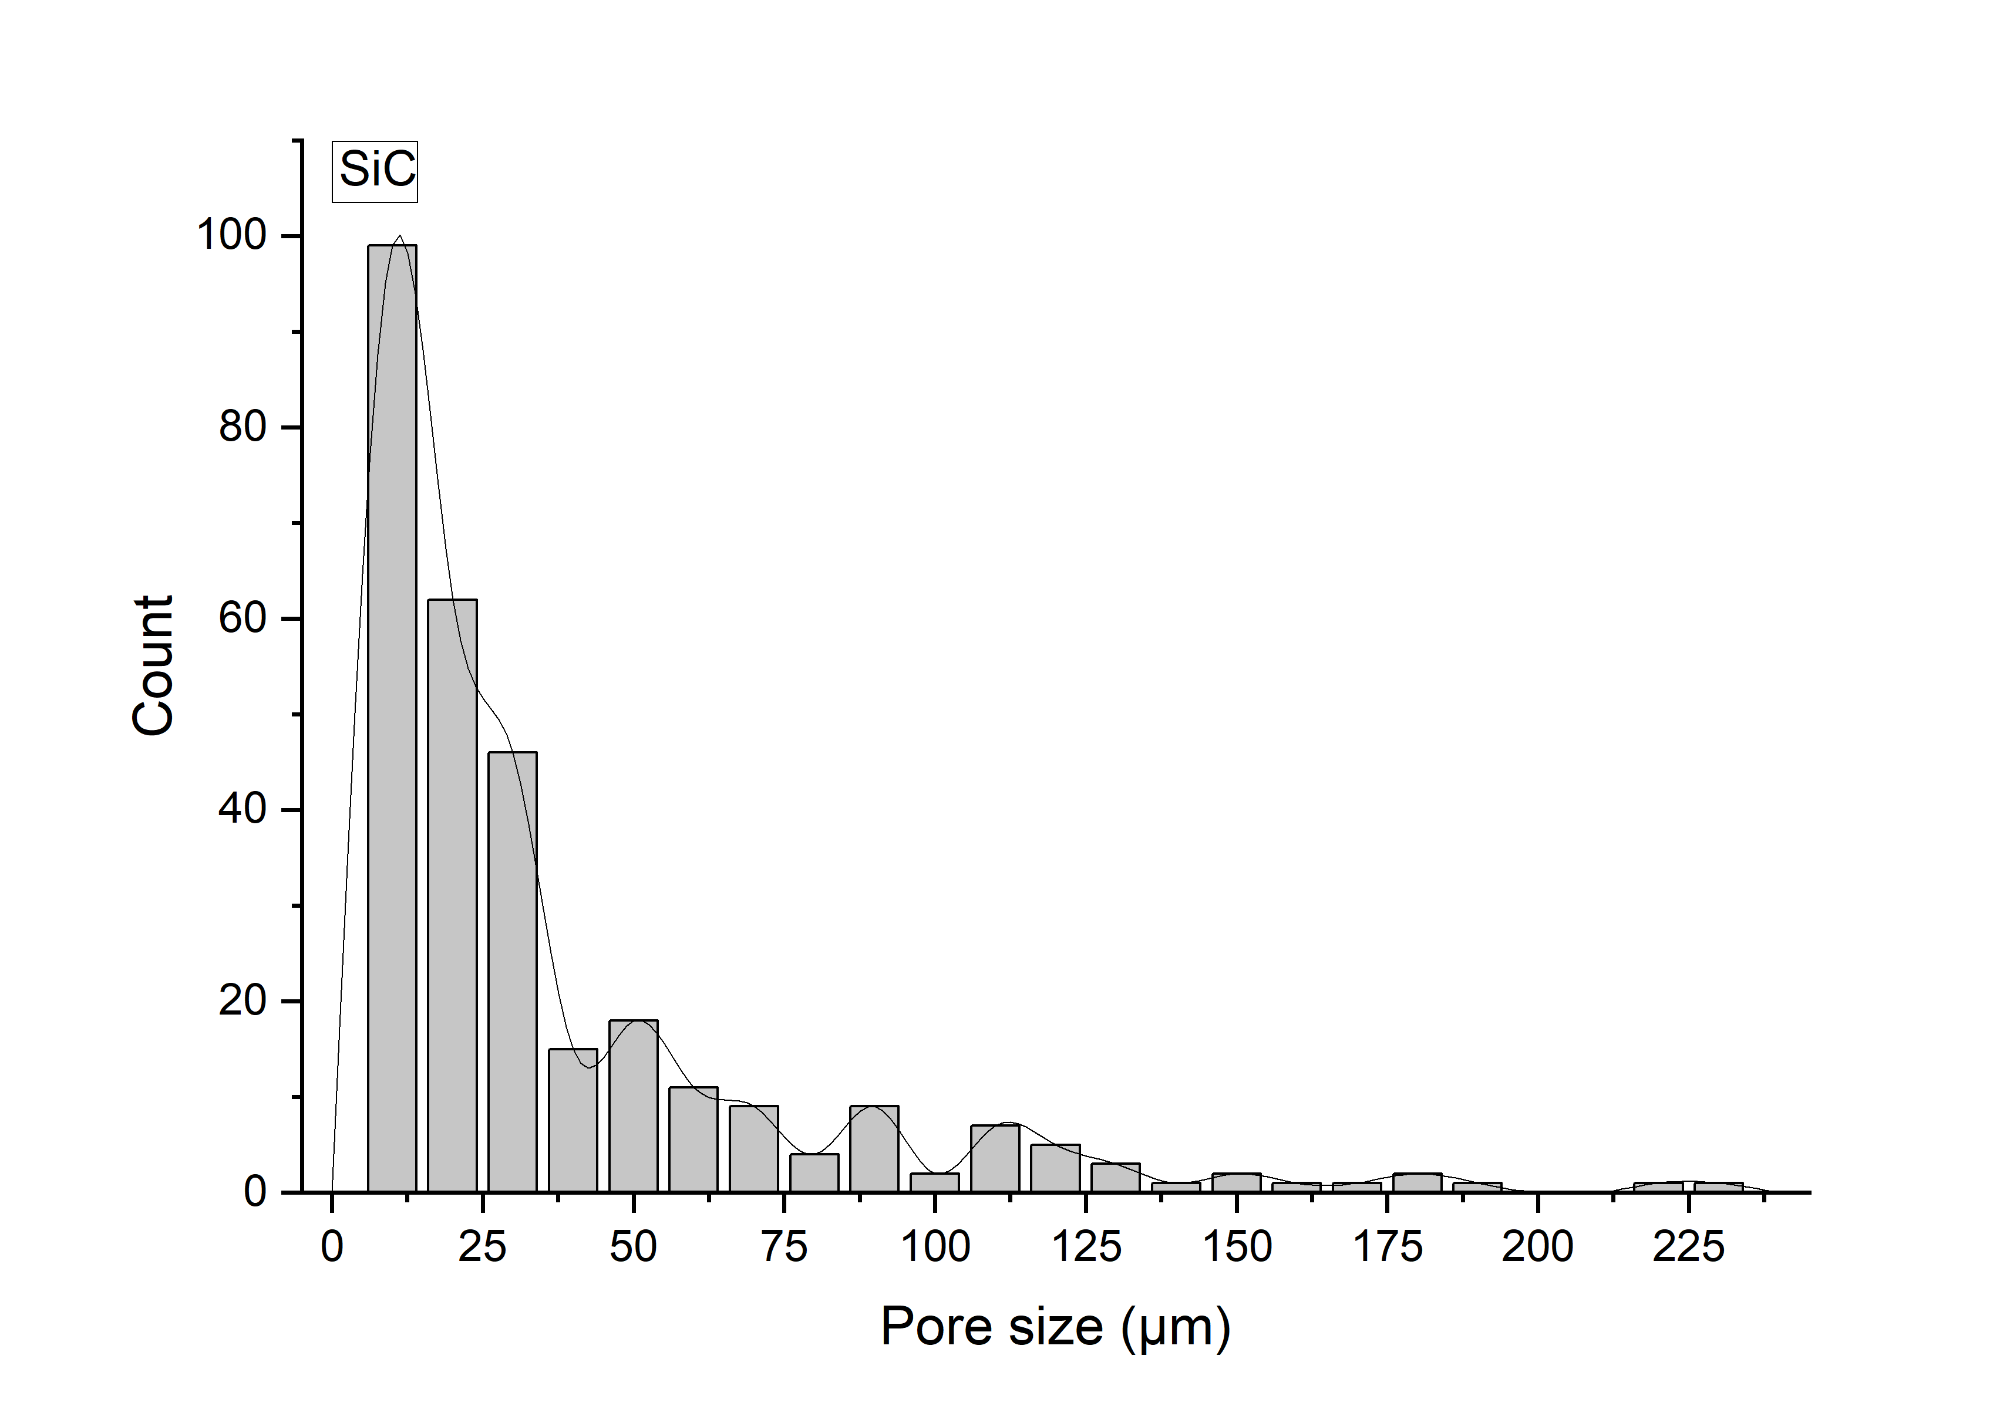
Figure 6. Pore size distribution in Al₂O₃ (a) and α-SiC/B₄C (b) printed samples

Conclusions

This study showcases a new type of phenolic resin-based ink designed for robocasting of ceramic powders with an intent of post-printing shaping. Phenolic resin in the inks acts as a binder and plasticizer and can be burned out during sintering, or, additionally, can be converted into carbon that can later act as a sintering aid. Parts of a wide range of shapes and sizes can be printed using the inks, from intricate nets and tapes to fully solid bars. Two types of materials were chosen to showcase the capabilities of the ink, alumina as a standard widely used technical ceramic material, and silicon carbide to explore the potential additional use of the phenolic resin ink medium as a sintering aid source.

Modifications to the flexible green bodies can be made in a certain time frame after printing (tens of minutes to tens of hours depending on the composition of the ink and the thickness of the printed part) and include, but are not limited to, bending, folding, cutting, draping over various objects. The use of only phenolic resin to provide flexibility provides a certain advantage over other hybrid robocasting strategies that feature multiple binders and plasticisers. The parts robocasted using phenolic resin-based inks have mechanical properties comparable with other printed samples as well as with conventionally produced ceramics. Future work will be conducted to further improve ink processability and minimise micropores and delamination in bulk samples. Additionally, storage strategies will be investigated to prolong shaping times.

Acknowledgements

The authors would like to acknowledge the EPSRC Program Manufacture Using Advanced Powder Processes (MAPP) (EP/P006566/1). We would also like to acknowledge Sumitomo Bakelite Co, Ltd for providing materials (phenolic resin) used in the reported experiments.

References

[1] Z. Chen et al., “3D printing of ceramics: A review,” J. Eur. Ceram. Soc., vol. 39, no. 4, pp. 661–687, 2019.
[2] K. M. Nair, D. Suvorov, R. W. Schwartz, and R. Guo, Advances in Electroceramic Materials: Ceramic Transactions, vol. 204. 2009.
[3] V. M. Orera and R. I. Merino, “Ceramics with photonic and optical applications,” Bol. la Soc. Esp. Ceram. y Vidr., vol. 54, no. 1, pp. 1–10, 2015.
[4] D. Zhang, E. Peng, R. Borayek, and J. Ding, “Controllable Ceramic Green-Body Configuration for Complex Ceramic Architectures with Fine Features,” Adv. Funct. Mater., vol. 29, no. 12, pp. 1–12, 2019.
[5] A. Zocca, P. Colombo, C. M. Gomes, and J. Günster, “Additive Manufacturing of Ceramics: Issues, Potentialities, and Opportunities,” J. Am. Ceram. Soc., vol. 98, no. 7, pp. 1983–2001, 2015.
[6] E. Feilden, E. G. T. Blanca, F. Giuliani, E. Saiz, and L. Vandeperre, “Robocasting of structural ceramic parts with hydrogel inks,” J. Eur. Ceram. Soc., vol. 36, no. 10, pp. 2525–2533, 2016.
[7] C. Xu, B. Quinn, L. L. Lebel, D. Therriault, and G. L’espérance, “Multi-Material Direct Ink Writing (DIW) for Complex 3D Metallic Structures with Removable Supports,” ACS Appl. Mater. Interfaces, vol. 11, no. 8, pp. 8499–8506, 2019.
[8] J. A. Lewis, “Direct ink writing of 3D functional materials,” Adv. Funct. Mater., vol. 16, no. 17, pp. 2193–2204, 2006.
[9] E. Peng, D. Zhang, and J. Ding, “Ceramic Robocasting: Recent Achievements, Potential, and Future Developments,” Adv. Mater., vol. 30, no. 47, pp. 1–14, 2018.
[10] J. A. Lewis, E. Hong, C. J. Hansen, D. C. Dunand, B. Y. Ahn, and D. Shoji, “Printed Origami Structures,” Adv. Mater., vol. 22, no. 20, pp. 2251–2254, 2010.
[11] M. Jabbari, R. Bulatova, A. I. Y. Tok, C. R. H. Bahl, E. Mitsoulis, and J. H. Hattel, “Ceramic tape casting: A review of current methods and trends with emphasis on rheological behaviour and flow analysis,” Mater. Sci. Eng. B Solid-State Mater. Adv. Technol., vol. 212, pp. 39–61, 2016.
[12] J. Al et al., “Hyperelastic ‘bone’: A highly versatile, growth factor-free, osteoregenerative, scalable, and surgically friendly biomaterial,” Sci. Transl. Med., vol. 8, no. 358, pp. 358ra127-358ra127, 2016.
[13] Y. de Hazan, M. Thänert, M. Trunec, and J. Misak, “Robotic deposition of 3d nanocomposite and ceramic fiber architectures via UV curable colloidal inks,” J. Eur. Ceram. Soc., vol. 32, no. 6, pp. 1187–1198, 2012.
[14] T. L. Brown, H. E. LeMay, B. E. Bursten, C. J. Murphy, P. M. Woodward, and Matthew W. Stotzfus, Chemistry the Central Science. 2013.
[15] M. Aulton and K. Taylor, Pharmaceutics, The Design and manufacture of medicines. 2017.
[16] H. W. Wong et al., “Quantitative determination of species production from phenol-formaldehyde resin pyrolysis,” Polym. Degrad. Stab., vol. 112, pp. 122–131, 2015.
[17] L. Rueschhoff, W. Costakis, M. Michie, J. Youngblood, and R. Trice, “Additive Manufacturing of Dense Ceramic Parts via Direct Ink Writing of Aqueous Alumina Suspensions,” Int. J. Appl. Ceram. Technol., vol. 13, no. 5, pp. 821–830, 2016.
[18] Ronal G. Munro, “Evaluated Material Properties for a Sintered alpha-Alumina,” J. Am. Ceram. Soc., vol. 80, no. 8, pp. 1919–1928, 1997.
[19] Saint-Gobain, “Hexoloy ® SA Silicon Carbide.” [Online]. Available: https://bit.ly/2wxLUfQ. [Accessed: 02-Jun-2019].
[20] Saint-Gobain, “Hexoloy ® SE Silicon Carbide.” [Online]. Available: https://bit.ly/2wufvqL. [Accessed: 02-Jun-2019].
[21] E. A. Griffin, D. R. Mumm, and D. B. Marshall, “Rapid prototyping of functional ceramic composites,” Am. Ceram. Soc. Bull., vol. 75, no. 7, pp. 65–68, 1996.

