Regulating the Interlayer Spacing of Graphene Oxide Membranes and Enhancing their Stability by use of PACl
Ting Liu^{1,2}, Long Tian¹, Nigel Graham², Bing Yang¹, Wenzheng Yu^{3,2}*, Kening Sun¹*

¹ School of Chemistry and Chemical Engineering, Beijing Institute of Technology, Beijing 100081, China (liuting@bit.edu.cn, keningsunhit@126.com)
² Department of Civil and Environmental Engineering, Imperial College London, South Kensington Campus, London SW7 2AZ, UK (n.graham@imperial.ac.uk)
³ Key Laboratory of Drinking Water Science and Technology, Research Center for Eco-Environmental Sciences, Chinese Academy of Sciences, Beijing 100085, China
(w.yu@imperial.ac.uk, wzyu@rcees.ac.cn)

Abstract：
Graphene oxide (GO) is an ideal membrane material for water treatment due to its outstanding physicochemical properties and unique lamellar structure. However, the separation performance and practical application of GO membranes are mainly affected by the interlayer spacing and stability in aqueous solutions. Here we report a novel and facile approach to fabricating GO membranes with adjustable interlayer spacing and high stability in aqueous solutions through crosslinking with polyaluminum chloride (PACl). With this approach, the lamellar spacing can be adjusted by changing the OH/Al ratios (B values) of the PACl, and the GO nanosheets can be tightly bonded by the strong electrostatic effect that PACl provides between them. The average interlayer spacing of the GO layer could be varied approximately in the range of 0.80-1.09 nm. The PACl-GO membranes demonstrated excellent stability in water and inorganic/organic solutions when the concentration of PACl was 0.1, 1 and 10 mM, remaining unchanged for at least two weeks. Moreover, the PACl-GO membranes featured exceptional sieving capabilities for model and natural organic substrates, while it was also observed that increasing the interlayer spacing of the PACl-GO membranes increased both the membrane flux and the separation performance of organic matter.

1. Introduction
There is growing interest in the development and use of graphene oxide (GO) -based membranes for the separation of molecules and ions due to their unique layered structure and physicochemical properties.¹⁻⁵ GO is a two-dimensional carbon nanomaterial with atomic thickness consisting of various oxygen-containing groups (e.g. carboxyl, hydroxyl, epoxy, etc.) decorated on the basal plane and the edges of the GO nanosheets.⁶⁻⁸ The oxidized groups can act as a spacer to provide channels between adjacent GO laminates, and water molecules can flow quickly in the graphitic region of the channel, while flow in the functionalized region is limited.⁹⁻¹¹ The ultrafast water permeation can be attributed to the capillary pressure and low friction flow of water molecules in the non-oxidized zone within the channel.^{8, 11} Therefore, GO is an ideal material for membrane preparation and for modifying polymer membranes to separate molecules/ions and improve their performance.¹²⁻¹⁶ The separation ability of multilayered GO membranes mainly depends on size exclusion and electrostatic forces.^{17, 18} The size of the two-dimensional nanochannels can be adjusted by changing the interlayer spacing of the GO nanosheets, which is the principal property that allows the precise separation of molecules or ions.^{12, 19, 20} However, previous studies have shown that GO membranes will disintegrate when exposed to water.^{21, 22} This is mainly due to hydration from the binding of water to the oxidized groups which provides a strong repulsive force between the GO nanosheets.^{23, 24} In addition, the hydroxyl and carboxyl groups can ionize in water to make the GO nanosheets negatively charged and the resulting electrostatic repulsion can cause the separation of GO nanosheets from each other.⁶ Thus, the stability of GO membranes in aqueous solution is considered to be the critical challenge in their practical application.^{9, 25}
Many previous studies have considered how to enhance the stability of GO membranes. So far, the most commonly used method for reducing the instability/disintegration of GO membranes in solution has been to use a crosslinking agent to connect the GO nanosheets, such as multivalent cations (Mg²⁺, Ca²⁺, Al³⁺ and Fe³⁺),²⁶⁻²⁸ modified graphene oxide (aminated-GO, partially reduced GO),^{29, 30} high-molecular polymers (including 1,3,5-benzenetricarbonyl trichloride polyallylamine,³¹ polyvinyl alcohol and polymethyl methacrylate¹⁷) or other chemicals (diamine,^{32, 33} thiourea,²⁵ borate,³⁴ etc.). Among these crosslinking agents, multivalent cations are preferable alternatives owing to their low-cost and facile operation in the membrane synthesis, but the interlayer spacing of GO membrane can be adjusted only in a small range.³⁵ The other crosslinking agents and methods usually require complex operation or involve toxic substances, which may cause secondary pollution to the treated water. Moreover, one crosslinking agent can only achieve a fixed interlayer spacing of the membrane. Thus, there is an urgent need to develop a new cross-linking agent that can cross-link GO by a simple method, in order to improve the stability of GO membranes significantly and adjust the interlayer spacing effectively.
In this study, we present a novel and facile method of synthesizing GO membranes which exhibit a high stability in water containing a variety of inorganic and organic constituents, representative of raw waters, and controllable lamellar spacings, by doping different forms of polyaluminum chloride (PACl). PACl is a pre-hydrolyzed aluminium-based cationic polymer which is widely used as a coagulant in the field of water treatment.^{36, 37} The cationic nature of PACl enables it to be used as a crosslinking agent for GO membranes by means of the electrostatic force and π electron-rich structures. PACl prepared with different OH/Al (basicity) ratios (B values) exhibit different properties, such as their polymeric size and charge,^{38, 39} and these will affect the stability and lamellar spacing of the synthesized GO membranes. In particular, the presence of highly charged Al₁₃ polymers (Al₁₃O₄(OH)₂₄⁷⁺) increases with basicity up to a maximum at approximately B=2.⁴⁰ Thus, in this study we have considered the influence of PACl with different B values on the nature of synthesized PACl-GO membranes in terms of their fundamental properties (e.g. stability, lamellar spacing) and their solute separation performance.

2. Materials and methods
2.1. Preparation of GO and PACl. GO was prepared using the modified Hummers method.^{41, 42} Natural flake graphite was oxidized to graphite oxide by H₂SO₄, NaNO₃ and KMnO₄, and the product was washed with a concentration of 5% hydrochloric acid to remove the residual metal ions in the product. After 4-6 cycles of acid washing, deionized (DI) water (Milli-Q) was used to wash out the residual acid in the graphite oxide suspension. The pure multilayer GO was exfoliated into GO nanosheets under ultrasonic vibration and after freeze-drying.
The PACl solutions with different B values were prepared according to an alkali titration method at room temperature.³⁸ Specifically, 0.2 M AlCl₃ solution was titrated slowly (0.1 mL/min) under rapid stirring with 0.5 M NaOH using a syringe pump (SPLab01, Baoding Shenchen Precision Pump Co., Ltd., China). The amount of NaOH added varied with the target OH/Al ratio (B value), i.e. 0, 0.5, 1.0, 1.5 and 2.0. The final concentration of aluminum was 0.1 M in all cases. The resultant solutions were denoted as PACl₀, PACl_{0.5}, PACl_{1.0}, PACl_{1.5} and PACl_{2.0}, respectively.

2.2. Membrane fabrication. A commercial PVDF ultrafiltration (UF) membrane (Beijing AnDe Membrane Technology Co., Ltd., China) with a MWCO of 100 KDa and contact angle of 85º, was used as the supporting layer to fabricate the GO membrane. Before the fabrication, the PVDF membrane was pre-conditioned by filtering 200 ml DI water, and then the GO was loaded onto the membrane surface by pressure filtration to produce a pure GO membrane. In order to obtain a range of alternative PACl-GO membranes, PACl was added as a crosslinking agent to 100 mL GO solution at a concentration of either 10 mg/L or 20 mg/L (1 mg or 2 mg, respectively) prior to coating a PVDF membrane by pressure filtration; the concentration of PACl in the mixed solution was adjusted to 0.05 mM, 0.1 mM, 1 mM or 10 mM. Finally, residual unbound PACl was removed from the synthesized GO membrane by rinsing/filtering with 15 mL DI water.

2.3. Characterization of GO nanosheets, membranes and PACl. The physical and chemical properties of GO nanosheets and the structure of GO membranes were evaluated by a range of analytical methods; these properties and structure determine the performance of the GO membrane. Scanning electron microscopy (SEM, QUANTA FEG 250, FEI, USA; sputter-coated with aurum) provided images of the GO membrane surface and cross section, while high-resolution transmission electron microscopy (HRTEM, JEOL, JEM-2100F, Japan) revealed the individual GO nanosheets and the folds. Raman spectroscopy (Renishaw, inVia, UK) was used to analyze the structural properties of GO. Contact angle (Dataphysics, OCA15EC, Germany) measurements were conducted to indicate membrane hydrophilicity. The charge properties of the PACl-GO solutions were tested by a commercial zeta potential analyzer (ZETASIZER NANO ZS90, Malvern, UK). The surface charge properties of PACl-GO membranes were analyzed by a solid zeta potential analyzer (SurPASSTM 3, Anton Paar, Germany), and all tests were performed under neutral pH with 1 mM KCl solution. X-ray photoelectron spectroscopy (XPS, ESCALAB 250Xi, Thermo Scientific, America) spectra were collected to identify the relative abundance of the different functional groups. X-ray diffraction (XRD, Rigaku UltimaIV, Cu-Κα radiation, 45 kV, 50 mA, Japan) characterization was used to determine the inter-nanosheet spacing of GO membranes. Fourier transform infrared spectroscopy (FT-IR, BRUKER, ALPHA-P, USA) was used to identify the presence of oxygen containing functional groups and other chemical bonds on the GO. Atomic force microscopy (AFM) (Multimode, Digital Instruments, Plainview, NY) enabled direct observation of the surface and thickness of GO nanosheets. Lastly, ²⁷Al nuclear magnetic resonance spectroscopy (²⁷Al NMR) (Avance Ⅲ HD 400 MHz, Bruker, Germany) was used to characterize the Al species in PACl solutions.

2.4. Stability Tests. The ‘as-prepared’ GO membranes were cut into 1.5 cm×1.5 cm square pieces, and then immersed at room temperature in the following alternative solutions: DI water, 1 M NaCl, BSA (bovine serum albumin) and SA (sodium alginate); the latter two aqueous solutions at concentrations of 10 mg/L, 50 mg/L and 200 mg/L. The stabilities of the membranes were recorded by visual observation/photography at intervals of time after the membrane had been immersed in the different solutions.

2.5. Flux and rejection tests. Water flux, normalized flux and rejection rate (removal efficiency) are important parameters to evaluate the fouling resistance of the GO membrane. These were evaluated using a commercial pressure filtration system (Millipore, Amicon 8400, USA) employing nitrogen gas as the means for obtaining a stable applied pressure (1 bar). A digital balance (ML3002, Mettler-Toledo International Inc., USA) was connected to a computer to automatically record the weight of the filtered water in real time by the data acquisition software. Three different kinds of model NOM (natural organic matter) solutions, namely bovine serum albumin (BSA) protein, humic acid (HA) and alginate (sodium salt, SA) polysaccharide, at a concentration of 10 mg/L were used as feed solutions to test the flux, rejection rate and the fouling resistance of the GO membranes. Samples of surface water from the South Long River, Beijing, China were also employed in this study. South Long River is a moderately contaminated water supply source for communities to the west of Beijing (see Table S1 in the supporting information for representative water quality parameters and values). Before each test the newly fabricated GO membrane was pre-conditioned by filtering 15 mL DI water to ensure there was no residual PACl on the surface of the GO membrane. The TOC concentration of samples of all feed waters and permeates were determined by total organic carbon (TOC) analyzer (TOC-V_{CPH}, Shimadzu, Japan), and the UV₂₅₄ absorbance of humic acid solution and surface water were analyzed by UV-visible spectrophotometer (U-3010, Hitachi, Japan) at a wavelength of 254 nm. Size exclusion chromatography (SEC) was used to determine the apparent molecular weight (MW) distribution of UV-active substances. SEC was performed using HPLC (Waters 2685, USA), with a BIOSEP-SEC-S3000 column (Phenomenex, UK) (7.8 mm×300 mm), and a Security Guard column fixed with a GFC-3000 disc 4 mm (ID). The injection volume of water samples was 100 μL and the UV-visible detector operated at a wavelength of 254 nm with autosampler.

3. Results and discussion
3.1. Properties of GO nanosheets. The GO nanosheets were fabricated by introducing a large quantity of oxygen-containing functional groups into the graphite sheets, and then the GO nanosheets were evenly separated in the water by an ultrasound process. The Raman spectrum of the GO nanosheets (Figure 1A) shows two peaks at 1350 cm⁻¹ (D peak) and 1593 cm⁻¹ (G peak), which signifies a defect of the carbon atomic lattice and in-plane stretching vibration of sp² hybridization of the graphitic carbon, respectively. Furthermore, the FTIR spectrum (Figure 1B) suggests that the GO nanosheets contain a stretching vibration of sp² C=C (1625 cm⁻¹), −C=O stretching vibration (1726 cm⁻¹), stretching vibration of C−O (1055 cm⁻¹), stretching vibration of C−OH (1226 cm⁻¹) and deformation vibration of O−H (1382 cm⁻¹).⁴³ The XRD pattern (Figure 1C) shows that there is a sharp peak at around 10 degrees, which is the characteristic peak of graphene oxide. The HRTEM image (Figure 1D) exhibits a uniform and typical wrinkled nanosheet structure of GO. It can be observed from the analysis of the AFM image (Figure 1E) that the lateral sizes of the GO nanosheets were in the range of 100 and 2000 nm. By analyzing the AFM image, the depth profiles were obtained and the results show that heights of the GO nanosheets were about 0.926 nm (Figure 1F), indicating the synthesized GO nanosheets were a single layer of carbon lattice.
(D)
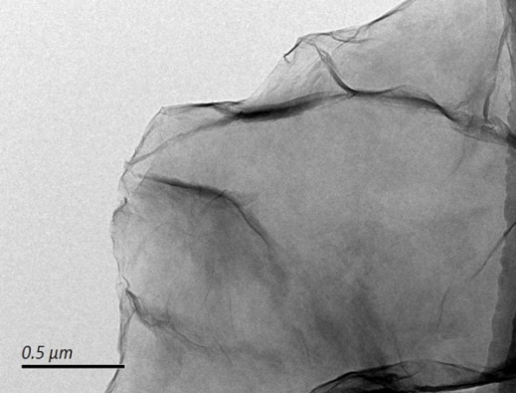
(E)
(F)
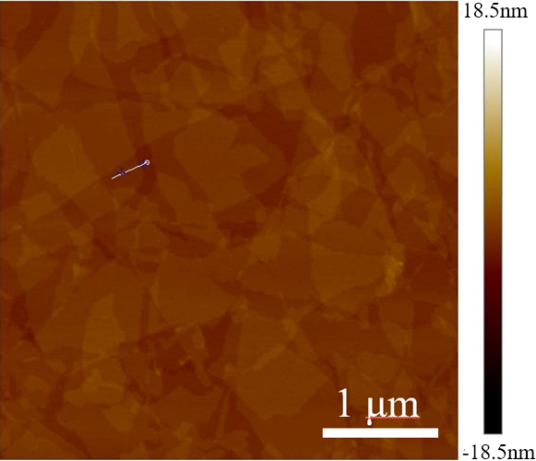
Figure 1. Characterization of GO nanosheets and layer: (A) Raman spectrum, (B) FTIR spectrum, (C) XRD pattern, and (D) TEM image of GO nanosheets; (E) AFM image, and (F) AFM height profiles of GO (the positions of the profiles are marked as the white line in (E)).

3.2. Effect of PACl on the fabrication of PACl-GO membrane
The physical and chemical properties of PACl with different B value (the ratio of OH/Al) were characterized. Figure 2A shows the nuclear magnetic resonance (NMR) spectra of ²⁷Al PACl in the deuterated reagents, and it can be seen that there is a resonance peak at the chemical shift of 0.6 ppm and 63 ppm for all PACls. The peak at 0.6 ppm of chemical shift represents the monomeric and dimeric aluminum species, the octahedral monomers of Al. The peak of chemical shift at 63 ppm represents Al¹³'s -Johannson⁷⁺ tetrahedron structure; the center of the structure is AlO₄, and twelve Al octahedral around the center.⁴⁴ From the NMR spectrum of PACl₀, there is no peak at 63 ppm, indicating that Al₁₃ is not contained in AlCl₃ solution. With the increase of B value, the intensity of the peak at 0.6 ppm decreases, while the peak intensity at 63 ppm increases. This indicates that with increasing B value the content of Al₁₃ also increased. According to the integral calculation of the peak area, the content of Al₁₃ in the solution was about 80% when the B value was 2.
In order to determine the effect of PACl basicity on the charge properties of the GO nanosheet, the zeta potential of the PACl-GO mixed solution was determined (Figure 2B). In the absence of PACl the GO solution was negatively charged due to the ionization of the functional groups containing carboxyl and hydroxyl groups on the GO nanosheets, and the zeta potential of the GO solution was about -42 mV. For low doses of PACl in the concentration range of 0-0.5 mM, added to the GO solution, the zeta potential of GO increased (more cationic) rapidly (Figure 2B, Inset). In contrast, at higher PACl concentrations, ≥ 1 mM, the zeta potential was positive and approximately unchanging (stable). The results also showed that for the same dose of PACl, the zeta potential value of PACl-GO solution increased (more cationic) with increase of the B value. Thus, the addition of PACl (especially for high B values) has a strong regulating effect on the charged properties of the GO nanosheets.
SEM images of the cross-section of the PACl-GO membrane showed that the nano-scale GO sheets were deposited layer by layer on the surface of the PVDF membrane support and bonded closely with it (Figures 2C). Both PACl_{0.5}-GO and PACl_{2.0}-GO (Figure 2D) membranes showed similar surface morphology with wrinkles and folds, which were commonly observed on GO membranes in previous studies.^{7, 20, 45} The average thickness of the GO layer was estimated to be in the range of 260-280 nm, with interspaces of a similar nano-scale between the layers, which provide channels for water flow and tortuous surfaces for the retention of NOM contaminants in the water. The presence and distribution of Al in the PACl-GO membrane were indicated by the EDX image with 10 mM PACl_{2.0} (Figure 2E). The characteristic peak of Al appears at 1.487 keV, and the element distribution image (EDX mapping) showed that the Al was uniformly distributed in the GO membrane; EDX mapping of the PACl₀-GO membrane is shown in the supporting information (Figure S1).

(C)
(D)
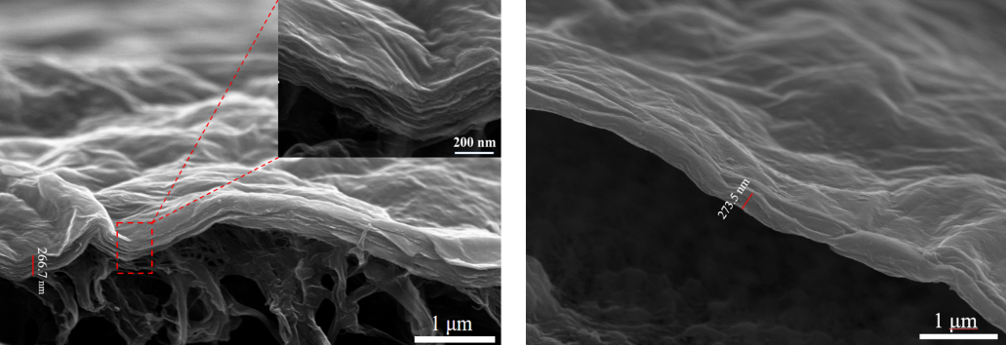
(E)
Figure 2. (A) NMR of PACl with different B value; (B) effect of different PACl concentrations and B value on the zeta potential of GO (20 mg/L); (C) and (D) cross-sectional SEM images of the GO membrane (2 mg) with 10 mM PACl, and B=0.5 and B=2, respectively; (E) element analysis and EDX mapping (Al distribution pattern at 5 k×) for PACl-GO membrane with 10 mM PACl (B=2)

The change of average interlayer spacing between the GO laminates caused by doping PACl with different B value was confirmed by the XRD patterns (Figure 3A and 3B). The peak for the PACl cross-linked GO membranes shifted to lower θ values, which indicated that the interlayer spacing increases with increasing B value of PACl. For the GO membranes without Al, the average interlayer spacing was around 0.80 nm, while the spacing of GO membranes with 0.01M PACl_{2.0} increased to ∼1.09 nm (Figure 3C), which indicated that the inclusion of PACl offers a significant enhancement (36%) of the interlayer distance between GO sheets. The concentration of PACl also influenced the interlayer spacing, with a reduced enhancement of the spacing at 1 mM compared to 10 mM (Figure 3C), for all B values; the spacing enhancement increased with PACl basicity (B value). These results indicate that GO membranes doped with PACl can be prepared with a layered structure and an adjustable interlayer spacing. The mechanism that explains how the B value changes the interlayer spacing of GO is discussed as follows. According to the results of the NMR spectra, as the B value increases, the monomeric and dimeric aluminum species (δ=0.6 ppm) in the PACl solution gradually decrease, while the content of tetrahedral polymeric species Al₁₃ (δ=63 ppm) gradually increases. Al₁₃ has a relatively larger size and higher positive charge compared to the monomeric and dimeric aluminum species, which could therefore cause a larger spacing between the GO sheets and more efficiently neutralize the negative charges of the GO. Therefore, the Al species within the PACl solution which mainly functions as the crosslinking agent for the GO membrane, gradually changes from monomer/dimeric aluminum to Al₁₃ with increasing B value, resulting in a gradual increase in the interlayer spacing of GO sheets. The variation of chemical bonds in the PACl-GO membranes evaluated by FTIR analysis (Figure 3D). Pure GO membranes contain a stretching vibration of sp² C=C (1654 cm⁻¹) while the same peak for the PACl₀-GO membranes shifted to larger wavenumbers (1670 cm⁻¹). The shift in the peak position of C=C to the larger wavenumber is regarded as an indication of carboxylate chelated with the metal or GO nanosheets crosslinked by π electron-rich structures, which is the mechanism of crosslinking between metal and GO. As the B value increases, the position of the peak moves to lower wave numbers due to the reduction of contact sites between PACl and GO. Hydrophilicity and charge are two important factors that could dramatically affect the separation performance of the membrane. Thus, the water contact angle and zeta potential of the membranes were determined and the results are shown in Figure 3E. The PACl₀-GO membrane displayed a greater hydrophilicity (lower contact angle) than the PACl_{1.0}-GO and PACl_{2.0}-GO membranes, and the contact angle of the PACl-GO membranes increased with increase of PACl basicity (B value). This can be attributed to the content of Al₁₃ within the PACl-GO membrane. The Al₁₃ polycation has a lower hydrophilicity compared with the monomer or dimer aluminum in PACl solution, and thus the membranes with higher B value exhibited higher hydrophobicity. The zeta potential results showed that the PACl-GO membrane systematically varied from being negatively charged to positively charged, as the B value increased from 0 to 2, and this charge reversal is believed to change the nature of the separation mechanism of the GO membrane. Since most organic substances (HA, BSA, SA) are negatively charged in raw waters, the membrane rejection/separation mechanism of electrostatic interaction shifted from electrostatic repulsion with low B value (B=0, 1) to electrostatic adsorption with high B value (B=2); the separation performance is discussed subsequently (section 3.5).

Figure 3. (A), (B) XRD intensity spectra for different PACl-GO membranes with 1 mM and 10 mM PACl; (C) the interlayer spacing of PACl-GO membranes with 1 mM and 10 mM PACl (mean value and variation bars based on ≥3 samples); (D) FTIR of PACl-GO membrane with 10 mM PACl; (E) water contact angle and zeta potential of PACl-GO membranes with 10 mM PACl.

Figure 4 shows the XPS spectra of the PACl-GO membrane, which was used to characterize the proportion of the functional groups in the GO membrane. The ratio (area) of the chemical bonds of C=O/O=C-O, C-O and C-C/C=C for a PACl-GO membrane without any Al ions was 11.4%, 42.3% and 46.3%, respectively (Table 1). With the addition of PACl, the proportion of the C-O bond decreased by about 3%, most likely because the metal cation induced the ring-opening of the epoxide to promote the destruction of the carbon-oxygen bonds.²⁷ With the increase of B value of PACl, the change in the proportion of functional groups in the PACl-GO membranes was less than 1% (Table 1). Therefore, the effect of PACl basicity (different B values) on the number of functional groups in the PACl-GO membranes was not significant, and overall, the incorporation of PACl had a negligible effect on the chemical properties of the GO membranes.
Figure 4. XPS spectra of GO membranes prepared with PACl with different B values: (A) no PACl; (B-D) 10 mM PACl with B=0 (B), B=1.0 (C) and B=2.0 (D)

Table 1. The proportion of oxygen functional groups in the GO membranes
GO Membrane  （2 mg GO, 0 or 10 mM PACl） | No PACl | B=0 | B=1 | B=2
C=O/O=C-O（%） | 11.4 | 10.6 | 9.7 | 10.3
C-O（%） | 42.3 | 39.1 | 38.9 | 39.3
C-C/C=C（%） | 46.3 | 50.3 | 51.4 | 50.4

3.3. Stability of PACl-GO membranes: immersion in aqueous solutions.
The stability of the GO membranes by doping different concentrations of PACl was investigated. As shown in Figure 5A, the extreme edges of 0.01mM PACl crosslinked GO membranes were prone to scatter under slight shaking. However, the membrane crosslinked by 10 mM PACl demonstrated enhanced stability and the integrity of the structure could be well maintained even under moderate shaking (Figure 5B). Figure 5C showed that the PACl-GO membrane had disintegrated into pieces and the stability of the structure could not be maintained when the concentration of PACl was further increased to 100 mM. Overall, when the PACl concentration was ≤0.01 mM or ≥100 mM, the crosslinking strength between GO nanosheets was low, and the synthesized PACl-GO membranes were unstable. For these two concentrations, the instability of the GO membranes can be explained as follows. When the PACl concentration is low, the GO nanosheets still remain negatively charged and the repulsive forces between the GO nanosheets make the GO membrane unstable. In addition, the number of binding points between the PACl and GO nanosheets is low, resulting in a weak cross-linking capacity, so the PACl is unable to sufficiently cross-link the GO nanosheets. In contrast, when the concentration of PACl is too high, charge reversal occurs where the PACl causes the surface of the GO nanosheets to become strongly cationic, leading similarly to charge repulsion between GO nanosheets, and therefore membrane instability. To provide comprehensive information concerning the stability of PACl-GO membranes, the behavior of membranes prepared with a matrix of PACl concentration and basicity, and exposed to alternative solutions (DI water, 1 M NaCl, BSA and SA) were investigated. For these tests, stable, ‘as-prepared’ PACl-GO membranes were synthesized with PACl concentrations of 0.05 mM, 0.1 mM, 1 mM and 10 mM. For all the membranes prepared with PACl concentrations of 0.1 mM, 1 mM and 10 mM, no changes were observed in all the solutions over at least two weeks, as illustrated in Figures 5D-5G. However, the stability of GO membranes doped with 0.05 mM PACl was dependent on the PACl basicity and type of solution. Thus, membranes remained stable in DI water and NaCl over two weeks and PACl₀-GO membranes were unchanged in all solutions, while for other B values the membranes readily disintegrated in 10 mg/L and 50 mg/L SA solution, and were partially dispersed in 200 mg/L SA solution. For GO membranes doped with PACl_{1.0}, PACl_{1.5}, PACl_{2.0} immersed in 10 mg/L BSA solution there was evidence of partial disintegration. It is noted that the stability of the GO membrane with 0.05 mM PACl changed with SA and BSA concentrations. The cross-linking strength between GO nanosheets is relatively weak with 0.05 mM PACl. It is suggested that a small quantity of SA and BSA entered the membrane channels and adsorption/complexation between the PACl and the organic molecules (SA and BSA) occurred at the low concentrations of SA and BSA, and this further reduced the crosslinking strength and caused membrane disintegration. In contrast, the organic molecules tend to aggregate at high concentrations,⁴⁶ and thus it was difficult for them to enter the channels and interact with the PACl owing to their larger size, leading to the relatively higher stability of the membrane. Images of the PACl-GO membranes in the alternative solutions and at different exposure times are shown in the supporting information (Fig S7-12).

(E)

(D)
(C)
(A)
(B)
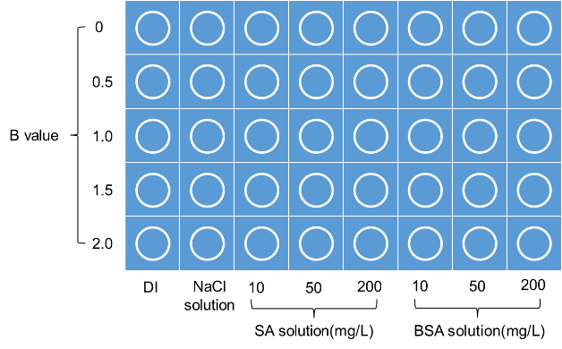
(G)

(F)

Figure 5. (A-C) PACl-GO membranes crosslinked with 0.01 mM PACl (A), 10 mM PACl (B) and 100 mM PACl (C); (D-G) Stability of PACl-GO membranes with different PACl concentration and basicity in different solutions: 0.05 mM PACl (D), 0.1 mM PACl (E), 1 mM PACl (F) and 10 mM PACl (G). (The circle mark in blue background means the membrane is intact, the circle mark in orange background means the membrane is broken, and the cross mark in red background means the membrane is dispersed).

3.4. Stability of PACl-GO membranes: filtration of NaCl solution.
Previous studies have shown that the interlayer cation (Mg²⁺/Ca²⁺/Al³⁺) in modified GO membranes can be exchanged with hydrogen ions (hydrochloric acid) or other monovalent cations such as Na⁺ and Li⁺, causing subsequent disintegration of the GO membrane with further exposure in water.⁶ However, the results reported previously (section 3.3) indicated that the stability of the PACl-GO membranes in 1 M NaCl was unaffected. In order to further confirm this, additional tests were performed involving the filtration of NaCl solution by GO membranes prepared with different PACl concentrations and basicities.
GO membranes prepared with 0.05 mM, 0.1 mM, 1 mM and 10 mM PACl were used to filter NaCl solution (0.1 mol/L, 100 ml), and were then immersed in DI water for periods up to 14 days. The stability of the membranes was observed visually and the results are summarized in Figure 6. For the membranes with the lowest PACl content (0.05 mM), the PACl_{0.5-2.0}-GO membranes remained stable only for a very short time in water and disintegrated into powder after 30 minutes, while the PACl₀-GO membrane remained stable for a long period (> 24 h). In contrast, GO membranes prepared with 0.1 mM, 1 mM and 10 mM PACl were stable up to 14 days, indicating a good resistance to cation substitution.
In order to further confirm the stability of the PACl-GO membrane, a longer period of filtration was considered. This involved a representative PACl-GO membrane (10 mM PACl_{2.0}) which was used to filter 3L NaCl solution at a concentration of 0.1 M, followed by immersion in DI water for one week. This confirmed the stability of the membrane (Figure 6F), but the accumulation of NaCl within the interlayers of the PACl-GO membrane resulted in the blockage of nanochannels and the gradual decline of flux (Figure 6E).

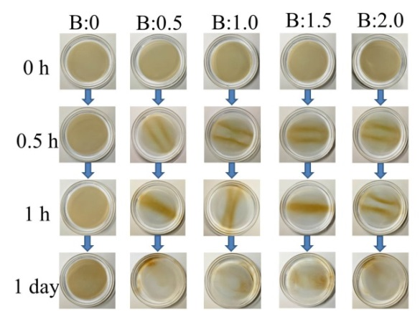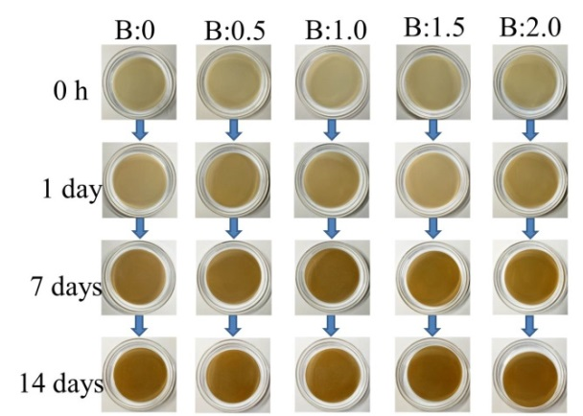
(B)

(C)

(A)
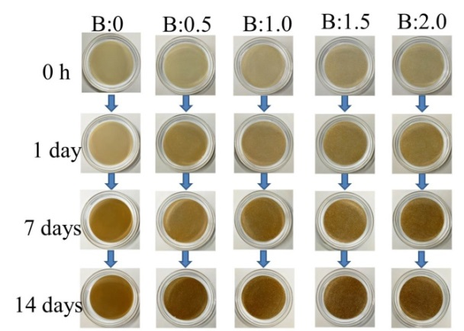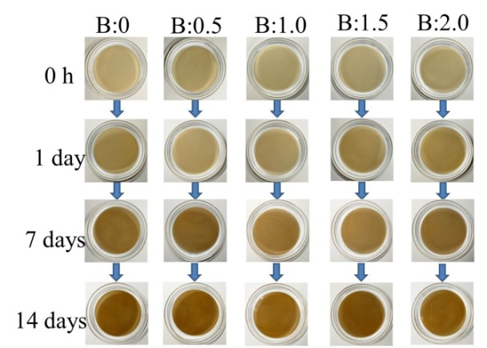
(F)
(D)

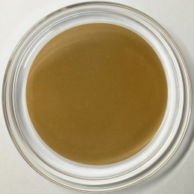
Figure 6. (A-D) The stability of PACl-GO membranes after NaCl filtration (100 mL 0.1 M) and subsequent immersion in DI water, for 0.05 mM PACl (A), 0.1 mM PACl (B), 1 mM PACl (C) and 10 mM PACl (D); (E)The variation of flux (L m⁻² h⁻¹) with filtered NaCl (0.1 M) for 10 mM PACl-GO membrane (B=2); (F) the PACl-GO membrane of (E) immersed in DI water for a week after NaCl filtration.
3.5. Permeability and separation performance of PACl-GO membranes
The doping of PACl in GO membranes results in an increase in the interlayer distance between adjacent GO nanosheets. Advantageously, the increase of interlayer spacing provides greater water penetration rates while still being capable of retaining organic substrates present in the feed water. To demonstrate this, filtration experiments involving 10 mg/L solutions of BSA, HA, and SA, and samples of real surface water, as the feed waters, were carried out. A summary of the results is given in Figure 7, where the initial flux (first 60 seconds) of the PACl-GO membranes is shown for different feed waters and two PACl concentrations. These show that for both PACl concentrations, the flux increases with the PACl basicity (increase of B value), and was greater at the higher PACl concentration (10 mM). However, for B values between 0 and 1.5, the order of magnitude increase in PACl concentration (10 mM vs 1 mM) corresponded to only a modest increase in flux. In contrast, for the highest basicity, PACl_{2.0}, the GO membrane doped with 10 mM had a much greater flux than that prepared with 1 mM; overall, the 10 mM PACl_{2.0}-GO membrane had the greatest flux of all the membranes prepared. These results are consistent with the XRD data, which showed that the spacing between 10 mM PACl_{2.0} cross-linked GO nanosheets was the largest compared to all other PACl-GO membranes. It is worth noting that according to the calculation of interlayer spacing (Figure 3C), the difference between the interlayer spacing for the PACl concentrations of 1 mM and 10 mM is 0.066 nm in the case of B=2, which corresponds to about 6%, but the variation between the membrane flux was 60-120%. The GO laminates are mainly supported by the Al₁₃ in the PACl solution when the B value is 2. Al₁₃ has a fixed size, so the interlayer spacing of the 1 mM and 10 mM PACl crosslinked GO membranes is similar. However, the quantity of Al₁₃ in 10 mM PACl is likely to be much greater than in 1 mM PACl, owing to an order of magnitude increase in PACl concentration, thus the number of crosslinking sites between GO nanosheets will increase significantly and many more nanochannels for water flow can be formed within the GO membrane, which leads to the remarkable increase in the water flux. Moreover, the water flux increase may also be caused by the weakened π-π interaction between the GO nanosheets with the slight increase of the interlayer spacing.

Figure 7. Variation of initial membrane flux (L·m⁻²·h⁻¹) with PACl concentration and B value (2 mg GO mass) for different NOM solutions: (A) BSA, (B) HA, (C) SA and (D) surface water.

Filtration experiments of the PACl-GO membranes with different concentrations of PACl were conducted with the four types of feed water, namely BSA, HA, SA and river/surface water. The results given in the supporting information (Figures S2-5) showed that the temporal variation (decline) in flux for the 1 mM and 10 mM PACl cross-linked GO membranes for the surface water feed was similar when expressed as normalized flux; this indicated that both concentrations of PACl-modified GO membrane had an almost equal ability to reduce membrane fouling caused by the surface water. However, given that the absolute flux of the 10 mM PACl_{2.0}-GO membrane was substantially greater than for 1 mM, the corresponding magnitude of the decline in the flux was also greater. The results of the filtration experiments with BSA, HA and SA solutions showed a similar pattern of behaviour.
The fouled membranes were cleaned (ultrasound washing with 100 ml DI water for 3 min) and then reused for two more filtration cycles to evaluate the flux recovery of the PACl-GO membranes. The results are given in the supporting information (Figure S6), which indicated a relatively high recovery ratio of the GO membranes, especially when treating HA and SA. Values for the flux recovery ratio (%), reversible fouling (%) and irreversible fouling (%) of the membranes for the first cycle were calculated and shown in Table S2. For the filtration of NOM solutions, PACl-GO membranes with higher B values have a better flux recovery and the highest flux recovery ratio achieved was 98.9%. Among the NOM solutions, BSA was found to cause the greatest degree of membrane fouling in terms of irreversible fouling and lower flux recovery ratio (81.0-86.7%) of the PACl-GO membranes. With the increase of B value, the degree of reversible fouling of the PACl-GO membranes in the filtration of NOM and surface water increased. BSA caused the greatest degree of membrane fouling in terms of irreversible fouling. This is probably related to the morphology of BSA, which mainly presents as spherical particles in aqueous solution. Hence, BSA tends to form a denser cake layer on the membrane surface compared with SA and HA in the pressure-driven filtration. A small amount of BSA could also be pressed into the interlayer channels of the membrane and become trapped between the layers, making it difficult for the particles to escape from the channels due to their spherical structure during the ultrasound washing. Thus, BSA caused the greatest degree of fouling of the GO membrane. At the lower B value of the PACl, the separation mechanism of the GO membrane is dominated by size exclusion and electrostatic repulsion (negatively charged membrane, as shown in Figure 3E). In the pressure-driven filtration, a small quantity of organic matter could penetrate into the interlayer channels and block them. It is difficult for them to escape during ultrasound washing owing to a small interlayer spacing. While for the higher B value, the separation mechanism mainly depends on size exclusion and electrostatic adsorption (positively charged membrane, as shown in Figure 3E). This type of physical adsorption between membrane and organic molecules is weak and unstable, and the molecules can detach easily under the ultrasound washing. Furthermore, the organic molecules within the channels are much easier to be removed owing to the larger interlayer spacing. Thus, the PACl-GO membrane with higher B value exhibited a greater fouling reversibility.
In this work, the removal efficiency of humic substances in the HA solution and surface water by the PACl-GO membranes were determined by the change in UV₂₅₄ absorbance. The average UV₂₅₄ value of the feed HA solution was 0.369 cm⁻¹, and this decreased to 0.002 cm⁻¹ after GO membrane filtration, representing a reduction of 99.6%, and the concentration and B value of the PACl-GO membrane had very little influence on the reduction. In contrast, the average UV₂₅₄ value of the river/surface water was 0.392 cm⁻¹ and this decreased to approximately 0.101 cm⁻¹ after GO membrane filtration, representing a reduction of 74%, and with this feed water there was a modest increase in the removal efficiency with the B value (Figure S13).
The removal of organic matter was also investigated in terms of the molecular weight (MW) distribution, as determined by SEC, to further evaluate the performance of the PACl-GO membranes for filtering different waters (Figures 8A-C). The PACl-GO membranes provided an almost complete removal of BSA as indicated by the MW range between 10 kDa and 100 kDa, regardless of the B value or concentration of the PACl. For the HA solution which has a smaller MW range of 1 kDa~10 kDa, the PACl-GO membranes also had an excellent rejection efficiency of the HA. For the treatment of surface water (Figure 8C), the separation was a little less extensive, with a large quantity of the humic acid-type compounds removed, but less retention of small molecular organics (>3-4 kDa). The results also showed that the filtration performance increased with the basicity of the PACl-GO membranes. Since SA has a low UV₂₅₄ absorbance, the removal was quantified by the change in TOC and found to be between 90%-95%, and with some dependence on the PACl concentration and B value (Figure 8D). The results showed that water flux increased with higher B values due to the enlarged interlayer spacing, while organic molecule rejection was also enhanced with higher B values, which seems inconsistent with a typical sieving mechanism. This behavior can be attributed to the increased proportion of Al₁₃ in the PACl with higher B values. The PACl-GO membrane changed from being negatively charged to positively charged as the B value increased from 0 to 2 (Figure 3E). Previous studies have reported that the highly charged Al₁₃ species has a strong adsorption capacity for negatively charged organic substances in water owing to electrostatic attraction.^{47, 48} Therefore, as the B value increases, the negatively charged organic molecules tend to be more easily adsorbed on the membrane surface (large amount) and within the interlayer (small amount) during pressure-driven filtration, which leads to an enhancement in the organic molecule rejection.
Figure 8. (A-C) Molecular weight distributions of feed and treated waters with PACl-GO membranes (10 mM PACl; 2 mg GO) for BSA model water (A), HA model water (B), and river/surface water (C); (D) NOM removal (% change in TOC) for SA model water.

Supporting Information
Element analysis and EDX mapping for PACl-GO membrane; Variation of flux of BSA/SA/HA solution and surface water with PACl concentration and basicity (B); Flux recovery of B=0/1/2 PACl-GO membrane for the filtration of the four water samples; Variation of PACl-GO membrane stability in DI water/NaCl solution/NOM solution with basicity and concentration of PACl; Variation of NOM removal (% change in UV₂₅₄) for HA solution/surface water by PACl-GO membrane; Representative water quality parameters and values of South Long River; Flux recovery ratio, reversible and irreversible fouling of the membranes in the first filtration cycle.

Acknowledgments
This work was financially supported by Beijing Natural Science Foundation (8192042) and instrumentally supported by Analysis & Testing Center, Beijing Institute of Technology. The authors would also like to thank Yuanlong Lian and Huimin Zhou for their assistance with laboratory analyses and characterization.

References
(1) Jiao, S.; Xu, Z. Non-Continuum Intercalated Water Diffusion Explains Fast Permeation through Graphene Oxide Membranes. ACS Nano 2017, 11(11), 11152-11161.
(2) Hu, M.; Mi, B. Layer-by-layer assembly of graphene oxide membranes via electrostatic interaction. J. Membr Sci. 2014, 469, 80-87.
(3) Chen, C.; Yang, Q. H.; Yang, Y.; Lv, W.; Wen, Y.; Hou, P. X.; Wang, M.; Cheng, H. M. Self-Assembled Free-Standing Graphite Oxide Membrane. Adv. Mater. 2009, 21(29), 3007-3011.
(4) Smith, Z. P.; Freeman, B. D. Graphene oxide: a new platform for high-performance gas- and liquid-separation membranes. Angew. Chem., Int. Ed. 2014, 53(39), 10286-10288.
(5) You, Y.; Jin, X. H.; Wen, X. Y.; Sahajwalla, V.; Chen, V.; Bustamante, H.; Joshi, R. K. Application of graphene oxide membranes for removal of natural organic matter from water. Carbon 2018, 129, 415-419.
(6) Yeh, C. N.; Raidongia, K.; Shao, J.; Yang, Q. H.; Huang, J. On the origin of the stability of graphene oxide membranes in water. Nat. Chem. 2014, 7(2), 166-170.
(7) Qi, B.; He, X.; Zeng, G.; Pan, Y.; Li, G.; Liu, G.; Zhang, Y.; Chen, W.; Sun, Y. Strict molecular sieving over electrodeposited 2D-interspacing-narrowed graphene oxide membranes. Nat. Commun. 2017, 8(1), 825.
(8) Sun, P.; Wang, K.; Zhu, H. Recent Developments in Graphene-Based Membranes: Structure, Mass-Transport Mechanism and Potential Applications. Adv. Mater. 2016, 28(12), 2287-2310.
(9) Thebo, K. H.; Qian, X.; Zhang, Q.; Chen, L.; Cheng, H. M.; Ren, W. Highly stable graphene-oxide-based membranes with superior permeability. Nat. Commun. 2018, 9(1), 1486.
(10) Jiao, S.; Zhou, K.; Wu, M.; Li, C.; Cao, X.; Zhang, L.; Xu, Z. Confined Structures and Selective Mass Transport of Organic Liquids in Graphene Nanochannels. ACS Appl. Mater. Interfaces 2018, 10(43), 37014-37022.
(11) Wang, F.; You, Y.; Jin, X.; Joshi, R. On the role of driving force in water transport through nanochannels within graphene oxide laminates. Nanoscale 2018, 10(46), 21625-21628.
(12) Joshi, R. K.; Carbone, P.; Wang, F. C.; Kravets, V. G.; Su, Y.; Grigorieva, I. V.; Wu, H. A.; Geim, A. K.; Nair, R. R. Precise and ultrafast molecular sieving through graphene oxide membranes. Science 2014, 343(6172), 752-754.
(13) Han, Y.; Xu, Z.; Gao, C. Ultrathin Graphene Nanofiltration Membrane for Water Purification. Adv. Funct. Mater. 2013, 23(29), 3693-3700.
(14) Huang, H.; Ying, Y.; Peng, X. Graphene oxide nanosheet: an emerging star material for novel separation membranes. J. Mater. Chem. A. 2014, 2(34), 13772-13782.
(15) Hu, R.; He, Y.; Zhang, C.; Zhang, R.; Li, J.; Zhu, H. Graphene oxide-embedded polyamide nanofiltration membranes for selective ion separation. J. Mater. Chem. A. 2017, 5(48), 25632-25640.
(16) Hu, R.; Zhang, R.; He, Y.; Zhao, G.; Zhu, H. Graphene oxide-in-polymer nanofiltration membranes with enhanced permeability by interfacial polymerization. J. Membr. Sci. 2018, 564, 813-819.
(17) An, D.; Yang, L.; Wang, T.-J.; Liu, B. Separation Performance of Graphene Oxide Membrane in Aqueous Solution. Ind. Eng. Chem. Res. 2016, 55(17), 4803-4810.
(18) Williams, C. D.; Carbone, P. Selective Removal of Technetium from Water Using Graphene Oxide Membranes. Environ. Sci. Technol. 2016, 50(7), 3875-3881.
(19) Huang, L.; Huang, S.; Venna, S. R.; Lin, H. Rightsizing Nanochannels in Reduced Graphene Oxide Membranes by Solvating for Dye Desalination. Environ. Sci. Technol. 2018, 52(21), 12649-12655.
(20) Li, W.; Wu, W.; Li, Z. Controlling Interlayer Spacing of Graphene Oxide Membranes by External Pressure Regulation. ACS Nano 2018, 12(9), 9309-9317.
(21) Stankovich, S.; Dikin, D. A.; Compton, O. C.; Dommett, G. H. B.; Ruoff, R. S.; Nguyen, S. T. Systematic Post-assembly Modification of Graphene Oxide Paper with Primary Alkylamines. Chem. Mater. 2010, 22(14), 4153-4157.
(22) Huang, L.; Li, Y.; Zhou, Q.; Yuan, W.; Shi, G. Graphene oxide membranes with tunable semipermeability in organic solvents. Adv. Mater. 2015, 27(25), 3797-3802.
(23) Liang, Y.; Hilal, N.; Langston, P.; Starov, V. Interaction forces between colloidal particles in liquid: theory and experiment. Adv Colloid Interface Sci. 2007, 134-135, 151-66.
(24) Zhang, Y.; Zhang, S.; Chung, T. S. Nanometric Graphene Oxide Framework Membranes with Enhanced Heavy Metal Removal via Nanofiltration. Environ. Sci. Technol. 2015, 49(16), 10235-10242.
(25) Yang, J.; Gong, D.; Li, G.; Zeng, G.; Wang, Q.; Zhang, Y.; Liu, G.; Wu, P.; Vovk, E.; Peng, Z.; Zhou, X.; Yang, Y.; Liu, Z.; Sun, Y. Self-Assembly of Thiourea-Crosslinked Graphene Oxide Framework Membranes toward Separation of Small Molecules. Adv. Mater. 2018, 30(16), 1705775.
(26) Long, Y.; Wang, K.; Xiang, G.; Song, K.; Zhou, G.; Wang, X. Molecule Channels Directed by Cation-Decorated Graphene Oxide Nanosheets and Their Application as Membrane Reactors. Adv. Mater. 2017, 29(16), 1606093.
(27) Park, S.; Lee, K. S.; Bozoklu, G.; Cai, W.; Nguyen, S. T.; Ruoff, R. S. Graphene oxide papers modified by divalent ions-enhancing mechanical properties via chemical cross-linking. ACS Nano 2008, 2(3), 572-578.
(28) Huang, L.; Zhang, M.; Li, C.; Shi, G. Graphene-Based Membranes for Molecular Separation. J. Phys. Chem. Lett. 2015, 6(14), 2806-2815.
(29) Choi, W.; Choi, J.; Bang, J.; Lee, J. H. Layer-by-layer assembly of graphene oxide nanosheets on polyamide membranes for durable reverse-osmosis applications. ACS Appl. Mater. Interfaces. 2013, 5(23), 12510-12519.
(30) Xi, Y. H.; Hu, J. Q.; Liu, Z.; Xie, R.; Ju, X. J.; Wang, W.; Chu, L. Y. Graphene Oxide Membranes with Strong Stability in Aqueous Solutions and Controllable Lamellar Spacing. ACS Appl. Mater. Interfaces. 2016, 8(24), 15557-15566.
(31) Park, S.; Dikin, D. A.; Nguyen, S. T.; Ruoff, R. S. Graphene Oxide Sheets Chemically Cross-Linked by Polyallylamine. J. Phys. Chem. C 2009, 113(36), 15801-15804.
(32) Qian, Y.; Zhou, C.; Huang, A. Cross-linking modification with diamine monomers to enhance desalination performance of graphene oxide membranes. Carbon 2018, 136, 28-37.
(33) Meng, N.; Zhao, W.; Shamsaei, E.; Wang, G.; Zeng, X.; Lin, X.; Xu, T.; Wang, H.; Zhang, X. A low-pressure GO nanofiltration membrane crosslinked via ethylenediamine. J. Membr. Sci. 2018, 548, 363-371.
(34) Han, J. L.; Haider, M. R.; Liu, M. J.; Wang, H. C.; Jiang, W. L.; Ding, Y. C.; Hou, Y. N.; Cheng, H. Y.; Xia, X.; Wang, A. J. Borate Inorganic Cross-Linked Durable Graphene Oxide Membrane Preparation and Membrane Fouling Control. Environ. Sci. Technol. 2019, 53(3), 1501-1508.
(35) Liu, T.; Yang, B.; Graham, N.; Yu, W.; Sun, K. Trivalent metal cation cross-linked graphene oxide membranes for NOM removal in water treatment. J. Membr. Sci. 2017, 542, 31-40.
(36) Gao, B. Y.; Chu, Y. B.; Yue, Q. Y.; Wang, B. J.; Wang, S. G. Characterization and coagulation of a polyaluminum chloride (PAC) coagulant with high Al₁₃ content. J. Environ. Manage. 2005, 76(2), 143-147.
(37) Tang, H.; Luan, Z. Features and mechanism for coagulation-flocculation processes of polyaluminum chloride. J. Enviro. Sci. 1995, 15(2), 204-211.
(38) Yu, W.; Gregory, J.; Campos, L. C. Breakage and re-growth of flocs: effect of additional doses of coagulant species. Water Res. 2011, 45(20), 6718-6724.
(39) Tang, H.; Xiao, F.; Wang, D. Speciation, stability, and coagulation mechanisms of hydroxyl aluminum clusters formed by PACl and alum: A critical review. Adv Colloid Interface Sci. 2015, 226(Pt A), 78-85.
(40) Bottero, J. Y.; Cases, J. M.; Fiessinger, F.; Poirier, J. E. Studies of Hydrolyzed Aluminum-Chloride Solutions .1. Nature of Aluminum Species and Composition of Aqueous-Solutions. J. Phys. Chem. 1980, 84(22), 2933-2939.
(41) Hummers, W. S.; Offeman, R. E. Preparation of Graphitic Oxide. J. Am. Chem. Soc. 1958, 80(6), 1339-1339.
(42) Li, D.; Muller, M. B.; Gilje, S.; Kaner, R. B.; Wallace, G. G. Processable aqueous dispersions of graphene nanosheets. Nat. Nanotechnol. 2008, 3, 101-105.
(43) Cao, L.; Li, Z.; Su, K.; Cheng, B. Hydrophilic Graphene Preparation from Gallic Acid Modified Graphene Oxide in Magnesium Self-Propagating High Temperature Synthesis Process. Sci Rep. 2016, 6, 35184.
(44) Casey, W. H. Large aqueous aluminum hydroxide molecules. Chem. Rev. 2006, 106(1), 1-16.
(45) Liu, J.; Wang, N.; Yu, L. J.; Karton, A.; Li, W.; Zhang, W.; Guo, F.; Hou, L.; Cheng, Q.; Jiang, L.; Weitz, D. A.; Zhao, Y. Bioinspired graphene membrane with temperature tunable channels for water gating and molecular separation. Nat. Commun. 2017, 8(1), 2011.
(46) Xiao, Q. Drying process of sodium alginate edible films forming solutions studied by LF NMR. Food Chem. 2018, 250, 83-88.
(47) Qu, J.; Liu, H. Optimum conditions for Al₁₃ polymer formation in PACl preparation by electrolysis process. Chemosphere. 2004, 55(1), 51-56.
(48) Lin, J. L.; Huang, C.; Chin, C. J.; Pan, J. R. The origin of Al(OH)(3)-rich and Al(13)-aggregate flocs composition in PACl coagulation. Water Res. 2009, 43(17), 4285-4295.

