# **Title:** Nitrogen and phosphorus constrain the CO2 fertilization of global plant biomass

**Authors:** César Terrer1,2,3*, Robert B. Jackson1,4, I. Colin Prentice5,6,7, Trevor F. Keenan8,9, Christina Kaiser10,11, Sara Vicca12, Joshua B. Fisher13,14, Peter B. Reich15,16, Benjamin D. Stocker17, Bruce A. Hungate18,19, Josep Peñuelas17,20, Ian McCallum3, Nadejda A. Soudzilovskaia21, Lucas A. Cernusak22, Alan F. Talhelm23, Kevin Van Sundert12, Shilong Piao24,25, Paul C. D. Newton26, Mark J. Hovenden27, Dana M. Blumenthal28, Yi Y. Liu29, Christoph Müller30,31, Klaus Winter32, Christopher B. Field4, Wolfgang Viechtbauer33, Caspar J. Van Lissa34, Marcel R. Hoosbeek35, Makoto Watanabe36, Takayoshi Koike37, Victor O. Leshyk18,19, H. Wayne Polley38, Oskar Franklin3

**Affiliations**:

1Department of Earth System Science, Stanford University, Stanford, California 94305, USA.

2Institut de Ciència i Tecnologia Ambientals (ICTA), Universitat Autònoma de Barcelona, Barcelona, Spain.

3Ecosystems Services and Management Program, International Institute for Applied Systems Analysis, Laxenburg, Austria.

4Woods Institute for the Environment and Precourt Institute for Energy, Stanford University, Stanford, California 94305, USA.

5AXA Chair Programme in Biosphere and Climate Impacts, Department of Life Sciences, Imperial College London, Silwood Park Campus, Buckhurst Road, Ascot, SL5 7PY, UK.

6Department of Biological Sciences, Macquarie University, North Ryde, NSW 2109, Australia.

7Department of Earth System Science, Tsinghua University, Beijing 100084, China.

8Department of Environmental Science, Policy and Management, UC Berkeley, Berkeley, CA, 94720 USA

9Climate and Ecosystem Sciences Division, Lawrence Berkeley National Laboratory, 1 Cyclotron Road, Berkeley, CA 94720, USA.

10Department of Microbiology and Ecosystem Science, Division of Terrestrial Ecosystem Research, Faculty of Life Sciences, University of Vienna, Althanstrasse 14, Vienna A-1090, Austria.

11Evolution and Ecology Program, International Institute for Applied Systems Analysis, Laxenburg, Austria

12Centre of Excellence PLECO (Plants and Ecosystems), Biology Department, University of Antwerp, Wilrijk, 2610, Belgium.

13Jet Propulsion Laboratory, California Institute of Technology, 4800 Oak Grove Drive, Pasadena, CA 91109, USA.

14Joint Institute for Regional Earth System Science and Engineering, University of California at Los Angeles, Los Angeles, CA 90095, USA.

15Department of Forest Resources, University of Minnesota, St. Paul, MN 55108, USA. 16Hawkesbury Institute for the Environment, Western Sydney University, Penrith, NSW 2753, Australia.

17CREAF, Cerdanyola del Vallès, 08193 Catalonia, Spain.

18Center for Ecosystem Science and Society, Northern Arizona University, Flagstaff, AZ 86011, USA.

19Department of Biological Sciences, Northern Arizona University, Flagstaff, AZ 86011, USA.

20CSIC, Global Ecology Unit CREAF-CEAB-UAB, Bellaterra, 08193 Catalonia, Spain.

21Environmental Biology department, Institute of Environmental Sciences, Leiden University, 2333 CC Leiden, the Netherlands.

22College of Marine and Environmental Sciences, James Cook University, Cairns, Queensland 4879, Australia.

23Department of Forest, Rangeland, & Fire Sciences, College of Natural Resources, University of Idaho, Moscow, ID 83844, USA.

24Sino-French Institute for Earth System Science, College of Urban and Environmental Sciences, Peking University, Beijing 100871, China.

25Institute of Tibetan Plateau Research, Chinese Academy of Sciences, Beijing, 100085, China.

26Land & Environmental Management, AgResearch, Palmerston North 4474, New Zealand. 27School of Biological Sciences, University of Tasmania, Private Bag 55, Hobart, TAS 7001, Australia.

28Rangeland Resources & Systems Research Unit, Agricultural Research Service, United States Department of Agriculture, Fort Collins, CO 80526, USA.

29ARC Centre of Excellence for Climate Systems Science & Climate Change Research Centre, University of New South Wales, Sydney, New South Wales 2052, Australia. 30Department of Plant Ecology, Justus Liebig University of Giessen, Heinrich-Buff-Ring 26, 35392 Giessen, Germany.

31School of Biology and Environmental Science, University College Dublin, Belfield, Dublin 4, Ireland

32Smithsonian Tropical Research Institute, Apartado 0843-03092, Balboa, Ancon, Republic of Panama.

33Department of Psychiatry and Neuropsychology, Maastricht University, 6200 MD Maastricht, The Netherlands.

34Department of Methodology and Statistics, Utrecht University, Padualaan 14, 3584 CH, Utrecht, the Netherlands.

35Soil Chemistry, Wageningen University, P.O. Box 47, 6700AA Wageningen, The Netherlands.

36Institute of Agriculture, Tokyo University of Agriculture and Technology, Fuchu, Tokyo 183-8509, Japan.

37Graduate School of Agriculture, Hokkaido University, Sapporo 060-8589, Japan.

38USDA, Agricultural Research Service, Grassland, Soil and Water Research Laboratory, 808 East Blackland Road, Temple, Texas 76502, USA.

*Corresponding author: [cesar.terrer@me.com](mailto:cesar.terrer@me.com)

**Abstract**

Elevated CO2 (eCO2) experiments provide critical information to quantify the effects of rising CO2 on vegetation1-6. Many eCO2 experiments suggest that nutrient limitations modulate the local magnitude of the eCO2 effect on plant biomass1,3,5, but the global extent of these limitations has not been empirically quantified, complicating projections of the capacity of plants to take up CO27,8. Here, we present the first data-driven global quantification of the eCO2 effect on biomass based on 138 eCO2 experiments. The strength of CO2 fertilization is primarily driven by nitrogen (N) in ~65% of global vegetation, and by phosphorus (P) in ~25% of global vegetation, with N- or P-limitation modulated by mycorrhizal association. Our approach suggests that CO2 levels expected by 2100 can potentially enhance plant biomass by 12±3% above current values, equivalent to 59±13 PgC. The global-scale response to eCO2 we derive from experiments is similar to past changes in greenness9 and biomass10 with rising CO2, suggesting that CO2 will continue to stimulate plant biomass in the future despite the constraining effect of soil nutrients. Our research reconciles conflicting evidence on CO2 fertilization across scales and provides an empirical estimate of the biomass sensitivity to eCO2 that may help to constrain climate projections.

---

Elevated CO2 (eCO2) affects the functioning and structure of terrestrial ecosystems and creates a negative feedback that reduces the rate of global warming8,9,11-14. However, this feedback remains poorly quantified, introducing substantial uncertainty in climate change projections7,8. eCO2 experiments simulate the response of plants to eCO2, and thereby provide important empirical and mechanistic constraints for climate projections. Numerous eCO2 experiments have been conducted over the last three decades, which collectively provide strong evidence for a fertilizing effect of eCO2 on leaf-level photosynthesis6. At the ecosystem-level, however, individual CO2 experiments show contrasting results for the magnitude of the growth and biomass response to eCO2, ranging from strongly positive in some studies2 to little or no response with N1, P5 or water3 limitations in other studies. Despite this conflicting evidence at the ecosystem scale, a global-scale carbon (C) sink in terrestrial ecosystems is robustly inferred12.

Here, we synthesize 1432 observations from 138 eCO2 studies in grassland, shrubland, cropland and forest systems (Supplementary Figs. 1-2, Supplementary Table 1), encompassing free-air CO2 enrichment (FACE) and chamber experiments. We train a random-forest meta-analysis model with this dataset and identify the underlying factors that explain variability within the dataset. We use these relationships to estimate the global-scale change in biomass in response to an increase in atmospheric CO2 from 375 ppm to 625 ppm, which is the increase in CO2 expected by 2100 in an intermediate emission scenario.

We included 56 potential predictors of the CO2 effect (Supplementary Table 2) belonging to four main categories: nutrients (N, P, mycorrhizal association; cf. ref4), climate (e.g. precipitation, temperature), vegetation (age and type), and experimental methodology (e.g. the increase in CO2 concentration, and the type of CO2 fumigation technology). More details on the model selection are available in the Supplementary Discussion.

The random forest meta-analysis indicated that the most important predictors of the CO2 fertilization effect on biomass in our dataset were experiment type (FACE or chambers), soil C:N ratio (an indicator of N availability), soil P-availability and mycorrhizal type, with different relationships for C:N and P between mycorrhizal types (*y ~ Myc*N + Myc*P + Fumigation.type*, pseudo-R2 = 0.94). A sensitivity test using a larger dataset of 205 studies confirmed the robustness of the relationships described by the statistical model (Supplementary Discussion). Among 56 potential predictors, mycorrhizal type was the primary modulator of aboveground biomass responses to eCO2 (*p-value*<0.001) (Supplementary Fig. 3).

The eCO2 effect in arbuscular mycorrhizal (AM) plants was best predicted by soil C:N (Fig. 1a, *p-value*<0.001), but not significantly by P (Supplementary Fig. 4a,*p-value* = 0.2830). The C:N ratio of soil organic matter is a proxy for plant N availability because it is associated with stoichiometric limitations of microbial processes in the soil15. Although the constraining role of N on CO2 fertilization has been reported in many eCO2 studies1,3,6, here we find that soil C:N is a powerful indicator to quantify the N-limitation on CO2 fertilization across experiments.

In contrast, the eCO2 effect in ectomycorrhizal (ECM) plants was best predicted by soil P (Fig. 1b, *p-value*<0.001), but not significantly by soil C:N (Supplementary Fig. 4b, *p-value* = 0.1141). The critical role of P on CO2 fertilization across a large number of studies was unexpected, but consistent with an increasing body of research5,16.

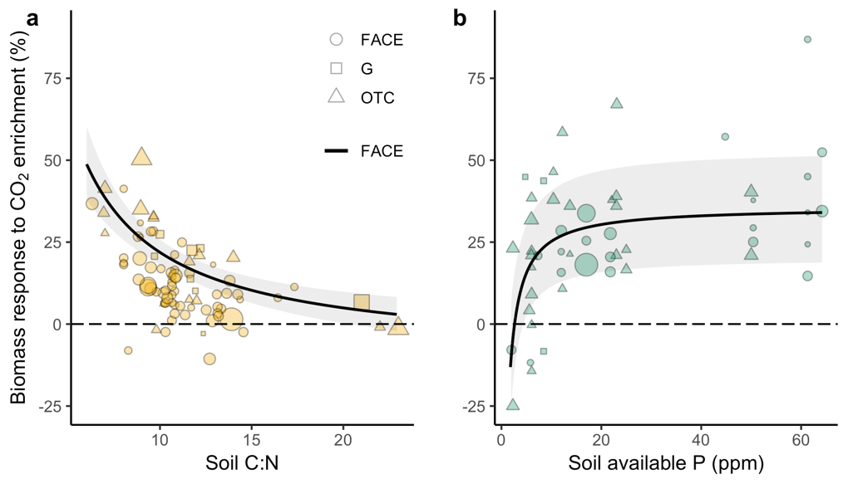

**Figure 1. Soil C:N and soil phosphorus are key plant resources driving the CO2 fertilization effect on aboveground biomass.** Model selection identified the most important drivers of the effect in the dataset of CO2 experiments (n=138), indicating responses to CO2 were modulated by mycorrhizal type. a,b, Meta-analytic scatterplot showing the relationship between the CO2 effect and (a) soil C:N (an indicator of nitrogen availability) in arbuscular mycorrhizal (AM) studies (n=86) at 0-10 cm, and (b) soil available phosphorus in ectomycorrhizal (ECM) studies (n=52) measured by Bray method at 0-10 cm. The type of fumigation technology used (FACE=free-air CO2 enrichment, G=growth chamber, OTC=open top chamber) significantly influenced the magnitude of the CO2 effect. Regression lines represent the response found in FACE studies, based on a mixed-effects meta-regression model (*pseudo-R2* = 0.94) and their 95% confidence intervals. Dot sizes are drawn proportional to the weights in the model, and represent, on average, an increase in atmospheric CO2 of +250 ppm.

Once the effects of mycorrhizal type, *C:N, P* and *Fumigation type* were accounted for, other predictors such as climate, biome type (e.g. temperate tree vs. grass) or the age of the vegetation did not explain an important fraction of the variability in the effect (Supplementary Fig. 5). Previous studies have variously attributed differences in the magnitude of the CO2 effect to either average temperature (MAT), or precipitation (MAP), or both17 (see Supplementary Discussion). Using the model *y ~ MAT + MAP + Fumigation.type* instead of our final model reduced explained variability (R2) from 0.94 to 0.05. These results suggest that the CO2 fertilization can only be reliably predicted when nutrient availability is considered.

We used the quantitative relationships derived from the meta-analysis to predict the global distribution of the eCO2 effect based on maps for soil C:N, P and mycorrhizal type. Plant responses to eCO2 were significantly higher in open top chamber (OTC) and growth chamber (G) experiments than in FACE (Supplementary Fig. 5, *p-value*<0.001) (see Supplementary Discussion), so we included *Fumigation.type* as a predictor in the scaling model to produce projections that are consistent with the response found in FACE experiments, as they allow CO2 to be fumigated with as little disturbance as possible.

Our global projections from FACE experiments show a relative (%) increase in biomass of 12±3% (Fig. 2a, Table 1) for the average 250 ppm ∆CO2 across experiments. The magnitude of the global effect is less than the overall effect of ~20% found previously in meta-analyses4,6 and the ~30% effect found in several FACE experiments2,4. This reduction arises in part because many CO2 experiments were conducted in relatively fertile soils or under nutrient fertilization regimes. Thus, extrapolating nutrient relationships to areas with naturally poor soils results in a lower global effect. In absolute terms, we estimated a global increase in total biomass of 59±13 PgC for a 250 ppm ∆CO2 (Fig. 2b, Table 1), scaled from satellite observations of current aboveground biomass18 and region-specific total to aboveground biomass ratios from the literature (Supplementary Table 4). Global anthropogenic emissions are currently around 10 PgC annually12, hence the additional C-sequestration in biomass is equivalent to 5-6 years of intermediate CO2 emissions.

Forests show the largest relative increases in biomass (Table 1, Fig 2a). Tropical forests are characterized by low P (Supplementary Fig. 6). However, their association with AM fungi, together with relatively high N (Supplementary Fig. 6), supports a widespread, though moderate, biomass enhancement. Our approach does not explicitly include symbiotic acquisition of atmospheric N (N2-fixation), which is relatively common in tropical forests19. Indeed, tropical N2-fixing species can show larger CO2 effects than non N2-fixing species20, and thus the response in tropical forests in our model may be underestimated. Nevertheless, our dataset contains tropical N2-fixing species21, indirectly including this effect. Temperate grasslands, which are also dominated by AM plants, show the lowest relative biomass-increment as a result of N-limitations. In temperate forests, some of the largest relative increases (~30%) occur in ECM-forests when P is high, but AM-forests show low relative biomass increases due to moderately high C:N (Supplementary Fig. 6).

The absolute eCO2 effect is dominated by tropical forests (Table 1, Fig. 2b), consistent with ground-based measurements showing increases in aboveground biomass in recent decades in intact tropical forests22, with CO2 identified as the main driver22,23. To account for uncertainties, and to highlight the environmental conditions not well represented in eCO2 experiments, we computed the standard error of the projections (Methods). Wet-tropical and boreal ecosystems show the largest uncertainties in absolute and relative terms, respectively (Fig. 2c,d), reflecting the limited number of studies in ecosystems with extreme values of climate and nutrient availability.

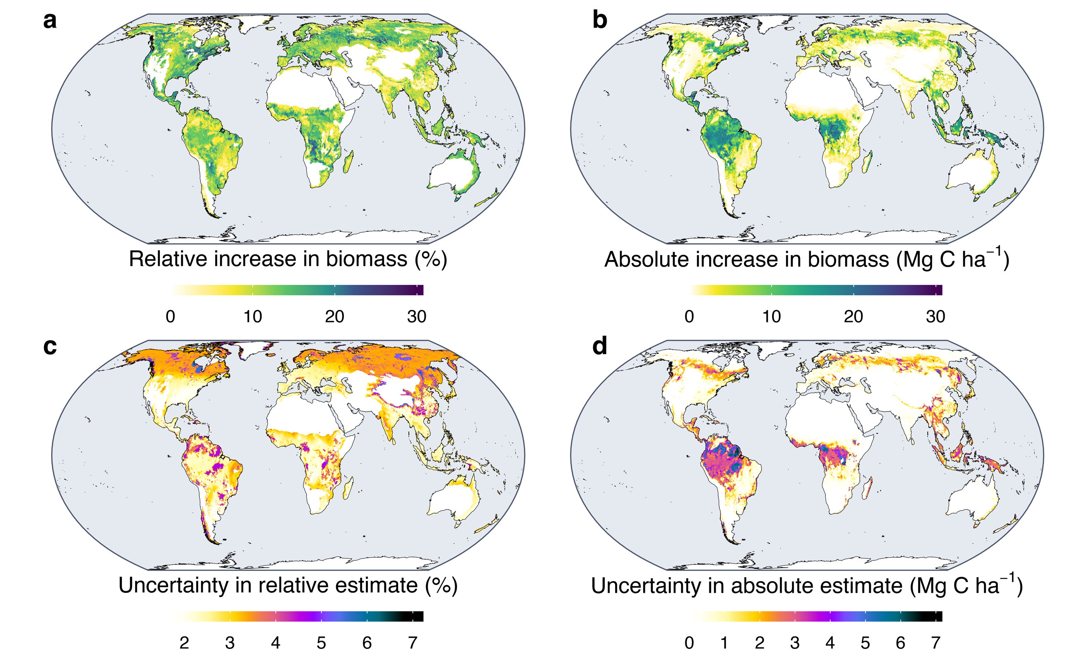

**Figure 2. Potential aboveground biomass enhancement in terrestrial ecosystems under elevated CO2.** These global estimates were upscaled using the empirical relationships from the key drivers of the effect across experiments synthesized through meta-analysis. The effects **(a,b)** and uncertainties in the estimations **(c,d)** shown in this figure represent an increase in atmospheric CO2 of +250 ppm in **(a,c)** relative (%) and **(b,d)** absolute (Mg C ha-1) terms. Uncertainties are based on the standard error of the effect adjusted for climate and nutrient sampling coverage, i.e. increasing in areas with values of nutrient availability, temperature and precipitation poorly represented by CO2 experiments.

To assess the magnitude of the global eCO2 effect we derive from FACE, we compared it with the increase in biomass attributed to rising CO2 concentration (β) from 1980 to 2010 by the TRENDY ensemble of Dynamic Global Vegetation Models (DGVMs), standardized for a 100 ppm increase in atmospheric CO2. Our estimated rate of increase in total biomass is 25±4 PgC 100 ppm-1, a value within the range of DGVMs and slightly larger than the multimodel ensemble mean β (Fig. 3a). This similarity is remarkable given the independency of both approaches and reported large inconsistencies in DGVMs in partitioning total to aboveground biomass24.

For comparing the geographical distribution of our global eCO2 effect, we used satellite-based observations of changes in leaf area (“greening”)9 attributed to CO2 rising in the period 1982-2009. Although changes in greenness and aboveground biomass are not necessarily correlated, we found an intriguingly strong correlation between the contemporary CO2-driven increase in greenness and our independently estimated biomass projections (Fig. 3b,c).

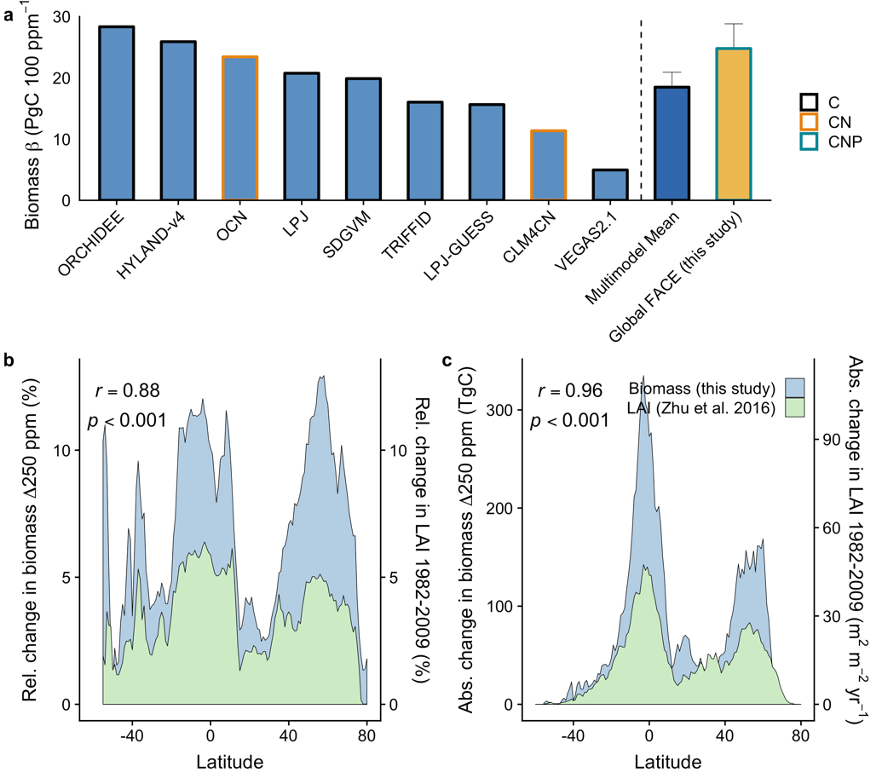

**Figure 3. Comparison of the global effect of elevated CO2 with existing independent approaches.** **(a)** Comparison of the magnitude of the effect of elevated CO2 on total biomass and the sensitivity of total biomass to the historical increase in atmospheric CO2 (β) in the period 1980-2010 as estimated by nine vegetation models. Results were standardised on a 100 ppm-1 basis. C=carbon-only models, CN=carbon models with coupled nitrogen cycle, CNP=carbon, nitrogen and phosphorus limitations. **(b,c)** Comparison of the latitudinal distribution of the relative **(b)** and absolute **(c)** effect of elevated CO2 on aboveground biomass (AGB) and past changes in greenness (LAI) attributed to the increase in atmospheric CO2 in the period 1982-20099. Relative latitudinal changes were computed as the average relative effect of all pixels contained within 1º latitude. Absolute latitudinal changes were computed as the sum of the absolute effect in all pixels contained within 1º latitude.

In summary, our results suggest that plant biomass responses to eCO2 are driven primarily by interactions with N and P modulated by mycorrhizal status. N constrains the strength of CO2 fertilization in most AM-plants (Figure 1a), which currently store ~65% of terrestrial vegetation C25, likely because the ability of AM-fungi to supply plants with N is relatively small26,27. In contrast, we observed that P availability alters the biomass response to eCO2 in ECM-plants, which store ~25% of terrestrial vegetation C25. eCO2 stimulates N-uptake by 24±2% in ECM-plants27, which together with wide-spread N-deposition, may increase N:P ratio, intensifying the sensitivity of ECM plants to P availability28.

Although our analysis uses the most comprehensive dataset of eCO2 observations currently available, it has several limitations. First, our data-driven approach, unlike DGVMs, is not intended to capture the complex interactions that drive long-term changes in the C cycle, such as warming, disturbance, changes in water availability or N-deposition. Instead, it is aimed at the empirical quantification of net CO2 effects, providing constraints on the attribution of modelled biomass responses to CO2 and a better mechanistic understanding of the underlying drivers of the effect. Second, tropical and boreal ecosystems are underrepresented in global eCO2 experiments (Supplementary Fig. 1). We have accounted for this uncertainty in our estimates, which we also use to highlight the specific regions where eCO2 experiments are urgently needed. Furthermore, it is critical that comprehensive soil data in eCO2 experiments are reported, ideally in more long-term studies.

We observed a strong similarity between the global-level responses to eCO2 found in FACE and past changes in biomass and greening attributed to CO2. The implications of this finding are threefold. First, this convergence supports our projections, indicating that empirical relationships with soil nutrients can be powerful for explaining large-scale patterns of eCO2 responses, despite ecosystem-level uncertainties. Second, the effect attributed to rising CO2 in past decades by DGVMs is similar in magnitude to our predicted effect of increasing CO2 expected in the future (Fig. 3a), suggesting that the past CO2 fertilization effect may continue at a similar magnitude for some time, despite nutrient limitations. Third, all else equal, the same ecosystems that are currently responsible for most of the greening9 and C uptake11,14 will remain important for future increases in biomass under eCO2 (see Fig. 3b-c).

A key strength of our upscaling approach is that it synthesizes observational evidence at local scales and captures a global view of the eCO2 effect on plant biomass and its drivers. DGVMs differ at the process level (including the current effects of CO2 on biomass, Fig. 3a), and consequently vary when projecting the future. Our data-based approach, along with new data from ongoing experiments, can be updated continuously and used to calibrate DGVMs, providing an empirical constraint for model simulations of the biomass sensitivity to CO2.

This research accounts for the extent of nutrient limitations on the eCO2 fertilization effect and shows that, despite local limitations, a global and positive effect, consistent with independent evidence of past CO2 fertilization, can be inferred. This result challenges the strong and pervasive limitations on the projected eCO2 fertilization suggested by some nutrient-enabled models29. For example, in the TRENDY ensemble of models in Fig. 3a, only OCN and CLM4CN take N-limitations into account, and none of them to our knowledge include P-limitations. While model simulations of the CO2 effect on biomass by OCN closely match our data-driven results, CLM4CN underestimate the effect by half. This may be related to the limited capacity of plant N-uptake to mediate an excessively open N-cycle in CLM4CN30.

Our results highlight the key role of terrestrial ecosystems, in particular forests, in mitigating the increase in atmospheric CO2 resulting from anthropogenic emissions. Thus, if deforestation and land use changes continue decreasing the extent of forests, or if warming and other global changes diminish or reverse the land carbon sink, we will lose an important contribution towards limiting global warming.

**Table 1. Summary of upscaled changes in plant aboveground (AGB) and total (TB) biomass to elevated CO2 across biomes.**

AM/ECM is the dominance of arbuscular (AM) or ectomycorrhizal (ECM) plants per biome type. C:N and P are the average soil C:N and available phosphorus (ppm) by Bray method at 0-10 cm. Relative (Rel.) changes are expressed in percentage effect, and absolute (Abs.) changes in PgC, for an increase in atmospheric CO2 of +250 ppm. Final row shows the absolute rate of increase in PgC for a standardised increase in CO2 of 100 ppm. Uncertainties represent the standard error of the effect.

|  |  |  |  |  |  |  |
| --- | --- | --- | --- | --- | --- | --- |
| **Biome** | **AM/ECM** | **C:N** | **P** | **AGB Rel. Effect (%)** | **AGB Abs. Effect (PgC)** | **TB Abs. Effect (PgC)** |
| Boreal Forest | 20/80 | 16.5 | 9 | 13.5±4 | 8.1±2.2 | 10±2.9 |
| Cropland | 90/10 | 11.5 | 14.5 | 10±1 | 2.5±0.4 | 3.1±0.5 |
| Grassland | 80/20 | 13 | 14.5 | 8±1 | 1.2±0.2 | 3.7±0.8 |
| Mixed | 65/35 | 14 | 9.5 | 10.5±2 | 2.2±0.5 | 2.3±0.6 |
| Shrubland | 80/20 | 13 | 11.5 | 11.5±2 | 1.7±0.3 | 6.8±1.3 |
| Temperate Forest | 40/60 | 13 | 11 | 14±3 | 4.2±1.1 | 4.8±1.4 |
| Tropical Forest | 80/20 | 12 | 7.5 | 12.5±3 | 22.7±6.5 | 31.4±8.9 |
| Global | 65/25 | 13 | 11 | 12±3 | 41.1±9.5 | 58.7±13.4 |
| Rate |  |  |  |  | 17.3±4.0 | 24.8±5.7 |

**Author information.** Reprints and permissions information is available at www.nature.com/reprints. The authors declare no competing financial interests.

Correspondence and requests for materials should be addressed to C.T. (cesar.terrer@me.com).

**Acknowledgements.** We thank C. Körner, R. Norby, M. Schneider, Y. Carrillo, E. Pendall, B. Kimball, M. Watanabe, T. Koike, G. Smith, S.J. Tumber-Davila, T. Hasegawa, B. Sigurdsson, S. Hasegawa, A.L. Abdalla-Filho and L. Fenstermaker for sharing data and advice. This research is a contribution to the AXA Chair Programme in Biosphere and Climate Impacts and the Imperial College initiative Grand Challenges in Ecosystems and the Environment. Part of this research was developed in the Young Scientists Summer Program at the International Institute for Systems Analysis, Laxenburg (Austria) with financial support from the Natural Environment Research Council (NERC, UK). C.T. also acknowledges financial support from the Spanish Ministry of Science, Innovation and Universities, through the “María de Maeztu” program for Units of Excellence (MDM-2015-0552). I.C.P. acknowledges support from the European Research Council (ERC) under the European Union’s Horizon 2020 research and innovation programme (grant agreement No: 787203 REALM). S.V. and K.vS. acknowledge support from the Fund for Scientific Research – Flanders (FWO). T.F.K. acknowledges support by the Director, Office of Science, Office of Biological and Environmental Research of the US Department of Energy under Contract DE-AC02-05CH11231 as part of the RuBiSCo SFA. J.P. acknowledges support from the European Research Council through Synergy grant ERC-2013-SyG-610028 “IMBALANCE-P”. T.F.K. and J.B.F. were supported in part by NASA IDS Award NNH17AE86I. J.B.F. was also supported by the US Department of Energy, Office of Science, Office of Biological and Environmental Research. J.B.F. contributed to this research from Jet Propulsion Laboratory, California Institute of Technology, under a contract with the National Aeronautics and Space Administration. California Institute of Technology. N.A.S. was supported by Vidi grant 016.161.318 by The Netherlands Organization for Scientific research. This paper is a contribution to the Global Carbon Project.

**Author contributions.** The study was originally conceived and developed by C.T., with ideas and contributions by R.J., I.C.P., O.F., T.F.K., P.B.R., C.K., S.V, B.S. and J.B.F. Data from DGVMs were analyzed by T.F.K. Analysis of drivers by C.T and P.B.R. Statistical analysis by C.T., C.J.vL. and W.V. Spatial analyses by C.T and I.M. P.B.R., B.A.H., L.A.C., A.F.T., P.C.D.N., M.J.H., D.M.B., C.M., K.W., C.B.F., M.R.H., M.W., T.K., H.W.P., and many more ran the experiments. Initial manuscript was written by C.T., with input from all authors.

**References**

1. Norby, R. J., Warren, J. M., Iversen, C. M., Medlyn, B. E. & McMurtrie, R. E. CO2 enhancement of forest productivity constrained by limited nitrogen availability. *Proc Natl Acad Sci U S A* **107,** 19368–19373 (2010).
2. McCarthy, H. R. *et al.* Re‐assessment of plant carbon dynamics at the Duke free‐air CO2 enrichment site: interactions of atmospheric [CO2] with nitrogen and water availability over stand development. *New Phytol* **185,** 514–528 (2010).
3. Reich, P. B., Hobbie, S. E. & Lee, T. D. Plant growth enhancement by elevated CO2 eliminated by joint water and nitrogen limitation. *Nature Geosci* **7,** 920–924 (2014).
4. Terrer, C., Vicca, S., Hungate, B. A., Phillips, R. P. & Prentice, I. C. Mycorrhizal association as a primary control of the CO₂ fertilization effect. *Science* **353,** 72–74 (2016).
5. Ellsworth, D. S. *et al.* Elevated CO2 does not increase eucalypt forest productivity on a low-phosphorus soil. *Nature Climate change* **320,** 1444–282 (2017).
6. Ainsworth, E. A. & Long, S. P. What have we learned from 15 years of free-air CO2 enrichment (FACE)? A meta-analytic review of the responses of photosynthesis, canopy properties and plant production to rising CO2. *New Phytol* **165,** 351–372 (2005).
7. Friedlingstein, P. *et al.* Uncertainties in CMIP5 Climate Projections due to Carbon Cycle Feedbacks. *J. Climate* **27,** 511–526 (2014).
8. Ciais, P. *et al.* in *Climate Change 2013: The Physical Science Basis. Contribution of Working Group I to the Fifth Assessment Report of the Intergovernmental Panel on Climate Change* (eds. Stocker, T. F. et al.) 465–570 (Cambridge University Press, 2013). doi:10.1017/CBO9781107415324.015
9. Zhu, Z. *et al.* Greening of the Earth and its drivers. *Nature Climate change* **6,** 791–795 (2016).
10. Sitch, S. *et al.* Recent trends and drivers of regional sources and sinks of carbon dioxide. *Biogeosciences* **12,** 653–679 (2015).
11. Keenan, T. *et al.* Recent pause in the growth rate of atmospheric CO2 due to enhanced terrestrial carbon uptake. *Nature Communications* **7,** 13428 (2016).
12. Le Quéré, C. *et al.* Global Carbon Budget 2017. *ESSD* **10,** 405–448 (2018).
13. Campbell, J. E. *et al.* Large historical growth in global terrestrial gross primary production. *Nature* **544,** 84–87 (2017).
14. Schimel, D., Stephens, B. B. & Fisher, J. B. Effect of increasing CO 2on the terrestrial carbon cycle. *Proc Natl Acad Sci U S A* **112,** 436–441 (2015).
15. Manzoni, S., Jackson, R. B., Trofymow, J. A. & Porporato, A. The Global Stoichiometry of Litter Nitrogen Mineralization. *Science* **321,** 684–686 (2008).
16. Hoosbeek, M. R. Elevated CO2 increased phosphorous loss from decomposing litter and soil organic matter at two FACE experiments with trees. *Biogeochemistry* **127,** 89–97 (2016).
17. Fernández-Martínez, M. *et al.* Global trends in carbon sinks and their relationships with CO 2 and temperature. *Nature Climate change* **10,** 1–79 (2018).
18. Liu, Y. Y. *et al.* Recent reversal in loss of global terrestrial biomass. *Nature Climate change* **5,** 470–474 (2015).
19. Steege, ter, H. *et al.* Continental-scale patterns of canopy tree composition and function across Amazonia. *Nature* **443,** 444–447 (2006).
20. Nasto, M. K., Winter, K., Turner, B. L. & Cleveland, C. C. Nutrient acquisition strategies augment growth in tropical N2 fixing trees in nutrient poor soil and under elevated CO2. *Ecology* e02646 (2019). doi:10.1002/ecy.2646
21. Cernusak, L. A. *et al.* Responses of Legume Versus Nonlegume Tropical Tree Seedlings to Elevated CO2 Concentration. *Plant Physiol.* **157,** 372–385 (2011).
22. Qie, L. *et al.* Long-term carbon sink in Borneo’s forests halted by drought and vulnerable to edge effects. *Nature Communications* **8,** 1966 (2017).
23. Almeida Castanho, A. D. *et al.* Changing Amazon biomass and the role of atmospheric CO2 concentration, climate, and land use. *Global Biogeochemical Cycles* **30,** 18–39 (2016).
24. Medlyn, B. E. *et al.* Using ecosystem experiments to improve vegetation models. *Nature Climate change* **5,** 528–534 (2015).
25. Soudzilovskaia, N. A. *et al.* Global mycorrhizal plants distribution linked to terrestrial carbon stocks. (2018). doi:10.1101/331884
26. Hodge, A. & Storer, K. Arbuscular mycorrhiza and nitrogen: implications for individual plants through to ecosystems. *Plant Soil* **386,** 1–19 (2015).
27. Terrer, C. *et al.* Ecosystem responses to elevated CO2 governed by plant–soil interactions and the cost of nitrogen acquisition. *New Phytol* **217,** 507–522 (2018).
28. Peñuelas, J. *et al.* Human-induced nitrogen-phosphorus imbalances alter natural and managed ecosystems across the globe. *Nature Communications* **4,** 2934–2934 (2013).
29. Wieder, W. R., Cleveland, C. C., Smith, W. K. & Todd-Brown, K. Future productivity and carbon storage limited by terrestrial nutrient availability. *Nature Geosci* **8,** 441–444 (2015).
30. Riley, W. J., Zhu, Q. & Tang, J. Y. Weaker land–climate feedbacks from nutrient uptake during photosynthesis-inactive periods. *Nature Climate change* **202,** 1–1006 (2018).

**Methods**

**Overview.** The goal of this paper is to scale the effects of elevated CO2 (eCO2) on biomass globally. This scaling requires a quantification of “current” plant biomass and its distribution worldwide together with a model based on the environmental drivers (“predictors”) that statistically best explain the observations derived from eCO2 studies. We collected data on aboveground biomass (Supplementary Figs. 1-2, Supplementary Table 1) because i) aboveground biomass is the metric most commonly reported in eCO2 studies, and ii) satellites can only detect aboveground biomass; thus, upscaling the effects of eCO2 on aboveground biomass avoids some of the uncertainties related to modelled products of plant productivity or total (aboveground and belowground) biomass.

From an initial pool of 56 potential predictors, we selected the most important predictors based on variable importance metrics from random-forest meta-analysis. We built a mixed-effects meta-regression model with the most important predictors of the effect, and applied this model with global maps to scale the effects of eCO2 on aboveground biomass.

Finally, our results were evaluated in terms of distribution and magnitude. For the distribution of the effect, we compared the latitudinal distribution of our estimates with the latitudinal effects of CO2 on LAI in the past three decades9. For the magnitude of the effect, we compared our sensitivity of biomass changes to eCO2 with the sensitivity of biomass changes to the historical increase in atmospheric CO2 (β) derived from the TRENDY ensemble of global vegetation models10.

**Data collection.** We collected 1432 aboveground biomass observations from 205 studies that met our criteria (below), of which 138 had data for all predictors considered and were therefore included in our analysis. Repeated measurements over time within the same plots (i.e. annual or seasonal measurements) were considered non-independent, and were thus aggregated so that only one synthetic measurement per study was included in the meta-analysis. Different species or treatments within the same site were considered independent, but we included “site” as a random effect in the mixed-effects meta-analysis to account for this potential source of non-independency (see section on meta-analysis). We consulted the list of CO2 experiments from INTERFACE (https://www.bio.purdue.edu/INTERFACE/experiments.php), the Global List of FACE Experiments from the Oak Ridge National Laboratory (http://facedata.ornl.gov/global_face.html), the ClimMani database on manipulation experiments (www.climmani.org), and the databases described by Dieleman *et al.* 31, Baig *et al.* 32, and Terrer *et al.*4,27,33. We used Google Scholar to locate the most recent publications for each of the previously listed databases.

We included as many observations as possible for our analysis. Criteria for exclusion from the main analysis were: i) Soil C:N and N content data for the specific soils in which the plants were grown were not reported. For example, studies that included a N fertilization treatment were only included when C:N was measured *in situ*, and not in unfertilized plots. ii) species did not form associations with either AM or ECM. Only species in two studies were non-mycorrhizal, insufficient to identify the drivers of the eCO2 response in this group; and iii) the duration of the experiment was less than 2 months.

We considered the inclusion of factorial CO2 x warming or CO2 x irrigation studies when specific soil data for those additional treatments were measured and reported. These treatments were treated as independent and were included in the dataset using the specific MAT and MAP for the warming and irrigation treatments, respectively. Approximately one quarter of the studies were irrigated, with irrigation more common in cropland studies. In those cases, and if the total amount of water used in irrigation was not indicated, we assigned the historical maximum value of MAP extracted from the coordinates of the site in the period 1900-2017 from ref34. Although in some studies we found soil data for several soil depth profiles, soil data were most commonly reported for a depth of 0-10 cm. We thus collected soil data at 0-10 cm, and scaled CO2 effects using global gridded datasets for this depth increment.

Data for MAP, MAT, soil C:N, soil N content, pH, available P, and vegetative and experimental predictors were reported in the literature. Data for the rest of the predictors were not commonly reported, so we extracted these data from global gridded datasets (Supplementary Table 2).

We used the check-lists in refs35,36, with additional classifications derived from the literature, to classify plant species as ECM, AM or non-mycorrhizal. Species that form associations with both ECM and AM fungi (e.g. *Populus spp*.) were classified as ECM because these species can potentially benefit from increased N-availability due to the presence of ECM-fungi4,27, as hypothesized. Overall, CO2 responses from species associated with AM and ECM were similar to strictly ECM species, and their exclusion did not alter the results of the meta-analysis, as found previously4.

Where possible, data were collected at the species level, and different species from the same site were considered independent when grown in monoculture with sufficient replication (i.e. multiple plots of the same species, and multiple individuals of the same species in the same plot).

Using these criteria, we found a total of 205 studies with data on aboveground biomass, with 138 of them including data for all the predictors considered, and thus included in the main analysis. Additionally, we run a sensitivity test including data from our full dataset of 205 studies, estimating missing soil N and P data from proxies, in the following order of preference: i) from studies that, due to proximity, used similar soils, ii) from gridded datasets (Supplementary Table 2) in the case of non-fertilized soils, and iii) using the mean values in the dataset for fertilized and non-fertilized studies within ecosystem types. For example, if a study comprised of temperate trees in a fertilized soil did not report soil data, and the characteristics of these soils could not be estimated from similar known soils, we assigned missing data as the average values in the dataset for temperate trees in fertilized soils.

An overview of the experiments included in the main analysis is in Supplementary Table 1, data included in the meta-analysis in Supplementary Fig. 2 and location of the studies in Supplementary Fig. 1. Overview of the studies excluded in the main analysis, but included in a sensitivity test in Supplementary Table 3.

**Model selection and relative importance.** We used random-forest model selection in the context of meta-analysis to identify the most important predictors of the CO2 effect in the dataset. This method has the advantage over maximum likelihood model-selection approaches that can handle many potential predictors and their interactions, and considers non-linear relationships.

Some of the 56 potential predictors included in the analysis were extracted from global datasets using the coordinates of the experiments (Table 2), and thus included missing values. Because random-forest and meta-analysis require complete data, and no methods for multiple imputation are currently available, we applied single imputation using the *missForest*37 algorithm. Like any random forests-based technique, the main advantage of this method is that it does not make any distributional assumptions, which means it easily handles (multivariate) non-normal data and complex interactions and nonlinear relations amongst the data.

Some of the potential predictors provided redundant and potentially correlated information (i.e. multiple methods to measure soil P, and multiple climate predictors) (Table 2). We used Principal Component analysis (PCA) for dimensional reduction, extracting components from map-based, potentially redundant predictors.

We included all field-based predictors, together with PCA map-based predictors in a bootstrapped random-forest meta-analysis recursive preselection with the *metaforest*38 R package. We trained a random-forest meta-analysis with preselected predictors and calculated variable importance with *metaforest*38 (Supplementary Fig. 3). Based on Partial Dependence plots (Supplementary Fig. 5), we used reciprocal transformations for nonlinear predictors showing ceiling/floor effects. We included the 10 most important predictors in a mixed-effects meta-regression model with the *metafor*39 R package, including reciprocal transformations for nonlinear predictors and potential interactions. Finally, we pruned the model once, keeping only significant predictors.

As a sensitivity test, we ran an alternative model-selection procedure using maximum likelihood estimation. For this purpose, we used the rma.mv() function from the *metafor* R package39 and the glmulti() function from the *glmulti* R package40 to automate fitting of all possible models containing the 7 most important predictors and their interactions. Model selection was based on Akaike Information Criterion corrected for small samples (AICc) as criterion, using a genetic algorithm for faster fitting of all potential models . The relative importance value for a particular predictor was equal to the sum of the Akaike weights (probability that a model is the most plausible model) for the models in which the predictor appears. A cut-off of 0.8 was set to differentiate between important and redundant predictors, so that predictors with relative importance near or less than 0.8 are considered unimportant.

**Meta-Analysis.** We used the response ratio (mean response in elevated to ambient CO2 plots) to measure effect sizes41. We calculated the natural logarithm of the response ratio (logR) and its variance for each experimental unit to obtain a single response metric in a weighted, mixed-effects model using the rma.mv function in the R package *metafor*39. We included “site” as a random effect (because several sites contributed more than one effect size and assuming different species or treatments within one site are not fully independent), and weighting effect size measurements from individual studies by the inverse of the variance42. 5% of studies did not report standard deviations (SDs), which were thus imputed using Rubin and Schenker’s43 resampling approach from studies with similar means, and performed using the R package *metagear*44.

Measurements across different time-points (i.e. over several years or harvests) were considered non-independent, and we computed a combined effect across multiple outcomes (e.g. time-points) so that only one effect size was analysed per study. The combined variance that accounts for the correlation among the different time-point measurements was calculated following the method described in Borenstein *et al.*45, using a conservative approach by assuming non-independency of multiple outcomes (*r*=1) and performed using the *MAd* package in *R*46.

We considered non-linear mixed-effects meta-regression models, which were fitted using reciprocal transformations (1/variable).

**Quantification of uncertainties.** Extrapolating the empirical relationships that drive biomass responses to eCO2 (e.g. *y* ~ *C:N*) in the dataset to the globe has an error associated with the mixed-effects meta-regressions. For the case of soil C:N, for example, this error is large for high C:N values, as the representativeness of soils with high C:N values in the dataset is lower, increasing uncertainty in the regression. For the projections of the eCO2 effect, we limited the maps of C:N and P to be constrained by the min and max values in the dataset of eCO2 studies, thus assuming saturating responses to avoid extremely high or low (negative) effects that are not representative of the observed effects. For the projection of uncertainties in Fig. 2, however, we aimed at representing not only the uncertainty associated with the representativeness of the most important predictors (C:N and P), but also the uncertainty associated with the lower sampling effort in areas with extreme climate (e.g. very dry and warm –deserts–, cold and dry –boreal– and wet and warm –tropical–). We thus ran an alternative model that included temperature and precipitation in addition to C:N and P. We extrapolated the standard error of this alternative model using unconstrained maps of temperature, precipitation, C:N and P to account for the higher level of uncertainty in areas with climate and soil values that are not well represented by eCO2 experiments. Thus, uncertainties in our projections represent the unconstrained standard error of the mixed-effects meta-regression, with larger values under soil and climate conditions that are not adequately studied due low sample size.

**Global estimates of N and P availability.** N can be limiting for plants if i) there is little total N content or ii) because N is bound in organic matter with a high C:N ratio. In the latter case, soil microbes that degrade the organic matter become N limited, resulting in low amounts of free N available for plant uptake. Therefore, soil N content and C:N ratio were included as potential predictors of the CO2 effect. Other potential predictors, such as nitrate and ammonium contents and N mineralisation, were not generally available and were therefore not included in the analysis.

Because soil C:N ratio was an important predictor of the CO2-driven increase in biomass in our dataset (Fig. 1a, Supplementary Fig. 3), we used a global dataset of soil C:N ratio from ISRIC-WISE on a 30 by 30 arcsec grid47 to upscale this effect. The range of C:N values covered by eCO2 experiments is representative of the range of C:N values represented in the C:N map47.

Arid regions typically have very low soil C:N ratios as a result of a small organic C pool, and also low N content48,49. Therefore, soil C:N is not a good indicator of N availability in arid soils, and the model would overestimate the CO2 effect in these areas, because it would assume relatively high N availability. To avoid the overestimation of the CO2 effect in arid areas with low C:N, yet low N availability, we followed the approach of Wang *et al.*50, who found a threshold of 0.32 in aridity index (ratio of precipitation to mean temperature) below which plant N uptake is limited by water availability, and characterised by low soil C:N despite extremely low soil N availability. We converted areas with aridity index < 0.32 to null values in the map of soil C:N, thereby treating these areas as missing data for analyses including soil C:N. We used the aridity data from the CGIAR-CSI Global-Aridity Database51. In our dataset of CO2 experiments, the Nevada Desert FACE fell within this category, with low soil C:N, but low total N52, and no CO2 effect on biomass53, supporting this assumption. Running the model strictly in areas with aridity index > 0.32 resulted in 0.4 PgC less than by running the model globally. This small difference was the result of the extremely low aboveground biomass in arid regions (Supplementary Fig. 7), rendering small absolute increases in biomass when incorporated in the analysis. Nevertheless, these areas were not included in the final analysis because it is not likely they could increase their biomass under elevated CO2 due to extremely low N availability. In areas outside this maximum aridity threshold limiting nitrogen uptake, we studied the impact of climatic and water availability predictors in explaining the magnitude of the CO2 effect.

The amount of P in the soil estimated by the Bray method was one of the important predictors of the biomass responses to eCO2. We constrained the map of P amount by the minimum and maximum value of P in the dataset of eCO2 studies, 2-64 ppm, assuming these values are representative of the conditions at <2 and >64 ppm.

**Climate data.** For the model selection analysis (Fig. 2) we used MAT and MAP data for the individual studies reported in the papers. As an alternative climatic predictors to MAT and MAP to account for the effect of temperature and water availability, we tested additional predictors not commonly reported in the papers, calculated using temperatures and precipitation values from CRU or extracted from other gridded datasets (Supplementary Table 2).

**Current aboveground biomass.** As global estimates of current aboveground biomass carbon we used passive microwave-based global aboveground biomass carbon from Liu *et al.*18 (Version 1.0) at 0.25º resolution and available online for the period 1993-2012 (<http://www.wenfo.org/wald/global-biomass/> ).

**Land cover types.** Calculations of changes in biomass in response to CO2 across biomes were performed through zonal statistics with the land cover maps from ESA (<http://maps.elie.ucl.ac.be/CCI/viewer/download.php)> at 300 m resolution (Table 1), and MODIS IGBP (<http://glcf.umd.edu/data/lc/)> at 5´resolution (Supplementary Table 4). Both maps were aggregated by dominant classes. The indication of climatic region (i.e. temperate, boreal, tropical) within forest land cover types was based on the classification by Pan *et al.*54.

**Changes in LAI.** In order to evaluate the geographical patterns of our predictions, we compared the latitudinal distribution of the effects of elevated CO2 on aboveground biomass with changes in greenness (LAI) attributed to CO2 in the period 1982-20099. We used LAI data from three different satellite records and averaged them, as described in ref9. The attribution of the relative and absolute effects of CO2 on LAI was estimated through vegetation models, as described in Zhu *et al*.9.

For the calculation of the effects of elevated CO2 on biomass, regions where water availability limits N uptake (aridity index < 0.32) were excluded from the analysis (see section Global estimates of N availability). Thereby, for the comparison of biomass and LAI changes, these arid regions were excluded from both maps.

**Global Vegetation Models.** In order to evaluate the magnitude of the sensitivity of plant biomass to eCO2 derived from our analysis, we analysed biomass β for the historical increase in atmospheric CO2 derived from the DGVMs considered in the TRENDY intercomparison project (http://dgvm.ceh.ac.uk/node/9). We used TRENDY-v1, which includes 9 DGVMs with common input forcing data, varying CO2 only from 1980 to 2010 (S1) and calculated biomass β as the change in biomass relative to the change in atmospheric CO2. For more details on the TRENDY model simulations see Sitch *et al.*10.

**Calculation of total biomass carbon.** The TRENDY models considered here output total biomass (above + belowground), whereas our results refer to aboveground biomass only. In order to compare the magnitude of the eCO2 effect derived from models and our approach, we have estimated the potential effect of eCO2 on total biomass using region-specific ratios of total biomass (TBC) and aboveground biomass (ABC) reported in the literature (Supplementary Table 4).

**Code availability**

The R code used in the analysis presented in this paper is available online and can be accessed at https://github.com/cesarterrer/CO2_Upscaling.

**Data availability**

The biomass data from CO2 experiments are summarised in Supplementary Fig. 2 supporting the findings of this study are available in published papers, and. Soil and climate data required to upscale CO2 effects are available in published datasets (Supplementary Table 2). Raw data can be accessed from the corresponding author upon reasonable request.

**References**

1. Dieleman, W. I. J. *et al.* Simple additive effects are rare: a quantitative review of plant biomass and soil process responses to combined manipulations of CO2 and temperature. *Global Change Biology* **18,** 2681–2693 (2012).
2. Baig, S., Medlyn, B. E., Mercado, L. M. & Zaehle, S. Does the growth response of woody plants to elevated CO2 increase with temperature? A model-oriented meta-analysis. *Global Change Biology* **21,** 4303–4319 (2015).
3. Terrer, C. *et al.* Response to Comment on ‘Mycorrhizal association as a primary control of the CO2 fertilization effect’. *Science* **355,** 358–358 (2017).
4. Harris, I., Jones, P. D., Osborn, T. J. & Lister, D. H. Updated high‐resolution grids of monthly climatic observations – the CRU TS3.10 Dataset. *Int. J. Climatol.* **34,** 623–642 (2014).
5. Maherali, H., Oberle, B., Stevens, P. F., Cornwell, W. K. & McGlinn, D. J. Mutualism Persistence and Abandonment during the Evolution of the Mycorrhizal Symbiosis. *The American Naturalist* **188,** E113–E125 (2016).
6. Wang, B. & Qiu, Y. L. Phylogenetic distribution and evolution of mycorrhizas in land plants. *Mycorrhiza* **16,** 299–363 (2006).
7. Stekhoven, D. J. & Buhlmann, P. MissForest--non-parametric missing value imputation for mixed-type data. *Bioinformatics* **28,** 112–118 (2011).
8. Van Lissa, C. J. MetaForest: Exploring heterogeneity in meta-analysis using random forests. (2017). doi:10.31234/osf.io/myg6s
9. Viechtbauer, W. Conducting Meta-Analyses in R with the metafor Package. *Journal of Statistical Software* **36,** (2010).
10. Calcagno, V. & de Mazancourt, C. glmulti: an R package for easy automated model selection with (generalized) linear models. *Journal of Statistical Software* **34,** (2010).
11. Hedges, L. V., Gurevitch, J. & Curtis, P. S. The meta-analysis of response ratios in experimental ecology. *Ecology* **80,** 1150 (1999).
12. Osenberg, C. W., Sarnelle, O., Cooper, S. D. & Holt, R. D. Resolving ecological questions through meta-analysis: goals, metrics, and models. *Ecology* **80,** 1105–1117 (1999).
13. Rubin, D. B. & Schenker, N. Multiple imputation in health‐are databases: An overview and some applications. *Statistics in Medicine* **10,** 585–598 (1991).
14. Lajeunesse, M. J. Facilitating systematic reviews, data extraction and meta‐analysis with the metagear package for r. *Methods in Ecology and Evolution* **7,** 323–330 (2016).
15. Borenstein, M., Hedges, L. V., Higgins, J. P. T. & Rothstein, H. R. in *Introduction to Meta-Analysis* 225–238 (John Wiley & Sons, Ltd, 2009).
16. Del Re, A. C. & Hoyt, W. T. MAd: Meta-Analysis with Mean Differences. *R package version 0.8-2* (2014).
17. Batjes, N. H. Harmonized soil property values for broad-scale modelling (WISE30sec) with estimates of global soil carbon stocks. *Geoderma* **269,** 61–68 (2016).
18. Post, W. M., Pastor, J., Zinke, P. J. & Stangenberger, A. G. Global patterns of soil nitrogen storage. *Nature* **317,** 613–616 (1985).
19. Jiao, F., Shi, X.-R., Han, F.-P. & Yuan, Z.-Y. Increasing aridity, temperature and soil pH induce soil C-N-P imbalance in grasslands. *Sci. Rep.* **6,** 19601 (2016).
20. Wang, C. *et al.* Aridity threshold in controlling ecosystem nitrogen cycling in arid and semi-arid grasslands. *Nature Communications* **5,** 4799–4799 (2013).
21. Zomer, R. J., Trabucco, A., Bossio, D. A. & Verchot, L. V. Climate change mitigation: A spatial analysis of global land suitability for clean development mechanism afforestation and reforestation. *Agriculture, Ecosystems & Environment* **126,** 67–80 (2008).
22. Billings, S. A., Schaeffer, S. M. & Evans, R. D. Trace N gas losses and N mineralization in Mojave desert soils exposed to elevated CO2. *Soil Biology and Biochemistry* **34,** 1777–1784 (2002).
23. Evans, R. D. *et al.* Greater ecosystem carbon in the Mojave Desert after ten years exposure to elevated CO2. *Nature Climate change* **4,** 394–397 (2014).
24. Pan, Y. *et al.* A Large and Persistent Carbon Sink in the World's Forests. *Science* **333,** 988–993 (2011).