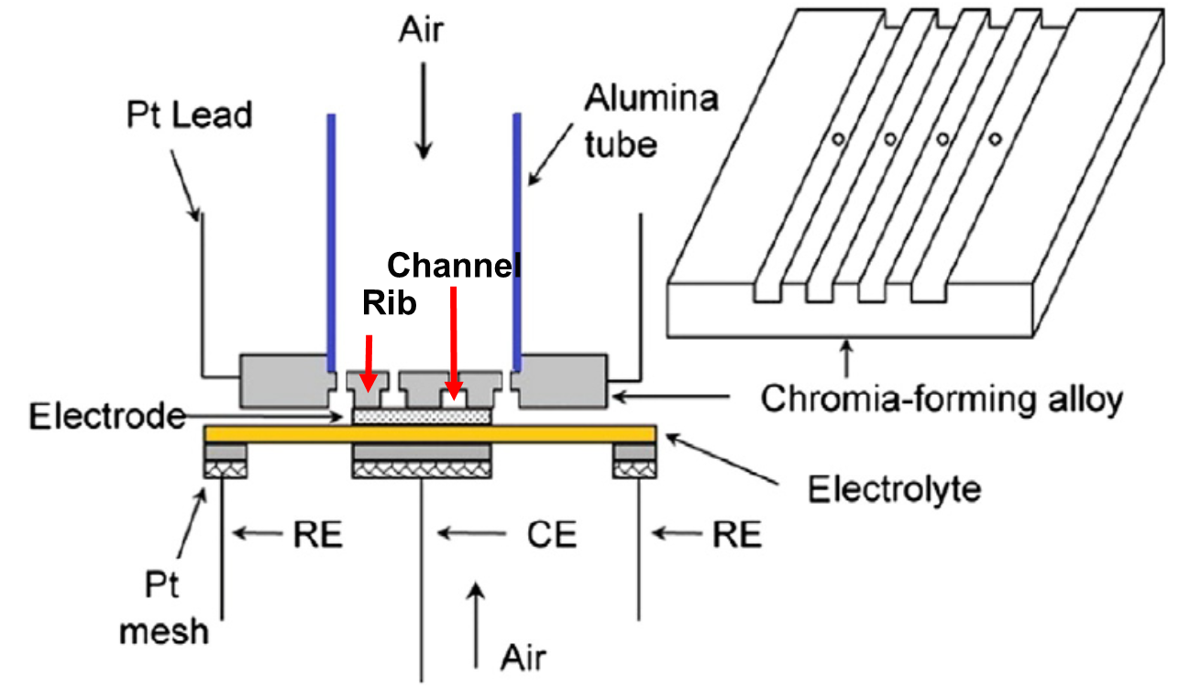

Figure S1 Schematic of a LSCF/GDC/Pt half-cell with the chromia-forming alloy as the source of Cr poisoning

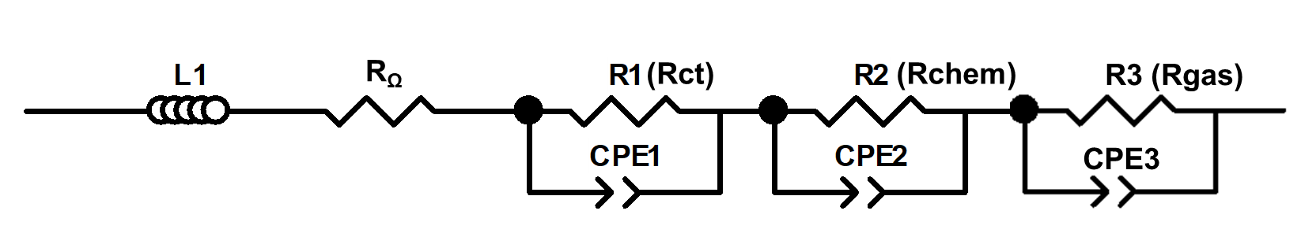

Figure S2 The equivalent circuits used for fitting the EIS spectra



Figure S3 X-ray diffraction patterns obtained from the LSCF electrode and CGO electrolyte

**Quantification of Cr contents**

All the EDX spectra were acquired on the same microscope using the same acquisition conditions (working distance, acceleration voltage and aperture size). The quantification module in the Inca software (Oxford Instruments, version 5.05 ) was used to obtain the relative quantification of Cr contents, where the line position, back ground subtraction, peak deconvolution, energy windows for integration of the peak intensity were determined automatically by the software. The option of “element by stoichiometry” with oxygen as the combined element was chosen as it gave the results closest to the expected compositions for pristine LSCF and formed SrCrO4. The change in parameters such as sample thickness and density has no effects on the results for SEM-EDX for obvious reasons. The optimized processing parameters were then used for all the quantification.

Although the principal Cr K-shell (Kα1 = 5414 eV, Kα2 = 5405 eV and Kβ1.3 = 5946 eV) lines overlap with La L-shell (Lα1 = 4650 eV, Lβ1 = 5042 eV and Lβ2.15 = 5383 eV), the spectra we obtained have an energy resolution good enough for firstly a qualitative identification of the presence of Cr by examining the peak shift in the energy range of 5.3-5.5 keV (Figure S4). With this achieved energy resolution, the deconvolution of the overlapping peaks for quantification in the Inca software is considered to have yielded a reasonably good estimation. We confirmed this by the fact that the quantification procedure gave a zero Cr content for pristine LSCF even if Cr is forced to be included as a present element present and a very small La content (<2 at. %) for the SrCrO4 phase if Sr is forced to be included.

In literature a common way to indicate Cr contents involves the comparison of intensity ratio between the La Lβ2.15 and Lα1 peaks, e.g. the work by Chen et al [1], and that a quantification method based on the ratio has been suggested by Schuler et al [2], where using ICP-OES quantification results as the reference an empirical relationship of $Cr at. \%=16.24×\frac{Lβ2.15}{Lα1}-4$ (Equation S1) was obtained for a strontium-doped lanthanum manganite (LSM)–yttria stabilized zirconia (YSZ) composite poisoned by Cr. The same procedure for comparing the Cr content in our samples were followed and the results are shown in Table S1. It can be seen this method yields the same trend as what shown in Table 2. It is noted that the empirical calibration constants of equation S1 depend on EDX acquisition conditions, which are difficult to be kept identical across different microscopes. Furthermore, the work by Schuler et al. also concluded that the Cr contents obtained by EDX software were close to the those from equation S1, indicating a proper deconvolution of the overlap peaks in the software. Therefore, for the purpose to show the trend of change in Cr contents, the quantification results obtained with the Inca software are used in Table 2 of the main manuscript.

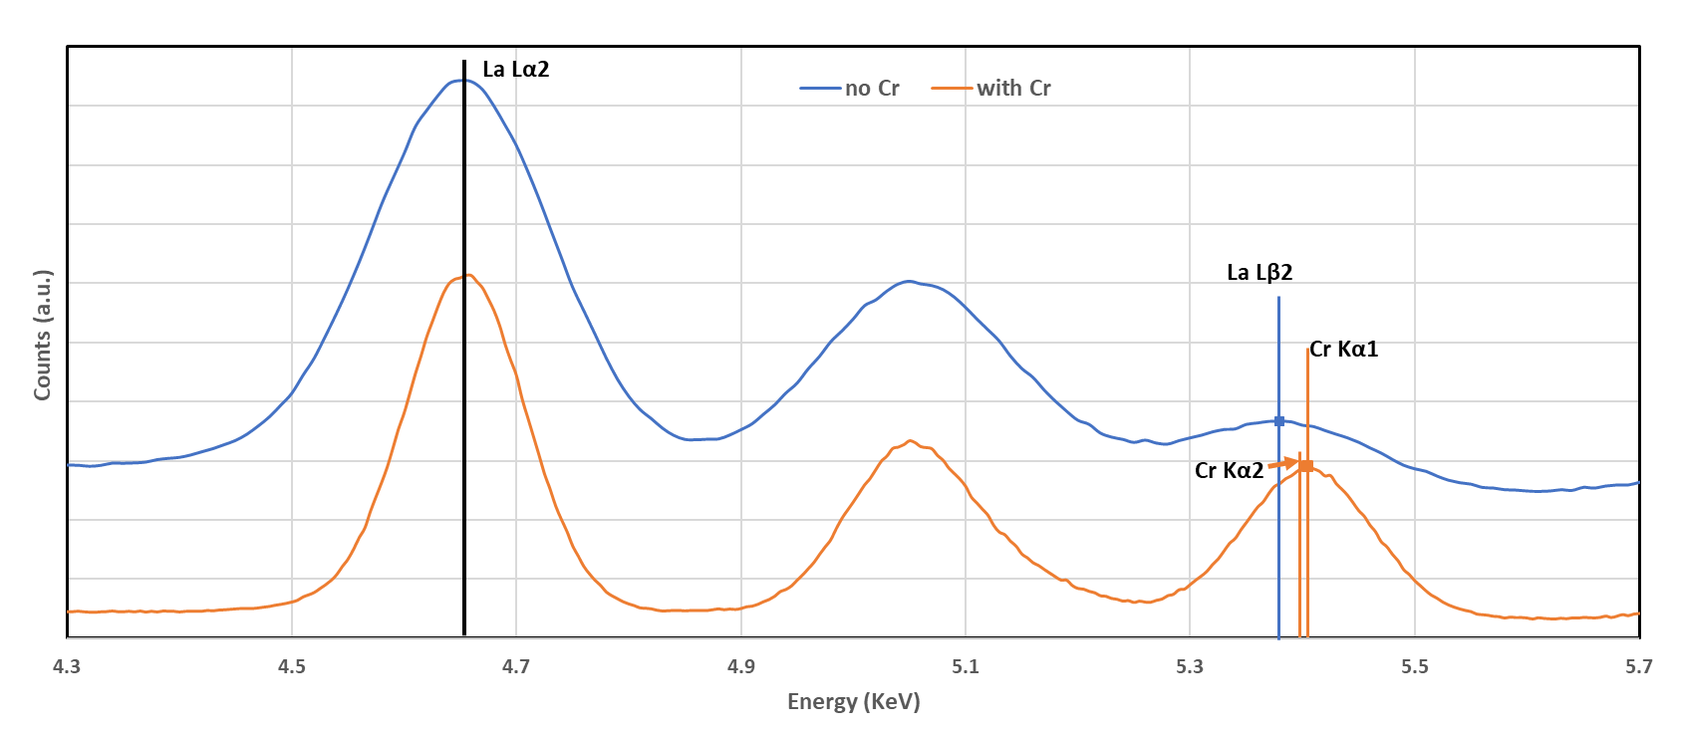

Figure S4 A comparison of the EDX spectra for pristine and Cr poisoned LSCF in the energy range of 5.3-5.5 KeV.

Table S1 Evaluation of Cr contents in different samples based on the ratio of La lines

|  |  |  |  |  |
| --- | --- | --- | --- | --- |
| Line intensity ratio: (La Lβ2.15/L1) | 800 oC | | 900 oC | |
| OCV | with polarization | OCV | with polarization |
| Below Rib | 0.35 | 0.52 | 0.59 | 0.75 |
| Below Channel | 0.25 | 0.33 | 0.28 | 0.36 |
| Cr content (at. %) according to the method from ref [2] |  |  |  |  |
| Below Rib | 1.6 | 4.5 | 5.5 | 8.2 |
| Below Channel | 0.1 | 1.3 | 0.5 | 1.8 |

(a) 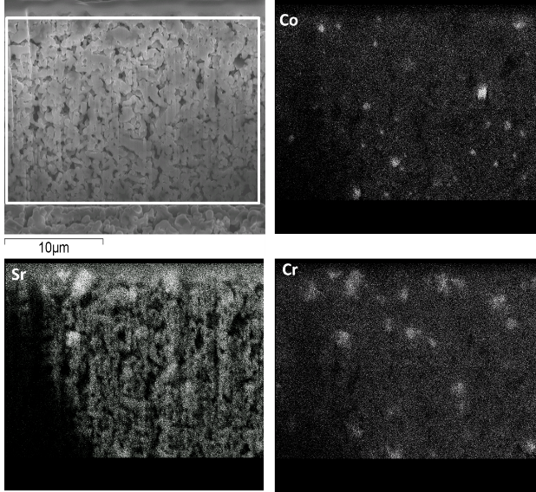 (b) 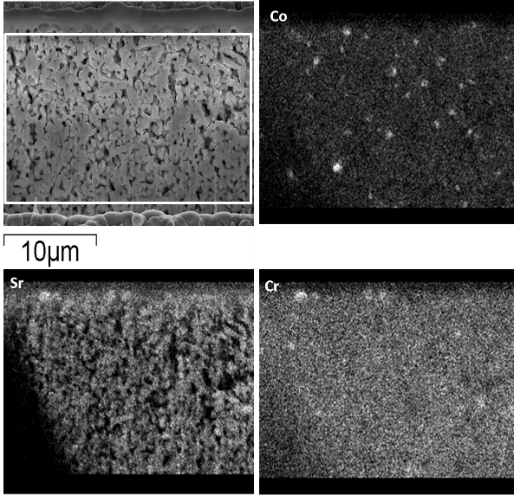

Figure S5 EDX map of the cross-section surface of the LSCF cathode layer for samples poisoned at 800 oC. (a) 200 mA cm-2 (b) OCV. The lower intensity shown in the bottom left corner of the elemental maps is due to the shadowing effect introduced by the position of the EDX detector.

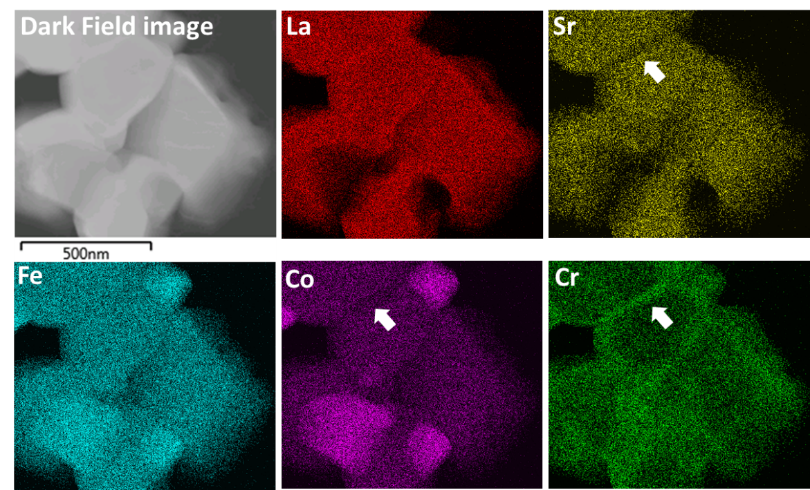

Figure S6 Grain boundary chemistry in Cr poisoned sample. The grain boundary is enriched in Cr and depleted in Co and Sr (arrowed).

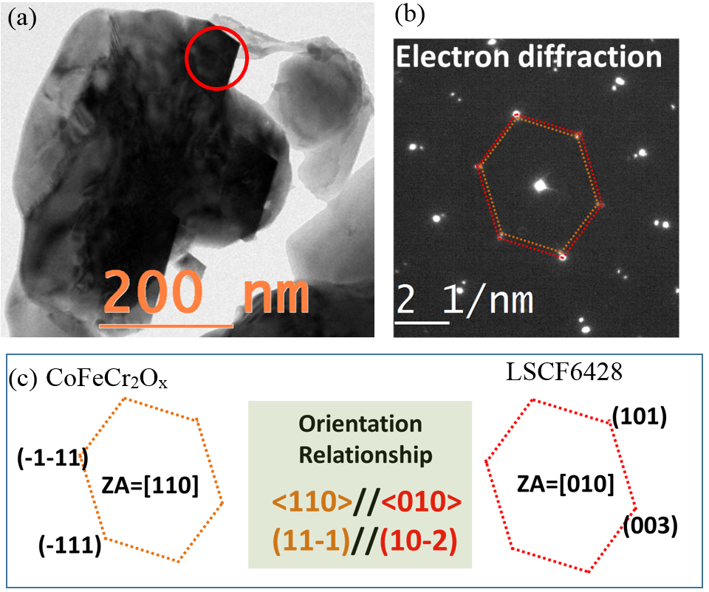

Figure S7 Epitaxial growth of the CoFeCr2Ox particle (circled in (a)) on LSCF6428 grains. (b) Electron diffraction patters from CoFeCr2Ox particle and the adjacent LSCF6428 grain. (c) Analysis of the diffraction pattern.

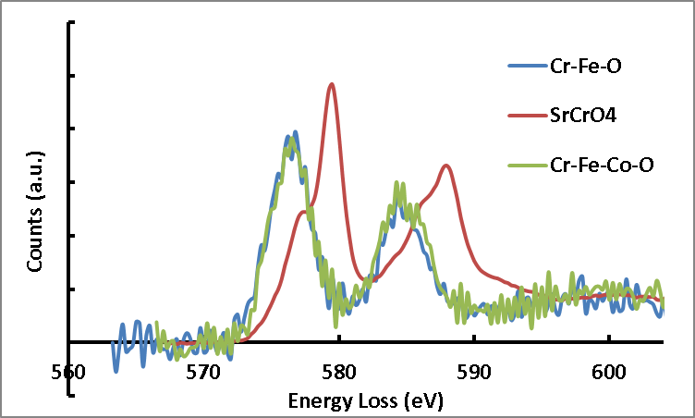

Figure S8 EELS of Cr L-edge fine structure. The Cr-L3 edge maximum from SrCrO4 particles is ~ 580 eV with a low energy shoulder and that from the Fe-Co-Cr spinel are ~ 577 eV, in good agreement with what have been reported for Cr 6+ and Cr 3+ respectively [3].

References:

[1] XB Chen, L Zhang, and SP Jiang, Chromium Deposition and Poisoning on (La0.6Sr0.4−xBax)(Co0.2Fe0.8)O3 (0≤x ≤0.4) Cathodes of Solid Oxide Fuel Cells, J*ournal of The Electrochemical Society* **2008**, *155* (11), B1093-B1101

[2] JA Schuler, P Tanasini, A Hessler-Wyser and JV herle, Rapid chromium quantification in solid oxide fuel cell cathodes, *Scripta Materialia* **2010**, *63*, 895-898

[3] TL Daulton and BJ Little, Determination of chromium valence over the range Cr(0)–Cr(VI) by electron energy loss spectroscopy, *Ultramicroscopy* **2006,** *106* (7), 561-573.