**Appendix**

**Supplemental Table 1**

|  |  |  |
| --- | --- | --- |
| Standard deviation of V-CoS Scores over 10 consecutive beats | SCD | Control |
| 0-minute post-exercise  (Peak Exercise) | 1.6 | 1.0 |
| 10-minutes post-exercise (Baseline) | 0.5 | 0.3 |

# **Supplemental Table 2**

|  |  |  |  |  |
| --- | --- | --- | --- | --- |
|  | SCD | Low-risk BrS | Control | p value |
| Number | 11 | 10 | 10 | - |
| Sex (M/F) | 10/1 | 8/2 | 4/6 | *p=0.03* |
| Age (mean ± sd) | 42±8 | 49±12 | 37±12 | *p=0.1* |
|  |  |  |  |  |
| Heart rate on Recovery  (mean ± sd) |  |  |  | p value (ANOVA) |
| 0 mins | 142±16 | 139±23 | 129±28 | *p=0.3* |
| 2 mins | 99±8 | 96±15 | 93±24 | *p=0.3* |
| 5 mins | 91±8 | 91±13 | 87±10 | *p=0.5* |
| 10 mins | 89±7 | 88±13 | 84±17 | *p=0.4* |
|  |  |  |  |  |
| Heart rate during Tilt Testing (mean ± sd) |  |  |  | p value (ANOVA) |
| Baseline Tilt down | 67±10 | 71±14 | 67±10 | *p=0.5* |
| Tilt up 0min | 77±11 | 74±17 | 73±12 | *p=0.7* |
| Tilt up 2min | 83±13 | 78±16 | 79±13 | *p=0.7* |
| Tilt up 5min | 82±12 | 76±11 | 82±13 | *p=0.5* |
| Tilt up 10min | 82±15 | 73±10 | 80±10 | *p=0.3* |
| Tilt up 15min | 77±12 | 74±10 | 81±10 | *p=0.4* |
| Tilt up 20min | 85±14 | 75±12 | 86±10 | *p=0.2* |
| Tilt down | 64±12 | 57±7 | 64±12 | *p=0.3* |

**Supplemental Figure 1**

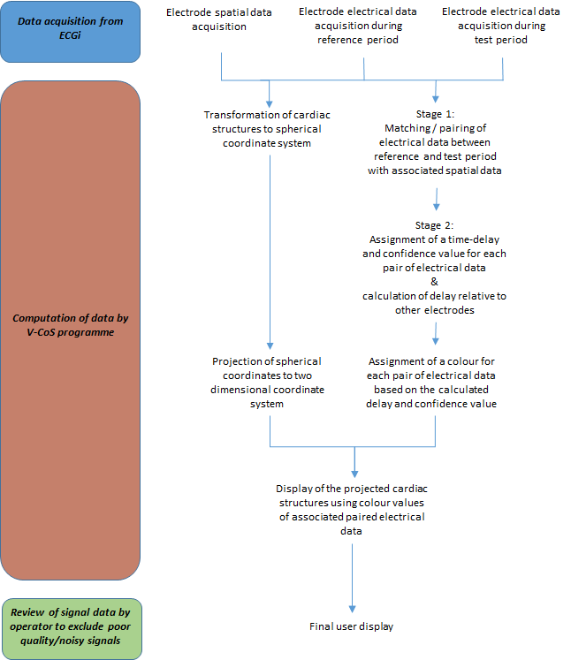

Key steps undertaken by the V-CoS programme in processing the data acquired from the ECGi system to compute V-CoS maps and scores.