A Randomised, Placebo-Controlled Study of Omipalisib (PI3K/mTOR) in Idiopathic Pulmonary Fibrosis

Pauline T Lukey1, Stephen A Harrison1, Shuying Yang1, Yim Man1, Beverley F Holman2, Alaleh Rashidnasab2, Gabrielle Azzopardi2, Michael Grayer1, Juliet K Simpson1, Philippe Bareille1, Lyn Paul4, Hannah V Woodcock3, Richard Toshner4, Peter Saunders4, Philip L Molyneaux4,5, Kris Thielemans2, Frederick J Wilson1, Paul F Mercer3, Rachel C. Chambers3, Ashley M Groves2, William A Fahy1, Richard P Marshall1, Toby M Maher4,5

1. GlaxoSmithKline Research and Development, United Kingdom.
2. University College London, Institute of Nuclear Medicine, London, United Kingdom.
3. University College London, Centre for Inflammation and Tissue Repair, London, United Kingdom.
4. NIHR Respiratory Clinical Research Facility, Royal Brompton Hospital, London, UK
5. National Heart and Lung Institute, Imperial College, London, UK.

**Contributions:** PTL, SAH, SY, JKS, PB, AMG, RPM and TMM made substantial contributions to the conception and design of the study. YM, BFH, AR, GA, MG, LP, HW, RT, PS, PLM, KT, FJW, PFM, RCC and WAF made substantial contributions to the acquisition, analysis, or interpretation of data for the study. All the authors contributed to drafting the manuscript or revising it critically for important intellectual content; all authors gave final approval of the version to be published; and all authors agreed to be accountable for all aspects of the work in ensuring that questions related to the accuracy or integrity of any part of the work are appropriately investigated and resolved.

**Short running heading:** Omipalisib experimental medicine study in IPF

**Keywords**: Idiopathic pulmonary fibrosis, omipalisib, PI3K/mTOR, pAKT/AKT, PIP3/PIP2, [18F]-FDG-PET, HRCT, bronchoalveolar lavage

**Impact**: this work may impact the early clinical development of new therapies for IPF; it highlights the importance of the PI3K/mTOR pathway in disease progression; it demonstrates the feasibility and utility of exploring pharmacology in the lungs using BAL and FDG-PET/CT.

**Corresponding author;**

Toby M Maher

Fibrosis Research Group, Inflammation, Repair & Development Section, NHLI,

Sir Alexander Fleming Building, Imperial College, London, SW7 2AZ.

E-mail: t.maher@imperial.ac.uk

Tel: +44 207 351 8018

Fax: +44 207 351 8951

# ABSTRACT

PI3 Kinases (PI3Ks) and mammalian target of rapamycin (mTOR) play a role in the pathogenesis of idiopathic pulmonary fibrosis (IPF). Omipalisib (GSK2126458) is a potent inhibitor of PI3K/mTOR.

A randomised, placebo-controlled, double-blind, repeat dose escalation, experimental medicine study of omipalisib in subjects with IPF was conducted (NCT01725139) to test safety, tolerability, pharmacokinetics (PK) and pharmacodynamics (PD). Omipalisib was dosed, at 0.25mg, 1mg and 2mg twice per day (BID) for approximately eight days in 4 cohorts of 4 subjects randomised 3:1 to receive omipalisib or placebo (two cohorts received 2mg BID).

Seventeen subjects with IPF were enrolled. The most common adverse event was diarrhoea, which was reported by four participants. Dose related increases in insulin and glucose were observed. PK analysis demonstrated that exposure in the blood predicts lung exposure. Exposure dependent inhibition of PIP3 and pAKT confirmed target engagement in blood and lungs. [18F]-FDG-PET/CT scans revealed an exposure dependent reduction in [18F]-FDG uptake in fibrotic areas of the lung, as measured by target to background ratio (TBR) thus confirming pharmacodynamic activity.

This experimental medicine study demonstrates acceptable tolerability of omipalisib in subjects with IPF at exposures for which target engagement was confirmed both systemically and in the lungs.

**Word count: 198 (≤ 200)**

# INTRODUCTION

Idiopathic pulmonary fibrosis (IPF) is a chronic, progressive, fatal interstitial lung disease of unknown aetiology [1]. Two approved medicines that slow the rate of decline in pulmonary function (pirfenidone and nintedanib) are available [2, 3]. However, apart from lung transplantation, there is currently no treatment that halts or reverses decline in pulmonary function.

IPF and lung cancer share several cellular signalling pathways and transcriptional and epigenetic signatures [4, 5]. [18F]-fluorodeoxyglucose (FDG) positron emission tomography (PET) is used in oncology as a diagnostic, prognostic and theranostic endpoint [6, 7]. Increased uptake of [18F]-fluorodeoxyglucose (FDG), has been observed in areas of active fibrosis in IPF [8, 9]. In addition, increased lactate has been measured in the lungs of subjects with IPF, providing evidence of increased glycolytic metabolism [8, 10, 11]. Together, these observations support the rationale for exploring glucose metabolism in IPF as a therapeutic target and for using [18F]-FDG-PET as a PD marker.

The Class 1 phosphatidylinositol 3-kinases (PI3Ks) lipid kinases form a key oncogenic signalling node that is critical for glucose metabolism, cell growth, proliferation and survival [12, 13]. Omipalisib, a potent and selective inhibitor of the PI3K/mTOR pathway [14], has been evaluated in a phase I clinical trial in subjects with solid tumours or lymphoma (NCT00972686). This signalling axis is being pursued as a target for anti-tumour therapy [15, 16]. A role for this pathway in IPF has been identified [11]. Detailed *in vitro* pharmacology demonstrates that omipalisib attenuates fibroblast proliferation and TGFβ induced collagen synthesis, in primary human lung fibroblasts and *ex vivo* precision cut lung slices derived from IPF lung tissue [11]. These data were integrated with human pharmacokinetic data from oncology trials to inform a PK/PD model and predict a dosing regimen for effective PI3K engagement in the lungs of IPF subjects. In addition, cells derived from bronchoalveolar lavage (BAL) of subjects with IPF, were tested for their potential as biosensors of pulmonary target engagement [11].

Having established a rationale for investigating the inhibition of the PI3k/mTOR pathway in IPF, we now describe the PK, PD and safety data from an experimental medicine study investigating the effects of short-term dosing of omipalisib in subjects with IPF.

# MATERIALS AND METHODS

## Study design

This was a double-blind, placebo-controlled, dose escalation study of omipalisib in subjects with IPF. The study was designed to explore the pharmacology of a range of short-term doses of omipalisib. Signed informed consent was obtained from each subject prior to the performance of any study-specific procedures. Each cohort consisted 4 subjects who were randomized 3:1 to receive omipalisib or placebo for 7 to 10 days. Subject and investigator were blinded to study treatment. PK and PD were measured for up to 8 hours (h) post-dose. Safety and tolerability were assessed throughout the study. First and last daily doses were administered in the clinic and other doses were taken by subjects at home. Participants received hand-held spirometers and instructions on action to be taken in case of >10% drop in forced vital capacity (FVC) or the development of new or worsening symptoms.

[18F]-FDG-PET/CT scans and bronchoalveolar lavage were conducted twice during the study: once, at least 2 days before dosing commenced and again between days 4 and 8 of dosing. PET/CT scan was always conducted before the BAL procedure to minimize interference of the BAL procedure on PET signals.

As previously described [17], BAL involved instillation of four successive 60 mL aliquots of 0.9% saline into a sub-segment of the right middle lobe. BAL fluid (BALF) was manually aspirated, pooled, mixed, and transferred to the laboratory on ice.

After the final subject in each cohort had completed dosing, a dose escalation meeting was conducted and safety, tolerability and PK data were reviewed by a safety committee (consisting of principal investigator, medical monitor, pharmacokineticist and statistician). The study statistician and pharmacokineticist were unblinded at the end of each cohort to conduct the analyses required for dose escalation decisions. A schematic representation of the study design is provided (Figure 1).

The primary objective was to define the blood and pulmonary PK/PD relationship for omipalisib in IPF subjects. Endpoints measured included; pAKT/AKT in platelet-rich plasma (PRP), pAKT/AKT and PIP3/PIP2 in bronchoalveolar lavage (BAL) cells, SUVmean and SUV99pc (99th percentile) of [18F]-fluoro-deoxyglucose (FDG)-positron emission tomography (PET)/computed tomography (CT), omipalisib pharmacokinetic parameters in blood (area under concentration-time curve [AUC], maximum observed concentration [Cmax], pre-dose [trough] concentration at the end of the dosing interval [Ctrough]) and omipalisib concentration in BAL fluid (BALF) and cells. Secondary objectives included; safety, tolerability and cough (Leicester Cough Questionnaire [18, 19]). Given the short duration of the study no formal assessment of anti-fibrotic efficacy was made.

## Regulatory and ethics approval

The study was approved by the West London & GTAC Research Ethics Committee, UK (12/LO/1634), and the Medicines and Healthcare Products Regulatory Agency (MHRA), UK (EudraCT: 2012-001376-11). Permission to administer radioisotopes was obtained from the Administration of Radioactive Substances Advisory Committee (ARSAC) of the UK (Ref: 630/3925/30809). The study was conducted at a single centre (Royal Brompton Hospital, London) with PET/CT scans performed at University College London Hospital (UCLH), Institute of Nuclear Medicine.

## Study participants

Participants with a multidisciplinary team (MDT) diagnosis of IPF according to international consensus criteria [1] and who met the following key inclusion criteria were eligible: FVC >40% and diffusing capacity of the lung for carbon monoxide (DLCO) >30% of the predicted values; left ventricular ejection fraction (LVEF) >=50 %; and males aged over 45 years and females over 50 years (this difference reflecting varying risks of radiation exposure between genders) with a body weight of ≥50 kg and ≥40 kg, respectively, and body mass index between 20 and 35 kg/m2. The main exclusion criteria included: unstable cardiovascular disease, IPF exacerbation, poorly controlled diabetes, current or previous use (within 30 days) of pirfenidone (nintedanib was not approved at the time the study was conducted).

## Study drug

Omipalisib tablets were administered orally twice per day (BID). A dose range of between 0.25mg BID and up to 2mg BID was predicted to provide pharmacologically relevant exposures as modelled using *in vitro* pharmacology and existing human PK data derived from oncology studies [11].

## Pharmacokinetics

Full PK profiles were conducted on day 1 and on the last day of dosing. Single mid-study PK samples were also taken before the BAL and PET procedure. Blood and BAL samples were analysed for omipalisib using a validated analytical method based on protein precipitation, followed by HPLC/MS/MS analysis.

A population PK modelling approach was utilised to characterise the blood PK and the total systemic exposure of omipalisib at each dose. A previously described PK model [11] was used as the base model and evaluated and updated using the PK data collected in this study. Cmax, Ctrough and AUC(0-24) following each dose were predicted from the model, and were summarised. BAL cell pellet concentrations were adjusted by total cell counts in the BAL samples (mean ± SD; 0.26 ± 0.20 million cells/mL BALF).

## Pharmacodynamic endpoints

Intracellular inhibition of PI3K in BAL cells and PRP was determined by measuring inhibition of AKT phosphorylation, assessed by Meso Scale Discovery (MSD) assay, Phospho (Ser473)/Total AKT Whole Cell Lysate Kit and expressed as a ratio of the total AKT signal within each well with target engagement by omipalisib being expected to decrease phosphorylation of AKT. Platelet pAKT have been demonstrated to be a surrogate for PI3K activity in blood [20].

PIP3 in snap-frozen BAL cells was assessed as PIP3 Peak Area, by mass spectrometry at the Babraham Institute [21] and expressed as a ratio to PIP2 Peak Area. Inhibition of Pi3K by omipalisib decreases phosphorylation of PIP2 to PIP3, thereby increasing the ratio of PIP2 to PIP3.

Subjects underwent an [18F]-FDG-PET/CT scan as described [22, 23]. Image analysis of whole lungs was the planned analysis for the [18F]-FDG-PET/CT data. Image reconstruction and analysis was performed as previously outlined, using combined CT images for both attenuation correction and computation of the air fraction, to derive the SUVmean, SUV99pc and Patlak determined influx rate constant (Ki) [22-26]. SUV99pc (the 99th percentile of SUV values in the lung mask) represents the maximum value in the lung whilst avoiding outlier pixels.

A *post-hoc* target to background (TBR) analysis was conducted, after unblinding of the study but without any reference to the treatment received, using methods described previously [27]. For each participant, the 3cm3 diseased region with the highest uptake and a 3cm3 region of normal tissue with minimal uptake in the same lung were identified on baseline static PET and confirmed on CT. These regions were automatically propagated to registered PET images of the mid-study scan. The TBR was calculated as the ratio of SUVmean in the disease region relative to SUVmean in the normal region, both with and without air fraction correction. Effective inhibition of Pi3K would be expected to decrease glucose uptake in metabolically active cells and thus decrease FDG-PET signal.

## Sample Size estimation

A simulation exercise was used to assess the probability of identifying a significant (at the p=0.05 level) concentration-response relationship between omipalisib and pAKT/AKT in BAL. *In vitro* data from BAL cells from six IPF donors from the PROFILE study [28] were used to simulate a concentration-response relationship when utilising three active participants at each chosen dose level. Based on this exercise, >99% of the simulated studies returned a significant concentration-response relationship, supporting the assumption that the chosen sample size would be appropriate.

## Statistical methods

The primary aim of the study was to estimate the dose and concentration response of the blood and lung PD endpoints (pAKT/AKT in PRP and BAL cells and [18F]-FDG-PET/CT of the whole lung). Estimates and 95% confidence interval (CI) for mean inhibition of each omipalisib dose level relative to placebo at each time point were obtained from the model. PRP pAKT/AKT data were analysed over time on each day of assessment using a repeated measures model, including covariates for treatment, time, baseline (pre-dose) value, and an interaction between time and baseline (pre-dose) value. Estimates and 95% CI for the mean pAKT/AKT value over time on each day were summarised and plotted. A dose-response model was fitted to the minimum observed pAKT/AKT value for each subject (maximum inhibition) and/or the AUC of the data over time on each day of assessment.

# RESULTS

Seventeen participants were enrolled into the study with 13 randomised to omipalisib and four to placebo. Three participants received 0.25 mg omipalisib BID, three received 1.0mg BID and seven received 2.0mg BID. One participant who received 2.0mg BID discontinued the study at the request of the sponsor following additional preclinical toxicology data (which was subsequently deemed by the sponsor, ethics committee and MHRA not to impact the benefit/risk assessment of omipalisib in IPF). A CONSORT diagram is provided to illustrate patient flow through the study (Figure 1) whilst subject disposition and demographics are presented in Table 1.

Population modelling confirmed that the PK profile of omipalisib is best described by a two-compartment, first order absorption and elimination model. Apparent clearance was 2.2 L/h, and apparent volume of distribution in the central and peripheral compartments was 4.9 L, and 39.6 L, respectively. The large total volume of distribution indicates potential distribution of omipalisib in body fluid as well as into tissues. A summary of predicted Cmax, Ctrough and AUC(0-24) following each dose is shown (Table 2).

Omipalisib PK in blood on the last day of dosing (Figure 2A) shows relatively quick absorption with quantifiable concentrations at 30min post dose. Concentration of omipalisib in blood (immediately before the BAL procedure) and BAL (fluid and cells) were correlated (Figure 2C and D).

The PK profile of omipalisib on the last day of dosing predicted inhibition of pAKT/AKT in PRP (Figure 2A) with a significant dose-response relationship (Figure 2B). Increasing omipalisib concentrations in blood showed a trend towards decreased pAKT/AKT (Figure 2E) and a significant decrease in PIP3/PIP2 ratios in BAL cells (Figure 2F). An Emax model (Figure 3) provided the best description of the relationship between pAKT/AKT in PRP and blood concentration of omipalisib with a predicted EC50 of 74.6ng/mL 95% CI (20.8, 267ng/mL).

Analysis of whole lung FDG-PET (SUVmean, SUV99pc and mean influx rate [Ki]) did not show an effect of omipalisib with or without air fraction correction. However, a possible regional effect of omipalisib was apparent on visual inspection of images (Figure 4A-C) and subsequent re-analysis of the FDG-PET data using TBR revealed a dose- and exposure-dependent reduction TBR (Figure 4D and E). Although some of the increased [18F]-FDG-PET signal in diseased regions could be explained by reduced air fraction in diseased lung [29, 30], the average lung density assessed from combined CT images did not change between the baseline and mid-study scans, thus confirming air fraction correction was not necessary for within subject comparison. Dynamic PET analysis accounts for the component of the signal arising from blood (reducing any effect of changes in blood glucose level due to omipalisib). When combined with air fraction correction dynamic analysis provides the influx rate (Ki) arising only from lung cells. Unfortunately, Ki was found to be too variable to enable reliable interpretation in this small sample size.

Drug-related AEs are tabulated (Table 3). No treatment-related AEs were reported in the placebo group. Two subjects (out of three) reported AEs in the 0.25mg BID group (diarrhoea and nausea), one subject (out of three) reported diarrhoea in the 1mg BID group and four subjects (out of seven) suffered AEs in the 2mg BID group (hyperglycaemia, lymph node pain, oral pain, rash and rhinitis). No serious AEs were reported. No AEs led to early termination of treatment. None of the clinical laboratory, vital signs or ECG abnormalities was clinically significant and none was reported as an AE.

A treatment-related decrease in ECG heart rate was apparent, though a consistent dose response was not observed (see supplemental figure 1). The decreases in heart rate were not considered to be clinically significant and were not reported as AEs during the study. There was no significant difference in adjusted mean LCQ or hand-held spirometry (FEV1 and FVC) for any treatment group.

Most subjects dosed with 1mg BID or 2mg BID omipalisib had fasting or post-prandial glucose levels above the upper limit of normal and associated with a significant rise in insulin levels (see supplementary table 2). This increase is a class effect that has been observed in other studies of PI3K/mTOR inhibitors [31]. Hyperglycaemia reversed after discontinuation of treatment.

# DISCUSSION

This is the first study to adopt an experimental medicine approach to evaluating the pharmacology of a novel therapeutic targeting the PI3K/mTOR pathway in IPF. Using a combination of blood, BAL and imaging biomarkers, this study demonstrates the feasibility of performing intensive experimental studies in IPF. It is hoped that this paradigm of providing robust early evidence of clinical pharmacology may be adopted in the development of novel IPF therapies in the future; thus avoiding unnecessary exposure of large numbers of subjects to ineffective therapies [32, 33]. We have demonstrated a relationship between omipalisib inhibition of PI3K/mTOR in the circulation and in the lungs. Thus, at concentrations that were tolerated, omipalisib inhibits PI3K/mTOR and demonstrates important downstream effects on key intra-cellular signalling in the fibrotic lung as measured by pAKT, PIP3 and FDG PET.

The PK of omipalisib had been described in a first-dose-in-humans study in subjects with cancer (NCT00972686). These data were used to build a PK model that predicted exposure in IPF [11]. The observed PK values from the current study were used to refine the model to more accurately predict PK in this population. This model was supported by extensive *in vitro* pharmacology exploring the effect of omipalisib on key fibrotic processes, including fibroblast proliferation and TGF-β induced collagen synthesis [11]. The predicted pharmacologically active dose range for omipalisib, based on *in vitro* data [11], fell between 0.25mg BID and 2.0mg BID. PK observed in IPF subjects was consistent with the model with the chosen doses inhibiting the PI3K/mTOR pathway as predicted.

Class I PI3K catalyses the conversion of phosphatidylinositol 4,5 bisphosphate (PIP2) to phosphatidylinositol 3,4,5 trisphosphate (PIP3), in turn inducing phosphorylation of the downstream kinase, AKT [12]. Inhibition of AKT phosphorylation by omipalisib has been shown to exert anti-fibrotic effects in IPF fibroblasts [11]. Whilst it was not feasible to obtain myofibroblasts (which would require repeat open-lung biopsy), we anticipate that inhibition of PI3K in (myo)fibroblasts should have occurred based on effective distribution of omipalisib from the blood into the alveolar compartment together with measurable reduction in PIP3/PIP2 and AKT phosphorylation in BAL cells. An Emax model best describes the relationship between systemic pAKT/AKT and the concentration of omipalisib in the blood. Adjusting for blood-protein binding, this model was in agreement with a previously reported *in vitro* PK/PD model of pAKT in IPF myofibroblasts [11].

FDG-PET was used in this study as a pharmacodynamic endpoint to explore the effect of omipalisib on glucose metabolism in the lungs of IPF participants. Increased FDG uptake in honeycomb areas of IPF lung has previously been described [8] and shown to be reproducible over relatively short periods [9]. The underlying biological processes resulting in increased metabolic activity in IPF lung are unknown. However, numerous cell types in the lung, including structural and immune cells express the GLUT1 receptor necessary for glucose uptake [34, 35] and FDG-PET activity. Furthermore, several studies have demonstrated alterations in glycolysis in both whole IPF lung and in fibroblasts isolated from fibrotic tissue [10, 36]; suggesting that the observed PET signal may reflect a range of abnormal, metabolic processes ongoing within fibrotic lung tissue.

IPF is temporally and spatially heterogeneous with relatively unaffected areas of lung adjacent to regions of active fibrosis. By measuring uptake of FDG within fibrotic regions in relation to uptake in relatively normal regions (TBR), it was possible to demonstrate that PI3K/mTOR inhibition results in a reduction in metabolic activity. In addition, a significant relationship between reduction in TBR and levels of omipalisib measured in blood (and BAL) of participants was observed. TBR of FDG-PET has also recently been shown to predict mortality in IPF [27], with high TBR at baseline correlating with poor prognosis. FDG-PET could therefore potentially represent a valuable, non-invasive, surrogate efficacy measure for use in early clinical development. Further studies are required to understand the long-term relevance of attenuating FDG-PET signal in fibrotic lung.

Analysis of FDG-PET/CT data in the lungs of subjects with IPF is complex, with many confounding factors. These include air- and blood-flow disruption [37], regional differences in tissue density [38] and differences in cell populations compared with healthy lung [39]. Metabolic changes due to omipalisib were observed using TBR; a technique that expresses FDG-PET signal as a ratio between uptake in selected fibrotic and relatively non-fibrotic regions. Thus, TBR uses an internal reference which compensates for some of the potential confounders when interpreting metabolic activity in IPF lung. This study contributes, not only to understanding of PI3K/mTOR inhibition in IPF, but also to technical aspects of using FDG-PET as an endpoint in fibrotic lung disease.

There are some potential limitations of this study that should be considered. It was designed as an experimental medicine study to understand the pharmacological and biological relevance of attenuating PI3K signalling with a potent small molecule inhibitor in IPF lung. As such only small numbers of subjects were enrolled and dosed with omipalisib for a short period of time. This permitted a clear understanding of the pharmacological effect of different concentrations of omipalisib but did not permit any assessment of efficacy. Furthermore, although the drug was continued by all subjects for the duration of the study, longer-term tolerability of omipalisib in IPF remains to be determined. Another potential limitation is that participants underwent PET/CT followed by BAL twice during a short time frame. Theoretically, residual effects of the baseline BAL may have impacted the mid-study PET/CT, however, the study was placebo controlled and so any effect of BAL should have been consistent across groups. Most of the endpoints were analysed prior to unblinding of the data with the exception of TBR analysis of FDG-PET data which was conducted after unblinding of the study. To mitigate any potential bias in interpretation of scans, all reference to study treatment was removed from FDG-PET/CT scans prior to *post hoc* analysis. A strength of this study is the clear demonstration of PI3K target engagement in fibrotic lung with demonstrable effects on lung metabolism. This suggests that it is feasible to inhibit PI3K in IPF subjects but later phase trials will be required to determine any clinically relevant effect on fibrosis.

Omipalisib was reasonably well tolerated in this short-term dose escalation study. It was anticipated based on oncology experience that diarrhoea could be a dose-limiting adverse event [40, 41]. Although there were a few cases of diarrhoea in the active group, these events were mild or moderate in intensity, were never of concern and did not lead to stopping of treatment. It is worth noting that AEs related to the gastro-intestinal tract are observed in IPF subjects treated with pirfenidone [3] and nintedanib [2]. The observed Increases in insulin and glucose suggest a degree of insulin resistance in some subjects; this was expected, based on the known pharmacology of PI3K/mTOR inhibition [31]. PI3K inhibition also appeared to be associated with a mild, but clinically non-significant, negative chronotropic effect.

In conclusion, we have shown that orally-dosed omipalisib exerts measurable dose- and exposure-dependent inhibition of PI3K/mTOR pathway in the systemic circulation and lungs of individuals with IPF. Omipalisib also reduces aberrant glucose signalling in fibrotic regions of IPF lungs as measured by FDG PET. These data support further assessment of the PI3K/mTOR pathway as a target for new treatments for IPF. Inhibitors with improved selectivity may minimise or avoid potential side-effects of broader PI3K/mTOR inhibition whilst providing similar potential therapeutic benefit.

**Word Count: 3595**

**Acknowledgments**

The authors would like to thank the wider team members who contributed to the successful conduct of this study. The GSK team consisting of Maria Costa, Jane Bentley, Nadia Garman, Tom Lumbers, Stuart Kendrick, Val Morrison, Tina Sawhney , Vikki Barratt, Simon Parry, Arthur Kang’ombe, Jane Gilbert. The Brompton team consisting of Shaun Kingston, Una Fraser. The UCL team consisting of Vesna Cuplov, Elise Emond, Raymond Endozo, Francesco Fraioli, Brian Hutton, Lynn Millner, Benjamin Thomas, Robert Shortman Manuela Plate, Linda Franklin. In addition, we would like to thank Jonathan Clark (Babraham Institute) for his contribution to the PIP3/PIP2 assays. TMM is supported by an NIHR Clinician Scientist Fellowship (NIHR Ref: CS-2013-13-017) and a British Lung Foundation Chair in Respiratory Research (C17-3).

**Disclosures**

PTL was a GSK employee at the time of the study and is currently a shareholder. She now works or has worked as an independent consultant to GSK R&D, the Francis Crick Institute, Syncona, Mereo BioPharma, Peptinnovate, BerGenBio and Morphic Therapeutics. SH, SY, YM, JKS, PB, FJW, WAF, RPM are employees and shareholders of GlaxoSmithKline. FJW has previously worked as an independent consultant to ECNP R&S, GlaxoSmithKline, IPPEC, King’s College London, Lundbeck A/S, Mentis Cura ehf and Pfizer Inc. and has received travel expenses as a guest speaker from Orion Pharma Ltd. MG was a contractor on assignment at GSK at the time the study was conducted. BFH received a grant from GSK/EPSRC in support of her PhD. AR received grants from GSK. GA, LP, PS, PLM, and AMG have nothing to disclose. PFM was funded through a collaborative framework agreement with GSK. HW received one year of funding from GSK for a clinical research fellowship. KT reports grants from GSK during the conduct of the study and grants from GE Healthcare outside of the submitted work. RCC declares research funding received from GSK as part of a collaborative framework agreement. TMM has, via his institution, received industry-academic funding from GlaxoSmithKline R&D and UCB and has received consultancy or speaker’s fees from Apellis, Astra Zeneca, aTyr Pharma, Bayer, Biogen Idec, Boehringer Ingelheim, Galapagos, GlaxoSmithKline R&D, ProMetic, Roche, Sanumed and UCB

GSK R&D sponsored and funded the study.

# TABLES

**Table 1. Baseline demographics**

|  |  |  |  |  |  |
| --- | --- | --- | --- | --- | --- |
| **Demographics** | **0.25 mg BID**  **Omipalisib**  **(N=3), n (%)** | **1 mg BID**  **Omipalisib**  **(N=3), n (%)** | **2 mg BID**  **Omipalisib**  **(N=7), n (%)** | **Placebo**  **(N=4),**  **n (%)** | **Total**  **(N=17),**  **n (%)** |
| **Age in Years** [Mean (SD)] | 64.3  (2.1) | 73.7  (6.1) | 68.9  (12.6) | 72.8  (5.0) | 69.8  (9.0) |
| **Sex** |  |  |  |  |  |
| Female: n (%) | 3  (100) | 0 | 2  (29) | 1  (25) | 6  (35) |
| Male: n (%) | 0 | 3  (100) | 5  (71) | 3  (75) | 11  (65) |
| **BMI (kg/m2)** [Mean (SD)] | 27.4  (3.9) | 27.5  (6.0) | 28.0  (3.6) | 26.3  (3.2) | 27.4  (3.7) |
| **Height (cm)** [Mean (SD)] | 156.0  (5.6) | 168.3  (5.0) | 172.4  (5.1) | 171.0 (15.8) | 168.5 (10.1) |
| **Weight (kg)** [Mean (SD)] | 66.4  (7.8) | 78.6  (21.5) | 83.2  (11.5) | 77.3 (16.8) | 78.1 (14.3) |
| **FVC** mean (SD)  **% predicted** | 87.2  (2.9) | 72.5  (15.1) | 86.5  (23.6) | 77.9 (14.7) |  |
| **DLCO** mean (SD)  **% predicted** | 47.6  (1.5) | 36.1  (4.1) | 42.0  (11.4) | 46.5 (10.6) |  |

**Table 2 Summary of Population PK Model Predicted PK Parameters (Pharmacokinetic Population)**

| Parameter | Dose (mg BID) | n | Geo Mean (95% CI) | Min | Median | Max |
| --- | --- | --- | --- | --- | --- | --- |
| Cmax  (ng/mL) | 0.25 | 3 | 13  (7-24) | 9 | 14 | 16 |
| 1 | 3 | 53  (26-108) | 35 | 64 | 67 |
| 2 | 6 | 86  (58-127) | 63 | 85 | 110 |
| Ctrough  (ng/mL) | 0.25 | 3 | 7  (3-16) | 4 | 7 | 10 |
| 1 | 3 | 31  (8-123) | 14 | 38 | 55 |
| 2 | 6 | 45  (26-79) | 33 | 44 | 66 |
| AUC(0-24)  (ng.h/mL) | 0.25 | 3 | 225  (110-459) | 153 | 235 | 316 |
| 1 | 3 | 968  (383-2445) | 562 | 1207 | 1336 |
| 2 | 6 | 1539  (1029-2303) | 1272 | 1415 | 1996 |

**Table 3 Summary of Drug-Related Adverse Events (Safety Population)**

|  |  |  |  |  |
| --- | --- | --- | --- | --- |
|  | **Omipalisib (BID)** | | | **Placebo**  **(N=4),**  **n (%)** |
| **0.25 mg**  **(N=3), n (%)** | **1 mg**  **(N=3), n (%)** | **2 mg**  **(N=7), n (%)** |
| Number of subjects with any events | 2 (67) | 1 (33) | 4 (57) | 0 |
| Diarrhoea | 1 (33) | 1 (33) | 0 | 0 |
| Hyperglycaemia | 0 | 0 | 1 (14) | 0 |
| Lymph node pain | 0 | 0 | 1 (14) | 0 |
| Nausea | 1 (33) | 0 | 0 | 0 |
| Oral pain | 0 | 0 | 1 (14) | 0 |
| Rash | 0 | 0 | 1 (14) | 0 |
| Rhinits | 0 | 0 | 1 (14) | 0 |

# FIGURE CAPTIONS

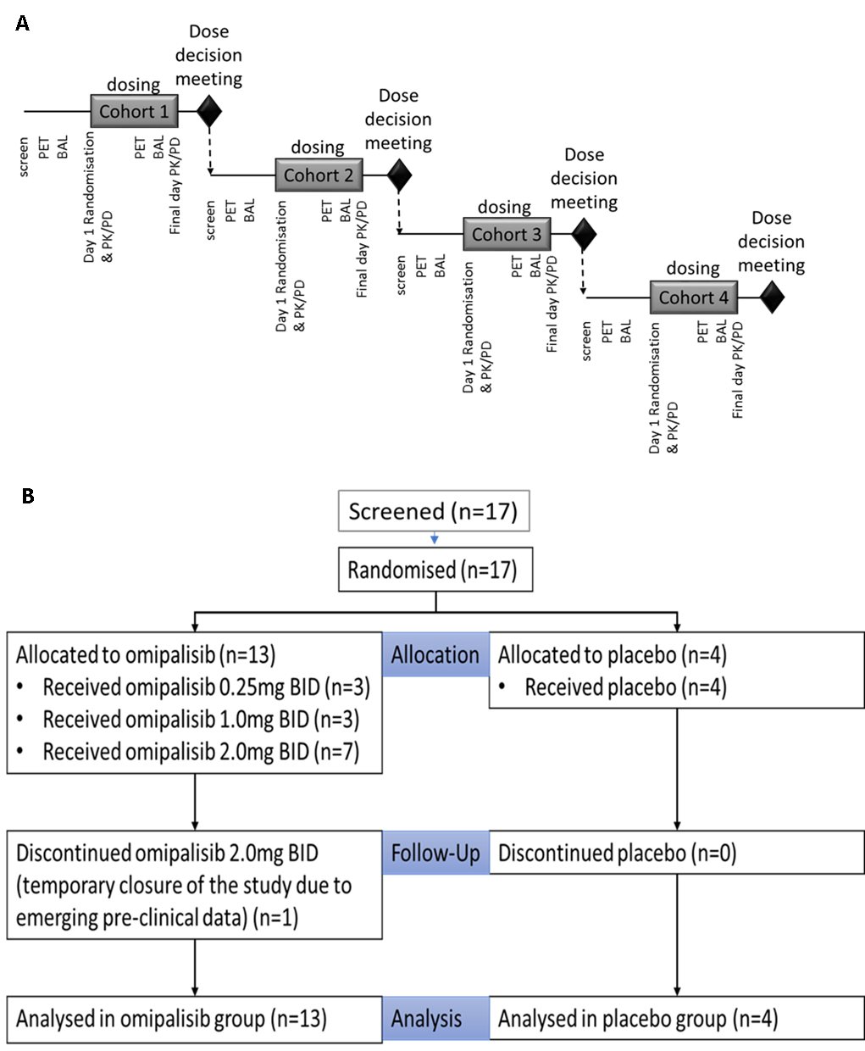

**Figure 1 Schematic of the study design and CONSORT Diagram.** (A) Each cohort consisted of 4 subjects randomised 3:1 to active and placebo. Doses of 0.25mg BID or placebo were administered in cohort 1, doses of 1.0mg BID or placebo were administered in cohort 2 and doses of 2.0mg BID or placebo were administered in cohorts 3 and 4. (B) the consort diagram

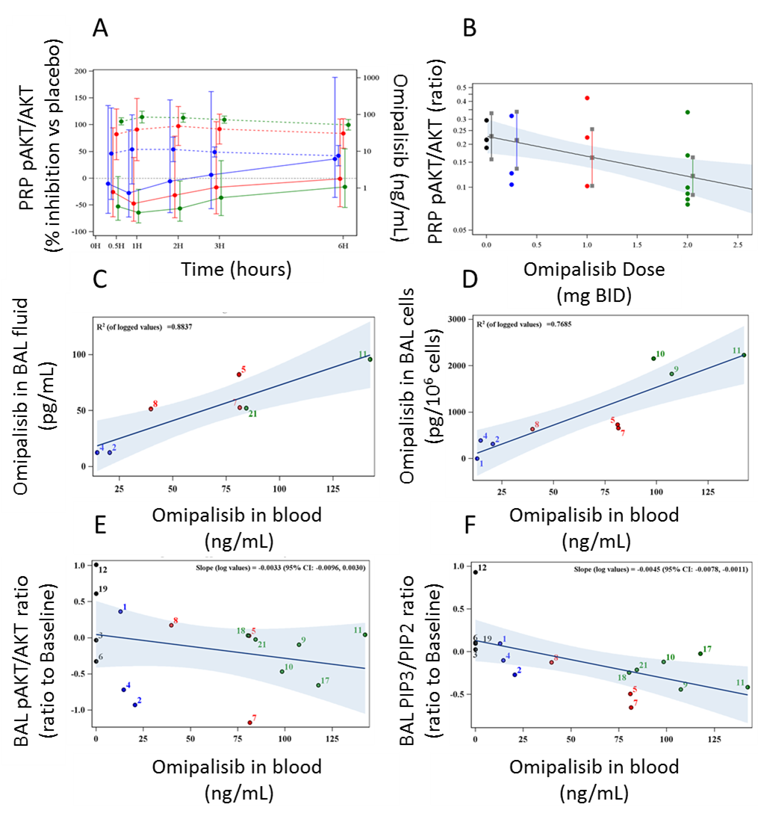

**Figure 2. Omipalisib Pharmacokinetics (PK) and Pharmacodynamics (PD) in Blood and BronchoAlveolar Lavage (BAL).** (A): Left-hand axis shows (mean, SEM) % inhibition of pAKT/AKT vs placebo in platelet-rich plasma (PRP) and the right-hand axis shows omipalisib concentration (ng/mL) in blood (dashed lines, colours correspond to omipalisib dose administered). (B) Individual subject pAKT/AKT ratio is presented by dose administered. Ratio to baseline of the pAKT/AKT ratio (weighted mean of 0-6 hr timepoints with blue-shaded 95% CI) in PRP at final dosing day vs omipalisib dose. (C) The correlation between the concentration of omipalisib in blood with the concentration of omipalisib in the BAL fluid (BALF). Trend line and 95% CI in shaded blue area. Individual subject data are illustrated by dose. (D) The correlation between the concentration of omipalisib in blood with the concentration of omipalisib in the BAL cells. Trend line and 95% CI in shaded blue area. Individual subject data are illustrated by dose. (E) Ratio to baseline of pAKT/AKT in BAL cells (log) at mid-study visit vs omipalisib concentration in blood. Trend line and 95% CI in shaded blue area. Individual subject data are illustrated by dose. (F) Ratio to baseline of BAL PIP3/PIP2 (log) at mid-study visit vs omipalisib concentration in blood. Trend line and 95% CI in shaded blue area. Individual subject data are illustrated by dose. Dose administered is indicated as follows: 0.25mg BID (blue), 1mg BID (red) and 2mg BID (green).

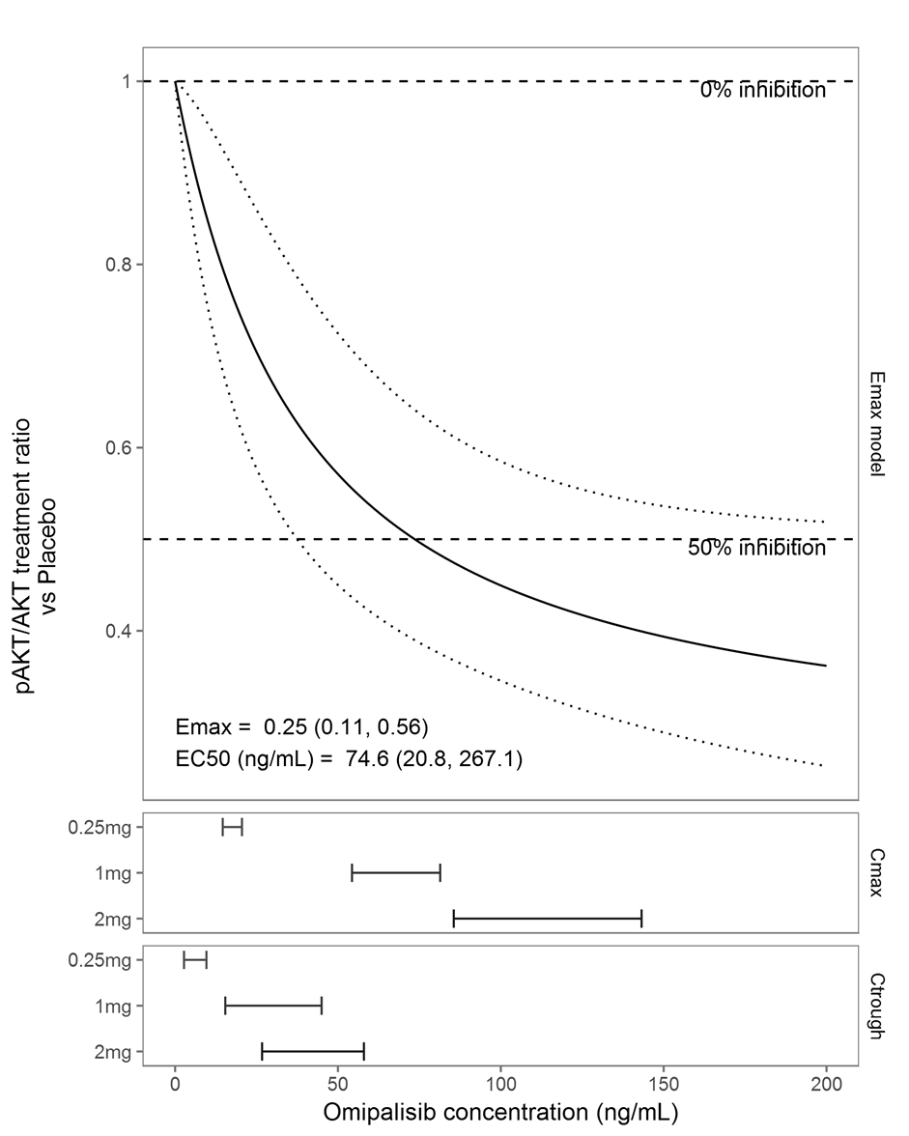**Figure 3 PK/PD model.** Fitted Emax model of the treatment ratio (vs Placebo) in pAKT/AKT on the final day of dosing (adjusted for pAKT/AKT at baseline) vs blood omipalisib concentration (black line and confidence band) (upper panel). The observed range of Cmax (middle panel) and Ctrough (bottom panel) for the three active treatment doses.

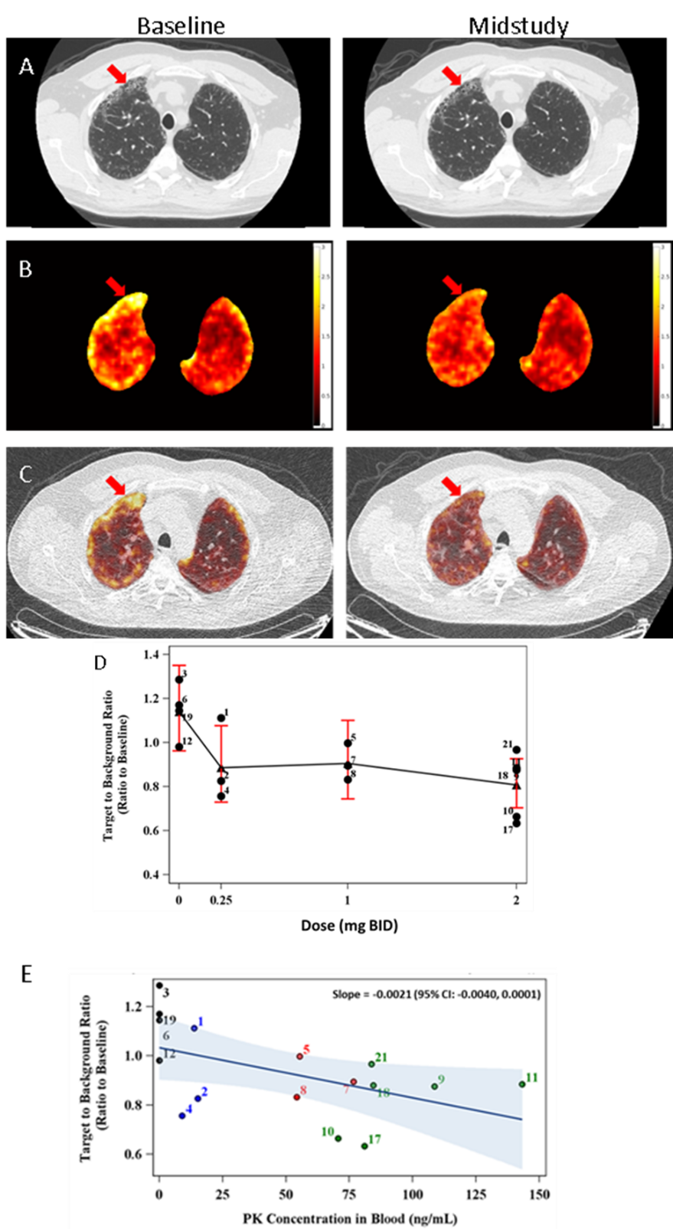

**Figure 4. Effect of omipalisib on FDG-PET.** (A) High resolution CT (HRCT) of the lungs of a representative subject dosed with 2mg BID of omipalisib taken at inspiration with reconstruction diameter of 37.2 cm at (left) baseline and (right) mid-study scan (grey scale window [-1350, 150] HU), (B) PET SUV images of the same subject (before air fraction correction), masked to show lung only and (C) fused PET/CTAC of the same subject at (left) baseline and (right) mid-study registered to baseline scan. The low dose CTAC (grey scale window [-1350, 150] HU) was acquired for attenuation correction with reconstruction diameter of 50 cm. The arrow shows an area of fibrosis that is apparent as honeycombing on the HRCT and that shows high FDG uptake at baseline which is reduced at mid-study. (D) the mean (filled triangle), individual subject values (filled circle) and 95% CI of Target to Background Ratio (TBR) of mid-study to baseline vs administered dose and (E) the TBR of mid-study to baseline ratio vs omipalisib plasma concentration measured at the mid-study PET visit. The individual subject values (for dose administered is indicated as follows: 0.25mg BID (blue), 1mg BID (red) and 2mg BID (green)), the regression line (unbroken black line) and the 95% CI (shaded blue area) are presented. ~~Participants from cohort 1 (0.25mg BID) are blue, those from cohort 2 (1mg BID) and red and those from cohorts 3 and 4 (2.0mg BID) are green~~. TBR is reported without air fraction correction.

# REFERENCES

1. Raghu, G., et al., *An official ATS/ERS/JRS/ALAT statement: idiopathic pulmonary fibrosis: evidence-based guidelines for diagnosis and management.* American journal of respiratory and critical care medicine, 2011. **183**(6): p. 788-824.

2. Richeldi, L., et al., *Efficacy and safety of nintedanib in idiopathic pulmonary fibrosis.* New England Journal of Medicine, 2014. **370**(22): p. 2071-2082.

3. King Jr, T.E., et al., *A phase 3 trial of pirfenidone in patients with idiopathic pulmonary fibrosis.* New England Journal of Medicine, 2014. **370**(22): p. 2083-2092.

4. Vancheri, C., *Common pathways in idiopathic pulmonary fibrosis and cancer.* European Respiratory Review, 2013. **22**(129): p. 265-272.

5. Selman, M. and A. Pardo, *Revealing the pathogenic and aging-related mechanisms of the enigmatic idiopathic pulmonary fibrosis: An integral model.* American Journal of Respiratory and Critical Care Medicine, 2014. **189**(10): p. 1161-1172.

6. Sarker, D., et al., *First-in-human phase I study of pictilisib (GDC-0941), a potent pan–class I phosphatidylinositol-3-kinase (PI3K) inhibitor, in patients with advanced solid tumors.* Clinical cancer research, 2015. **21**(1): p. 77-86.

7. Hennessy, B.T., et al., *Exploiting the PI3K/AKT pathway for cancer drug discovery.* Nature Reviews Drug Discovery, 2005. **4**(12): p. 988-1004.

8. Groves, A.M., et al., *Idiopathic pulmonary fibrosis and diffuse parenchymal lung disease: implications from initial experience with 18F-FDG PET/CT.* Journal of Nuclear Medicine, 2009. **50**(4): p. 538-545.

9. Win, T., et al., *18F-Fluorodeoxyglucose positron emission tomography pulmonary imaging in idiopathic pulmonary fibrosis is reproducible: implications for future clinical trials.* European journal of nuclear medicine and molecular imaging, 2011: p. 1-8.

10. Kottmann, R.M., et al., *Lactic acid is elevated in idiopathic pulmonary fibrosis and induces myofibroblast differentiation via pH-dependent activation of transforming growth factor-β.* American journal of respiratory and critical care medicine, 2012. **186**(8): p. 740-751.

11. Mercer, P.F., et al., *Exploration of a potent PI3 kinase/mTOR inhibitor as a novel anti-fibrotic agent in IPF.* Thorax, 2016. **71**(8): p. 701-711.

12. Vanhaesebroeck, B., et al., *The emerging mechanisms of isoform-specific PI3K signalling.* Nature Reviews Molecular Cell Biology, 2010. **11**(5): p. 329-341.

13. Brana, I. and L.L. Siu, *Clinical development of phosphatidylinositol 3-kinase inhibitors for cancer treatment.* BMC medicine, 2012. **10**(1): p. 161.

14. Knight, S.D., et al., *Discovery of GSK2126458, a highly potent inhibitor of PI3K and the mammalian target of rapamycin.* ACS medicinal chemistry letters, 2010. **1**(1): p. 39-43.

15. Agarwal, R., et al., *PI3K pathway-directed therapeutic strategies in cancer.* Current Opinion in Investigational Drugs, 2010. **11**(6): p. 615-628.

16. Knight, S.D., et al., *Discovery of GSK2126458, a highly potent inhibitor of PI3K and the mammalian target of rapamycin.* ACS Medicinal Chemistry Letters, 2010. **1**(1): p. 39-43.

17. Molyneaux, P.L., et al., *The role of bacteria in the pathogenesis and progression of idiopathic pulmonary fibrosis.* American journal of respiratory and critical care medicine, 2014. **190**(8): p. 906-913.

18. Birring, S., et al., *Development of a symptom specific health status measure for patients with chronic cough: Leicester Cough Questionnaire (LCQ).* Thorax, 2003. **58**(4): p. 339-343.

19. Norman, P., *Evaluation of WO2013117503 and WO2013117504: the use of PI3K inhibitors to treat cough or idiopathic pulmonary fibrosis.* Expert Opinion on Therapeutic Patents, 2014. **24**(6): p. 719-722.

20. Dolly, S.O., et al., *Phase I study of apitolisib (GDC-0980), dual phosphatidylinositol-3-kinase and mammalian target of rapamycin kinase inhibitor, in patients with advanced solid tumors.* Clinical Cancer Research, 2016.

21. Clark, J., et al., *Quantification of PtdInsP3 molecular species in cells and tissues by mass spectrometry.* Nature methods, 2011. **8**(3): p. 267-272.

22. Holman, B.F., *Improving Quantification of PET/CT Biomarkers for Evaluation of Disease Progression and Treatment Effectiveness in Pulmonary Fibrosis’*, in *Institute of Nuclear Medicine*. 2016, University College London: London UK.

23. Beverley F Holman , V.C., Lynn Millner , Raymond Endozo, Toby M Maher, Ashley M Groves , Brian F Hutton, Kris Thielemans, *Improved Quantitation and Reproducibility in Multi-PET/CT Lung studies by Combining CT Information.* European Journal of Nuclear Medicine and Molecular Imaging Physics, 2018. **5**: p. 14.

24. Lambrou, T., et al., *The importance of correction for tissue fraction effects in lung PET: preliminary findings.* European journal of nuclear medicine and molecular imaging, 2011. **38**(12): p. 2238-2246.

25. Patlak, C.S., R.G. Blasberg, and J.D. Fenstermacher, *Graphical evaluation of blood-to-brain transfer constants from multiple-time uptake data.* Journal of Cerebral Blood Flow & Metabolism, 1983. **3**(1): p. 1-7.

26. Cuplov, V., et al., *Issues in quantification of registered respiratory gated PET/CT in the lung.* Journal of Nuclear Medicine, 2015. **56**(supplement 3): p. 537.

27. Win, T., et al., *Pulmonary 18F-FDG uptake helps refine current risk stratification in idiopathic pulmonary fibrosis (IPF).* European Journal of Nuclear Medicine and Molecular Imaging, 2018.

28. Maher, T.M., et al., *An epithelial biomarker signature for idiopathic pulmonary fibrosis: an analysis from the multicentre PROFILE cohort study.* The Lancet Respiratory Medicine, 2017. **5**(12): p. 946-955.

29. Holman, B., et al., *Improved correction for the tissue fraction effect in lung PET/CT imaging.* Physics in Medicine and Biology, 2015. **60**(18): p. 7387.

30. Chen DL, C.J., Chilvers E, , *Quantification of lung PET images: challenges and opportunities.* Journal of Nuclear medicine, 2017. **58**(2): p. 7.

31. Geuna, E., et al., *Complications of hyperglycaemia with PI3K–AKT–mTOR inhibitors in patients with advanced solid tumours on Phase I clinical trials.* British journal of cancer, 2015. **113**(11): p. 1541.

32. Collard, H.R., *Where do we go from here? Clinical drug development in idiopathic pulmonary fibrosis.* European Respiratory Journal, 2015. **45**(5): p. 1218-1220.

33. Blackwell, T., S.T.S., *Future directions in idiopathic pulmonary fibrosis research an NHLBI workshop report.* American Journal of Respiratory and Critical Care Medicine, 2014. **189**(2): p. 214-222.

34. Andrianifahanana, M., et al., *Profibrotic up-regulation of glucose transporter 1 by TGF-beta involves activation of MEK and mammalian target of rapamycin complex 2 pathways.* Faseb j, 2016. **30**(11): p. 3733-3744.

35. Cho, S.J., et al., *Glucose Transporter 1-Dependent Glycolysis Is Increased during Aging-Related Lung Fibrosis, and Phloretin Inhibits Lung Fibrosis.* Am J Respir Cell Mol Biol, 2017. **56**(4): p. 521-531.

36. Kottmann, R.M., et al., *Pharmacologic inhibition of lactate production prevents myofibroblast differentiation.* American Journal of Physiology-Lung Cellular and Molecular Physiology, 2015. **309**(11): p. L1305-L1312.

37. Strickland, N.H., et al., *Cause of regional ventilation-perfusion mismatching in patients with idiopathic pulmonary fibrosis: A combined CT and scintigraphic study.* American Journal of Roentgenology, 1993. **161**(4): p. 719-725.

38. Galvin, J.R., A.A. Frazier, and T.J. Franks, *Collaborative radiologic and histopathologic assessment of fibrotic lung disease.* Radiology, 2010. **255**(3): p. 692-706.

39. King Jr, T.E., A. Pardo, and M. Selman, *Idiopathic pulmonary fibrosis.* The Lancet, 2011. **378**(9807): p. 1949-1961.

40. Wagner, A., et al., *A first-in-human phase I study to evaluate GDC-0980, an oral PI3K/mTOR inhibitor, administered QD in patients with advanced solid tumors.* Journal of Clinical Oncology, 2011. **29**(15_suppl): p. 3020-3020.

41. Bendell, J.C., et al., *A phase 1 study of the sachet formulation of the oral dual PI3K/mTOR inhibitor BEZ235 given twice daily (BID) in patients with advanced solid tumors.* Investigational new drugs, 2015. **33**(2): p. 463-471.