**Review**

**Emerging technologies for low-cost, rapid vaccine manufacture**

Zoltán Kis1

Robin Shattock2

Nilay Shah1

Cleo Kontoravdi1

1Department of Chemical Engineering, Faculty of Engineering, Imperial College London, London, UK.

2Department of Medicine, Faculty of Medicine, Imperial College London, London, UK.

**Correspondence:** Dr. Cleo Kontoravdi, Department of Chemical Engineering, Faculty of Engineering, Imperial College London, Exhibition Road, SW7 2AZ, London, UK.

**E-mail**: [cleo.kontoravdi98@imperial.ac.uk](mailto:cleo.kontoravdi98@imperial.ac.uk)

**Keywords:** bacterial outer-membrane vesicle vaccines, insect cell-baculovirus vaccine manufacturing, RNA vaccines, vaccine manufacturing technology assessment, yeast-based vaccine manufacturing platform.

**Abbreviations:** **OMV**, outer-membrane vesicle; **GMMA**, Generalized Modules for Membrane Antigens; **MCB**, master cell bank; **WCB** working cell bank; **MVB**, master virus bank; **WVB**, working virus bank; **WVS**, working virus stock; **HBV**, hepatitis B virus; **HBsAg**, hepatitis B virus surface antigen S-protein; **HPV**, human papillomavirus; **VLP**, virus-like particle; **HA**, influenza virus hemagglutinin; **FDA**, U.S. Food and Drug Administration; **EMA**, European Medicines Agency; **siRNA**, short interfering RNA; **PEI**, polyethylenimine; **TTF**, tangential flow filtration; **MOI**, multiplicity of infection; **h,** hour; **DO**, dissolved oxygen concentration as percentage of saturation concentration; **OD(600)**, optical density at 600 nm wavelength; **PSI**, pound-force per square inch; **QC**, quality control, **HPLC**, High-performance liquid chromatography; **MS**, mass spectrometry.

**Abstract**

To stop the spread of future epidemics and meet infant vaccination demands in low- and middle-income countries, flexible, rapid and low-cost vaccine development and manufacturing technologies are required. Vaccine development platform technologies that can produce a wide range of vaccines are emerging, including: (a) humanised, high-yield yeast recombinant protein vaccines, (b) insect cell-baculovirus ADDomerTM vaccines, (c) Generalized Modules for Membrane Antigens (GMMA) vaccines; (d) RNA vaccines. Herein, existing and future platforms are assessed in terms of addressing challenges of scale, cost and responsiveness. To assess the risk and feasibility of the four emerging platforms, the following six metrics were applied: (1) technology readiness, (2) technological complexity, (3) ease of scale-up, (4) flexibility for the manufacturing of a wide range of vaccines, (5) thermostability of the vaccine product at tropical ambient temperatures, and (6) speed of response from threat identification to vaccine deployment. The assessment indicated that technologies in the order of increasing feasibility and decreasing risk are the yeast platform, ADDomerTM platform, followed by RNA and GMMA platforms. The comparative strengths and weaknesses of each technology are discussed in detail, illustrating the associated development and manufacturing needs and priorities.

# 1. Introduction

Developing a vaccine from concept to market costs $200-$500 million, and takes 5-18 years [1–5]. Additionally, it costs an estimated $50-$700 million to construct, equip and commission a vaccine manufacturing facility, taking on average 7 years [1,5–7], while the lead time to manufacture a vaccine ranges between 0.5-3 years [1,8].

To better understand these high costs and lengthy development times, existing vaccine manufacturing processes are reviewed. One of the earliest viral vaccine mass-production technologies, developed in the 1940s, involves the parallel use of many embryonated hens’ eggs as “mini-factories” for influenza vaccines manufacturing [9,10]. Here, fertilized hens’ eggs are inoculated with the virus and are incubated to allow viral replication. Next, the contents of the eggs are pooled, the virus is separated, purified, in some cases inactivated, formulated, filled in vials or syringes and packaged [9,10]. The mean estimated yield is one vaccine dose per 1 to 2 eggs [10]. This manufacturing technology is well-established and still widely used. However, it has the following disadvantages: (1) the production capacity can be restricted due to limited egg availability, especially due to their susceptibility to potential pandemic influenza strains; (2) the viruses propagated in eggs might antigenically differ from wild-type viruses and might not induce the desired immune response; (3) induction of egg-related allergies in some patients [9,10]. To address some of these drawbacks, animal cell culture-based viral vaccine manufacturing technologies were developed. For this, animal cells are cultured *in vitro* and infected with the virus. The virus replicates within the cells and can also lyse them. Next, the remainder of the cells are lysed, the virus is separated using microfiltration or disk-stack centrifugation, and the virus is inactivated using heat or chemical agents (e.g. formaldehyde, β-propiolactone, or aziridines) [7]. The genetic material is subsequently broken down with nuclease enzymes and the antigen is purified using a combination of ultra-filtration and chromatography techniques [7]. The purified antigen is formulated into a vaccine, it is then filled into vials or syringes and packaged [7]. Animal cell-based vaccine production technologies are associated with: (1) high production costs, (2) low growth rates, (3) high contamination risks, requiring high levels of sterility, and (4) difficulties in genetically engineering cells for improved production. Both egg and animal cell culture grown viruses are in some cases broken down into subunits with antigenic properties, rendering them replication deficient and further reducing the disease-causing potential of viruses. Besides inactivated and subunit antigens, intact live viruses attenuated by passage in a foreign host can also be formulated into vaccines. Live attenuated viral vaccines generally induce a stronger and long-lasting vaccination effect but harbour a higher disease-causing potential [11,12].

Whole bacterial vaccines are manufactured by growing the pathogenic bacteria in the appropriate culture medium, separation from the culture media by filtration and/or centrifugation, and formulation commonly accompanied by lyophilization [7,12–14]. Whole bacterial vaccines can consist of either live attenuated bacterial cells or inactivated bacterial cells, the former being more common, as these offer a more potent vaccination effect [7,11,15]. Bacterial subunit vaccines have also been developed and these can be divided into 2 broad categories: toxoid (detoxified toxins) vaccines and capsular polysaccharides vaccines. A variation of these are the conjugate or glycoconjugate vaccines, which consist of an antigen (often the bacterial polysaccharides) covalently attached to a carrier protein (e.g. tetanus toxoid or CRM197), yielding a more efficacious vaccine [11,12]. Subunit vaccines tend to induce lower levels of immunogenicity and vaccination effects compared to live attenuated vaccines [11,12].

The protein antigens from both viruses and bacteria can be recombinantly produced in the following host organisms with increasing complexity and costs: (1) *Escherichia coli*, (2) yeast, (3) insect cells and (4) animal cells [7,16–19]. All the vaccine manufacturing technologies mentioned so far were developed and applied for producing one specific vaccine or a narrow set of vaccines. Thus, none of these technologies can readily be used to produce a wide range of antigens within lead times of below 2 months at costs of around $1 per vaccine dose. This is especially important for supplying vaccines at low cost for infant and early childhood vaccination in low-income countries, and responding quickly to new threats in regional outbreaks, such as the 2014 West Africa Ebola outbreak and the 2015–2016 Zika epidemic. To address these pressing needs, new vaccine platform technologies are being developed which can enable rapid and low-cost process development and scale-up [7], such as (1) humanised, high-yield yeast platform for recombinant protein vaccine production; (2) insect cell-baculovirus platforms for ADDomer-based and VLP vaccine production; (3) Outer membrane vesicle (OMV) and GMMA vaccines manufacturing; (4) RNA vaccines. These four platform technologies were chosen based on their low technological complexity, scalability, flexibility for producing a wide range of vaccines and potential thermostability of the formulated product. Compared to other vaccine platform and expression technologies such as peptide vaccines [20–22], recombinant protein expression in mammalian cells [7,17], recombinant protein expression in *E. coli* [7,17], budded virus-like particles [23,24], recombinant protein expression in avian embryos and related cell lines [25], exosome-based vaccines [26,27], the four platform technologies chosen in this study satisfy the above requirements to a much higher extent [7,17,23,25–27]. In addition, these 4 platforms, can exhibit self-adjuvancy: the ADDomerTM and GMMA can be programmed to also display adjuvant-like entities on their surface; the humanised, high-yield yeast platform can produce proteins with adjuvant function and RNA molecules can have self-adjuvant properties. Herein, these four emerging vaccine platform technologies are comparatively evaluated for rapidly producing a wide range of vaccines at low costs.

# 2. Overview of the four vaccine platform technologies

Common examples of recombinant vaccines expressed in conventional yeast and insect cells, as well as OMVs and nucleic acids vaccines are shown in Table 1. These existing expression systems and vaccine technologies are related, and can be considered proxies, to the 4 emerging platform technologies. These proxies indicate the feasibility of producing vaccines using the emerging platform technologies analysed herein.

**Table 1**. Examples of vaccines produced using the following proxies for emerging vaccine technologies: yeast expression system, insect cell expression system, OMV-yielding bacteria and DNA vaccines.

|  |  |  |  |  |  |
| --- | --- | --- | --- | --- | --- |
| **Vaccine technology\*** | **Licenced vaccines**  **(trade name)** | **Regulatory approval year and authority** | **Antigen** | **Antigen type** | **Ref.** |
| Yeast | hepatitis B (Recombivax HB®) | 1983 FDA | S-protein, HBsAg | VLP | [7,17,28] |
| human papillomavirus (Gardasil®) | 2006 FDA | L1 protein | VLP | [29,30] |
| Insect cells | Influenza, (Flublok®) | 2014 FDA | Hemagglutinin, HA | recombinant protein | [10] |
| human papillomavirus, (Cervarix®) | 2007 EMA | L1 protein | VLP | [31,32] |
| Detergent-extracted OMVs | Meningitis (Bexsero®) | 1991 Cuba, 1991 Norway, 2012 EMA, 2015 FDA | Neisseria meningitidis serogroup B | OMV | [33–35] |
| DNA (for veterinary use) | West Nile Virus, for equines (West Nile-Innovator® DNA) | 2005 USDA | prM and E proteins | DNA | [36,37] |
| Infectious hematopoietic necrosis virus, IHNV, for salmon (Apex‐IHN®) | 2005 USDA | IHNV surface glycoprotein G | DNA | [37,38] |
| Melanoma, for canines (ONCEPT®) | 2010 USDA | human tyrosinase antigen | DNA | [37,39] |

* These vaccine expression systems and platform technologies were used as proxies for the 4 emerging technologies as follow: yeast expression system for the humanised, high-yield yeast platform; the insect cell expression system for the insect cell-baculovirus ADDomerTM vaccines; Detergent-extracted OMVs for the GMMA platform; and DNA vaccines for the RNA vaccines.

Figure 1 shows a generic overview of vaccine manufacturing processes, and specific differences in the Bioprocessing segment (Upstream processing, Mid-stream bioprocessing and Downstream separation and purification) will be highlighted for the four vaccine platforms and illustrated in Figures 2 and 3. A generic overview of the formulation, quality control, filling, capping & sealing, labelling and packaging operations is described below.

The aims of the formulation process are: (i) to maintain the structure and stability of the active ingredient or ingredients and by this maintaining the potency of the vaccine; (ii) increase the shelf-life of the vaccine product; (iii) to enhance the potency of the vaccine by adding adjuvants which are stimulating the immune response; (iv) to minimize potential negative side-effects; (v) and in case of RNA vaccines to enhance the uptake of the RNA by the cells of the body which will produce the antigen [7].

For formulation, antigens can be adsorbed to aluminium compounds, (e.g. aluminium hydroxide) [7]. New adjuvants, such as toll-like receptor agonists (e.g. monophosphoryl lipid A and immunostimulatory CpG-motif oligonucleotides) were shown to enable faster protection and improved efficacy [7]. Preservatives (e.g. mercury-containing thimerosal) were also added to vaccines, however, these preservatives are not used in most modern formulations, because the sterility of the manufacturing technique was improved and preservatives were no longer needed [7]. Vaccines can be monovalent (containing a single strain of a single antigen), polyvalent (containing two or more strains or serotypes of the same antigen) or combination vaccines (mix of monovalent and/or polyvalent vaccines against more than one disease or multiple strains of an infectious agent). Vaccines are commonly formulated in the liquid phase, however, vaccines are also lyophilized to increase their shelf-life [7,40]. Through and after formulation the following parameters are kept within well-controlled optimal ranges: solution pH, ionic strength, redox potential, concentration, and temperature [7].

For quality control, vaccine active ingredients are characterized structurally, (e.g. amino acid composition, partial amino acid sequencing, peptide mapping, lipid and carbohydrate structure, buoyant density, and epitope characterization) using amino acid sequencing, Western blotting, gel electrophoresis and HPLC. Additionally, the antigenicity and sterility are also routinely checked before formulation. For the formulated vaccine, protein and aluminium content, pyrogenicity, and *in vivo* potency (determined as ED50) are tested. Additionally, for quality control, the following parameters are measured and kept within optimal ranges throughout the manufacturing process: temperature, pressure, pH, electric conductivity, concentration of various components, homogeneity, presence of chemical and biological contaminants, etc. [7].

After the formulated product has passed quality control, it is filled into sterile glass vials, plastic vials, plastic syringes, glass bottles or plastic bottles [7]. Next, vials are capped, sealed, labelled and packaged for distribution [7].

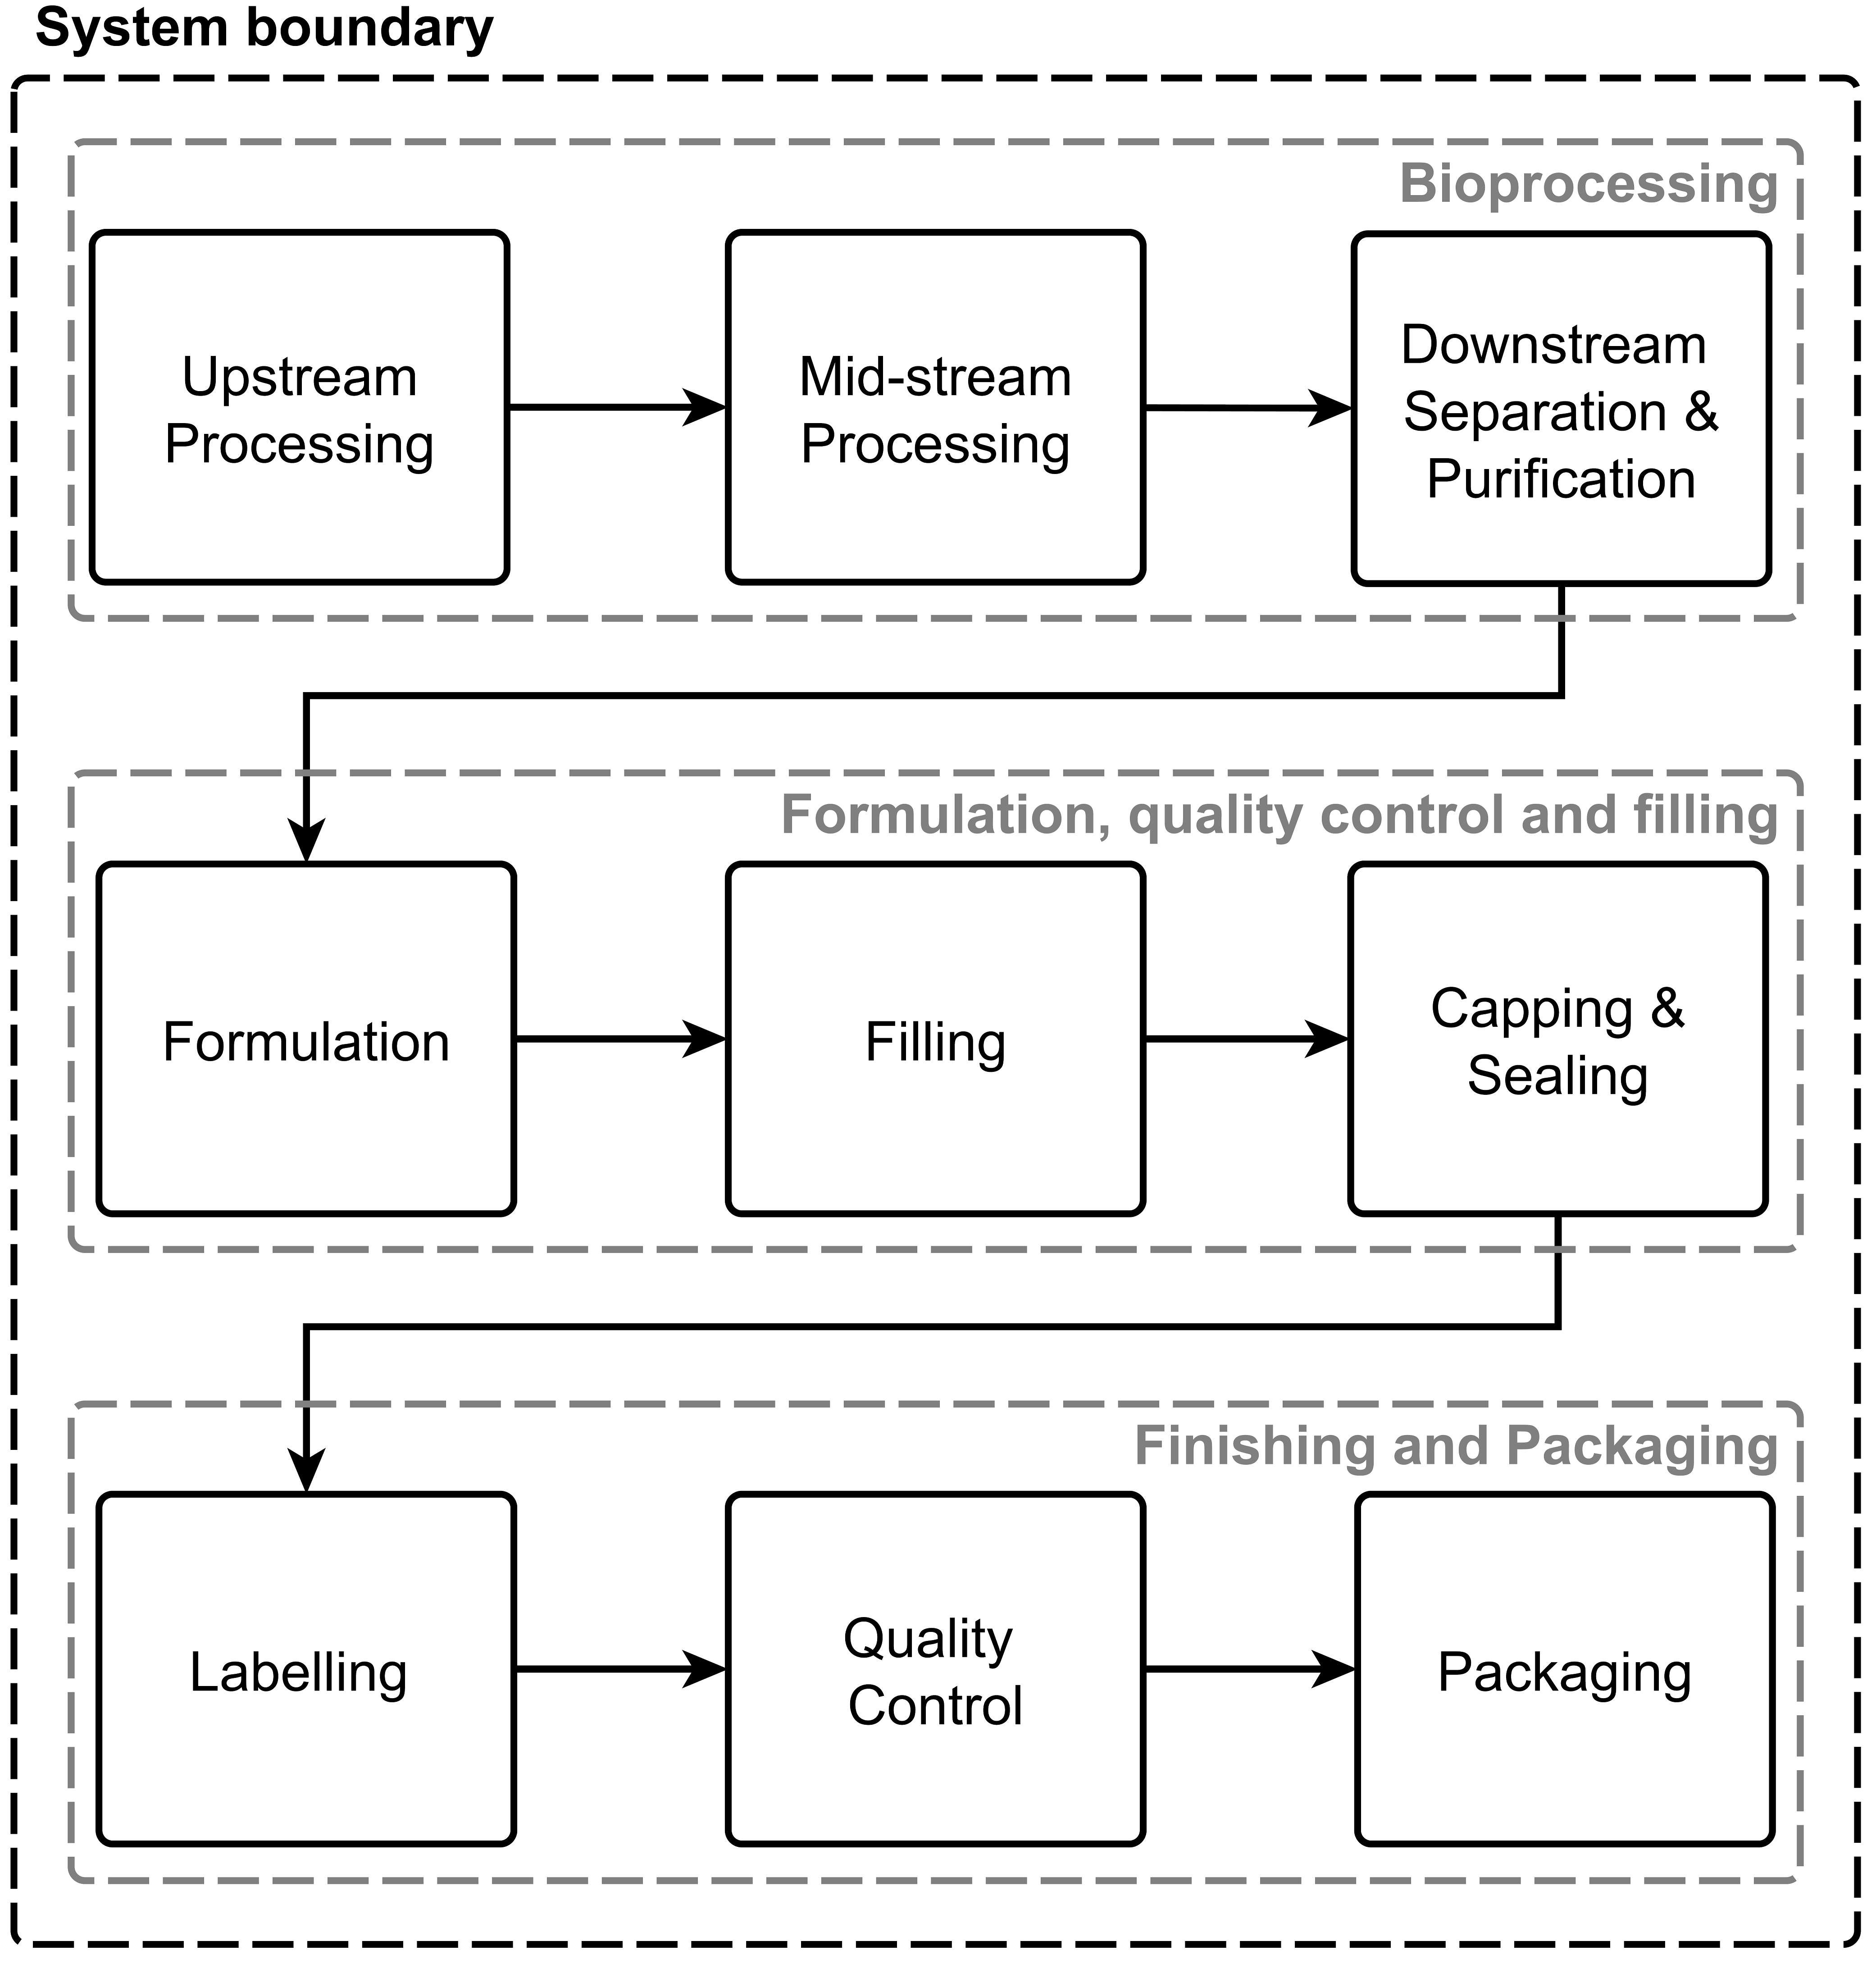

**Figure 1**. Generic overview of vaccine manufacturing processes.

# 3. Humanised, high-yield yeast platform for recombinant vaccine manufacturing

The key challenges for yeast platforms are: 1) different glycosylation patterns compared to human cells [41–43]; 2) the specific productivity is low[44–46], and 3) for many vaccines it is necessary for the recombinant protein antigens to assemble into VLPs for increasing the potency of the vaccination [7,47]. To address these challenges high-yield humanized yeast-based expression platforms are being developed by over-expressing chaperones [44–46]. To change the high-mannose profile of yeast to the human-type complex glycan pattern, the glycosylation pathways are genetically altered in *S.* *cerevisiae*, *H. polymorpha* and *P. pastoris* [42,43]. The yeasts glycoengineered so far express and secrete most recombinant proteins at titres below 1 g/L [48,49] and some at 4-5 g/L [50]. Additional yield-increasing genetic engineering is required to reach the secretion levels reported in non-glycoengineered *P. pastoris* of up to 35 g/L and 20 g/L, using methanol-induction and methanol-free processes, respectively (source: Purkarthofer T. Pichia pastoris protein expression services. Austria: VTU Technology GmbH; 2018. Available from: https://www.vtu-technology.com/Downloads/files/VTUTechnologyDownloads/VTUTechnologyFolder.pdf). To avoid the need for self-assembly of recombinant antigenic proteins into VLPs, the immunogenicity of monomeric heterologous antigens could be increased by linking it to a highly immunogenic protein domain or by using an appropriate adjuvant [51].

## 3.1. Upstream and mid-stream processing

The manufacturing process for humanised, high-yield yeast-based vaccine production is illustrated in Figure 2A, based on HBsAg antigen production in *S.* *cerevisiae*. The humanized yeast would be cell banked and expanded similarly to conventional yeast [7].

For humanized yeast-based recombinant antigen production, standard yeast bioprocesses can be employed. The antigen gene promoters on the plasmid are typically derived from constitutive glycolytic genes, thus, antigen expression is proportional to glucose consumption, and biomass growth [7]. To minimize episomal plasmid loss and consequent yield decrease, plasmid retention is monitored during the process and a selection pressure is applied [7]. The final fermentation culture harvest is also tested for microbial purity [7]. Yeast-based production systems inherently do not bear the risk of contamination with human or animal viruses, and thus, do not require specific testing in this regard [7]. The entire culturing cycle, from thawing to the end of the batch-fermentation takes 1 week.

## 3.2. Separation, cell lysis and purification

The downstream processes for proteins produced using humanized yeast are similar to protein separation and purification from conventional yeast fermentation [7]. The separation downstream of yeast-based production, can be substantially simplified and made more economical compared to animal cell-based production, due to: (1) potentially high recombinant protein expression and secretion yields by yeast; and (2) low amounts of secreted native host-cell yeast proteins. However, the expression and secretion yields still need to be increased in glycoengineered yeast to reach the levels reported in non-glycoengineered *P. pastoris* of up to 35 g/L (source: Purkarthofer T. Pichia pastoris protein expression services. Austria: VTU Technology GmbH; 2018. Available from: https://www.vtu-technology.com/Downloads/files/VTUTechnologyDownloads/VTUTechnologyFolder.pdf).

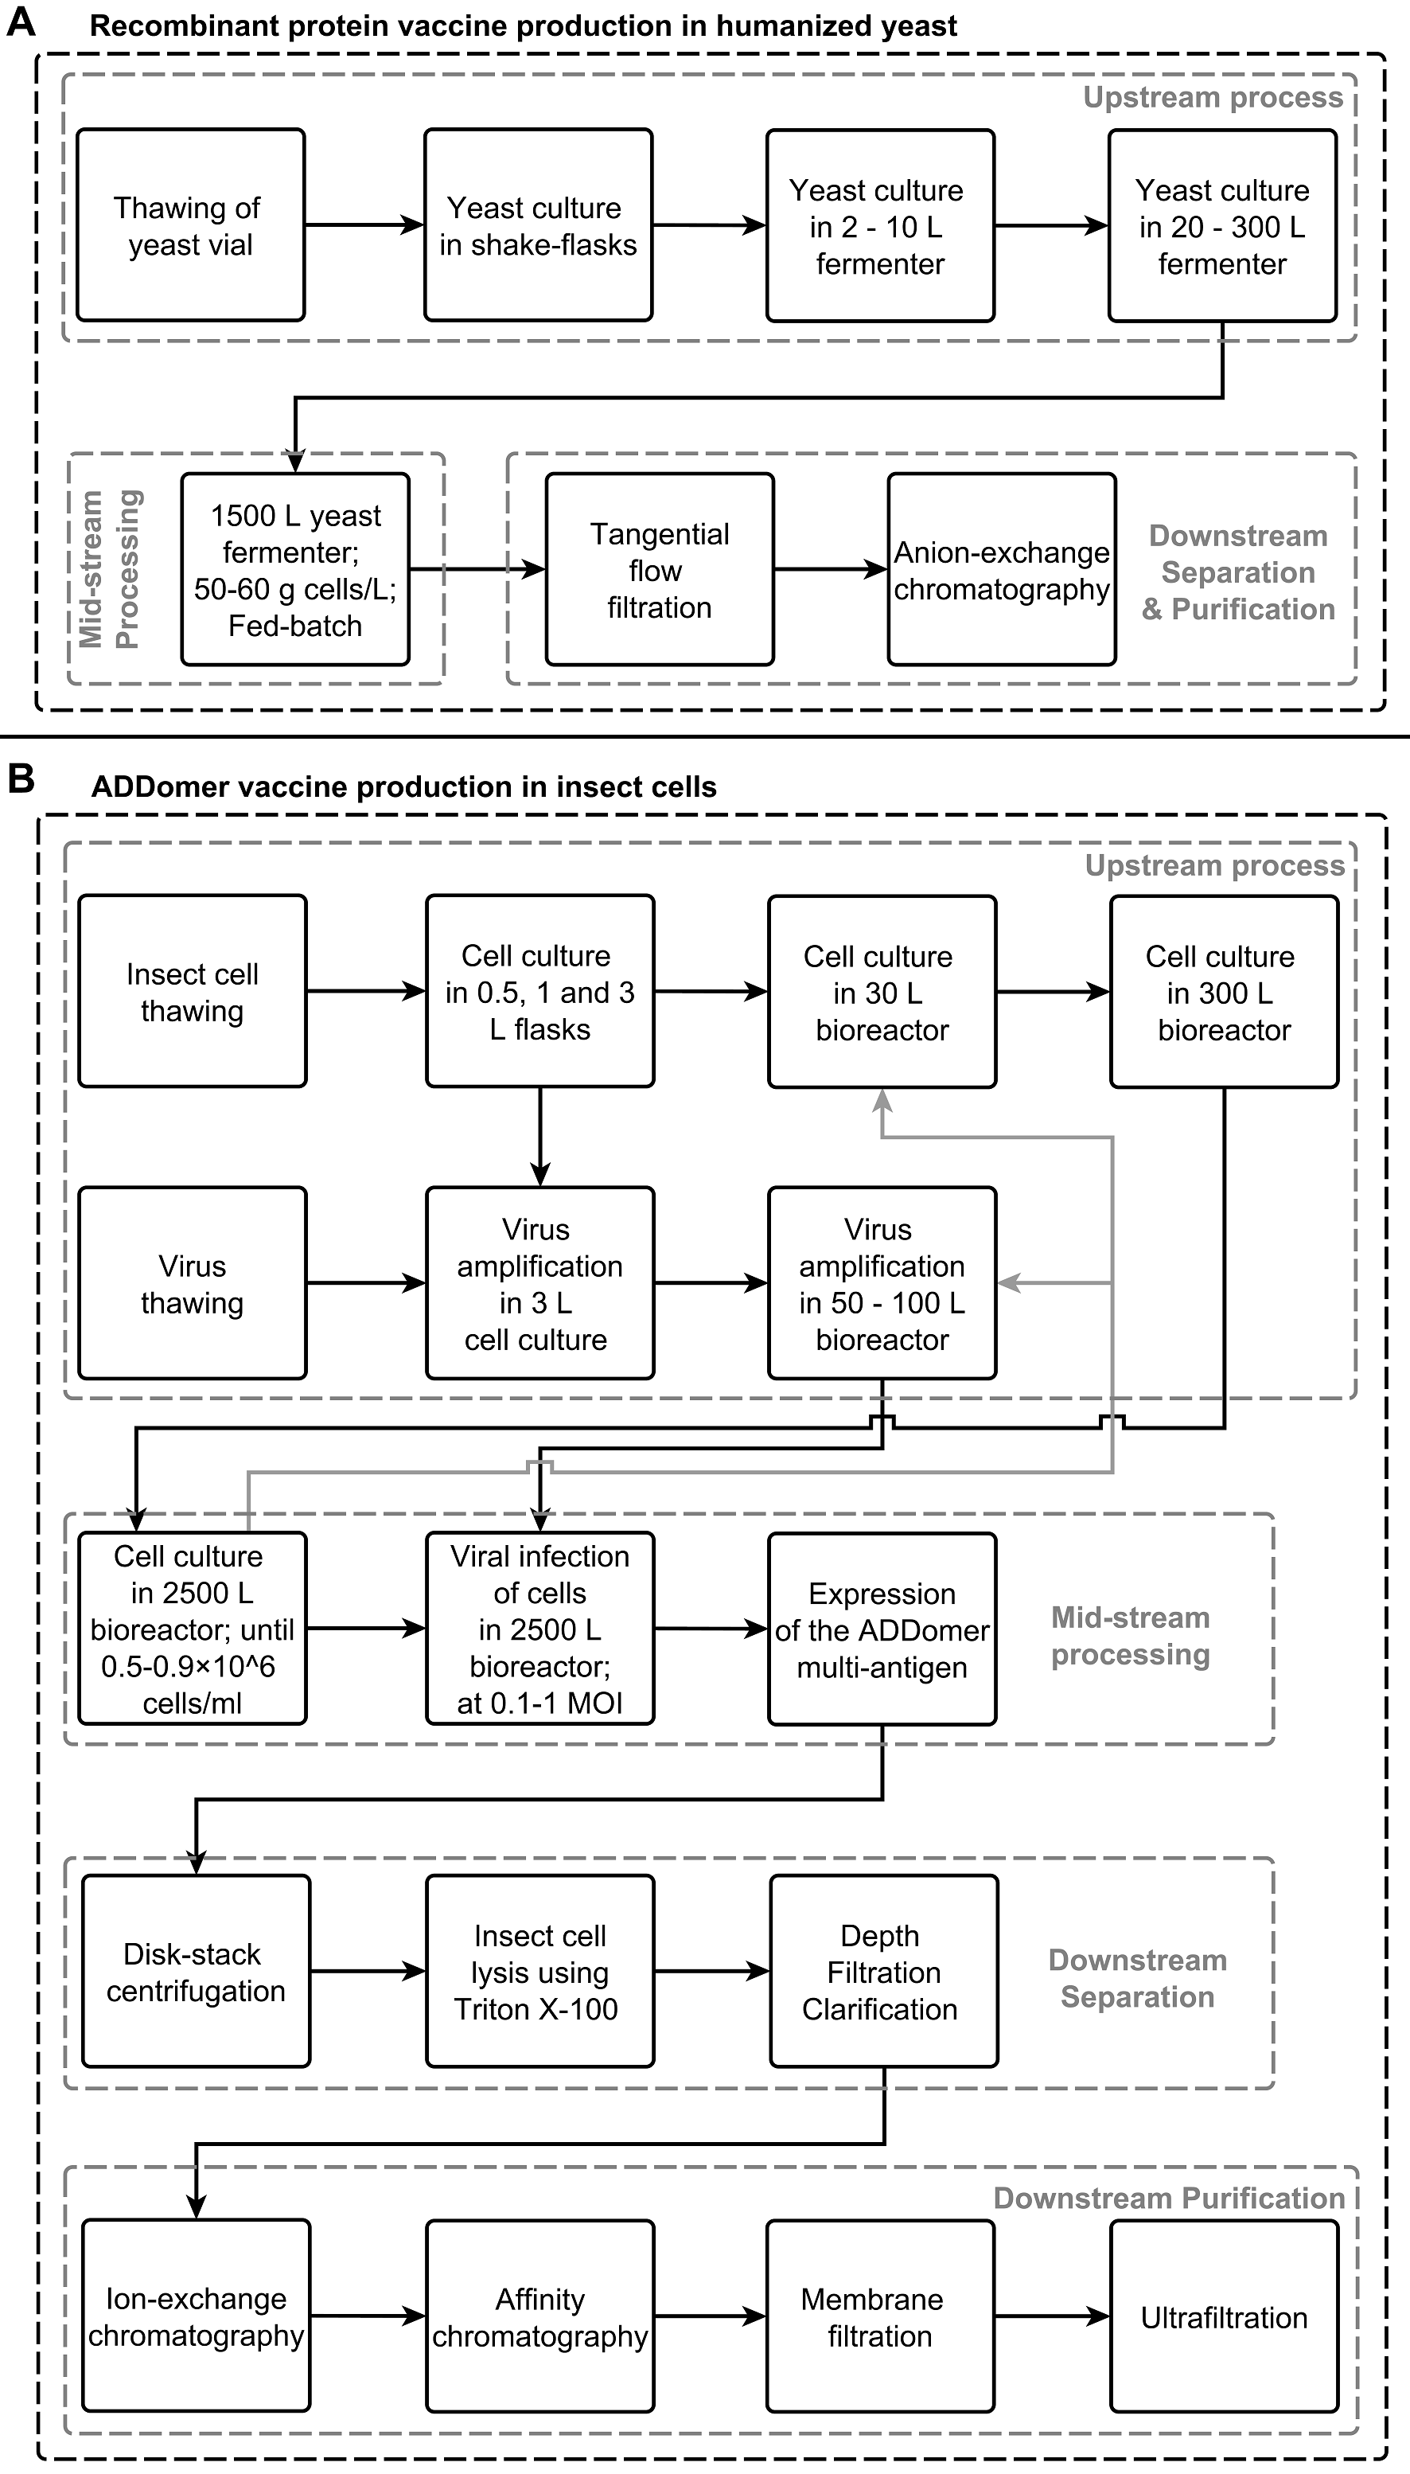

**Figure 2.** Operation scheme for the manufacturing of protein vaccines in humanised, high-yield yeast and in insect cell platforms. **A.** Recombinant protein vaccines production in humanised, high-yield yeast. Human-like complex glycosylation has been reported in yeast [52], however, this and high-yield secretion is not yet implemented at production-scale [7,52–54]. **B.** Bio-manufacturing of recombinant ADDomerTM multi-antigen vaccines using the MultiBacTM insect cell–baculovirus expression system [55–57]. The process was scaled up here based on recombinant HA protein expression for influenza vaccine manufacturing [10,58,59]. The grey arrows indicate the feeding back of excess insect cells from the 2500 L production bioreactor into the upstream process prior to viral infection.

# 4. Insect cell-baculovirus platform for recombinant vaccine manufacturing

Baculoviruses, a family of large double-stranded DNA insect viruses, can accommodate multiple additional foreign genes and are commonly used for recombinant protein production in insect cell lines[16,17]. Molecular cloning methods are commercially available for the rapid generation of baculovirus vectors [17,60], including the CRISPR-Cas9 technology [61], within 1 day. However, selection of the recombinant baculovirus that contains the gene of interest by plaque purification usually takes about 1 week [60]. To alleviate plaque selection and purification recombinant baculovirus are commonly generated using a progenitor baculoviral genome in form of a bacterial artificial chromosome (BAC) and Tn7 transposition in *E. coli* cells [62–64].

Insect cell cultures have the following advantages for recombinant protein production: (1) higher robustness than animal cell lines [16,17], for large volume culture [16]; (2) effective baculovirus vector construction techniques [17,60,61,64]; (3) S2 stably modified insect cells can be grown in continuous mode in perfusion cultures [16]; (4) proven industrial scale applicability for recombinant protein and vaccine production [16,17]; (5) baculoviruses do not represent a human health risk [16].

The growth rate of insect cells is higher than animal cells but lower than yeast or bacteria [17]. Insect cell cultures have the following limitation for recombinant protein production: (i) cannot synthesize the mammalian-specific complex glycan structures [16,17,58], this however was improved recently by baculoviral systems outfitted with functions to mimic human glycosylation [65–67] (ii) higher vaccine manufacturing costs, comparable to animal cell culture vaccine manufacturing costs [17].

In order to apply the insect cell-baculovirus expression system to the production of a wide range of vaccines, the MultiBacTM [55,64,68,69] and ADDomerTM [57] multiprotein expression platforms can be employed. MultiBacTM offers a simple and versatile method for generating recombinant baculovirus DNA to express VLP multiprotein complexes in insect cell culture [55,68,69]. ADDomerTM is a synthetic multiprotein scaffold derived from a VLP from the human adenovirus serotype 3, produced at high yields using MultiBacTM [57,70]. ADDomerTM is composed of ~60 kDa protein subunits (protomers) which self-assembles into pentameric protein complexes (pentons) of ~300 kDa. Twelve of these pentons then form the ADDomerTM, which has a total a molecular mass of ~3.6 MDa. The ADDomerTM protein scaffold can present up to 360 genetically encoded antigenic determinants (aka. epitopes) on its surface [57], including purification tags (e.g. biotin, chitin binding protein, Myc tag and preferentially the histidine tag for production scale) to facilitate downstream purification [56,57]. ADDomerTM was chosen as the next-generation vaccine platform to represent insect cell-baculovirus expression system because: (1) it is highly customizable to display a variety of antigenic peptides, proteins and protein domains with lengths of up to 200 amino acids on its surface; (2) it can be rapidly re-configured using the MultiBacTM system; (3) it consists of copies of adenoviral penton base proteins which spontaneously form highly stable VLPs; (4) it has a size which is similar to a virus, enhancing its immunogenicity; (5) it can harbour adjuvant-like epitopes; (6) it is non-replicative and does not carry genetic material; (7) it can easily be produced at industrial scale; (8) it is thermostable and independent of a cold chain, an advantage in low- and middle-income countries [57].

Here, the process for manufacturing multiprotein complexes, such as ADDomerTM, in insect cells is described. The scaling-up of the ADDomerTM manufacturing process was based on influenza virus hemagglutinin (HA) production for Flublok® vaccine manufacturing, since HA multimers have a similar size to ADDomerTM [71,72].

## 4.1. Upstream and mid-stream processing

The ADDomerTM is expressed in Hi5 or Sf21 insect cells from the MultiBacTM expression vectors, and for this, the cells and baculovirus are expanded [55–57].

Following the expansion of insect cells in small and medium scale bioreactors, cells are transferred into the production bioreactor. Prior to infection, excess cells from the production bioreactor can be fed back into the upstream process, as indicated by the grey arrows in Figure 2B. After the insect cells have divided and reached a density of around 0.5–0.9×106 cells/ml, the baculovirus is added at an MOI between 0.1-1, such that the cell population can double at least once post-infection [55,56]. The added viruses infect the insect cells and the ADDomerTM is expressed and remains inside the cells [56,57]. Virus expression can be monitored every 12 or 24 hours by the use of expression markers (e.g. yellow fluorescent proteins) or by monitoring cell densities [56]. The cells should be harvested once expression plateaued or 24 hours after cell densities stop increasing [56].

## 4.2. Separation and Purification

The infected cells are harvested using centrifugation, in a disk stack centrifuge [10,59]. The ADDomerTM is extracted from the cells using non-ionic surfactants (e.g. sodium deoxycholate, sodium dodecylsulfate, polysorbates and Triton X-100) and then clarified using depth filtration [10,56–58]. During depth filtration, the cellular debris and other contaminants are retained by the depth filter and clarified solution containing the ADDomerTM passes through the filter.

The clarified solution from the depth filtration step is passed through an ion-exchange chromatography column. The ADDomerTM protein can be bound on a cation-exchange column using a buffer with a pH below the ADDomer’s isoelectric point (pI), and eluted with a buffer with a pH above this pI value. Next, affinity chromatography can be used to further purify the ADDomerTM based on the specific interaction between the tag of the ADDomerTM, added during the molecular cloning, and the coating of the chromatography column [56,57]. Following the two column chromatography steps, a membrane filtration follows whereby residual DNA is removed using a Q-membrane [10]. Next, the buffer composition of the ADDomerTM solution is brought to its final state using ultrafiltration [58].

# 5. Outer membrane vesicle vaccines, Generalized Modules for Membrane Antigen vaccine manufacturing

Outer membrane vesicles (OMVs) are naturally generated by all gram-negative bacteria during their growth [73,74]. Gram-positive bacteria [75,76], mycobacteria [77], and archaea [78] can also naturally release OMVs. OMVs are spherical entities of endocytic origin with diameters normally ranging between 20–250 nm [73,74]. These virus-sized lipid bilayer vesicles with embedded proteins can be highly immunogenic [74,79,80]. OMV-based vaccines can be produced by: (a) culturing wild-type bacteria which naturally secrete OMVs [74], (b) detergent extraction using sodium deoxycholate in the presence of EDTA [33,81], and (c) culturing genetically altered bacteria for enhanced OMV production [81–83]. Detergent extraction removes reactogenic or toxic lipopolysaccharide [74,81,84], but has the following disadvantages: (1) loss of negatively charged surface antigens [74,84]; (2) OMVs can aggregate and be heterogeneous in size, losing a fraction of OMVs during sterile filtration [84,85]; (3) contamination of OMV vaccines with cytoplasmic proteins due to bacterial cell lysis [81,86]. To overcome these limitations, OMV‐generating bacteria are genetically engineered to improve OMV vaccine production. These genetic engineering modifications can include: (1) altering the bacterial lipopolysaccharide biosynthesis pathway to reduce endotoxicity and reactogenicity; (2) overexpression of antigens; (3) simultaneous expression of multiple antigens and antigenic variants; (4) retention of secreted antigens in the outer membrane; (5) enhancing OMV generation by removing outer membrane anchor proteins; (6) removal of immune‐modulating components which could trigger an undesired type of immune response; and (7) inclusion of antigens from pathogens other than the host OMV producing strain [74,82]. The integrity and attachment of inner and outer cell wall membranes are normally regulated by the Tol-Pal system, and modification of this pathway can be exploited to enhance OMV generation [73,87].

Generalized Modules for Membrane Antigens (GMMA) are OMVs engineered to enhance native OMV formation (by deletion of the *gna33* in meningococcus and *tolR* in *Shigella sonnei* and *Salmonella*), reduce reactogenicity and toxicity (by modifying the acylation pattern of lipid A) and over-express immunogenic antigens, [80,83,88]. GMMA contain pathogen-associated molecular patterns, including toll-like receptor ligands, which can act as self-adjuvants in the immune responses they elicit [87]. GMMA are highly immunogenic [80,88], effective, have low reactogenicity, are safe, and can be manufactured at low cost in a scalable process [80,83,89,90]. The main limitation of GMMA is that it cannot perform human-like post-translational modifications (e.g. glycosylation). GMMA production has already been scaled up for GMP-quality production using *Shigella sonnei* and nontyphoidal *Salmonella* vaccines [80,83]. Here, GMP-quality GMMA production in *Shigella sonnei* is described, because this GMMA-based vaccine is developed to the most advanced stage, shown to be safe and immunogenic in clinical trials for adults. The production time from thawing of the inoculum for fermentation to final purified GMMA was 3 days and thus, depending on the size of the vaccine dose, a relatively small production facility with a 500 L fermenter could produce in excess of 100,000,000 doses of vaccines per year [80]. The operation scheme for the manufacturing of OMV vaccines exemplified by GMMA is shown in Figure 3A below.

## 5.1. Upstream and mid-stream processing

The bacterial strains of interest were genetically engineered to obtain the desired properties for GMMA vaccine production. For this, in *Shigella sonnei* the *tolR,* *galU* and *msbB1* genes were replaced by antibiotic selection markers [91]. For GMMA vaccine production in *Salmonella*, the *tolR, msbB, htrB* and *pagP* genes can be deleted and replaced by antibiotic selection markers [90]. The obtained bacterial strains are stored in a 2-tiered cell bank and then expanded for production. Compared to animal cells, bacteria grow faster and can be cultured in larger volume bioreactors, because bacterial cells are more robust and can withstand higher pressure and stirring rates compared to animal cells [13].

Once the required inoculation volume was obtained, bacteria are seeded into the fed-batch production bioreactors. Bacterial fermenters can have a volume of several hundreds of cubic meters, and fermenters with volumes as large as 2000 m3 were also described [13]. Once the bacteria reach the stationary growth phase, the broth is transferred to the downstream purification phase.

## 5.2. Separation and Purification

The GMMA produced during fermentation are released into the fermentation broth, and are separated from other broth components using two consecutive TFF steps: microfiltration and ultrafiltration [80]. In the first microfiltration step, the bioreactor is connected to the TFF system and is used as a recirculation tank, thereby bacteria are removed from the broth and the GMMA remains in the broth [80]. The culture supernatant is concentrated three times and then a discontinuous diafiltration is carried out against 5 volumes of buffer, relative to the 3-fold concentrated supernatant volume [80]. In the second ultrafiltration step, a substantial part of the soluble proteins and nucleic acids are removed. Next, the GMMA solution is concentrated to the level required for the formulation process, using a cellulose acetate sterilizing filter.

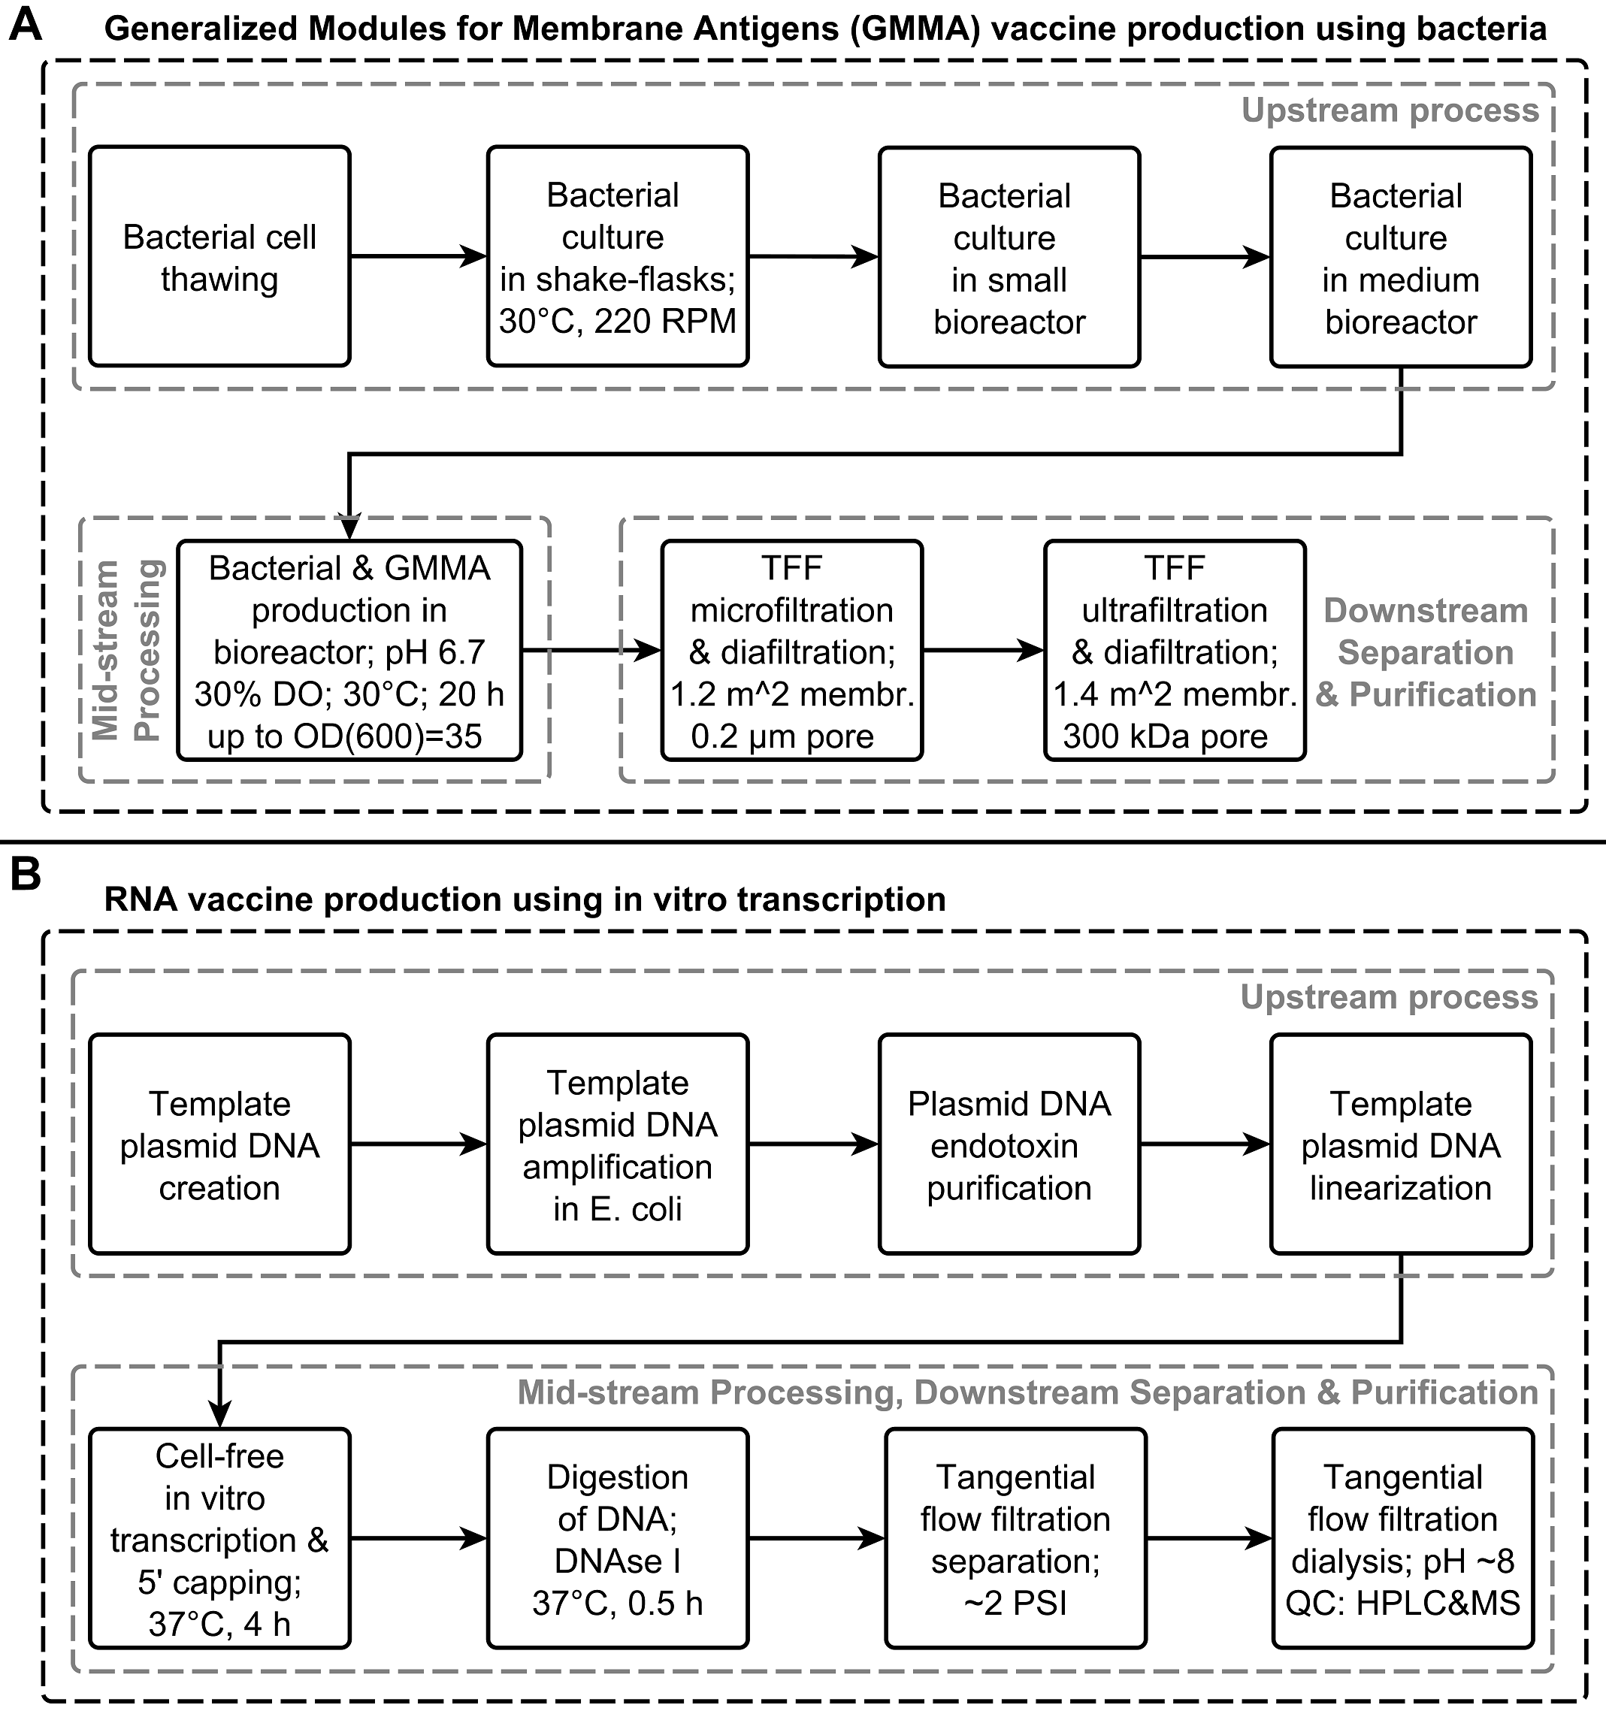

**Figure 3**. Operation scheme for the manufacturing of Generalized Modules for Membrane Antigens (GMMA) and RNA vaccines. **A.** GMMA vaccine production using gram-negative bacteria. GMMA are released constantly during bacterial culture and are separated using two sequential TFF steps [80]. **B.** RNA vaccine production using *in vitro* transcription. The self-replicating RNA, which encodes the antigen of interest, is transcribed from a DNA template using *in vitro* transcription, 5’ capped co-transcriptionally, the template DNA is digested and then purified using TFF [92,93].

# 6. RNA vaccine manufacturing

Nucleic acid (DNA or RNA) vaccines encode the antigen, and this vaccine antigen is produced in the cells of the patient. This way, a wide range of antigens can be expressed in the human body with the correct human-specific post-translational modifications. Large-scale manufacturing of RNA molecules or vaccines is uncharted and can pose challenges.

Currently there are no regulatory approved RNA vaccines, however, RNA antisense oligonucleotides and aptamer therapeutics are already clinically approved for the modulation of protein expression [94,95]. Short interfering RNA (siRNA) therapeutics are also being developed [95–97]. These RNA therapeutics are considerably shorter in length than RNA vaccines, however, these open avenues for clinically approving RNA vaccines. RNA vaccines are currently being tried clinically [98,99]. The efficiency of RNA vaccines can be improved when self-replicating RNA vectors are used instead of mRNA based vaccines [100,101]. Thus, current research focuses on using RNA-dependent RNA polymerase (aka. replicase) based RNA vaccines [102–104]. In the case of these replicase-based RNA vaccines, first the replicase is expressed and this allows the amplification of RNA template [100,101]. Non-viral delivery methods (e.g. nanoparticulate polyplex polyethylenimine (PEI) [105,106]) are preferred for RNA vaccines due to lower cost, ease of large-scale production, and improved safety potential [107–109].

Indeed, RNA vaccines were delivered into the cytoplasm using nanoparticulate cationic polyplexes[105,106] or liposomal formulations. The fully synthetic manufacture of RNA and ease of production allows the generation of thousands of doses within weeks after emerging pathogen identification. Constructs targeting strain diversity or multiple infectious disease targets can easily be combined. In addition, low infrastructure and equipment costs make it feasible to establish manufacture in low-income settings. Hereby, self-replicating RNA vaccine manufacturing was chosen for further analysis due to the ease of delivery using polyplexes or liposomes [110], effectiveness and non-mutagenic properties of self-replicating RNA vaccines, in comparison to DNA vaccines. The active pharmaceutical ingredient of the proposed RNA vaccine is a self-replicating RNA molecule (aka. RNA replicon) based on the alphaviral genome. This RNA molecule is 9000–12000 nucleotides long and encodes: (1) a non-structural protein that self-cleaves to release the helicase and replicase proteins required for replicon RNA duplication and (2) the antigen gene of interest. Flanking these coding genes, the replicon RNA also contains a 5’ untranslated region (UTR), a 3’ UTR, a 5’ capping sequence, and ploy(A) tail sequence. The self-replicating RNA molecule is produced using a cell-free *in vitro* transcription reaction, as illustrated in Figure 3B.

## 6.1. Upstream and mid-stream processing

First, the plasmid DNA which encodes the full length of the RNA replicon is created, by inserting the antigen-encoding gene at the correct location in the RNA replicon expressing sequence [92]. The RNA replicon is under the control of the T7 promoter and hence it is transcribed using the T7 RNA polymerase. The plasmid DNA is amplified in *Escherichia coli*, purified and linearized using two restriction enzymes [92].

The cell-free *in vitro* transcription (IVT) reaction, transcribes the replicon RNA from the DNA template using the T7 RNA polymerase enzyme and yields a complex mixture of DNA, RNA and protein enzymes [92]. The 5’ end of the RNA replicon can be capped during IVT by supplementing the reactions with m7GpppG cap structure analogues and by keeping the molar ratio of the cap molecule high relative to the first nucleotide (i.e. GTP) of the RNA sequence [92,111,112]. Alternatively, RNA can be capped in a separate step using vaccinia virus-derived capping enzyme. Here, potential cost trade-off emerges between the use of costly cap analogues in a single IVT reaction versus the use of a cheaper capping reaction that requires the introduction of an additional enzymatic manufacturing step.

The role of the 5’ cap in RNA vaccines is to: (1) prevent degradation by exonucleases, (2) promote translation, and (3) evade the innate immune response against RNA molecules [113]. The 3’ end of the RNA replicon can be polyadenylated during IVT by encoding the poly(A) tail on the DNA template [92]. DNAse I enzyme is added to the IVT reaction mixture to digest the template DNA molecules [92].

## 6.2. Separation and Purification

The replicon RNA molecule can be separated from the reaction mix using TFF based on size differences using polysulfone, polyethersulfone and polyethersulfone filter membranes modified for increased hydrophilicity [93]. Smaller molecular weight impurities (e.g. ribonucleoside triphosphates, small nucleic acid fragments, amino acids, etc.) pass through this membrane. The transmembrane pressure during TFF is normally around 2 psi (13790 Pa) and the shear rate is around 800 s-1 [93]. During TFF, buffer exchange (dialysis) can also be carried out, by flowing a new buffer into the TFF hollow fibre filter. The buffer is typically replaced with a buffer pH of around 8 with a total salt concentration of around 250 mM [93]. The total volume increase of the reaction mix during TFF is between 5 and 10 fold, a ratio of about final to initial volume of 8:1 is advantageous [93].

# 7. Discussion and technology comparison

Conventional vaccine manufacturing technologies are limited to producing only one vaccine or a very narrow range of vaccines, thus individual manufacturing processes need to be developed for each vaccine, making vaccine manufacturing process development costly and time-consuming. However, the cost of capital as well as construction time, and regulatory risk can be reduced, by installing single-use, disposable manufacturing equipment, while increasing flexibility [1,7,114,115]. Additionally, constructing manufacturing facilities in low- or middle-income countries, where vaccine demand is the highest, has the following advantages: lower real estate costs, lower construction material and construction labour costs, lower costs for low-skilled labour, lower costs for transporting the vaccine products to the communities in need of vaccination. However, this might require the import of specialized equipment, raw materials and high-skilled labour from developed countries. Moreover, vaccine-generated revenues are low due to: (a) insufficient funding available to cover vaccination costs in developing countries, and (b) epidemics vanishing by the time vaccines are made available [116].

The 4 new platform technologies described in sections 3, 4, 5 and 6 can be cost-effectively implemented using the above-described cost reduction strategies. More importantly, these can operate at low cost, with the flexibility to produce a wide range of vaccines for: (a) stopping the spread of future epidemics in low and middle-income countries by delivering 100,000 doses of vaccines within weeks after the identification of a new pathogen and, (b) allowing the immunization of 60 million infants per year at a cost of approximately $1 per dose. When reducing costs to ~1 $/dose, the last part of the manufacturing process (i.e. formulation, filling into the final delivery form, sealing, labelling and packaging) forms a fixed cost per dose which may come to dominate the total cost. Therefore, measures should be taken to reduce this fixed cost component.

To estimate the overall risk and feasibility of these 4 emerging vaccine manufacturing technologies, the following 6 metrics were developed and applied to each of these technology: (1) technology readiness, (2) technological complexity, (3) ease of up- or out-scalability, (4) flexibility, universal applicability for the manufacturing of a wide range of vaccines, (5) stability of the vaccine product at tropical ambient temperatures, and (6) speed of response from the identification of the nucleic acid sequence of a new threat antigen to vaccine deployment. For each of these 6 metrics, a rating from 1 (indicating challengingness or high risk) to 5 (indicating attainability with up to 5 years of R&D) was provided, based on information available in the literature and the expertise of the authors in vaccinology, molecular and cellular biology and manufacturing process development. Results from this risk and feasibility estimate rating are presented in Table 2 below.

For the technology readiness metric, the highest rating of 5 was allocated to the GMMA vaccines since regulatory-approved OMV vaccines exist [33,34], GMP grade GMMA production has already been described at pilot scale [80] , and GMMA vaccines have passed phase 1 (NCT03089879) and phase 2a (NCT02676895), and are now entering phase 2 clinical trials (NCT03527173). Thus, this technology appears mature enough for production-scale implementation within 5 years. The RNA platform comes in at 4, as RNA vaccines have reached phase 2 and 3 clinical trials and have been produced at pilot scale. The yeast platform was rated at 2 for technology readiness because although human glycosylation in yeast has been previously reported [52], human glycosylation has not yet been successfully implemented for humanized protein biomanufacturing in yeast. Vaccine development using this yeast platform is at the R&D stage however, yeast-based production-scale fermentation technologies are well-established. The ADDomerTM platform is rated at 3. Although the ADDomerTM multiprotein has only been produced at lab scale, and ADDomerTM based vaccines are in pre-clinical development, the insect cell-baculovirus platform has already been utilized for recombinant vaccine manufacturing. However, no ADDomer-based vaccines are yet subjected to clinical trials, thus their potential utility will require clinical evaluation.

The technological complexity metric assesses risks that can hinder the manufacturing process due to contamination by faster-growing micro-organisms, due to unstable products and production intermediates, or due to complex downstream processes. For this metric, 1 was allocated to the ADDomerTM platform due to bacterial and yeast contamination risks, and the GMMA platform was ranked at 5 since it is a bacterial manufacturing technology with simple downstream purification. The yeast platform was graded 3 for technological complexity since yeast-based manufacturing is robust, however: (i) it is still susceptible to bacterial contamination, (ii) the downstream purification is relatively complex, and (iii) the highly-engineered yeast might be sensitive to changes in culture conditions. The technological complexity of the RNA platform was estimated at 2, due to: (1) the relatively high degradation risk in the mid-stream process and downstream purification, due to contamination with RNAse or hydrolysis, and (2) sensitive enzymatic reactions.

For ease of up- or out-scaling, the GMMA platform was ranked at 5, since bacterial cells are robust and because the bioprocessing and downstream processing are simple and robust. The yeast platform was ranked at 4 for scalability since the robustness of these micro-organisms allows up-scaling, but the complexity of the downstream process increases the difficulty of both out- and up-scaling. The RNA platform was ranked at 3 for ease of scaling because the enzymatic reactions are in principle up- and out-scalable, and because the downstream purification is less complex than that of the GMMA or yeast platform. However, the ability for sustainable manufacture of long replicon RNA at scale has yet to be demonstrated. The ADDomerTM platform was ranked at 3 for scalability because insect cells are fragile under higher pressures and shear rates compared to yeast and bacteria, thus limit up-scaling, and because the complexity of the downstream process increases the difficulty of both out- and up-scaling.

In terms of flexibility, the technology with the highest rating of 5, within 5 years of R&D, can produce any kind of vaccines, including: proteins with human-like post-translational modifications (complex glycosylation), proteins embedded in lipid membranes, proteins in viral capsid-type complexes, proteins with bacteria-specific post-translational modifications, and bacterial polysaccharides. The low end of the flexibility spectrum, at 1, was attributed to technologies which can produce only one particular vaccine, and most, if not all, existing vaccine manufacturing technologies would fall under this rating. The RNA platform can express any type of protein antigen with the complex human glycosylation profile, however, it cannot produce bacterial polysaccharides and bacterial and parasite proteins are processed atypically, hence graded at 4 for flexibility. The yeast and ADDomerTM platforms are limited in producing bacterial polysaccharides, bacteria-specific post-translational modifications, and lipid membrane-embedded proteins, thus graded at 3. In contrast to humanized yeast expression, ADDomerTM molecules glycosylated post-translationally inside the cell cannot be currently expressed at high yields. Contrarily, recombinant proteins expressed in humanized yeast might require assembly into VLPs or embedding into membranes to achieve immunogenicity levels readily induced by the ADDomerTM platform. The GMMA platform was graded at 2 for flexibility, because it cannot yield human-specific post-translational modifications and viral capsid-like multiprotein complexes. However out of these platforms, GMMA is the most suitable for bacterial vaccines.

For thermostability, the high end of the scale, at 5, was set for vaccines which can have a half-life of at least 6 months at 40°C, with up to 5 years of R&D investment. ADDomerTM can be stabilized with disulphide bonds to increase its thermostability between 37°C and 45°C for several months [57], thus it seems that grade 5 for ADDomerTM thermostability is achievable. GMMA is stable at room temperature for weeks, hence its thermostability was estimated at 3. Recombinant vaccines yielded by the yeast platform would have a wide range of thermostabilities, however, in general, could be formulated in thermostable products, thus their thermostability was estimated at 3. RNA molecules are relatively fragile and can undergo hydrolysis or transesterification, even in the absence of RNAse enzymes [117], hence graded at 2 for thermostability. However, substantially increasing the thermostability of RNA vaccines appears feasible using lyophilization or ionic liquids, since this has already been achieved for DNA and siRNA molecules [118,119]. Lyophilization and ionic liquids can also increase the thermostability of the other vaccines presented here. Thermostability is crucial especially in the last part of the delivery process to reach isolated communities in tropical areas, in the absence of a cold-chain [120,121].

For speed of response, the RNA platform is rated at 5, due to the ease and speed of generating custom DNA template and RNA replicon sequences. The ADDomerTM platform is rated at 4, due to rapid genetic design offered by the MultiBacTM system. The GMMA platform is rated at 2 for the speed of response since genetic re-engineering of these OMVs is time-consuming. The yeast platform is rated at 1, since it requires advanced genetic re-programming and potentially generating a high-yield secretion cell line.

Finally, a uniformly weighted overall feasibility and risk estimate was calculated by summing up the values for each metric along the columns in Table 2 for each technology. This way, the technologies in the order of increasing near-term feasibility and decreasing risk are: (1) yeast platform, (2) ADDomerTM platform, (3) RNA platform, (4) GMMA platform. This comparative overview facilitates research prioritisation for further improving these platform technologies.

Table 2. Feasibility and risk assessment of the 4 emerging platform technologies described in sections 3, 4, 5, and 6.

|  |  |  |  |  |  |
| --- | --- | --- | --- | --- | --- |
| Platform a) Metric | | Yeast platform | ADDomer platform | GMMA  platform | RNA platform |
| 1 | Technology readiness | 2 | 3 | 5 | 4 |
| 2 | Technological complexity | 3 | 1 | 5 | 2 |
| 3 | Ease of scale-up and -out | 4 | 2 | 5 | 3 |
| 4 | Flexibility b) | 3 | 3 | 2 | 4 |
| 5 | Thermo-stability of product | 3 | 5 | 3 | 2 |
| 6 | Speed of response | 1 | 4 | 2 | 5 |
| Sum: overall feasibility and risk estimate c) | | 16 | 18 | 22 | 20 |

a)Yeast platform - Humanised, high-yield yeast platform for recombinant vaccine manufacturing; ADDomerTM platform - Insect cell-baculovirus platform for recombinant vaccine manufacturing; GMMA platform - Outer membrane vesicle vaccines, Generalized Modules for Membrane Antigen vaccine manufacturing; RNA platform - RNA vaccine manufacturing.

b) Universal applicability for the manufacturing of a wide range of vaccines.

c) The overall feasibility and risk estimate was calculated by summing up the values for each metric per technology.

As part of the roadmap towards full-scale commercialization, the technical and economic feasibility of these vaccine platform technologies should be evaluated in detail by modelling, simulating and optimizing the manufacturing processes and their respective supply chains. Thus, additionally to the above described 6 metrics, the capital costs (consisting mostly of facility construction, equipment and machinery costs) and operational & maintenance costs (consisting mostly of the costs of raw materials and consumables, labour cost and utility costs) should also be computed. For the techno-economically most viable vaccine platform technology, a pilot scale facility should be constructed, which can produce a wide range of high-demand or currently costly vaccines at low costs for clinical trials. To satisfy vaccine demands and to further reduce manufacturing costs, a production scale facility should subsequently be constructed. The profits should be reinvested in constructing more production-scale facilities which will contribute to meeting regional and international vaccine demands.

# 8. Conclusions

Existing vaccine manufacturing technologies have been reviewed and the following four promising future vaccine manufacturing technologies were evaluated: (1) humanised, high-yield yeast platform, (2) insect cell-baculovirus ADDomerTM platform, (3) GMMA vaccine platform; (4) RNA vaccine platform. The strengths and weaknesses of each of the 4 vaccine manufacturing platform technologies were assessed using the 6 metrics of technology readiness, technological complexity, ease of scale-up, flexibility, thermo-stability of product, and speed of response. This way, a detailed comparative picture of these 4 vaccine manufacturing platform technologies was obtained and based on this analysis measures can be taken to improve these vaccine platform technologies. The 4 emerging technologies were ordered by decreasing near-term feasibility and increasing risk as: (1) GMMA platform, (2) RNA platform, (3) ADDomerTM platform, (4) yeast platform. Future work is needed and being carried out to more accurately evaluate the techno-economic feasibility of these technologies and then build manufacturing facilities for the most viable technology.

**Acknowledgement**

The authors thankfully acknowledge Prof. Imre Berger and Dr. Frederic Garzoni (University of Bristol) for helpful discussions. The authors are grateful to the U.K. Department of Health and Social Care for funding the Future Vaccine Manufacturing Hub through the Engineering and Physical Sciences Research Council (EPSRC, grant number: EP/R013764/1).

**Conflict of interest**

The authors declare no financial or commercial conflict of interest.

**Figure 1**. Generic overview of vaccine manufacturing processes.

**Figure 2.** Operation scheme for the manufacturing of protein vaccines in humanised, high-yield yeast and in insect cell platforms. **A.** Recombinant protein vaccines production in humanised, high-yield yeast. Human-like complex glycosylation has been reported in yeast [52], however, this and high-yield secretion is not yet implemented at production-scale [7,52–54]. **B.** Bio-manufacturing of recombinant ADDomerTM multi-antigen vaccines using the MultiBacTM insect cell–baculovirus expression system [55–57]. The process was scaled up here based on recombinant HA protein expression for influenza vaccine manufacturing [10,58,59]. The grey arrows indicate the feeding back of excess insect cells from the 2500 L production bioreactor into the upstream process prior to viral infection.

**Figure 3**. Operation scheme for the manufacturing of Generalized Modules for Membrane Antigens (GMMA) and RNA vaccines. **A.** GMMA vaccine production using gram-negative bacteria. GMMA are released constantly during bacterial culture and are separated using two sequential TFF steps [80]. **B.** RNA vaccine production using *in vitro* transcription. The self-replicating RNA, which encodes the antigen of interest, is transcribed from a DNA template using *in vitro* transcription, 5’ capped co-transcriptionally, the template DNA is digested and then purified using TFF [92,93].

# 9. References

[1] S. Plotkin, J. M. Robinson, G. Cunningham, R. Iqbal, et al., Vaccine 35, 2017 4064–4071.

[2] A. Waye, P. Jacobs, A. B. Schryvers, Expert Rev. Vaccines 12, 2013 1495–1501.

[3] F. Qadri, in: GAVI Alliance Partner’s Forum, GAVI Partners’ Forum, Dar es Salaam, Tanzania, 2012.

[4] E. S. Pronker, T. C. Weenen, H. Commandeur, E. H. J. H. M. Claassen, et al., PLoS One 8, 2013 e57755.

[5] P. Wilson, Giving Developing Countries the Best Shot : An Overview of Vaccine Access and R & D, Switzerland, 2010.

[6] M. Datla, in: GAVI Alliance Partner’s Forum, GAVI Partners’ Forum, Dar es Salaam, Tanzania, 2012.

[7] E. P. Wen, R. J. Ellis, N. S. Pujar, Vaccine Development and Manufacturing, John Wiley & Sons, Inc., 2015.

[8] E. Vidor, B. Soubeyrand, Expert Rev. Vaccines 15, 2016 1575–1582.

[9] R. G. Webster, A. S. Monto, T. J. Braciale, R. A. Lamb, Textbook of Influenza, 2013.

[10] E. Milián, A. A. Kamen, Biomed Res. Int. 2015, 2015 1–11.

[11] R. S. Kallerup, C. Foged, in: C. Foged, T. Rades, Y. Perrie, S. Hook (Eds.), Subunit Vaccine Deliv., Springer International Publishing AG., New York, NY, 2015, pp. 15–30.

[12] B. R. Bloom, P.-H. Lambert, The Vaccine Book, 2nd ed., Elsevier, Academic Press, London, UK, 2016.

[13] H.-P. Meyer, W. Minas, D. Schmidhalter, in: C. Wittmann, J.C. Liao, S.Y. Lee, J. Nielsen, et al. (Eds.), Ind. Biotechnol. Prod. Process., Wiley, 2017.

[14] O. S. Kumru, S. B. Joshi, D. E. Smith, C. R. Middaugh, et al., Biologicals 42, 2014 237–259.

[15] R. W. Ellis, B. R. Brodeur, New Bacterial Vaccines, Springer US, New York, U.S.A., 2003.

[16] L. E. Gallo–Ramírez, A. Nikolay, Y. Genzel, U. Reichl, Expert Rev. Vaccines 14, 2015 1181–1195.

[17] I. Legastelois, S. Buffin, I. Peubez, C. Mignon, et al., Hum. Vaccines Immunother. 13, 2017 947–961.

[18] L. Chu, D. K. Robinson, Curr. Opin. Biotechnol. 12, 2001 180–187.

[19] S. Stephan, P. Michael, A. Sang‐Jeom, P. Adam, et al., Hansen. Polymorpha 2005.

[20] H. Yang, D. S. Kim, in: R.B.T.-A. in P.C. and S.B. Donev (Ed.), Pept. Protein Vaccines, Academic Press, 2015, pp. 1–14.

[21] B. J. Hos, E. Tondini, S. I. van Kasteren, F. Ossendorp, Front. Immunol. 9, 2018 884.

[22] Y. Pan, Y. Zhou, H. Wu, X. Chen, et al., Sci. Rep. 7, 2017 12534.

[23] G. P. Pijlman, Biotechnol. J. 10, 2015 659–670.

[24] Y. Gao, C. Wijewardhana, J. F. S. Mann, Front. Immunol. 9, 2018 345.

[25] M. Farzaneh, S.-N. Hassani, P. Mozdziak, H. Baharvand, Biotechnol. J. 12, 2017 1600598.

[26] S. Anticoli, F. Manfredi, C. Chiozzini, C. Arenaccio, et al., Biotechnol. J. 13, 2017 1700443.

[27] A. Jungbauer, Biotechnol. J. 13, 2018 1700749.

[28] P. Valenzuela, A. Medina, W. J. Rutter, G. Ammerer, et al., Nature 298, 1982 347–50.

[29] C. McNeil, JNCI J. Natl. Cancer Inst. 98, 2006 433.

[30] R. Kirnbauer, J. Taub, H. Greenstone, R. Roden, et al., J. Virol. 67, 1993 6929–6936.

[31] M. Deschuyteneer, A. Elouahabi, D. Plainchamp, M. Plisnier, et al., Hum. Vaccin. 6, 2010 407–419.

[32] A. L. Cunningham, N. Garçon, O. Leo, L. R. Friedland, et al., Vaccine 34, 2016 6655–6664.

[33] R. Acevedo, S. Fernández, C. Zayas, A. Acosta, et al., Front. Immunol. 5, 2014 1–6.

[34] J. Holst, P. Oster, R. Arnold, M. V Tatley, et al., Hum. Vaccin. Immunother. 9, 2013 1241–1253.

[35] G. Vernikos, D. Medini, Pathog. Glob. Health 108, 2014 305–316.

[36] B. S. Davis, G.-J. J. Chang, B. Cropp, J. T. Roehrig, et al., J. Virol. 75, 2001 4040–4047.

[37] B. Wahren, M. A. Liu, Vaccines 2, 2014 785–796.

[38] M. A. and J.-A. C. Leong, Recent Patents DNA Gene Seq. 7, 2013 62–65.

[39] C. L. Zuleger, C. Kang, E. A. Ranheim, I. D. Kurzman, et al., Vet. Med. Sci. 3, 2017 134–145.

[40] K. A. Wiedenmayer, S. Weiss, C. Chattopadhyay, A. Mukherjee, et al., Vaccine 27, 2009 655–659.

[41] F. P. Nasab, M. Aebi, G. Bernhard, A. D. Frey, Appl. Environ. Microbiol. 79, 2013 997–1007.

[42] S. Wildt, T. U. Gerngross, Nat. Rev. Microbiol. 3, 2005 119.

[43] J. M. Laurent, J. H. Young, A. H. Kachroo, E. M. Marcotte, Brief. Funct. Genomics 15, 2016 155–163.

[44] S. Larsen, J. Weaver, K. de Sa Campos, R. Bulahan, et al., Biotechnol. Lett. 35, 2013 10.1007/s10529-013-1290-7.

[45] K. R. Love, T. J. Politano, V. Panagiotou, B. Jiang, et al., PLoS One 7, 2012 e37915.

[46] S. Yang, Y. Kuang, H. Li, Y. Liu, et al., PLoS One 8, 2013 e75347.

[47] J. Nielsen, Bioengineered 4, 2013 207–211.

[48] P. P. Jacobs, S. Geysens, W. Vervecken, R. Contreras, et al., Nat. Protoc. 4, 2008 58.

[49] T. I. Potgieter, M. Cukan, J. E. Drummond, N. R. Houston-Cummings, et al., J. Biotechnol. 139, 2009 318–325.

[50] L. M. Damasceno, I. Pla, H.-J. Chang, L. Cohen, et al., Protein Expr. Purif. 37, 2004 18–26.

[51] A. Heath, P. Laing, Nematode Polypeptide Adjuvant, US2007/0053920A1, 2007.

[52] S. R. Hamilton, T. U. Gerngross, Curr. Opin. Biotechnol. 18, 2007 387–392.

[53] J. Stephenne, Vaccine 8, 1990 Suppl:S69-73, discussion S79-80.

[54] C. A. Schulman, R. W. Ellis, R. Z. Maigetter, J. Biotechnol. 21, 1991 109–125.

[55] D. J. Fitzgerald, P. Berger, C. Schaffitzel, K. Yamada, et al., Nat. Methods 3, 2006 1021–1032.

[56] I. Berger, F. Garzoni, M. Chaillet, M. Haffke, et al., J. Vis. Exp. 2013 50159.

[57] I. Berger, F. Garzoni, P. Fender, Adenoviral Coat Protein Derived Delivery Vehicles, WO2017167988A1; PCT/EP2017/057747, 2017.

[58] M. M. J. Cox, Vaccine 30, 2012 1759–1766.

[59] B. Buckland, R. Boulanger, M. Fino, I. Srivastava, et al., Vaccine 32, 2014 5496–5502.

[60] S. G. Sebastian, J. L. Vidal, J. A. M. Escribano, Baculovirus System for Expressing Proteins Forming Virus-like Particles, US9879280B2, 2015.

[61] H. Mabashi-Asazuma, D. L. Jarvis, Proc. Natl. Acad. Sci. 2017.

[62] V. A. Luckow, S. C. Lee, G. F. Barry, P. O. Olins, J. Virol. 67, 1993 4566–4579.

[63] I. Berger, A. Poterszman, Bioengineered 6, 2015 316–322.

[64] D. Sari, K. Gupta, D. B. Thimiri Govinda Raj, A. Aubert, et al., in: Adv. Exp. Med. Biol., United States, 2016, pp. 199–215.

[65] C. Geisler, H. Mabashi-Asazuma, D. L. Jarvis, in: A. Castilho (Ed.), Springer New York, New York, NY, 2015, pp. 131–152.

[66] D. Palmberger, M. Klausberger, I. Berger, R. Grabherr, Bioengineered 4, 2013 78–83.

[67] D. Palmberger, I. B. H. Wilson, I. Berger, R. Grabherr, et al., PLoS One 7, 2012 e34226.

[68] D. Sari, K. Gupta, D. B. T. G. Raj, A. Aubert, et al., in: M.C. Vega (Ed.), Springer International Publishing, Cham, 2016, pp. 199–215.

[69] I. Berger, D. J. Fitzgerald, T. J. Richmond, Nat. Biotechnol. 22, 2004 1583.

[70] P. Fender, K. Hall, G. Schoehn, G. E. Blair, J. Virol. 86, 2012 5380–5385.

[71] J. J. Skehel, M. D. Waterfield, Proc. Natl. Acad. Sci. U. S. A. 72, 1975 93–97.

[72] O. P. Zhirnov, M. R. Ikizler, P. F. Wright, J. Virol. 76, 2002 8682–8689.

[73] A. Kulp, M. J. Kuehn, Annu Rev Microbiol. 2012 163–184.

[74] L. van der Pol, M. Stork, P. van der Ley, Biotechnol. J. 10, 2015 1689–1706.

[75] L. Eun‐Young, C. Do‐Young, K. Dae‐Kyum, K. Jung‐Wook, et al., Proteomics 9, 2009 5425–5436.

[76] J. Rivera, R. J. B. Cordero, A. S. Nakouzi, S. Frases, et al., Proc. Natl. Acad. Sci. 107, 2010 19002–19007.

[77] R. Prados-Rosales, A. Baena, L. R. Martinez, J. Luque-Garcia, et al., J. Clin. Invest. 121, 2011 1471–1483.

[78] A. F. Ellen, S.-V. Albers, W. Huibers, A. Pitcher, et al., Extremophiles 13, 2008 67.

[79] G. Norheim, H. Sanders, J. W. Mellesdal, I. Sundfør, et al., PLoS One 10, 2015 1–23.

[80] C. Gerke, A. M. Colucci, C. Giannelli, S. Sanzone, et al., PLoS One 10, 2015 1–22.

[81] J. Klimentová, J. Stulík, Microbiol. Res. 170, 2015 1–9.

[82] D. J. Chen, N. Osterrieder, S. M. Metzger, E. Buckles, et al., Proc. Natl. Acad. Sci. 107, 2010 3099–3104.

[83] O. Koeberling, E. Ispasanie, J. Hauser, O. Rossi, et al., Vaccine 32, 2014 2688–2695.

[84] B. van de Waterbeemd, M. Streefland, P. van der Ley, B. Zomer, et al., Vaccine 28, 2010 4810–4816.

[85] B. van de Waterbeemd, G. Zomer, P. Kaaijk, N. Ruiterkamp, et al., PLoS One 8, 2013 e65157.

[86] B. van de Waterbeemd, G. P. M. Mommen, J. L. A. Pennings, M. H. Eppink, et al., J. Proteome Res. 12, 2013 1898–1908.

[87] C. A. MacLennan, Semin. Immunol. 25, 2013 114–123.

[88] O. Rossi, I. Pesce, C. Giannelli, S. Aprea, et al., J. Biol. Chem. 289, 2014 24922–24935.

[89] E. Meloni, A. M. Colucci, F. Micoli, L. Sollai, et al., J. Biotechnol. 198, 2015 46–52.

[90] G. De Benedetto, R. Alfini, P. Cescutti, M. Caboni, et al., Vaccine 35, 2017 419–426.

[91] F. Berlanda Scorza, A. M. Colucci, L. Maggiore, S. Sanzone, et al., PLoS One 7, 2012 e35616.

[92] N. Pardi, H. Muramatsu, D. Weissman, K. Karikó, in: P.M. Rabinovich (Ed.), Humana Press, Totowa, NJ, 2013, pp. 29–42.

[93] Scorza Francesco Berlanda, Yingxia Wen, Andrew Geall, Frederick Porter, RNA Purification Methods, 20160024139, EP2970948A1; WO2014140211A1, 2016.

[94] C. A. Stein, D. Castanotto, Mol. Ther. 25, 2017 1069–1075.

[95] J. C. Kaczmarek, P. S. Kowalski, D. G. Anderson, Genome Med. 9, 2017 60.

[96] C. Chakraborty, A. R. Sharma, G. Sharma, C. G. P. Doss, et al., Mol. Ther. Nucleic Acids 8, 2017 132–143.

[97] J. Chery, Postdoc J. a J. Postdr. Res. Postdr. Aff. 4, 2016 35–50.

[98] K. A. Hajj, K. A. Whitehead, Nat. Rev. Mater. 2, 2017 17056.

[99] N. Pardi, M. J. Hogan, F. W. Porter, D. Weissman, Nat. Rev. Drug Discov. 2018.

[100] W. W. Leitner, H. Ying, N. P. Restifo, Vaccine 18, 1999 765–777.

[101] J. A. Williams, Vaccines 1, 2013 225–249.

[102] A. B. Vogel, L. Lambert, E. Kinnear, D. Busse, et al., Mol. Ther. 2018.

[103] K. Ljungberg, P. Liljeström, Expert Rev. Vaccines 14, 2015 177–194.

[104] R. P. Deering, S. Kommareddy, J. B. Ulmer, L. A. Brito, et al., Expert Opin. Drug Deliv. 11, 2014 885–899.

[105] T. Démoulins, P. Milona, P. C. Englezou, T. Ebensen, et al., Nanomedicine Nanotechnology, Biol. Med. 12, 2016 711–722.

[106] T. Démoulins, T. Ebensen, K. Schulze, P. C. Englezou, et al., J. Control. Release 266, 2017 256–271.

[107] M. A. McNamara, S. K. Nair, E. K. Holl, J. Immunol. Res. Hindawi Publ. Corp. 2015, 2015 e794528.

[108] D. W. Pack, A. S. Hoffman, S. Pun, P. S. Stayton, Nat. Rev. Drug Discov. 4, 2005 581.

[109] R. Juliano, M. R. Alam, V. Dixit, H. Kang, Nucleic Acids Res. 36, 2008 4158–4171.

[110] L. A. Brito, S. Kommareddy, D. Maione, Y. Uematsu, et al., in: L. Huang, D. Liu, E.B.T.-A. in G. Wagner (Eds.), Nonviral Vectors Gene Ther., Academic Press, 2015, pp. 179–233.

[111] A. Wochner, T. Roos, T. Ketterer, Methods and Means for Enhancing RNA Production, US 2017/0114378 A1, 2017.

[112] A. N. Kuhn, M. Diken, S. Kreiter, A. Selmi, et al., Gene Ther. 17, 2010 961.

[113] A. Ramanathan, G. B. Robb, S.-H. Chan, Nucleic Acids Res. 44, 2016 7511–7526.

[114] A. Nigel, R. Jackie, J. Chem. Technol. Biotechnol. 89, 2013 1283–1287.

[115] R. Jacquemart, M. Vandersluis, M. Zhao, K. Sukhija, et al., Comput. Struct. Biotechnol. J. 14, 2016 309–318.

[116] P. Oyston, K. Robinson, J. Med. Microbiol. 61, 2012 889–894.

[117] M. Oivanen, S. Kuusela, H. Lönnberg, Chem. Rev. 98, 1998 961–990.

[118] E. Seelenfreund, W. A. Robinson, C. M. Amato, A.-C. Tan, et al., PLoS One 9, 2014 e111827.

[119] R. R. Mazid, U. Divisekera, W. Yang, V. Ranganathan, et al., Chem. Commun. 50, 2014 13457–13460.

[120] World Health Organization, in: Immun. Pract. A Pract. Guid. Heal. Staff - 2015 Updat. Non-Serial Publ., World Health Organization, ISBN: 9241549092, 9789241549097, 2015, pp. 1–46.

[121] J. Lloyd, J. Cheyne, Vaccine 35, 2017 2115–2120.