# Supplementary Information

CO2 capture and photocatalytic reduction using bifunctional TiO2/MOF nanocomposites under UV-visible irradiation

Angus Crake,a Konstantinos C. Christoforidis,a Andreas Kafizas,b Spyridon Zafeiratos,c Camille Petit*a

*a Department of Chemical Engineering, Imperial College London, South Kensington Campus, London SW7 2AZ, UK*

b *Department of Chemistry, Imperial College London, South Kensington Campus, London SW7 2AZ, UK*

c *Institut de Chimie et Procédés Pour l'Energie, l'Environnement et la Santé, (ICPEES) ECPM, University of Strasbourg, 25 rue Becquerel Cedex 2, Strasbourg, France*

*\* E-mail:*[*camille.petit@imperial.ac.uk*](mailto:camille.petit@imperial.ac.uk)*; Phone: +44 (0)20 7594 3182 (Petit C.)*



Figure S1. Photocatalytic gas/solid reactor setup used to evaluate photocatalytic CO2 reduction: 1) CO2 cylinder, 2) H2 generator, 3) mass flow controllers, 4) non‑return valves, 5) photoreactor, 6) xenon arc lamp, 7) pressure transducer, 8) gas chromatograph, 9) vacuum pump.

\\icnas4.cc.ic.ac.uk\agc10\PhD\Exp Data\Material Characterisation\TiO2NH2UiO66 (TiO2 syn)\TGA\FigureS2.tif

**Figure S2. Thermogravimetric curves of TiO2, NH2‑UiO‑66 and TiO2/NH2‑UiO‑66 nanocomposites (x‑TiMOF) under N2 atmosphere.**

**Table S1. Thermal gravimetric analysis of of TiO2, NH2‑UiO‑66 and TiO2/NH2‑UiO‑66 composites (x-TiMOF).**

|  |  |  |  |  |  |
| --- | --- | --- | --- | --- | --- |
|  | **Final mass (% mass)** | **Δmass lossa (% mass)** | **xTiO2*b* (% mass)** | **xNH2-UiO-66*c* (% mass)** | **xTiO2Theo*d* (% mass)** |
| TiO2 | 97.2 |  | 100.0 | 0.0 | 100.0 |
| 1-TiMOF | 89.0 | 35.1% | 81.0 | 19.0 | 80.0 |
| 2-TiMOF | 88.8 | 35.3% | 80.5 | 18.5 | 70.0 |
| 3-TiMOF | 86.6 | 32.7% | 75.5 | 24.5 | 60.0 |
| 4-TiMOF | 81.3 | 27.4% | 63.2 | 16.8 | 45.0 |
| NH2-UiO-66 | 53.9 |  | 0.0 | 100.0 | 0.0 |

*a*. Calculated: Δmass loss = TiO2 Final mass – Final mass, *b*. Calculated: xTiO2 = (Δmass loss)/(TiO2 Final mass – NH2‑UiO‑66Final mass), *c*. xNH2-UiO-66 = 1 - xTiO2, *d*. xTiO2 theo is the expected TiO2 content base on the unmodified NH2‑UiO‑66 synthesise yield



Figure S3. XPS survey spectra of the pure NH2-UiO-66 and TiO2 and the 2-TiMOF nanocomposite.



**Figure S4. High resolution XPS spectra in the region of : a) C1s, b) N1s and c) O 1s.**

**H:\PhD\Exp Data\Material Characterisation\TiO2NH2UiO66 (TiO2 syn)\Paper\Submission\FigureS5.tif**

Figure S5. N2 adsorption-desorption isotherms at -196 °C.

Table S2. Experimental and calculated BET surface areas for the photocatalysts.

|  |  |  |
| --- | --- | --- |
|  | **BETexp (m2 g-1)** | **BETcalca (m2 g-1)** |
| TiO2 | 42 | 42 |
| 1-TiMOF | 173 | 200 |
| 2-TiMOF | 202 | 204 |
| 3-TiMOF | 268 | 245 |
| 4-TiMOF | 284 | 347 |
| NH2-UiO-66 | 871 | 871 |

*a.* BETcalc = xNH2-UiO-66.BETNH2-UiO-66 + xTiO2.BETTiO2

Table S3. CO evolution rates for photocatalysts.

|  |  |  |
| --- | --- | --- |
|  | **CO (µmol g-1 h-1)***a* | **CO (µmol cm-2 h-1)***b* |
| TiO2 | 2.85 | 0.0019 |
| 1-TiMOF | 3.74 | 0.0025 |
| 2-TiMOF | 4.24 | 0.0028 |
| 3-TiMOF | 3.37 | 0.0022 |
| 4-TiMOF | 2.85 | 0.0019 |
| NH2-UiO-66 | 1.50 | 0.0010 |

*a.* 3 mg photocatalyst mass used, *b.* photocatalyst illumination area 4.5 cm2



Figure S6. a) Kulbelka-Munk absorption spectra and b) Tauc plot of TiO2, NH2‑UiO‑66 and TiO2/NH2‑UiO‑66 composites.

H:\PhD\Exp Data\Material Characterisation\TiO2NH2UiO66 (TiO2 syn)\Rxn\kinetics\Kinetics plot no fit.tif

Figure S7. 2-TiMOF photocatalytic CO evolution as a function of time.

H:\PhD\Exp Data\Material Characterisation\TiO2NH2UiO66 (TiO2 syn)\Rxn\recycle\recycle.tif

Figure S8. 2-TiMOF CO evolution repeated for three 6 h photocatalytic cycles.

H:\PhD\Exp Data\Material Characterisation\TiO2NH2UiO66 (TiO2 syn)\XRD\recycle\recycle figure.tif

Figure S9. 2-TiMOF XRD patterns before and after photocatalytic testing.

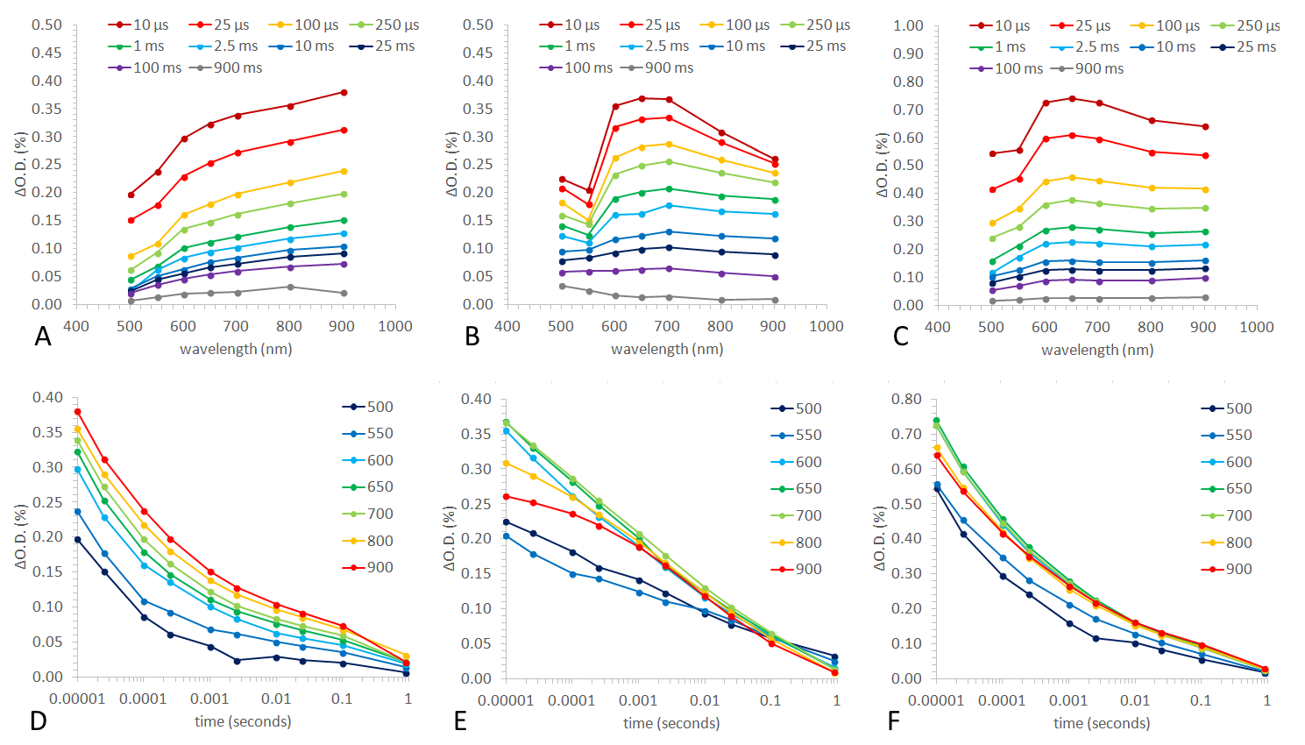

Figure S10. Transient absorption spectroscopy of pure TiO2 (A & D), NH2-UiO-66 MOF (B & E) and a composite 2-TiMOF (C & F) showing the transient absorption spectra at select times from 10 µs to 900 ms after a laser pulse (A-C) and the kinetics of charge carrier recombination at numerous wavelengths from 500 – 900 nm (D-F), [λexc = 355 nm, ~2 mJ.cm-2, 6 ns pulse width, 0.6 Hz].