Quantification of thermal residual stresses relaxation in AA7xxx aluminium alloy through cold rolling

Ran Pana*, Thilo Pirlingb, Jinghua Zhenga, Jianguo Lina, Catrin M. Daviesa

1. Department of Mechanical Engineering, Imperial College London, London SW7 2AZ, UK
2. Institut Laue-Langevin, No. 71 avenue des Martyrs, Grenoble 38042, France

**Abstract**

Residual stresses (RS) are often induced through quenching of aluminum alloys and present a potential risk of developing crack or distortion in subsequent manufacturing processes. Study of methods to minimise the RS in quenched components is of practical importance. In this paper, cold rolling (CR) has been carried out to remove the RS in quenched AA7050 blocks. The CR effect on relaxing RS in quenched AA7050 blocks has been evaluated via the neutron diffraction (ND), X-ray diffraction (XRD) and contour techniques. The results reveal that although CR transforms near-surface residual stresses from large compression to large tension along the rolling direction, it results in remarkable RS relief in the core part of the material. An integrated finite element model for RS evolution through the CR process was put forward and has been validated by the experimental results.

**Keywords:** Residual stress, numerical analysis, Neutron, X-ray, contour, cold rolling, quenching, stress relief

Nomenclature

|  |  |
| --- | --- |
| $$σ_{y}$$ | the yield stress of AA 7050 |
| *K* | drag stress |
| *E* | Young’s modulus |
| *H* | isotropic hardening parameter |
| $$σ$$ | total stress |
| $α_{k}$, $α_{B}$ | Expansion coefficients in the constitutive model |
| $$σ_{v}$$ | Mises equivalent stress |
| $$\overline{ρ}$$ | dislocation density |
| $$ε_{p}$$ | plastic strain |
| $$ε_{T}$$ | total strain |
| $$∆ε_{p}$$ | visco-plastic strain increment |
| $$∆ε_{e}$$ | elastic strain increment |
| $$∆ε_{t}$$ | thermal strain increment |
| $$∆ε_{T}$$ | total strain increment |
| *A, B, C1*,, , | material constants in the constitutive model |
| $Q_{K}$, $Q_{C_{1}}$, $Q_{E}$, $Q_{n_{1}}$ | Constants for the Arrhenius laws in the constitutive model |
| $$∆t$$ | Time Increment |
| $$θ_{hkl}^{0}, d_{hkl}^{0}$$ | $θ_{hkl}^{0} and d_{hkl}^{0}$ are the values of reference Bragg angle and lattice spacing. |
| $$Δθ_{hkl},Δd_{hkl}$$ | $Δθ_{hkl} andΔd_{hkl}$ are the values of Bragg angle and lattice spacing increment |
| $$ε_{hkl}$$ | The elastic strain of the $\left\{hkl\right\}$ crystallographic plane |
| $E_{hkl}$, $ν_{hkl}$ | $E_{hkl}$ and $ν_{hkl}$ are the elastic modulus and Poisson’s ratio of the $\left\{hkl\right\}$ crystallographic plane |
| $$σ_{ii}, ε_{ii}$$ | $σ_{ii} and ε_{ii}$ are the direct stress and strain, $ii$ (11,22,33) is the related index |

# Introduction

Many structural components are fabricated from heat-treated aluminium alloys, especially for aviation applications because of their low density and high stiffness to weight ratio. The process of solution heat treatment (SHT), quenching and subsequent precipitation hardening, is essential to strengthen these alloys and to achieve the formability required. Quenching, however, introduces large RS into components, especially extra-long components (> 5000 mm) which lead to component distortion and impacts their structural integrity during final machining, as described in Singh and Agrawal (2015). One conventional manufacturing process of an extra-long structural component includes a variety of steps as elucidated in Figure 1. A plate billet is firstly hot multiple-forged and SHTed for several hours and quenched in warm water to form the supersaturated solid solution. Hence, when the following multiple cold compression and ageing treatment cannot mitigate residual stresses to a sufficiently low magnitude, at the final machining step distortion or crack could be led by large quench-induced RS (> 200MPa).

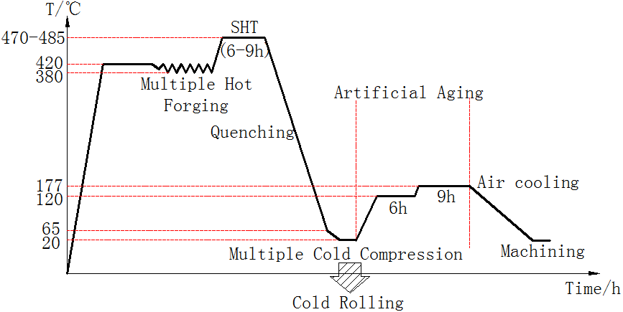

Figure 1 The schematic of the manufacturing process for extra-long aluminium alloy components

Therefore there has been significant work on RS mitigation techniques. Younger and Eckelmeyer (2007)analysed the effectiveness of heat and aging treatment on the RS map of a heat-treated aluminium satellite box. Their results indicated that compared with cold working techniques, aging treatments could only reduce the RS magnitude by 40 % and lead to a decrease in key material properties such as tensile strength and stiffness. Some innovative methods e.g. vibratory stress relief, uphill quenching treatment, multi-stage quenching and changing quenchant media, have been investigated by Rao, Wang et al. (2007), Croucher (1983), Jones (2014), Zhang, Deng et al. (2014) and Robinson, Tanner et al. (2014) for residual stress relaxation in components. Although these methods are effective in relieving RS in a material, regarding economy or material properties, the corresponding cost for reducing RS in extra-long components is quite high given the availability of equipment and existing capabilities.

Tanner and Robinson (2003) and Robinson, Pirling et al. (2017) investigated the effectiveness of cold working techniques, e.g. cold compression and cold stretching, on the RS distribution of heat-treated components. They revealed that these two methods could significantly mitigate the quenching-induced RS magnitudes by around 90 %. However, applying these techniques to extra-long components is inappropriate, e.g. aviation components over 5 m long. For cold stretching, handling problems could cause the asymmetric loading for extra-long components, making it difficult to adopt, as described by Koç, Culp et al. (2006). Also, provided that most extra-long components may have various curvatures, it is unavailable to apply the cold stretching technique. For cold compression, building a set of sufficient long die to cover the whole component is expensive, while Tanner and Robinson (2003)’s research showsthat multi-step cold compression could also induce a stress concentration around the surface of materials and in overlap regions of compression bites. In comparison to the methods mentioned above, cold rolling, given that it is relatively cost-effective and versatile, may be applied in relieving RS in heat-treated extra-long components.

Zhao and Zhang (2004) and De Giorgi (2011) ‘s research has indicated that CR can induce relatively large tensile RS (about 53% of its yield stress) being generated on the surface of the cold rolled material. Although De Giorgi (2011) revealed that, for AISI 301 stainless steel, the tensile RS existed (up to 35.4 % of the yield stress of AISI 301 steel) at the surfaces of the one pass rolled products, little research has been conducted to investigate the effectiveness of cold-rolling on RS mitigation in quenched material.

For this study, the influence of CR technique for relaxing the RS in heat-treated AA7050 specimens is evaluated, with the aim of developing a cost-effective method of mitigating the RS in extra-long Aluminium alloy products. ND, XRD and contour techniques have been carried out to quantify the residual stress distributions on (i) quenched-only and (ii) quenched & cold rolled specimens of AA7050 to study the influence of RS on mitigating the quench-led RS. Finite element (FE) analysis techniques have also been developed, employing a dislocation-based material model, to simulate the SHT process, quenching and subsequent CR to predict the RS evolution during the manufacturing process. These RS predictions were validated through the comparisons with experimental measurement results.

# Material and Experimental Preparation

AA 7050 aluminium forgings were provided by Aviation Industry Corporation of China (AVIC Ltd). The experimental geometries considered consisted of several blocks 62.0 × 62.0 × 25.4 mm3in dimensions. In industry, solution heat-treated components are often quenched in warm water (around 60~70 °C) as cold water (about 20 °C) could lead to relatively large RS. If a component were quenched in boiling water, it would constrain the generation of the desired super-saturated solid solution, although less RS would be generated. However, in this case, in order to investigate the influence of CR on RS evolution in 7050 Al alloy block, given the relatively small specimen size, cold water (20 °C) was used as the quenchant so as to maximise the quench-induced RS in the aluminium blocks, according to Robinson, Tanner et al. (2010) ’s study.

The material considered here were first heated to approx. 485 °C, held at temperature for 3 hours then rapidly cooled in agitated water at 20 °C, as described in Figure 2. The specimens were immersed in the water along their thickness direction such that the 62 × 62 mm2 face entered the water first. After quenching, some specimens were cold rolled, within half an hour of quenching, to minimise any natural aging effects. The average deformation ratio during rolling was 1%, 1.5% and 3%, using a 2 hi rolling mill with two rolls of diameter 140 mm and an angular velocity of 1 rad/s. The grease-based graphite lubricant was used. To guarantee the accuracy of various roll gaps, several HSS gages with specific thickness and a calliper were prepared and used.

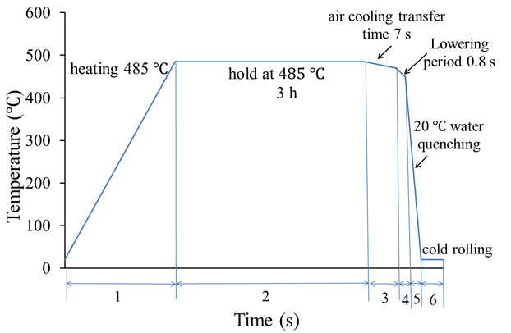

Figure 2. The schematic temperature profile of heat treatment and CR applied to the A7050 alloy blocks

## Material Property Characterisation

The dislocation based material model and calibration technique employed in this work have previously been described in Pan, Shi et al. (2016), however, a brief review is also provided here for completeness. The material’s constitutive behaviour was characterised through compression testing 8 mm diameter, 12 mm long cylindrical samples of AA7050 in the Gleeble 3800 thermo-mechanical test machine. Prior to compression testing, the test specimens were firstly heated to the SHT temperature in a furnace and held at that temperature for 3 h, subsequently, they were quenched in the water around 20 °C. After quenching, isothermal compression tests were performed at a series of temperatures from 20 to 450 °C and strain rates, from 0.01 to 1 $s^{-1}$, as shown by Pan (2017).

### Material model

For this work, a constitutive material model based on Cao, Lin et al. (2008) was employed. The constitutive equations for the material model are shown below:

|  |  |
| --- | --- |
|  | Equation 1 |
| $$\dot{\overline{ρ}}=A\left(1-\overline{ρ}\right)\dot{ε_{p}}-C_{1}{\overline{ρ}}^{n_{2}} ,$$ | Equation 2 |
| $$H=B\sqrt{\overline{ρ}} ,$$ | Equation 3 |
| $$σ_{total}=E\left(ε_{T}-ε_{p}-ε_{t}\right) ,$$ | Equation 4 |

where $σ_{total}$ is the total stress, $σ_{v}$ is the von Mises stress, *H* is the isotropic hardening parameter, $\overline{ρ}$ is the normalised dislocation density, $ε_{p}$ is the plastic strain, $ε_{T}$ is the total strain, $σ_{y}$ is yield stress, *K* is the drag stress, *E* is the Young’s modulus, and *A, B, C1,*  and are constants. Some parameters, e.g., yield stress $σ_{y}$ and drag stress *K*, are temperature-dependent and given by Equations 1-10:

|  |  |
| --- | --- |
| $K=K_{0}exp⁡\left(\frac{Q_{K}}{R_{g}T}\right)$, | Equation 5 |
| $$C_{1}=C_{1,0}exp\left(\frac{-Q_{C_{1}}}{R_{g}T}\right),$$ | Equation 6 |
| $$E=E_{0}exp\left(\frac{Q_{E}}{R_{g}T}\right),$$ | Equation 7 |
| $$n_{1}=n_{1,0}exp\left(\frac{Q_{n_{1}}}{R_{g}T}\right),$$ | Equation 8 |
| $σ_{y}=\frac{{σ_{y}}_{0}}{\cosh^{2}\left(α_{k}\left(T-T_{0}\right)\right)}$, | Equation 9 |
| $B=\frac{B_{0}}{\cosh^{2}\left(α_{B}\left(T-T_{0}\right)\right)} ,$ | Equation 10 |

The material model was calibrated using the results of these uniaxial compressive tests described above. The material constants determined are shown in Table 1.

Table 1**.** Material constants for the visco-plastic constitutive equations of AA7050.

|  |  |  |  |
| --- | --- | --- | --- |
| Material constant | Value | Material constant | Value |
| *A* | 15.62 | *C0* (s-1) | 2.99 |
| *n2* | 1.6 | *Qc* (J mol-1) | 5.88 |
| *k0* (MPa) | 166.12 | *B0* (MPa) | 255 |
| (1/°C ) | 4.11 | (1/°C) | 3 |
| *K0* (MPa) | 13.11 | *E0* (MPa) | 6.13 |
| *QK* (J mol-1) | 4.11 | *QE* (J mol-1) | 795.24 |
| *n1,0* | 0.69 | (J mol-1) | 6.81 |

# Thermo-Mechanical Quenching and Rolling Model

## FE modelling of Quenching and Cold Rolling Processes

Half of the specimen was modelled, employing symmetry conditions, as shown in Figure 3. The co-ordinate directions of FE model are defined such that *x* is along the rolling direction, *z* is transverse to the rolling orientation and *y* is through the thickness of the block and the origin is defined at the corner of the top surface about the block. The lowering direction of the component into water is shown in Figure 3 as well.

As the specimen has been held uniformly at SHT temperature for 3h, the RS due to the previous manufacturing processes can be removed, and it is logical to assume that the stresses in materials can be ignored before water quenching. Although quenching is a phenomenon of thermos-elastic-plasticity in materials, the materials’ temperature fields are mainly determined by the heat transfer in the material and at the material’s surface as any heat generation from plasticity during quenching is considered negligible, described by Tanner and Robinson (2000). Therefore, a sequentially coupled thermal-mechanical analysis was implemented for the quenching process. Three dimensional (3D), 8 node heat transfer elements DC3D8, were adopted in the thermal analysis and 8 node 3D continuum reduced integration elements, C3D8R, were adopted in the mechanical analysis as the C3D8 elements are considered overly stiff, as proposed by Tanner and Robinson (2003) and C3D8R elements improve the computational efficiency. The 3D roll model included 75,226 elements. The mesh close to the surface was refined, where large stress gradients are expected after rolling, to a minimum element size of 0.4 × 1 × 1 mm3 as shown in Figure 3. The mesh gradually changes to larger elements, of 1 mm cube in the core part.

In this work, the first stage of the model is to represent the block after removal from a furnace after solution heat treatment, *i.e.* the third section in Figure 2 where the block temperature is uniformly at 485 °C. As previously described, it took about 7 s to transfer the block in air from a furnace to a water pool. Then, the component cools down in the water, which remains constant and uniform at 20 °C.

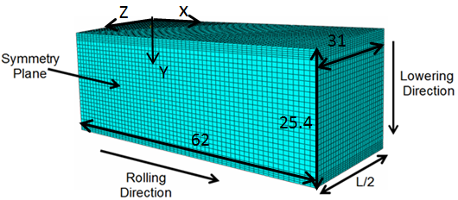

Figure 3. The half geometry of the block modelled indicated symmetry plane and illustration of the finite element mesh

Both radiation and convection heat transfer boundary conditions were applied to the block. Ambient temperature was also taken to be 20 $℃$ and the radiative emissivity ratio was set as 0.3, taken from Wen and Mudawar (2002). The convective heat transfer coefficient was 10 W/m2 K for natural convection in the air, as mentioned in Pan, Shi et al. (2016). For water quenching, the temperature dependent heat convection values, which were calibrated via a closed-form method to fit with the data from thermocouples, were adopted, as described in Pan (2017). Other temperature-dependent thermal properties of 7050 aluminium alloy, e.g. thermal conductivity, density and specific heat, were drawn from Koç, Culp et al. (2006).

For the cold rolling process, the rolls were assumed to be analytical rigid bodies as they are made of H13 steel. The final state of the quenched aluminium block in the FE model was used as the initial state of the CR model. For the CR process, under the lubricated condition, the friction coefficient between rolls and block was taken as 0.1 (data from Stolarski and Tobe (2000)). For the FE analysis, the effect of two work parameters, e.g. rolling deformation ratio and roll radius, on RS evolution in specimens was investigated. When the radius of both rolls is 70 mm, the deformation ratios of 0 %, 1%, 1.5 % and 3 % were simulated. The rolling cases of the roll radius 70 mm, 105 mm and 140 mm under the condition 1.5% rolling deformation ratio were predicted. A rolling horizontal velocity 70 mm s-1 was used for all analyses (i.e. 1 rad/s when the roll radius is 70 mm). The modelling of the cold rolling process consists of two displacement controlled steps: (a) the specimen is inserted into the roll gap with an arbitrary velocity (4 mm/s) before touching the rolls (b) once the specimen contacts with the rolls, the velocity of the specimen is determined by both rotating rolls. Since the plastic deformation is relatively small, the effect of heat generated by plastic deformation during rolling has been considered negligible.

# Techniques for Residual Stress evaluation

When selecting the RS measurement methods, not only their measurement accuracy but the availability of these techniques for in-field use should be considered. Generally, for measuring the RS in large-size aviation panels, despite the high requirement for measurement condition, non-destructive methods are ideal than destructive techniques, provided components’ integrity. The ND is applied in the case-study as in a lab environment this technique is often considered as a reference to check the effectiveness of other methods for evaluating RS distribution in ‘thick’ Al alloy materials. Given the complicated surface stress states from FE prediction shown later, for measuring surface RS profile, the low energy XRD was applied. Researchers, e.g. Nobre, Oliveira et al. (2014) and Nobre, Kornmeier et al. (2018), use the XRD technique as a reference to check the effectiveness of methods, e.g. HD technique, on RS measurement in various stress states. Additionally, a portable XRD stress analyser using a $cosα$ calculation method for plane stress conditions has been introduced in quite a few researches, e.g. Delbergue, Texier et al. (2017) and Tanner and Robinson (2016), etc. For destructive methods, although all suffer from systematic errors including the plasticity effect, as a complementary to non-destructive techniques, the contour was used in this case. Compared to the results from the ND method or (deep) hole drilling are confined to a line distribution, the contour has the advantage of being able to get detailed $σ_{xx}$ stress maps with acceptable accuracy in the specimens. After all, for extra-long components, the stress component aligned with the rolling direction is of most interest. According to Zhang, Yang et al. (2015), the contour is applicable for measuring RS in extra-long straight or curved panels. Hence, the ND, XRD and contour methods were applied which are described in detail in this section.

## Neutron diffraction measurement technique

ND is a well-established technique to non-destructively measure the RS deep within the material. ND measurements were conducted on the instrument SALSA using the reactor source of the Institut Laue-Langevin (ILL). A summary of the experimental procedure and the subsequent method for the data analysis are mentioned below. More information is inHutchings, Withers et al. (2005).

According to Pirling, Bruno et al. (2006), elastic strain can be determined through a shift of $2θ_{hkl}$ value for a specific crystallographic plane. This technique depends on the principle that elastic strain relies on the variation in lattice spacing $d_{hkl}$ achieved by differentiating Equation 11 at constant wavelength:

|  |  |
| --- | --- |
| $$ε_{hkl}=\frac{Δd_{hkl}}{d_{hkl}^{0}}=-cotθ_{hkl}^{0}Δθ_{hkl}$$ | Equation 11 |

where $Δθ_{hkl}$ is in radians and $θ_{hkl}^{0} and d_{hkl}^{0}$ are the values of reference Bragg angle and lattice spacing. The values must be obtained from measurements on stress-free reference coupons, as described by Schajer (2013). When residual strains have been recorded along three perpendicular directions, the principle stresses, $σ_{11}$, $σ_{22}$ and $σ_{33}$, can be determined from

|  |  |
| --- | --- |
| $$σ_{ii}=\frac{E_{hkl}}{1+ν_{hkl}}ε_{ii}+\frac{ν_{hkl}E_{hkl}}{\left(1+ν_{hkl}\right)\left(1-2ν_{hkl}\right)}\left(ε_{11}+ε_{22}+ε_{33}\right)$$ | Equation 12 |

where *ii* is the principle stress index, $ν_{hkl}$ and $E_{hkl}$ are the Poisson’s ratio and elastic modulus of the $\left\{hkl\right\}$ crystallographic plane, respectively.

Since the measurements are associated with a specific crystallographic plane, plane particular values of the Poisson ratio and elastic modulus are adopted in Equation 12. For Al alloy, the 311 lattice plane is recommended. Therefore the peak specific Poisson ratio, *v311* = 0.35 and elastic modulus, *E311* = 70.2 GPa, (data from Schajer (2013)), have been employed.

|  |  |  |  |
| --- | --- | --- | --- |
| a) |  | b) |  |

Figure 4 .a) The position of the ND measurements points in AA 7050 specimens; b) The location of reference coupons extracted from the specimen with the same treatment (all dimensions in mm).

ND measurements have been carried out on two specimens, one quenched-only and another quenched and 1.5% cold rolled. Since, through measuring the residual strains in a specimen along eight directions, Traore, Paddea et al. (2013)’s experimental results indicate the axes of the block specimens were almost aligned with the principal stress components. Thus, as illustrated in Figure 4, for the quenched only specimen, measurements were conducted at 46 points in the mid-length and mid-thickness of the block along rolling direction (line A-B), 24 points through the thickness of the block (along line C-D), and 26 points along the mid-width and mid-thickness of the block, transverse to the rolling direction (line E-F). All points were distributed evenly on three analysis lines. Results were achieved in the three perpendicular directions (i) the rolling direction, (ii) transverse to the rolling direction, (iii) through-thickness direction, which are considered to be the direct stress directions. A gauge volume of 2 × 2 × 2 mm3 was applied for the RS measurements of quenched only block.

For the quenched & cold rolled block, considered the FE predicted RS distribution is steady in the most of the specimen (shown later), measurements were only conducted along the line C-D (see Figure 4) across the part thickness. Given the interface friction effect between rolls and specimens, 54 measurement points were made at 0.5 mm intervals close to both surfaces, raising the increment to 1 mm for the region 2 mm below both surfaces. A gauge volume of 0.6 × 0.6 × 10 mm3 was adopted, achieving a higher special resolution close to the surface of the specimen, which is supposed to have relatively high RS gradients due to CR.

Cold rolling may cause the elongation of grain and further microstructural changes to specimens. As a consequence, it could lead to the variety of reference scattering angles in materials. As illustrated in Figure 4b, small cubes of dimensions 4 × 4 × 4 mm3, were extracted from a quenched-only specimen and a quenched & cold rolled specimen, which was considered nominally identical to those used for RS measurements, to achieve stress-free lattice parameter measurement results. The reference coupons were extracted from the mid-length and mid-thickness of the specimen along x-direction (line A-B) and through the thickness of the specimen at the mid-length and mid-width (line C-D). Considering that the dimension of length and width of these plates are basically the same, coupons from line A-B identified in Figure 4b are used in processing the data about diffraction angle from line E-F for the quenched block. During this measurement for the quenched specimen, the reference cubes were rotated to achieve the averaging $2θ_{0}$ reference Bragg values.

Figure 5(a), (b) and (c) illustrates the stress-free lattice parameter measurements in the quenched-only block and quenched & rolled block. Since no clear trends can be seen with position, hence the measurements achieved from every coupon along a given analysis path have been averaged and used in the following RScalculation. The average values are shown in Table 2. It should be noted that these values are different between two measurements because these results were achieved during two visits to the ILL. The wavelengths of the monochromatic radiation of the instrument were 1.68 Å for measuring the quenched & cold rolled block and 1.72 Å during the stress measurement of the quenched block.

|  |  |  |  |
| --- | --- | --- | --- |
| a) |  | b) |  |
| c) |  | | |

Figure 5. Stress-free lattice parameter measurements in the a) quenched-only sample (Cubes A-G-M);

b) quenched sample (Cubes 1-2-G-3-4); and c) quenched & cold rolled sample (Cubes 1-2-G-3-4).

Table 2 Average stress-free lattice parameter of AA 7050 samples

|  |  |
| --- | --- |
| Block condition | The average value (2*θ0 °*) |
| Quenched-only specimen (18 Points) | 95.5291° $±$ 0.0025° |
| Quench & Rolled specimen (5 Points) | 79.9393° $±$ 0.0086° |

## X-ray Diffraction Techniques

To measure the near-surface stresses in the quenched & cold rolled material, the Plustec $μ-X360$ X-ray diffractometer using the cos $α$ technique was employed. Before measurement, the Plustec $μ-X360$ X-ray stress analyser was calibrated by measuring a stress-free coupon of AA7050. To ensure the detector can capture the diffracted X-ray beam, the blocks were placed on a lifting platform, meanwhile, the angle between the sensor unit and horizontal plane could be adjusted manually or automatically. In this case, the angle between the X-ray incident beam and horizontal plane was $25°$. The axes of the specimens were aligned with the direct stress directions of the block, hence for each measurement point, two residual stress components along the x and z directions can be measured. To compare with experimental results of other techniques, the central points located at mid-length and mid-width of the top and bottom surfaces of quenched and quenched & cold rolled blocks were measured.

This device using a single tilt angle measured distortion in the full Debye circle shaped from diffraction from the 311 planes, as proposed in Hiratsuka, Sasaki et al. (2003) and Sasaki and Kobayashi (2009). The peak position arising from diffraction by the Al 311 planes were recorded and the related diffraction angle ($2θ$) ranged from 138 $°$ to 139 $°$. The elastic parameters were also taken from the reference Schajer (2013).

An array of X-ray measurements was conducted on the 62 × 62 mm2 top and bottom surfaces on four specimens rolled at various rolling deformation ratio (0%, 1%, 1.5%, 3%). For every measurement point, the XRD measurement was repeated at least three times to reduce the possible error and reliability of the measurement results. Each representative value presented in Figure 11, Figure 12 and Figure 16, is an average of three X-ray measurement results and the related standard deviations were calculated via equations from Kirk and Miller (1986).

## The contour measurement method

As a destructive RS measurement method, the contour technique can determine the stress distribution of the target plane via carefully cutting a specimen into two along the plane and recording the related displacement data caused by the stress/strain relief, as described by Johnson (2008). The specimen is firstly cut along the plane of interest via an electro-discharge machine (EDM). Then the out-of-plane deformation on the target surface can be measured using a coordinate measuring machine (CMM). The related displacement data is implemented as a surface boundary condition of an elastic FE model of the cut specimen and the stress distribution calculated. According to the theory of Bueckner’s superposition principle extended by Prime, Sebring et al. (2004), the calculated stress should be equal to the RS component in the material perpendicular to the cut plane that existed in the specimen before cutting.

|  |  |  |  |
| --- | --- | --- | --- |
| a) |  | b) |  |

Figure 6. a) Location of cutting plane indicating the cutting direction for the quenched only specimen and the quenched & cold rolled specimen; b) The FE mesh of quenched & cold rolled specimen.

The contour method was implemented on the quenched-only and quenched & rolled aluminium blocks. The blocks were EDM cut along the plane vertical to the symmetry plane of the FE model as shown in Figure 6a. During the cutting process, both sides of the specimens were clamped to minimise the deformation of the cutting planes. The cuts were made by a brass wire with a 0.125 mm radius. The machine was set to “skim cut” settings to mitigate the stress generated during EDM cut.

The physical geometrical characteristics of the deformed cutting planes were measured at the Open University through an experiment procedure same with that reviewed in Traore, Paddea et al. (2013). A 1.5 mm radius Reinshaw PH10M touch trigger probe mounted on a Mitutoyo Crysta Plus 574 co-ordinate measuring machine was used. For measurement results, an accuracy of 4.9 μm can be achieved. For both blocks, the measurements were implemented in a 0.25×0.25 mm2 grid and the profiles of the perimeter of both cutting surfaces were recorded as well, giving between 23,600~24,600 points on each cut surface.

To minimise the deviation between the actual cut surface and the original cut surface caused by stress relaxation during cutting, the blocks were constrained from moving through clamping the material on both sides of the cut. For each block, the two displacement data sets of both cutting surfaces were averaged to minimise the anti-symmetric errors (because of the shear stress caused by wire or the artefacts) and the result was updated by fitting spline bivariate smoothing splines using Matlab to avoid the possible localized stress peaks in the following numerical analysis caused by the noise of the raw data. Similarly, the two data sets about the perimeters of both surfaces were also averaged to form the common perimeter and this perimeter has been applied in building the perimeter of the FE model. The optimum knot spacing was chosen by the calculated stress results from 0.5 mm to 4 mm at 0.5 mm intervals. A fitting error could be obtained through the root-mean-square of all the nodal stress difference between the stress about the current knot spacing and that of the previous, coarser spacing spline solution. The detail can be found in Prime, Sebring et al. (2004).

3D FE models of the quenched and quenched & cold rolled blocks were built in ABAQUS employing symmetry condition. The element size at the cutting surface was 0.5 × 0.5 × 0.15 mm3 and the mesh biased at the cut surface and transitioned to increasingly larger elements, of maximum size 0.5 × 0.5 × 1.5 mm3, as shown in Figure 6b. Consequently, the model of the quenched specimen has 126,198 reduced integration, quadratic hexahedral brick elements (type C3D20R) and 535,200 nodes, among them, 20,281 nodes are at the cutting surface. For the model of the quenched & cold rolled specimen, it has 127,889 elements with the same element type and 542,408 nodes, among them, 20,554 nodes are cutting surface nodes. The processed displacement data were imposed as the boundary conditions of the cut planes. The material behaviour was isotropic and linearly elastic with a Poisson’s ratio of 0.35 and a bulk modulus *E* of 70.2 GPa. In addition, the boundary conditions that were imposed in the FE model were that the *y* and *z*-directions of a node at the centre of the other surface of the model (opposite to the cut surface) were fixed and the *y-*direction of another node at the same surface was constrained as well so as to restrict the movement of the half block and its rotation.

# Experimental results and discussion

## The Quenched Block

The RS profiles of the quenched block along the rolling direction (line A-B) and through the thickness of the specimen (line C-D) can be seen in Figure 7 and 11, respectively, in the three measurement directions. The stresses distribution of the post-quench block along line E-F is also measured, as illustrated in Figure 8, the tendency of RS is quite similar to that of line A-B. As described in Figure 7(b) and (c), the components of RS post quenching through the thickness and transverse directions, *σyy* and *σzz,* are compressive at the surface of the component. Since the thickness of the plate is much smaller than the length of the other two sides, the peak value of the tensile stress in stress component $σ_{yy}$ is lower than that of $σ_{xx} and σ_{zz}$. As expected, in the rolling direction, $σ_{xx}$ measured near the free surface of the specimen tends to zero. In Figure 7(a) a large tensile residual stress (90 % of uniaxial as-quenched yield strength $σ_{yield(quench)}$ approx. 250 MPa, data from Robinson, Tanner et al. (2014)) exists in the core. In addition, for the transverse component $σ_{zz}$ in Figure 7(c), the *z*-component tensile RS reaches its highest value around 235 MPa. At the surface, the $σ_{yy}$ RS is compressive and becomes tensile at an approximate distance 5 mm from the surface (i.e. edge effect). Towards the core region of the material, $σ_{yy}$ tends to zero. In general, the fitting uncertainty in the RS along rolling direction of the quenched-only specimen ranged from $±$ 4 MPa to $±$ 7 MPa.

|  |  |  |  |
| --- | --- | --- | --- |
| a) |  | b) |  |
| c) |  | | |

Figure 7 . Comparison of the ND (symbols) and FE simulation (solid lines) results of the RS measured along line A-B in the a) longitudinal (x); b) normal (y); and c) transversal (z) directions.

|  |  |  |  |  |  |
| --- | --- | --- | --- | --- | --- |
| a) | | |  | b) |  |
| c) |  | | | |

Figure 8. Comparison of the ND (symbols) and FE simulation (solid lines) results of the RS measured from surface to core along line E-F in the a) longitudinal (*x*); b) normal (*y*); and c) transversal (*z*) directions.

Figure 9a displays the averaged and smoothed deformation data of both cut surfaces of the quenched specimen which were measured via a CMM. The optimum knot spacing that was implemented to fit bivariate splines with the displacement data chosen via a method introduced by Prime, Sebring et al. (2004) about the relationship between the average stress uncertainty and different knot spacing. Figure 9b shows the contour result about quenched specimen has the smallest error when the knot spacing is 3 mm and the stress uncertainties are still large although the data about knot spacing 1 mm or 2 mm were smoothed as well. Though not shown for brevity, the influence of mesh size and knot spacing was examined and little influence was seen for the cases considered. $σ_{xx}$ stresses distribution along CD line were almost the same for models with element sizes of 0.50 × 0.50 × 0.15 mm3 and 1.00 × 1.00 × 0.15 mm3.

|  |  |  |  |
| --- | --- | --- | --- |
| a) |  | b) |  |

Figure 9. a)The averaged and smoothed contours created by the cuts and evaluated at surface nodal locations of FE contour model; b)The quench-induced stress uncertainties about determining the optimum knot spacing in the bivariate smoothing spline.

a) 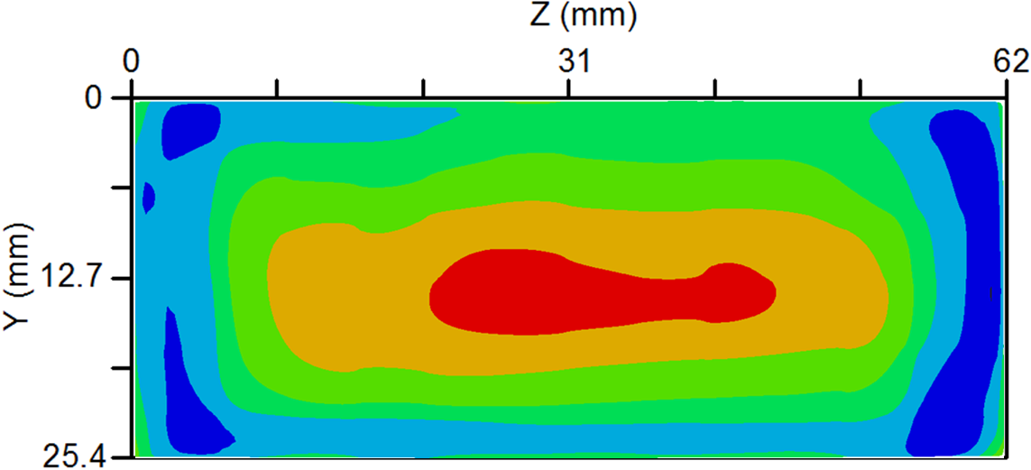

b) 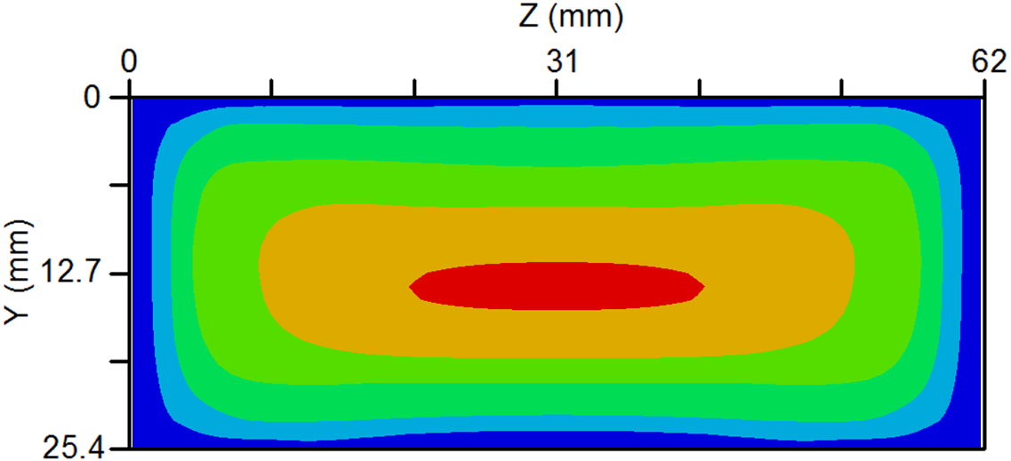 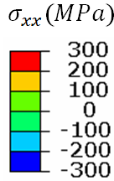

Figure 10. The comparison of quenched-induced $σ_{xx}$ residual stress maps of cutting plane between a) contour result; and b) FE result.

The RS maps calculated from the smoothed displacement data of the cut surfaces of quenched blocks are shown in Figure 10. A magnitude of peak tensile RS (232 MPa) at the core and a magnitude of peak compressive RS approaching 93.8 % of $σ_{yield(quench)}$ around the surface of the block were measured. It can be illustrated that the FE predicted RS is more symmetric than the contour result as the thermal boundary condition is assumed to be same for the whole block surfaces. In reality, the anisotropy of material due to forging orientation and the subsequent additional material loss during EDM cutting all could lead to the inaccuracy of cutting surface profile measurement and induce the asymmetries in the stress calculation.

|  |  |  |  |  |
| --- | --- | --- | --- | --- |
| a) |  | b) |  | |
| c) | |  | | |

Figure 11. Comparison of the Neutron, X-ray diffraction, contour and FE simulation results of the quench-induced residual stresses measured along line C-D in the a) longitudinal (*x*); b) normal (*y*); and c) transversal (*z*) directions

The ND results are compared to the data from other measurement methods in Figure 11. Due to the square nature of the geometry, the stress distribution of *x* and *z*-components ($σ_{xx} and σ_{zz}$) are very similar in the thickness (y) direction. Similarly, with contour result in Figure 10, Figure 11(a) and (c) indicate that the stress distribution is asymmetric. This variation is probably due to the fact that the bottom side of the block (*y* = 25.4 mm along the thickness position) touched the water first when it is lowered. Figure 11(a) and (c) illustrate, at 5 mm from the surface they become tensile and approximately constant at 9 mm from the surface with peak values of over 215 MPa, respectively. The *y*-component RS $σ_{yy}$ is approx. zero at the centre of the block.

For the $σ_{xx}$ RS map along the line CD of the contour result in Figure 11a, the large tensile $σ_{xx}$ RS (88 % of $σ_{yield(quench)}$) exists at the core part and a magnitude of peak compressive RS about 195 MPa close to the material surface is detected via contour method. Similar stress distribution between the contour result, ND result and FE result can be observed. Like ND result, the contour result also shows that the magnitude of compressive RS at the bottom surface of the quenched block is larger than that of the top surface due to the lowering direction of quenching.

Regarding the X-ray result, the $σ_{xx}$ and $σ_{zz}$ RS of top surface of the material are about 70% and 74% of the $σ_{yield(quench)}$ respectively. The fitting error of $σ_{xx}$ and $σ_{zz}$ stress component for the $cosα$ technique are about $±$ 29 MPa and $±$ 28 MPa, respectively. For the bottom surface, the stress value of $σ_{xx}$ and $σ_{zz}$ were around the uniaxial yield magnitude. The corresponding fitting uncertainties are similar with that of the top surface.

Generally, considering the results of different measurement methods and FE analysis, the stress distribution of the FE model matches well with the ND, XRD and contour measurements. For the measurement results of the quenched specimen, it can be found that for some RS components, their RS magnitude is slightly smaller or larger than the yield stress $σ_{yield(quench)}$ of as-quenched 7050 aluminium alloy. Given the Von Mises criteria, it is reasonable the magnitude of RS close to a surface can be larger than the uniaxial yield strength by a small degree.

Additionally, the uncertainties of measured neutron stress result of quenched specimen range from $±$ 3.6 MPa to $±$ 6.7 MPa, which were subject to a systematic fitting error of the Gauss algorithm. For the asymmetric RS map through the thickness direction of the aluminium block, the deviation between both sides of quenched block approaches approx. 45 % $σ_{yield(quench)}$.

## The quenched and cold rolled block

### FE prediction of rolling deformation ratio effect on RS relaxation in quenched & cold rolled specimen

In Figure 12, the RS distribution after rolling deformation ratios of 0%, 1 %, 1.5 % and 3 %, via 70 mm radius rolls, were predicted in FE and the most effective ratio subsequently used. The RS distributions predicted through the thickness of the block, at its mid-length and its mid-width, are shown in Figure 12. Post cold rolling, $σ_{xx} and σ_{zz}$ tensile RS appear at the material surfaces and leave RS in the central part remarkably relieved. The effect of deformation ratio on $σ_{yy}$ RS distribution in quenched and cold rolled block is relatively small. At the measurement positions of both surfaces in Section 4.2, the comparison of RS magnitude between the XRD results and the FE results have been shown and the good agreement is obtained. The magnitude of these surface RS were found to increase with the degree of the rolling deformation ratio adopted.

|  |  |  |  |  |  |
| --- | --- | --- | --- | --- | --- |
| a) |  | | b) |  | |
| c) |  | | |

Figure 12. Comparison of X-ray Diffraction (Dots) and FE Predicted (lines) stress results along a) longitudinal (*x*); b) normal (*y*); and c) transversal (*z*) directions in the quenched and cold rolled aluminium blocks along line C-D.

### FE prediction of roll radius effect on RS relaxation in quenched & cold rolled specimen

As shown in Figure 13, it can be seen that for the core part of the material, during rolling via larger rolls, $σ_{xx}$ and $σ_{zz}$ RS have a further limited decrease after external loading removal. The $σ_{xx}$ and $σ_{zz}$ tensile stress magnitude along CD’ line close to both surfaces have also been investigated but no significant change was found. The various roll radii have no remarkable influence on the $σ_{yy}$ stress distribution. Hence, it can be summarized that, under average 1.5% rolling deformation ratio, the roll radius varying from 70 mm to 140 mm could be relatively poor sensitive to the RS reduction.

|  |  |  |  |
| --- | --- | --- | --- |
| a) |  | b) |  |
| c) |  | | |

Figure 13. FE Predicted stress distribution along a) longitudinal (x); b) normal (y); and c) transversal (z) directions in the quenched and cold rolled aluminium block under different roll radius along line C-D.

Generally, it seems a case of average rolling deformation ratio of 1.5 % via a set of rolls with 70 mm roll radius is the optimum condition in relaxing the stresses $σ_{xx}$ and $σ_{zz}$ at the core of the block. Therefore, due to limited beam time, a block under the optimum work condition was selected for the neutron and contour measurements.

## Verification of FE cold rolling models via experimental data

For the contour measurement, the fitted displacement of both cut surfaces of quenched & 1.5% cold rolled specimen was measured via a CMM as illustrated in Figure 14a. For the quenched and 1.5% cold rolled block, Figure 14b illustrates the contour result with 2.5 mm knot spacing has the smallest error, thus the contour result under this condition was adopted in the analysis. For the mesh density effect, the $σ_{xx}$ stress distribution along CD line for both models with different element size is almost the same.

|  |  |  |  |
| --- | --- | --- | --- |
| a) |  | b) |  |

Figure 14. a) The averaged and smoothed contours created by the cuts and evaluated at surface nodal locations of contour model; b) The stress uncertainties of quenched and rolled specimen about determining the optimum knot spacing in the bivariate smoothing spline.

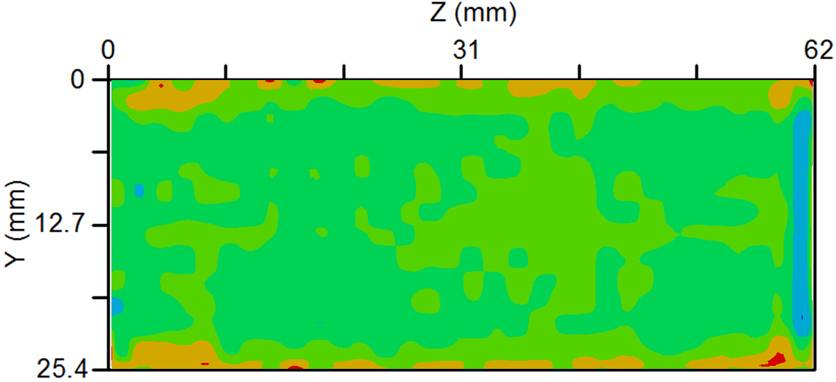

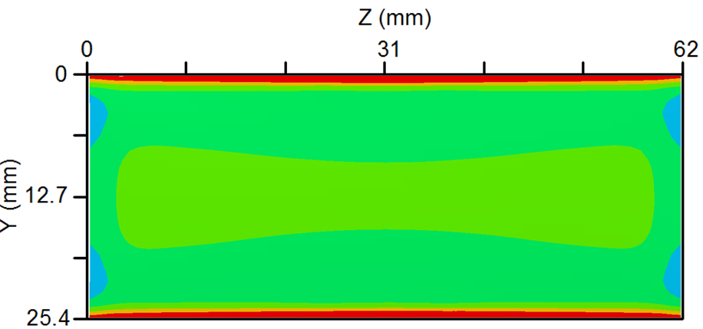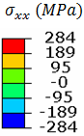

Figure 15. The comparison of $σ_{xx}$ RS maps of cutting plane of quenched & cold rolled block between a) contour result; and b) FE result.

Figure 15 shows the measured and FE predicted $σ_{xx}$ RS maps for quenched & 1.5% cold rolled specimen. Generally, the comparisons are in good agreement, considering the measured error due to the material loss via EDM cutting e.g. the possibility of the plasticity of the cutting tip during cutting (which will be discussed later). Both results all indicate the similar tendency of stress distribution. For $σ_{xx}$ stress, the quench induced compressive stress at the surfaces is turned into tensile stress while leaving the residual stress in the core part significantly relaxed. However, for the magnitude of surface RS, the deviation between the contour and FE results could be up to 80 MPa.

|  |  |  |  |
| --- | --- | --- | --- |
| a) |  | b) |  |
| c) | |  | | |

Figure 16. Comparison of the Neutron, X-ray diffraction, contour and FE simulation results of the residual stresses measured along line C-D of quenched & cold rolled specimen in the a) longitudinal (*x*); b) normal (*y*); and c) transversal (*z*) directions.

As illustrated in Figure 16, in general, the contour result and neutron, X-ray experimental results show good agreement with each other. It shows after rolling, for the stress distribution along CD line, tensile surface RS exist while the original tensile RS in the core part has been remarkably relieved. Since the depth of the tensile RS region is shallow (approx. 1.5 mm), the RS layout is an advantage for the final machining process of forming aviation components because the regions that tensile stresses exist will be removed (no less than 60% material will be machined for the final machining, as described in L.Chen (2016) and Zheng, Pan et al. (2018)), leaving the core part with low RS.

The forward slip during the rolling process may be able to explain the phenomena above. According to Hwang and Tzou (1997) ‘s study, the velocity of the block is faster than that of both rolls between the neutral point and the exit point of the rolls. As a whole, the materials near both surfaces have to keep the uniform velocity with the inner materials. Meanwhile, they are also constrained by the backward friction due to rolls, tuning the quench-induced compressive stresses into large tensile stresses around the material surfaces.

Additionally, for less than 3% cold rolling, the thickness reduction (no more than 0.76 mm) is much smaller than the block thickness, hence the interface friction could only influence the stress profile around the surfaces. For the core material, the cold rolling plays a similar role with the cold compression technique. Hence, after rolling pressure (stress component vertical to specimen surfaces) removal, the quench-induced tensile stress in the centre of material is significantly relieved, as illustrated in Figure 17.

|  |  |  |  |
| --- | --- | --- | --- |
| a) |  | b) |  |
| c) |  |

Figure 17. Contour plot of the FE predicted longitudinal residual stress $σ_{xx}$ within Plane of Symmetry during cold rolling, with different work conditions. a) Specimen geometry profile; b) 1.5% cold roll and 70 mm roll radius; c) 3% cold roll and 70 mm roll radius.

For ND result shown in Figure 16, along with the thickness direction, for the longitudinal component $σ_{xx}$, tensile RS were recorded within an area around 1.5 mm below the surface which have the largest values of 77% of the $σ_{yield\left(CR 1.5\%\right)}$, approx. 320 MPa, data from (Pan, Shi et al. 2016). Relatively low compressive RS (no more than 31 % of the $σ_{yield\left(CR 1.5\%\right)}$) exists in the core part of the quenched & cold rolled specimen. This region with large tensile RS is balanced by a wide range of region having compressive RS approx. -100 MPa at distances 2 mm from both surfaces. For the $σ_{zz}$ stress component, the rolling process also has relaxed the $σ_{zz}$ RS magnitude in the transverse direction.

The largest difference between ND result and FE result is illustrated in Figure 16(b), regarding with ND result, tensile RS appears around the top surface while the stress magnitude near the bottom surface is around 0. Although it was initially thought that the $σ_{yy}$ residual stress along CD line of the cold rolled specimen should still be close to 0, the ND result shows that relatively large $σ_{yy}$ residual stress fluctuated around 0, ranging from -75.3 MPa to 80.2 MPa.

For the deviation of quenched & cold rolled specimen between the ND measurements and other techniques’ results, it may be caused by the adoption of the average reference scattering angle, ${2θ}_{0}$ determined from the stress-free material. According to Wimpory and Boin (2011) and Withers, Preuss et al. (2007) studies, given the effects of different factors on determining reference lattice parameters, i.e. the phenomena that the $θ_{0}$ varies from position to position along analysis path (A-B line or C-D line) in Figure 5. Hence, for the stress calculation of the cold rolled specimen, the application of the average ${2θ}_{0}$ value could lead to the large stress variation. In other words, the average reference scattering angle may not represent the reference scattering angle measurements of the whole material.

Four samples with the size of 6 mm × 6 mm × 4 mm were cut along the thickness direction from the near-surface and core regions of one quenched & 1.5% cold rolled block and one quenched only block to check the possible factor that can affect the $θ_{0}$ value in this case. Before any characterization procedure, all samples were polished mechanically for several hours and a further polishing of OP-S for 30 min and then etched by the Keller’s solution for 20 s. The optical micrographs of the AA 7050 aluminium alloy samples are in Figure 18.

|  |  |  |  |
| --- | --- | --- | --- |
| a) |  | b) |  |
| c) |  | d) |  |

Figure 18. Grain structure of the AA7050 samples a) at the core part of quenched and rolled block; b) close to the surface of quenched and rolled block; c) at the core part of quenched only block; d) close to the surface of quenched only block (The scale is 50 $μm$)

The grain structures from the centre and near-surface regions of the cold rolled block are shown in Figure 18. Compared with relative uniform grains in the whole quenched material (Figure 18(c) and (d)), after cold rolling, the grains are significantly elongated along the rolling direction for the entire block. Furthermore, the grains in the near-surface region are finer than those in the centre region of the specimen. For example, as indicated in Figure 18b, the average length (dl) of the elongated grains in the subsurface region is 17.0 $μm$ in Figure 18b, whereas the corresponding value in the centre region is 19.8 $μm$ in Figure 18a.

As the thermal and elastic characteristics of variously oriented grains due to cold rolling could be quite different (the source of type II RS, as proposed by Withers and Bhadeshia (2013)), it can partially explain the variation of ${2θ}_{0}$ diffraction angle in Figure 5. In addition, it can be found, the difference between every measured ${2θ}_{0}$ value for the quenched block is relatively small than that of the quenched and cold rolled block. Hence, although the ND result for the cold rolled material has acceptable accuracy and shows the RS redistribution, the method of applying the average ${2θ}_{0}$ value that is available for the quenched specimen may not get the result with the same accuracy for the quenched and cold rolled one. As in Figure 5 there is no clear tendency for ${2θ}_{0}$ values, further study should be required on how to choose a better reference diffraction angle for the RS calculation.

Since the neutron diffraction technique can record the combined stresses including phase/grain independent macro-stress (type I) and grain stress (type II), as described by Wyatt, Berry et al. (2007) (The related shifts of peak $2θ$ are contributed by the type I and type II stresses), for this study the errors of the neutron result near the cold rolled surfaces may be caused by the adoption of average reference scattering angle, ${2θ}_{0,311}$.

For the contour result, it did not detect the relatively large tensile residual stress at both surfaces of quenched & cold rolled material which also proves the complexity of stress distribution close to the quenched & cold rolled material surfaces. Although the contour result agrees well with the corresponding FE result in the core, for the regions close to both surfaces of specimens under different conditions, the surface residual stress magnitude determined via contour is lower than the stress value measured by neutron or X-ray. The phenomena imply that plastic deformation may occur at the cut surface of the specimen during EDM sectioning, proposed by Kapadia (2014). For the quenched & cold rolled specimen, if the tensile RS appearing at the surfaces’ regions is large enough, it could induce the deformation of the material at the tip of the EDM cut. This means the width of material removed in the regions close to the surface has been reduced compared with the ideal state. Hence, if the $σ_{xx}$ stress shown in Figure 15 is applied on the deformed surfaces, it may not make the surfaces back to flat. In other words, it could cause an error in the surface stress calculation if a cut tip displacement occurs.

Although there is some error in each measurement technique, for the RS measurement of quenched and cold rolled components, given the following conditions:

1. For forming extra-long aviation panel-type components, no less than 60% material will be removed during final machining.
2. Apart from two regions having edge effect, i.e. within 2 mm to both ends. The RS distributions in most regions of a quenched & cold rolled component are consistent (See Figure 15-17).

A combination of XRD method, contour method and FE simulation could be applied in investigating RS distribution in extra-long aviation components. For the contour method, although there is surface stress deviation between ND and contour results, it can indicate the thickness of the layer containing tensile RS which could guide the pattern of the final machining. Additionally, for the cutting plane, it can be a plane within the steady RS region and close to one end. For extra-long straight or curved panels, the contour method can be applied at each step before the final machining.

Additionally, according to Robinson, Tiernan et al. (2015) ‘s study, for large-size components, the post-quench delay (PQD, the time interval between quenching and the following mechanical stress relief method) is also one of the factors to affect the effectiveness of the cold working process on RS distribution in materials. Since the longer PQD will aggravate the difference in work-hardening behaviour between the core and surfaces of quenched materials, thus a shorter PQD period would lead to a better potential RS mitigation. Compared to the cold compression technique of which apparatus, e.g. a set of huge dies, require lots of space the cold rolling mill with a set of rolls only takes limited space. Hence, given the industrial condition, it could be relatively easier to put the mill and the huge pool in one place (e.g. workshop). As a consequence, for straight or curved extra-long components, it is possible to roll the materials within a short time after quenching.

# CONCLUSIONS

The CR effect on the distribution of RS in heat-treated AA7050 specimens has been evaluated via the ND, XRD and contour techniques. The comparison of the ND, XRD results and the FE data demonstrate a good agreement. However, for the quenched specimen, there is a stress difference between predicted compressive RS and those measured by experimental methods, in a narrow region close to the top surface of the specimen. In addition, for the quenched and rolled specimen, the RS measured by ND & XRD techniques and those predicted by FE are much larger than the contour result, in a small region close to both surfaces of the material. The error source of ND technique may be the application of average reference diffraction angle. For the possible error source of contour results, it could be caused by the cut tip displacement. The agreement of the RS predictions and that measured by contour techniques was improved via including smoothed displacements in the contour method analysis. The results of this research can be summarised as below.

* FE simulation and experimental results indicate that the cold rolling technique is able to relieve RS in heat-treated components. It can avoid the spatial variation of stresses caused by overlap region during multiple cold compression.
* Both numerical and experimental results indicate that cold water quenching the AA 7050 specimens leads to large magnitude RS that vary from biaxial surface compression (up to 254 MPa) to tension in the core over 220 MPa.
* The RS in quenched specimen were completely redistributed after CR. When rolling deformation ratio is approx. 1.5% and roll radius is 70 mm. The tensile RS in the central part of the material were turned into compressive RS with low magnitude (no more than -100 MPa) while leaving large tensile RS (>150 MPa) around the material surfaces. Except the regions influenced by the edge effect, the RS distribution in most of the specimen is consistent.
* The surface tensile stresses are mainly attributed to the interface friction and the rolling pressure (perpendicular to the material surfaces) contributes to the relatively lower RS magnitude in a wide region of the core part of the material.

# Future work

Although tensile RS exists at both surfaces of cold rolled blocks, the depth of regions that tensile stress exists is shallow. Provided the above conditions and following factors,

* 1. The subsequent multistage ageing, shown in Figure 1, could further relieve approx. 40% RS in the material, as proposed by Zheng, Pan et al. (2018) and Younger and Eckelmeyer (2007);
  2. Low RS consistently exists in the central part of the material;

1. For extra-long aviation components, more than 60% material is usually removed during the machining process.

hence, if the cut depth of a milling machine or an EDM, etc., in one go can be larger than the thickness of the layer containing tensile RS, the possibility of the occurrence of unacceptable part distortion of a component during final machining may be low as only the core material with low RS remains. However, despite above research results, it needs further evidence to confirm that the possibility will be low as the material removal during final machining could break the original stress self-equilibrium and lead RS redistribution in the rest material which may be a potential source of distortion.

Therefore, to guide a novel manufacturing method including the cold rolling process to form extra-long aviation component with low RS, the effect of the subsequent over-ageing and final machining processes on the material properties should be further numerically and experimentally investigated.

**Acknowledgement**

The author would like to acknowledge the financial support from the First Aircraft Institute of Aviation Industry Corporation of China. The research, which the project number is 2014DFA51250, was carried out at the AVIC Centre at Imperial College London. Dr Catrin M. Davies acknowledges the support of EPSRC, UK for the support under grant EP/I004351/1. We also acknowledge the Institute Laue-Langevin for the allocation of neutron beam-time and the dataset doi:10.5291/ILL-DATA.1-02-166.

# References

Cao, J., J. Lin and T. A. Dean (2008). "An implicit unitless error and step-size control method in integrating unified viscoplastic/creep ODE-type constitutive equations." International Journal for Numerical Methods in Engineering **73**(8): 1094-1112.

Croucher, T. (1983). "Uphill quenching of aluminum: rebirth of a little-known process." Heat Treating **15**(10): 30-34.

De Giorgi, M. (2011). "Residual stress evolution in cold-rolled steels." International Journal of Fatigue **33**(3): 507-512.

Delbergue, D., D. Texier, M. Levesque and P. Bocher (2017). "Comparison of two X-Ray residual stress measurement methods: Sin2 ψ and Cos α, through the determination of a martensitic steel X-Ray elastic constant." Materials Research Proceedings **2**.

Hiratsuka, K., T. Sasaki, K. Seki and Y. Hirose (2003). "Development of measuring system for stress by means of image plate for laboratory X-ray experiment." International Centre for Diffraction Data, Advances in X-ray Analysis **46**: 61-67.

Hutchings, M. T., P. J. Withers, T. M. Holden and T. Lorentzen (2005). Introduction to the characterization of residual stress by neutron diffraction, CRC press.

Hwang, Y.-M. and G.-Y. Tzou (1997). "Analytical and experimental study on asymmetrical sheet rolling." International Journal of Mechanical Sciences **39**(3): 289-303.

Johnson, G. (2008). Residual stress measurements using the contour method, University of Manchester.

Jones, R. M. (2014). "Prediction of residual stress and distortion from residual stress in heat treated and machined aluminum parts."

Kapadia, P. (2014). "Experimental and numerical analysis of creep cracking under secondary and combined loading."

Kirk, J. and M. L. Miller (1986). Reliability and validity in qualitative research, Sage.

Koç, M., J. Culp and T. Altan (2006). "Prediction of residual stresses in quenched aluminum blocks and their reduction through cold working processes." Journal of Materials Processing Technology **174**(1-3): 342-354.

L.Chen (2016). The fabrication method of 7050 Aluminium Alloy T-type Panel. Internal Report, First Aircraft Institute of Aviation Industry Corporation of China.

Nobre, J., M. Kornmeier and B. Scholtes (2018). "Plasticity effects in the hole-drilling residual stress measurement in peened surfaces." Experimental Mechanics **58**(2): 369-380.

Nobre, J. P., M. Oliveira, A. Albertazzi, M. Viotti, A. C. Batista, L. Coelho and M. J. Marques (2014). Assessing shot-peening residual stresses by using the incremental hole-drilling technique and laser interferometry (DSPI). Advanced Materials Research, Trans Tech Publ.

Pan, R. (2017). A Novel Process for Forming T-Section Components with Low Residual Stresses in Aluminium Alloys. PHD, Imperial College London.

Pan, R., Z. Shi, C. M. Davies, C. Li, M. Kaye and J. Lin (2016). "An integrated model to predict residual stress reduction by multiple cold forging operations in extra-large AA7050 T-section panels." Proceedings of the Institution of Mechanical Engineers, Part B: Journal of Engineering Manufacture: 0954405416673097.

Pirling, T., G. Bruno and P. J. Withers (2006). "SALSA—A new instrument for strain imaging in engineering materials and components." Materials Science and Engineering: A **437**(1): 139-144.

Prime, M. B., R. J. Sebring, J. M. Edwards, D. J. Hughes and P. J. Webster (2004). "Laser surface-contouring and spline data-smoothing for residual stress measurement." Experimental Mechanics **44**(2): 176-184.

Rao, D., D. Wang, L. Chen and C. Ni (2007). "The effectiveness evaluation of 314L stainless steel vibratory stress relief by dynamic stress." International Journal of Fatigue **29**(1): 192-196.

Robinson, J., D. Tanner and C. Truman (2014). "50th Anniversary Article: The Origin and Management of Residual Stress in Heat‐treatable Aluminium Alloys." Strain **50**(3): 185-207.

Robinson, J., P. Tiernan and J. Kelleher (2015). "Effect of post-quench delay on stress relieving by cold compression for the aluminium alloy 7050." Materials Science and Technology **31**(4): 409-417.

Robinson, J. S., T. Pirling, C. E. Truman and T. Panzner (2017). "Residual stress relief in the aluminium alloy 7075." Materials Science and Technology **33**(15): 1765-1775.

Robinson, J. S., D. A. Tanner, C. E. Truman and R. C. Wimpory (2010). "Measurement and Prediction of Machining Induced Redistribution of Residual Stress in the Aluminium Alloy 7449." Experimental Mechanics **51**(6): 981-993.

Sasaki, T. and Y. Kobayashi (2009). "X-ray multiaxial stress analysis using two debye rings." Adv X-ray Anal **52**: 248-255.

Schajer, G. S. (2013). Practical residual stress measurement methods, John Wiley & Sons.

Singh, A. and A. Agrawal (2015). "Investigation of surface residual stress distribution in deformation machining process for aluminum alloy." Journal of Materials Processing Technology **225**: 195-202.

Stolarski, T. and S. Tobe (2000). "Rolling contacts."

Tanner, D. and J. Robinson (2003). "Modelling stress reduction techniques of cold compression and stretching in wrought aluminium alloy products." Finite elements in analysis and design **39**(5): 369-386.

Tanner, D. A. and J. Robinson (2000). "Residual stress prediction and determination in 7010 aluminum alloy forgings." Experimental Mechanics **40**(1): 75-82.

Tanner, D. A. and J. S. Robinson (2016). "Time transient validation of residual stress prediction models for aluminium alloy quenching." Materials Science and Technology **32**(14): 1533-1543.

Traore, Y., S. Paddea, P. Bouchard and M. Gharghouri (2013). "Measurement of the residual stress tensor in a compact tension weld specimen." Experimental Mechanics **53**(4): 605-618.

Wen, C.-D. and I. Mudawar (2002). "Experimental investigation of emissivity of aluminum alloys and temperature determination using multispectral radiation thermometry (MRT) algorithms." Journal of materials engineering and performance **11**(5): 551-562.

Wimpory, R. C. and M. Boin (2011). "Emphasizing the accuracy of the uncertainty of residual stress determination using neutron diffraction." Procedia Engineering **10**: 1639-1644.

Withers, P. J. and H. K. D. H. Bhadeshia (2013). "Residual stress. Part 1 – Measurement techniques." Materials Science and Technology **17**(4): 355-365.

Withers, P. J., M. Preuss, A. Steuwer and J. W. L. Pang (2007). "Methods for obtaining the strain-free lattice parameter when using diffraction to determine residual stress." Journal of Applied Crystallography **40**(5): 891-904.

Wyatt, J., J. Berry and A. Williams (2007). "Residual stresses in aluminum castings." Journal of materials processing technology **191**(1): 170-173.

Younger, M. S. and K. H. Eckelmeyer (2007). "Overcoming residual stresses and machining distortion in the production of aluminium alloy satellite boxes." Sandia Report SAND2007-6811, Sandia National Laboratories.

Younger, M. S. and K. H. Eckelmeyer (2007). Overcoming residual stresses and machining distortion in the production of aluminum alloy satellite boxes, Sandia National Laboratories.

Zhang, J., Y. Deng, W. Yang, S. Hu and X. Zhang (2014). "Design of the multi-stage quenching process for 7050 aluminum alloy." Materials & Design (1980-2015) **56**: 334-344.

Zhang, Z., Y. Yang, L. Li, B. Chen and H. Tian (2015). "Assessment of residual stress of 7050-T7452 aluminum alloy forging using the contour method." Materials Science and Engineering: A **644**: 61-68.

Zhao, L. and Y. Zhang (2004). Computer simulation of residual stress of cold rolling pre-stretch board. Intelligent Control and Automation, 2004. WCICA 2004. Fifth World Congress on, IEEE.

Zheng, J.-H., R. Pan, C. Li, W. Zhang, J. Lin and C. M. Davies (2018). "Experimental investigation of multi-step stress-relaxation-ageing of 7050 aluminium alloy for different pre-strained conditions." Materials Science and Engineering: A **710**: 111-120.