**Title: Assessing the vulnerability of freshwater crayfish to climate change**

**Running title: Vulnerability of crayfish to climate change**

**List of Authors:** M. Anwar Hossain1, *, José J. Lahoz-Monfort1, Mark Burgman2, Monika Böhm3, Heini Kujala1, Lucie M. Bland4

**\*Corresponding author:** M. Anwar Hossain, tel: +61451769682, e-mail: [anwar79du@gmail.com](mailto:anwar79du@gmail.com)

**Institutional affiliations:**

1 School of BioSciences,The University of Melbourne, Parkville, Victoria 3010, Australia

2 Centre for Environmental Policy, South Kensington, Imperial College London, United Kingdom

3 Institute of Zoology, Zoological Society of London, Regent's Park, London NW1 4RY, United Kingdom

4 Centre for Integrative Ecology, School of Life and Environmental Sciences, Deakin University, Burwood, Victoria 3125, Australia

**ACKNOWLEDGEMENTS**

This study was supported by the University of Melbourne’s postgraduate research scholarship, grant from Australian Wildlife Society, Drummond Travel Award, and BioSciences Travel Award. LMB is funded by a ‘Veski Inspiring Women Fellowship’, MoBö is funded by the Rufford Foundation and the ZSL Mission Opportunities Fund, JJLM and HK are funded by Australian Research Centre Discovery Project grant DP160101003. We are also grateful to the IUCN Red List Unit for the open access to spatial data sources. We thank Dr Jane Carey for her comments on the abstract and Dr Wendy Foden from the IUCN Climate Change Specialists’ Group for her comments and feedback.

**ABSTRACT**

**Aim:** Climate change is one of the major threats to the persistence of biodiversity. Global assessments highlight the most climate-vulnerable species and geographic regions based on species traits and measures of exposure to climate change. Yet the majority of climate change vulnerability assessments have focused on terrestrial and marine vertebrates and largely ignored freshwater species and invertebrates. We present the first global analysis for 574 species of freshwater crayfish (Families: Astacidae, Parastacidae, and Cambaridae) using IUCN’s trait-based vulnerability assessment protocol.

**Location:** Global.

**Methods:** We collected species-specific information on sensitivity (eight traits), adaptive capacity (four traits), and exposure (five traits) to climate change, and combined those dimensions to assess overall species vulnerability.

**Results:** Our results predicted that 87% of freshwater crayfish species are highly sensitive to climate change (primarily due to habitat specialization), 35% have low adaptive capacity, and 57% are highly exposed (based on an ensemble mean of four general circulation models for a moderate IPCC scenario: RCP6.0). Combining sensitivity, low adaptive capacity, and exposure, we assessed 87 species (15%) as vulnerable to climate change. Climate change-vulnerable species are distributed globally, with high concentrations in the south-eastern USA (36 species), south-eastern Australia (21 species), and Mexico (10 species) reflecting global patterns of crayfish species richness. Of the 91 species listed as threatened by climate change in the IUCN Red List, 18 species were predicted to be climate change vulnerable in this study.

**Main conclusions:** We identified hotspots of species vulnerable to climate change that require further conservation attention. The IUCN trait-based protocol can help identify data gaps and key traits that should be investigated further, and thus help overcome major knowledge shortfalls on the effects of climate change. Our study provides key insights for the application of climate change vulnerability assessment to data-poor invertebrates, which remain low in global conservation priorities.

**KEYWORDS:** Climate change, vulnerability, sensitivity, exposure, adaptive capacity, freshwater crayfish, traits, freshwater biodiversity.

**INTRODUCTION**

Freshwater ecosystems are some of the most threatened on earth and contain disproportionate numbers of threatened species (Collen *et al.*, 2014), yet remain largely neglected in global conservation priority-setting. Over the past centuries, humans have modified the majority of land and aquatic areas through overexploitation, habitat destruction/degradation, flow modification, pollution and introduction of exotic species (Dudgeon *et al.*, 2006). Land use change is expected to exceed all other drivers of decline for freshwater biodiversity by 2100, exacerbating risks from other sources (Sala *et al.*, 2000). The Intergovernmental Panel on Climate Change (IPCC) estimates that 20–30% of the world’s species are likely to be at high risk of extinction from climate change impacts within this century (IPCC, 2014), while the combined effects of climate change and increased water consumption are predicted to cause the loss of up to 75% of local fish diversity by 2070 (Xenopoulos *et al.*, 2005).

Climate is the predominant environmental driver that shapes the biogeography of freshwater organisms at large spatial scales and affects their thermal ecology, growth and performance (Poff *et al.*, 2010). Changes in climate may affect the persistence of freshwater species through a number of mechanisms. Species may be highly sensitive to change due to narrow environmental tolerance (e.g., intolerance to changes in temperature, precipitation and dissolved oxygen; Bone *et al.* 2014, Nussey *et al.* 2005), dependence on specialized habitats, changing interspecific interactions (Rahel & Olden, 2008), and rarity (i.e., abundance). Species may also be exposed to sea-level rise and temperature and precipitation changes (Furse *et al.*, 2012). Changes in precipitation and flow regime due to climate change have already been observed in many parts of crayfish species’ ranges, and these changes are expected to continue under future climate change scenarios (Hughes, 2003; Karmalkar & Bradley, 2017). Some species may have low adaptive capacity to climate change due to poor dispersability (e.g., low dispersal capability, limited habitat availability and dispersal barriers, leading in conjunction with other factors to restricted ranges) and/or poor evolvability (e.g., small reproductive output and long life span), so may not be able to adapt readily to climate-driven changes (Foden *et al.*, 2013).

Because the impacts of climate change on species are diverse, multiple methods have been developed to assess species’ vulnerability to climate change. For example, correlative distribution models are used to estimate species’ realized niches and are applied to a wide range of taxa at various spatial scales, although the approach requires access to adequate species’ occurrence data (Wiens *et al.*, 2009). Mechanistic models are developed from field studies and laboratory experiments on a particular taxon, but they are not applicable to species lacking detailed physiological or life-history data (Moore *et al.*, 2013; Pacifici *et al.*, 2015). The IUCN Red List of Threatened SpeciesTM has been criticized for under-representing slow-acting threats (e.g., climate change; Keith *et al.* 2014, but see Pearson *et al.* 2014). Trait-based approaches may be useful for poorly-known species and have been used to complement IUCN Red List assessments (Böhm *et al.*, 2016).

Trait-based vulnerability assessment protocols integrate species’ biological and ecological characteristics (i.e., sensitivity and adaptive capacity) with species’ exposure to potential climate change impacts (Foden *et al.*, 2013). Trait-based approaches are increasingly used in the scientific literature with a wide range of taxa including regional populations of plants (Still *et al.*, 2015), insects (Conti *et al.*, 2014), freshwater fish (Carr *et al.*, 2014), and mammals (Dickinson *et al.*, 2014) and global populations of corals, amphibians, birds (Foden *et al.*, 2013), and reptiles (Böhm *et al.*, 2016). The lack of data on species occurrences, demography, and thermal tolerance for many invertebrates and freshwater species (Moore *et al.*, 2013; Westhoff *et al.*, 2006) precludes the use of data-hungry distribution and demographic models for assessing the effects of climate change. For poorly-known species, accounting for biological traits and species’ exposure to climate change may be the only feasible approach (Foden *et al.*, 2013).

To assess species’ vulnerability to climate change, trait-based protocols, such as the IUCN climate change vulnerability assessment (Foden *et al.*, 2013) use Boolean coding (i.e., yes or no) for categorical variables and set thresholds for continuous variables. For example, a species within the lowest 25% of the distribution of range size values would be classified as having low adaptive capacity to respond to climate change. However, the use of arbitrary thresholds for continuous variables introduces a degree of subjectivity to estimates of species responses to climate change. Both the selection of traits and values for some traits are derived from unstructured expert elicitation, thereby increasing uncertainty. Because traits influencing responses to climate change differ among taxa (Böhm *et al.*, 2016; Foden *et al.*, 2013), comparing climate vulnerability among taxa is difficult. Owing to the limited data on species’ current responses to climate change, the trait-based approach has not yet been validated for global populations of amphibians, reptiles, or birds (Böhm *et al.*, 2016; Foden *et al.*, 2013). In groups where mechanistic models and species distribution models are lacking, the IUCN Red List threat classification provides the only means of validating the protocol, or at least comparing the outputs of multiple protocols.

Freshwater crayfish (Families: Astacidae, Parastacidae, and Cambaridae) are a useful case study for assessing the vulnerability of freshwater species to climate change because they are economically important (Crandall & Buhay, 2008) and 32% of species are globally threatened (Richman *et al.*, 2015), a higher percentage than birds (13%), and mammals (25%), but lower than amphibians (41%) and reptiles (35%) (IUCN, 2018). Freshwater crayfish are a diverse group of crustaceans with 669 species identified globally (Crandall & De Grave, 2017) and divided into two superfamilies: Astacoidea (in the Northern Hemisphere) and Parastacoidea (in the Southern Hemisphere). Crayfish are distributed in 60 countries with high species diversity in the southeastern USA (~500 spp.) and in southeast Australia (150 spp.). A few species are described from East Asia, Europe, Madagascar, and South America.

In this study, we use a trait-based vulnerability assessment to predict the climate change vulnerability of 574 species of freshwater crayfish already assessed on the global IUCN Red List (Richman *et al.*, 2015). Here, we investigate which species possess traits that are assumed to underpin vulnerability and discuss possible mitigation measures to aid adaptation and conservation policy. We ask three questions: i) Which species of freshwater crayfish are vulnerable to climate change, and what are the implications for their conservation?, ii) How does uncertainty in trait selection and data quality affect the vulnerability assessment?, and iii) How do the results of the vulnerability assessment compare with species already identified as threatened by climate change in the IUCN Red List? In doing so, we conduct the first global vulnerability assessment for a freshwater invertebrate taxon, extensively testing the IUCN’s climate change vulnerability assessment protocol for an invertebrate group. We provide key recommendations for its robust application in data-poor taxa.

**METHODS**

**Dataset**

The IUCN lists 590 species of freshwater crayfish including four extinct species as of 2009 (species discovered after 2009 are not included; Richman *et al.,* 2015). We removed 12 species from the analysis due to the absence of range maps and four species with no biological information, resulting in a global dataset of 574 species. Trait information for these species of freshwater crayfish were collected from species descriptions, field guides and morphological measurements obtained from >1,700 field and museum specimens, reported in Bland *et al.* (2015).We collated additional data from multiple sources, focusing on dissolved oxygen dependency, extrinsic barriers to dispersal, environmental tolerance to temperature and precipitation changes, dependence on habitats which are prone to sea-level rise, exposure to changes in mean temperature and precipitation, and changes in temperature and precipitation variability (details available in Supplementary Material).

We followed the IUCN’s climate change vulnerability assessment protocol that combines three key dimensions of climate change vulnerability: sensitivity, exposure and adaptive capacity (Foden *et al.*, 2013). For each dimension, key traits were selected and thresholds were used for continuous traits to determine whether a species scored *low* or *high* for that trait. Species with a *high* score on any trait of sensitivity, adaptive capacity, or exposure were considered to be highly sensitive, have low adaptive potential, or be highly exposed, respectively. Species that were highly sensitive and had low adaptive potential were considered to be *biologically susceptible* to climate change. Species that were highly sensitive, with low adaptive potential, and highly exposed to climate change (i.e., scored high on all three dimensions) were considered *climate change vulnerable*. The traits and thresholds used to determine species’ positions along each of these dimensions are summarized in Table 1 (for details see Supplementary Material).

**Sensitivity**

We defined sensitivity as a species’ inability to persist in its habitat under climate change. We collected data on the following traits: habitat specialization, microhabitat specialization, narrow tolerance to temperature and precipitation changes, dependence on high dissolved oxygen, dependence on interspecific interactions, rarity within populations and fragmented population ranges. We considered all habitat and microhabitat specialists to be highly sensitive to climate change (Table 1 and Supplementary Material). Any species known to depend on only one habitat type listed in the IUCN habitat classification; **Table S1**; Richman *et al.* 2015 was considered a habitat specialist.

Similarly, if a species was known to depend on a microhabitat (e.g., burrows or caves) it was considered a microhabitat specialist. Burrowers are particularly dependent on predictable levels and seasonality of waters (Horwitz & Richardson, 1986). The increased frequency and duration of droughts due to climate change may result in reduced flow regime and habitat connectivity (Dhungel *et al.*, 2016) and may affect the survival of burrow-dependent crayfish (Acosta & Perry, 2001). While some burrowers are currently able to withstand annual drying of waters (DiStefano *et al.*, 2009) others have been found to be negatively impacted by droughts (Kouba *et al.*, 2010). Therefore, in this study we precautionarily considered burrowers to be sensitive to climate change.

Theoretical models (Badino, 2010; Covington & Perne, 2015) and direct field observations (Dominguez-Villar *et al.*, 2015) have revealed that climate change may significantly influence and modify underground climate and threaten invertebrate ectotherms. Species that depend on caves may be as vulnerable to climate change, if not more, than species depending on other habitats based on observation for cave-dwelling spiders (Mammola *et al.*, 2018). Previous studies have shown that 75% (out of 28 spp.) of North American cave dependent crayfishes were considered threatened (Adamowicz & Purvis, 2006). Species that depend on cave habitats have been found to be at high risk of extinction in a study assessing global correlates of extinction risk in freshwater crayfish (Bland, 2017). Following the approach taken by Foden *et al*. (2013), Carr *et al*. (2014), and Böhm *et al*. (2016) on cave dependent species, we considered cave-dependent species as highly sensitive to climate change. Other studies suggest that burrows and caves provide refuges from climate change impacts for species (Adamowicz *et al.*, 2006; DiStefano *et al.*, 2009). For this reason, we have analysed the sensitivity of our results to the listing of burrow- and cave- dependent crayfish as sensitive to climate change to evaluate the impact of associating cave or burrow dwellers with high or low sensitivity to climate change.

Due to the lack of empirical data on species’ environmental tolerances (Westhoff & Rosenberger, 2016), we used average absolute deviation (AAD) of temperature and precipitation across species’ ranges as a proxy (Böhm *et al.*, 2016; Foden *et al.*, 2013). Using the Worldclim global dataset (Hijmans *et al.*, 2005) we extracted the monthly mean temperature and precipitation for 1975 (average of 1961–1990) across each species’ range. The AAD for a given dataset: *x1, x2, … xn* is defined as, $AAD= \frac{1}{n}\sum_{i=1}^{n}{|x_{i}- \overline{x}|}$ where x is the monthly mean of temperature or precipitation in the species’ range, $\overline{x}$ is the monthly mean of temperature or precipitation of all months over the whole period, and *n* is the number of months.

Following Foden *et al*. (2013), we selected the 25% of species with the lowest values (i.e., species occurring naturally across the smallest range of temperature and precipitation) as highly sensitive. We also used dissolved oxygen (DO) as a proxy for environmental tolerance, as DO plays a crucial role in the growth rate and survival of aquatic species (Dean & Richardson, 1999). Because burrowers and cave dwellers can switch from water to air as their oxygen sources when oxygen becomes depleted in waters, DO is not a limiting factor for their survival (McMahon, 2002). Therefore, we considered all burrowers and cave dwellers as tolerant to low DO content. We only considered a species as dependent on high DO concentrations based on literature on DO requirements or qualitative assessments by experts in the IUCN Red List. Species with high DO dependency were considered to be highly sensitive to climate change.

Climate change may favour dispersal of some invasive species (Rahel *et al.*, 2008). Due to the antagonistic behaviour of crayfish, smaller body-sized species can be susceptible to large-bodied or aggressive invaders (Adamowicz *et al.*, 2006). Local extinction of *Faxonius virilis* and *F. propinquus,* the widespread crayfish in upper Midwestern USA, have been documented due to the competition with larger, invasive *F. rusticus* (Lodge *et al.*, 2000).Therefore, we considered body size as a proxy for species affected by increased competition with invasive species due to climate change; the 25% of species with the smallest body size to be highly sensitive to climate change.

Some freshwater crayfish are slow growing, late maturing, long lived and/or rare (Furse & Coughran, 2011). Rare species will face greater climate change impacts due to Allee effects, risk of stochastic events, and reduced recovery capacity. Because data on population size is lacking for most freshwater crayfish, we assessed species rarity as low species abundance or high range fragmentation based on qualitative data recorded in the IUCN Red List.

**Adaptive capacity**

Adaptive capacity is defined as the degree to which a species is able to reduce or avoid the adverse eﬀects of climate change through dispersal and colonization of climatically suitable areas and/or evolutionary responses (Foden *et al.*, 2013). We collected data on geographic range restriction, extrinsic barriers to dispersal, declining population trends, and clutch size to assess adaptive capacity. Shifts in distribution may be difficult for species with narrow distribution ranges, slow dispersal rates, or for species occurring in high altitudes or in areas limited by dispersal barriers (Reynolds & Soutty-Grosset, 2012). Studies suggest that species with smaller range sizes have relatively low population sizes (under an assumption of uniform spatial distribution within habitat) and less genetic variation (Ouborg *et al.*, 2006), hence low adaptive capacity to climate change. Therefore, we considered 25% of species with the lowest threshold values for distribution ranges as having low adaptive capacity to climate change.

To escape the adversity of localized climate change impacts, species may have to disperse into new climatically suitable habitats at higher elevations or latitudes. Dispersal barriers, whether natural (e.g., arid zones, oceans, mountain ridges) or anthropogenic (e.g., roads, areas converted by humans), can prevent species from dispersing to climatically suitable areas, lessening their ability to adapt to climate change. Dispersal barriers also hamper gene flow among populations which may make species more vulnerable to environmental disturbances (Whiterod *et al.*, 2017). For this study, any species exclusively occurring at or above 1000 m above sea level was assumed to be dispersal limited, as were species for which the IUCN Red List identified dispersal barriers.

Global species extinctions result from a sequence of population declines and local extinctions. A population that is already declining because of other pressures (e.g., habitat loss, overexploitation, invasive species), is unlikely to have similar capacity to adapt to new environmental changes as stable or increasing populations. As many of the current, non-climatic threats to species do not appear to be slowing (Butchart *et al.*, 2010), we assume species’ adaptive capacity to maintain sustainable populations under changing climate conditions to be limited. In this study, we considered species with declining population trends as having low adaptive capacity to climate change. Similarly, reproduction plays an important role in the evolution and persistence of populations. Species with low reproductive rates are less equipped to adapt to catastrophic events and environmental impacts (Beissinger, 2000). We considered the 25% of species with the lowest number of maximum eggs produced per clutch as having low reproductive rates.

In summary, we defined species with restricted distributions, low intrinsic dispersal ability, declining population trends, barriers to dispersal or small clutch size as having low capacity to adapt to climate change (**Table 1**).

**Exposure**

Exposure is defined as the nature, rate, and magnitude of environmental pressure experienced by a species from both climatic changes (e.g., temperature and precipitation) and associated factors (e.g., sea-level rise) (Foden *et al*., 2013). We collected data on species’ dependence on habitats that are prone to sea-level inundation, and exposure to changes in mean temperature and temperature variability, as well as changes in mean precipitation and precipitation variability (Table 1). Any species with a range entirely within habitats (as defined in IUCN Habitats Classification, Table S1) susceptible to future sea level rise was considered to be highly exposed to climate change.

For climatic change variables, we used climate-change projections at 30-s resolution (Hijmans *et al.*, 2005) based on an ensemble of four General Circulation Models (BCC-CSM1-1, MIROC-ESM, MIROC-ESM-CHEM, and MIROC5), and three representative concentration pathways (RCP4.5, RCP6.0, and RCP8.5) for 2050 (average for 2041–2060) and 2070 (average for 2061–2080). These pathways represent low (RCP4.5), intermediate (RCP6.0), and high (RCP8.5) emission scenarios from 1975 to 2050 and 2070.

We assessed changes in mean temperature as the absolute change in mean temperature across species' ranges for all months between 1975 and 2050. We assessed changes in temperature variability as the absolute difference in Average Absolute Deviation (AAD) in temperature across species' ranges for all months between 1975 and 2050.

Some crayfish will be highly exposed to the changes in mean precipitation and its variability due to climate change. To assess changes in mean precipitation we calculated the absolute ratio of changes in mean precipitation across species’ ranges for all months between 1975 and 2050. For changes in precipitation variability, we calculated the absolute ratio of changes in AAD in precipitation across species’ ranges for all months between 1975 and 2050. We considered the 25% of species with the highest values for climatic change variables to be highly exposed to climate change. We repeated the analyses for projections to 2070. We reported overall vulnerability using RCP6.0 for 2050 as an average projection compared to pessimistic RCP8.5 and optimistic RCP4.5. Results using other RCPs in 2050 and 2070 are presented in the Supplementary Material.

**Sensitivity analyses**

The use of traits in which most species lacks information and the selection of arbitrary thresholds for continuous traits may affect the output of TVA. We assessed the sensitivity of results to missing data by first considering all unknown trait values as not vulnerable to climate change (treatment 1, described in the main results unless mentioned otherwise), and then considering these as highly vulnerable to climate change (treatment 2). We also repeated the analysis by excluding traits with more than 40% missing data or where alternative assumptions concerning the relationship of traits with climate change can be made (e.g., burrowers and cave dwellers) (treatment 3). Detailed sensitivity analyses are presented in the Supplementary Material.

Another source of uncertainty was the selection of arbitrary thresholds for continuous variables. There are no ecological thresholds in most continuous variables used to classify species as highly sensitive, with low adaptive capacity or highly exposed to climate change. To investigate the sensitivity of our results to arbitrary thresholds, we repeated the analyses with thresholds from 5% to 50% in 5% increasing intervals. The main result is described using the 25% threshold for continuous variables as used in Foden *et al.* 2013 and Böhm *et al.* 2016. To investigate species’ sensitivity to trait selection, we removed each trait in turn from the analysis and identified the total number of species sensitive to the removal of that trait.

**Comparison with the IUCN Red List**

The IUCN Red List uses unstructured expert elicitation to apply a threat classification scheme to identify key threatening processes affecting species (Salafsky *et al.*, 2008).. Given the differences in time scale over which assessments of climate change vulnerability are carried out (i.e., > 50 years) in contrast to time scales applied under IUCN Red List assessments (i.e., 10 years or three generations, whichever is longer), the identification of climate change as a key threat to species in the IUCN Red List is likely to differ from the assessment made with the climate change vulnerability protocol. We compared which of our species assessed as vulnerable to climate change were threatened (Vulnerable, Endangered, or Critically Endangered) in the IUCN Red List. We also compared our assessments with the species mentioned as threatened by climate change in the IUCN Red List.

**RESULTS**

**Overall vulnerability**

Based on the first treatment of missing data, where all unknown traits were assumed to lead to low vulnerability to climate change, and default climate change scenarios (RCP6.0 for 2050), we found that 15% of freshwater crayfish (87 species) were highly vulnerable to climate change (Fig. 1). Climate change vulnerable species belonged to 19 of the 32 crayfish genera. Of these, *Procambarus* possessed the highest number of climate change vulnerable species (14 spp.), followed by *Cambarus* (13 spp.), *Euastacus* (12 spp.), *Orconectes* (7 spp.; Table S2). The highest number of climate change vulnerable species were located in the south-eastern USA (36 out of 346 spp.), Australia (22 out of 151 spp.), Mexico (10 out of 49 spp.), and Madagascar (6 out of 7 spp.) (Fig. 2a). Combining sensitivity and low adaptive capacity alone, 196 species (34%) were found to be biologically susceptible to climate change (Fig. 1). The application of different thresholds for quantitative traits showed a linear relationship between the threshold used and the number of species vulnerable to climate change (Fig. 3). Excluding burrowers and cave dwellers from treatment 1 (missing traits as not vulnerable) resulted in 85 species (removing two spp. only) as vulnerable to climate change.

Climate-change vulnerability varied among different climate change scenarios, with most species vulnerable under scenario RCP8.5 (Fig. S1 and Table S3). The total numbers of climate change vulnerable species under different missing data treatments and RCPs are summarised in Fig. 4and Table S3(see, Fig. S1for species richness in 2050 and 2070).

When all unknown traits were considered to lead to high vulnerability to climate change (treatment 2, missing traits as vulnerable), 249 (43%) species were assessed as vulnerable (Fig. 2b). Hotspots of climate vulnerable species were found in the USA (180 spp.), Australia (32 spp.), Mexico (13 spp.), and South American countries (9 spp.). The proportion of missing data ranged between 0.6% and 64.6% of species among traits, with large data gaps for clutch size (64.6% of species missing data), high dissolved oxygen dependency (63.6%), rarity (44%), and fragmented population ranges (41.6%; Table S4). There were no missing data for exposure variables. Exclusion of these traits (treatment 3) resulted in 68 species assessed as vulnerable to climate change, removing species from Cuba, Chile, Brazil, Europe, and Japan which were assessed as highly vulnerable under treatment 1 (Fig. 2c, Fig. S2). Excluding burrowers and cave dwellers from treatment 3 (missing traits excluded) resulted in 66 species (removing two spp. only) as vulnerable to climate change.

**Sensitivity**

Considering sensitivity alone, when missing data were assumed to lead to low vulnerability to climate change (treatment 1), 87% (502) of species were highly sensitive to climate change. Among the eight sensitivity traits assessed in this study, high sensitivity was primarily triggered by habitat specialization (291 spp.), microhabitat specialization (173 spp.), tolerance to temperature and precipitation changes (143 spp.), and interspecific dependencies (142 spp.). Overall, 172 species scored high for sensitivity due to a high sensitivity score on a single trait, with the largest number of species (69) receiving a high score due to habitat specialization only. Removing habitat specialization resulted in 433 species listed as highly sensitive to climate change. Removing interspecific dependencies resulted in 475 species listed as highly sensitive. Removing other traits (dependence on high dissolved oxygen, rarity and fragmented population ranges) had little effect on the results (Table S5).

In treatment 2 (missing traits as vulnerable), 570 species were scored as highly sensitive to climate change. Excluding traits with poor data quality (treatment 3) resulted in 490 species being listed as highly sensitive. Of the 12 species that were removed due to poor data quality (treatment 3), three were listed as threatened by climate change in the IUCN Red List. Excluding burrowers and cave dwellers from treatment 3 resulted in 462 species being listed as highly sensitive. Of the 40 species that were removed compared to treatment 1 (missing traits as not vulnerable), nine were predicted to have climate change as a threat in the IUCN Red List and six were vulnerable in our main analysis (treatment 1).

**Adaptive capacity**

We found 204 species (36%) to have low adaptive capacity in treatment 1 (missing traits as not vulnerable). Of the four traits assessed in this dimension, the largest number of species was found to have low adaptive capacity due to range restriction (143 spp.) and clutch size (50 spp.). Altogether, 159 species were scored as having low adaptive capacity due to the contribution of a single trait, mostly range restriction (100 spp.). Removing range restriction from the adaptive capacity dimension resulted in 104 species having low adaptive capacity. Extrinsic barriers to dispersal had the lowest effect on adaptive capacity and its removal resulted in 198 species being assessed as having low adaptive capacity. Under treatment 2 (missing traits as vulnerable), 455 species were assessed to have low adaptive capacity (see Fig S3for the global richness of climate change vulnerable crayfish using treatment 2 for RCP6.0 in 2050). Removing declining population trend and clutch size from the adaptive capacity dimension (treatment 3, missing traits excluded) resulted in 181 and 174 species being listed as having low adaptive capacity, respectively. **Exposure**

Data were available for all variables in the exposure dimension. Overall, 57% of species (325) were scored as highly exposed to climate change based on an ensemble mean of four general circulation models for a moderate IPCC scenario, RCP6.0. For 142 species this was due to exceeding the threshold value in a single variable. Changes in precipitation and temperature variability resulted in 65 and 33 species being listed as highly exposed, respectively. Removing sea level rise habitats had the smallest impact (322 spp. out of 325), whereas, changes in precipitation had the largest impact, resulting in 260 (out of 325 spp.) highly exposed species. Removing changes in temperature variability, change in precipitation variability and changes temperature changes resulted in 292, 297, and 311 species listed as highly exposed, respectively.

**Comparison with the IUCN Red List**

Of the 574 crayfish species assessed in this study 144 were listed as threatened in the IUCN Red List. Of these, 41 were predicted to be climate change vulnerable in this study (37 species based on treatment 3, missing traits excluded). The number of climate change vulnerable species in each country or region (USA(36 spp.), Australia (21 spp.), Mexico (10 spp.), and Madagascar (6 spp.) differed from the number of species predicted to have climate related threats in the IUCN Red List (Fig. 5a). Of the 91 species (83 in Australia alone) listed as threatened by climate change on the IUCN Red List, 18 species were also predicted to be climate change vulnerable in this study (Fig. 5b, Table S6). In Australia, 16 (out of 18) species were identified as vulnerable to climate change under both the IUCN Red List and the trait-based vulnerability protocol (Table S7).

**DISCUSSION**

We present the first trait-based global climate change vulnerability analysis of freshwater crayfish, a highly imperilled group (32% threatened; Richman *et al.,* 2015). We assess 15% of crayfish (87 species) as vulnerable to climate change by 2050, with large variations in species identified as sensitive (87%), having low adaptive capacity (36%), or exposed (57%). Sensitivity analyses revealed wide variation in the contribution of different traits to the overall vulnerability assessments. Comparisons with species listed as threatened on the IUCN Red List showed that a large number of our climate change vulnerable species (41 spp.) are also threatened by a range of threats in the IUCN Red List. However, there was little congruence between species identified as vulnerable to climate change by our protocol and species identified as threatened by climate change on the IUCN Red List. This implies that climate change vulnerability assessment conducted here produces additional conservation priorities to those identified by the IUCN Red List.

One reason behind the differences found between IUCN Red List and our analysis is the different objectives of the two protocols. While the IUCN Red List focuses on symptoms (range size and population size) to assess risks from a wide variety of threats, climate change vulnerability analysis uses risks from sensitivity, exposure, and low adaptive capacity to quantify overall climate-change vulnerability. The two protocols are likely to assess risk to species over different time scales for our crayfish group, which typically have small generation lengths (Bland, 2017; Moore *et al.*, 2013). However, the two protocols may identify similar mechanisms of risk, with IUCN threatened species using species range (Bland, 2017), an important trait in our analysis.

A disproportionately high number of species from Australia (83 spp.) were deemed to have climate-related threats compared to species from the USA (5 spp.), although the USA has more than twice the number of species as Australia (Richman *et al.*, 2015). While the total number of vulnerable species changed with different traits selections (i.e., sensitivity analyses), these patterns were robust (both the USA and Australia always had high numbers of vulnerable species). Climate change modelling predicts that both south-eastern Australia (Hughes, 2003), and the USA (Karmalkar *et al.*, 2017) will experience extreme weather events in the future, suggesting that there are discrepancies between regions in the consideration of climate change as a threat on the IUCN Red List. We recommend assessors should aim for consistency when listing climatic threats among regions. Ideally, the assessment of threats under the IUCN Red List Threats Classification should be based on empirical evidence, such as predicted climate scenarios for each region (i.e., threat mapping; Bland *et al.* 2017). This could contribute to increased transparency of listing species under specific threats and greater consistency in assessments among geographic regions.

Our results show that most crayfish species are sensitive to climate change, although large numbers of species are also highly exposed or show low adaptive capacity. Sensitivity to climate change in freshwater crayfish is higher than in other terrestrial taxa to which the protocol has been applied (amphibians: 72%, reptiles: 81%, birds: 64%), but lower than in corals (99%). These differences between taxa can be due to differences in trait selection as well as the quality of datasets used in each study (Böhm *et al.*, 2016). For these reasons, comparisons of outcomes of vulnerability assessments between taxa must account for trait selection and data availability. Although we followed a standard IUCN approach (Foden *et al.*, 2013), our assessment differed in terms of data collection, climate datasets included and it used a range of sensitivity analyses not previously conducted as part of this trait-based protocol..

Crustaceans are neglected in the species protection lists of many countries. Only six species of crayfish (out of 375) are protected under the Endangered Species Act in the USA (Table S8) and 12 species (out of 148) are protected in Australia under the Environment Protection and Biodiversity Conservation (EPBC) Act (Table S9), despite indications from the global IUCN Red List that many more species are at risk (Richman *et al.*, 2015). As two major hotspots of climate change vulnerability for crayfish are found in the USA and Australia, further analysis should be conducted to assess in-situ protection levels of vulnerable species. Although protected areas do not always protect species from climate change (Araujo *et al.*, 2011), they can reduce the impacts from cumulative threats. In addition, these climate change vulnerable species should be brought to the attention of policy makers to ensure better statutory protections against harvesting and modifications to freshwater ecosystems.

Assigning traits with no information a high score (treatment 2) rendered disproportionately large number of species as (43%, 249 spp.) vulnerable to climate change compared to treatment 1 (15%, 87 spp.). This indicates the substantial data-gaps for large numbers of species, conforming to the studies of Moore *et al.* (2013) and Westhoff *et al*. (2016). In addition, this finding highlights the importance of field data collection for species for which there is no information on certain traits. Sensitivity analyses for threshold selection for quantitative traits revealed a linear relationship between the thresholds and the number of species at risk, making it difficult to select thresholds objectively (Fig. 3). The choice of a 25% threshold for treatment 1 is arbitrary but results in a manageable number of species for conservation priorities.

Thirty-seven (43%) of our climate change vulnerable species are not listed as threatened in the IUCN Red List., and should be given increased attention in conservation planning and future IUCN Red List assessments. Species that are both climate change vulnerable and threatened according to the IUCN Red List, and regions where they are concentrated, should be evaluated to reduce existing threats and create management plans for future climate change mitigation interventions. The 16 Australian crayfish species classified as vulnerable to climate change and also included as threatened by climate change in the IUCN Red List (Table S6) should be the focus of immediate conservation action, followed by establishment of a monitoring program and potentially, recovery plans for the remaining climate change vulnerable species. This would in part drive conservation recommendations in terms of whether there are special areas which provide future refugia from climate change which should be immediately protected to minimise the adverse effects of climate change. Special consideration for environmental monitoring should be given to 196 species that are not presently exposed but are biologically susceptible.

Climate change might enhance the rate of invasiveness in freshwater species (Rahel *et al.*, 2008), with potential for significant alteration in macroinvertebrate communities (Mathers *et al.*, 2016). Out of the 669 described species of freshwater crayfish, 28 have established self-reproducing populations outside their native range after human translocation (Gherardi, 2010). Invasive crayfish threaten native species through competition for space and food (Lodge *et al.*, 2000), or cause mortality as disease vectors (Capinha *et al.*, 2013). While range contraction may occur for some invasive species (Carreira *et al.*, 2017), climate change may favour range expansion for other invasive crayfish (Feria & Faulkes, 2011). Invasive crayfish often have broad evolutionary potential and tolerance to temperature changes compared to native species (Paglianti & Gherardi, 2004). Therefore, native species may have to confront challenges from both climate change related impacts and invasive crayfish.

A large number of species (433) were sensitive to climate change due to habitat specialization. A recent global study on crayfish found that habitat specialists are more at risk of extinction (Bland, 2017). Crayfish are extremely range-limited, with 25% of species with ranges smaller than 6,860 km2. We found that range restriction alone is responsible for the assessment of 100 species as having low adaptive capacity. Small range size is typically associated to higher extinction risk in ecological theory, supported by the findings of Bland *et al.* (2017). However, the mechanisms through which climate change is likely to affect narrow-ranged crayfish species, particularly those dependent on lotic environments, is currently unclear, some evidence suggesting high past resilience to prolonged droughts (DiStefano *et al.*, 2009) and other increased mortality (Wolff *et al.*, 2016). In addition, range restriction inevitably leads to higher risk from spatially explicit stochastic threats that may result from climate change (Murray *et al.*, 2017). To better understand these interacting mechanisms, further research is required to assess the impacts of flow regime change to freshwater crayfish. A second important step is to assess whether species will be able to track shifting conditions fast enough through habitat connectivity. Our study showed that four out of five European freshwater crayfish are climate-change vulnerable, in agreement with a previous study that concluded that climate suitable areas for native freshwater crayfish will decrease by 19–72% (in 2080) with most future suitable areas being inaccessible (Capinha *et al.*, 2013). Even if a species can move into new climatically suitable locations, it may face competition with other crayfish species living in the area with uncertain consequences. Resolving these issues requires further research, and is vital when considering future conservation translocations of crayfish threatened by climate change.

Our analyses relied on a number of assumptions relating species’ traits to climate change responses and considerable data gaps exist in some of the traits used in this study (Table S4). Most of our assumptions may not suit every species due to the nature of our macro-ecological analysis. Some traits (e.g., high DO dependency, rarity within population and fragmented ranges) were derived as categorical variables based on expert opinion in the IUCN Red List, with unknown data sources and quality. Further quantitative data collection from field observations will reduce data gaps and improve data quality for these traits. Due to the paucity of information about the number of reproductive events per year for the majority of species, we used maximum egg number as a proxy for clutch size. Information on traits which are more directly linked with climate change vulnerability and may therefore generate more reliable results, are also more difficult to obtain. Although seasonality dependent development (e.g., reproduction) is considered to be one of the major life-history traits likely to be impacted by climate change (Foden *et al.*, 2013), the lack of information prevented us from including this trait. A global review for thermal tolerance of freshwater crayfish concluded that thermal tolerance data are available for only 6% of species (Westhoff *et al.*, 2016). Field data collection, thermal tolerance experiments and data collation efforts through regional and global assessments, should be a key focus of research for data-poor crayfish (Bland, 2017; Moore *et al.*, 2013; Westhoff *et al.*, 2006).

An important caveat of our study is the quality of IUCN range maps, especially for poorly known freshwater species mapped at the watershed level. With only few species (62 out of 574), known to have some occurrence data (in GBIF and ALA; Troja & McManamay, 2016), modelling the potential distributions of freshwater crayfish under changing climate conditions, is challenging. Global climate projections improved substantially in CMIP5 models but are still not free from biases and uncertainty (Wang *et al.*, 2014).Our spatial metrics of sensitivity and exposure to climate change could be refined through the use of habitat suitability models (Rondinini *et al.*, 2011) which more accurately describe species distribution.

Climate change will not affect traits of all taxa and species in the same way. For example, species may respond to changes in climate at different rates and some may benefit from climate change through improved reproduction and/or range expansion (Gallardo & Aldridge, 2013). For example, the distribution of the Redclaw Crayfish, *Cherax quadricarinatus,* is restricted to tropical and subtropical climate and the species is unable to tolerate prolonged exposure to temperatures below 10°C (Reynolds *et al.*, 2012). Climate warming is likely to be beneficial, facilitating range expansion for the species, but our protocol does not account for this. Similarly, some species may be worse off under climate change, with laboratory experiments suggest that one Australian species, *Euastacus sulcatus*, shows distress at 2°C temperature increase above ambient maxima (Bone *et al.*, 2014). If global temperature increases exceed 4°C by 2100 (IPCC, 2014), climate change would be a major threat for species’ that have such low tolerance to changes in temperature.

This study provides a blueprint for the application of climate change vulnerability assessment to data-poor invertebrates, with crayfish as a case study. Our key recommendations for applying this protocol in data-poor contexts are: i) conduct extensive sensitivity analysis on missing data, trait selection, thresholds, and the use of different climate models; and ii) assess similarities and differences with other threatened species list such as the IUCN Red List or if available, distribution models and mechanistic models. The strength of the protocol lies in its ability to identify data gaps and key traits that should be investigated further and thus help overcoming major knowledge shortfalls (Hortal *et al.*, 2015) to protect species from climate-change impacts.

**REFERENCES**

Acosta, C. A., & Perry, S. A. (2001). Impact of hydropattern disturbance on crayfish population dynamics in the seasonal wetlands of Everglades National Park, USA. *Aquatic Conservation-Marine and Freshwater Ecosystems, 11*(1), 45-57. doi:10.1002/aqc.426.

Adamowicz, S. J., & Purvis, A. (2006). Macroevolution and extinction risk patterns in freshwater crayfish. *Freshwater Crayfish, 15*, 1-23.

Araujo, M. B., Alagador, D., Cabeza, M., Nogues-Bravo, D., & Thuiller, W. (2011). Climate change threatens European conservation areas. *Ecology Letters, 14*(5), 484-492. doi:10.1111/j.1461-0248.2011.01610.x.

Badino, G. (2010). Underground meteorology - "What's the weather underground?". *Acta Carsologica, 39*(3), 427-448.

Beissinger, S. R. (2000). Ecological mechanisms of extinction. *Proceedings of the National Academy of Sciences of the United States of America, 97*(22), 11688-11689. doi:10.1073/pnas.97.22.11688.

Bland, L. M. (2017). Global correlates of extinction risk in freshwater crayfish. *Animal Conservation, 20*(6), 532-542. doi:10.1111/acv.12350.

Bland, L. M., Orme, C. D. L., Bielby, J., Collen, B., Nicholson, E., & McCarthy, M. A. (2015). Cost-effective assessment of extinction risk with limited information. *Journal of Applied Ecology, 52*(4), 861-870. doi:10.1111/1365-2664.12459.

Böhm, M., Cook, D., Ma, H., Davidson, A. D., García, A., Tapley, B., . . . Carr, J. (2016). Hot and bothered: Using trait-based approaches to assess climate change vulnerability in reptiles. *Biological Conservation, 204 (A)*, 32-41. doi:10.1016/j.biocon.2016.06.002.

Bone, J. W. P., Wild, C. H., & Furse, J. M. (2014). Thermal limit of Euastacus sulcatus (Decapoda: Parastacidae), a freshwater crayfish from the highlands of central eastern Australia. *Marine and Freshwater Research, 65*(7), 645-651. doi:10.1071/mf13189.

Butchart, S. H. M., Walpole, M., Collen, B., van Strien, A., Scharlemann, J. P. W., Almond, R. E. A., . . . Watson, R. (2010). Global Biodiversity: Indicators of Recent Declines. *Science, 328*(5982), 1164-1168. doi:10.1126/science.1187512.

Capinha, C., Larson, E. R., Tricarico, E., Olden, J. D., & Gherardi, F. (2013). Effects of Climate Change, Invasive Species, and Disease on the Distribution of Native European Crayfishes. *Conservation Biology, 27*(4), 731-740. doi:10.1111/cobi.12043.

Carr, J. A., Hughes, A. F., & Foden, W. B. (2014) A climate change vulnerability assessment of West African species. In*. UNEP-WCMC Technical Report*. Cambridge, UK.

Carreira, B. M., Segurado, P., Laurila, A., & Rebelo, R. (2017). Can heat waves change the trophic role of the world’s most invasive crayfish? Diet shifts in Procambarus clarkii. *Plos One, 12*(9), e0183108.

Collen, B., Whitton, F., Dyer, E. E., Baillie, J. E. M., Cumberlidge, N., Darwall, W. R. T., . . . Böhm, M. (2014). Global patterns of freshwater species diversity , threat and endemism. *Global Ecology and Biogeography, 23*(1), 40-51. doi:10.1111/geb.12096.

Conti, L., Schmidt-Kloiber, A., Grenouillet, G., & Graf, W. (2014). A trait-based approach to assess the vulnerability of European aquatic insects to climate change. *Hydrobiologia, 721*(1), 297-315. doi:10.1007/s10750-013-1690-7.

Covington, M. D., & Perne, M. (2015). Consider a cylindrical cave: a physicist's view of cave and karst science. *Acta Carsologica, 44*(3), 363-380.

Crandall, K., & Buhay, J. (2008). Global diversity of crayfish (Astacidae, Cambaridae, and Parastacidae––Decapoda) in freshwater. *Hydrobiologia, 595*(1), 295-301. doi:10.1007/s10750-007-9120-3.

Crandall, K. A., & De Grave, S. (2017). An updated classification of the freshwater crayfishes (Decapoda: Astacidea) of the world, with a complete species list. *Journal of Crustacean Biology, 37*(5), 615-653. doi:10.1093/jcbiol/rux070.

Dean, T. L., & Richardson, J. (1999). Responses of seven species of native freshwater fish and a shrimp to low levels of dissolved oxygen. *New Zealand Journal of Marine and Freshwater Research, 33*(1), 99-106.

Dhungel, S., Tarboton, D. G., Jin, J., & Hawkins, C. P. (2016). Potential Effects of Climate Change on Ecologically Relevant Streamflow Regimes. *River Research and Applications, 32*(9), 1827-1840. doi:10.1002/rra.3029.

Dickinson, M. G., Orme, C. D. L., Suttle, K. B., & Mace, G. M. (2014). Separating sensitivity from exposure in assessing extinction risk from climate change. *Scientific Reports, 4*, 6. doi:10.1038/srep06898.

DiStefano, R. J., Magoulick, D. D., Imhoff, E. M., & Larson, E. R. (2009). Imperiled crayfishes use hyporheic zone during seasonal drying of an intermittent stream. *Journal of the North American Benthological Society, 28*(1), 142-152. doi:10.1899/08-072.1.

Dominguez-Villar, D., Lojen, S., Krklec, K., Baker, A., & Fairchild, I. J. (2015). Is global warming affecting cave temperatures? Experimental and model data from a paradigmatic case study. *Climate Dynamics, 45*(3-4), 569-581. doi:10.1007/s00382-014-2226-1.

Dudgeon, D., Arthington, A. H., Gessner, M. O., Kawabata, Z.-I., Knowler, D. J., eacute, . . . Sullivan, C. A. (2006). Freshwater biodiversity: importance, threats, status and conservation challenges. *Biological Reviews, 81*(02), 163-182. doi:doi:10.1017/S1464793105006950.

Feria, T. P., & Faulkes, Z. (2011). Forecasting the distribution of Marmorkrebs, a parthenogenetic crayfish with high invasive potential, in Madagascar, Europe, and North America. *Aquatic Invasions, 6*(1), 55-67. doi:10.3391/ai.2011.6.1.07.

Foden, W. B., Butchart, S. H. M., Stuart, S. N., Vie, J. C., Akcakaya, H. R., Angulo, A., . . . Mace, G. M. (2013). Identifying the World's Most Climate Change Vulnerable Species: A Systematic Trait-Based Assessment of all Birds, Amphibians and Corals. *Plos One, 8*(6), 13. doi:10.1371/journal.pone.0065427.

Furse, J. M., & Coughran, J. (2011). An assessment of the distribution, biology, threatening processes and conservation status of the freshwater crayfish, genus Euastacus (Decapoda: Parastacidae), in continental Australia. III Case studies and recommendations. *New Frontiers in Crustacean Biology*, 265-274.

Furse, J. M., Coughran, J., & Wild, C. H. (2012). Report of a mass mortality of Euastacus valentulus, with a discussion of the potential impacts of climate change induced severe weather events on freshwater crayfish species. *Crustacean Research Special Number, 7*, 15-24.

Gallardo, B., & Aldridge, D. C. (2013). Evaluating the combined threat of climate change and biological invasions on endangered species. *Biological Conservation, 160*, 225-233. doi:10.1016/j.biocon.2013.02.001.

Gherardi, F. (2010). Invasive crayfish and freshwater fishes of the world. *Revue Scientifique Et Technique-Office International Des Epizooties, 29*(2), 241-254.

Hijmans, R. J., Cameron, S. E., Parra, J. L., Jones, P. G., & Jarvis, A. (2005). Very high resolution interpolated climate surfaces for global land areas. *International Journal of Climatology, 25*(15), 1965-1978. doi:10.1002/joc.1276.

Hortal, J., de Bello, F., Diniz, J. A. F., Lewinsohn, T. M., Lobo, J. M., & Ladle, R. J. (2015). Seven Shortfalls that Beset Large-Scale Knowledge of Biodiversity. *Annual Review of Ecology, Evolution, and Systematics, 46*, 523-549. doi:10.1146/annurev-ecolsys-120213-054400.

Horwitz, P. H. J., & Richardson, A. M. M. (1986). An ecological classification of the burrows of Australian freshwater crayfish. *Australian Journal of Marine and Freshwater Research, 37*(2), 237 - 242. doi:10.1071/MF9860237.

Hughes, L. (2003). Climate change and Australia: Trends, projections and impacts. *Austral Ecology, 28*(4), 423-443. doi:10.1046/j.1442-9993.2003.01300.x.

IPCC (Ed.) (2014). *Climate Change 2014: Synthesis Report. Contribution of Working Groups I, II and III to the Fifth Assessment Report of the Intergovernmental Panel on Climate Change*: IPCC, Geneva, Switzerland.

IUCN. (2018). International Union for the Conservation of Nature. Retrieved from <www.iucnredlist.org>

Karmalkar, A. V., & Bradley, R. S. (2017). Consequences of Global Warming of 1.5 degrees C and 2 degrees C for Regional Temperature and Precipitation Changes in the Contiguous United States. *Plos One, 12*(1), 17. doi:10.1371/journal.pone.0168697.

Keith, D. A., Mahony, M., Hines, H., Elith, J., Regan, T. J., Baumgartner, J. B., . . . Akcakaya, H. R. (2014). Detecting Extinction Risk from Climate Change by IUCN Red List Criteria. *Conservation Biology, 28*(3), 810-819. doi:10.1111/cobi.12234.

Kouba, A., Buřič, M., & Kozák, P. (2010). Bioaccumulation and effects of heavy metals in crayfish: a review. *Water, Air, & Soil Pollution, 211*(1-4), 5-16.

Lodge, D., Taylor, C., Holdich, D., & Skurdal, J. (2000). Nonindigenous Crayfishes Threaten North American Freshwater Biodiversity: Lessons from Europe. *Fisheries, 25*(8), 7-20. doi:10.1577/1548-8446(2000)025<0007:nctnaf>2.0.co;2.

Mammola, S., Goodacre, S. L., & Isaia, M. (2018). Climate change may drive cave spiders to extinction. *Ecography, 41*(1), 233-243. doi:10.1111/ecog.02902.

Mathers, K. L., Chadd, R. P., Dunbar, M. J., Extence, C. A., Reeds, J., Rice, S. P., & Wood, P. J. (2016). The long-term effects of invasive signal crayfish (Pacifastacus leniusculus) on instream macroinvertebrate communities. *Science of the Total Environment, 556*, 207-218. doi:10.1016/j.scitotenv.2016.01.215.

McMahon, B. R. (2002). Physiological adaptation to environment. In D. M. Holdich (Ed.), *Biology of Freshwater Crayfsh* (pp. 327-376). Oxford, UK: Blackwell Science.

Moore, M. J., DiStefano, R. J., & Larson, E. R. (2013). An assessment of life-history studies for USA and Canadian crayfishes: identifying biases and knowledge gaps to improve conservation and management. *Freshwater Science, 32*(4), 1276-1287. doi:10.1899/12-158.1.

Murray, N. J., Keith, D. A., Bland, L. M., Nicholson, E., Regan, T. J., Rodriguez, J. P., & Bedward, M. (2017). The use of range size to assess risks to biodiversity from stochastic threats. *Diversity and Distributions, 23*(5), 474-483. doi:10.1111/ddi.12533.

Nussey, D. H., Postma, E., Gienapp, P., & Visser, M. E. (2005). Selection on heritable phenotypic plasticity in a wild bird population. *Science, 310*(5746), 304-306. doi:10.1126/science.1117004.

Ouborg, N. J., Vergeer, P., & Mix, C. (2006). The rough edges of the conservation genetics paradigm for plants. *Journal of Ecology, 94*(6), 1233-1248. doi:10.1111/j.1365-2745.2006.01167.x.

Pacifici, M., Foden, W. B., Visconti, P., Watson, J. E. M., Butchart, S. H. M., Kovacs, K. M., . . . Rondinini, C. (2015). Assessing species vulnerability to climate change. *Nature Clim. Change, 5*(3), 215-224. doi:10.1038/nclimate2448.

Paglianti, A., & Gherardi, F. (2004). Combined effects of temperature and diet on growth and survival of young-of-year crayfish: A comparison between indigenous and invasive species. *Journal of Crustacean Biology, 24*(1), 140-148. doi:10.1651/c-2374.

Pearson, R. G., Stanton, J. C., Shoemaker, K. T., Aiello-Lammens, M. E., Ersts, P. J., Horning, N., . . . Akcakaya, H. R. (2014). Life history and spatial traits predict extinction risk due to climate change. *Nature Climate Change, 4*(3), 217-221. doi:10.1038/nclimate2113.

Poff, N. L., Pyne, M. I., Bledsoe, B. P., Cuhaciyan, C. C., & Carlisle, D. M. (2010). Developing linkages between species traits and multiscaled environmental variation to explore vulnerability of stream benthic communities to climate change. *Journal of the North American Benthological Society, 29*(4), 1441-1458. doi:10.1899/10-030.1.

Rahel, F. J., & Olden, J. D. (2008). Assessing the effects of climate change on aquatic invasive species. *Conservation Biology, 22*(3), 521-533. doi:10.1111/j.1523-1739.2008.00950.x.

Reynolds, J. D., & Soutty-Grosset, C. (2012). *Management of Freshwater Biodiversity: Crayfish as Bioindicators*. New York: Cambridge University Press.

Richman, N. I., Böhm, M., Adams, S. B., Alvarez, F., Bergey, E. A., Bunn, J. J. S., . . . Collen, B. (2015). Multiple drivers of decline in the global status of freshwater crayfish (Decapoda: Astacidea). *Philosophical Transactions of the Royal Society B: Biological Sciences, 370*(1662). doi:10.1098/rstb.2014.0060.

Rondinini, C., Di Marco, M., Chiozza, F., Santulli, G., Baisero, D., Visconti, P., . . . Boitani, L. (2011). Global habitat suitability models of terrestrial mammals. *Philosophical Transactions of the Royal Society B-Biological Sciences, 366*(1578), 2633-2641. doi:10.1098/rstb.2011.0113.

Sala, O. E., Chapin, F. S., Armesto, J. J., Berlow, E., Bloomfield, J., Dirzo, R., . . . Wall, D. H. (2000). Biodiversity - Global biodiversity scenarios for the year 2100. *Science, 287*(5459), 1770-1774. doi:10.1126/science.287.5459.1770.

Salafsky, N., Salzer, D., Stattersfield, A. J., Hilton-Taylor, C., Neugarten, R., Butchart, S. H. M., . . . Wilkie, D. (2008). A standard lexicon for biodiversity conservation: Unified classifications of threats and actions. *Conservation Biology, 22*(4), 897-911. doi:10.1111/j.1523-1739.2008.00937.x.

Still, S. M., Frances, A. L., Treher, A. C., & Oliver, L. (2015). Using Two Climate Change Vulnerability Assessment Methods to Prioritize and Manage Rare Plants: A Case Study (vol 35, pg 106, 2015). *Natural Areas Journal, 35*(2), 1.

Troja, M. J., & McManamay, R. A. (2016). Filling in the GAPS: evaluating completeness and coverage of open-access biodiversity databases in the United States. *Ecology and Evolution, 6*(14), 4654-4669. doi:10.1002/ece3.2225.

Wang, C. Z., Zhang, L. P., Lee, S. K., Wu, L. X., & Mechoso, C. R. (2014). A global perspective on CMIP5 climate model biases. *Nature Climate Change, 4*(3), 201-205. doi:10.1038/nclimate2118.

Westhoff, J. T., Guyot, J. A., & DiStefano, R. J. (2006). Distribution of the imperiled Williams' crayfish (Orconectes williamsi) in the White River drainage of Missouri: Associations with multi-scale environmental variables. *American Midland Naturalist, 156*(2), 273-288. doi:10.1674/0003-0031(2006)156[273:dotiwc]2.0.co;2.

Westhoff, J. T., & Rosenberger, A. E. (2016). A global review of freshwater crayfish temperature tolerance, preference, and optimal growth. *Reviews in Fish Biology and Fisheries, 26*(3), 329-349. doi:10.1007/s11160-016-9430-5.

Whiterod, N. S., Zukowski, S., Asmus, M., Gilligan, D., & Miller, A. D. (2017). Genetic analyses reveal limited dispersal and recovery potential in the large freshwater crayfish Euastacus armatus from the southern Murray-Darling Basin. *Marine and Freshwater Research, 68*(2), 213-225. doi:10.1071/mf16006.

Wiens, J. A., Stralberg, D., Jongsomjit, D., Howell, C. A., & Snyder, M. A. (2009). Niches, models, and climate change: Assessing the assumptions and uncertainties. *Proceedings of the National Academy of Sciences of the United States of America, 106*, 19729-19736. doi:10.1073/pnas.0901639106.

Wolff, P. J., Taylor, C. A., Heske, E. J., & Schooley, R. L. (2016). Predation risk for crayfish differs between drought and nondrought conditions. *Freshwater Science, 35*(1), 91-102. doi:10.1086/683333.

Xenopoulos, M. A., Lodge, D. M., Alcamo, J., Marker, M., Schulze, K., & Van Vuuren, D. P. (2005). Scenarios of freshwater fish extinctions from climate change and water withdrawal. *Global Change Biology, 11*(10), 1557-1564. doi:10.1111/j.1365-2486.2005.01008.x.

**BIOSKETCH**

M. Anwar Hossain is a macro-ecologist at Quantitative and Applied Ecology (www.qaeco.com) group and the University of Melbourne. He is interested in analysing the impacts of climate and other environmental changes on the species distribution across time and space. He is also interested in testing how well trait-based protocols for species’ vulnerability to climate change have succeeded and how these could be improved further.

Author contributions: All co-authors have supervised the study, discussed key ideas and provided corrections to manuscript drafts.

**SUPPORTING INFORMATION**

Additional supporting information may be found in the online version of this article:

**Table S1.** List of crayfish habitats based on IUCN habitat classification

**Table S2.** List of freshwater crayfish projected to be vulnerable to climate change.

**Table S3.** Summary of vulnerable crayfish in different RCPs for 2050 and 2070.

**Table S4.** Total number unknown, high and low scoring species for each trait of freshwater crayfish used in this study under treatment 1 (missing traits as not vulnerable) using RCP6.0 in 2050.

**Table S5.** Summary of total number of species qualifying high score for a single trait in sensitivity, adaptive capacity, and exposure.

**Table S6.** List of species predicted to be vulnerable due to climate change found in this study and climate change as a threat mentioned in the IUCN Red List.

**Table S7.** Summary of Australian species vulnerable to climate change found in this study with species mentioned to have potential impacts from climate change in the IUCN Red List.

**Table S8.** Freshwater crayfish that are protected under ESA in USA

**Table S9.** Freshwater crayfish that are protected under EPBC Act in Australia

**Figure S1.** Richness map of climate change vulnerability under treatment 1 (missing traits as not vulnerable): **(a-b)** RCP4.5; **(c-d)** RCP6.0; **(e-f)** RCP8.5; left panel is for projection in 2050, right panel is for projection in 2070.

**Figure S2.** Species richness map (n = 68) of climate change vulnerability (for RCP6.0 and with 25% threshold of continuous traits) when traits of high unknown values are removed **(a)**, and distribution of species (n = 19) showing no vulnerability after traits of high unknown value removed from the analysis **(b)**.

**Figure S3.** Richness map of climate change vulnerable species under treatment 2 (missing traits as vulnerable) for RCP6.0 in 2050.

Table 1. Species traits and thresholds included in this study for three dimensions of sensitivity, exposure and adaptive capacity. Under each trait set traits are numbered with S for sensitivity, A for adaptive capacity, and E for exposure. See supplementary materials for further information on traits selection.

|  |  |  |  |  |  |  |  |  |  |
| --- | --- | --- | --- | --- | --- | --- | --- | --- | --- |
| Sensitivity | | | | | | | | | |
| Traits | | | Explanation | | | Threshold | | | Hypotheses |
| Trait set: Specialized habitat and/or microhabitat requirements | | | | | | | | | |
| S1. Habitat specialization | | | Total number of dependent habitats a species is known to live | | | Low = > 1 habitat type  High = 1 habitat type | | | Under climate change, generalists’ are likely to be able to shift distribution and resources use between habitat types, while habitat specialists will be directly impacted by changes occurring in their habitat type. |
| S2. Microhabitat specialization | | | Species which is dependent in one or more microhabitats (e.g., burrows, caves) | | | Low = False  High = True | | | Burrowers are dependent on predictable level and seasonality of waters. The frequency and duration of droughts and reduced flow regime due to climate change may affect the survival of burrow-dependent crayfish. Similarly, species dependent on caves are also vulnerable to climate change. |
| Trait set: Narrow environmental tolerances that are likely to be exceeded due to climate change at any stage in the life cycle | | | | | | | | | |
| S3. Narrow tolerance to precipitation changes | | | Average Absolute Deviation of precipitation change across species' ranges | | | Low = Highest 75%  (> 16.82 mm)  High = Lowest 25%  (≤ 16.82 mm) | | | Species with narrow tolerance to precipitation changes are likely to be sensitive to reductions in flow regime (in both magnitude and seasonality) due to climate change |
| S4. Narrow tolerance to temperature changes | | | Average Absolute Deviation of temperature change across species' ranges | | | Low = Highest 75%  (> 3.64°C)  High = Lowest 25%  (≤ 3.64°C) | | | Species’ with narrow temperature tolerance ranges are likely to be sensitive to temperature changes due to climate change |
| S5. High dissolved oxygen dependency | | | Species has high dissolved oxygen dependency | | | Low = False  High = True | | | Species dependent on high dissolved oxygen are likely to be sensitive to changes in dissolved oxygen due to climate change |
| Trait set: Dependence on interspecific interactions which are likely to be disrupted by climate change | | | | | | | | | |
| S6. Interspecific dependency | | | Smaller bodied species’ are unable to persist in interaction with larger bodied species | | | Low = Highest 75 %  (> 28.8 mm)  High = Lowest 25 %  (≤ 28.8 mm) | | | Smaller bodied species will be susceptible to invasion and aggression by larger bodied crayfish shifting their distribution due to climate change |
| Trait set: Rarity | | | | | | | | | |
| S7. Rare within population | | | Species is rare within population | | | Low = False  High = True | | | Species which are rare within population will not be able to recover population collapse by any catastrophic event |
| S8. Fragmented population ranges | | | Species has highly fragmented population ranges | | | Low = False  High = True | | | Climate change may induce further contraction of ranges of species which are already geographically fragmented, and thus contribute in more population declines |
| Adaptive capacity | | | | | | | | | |
| Traits | | Explanation | | | Threshold | | | Hypotheses | |
| Trait set: Poor dispersability | | | | | | | | | |
| A1. Range restriction | | Species are living in smaller distribution ranges | | | Low = highest 75%  (> 6,860 km2)  High = lowest 25%  (≤ 6,860 km2) | | | Species which are living in restricted geographic range may have low adaptive capacity to climate change impacts | |
| A2. Extrinsic barriers to dispersal | | Species is surrounded by barriers like uplands, hills, ocean surroundings or other anthropogenic developments | | | Low = False  High = True | | | Species located in areas with extrinsic barriers that prevents species' from dispersing to climatically suitable areas will be adversely impacted by climate change | |
| Trait set: Poor evolvability | | | | | | | | | |
| A3. Declining population trends | Species has declining population trends | | | Low = False  High = True | | | Species with declining population trends likley unable to maintain a sustainable population under additional threats such as climate change | | |
| A4. Clutch size | Species is producing small number of eggs | | | Low = highest 75%  (> 56) High = lowest 25% (≤ 56) | | | Species with smaller clutch size are less equipped to adapt climate change impacts | | |
| Exposure | | | | | | | | | |
| Traits | | | Explanation | | | Threshold | | | Hypotheses |
| Trait set: See level rise habitats | | | | | | | | | |
| E1. Exposure to sea level rise | | | Species dependent only in habitats prone to sea level rise | | | Low = False  High = True | | | Habitats already prone to sea level inundation are likely to become permanently unsuitable due to further sea level rise resulting from climate change |
| Trait set: Temperature changes | | | | | | | | | |
| E2. Changes in mean temperature | | | Changes in mean temperature across the species' range (measured as the absolute difference in mean temperature across the species' ranges for all months between 1975-2050 and 2070) | | | Low = lowest 75%  (< 2.39°C)  High = highest 25%  (≥ 2.39°C) | | | Changes in mean temperature due to climate change may exceed the upper limit of tolerance for some species |
| E3. Changes in temperature variability | | | Changes in temperature variability across the species' range (measured as the absolute difference in Average Absolute Deviation in temperature across the species' ranges for all months between 1975-2050 and 2070) | | | Low = lowest 75%  (< 0.264°C)  High = highest 25%  (≥ 0.264°C) | | | Changes in temperature variability due to climate change may exceed the upper limit of tolerance for some species |
| Trait set: Precipitation changes | | | | | | | | | |
| E4. Changes in mean precipitation | | | Changes in mean precipitation across the species' range (measured as absolute ratio of change in mean precipitation across the species' range for all months between 1975-2050 and 2070) | | | Low = lowest 75% (< 0.034 mm) High = highest 25% (≥ 0.034 mm) | | | Species experiencing severe changes in mean precipitation are likely to be highly exposed to climate change impacts, especially where species are currently occurring in areas of seasonal droughts or for species dependent on intermittent streams |
| E5. Changes in precipitation variability | | | Changes in precipitation variability across the species' range (measured as absolute ratio of change in average absolute deviation in precipitation across the species' range for all months between 1975 – 2050 and 2070) | | | Low = lowest 75% (< 0.269 mm) High = highest 25% (≥ 0.269 mm) | | | Species experiencing severe changes in precipitation variability are likely to be highly exposed to climate change impacts, especially where species are currently occurring in areas of seasonal droughts or for species dependent on intermittent streams |

**FIGURE LEGENDS**

Figure1**.** Summary of climate change vulnerability in freshwater crayfish using RCP6.0 for 2050. Using full trait variables, species with *high* score in all three dimensions of climate change vulnerability (i.e., sensitivity, adaptive capacity, and exposure) were assigned as *climate change vulnerable.* Of the 574 species analysed in this study 502 (87%) species were found to be highly sensitive, 204 (35%) were low adaptive, and 325 (57%) were highly exposed to climate change. Of these 196 (34%) species were both sensitive and low adaptive, 282 (49%) were both sensitive and highly exposed, and 90 (16%) were highly exposed and low adaptive to climate change. Overall, 87 (15%) species were predicted to be climate change vulnerable and 24 species were scored to be immune to any climate change impacts.

Figure2.Species richness map of climate change vulnerable species (87) using intermediate RCP6.0 in 2050, when species with missing data were considered (a) as not vulnerable or (b)vulnerable to climate change, and (c)richness of climate vulnerable species (68) when traits with mostly unknown values were excluded.

Figure3.Trait-based vulnerability scores, broken down for the different dimensions, under varying threshold values for quantitative traits, using intermediate RCP6.0 in 2050. Here species with missing trait values were assumed as not vulnerable to climate change.

Figure4. Climate change vulnerability under different RCPs for 2050 and 2070. Treatment 1 assumes species with unknown traits values as not vulnerable to climate change, while treatment 2 assumes these species as vulnerable to climate change.

Figure5. (a) Richness map of the species (n = 91) mentioned to have climate change as a threat in the IUCN Red List, and (b) richness map of our climate change vulnerable species (n = 18) which are also mentioned to have climate change as a threat in the IUCN Red List.

Figure 1.

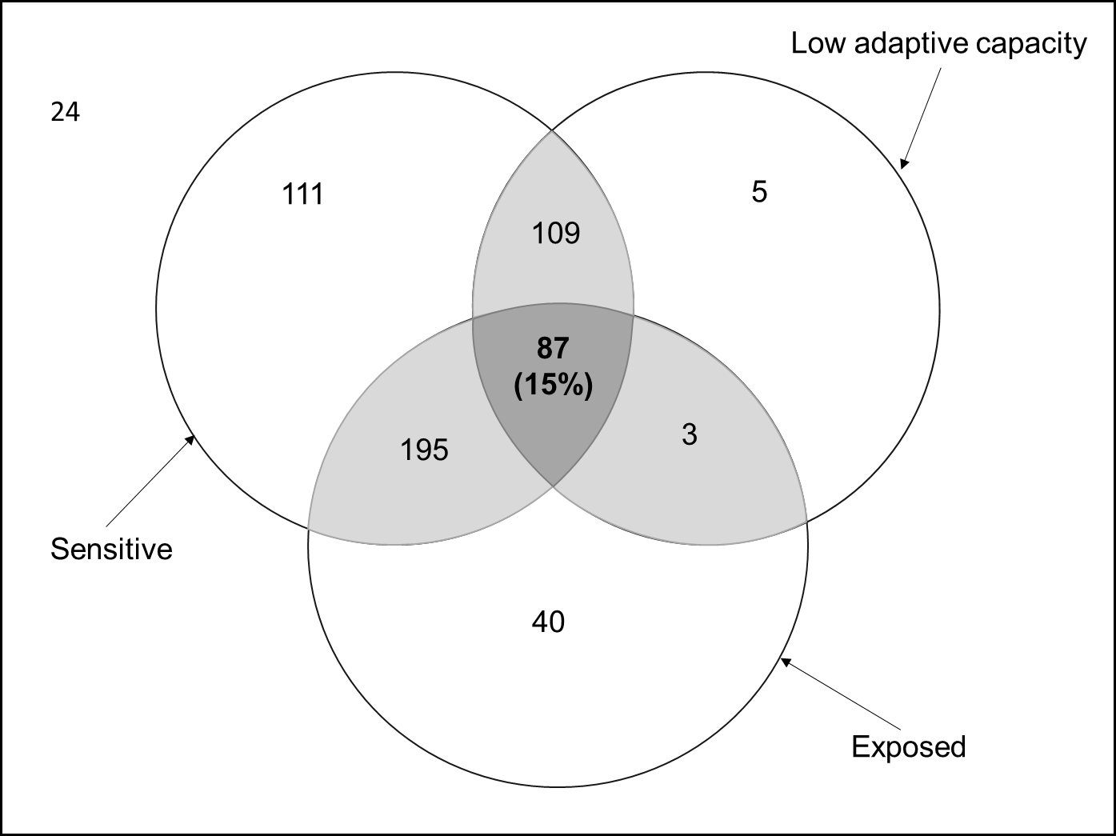

Figure 2.

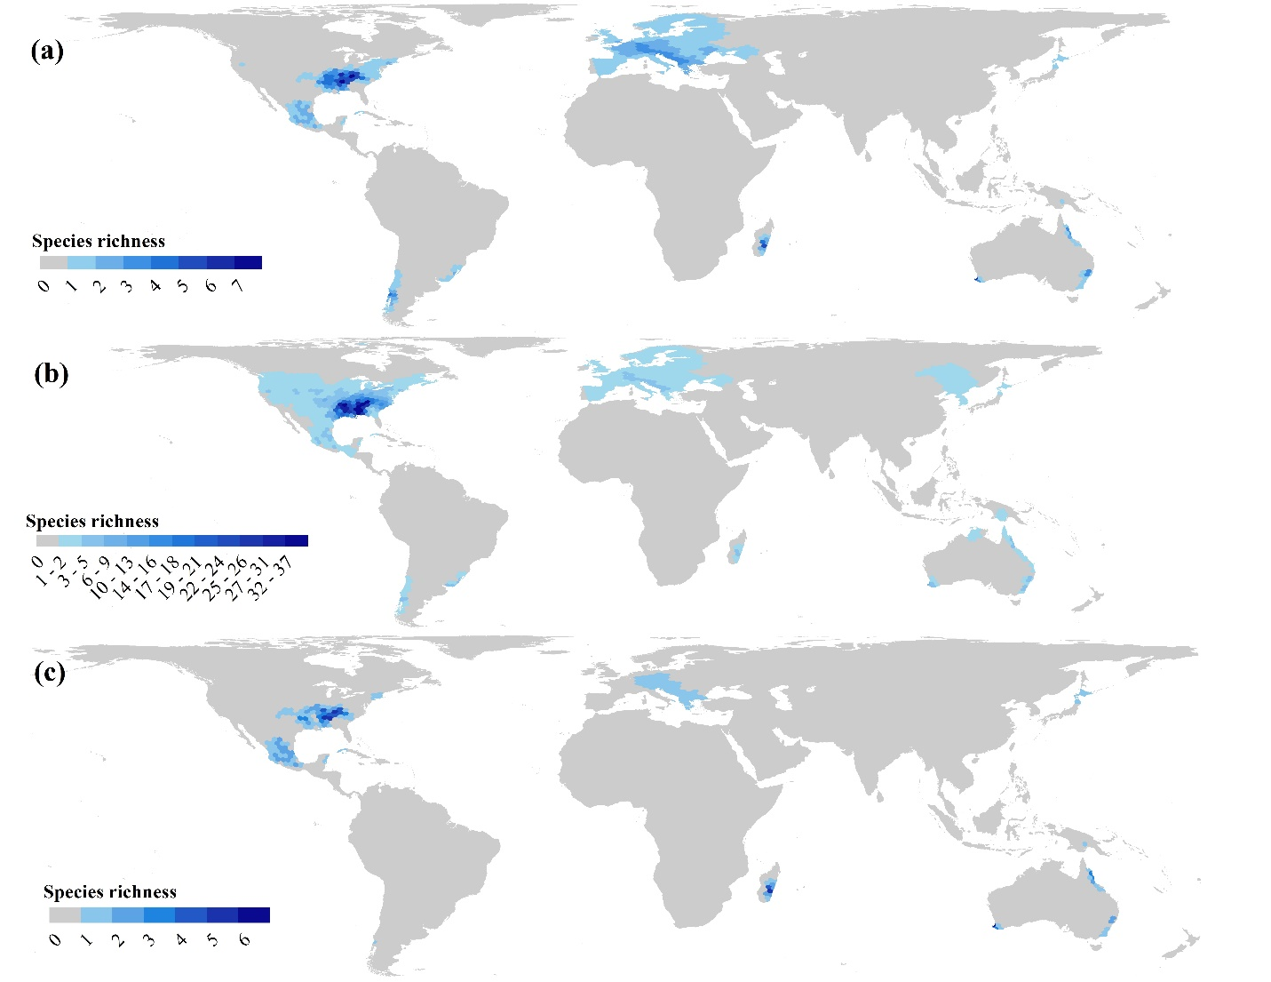

Figure 3

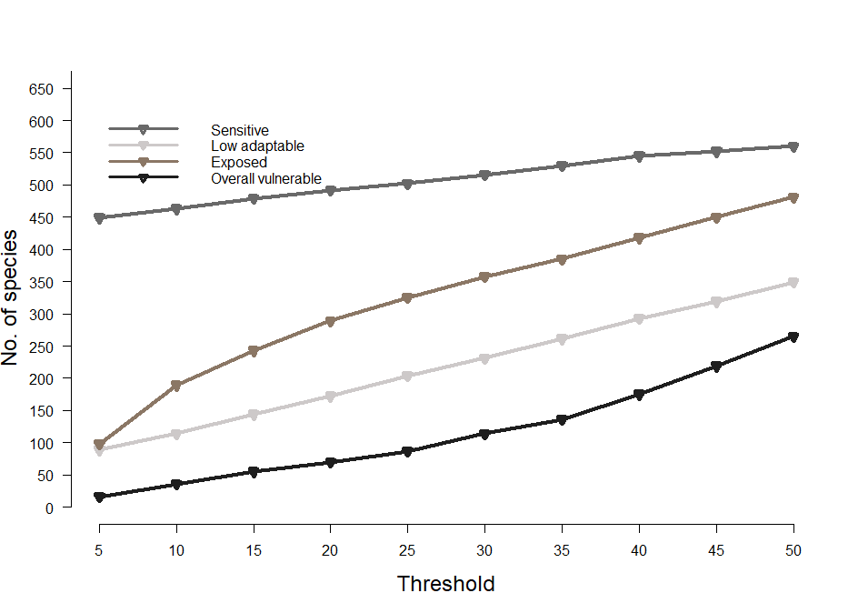

Figure 4.

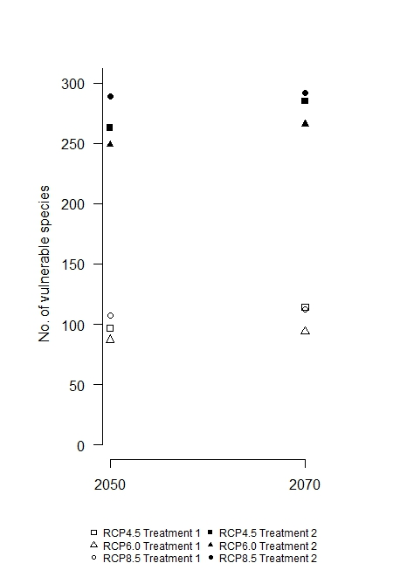

Figure 5.

