Electrical conductivity and oxygen diffusion behaviour of the (La0.8Sr0.2)0.95Cr*x*Fe1-*x*O3-*δ* (*x*=0.3, 0.5 and 0.7) A-site deficient perovskites

Zonghao Shen, John A. Kilner, Stephen J. Skinner*

Department of Materials, Exhibition Road, Imperial College London, London SW7 2AZ, UK

Corresponding Author Email: [s.skinner@imperial.ac.uk](mailto:s.skinner@imperial.ac.uk)

Abstract

Lanthanum strontium chromite ferrite ((La0.8Sr0.2)0.95Cr*x*Fe1-*x*O3-*δ*, LSCrF) pellets with 5% A-site deficiency were fabricated and the electrical conductivity and oxygen diffusion behaviour with different Cr substitution levels (*x* = 0.3, 0.5 and 0.7) were investigated. As the Cr content increased, the electrical conductivity increased and then a maximum value was achieved at *x* = 0.7. In the oxygen diffusion studies, all the measured materials present good surface exchange rates (>910-8 cm s-1 at 900 ) while the bulk diffusivity of the investigated materials decreased as the Cr substitution level increased: at 900 $℃$ the oxygen diffusion coefficients of the LSCrF materials (*x* = 0.3, 0.5 and 0.7) are 1.110-10 cm2 s-1, 3.710-12 cm2 s-1 and 8.610-13 cm2 s-1, respectively. Oxygen diffusion in the perovskite materials (LSCrF) is shown to be bulk diffusion limited and it was found that analysis on this type of material using line scan mode in Time-of-Flight Secondary Ion Mass Spectrometry may result in significant underestimation of the surface exchange coefficient due to the oxygen saturation, while the depth profile mode provides more reliable results but the obtained surface exchange coefficients may also only reach a lower limit. Moreover, fast grain boundary diffusion behaviour was observed in the LSCrF (*x*=0.7) material and the Le Claire, and Chung and Wuensch approximations were applied to analyse the oxygen diffusion profiles. For this material, the two approximations provided similar results for the grain boundary product ($D_{gb}δ$) and under the assumption that the width of a grain boundary is on the nanometre scale, the oxygen diffusion coefficient of the grain boundaries was about 4-5 orders of magnitude higher than that of the bulk at temperatures ≤ 900 $℃$.

Key words: LSCrF, electrical conductivity, oxygen diffusion, fast grain boundary diffusion

# Introduction

(La,Sr)(Cr,Fe)O3-*δ* (LSCrF) based ceramics, which can be used in Oxygen Transport Membranes (OTM), and Solid Oxide Fuel Cell (SOFC) devices, have attracted considerable attention. [1-10] To function effectively in these industrial applications, materials are required to possess considerable oxygen and electrical transport properties as well as high stability over a wide range of oxygen partial pressure and a high durability commensurate with device operating lifetimes.

For single phase LSCrF, substitution of La3+ by Sr2+ introduces a lower charge on the A-site of the perovskite structure. In order to balance the charge, increasing the oxidation state of the transition metal cations on the B-site is one possibility, which leads to the generation of p-type electronic conductivity. Alternatively, creating oxygen vacancies is the other possibility to compensate for the lower charge on the A-site, which contributes to any increase in the oxygen diffusivity in the material [2, 4] (see the Eq. 1-2).

$SrO\underset{→}{{La}_{2}O_{3}}{Sr}_{La}^{'}+O_{o}^{×}+h^{·}$ (1)

$2SrO\underset{→}{{La}_{2}O_{3}}2{Sr}_{La}^{'}+2O_{o}^{×}+V_{o}^{··}$ (2)

However, though increased Sr substitution is beneficial for the oxygen diffusivity, it is proven to be disadvantageous for the thermochemical stability in practical applications and can lead to crystal structure rearrangements. [2, 11] Moreover, A-site deficiency is also advantageous for increasing the bulk diffusivity and improving the surface exchange process (Eq. 3). Additionally, it is also presumed that A-site deficiency in Lanthanum Strontium Manganate (LSM) is beneficial in suppressing the formation of the pyrochlore phase in the dual-phase LSM-Yttria Stabilised Zirconia (YSZ) system. [12] Thus, in this work materials with fixed 20% Sr substitution and 5% overall A-site deficiency in the perovskite lattice were investigated.

$O_{O}^{x}→V_{o}^{··}+2e^{'}+1/2O_{2}(g)$ (3)

On the B-site of the perovskite structure, the transition metal has a direct impact on the properties of the materials. In literature, the (La,Sr)(Fe,Ga)O3-*δ* perovskites exhibited good chemical and thermal stability as well as excellent oxygen semi-permeation [13-15]. The oxygen permeation behaviour reported was largely unrelated to the Ga dopant content but the Ga substitution was observed to be beneficial for the thermal and chemical stability of the membranes. Moreover, the oxygen permeability of the perovskite-type oxides, (La,Sr)(Fe,Mn)O3-*δ* were also investigated. B-site substitution of the perovskite oxides La0.5Sr0.5Fe1-*x*Mn*x*O3-*δ* showed that the thermal expansion as well as the oxygen ion conductivity increased with the Mn substitution content and among the investigated materials the composition La0.5Sr0.5Fe0.67Mn0.33O3-*δ* was suggested as a promising membrane material [16]. In industry, durability and stability are always vital factors that should be taken into account. Dependent upon the different redox characteristics of the transition metals, the stability of the perovskites varies: in additional to the aforementioned Ga, Fe and Cr present very high stability while Co provides relatively low stability in LaBO3 materials (B is the transition metal) [17]. Furthermore, it is reported that substitution of Fe by Cr is advantageous for increasing the stability but, due to volatilisation of Cr, significant substitution leads to decreased sinterability and is problematic for densification. [2, 18] Hence, dependent on the requirements of the application, the Fe/Cr ratio should be optimised. Assuming the valence state of iron is +3 the defect equation can be written as Eq. (4).

${{Cr}_{2}O}_{3}\underset{→}{{Fe}_{2}O_{3}}2{Cr}_{Fe}^{×}+3O_{o}^{×}$ (4)

In this work the influence of different Fe/Cr ratios on the electrical and oxygen diffusion behaviour in the LSCrF compounds, to be used as part of a dual phase composite system, with 5% A-site deficiency were investigated. For clarity the (La0.8Sr0.2)0.95Cr0.3Fe0.7O3-*δ*, (La0.8Sr0.2)0.95Cr0.5Fe0.5O3-*δ*, and (La0.8Sr0.2)0.95Cr0.7Fe0.3O3-*δ* materials are denoted as LSCrF37, LSCrF55 and LSCrF73, respectively. Characterisation investigations of the transport behaviour comprising 4-point DC measurements and oxygen diffusivity studies by Isotopic Exchange Depth Profile (IEDP)-Secondary Ion Mass Spectrometry (SIMS) were carried out on the fabricated ceramics.

# Experimental

## Preliminary characterisation

The starting LSCrF powders were all supplied directly by Praxair, Inc. (USA). The powders of the LSCrF37, LSCrF55 and LSCrF73 were die pressed in a uniaxial geometry followed by isostatic pressing with a final pressure of 300MPa. The resulting green bodies were sintered in air at 1450 $℃$ for 6 hours. Before and after sintering, X-ray diffraction (XRD), using a Bruker D2 Phaser diffractometer (Cu Kα), was used to confirm the phase purity of the samples for the following measurements. X-ray diffraction data were collected between 20° and 80° 2θ in 0.017° increments with 0.5 s step time.

Moreover, scanning electron microscopy (SEM) combined with energy dispersive X-ray (EDX) spectroscopy was used to measure the grain size of the sintered pellets and to confirm that the elemental ratios in the LSCrF single phases were in good agreement with the nominal compositions. The JSM-6010 LA SEM (JEOL Ltd.) and the LEO Gemini 1525 Field Emission Gun (FEG)-SEM (Carl Zeiss Ltd.) were the two main analytical SEM instruments applied for material surface topography and compositional analysis in this work.

The density of the pellet is required to be greater than 95% of theoretical values and is essential for the reliability and validity of the conductivity and diffusion measurements because in this circumstance, the open porosity is regarded as eliminated [19]. The theoretical density was determined via XRD refinement and the experimental density was measured via the Archimedes method.

The electrical conductivity results were obtained via four-point DC conductivity measurements using a Solartron ModuLab Electrochemical System (Solartron analytical, Ametek. Inc., UK). In order to have a good contact between the Pt electrodes and the samples and to avoid the movement of the Pt electrodes, a small amount of Pt paste was applied. The samples were heated to 1000 $℃$ in static air with a heating rate of 250 hr-1 and were held at 1000 $℃$ for one hour. The measurements were then performed in static air from 1000 $℃$ to 300 $℃$ during the cooling cycle.

## Isotopic Exchange Depth Profiling (IEDP) and Secondary Ion Mass Spectroscopy (SIMS)

The oxygen diffusion coefficients (*D*\*) and surface exchange coefficients (*k*) of the samples were all unambiguously determined by a well-established technique: Isotopic Exchange Depth Profiling (IEDP) followed by Time-of-Flight (ToF) Secondary Ion Mass Spectrometry (SIMS) analysis.

In order to obtain reliable results, the sintered pellets were all abraded, initially with successive grades of SiC paper (Struers UK Ltd.), and then polished down to ¼ μm with diamond suspensions (Kemet International Ltd., UK). In the oxygen isotopic exchange experiments, a long 16O2 pre-annealing experiment in high purity (BOC research grade) was applied at the chosen temperature and pressure (200 mbar) before the isotopic exchange annealing (18O2) in order to remove the damage caused by mechanical polishing and to set the oxygen stoichiometry of each sample before the isotopic exchange, thus ensuring that there is no chemical gradient for the isotopic anneal step [20]. The specimens were cooled to room temperature and then isotopically exchanged at the same temperature and pressure as the pre-anneal for the required time. The isotopic exchange was carried out in a turbomolecular pumped, conflated sealed, purpose built annealing rig capable of achieving a high vacuum. The 18O2 was stored in a molecular sieve reservoir allowing the gas to be recovered after each experiment. This arrangement provides extremely dry oxygen (<1vpm H2O) to remove the known surface exchange enhancement effect of water vapour in the exchanging gas [21]. In this paper, the choices of the analysis modes (line scan or depth profile) and instruments (TOF-SIMS, ION-TOF GmbH, Germany or FIB-SIMS work station, FEI) were dependent upon the diffusion behaviour of the samples. The surface roughness and topography of the samples before isotopic exchange as well as the depth of the crater after depth profiling analysis, were determined by Coherence Scanning Interferometry (CSI) using a Zygo Newview instrument. For line scanning mode, after the isotopic exchange experiments the exchanged samples were sectioned and the cross sections were polished to ¼ μm mirror finish before ToF-SIMS analysis. Moreover, a burst alignment operating mode in ToF-SIMS was used for line scan analysis for higher lateral resolution [22]. To obtain the oxygen transport parameters, the solution to the diffusion equation in a semi-infinite medium developed by Crank (Eq. (5)) [23] was applied to fit the experimental data by using the MATLAB app TraceX . [21, 24]

$C^{'}\left(x,t\right)=\frac{C\left(x,t\right)-C_{bg}}{C_{g}-C_{bg}}=erfc\left[\frac{x}{2\sqrt{D^{*}t}}\right]-\left[exp\left(\frac{kx}{D^{*}}+\frac{k^{2}t}{D^{*}}\right)×erfc\left(\frac{x}{2\sqrt{D^{*}t}}+k\sqrt{\frac{t}{D^{*}}}\right)\right]$ (5)

where *t* is the duration of the isotopic exchange, *D\** is the oxygen self-diffusion coefficient, *k* is the surface exchange coefficient, $C^{'}\left(x,t\right)$ is the normalised 18O fraction corrected by the background 18O isotopic fraction (*C*bg) and the isotopic fraction of the annealing gas (*C*g). All the aforementioned processes and techniques have been clearly described previously. [22, 25, 26]

At a surface i.e. *x* = 0, this equation can be re-written as

$C^{'}\left(0\right)=\frac{C_{0}-C_{bg}}{C_{g}-C_{bg}}=1-\exp\left(h^{2}D^{*}t\right)erfc\left(h\sqrt{D^{*}t}\right)$ (6)

where *h* = *k*/*D\**. By plotting this expression as a function of $h^{'}=h\sqrt{D^{*}t}$ (*h*’ is a dimensionless parameter), the curve of the theoretical isotope surface concentration as a function of isotope exchange time (for fixed *h*) or as a function of *h* (for fixed isotope exchange time) can be obtained.

## Grain boundary analysis and background theory

In the literature, three different types of preferential diffusion have been suggested by Harrison [27], namely types A, B and C. In type A, there is no obvious diffusion preference along the dislocations, (grain boundaries in this paper), i.e. the diffusion coefficient of the grain boundaries is not significantly greater than the bulk diffusion coefficients. In type C, the diffusion process only takes place in the grain boundaries and the bulk diffusion is negligible. However, type B diffusion exists when conditions for both type A and type C are violated and a *preferred* diffusion pathway of oxygen along grain boundaries results. In order to apply the approximation equations for accurate estimation, the grain boundary diffusion should follow Harrison type B kinetics, i.e. the bulk diffusion length is supposed to be much shorter than the grain size [28, 29]. This requirement has been formulised by Kaur et al [30] and is shown as Eq. (7):

$20{(D_{b}t)}^{1/2}<d_{g}$ (7)

where $d_{g}$ is the grain size, $D_{b}$ is the diffusion coefficient of the bulk and *t* is the oxygen isotopic exchange duration.

To investigate the diffusion behaviour of the grain boundary in type B diffusion, mathematically the grain boundary is treated as an isolated slab with a width *δ* and a fast diffusivity of *D*bg (shown in Fig.1). Whipple [31] reported a diffusion solution to the grain boundary effects but the solution is in integral form that confines its practical applications to experimental data. A modified expression has been provided by De Souza et al [28] Eq. (8):

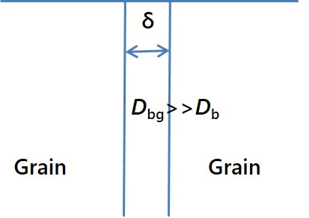

**Figure 1** Schematic of the mathematic fast grain boundary model

$$C^{'}\left(x,t\right)=\frac{C\left(x,t\right)-C_{bg}}{C_{g}-C_{bg}}$$

$=erfc\left[\frac{x}{2\sqrt{D^{*}t}}\right]-\left[exp\left(\frac{kx}{D^{*}}+\frac{k^{2}t}{D^{*}}\right)×erfc\left(\frac{x}{2\sqrt{D^{*}t}}+k\sqrt{\frac{t}{D^{*}}}\right)\right]+A_{gb}exp\left(-Z_{gb}x^{6/5}\right)$ (8)

where $A_{gb}$ and $Z_{gb}$ are the grain boundary tailing function parameters. In Eq. (8) the initial part is the solution for a semi-infinite medium developed by Crank (Eq.5), and the latter part [$A_{gb}exp\left(-Z_{gb}x^{6/5}\right)$] is attributed to grain boundary diffusion. Hence in the ‘tail’ region, the diffusion profile is a straight line in the plot where ln *C*’ is as a function of $x^{6/5}$ with the slope of $-Z_{gb}$. In literature, based upon Whipple’s solution, two mathematical approximations have been provided, namely the Le Claire approximation [32] and the Chung and Wuensch approximation [33]. Though the Le Claire approximation is the one more commonly used, reports have revealed that this approximation can lead to large errors and hence in literature [28, 34] the Chung and Wuensch approximation has been suggested. In this work a comparison between these two approximate expressions has been provided.

### Chung and Wuensch approximation

Eq. (9) presents the grain boundary diffusion product ( $D_{gb}δ)$ in the Chung and Wuensch approximation:

$D_{gb}δ=2{(D_{b})}^{3/2}t^{1/2}\left[{10}^{A}{(-\frac{∂lnC(x,t)}{∂η^{6/5}})}^{B}\right]$ (9)

where $D_{b}$ is the diffusion coefficient for the bulk , A and B are constants and can be chosen from [33] dependent upon different $\frac{∂lnC(x,t)}{∂η^{6/5}}$ values and different dimensionless parameterβ and η which are written in Eq. (10) and Eq. (11):

$β=\frac{D_{gb}δ}{2D_{b}^{3/2}t^{1/2}}$ (10)

$η=\frac{x}{\sqrt{D_{b}t}}$ (11)

### Le Claire approximation

The grain boundary diffusion product ( $D_{gb}δ)$ can be determined by using the Le Claire approximation, Eq.(12), and the expression can be further written in a similar format as the Chung and Wuensch approximation in Eq. (13)

$D_{gb}δ=0.66{\left(\frac{{4D}_{b}}{t}\right)}^{1/2}Z_{gb}^{-5/3}$ (12)

$D_{gb}δ=1.32({D_{b})}^{3/2}t^{1/2}[{(-\frac{∂lnC(x,t)}{∂η^{6/5}})}^{-5/3}]$ (13)

### Comparison of the two approximations

In the range of *β* = 10-100 where, in this work, the LSCrF73 phase falls (detailed calculation in grain boundary fast diffusion section), the Chung and Wuensch estimation can be further written as Eq. (14) where *A* = -0.326 and *B* = -1.865 (three decimal digits from the original data).

$D_{gb}δ=0.944{(D_{b})}^{3/2}t^{1/2}\left[{(-\frac{∂lnC(x,t)}{∂η^{6/5}})}^{-1.865}\right]$ (14)

For the same *D*b and *t*, a comparison between the Le Claire approximation and the Chung and Wuensch estimation of the grain boundary products has been provided in the following Eq. (15):

$\frac{D_{gb}δ\left(Le Claire\right)}{D_{gb}δ (Chuang and Wuensch)}=1.398\left[{(-\frac{∂lnC(x,t)}{∂η^{6/5}})}^{0.198}\right]$ (15)

In this range the ratio ($\frac{D_{gb}δ\left(Le Claire\right)}{D_{gb}δ (Chung and Wuensch)}$) of the Le Claire approximation and Chung and Wuensch approximations is 1.01-0.79 suggesting that in the range of *β* = 10-100, theoretically, these two methods provide similar estimations. However, out of this range using the Le Claire approximation may result in significant errors. It has been proven that for *β* < 10 the Le Claire approximation would overestimate the grain boundary product $D_{gb}δ$. Additionally, to achieve the validity and accuracy in the determination of grain boundary diffusivity via the Le Claire approximation, the range of *β* ≥ 10 and $η/{\sqrt{β}}$ ≥ 2, was suggested by Chung and Wuensch [33].

# Results and discussion

## Preliminary characterisation

The X-ray diffraction patterns of the LSCrF37, LSCrF55 and LSCrF73 pellets are shown in Figure 2. Clearly, all the LSCrF materials adopt the perovskite structure and no secondary phase was detected after sintering within the limitation of the laboratory X-ray diffraction system. The inset is an example Rietveld refinement result of the LSCrF37 materials providing the positions of Bragg reflection.

Moreover, as the Cr content increased, sintering was found to become problematic due to the formation of volatile CrO2(OH)2 species. Among all of the LSCrF materials reported in this work, the LSCrF37 exhibits the best sinterability where the density was confirmed to be higher than 98% of the theoretical value by the Archimedes method. The LSCrF55 single phase was well sintered with a grain size of 2.4(±0.9) μm measured from the microstructure image (Fig. 3) and the pellets following the same fabrication procedure had very similar microstructures with densities greater than 97% of theoretical values. EDX measurements were then performed on the as-sintered LSCrF55 pellet. The La/Sr and Fe/Cr ratios of the experimental data are 3.9 and 1.0 respectively which are very close to the theoretical values where La/Sr = 4 and Fe/Cr = 1. The slightly higher Sr fraction may be associated with Sr surface segregation. Thus, the chemical composition of the LSCrF55 can be confirmed as the nominal number within the errors of the measurements. For the LSCrF73 materials, based on the density measurements, the LSCrF73 pellets following the same processing procedure all have densities greater than 95% of the theoretical value.

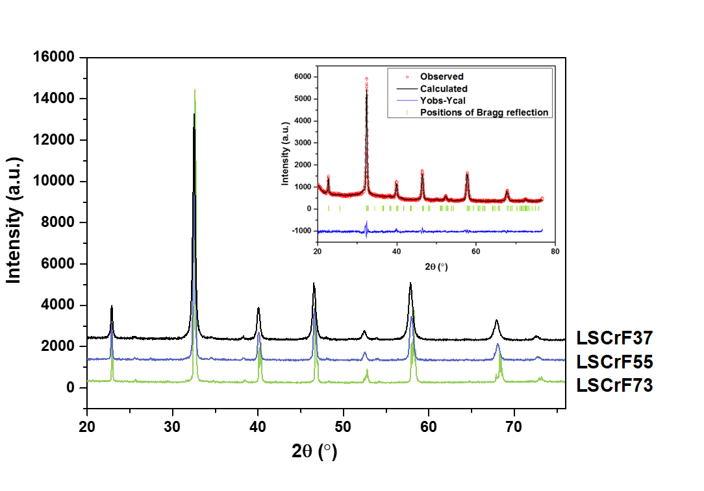

**Figure 2** XRD patterns of the LSCrF pellets and the inset is the Rietveld refinement result of the LSCrF37 by FullProf software suite [36]: (1) red circles are the observed experimental data; (2) black solid line represents the calculated intensities; (3) green vertical bars are the positions of Bragg reflection; and (4) blue solid line is the difference of the intensities between the observed and calculated data (Space group: *Pnma*)

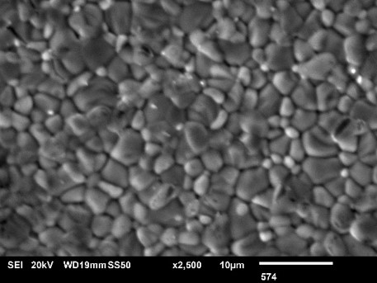

**Figure 3** SEM image of the as sintered LSCrF55 single phase pellet

Figure 4 presents the total electrical conductivity of the LSCrF compounds as a function of Cr content and it also shows that as the Cr content increases the total conductivity increases and achieves a peak value at Cr:Fe = 7:3. In the high temperature region (800 $℃$-1000 $℃$), no significant difference in the electrical conductivity was observed between the LSCrF37 and LSCrF55 materials, but due to the larger activation energy of the LSCrF37 sample, with the decrease of temperature this difference between the LSCrF55 and the LSCrF37 increases.

The Arrhenius plots for the LSCrF materials with different Cr:Fe ratios (LSCrF37, LSCrF55 and LSCrF73) are shown in Fig. 4 along with the A-site stoichiometric LSCrF from the literature [36]. For the materials studied in this work, it is obvious that LSCrF73 presents the highest electrical conductivity in the entire measured temperature region from 300 $℃$ to 1000 $℃$ and the lowest activation energy among all the investigated LSCrF compounds. In literature for the (La,Sr)(Co,Fe)O3-*δ* materials [37, 38] decreasing the content of Fe also results in an increase in the electronic conductivity. However, compared with the electrical conductivity of the A-site stoichiometric LSCrF perovskite reported in the literature [36], though the conductivity values for both series are close, it can be seen that the stoichiometric LSCrF materials present totally opposite behaviour of the total conductivity to the 5% A-site deficient materials reported in this work: for the A-site stoichiometric LSCrF materials, as the Fe content increased the electrical conductivity of the LSCrF materials increased, while for the A-site non-stoichiometric materials, the LSCrF73 material presented higher electrical conductivity than the LSCrF55 and LSCrF37 materials. The different behaviour between these two materials may be due to the A-site non-stoichiometry which requires further investigation. Based on their total conductivity behaviour, the LSCrF materials may be good candidate in a dual-phase membrane system to provide a counter flow of electrons to balance the electrical neutrality.

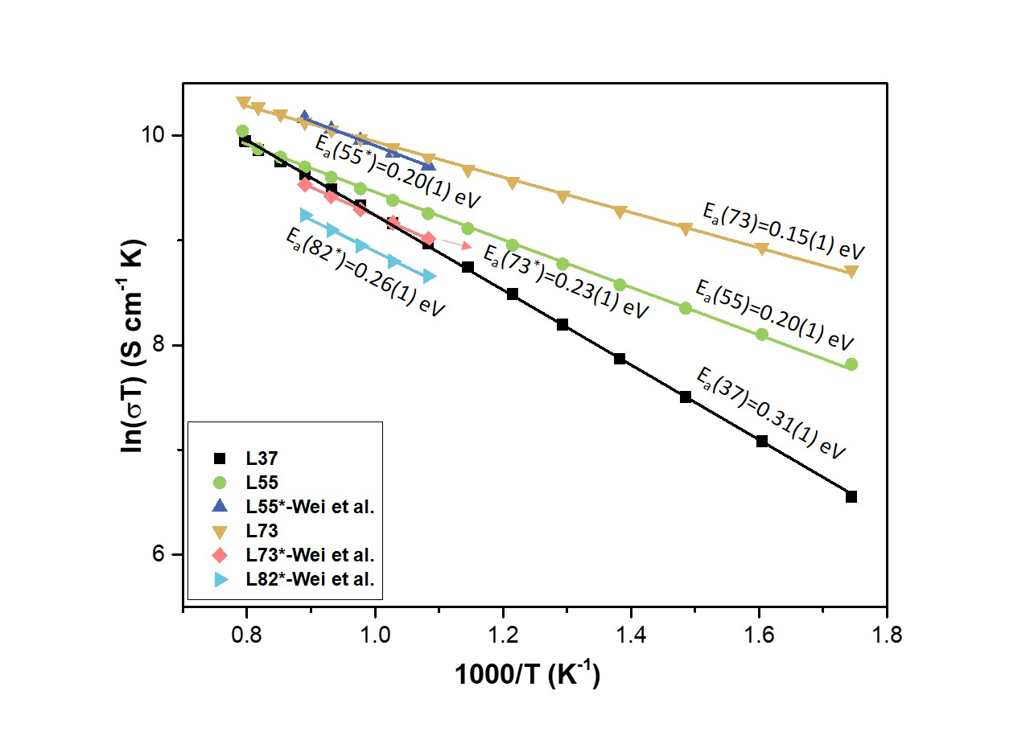

**Figure 4** Arrhenius plots for the electrical conductivity of the LSCrF compounds with different Cr:Fe ratios and the data with asterisk(*) are the electrical conductivity of the A-site stoichiometric LSCrF perovskites from [36]

## Oxygen Transport in LSCrF Phase

The oxygen diffusivity of all the LSCrF materials was studied using the dry oxygen isotopic exchange experiments and depending upon the diffusion behaviour of the LSCrF materials at different temperatures, the analysis modes and instruments also varied in order to obtain more reliable and precise diffusion kinetic values efficiently.

### SIMS Analysis on the LSCrF Materials

In order to investigate the validity and reliability of the fitted diffusion kinetic values, the *h*-plot, where the normalised 18O surface fraction is plotted as a function of the reduced variable *h*’, is introduced and the plot is shown in Fig. 5 as the green curve (based on Eq. (6)). Previous studies by Kilner and De Souza [39] reported that in the large *h*’ region where the normalised 18O surface fraction is close to the gas concentration, it becomes difficult and problematic to obtain reliable values for the surface exchange coefficient and only the lower limit of *k* can be achieved, while in the low *h*’ region where the surface 18O fraction is low, the low surface concentrations result in inaccurate diffusion kinetics due to the greater scatter in the data points. Hence, an *h*’ range of 0.1-4 is suggested to obtain reliable diffusion kinetics.

However, for the materials with high surface exchange rate and relatively low diffusivity, as in the case of these LSCrF materials, it is impractical to make the 18O surface concentrations fall outside of the region with large *h*’ at certain temperatures via varying the isotopic exchange duration. To ensure the reliability and accuracy of the diffusion kinetics, the experimentally obtained normalised 18O surface fractions as a function of the reduced variable *h*’ for all the LSCrF pellets at measured temperatures are also plotted in Fig. 5. It is obvious that some of the data points are much lower than the calculated curve and these points have been circled in grey. Interestingly, these marked points were all obtained via the line scan mode in the ToF-SIMS instrument. For the isothermal LSCrF55 samples (950 $℃$ and 1000 $℃$) measured under the depth profile mode, more accurate surface 18O concentrations were observed, i.e. the blue triangles in Fig. 5 fall onto or close to the theoretically calculated *h*-curve. To study the limitations of the SIMS analysis for measuring the diffusion kinetics of the LSCrF materials, the LSCrF55 pellets were chosen as an example, and discussions of the potential reasons for the underestimation of surface exchange coefficients obtained via line scan measurement mode will be provided.

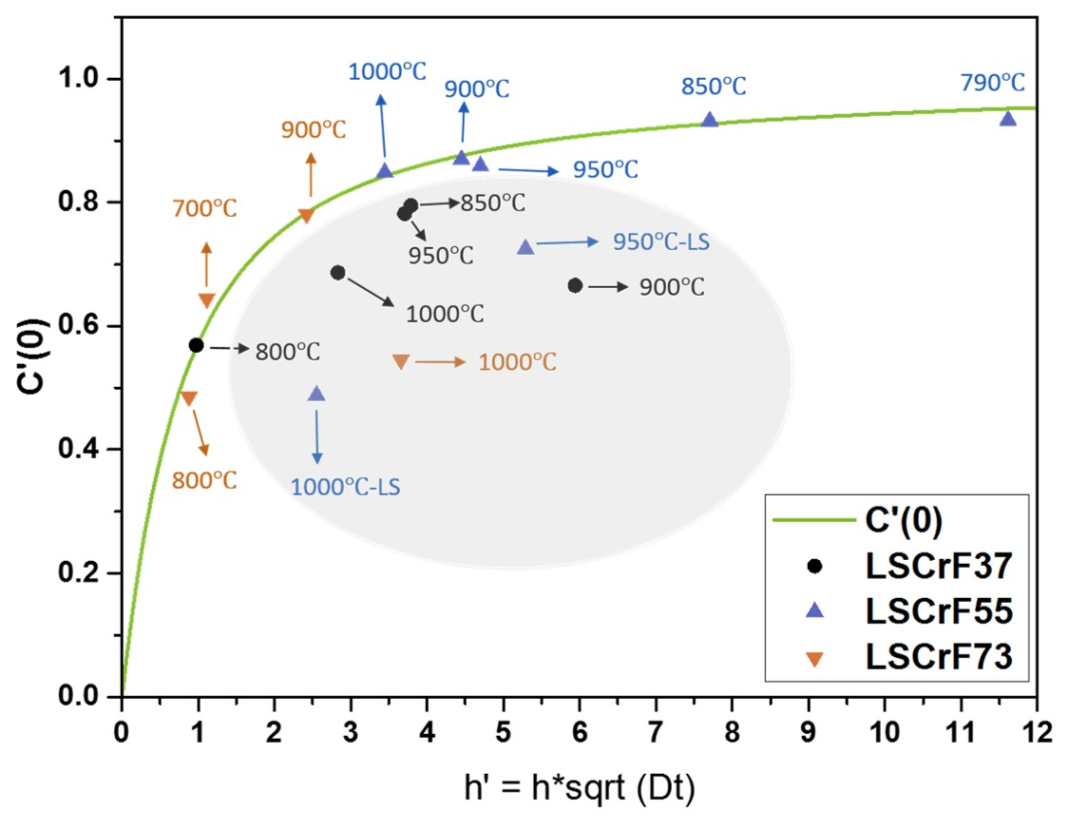

**Figure 5** Normalised surface isotope fraction as a function of the reduced variable *h*’: the curve is the calculated surface isotope fraction based on Eq. (6) and the points are the experimental values of the normalised surface isotope fraction of the LSCrF materials (LS-Line scan mode via ToF-SIMS elemental mapping analysis). The grey oval circles the data obtained by line scan mode which present much lower values than the theoretical results.

Fig. 6 displays the diffusion profiles of the LSCrF55 pellets isotopically exchanged at 950 $℃$ and 1000 $℃$ and analysed via different analysis modes dependent upon the isotopic exchange duration. The obtained diffusion kinetics and the corresponding isotopic exchange conditions are listed in Table 1. Obviously, compared with the diffusion profiles obtained by the depth profile mode where the experimental data agree well with the calculated profile, an apparent and significant mismatch between the experimental values and the fitted profile can be clearly seen in the diffusion profiles especially in the first few microns of the depth profile obtained via the line scan mode. This dramatic discrepancy results in the significant underestimation of the surface exchange coefficients (Table 1). The surface exchange coefficients obtained by the line scan mode are significantly lower than those obtained using the depth profile mode, while the diffusion coefficients obtained via these two analysis modes can be considered as identical. The underestimated surface exchange coefficients may be related to the edge effects of the line scan mode, and ‘dead time’ and saturation effects of a ToF-SIMS detector or a combination of these two possible reasons.

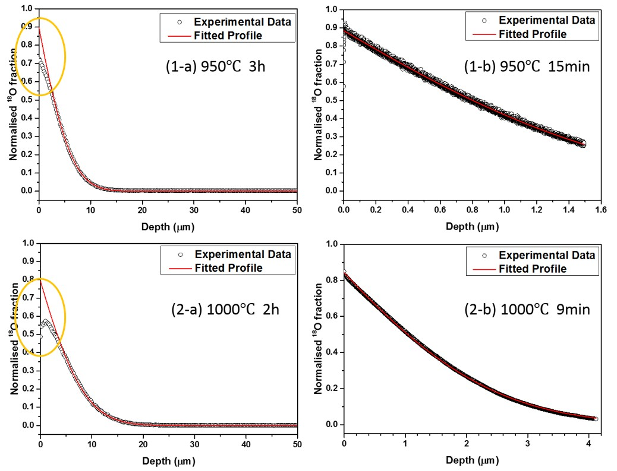

**Figure 6** Diffusion profiles of the LSCrF55 materials exchanged at 950 $℃$ and 1000 $℃$ determined via different analysis modes (1) LSCrF55 isotopic exchanged at 950 $℃$ and analysed via (a) line scan mode (LS) (b) depth profile mode (DP); and (2) LSCrF55 isotopic exchanged at 1000 $℃$ and analysed via (a) line scan mode (b) depth profile mode. (The orange ovals mark the discrepancies between the theoretical and experimental values in the diffusion profiles via line scan mode.)

**Table 1** Comparisons of the diffusion kinetics of LSCrF55 analysed via different modes

|  |  |  |  |  |  |
| --- | --- | --- | --- | --- | --- |
| **Temperature** | **Duration (h)** | ***D*\*(cm2 s-1)** | ***k* (cm s-1)** | **Instrument** | **Mode** |
| **950** | 3 | 1.310-11 | 1.910-7 | ToF | LS |
| 0.25 | 1.310-11 | 5.710-7 | ToF | DP |
| **1000** | 2 | 4.110-11 | 1.910-7 | ToF | LS |
| 0.15 | 4.310-11 | 9.710-7 | FIB | DP |

The line scan analysis is over the cross section of a sample which is perpendicular to the original exchanged surface and the sharp edge prevents the constant ion count. In order to mitigate the edge effects, the two cut pellets were adhered together prior to the polishing process for SIMS line scan analysis, which is known to be advantageous for minimising the non-linear region and is beneficial for ion count statistics. In this work, all the line-scanned samples were prepared where two cross sections were adhered to each other and the influence from the edge effect is supposed to be limited for the samples [40]. In line scan mode the discrepancy between the experimental data and theoretical values on sample surface become more obvious when the normalised 18O surface fraction is closer to unity, i.e. for highly bulk diffusion limited materials, under the circumstances that the samples have been properly prepared only a minor contribution comes from the geometric effect.

In ToF-SIMS, for the isotopically exchanged LSCrF materials where oxygen isotopic species were present in high concentrations, the precision of the oxygen isotopic analysis is significantly affected by the ‘dead time’ and the saturation effects of the ToF detector. Conventionally, in order to avoid or mitigate the effects of this non-linear response of the detector, the correction for the ‘dead time’ of the ToF detector is based on a Poisson distribution which is capable of effectively correcting the statistical counts [41, 42]. However, in the ion imaging mode for line scan, due to the low counts per pixel of the raster area, applying a Poisson correction to the ion images cannot effectively correct the non-linear detection and further results in large errors [43]. Alternatively, the intensity of the incoming secondary ions can be decreased by reducing the primary ion current but this ultimately results in the high uncertainties of the isotopic measurements. Recently, Tellez et al [34] applied the selective attenuation of secondary ion signals (SASI) method to oxygen diffusivity in the LSM materials but this method requires the ToF-SIMS equipped with a signal attenuator unit. In this work, to obtain more reliable surface exchange coefficients, a significant shortening of the isotopic exchange duration which allows an appropriate sample for the depth profile analysis, is the compromise approach adopted for the LSCrF55 samples. It is clear that the depth profile provides better fitting and dramatically improved surface exchange coefficients, as can be seen in Fig. 6.

Moreover, a point that needs to be repeatedly strengthened here is that although the depth profile mode gives a better fit to the solution to the diffusion equation for the LSCrF samples, there are limitations to the accuracy of the fitted surface exchange coefficients caused by the extremely high 18O surface isotopic fraction, i.e. close to that of the exchanging gas. This means that the surface exchange coefficients correspond to the minimum possible values for these high *h*(=*k*/*D*\*) materials where the oxygen transport is limited by the low bulk diffusivity. Consequently, for these LSCrF samples, the surface exchange coefficient could be significantly underestimated.

### Diffusion Behaviour of LSCrF Compounds

Fig. 7(a) and Fig. 7(b) are the Arrhenius plots for the diffusion coefficients and surface exchange coefficients, respectively, of the LSCrF materials and Table 2 lists the kinetic parameters of the materials at all measured temperatures and the analysis modes applied to obtain these data.

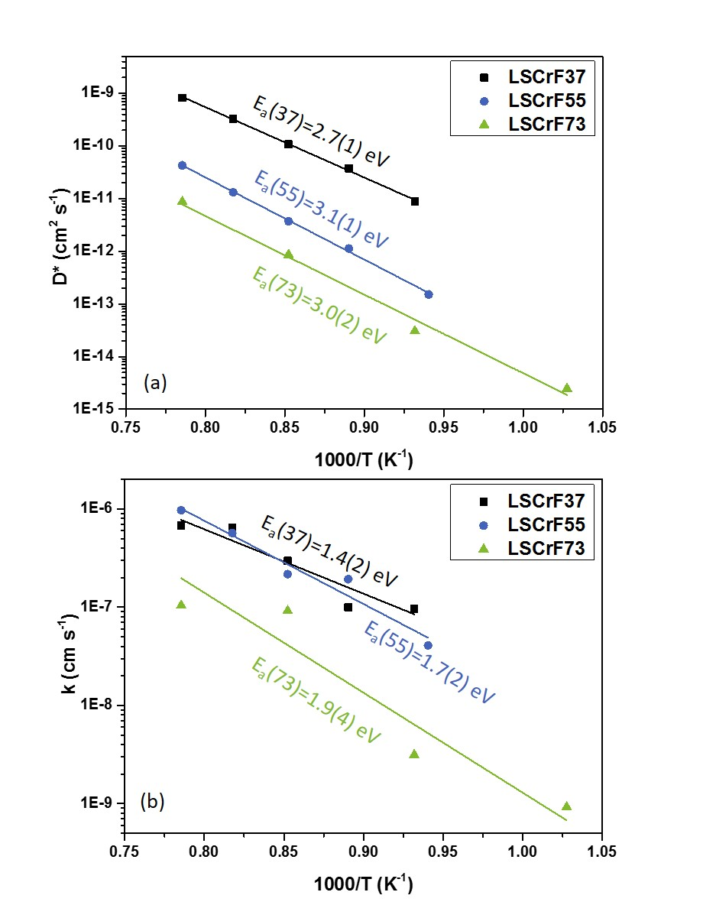

**Figure 7** (a) Arrhenius plots for the diffusion coefficients of LSCrF materials (b) Arrhenius plots for the surface exchange coefficients of LSCrF materials

It is obvious that LSCrF37 presents the highest bulk diffusivity, e.g. at 1000 $℃$ the diffusion coefficient of the LSCrF37 phase is about one order of magnitude higher than that of the LSCrF55 compound and nearly two orders of magnitude higher than that of the LSCrF73 material. From the diffusion data here, it can be concluded that the Cr substitution decreases the bulk diffusivity of the LSCrF compounds. For the activation energy for the bulk diffusion, given the errors, the values of the activation energy for the three materials are very close and they are of a similar order to lanthanum strontium cobalt manganites (LSCM) measured by De Souza [44]. The high activation energy indicates that there are very few oxygen vacancies in this material and it is probably oxygen stoichiometric or low oxygen excess, which means the observed activation energy contains both a mobility term and a vacancy formation term. However, for the La0.3Sr0.7CoO3-*δ* [45] this material has a very high oxygen vacancies concentration that results in an activation energy of 0.58 eV, which is likely associated with the vacancy migration term.

**Table 2** Diffusion kinetics of (La0.8Sr0.2)0.95Cr*x*Fe1-*x*O3-*δ* (*x* = 0.3, 0.5 and 0.7)

|  |  |  |  |  |  |  |  |
| --- | --- | --- | --- | --- | --- | --- | --- |
|  | ***T* ()** | ***t*(h)** | ***D*\*(cm2 s-1)** | ***k*(cm s-1)** | ***h*=*k*/*D*\*(cm-1)** | ***h*’=*h*√(*Dt*)** | **Mode** |
| **LSCrF37** | 800 | 0.25 | 8.8-12 | 9.710-8 | 10941 | 0.97 | DP^ |
| 850 | 15 | 3.710-11 | 1.010-7 | 2665 | 3.79 | LS^^ |
| 900 | 12 | 1.110-10 | 3.010-7 | 2750 | 5.94 | LS |
| 950 | 3 | 3.310-10 | 6.510-7 | 1969 | 3.37 | LS |
| 1000 | 4 | 8.210-10 | 6.810-7 | 824 | 2.83 | LS |
| **LSCrF55** | 790 | 3.4 | 1.510-13 | 4.110-8 | 270198 | 11.62 | DP |
| 850 | 0.5 | 1.110-12 | 1.910-7 | 170796 | 7.70 | DP |
| 900 | 0.43 | 3.710-12 | 2.210-7 | 58490 | 4.45 | DP |
| 950 | 0.25 | 1.310-11 | 5.710-7 | 43106 | 4.70 | DP |
| 1000 | 0.15 | 4.310-11 | 1.010-6 | 22693 | 3.45 | DP |
| **LSCrF73** | 700 | 1 | 2.510-15 | 9.210-10 | 373279 | 1.11 | DP |
| 800 | 0.667 | 3.110-14 | 3.110-9 | 102622 | 0.88 | DP |
| 900 | 0.167 | 8.610-13 | 9.210-8 | 106504 | 2.42 | DP |
| 1000 | 3 | 8.710-12 | 1.010-7 | 11913 | 3.66 | LS |

^DP – Depth Profile measurement mode

^^LS – Line Scan measurement mode

Additionally, there is no doubt that the LSCrF materials all exhibit very high surface exchange rates, given the caveats discussed above. According to the apparent data, the surface exchange of the LSCrF37 and LSCrF55 behave very similarly to each other. However, the LSCrF73 material exhibits the lowest surface exchange rate among the three measured single-phase compounds, i.e. nearly one order of magnitude lower than that of the other two materials. A lack of oxygen vacancies on surface could be one of the potential reasons, as it has been recently pointed out that on the surfaces of these perovskite materials an oxygen vacancies are necessary for the oxygen exchange reaction [46]. The low bulk diffusivity for LSCrF73 and higher electronic conductivity implies a lower oxygen vacancy concentration. Moreover, for the bulk diffusivity-limited materials only a lower bound for the surface exchange coefficient can be obtained as discussed above. This inherent limitation can be further exacerbated by the significant underestimation of the surface isotopic fraction of the LSCrF73 sample due to its low oxygen diffusivity. Especially for the sample exchanged at 1000 $℃$ the limitations arising from using the line scan analysis mode in the TOF-SIMS, which has been discussed in the above section, Fig. 5, results in the underestimated surface exchange coefficient.

To summarise, as mixed ionic-electronic conductors, the measured LSCrF series exhibited high surface exchange rates but low bulk diffusion and the oxygen transport in these materials is bulk diffusion limited. Furthermore, the low bulk diffusivity prohibits the precise and accurate determination of the surface exchange coefficients and only a lower bound can be achieved.

### Grain Boundary Fast Diffusion

The diffusion profiles of the LSCrF73 samples at all measured temperatures are plotted in Fig. 8 and there are apparent discrepancies between the fitted profiles and the experimental data in all four diffusion profiles. In the first three figures (700 $℃$, 800 $℃$ and 900 $℃$), a clear ‘tail’ indicates the potential fast diffusion pathways in the LSCrF73 materials. Extended defects, e.g. dislocations, grain boundaries, twin boundaries etc. can act as these fast diffusion pathways for oxygen ions, resulting in very similar long ‘tails’ in the diffusion profile. In order to discriminate between the possible pathways an isotopic map was recorded over the sample by using the 18O- signal in FIB-SIMS as shown in Fig. 9 which displays the 18O isotopic map of the LSCrF73 sample exchanged at 800 $℃$ at the depth where the mismatch between the measured and theoretical profile occurs (around 0.3 μm beneath the surface). Obviously, on the grain boundaries a higher 18O fraction has been clearly observed indicating fast grain boundary diffusion.

Furthermore, and interestingly, for the same material no visible ‘tail’ appears in the diffusion profile at obtained at 1000 $℃$ with only a clear mismatch at the surface layers observed due to the limitations of SIMS analysis mentioned above. This behaviour confirms that the pathways for oxygen diffusion along grain boundaries can be fast or slow depending upon the lattice diffusivity, i.e. whether the grain boundary pathways exhibit quite obvious or more limited behaviour is dependent upon the lattice diffusivity of the materials: if the lattice diffusivity is low, the grain boundaries will have a more significant and obvious effect while if the material itself has high lattice diffusivity the effects of the grain boundaries will be limited. The diffusivity data for the LSCrF73 material are all listed in Table 3, and it was shown that the diffusion coefficients (*D*\*) at 700 $℃$, 800 $℃$ and 900 $℃$ are all below 10-12 cm2 s-1, while the only diffusion profile without the ‘tail’ is the one isotopically exchanged at 1000 $℃$ with a bulk diffusivity greater than 10-12 cm2 s-1 which agrees well with the critical value of the visible behaviour of the grain boundary fast diffusion provided by Kilner [47].

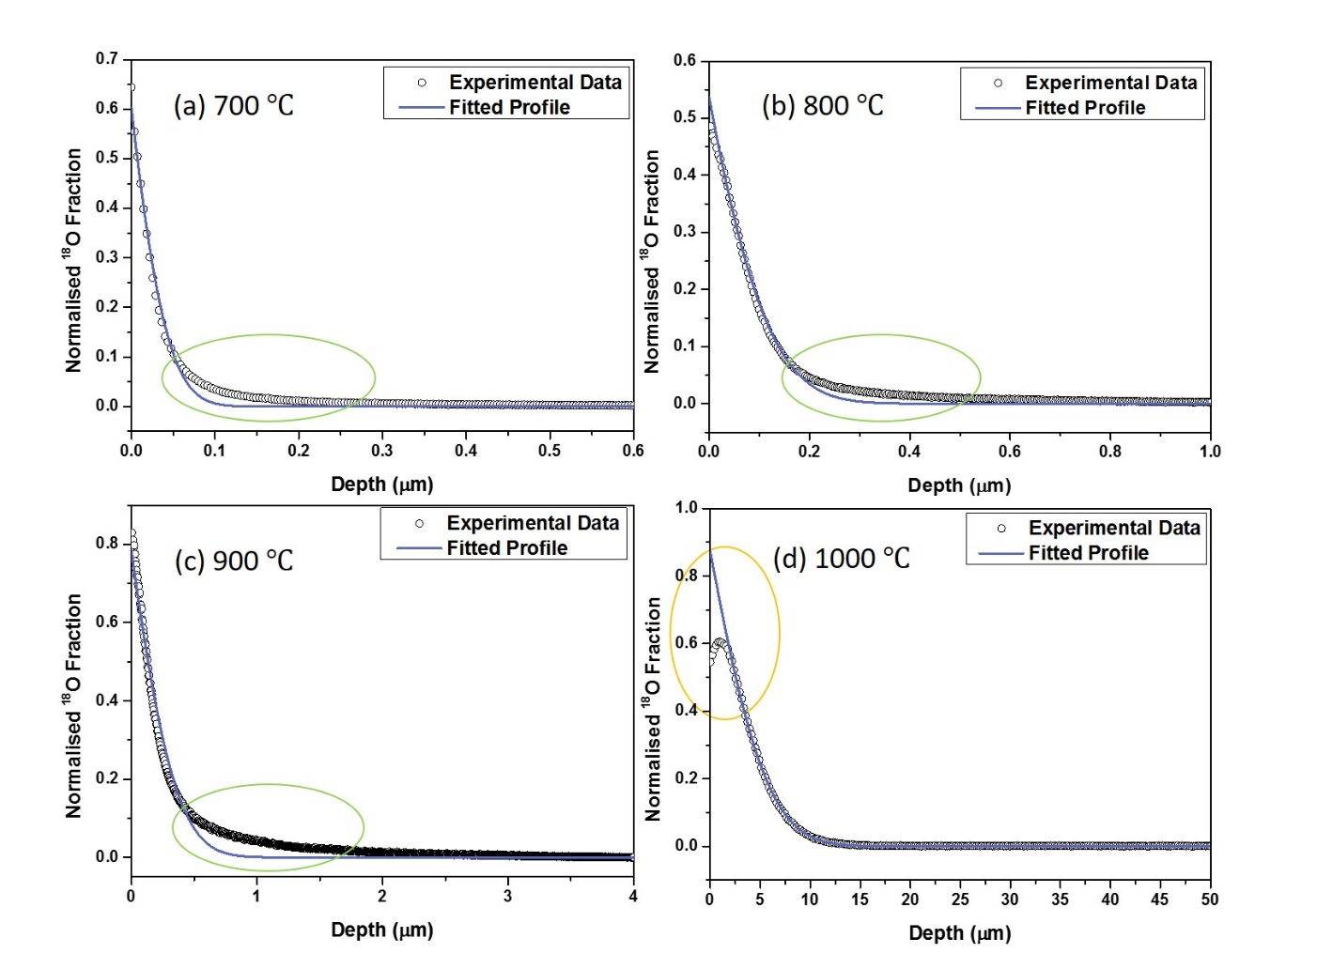

**Figure 8** Diffusion profiles of the LSCrF73 materials at different temperatures (The green horizontal ovals display the discrepancies from the grain boundary fast diffusion and the orange vertical oval highlights the difference caused by the line scan measurement mode.)

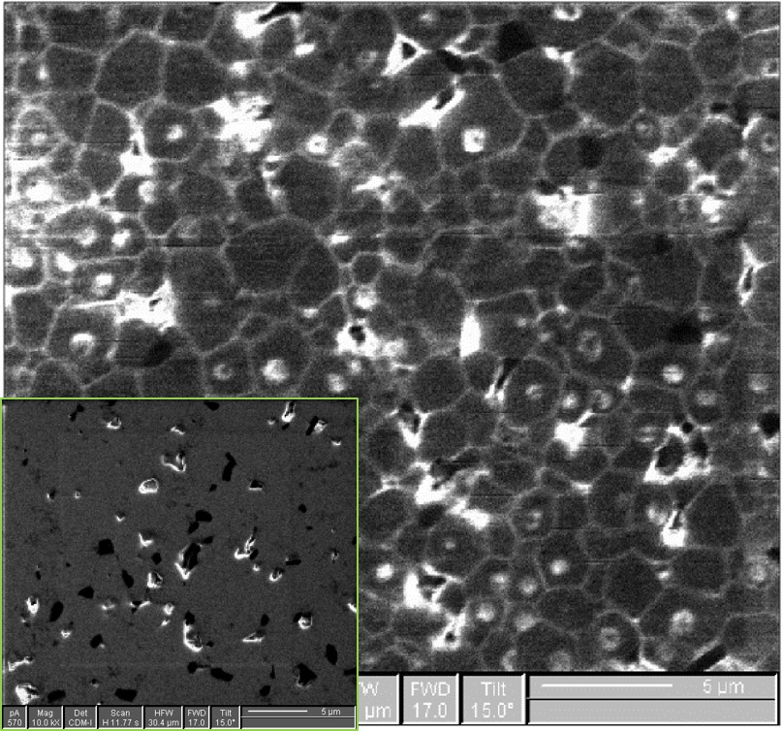

**Figure 9** 18O elemental map of the LSCrF73 sample isotopically exchanged at 800 $℃$ showing the grain boundary fast diffusion behaviour where the brighter areas correspond to higher 18O concentration. The ion map was taken at a depth of around 0.3 μm beneath the surface after sputtering where apparent mismatch was observed between the fitted profile and experimental data. The inset is the 16O ion map of the LSCrF73 sample over a sputtering crater showing that there is no orientation effect of oxygen elemental imaging along grain boundaries.

For the LSCrF73 material, both the Le Claire, and Chung and Wuensch approximations have been applied to estimate the grain boundary products ($D_{gb}δ$) and a comparison between these two approaches is discussed. Figure 10 shows the 18O diffusion profiles of the LSCrF73 phase from 700 $℃$ to 1000 $℃$ plotted as ln[*C*’] against *η*6/5 and the gradients of the diffusion profiles at 700 $℃$, 800 $℃$ and 900 $℃$ were determined in the depth range of 6 ≤ *η* ≤ 10. Moreover, again, from this plot no obvious grain boundary ‘tail’ effect can be observed in the diffusion profile of the material isotopically exchanged at 1000 $℃$. The calculated grain boundary products obtained via the two approximations and *β* factors are listed in Table 3. From the grain boundary products obtained via these two different approximations, it is clear that these two approaches provide very close results with negligible differences. Compared to the Chung and Wuench approximation, the Le Claire equation provides slightly smaller grain boundary products at the three temperatures.

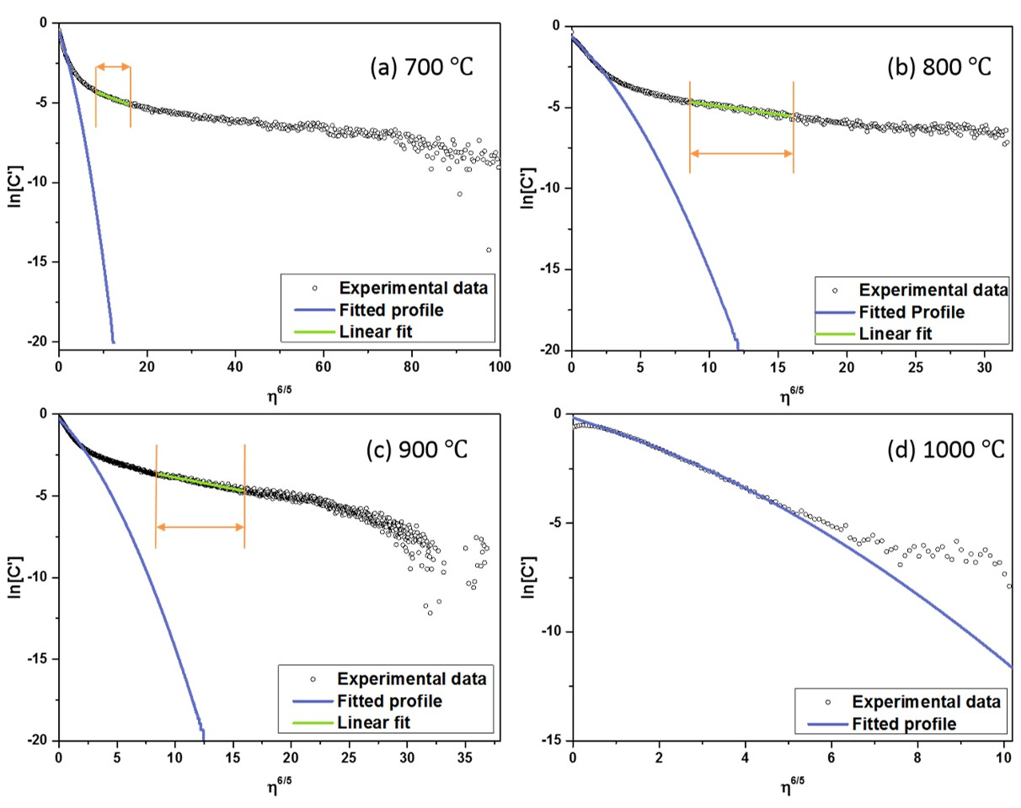

**Figure 10** Diffusion profiles of the LSCrF73 samples plotted as ln[*C*’] against *η*6/5 (a) 700 $℃$ (b) 800 $℃$ (c) 900 $℃$ (d) 1000 $℃$. The grain boundary fitting was performed on the diffusion profiles of 700 $℃$, 800 $℃$ and 900 $℃$.

Based on the microstructural image obtained by SEM, the average grain size of the LSCrF73 is estimated as 1.8 (±0.7) μm. For the oxygen diffusion at 700 $℃$ and 800 $℃$, the values of the factor 20(*D*b*t*)1/2 falls in the valid range of the Harrison type B diffusion kinetics and with the *β* factor, the accuracy of the Le Claire approximation has also been guaranteed. However, for the diffusion at 900 $℃$, the value of 20(*D*b*t*)1/2 is outside the range of the type B diffusion kinetics but considering the value of this factor is still in the same order of grain size, thus the diffusion at 900 $℃$ is still treated as type B kinetics though some uncertainty may be introduced into the estimated results. For the diffusion at 1000 $℃$, the value of the factor 20(*D*b*t*)1/2 is much larger than the grain size thus type B kinetics are no longer valid. In this circumstance, there is no obvious preference in diffusion along the grain boundary and a transition from type B to type A can be considered as occurring. Hence, due to the increase of the bulk diffusion at elevated temperature, preferential diffusion along grain boundaries may gradually disappear for the LSCrF73 material.

**Table 3** Comparison of the obtained grain boundary products calculated via the Le Claire and Chung and Wuensch approximations

|  |  |  |  |  |  |  |  |
| --- | --- | --- | --- | --- | --- | --- | --- |
| ***T* ()** | ***D*\*(cm2/s)** | ***t* (s)** | **20(*D*b*t*)1/2 (μm)** | ***D*gb·*δ***  **(cm3 s-1)^** | ***β*^** | ***D*gb·*δ* (cm3 s-1) ^^** | ***β*^^** |
| **700** | 2.510-15 | 3600 | 0.60 | 4.410-19 | 29.64 | 4.910-19 | 33.34 |
| **800** | 3.110-14 | 2400 | 1.71 | 1.210-17 | 22.70 | 1.310-17 | 24.74 |
| **900** | 8.610-13 | 600 | 4.55 | 6.810-16 | 17.48 | 7.210-16 | 18.47 |
| **1000** | 8.710-12 | 10800 | 61.41 | -- | -- | -- | -- |

^ Le Claire approximation

^^ Chung and Wuensch approximation

Since the two approximations only provide the grain boundary products with the width of the grain boundary included, the common approach to estimate the diffusion coefficient of the grain boundary is based on the assumption that the width of the grain boundary is in the nanometre scale though the definition of a grain boundary width is still under debate. Using a value for *δ* of 1 nm, estimation can be made of the grain boundary diffusivity. For the LSCrF73 material the grain boundary provides a much faster diffusion pathway for the oxygen species, by 3 to 4 orders of magnitude, than the bulk diffusion coefficients in the temperature range from 700 $℃$ to 900 $℃$.

Figure 11 is the Arrhenius plot of the activation energy of *D*gb·*δ* based on both approximation methods. It is apparent that these two approximation equations provide very similar plots and the activation energy has been determined as 3.6(4) eV. The error of the activation energy is based on the deviations of the linear fitting and because there are only three data points (700 $℃$, 800 $℃$ and 900 $℃$) the uncertainly of the activation energy may be large. Compared with the activation energy for the bulk diffusion (Ea = 3.0(2) eV), given the errors, the required energy for the diffusion along the grain boundary is very close to the diffusion through the bulk of the material.

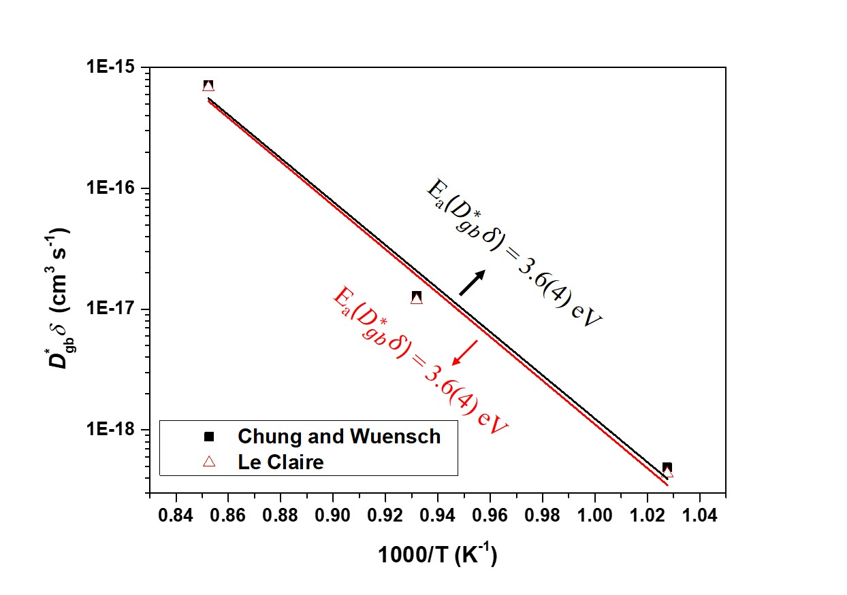

**Figure 11** Activation energy of the *D*gb·*δ* based on both the Chung and Wuensch approximation (black) and the Le Claire estimation (red)

In the literature, the oxygen diffusion data obtained via the oxygen isotopic exchange technique tends to focus on good bulk diffusers and only limited values of *D*gb·*δ* are reported for perovskites, among which the grain boundary products are measured predominantly on LSM materials including both pellet and thin film samples. Figure 12 compares the grain boundary product *D*gb·*δ* of LSCrF73 with the material reported in the literature. It can be seen that the grain boundary diffusion product of the lead zirconate titanate (PZT) material is orders of magnitude higher than most reported materials. Moreover, it is surprising to see that the grain boundary product *D*gb·*δ* of La0.7Ca0.3CrO3 is almost 5 orders of magnitude higher than its analogous material La0.8Ca0.2CrO3. Since the oxygen diffusion measurement on the La0.7Ca0.3CrO3 material is sparse, experiments should be repeated to confirm the validity of the value. For the material studied in this work, the grain boundary product *D*gb·*δ* of the LSCrF73 material is higher than most of the reported data for the LSM materials. For all these materials, increasing the volume percentage of grain boundaries may be a lever to increase the oxygen diffusion behaviour.

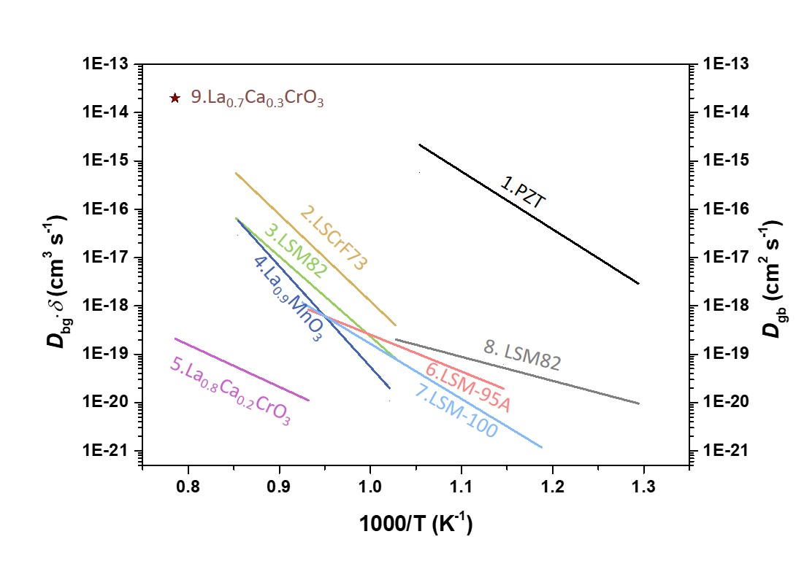

**Figure 12** Comparison of the grain boundary products *D*gb·*δ* between the LSCrF73 material and the materials reported in literature: 1- PZT (Lead zirconate titanate)[48]; 2-LSCrF73 from this work; 3- LSM82-La0.8Sr0.2MnO3+*δ* [28]; 4-La0.9MnO3±*δ* [49]; 5-La0.8Ca0.2CrO3-*δ* [50]; 6-LSM82-95A, 5% A-site non-stoichiometry (La0.8Sr0.2)0.95MnO3 thin film with the grain size of 70 nm [51]; 7-LSM-100 Stoichiometry (average values of the thin film LSM82 with the grain sizes of 30 nm 40 nm and 45 nm)[51]; 8-LSM82 thin film [52] and 9-La0.7Ca0.3CrO3 [53]

# Conclusions

The electrical conductivity and diffusion behaviour of the 5% A-site non-stoichiometric LSCrF materials were investigated. As the Cr substitution level increased, the electrical conductivity of the LSCrF materials gradually increased and a maximum value was obtained for the LSCrF73 composition.

The reliability and validity of the diffusion kinetic data were firstly discussed. For the material with high surface exchange rate but low bulk diffusivity, i.e. bulk diffusion limited materials with high *h*(=*k*/*D\**), the normalised 18O surface fraction is close to unity which introduces errors in measuring the surface exchange coefficients via line scan mode. Although the obtained surface exchange coefficients by depth profile mode are more accurate, only a lower bound of the actual surface exchange coefficient can be achieved for this kind of materials.

For oxygen diffusion behaviour, as the Cr content increased the bulk diffusivity presented a decreasing trend. All three LSCrF compounds, LSCrF37, LSCrF55 and LSCrF73, presented fast surface exchange rates (>910-8 cm s-1 at 900 ) but the surface exchange coefficients of the LSCrF73 material are nearly one order of magnitude lower than the surface exchange coefficients of the other two samples. This behaviour is suggested to be attributed to the low oxygen vacancy concentration on the surface and the pronounced underestimation of the surface exchange coefficient of the LSCrF73 compound due to its lower bulk diffusivity.

Moreover, grain boundary fast diffusion was observed for the LSCrF73 material. Two approximation methods, i.e. Le Claire approximation and Chung and Wuensch approximation, were applied to obtain the grain boundary product ($D_{gb}δ$). For the compositions in accord with Harrison type B kinetics with 10 <*β*< 100, these two approaches provided very close approximations for the grain boundary products while in other circumstances the Le Claire approximation results in large errors and the Chung and Wuensch method is preferred.

**Acknowledgements**

The authors would like to thank Praxair Inc., USA for funding and Dr J. Lane for advices. The authors further acknowledge the assistance from Dr R. Chater and Dr S. Fearn in the oxygen isotopic exchange experiments and SIMS analysis.

# References

|  |  |
| --- | --- |
| [1] | Y.-S. Chou, K. Kerstetter, L. R. Pederson and R. E. Williford, *J. Mater. Res.,* 2001, **16**, 3545-3553. |
| [2] | A. Atkinson, R. J. Chater and R. Rudkin, *Solid State Ionics,* 2001,**139**, 233-240. |
| [3] | S. Tao and J. T. S. Irvine, *Chem. Mater.,* 2004 **16**, 4116-4121. |
| [4] | T. Ramos and A. Atkinson, *Solid State Ionics,* 2004, **170**, 275-286. |
| [5] | J. Yoo, S. Kim, H. Choi, Y. Rhim, J. Lim, S. Lee and A. J. Jacobson, *J. Electroceram.,* 2011 **26**, 56-62. |
| [6] | M. F. Lu, E. V. Tsipis, J. C. Waerenborgh, A. A. Yaremchenko, V. A. Kolotygin, S. Bredikhin and V. V. Kharton, *J. Power Sources,* 2012, **206**, 59-69. |
| [7] | T. Wei, X. Zhou, Q. Hu, Q. Gao, D. Han, X. Lv and S. Wang, *Electrochim. Acta,* 2014, **148**, 33-38. |
| [8] | D. E. Fowler, J. M. Haag, C. Boland, D. M. Bierschenk, S. A. Barnett and K. R. Poeppelmeier, *Chem. Mater.,*2014, **26**, 3113-3120. |
| [9] | H. Sabarou, S. Darvish, S. Gupta, P. Singh and Y. Zhong, *Solid State Ionics,* 2017, **310**, 1-9. |
| [10] | S. Gupta, H. Sabarou, Y. Zhong and P. Singh, *Int. J. Hyd. Energy,* 2017, **42**, 6262-6271. |
| [11] | N. Miura, H. Murae, H. Kusaba, J. Tamaki, G. Sakai and N. Yamazoe, *J. Electrochem. Soc.,* 1999 **146**, 2581-2586. |
| [12] | M. Dhallu, "Oxygen transport in mixed conducting LSM-YSZ composite materials", PhD Thesis, Imperial College London, 2006. |
| [13] | E. Juste, A. Julian, G. Etchegoyen, P. M. Geffroy, T. Chartier, N. Richet and P. Del Gallo, *J. Mem. Sci.,* 2008, **319**, 185-191. |
| [14] | A. Vivet, P. M. Geffroy, T. Chartier, P. Del Gallo and N. Richet, *J. Mem. Sci.,* 2011, **372**, 373-379. |
| [15] | P. M. Geffroy, A. Vivet, J. Fouletier, N. Richet, P. Del Gallo and T. Chartier, *J. Electrochem. Soc.,* 2011, **158**, B971-979. |
| [16] | A. A. Markov, K. Y. Chesnoko, M. V. Patrakeev, I. A. Leonidov, A. V. Chukin, O. N. Leonidova and V. L. Kozhevnikov, *J. Solid State Electrochem.,* 2016, **20**, 225-234. |
| [17] | T. Nakamura, G. Petzow and L. J. Gauckler, *Mater. Res. Bull.,* 1979, **14**, 649-659. |
| [18] | H. Yokohama, N. Sakai, T. Kawada and M. Dokiya, *J. Electrochem. Soc.,* 1991, **138**, 1018-1027. |
| [19] | W. D. Kingery, H. K. Bowen and D. R. Uhlmann, Introduction to ceramics. 2nd ed, New York; London: Wiley-interscience: Wiley series on the science and technology of materials, 1976. |
| [20] | R. A. De Souza and R. J. Chater, *Solid State Ionics,* 2005, **176**, 1915-1920. |
| [21] | S. J. Cooper, M. Niania, F. Hoffmann and J. A. Kilner, *Phys. Chem. Chem. Phys.,* 2017, 19, 12199-12205. |
| [22] | R. A. De Souza, J. Zehnpfenning, M. Martin and J. Maier, *Solid State Ionics,* 2005, **176**, 1465-1471. |
| [23] | J. Crank, "The mathematics of diffusion", Oxford University Press, Oxford, 1975. |
| [24] | S. J. Cooper, "Quantifying the transport properties of solid oxide fuel cell electrodes", PhD Thesis, Imperial College London, 2015. |
| [25] | R. J. Chater, S. Carter, J. A. Kilner and B. C. H. Steele, *Solid State Ionics,* 1992, **53-56**, 859-867. |
| [26] | J. A. Kilner, S. J. Skinner and H. H. Brongersma, *J. Solid State Electrochem.,* 2011, **15**, 861-876. |
| [27] | L. G. Harrison, *Trans. Faraday Soc.,* 1961,1191-1199. |
| [28] | R. A. De Souza, J. A. Kilner and J. F. Walker, *Mater. Lett.,* 2000, **43**, 43-52. |
| [29] | R. A. De Souza and M. Martin, *MRS bulletin,* 2009, **34**, 907-914. |
| [30] | I. Kaur, Y. Mishin and W. Gust, "Fundamentals of grain and interphase boundary diffusion", Wiley, 1995. |
| [31] | R. T. P. Whipple, *The London, Edinburgh, and Dublin Philosophical Magazine and Journal of Science,* 1954, **45**, 1225-1236. |
| [32] | A. D. Le Claire, *Br. J. Appl. Phys.,* 1963, **14**, 351-356. |
| [33] | Y. -C. Chung and B. J. Wuensch,” *J. Appl. Phys.,* 1996, **79**, 8323. |
| [34] | H. Tellez, J. Druce, J.-E. Hong, T. Ishihara and J. A. Kilner, *Anal. Chem.,* 2015, **87**, 2907-2915. |
| [35] | J. Rodriguez-Carvajal, *Physica B* 1993, **192**, 55, [Online]. Available: https://www.ill.eu/sites/fullprof/. |
| [36] | T. Wei, X. Liu, C. Yuan, Q. Gao, X. Xin and S. Wang, *J. Power Sources,* 2014, **250**, 152-159. |
| [37] | Y. Teraoka, H. M. Zhang, K. Okamoto and N. Yamazoe, *Mater. Res. Bull.,* 1988, **23**, 51-58. |
| [38] | P. M. Geffroy, J. Fouletier, N. Richet and T. Chartier, *Chem. Eng. Sci.,* 2013, **87**, 408-433. |
| [39] | J. A. Kilner and R. A. De Souza, “Measurement of oxygen transport in ceramics by SIMS,” in *High Temperature Electrochemistry: Ceramics and Metals, Proceedings of the 17th Risø International Symposium on Materials Science*, Risø National Laboratory, Roskilde, 1999. |
| [40] | M. Niania, "In-situ analysis of La0.6Sr0.4Co0.2Fe0.8 O3-*δ* surfaces in ambient atmospheres", PhD thesis, Imperial College London, 2016. |
| [41] | T. Stephan, J. Zehnpfenning and A. Benninghoven, *J. Vac. Sci. Tech. A,* 1994, **12**, 405-410. |
| [42] | K. Langer-Hansel, A. Schintlmeister, J. Fleig and H. Hutter, *Surf. Interface Anal.,* 2013, **45**, 486-489. |
| [43] | B. J. Tyler and R. E. Peterson, *Surf. Interface Anal.,* 2013, **45**, 475-478. |
| [44] | R. A. De Souza and J. A. Kilner, *Solid State Ionics,* 1998, **106**, 175-187. |
| [45] | R. E. van Doorn, I. C. Fullarton, R. A. de Souza, J. A. Kilner, H. J. Bouwmeester and A. J. Burggraaf, *Solid State Ionics,* 1997, **98**, 1-7. |
| [46] | A. Staykov, H. Tellez, T. Akbay, J. Druce, T. Ishihara and J. Kilner, *Chem. Mater.,* 2015, **27**, 8273-8281. |
| [47] | J. A. Kilner, *Farad. Disscus.,* 2007, **134**, 9-15. |
| [48] | C. Slouka, G. Holzlechner, L. Andrejs, E. Navickas, H. Hutter and J. Fleig, *J. Am. Ceram. Soc.,* 2015, **98**, 3259-3269. |
| [49] | A. V. Berenov, J. L. MacManus-Driscoll and J. A. Kilner, *Solid State Ionics,* 1999, **122**, 41-49. |
| [50] | N. Sakai, K. Yamaji, T. Horita, H. Yokokawa, T. Kawada and M. Dokiya, *J. Electrochem.Soc.,* 2000, **147**, 3178-3182. |
| [51] | E. Navickas, T. M. Huber, Y. Chen, W. Hetaba, G. Holzlechner, G. Rupp, M. Stoger-Pollach, G. Friedbacher, H. Hutter, B. Yildiz and J. Fleig, *Phys. Chem. Chem. Phys.,* 2015, **17**, 7583-8284. |
| [52] | A. M. Saranya, D. Pla, A. Morata, A. Cavallaro, J. Canales-Vazquez, J. A. Kilner, M. Burriel and A. Tarancon, *Adv. Energy Mater.,* 2015, **5**, 1500377. |
| [53] | T. Kawada, T. Horita, N. Sakai, H. Yokokawa and M. Dokiya, *Solid State Ionics,* 1995, **79**, 201-207. |