**Digital transformation and possession attachment: examining the endowment effect for consumers’ relationships with hedonic and utilitarian digital service technologies**

Martin P. Fritze,a,* Andreas B. Eisingerich,b Martin Benkensteinc

aUniversity of Cologne, Universitätsstraße 24, 50931 Cologne, Germany

bImperial College Business School, Imperial College London, South Kensington Campus, London, SW7 2AZ, UK

cUniversity of Rostock, Ulmenstraße 69, 18057 Rostock, Germany

**\*Corresponding author:** E-mail: fritze@wiso.uni-koeln.de, Tel.: +49 221 470 56 07, Fax +49 221 470 5648

**Abstract**

A significant body of research has examined the importance of material possession attachment and its influence on consumer behavior. Critical questions, however, remain with regard to the extent to which, and if at all, consumers form instantaneous possession attachment in electronic commerce. In this research, we conducted one quasi-experimental field study and one scenario-based online experiment to examine the endowment effect (EE) for digital services. The current findings demonstrate that consumers become instantaneously attached to and are reluctant to give up digital services once they have obtained them. Two main explanations of the EE in electronic commerce are investigated. Critically, the results show that the psychological processes underlying the effect differ between utilitarian and hedonic digital services. Proprietary feelings towards utilitarian digital services occur due to loss aversion, whereas proprietary feelings towards hedonic digital services reflect the consumer’s conscious self-relatedness to the digital service.

**Keywords:** Possession, ownership, loss aversion, endowment effect, digital consumption, attachment

**1 Introduction**

When asked about their very first activity in the day, the majority of participants in an executive MBA program did not mention brushing one’s teeth, drinking coffee, or even saying ‘Good Morning’ to the other person in bed but rather replying to messages, downloading the latest news, and ordering something online using various digital services. Scholars across disciplines have studied and shown how important the ownership of material products is for individuals. For example, consumers acquire material possessions as tangible expressions of their identity [1], extend themselves through products [2], and use material possessions as symbolic markers of group membership [3]. Given the profound power of material possessions and individuals’ attachment to them, significant research has been conducted in an effort to understand the positive and negative consequences of such possession and attachment for consumers [1, 4-6]. However, more recently, there has been a call for “reconceptualizing consumerism for digital markets” [7]. Today, digital services such as Spotify, Tidal, or Apple Music for music streaming, Tinder, Grindr, or eHarmony for online dating solutions, and PayPal, Alipay, or WeChat Pay for online payment offerings, extensively permeate consumers‘ lives [8-10] and thereby dramatically affect their personal well-being, either positively or negatively [11, 12].

While crucial insights in consumer behavior in electronic commerce are increasingly revealed [13-18], we know little about consumers’ formation of proprietary feelings towards digital service technologies. However, the research about the human desire to acquire and retain external objects is crucial in understanding consumers’ economic decision-making [19]. One of the most important and robust empirical findings noted in consumer psychology is the endowment effect [20]. It shows that ownership of an item can increase the item’s perceived value and thereby explains why it is difficult for people to let go of their possessions from the very moment they acquire them [21]. Do people also become attached to the digital service technologies they use? The extant research has yet to address this critical question. Therefore, in this research we explore when and how consumers, if at all, form attachments to digital services technologies and examine the extent to which and why people immediately stick to a digital service after using it for the first time (i.e., they become instantaneously attached).

A novel and important contribution of our research is to examine the endowment effect’s (hereafter, EE) “instantaneous nature of the reference point shift and consequent value change” [22] for digital service technologies. We conducted a quasi-experimental prestudy with field data to test the EE in a digital services environment. Moreover, a large-scale scenario-based online experiment was employed to distinguish the EE for hedonic and utilitarian digital service technologies and to further explore the underlying psychological processes that help explain the noted effects. The provocative finding that people indeed can become instantaneously attached to a digital service calls for researchers and marketers to consider the consequences of consumers’ attachment to digital service consumption and provides new insights to enhance our understanding of consumer behavior in electronic commerce.

**2 Theoretical background**

***2.1 Proprietary feelings towards digital services***

Although the prior work has conceptually suggested that people also develop ownership feelings towards digital goods (e.g., social media profiles, blogs, websites), there is a dearth of research that empirically investigates the influence of consumers’ ownership feelings for the digital service technologies they use. Some initial work has observed the emergence of proprietary feelings towards digital services such as mobile health [23] and music streaming [24]. For example, Mifsud et al. [25] introduced the concept of service appropriation as “a process by which customers make the service their own” and can develop possessive feelings towards the service. Interestingly, a sense of ownership towards consumption objects heightens consumers’ willingness to pay and is positively associated with customer loyalty [22, 26, 27]. However, important questions remain regarding the emergence of proprietary feelings towards digital services and whether people can become attached to a new digital service they have not been using for a long time. That is, can they become attached to it in an instantaneous manner? If so, how?

Building on the previous evidence for a strong desire to possess physical objects that influences human behavior, the emergence of ownership feelings towards digital service technologies should also be “spontaneously constituted as an internal need without any external influence” [28]. That is, in addition to the psychological processes connected to time and resource investment by the customer that eventually elicit proprietary feelings for a digital service, there should be an instinctive tendency of customers to hold onto such services. However, digital services such as music streaming with Spotify or Tidal, are not tangibly held in possession or stored as material goods (e.g., CDs or vinyl records that one collects and displays in one’s living room). Therefore, interesting and critical questions remain as to why consumers would hold onto digital services before they even start to consume them for a longer period and invest personal resources in such service technologies. Accordingly, the research on the EE seeks to answer whether and why people become instantaneously attached to and reluctant to let go of personal possessions.

***2.2 The endowment effect (EE)***

The EE indicates that “goods that are included in the individual’s endowment will be more highly valued than those not held in the endowment” [22, 29]. It is noteworthy that in the series of experiments on the EE, people assigned approximately twice the value to commonly desired material items such as pens or mugs when they were endowed with the item and asked to state prices to sell the item compared with people who were asked to make offers to buy these items [22]. This difference in monetary evaluations quantifies the EE and is known as the price disparity between owner-sellers’ willingness to accept (WTA) and nonowner-buyers’ willingness to pay (WTP). Although a large body of research has examined the EE for material products, there is limited work to date that investigates the EE with regard to a digital consumption environment.

Given how important digital services such as Instagram, Tinder, and WeChat have become to people’s lives and how much time and emotional energy individuals spend using such services on a daily basis, this constitutes an important research gap that we aim to address. As a next step, we thus conducted a prestudy to test whether the EE can be observed for digital service technologies.

**3 Prestudy: to what extent do consumers show an endowment effect for digital service technologies?**

As a preliminary test of our theoretical perspective, we conducted a field study to examine the real-world relevance of the EE for digital services. We followed the recommended standard procedures employed in most previous studies [22]. According to the established experimental standard approach of the EE, the participants are randomly designated owners (nonowners) of a target object (e.g., pens, mugs). They are then told that they are (not) allowed to keep the object. Owners (vs. nonowners) are asked about the amount of money for which they would be willing to sell (buy) the object, indicating their willingness to accept, “WTA” (willingness to pay for the object, “WTP”). The endowment effect is quantified by the resulting WTA‒WTP disparity (WTA > WTP). Accordingly, and simply put, in the prestudy we expect that actual users of a digital service technology will state higher prices to give up using the service (WTAU-S) than nonusers will be willing to pay (WTPNU-B) to start using it (WTAU-S > WTPNU-B).

***3.1 Design and procedure***

The study followed a quasi-experimental design and included one manipulated between-subjects factor (group: nonuser-seller, user-buyer) and one measured variable (price). The real-world digital service referred to is a complimentary mobile app offered at some universities. It provides students with information about canteen menus, available jobs, events, and accommodation offers, all customized to their particular university. An online survey was conducted at a university that provides the app to its students. College students are representative of the electronic commerce shopping population because they are likely to be familiar with and users of electronic commerce [30]. In total, 51 students took part (43% female; Mage=25.5). The participants were told that this was a survey to rate university-related services. After a filler task had been presented, they were shown the app’s brand logo and asked whether they knew the app (yes, no) and whetherthey currently used the app (yes, no). All participants were subsequently exposed to a screenshot from the app’s home page presenting an overview of its range of functions. They were asked to read the information presented carefully and to imagine the following scenario:

Usage of the app requires a fee at your university. However, the costs are covered by semester fees. At the beginning of each new semester, every student is allowed to decide whether they want to use the app. If they decide to use the app, the individual semester fee increases. If they decide not to use the app any more, the individual semester fee decreases by the same amount.

Those who stated they did not know the app or did not currently use it were automatically assigned to the nonuser-buyer group. The participants who stated they currently used it were assigned to the user-seller group. The user-seller (nonuser-buyer) group received the following question: “You indicated that you are currently (not) using the app. You now decide not to use the app any more (use the app) in the next semester. How much should your semester fee consequently decrease (increase) at the minimum (maximum)?” The user-seller and nonuser-buyer groups had to state their evaluation of the price in a given interval, ranging from $0–10 ($0.25 increments). The study was conducted when a new term was about to start, which predisposed the participants’ actual situation to be in accordance with the decision situation modeled by the scenario.

***3.2 Manipulation check***

To check whether the transaction treatment (seller vs. buyer) was effective, the survey included a question directly after the price measurement asking the participants from which position they had stated a price for the service (“Please think again about the situation presented earlier. From which position have you just been asked to state a price?”). The participants were asked to indicate one of two possible statements (nonuser-buyer: “I should state the amount of money I would be willing to pay to use [the service].” User-seller: “I should state the amount of money I would want to be paid back if I could no longer use [the service]”). That is, the manipulation check had a dichotomous response format. This tested whether they had correctly perceived the rating of either an amount of money they should be reimbursed because of discontinuing the use of the app (WTA for user-seller) or a price they would pay to use the app in the future (WTP for nonuser-buyer). A chi-square test of independence was performed to examine the relationship between the experimental group assignment and the participants’ answers. This revealed that the manipulation was overall successful (χ2 (1)=39.51, p < .001). However, three participants were excluded from further analysis because their answer to the manipulation check statement was not in accordance with their experimental group. After this deletion, 48 participants (44% female; Mage=25.4.; Nnonuser-buyer=28, Nuser-seller=20) remained.

***3.3 Results***

Fig. 1 shows that the user-sellers (Muser-seller=2.91, SDuser-seller=2.99) stated significantly higher prices than nonuser-buyers (Mnonuser-buyer=1.29, SDnonuser-buyer=1.61; t(26.84)=2.20, p < .05; unequal variances). This finding is noteworthy since the prestudy examined the EE for services following the standard experimental approach and thus was able to establish the EE for digital services as a real-world phenomenon. As such, the prestudy replicated the prior results in the context of material products in the context of digital service technologies.

- INSERT FIGURE 1 ABOUT HERE -

While we find empirical support for the EE with digital services, the recent research on the EE attempts to further specify its underlying cognitive and neural processes that can help explain consumers’ initial attachment to external objects. The findings of our prestudy indicated that consumers develop possession attachment for digital service technologies. To better understand these findings and to further answer the guiding research question as to how consumers become attached to digital services in an instantaneous manner, we now extend our view on the EE by referring to its various underlying psychological mechanisms. Therefore, the next section discusses the conceptual background to investigate the EE’s underlying psychological processes in the context of digital services. Specifically, two different accounts known as “loss aversion” and “ownership,” are widely discussed in the current research on the endowment effect [31] and hence are reviewed in the following section.

**4 Explanations of the endowment effect: loss aversion and ownership**

Since the initial studies on the EE, the effect has long been ascribed to loss aversion or the fact that losses loom larger than gains [32]. That is, owners state higher prices to sell an object than buyers are willing to pay for it because, for owners, giving away the object is a loss. This loss for the owners is more severe than the gain buyers derive from obtaining the object. Therefore, higher price evaluations for the object by owners are mainly driven by a perceived “parting disutility” [33]. More specifically, owners are simply reluctant to part with their possessions. As such, loss aversion denotes a deeply rooted, evolutionarily conditioned human tendency to secure external objects [34]. The main reason for this is that the accumulation of possessions provides existential security for individuals [6, 35]. It is noteworthy that this human behavior with its evolutionary heritage may even be independent of the object-related evaluation [36]. Therefore, referring to the “loss aversion account”, the general reluctance of giving up objects does not necessarily relate to the current meaning such objects might have for the owners but rather their general practicability [37].

Critically, a growing stream of research directly challenges the “loss aversion account” and instead highlights the “ownership account” to explain the EE [38-40]. According to the “ownership account”, the higher valuation of the target object relates to a special bond with the object, which in turn induces “ownership-utility” [33]. This is ascribed to a resulting possession‒self link, as the object is incorporated into the extended self, becoming a self-referential part of the person’s identity [2, 41, 42]. Referring to the “ownership account”, the reluctance of giving up an object is related to a special meaning of the object for the owner [43].

Both accounts, loss aversion and ownership, help to explain the EE; however, as researchers have just begun to investigate their underlying psychological processes, important questions remain about how and why either of the accounts is decisive for the EE to occur. More recently, the research on material objects suggests that there seem to be crucial differences between hedonic and utilitarian objects [44, 45]. Specifically, Chan’s [44] study on material goods compared the EE for utilitarian and hedonic products. It revealed that the EE occurs primarily for hedonic goods because they have a special meaning for owners. Given the findings by Chan [44], one could argue that the EE primarily occurs when the reference object entails self-related importance for the individual. This explanation of the EE would conceptually align with the abovementioned “ownership account”. Chan’s [44] findings give us valid indication that the question as to *how* consumers form possession attachment that results in the EE depends on utilitarian and hedonic specifications of the reference object. However, Chan [44] did not distinguish between loss aversion and ownership when testing and explaining the different EEs for hedonic and utilitarian goods.

Taken together, to explain *how* consumers become attached to digital service technologies, the prior research indicates that loss aversion and ownership as explanations of the EE should be investigated with specific regard to the utilitarian and hedonic specifications of digital services. Accordingly, in the next section, we derive our hypotheses to test and explain how consumers form possession attachments to digital services leading to the EE by exploring both hedonic and utilitarian digital services.

**5 Model development**

***5.1 Loss aversion and ownership: hedonic and utilitarian digital services***

Just like material objects, services can be classified as either hedonic or utilitarian, based on the core benefits derived from consumption [46]. Hedonic services offer value beyond practicability. When consumers use a hedonic digital service to fulfill self-motivated psychological needs (e.g., listening to music through streaming services) the service becomes relevant to the individual’s self-concept [47]. In contrast, utilitarian services are used to solve practical tasks [48]. That is, the need to use utilitarian digital services is often externally impelled (e.g., making a bank transfer to pay one’s rent). Utilitarian services might also be important for the individual; however, if that is so, then it is because of their practicability, whereas using hedonic services elicits self-related relevance for the individual even beyond practical considerations.

We posit that the differences in prevailing service characteristics (hedonic vs. utilitarian) are likely to influence the EE for digital services because the instantaneous formation of proprietary feelings for external objects is driven by people’s foresight or expectations of the object’s future use [28, 49]. That is, people instantaneously develop proprietary feelings for an object after evaluating their future usage intentions. Specifically, people retain psychological possessions because of two underlying saving patterns: instrumental saving and sentimental saving [50]. Instrumental saving refers to the perceived future need for an object. The object fulfills the purpose of solving a task, and the person acknowledges the possibility of being able to use the object in the future. Simply put, people hold onto an object they have obtained simply because they might need it in the future, even if they currently have no immediate need for using it (e.g., insurance policy, antivirus software). In contrast, sentimental saving is determined by the person’s self-related feelings for the object (e.g., family video, lifestyle app). That is, the object serves as an extension of the person’s self and is thus a reminder of a relevant part of the self-concept. Sentimental saving occurs when an individual consciously acknowledges that the object is relevant to maintain the individual self-concept.

Considering the different explanations of the EE, we expect the EE to hold for both hedonic and utilitarian digital services. However, we argue that the difference in the occurrence of the EE for both types of digital services lies in the psychological processes driving the effect.

*5.1.1 Instrumental saving of utilitarian digital services*

People are likely to hold onto utilitarian digital services based on instrumental saving because the usage of utilitarian services does not tie-in with consumers’ identities but rather their practicability triggers future usage considerations (i.e., “I might need it in the future”). This is related to the EE because loss aversion occurs due to a reluctance to give away external objects even when such objects currently have no special meaning for the owner [37]. As such, loss aversion indicates instrumental saving patterns that people apply to obtain existential security by accumulating possessions even if those possessions currently have no special self-related meaning [6]. Consequently, the EE for utilitarian services is expected to be driven by loss aversion.

*5.1.2 Sentimental saving of hedonic digital services*

In contrast, people are likely to hold onto hedonic services based on sentimental saving because the usage of hedonic services ties in with consumers’ identities. The practicability of a hedonic service is evaluated by consumers with reference to their self-related needs rather than by the service’s general applicability to solving common practical tasks. Therefore, once a hedonic service is evaluated to provide self-related relevance for the individual, the service is connected to the person’s identity. This conscious acknowledgment of an object’s self-related importance is referred to as the “ownership account” because the reluctance to switch from a hedonic service should occur due to the self-related importance of the service for the user. Therefore, the EE for hedonic services is expected to be driven by ownership.

Taken together, utilitarian digital services should elicit the consumers’ loss aversion (i.e., the EE’s loss aversion account) because such services are evaluated in terms of their practical future use (i.e., “It might be useful to keep it”). In contrast, hedonic digital services elicit ownership feelings (i.e., the EE’S ownership account) because consumers instantaneously evaluate these services in terms of their self-related relevance (i.e., “It is something that relates to me”).

However, the previous research by Morewedge et al. [40] urges researchers to extend the standard experimental design of EE studies to test for these different explanations (i.e., loss aversion vs. ownership) of the EE.

***5.2 Experimental design: loss aversion vs. ownership***

Our prestudy employed the standard approach to test for the endowment effect. This allowed us to assess the extent to which the EE for digital service technologies is generally a real-world phenomenon. To account for the conceptual distinction between loss aversion and ownership, Morewedge et al. [40] proposed a more advanced approach to test both explanations of the EE separately, because in standard approach studies they are confounded. More specifically, in those studies, participants put in the owner position were always asked to sell (owner-seller), while participants who were ask to buy the item were always nonowners (nonowner-buyer):

“In the real world, people who sell goods typically own them and people who buy goods typically do not, which is to say that loss aversion and ownership are typically confounded. Unfortunately, they have typically been confounded in experiments as well. […] In such studies the sellers are owners and the buyers are nonowners, and thus it is impossible to tell from the results whether ownership or loss aversion produced the endowment effect” [40].

Based on Morewedge et al. [40], we put both accounts into direct competition. Therefore, loss aversion is tested through *transaction* (seller, buyer), and ownership is tested through *usage* (user, nonuser). Based on these arguments, we test the following formal hypotheses:

**Hypothesis 1.** Loss aversion explains the EE for utilitarian digital services, meaning that sellers will state a higher price for utilitarian services than buyers, regardless of whether they are users or nonusers of the service.

**Hypothesis 2.** Ownership explains the EE for hedonic digital services, meaning that users will state a higher price for hedonic services than nonusers, regardless of whether they are sellers or buyers of the service.

Briefly, we argue above that referring to the ownership account of the EE, people associate the reference object with their self-concept. More recently, important research has been devoted to specifying this ownership explanation of the EE. First, the neuroscience literature [51] and the work in consumer psychology [52] provides empirical evidence that objects first and foremost must be relevant to the individual to become associated with the self-concept, which in turn results in an increased value judgment towards the object. In line with that, Diesendruck and Perez [53] recently showed that even children extend themselves to toys depending on whether they designate those objects as relevant. Second, it is well known that people strive to see themselves in a favorable light to maintain a positive self-concept [54]. Accordingly, the mere ownership effect assumes that once a target object is perceived as a possession, the owner evaluates it more attractively [55, 56]. The prior research also suggests that the EE is closely related to the mere ownership effect [57]. Similar to the EE, this effect occurs instantaneouslyand indicates an increased non-monetary value judgment for an object[58]. Critically, a hedonic service is evaluated by consumers with reference to their self-related needs rather than by the service’s general applicability to solving practical tasks.

Thus, when the EE is driven by ownership, the target object must be *relevant to become attractive* to the individual, which together elicit a higher willingness to pay for that object [59]. Therefore, we expect that the ownership account is constrained to situations wherein users perceive the service to be relevant to themselves, as only then will they rate the service more favorably and in turn state higher price-related evaluations for the service.

One of the most established concepts in the consumer research for capturing a subjectively perceived relevance of an object is involvement [60, 61]. Therefore, we posit that high involvement acts as a potential boundary condition for the mere ownership effect (i.e., higher perceived attractiveness) as the underlying mechanism of the EE for hedonic services. Based on this, we argue that a conditional indirect effect explains the EE’s ownership account for hedonic services. Accordingly, we hypothesize the following:

**Hypothesis 3.** Only highly involved users will rate a hedonic digital service as more attractive and in turn will state a higher price for the service compared with nonusers, regardless of whether they are sellers or buyers of the service.

Fig. 2 illustrates the conceptual model of our research including the direct effects proposed by Hypotheses 1-2 and the conditional indirect effect proposed by Hypothesis 3.

- INSERT FIGURE 2 ABOUT HERE -

**6 Main study**

***6.1 Design and participant recruitment***

The prestudy referred to actual users and nonusers. As such, users differed in their interaction time with the service. However, we are interested in the instantaneous preference shifts supposed by the EE. Therefore, the main study applied the scenario technique for an online-experiment to enable random and initial experimental manipulation. Moreover, the main study extended the experimental design by separately testing ownership and loss aversion. Following Morewedge et al. [40], the experimental group (user-seller, nonuser-buyer) applied in the prestudy was split into transaction (seller, buyer) and usage (user, nonuser) to experimentally examine the ownership account and the loss-aversion account of the EE simultaneously. This led to a 2 × 2 × 2 design with transaction (buyer vs. seller), usage (user vs. nonuser), and service (hedonic vs. utilitarian) as the between-subjects manipulated factors. The participants were randomly assigned to user-seller, nonuser-seller, user-buyer, or nonuser-buyer conditions, each customized to either a utilitarian or a hedonic service, leading to eight experimental groups in total. The experiment was conducted online as this fit the digital service context [62]. In total, the questionnaires of 422 students (60% female; *M*age=24.1) were analyzed. The participants were recruited by the authors’ research students, who were blind to the purpose of the study and who distributed the link to the experiment (through social media, personal e-mail, and printed notes distributed face to face) as one task in a course on research methodology in economic sciences that they were attending. A technical restriction was implemented to prevent participants from reaccessing the online questionnaire following completion. The data were collected from different universities to increase participant variety. All participants were offered a chance to win Amazon.com gift cards at the end of the study as a compensation for completing the questionnaire. The participants were told at the beginning of the study that the survey was being conducted on behalf of a company that only operates in a foreign market and had asked not to be mentioned by name. It was stated that although the company’s name had been changed, all the information would describe factual situations.

***6.2 Stimulus development***

The details of the experiment described in the following were carefully chosen to address the methodological concerns raised in the literature on the EE.

*6.2.1 Services (hedonic, utilitarian)*

The utilitarian service was labeled “CashHelp”. The service offer was described as enabling and simplifying online payments by providing every user with a virtual account to administer monetary transactions (see Appendix A). The hedonic service was named “TuneFountain” and was characterized as a music streaming service, which provides every user with an online account that allows them to create, store, and share playlists (see Appendix B). A pretest (*N* = 53) was conducted through a paper–pencil survey to check whether the service presented was considered hedonic or utilitarian. The participants were either exposed to the hedonic or the utilitarian service. To test the hedonic and utilitarian evaluations of the services, a procedure was applied based on Lessard-Bonaventure and Chebat [63]. Hedonic and utilitarian services were defined within the questionnaire:

Services can among other terms be classified as hedonic and utilitarian. A hedonic service is defined as pleasant and fun. It primarily serves as enjoyment. A utilitarian service is defined as functional and useful. It primarily serves to achieve practical goals.

The participants were then asked to rate the service to which they were exposed by referring to this two-item classification. Both were measured on a seven-point scale, with the hedonic item anchored at 1 = “the service is not at all hedonic” and 7 = “the service is totally hedonic,” and the utilitarian item was correspondingly anchored at 1 = “not at all utilitarian” and 7 = “totally utilitarian.” As expected, the hedonic service, “TuneFountain,” was rated as more hedonic (*M*TuneFountain = 5.56,*SD*TuneFountain = 1.39, *M*CashHelp =2.93, *SD*CashHelp=1.72, *t*(51)=6.08, *p* < .001) and less utilitarian than the utilitarian service “CashHelp” (*M*TuneFountain =3.56,*SD*TuneFountain =1.61, *M*CashHelp =5.71, *SD*CashHelp =1.41, *t*(51) = 5.19, *p* < .001). The main study conveyed each service description as a recently released newsflash about the respective service, including a line that the company had decided to offer the service without any advertising and therefore would demand a one-time registration fee from new customers. This was crucial, as it allowed a transaction scenario to be drawn to assign participants to either the buyer or the seller group later in the questionnaire.

*6.2.2 Usage (user, nonuser)*

The participants assigned to the user group were told to mentally put themselves into a situation of regularly using the service presented. Afterwards, they completed a task designed to additionally trigger the user position. Six potential advantages of users of the service over nonusers were listed. The participants were then invited to indicate the relevant advantages from their current position as users. The rationale behind this was twofold. First, by reading through all the advantages the participants could choose from, they could think more thoroughly about what it might mean for them to use the service with its entire range of functions. Second, all of the advantages semantically fit the user position because they were formulated from the first-person perspective, so that the participants could become more conscious of their user group affiliation (e.g., CashHelp: “The service provides me with security when I shop online,” “I can easily shop by mobile phone;” TuneFountain: “I can always access the latest music,” “I can get suggestions for new music titles through friends’ playlists”). The nonusers were instructed to imagine they could not use the service at all. The previously described advantages of the service were then listed; however, this time they were semantically aligned with the nonuser position—that is, formulated not from the first-person but rather from the user perspective. The nonusers had to choose among the relevant advantages they thought users had over them because they could access the service (e.g., CashHelp: “The service provides users with security when they shop online,” “Users can easily shop by mobile phone;” TuneFountain: “Users can always access the latest music,” “Users can get suggestions for new music titles through friends’ playlists”). Importantly, the previous research proposes that the differences in price statements in studies on the EE might be driven by differential perceptions of the reference object because owner-sellers were shown to focus more on positive and nonowner-buyers more on negative features [64]. Therefore, in our study, all experimental groups were exposed to the advantages of the service.

*6.2.3 Transaction (seller, buyer)*

The transactions (buyer, seller) were manipulated with a neutral transaction scenario. Derived from projection technique [65], the participants were exposed to a fictitious dialog between two unspecified persons (A and B), modified to ask for either the participants’ WTA or their WTP for the service to which they were assigned.

In the WTA dialog exposed to which the participants assigned to the group of sellers were exposed, person A stated the following:

I will now register at CashHelp/TuneFountain. Recently, users had to pay a one-time registration fee. However, users can also acquire the existing account from someone. Assuming that you safely erased all your personal data, for how much would you sell your account?

The dialog box of person B contained a free field and represented a reply to person A: “Well, therefore, I would demand at least $___ .” The participants were asked to complete the field for B by stating a price (WTA). Similarly, the participants assigned to the group of buyers were asked to indicate a price (WTP) in the same given range but with reference to the following dialog:

I will now register at CashHelp/TuneFountain. Recently, users had to pay a one-time registration fee if they did not yet have an account. Do you know how much it was?

Again, the reply for person B contained a dialog box was as follows: “I do not know. But I would pay $___ at most.”

***6.3 Measurement***

The price as the key dependent variable was measured in a given interval, ranging from $0–20 ($0.50 increments), as applied in previous EE studies (see also [29]). Some early EE studies employed so-called Becker–DeGroot–Marschak auctions to measure price (“BDM auctions”). However, more recent studies do not employ this technique because it requires real transactions to conduct the experiment [66].

The moderated mediation model for the ownership account (Fig. 2) comprises the mere ownership effect as part of the EE ownership account. Given the conceptual definition of the mere ownership effect as specified by Beggan [55] —“people will rate an object as more attractive when they own it”—the effect was measured by assessing the participants’ evaluation of the service’s attractiveness. The previous studies argue that attractiveness is a global evaluation criterion and as such can be measured with a single-item approach [67, 68]. In line with that, to assess the perceived attractiveness the item “I consider the app to be attractive” was measured on a seven-point scale anchored at “1 = strongly disagree” and “7 = strongly agree.”Moreover, the participants’ involvement with the service was measured on a six-item (“unimportant to me/important to me,” “of no concern to me/of concern to me,” “irrelevant to me/relevant to me,” “means nothing to me/means a lot to me,” “useless to me/useful to me,” “insignificant to me/significant to me”), seven-point bipolar scale from Jiménez and Voss [69].

***6.4 Manipulation checks***

The manipulation of usage (user, nonuser) was checked by asking the participants to state whether they perceived the scenario as a user or nonuser of the service as shown above. Similarly, the transaction (seller, buyer) manipulation was checked by asking the participants whether they had stated a price as seller or buyer. Hence, the manipulation check had a dichotomous response format for both factors. The results confirmed that both manipulations were overall successful (χ2Usage (1) = 207.01, *p* < .001; χ2Transaction (1) = 267.38, *p* < .001). However, the participants were excluded from further analysis when at least one of their manipulation check statements was not in accordance with their experimental group. In total, 323 (63% female; *M*age=24.2) remained from the initial sample (see Fig. 3).

***6.5 Data analysis and results***

The service factor (hedonic, utilitarian) was deliberately not modeled as a moderator variable of specific paths, but the research models were tested separately in both service contexts. This was appropriate because no presumptions were made regarding which paths of the models would be affected in which way by service characteristics [70]. Fig. 3 summarizes the descriptive statistics of all variables for each group.

- INSERT FIGURE 3 ABOUT HERE –

To test the EE (loss aversion)for utilitarian digital services (Hypothesis 1), the data of those groups assigned to the utilitarian service were analyzed with a two-way ANOVA, with price as the dependent measure and usage (user, nonuser), transaction (seller, buyer), and their interaction as independent variables. Consistent with Hypothesis 1, the main effect of the transaction on price (*F*(1, 151) = 14.70, *p* < .001) was significant. There was a nonsignificant main effect of usage on price (*F*(1, 151)=.01, *p =* .920). The interaction between transaction and usage on price was nonsignificant (*F*(1, 151) = .01, *p =* .924). An analysis of planned contrasts further revealed group differences as expected, with the user-seller rating higher than the user-buyer rating (Muser-seller = 7.32 SDuser-seller = 8.05, Muser-buyer = 3.87, SD user-buyer = 3.49, *t*(51.03) = 2.47, *p* < .001; unequal variances) and the nonuser-seller group stating higher prices than the nonuser-buyer group (Mnonuser-seller = 7.15 SDnonuser-seller = 5.75, Mnonuser-buyer = 3.86, SD nonuser-buyer = 3.08, *t*(55.13)=3.06, *p* < .001; unequal variances). Fig. 4 illustrates that sellers stated higher prices than buyers as both users and nonusers. Thus, the results support Hypothesis 1.

- INSERT FIGURE 4 ABOUT HERE –

Moreover, the EE *(ownership)* for hedonic service was tested (Hypothesis 2). The data of those groups assigned to the hedonic service was analyzed with a two-way ANOVA, with price as the dependent measure and usage (user, nonuser), transaction (seller, buyer), and their interaction as independent variables. The main effect of usage on price (F(1, 164) = .33, *p* = .565) was nonsignificant. Hence, Hypothesis 2 was not supported. There was no significant main effect of transaction on price (*F*(1, 151) = .378, *p =* .540). Moreover, the interaction between transaction and usage on price (*F*(1, 151)=1.52, *p =* .219) was nonsignificant.

However, for hedonic services it was furthermore hypothesized that service attractiveness conditionally mediated the effect of usage (user, nonuser) on price. That is, for hedonic services Hypothesis 3 posited that the indirect effect of usage on price through attractiveness would be qualified by a significant moderating effect of involvement on the relationship between usage and attractiveness. This first-stage moderated mediation model was tested using Hayes’ [70] PROCESS macro for Model 7 with bias-corrected bootstrapping (5,000 samples, 95% C.I.) and the heteroskedasticity-consistent standard error estimator HC3 [71]. The analysis was run with usage (coded as 0-nonuser vs. 1-user) as the independent variable, attractiveness as the presumed mediating variable, price as the dependent variable, and involvement (Cronbach’s *α* = .95) as the presumed moderating variable [70]. Importantly, according to Hypothesis 3, transaction (coded as 0-buyer vs. 1-seller) had to be integrated as a covariate, because users were expected to state higher prices than nonusers, independently of whether they were assigned to the buyer or seller group. Hence, the model was analyzed (see Fig. 2) while statistically controlling for transaction.

The PROCESS results evidenced a significant moderating effect of involvement on the path between usage and attractiveness (B *=* .32; *t* = 2.23; *p* < 0.05). Additionally, controlling for usage and transaction, attractiveness had a significant effect on price (B = .80; *t* = 2.52; *p* < .05); controlling for attractiveness and transaction, the direct effect of usage on price was nonsignificant (B = .40; *t* = .45; *p* = .66). However, based on Hypothesis 3, it was expected that only highly involved users would rate the service as more attractive and thus state a higher price for a hedonic service than nonusers (regardless of whether they are sellers or buyers of the service). Thus, the conditional indirect effect of usage through attractiveness on price is a function of the moderator involvement and should solely operate for highly involved users. Therefore, a spotlight analysis was conducted to further probe the influence of the moderator on the indirect effect [72]. Since the moderator (involvement) was continuous, the turning points were sought where exactly, in the absolute value of the moderator, the indirect effect of the independent variable usage (user, nonuser) on price through the mediator attractiveness turned from nonsignificance to significance for the prespecified significance level of 0.05. For this purpose, PROCESS enabled probing of the moderating effect of involvement on the indirect relationship from usage on price through attractiveness. Specifically, it allowed for inferential tests of the effect at the percentiles. This revealed a significant indirect effect of usage on price through attractiveness at the higher levels of the moderator involvement (75th and 90th percentiles of involvement). The 95% lower-level confidence intervals (LLCI) and upper-level confidence interval confidence intervals (ULCI) for the two tests were LLCI75=.051 and ULCI75=1.162, and LLCI90=.087 and ULCI90=1.559, respectively, implying that neither of the two intervals included zero. A significant effect was not obtained for lower levels of involvement (10th, 25th, and 50th percentiles of involvement). Furthermore, the spotlight analysis was extended by probing the values of the moderator involvement using the focal-point approach. The study applied 0.5 increments of a seven-point Likert-type scale to measure the moderator involvement. That is, the model was analyzed with the mean-shifted data values of the moderator involvement in 0.5 increments. As illustrated in Fig. 5, the spotlight analysis showed that involvement at a value of 4.5 is the turning point from nonsignificance to significance of the conditional indirect effect.

- INSERT FIGURE 5 ABOUT HERE -

Finally, the index of moderated mediation was applied as a formal test of the supposed first-stage moderated mediation model [81]. The significant index of moderated mediation with a value of 0.259 [LLCI .043, ULCI .698] confirmed overall that the mediation relationship of usage on price through attractiveness is moderated by involvement, because the proposed moderator involvement has a nonzero weight in the function linking the indirect effect of usage on price through involvement to the moderator. All results of the first-stage moderated mediation analysis are shown in Fig. 6. Taken together, Hypothesis 3 was supported. Furthermore, the same analysis was conducted for the utilitarian service (see Fig. 6). The results showed that the data for the utilitarian service do not fit the model. That is, for the utilitarian service, there was only a direct effect of transaction on price.

- INSERT FIGURE 6 ABOUT HERE -

***6.6 Discussion***

In our research, we tested Hypotheses 1–3 by separately modeling loss aversion through transaction (seller, buyer) and ownership through usage (user, nonuser) as the main drivers of the EE. Table 1 provides an overview of the results of our hypotheses testing.

- INSERT TABLE 1 ABOUT HERE -

Hypothesis 1 was related only to utilitarian services and could be confirmed. Thus, loss aversion explains the EE for utilitarian services. Hypothesis 2 received no support; that is, there is no main effect of ownership explaining the EE for hedonic services. Interestingly, Hypothesis 3, was supported—ownership explained the EE for hedonic services; however, the underlying psychological process’s complexity cannot be explained by simple effect analysis (i.e., Hypothesis 2 was not supported). The conditional indirect effect (Fig. 2) of usage on price through attractiveness only operates when consumers are highly involved with the digital service.

When a digital hedonic service exhibits self-related relevance for users, they were found to evaluate the service as more attractive and in turn state higher prices for the digital service than nonusers did. Thus, the instantaneous emergence of proprietary feelings towards digital hedonic services reflects the consumer’s conscious self-relatedness of the service. This supports the EE’s ownership account for hedonic services, which refers to sentimental saving. In contrast, digital utilitarian services are more task-oriented and often externally impelled due to the need to solve practical tasks. Therefore, the consumption of utilitarian services is not based on considerations of their self-referential relevance. Accordingly, the results demonstrate that the EE for digital utilitarian services is explained by loss aversion. Thus, proprietary feelings towards digital services reflect the mere awareness of being entitled (loss aversion) to use them. This can be understood as an instrumental saving process by consumers, referring to perceived practical future needs for the utilitarian digital service [73]. Together, the current results shed light on people’s consumption habits for digital service technologies.

An important takeaway is that it is not only material objects that are targets of the human tendency to hoard personal belongings but also intangible objects and activities such as digital services. Our findings indicate that individuals consciously or unconsciously hold onto digital utilitarian services simply because they are reluctant to feel a loss when with regard to giving them up. In turn, digital hedonic services hold a special self-referred meaning to individuals.

**7 Conclusions and implications for practice and research**

This article calls attention to the formation of instantaneous attachment towards digital service technologies. First, the findings shed light on the emergence of individuals’ habitual adoption process of everyday digital services. Digital services are ubiquitous, especially in digitized economies [74] and often lead to time-consuming activities and habits [75], which can dramatically affect individuals’ well-being, either positively or negatively [55].Importantly, digital service consumption compared to other services often comes with very low entry barriers. For example, obtaining a membership at a gym demands that customers make an effort (i.e., making an appointment, driving to the location, talking to sales staff) even before the consumption process has begun. The “let’s give it a try” barrier is much higher in terms of personal resource investment than for digital service consumption. Simply downloading a new app, trying out a streaming service, or registering on a social media platform takes seconds and requires little resource investment [7]. Thus, attachment towards ever more digital services is very likely, as there are lower entry barriers and fewer accumulation constraints. Critically, the accumulation of ever more apps or digital services on one’s mobile device might increase the probability for individuals to become addicted to using their electronic devices. In showing that consumers instantaneously stick to digital services, we raise awareness of the potential harmful accumulation of digital service applications on people’s devices such as smartphones and tablets.

Second, digital businesses might actively trade upon some of the insights of this research to align the customer journey so that (potential) customers become attached to their services. More specifically, for utilitarian services, managers should emphasize a variety of practical usage possibilities to increase people’s instrumental saving pattern regarding these services. This outlook for future need is already established in the advertisement of assurance services. In accordance with our findings, the “You never know” principle should be employed to instantaneously attach customers to utilitarian digital services. For example, this should lead people to download a utilitarian app, which provides marketers with better possibilities to further engage service customers. A key takeaway for marketers of utilitarian digital services is to promote their offers such as a Swiss Army Knife full of useful applications and the potential to be needed in the future.

In contrast, for hedonic services, managers should emphasize the relevance of self-related experiences provided by the service to tie people into mental attachment to the service. Consumers develop feelings of ownership towards digital hedonic services and incorporate the related usage into their self-concept. In such cases, people consciously hold onto those digital services when they attach some meaning to those services, which exceeds purely functional dimensions and stands in connection with individuals’ thoughts and feelings in relation to themselves. Therefore, in addition to the symbolic and socially created importance of online spaces of self-extension posited by Belk [76], the current results show that the mere process of using digital services itself shapes identity if such services are consumed with mainly hedonic intent. When hedonic digital services are promoted in reference to a certain style of consumption, users can be guided to evaluate them referring to their self-concept. With that said, to make the services more relevant for people, the promotion of hedonic digital services should refer to common consumption values (e.g., “I like to interact with other people”, “Vegan for life”, “I root for geeks”).

***7.1 Limitations and future research***

The current research focused on digital service technology usage and experimentally excluded any tangible context of the service offering. We invite future research to build on the current results and investigate the extent to which proprietary feelings are separately directed to the entirety of the servicescape [77, 78]—specifically, the physical environment in which a service takes place. Interestingly, in the case of digital services, this would typically refer to the consumer’s own electronic devices (e.g., smartphone, tablet or laptop). Therefore, do proprietary feelings for a digital service transcend the digital usage environment and transfer to the user’s device? For example, do apps such as Spotify, Instagram, or Tinder enhance individuals’ attachment to their smartphone or laptop? That said, would this transcendence of proprietary feelings from the intangible to the tangible differ for utilitarian (i.e., “my device is my storehouse of things I (might) need”) and hedonic services (i.e., “my device contains things that define me”)? Accordingly, additional research that differentiates tangible and intangible objects of proprietary feelings is richly deserved.

Moreover, further research is needed to investigate how the instantaneous emergence of proprietary feelings functions as an opening or hurdle for long-term attachment toward a digital service technology. More specifically, it would be valuable to understand when and why the initial attachment ends, and at which point in time or interaction intensity other mechanisms operate that make the consumer stick to the service. We speculate that the initial reflex-like process shown in the current study paves the way for long-term attachments. More insights might help explain how the “chain of attachment” can be broken to prevent the harmful consequences of excessive digital service consumption. Given that we live in an age of digital transformation, the research in this space will help our understanding not only of the objects/services in our lives but also ourselves as human beings and our interaction with various extant and emerging technologies. Moreover, the current research focused on the instantaneous emergence of proprietary feelings. That is, the main study showed that consumers show the EE for services they have not used before. However, the differences in the prevailing service characteristics might change in the perception of the consumer when the service is used for a longer period. Even mere utilitarian services might become self-relevant (i.e., perceived as hedonic) to the individual over time. Therefore, it would be interesting to investigate how the explanations of the EE for a digital service might change over the course of usage period and at different intensities.

Finally, as we used scenario techniques to conduct the experiments, we encourage researchers to employ field studies and replicate or extend our results in various different digital service contexts. Additional moderation and mediation paths are worth further investigation to complement our understanding about the formation of possession attachment towards digital service technologies. Given the ongoing progress in artificial intelligence and the potential for virtual reality to act as the next ‘super drug’ [79], further research on human attachment to digital service offerings is rich in potential. We invite additional research on what we believe is a promising and important field of work not only for business to better maneuver an environment with an increased offering of digital services but also to help humankind in the pursuit of self-understanding and autonomy [80].

**References**

1. Dittmar, H., & Pepper, L. (1992). Materialistic values, relative wealth, and person perception: social psychological belief systems of adolescents from different socio-economic backgrounds. In F. W. Rudmin, & M. L. Richins (Eds.), *Meaning, measure, and morality of materialism* (pp. 40–45). Provo, UT: Association for Consumer Research.

2. Belk, R. W. (1988). Possessions and the extended self. *Journal of Consumer Research,* 15(2), 139–168.

3. Dittmar, H. (1994). Material possessions as stereotypes: material images of different socio-economic groups. *Journal of Economic Psychology,* 15(4), 561–585.

4. Belk, R. W. (1992). Attachment to possessions. In I. Altman, & S. M. Low (Eds.), *Place attachment* (pp. 37–62). New York: Springer US.

5. Richins, M. L. (1994). Valuing things: the public and private meanings of possessions. *Journal of Consumer Research,* 21(3), 504–521.

6. Rindfleisch, A., Burroughs, J. E., & Wong, N. (2009). The safety of objects: materialism, existential insecurity, and brand connection. *Journal of Consumer Research,* 36(1), 1–16.

7. Wirtz, J., den Ambtman, A., Bloemer, J., Horváth, C., Ramaseshan, B., van de Klundert, J., et al. (2013). Managing brands and customer engagement in online brand communities. *Journal of Service Management,* 24(3), 223–244.

8. Deng, R. H., Veijalainen, J., Lian, S., & Kanellopoulos, D. (2011). Editorial: special issue on ubiquitous electronic commerce systems. *Electronic Commerce Research,* 11(1), 1–4.

9. Lian, S., Chen, X., & Michael, K. (2013). Editorial: special issue on service-based electronic commerce systems. *Electronic Commerce Research,* 13(2), 125–127.

10. Rifkin, J. (2000). *The age of access: the new culture of hypercapitalism, where all of life is a paid-for experience*. New York: Penguin.

11. Davis, B., & Pechmann, C. (2013). Introduction to the special issue on transformative consumer research: developing theory to mobilize efforts that improve consumer and societal well-being. *Journal of Business Research,* 66(8), 1168–1170.

12. Walsh, D., Parisi, J. M., & Passerini, K. (2017). Privacy as a right or as a commodity in the online world: the limits of regulatory reform and self-regulation. *Electronic Commerce Research,* 17(2), 185–203.

13. Cozzarin, B. P., & Dimitrov, S. (2016). Mobile commerce and device specific perceived risk. *Electronic Commerce Research,* 16(3), 335–354.

14. Lee, P.-M. (2002). Behavioral model of online purchasers in e-commerce environment. *Electronic Commerce Research,* 2(1), 75–85.

15. Ma, Y., Chen, G., & Wei, Q. (2017). Finding users preferences from large-scale online reviews for personalized recommendation. *Electronic Commerce Research,* 17(1), 3–29.

16. Mou, J., Shin, D.-H., & Cohen, J. F. (2017). Trust and risk in consumer acceptance of e-services. *Electronic Commerce Research,* 17(2), 255–288.

17. Ramanathan, R. (2010). E-commerce success criteria: determining which criteria count most. *Electronic Commerce Research,* 10(2), 191–208.

18. Eisingerich, A. B., & Kretschmer, T. (2008). In e-commerce more is more. *Harvard Business Review,* 86(3), 20–21.

19. Vickers, B. D., & Preston, S. D. (2014). The economics of hoarding. In R. O. Frost, & G. Steketee (Eds.), *The oxford handbook of hoarding and acquiring* (pp. 221–235). New York: Oxford University Press.

20. Loewenstein, G., & Issacharoff, S. (1994). Source dependence in the valuation of objects. *Journal of Behavioral Decision Making,* 7(3), 157–168.

21. Thaler, R. (1980). Toward a positive theory of consumer choice. *Journal of Economic Behavior & Organization,* 1(1), 39–60.

22. Kahneman, D., Knetsch, J. L., & Thaler, R. H. (1990). Experimental tests of the endowment effect and the coase theorem. *Journal of Political Economy,* 98(6), 1325–1348.

23. El-Hilly, A. A., Iqbal, S. S., Ahmed, M., Sherwani, Y., Muntasir, M., Siddiqui, S., et al. (2016). Game on? Smoking cessation through the gamification of mHealth: a longitudinal qualitative study. *Journal of Medical Internet Research Serious Games,* 4(2), e18.

24. Sinclair, G., & Tinson, J. (2017). Psychological ownership and music streaming consumption. *Journal of Business Research,* 71, 1–9.

25. Mifsud, M., Cases, A.-S., & N'Goala, G. (2015). Service appropriation: how do customers make the service their own? *Journal of Service Management,* 26(5), 706–725.

26. Asatryan, V. S., & Oh, H. (2008). Psychological ownership theory: an exploratory application in the restaurant industry. *Journal of Hospitality & Tourism Research,* 32(3), 363–386.

27. Zhao, Q., Chen, C.-D., & Wang, J.-L. (2016). The effects of psychological ownership and TAM on social media loyalty: an integrated model. *Telematics and Informatics,* 33(4), 959–972.

28. Litwinski, L. (1942). Is there an instinct of possession? *British Journal of Psychology,* 33(1), 28–39.

29. Miller, K. M., Hofstetter, R., Krohmer, H., & Zhang, Z. J. (2011). How should consumers' willingness to pay be measured? An empirical comparison of state-of-the-art approaches. *Journal of Marketing Research,* 48(1), 172–184.

30. Ozok, A. A., & Wei, J. (2010). An empirical comparison of consumer usability preferences in online shopping using stationary and mobile devices: results from a college student population. *Electronic Commerce Research,* 10(2), 111–137.

31. Morewedge, C. K., & Giblin, C. E. (2015). Explanations of the endowment effect: an integrative review. *Trends in Cognitive Sciences,* 19(6), 339–348.

32. Kahneman, D., Knetsch, J. L., & Thaler, R. H. (1991). Anomalies: the endowment effect, loss aversion, and status quo bias. *Journal of Economic Perspectives,* 5(1), 193–206.

33. Bischoff, I., & Meckl, J. (2008). Endowment effect theory, public goods and welfare. *The Journal of Socio-Economics,* 37(5), 1768–1774.

34. Kahneman, D. (2011). *Thinking, fast and slow*. New York: Macmillan.

35. Richins, M. L., & Dawson, S. (1992). A consumer values orientation for materialism and its measurement: scale development and validation. *Journal of Consumer Research,* 19(3), 303–316.

36. Kummer, H. (1991). Evolutionary transformations of possessive behavior. *Journal of Social Behavior and Personality,* 6(6), 75–83.

37. Brenner, L., Rottenstreich, Y., Sood, S., & Bilgin, B. (2007). On the psychology of loss aversion: possession, valence, and reversals of the endowment effect. *Journal of Consumer Research,* 34(3), 369–376.

38. Chatterjee, P., Irmak, C., & Rose, R. L. (2013). The endowment effect as self-enhancement in response to threat. *Journal of Consumer Research,* 40(3), 460–476.

39. Dommer, S. L., & Swaminathan, V. (2013). Explaining the endowment effect through ownership: the role of identity, gender, and self-threat. *Journal of Consumer Research,* 39(5), 1034–1050.

40. Morewedge, C. K., Shu, L. L., Gilbert, D. T., & Wilson, T. D. (2009). Bad riddance or good rubbish? Ownership and not loss aversion causes the endowment effect. *Journal of Experimental Social Psychology,* 45(4), 947–951.

41. Park, C. W., Eisingerich, A. B., & Park, J. W. (2013). Attachment–aversion (AA) model of customer–brand relationships. *Journal of Consumer Psychology,* 23(2), 229–248.

42. Park, C. W., Eisingerich, A. B., & Park, J. W. (2013). From brand aversion or indifference to brand attachment: authors' response to commentaries to Park, Eisingerich, and Park's brand attachment–aversion model. *Journal of Consumer Psychology,* 23(2), 269–274.

43. Reb, J., & Connolly, T. (2007). Possession, feelings of ownership and the endowment effect. *Judgment and Decision Making,* 2(2), 107–114.

44. Chan, E. Y. (2015). Endowment effect for hedonic but not utilitarian goods. *International Journal of Research in Marketing,* 32(4), 439–441.

45. Dhar, R., & Wertenbroch, K. (2000). Consumer choice between hedonic and utilitarian goods. *Journal of Marketing Research,* 37(1), 60–71.

46. Ng, S., Russell‐Bennett, R., & Dagger, T. (2007). A typology of mass services: the role of service delivery and consumption purpose in classifying service experiences. *Journal of Services Marketing,* 21(7), 471–480.

47. Gilovich, T., & Kumar, A. (2015). We’ll always have Paris: the hedonic payoff from experiential and material investments. In M. Zanna, & J. Olson (Eds.), *Advances in experimental social psychology* (pp. 147–187). New York: Elsevier.

48. Park, C. W., MacInnis, D. J., Eisingerich, A. B., & Weiss, A. M. (2016). *Brand admiration: building a business people love*. New Jersey: John Wiley & Sons.

49. Litwinski, L. (1947). The psychology of “mine”. *Philosophy,* 22(83), 240–251.

50. Furby, L. (1978). Possessions: toward a theory of their meaning and function throughout the life cycle. In P. B. Baltes (Ed.), *Life-span development and behavior* (pp. 297–336). New York: Academic Press.

51. Kim, K., & Johnson, M. K. (2012). Extended self: medial prefrontal activity during transient association of self and objects. *Social Cognitive and Affective Neuroscience,* 7(2), 199–207.

52. Eisingerich, A. B., Chun, H. H., Liu, Y., Jia, H., & Bell, S. J. (2015). Why recommend a brand face-to-face but not on Facebook? How word-of-mouth on online social sites differs from traditional word-of-mouth. *Journal of Consumer Psychology,* 25(1), 120–128.

53. Diesendruck, G., & Perez, R. (2015). Toys are me: children’s extension of self to objects. *Cognition,* 134, 11–20.

54. Barrick, M. R., & Mount, M. K. (1996). Effects of impression management and self-deception on the predictive validity of personality constructs. *Journal of Applied Psychology,* 81(3), 261–272.

55. Beggan, J. K. (1992). On the social nature of nonsocial perception: the mere ownership effect. *Journal of Personality and Social Psychology,* 62(2), 229–237.

56. Heider, F. (1958). *The psychology of interpersonal relations*. New York: Wiley.

57. Gawronski, B., Bodenhausen, G. V., & Becker, A. P. (2007). I like it, because I like myself: associative self-anchoring and post-decisional change of implicit evaluations. *Journal of Experimental Social Psychology,* 43(2), 221–232.

58. Tseng, K.-K., Lin, R. F.-Y., Zhou, H., Kurniajaya, K. J., & Li, Q. (2017). Price prediction of e-commerce products through internet sentiment analysis. *Electronic Commerce Research,* 18(1), 65–88.

59. Pierce, J. L., Kostova, T., & Dirks, K. T. (2003). The state of psychological ownership: integrating and extending a century of research. *Review of General Psychology,* 7(1), 84–107.

60. Saqib, N. U., Frohlich, N., & Bruning, E. (2010). The influence of involvement on the endowment effect: the moveable value function. *Journal of Consumer Psychology,* 20(3), 355–368.

61. Zaichkowsky, J. L. (1985). Measuring the involvement construct. *Journal of Consumer Research,* 12(3), 341–352.

62. Van Selm, M., & Jankowski, N. W. (2006). Conducting online surveys. *Quality and Quantity,* 40(3), 435–456.

63. Lessard-Bonaventure, S., & Chebat, J.-C. (2015). Psychological ownership, touch, and willingness to pay for an extended warranty. *Journal of Marketing Theory and Practice,* 23(2), 224–234.

64. Johnson, E. J., Häubl, G., & Keinan, A. (2007). Aspects of endowment: a query theory of value construction. *Journal of Experimental Psychology: Learning, Memory, and Cognition,* 33(3), 461–474.

65. Haire, M. (1950). Projective techniques in marketing research. *Journal of Marketing,* 14(5), 649–656.

66. Fuchs, C., Prandelli, E., & Schreier, M. (2010). The psychological effects of empowerment strategies on consumers' product demand. *Journal of Marketing,* 74(1), 65–79.

67. Gneezy, A., Gneezy, U., & Lauga, D. O. (2014). A reference-dependent model of the price–quality heuristic. *Journal of Marketing Research,* 51(2), 153–164.

68. Jiang, L., & Sood, S. (2014). The endowment effect for experiences. In J. Cotte, & S. Wood (Eds.), *Advances in consumer research* (pp. 529–530). Duluth, MN: Association for Consumer Research.

69. Jiménez, F. R., & Voss, K. E. (2014). An alternative approach to the measurement of emotional attachment. *Psychology & Marketing,* 31(5), 360–370.

70. Hayes, A. F. (2013). *Introduction to mediation, moderation, and conditional process analysis: a regression-based approach*. New York: Guilford Publications.

71. Hayes, A. F., & Cai, L. (2007). Using heteroskedasticity-consistent standard error estimators in OLS regression: an introduction and software implementation. *Behavior Research Methods,* 39(4), 709–722.

72. Krishna, A. (2016). A clearer spotlight on spotlight: understanding, conducting and reporting. *Journal of Consumer Psychology,* 26(3), 315–324.

73. Zeithaml, V. A., Bitner, M. J., & Gremler, D. D. (2009). *Services marketing*. Singapore: McGraw-Hill.

74. Herrando, C., Jiménez-Martínez, J., & Martín-De Hoyos, M. J. (2017). Passion at first sight: how to engage users in social commerce contexts. *Electronic Commerce Research,* 17(4), 701–720.

75. Lin, Y., Eisingerich, A., & Doong, H. (2017). Tyrant leaders as e-government service promoters: the role of transparency and tyranny in the implementation of e-government service. In A. Ko, & E. Francesconi (Eds.), *Electronic government and the information systems perspective* (pp. 9–18). Cham: Springer.

76. Belk, R. W. (2013). Extended self in a digital world. *Journal of Consumer Research,* 40(3), 477–500.

77. Bitner, M. J. (1992). Servicescapes: the impact of physical surroundings on customers and employees. *Journal of Marketing,* 56(2), 57–71.

78. Booms, B. H., & Bitner, M. J. (1981). Marketing strategies and organization structures for service firms. In J. H. Donnelly, & W. R. George (Eds.), *Marketing of services* (pp. 47–51). Chicago, IL: American Marketing Association.

79. Rottenberg, J. (2018). Ready player one’s’ Steven Spielberg and Ernest Cline on pooling their nostalgia to tell a new story. Los Angeles Times, March 23rd 2018. http://www.latimes.com/entertainment/movies/la-ca-mn-ready-player-one-spielberg-cline-20180323-htmlstory.html. Accessed 8 April 2018.

80. Nietzsche, F. W. (1883). *Thus spoke Zarathustra: a book for all and none*. Chemnitz: Ernst Schmeitzner.

81. Hayes, A. F. (2015). An index and test of linear moderated mediation. Multivariate Behavioral Research, 50(1), 1–22.

**Figure captions**

**Fig. 1** Prestudy means plot

**Fig. 2** Conceptual model and hypotheses

**Fig. 3** Descriptive statistics for experimental groups

**Fig. 4** Study means plot: EE for utilitarian service

**Fig. 5** Regions of significance for the conditional indirect effect of usage on price through attractiveness at values of involvement

**Fig. 6** Results of first–stage moderated mediation analysis (PROCESS, Model 7)

**Appendices**

**Appendix A.** Stimulus for study: “CashHelp”

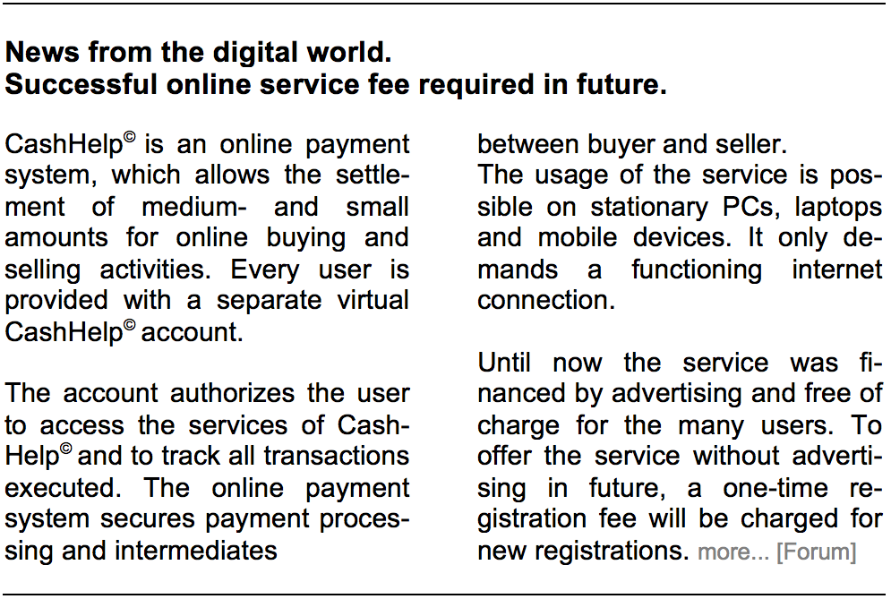

**Appendix B.** Stimulus for study: “TuneFountain”

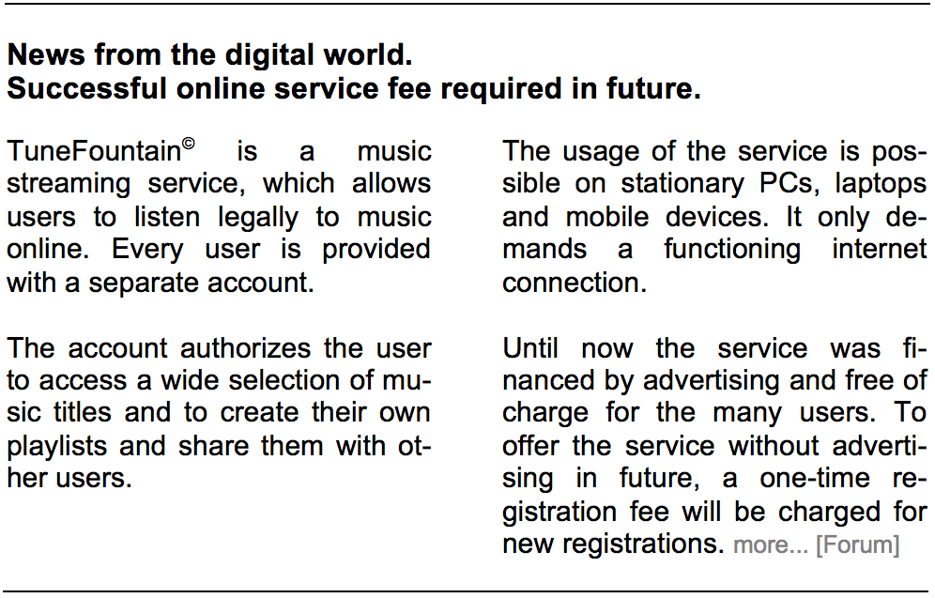

**Figures**

**Figure 1**



**Fig. 1.** Prestudy means plot

**Figure 2**



**Fig. 2.** Conceptual model and hypotheses

**Figure 3**

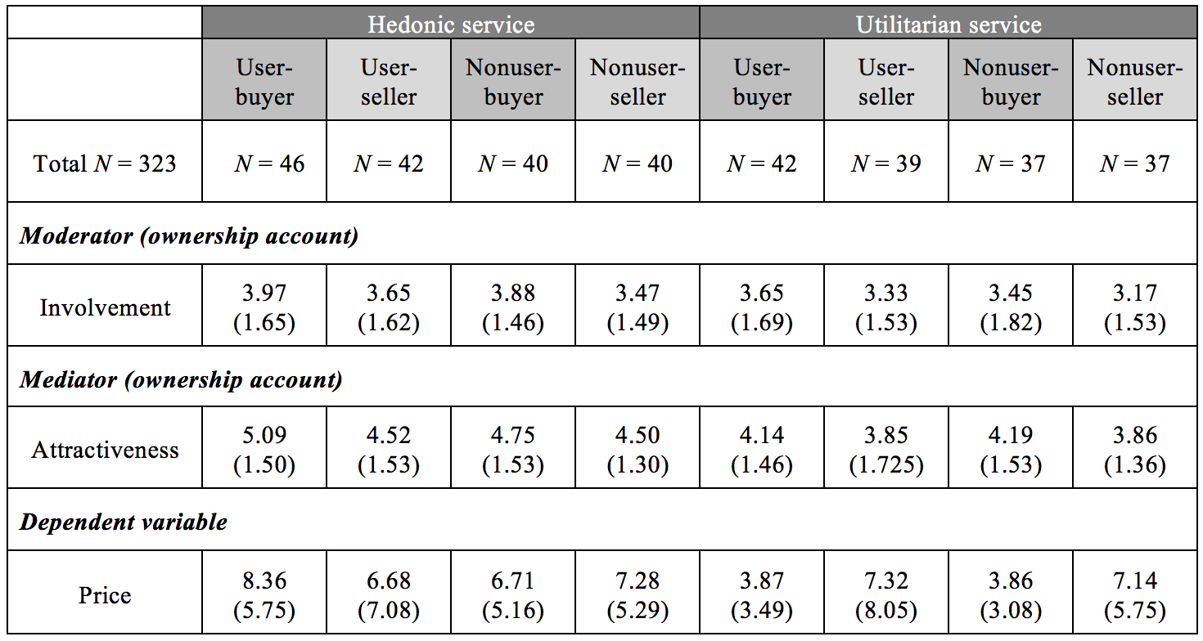

**Fig. 3.** Descriptive statistics for experimental groups

**Figure 4**



**Fig. 4.** Study means plot: EE for utilitarian service

**Figure 5**

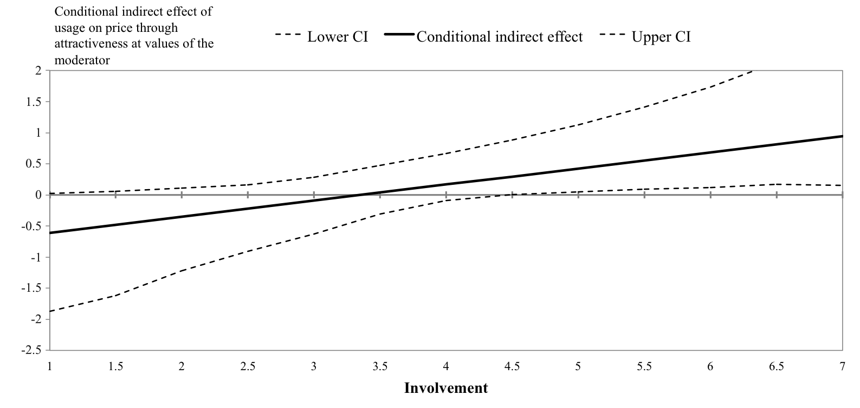

**Fig. 5.** Regions of significance for the conditional indirect effect of usage on price

through attractiveness at values of involvement

**Figure 6**





**Fig. 6.** Results of first–stage moderated mediation analysis (PROCESS, Model 7)

**Tables**

**Table 1**

|  |  |  |
| --- | --- | --- |
| **Hypothesis 1** | Loss aversion explains the EE for utilitarian digital services, meaning that sellers will state a higher price for utilitarian services than buyers, regardless of whether they are users or nonusers of the service. | **Supported** |
| **Hypothesis 2** | Ownership explains the EE for hedonic digital services, meaning that users will state a higher price for hedonic services than nonusers, regardless of whether they are sellers or buyers of the service. | **Not supported** |
| **Hypothesis 3** | Only highly involved users will rate a hedonic digital service as more attractive and in turn state a higher price for the service compared with nonusers, regardless of whether they are sellers or buyers of the service. | **Supported** |

**Table 1.** Results of hypotheses testing