***A Greener Gas Grid: What Are The Options***

Jamie Speirsa,b*, Paul Balcombea,c, Erin Johnsonc, Jeanne Martina, Nigel Brandona,b, Adam Hawkesa,c

a. Sustainable Gas Institute,Imperial College London, 11 Prince’s Gardens, London SW7 1NA,U.K.

b. Department of Earth Science and Engineering, Royal School of Mines, Prince Consort Road, Imperial College London, SW7 2BP U.K.

c. Department of Chemical Engineering, South Kensington Campus, Imperial College London, SW7 2AZ, U.K.

* Corresponding author

# Abstract

There is an ongoing debate over future decarbonisation of gas networks using biomethane, and increasingly hydrogen, in gas network infrastructure. Some emerging research presents gas network decarbonisation options as a tractable alternative to ‘all-electric’ scenarios that use electric appliances to deliver the traditional gas services such as heating and cooking. However, there is some uncertainty as to the technical feasibility, cost and carbon emissions of gas network decarbonisation options. In response to this debate the Sustainable Gas Institute at Imperial College London has conducted a rigorous systematic review of the evidence surrounding gas network decarbonisation options. The study focuses on the technologies used to generate biomethane and hydrogen, and examines the technical potentials, economic costs and emissions associated with the full supply chains involved. The following summarises the main findings of this research. The report concludes that there are a number of options that could significantly decarbonise the gas network, and doing so would provide energy system flexibility utilising existing assets. However, these options will be more expensive than the existing gas system, and the GHG intensity of these options may vary significantly. In addition, more research is required, particularly in relation to the capabilities of existing pipework to transport hydrogen safely.

# Highlights

* Summarises a study into the future decarbonisation options for low pressure gas networks
* Presents routes to biomethane and hydrogen production, including network impacts
* Presents estimates of cost and greenhouse gas emissions for these routes to low carbon gas

# Keywords

Hydrogen, biomethane, gas network, emissions, cost.

# Abbreviations

AD Anaerobic Digestion

BioSNG Bio Synthetic Natural Gas

CCS Carbon Capture and Storage

CO2 Carbon Dioxide

GHG Greenhouse Gas

SGI Sustainable Gas Institute

SMR Steam Methane Reforming

TPA Technology and Policy Assessment

UKERC UK Energy Research Centre

# Introduction

The future for natural gas infrastructure is currently uncertain. Gas networks are used across the world to transport natural gas to industrial, commercial and residential consumers, providing energy for a range of uses including power generation, industrial process heat and chemical industries, space and water heating and transport. However, current use of natural gas and associated methane emissions are unlikely to be compatible with climate change goals in countries with ambitious climate targets given the carbon dioxide (CO2) produced by natural gas combustion (Dodds & McDowall 2013; Budinis *et al.* 2016; McGlade *et al.* 2016). Country level emissions abatement scenarios, particularly in regions with high reliance on gas for heating, typically demonstrate a reduced role for natural gas networks in the future, often preferring electricity networks as the carriers of decarbonised energy for domestic and commercial consumers (Committee on Climate Change (CCC) 2008; Department of Energy and Climate Change (DECC) 2009; UK Energy Research Centre (UKERC) 2009; Steinberg *et al.* 2017; Colier 2018). However, significant technical, economic and consumer barriers to electrifying heat make deep penetrations of electric heat challenging, including uncertainty over heat pump efficiency in situ, significant cost differential between heat pump and traditional gas boiler installation, and consumer resistance to novel heat technology adoption (Committee on Climate Change (CCC) 2016; Howard & Bengherbi 2016; KPMG 2016). Given these concerns there is a growing argument that decarbonised gas networks (carrying hydrogen or biomethane for example) can play a significant role in the future energy system and that their energy storage characteristics and existing asset value are of value to future energy system decarbonisation (Dodds & McDowall 2013; Howard & Bengherbi 2016; KPMG 2016; Sadler *et al.* 2016).

The Sustainable Gas Institute (SGI) at Imperial College London has conducted a systematic review of the available evidence surrounding the options for gas network decarbonisation to bring evidence and rigour to the debate. This paper examines the evidence surrounding low pressure gas network decarbonisation options, including the technical characteristics, associated costs and implications for greenhouse gas (GHG) emissions, bringing together research conducted as part of the SGI White Paper Series (SGI 2018). The paper focusses on the options for decarbonising fuel sources and the associated infrastructure required, presenting findings in the context of the alternative option; using electricity and heat pumps. While much of the evidence arises from countries where the use of gas networks is common (e.g. UK, Netherlands), implications for these options in other countries are explored. While this study focusses on the implications for the use of hydrogen and biomethane primarily in domestic and commercial sectors, there is clearly a significant potential for these energy vectors in transport and industrial applications. This is not covered in this study but is an important area for future research.

# Method

This comprehensive review of academic, industrial and governmental literature draws on the methodology created by the UK Energy Research Centre (UKERC) Technology and Policy Assessment (TPA) theme (Gross *et al.* 2006) and refined by the SGI for its White Paper Series (Balcombe *et al.* 2015). The methodology uses systematic and well-defined search procedures to document the evidence review, providing clarity, transparency, replicability and robustness. An external expert advisory panel is appointed with a broad range of perspectives to consult on the initial framing and specification of the review procedure, as well as providing additional comments on the emerging analysis and final drafting. The assessment process carried out is presented in Figure 1.

Over 300 peer reviewed and grey literature articles were examined and interrogated to provide the evidence base used to investigate the options for gas network decarbonisation. Evidence on the technological options, their costs and the associated GHG emissions were extracted from these studies, and analysed as part of the project. These issues are discussed in turn below.

[Figure 1 here]

# What are the future options for gas networks?

There are two gases typically discussed in the literature with a significant potential to decarbonise gas networks: hydrogen and biomethane. These gasses can be produced in a number of ways (as shown in Figure 2 and Figure 3) and have specific infrastructure requirements.

## Decarbonised hydrogen

Hydrogen can be used for heat or electricity generation, or as a transport fuel. The key benefit of hydrogen over natural gas is that there are no CO2 emissions at point-of-use. However, producing hydrogen may result in CO2 emissions, efficiency losses and supply chain emissions. Additionally, differences in the physical properties of hydrogen and natural gas mean that some modifications to existing infrastructure are required, adding costs to natural gas system conversion.

There are several main techniques used to produce hydrogen, including:

* Reforming of oil;
* Steam methane reforming (SMR);
* Anaerobic digestion and SMR;
* Coal gasification;
* Biomass gasification;
* Any of the above technologies in conjunction with carbon capture and storage (CCS); and
* Electrolysis of water.

Figure 2 sets out these options, excluding oil reforming, which seldom features in studies of future hydrogen production.

Approximately 48% of the 55 million tonnes per year global hydrogen production is by reforming natural gas. Reforming of oil contributes around 30%, gasification of coal (18%) and electrolysis of water (4%) (Muradov & Veziroǧlu 2005; Kothari *et al.* 2008; Ursua *et al.* 2012; Kalamaras & Efstathiou 2013).

[Figure 2 here]

The infrastructural implications of using hydrogen in gas networks are significant. First, there will be a need to build hydrogen production plant of some form, with resulting capital and operating costs. It will then be necessary to connect that plant to the gas network, including gas storage. Existing high pressure gas pipelines, and gas storage facilities are likely incompatible with hydrogen due to the embrittlement of high pressure steel pipes in the presence of hydrogen and the likely need to operate these assets for natural gas in power generation and industry in the future. However, some research suggests low pressure local distribution assets could be used to transport hydrogen to commercial and domestic gas consumers with minimal modification. Finally, the appliances connected to the low pressure gas network will also require replacement or modification in order to use hydrogen safely and efficiently.

## Biomethane

Another option to decarbonise the gas network is to inject low carbon methane from biomass, known as biomethane (CCC 2016). If biomethane is used then gas networks would need little modification, utilisation of network assets would be maintained and the carbon intensity of the network would be reduced. However, the extent to which this would reduce the carbon intensity, and the cost implication of such a change would depend upon the biomass source, conversion technology and biomass resource availability.

Biomethane is derived from organic feedstock such as plant material or sources of biogenic waste. Biomethane can be produced from a variety of processes, but these are typically based on anaerobic digestion (AD) or methanation of biologically-sourced hydrogen (BioSNG) (Figure 3).

[Figure 3 here]

# Costs

The options for gas network decarbonisation have a range of different costs[1], including the cost of gas production, network and storage costs as well as different cost implications for the end user. The costs do not simply relate to the costs of network infrastructure, but with the wider supply chain implications of chosen options. However, the full system implications of particular options are difficult to estimate without the use of whole-system modelling tools given the interconnected nature of the impact on costs (Speirs *et al.* 2017). The ultimate cost to consumers includes: the cost of gas production; the cost of gas transportation through gas networks; the cost of end-user appliances and services, and the administrative, profit and tax costs throughout the supply chain. Six groups of costs are addressed[2]:

* Gas production plant capital costs in 2016£ per kilowatt production capacity;
* Gas production costs in 2016pence per kilowatt hour of gas produced[3];
* Pipeline investment costs in million 2016£ per kilometre;
* Capital cost of hydrogen storage in 2016£ per kilowatt hour
* Retail hydrogen or biomethane price in 2016 pence per kilowatt hour
* Cost to consumers in 2016£ per consumer property

It is also worth note that if hydrogen infrastructure is developed it will take place over the coming decades. As such infrastructure planning will need to consider the highly uncertain nature of future costs, and not just current cost estimates.

## Gas plant capital and gas production costs

Gas production cost estimates in the literature for hydrogen and biomethane production are summarised in Figure 4, which aggregates a number of routes to production for each gas. This data highlights the significant range in hydrogen and biomethane production costs represented in the existing research literature. In Figure 4 the average hydrogen production cost is 4.8p/kWh, with a range between 1.4 p/kWh and 12.1 p/kWh. The average biomethane production cost is 5.4p/kWh, with a range between 2.1p/kWh and 10.2p/kWh. This figure also presents the EU average wholesale natural gas price in 2015[4]. This demonstrates that future costs of hydrogen or biomethane production costs is likely to result in decarbonised gas wholesale prices greater than the current natural gas price.

[Figure 4 here]

## Pipeline and storage costs

The infrastructure cost implications of hydrogen require an examination of the costs of new high pressure gas lines, gas distribution pipework, and gas storage. Figure 5 presents the range of capital cost estimates in the literature for high pressure and distribution hydrogen pipework, while Figure 6 presents a range of capital cost estimates in the literature for hydrogen storage in salt caverns, and a single estimate for bulk compressed hydrogen storage for comparison. While the cost of building new pipework is often presented in the literature as a cost per pipe length, or a cost per unit of energy transported, it is important to reconcile both of these metrics to understand the implications of pipeline cost estimates across different spatial conditions. To address this the units represented in Figure 5 capture both. To provide context for the composition of pipeline costs, an Oil and Gas journal survey estimates that costs associated with laying natural gas pipelines consist of: 47% labour costs; 13% material costs 6% Right of Way and damages costs; and 34% miscellaneous[5] costs (Smith 2016).

It is worth noting that these costs relate to the costs of new pipeline construction. A key aspect of emerging hydrogen gas network literature is the repurposing of existing gas network assets. There is currently little evidence on the costs of converting existing assets to carry 100% hydrogen. However, a report examining the potential for a hydrogen gas network in the city of Leeds, UK, suggests that the cost of retrofitting the existing low pressure gas network in that region would be in the order of £10,000 per kilometre of pipeline (Sadler *et al.* 2016). This is an order of magnitude cheaper than the cheapest estimated costs of building new low pressure hydrogen distribution pipelines (Speirs *et al.* 2017).

[Figure 5 here]

[Figure 6 here]

## Retail price and cost to consumers

The final cost of gas to consumers is uncertain and dependent on a number of factors, including the capital and operating costs of the production plant, gas storage, gas pipelines and other infrastructure needed. The relatively high cost of biomethane production is offset by the relatively low costs of repurposing existing gas network infrastructure to transport and store biomethane. This results in a final retail price for biomethane estimated at 4.4 to13.6 pence per kilowatt hour (average 8.1 pence per kWh).

For hydrogen, the relatively lower gas production costs are balanced by the relatively higher costs of upgrading and replacing infrastructure to transport hydrogen. This results in a hydrogen retail price of 4.9 to 18.4 pence per kilowatt hour (average 9.3 pence per kilowatt hour).

Another cost for consumers is the cost of upgrading or replacing consumer appliances, meters or pipework. This is a cost that is unlikely to be captured in the retail gas price. Biomethane is likely compatible with current consumer gas systems, though hydrogen is likely to require new or upgraded appliances, meters and pipework. The literature suggests that the cost of hydrogen conversion could be between £3,100 and £3,600 per household, though significantly lower estimates appear in the literature at £580 per household where conversion actions are limited to replacement of burner tips in gas cookers and fires (Dodds & Demoullin 2013). A new hydrogen boiler is estimated to cost £2,200 and £3,000 {Howard, 2016 #1778}.

[Figure 7 here]

# Greenhouse gas emissions

In producing and using hydrogen or biomethane, greenhouse gases (GHGs) are emitted both in the supply chain, in the gas production process, and in end-use. There are a number of estimates of GHG emissions for several routes to decarbonised gas production. The range of estimates is very large, from -370 to 642 gCO2eq/kWh for hydrogen production, and -50 to 450 gCO2eq/kWh for biomethane production (Figure 8). These ranges are driven by different feed sources, efficiencies as well as different Life Cycle Analysis (LCA) estimation methods and methodological boundaries.

Hydrogen production from fossil fuels without carbon capture and storage have the highest and most variable GHG emissions estimates, and this will emit more CO2 emissions than current domestic and commercial natural gas use due to efficiency losses from hydrogen conversion. This is therefore incompatible with longer-term decarbonisation targets in countries like the UK. Estimates in the literature of GHG emissions from SMR with CCS lie in the range 23 to 150 gCO2eq/kWh and electrolysis lies in range 25 to 178 gCO2eq/kWh for renewable energy sources. The lowest emissions are associated with the production of hydrogen through biomass gasification with CCS, estimated in one study to be -370 gCO2eq/kWh. This opens up the possibility of negative emissions to help actively reduce atmospheric CO2 concentrations. However, this represents only a single estimate and further research is needed to reinforce the evidence base in this regard.

Supply chain emissions are increasingly important as the emissions at point of conversion are reduced. Supply chain emissions includes methane and carbon dioxide emissions emitted in upstream natural gas production and transport, and the GHG emissions associated with electricity production and the manufacturing of electricity generating technologies such as solar photovoltaics or wind turbines. Supply chain emissions may contribute between 40 and 100% of total emissions for hydrogen production using SMR with CCS and electrolysis.

Biomethane emissions from anaerobic digestion range from -54 to 450 gCO2eq/kWh. Main contributors to GHG emissions include methane emissions from digestate storage, nitrous oxide emissions from fertilizer use and CO2 emissions from agricultural machinery and plant construction (Whiting & Azapagic 2014).

[Figure 8 here]

# Conclusions

There is a growing interest in the options for gas network decarbonisation for a number of reasons, including pressure to reduce GHG emissions and the relatively slow progress on electrifying heat. In response to this growing debate the SGI conducted a systematic review of the available published evidence to improve the understanding of what is known regarding these gas decarbonisation options. This concluded that there is an important potential role for gas networks in the future energy system. There are a range of different options for gas network decarbonisation, each with benefits and limitations and no clear best option. However, further research is needed including work to understand the suitability of existing networks for decarbonised gas (particularly hydrogen) and the level of decarbonisation achievable.

The relatively cheap energy storage potential of decarbonised gas networks presents a significant advantage over electricity networks. However, the value of this flexibility needs to be better understood. A fair comparative analysis must be based not just on the difference between costs of gas and electricity storage, but in the full suite of flexibility options, including electricity interconnection, demand side management, back-up gas electricity generation and all gas and electricity storage options.

The cost estimates for decarbonised gas options vary over a significant range. This results in an estimate for retail price of 4.4 to 13.6 p/kWh (average 8.1 p/kWh) for biomethane compared to a hydrogen price estimate of 4.9 to 18.4 p/kWh (average 9.3 p/kWh). The cost of delivered heat, will change based on the efficiency of the heating appliance. This becomes important when comparing boiler based technologies with heat pumps, which may have significantly different efficiencies.

There are also extremely large variations in the estimates of greenhouse gas emissions from decarbonised gas production. This includes the emissions in the upstream supply chain. The range of CO2 emissions estimates for the different methods to produce low carbon gas is 371 to 642 gCO2eq/kWh for hydrogen and -50 to 450 gCO2eq/kWh for biomethane.

Future research is needed to develop both practical demonstration and develop the whole system modelling needed to examine the implications of gas and electricity networks operating synergistically.

For policy, the increasing attention on hydrogen, and emerging demonstration proposals hasten the need for policy understanding on a number of issues. These include the need to demonstrate hydrogen safety and develop hydrogen safety standards, the need to develop transparent and equitable funding models, and the need to develop gas standards that ensure lowest possible GHG emissions associated with hydrogen.

# Acknowledgements

Funding: The Sustainable Gas Institute is supported by funding from Royal Dutch Shell.

# References

Agnolucci, P., O. Akgul, W. McDowall and L. G. Papageorgiou (2013). "The importance of economies of scale, transport costs and demand patterns in optimising hydrogen fuelling infrastructure: An exploration with SHIPMod (Spatial hydrogen infrastructure planning model)." International Journal of Hydrogen Energy **38**(26): 11189-11201.

Åhman, M. (2010). "Biomethane in the transport sector—An appraisal of the forgotten option." Energy Policy **38**(1): 208-217.

Balcombe, P., K. Anderson, J. Speirs, N. Brandon and A. Hawkes (2015). Methane and CO2 emissions from the natural gas supply chain: an evidence assessment. White Paper Series. Sustainable Gas Institute. [www.sustainablegasinstitute.org/publications/white-paper-1](http://www.sustainablegasinstitute.org/publications/white-paper-1), Imperial College London.

BEIS. (2017). "Quarterly energy prices." Retrieved 11th April 2017, from <https://www.gov.uk/government/uploads/system/uploads/attachment_data/file/580186/QEP_Q316.pdf>.

Bekkering, J., E. J. Hengeveld, W. J. T. van Gemert and A. A. Broekhuis (2015). "Designing a green gas supply to meet regional seasonal demand - An operations research case study." Applied Energy **143**: 348-358.

Bhandari, R., C. A. Trudewind and P. Zapp (2014). "Life cycle assessment of hydrogen production via electrolysis – a review." Journal of Cleaner Production **85**: 151-163.

Budinis, S., S. Krevor, N. MacDowell, N. Brandon and A. Hawkes (2016). Can Technology Unlock 'Unburnable Carbon'? White Paper Series. London, UK, Sustainable Gas Institute, Imperial College London**:** 1 - 87.

Burmistrz, P., T. Chmielniak, L. Czepirski and M. Gazda-Grzywacz (2016). "Carbon footprint of the hydrogen production process utilizing subbituminous coal and lignite gasification." Journal of Cleaner Production **139**: 858-865.

Castello, P., E. Tzimas, P. Moretto and S. D. Peteves. (2005). "Techno-Economic Assessment of Hydrogen Transmission & Distribution Systems in Europe in the Medium and Long Term." from file://icnas4.cc.ic.ac.uk/jfs106/downloads/LDNA21586ENC_002.pdf.

Caumon, P., M. L.-B. Zulueta, J. Louyrette, S. Albou, C. Bourasseau and C. Mansilla (2015). "Flexible hydrogen production implementation in the French power system: Expected impacts at the French and European levels." Energy **81**: 556-562.

CCC (2016). Next Steps for UK Heat Policy. London, UK, Committee on Climate Change.

Cetinkaya, E., I. Dincer and G. F. Naterer (2012). "Life cycle assessment of various hydrogen production methods." International Journal of Hydrogen Energy **37**(3): 2071-2080.

Colier, U. (2018). Renewable heat policies: Delivering clean heat solutions for the energy transition. Paris, International Energy Agency.

Committee on Climate Change (CCC) (2008). Building a low carbon economy - The UKs contribution to tackling climate change: The First Report of the Committe on Climate Change. London, Climate change Committee.

Committee on Climate Change (CCC). (2016). "Next steps for UK heat policy." Retrieved 17th March 2017, from <https://www.theccc.org.uk/wp-content/uploads/2016/10/Next-steps-for-UK-heat-policy-Committee-on-Climate-Change-October-2016.pdf>.

Department of Energy and Climate Change (DECC) (2009). The UK Renewable Energy Strategy. London, The Stationery Office.

Dodds, P. E. and S. Demoullin (2013). "Conversion of the UK gas system to transport hydrogen." International Journal of Hydrogen Energy **38**(18): 7189-7200.

Dodds, P. E. and W. McDowall (2013). "The future of the UK gas network." Energy Policy **60**: 305-316.

Dufour, J., D. P. Serrano, J. L. Galvez, A. Gonzalez, E. Soria and J. L. G. Fierro (2012). "Life cycle assessment of alternatives for hydrogen production from renewable and fossil sources." International Journal of Hydrogen Energy **37**(2): 1173-1183.

Dufour, J., D. P. Serrano, J. L. Gálvez, J. Moreno and A. González (2011). "Hydrogen Production from Fossil Fuels: Life Cycle Assessment of Technologies with Low Greenhouse Gas Emissions." Energy & Fuels **25**(5): 2194-2202.

Dufour, J., D. P. Serrano, J. Moreno and J. L. G·lvez (2010). Life Cycle Assessment of Hydrogen Production Processes: Steam Reforming of Natural Gas, Ethanol and Bioethanol. 18th World Hydrogen Energy Conference 2010, Essen, Germany.

E4tech. (2010). "The potential for bioSNG production in the UK." Retrieved 3rd March 2017, from <http://www.e4tech.com/wp-content/uploads/2016/01/BioSNG-final-report-E4tech-14-06-10.pdf>.

EC (2010). Guidance on Interpretation of Annex I of the EU ETS Directive (excl. aviation activities), European Commission DIRECTORATE-GENERAL CLIMATE ACTION Directorate B - European & International Carbon Markets.

EC. (2016). "Energy prices and costs in Europe." Retrieved 14th March 2017, from <http://ec.europa.eu/energy/sites/ener/files/documents/com_2016_769.en_.pdf>.

EIA. (2008). "The Impact of Increased Use of Hydrogen on Petroleum Consumption and Carbon Dioxide Emissions." Retrieved 14th February 2017, from <http://www.eia.gov/oiaf/servicerpt/hydro/pdf/oiafcneaf(08)04.pdf>.

ETI. (2015). "Hydrogen: The role of hydrogen storage in a clean responsive power system." Retrieved 20th March 2017, from file://icnas4.cc.ic.ac.uk/jfs106/downloads/3380-ETI-Hydrogen-Insights-paper.pdf.

Gross, R., P. Heptonstall, D. Anderson, T. Green, M. Leach and J. Skea (2006). The Costs and Impacts of Intermittency, UK Energy Research Centre, Imperial College London.

H21 (2016). H21 Leeds city gate.

Hart, D., J. Howes, F. Lehner, P. E. Dodds, N. Hughes, B. Fais, N. Sabio and M. Crowther (2015). Scenarios for deployment of hydrogen in contribution to meeting carbon budgets and the 2050 target E4Tech; UCL Energy Institute; Kiwa Gastec.

Hirst, D. (2018). "Carbon Price Floor (CPF) and the price support mechanism." Briefing Paper Number 05927 Retrieved 16th March 2018, from <http://researchbriefings.files.parliament.uk/documents/SN05927/SN05927.pdf>.

Howard, R. and Z. Bengherbi (2016). Too Hot to Handle? How to decarbonise domestic heating. London, Policy Exchange.

IEA (2007). Hydrogen Production & Distribution, International Energy Agency.

IEA. (2008). "Co-production of hydrogen and electricity by coal gasification with CO2 capture. ." Retrieved 17th March 2017, from <http://ieaghg.org/docs/General_Docs/Reports/2008-9.pdf>.

IEA. (2013). "Biogas and Bio-syngas Production Technical Highlights." Retrieved 16th February 2017, from <https://iea-etsap.org/E-TechDS/PDF/P11_BiogasProd_ML_Dec2013_GSOK.pdf>.

Kalamaras, C. M. and A. M. Efstathiou (2013). "Hydrogen Production Technologies: Current State and Future Developments." Conference Papers in Energy **2013**: 9.

Kalinci, Y., A. Hepbasli and I. Dincer (2012). "Life cycle assessment of hydrogen production from biomass gasification systems." International Journal of Hydrogen Energy **37**(19): 14026-14039.

Koroneos, C., A. Dompros, G. Roumbas and N. Moussiopoulos (2004). "Life cycle assessment of hydrogen fuel production processes." International Journal of Hydrogen Energy **29**(14): 1443-1450.

Kothari, R., D. Buddhi and R. L. Sawhney (2008). "Comparison of environmental and economic aspects of various hydrogen production methods." Renewable and Sustainable Energy Reviews **12**(2): 553-563.

KPMG. (2016). "2050 Energy Scenarios: The UK Gas Networks role in a 2050 whole energy system." Retrieved 16th August 2016, from <http://www.energynetworks.org/assets/files/gas/futures/KPMG%20Future%20of%20Gas%20Main%20report%20plus%20appendices%20FINAL.pdf>.

Krich, K., D. Augenstein, J. Batmale, J. Benemann, B. Rutledge and D. Salour. (2005). "Biomethane from Dairy Waste: A Sourcebook for the Production and Use of Renewable Natural Gas in California " Retrieved 10th February 2017, from <http://suscon.org/pdfs/cowpower/biomethaneSourcebook/Full_Report.pdf>.

McGlade, C., S. Pye, J. Watson, M. Bradshaw and P. Ekins (2016). The future role of natural gas in the UK. London, UKERC.

Mintz, M., S. Folga, J. Molburg and J. Gillette. (2002). "Cost of Some Hydrogen Fuel Infrastructure Options." Retrieved 6th April 2017, from <http://www.solarelectrode.com/gov224.pdf>.

Muradov, N. Z. and T. N. Veziroǧlu (2005). "From hydrocarbon to hydrogen–carbon to hydrogen economy." International Journal of Hydrogen Energy **30**(3): 225-237.

NETL. (2003). "Capital and operating cost of hydrogen production from coal gasification." Retrieved 14th February 2017, from <https://www.netl.doe.gov/File%20Library/research/energy%20analysis/publications/HydrogenFromCoalGasificationFinalReport.pdf>.

Ofgem. (2017). "Understand your gas and electricity bills." Retrieved 11th April 2017, from <https://www.ofgem.gov.uk/consumers/household-gas-and-electricity-guide/understand-your-gas-and-electricity-bills>.

Paturska, A., M. Repele and G. Bazbauers (2015). "Economic Assessment of Biomethane Supply System based on Natural Gas Infrastructure." Energy Procedia **72**: 71-78.

Rabou, L. (2013). "Biomass gasification and upgrading to biomethane." Retrieved 3rd March 2017, from file://icnas4.cc.ic.ac.uk/jfs106/downloads/Rabou_biomass_gassification.pdf.

Ruether, J., M. Ramezan and P. Balash (2004). "Greenhouse Gas Emissions from Coal Gasification Power Generation Systems." Journal of Infrastructure Systems **10**(3).

Ruether, J., M. Ramezan and E. Grol (2005). Life-Cycle Analysis of Greenhouse Gas Emissions for Hydrogen Fuel Production in the United States from LNG and Coal U. Department of Energy, National Energy Technology Laboratory.

Sadler, D., A. Cargill, M. Crowther, A. Rennie, J. Watt, S. Burton and M. Haines. (2016). "H21 Leeds City Gate." Retrieved 17th August 2016, from <http://www.northerngasnetworks.co.uk/document/h21-leeds-city-gate/>.

Samsatli, S., I. Staffell and N. J. Samsatli (2016). "Optimal design and operation of integrated wind-hydrogen-electricity networks for decarbonising the domestic transport sector in Great Britain." International Journal of Hydrogen Energy **41**(1): 447-475.

Schoots, K., R. Rivera-Tinoco, G. Verbong and B. van der Zwaan (2011). "Historical variation in the capital costs of natural gas, carbon dioxide and hydrogen pipelines and implications for future infrastructure." International Journal of Greenhouse Gas Control **5**(6): 1614-1623.

SGI. (2018). "SGI White Papers Series." Retrieved 14th March 2018, from <http://www.sustainablegasinstitute.org/white_paper_series/>.

Smit, R., M. Weeda and A. de Groot (2007). "Hydrogen infrastructure development in The Netherlands." International Journal of Hydrogen Energy **32**(10–11): 1387-1395.

Smith, C. E. (2016). "SPECIAL REPORT: PIPELINE ECONOMICS Natural gas pipeline profits, construction both up." Oil and Gas Journal **114**(9): 84-102.

Spath, P. L. and M. K. Mann (2001). Life Cycle Assessment of Hydrogen Production via Natural Gas Steam Reforming. Boulder, Colorado, National Renewable Energy Laboratory**:** 1 - 33.

Speirs, J., P. Balcombe, E. Johnson, J. Martin, N. Brandon and A. Hawkes (2017). A Greener Gas Grid: What Are the Options?, Sustainable Gas Institute, Imperial College London.

Steinberg, D., D. Bielen, J. Eichman, K. Eurek, J. Logan, T. Mai, C. McMillan, A. Parker, L. Vimmerstedt and E. Wilson (2017). Electrification & Decarbonization: Exploring U.S. Energy Use and Greenhouse Gas Emissions in Scenarios with Widespread Electrification and Power Sector Decarbonization. Golden, Colorado, National Renewable Energy Laboratory.

Stromman, A. H. and E. Hertwich (2004). Hybrid Life Cycle Assessment of Large Scale Hydrogen Production Facilities. I. E. Programme. Trondheim, Norway, Norwegian University of Science and Technology**:** 1 - 33.

Susmozas, A., D. Iribarren and J. Dufour (2015). "Assessing the Life-Cycle Performance of Hydrogen Production via Biofuel Reforming in Europe." Resources **4**(2): 398.

Tock, L. and F. Maréchal (2012a). "CO2 Mitigation in Thermo-Chemical Hydrogen Processes: Thermo-Environomic Comparison and Optimization." Energy Procedia **29**: 624-632.

Tock, L. and F. Maréchal (2012b). "H2 processes with CO2 mitigation: Thermo-economic modeling and process integration." International Journal of Hydrogen Energy **37**(16): 11785-11795.

UK Energy Research Centre (UKERC) (2009). UKERC Energy 2050 Making the transition to a secure and low-carbon energy system: synthesis report. London UK Energy Research Centre.

Ursua, A., L. M. Gandia and P. Sanchis (2012). "Hydrogen Production From Water Electrolysis: Current Status and Future Trends." Proceedings of the IEEE **100**(2): 410-426.

Whiting, A. and A. Azapagic (2014). "Life cycle environmental impacts of generating electricity and heat from biogas produced by anaerobic digestion." Energy **70**: 181-193.

Figure 1: Diagram of the systematic review methodology

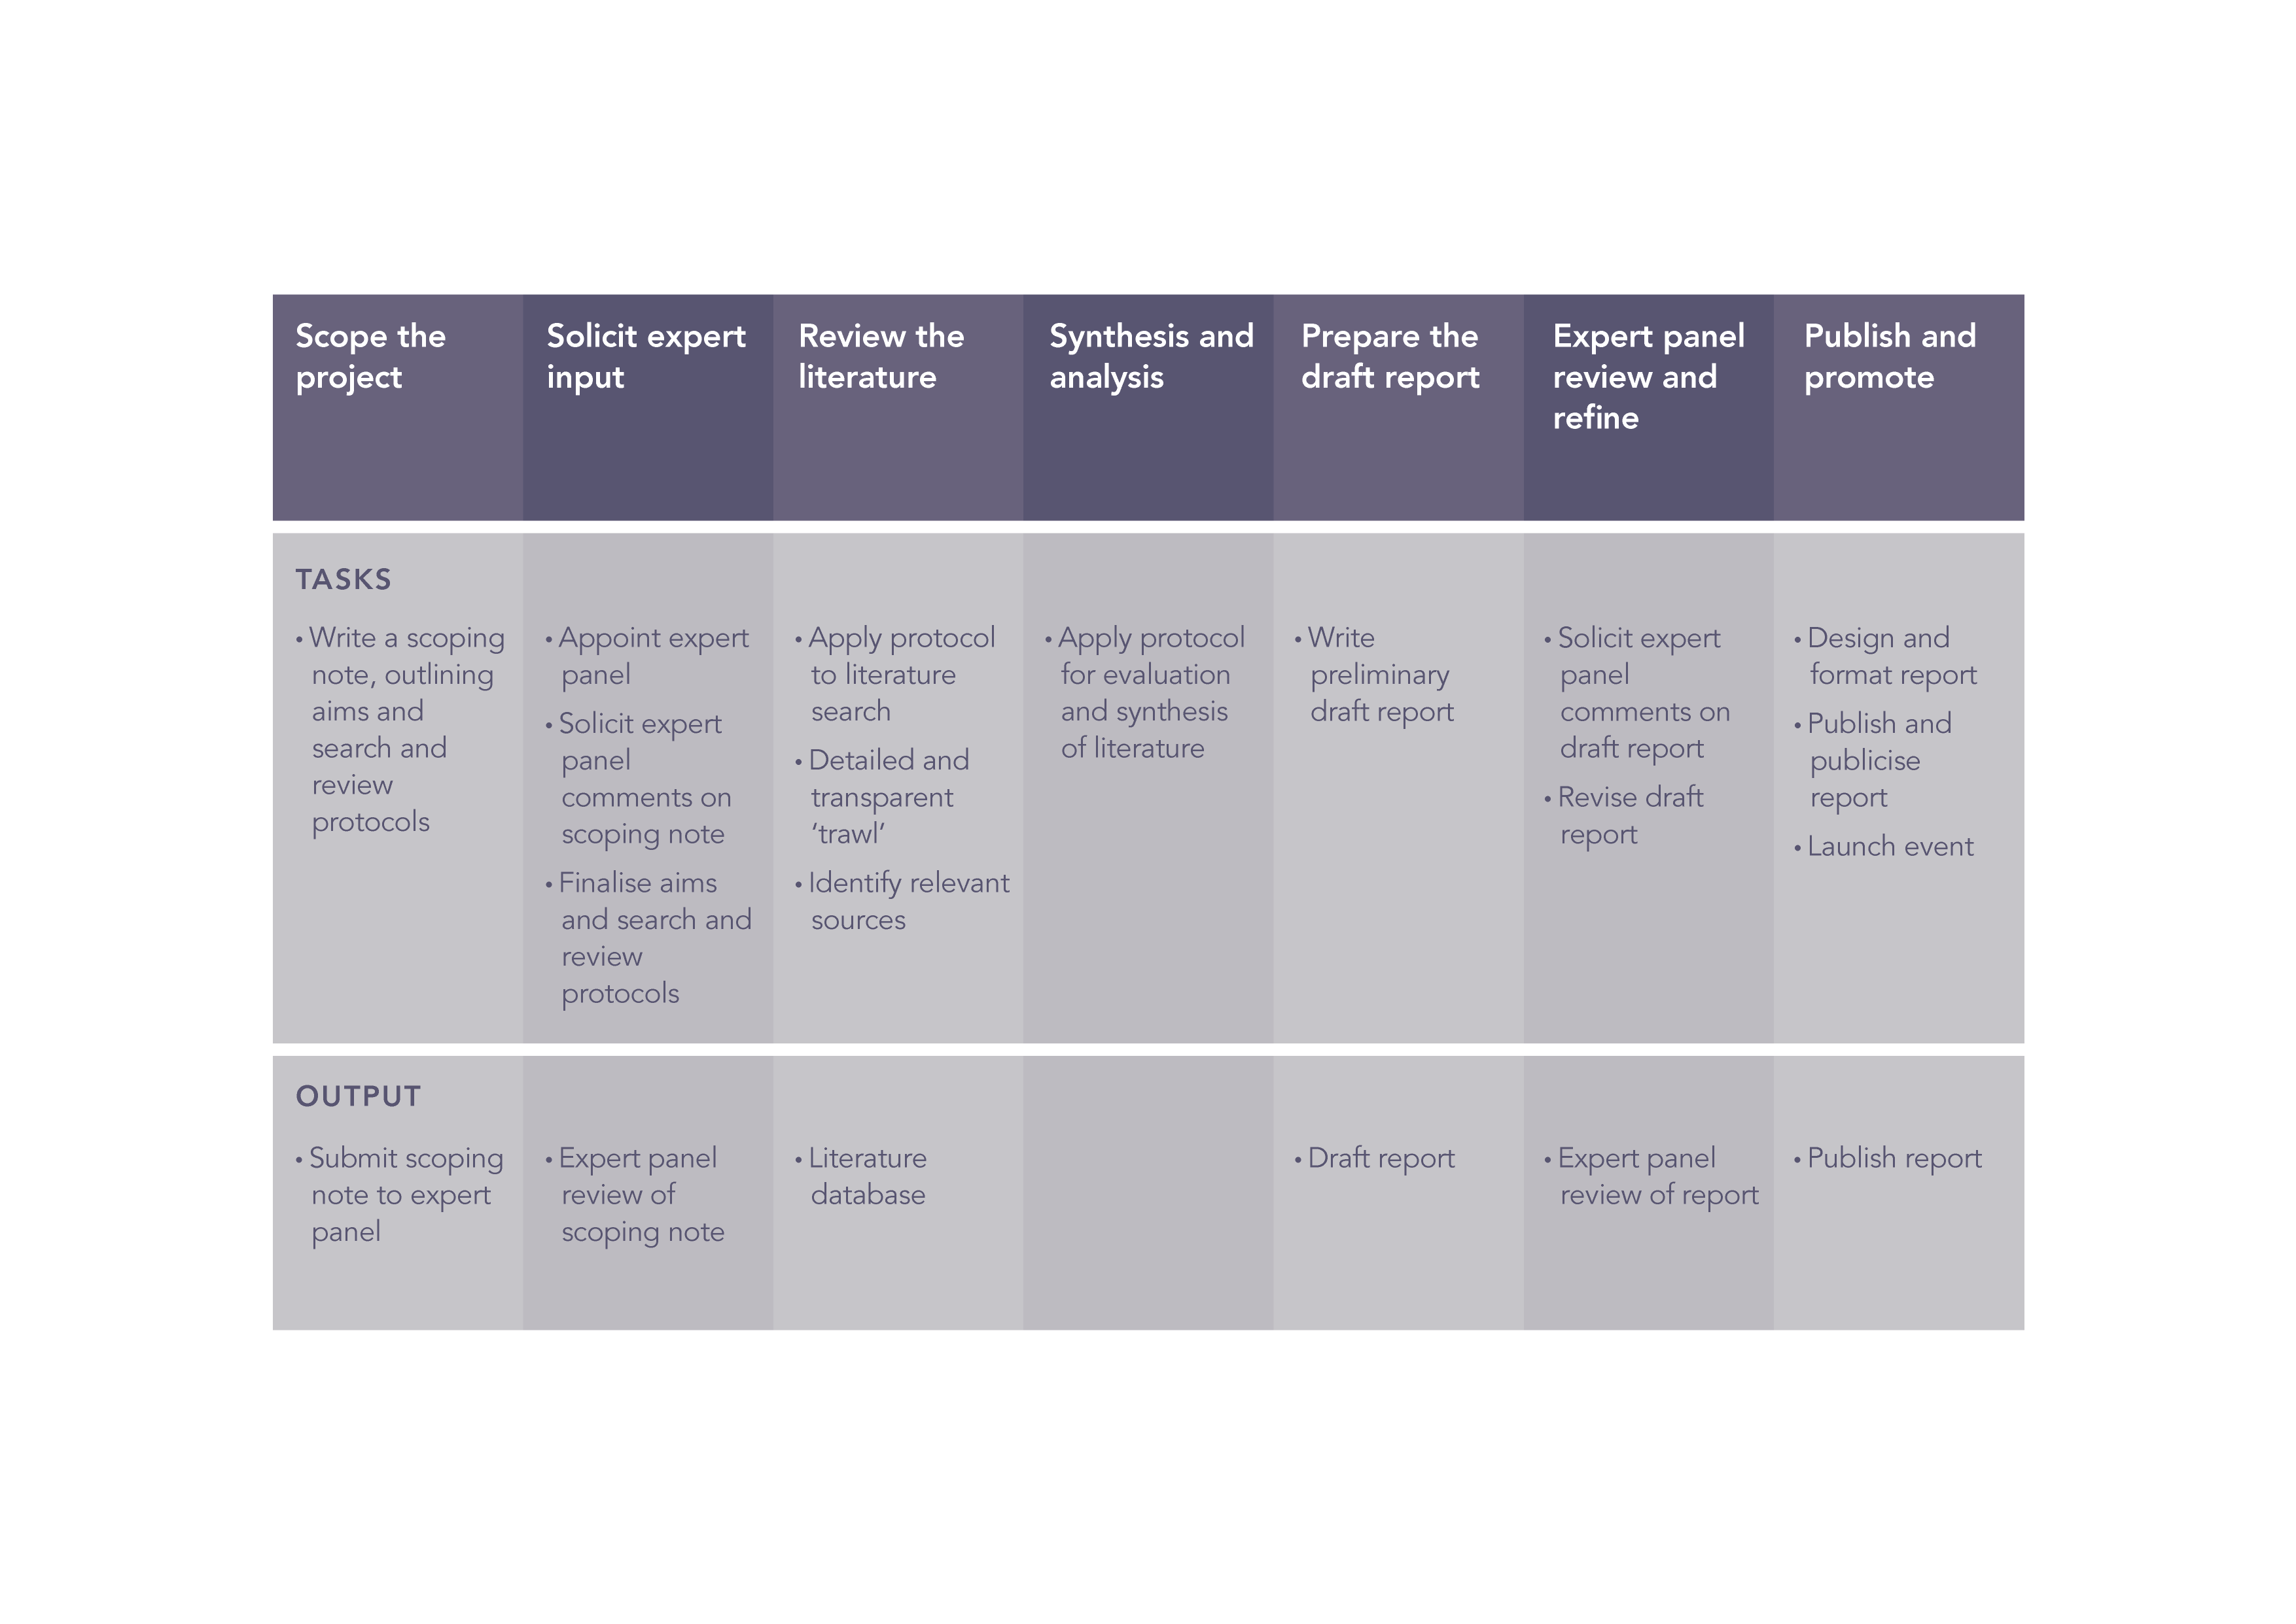

Source: Speirs *et al.* (2017)

Figure 2: The different routes to hydrogen production

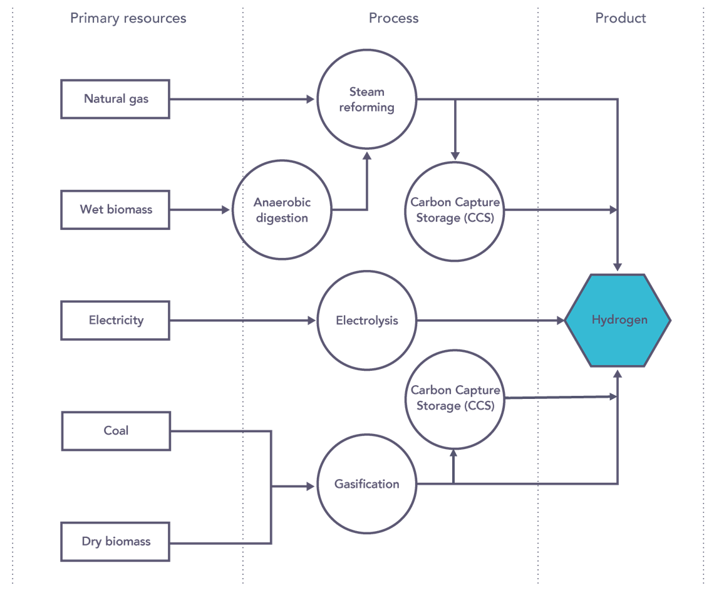

Source: Speirs *et al.* (2017)

Figure 3: The different routes to biomethane production

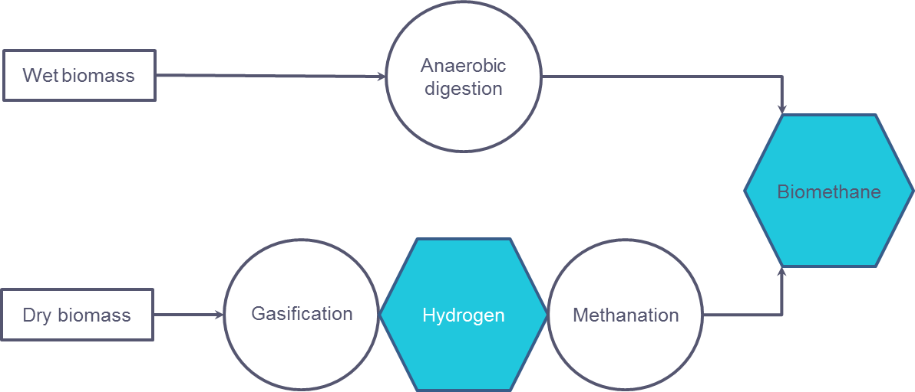

Source: Speirs *et al.* (2017)

Figure 4: Illustrations of cost range for hydrogen and biomethane production costs

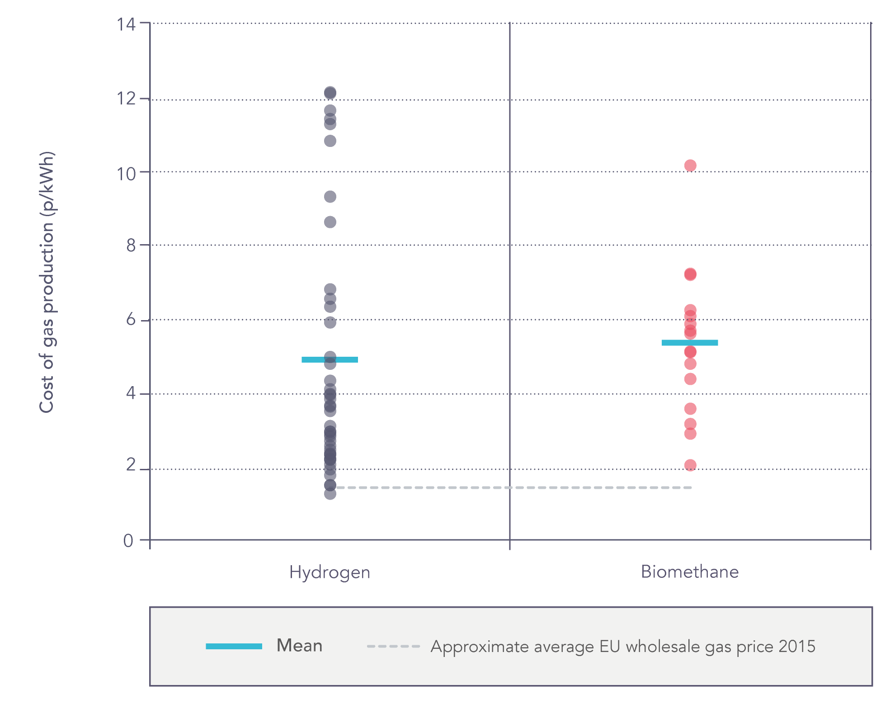

Source: (NETL 2003; Krich *et al.* 2005; IEA 2007; Smit *et al.* 2007; EIA 2008; Åhman 2010; E4tech 2010; Agnolucci *et al.* 2013; IEA 2013; Rabou 2013; Bekkering *et al.* 2015; Caumon *et al.* 2015; Paturska *et al.* 2015; EC 2016; Sadler *et al.* 2016)

Figure 5: Infrastructure costs associated with hydrogen gas networks as a function of pipe diameter and pipeline length

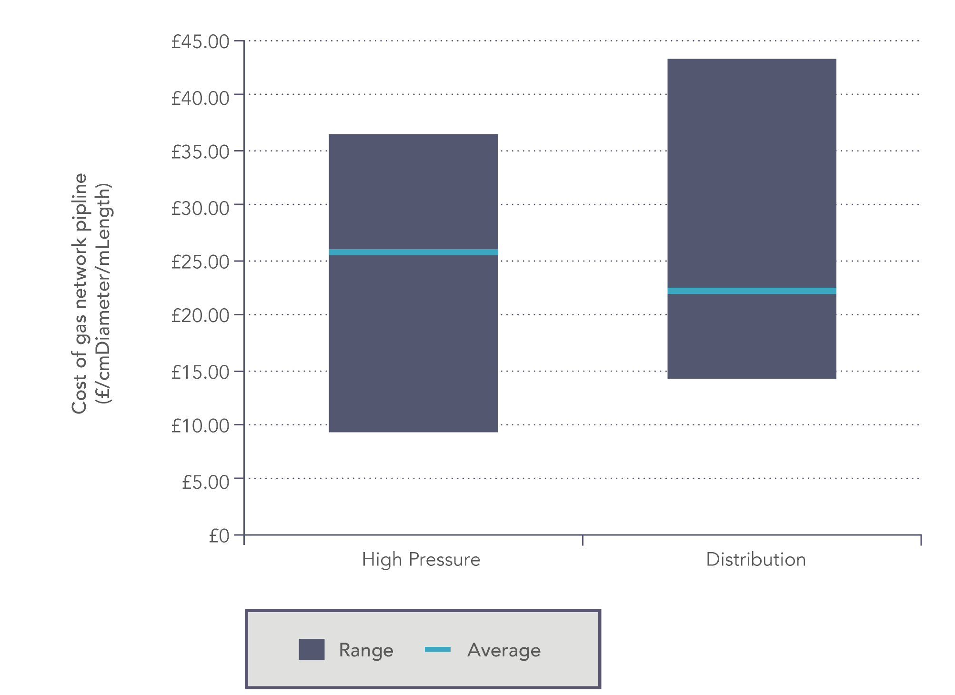

Source: (Mintz *et al.* 2002; Castello *et al.* 2005; Schoots *et al.* 2011; Hart *et al.* 2015; Sadler *et al.* 2016; Samsatli *et al.* 2016)

Figure 6: Comparison of estimates of hydrogen storage costs

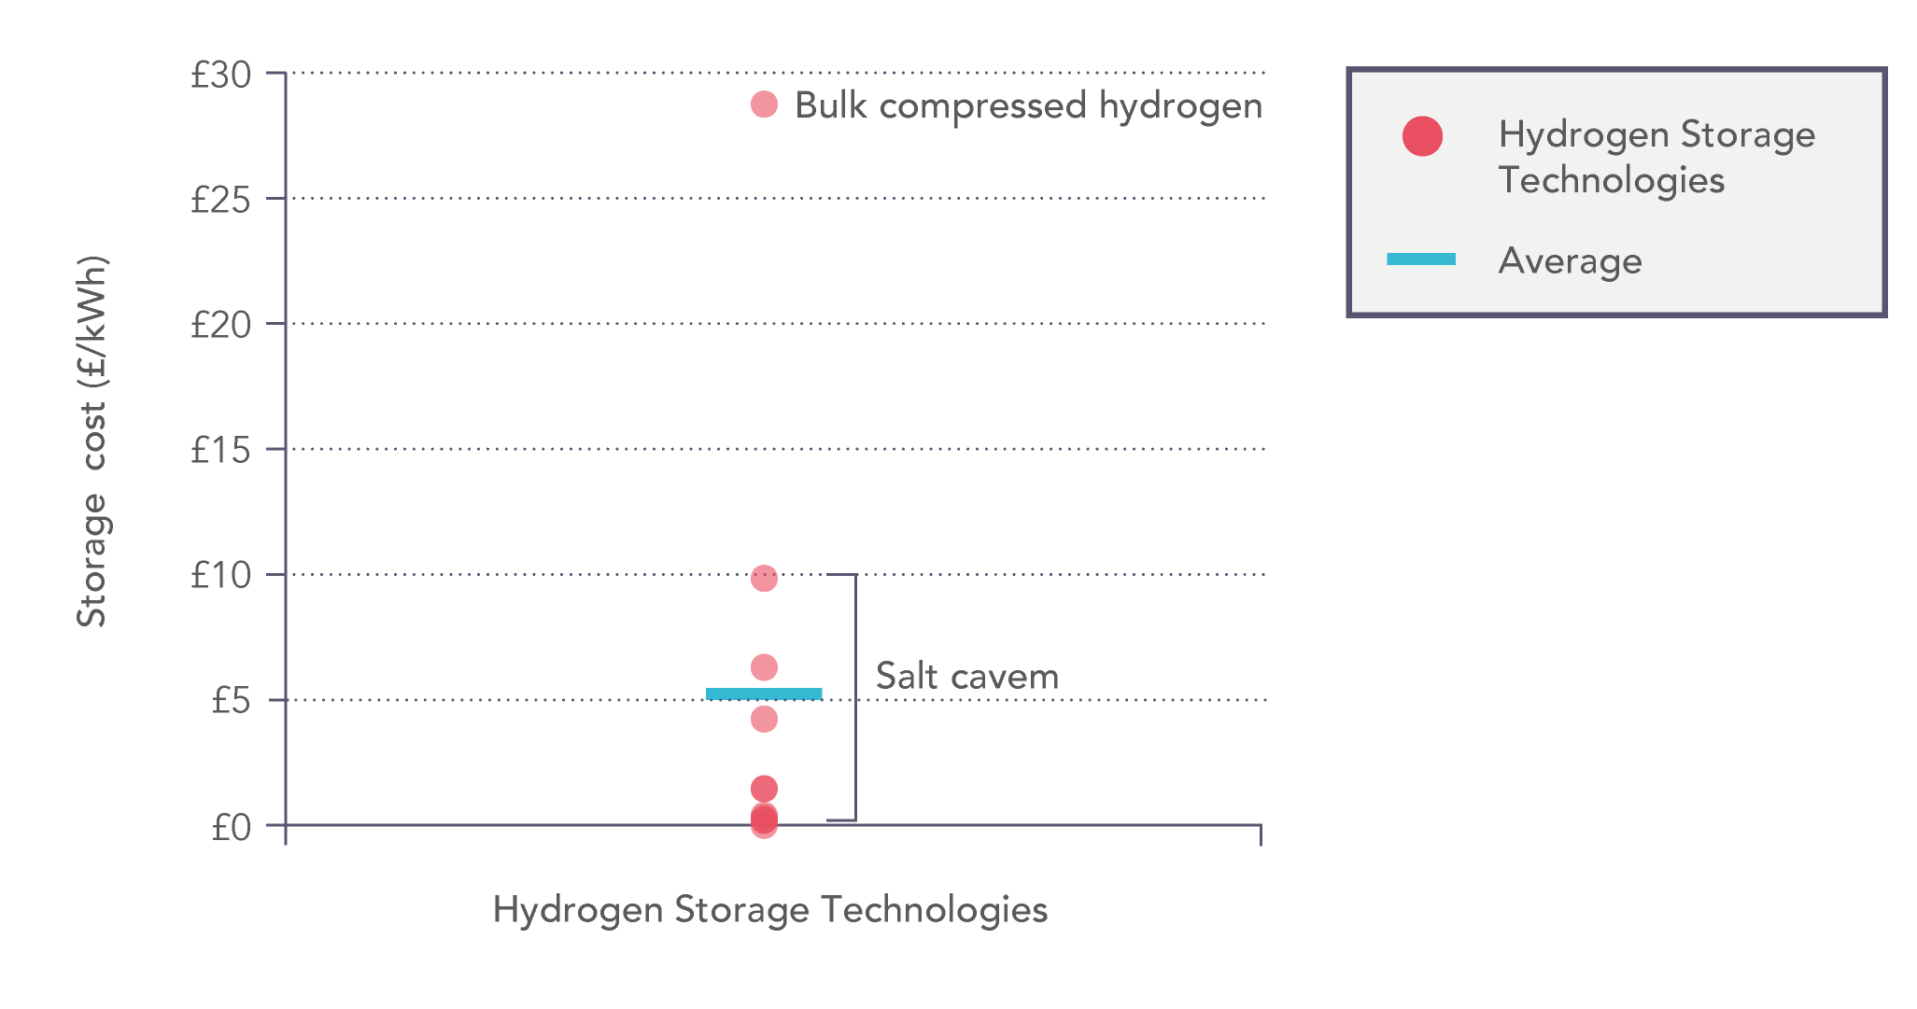

Source: (IEA 2008; ETI 2015; Hart *et al.* 2015; Sadler *et al.* 2016)

Figure 7: Estimate of retail price (in pence sterling) of decarbonised gas based on the composition of current UK gas retail price

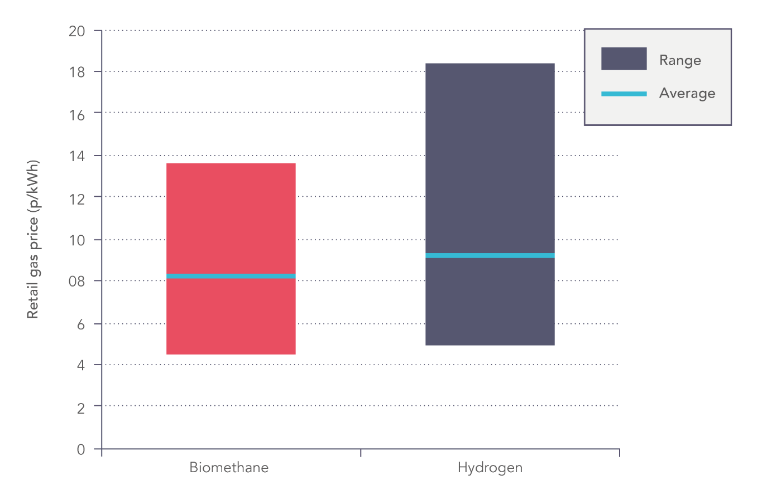

Source: (Krich *et al.* 2005; IEA 2007; Smit *et al.* 2007; IEA 2008; Åhman 2010; E4tech 2010; Schoots *et al.* 2011; Agnolucci *et al.* 2013; IEA 2013; Rabou 2013; Bekkering *et al.* 2015; ETI 2015; Hart *et al.* 2015; Paturska *et al.* 2015; Sadler *et al.* 2016; Samsatli *et al.* 2016; BEIS 2017; Ofgem 2017)

Figure 8: Ranges of estimates of total GHG emissions associated with hydrogen production from different technologies and feedstocks, expressed in gCO2eq/kWh H2 produced.

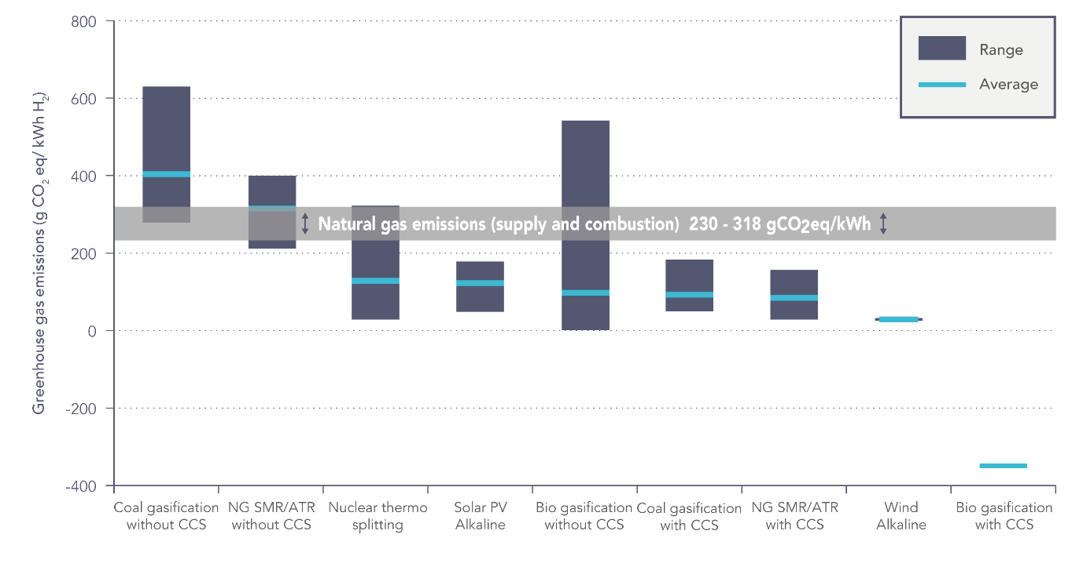

Source: (Spath & Mann 2001; Koroneos *et al.* 2004; Ruether *et al.* 2004; Stromman & Hertwich 2004; Ruether *et al.* 2005; Dufour *et al.* 2010; Dufour *et al.* 2011; Cetinkaya *et al.* 2012; Dufour *et al.* 2012; Kalinci *et al.* 2012; Tock & Maréchal 2012a; Tock & Maréchal 2012b; Bhandari *et al.* 2014; Susmozas *et al.* 2015; Burmistrz *et al.* 2016; H21 2016)

1. All costs normalised from original estimate to 2016£ sterling
2. A cost not addressed in this study is the cost of carbon. For example, in Europe, producing hydrogen from methane at a production rate of over 25 tonnes per day would come under the EU Emissions Trading Scheme and be subject to payment for emissions allowances, or additional country level taxes such as the UK carbon price support mechanism (EC 2010; Hirst 2018).
3. Gas production costs include capital costs, operating costs and fuel costs. This is equivalent to levelised costs, though where these costs are stated authors often do not expose key assumptions in typical levelised cost calculations such as weighted costs of capital.
4. Wholesale price and production cost are not directly comparable, with profit margin being the most significant distinction between the two.
5. Miscellaneous costs vary between pipelines, but typically include surveying, engineering, supervision, administration and overhead, interest, contingencies and allowances for funds used during construction (AFUDC).