Robotic wide-field optical biopsy endoscopy

Fernando B. Avila-Rencoret^{1,2}, George P. Mylonas², and Dan S. Elson^{1,2}

¹The Hamlyn Centre for Robotic Surgery; ² Department of Surgery and Cancer, Imperial College London, London, SW7 2AZ, UK

fba13@ic.ac.uk

Abstract: This paper describes a novel robotic framework for wide-field optical biopsy endoscopy, characterizes in vitro its spatial and spectral resolution, real time hyperspectral tissue classification, and demonstrates its feasibility on fresh porcine cadaveric colon.
OCIS codes: (170.2150) Endoscopic imaging; (110.4234) Multispectral and hyperspectral imaging.

1. Introduction
Conventional endoscopy’s diagnostic power is reaching a plateau because it relies exclusively on human operators’ skills. Between 22% to 45% of colonoscopies fail to detect flat and small adenomas [1]. Multiple advanced techniques are used to reduce the number of missed lesions by increasing the contrast between normal and pathological tissue areas. However, they do not outperform conventional endoscopy [2]. On the other hand, highly sensitive single-probe optical biopsy (OB) techniques are being adopted for endoscopic use, but their specificity still relies heavily on the expertise of the operator [3]. This is consistent with significant inter-operator variability due to the subjective nature of the endoscopic diagnostic workflow [4]. Objective automated endoscopic real-time OB tissue classification is feasible [5]. However, with a sub-millimeter field of view, endoscopic wide-field OB scanning represents a challenge: it requires stable probe-tissue interaction, minimization of tissue deformation, and accurate probe-position tracking. Robotic actuated OB scanning represents the logic step to fulfill these requirements. Recent reports using robotic actuation of single-probes are encouraging [6], but wide-field OB scanning for flexible endoscopy remains unsolved. We propose a robotic wide-field scanning framework for gastrointestinal endoscopy as an add-on accessory for any conventional endoscope. This paper describes recent progress since first iterations [7] and undergoing efforts for the in vitro and ex vivo validation of such framework.

2. Materials and Methods

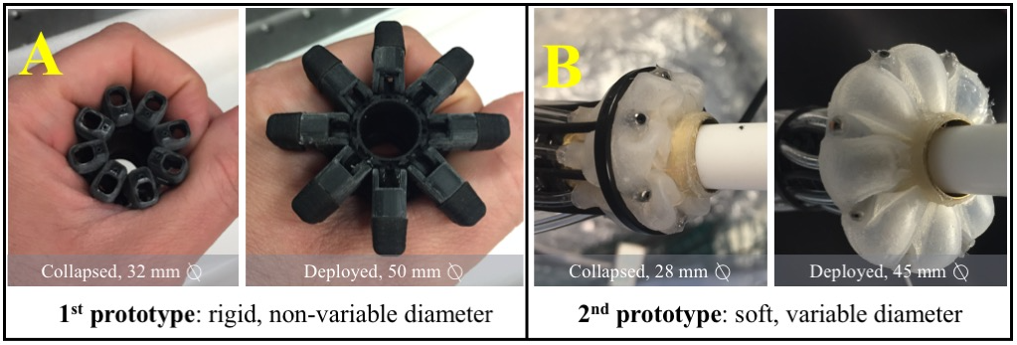 | 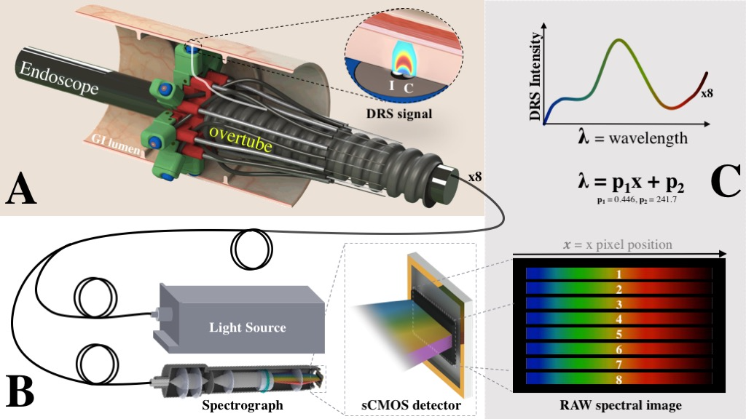
Fig. 1. Past and current iteration for radial arrays of OB probes | Fig. 2. Optical design of DRS OB multi-probe
The framework comprises a radial array of eight OB sensors that are partially rotated and translated along the GI tract while acquiring optical data (Fig. 1, A-B). Each of the OB sensors are single-point diffuse reflectance spectroscopy (DRS) fiber optic probes, introduced in a collapsed configuration as an over-tube add-on accessory to any conventional endoscope (Fig. 2, A). Deployment is achieved by externally actuated tendons. Each probe contains an illumination fiber that emits broadband light in the visible spectrum. The light is diffusely scattered inside the tissue and a parallel fiber collects and transmits it to a spectrograph where is diffracted into its spectrum and finally captured by an sCMOS camera. From each spectral image acquired, an image processing sub-routine converts it to 8 DRS spectra (Fig. 2, C). The device is simultaneous and continuously translated and rotated to scan and obtain a wide-field image. Rotation is provided by an external hollow rotary actuator through which the endoscope is inserted. Translation along the lumen using the endoscope as a rail is achieved by a stepper motor actuating a linear stage (not shown). Actuation control, data acquisition, HS data processing and visualization, are fully integrated into a MATLAB framework. The position of all probes is derived from a single angular and linear position reported by the actuators. Each scanning position is co-registered with its corresponding DRS spectrum. Grayscale, RGB, and machine-learning segmented images are generated by real-time processing of each DRS spectrum. A user interface allows real-time visualization of acquired raw and processed data as 2D and a pseudo-3D map (2D texture-mapped to a cylinder), simulating a representation of the colon (not shown). For rigid targets, we scanned a tube covered with a standard resolution target (1959 USAF). The scanning sequence comprised a 48º partial rotation (step size=1º) while axially advancing the device along the tubular target (step size=0.4 mm). Silicone phantoms were manufactured as deformable targets (Fig. 2 A). They included simulated flat lesions (Ø = 0.5 to 6.0 mm, height = 0.7 mm) that were pigmented to provide a clear HS signal over the simulated mucosa background color (Fig. 2 A, B).

3. Results

The average angular rotation error of the current device is 0.02º (SD 0.06º). The linear stage positioning error is stated to be at ±0.02 mm. The optical resolution achievable is 0.5 line pairs per mm (Fig. 2 C). This optical resolution is consistent with the smallest simulated flat pre-cancerous lesions resolved (0.75 mm), even while the scanning was performed inside deformable and stretchable phantoms (Fig. 2-E). Real-time machine-learning (SVM) classification of HS data from the phantom allows automated segmentation of the acquired image, with sensitivity and specificity over 95% (Fig. 2, Table 1). Preliminary fresh cadaveric studies show that the robotic scanning sequence is able to acquire HS data (data not shown).
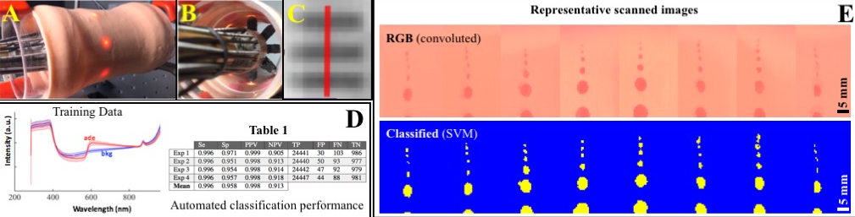
Fig. 2. (A-B) In vitro validation using silicone phantoms; (C) Cropped sub-section of a scanned 1951 USAF paper target showing optical resolution of 0.5 line pairs per mm; (D) Plot: Training dataset for ML classification, representative 11500 DRS spectra (mean ± SD) of simulated adenomas (ade) vs. 9000 spectra of simulated mucosa (bkg) on a silicone phantom; (D) Table 1: Performance of machine-learning (SVM) classification, using the training dataset shown in the plot. Total DRS spectra per experiment: 25560 (ground-truth: human manual registration); (E) Representative scanned RGB (DRS HS data convoluted using RGB color matching functions) and class-segmented images.

4. Discussion
We report for the first time real-time endoscopic wide-area HS optical-biopsy imaging and its in vitro validation for GI tract applications. We achieve this via the robotic scanning of a simulated colon by a radial array of contact single-point DRS probes. Sub-millimeter optical resolution and online machine learning segmentation was demonstrated, which could allow the identification of flat pre-cancerous lesions that are currently missed. The size is compatible with real dimensions of the colon, but additional miniaturization is desirable. Our framework is evolving from this early rigid design into a soft-robotic deployment (Fig. 1 B) and passive scanning along areas with variable diameter, folds, flexures, and the integration of pressure sensing and force control safety features, while validating in ex vivo and in vivo models. Eventually, any optical-biopsy modality and data acquired with the framework could be registered with the video stream of any conventional endoscope, paving the way towards computer-assisted augmented reality endoscopy, while increasing GI endoscopy’s sensitivity and specificity.
This work is supported by the Institutional Strategic Support Fund: Networks of Excellence Scheme 2015 (GM), UK ERC award 242991 (DSE) and Becas Chile scholarship from the Chilean Government (FBA).

5. References

- van Rijn, J.C., et al., Polyp miss rate determined by tandem colonoscopy: a systematic review. Am J Gastroenterol, 2006. 101(2): p. 343-50.
- Ignjatovic, A., et al., What is the most reliable imaging modality for small colonic polyp characterization? Study of white-light, autofluorescence, and narrow-band imaging. Endoscopy, 2011. 43(2): p. 94-9.
- Committee, A.T., et al., ASGE Technology Committee systematic review and meta-analysis assessing the ASGE PIVI thresholds for adopting real-time endoscopic assessment of the histology of diminutive colorectal polyps. Gastrointest Endosc, 2015. 81(3): p. 502 e1-502 e16.
- Teng, T.Y., et al., Morning colonoscopies are associated with improved adenoma detection rates. Surg Endosc, 2016. 30(5): p. 1796-803.
- Mori, Y., et al., Computer-aided diagnosis for colonoscopy. Endoscopy, 2017.
- Erden, M.S., et al., Conic-Spiraleur: A Miniature Distal Scanner for Confocal Microlaparoscope. IEEE/ASME Transactions on Mechatronics, 2014. 19(6): p. 1786-1798.
- Avila-Rencoret, F., D. Elson, and G. Mylonas, Towards a robotic-assisted cartography of the colon: a proof of concept, in 2015 IEEE International Conference on Robotics and Automation (accepted). 2015, IEEE: Seattle, WA, USA.

